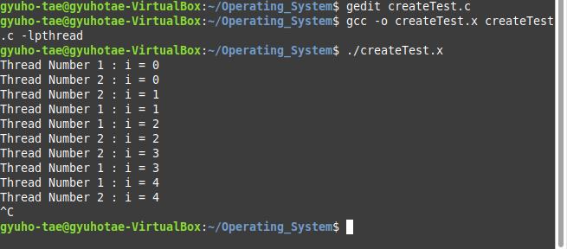
Creating New Thread
createTest.x

two different thread is looping infinitely
The sequence of 1,2 may different from what is shown since both starts almost the same.

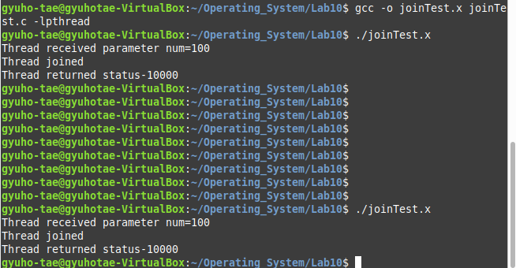

Joining a Thread
joinTest.x

Thread joins after new thread exit and new thread waits.

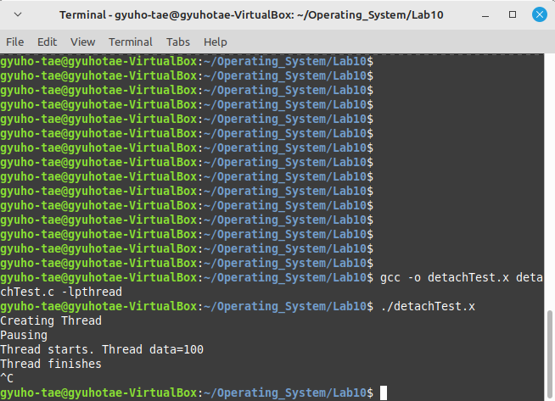

Detaching a Thread
detachTest.x

new thread created, and when 5 seconds is passed automatically, original thread waits since detached.

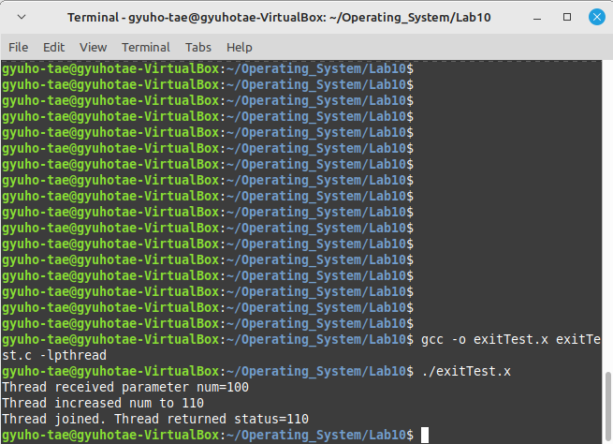

Exiting a Thread
exitTest.x

pthread_join receive new value from pthread_exit, new thread exit.

