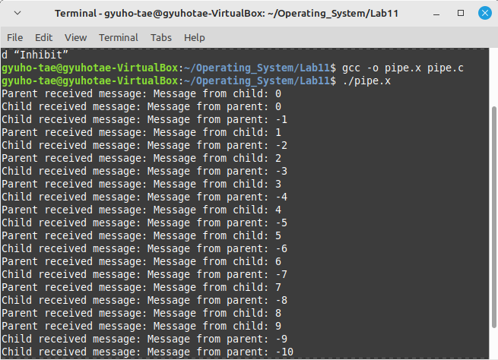
./pipe.x

Parent and child two different processes are sending message through the pipe.
So array 0 is reading and 1 is sending message.

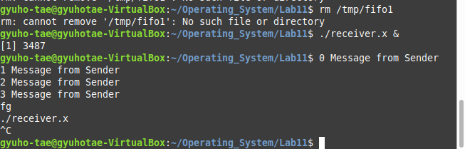
./receiver.x

It is using FIFO, special file that can open read and write.
In the code, name of the FIFO file is fifo1.
It is reading it by every buffer.
In here the message is “Message from Sender”.

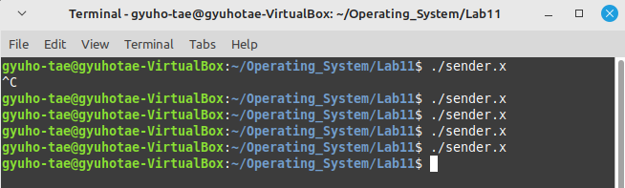
./sender.x

In the sender file, we send the message “Message from Sender”.
And this message is written in FIFO_FILE, which is /tmp /fifo1.
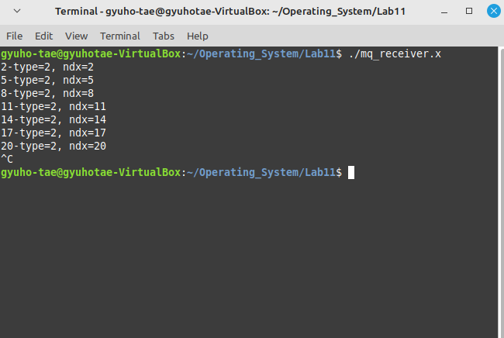
./mq_receiver.x

mq is message queue
Here msq is used, each queue having id .

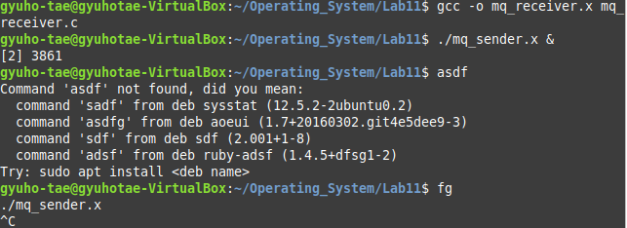
./mq_sender.x

It is sending with specific algorithm that (ndx ++%3)+1 starting from 0.
And it is giving it by queue.
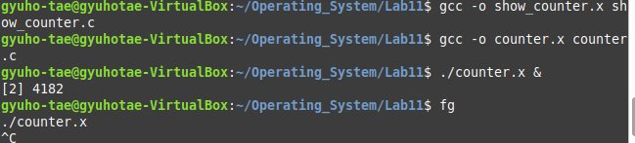
./counter.x

It contains the id address and the count starting from 0.

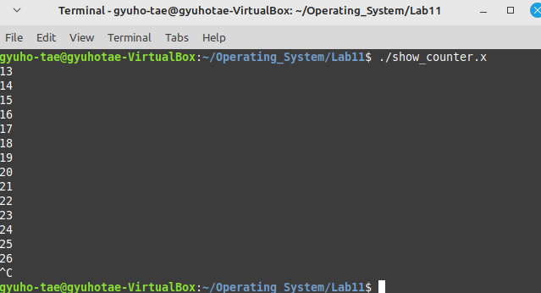
./show_counter.x

by knowing the key , get id address, memory size, ipc.
And prints what is written in allocated address.
In here it is number, since the counter is running while loop in the background, number has started from 13 when it turned on.

