**This doc describes a review of the tools used to create a template raster grid in Mollweide projection from which a vector grid can be created of equal area cell size for subsequent intersections with other vector layers like roads and concession areas and raster for zonal stats. The desired spatial resolution or grid cell size was 10km.**

**RASTER Method**

**Tool1: create random raster**

This tool does not allow the coordinate system to be set and the outputs raster is a spatially undefined grid of x/y columns and rows and output extent set by user in arbitrary units.

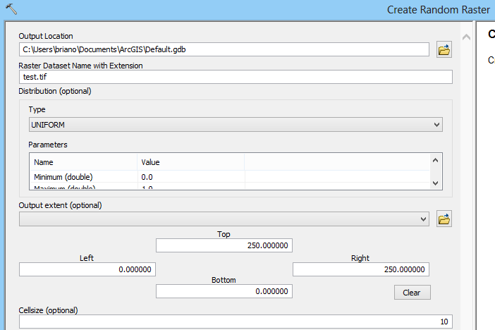

Output looks like this:

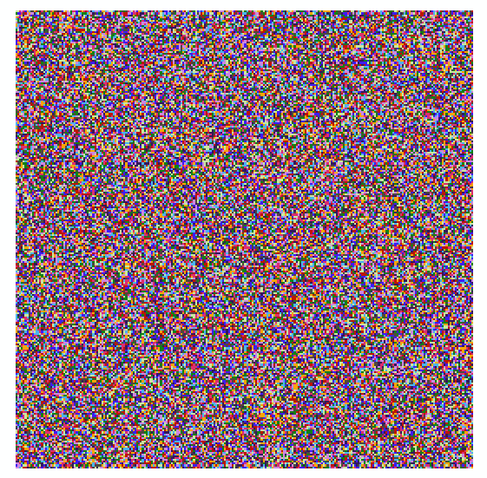

**Tool2: create raster dataset**

This tool allows the projection to be set plus all the usual spatial configuration items but only creates an empty, four-sided bounding box, to be populated by raster values using the mosaic tool, for example.

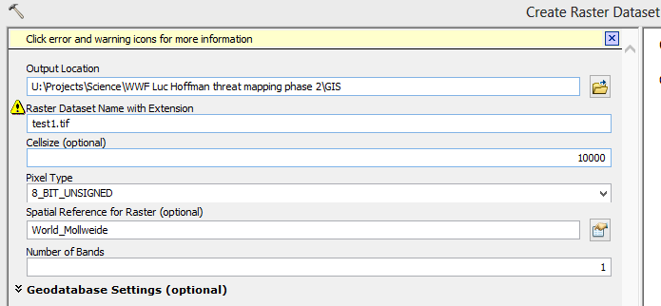

Since this isn’t useful, I then tried to create a projection for the random raster, created in tool1, since it has the desired spatial configuration items but no projection.

**Tool 3: Define Projection**

Assigned Mollweide to the random raster but the data frame still reads unknown units which makes me suspicious and I can’t manually define the global extent in metres.

**Tool 4: Raster to Polygon**

I tried to convert the random raster with a defined projection, in Mollweide, to polygon. **This tool wouldn’t allow rasters with float so had to go back to tool 1 and assign an “integer” type to the raster in the tool settings and start again.**

The output then produced unclosed grid cells:

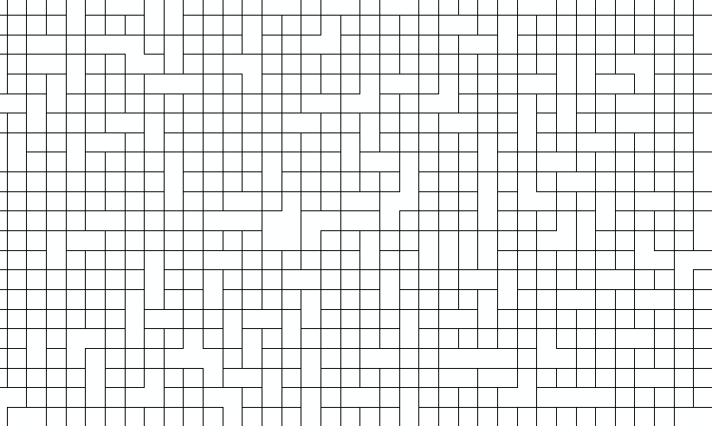

**Something wrong here!**

Then tried another way:

1. Right-click a geodatabase and click New > Raster Dataset.
2. Type the name of the new raster dataset.
3. Set the Cell Size of the geodatabase raster dataset.
4. Set the Pixel Type for the geodatabase raster dataset
5. Set the spatial reference, i.e. Mollweide

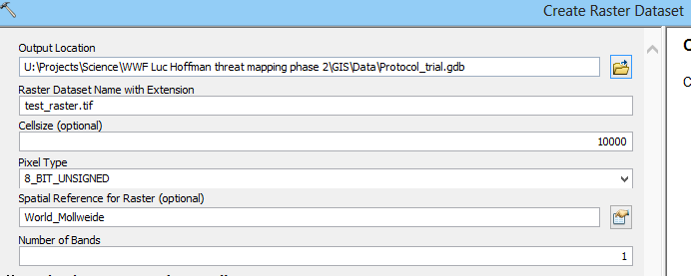

This doesn’t allow an output extent to be set so the output was meaningless and seems to do the same thing as tool 2 above.

The solution might be to follow tool 1 but define the outputs extent from a global raster already in Mollweide which I don’t have. This would appear to defeat the purpose of creating a Mollweide raster from scratch if you already need an existing one to make it work.

**VECTOR Method**

1. **Create Fishnet tool**

Easiest is to set up a template extent from an existing global feature class or raster – I used “UN_baselayer_2012”. This is a political map of the world.

I used a geographic grid so all params now in geographic coordinates, e.g. I set the cell size to 0.1 degree instead of 10km., not the Mollweide projection I originally wanted.

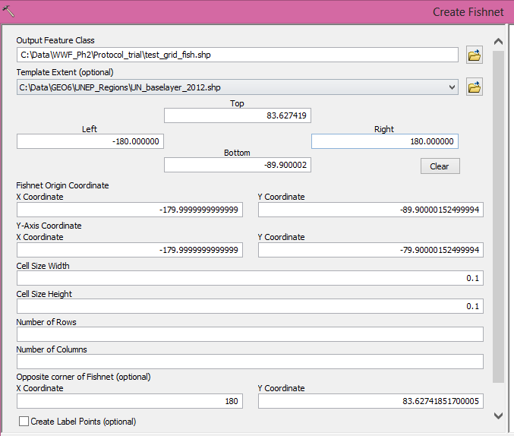

The output still has an undefined coordinate system:

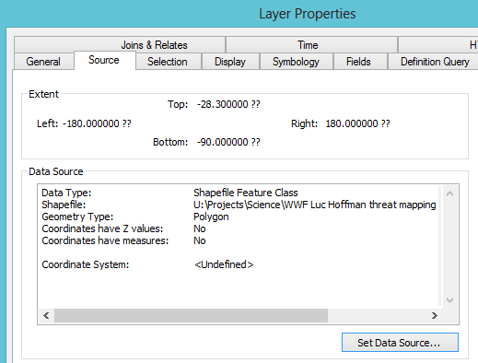

The result is a grid for the globe not limited to land boundaries (even though the template used was of country boundaries); it takes up about 900MB of memory:



1. **Grid Index Feature Tool**

For this tool, I used an existing template instead of manually inputting coordinates. I chose the same global shapefile of political boundaries (UNEP 2012). The tool is traditionally used for the data driven pages function for map booklets but can be adapted for drawing fishnets (you just get an extra two columns in the attribute table for the page ID numbers which can be deleted – removing these two extra columns means it’s only 448 MB in memory):

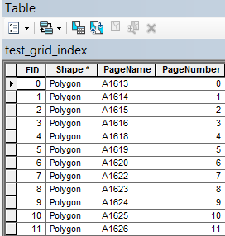

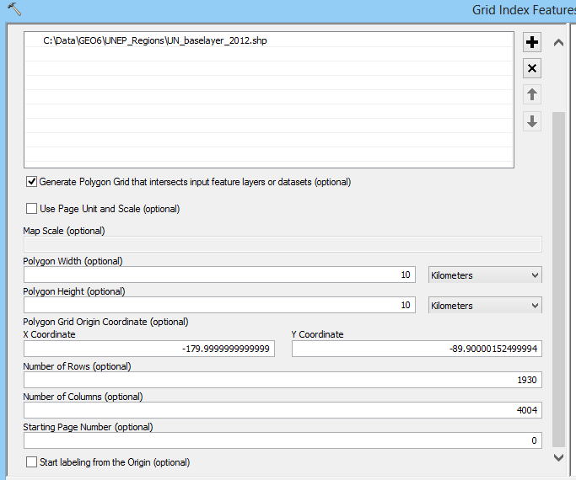

Though the pivot coordinate of the grid is in lat/lon it allowed me to choose a cell size in km. the result looked good: 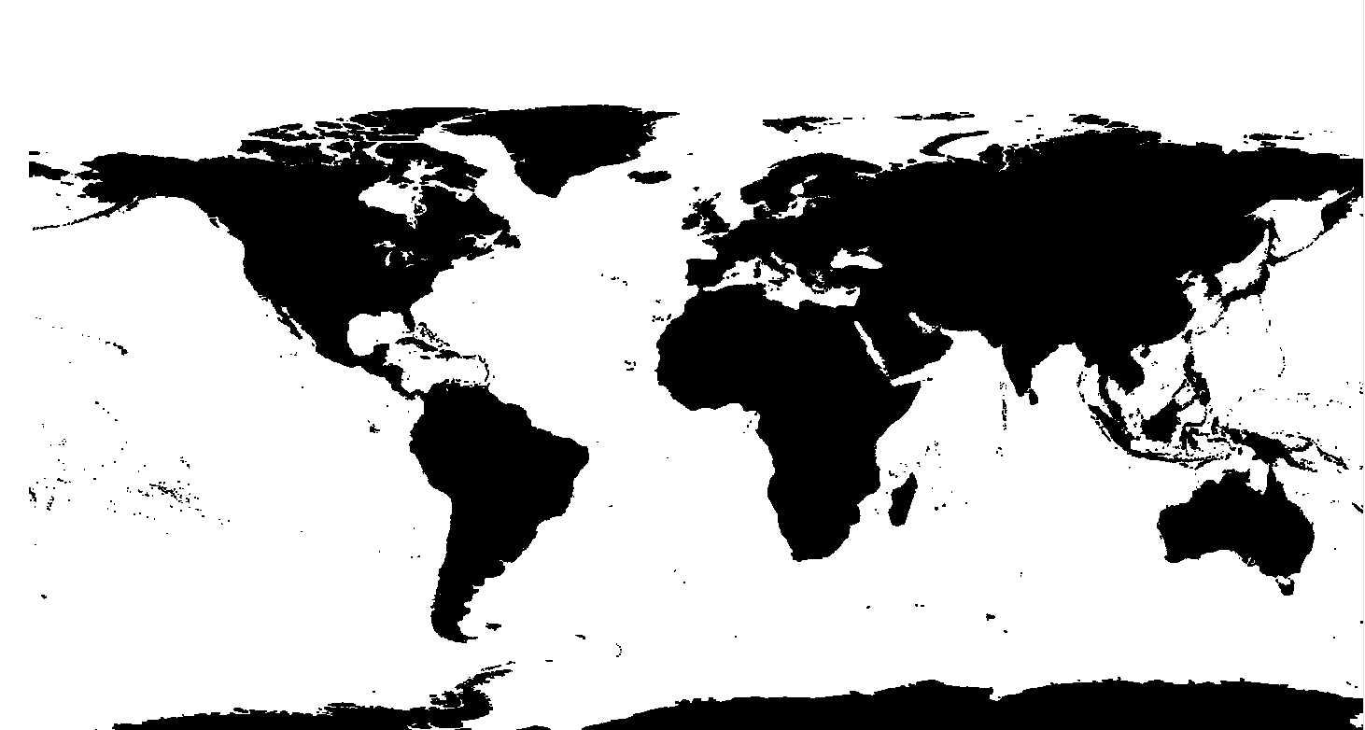 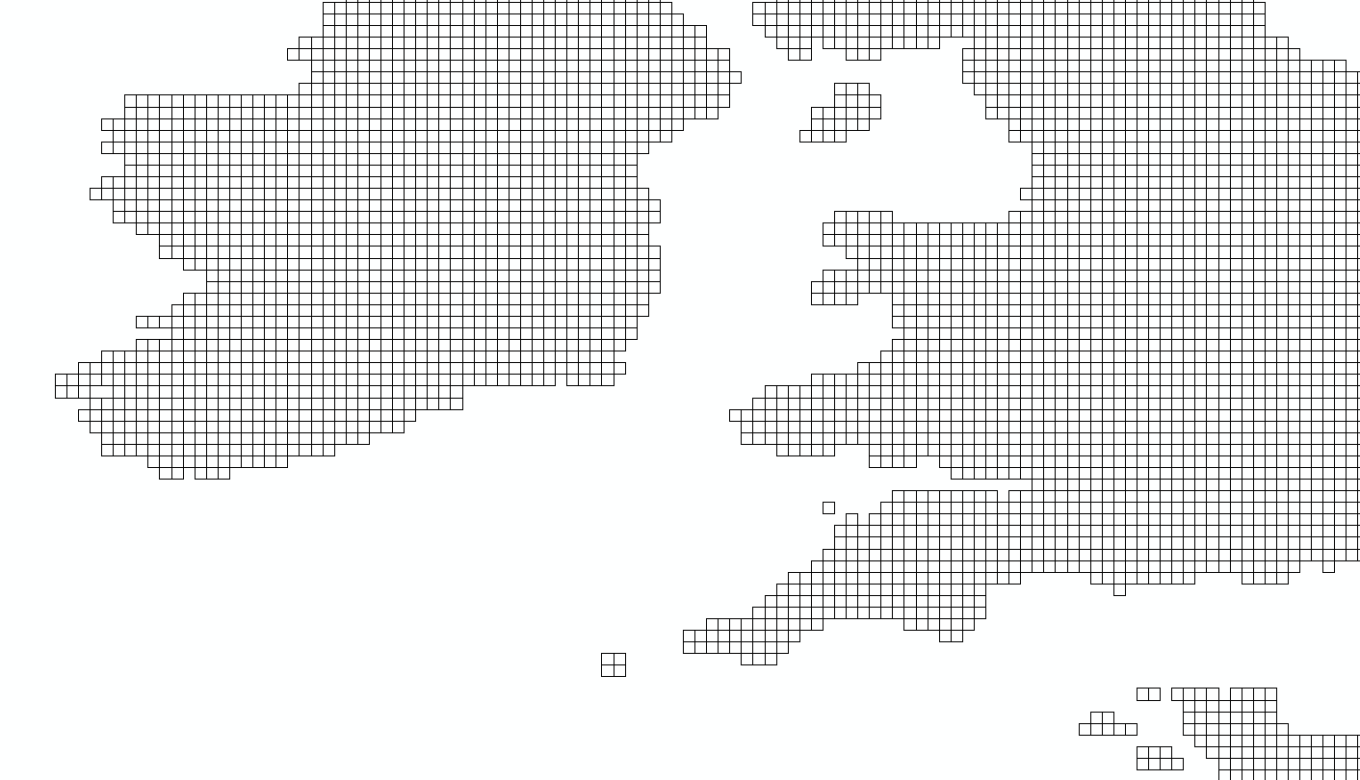 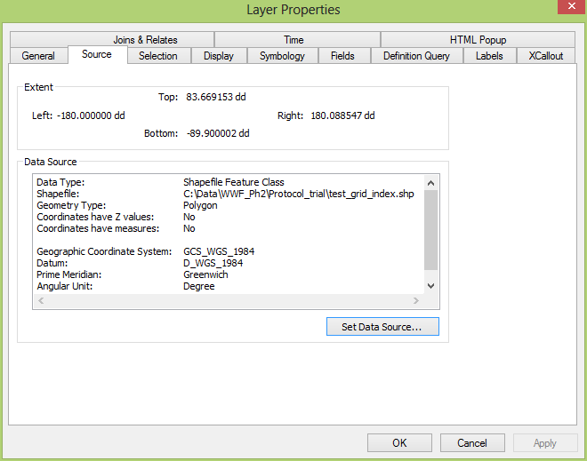

The output is still a geographic, unprojected grid. So in order to get the true area of polygon cells for later calculation of densities etc. I used this tool:

1. **Add Geometry Attributes tool**

I selected the coordinate system as Mollweide from the optional setting and geodesic area in kilometres.

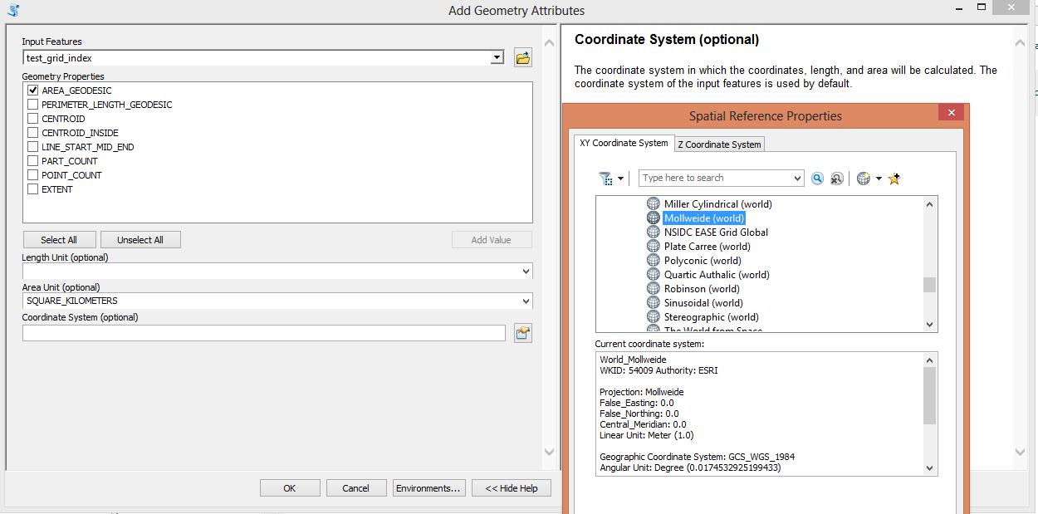

The result is not an equal area grid with polar grid cells much smaller (~0.25km2) than equatorial (99.25 km2).

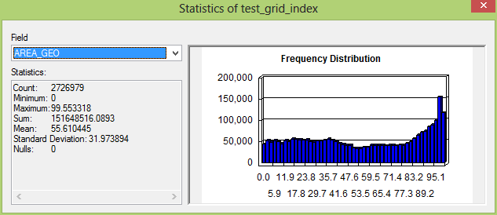

**SCRIPT (python) method:**

This method is based on a simple script that Andy wrote which summarise most of the above– with 3 basic steps:

arcpy.CreateRandomRaster_management (creates a normal raster in a global extent and cell size=10,000m)

arcpy.gp.RasterCalculator_sa (ensures that the raster is integer)

arcpy.RasterToPolygon_conversion

The full script is here:

P:\PROGRAMMES\SCIENCE\Temp_DataTransfer\Andy_to_brian

I then added an extra step to define the projection of the output polygon grid since it didn’t have one. I assigned Mollweide. The output is also a global grid, i.e. not terrestrial only.

I added a column of geodesic area (using the add geometry attribute tool) to the attribute table to ensure it was equal area but it was not. Max cell size area is 392 km2 and min area is 0 km2. **Very strange!**

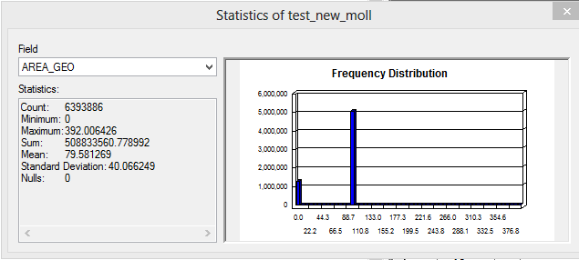

**REVISION TO ABOVE:**

1. For the Vector and Grid Index approach use as the template extent the already projected to Mollweide UN countries map.

I first projected the UN base layer from WGS 84 to Mollweide but the output still retains the WGS84 datum and has zero for the parameters needed, i.e. false easting, northing and central meridian. Perhaps these parameters are genuinely zero as it uses these values, e.g. Greenwich Meridian=0 longitude.

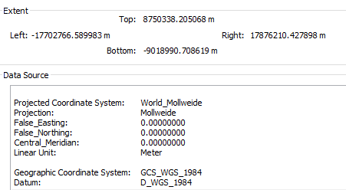

**REVISION: Grid Index Feature Tool**

For this second attempt with the grid index feature tool I went with the UN base layer in Mollweide projection as a template extent and left everything else the same:

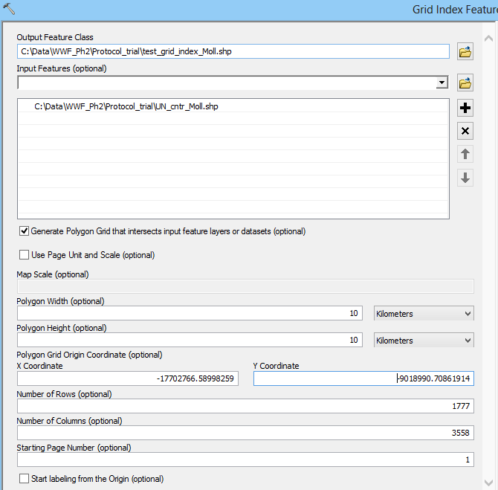

Now the grid index is in Mollweide (but it still has the WGS84 datum and I cannot figure out if this is important or not):

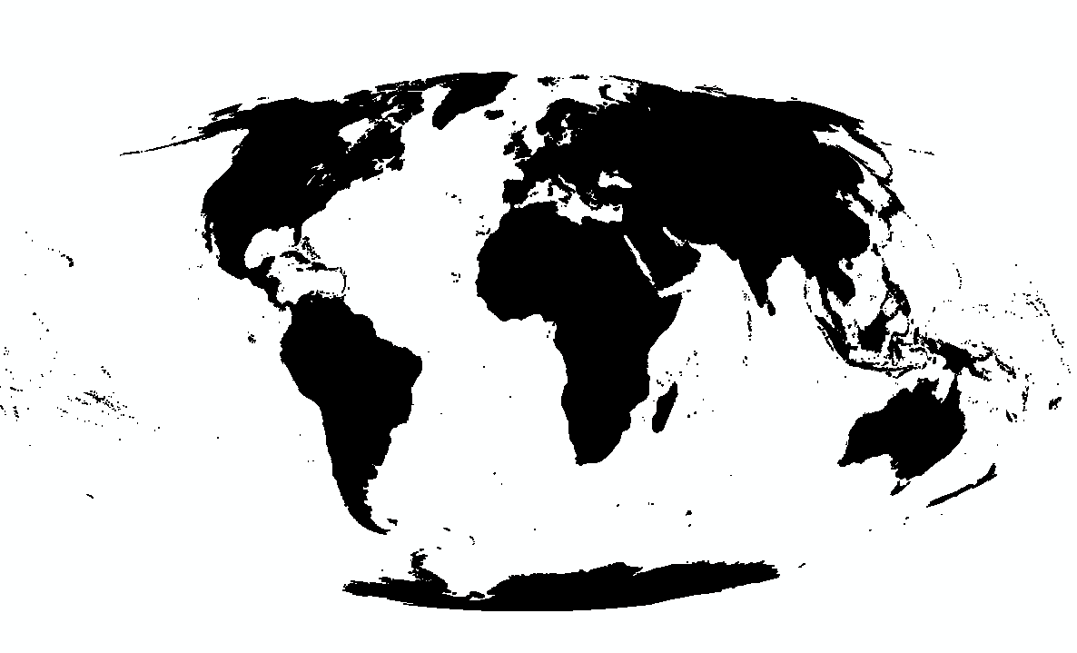 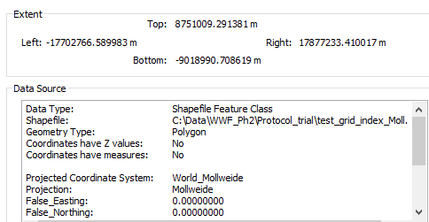

To test accuracy of result ran geodesic area again:

The polygons are still not equal area but have a much tighter distribution around the mean (100km2) so perhaps getting closer to an equal area grid:

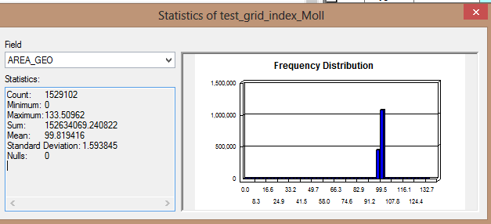

**REVISION: Fishnet Tool**

For this second attempt with the fishnet tool I went with the UN base layer in Mollweide projection as a template extent and left everything else the same **except in ‘Environment Setting’ I selected the output projection as Mollweide.**

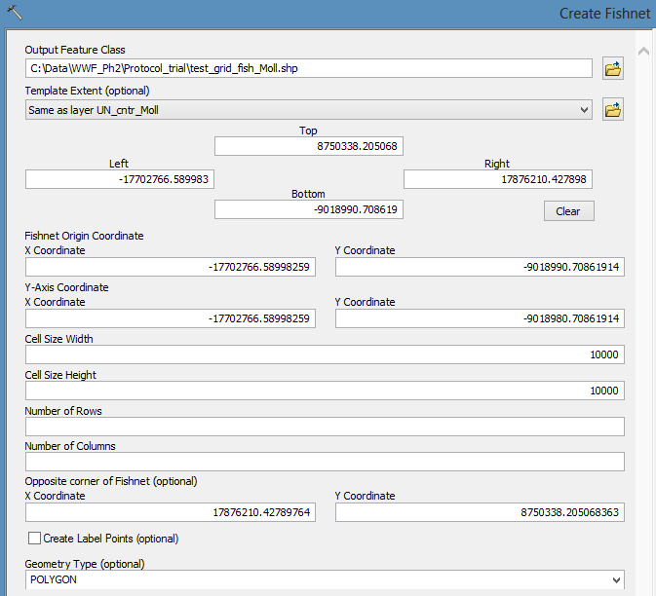

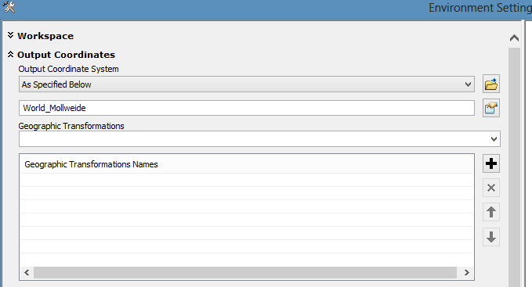

The polygon feature produced is once again in Mollweide with a WGS84 datum:

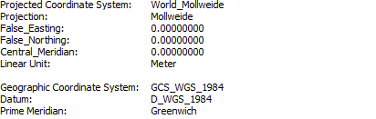

The summary statistics of the geodesic area are also puzzling:

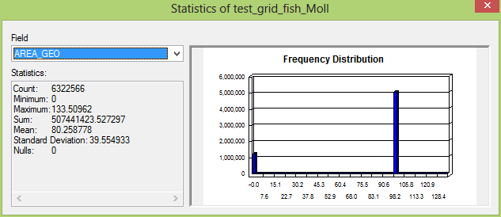

I was curious about the polygons which had ‘zero’ area so I selected them (in blue):

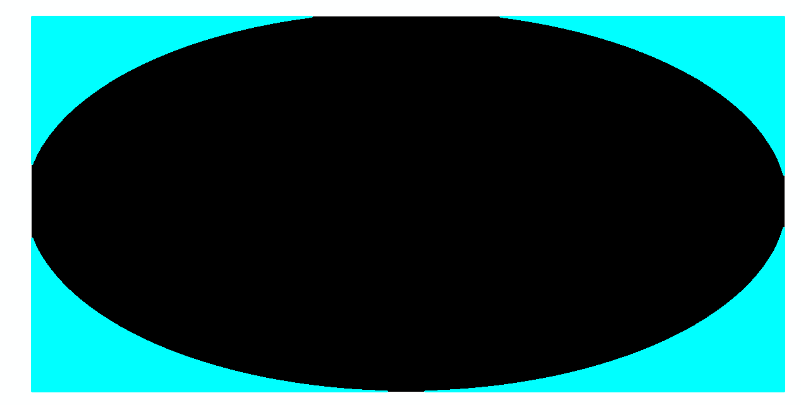

Then I ran statistics on just the valid polygon cells (highlighted):

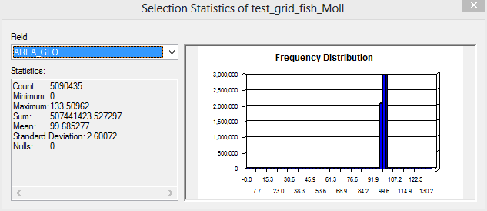

The mean is now pretty close (99.685277 km2 vs. 99.89416 km2) to the result produced from the grid index tool above although there is slightly more variance from the mean (SD= 2.60072 when using fishnet vs. 1.593845 when using the grid index**). So the grid index tool seems to be creating more equal area polygons than the fishnet tool.**

I then created a raster from the ‘Geodesic area’ field of the grid index table using the ‘Feature to Raster’ tool stating the output cell size as 10km:

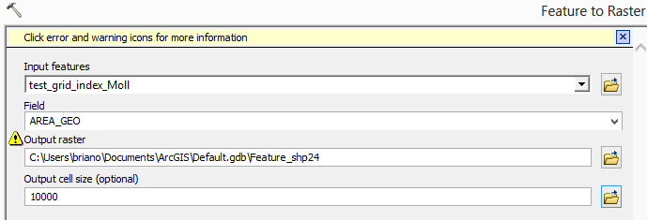

Output raster looks like this:

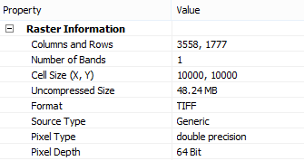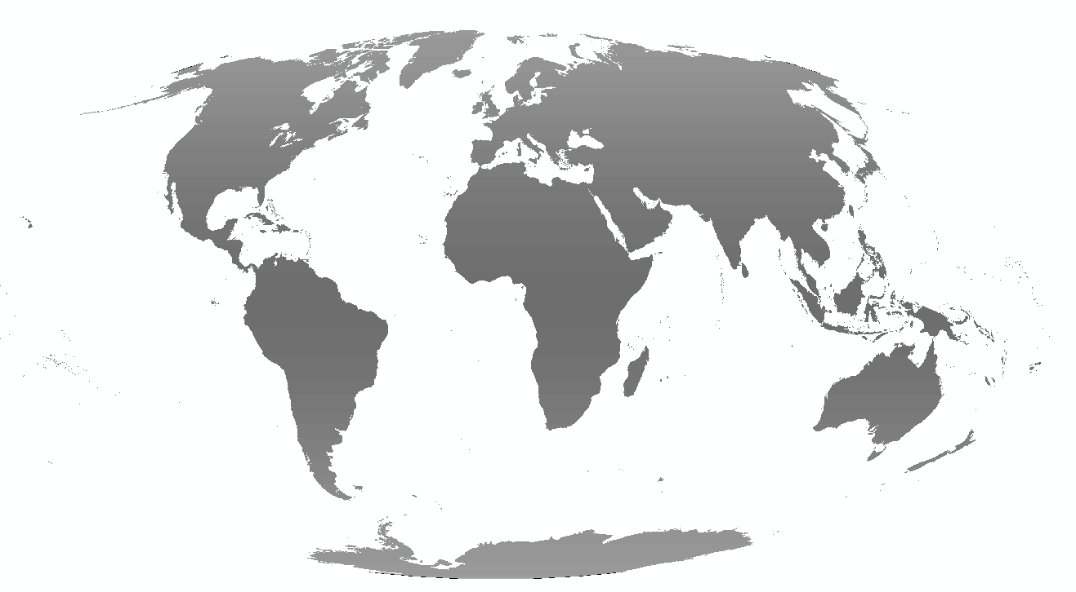

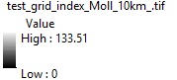

**A general inspection shows that most grid cells are 100km2. Some near the poles are 100.64 km2, some near equator are 99.33 km2.**

**Conclusion / Summary of steps:**

1. Create or find a suitable vector template, e.g. UN political base layer, projected in Mollweide
2. Use the grid index feature tool and add the above layer as a template – state Mollweide as output projection in the environment settings (this is optional- doesn’t seem to change the result if you don’t set it)
3. Delete the extra columns (page number and ID) from the output grid as they reduce the memory needed to save and store the file
4. Add geometry attribute tool to create a field for geodesic area in kilometres – all should now be in and around the mean of 100km2 (i.e. assuming an original cell size of 10km2)
5. Any raster created from this master grid should therefore be 10km spatial resolution and equal area (as example shows above)