Open Bible Stories

The Ten Plagues

## 0 Introduction

### 0.1 Key Idea

The story of the Ten Plagues teaches us of God’s judgment against his enemies.

### 0.2 Creedal Verse

“And if you are Christ’s, then you are Abraham’s offspring, heirs according to promise.” Galatians 3:29

### 0.3 Metanarrative Summary

The eternal God created all things in six days. He made a good and perfect world. He made humans in his image to fill the earth and rule over creation. But humans rebelled against God and ruined God’s creation. God set to restore his world through his promise. God made a covenant with Abraham. He promised to bless all nations through Abraham. God kept his promises across the generations. God provided Abraham with a promised child, Isaac. God gave Isaac a wife and she bore twins, Jacob and Esau. God blessed Jacob and his sons, and the blessing continued to the next generation. God rescued Joseph, one of Jacob’s sons, and used him to rescue his family. God caused his people, the Israelites, to multiply in the land of Egypt; eventually, they became slaves. But, God raised up a deliverer, Moses, to deliver his people from their slavery. God sent judged the Egyptians with harsh plagues.

### 0.4 Open Bible Story: The Ten Plagues

10-01

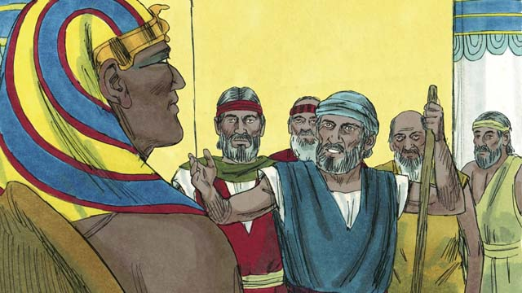

God warned Moses and Aaron that Pharaoh would be stubborn. When they went to Pharaoh, they said, “This is what the God of Israel says, ‘Let my people go!’” But Pharaoh did not listen to them. Instead of letting the Israelites go free, he forced them to work even harder!

10-02

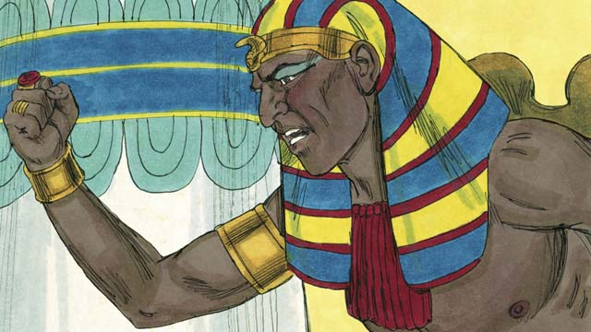

Pharaoh kept refusing to let the people go, so God sent ten terrible plagues on Egypt. Through these plagues, God showed Pharaoh that he is more powerful than Pharaoh and all of Egypt’s gods.

10-03

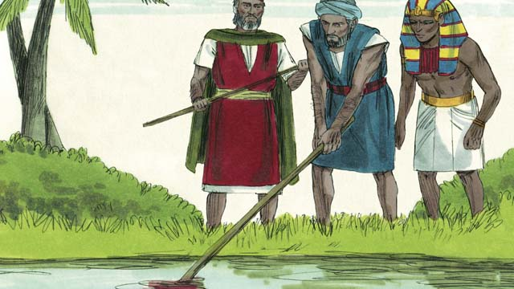

God turned the Nile River into blood, but Pharaoh still would not let the Israelites go.

10-04

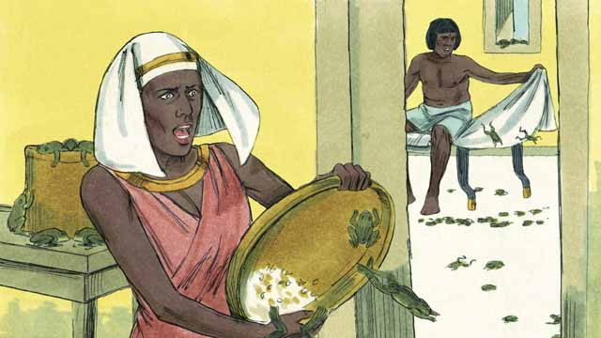

God sent frogs all over Egypt. Pharaoh begged Moses to take away the frogs. But after all the frogs died, Pharaoh hardened his heart and would not let the Israelites leave Egypt.

10-05

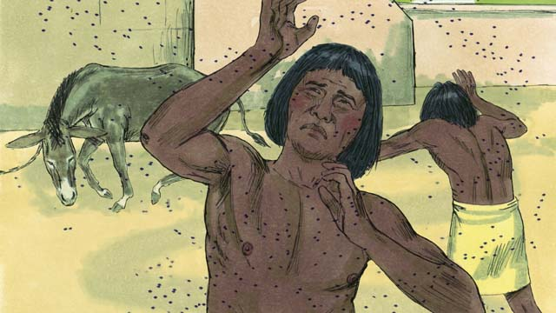

So God sent a plague of gnats. Then he sent a plague of flies. Pharaoh called Moses and Aaron and told them that if they stopped the plague, the Israelites could leave Egypt. When Moses prayed, God removed all the flies from Egypt. But Pharaoh hardened his heart and would not let the people go free.

10-06

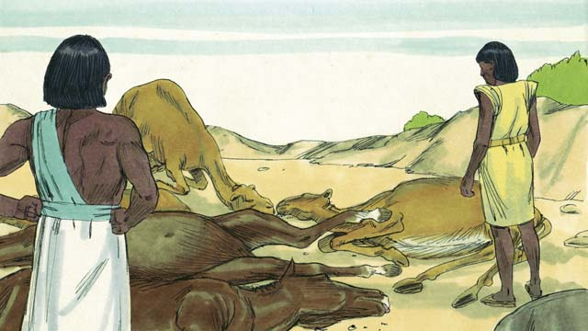

Next, God caused all the farm animals that belonged to the Egyptians to get sick and die. But Pharaoh’s heart was hardened, and he would not let the Israelites go.

10-07

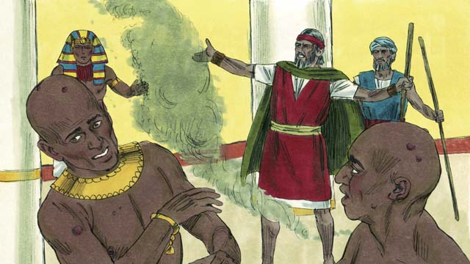

Then God told Moses to throw ashes into the air in front of Pharaoh. When he did, painful skin sores appeared on the Egyptians, but not on the Israelites. God hardened Pharaoh’s heart, and Pharaoh would not let the Israelites go free.

10-08

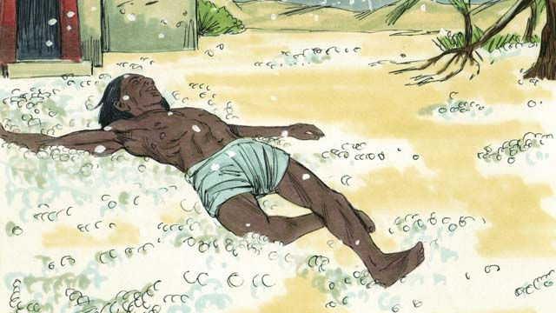

After that, God sent hail that destroyed most of the crops in Egypt and killed anybody who went outside. Pharaoh called Moses and Aaron and told them, “I have sinned. You may go.” So Moses prayed, and the hail stopped falling from the sky.

10-09

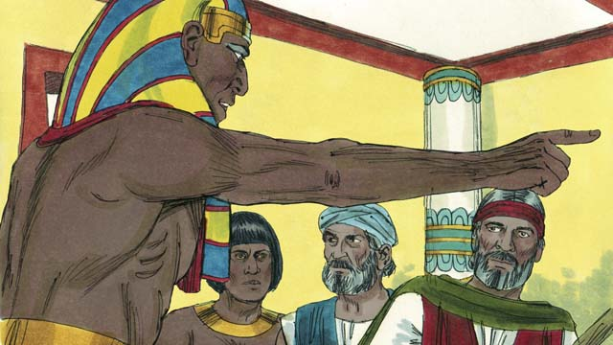

But Pharaoh sinned again and hardened his heart. He would not let the Israelites go free.

10-10

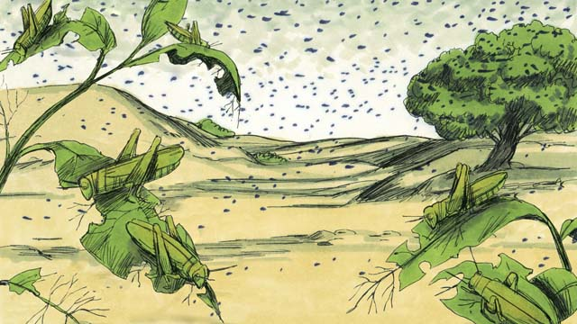

So God caused swarms of locusts to come over Egypt. These locusts ate all the crops that the hail had not destroyed.

10-11

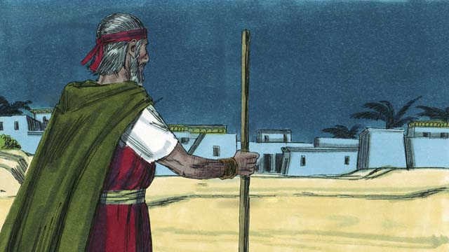

Then God sent darkness that lasted for three days. It was so dark that the Egyptians could not leave their houses. But there was light where the Israelites lived.

10-12

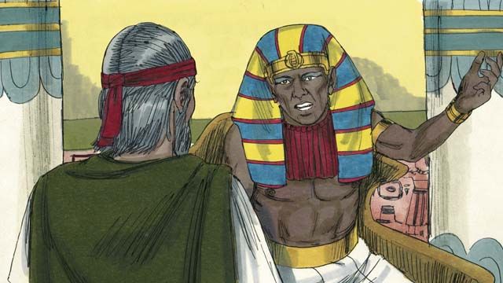

Even after these nine plagues, Pharaoh still refused to let the Israelites go free. Since Pharaoh would not listen, God planned to send one last plague. This would change Pharaoh’s mind.

*A Bible story from: Exodus 5-10*

## 1 Community Study: Things Which Are Not Proper—Recognizing the Community Damage of Sin

* **Key Idea**: acknowledging the negative impact of sin
* **Key Passage**: Romans 1:28-32
* **Main Session**: OBS 10 (The Ten Plagues)

### 1.1 Sing to God (3–5 minutes)

Choose a song to sing to praise God and encourage one another.

### 1.2 Recite the Creedal Verse (3–5 minutes)

The verse below summarizes the teaching of the current passage. Read the verse out loud as a community. Read it again several times as a group until the whole community can recite it from memory.

The God of this people Israel chose our fathers and made the people numerous when they stayed in the land of Egypt, and with an uplifted arm he led them out of it. Acts 13:17

### 1.3 Read the Passage (5 minutes)

When people reject God, they live in a way that dishonors God and harms others. Christians need to guard themselves against ungodly attitudes, behaviors, and desires. In order to understand the danger of such ungodliness, read the passage below.

28 Because they did not approve of having God in their awareness, he gave them up to a depraved mind, for them to do those things that are not proper. 29 They have been filled with all unrighteousness, wickedness, covetousness, and malice. They are full of envy, murder, strife, deceit, and evil intentions. They are gossips, 30 slanderers, haters of God, insolent, arrogant, boastful, inventing ways of doing evil; they are disobedient to parents. 31 They are senseless, faithless, heartless, and unmerciful. 32 They understand the regulations of God, that those who practice such things are deserving of death. But not only do they do these things, they also approve of others who do them. Romans 1:28-32

### 1.4 Discuss the Idea (10–15 minutes)

Christians should guard themselves against ways of life that are wrong and evil. Use the following questions to discuss the destructive effects of sin in the Christian community.

1. What are sinful effects that result when people reject God?
2. How do such sinful ways dishonor God and harm others?
3. Even though Christians have been set free from sin, how might these sinful ways still damage and disrupt the Christian community?
4. How can your community guard itself against these sinful ways?

### 1.5 Pick One from the List (5 minutes)

Thinking about the list of sinful ways, pick one specific sin that you feel could disrupt your community life. Think out loud of the consequences that would result if this sinful way made inroads into your community.

If the sin of [choose one from the passage above] was present in our community, then the results would be…

### 1.6 Pray to God (5 minutes)

Divide the community into groups of 2–3. Pray that God would guard you as individuals and as a community against the effects of these sinful ways.

## 2 Biblical Interpretation: Observing the Details of the Story

After reading the crafted biblical story, answer the following questions to familiarize yourself with the details of the story.

### 2.1 Observation Questions

Answer the following observation questions to gain a basic understanding of the the story. Read the story as a community and answer these questions as a group.

#### 10-01

How did God say that Pharaoh would respond?  
God cared Moses and Aaron that Pharaoh would be stubborn.

What was God’s message that Moses and Aaron gave to Pharaoh?  
God’s message to Pharaoh was, “Let my people go!” What did Pharaoh do when he heard this command?  
Pharaoh did not listen to them. He forced the Israelites to work even harder.

#### 10-02

What did God do when Pharaoh refused to let the Israelites go?  
He sent ten terrible plagues on Egypt.

What did God show Pharaoh through these plagues?  
He showed that he is more powerful than Pharaoh and all of Egypt’s gods.

#### 10-03

What was the first plague? What did God do to the water in the Nile River?  
God turned water in the Nile River into blood.

#### 10-04

What happened in the second plague?  
God sent frogs all over Egypt.

What did Pharaoh do after this plague?  
Pharaoh hardened his heart and would not the the Israelites go free.

#### 10-05

What happened in the third and fourth plague?  
God sent gnats. Then God sent flies

What did Pharaoh tell Moses and Aaron to do?  
Pharaoh told Moses and Aaron that if the plagued stopped he would let the Israelites go free.

What did Moses and Aaron do?  
Moses and Aaron prayed to God. God removed all the flies from Egypt.

What did Pharaoh do after this plague?  
Pharaoh hardened his heart and would not the the Israelites go free.

#### 10-06

What happened in the fifth plague?  
God caused the farm animals that belonged to the Egyptians to get sick and die.

What did Pharaoh do after this plague?  
Pharaoh hardened his heart and would not the the Israelites go free.

#### 10-07

What happened in the sixth plague?  
God caused painful skin sores to appear on the Egyptians.

Who was affected by the plague of the painful skin sores?  
The sores appeared on the Egyptians, but not on the Israelites.

What did Pharaoh do after this plague?  
God hardened Pharaoh’s heart and would not the the Israelites go free.

#### 10-08

What happened in the seventh plague?  
God sent hail that destroyed most of the Egyptian crops and killed people who went outside.

What did Pharaoh do after this plague?  
Pharaoh said he sinned. He told the Israelites they could go free and the hail stopped falling form the sky.

#### 10-09

How did Pharaoh change his mind about letting the Israelites go free?  
Pharaoh sinned, hardened his heart, and would not the the Israelites go free.

#### 10-10

What happened in the eighth plague?  
God sent locusts to come over Egypt.

What did the locusts destroy?  
The locusts destroyed the Egyptian crops that the hail did not destroy.

#### 10-11

What happened in the ninth plague?  
God sent darkness that lasted for three days. It was so dark the Egyptians could not leave their houses.

Did the plague of darkness affect everyone equally?  
No, it was dark where the Egyptians lived, but there was light where the Israelites lived.

#### 10-12

How did Pharaoh respond to each of the first nine plagues?  
He refused to let the people go free.

What did God do after Pharaoh did not respond to the first nine plagues?  
God planned to send one last plague.

What would this last plague do that the first nine had not done?  
It would change Pharaoh’s mind.

### 2.2 Translation Questions

Use the following translation questions to understand specific details of the passage. Discuss how you might translate these specific elements of the story.

#### 10-01

**stubborn** Pharaoh refused to obey God. What words in your language mean **stubborn** as in to refuse to change or listen/obey someone?

  

**the God of Israel** This phrase refers to the God whom the Israelites worship. It refers God as the one who chose and rules the Israelites and the God whom the Israelites serve. How would you express **the God of Israel** to mean the God whom the Israelites serve and worship?

  

**Let my people go!** God commands Pharaoh to allow his people to go free. This command tells/orders Pharaoh to free God’s people to leave Egypt. How would you express **Let my people go!** as a command in which God is telling Pharaoh to let his people to go free and leave Egypt?

  

**listen to** This means to heed or obey. What words in your language mean **listen to** as in to heed or obey?

  

**But Pharaoh did not listen** The word But contrasts what Moses and Aaron told Pharaoh and how Pharaoh responded. Moses and Aaron told Pharaoh that God ordered him to let the Israelites go free. The opposite happened. Pharaoh refused to listen to God’s command. How would you express **But Pharaoh did not listen** to mean Pharaoh responded opposite/different from what Moses and Aaron told him?

  

**he forced them to work even harder!** Pharaoh not only did not free the Israelites, he made their lives even harder. This statement shows strong emotion that things go more difficult for the Israelites. How would you express **he forced them to work even harder!** as a strong statement of emphasis to show that things became even more difficult for the Israelites?

  

#### 10-02

**so God sent** The word so tells the result (or what happened because) of Pharaoh making the Israelites work harder instead of letting them go. The result was God sent ten terrible plagues on Egypt. How would you express **so God sent** to mean the result of Pharaoh making the Israelites work harder instead of letting them go was God sent ten terrible plagues on Egypt?

  

**terrible plagues** A plague is something very bad or terrible that happens to someone or something. A plague usually refers to something that affects many people or happens over a large geographic area. Another word for plague would be ‘disaster.’ How would you express **terrible plagues** to mean a really bad thing that brings death or disaster to many people in a large geographic area?

  

**all of Egypt’s gods** These are all the gods that the Egyptian people worshiped. The people of Egypt worshiped many different false gods. Some of these false gods did not exist. Other false gods that they worshiped were actually demons. Demons are not as powerful as the God of Israel. How would you express **all of Egypt’s gods** to mean the false gods that the Egyptian people worshiped?

  

#### 10-03

**turned the Nile River into blood** God turned the water in the Nile River into blood. There was blood in the river instead of water, so the fish died and the people had no water to drink. How would you express **turned the Nile River into blood** to mean God caused the water of the Nile River to become blood such that the fish died and the people had no water to drink?

  

**but Pharaoh still** The word but contrasts God turning the river to blood with Pharaoh not letting the Israelites go. This is not the first time Pharaoh refused to let the Israelites go. How would you express **but Pharaoh still** to mean Pharaoh continued to refuse to let the Israelites go?

  

#### 10-04

**Pharaoh begged** Moses Pharaoh pleaded with Moses to take the frogs away. How would you express **Pharaoh begged** Moses to mean Pharaoh earnestly pleaded with Moses to take the frogs away?

  

**hardened his heart** Pharaoh became stubborn again and refused to obey God. Pharaoh’s stubborn attitude is spoken of as if his heart were hard. Something that is hard is not easily changed. How would you express **hardened his heart** to mean Pharaoh caused his own heart to be stubborn and he refused to change his heart like something that is hard is difficult to change?

  

#### 10-05

**God sent a plague** God caused a plague (of gnats) to come over the land of Egypt. How would you express **God sent a plague** to mean God caused there to be a plague?

  

**gnats** These were tiny, biting insects flying in large swarms, annoying and landing on all the people and animals of Egypt. What words in your language mean **gnats** as in tiny, biting insects flying in large swarms?

  

**flies** These were much bigger flying insects that were both annoying and destructive. There were so many of these **flies** that they covered everything, even filling the Egyptians’ houses. What words in your language mean **flies** as in bigger flying insects that were both annoying and destructive?

  

**God removed all the flies** God caused all the flies to go away after Moses prayed. How would you express **God removed all the flies** to mean God took the flies away?

  

#### 10-06

**farm animals** This refers to large animals that the Egyptians used to help them in their work, such as horses, donkeys, camels, cattle, sheep, and goats. How would you express **farm animals** as in large animals that help people in their work such as horses, donkeys, camels, cattle, sheep, and goats?

  

#### 10-07

**to throw ashes into the air** Ashes are the leftover soot from a fire. God told Moses to throw leftover soot from a fire up into the air. He did this in front of Pharaoh so he could see. This action was a sign or symbol that showed Pharaoh what God was about to do. How would you express **to throw ashes into the air** to mean toss leftover soot from a fire upward into the air?

  

**God hardened Pharaoh’s heart** God caused Pharaoh to continue to be stubborn. Before this Pharaoh had made his own heart stubborn and refused to change and listen to God. Now, God is making Pharaoh’s heart hard and stubborn. How would you express **God hardened Pharaoh’s heart** to mean God caused Pharaoh’s heart to be stubborn and refuse to listen to God’s command?

  

#### 10-08

**After that** This refers to after God caused the painful sores to appear on the Egyptians’ skin. How would you express **After that** to mean that God sent the plague of hail subsequent to the plague of painful sores?

  

**God sent hail** God caused hail to fall from the sky. Hail is like chunks of ice that fall down from the clouds as rain does. These chunks can be very small or very large. The larger ones will hurt or kill whatever they fall on. How would you express **God sent hail** to mean God caused chunks of ice that fall down from the clouds as rain does?

  

**You may go** The word You refers to Moses, Aaron, and the Israelites. Pharaoh is giving permission for the Israelites to be free and leave Egypt. How would you express **You may go** to mean Pharaoh is giving permission to Moses, Aaron, and the Israelites to leave Egypt and be free?

  

#### 10-09

**sinned again** To sin is to disobey God’s commands. This is not the first time Pharaoh disobeyed God’s command. How would you express **sinned again** to mean Pharaoh disobeyed God’s commands yet another time?

  

#### 10-10

**swarms of locusts** Locusts are grasshoppers that fly together in swarms, or large groups, and that can destroy large areas of all kinds of plants and food crops by eating them. How would you express **swarms of locusts** to mean grasshoppers that fly together in swarms, or large groups, and that can destroy large areas of all kinds of plants and food crops by eating them?

  

#### 10-11

**God sent darkness** God caused darkness to cover or spread over most of Egypt. In other words, God took away the light from this part of Egypt. This darkness was darker than ordinary nighttime darkness, and it continued to be totally dark for three whole days. How would you express **God sent darkness** to mean God took away the light and caused darkness to cover or spread over the land?

  

**But there was light where the** Israelites lived The word but contrasts how the Egyptians and Israelites were affected by the darkness. The place where the Egyptians lived was dark for three days. It was different for the Israelites. There was light in the place where the Israelites lived. How would you express **But there was light where the** Israelites lived to mean the fact that there was light where the Israelites lived was different/opposite to the darkness where the Egyptians lived?

  

#### 10-12

**Since** Pharaoh would not listen The word **Since** tells the reason God sent one last plague. The reason God sent one last plague was Pharaoh refused to let the Israelites go free. Pharaoh would not do what God was telling him to do. He refused to obey God. How would you express **Since** Pharaoh would not listen to mean God was sending one last plague because Pharaoh would not listen?

  

**This would change Pharaoh’s mind** This last plague would cause Pharaoh to change how he thought about God and, as a result, he would let the Israelites go free. How would you express **This would change Pharaoh’s mind** to mean this would be this last plague would cause Pharaoh to change how he thought about God and, as a result, he would let the Israelites go free?

  

## 3 Theological Dialogue: Discussing the Meaning of the Story

Take time to explore the meaning of this story together as a community. Use the following discussions as a way to grasp what truth the story teaches.

### 3.1 Discourse Questions

Use the following discourse questions to understand the meaning of the story. Pay attention to how the story itself addresses each question or theme.

##### How did God bring judgment on the Egyptians? What effects did the plagues have on the Egyptians? (10-02, 10-03, 10-04, 10-05, 10-06, 10-07, 10-08, 10-10, 10-11, 10-12)

God sent terrible plagues on Egypt. These plagues brought disaster and death to the Egyptians. (10-02)

  

God turned the water of the Nile River into blood. God took away the Egyptian source of nourishment. (10-03)

  

God sent frogs all over Egypt. The frogs were everywhere. This made it really hard to do normal things in life. (10-04)

  

God sent gnats and flies in the land. The gnats and flies swarmed everywhere. This also made it really hard to live. (10-05)

  

God caused the farm animals of the Egyptians to get sick and die. God took away the Egyptians work animals and source of food. (10-06)

  

God caused Egyptians to have painful skin sores. This affected the Egyptians health. (10-07)

  

God sent hail. This destroyed crops and killed people. God then sent locusts. These locusts ate up the crops of the Egyptians. (10-08, 10-10)

  

God sent darkness over the land. The Egyptians could not leave their houses. This darkness prevented the Egyptians from experiencing the normal rhythms of day and night. (10-11)

  

God would send a final plague that would change Pharaoh’s mind. (10-12)

  

##### How did Pharaoh respond throughout the time God sent the ten plagues?

Stubborn: God told Moses and Aaron that Pharaoh’s would be stubborn. Pharaoh would do what Pharaoh wanted to do not what God wanted to do. It would be difficult to change Pharaoh’s mind. (10-01, 10-12)

  

Contrary: Pharaoh would not listen to God or obey his commands. (10-01, 10-10)

  

Oppressive: Instead of obeying God’s commands, Pharaoh caused the Israelites to work harder. Pharaoh’s stubborn and disobedient heart caused him be even more defiant of God and oppressive of God’s people. (10-01)

  

Persistent Refusal : Pharaoh continued to be stubborn. He kept refusing to listen to God’s commands. He persisted in his disobedience and defiance. (10-02)

  

Temporary Request: At times, Pharaoh asked Moses and Aaron to take away the plagues. Pharaoh asked Moses to take away the frogs. Moses prayed for the flies to go away, the hail to stop (10-04, 10-05, 10-08)

Unpersuadable: Even though God sent many plagues that caused disaster in Egypt, Pharaoh still did listen to God’s voice. (10-03, 10-04, 10-05, 10-06, 10-07, 10-09, 10-12)

  

Pharaoh Hardened: Pharaoh hardened his heart. He would not change his mind and grew even more defiant of God. His caused his heart to become like something that is hard and difficult to change. (10-04, 10-05, 10-06, 10-09)

  

God Hardened: Eventually, God hardened Pharaoh’s heart. God caused Pharaoh to continue in his stubborn refusal to listen to God’s commands. (10-07)

  

Changed His Mind: When God sent hail that destroyed crops and killed people, Pharaoh admitted that he sinned. At first, he let the Israelites go free. However, he sinned again, hardened his heart, and refused to let the Israelites go free. (10-08, 10-09)

  

##### How was God acting on behalf of his people? (10-01, 10-02, 10-0??)

Freedom: God commanded that Pharaoh let the Israelites go free. God sent Moses and Aaron to bring the Israelites out of slavery. (10-01)

  

Judgment: God sent disaster upon the Egyptians. They Egyptians forced the Israelites into harsh slave work. God was defending his people by judging the Egyptians. (10-02)

  

True God: God showed the Egyptians that he was the true God and the false gods were not real gods. The plagues that God sent showed that God was more powerful than the false gods the Egyptians worshiped. (10-02)

  

Distinction: God made a distinction between the Israelites and the Egyptians. We learn that some of the plagues did not affect the Israelites. The Israelites did not get painful skin sores. Darkness came upon the land of Egypt but did not come upon the land where the Israelites were living. God was showing that the Israelites were his people. He would protect them and defend them. (10-07, 10-11)

  

### 3.2 Theological Questions

Answer the following theology questions as a community. Discuss what truths this story teaches.

1. What are some of the ways sin and disobedience can affect us and others? How do the actions of Pharaoh warn us about the effects of sin and disobedience?
2. How does God bring about judgment on those who do not follow him? What does this story teach us about God’s judgment?
3. How does God bring freedom to his people? What does this story teach us about how God rescues and frees his people?

### 3.3 Translation Draft

Work as a translation team to draft each panel of this story. Pay attention to any specific translation issues that are challenging or significant.

#### Make Translation Draft

Make a draft for each section of this story.

#### Discuss and Revise

After drafting the story, discuss any translation issues that you think need special explanation.

#### Drafting Summary Reflection

Summarize any noteworthy translation decisions and the rationale/reasoning behind these translation decisions. In the final movement of this class, you will use these observations to give an account (i.e., chronicle/narrate) of how your translation improved through the checking process.

## 4 Personal Reflection: Following the Teaching of the Story

Take a moment to allow this story to evaluate your own life and to consider how God would have you respond. After this reflection, use the quality checking questions to check your translation draft among the translation team.

### 4.1 Journal Reflection

Prayerfully think about the following personal reflection questions. Write/Record your answers and/or discuss them as a group.

1. How does the condition of Pharaoh’s heart serve as a warning for you?
2. How do you respond when you hear about God’s judgment on the Egyptians?
3. How is your life in need of freedom?
4. What would it look like to trust God to give you freedom?

### 4.2 Team Check

*The following activity will help you check the clarity, accuracy, and naturalness of your draft. Read the passage aloud and discuss the checking questions with other members of your translation community. You might need to reread portions (or the whole) of the biblical passage multiple times as you answer each of these questions. Record answers to these questions below.*

#### Team Checking Questions

*Use the following questions to check your translation draft for accuracy, clarity, and naturalness.*

1. **Accurate**: Has anything been **added** to your translation of this passage that is not a part of the meaning of the source text? *If additions exist, are they included only added to clarify meaning (such as implied information)?*
2. **Accurate**: Is anything **missing** from your translation of this passage that is a part of the meaning of the source text? *If some part of the meaning is missing from your translation, add it.*
3. **Accurate**: Does any meaning in your translation of this passage appear to be **different** than the meaning of the source text? *If the meaning is different, try changing your translation so that the meaning remains the same.*
4. **Natural**: Does anything sound **unnatural** to how you would say it in your language? *If portions of the passage sound unnatural in your language, try to make them sound the way you would say it in your language while staying true to the meaning of the source text.*
5. **Clear**: Is anything **unclear** or **confusing** in your translation that confuses the meaning of the source text? *If portions of the passage are unclear or confusing, revise them to clearly communicate the meaning of the source text.*
6. **Consistent**: How **consistent** is your translation within the passage and with other passages? *If portions of the passage need to be made consistent or if you need to revise translations of other passages, make these adjustments.*

#### Record Feedback

*After discussing the checking questions above as a translation community, record any feedback on your translation draft. Pay attention for parts of your translation that are translated well and parts of your translation that need correction.*

#### Discuss and Revise

*After gathering feedback on your draft, discuss it together with your translation community and make appropriate revisions in your translation.*

#### Record Translation Decisions

*As a community, discuss some of the most noteworthy translation decisions in your draft. Summarize each decision and explain the reasons your community decided on that translation. You should update these decisions each time you check your draft with various groups of people.*

You should **measure** the quality of your translation draft. You can **record translation decisions** to make it clear why you translated things a certain way. Translation decisions can help your translation team and the surrounding community be a part of the translation process.

How can you know the quality of your translation?

1. **Measure** the translation by marks/standards of quality (i.e., clear, accurate, natural, church-approved)
2. **Test** the translation with others and record feedback and conversations from in the field (i.e., church and community check)
3. **Compare** and **contrast** the translation with the source text (i.e., meaning of text and notes) and alternatives (i.e., other translation choices)
4. **Explain** the reasons why you translated a particular portion of the text.

**Example Sentences That Help Explain Your Translation Decision** Use the following example sentences to help explain your translation decisions:

1. The original text literally **says/means**, so we translated the term in this way…
2. We originally decided to translate **the biblical term** in with **this term**, but we changed it because…
3. When our translation team discussed **the biblical term**, this is what we talked about…
4. **The term** is [clear, accurate, natural, consistent] because…
5. The community understands **this term** it to mean…
6. We considered these other terms. We did not use **these terms** because…
7. When we checked this in the church, we learned…
8. When we checked this in the community, we learned…

**Example of Translation Decision**

In OBS 01-07 we decided to translate **blessed** like this: [actual translation]. We decided this translation because of these reasons:

1. The word [actual translation] means to cause good things to happen to someone or something. This term is used when a person desires someone or something to prosper or flourish. This term does not refer to magic or witchcraft.
2. When we checked this word with other believers, they said it describes God showing his kindness and favor on someone or something. These are some of the terms that we did not decide to use…
3. Many of our people will understand this word. When we discussed this phrase with the surrounding community, we discovered it was a natural way to describe God causing good and beneficial things to happen.

## 5 Ministry Practice: Serving the Church with the Story

Now that you have a draft of this story, consider how this story can encourage other believers in their faith. After ministering this story to others, you will also perform a community check of your translation draft.

### 5.1 Church Ministry

Reflect on how this story can edify and mature the Christian community. Design a way to minister this story to your church community.

**Ministry Preparation**: Take time to consider how you could minister this story to others. Record some ministry ideas below.

**Ministry Implementation**: Minister this story to a group of believers as you had planned. Use the information in this study to help develop a teaching/lesson or lead a discussion of this story to other believers. Record your ministry plan below.

**Ministry Reflection**: Think about what you learned from ministering this story to other believers. Reflect on your experience below.

### 5.2 Church Community Check

After teaching or ministering this story to the church, check the translation quality with the church community. Record any feedback from your checking experience.

#### Create Checking Questions

You can use **Translation Questions** to check you draft. Each **Translation Question** explains the meaning of a specific part of the story and asks you to consider how you would translate that part of the story in your own language. Change each **Translation Question** into a **Checking Question** by asking the following questions. The first question asks you to identity how each specific phrase was translated in your language. The second question asks people in the church to determine if your translation of the phrase expresses the meaning clearly, accurately, and naturally. Look at the following examples to see how to change **Translation Questions** into **Checking Questions**:

#### Translation Question Example 1

**to proclaim the good news about Jesus** Paul and Silas traveled to Philippi for the purpose of preaching the gospel. The gospel is the good news that Jesus saves people from their sins if they will believe in Jesus. How would you express **to proclaim the good news about Jesus** to mean to tell other people the message about how Jesus can save people from their sins?

#### Translation Question Example 2

**a merchant** Paul and Silas met a woman named Lydia at the place by the river. She owned a business and sold items to make money. How would you express **a merchant** to mean a business owner who sells items for a profit?

#### Translation Question Example 3

**so Paul and Silas baptized them** The jailer and his whole family followed Paul’s instructions. They believed in Jesus. The result of this was Paul and Silas baptized them. How would you express **so Paul and Silas baptized them** to mean the result of the jailer and his family believing in Jesus that Paul and Silas baptized all of them?

You can change these into **Checking Questions** like this:

#### Checking Question Example 1

**to proclaim the good news about Jesus** How did you translate **to proclaim the good news about Jesus**? Does it mean to tell other people the message about how Jesus can save people from their sins?

#### Checking Question Example 2

**a merchant** How did you translate **a merchant**? Does it mean a business owner who sells items for a profit?

#### Checking Question Example 3

**so Paul and Silas baptized them** How did you translate **so Paul and Silas baptized them**? Does it mean the result of the jailer and his family believing in Jesus that Paul and Silas baptized all of them?

#### Record Feedback

*Discuss the* ***Checking Questions*** *with your church community, and record any feedback on your translation draft. Pay attention for parts of your translation that are translated well and parts of your translation that need correction.*

#### Discuss and Revise

*After gathering feedback on your draft, discuss it together with your translation community and make appropriate revisions in your translation.*

#### Record Translation Decisions

*Update your translation decisions and record and new any noteworthy observations on the quality of your draft.

## 6 Missional Outreach: Sharing the Truth of the Story

*After sharing this story with others, check the translation quality with the wider language community. Record any feedback from your checking experience.*

### 6.1 Mission Engagement

*Consider how you will witness this story to unbelievers. Design a way to share this story and engage them in what it teaches about Christianity and the gospel.*

**Witness Preparation**: Take time to consider how you will witness this narrative to unbelievers. Record some ideas below.

**Witness Implementation**: Share this story with an unbeliever. Use the information in this study to help develop a teaching/lesson or lead a discussion of this story to other believers. Record your ministry plan below.

**Witness Reflection**: Think about what you learned from ministering this story to unbelievers. Reflect on your experience below.

### 6.2 Sociolinguistic Check

After sharing this story with the language community, check your translation draft with the surrounding community. Record your observations.

#### Checking Approach

After witnessing this story to unbelievers, use one of the following methods to check the translation of this story. Consider using the **Observation Questions** to check your translation draft or come up with your own quality checking questions.

**Read-Retell Check:** Read your draft to those the community and ask them to retell the passage. Be attentive for any portions of the passage that are unclear, unnatural, or inaccurate.

**Comprehension Questions Checklist:** Read the draft of the passage and ask a list of comprehension questions to make sure the passage is being rightly understood. You can use the **Observation Questions** in this guide or come up with your own questions. Then, record any insights or issues that arise.

**Discussion Group:** Develop key questions to ask about the passage (both formational and translational). Read the passage and have a group discussion about the passage, paying attention to issues that need to be addressed, edited, and revised.

#### Record Feedback

*After sharing your draft with language community, discuss the* ***Observations Questions****, and record any feedback on your translation draft. Pay attention for parts of your translation that are translated well and parts of your translation that need correction.*

#### Discuss and Revise

*After gathering feedback on your draft, discuss it together with your translation community and make appropriate revisions in your translation.*

#### Record Translation Decisions

*Update your translation decisions and record and new any noteworthy observations on the quality of your draft.

## 7 Conclusion

As a translation community, take time to reflect on all that was learned in studying, drafting, and checking this story. Celebrate all that God has taught you as a community. Then, submit your revised draft and checking summaries to network leaders for further review.