Open Bible Stories

The Passover

## 0 Introduction

### 0.1 Key Idea

The story of the Passover teaches us how God protected his people from judgment.

### 0.2 Creedal Verse

“By faith he kept the Passover and sprinkled the blood, so that the Destroyer of the firstborn might not touch them.” Hebrews 11:28

### 0.3 Metanarrative Summary

The eternal God created all things in six days. He made a good and perfect world. He made humans in his image to fill the earth and rule over creation. But humans rebelled against God and ruined God’s creation. God set to restore his world through his promise. God made a covenant with Abraham. He promised to bless all nations through Abraham. God kept his promises across the generations. God provided Abraham with a promised child, Isaac. God gave Isaac a wife and she bore twins, Jacob and Esau. God blessed Jacob and his sons, and the blessing continued to the next generation. God rescued Joseph, one of Jacob’s sons, and used him to rescue his family. God caused his people, the Israelites, to multiply in the land of Egypt; eventually, they became slaves. But, God raised up a deliverer, Moses, to deliver his people from their slavery. God sent judged the Egyptians with harsh plagues; in the final judgment, he passed over his people who covered their doorposts with the blood of a sacrificed lamb.

### 0.4 Open Bible Story: The Passover

11-01

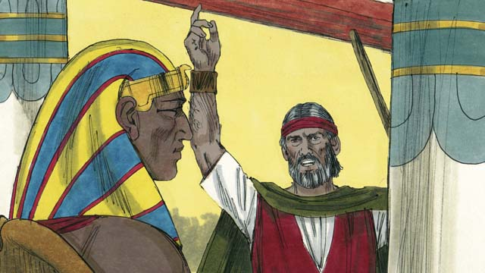

God sent Moses and Aaron to tell Pharaoh to let the Israelites go. They warned him that if he did not let them go, God would kill all the firstborn males of Egypt’s people and animals. When Pharaoh heard this, he still refused to believe and obey God.

11-02

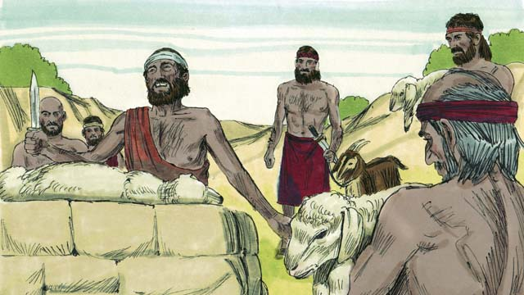

God provided a way to save the firstborn son of anyone who believed in him. Each family had to choose a perfect lamb and kill it.

11-03

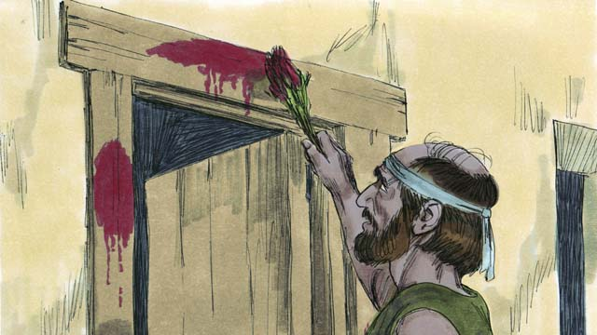

God told the Israelites to put the blood of this lamb around the door of their houses. They should roast the meat. Then they should quickly eat it, along with unleavened bread. He also told them to be ready to leave Egypt immediately after they ate this meal.

11-04

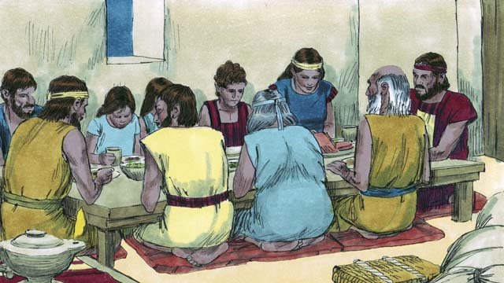

The Israelites did everything just as God had commanded them to do. In the middle of the night, God went throughout Egypt killing every firstborn son.

11-05

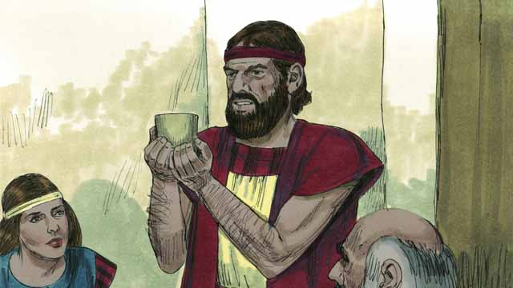

All the houses of the Israelites had blood around the doors, so God passed over those houses. Everybody inside them was safe. They were saved because of the lamb’s blood.

11-06

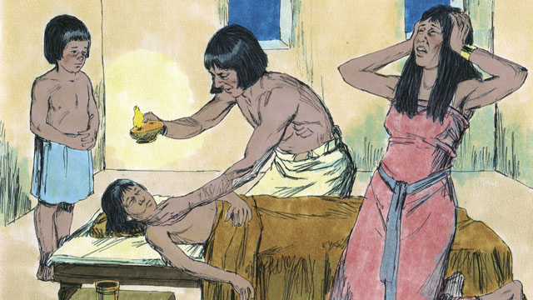

But the Egyptians did not believe God or obey his commands. So God did not pass over their houses. God killed every one of the Egyptians’ firstborn sons.

11-07

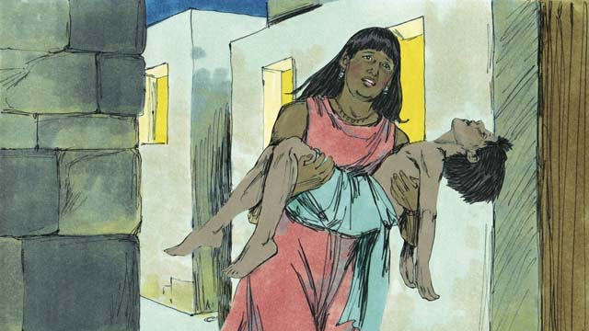

Every Egyptian firstborn male died, from the firstborn of the prisoner in jail to the firstborn of Pharaoh. Many people in Egypt were crying and wailing because of their deep sadness.

11-08

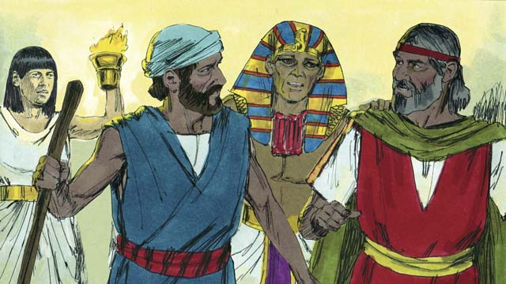

That same night, Pharaoh called for Moses and Aaron and said, “Take the Israelites and leave Egypt immediately!” The Egyptian people also urged the Israelites to leave right away.

*A Bible story from: Exodus 11:1-12:32*

## 1 Community Study: A Godly Community—Thinking about the Right Things

* **Key Idea**: focusing our thoughts on things that please God
* **Key Passage**: Philippians 4:8-9
* **Main Session**: OBS 11 (The Passover)

### 1.1 Recite the Creedal Verse (3–5 minutes)

The verse below summarizes the teaching of the current passage. Read the verse out loud as a community. Read it again several times as a group until the whole community can recite it from memory.

It was by faith that he kept the Passover and the sprinkling of the blood, so that the destroyer of the firstborn should not touch the Israelites’ firstborn sons. Hebrews 11:28

### 1.2 Sing a Song (3–5 minutes)

Choose a song to sing to praise God and encourage one another.

### 1.3 Read the Passage (5 minutes)

When people follow God, they live in a way that honors God and encourages others. Christians need to focus their minds on those things which most please God. When we do this, we build up a community of faith. In order to learn about godly ways of thinking, read the passage below.

8 Finally, brothers, whatever things are true, whatever things are honorable, whatever things are just, whatever things are pure, whatever things are lovely, whatever things are of good report, if there is anything excellent, if there is anything to be praised, think about these things. 9 The things that you have learned and received and heard and seen in me, do these things, and the God of peace will be with you. Philippians 4:8-9

### 1.4 Discuss the Idea (10–15 minutes)

How we think affects the way that we live and interact with others. Use the following questions to discuss the godly types of things we should think about.

1. What kinds of things should Christians think about?
2. How does our thinking affect the way we live and interact with others? How does thinking about such things honor God and encourage other Christians?
3. Why is it important to be intentional/purposeful/proactive about the things we think about?
4. What practices and habits will your community do to help each other think about such things as you work and serve together?

### 1.5 Describe One Characteristic (5–10 minutes)

Divide your community into groups of 2–3. Give each group one of the characteristics in the passage above (true, honorable, just, pure, lovely, good report, excellent, to be praised). Each group should try to identify specific thoughts that correspond to that characteristic that would help make your community strong. See the example below.

**True** thoughts that make the Christian community strong: God wants the whole community to participate in his work God gifted people in my community in different ways to make the community healthy I should honor community members who do not naturally get attention.

### 1.6 Pray to God (5 minutes)

Use the passage above to pray to God. As a community, ask God to help you think about the specific characteristics above.

## 2 Biblical Interpretation: Observing the Details of the Story

After reading the crafted biblical story, answer the following questions to familiarize yourself with the details of the story.

### 2.1 Observation Questions

Answer the following observation questions to gain a basic understanding of the the story. Read the story as a community and answer these questions as a group.

#### 11-01

What did God say he would do to the Egyptians if Pharaoh did not let the Israelites go?  
He would kill all the firstborn males of both people and animals.

What did Pharaoh do when he heard that God would kill all the male firstborn people and animals if he did not let the Israelites go free?  
Pharaoh refused to believe and obey God.

#### 11-02

Who provided a way for the firstborn son to be saved?  
God provided a way to save the firstborn son.

How could people save their firstborn son?  
People had to believe God and kill a perfect lamb.

#### 11-03

What did God tell the Israelites to do with the blood of the lamb?  
God told them to put the blood of the lamb around the door of their house.

What specific food did God tell the Israelites to eat with the roasted lamb?  
They were to eat bread that was made without yeast.

What were the Israelites to be ready to do when they ate?  
They were to be ready to leave Egypt.

#### 11-04

How did the Israelites respond to God’s commands ?  
The Israelites did everything that God commanded.

What did God do in the middle of the night?  
God went throughout Egypt killing the firstborn son of every family that did not follow God’s commands.

#### 11-05

What did God do at the houses that had the blood around the doors?  
He passed over those houses with blood around the doors.

What happened to the people inside of houses with lamb’s blood around the doors?  
Everybody inside the houses with blood around the doors were safe because of the lamb’s blood.

#### 11-06

How did the Egyptians respond to God’s commands?  
The Egyptians did not believe God or obey his commands.

What did God do at every Egyptian house?  
God did not pass over the Egyptians houses. He killed the firstborn sons.

#### 11-07

How many of the firstborn sons of the Egyptians were killed?  
All of them died, including Pharaoh’s son.

How did the Egyptians feel after the firstborn sons were killed?  
Many Egyptians cried and wailed because of deep sadness.

#### 11-08

What did Pharaoh tell Moses and Aaron after this plague?  
That same night, Pharaoh told them to take the Israelites and leave Egypt immediately! What did the Egyptians urge the Israelites to do?  
The Egyptians also urged the Israelites to leave right away.

### 2.2 Translation Questions

Use the following translation questions to understand specific details of the passage. Discuss how you might translate these specific elements of the story.

#### 11-01

**the firstborn males of Egypt’s people and animals** God warned Pharaoh that if he did not let the Israelites go, God would kill the eldest son in every Egyptian family and the first male offspring of any of their animals. How would you express **the firstborn males of Egypt’s people and animals** to mean the eldest son in every Egyptian family and the first male offspring of any of their animals?

  

**if he did not let them go** The word if means that something will happen in the event that something else happens first. God would kill the firstborn males in Egyptian in the event that Pharaoh did not let the Israelites go free. How would you express **if he did not let them go** to mean God would kill the firstborn males in Egyptian in the event that Pharaoh did not let the Israelites go free?

  

**believe** Pharaoh did not trust that what God said was true. What words in your language mean **believe** as in to trust that something is true?

  

#### 11-02

**God provided** God is the only one who could supply the way to save the Israelites’ sons from death. How would you express **God provided** as in God was the one who supplied a way to save the Israelites’ sons from death?

  

**to save** God supplied a way to rescue firstborn males from death. This rescue was possible for those who believed in God. How would you express **to save** as in to rescue from death, destruction, or judgment?

  

**a perfect lamb** This perfect lamb was a young sheep or goat that had no blemishes or defects. How would you express **a perfect lamb** to mean a young sheep or goat that had no blemishes or defects?

  

#### 11-03

**They should roast the meat** The word should explains something is expected or supposed to happen. It does not explain that the action actually happened yet. God was giving the Israelites instructions and telling them what he expected them to do. How would you express **They should roast the meat** to mean God was giving the Israelites instructions that he expected them to roast the meat of the lamb?

  

**unleavened bread** Unleavened bread is bread that is prepared without yeast. Yeast is mixed into bread dough to make the dough expand and rise as it bakes. This bread was made without something that would make it rise. Making bread with yeast takes longer than without it, so **unleavened bread** shows that this meal was urgent and the people needed to do it quickly. How would you express **unleavened bread** to mean bread that is prepared without yeast that would normally cause the bread to rise?

  

**immediately after they ate this meal** The Israelites needed to be prepared to leave before they started to eat so they could leave Egypt right away after they finished eating their meal. How would you express **immediately after they ate this meal** to mean the Israelites needed to be prepared to leave before they started to eat so they could leave Egypt right away after they finished eating their meal?

  

#### 11-04

**God went throughout Egypt** God in to every place in the land of Egypt where the people lived to bring judgment on the families who did not follow his command. How would you express **God went throughout Egypt** to mean God went in to every place in the land of Egypt where the people?

  

**every firstborn son** This means **every firstborn son** of families who had not made the blood sacrifice, that is, the Egyptians. Every Egyptian firstborn son. The firstborn of the Israelite families lived because they had put the blood on their doorposts. This is explained in 11-05. How would you express **every firstborn son** to clearly mean that God killed the firstborn of the families who did not follow his command to put the lamb’s blood around the door?

  

#### 11-05

**passed over** This means that God passed by those houses and did not stop to kill anyone there. This phrase became the name of the Jewish festival, ‘Passover.’ How would you express **passed over** to mean God moved by the houses which had the lamb’s blood around the door and did not stop to kill anyone there?

  

**because of the lamb’s blood** The reason God did not kill their firstborn son was the lamb’s blood around the door. The Israelites did not save themselves. Without the lamb’s blood, even the Israelite families would have their firstborn males killed. But God saw that they had killed their lamb as he had commanded, so he did not kill their son. How would you express **because of the lamb’s blood** to mean the reason the Israelites were saved was they had killed their lamb as God had commanded and he did not kill their son because he saw the lamb’s blood around the door?

  

#### 11-06

**did not believe God or obey his commands** The Egyptians did not trust God and so they did not follow his commands. How would you express **did not believe God or obey his commands** to mean the Egyptians did not trust God and so they did not follow his commands?

  

**did not pass over** God did not pass by the Egyptian houses. Rather, he stopped at each house and killed their eldest son because they did not have the lamb’s blood around their doors. How would you express **did not pass over** to mean God did not move by the Egyptian houses but stopped at each house and killed their firstborn males?

  

#### 11-07

**from the firstborn of the prisoner in jail to the firstborn of Pharaoh** This is a way of saying that everyone’s firstborn son died�from the son of the least important person to the son of the most important person, and everyone in between. How would you express **from the firstborn of the prisoner in jail to the firstborn of Pharaoh** to mean everyone’s firstborn son died—from the son of the least important person to the son of the most important person, and everyone in between?

  

**wailing** The Egyptians were so sad that they were crying out loud and expressing their sadness with sobbing sounds. What words in your language mean **wailing** as in crying out loud and expressing their sadness with sobbing sounds?

  

#### 11-08

**called for** Pharaoh told his servants to tell Moses and Aaron to come to him. How would you express **called for** to mean Pharaoh told his servants to tell Moses and Aaron to come to him?

  

**Take the Israelites and leave Egypt immediately!** This is a command. It is stated as an exclamation because Pharaoh was finally afraid of God and urgently wanted the Israelites to leave Egypt. The words Take and leave describe one action. Pharaoh is commanding Moses and Aaron to go out of Egypt with all the Israelites without delay. How would you express **Take the Israelites and leave Egypt immediately** as a command in which Pharaoh is ordering Moses and Aaron to go out of Egypt with all the Israelites without delay?

  

## 3 Theological Dialogue: Discussing the Meaning of the Story

Take time to explore the meaning of this story together as a community. Use the following discussions as a way to grasp what truth the story teaches.

### 3.1 Discourse Questions

Use the following discourse questions to understand the meaning of the story. Pay attention to how the story itself addresses each question or theme.

##### What did God say he would do because of Pharaoh’s refusal to believe and obey God?

Warning: God sent Moses and Aaron to Pharaoh to tell him to let the Israelites go free. They warned Pharaoh that God would kill all the firstborn males of Egypt if he did not let them go. God brought a warning of judgment to Pharaoh. (11-01)

  

Unbelief and Disobedience: Pharaoh refused to believe and obey God. His heart was hard and stubborn. He chose to disobey God and did not listen to the warning of judgment. (11-01)

  

##### How could people escape God’s judgment and have their firstborn males saved?

Divine Provision: God provided a way for anyone to save the firstborn males of their household. This was not something people could provide on their own. Only God could provide the way to save their male firstborn. (11-02)

  

Belief: To save their male firstborn, people had to believe in God. Only if people believed in God would they be able to have the firstborn saved. (11-02)

  

Sacrifice: God told the Israelites that they had to sacrifice a perfect lamb. They had to put the blood from the lamb around the door of their houses. (11-02, 11-03)

  

Haste: God told the Israelites to east roasted meat and unleavened bread. God would bring them out of Egypt quickly. They should be ready to leave as soon as they left the meal. (11-03)

  

Obedience: The Israelites not only believed in God, but they did all that God commanded them to do. (11-04)

  

##### What happened to the Egyptians because they did not believe or obey God?

Death: God went throughout Egypt and killed every male firstborn. The Egyptians did not believe or obey God. God did not pass over their houses. Their firstborn males died. The Israelites believed and obeyed God. God passed over their houses. Their firstborn males lived. (11-04, 11-05, 11-06)

  

All People: Every Egyptian firstborn male died. This happened to the firstborn of the prisoner to the firstborn of Pharaoh and everyone in between. God’s judgment was not determined by people’s social class. It was determined by whether someone believed in God and followed his ways. (11-07)

  

Sadness and Grief: The people of Egypt cried and wailed loudly. They were deeply sad. Not believing God and not following his ways brought about great sadness and grief to the Egyptians. (11-07)

  

##### What happened to the Israelites because they did believe and obey God?

Passover: God passed over the houses with the lamb’s blood around the door. God killed the male firstborn of the houses without the lamb’s blood around the door. (11-05, 11-06)

  

Freedom: The same night, Pharaoh told the Israelites to leave Egypt. He told them to leave immediately. In fact, the Egyptians urged the Israelites to leave right away. God caused the Israelites to be free swiftly. (11-08)

  

### 3.2 Theological Questions

Answer the following theology questions as a community. Discuss what truths this story teaches.

1. Why does God bring judgment upon humans? How does the story of the Passover teach us about how and why God brings judgment on people?
2. How does God save his people? What does this story teach us about how God brings about salvation and freedom for his people?
3. How can people receive God’s salvation and freedom? How does the story of the Passover teach us about how humans can escape God’s judgment and receive salvation/freedom?

### 3.3 Translation Draft

Work as a translation team to draft each panel of this story. Pay attention to any specific translation issues that are challenging or significant.

#### Make Translation Draft

Make a draft for each section of this story.

#### Discuss and Revise

After drafting the story, discuss any translation issues that you think need special explanation.

#### Drafting Summary Reflection

Summarize any noteworthy translation decisions and the rationale/reasoning behind these translation decisions. In the final movement of this class, you will use these observations to give an account (i.e., chronicle/narrate) of how your translation improved through the checking process.

## 4 Personal Reflection: Following the Teaching of the Story

Take a moment to allow this story to evaluate your own life and to consider how God would have you respond. After this reflection, use the quality checking questions to check your translation draft among the translation team.

### 4.1 Journal Reflection

Prayerfully think about the following personal reflection questions. Write/Record your answers and/or discuss them as a group.

1. How are you growing in your understanding about how God saves and frees his people?
2. What things keep you from (make it hard) believing and obeying God?
3. How would your life be different if you knew God’s judgment would pass over you?

### 4.2 Team Check

*The following activity will help you check the clarity, accuracy, and naturalness of your draft. Read the passage aloud and discuss the checking questions with other members of your translation community. You might need to reread portions (or the whole) of the biblical passage multiple times as you answer each of these questions. Record answers to these questions below.*

#### Team Checking Questions

*Use the following questions to check your translation draft for accuracy, clarity, and naturalness.*

1. **Accurate**: Has anything been **added** to your translation of this passage that is not a part of the meaning of the source text? *If additions exist, are they included only added to clarify meaning (such as implied information)?*
2. **Accurate**: Is anything **missing** from your translation of this passage that is a part of the meaning of the source text? *If some part of the meaning is missing from your translation, add it.*
3. **Accurate**: Does any meaning in your translation of this passage appear to be **different** than the meaning of the source text? *If the meaning is different, try changing your translation so that the meaning remains the same.*
4. **Natural**: Does anything sound **unnatural** to how you would say it in your language? *If portions of the passage sound unnatural in your language, try to make them sound the way you would say it in your language while staying true to the meaning of the source text.*
5. **Clear**: Is anything **unclear** or **confusing** in your translation that confuses the meaning of the source text? *If portions of the passage are unclear or confusing, revise them to clearly communicate the meaning of the source text.*
6. **Consistent**: How **consistent** is your translation within the passage and with other passages? *If portions of the passage need to be made consistent or if you need to revise translations of other passages, make these adjustments.*

#### Record Feedback

*After discussing the checking questions above as a translation community, record any feedback on your translation draft. Pay attention for parts of your translation that are translated well and parts of your translation that need correction.*

#### Discuss and Revise

*After gathering feedback on your draft, discuss it together with your translation community and make appropriate revisions in your translation.*

#### Record Translation Decisions

*As a community, discuss some of the most noteworthy translation decisions in your draft. Summarize each decision and explain the reasons your community decided on that translation. You should update these decisions each time you check your draft with various groups of people.*

You should **measure** the quality of your translation draft. You can **record translation decisions** to make it clear why you translated things a certain way. Translation decisions can help your translation team and the surrounding community be a part of the translation process.

How can you know the quality of your translation?

1. **Measure** the translation by marks/standards of quality (i.e., clear, accurate, natural, church-approved)
2. **Test** the translation with others and record feedback and conversations from in the field (i.e., church and community check)
3. **Compare** and **contrast** the translation with the source text (i.e., meaning of text and notes) and alternatives (i.e., other translation choices)
4. **Explain** the reasons why you translated a particular portion of the text.

**Example Sentences That Help Explain Your Translation Decision** Use the following example sentences to help explain your translation decisions:

1. The original text literally **says/means**, so we translated the term in this way…
2. We originally decided to translate **the biblical term** in with **this term**, but we changed it because…
3. When our translation team discussed **the biblical term**, this is what we talked about…
4. **The term** is [clear, accurate, natural, consistent] because…
5. The community understands **this term** it to mean…
6. We considered these other terms. We did not use **these terms** because…
7. When we checked this in the church, we learned…
8. When we checked this in the community, we learned…

**Example of Translation Decision**

In OBS 01-07 we decided to translate **blessed** like this: [actual translation]. We decided this translation because of these reasons:

1. The word [actual translation] means to cause good things to happen to someone or something. This term is used when a person desires someone or something to prosper or flourish. This term does not refer to magic or witchcraft.
2. When we checked this word with other believers, they said it describes God showing his kindness and favor on someone or something. These are some of the terms that we did not decide to use…
3. Many of our people will understand this word. When we discussed this phrase with the surrounding community, we discovered it was a natural way to describe God causing good and beneficial things to happen.

## 5 Ministry Practice: Serving the Church with the Story

Now that you have a draft of this story, consider how this story can encourage other believers in their faith. After ministering this story to others, you will also perform a community check of your translation draft.

### 5.1 Church Ministry

Reflect on how this story can edify and mature the Christian community. Design a way to minister this story to your church community.

**Ministry Preparation**: Take time to consider how you could minister this story to others. Record some ministry ideas below.

**Ministry Implementation**: Minister this story to a group of believers as you had planned. Use the information in this study to help develop a teaching/lesson or lead a discussion of this story to other believers. Record your ministry plan below.

**Ministry Reflection**: Think about what you learned from ministering this story to other believers. Reflect on your experience below.

### 5.2 Church Community Check

After teaching or ministering this story to the church, check the translation quality with the church community. Record any feedback from your checking experience.

#### Create Checking Questions

You can use **Translation Questions** to check you draft. Each **Translation Question** explains the meaning of a specific part of the story and asks you to consider how you would translate that part of the story in your own language. Change each **Translation Question** into a **Checking Question** by asking the following questions. The first question asks you to identity how each specific phrase was translated in your language. The second question asks people in the church to determine if your translation of the phrase expresses the meaning clearly, accurately, and naturally. Look at the following examples to see how to change **Translation Questions** into **Checking Questions**:

#### Translation Question Example 1

**to proclaim the good news about Jesus** Paul and Silas traveled to Philippi for the purpose of preaching the gospel. The gospel is the good news that Jesus saves people from their sins if they will believe in Jesus. How would you express **to proclaim the good news about Jesus** to mean to tell other people the message about how Jesus can save people from their sins?

#### Translation Question Example 2

**a merchant** Paul and Silas met a woman named Lydia at the place by the river. She owned a business and sold items to make money. How would you express **a merchant** to mean a business owner who sells items for a profit?

#### Translation Question Example 3

**so Paul and Silas baptized them** The jailer and his whole family followed Paul’s instructions. They believed in Jesus. The result of this was Paul and Silas baptized them. How would you express **so Paul and Silas baptized them** to mean the result of the jailer and his family believing in Jesus that Paul and Silas baptized all of them?

You can change these into **Checking Questions** like this:

#### Checking Question Example 1

**to proclaim the good news about Jesus** How did you translate **to proclaim the good news about Jesus**? Does it mean to tell other people the message about how Jesus can save people from their sins?

#### Checking Question Example 2

**a merchant** How did you translate **a merchant**? Does it mean a business owner who sells items for a profit?

#### Checking Question Example 3

**so Paul and Silas baptized them** How did you translate **so Paul and Silas baptized them**? Does it mean the result of the jailer and his family believing in Jesus that Paul and Silas baptized all of them?

#### Record Feedback

*Discuss the* ***Checking Questions*** *with your church community, and record any feedback on your translation draft. Pay attention for parts of your translation that are translated well and parts of your translation that need correction.*

#### Discuss and Revise

*After gathering feedback on your draft, discuss it together with your translation community and make appropriate revisions in your translation.*

#### Record Translation Decisions

*Update your translation decisions and record and new any noteworthy observations on the quality of your draft.

## 6 Missional Outreach: Sharing the Truth of the Story

*After sharing this story with others, check the translation quality with the wider language community. Record any feedback from your checking experience.*

### 6.1 Mission Engagement

*Consider how you will witness this story to unbelievers. Design a way to share this story and engage them in what it teaches about Christianity and the gospel.*

**Witness Preparation**: Take time to consider how you will witness this narrative to unbelievers. Record some ideas below.

**Witness Implementation**: Share this story with an unbeliever. Use the information in this study to help develop a teaching/lesson or lead a discussion of this story to other believers. Record your ministry plan below.

**Witness Reflection**: Think about what you learned from ministering this story to unbelievers. Reflect on your experience below.

### 6.2 Sociolinguistic Check

After sharing this story with the language community, check your translation draft with the surrounding community. Record your observations.

#### Checking Approach

After witnessing this story to unbelievers, use one of the following methods to check the translation of this story. Consider using the **Observation Questions** to check your translation draft or come up with your own quality checking questions.

**Read-Retell Check:** Read your draft to those the community and ask them to retell the passage. Be attentive for any portions of the passage that are unclear, unnatural, or inaccurate.

**Comprehension Questions Checklist:** Read the draft of the passage and ask a list of comprehension questions to make sure the passage is being rightly understood. You can use the **Observation Questions** in this guide or come up with your own questions. Then, record any insights or issues that arise.

**Discussion Group:** Develop key questions to ask about the passage (both formational and translational). Read the passage and have a group discussion about the passage, paying attention to issues that need to be addressed, edited, and revised.

#### Record Feedback

*After sharing your draft with language community, discuss the* ***Observations Questions****, and record any feedback on your translation draft. Pay attention for parts of your translation that are translated well and parts of your translation that need correction.*

#### Discuss and Revise

*After gathering feedback on your draft, discuss it together with your translation community and make appropriate revisions in your translation.*

#### Record Translation Decisions

*Update your translation decisions and record and new any noteworthy observations on the quality of your draft.

## 7 Conclusion

As a translation community, take time to reflect on all that was learned in studying, drafting, and checking this story. Celebrate all that God has taught you as a community. Then, submit your revised draft and checking summaries to network leaders for further review.