Open Bible Stories

The Exodus

## 0 Introduction

### 0.1 Key Idea

The story of the exodus teaches us about God’s deliverance of his people from slavery.

### 0.2 Creedal Verse

“By faith the people crossed the Red Sea as on dry land, but the Egyptians, when they attempted to do the same, were drowned.” Hebrews 11:29

### 0.3 Metanarrative Summary

The eternal God created all things in six days. He made a good and perfect world. He made humans in his image to fill the earth and rule over creation. But humans rebelled against God and ruined God’s creation. God set to restore his world through his promise. God made a covenant with Abraham. He promised to bless all nations through Abraham. God kept his promises across the generations. God provided Abraham with a promised child, Isaac. God gave Isaac a wife and she bore twins, Jacob and Esau. God blessed Jacob and his sons, and the blessing continued to the next generation. God rescued Joseph, one of Jacob’s sons, and used him to rescue his family. God caused his people, the Israelites, to multiply in the land of Egypt; eventually, they became slaves. But, God raised up a deliverer, Moses, to deliver his people from their slavery. God sent judged the Egyptians with harsh plagues; in the final judgment, he passed over his people who covered their doorposts with the blood of a sacrificed lamb. Then, God delivered the Israelites by bringing them out of Egypt and crossing the Red Sea on dry land.

### 0.4 Open Bible Story: The Exodus

12-01

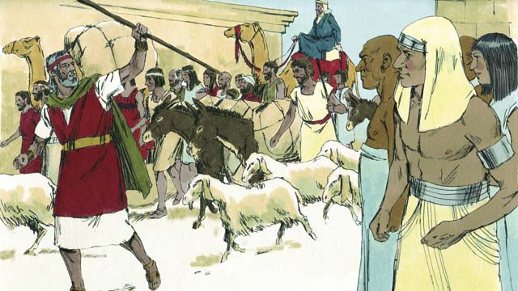

The Israelites were very happy to leave Egypt. They were no longer slaves, and they were going to the Promised Land! The Egyptians gave the Israelites whatever they asked for, even gold and silver and other valuable things. Some people from other nations believed in God and went along with the Israelites as they left Egypt.

12-02

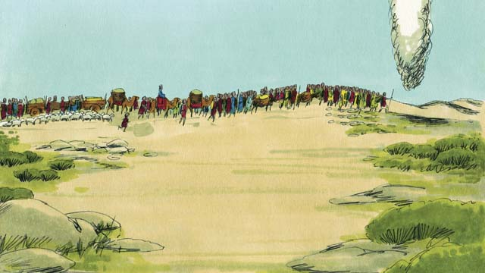

A tall pillar of cloud went ahead of them during the day. It became a tall pillar of fire at night. God, who was in the pillar of cloud and the pillar of fire, was always with them and guided them as they traveled. All they had to do was follow him.

12-03

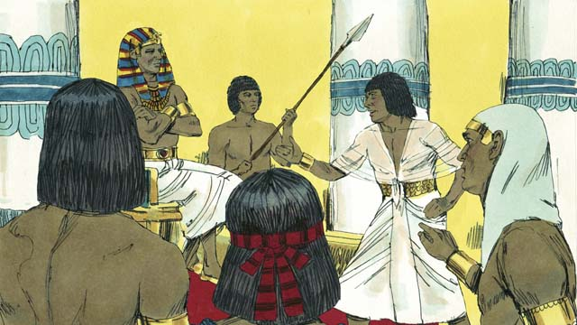

After a short time, Pharaoh and his people changed their minds. They wanted to make the Israelites their slaves again. So they chased after the Israelites. It was God who made them change their minds. He did this because he wanted everyone to know that he, Yahweh, is more powerful than Pharaoh and all the gods of the Egyptians.

12-04

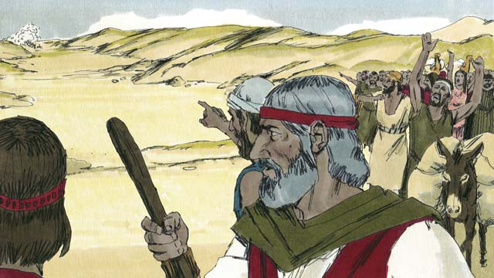

When the Israelites saw the Egyptian army coming, they realized they were trapped between Pharaoh’s army and the Red Sea. They were very afraid and cried out, “Why did we leave Egypt? We are going to die!”

12-05

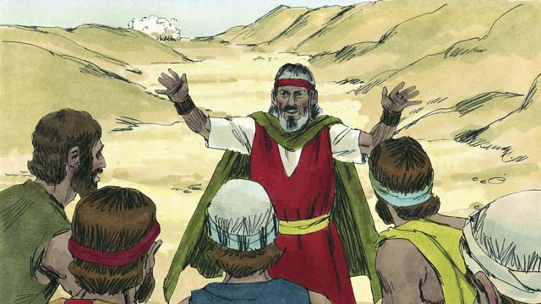

Moses told the Israelites, “Stop being afraid! God will fight for you today and save you.” Then God told Moses, “Tell the people to move toward the Red Sea.”

12-06

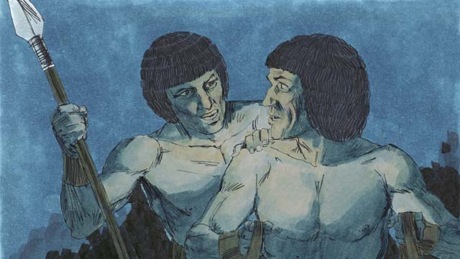

Then the pillar of cloud moved between the Israelites and the Egyptians and became a pillar of fire at night. The Egyptians were not able to come near the Israelites all night.

12-07

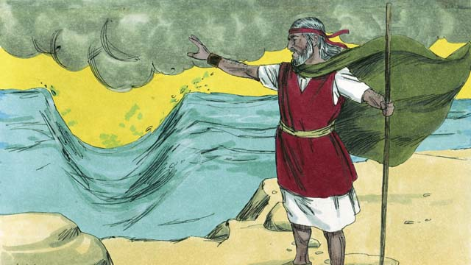

God told Moses to raise his hand over the sea. Then God caused the wind to push the water in the sea to the left and the right, so that there was a path through the sea.

12-08

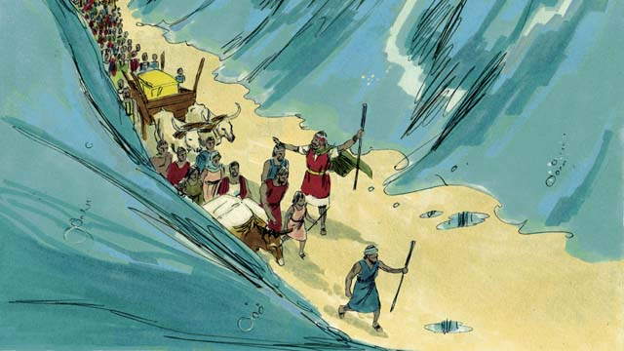

The Israelites marched through the sea on dry ground with a wall of water on either side of them.

12-09

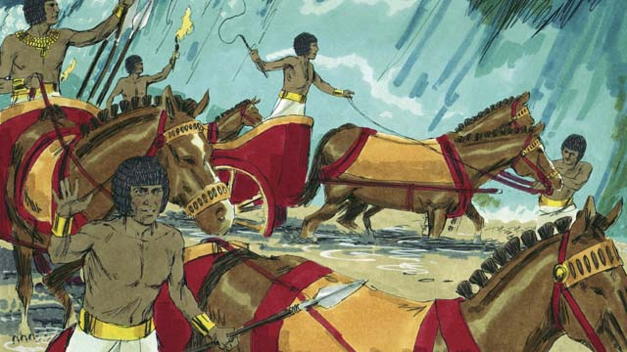

Then the Egyptians saw that the Israelites were escaping. The Egyptians started chasing after them again.

12-10

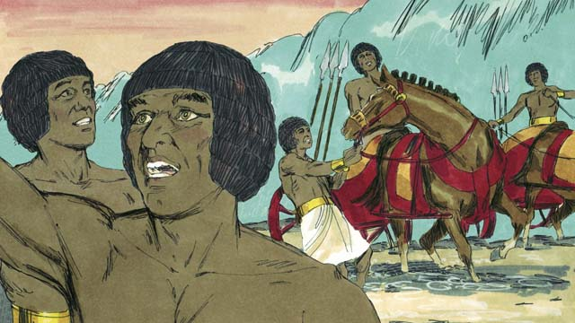

So they followed the Israelites onto the path through the sea, but God caused the Egyptians to panic and caused their chariots to get stuck. They shouted, “Run away! God is fighting for the Israelites!”

12-11

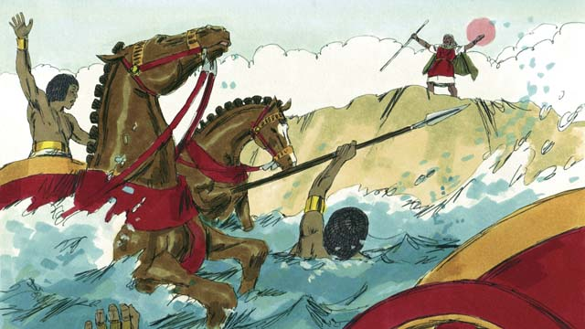

The Israelites all arrived at the other side of the sea. Then God told Moses to stretch out his hand again over the water. When Moses did that, the water fell on the Egyptian army and returned to its normal place. The whole Egyptian army drowned.

12-12

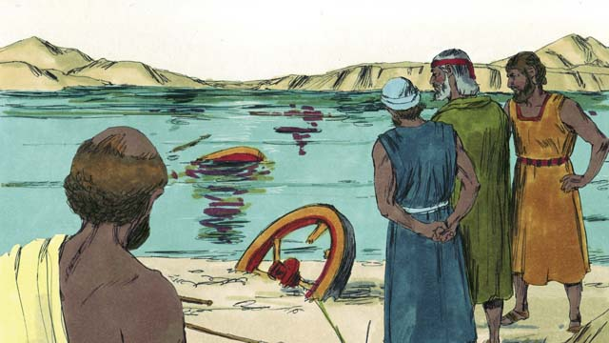

When the Israelites saw that the Egyptians were dead, they trusted in God. They believed that Moses was a prophet of God.

12-13

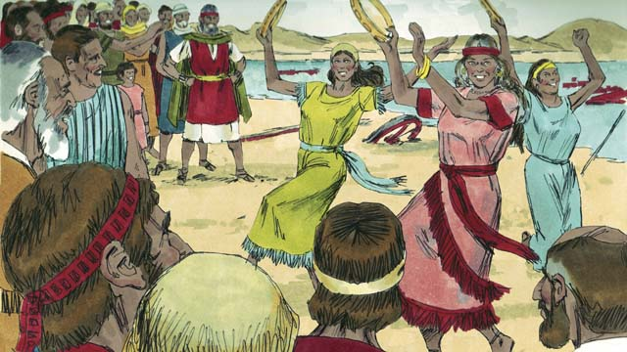

The Israelites also rejoiced very much because God had saved them from dying and from being slaves. Now they were free to worship God and obey him. The Israelites sang many songs to celebrate their new freedom and to praise God because he saved them from the Egyptian army.

12-14

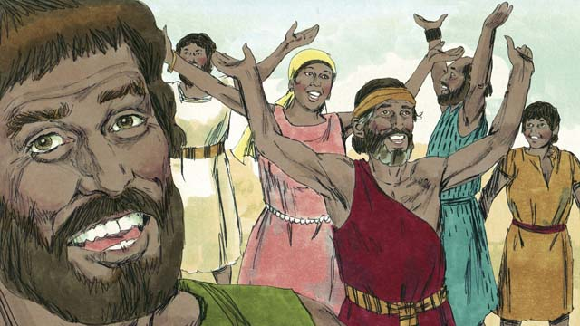

God commanded the Israelites to celebrate a festival every year in order to remember how God had defeated the Egyptians and freed them from being slaves. This festival was called the Passover. In it, they had to celebrate by killing a healthy lamb, roasting it, and eating it with bread made without yeast.

*A Bible story from: Exodus 12:33-15:21*

## 1 Community Study: Bearing Godly Fruit—Making Progress in the Faith

* **Key Idea**: growing in godly characteristics
* **Key Passage**: 2 Peter 1:5-9
* **Main Session**: OBS 12 (The Exodus)

### 1.1 Recite the Creedal Verse (3–5 minutes)

The verse below summarizes the teaching of the current passage. Read the verse out loud as a community. Read it again several times as a group until the whole community can recite it from memory.

It was by faith that they passed through the Sea of Reeds as if over dry land. When the Egyptians tried to do this, they were swallowed up. Hebrews 11:29

### 1.2 Read the Passage (5 minutes)

God wants us to grow in our faith. As we grow, we develop different character traits that make us mature and godly. These character traits help the whole community to be strong and healthy. In order to learn about growing in godliness, read the passage below.

5 For this reason, do your best to add goodness to your faith; and to goodness add knowledge; 6 to knowledge add self-control; to self-control add endurance; to endurance add godliness; 7 to godliness add brotherly affection; and to brotherly affection add love. 8 If these things are in you and grow in you, you will not be barren or unfruitful in the knowledge of our Lord Jesus Christ. 9 But whoever lacks these things is so nearsighted that he is blind, having forgotten he has been cleansed from his past sins. 2 Peter 1:5-9

### 1.3 Discuss the Idea (10–15 minutes)

As Christians grow in their faith, they will develop the character traits in the passage above. Use the following questions to discuss the godly attributes of mature Christians.

1. What kinds of characteristics will develop in Christians and churches as they grow in the faith?
2. How can Christians grow in these character traits?
3. How do these character traits help Christians relate to one another in godly and mature ways?
4. Which of these specific areas of these character traits would you want to grow and develop?

### 1.4 Think about Your Growth (5–10 minutes)

Think about one area/trait in the passage you want to develop. Imagine the impact in your personal life and community if you were to grow in that specific area/trait. See the examples below.

If I grew in [self-control], this is how things would change in my life… If I grew in [self-control], this is how I could encourage and strengthen this community…

### 1.5 Pray to God (5 minutes)

Use the list of character traits above as a guide for prayer. Assign one character trait for different members of the group. Have each of them take turns praying that the whole community would grow in these areas.

### 1.6 Sing a Song (3–5 minutes)

Choose a song to sing to praise God and encourage one another.

## 2 Biblical Interpretation: Observing the Details of the Story

After reading the crafted biblical story, answer the following questions to familiarize yourself with the details of the story.

### 2.1 Observation Questions

Answer the following observation questions to gain a basic understanding of the the story. Read the story as a community and answer these questions as a group.

#### 12-01

Why were the Israelites happy to leave Egypt?  
The Israelites were happy to leave Egypt. They were longer slaves and were going to the Promised Land.

What did the Egyptians give the Israelites as they left Egypt?  
They gave them whatever they asked for, even gold and silver and other valuable things.

Who else left Egypt with the Israelites?  
Some people from other nations who believed in God left with them.

#### 12-02

How did God lead the Israelites?  
He led them in a pillar of cloud during the day and a pillar of fire at night.

How did the Israelites follow God?  
All the Israelites had to do was follow the pillar of cloud and pillar of fire.

#### 12-03

What happened after the Egyptians changed their minds about letting the Israelites go free?  
After only a short time, Pharaoh and the Egyptians changed their minds and wanted to make the Israelites salves again. They chased after the Israelites.

Who changed the minds of the Egyptians?  
God changed the minds of the Egyptians.

Why did God cause Pharaoh to be stubborn and chase the Israelites?  
God did this to show that he is is the One True God who is more powerful than Pharaoh and his gods.

#### 12-04

Between what two things were the Israelis trapped?  
The Israelites were trapped between Pharaoh’s army and the Red Sea.

How did the Israelites react when they were trapped between the sea and Pharaoh’s army?  
They were afraid said, “Why did we leave Egypt? We are going to die!”

#### 12-05

What did Moses say to the Israelites to calm their fear?  
He told them to stop being afraid! God would fight for them that day and save them.

What did God tell Moses to tell the people?  
God told Moses to tell the people to move toward the Red Sea.

#### 12-06

How did God prevent the Egyptians from coming near the Israelites as they started to escape?  
He placed the pillar of cloud between them.

#### 12-07

What did God tell Moses to do in order to make a path of escape for the Israelites?  
God told him to raise his hand over the sea so that the waters would divide.

What did God do to the waters of the Red Sea?  
God caused a wind to push the water to the right and left so that there was a path for the Israelites to cross the Red Sea.

#### 12-08

How were the Israelites able to cross the sea?  
They walked through it on dry ground with a wall of water on either side of them.

#### 12-09

What did the Egyptians do when they saw the Israelites escaping?  
The Egyptians started chasing after the Israelites.

#### 12-10

Where did the Egyptians chase the Israelites?  
The Egyptians followed the Israelites onto the path through the sea.

What happened to the Egyptians as they chased the Israelites through the sea?  
He caused the Egyptians to panic and their chariots to get stuck.

What did the Egyptians do when their chariots got stuck?  
They ran away because God was fighting for the Israelites.

#### 12-11

What did God tell Moses to do after the Israelites reached the other side of the sea?  
God told Moses to stretch out his hand over the water.

What happened to the walls of water?  
The water returned back to its normal place. The water fell on the Egyptian army.

How did God destroy the Egyptian army?  
The water covered the Egyptian army so that they drowned.

#### 12-12

How did the Israelites react when they saw that the Egyptians were dead?  
They trusted in God and believed that Moses was a prophet of God.

#### 12-13

Why did the Israelites sing and praise God?  
They praised him because he had saved them from the Egyptians. They were free to worship and obey God.

How did the Israelites praise God?  
They sang songs to celebrate their new freedom. They sang to praise God for saving them from the Egyptian army.

#### 12-14

What did God tell the Israelites to do in order to remember his victory over the Egyptians?  
He commanded them to celebrate the Passover every year.

How were the Israelites supposed to celebrate the Passover?  
The Israelites celebrated the Passover by killing a healthy lamb, roasting it, and eating it with unleavened bread.

### 2.2 Translation Questions

Use the following translation questions to understand specific details of the passage. Discuss how you might translate these specific elements of the story.

#### 12-01

**They were no longer slaves** The Israelites were not slaves anymore. While they were in Egypt they were slaves. Now Israelites left Egypt and they were not slaves as they were before. How would you express **They were no longer slaves** to mean the Israelites left Egypt and were not slaves as they were before?

  

**were going** The Israelites would be going a long distance to the Promised Land. It would take some time for them to travel this distance. How would you express **were going** to mean the Israelites were traveling or journeying to the Promised Land?

  

**the Promised Land** The Israelites were traveling to the land that God had promised that he would give to Abraham’s descendants. How would you express **the Promised Land** to mean the land that God had promised that he would give to Abraham’s descendants?

  

**went along with the Israelites as they left Egypt** People from other nations believed in God. These people from other nations traveled together with the Israelites at the time the Israelites left Egypt. How would you express **went along with the Israelites as they left Egypt** to mean people from other nations traveled together with the Israelites at the time the Israelites left Egypt?

  

#### 12-02

**A tall pillar of cloud** This was not an actual pillar such as something that supports a building. In appearance it resembled a pillar, but it was made out of clouds. This tall cloud was shaped like a pillar. How would you express **A tall pillar of cloud** to mean a tall cloud was shaped like a pillar as it hung in the sky?

  

**a tall pillar of fire** This was a column of fire that hung or floated in the air in front of the Israelites. This was not an actual pillar such as something that supports a building. It resembled a pillar in appearance, but it was made out of fire. This fire was shaped like a pillar. How would you express **a tall pillar of fire** to mean fire was shaped like a pillar as it hung in the sky?

  

**guided them** God showed them the way by making the pillar move along in front of them so they could follow it. How would you express **guided them** to mean God showed them the way by making the pillar move along in front of them so they could follow it?

  

#### 12-03

**After a short time** Probably at least two days had gone by. This part of the story happened a few days after the Israelites left Egypt. How would you express **After a short time** to mean after a few days had passed?

  

**changed their minds** The Egyptians did not replace their minds, but made a decision that was not the same as the one they first made. They decided the Israelites should leave, but later decided that was the wrong choice and that they should have kept the Israelites as slaves. This means that the Egyptians began to think differently than they had before. How would you express **changed their minds** to mean the Egyptians began to think differently than they had before?

  

**chased** The Egyptians pursued the Israelites to catch up to them. What words in your language mean **chased** as in to pursue someone to catch up to them?

  

**So they chased** The word So explains that the result of the Egyptians wanted the Israelites to be their slaves again was the Egyptians chased after the Israelites. How would you express **So they chased** to mean the result of the Egyptians wanted the Israelites to be their slaves again was the Egyptians chased after the Israelites?

  

#### 12-04

**they were trapped between Pharaoh’s army and the Red Sea** There was nowhere they could go to escape since the Egyptians were behind them and the Red Sea was in front of them. How would you express **they were trapped between Pharaoh’s army and the Red Sea** to mean there was nowhere they could go to escape since the Egyptians were behind them and the Red Sea was in front of them?

  

**Why did we leave Egypt?** The Israelites were not asking for reasons. This question does not expect an answer. Because they were afraid, in this moment they were wishing they had not left Egypt (even though it had been very difficult for them there). Even though they are asking a question, the Israelites mean they should not have left Egypt. How would you express the question **Why did we leave Egypt?** to mean the Israelites thought that they should not have left Egypt?

  

**We are going to die!** This is a strong statement that expresses the Israelites’ belief that the Egyptians would kill them. They felt certain about this. How would you express We are going to die as a strong statement of emphasis and emotion that the Israelites felt certain that the Egyptians would kill them?

  

#### 12-05

**Stop being afraid!** Moses was telling the people in very strong terms that they were wrong to be afraid, rather than trusting God to protect them. How would you express the command **Stop being afraid!** as a very strong instruction to not be fearful/scared of the Egyptians but to trust God to protect them?

  

**God will fight for you today and save you** Moses told the Israelites that today God would defeat the Egyptians and keep them from harming the Israelites. How would you express **God will fight for you today and save you** to mean God would defeat the Egyptians and keep them from harming the Israelites?

  

**to move toward the Red Sea** God told Moses to instruct the people to walk in the direction of the Red Sea. How would you express **to move toward the Red Sea** to mean to walk in the direction of the Red Sea?

  

#### 12-06

**Then the pillar of cloud moved** The word Then explains that, after God’s instructions that the Israelites are to move forward in the direction of the Red Sea, the pillar of cloud moved behind them. How would you express **Then the pillar of cloud moved** to mean the pillar of cloud moved behind the Israelites after God’s instructions for the Israelites to move in the direction of the Red Sea?

  

#### 12-07

**raise his hand over the sea** God told Moses to hold out his hand over the sea. This was a gesture to show that God was doing this miracle through Moses. How would you express **raise his hand over the sea** to mean to lift up one’s hand and hold it out over the sea?

  

**Then God caused** The word **Then** explains that God causing the wind to blow happened after Moses’ action of obedience in raising his hand over the sea. How would you express **Then God caused** to mean God causing the wind to blow happened after Moses’ action of obedience in raising his hand over the sea?

  

**so that there was a path through the sea** The words so that explain that the result of the wind blowing was that there was a path through the sea for the Israelites. How would you express **so that there was a path through the sea** to mean the result of the wind blowing was that there was a path through the sea for the Israelites?

  

#### 12-08

**marched** The Israelites walked through the sea on dry ground to get to the other side. What words in your language mean **marched** as in to walk in an orderly fashion to a destination or with a purpose?

  

**a wall of water on either side of them** The water was both sides of Israelites and stood up tall and straight like a wall. How would you express **a wall of water on either side of them** to mean the water was both sides of Israelites and stood up tall and straight like a wall?

  

#### 12-09

**the Israelites were escaping** At this point in the story, the Israelites were in the process of escaping. They had already started to escape but had not yet finished escaping. How would you express **the Israelites were escaping** to mean the Israelites were in the process of escaping at this point in the story?

  

**started chasing** The Egyptians began to go after the Israelites when they saw that they were escaping. How would you express **started chasing** to mean the Egyptians began to go after the Israelites when they saw that they were escaping?

  

#### 12-10

**the path through the sea** This was the dry strip of land across the bottom of the sea, with a wall of water on each side. How would you express **the path through the sea** to mean the dry strip of land across the bottom of the sea, with a wall of water on each side?

  

**but God** The word but contrasts the movement of the Israelites God caused by opening the path, with the lack of movement of the Egyptians God caused with their panic and chariots becoming stuck? How would you express **but God** to mean God causing the Egyptians to panic and their chariots to get stuck was different/opposite to the path God opened for the Israelites to pass through the sea?

  

**to panic** The Egyptians became fearful and confused. How would you express **to panic** to mean the Egyptians became fearful and confused?

  

**to get stuck** The Egyptian chariots could no longer move. How would you express **to get stuck** to mean the Egyptian chariots could no longer move?

  

**Run away!** The Egyptians were so afraid when they realized that they were in great danger that they shouted a command with strong emotion telling the people to flee. How would you express the command **Run away!** as a strong statement telling people to flee?

  

**God is fighting for the Israelites!** The Egyptians were afraid when they realized that God had led them into a trap in the sea, and they were going to drown. They expressed their fear by shouting God was fighting for the Israelites. How would you express **God is fighting for the Israelites!** as a strong statement of emotion in which the Egyptians were afraid that God was fighting on the side of the Israelites?

  

#### 12-11

**returned to its normal place** The water of the sea covered the place again where the path had been. The water on either side of the path filled the whole sea again and went back to where it was before God separated it. How would you express **returned to its normal place** to mean the water on either side of the path filled the whole sea again and went back to where it was before God separated it?

  

**The whole Egyptian army drowned** Everyone in Egypt’s army drowned in the water. They all died. How would you express **The whole Egyptian army drowned** to mean everyone in Egypt’s army died by drowning in the water?

  

#### 12-12

**trusted in God** The people now trusted that God was powerful and could protect them. How would you express **trusted in God** to mean the people now trusted that God was powerful and could protect them

**When the Israelites saw** The word When explains the time when the Israelites trusted in God. The Israelites trusted God at the time they saw that God destroyed the Egyptian army. How would you express **When the Israelites saw** to mean the Israelites trusted God at the time they saw that God destroyed the Egyptian army?

  

#### 12-13

**rejoiced very much** The Israelites were very happy and they showed it enthusiastically. They showed their joy with their whole hearts and with all their strength. How would you express **rejoiced very much** to mean the Israelites were very happy and they showed their joy with their whole hearts?

  

**because God had saved them** The word **because** tells that the reason the Israelites rejoiced was that God saved them. How would you express **because God had saved them** to mean the reason the Israelites rejoiced was that God saved them?

  

**free to worship and obey him** God freed, or rescued, the Israelites from being slaves in Egypt so that they could serve him and obey him. How would you express **free to worship and obey him** to mean the outcome of the Israelite freedom was the Israelites would worship and obey God?

  

**to praise God** The Israelites lifted up God’s name and said that God was great. What words in your language mean **to praise God** as in to lift up God’s name and said that God was great?

  

#### 12-14

**in order to** The words **in order to** indicate the goal or purpose of the festival. The goal of the festival was to remind the Israelites and their descendants of how God had delivered them. How would you express **in order to** indicate the goal of the festival was to remind the Israelites and their descendants of how God had delivered them?

  

**remember** This yearly festival would regularly remind the Israelites how God defeated the Egyptians. The word **remember** here doesn’t just mean to not forget; it also means to formally commemorate something. How would you express **remember** to mean to commemorate or celebrate an important day or event that helps people remind themselves of a special event that took place?

  

**healthy lamb** This here refers to a lamb with no disease or anything else wrong with it. This was a completely healthy and well-formed lamb. How would you express **healthy lamb** to mean a completely healthy and well-formed lamb with no disease or anything else wrong with it?

  

## 3 Theological Dialogue: Discussing the Meaning of the Story

Take time to explore the meaning of this story together as a community. Use the following discussions as a way to grasp what truth the story teaches.

### 3.1 Discourse Questions

Use the following discourse questions to understand the meaning of the story. Pay attention to how the story itself addresses each question or theme.

##### What was life like for the Israelites after they left Egypt? (12-01, 12-02)

Freedom: The Israelites were happy to leave Egypt. They were no longer slaves. God rescued his people from slavery and brought them into freedom. (12-01)

  

Promised Land: The Israelites were not only set free from slavery but were also traveling to the Promised Land. God was bringing the Israelites out of slavery and into a land of promise and fullness. (12-01)

  

Provision: When the Israelites were freed, the Egyptians gave the Israelites whatever they asked for. God provided for the Israelites. (12-01)

  

Multicultural: Those from other nations believed in God and came along with the Israelites out of Egypt. Freedom was provided for people from different ethnic, cultural, and national groups. (12-01)

  

Guidance: God guided his people with a pillar of cloud during the daytime and a pillar of fire during the nighttime. God leads his people in their freedom and travels to the Promised Land. (12-02)

  

##### How did God act on behalf of his people to save them from the Egyptians? (12-03, 12-04, 12-05, 12-06, 12-07, 12-08, 12-09, 12-10, 12-11, 12-12)

Changed Minds: Pharaoh and the Egyptians changed their minds about letting the Israelites go free. They chased after them to make them slaves again. God caused them to change their minds to show he was more powerful than all the other Egyptian gods. (12-03)

  

No Fear: The Israelites were afraid when they were trapped between the Red Sea and the Egyptians. Moses told the Israelites to stop being afraid. He told the Israelites that God would fight for them. He would save them. (12-04, 12-05)

  

Protection: The Israelites moved toward the Red Sea. The pillar of cloud was between the Israelites and Egyptians all night. The Egyptians could not get near the Israelites. (12-05, 12-06)

  

Path, Dry Ground: God caused the wind to push the water to the right and to the left so there was a path through the sea. The Israelites walked through the sea on dry ground. (12-07, 12-08)

  

Delay/Weaken Enemies: The Egyptians chased after the Israelites. God caused them to go into a panic. God caused their chariots to get stuck. The Egyptians realized God was fighting for the Israelites. God (12-09, 12-10)

Defeat Enemies: When Moses lifted his hand over the water again, the water fell on the Egyptians. All the Egyptians died from drowning. (12-11, 12-12)

  

##### How did the Israelites change as they saw God bring about their salvation/freedom? (12-04, 12-12, 12-13, 12-14)

Fear, Doubt: When they were trapped between the Red Sea and the Egyptian army, the Israelites were afraid. They thought they were going to die and thought that leaving Egypt was a bad idea. (12-04)

  

Trust God: When they saw God defeated the Egyptians, the Israelites trusted God. They saw with their own eyes God defeat the Egyptian army. (12-12)

  

Trust Moses: The Israelites believed that Moses was a prophet of God. They trusted that God sent Moses to do God’s work. (12-12)

  

Joyful Worship: The Israelites rejoiced much in their freedom. The were very happy because God saved them and set them free. They sang songs to celebrate their freedom and praise God. (12-13)

  

Passover Celebration: The Israelites celebrated a yearly festival during which they remembered God’s work in saving them. They sacrificed a healthy lamb, roasted it, and ate it with unleavened bread. This festival was called the Passover. It commemorated God freeing his people from slavery. (12-14)

  

### 3.2 Theological Questions

Answer the following theology questions as a community. Discuss what truths this story teaches.

1. How does save his people? How can this story teach us about how God saves and frees his people?
2. What does it mean to trust God? How does the story of the Exodus teach us about what faith/trust looks like?
3. How should followers of God practice their faith? What can we learn about living a life of freedom from the story of the Exodus?

### 3.3 Translation Draft

Work as a translation team to draft each panel of this story. Pay attention to any specific translation issues that are challenging or significant.

#### Make Translation Draft

Make a draft for each section of this story.

#### Discuss and Revise

After drafting the story, discuss any translation issues that you think need special explanation.

#### Drafting Summary Reflection

Summarize any noteworthy translation decisions and the rationale/reasoning behind these translation decisions. In the final movement of this class, you will use these observations to give an account (i.e., chronicle/narrate) of how your translation improved through the checking process.

## 4 Personal Reflection: Following the Teaching of the Story

Take a moment to allow this story to evaluate your own life and to consider how God would have you respond. After this reflection, use the quality checking questions to check your translation draft among the translation team.

### 4.1 Journal Reflection

Prayerfully think about the following personal reflection questions. Write/Record your answers and/or discuss them as a group.

1. When have you ever felt trapped or afraid like the Israelites did when they were caught between the Egyptians and the Red Sea?
2. How has God worked on your behalf to bring you salvation and freedom?
3. What would it look like to trust in God to save/free you?
4. What song of praise can you offer to God?

### 4.2 Team Check

*The following activity will help you check the clarity, accuracy, and naturalness of your draft. Read the passage aloud and discuss the checking questions with other members of your translation community. You might need to reread portions (or the whole) of the biblical passage multiple times as you answer each of these questions. Record answers to these questions below.*

#### Team Checking Questions

*Use the following questions to check your translation draft for accuracy, clarity, and naturalness.*

1. **Accurate**: Has anything been **added** to your translation of this passage that is not a part of the meaning of the source text? *If additions exist, are they included only added to clarify meaning (such as implied information)?*
2. **Accurate**: Is anything **missing** from your translation of this passage that is a part of the meaning of the source text? *If some part of the meaning is missing from your translation, add it.*
3. **Accurate**: Does any meaning in your translation of this passage appear to be **different** than the meaning of the source text? *If the meaning is different, try changing your translation so that the meaning remains the same.*
4. **Natural**: Does anything sound **unnatural** to how you would say it in your language? *If portions of the passage sound unnatural in your language, try to make them sound the way you would say it in your language while staying true to the meaning of the source text.*
5. **Clear**: Is anything **unclear** or **confusing** in your translation that confuses the meaning of the source text? *If portions of the passage are unclear or confusing, revise them to clearly communicate the meaning of the source text.*
6. **Consistent**: How **consistent** is your translation within the passage and with other passages? *If portions of the passage need to be made consistent or if you need to revise translations of other passages, make these adjustments.*

#### Record Feedback

*After discussing the checking questions above as a translation community, record any feedback on your translation draft. Pay attention for parts of your translation that are translated well and parts of your translation that need correction.*

#### Discuss and Revise

*After gathering feedback on your draft, discuss it together with your translation community and make appropriate revisions in your translation.*

#### Record Translation Decisions

*As a community, discuss some of the most noteworthy translation decisions in your draft. Summarize each decision and explain the reasons your community decided on that translation. You should update these decisions each time you check your draft with various groups of people.*

You should **measure** the quality of your translation draft. You can **record translation decisions** to make it clear why you translated things a certain way. Translation decisions can help your translation team and the surrounding community be a part of the translation process.

How can you know the quality of your translation?

1. **Measure** the translation by marks/standards of quality (i.e., clear, accurate, natural, church-approved)
2. **Test** the translation with others and record feedback and conversations from in the field (i.e., church and community check)
3. **Compare** and **contrast** the translation with the source text (i.e., meaning of text and notes) and alternatives (i.e., other translation choices)
4. **Explain** the reasons why you translated a particular portion of the text.

**Example Sentences That Help Explain Your Translation Decision** Use the following example sentences to help explain your translation decisions:

1. The original text literally **says/means**, so we translated the term in this way…
2. We originally decided to translate **the biblical term** with **this term**, but we changed it because…
3. When our translation team discussed **the biblical term**, this is what we talked about…
4. **The term** is [clear, accurate, natural, consistent] because…
5. The community understands **this term** to mean…
6. We considered these other terms. We did not use **these terms** because…
7. When we checked this in the church, we learned…
8. When we checked this in the community, we learned…

**Example of Translation Decision**

In OBS 01-07 we decided to translate **blessed** like this: [actual translation]. We decided on this translation because of these reasons:

1. The word [actual translation] means to cause good things to happen to someone or something. This term is used when a person desires someone or something to prosper or flourish. This term does not refer to magic or witchcraft.
2. When we checked this word with other believers, they said it describes God showing his kindness and favor on someone or something. These are some of the terms that we did not decide to use…
3. Many of our people will understand this word. When we discussed this phrase with the surrounding community, we discovered it was a natural way to describe God causing good and beneficial things to happen.

## 5 Ministry Practice: Serving the Church with the Story

Now that you have a draft of this story, consider how this story can encourage other believers in their faith. After ministering this story to others, you will also perform a community check of your translation draft.

### 5.1 Church Ministry

Reflect on how this story can edify and mature the Christian community. Design a way to minister this story to your church community.

**Ministry Preparation**: Take time to consider how you could minister this story to others. Record some ministry ideas below.

**Ministry Implementation**: Minister this story to a group of believers as you had planned. Use the information in this study to help develop a teaching/lesson or lead a discussion of this story to other believers. Record your ministry plan below.

**Ministry Reflection**: Think about what you learned from ministering this story to other believers. Reflect on your experience below.

### 5.2 Church Community Check

After teaching or ministering this story to the church, check the translation quality with the church community. Record any feedback from your checking experience.

#### Create Checking Questions

You can use **Translation Questions** to check your draft. Each **Translation Question** explains the meaning of a specific part of the story and asks you to consider how you would translate that part of the story in your own language. Change each **Translation Question** into a **Checking Question** by asking the following questions. The first question asks you to identify how each specific phrase was translated into your language. The second question asks people in the church to determine if your translation of the phrase expresses the meaning clearly, accurately, and naturally. Look at the following examples to see how to change **Translation Questions** into **Checking Questions**:

#### Translation Question Example 1

**to proclaim the good news about Jesus** Paul and Silas traveled to Philippi for the purpose of preaching the gospel. The gospel is the good news that Jesus saves people from their sins if they will believe in Jesus. How would you express **to proclaim the good news about Jesus** to mean to tell other people the message about how Jesus can save people from their sins?

#### Translation Question Example 2

**a merchant** Paul and Silas met a woman named Lydia at the place by the river. She owned a business and sold items to make money. How would you express **a merchant** to mean a business owner who sells items for a profit?

#### Translation Question Example 3

**so Paul and Silas baptized them** The jailer and his whole family followed Paul’s instructions. They believed in Jesus. The result of this was Paul and Silas baptized them. How would you express **so Paul and Silas baptized them** to mean the result of the jailer and his family believing in Jesus that Paul and Silas baptized all of them?

You can change these into **Checking Questions** like this:

#### Checking Question Example 1

**to proclaim the good news about Jesus** How did you translate **to proclaim the good news about Jesus**? Does it mean to tell other people the message about how Jesus can save people from their sins?

#### Checking Question Example 2

**a merchant** How did you translate **a merchant**? Does it mean a business owner who sells items for a profit?

#### Checking Question Example 3

**so Paul and Silas baptized them** How did you translate **so Paul and Silas baptized them**? Does it mean the result of the jailer and his family believing in Jesus that Paul and Silas baptized all of them?

#### Record Feedback

*Discuss the* ***Checking Questions*** *with your church community, and record any feedback on your translation draft. Pay attention to parts of your translation that are translated well and parts of your translation that need correction.*

#### Discuss and Revise

*After gathering feedback on your draft, discuss it together with your translation community and make appropriate revisions to your translation.*

#### Record Translation Decisions

*Update your translation decisions and record any new and noteworthy observations on the quality of your draft.

## 6 Missional Outreach: Sharing the Truth of the Story

*After sharing this story with others, check the translation quality with the wider language community. Record any feedback from your checking experience.*

### 6.1 Mission Engagement

*Consider how you will witness this story to unbelievers. Design a way to share this story and engage them in what it teaches about Christianity and the gospel.*

**Witness Preparation**: Take time to consider how you will witness this narrative to unbelievers. Record some ideas below.

**Witness Implementation**: Share this story with an unbeliever. Use the information in this study to help develop a teaching/lesson or lead a discussion of this story to other believers. Record your ministry plan below.

**Witness Reflection**: Think about what you learned from ministering this story to unbelievers. Reflect on your experience below.

### 6.2 Sociolinguistic Check

After sharing this story with the language community, check your translation draft with the surrounding community. Record your observations.

#### Checking Approach

After witnessing this story to unbelievers, use one of the following methods to check the translation of this story. Consider using the **Observation Questions** to check your translation draft or come up with your own quality checking questions.

**Read-Retell Check:** Read your draft to those the community and ask them to retell the passage. Be attentive to any portions of the passage that are unclear, unnatural, or inaccurate.

**Comprehension Questions Checklist:** Read the draft of the passage and ask a list of comprehension questions to make sure the passage is being rightly understood. You can use the **Observation Questions** in this guide or come up with your own questions. Then, record any insights or issues that arise.

**Discussion Group:** Develop key questions to ask about the passage (both formational and translational). Read the passage and have a group discussion about the passage, paying attention to issues that need to be addressed, edited, and revised.

#### Record Feedback

*After sharing your draft with the language community, discuss the* ***Observations Questions****, and record any feedback on your translation draft. Pay attention to parts of your translation that are translated well and parts of your translation that need correction.*

#### Discuss and Revise

*After gathering feedback on your draft, discuss it together with your translation community and make appropriate revisions to your translation.*

#### Record Translation Decisions

*Update your translation decisions and record and new any noteworthy observations on the quality of your draft.

## 7 Conclusion

As a translation community, take time to reflect on all that was learned in studying, drafting, and checking this story. Celebrate all that God has taught you as a community. Then, submit your revised draft and checking summaries to network leaders for further review.