Open Bible Stories

God’s Covenant with Israel

## 0 Introduction

### 0.1 Key Idea

The story of God’s covenant with Israel teaches us how God’s people live in relationship with God.

### 0.2 Creedal Verse

For whoever keeps the whole law but fails in one point has become guilty of all of it. James 2:10

### 0.3 Metanarrative Summary

The eternal God created all things in six days. He made a good and perfect world. He made humans in his image to fill the earth and rule over creation. But humans rebelled against God and ruined God’s creation. God set to restore his world through his promise. God made a covenant with Abraham. He promised to bless all nations through Abraham. God kept his promises across the generations. God provided Abraham with a promised child, Isaac. God gave Isaac a wife and she bore twins, Jacob and Esau. God blessed Jacob and his sons, and the blessing continued to the next generation. God rescued Joseph, one of Jacob’s sons, and used him to rescue his family. God caused his people, the Israelites, to multiply in the land of Egypt; eventually, they became slaves. But, God raised up a deliverer, Moses, to deliver his people from their slavery. God sent judged the Egyptians with harsh plagues; in the final judgment, he passed over his people who covered their doorposts with the blood of a sacrificed lamb. Then, God delivered the Israelites by bringing them out of Egypt and crossing the Red Sea on dry land. God made a covenant with the Israelites and made them his people.

### 0.4 Open Bible Story: God’s Covenant with Israel

13-01

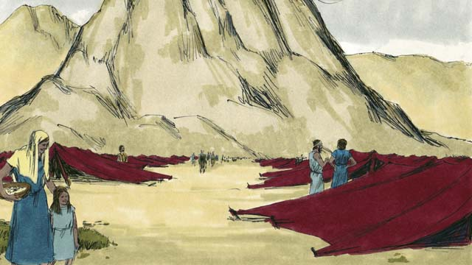

After God led the Israelites through the Red Sea, he led them through the wilderness to a mountain called Sinai. This was the same mountain where Moses had seen the burning bush. The people set up their tents at the base of the mountain.

13-02

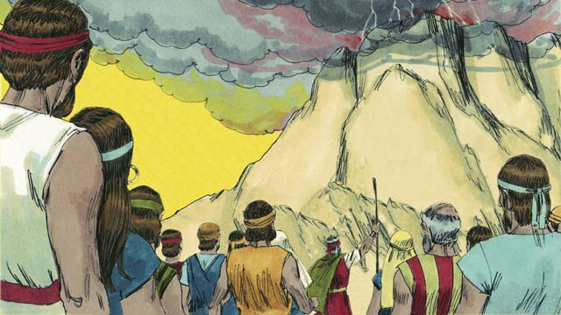

God said to Moses and all the people of Israel, “You must always obey me and keep the covenant I am making with you. If you do this, you will be my prized possession, a kingdom of priests, and a holy nation.”

13-03

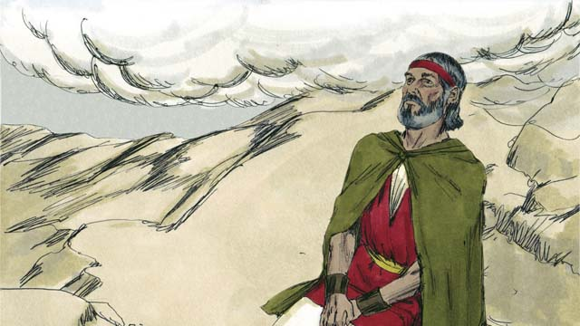

For three days the people made themselves ready for God to come near to them. Then God came down to the top of Mount Sinai. When he came, there was thunder, lightning, smoke, and sounds of loud trumpets. Then Moses went by himself up the mountain.

13-04

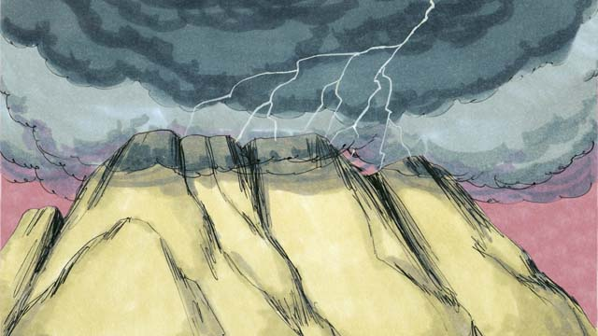

Then God made a covenant with the people. He said, “I am Yahweh, your God. It is I who saved you from being slaves in Egypt. Do not worship any other god.”

13-05

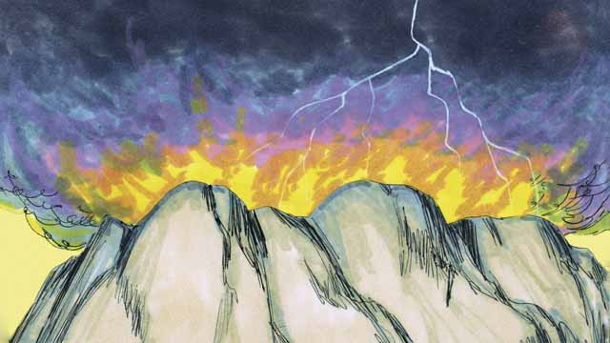

“Do not make idols and do not worship them, because I, Yahweh, must be your only God. Do not use my name in a disrespectful way. Be sure to keep the Sabbath day holy. In other words, do all your work in six days, for the seventh day is a day for you to rest and to remember me.”

13-06

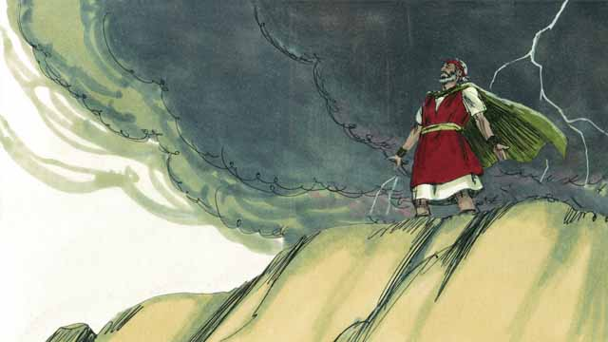

“Honor your father and your mother. Do not murder. Do not commit adultery. Do not steal. Do not lie. Do not desire to have your neighbor’s wife, his house, or anything that belongs to him.”

13-07

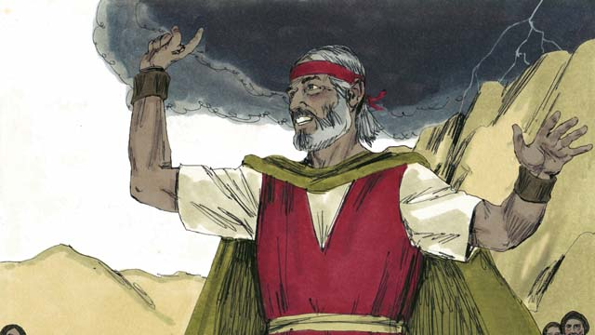

The people all agreed to obey the laws that God had given them. They agreed to belong to God alone and to worship only him.

13-08

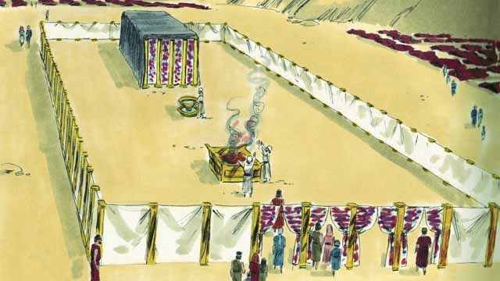

God also told the Israelites to make a large tent—the Tent of Meeting. He told them exactly how to make this tent and what things to put in it. He told them to make a large curtain to separate the tent into two rooms. God would come into the room behind the curtain and stay there. Only the high priest was allowed to go into that room where God was.

13-09

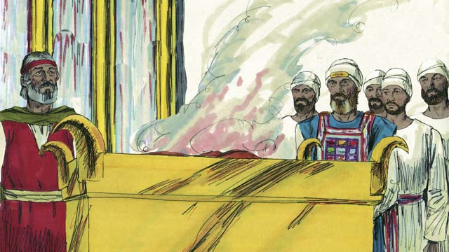

The people must also make an altar in front of the Tent of Meeting. Anyone who had disobeyed God’s law should bring an animal to that altar. A priest would then kill it and burn it on the altar as a sacrifice to God. God said that the animal’s blood would cover that person’s sin. In this way, God would not see that sin any longer. That person would become “clean” in God’s sight. God chose Moses’ brother, Aaron, and Aaron’s descendants to be his priests.

13-10

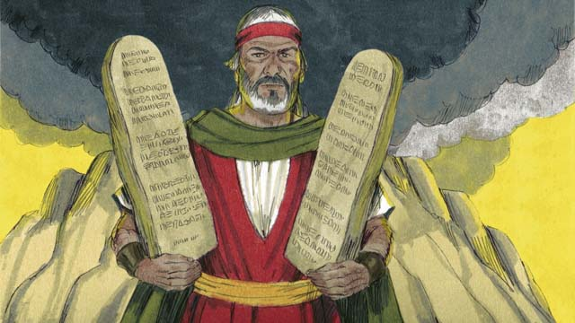

God wrote these Ten Commandments on two stone tablets and gave them to Moses. God also gave the people many other laws and rules to follow. God promised to bless the people and protect them if they obeyed these laws. But he said he would punish them if they did not obey them.

13-11

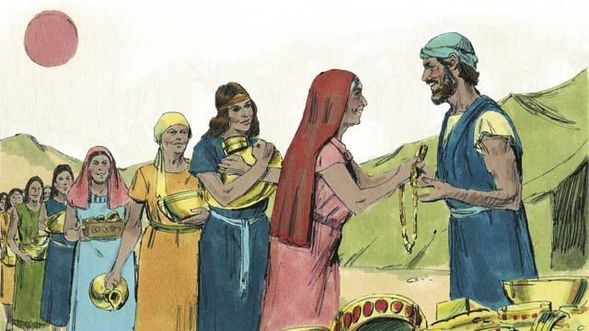

For many days, Moses remained on top of Mount Sinai. He was talking with God. But the people became tired of waiting for him to return to them. So they brought gold to Aaron and asked him to make an idol that they could worship instead of God. In this way, they sinned terribly against God.

13-12

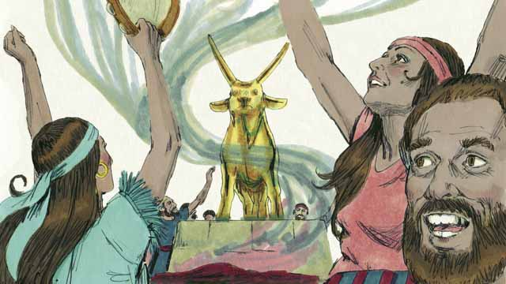

Aaron made a golden idol in the shape of a calf. The people began to wildly worship the idol and make sacrifices to it! God was very angry with them because of their sin. God told Moses he wanted to destroy them. But Moses asked God not to kill them. God listened to his prayer and did not destroy them.

13-13

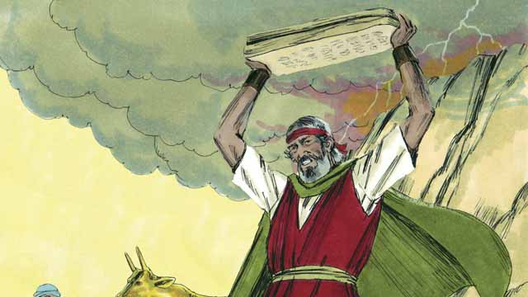

When Moses came down from Mount Sinai, he was carrying the two stone tablets on which God had written the Ten Commandments. When Moses saw the idol, he was so angry that he smashed the tablets.

13-14

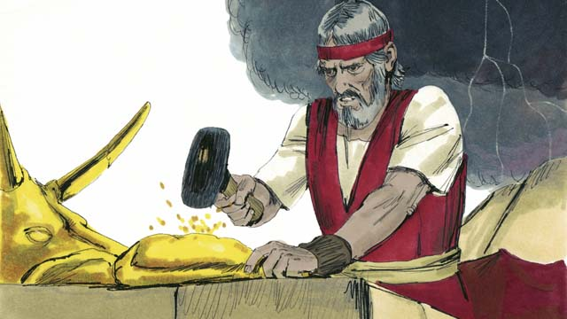

Then Moses burned the idol and ground it into powder. He threw the powder into a stream and made the people drink the water. God sent a plague on the people and many of them died.

13-15

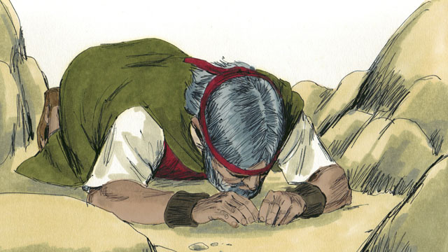

Moses made new stone tablets for the Ten Commandments to replace the ones that he had broken. Then he climbed the mountain again and prayed that God would forgive the people. God listened to Moses and forgave them. Moses came back down the mountain with the Ten Commandments on the new tablets. Then God led the Israelites away from Mount Sinai toward the Promised Land.

*A Bible story from: Exodus 19-34*

## 1 Biblical Interpretation: Observing the Details of the Story

After reading the crafted biblical story, answer the following questions to familiarize yourself with the details of the story.

### 1.1 Observation Questions

Answer the following observation questions to gain a basic understanding of the the story. Read the story as a community and answer these questions as a group.

#### 13-01

Where did God lead the Israelites after they crossed the Red Sea?  
He lead them through the wilderness to a mountain called Sinai.

Why was this mountain important?  
This was the same mountain where Moses saw the burning bush.

What did the people do when they arrived at Mount Sinai?  
The people set up their tents at the base of the mountain.

#### 13-02

What message did God give Moses to tell the people?  
God told Moses to tell the Israelites that they must always obey God and keep his covenant.

What did God promise the Israelites that they would become if they would obey him?  
They would be his prized possession, a kingdom of priests, and a holy nation.

#### 13-03

How many days did the people make themselves ready for God to come near to them?  
The people made themselves ready for three days.

What signs accompanied God when he came down on Mount Sinai?  
Thunder, lightning, smoke, and a loud trumpet blast accompanied God when he came down.

Who went up to the mountain?  
Moses went by himself up to the mountain.

#### 13-04

What did God say to the Israelites when he made a covenant with them?  
God told the Israelites that he was Yahweh, their God. He told them that he was the one who saved them from being slaves in Egypt.

What did God command the Israelites about other gods?  
God commanded the Israelites to not worship any other god.

#### 13-05

What did God command the Israelites about other worship?  
God commanded the Israelites to not make any idols and not to worship any idols.

What did God command the Israelites about God’s name?  
God commanded the Israelites to not treat God’s name in a disrespectful way.

What did God command the Israelites about the Sabbath day?  
God commanded the Israelites to work for six days and rest on the seventh day.

#### 13-06

What did God command the Israelites about how they should treat one another?  
God commanded the Israelites to honor their parents. He commanded them to not murder, not steal, not lie, and not covet what other people have.

#### 13-07

How did the Israelites respond to God’s words?  
The people agreed to obey God’s commands. They agreed to only worship God.

#### 13-08

What did God tell the Israelites to build for him?  
He told them to make the Tent of Meeting.

What did God tell the Israelites to make to separate the two rooms of the tent?  
God told the Israelites to make a large curtain to separate the two rooms.

Who could enter into the room behind the curtain where God was?  
Only the high priest could enter there because God would come behind the curtain.

#### 13-09

What did God tell the Israelites to make and put in front of the Tent of Meeting?  
God told the Israelites to make an altar so anyone who had disobeyed God’s law could bring an animal sacrifice to the altar.

How could the people cover their sin?  
They could bring an animal for the priests to sacrifice.

What did the sacrifice do to the people’s sin?  
The blood of the sacrifice would cover their sin. God would no longer see their sin and the person would become clean in God’s sight.

Who did God choose to be his priests?  
He chose Aaron and his descendants.

#### 13-10

How did God record his commands to his people?  
God wrote the Ten Commandments on two stone tablets and gave the tablets to Moses. God also gave the people other laws and rules to follow.

What would God do to the Israelites if they obeyed God’s commandments?  
He would bless them and protect them.

What would God do to the Israelites if they disobeyed his commandments?  
He would punish them.

#### 13-11

How long was Moses on top of Mount Sinai?  
Moses was on top of Mount Sinai for many days talking with God.

What did the people do when they got tired of waiting for Moses to return from Mount Sinai?  
They asked Aaron to make a gold idol that they could worship.

Was it good or bad for the Israelites to ask Aaron to make a gold idol?  
The people sinned greatly against God in doing this.

#### 13-12

What did the Israelites do with the gold idol that Aaron made?  
The Israelites worshiped it and made sacrifices to it.

What did God think of the Israelites worshiping the gold idol?  
God was angry with the Israelites. He told Moses he wanted to destroy them.

Why did God not destroy the Israelites when they disobeyed?  
He did not destroy them because Moses prayed for them.

#### 13-13

What happened to the stones on which God had written the Ten Commandments?  
Moses saw the idol when he came down the mountain. He was angry and smashed the stone tablets.

#### 13-14

What did Moses do to the idol?  
Moses burned the idol and ground it into powder, and then he made the people drink it in water.

What did God do the Israelites?  
God sent a plague that caused many to die.

#### 13-15

What did God tell Moses to do to replace the stone tablets?  
God told Moses to make new stone tablets to replace the old ones he had broken.

What did Moses do to ask God to forgive the people?  
Moses climbed the mountain again. He prayed that God would forgive the people. God listened to Moses’ prayer and forgave the people.

Where did the Israelites go after Mount Sinai?  
God led the Israelites toward the Promised Land.

### 1.2 Translation Questions

Use the following translation questions to understand specific details of the passage. Discuss how you might translate these specific elements of the story.

#### 13-01

**After God led the Israelites through the Red Sea** This introduces a new event to the story. This explains that the events of this story begin following God leading the Israelites through the Red Sea. How would you express **After God led the Israelites through the Red Sea** to mean the events of this story took place subsequent to God leading the Israelites through the Red Sea?

  

**This was the same mountain where Moses had seen the burning bush** This is background information about the mountain to which the Israelites traveled. This information is told in an earlier story. How would you express **This was the same mountain where Moses had seen the burning bush** to explain that the mountain to which God led the Israelites is the same mountain Moses saw the burning bush?

  

**set up their tents** The Israelites had to travel a great distance from Egypt to the Promised Land. So they took tents with them so that they could set them up as shelters and sleep in them along the way. How would you express **set up their tents** to mean the Israelites set up their portable shelters which they had slept in along their journey?

  

**the base of the mountain** This is the bottom of the mountain. This refers to the area of land that is located next to the place where the ground starts to slant upward to form a mountain. How would you express **the base of the mountain** to mean the area of land that is located next to the place where the ground starts to slant upward to form a mountain?

  

#### 13-02

**obey me and keep the covenant** God commands the Israelites to do what God’s covenant required them to do. Obeying and keeping the covenant are not two different things. God is telling his people to follow God’s covenant commands. God will give these commands in the next part of the story. How would you express **obey me and keep the covenant** as a command which God tells his people to do what God says and follow the commands in his covenant?

  

**If you do this** The word If introduces a conditional statement. The blessings are dependent on the Israelites obeying the commandments God had given. How would you express **If you do this** to mean Israel would be God’s prized possession, a kingdom of priests, and a holy nation on the condition the Israelites obeyed God and followed his covenant commands?

  

**prized possession** If the Israelites obeyed God’s covenant God commands, they would be God’s possession that he valued most. The would be God’s own precious people. How would you express **prized possession** to mean the Israelites would be the people that God treasured more than any other group of people?

  

**a kingdom of priests** God speaks of his people as if they were priests. If the Israelites obeyed God, he would make them a kingdom of people who are like priests or a kingdom of people who do what priests do. The Israelites were supposed to teach the other nations about God and be a mediator between God and the nations just as there were priests in the nation of Israel to go between God and the Israelites. How would you express **a kingdom of priests** to mean a kingdom of people who are like priests or do what priests do?

  

**a holy nation** If the Israelites obeyed God’s covenant commands, God would make them a nation set apart for himself. How would you express **a holy nation** to mean a people set apart for God and separated from all that is sinful or imperfect?

  

#### 13-03

**For three days** Three days after they arrived at Mount Sinai and God first spoke to them the people made themselves ready to meet with God. How would you express **For three days** to mean the Israelites took three days to get themselves read to meet with God?

  

**made themselves ready for God to come near to them** This refers to ceremonial cleansing in preparation to meet with God. The Israelites got ready to meet with God. How would you express **made themselves ready for God to come near to them** to mean the Israelites prepared themselves to meet with God?

  

**sounds of loud trumpets** Loud sounds came from horns and the Israelites heard the loud sounds of horns blowing. These trumpets were not blown by men, but by God or by his angels. How would you express **sounds of loud trumpets** to mean horns were blown and they made loud sounds?

  

**Moses went by himself** God only permitted Moses to go up, but he did not permit anyone else to go. How would you express **Moses went by himself** to mean that Moses was the only one that went up the mountain because God did not permit anyone else to go?

  

#### 13-04

**made a covenant with the people** A covenant is a formal, binding agreement between two parties that one or both parties must fulfill. God made a formal agreement with the Israelites. The terms of this covenant are explained in what God says next in the story. How would you express **made a covenant with the people** to mean God made a formal, binding agreement with the Israelites by telling the Israelites the things they must obey?

  

**Yahweh, your God** The Israelites worshiped the one true God. whose name is Yahweh. The name of the the true God whom the Israelites worshiped is Yahweh. How would you express **Yahweh, your God** to mean Yahweh, who is your God or your God, whose name is Yahweh?

  

**who saved you from being slaves** God rescued the Israelites from slavery when he brought them out of Egypt. How would you express **who saved you from being slaves** to mean God rescued and freed the Israelites from slavery?

  

**Do not worship any other god** God forbids the Israelites from worshiping any other god? This command orders the Israelites to only worship the true God, whose name is Yahweh. How would you express **Do not worship any other god** as a command that forbids Israel worshiping other gods and commands them to only worship Yahweh, the true God?

  

#### 13-05

**Do not make idols** An idol is an object that people make to worship. God forbids the Israelites from making idols. This is a command from God to all of the Israelites. God also forbids the Israelites using idols to worship the true God or false Gods. The Israelites are to only worship God alone. They must only worship God and do so without the use of idols. How would you express **Do not make idols** as a command which forbids the Israelites for making objects or images to worship?

  

**because** The word **because** indicates the reason the Israelites were not to make idols or worship them was Yahweh was jealous of their worship. Yahweh was not like the false gods people worshiped. Many false gods did not care if the people worshiped other gods. The true God, Yahweh, wants his people to only worship him. How would you express **because** to mean the reason God commanded the Israelites to not make idols or worship them was God wanted the Israelites to only worship him?

  

**Do not use my name in a disrespectful way** God forbids the Israelites from talking about God in a way that does not show respect and honor. This is a command from God to all of the Israelites. God commands his people to talk about him in a way that gives him proper respect and honor. How would you express **Do not use my name in a disrespectful way** as a command which forbids the Israelites from talking about God or saying his name in a way that does not show respect and honor?

  

**Be sure to keep the** Sabbath day holy God commands the Israelites to treat the Sabbath day as a special day that is different from all the other days in the week. It is a day fully dedicated to God. The Jewish Sabbath day was the seventh day of the week. This was Saturday. This is a command from God to all of the Israelites. How would you express **Be sure to keep the** Sabbath day holy as a command to treat the Sabbath day as a special day dedicated to God that is different from all the other days in the week?

  

**remember me** To remember God means to keep him in mind or to honor him. How would you express **remember me** as in to keep in mind or to honor?

  

#### 13-06

**Honor your father and your mother** God commands the Israelites to show respect and for their parents. This is a command from God to all of the Israelites. How would you express **Honor your father and your mother** as a command to respect or esteem one’s parents?

  

**Do not commit adultery** God forbids the Israelites from having sexual relations with someone else’s spouse. This is a command from God to all of the Israelites. How would you express **Do not commit adultery** as a command that prohibits people from having marital relations with another man’s wife or another woman’s husband?

  

**Do not lie** God forbids the Israelites from saying false things about other people. This is a command from God to all of the Israelites. How would you express **Do not lie** as a command that prohibits people from saying false or untrue things?

  

**Do not desire** God forbids the Israelites from coveting things that they do not own. This is a command from God to all of the Israelites. How would you express **Do not desire** as a command that prohibits people from wanting/coveting things that other people have?

  

#### 13-07

**the laws** God had given them God had told his people the things/laws that he wanted them to obey. How would express **the laws** God had given them to mean the commands that God told them to obey?

  

**to belong to God alone** From among all the nations, God had chosen the Israelites for his special purpose. The Israelites were chosen to be God’s special nation which he chose to be his people or God’s own people. As God’s chosen people, the Israelites were to be committed to God and only worship God. This also meant the Israelites considered God to have special ownership over them as his people. How would you express **to belong to God alone** to mean the Israelites were to be committed to God and considered God to have special ownership of them as his people?

  

#### 13-08

**the Tent of Meeting** God commanded the Israelites to make a large tent which would be a place where God’s people would meet with God. How would you express **the Tent of Meeting** to mean a large tent in which God would meet with his people and reveal himself to them?

  

**the room behind the curtain** This room was hidden by the curtain. The room was on the other side at the back of the curtain. How would you express **the room behind the curtain** to mean the room hidden by the curtain?

  

**where God was** God is not confined to a certain space. God was not limited to living in the tent. This was the place where God revealed himself to his people. How would you express **where God was** to mean the place where God met with humans and revealed himself to humans?

  

#### 13-09

**cover that person’s sin** When people brought animals to sacrifice, God chose to see the blood of the animals as a covering over their sin. This is like hiding something that is ugly or dirty by covering it. When sin is covered, God would not judge them for their sin. How would express **cover that person’s sin** to mean to put something over sin so that it is hidden and God would judge that person for their sin?

  

**God would not see that sin any longer** God knows all things. Nothing is hidden from God’s knowledge. When someone’s sin is covered by a sacrifice, God no longer counts that sin against the person. How would you express **God would not see that sin any longer** to mean God no longer counts sin against the person whose sin is covered by sacrifice?

  

**clean in God’s sight** The person who is **clean in God’s sight** is as if he did not have the sin according to God. Because the person is viewed as not guilty of sin before God, they are free of the punishment for breaking God’s law. How would you express **clean in God’s sight** to mean someone is viewed by God as if he ddi not have the sin and is free of the punishment of breaking God’s law?

  

#### 13-10

**Ten Commandments** This refers to the commands God gave to Moses for the Israelites to obey. These ten commandments were listed earlier in the story. How would you express **Ten Commandments** to mean the ten laws God gave his people as part of the terms of his covenant?

  

**two stone tablets** A tablet was a flat piece of stone or other hard material used in ancient times for writing. How would you express **two stone tablets** to mean two flat pieces of stone on which one would write?

  

**to follow** God expected his people to obey his commands. To follow God’s laws means to do what God instructed. How would you express **to follow** to mean to do what God instructed in his laws and commands?

  

**if they obeyed** The word if indicates a hypothetical or conditional relationship. God’s blessing depends on the Israelites obeying the laws. How would you express **if they obeyed** to mean God would bless the Israelites on the condition that they obeyed God’s commands?

  

**if they did not obey** The word if indicates a hypothetical or conditional relationship. God would punish the Israelites **if they did not obey** the laws. How would you express **if they did not obey** to mean God would punish the Israelites on the condition that they disobeyed his commands?

  

#### 13-11

**the people became tired of waiting** The people became impatient because Moses did not return quickly. The people didn’t want to wait any longer for him to return. How would you express **the people became tired of waiting** to mean the people became impatient because Moses did not return quickly and did not want to wait any longer for him to return?

  

**instead of God** The people would worship the gold idol rather than God. How would you express **instead of God** to mean the people would worship the gold idol as a substitute for worshipping God?

  

**they sinned terribly against God** They sinned in a way that was especially offensive to God. The people sinned badly and did something very bad that made God very angry. How would you express **they sinned terribly against** God to mean the people did something very bad that was offensive to God and made God angry?

  

#### 13-12

**made a golden idol** Aaron took the things made of gold that the people had brought to him, melted them, combined them, and formed them into the shape of a calf. How would you express **made a golden idol** to mean Aaron took the things made of gold that the people had brought to him, melted them, combined them, and formed them into the shape of a calf?

  

**to wildly worship** The people were sinning by worshiping the idol and also by doing sinful things as they worshiped it. How would you express **to wildly worship** to mean the people sinned by worshipping the idol and also by doing sinful things as they worshiped it?

  

**listened to his prayer** God always hears prayer. In this situation, listened means that God agreed to do what Moses asked. How would you express **listened to his prayer** to mean God agreed to do what Moses asked?

  

#### 13-13

**When Moses saw the idol** The word when explains that Moses became angry at the time he saw the the people worshiping to the idol. How would you express **When Moses saw the idol** to mean Moses became angry at the time he saw the the people worshiping to the idol?

  

**smashed the tablets** Moses threw the stone tablets down on the ground and they broke up into little pieces. How would you express **smashed the tablets** to mean Moses threw the stone tablets down on the ground and they broke up into little pieces?

  

#### 13-14

**burned the idol** Moses destroyed the idol in a fire. How would you express **burned the idol** to mean Moses destroyed the idol by the fire?

  

**ground it into powder** Moses utterly destroyed the idol by pounding it into fine particles. How would you express **ground it into powder** to mean Moses crushed the gold idol he burned into fine grains/particles?

  

**plague** This **plague** may have been a serious illness which made the people very sick. The **plague**d caused people to die. What words in your language mean **plague** as in a serious illness or disease that causes many people to get very sick and die?

  

#### 13-15

**Moses made** Moses carved the stone tablets with tools such as a hammer and chisel. How would you express **Moses made** to mean Moses carved the stone tablets with tools such as a hammer and chisel?

  

**forgive the people** Moses asked God to pardon his people for the sin they did wrong. To forgive someone is to cancel a debt of wrong which someone has done. How would you express **forgive the people** to mean Moses asked God to pardon the people for the wrong things they did?

  

## 2 Theological Dialogue: Discussing the Meaning of the Story

Take time to explore the meaning of this story together as a community. Use the following discussions as a way to grasp what truth the story teaches.

### 2.1 Discourse Questions

Use the following discourse questions to understand the meaning of the story. Pay attention to how the story itself addresses each question or theme.

##### How did God set his covenant with the Israelites? (13-01, 13-02, 13-03)

God made a covenant with the Israelites at Sinai. This was the same mountain where God revealed himself to Moses in the burning bush. The first time God met with Moses at Sinai, he told Moses how he would free the Israelites from slavery. Now, God was making a covenant with his people for how to live as God’s freed people. (13-01)

  

God commanded the Israelites to obey him. Following God’s commands would be the way the Israelites kept the covenant. (13-02)

  

God made the Israelites his people. God made Israel his prized possession: valuable treasure God cherished. God made Israel a kingdom of priests: royal representatives who representing God to other people. God made Israel a holy nation: a chosen and purified people set apart to God. (13-02)

  

The Israelites prepared for three days to meet with God. Moses went up on the mountain alone to meet with God. The Israelites had to prepare themselves to meet with God. (13-03)

  

God came down on the mountain with thunder, lightning, smoke, and trumpet sounds.. God met with his people in power, glory, and strength. (13-03)

  

He made the covenant by telling Israel that he was Yahweh, the God who rescued them from Egypt. God’s covenant commands were given to his people that God had already freed by his grace. (13-04)

  

##### What commands did God give in his covenant with the Israelites? (13-04, 13-05, 13-06)

God commanded the Israelites to obey his commands. God’s commanded the people whom he had freed to obey him. Obedience to God’s commands came after God’s gracious liberation. God’s commands were how the Israelites lived as God’s freed people (not how they gained their freedom). (13-04)

  

God gave the Israelites ten commandments. The first four commands told Israel how to relate to God. The next six commands told Israel how to relate to others. (13-04 ,13-05, 13-06)

  

The first four commands told Israel how to relate to God. God told the Israelites to worship God alone, worship God the way he told them to, treat God’s name with respect, and honor God by keeping the Sabbath day. (13-04-13-05)

  

The next six commands told Israel how to relate to others. God told the Israelites to honor their parents, treasure life (do not murder), practice sexual purity in marriage (do not commit adultery), be generous with and grateful for one’s possessions (do not steal), speak the truth (do not lie), and practice contentment (do not covet things others have). (13-06)

  

##### What were the Israelites supposed to do to keep the covenant? (13-07, 13-08, 13-09, 13-10)

Obedience: The Israelites agreed to obey God’s laws.To keep the covenant, Israel would follow God’s ways. (13-07)

  

Belonging: The Israelites agreed to belong to God alone. To keep the covenant, Israel would not serve any other gods. (13-07)

  

Worship: The Israelites committed themselves to worship God alone. To keep the covenant, Israel would be devoted to God alone. (13-07)

  

Tent of Meeting: God told the Israelites to build a Tent of Meeting. God would meet with his people in the inner room behind the curtain. (13-08)

  

Altar: God told the Israelites to make an altar in the Tent of Meeting. A priest would offer an animal sacrifice for the sin of the people. The sacrifice would cover their sin and make them clean before God. (13-09)

  

Stone Tablets: God recorded his commandments on tablets of stone. Like stone is solid and enduring, God was making a covenant with his people that would last. God would bless the Israelites if they kept his ways. God would punish them if they disobeyed. (13-10)

  

##### How well did the Israelites keep the covenant while Moses was on Mount Sinai? (13-11, 13-12, 13-13)

Impatience: The Israelites became impatient waiting for Moses while he was meeting with God on Mount Sinai. Disobedience comes from impatience and lack of trust in God. (13-11).

  

False Worship: The Israelites sinned terribly by having Aaron make a gold idol to worship. The gold idol was shaped like a calf. The people worshiped the idol and made sacrifices to it. The Israelites disobeyed the very first two commandments God had given. Disobeying God’s commands begins with false worship. (13-11, 13-12)

  

Divine Anger: God became angry at the Israelites because of their sin. God told Moses he wanted to destroy the Israelites. Disobedience to God provokes God to anger. (13-12)

  

Covenant Unfaithfulness: When Moses saw the Israelites worshiping the gold idol, he destroyed the stone tablets. The stone tablets represented God’s covenant with his people. Disobeying God’s commands breaks the covenant with God. (13-13)

  

##### What are the ways God provided for Israel to deal with their disobedience and sin? (13-09, 13-12, 13-14, 13-15)

Sacrifice: God told the Israelites to offer animal sacrifices for their sin. The sacrifice would cover the sin of a person and make them clean in God’s sight. (13-09)

  

Intercession: When the Israelites worshiped the gold idol, God wanted to destroy the Israelites. Moses prayed to God. God listened to Moses and God did not destroy his people. Moses also prayed that God would forgive the Israelites. (13-12, 13-15)

  

Repentance: Moses destroyed the gold calf. He burned it, ground it in powder, threw it in water, and had the people drink it. This action symbolized removing the idol and taking ownership for one’s sin. (13-14)

  

Consequences: God brought a plague on the people and many died. Even though God forgave his people, there were still consequences for their sin. (13:14)

  

Forgiveness: Moses asked God to forgive the Israelites. God listened to Moses’ prayer and forgave his disobedient people. (13-15)

  

Restoration: Moses made new stone tablets. The relationship with God and the Israelites was restored. (13-15)

  

### 2.2 Theological Questions

Answer the following theology questions as a community. Discuss what truths this story teaches.

1. What does it mean to be devoted to God? What does this story teach us about what it means to practice covenant faithfulness?
2. What kind of life should God’s people live? How do the Ten Commandments summarize principles for living?
3. How serious is sin? What do we learn about sin and its consequences from this story?
4. How can God’s people find forgiveness and restoration from their sin? How does this story help us understand how people can be forgiven of their sin?

### 2.3 Translation Draft

Work as a translation team to draft each panel of this story. Pay attention to any specific translation issues that are challenging or significant.

#### Make Translation Draft

Make a draft for each section of this story.

#### Discuss and Revise

After drafting the story, discuss any translation issues that you think need special explanation.

#### Drafting Summary Reflection

Summarize any noteworthy translation decisions and the rationale/reasoning behind these translation decisions. In the final movement of this class, you will use these observations to give an account (i.e., chronicle/narrate) of how your translation improved through the checking process.

## 3 Personal Reflection: Following the Teaching of the Story

Take a moment to allow this story to evaluate your own life and to consider how God would have you respond. After this reflection, use the quality checking questions to check your translation draft among the translation team.

### 3.1 Journal Reflection

Prayerfully think about the following personal reflection questions. Write/Record your answers and/or discuss them as a group.

1. How would you describe your devotion to God?
2. Which of the Ten Commandments do you find the hardest to obey? Why?
3. Which specific sins do you need to ask God for forgiveness?
4. What steps will you take to seek God’s forgiveness and restoration?

### 3.2 Team Check

*The following activity will help you check the clarity, accuracy, and naturalness of your draft. Read the passage aloud and discuss the checking questions with other members of your translation community. You might need to reread portions (or the whole) of the biblical passage multiple times as you answer each of these questions. Record answers to these questions below.*

#### Team Checking Questions

*Use the following questions to check your translation draft for accuracy, clarity, and naturalness.*

1. **Accurate**: Has anything been **added** to your translation of this passage that is not a part of the meaning of the source text? *If additions exist, are they included only added to clarify meaning (such as implied information)?*
2. **Accurate**: Is anything **missing** from your translation of this passage that is a part of the meaning of the source text? *If some part of the meaning is missing from your translation, add it.*
3. **Accurate**: Does any meaning in your translation of this passage appear to be **different** than the meaning of the source text? *If the meaning is different, try changing your translation so that the meaning remains the same.*
4. **Natural**: Does anything sound **unnatural** to how you would say it in your language? *If portions of the passage sound unnatural in your language, try to make them sound the way you would say it in your language while staying true to the meaning of the source text.*
5. **Clear**: Is anything **unclear** or **confusing** in your translation that confuses the meaning of the source text? *If portions of the passage are unclear or confusing, revise them to clearly communicate the meaning of the source text.*
6. **Consistent**: How **consistent** is your translation within the passage and with other passages? *If portions of the passage need to be made consistent or if you need to revise translations of other passages, make these adjustments.*

#### Record Feedback

*After discussing the checking questions above as a translation community, record any feedback on your translation draft. Pay attention for parts of your translation that are translated well and parts of your translation that need correction.*

#### Discuss and Revise

*After gathering feedback on your draft, discuss it together with your translation community and make appropriate revisions in your translation.*

#### Checking Summary Reflection

*Summarize any noteworthy translation decisions (things you corrected or affirmed in your draft) and the rationale/reasoning behind these translation decisions. In the final movement of this class, you will use these observations to give an account (i.e., chronicle/narrate) of how your translation improved through the checking process.*

## 4 Ministry Practice: Serving the Church with the Story

Now that you have a draft of this story, consider how this story can encourage other believers in their faith. After ministering this story to others, you will also perform a community check of your translation draft.

### 4.1 Church Ministry

Reflect on how this story can edify and mature the Christian community. Design a way to minister this story to your church community.

**Ministry Preparation**: Take time to consider how you could minister this story to others. Record some ministry ideas below.

**Ministry Implementation**: Minister this story to a group of believers as you had planned. Use the information in this study to help develop a teaching/lesson or lead a discussion of this story to other believers. Record your ministry plan below.

**Ministry Reflection**: Think about what you learned from ministering this story to other believers. Reflect on your experience below.

### 4.2 Church Community Check

After teaching or ministering this story to the church, check the translation quality with the church community. Record any feedback from your checking experience.

#### Create Checking Questions

You can use **Translation Questions** to check you draft. Each **Translation Question** explains the meaning of a specific part of the story and asks you to consider how you would translate that part of the story in your own language. Change each **Translation Question** into a **Checking Question** by asking the following questions. The first question asks you to identity how each specific phrase was translated in your language. The second question asks people in the church to determine if your translation of the phrase expresses the meaning clearly, accurately, and naturally. Look at the following examples to see how to change **Translation Questions** into **Checking Questions**:

#### Translation Question Example 1

**to proclaim the good news about Jesus** Paul and Silas traveled to Philippi for the purpose of preaching the gospel. The gospel is the good news that Jesus saves people from their sins if they will believe in Jesus. How would you express **to proclaim the good news about Jesus** to mean to tell other people the message about how Jesus can save people from their sins?

#### Translation Question Example 2

**a merchant** Paul and Silas met a woman named Lydia at the place by the river. She owned a business and sold items to make money. How would you express **a merchant** to mean a business owner who sells items for a profit?

#### Translation Question Example 3

**so Paul and Silas baptized them** The jailer and his whole family followed Paul’s instructions. They believed in Jesus. The result of this was Paul and Silas baptized them. How would you express **so Paul and Silas baptized them** to mean the result of the jailer and his family believing in Jesus that Paul and Silas baptized all of them?

You can change these into **Checking Questions** like this:

#### Checking Question Example 1

**to proclaim the good news about Jesus** How did you translate **to proclaim the good news about Jesus**? Does it mean to tell other people the message about how Jesus can save people from their sins?

#### Checking Question Example 2

**a merchant** How did you translate **a merchant**? Does it mean a business owner who sells items for a profit?

#### Checking Question Example 3

**so Paul and Silas baptized them** How did you translate **so Paul and Silas baptized them**? Does it mean the result of the jailer and his family believing in Jesus that Paul and Silas baptized all of them?

#### Record Feedback

*Discuss the* ***Checking Questions*** *with your church community, and record any feedback on your translation draft. Pay attention for parts of your translation that are translated well and parts of your translation that need correction.*

#### Discuss and Revise

*After gathering feedback on your draft, discuss it together with your translation community and make appropriate revisions in your translation.*

#### Checking Summary Reflection

*Summarize any noteworthy translation decisions (things you corrected or affirmed in your draft) and the rationale/reasoning behind these translation decisions. In the final movement of this class, you will use these observations to give an account (i.e., chronicle/narrate) of how your translation improved through the checking process.*

## 5 Missional Outreach: Sharing the Truth of the Story

*After sharing this story with others, check the translation quality with the wider language community. Record any feedback from your checking experience.*

### 5.1 Mission Engagement

*Consider how you will witness this story to unbelievers. Design a way to share this story and engage them in what it teaches about Christianity and the gospel.*

**Witness Preparation**: Take time to consider how you will witness this narrative to unbelievers. Record some ideas below.

**Witness Implementation**: Share this story with an unbeliever. Use the information in this study to help develop a teaching/lesson or lead a discussion of this story to other believers. Record your ministry plan below.

**Witness Reflection**: Think about what you learned from ministering this story to unbelievers. Reflect on your experience below.

### 5.2 Sociolinguistic Check

After sharing this story with the language community, check your translation draft with the surrounding community. Record your observations.

#### Checking Approach

After witnessing this story to unbelievers, use one of the following methods to check the translation of this story. Consider using the **Observation Questions** to check your translation draft or come up with your own quality checking questions.

**Read-Retell Check:** Read your draft to those the community and ask them to retell the passage. Be attentive for any portions of the passage that are unclear, unnatural, or inaccurate.

**Comprehension Questions Checklist:** Read the draft of the passage and ask a list of comprehension questions to make sure the passage is being rightly understood. You can use the **Observation Questions** in this guide or come up with your own questions. Then, record any insights or issues that arise.

**Discussion Group:** Develop key questions to ask about the passage (both formational and translational). Read the passage and have a group discussion about the passage, paying attention to issues that need to be addressed, edited, and revised.

#### Record Feedback

*After sharing your draft with language community, discuss the* ***Observations Questions****, and record any feedback on your translation draft. Pay attention for parts of your translation that are translated well and parts of your translation that need correction.*

#### Discuss and Revise

*After gathering feedback on your draft, discuss it together with your translation community and make appropriate revisions in your translation.*

#### Checking Summary Reflection

*Summarize any noteworthy translation decisions (things you corrected or affirmed in your draft) and the rationale/reasoning behind these translation decisions. In the final movement of this class, you will use these observations to give an account (i.e., chronicle/narrate) of how your translation improved through the checking process.*

## 6 Conclusion

As a translation community, take time to reflect on all that was learned in studying, drafting, and checking this story. Celebrate all that God has taught you as a community. Then, submit your revised draft and checking summaries to network leaders for further review.