Open Bible Stories

Wandering in the Wilderness

## 0 Introduction

### 0.1 Key Idea

The story of the wandering in the wilderness teaches us how God tests his people and provides for his people in the life of faith.

### 0.2 Creedal Verse

“This man led them out, performing wonders and signs in Egypt and at the Red Sea and in the wilderness for forty years.” Acts 7:36

### 0.3 Metanarrative Summary

The eternal God created all things in six days. He made a good and perfect world. He made humans in his image to fill the earth and rule over creation. But humans rebelled against God and ruined God’s creation. God set to restore his world through his promise. God made a covenant with Abraham. He promised to bless all nations through Abraham. God kept his promises across the generations. God provided Abraham with a promised child, Isaac. God gave Isaac a wife and she bore twins, Jacob and Esau. God blessed Jacob and his sons, and the blessing continued to the next generation. God rescued Joseph, one of Jacob’s sons, and used him to rescue his family. God caused his people, the Israelites, to multiply in the land of Egypt; eventually, they became slaves. But, God raised up a deliverer, Moses, to deliver his people from their slavery. God sent judged the Egyptians with harsh plagues; in the final judgment, he passed over his people who covered their doorposts with the blood of a sacrificed lamb. Then, God delivered the Israelites by bringing them out of Egypt and crossing the Red Sea on dry land. God made a covenant with the Israelites and made them his people. God tested Israel in a series of wilderness wanderings and

### 0.4 Open Bible Story: Wandering in the Wilderness

14-01

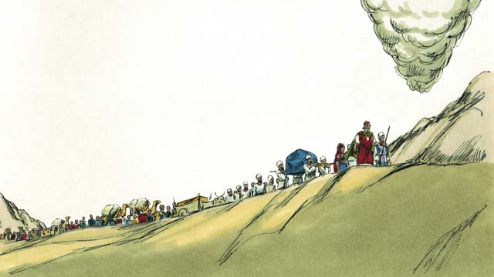

God finished telling the Israelites about all the laws that they must obey because of his covenant with them. Then he led them away from Mount Sinai. He wanted to take them to the Promised Land. This land was also called Canaan. God went ahead of them in the pillar of cloud, and they followed him.

14-02

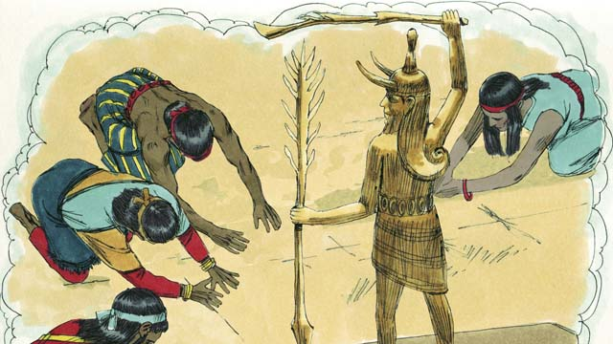

God had promised Abraham, Isaac, and Jacob that he would give the Promised Land to their descendants, but now there were many people groups living there. They were called Canaanites. The Canaanites did not worship or obey God. They worshiped false gods and did many evil things.

14-03

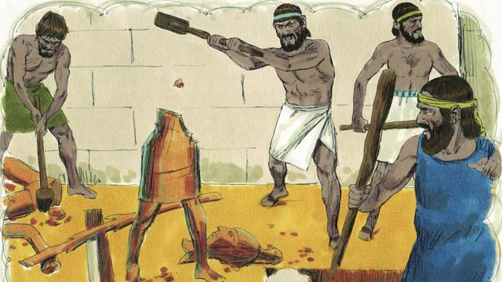

God told the Israelites, “After you go into the Promised Land, you must get rid of all the Canaanites there. Do not make peace with them and do not marry them. You must completely destroy all of their idols. If you do not obey me, you will end up worshiping their idols instead of me.”

14-04

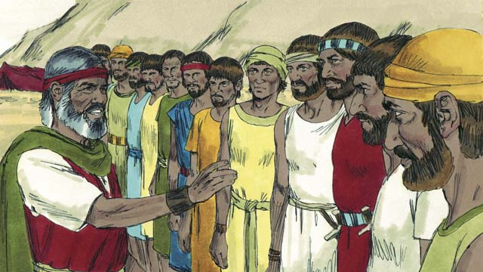

When the Israelites reached the border of Canaan, Moses chose 12 men, one from each tribe of Israel. He gave the men instructions to go and spy on the land to see what it was like. They were also to spy on the Canaanites to see if they were strong or weak.

14-05

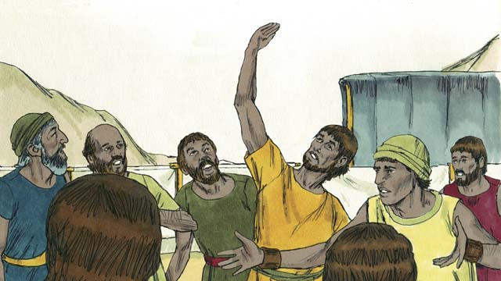

The 12 men traveled through Canaan for 40 days, and then they came back. They told the people, “The land is very fertile and the crops are plentiful!” But ten of the spies said, “The cities are very strong and the people are giants! If we attack them, they will certainly defeat us and kill us!”

14-06

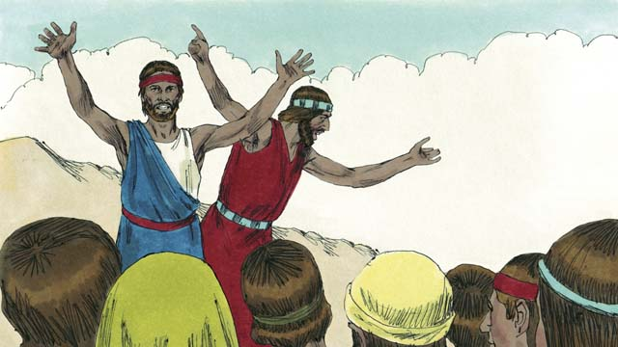

Immediately, Caleb and Joshua, the other two spies, said, “It is true that the people of Canaan are tall and strong, but we can certainly defeat them! God will fight for us!”

14-07

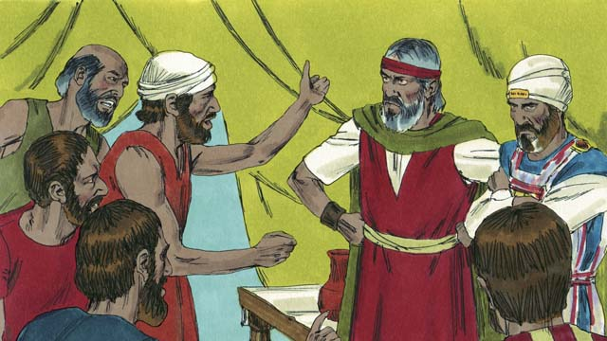

But the people did not listen to Caleb and Joshua. They became angry with Moses and Aaron and said, “Why did you bring us to this horrible place? We should have stayed in Egypt. If we go into the land, we will die in battle, and the Canaanites will make our wives and children to be slaves.” The people wanted to choose a different leader to take them back to Egypt.

14-08

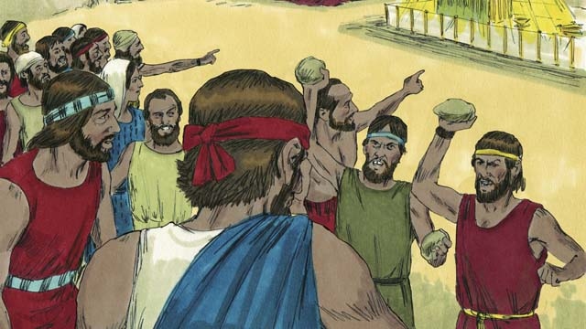

When the people said this, God was very angry. He came to the Tent of Meeting and said, “You have rebelled against me, so all of you will have to wander in the wilderness. Everyone who is 20 years or older will die there and never enter the land I am giving you. Only Joshua and Caleb will enter it.”

14-09

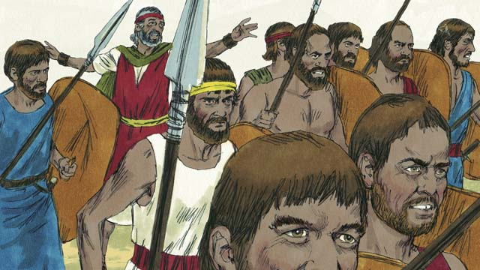

When the people heard God say this, they were sorry they had sinned. So they decided to attack the people of Canaan. Moses warned them not to go because God would not go with them, but they did not listen to him.

14-10

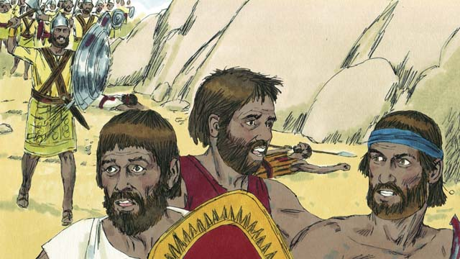

God did not go with them into this battle, so the Canaanites defeated them and killed many of them. Then the Israelites turned back from Canaan. For the next 40 years, they would wander through the wilderness.

14-11

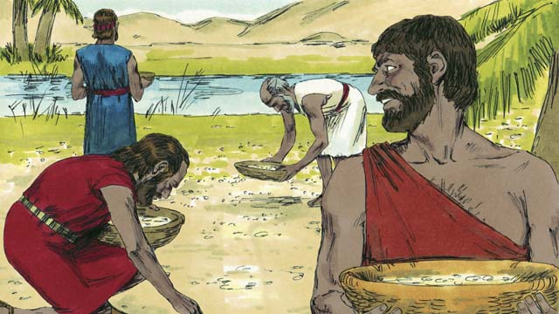

During the 40 years that the people of Israel wandered in the wilderness, God provided for them. He gave them bread from heaven, called manna. He also sent flocks of quail (which are medium-sized birds) into their camp so they could have meat to eat. During all that time, God kept their clothes and sandals from wearing out.

14-12

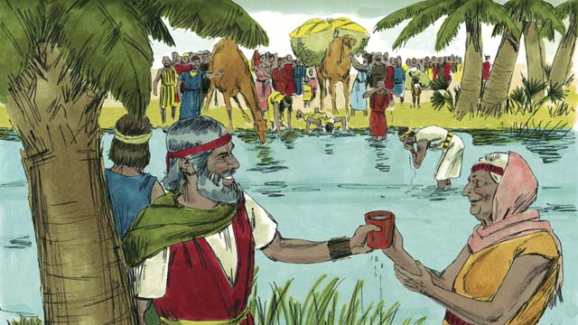

To provide them with water to drink, God miraculously made it come out of a rock. But despite all this, the people of Israel complained and grumbled against God and against Moses. Even so, God was still faithful. He did what he promised that he would do for the descendants of Abraham, Isaac, and Jacob.

14-13

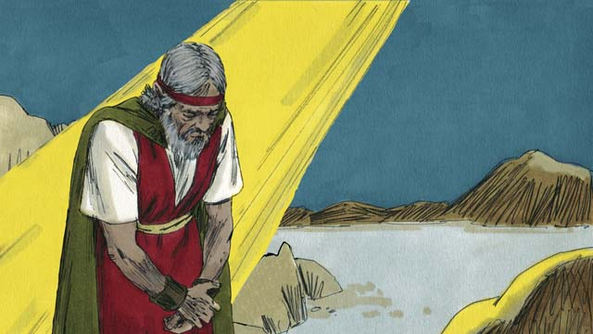

Another time when the people did not have any water, God told Moses, “Speak to the rock, and water will come out of it.” But Moses did not speak to the rock. Instead, he hit the rock twice with a stick. In this way, he dishonored God. Water came out of the rock for everyone to drink, but God was angry with Moses. He said, “Because you did this, you will not enter the Promised Land.”

14-14

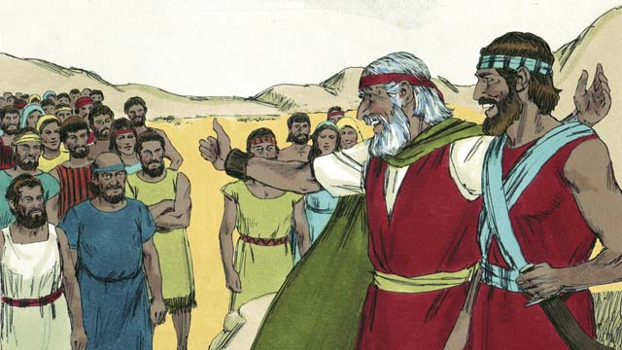

After the Israelites had wandered in the wilderness for 40 years, all of those who had rebelled against God were dead. Then God led the people to the edge of the Promised Land again. Moses was now very old, so God chose Joshua to lead the people. God also promised Moses that one day he would send to the people another prophet like Moses.

14-15

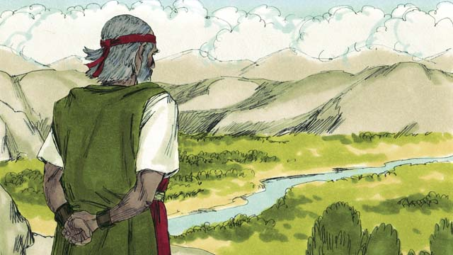

Then God told Moses to go to the top of a mountain so he could see the Promised Land. Moses saw the Promised Land but God did not permit him to enter it. Then Moses died, and the Israelites mourned for 30 days. Joshua became their new leader. Joshua was a good leader because he trusted and obeyed God.

*A Bible story from: Exodus 16-17; Numbers 10-14; 20; 27; Deuteronomy 34*

## 1 Community Study: Godly Wisdom—Living by the Wisdom from Above

* **Key Idea**: grounding our lives in God’s wisdom
* **Key Passage**: James 3:13-18
* **Main Session**: OBS 14 (Wandering in the Wilderness)

### 1.1 Sing a Song (3–5 minutes)

Choose a song to sing to praise God and encourage one another.

### 1.2 Recite the Creedal Verse (3–5 minutes)

The verse below summarizes the teaching of the current passage. Read the verse out loud as a community. Read it again several times as a group until the whole community can recite it from memory.

Moses led them out of Egypt, after doing miracles and signs in Egypt and at the Sea of Reeds, and in the wilderness during forty years. Acts 7:36

### 1.3 Read the Passage (5 minutes)

It takes wisdom to live godly lives in a sinful world. It takes wisdom to be a mature Christian community in a sinful world. In order to learn about godly wisdom that makes Christian community strong, read the passage below.

13 Who is wise and understanding among you? Let that person show a good life by his works in the humility of wisdom. 14 But if you have bitter jealousy and ambition in your heart, do not boast and lie against the truth. 15 This is not the wisdom that comes down from above. Instead, it is earthly, unspiritual, demonic. 16 For where there are jealousy and ambition, there is confusion and every evil practice. 17 But the wisdom from above is first pure, then peace-loving, gentle, reasonable, full of mercy and good fruits, impartial and sincere. 18 The fruit of righteousness is sown in peace among those who make peace. James 3:13-18

### 1.4 Discuss the Idea (10–15 minutes)

Wisdom helps us to live godly lives and to enjoy loving community relationships. Use the following questions to discuss the kind of wisdom that pleases God.

1. What are the two kinds of wisdom described in this passage?
2. How is each kind of wisdom described? What are the characteristics of each kind of wisdom?
3. What bad characteristics are a great threat to your community? What good characteristics are most needed in your community?
4. How will your community develop wisdom that honors God and builds up the community?

### 1.5 Think about Your Heart (5 minutes)

Take some time to think about your own heart. Identify which list of characteristics most describes your heart and your community. Try to explain the reasons why you selected these characteristics. Then, identify which characteristics you want to most describe your life.

### 1.6 Pray to God (5 minutes)

Pray that God would help your community to have godly wisdom. Use the passage above to ask God for the specific characteristics that describe godly wisdom.

## 2 Biblical Interpretation: Observing the Details of the Story

After reading the crafted biblical story, answer the following questions to familiarize yourself with the details of the story.

### 2.1 Observation Questions

Answer the following observation questions to gain a basic understanding of the the story. Read the story as a community and answer these questions as a group.

#### 14-01

Where did God lead the Israelites after they left Mount Sinai?  
He led them towards Canaan, the Promised Land.

How did God lead the Israelites to Canaan?  
God went ahead of the Israelites in the pillar of cloud. The Israelites followed the pillar of cloud.

#### 14-02

Who was living in Canaan, the Promised Land God said he would give to the Israelites?  
Many different people called the Canaanites were living in the land.

What kind of people were the Canaanites?  
The Canaanites did not worship or obey God. They worshiped false Gods. They did evil things.

#### 14-03

What did God tell the Israelites to do to the Canaanites?  
He told them to get rid of all of them, not to make peace with them, not to marry them, and to destroy all of their idols.

What did God say would happen if the Israelites did not get rid of the Canaanites and destroy their idols?  
If the Israelites disobeyed God and did not remove the Canaanites and destroy their idols, the Israelites would end up worshipping the Canaanite idols instead of God.

#### 14-04

When the Israelites reached the border of Canaan, who did Moses choose as spies?  
Moses chose twelve men. He chose a man from each tribe of Israel.

What were these men supposed to do?  
These men were supposed to spy on the land to see what it was like. They were also supposed to see if the Canaanites were strong or weak.

#### 14-05

How long did the spies travel throughout Canaan?  
The spies traveled through Canaan for 40 days.

What did the 12 spies say about the land of Canaan?  
The land is very fertile and the crops are plentiful.

Why did ten of the spies say the Israelites should not attack the people of Canaan?  
They said, “The cities are strong and the people are giants. If we attack them, they will defeat us and kill us!”

#### 14-06

What did Caleb and Joshua say about the people of Canaan?  
They said, “The people are strong, but we can defeat them. God will fight for us!”

#### 14-07

How did the people respond to the report of the spies?  
The people did not listen to Caleb and Joshua. They became angry with Moses and Aaron. They regretted leaving Egypt and feared dying in battle.

What did the people want to do after they heard the report of the spies?  
They wanted to choose another leader and go back to Egypt.

#### 14-08

What did God think of the Israelites’ refusal to enter the land?  
Go was very angry with the people. He said that they had rebelled against God.

How did God say he would punish the people for their disobedience?  
They would wander in the wilderness until everyone twenty years or older, except Caleb and Joshua, died.

#### 14-09

How did the people react to God telling them their punishment?  
The people were sorry they had sinned.

What did the people do to try to correct their sin?  
They decided to attack the people of Canaan. Moses warned them that God would not go with them, but they did not listen and went up into Canaan anyway.

#### 14-10

Why were the Israelites defeated when they attacked the Canaanites?  
They were defeated because God did not go with them into the battle.

What happened after the Israelites were defeated by the Canaanites?  
The Israelites turned back from Canaan and wandered the wilderness for 40 years.

#### 14-11

How long did the Israelites wander in the wilderness?  
They wandered for 40 years.

How did God provide for the Israelites in the wilderness?  
He gave them manna, sent flocks of quail, and kept their clothes and shoes from wearing out.

#### 14-12

What miracle did God do with a rock to provide for Israel?  
God caused water to come out of a rock to provide for the Israelites.

How did the Israelites commonly respond to God and Moses?  
The Israelites complained and grumbled against God and Moses.

How did God respond when the people complained and grumbled?  
God was still faithful to his promises to Abraham, Isaac, and Jacob.

#### 14-13

What did God tell Moses to do to provide water out of a rock a later time?  
God told Moses to speak to the rock and water would come out of it.

Why was God angry when Moses struck the rock?  
God was angry because Moses dishonored God by not speaking to the rock as God told him to do. Instead of speaking to the rock, Moses hit the rock twice with a stick.

How did God punish Moses for his disobedience?  
God said that Moses would not enter the Promised Land.

#### 14-14

What happened after Israel wandered in the wilderness for 40 years?  
After Israel wandered in the wilderness for 40 years, all the rebellious generation had died.

When Israel reach the edge of the Promised Land again, who did God choose to replace Moses?  
God chose Joshua to lead the people into the land of Canaan.

Who did God promise to send one day in the future?  
He would send another prophet like Moses.

#### 14-15

What did God tell Moses to do before Moses died?  
God told Moses to go up on a mountain to see the Promised Land. Moses saw the Promised land but God did not allow him to enter it.

What happened after Moses died?  
The Israelis mourned for 30 days after Moses died. Joshua became their new leader.

What kind of leader was Joshua?  
He was a good leader because he trusted and obeyed God.

### 2.2 Translation Questions

Use the following translation questions to understand specific details of the passage. Discuss how you might translate these specific elements of the story.

#### 14-01

**all the laws that they must obey** God gave the Israelites many more commands in addition to the Ten Commandments. The Israelites were expected to obey all these laws, not just some of them. How would you express **all the laws that they must obey** to mean all the commands God gave the Israelites which they were supposed to obey?

  

**because of his covenant with them** The word because explains the reason the Israelites must obey the God’s laws was they were in a covenant relationship with God. How would you express **because of his covenant with them** to mean the reason the Israelites must obey all the laws God told them was the covenant God made with them?

  

#### 14-02

**God had promised** God made a promise to Abraham, Isaac, and Jacob to give their descendants the Promised Land. This promises was made many years ago and not at the time of this story. God would fulfill this promise to Abraham’s descendants. The Israelites are Abraham’s descendants. This statement gives background that summarizes what has already happened in previous stories. How would you express **God had promised** to mean God already made the promise years ago to give the Promised Land to Abraham’s descendants?

  

**They were called Canaanites** The Canaanites were the people groups who lived in the Promised Land, the land of Canaan. They are introduced in the story. We learn that they did not worship or obey God. The worshiped false gods and did many evil things. How would you express **They were called Canaanites** to clearly indicate the Canaanites as those who lived in the Promised Land and did not follow God?

  

#### 14-03

**you must get rid of all the Canaanites there** This is a polite way to say that they were to kill or drive out all the Canaanites out of the Promised Land. God commanded the Israelites to get all the Canaanites out of the land who were living there. How would you express **you must get rid of all the Canaanites there** as a polite way of saying the Israelites must remove all of the Canaanites from the land by killing them or driving them out of the land?

  

**Do not make peace with them** God forbid the Israelites from living peacefully among or alongside the Canaanites. God did not want the Israelites to make a promise or treaty to live peacefully with them. How would you express **Do not make peace with them** to mean God forbid the Israelites from living peacefully among or alongside the Canaanites?

  

**If you do not obey me, you will end up worshiping their idols** The word If introduces the situation that the Israelites would in time disobey God by worshiping idols if the Israelites did not obey God by driving out the Canaanites. If the Israelites became friends with the Canaanites and did not destroy the idols, they would be tempted to worship those idols instead of God. How would you express **If you do not obey me, you will end up worshiping their idols** to mean the Israelites would eventually disobey God and worship idols if they did not obey God by driving out the Canaanites from the land?

  

#### 14-04

**border** A **border** is a line, or boundary, separating two countries. What words in your language mean **border** as in a line, or boundary, separating two countries?

  

**spy** To **spy** is to secretly get information about something or to secretly learn about something. What words in your language mean **spy** as in to secretly get information about something without other people noticing?

  

**go and spy** The Israelites chosen for this mission were to leave the place where they were camped, enter the land of Canaan, and secretly gain information about the land. How would you express **go and spy** to mean as a command telling the twelve Israelites to leave the place where they were camped, enter the land of Canaan, and secretly gain information about the land?

  

**to see if they were strong or weak** The spies were supposed to find out how powerful the Canaanite armies were. They wanted to know if the Canaanites were prepared to fight against them. How would you express **to see if they were strong or weak** to mean the spies were to go in the land to discover, or find out, if the Canaanite armies were powerful or not powerful?

  

#### 14-05

**The land is very fertile** The land was extremely good for growing food. How would you express **The land is very fertile** to mean the land was extremely productive in growing food?

  

**the crops are plentiful** The land produced a lot of food and yielded full harvests. How would you express the crops were plentiful to mean the land produced a lot of food and yielded full harvests?

  

**The cities are very strong** The cities had strong walls around them, so it would be very difficult for the Israelites to attack them. How would you express **The cities are very strong** to mean the cities were fortified with strong walls that would make them hard to attack?

  

**the people are giants** This was not simply referring to unusually tall people, but a particular race of people that were far larger than even the tallest normal people. The Israelites spies said the Canaanites were much taller and stronger than they were. How would you express **the people are giants** to mean the Israelite spies said the Canaanites were far larger than even the tallest normal people and were far stronger than even the strongest normal people?

  

**If we attack them, they will certainly defeat us and kill us!** This is a strong statement that emphasizes that the Israelites were certain the Canaanites would defeat them in battle. How would you express **If we attack them, they will certainly defeat us and kill us!** as a strong statement that the spies believed if they attacked the Canaanites they would surely lose the battle and die?

  

#### 14-06

**Immediately** Caleb and Joshua spoke right after the other spies gave their report. How would you express **Immediately** to mean something that happens right away after something else without delay?

  

**but we can certainly defeat them** The word but indicates that there was an exceptional reason why the Canaanites would be defeated rather than the Israelites. Caleb and Joshua acknowledged that the Canaanites were tall and strong. Even though the Canaanites were tall and strong, Caleb and Joshua said that the Israelites would beat them in battle. This is a different result than people would normally think would happen. How would you express **but we can certainly defeat them** to mean Caleb and Joshua were confident that the Israelites would surely beat the Canaanites in battle even though they were tall and strong?

  

**God will fight for us!** Caleb and Joshua made a strong statement that God would battle alongside the Israelites and help the Israelites defeat the Canaanites. How would you express **God will fight for us!** as a strong statement that emphasizes God would battle alongside the Israelites and help the Israelites defeat the Canaanites?

  

#### 14-07

**But the people did not listen** The word But indicates that the refusal of the people to listen was different/opposite to the reasoning of Caleb and Joshua. How would you express **But the people did not listen** to mean the people not listening was different/opposite of what Caleb and Joshua told them?

  

**Why did you bring us to this horrible place?** The people were not expecting an answer from Moses or from God. The news about the Canaanites made them think the place was terrible. Their question expressed that they thought the place was terrible and they wished that they had never come there. How would you express the question **Why did you bring us to this horrible place?** to mean the people thought the plan was terrible and they wish they had never come there?

  

#### 14-08

**He came to** God did not appear as a person, but came in some other form that showed his glory and power. How would you express **He came to** to mean God appeared in a way that showed his glory and power?

  

**You have rebelled against me** God said that the Israelites refusal to follow God’s instructions and remove the Canaanites from the land was rebellion against God. To rebel means oppose God by rejecting his authority and what he says. How would you express **You have rebelled against me** to mean God said the Israelites opposed God by rejecting his authority and not doing what he said?

  

**so all of you** The word so explains the consequence of the people rebelling against God was that they would wander in the wilderness. How would you express **so all of you** to mean the consequence/result of the Israelites rebelling against God was to wander in the wilderness?

  

**to wander in the wilderness** God would lead the people around in the wilderness with no specific destination until all of the adults who rebelled against him died. How would you express **to wander in the wilderness** to mean Israel would travel around barren and uncultivated land with no specific destination or direction?

  

#### 14-09

**When the people heard God say this** The word When explains that the people had become sorry they had sinned at the moment they heard God words of judgment. How would you express **When the people heard God say this** to mean the people had become sorry they had sinned against God by not conquering the Canaanites at the moment they heard God words of judgment?

  

**Moses warned them not to go** Moses told them not to go to fight against the Canaanites because they would be in danger if they did that. How would you express **Moses warned them not to go** to mean Moses told them in advance that they should not go into Canaan and would be in danger if they chose to go into Canaan?

  

**God would not go with them** God would not be with them to help them. Because of the Israelites’ disobedience, God withdrew from them his presence, protection, and power. How would you express **God would not go with them** to mean God refused to help the Israelites fight the Canaanites?

  

**but they did not listen to him** The Israelites did not obey Moses. They went to attack the Canaanites anyway. The word but indicates that the Israelites deciding to attack the Canaanites is opposite/different than what Moses had warned them. How would you express **but they did not listen to him** to mean the Israelites decision to attack the Canaanites was opposite/different than what Moses warned them?

  

#### 14-10

**God did not go with them into this battle** God did not help them in this fight. How would you express **God did not go with them into this battle** to mean God did not help the Israelites fight in this battle against the Canaanites?

  

**turned back from Canaan** The Israelites left Canaan and went back into the wilderness where they were before. How would you express **turned back from Canaan** to mean to leave Canaan and go back in the direction they were before?

  

**wander through the wilderness** The Israelites would live in the wilderness. Together they moved from place to place in that large, dry land, looking for food and water for themselves and their animals. How would you express **wander through the wilderness** to mean move from place to place in the large, dry land with no specific destination?

  

#### 14-11

**God provided for them** God gave the Israelites everything they needed for food, water, and shelter during their time in the wilderness. How would you express **God provided for them** to mean God gave the Israelites everything they needed during their time in the wilderness?

  

**bread from heaven** Overnight, this thin, bread-like food fell onto the grass like dew from the sky. They called it manna. Almost every day the people gathered this manna and cooked it as their food. How would you express **bread from heaven** to mean bread-like food that fell onto the grass like dew from the sky?

  

**flocks of quail** God caused a large number of medium-sized birds to fly into the Israelite camp. How would you express **flocks of quail** to mean a large number of medium-sized birds?

  

#### 14-12

**God miraculously made it come out of a rock** By doing something that only God can do, God made water pour out of a rock so the people and animals could drink. How would you express **God miraculously made it come out of a rock** to mean God supernaturally caused water to come out of a rock in a way that was not explainable by natural causes but only that God caused it to happen?

  

**God was still faithful** God continued to do what he had told Abraham, Isaac, and Jacob he would do. God did not break his promise. How would you express **God was still faithful** to mean God did not break his promise but continued to do what he had told Abraham, Isaac, and Jacob he would do?

  

#### 14-13

**he dishonored God** Moses disobeyed God and disrespected God. God had a specific way He wanted Moses to show the people God’s power to provide for them. When Moses disobeyed God by doing it in a different way, he showed a lack of respect for God. HOw would you express **he dishonored God** to mean Moses disrespected God by disobeying God’s command?

  

**Because you did this** The words Because explains Moses’ disobedience as the reason God would not allow him into the Promised Land. How would you express **Because you did this** to mean the reason the reason God would not allow Moses into the Promised Land was because of Moses’ disobedience?

  

#### 14-14

**those who had rebelled against God** The people who refused to obey God when he told them to go into the Promised Land died in the wilderness. How would you express **those who had rebelled against God** to mean the people who rejected God’s authority and refused to obey God when he told them to go into the Promised Land?

  

**so God chose** The word so indicates that Moses’ old age is the rea**so**n God chose someone else to lead Israel. How would you express **so God chose** to mean the reason God chose Joshua to lead Israel was because of Moses’ old age?

  

**one day** Some time in the future God would send another prophet like Moses. How would you express **one day** to mean some unspecified day in the future?

  

#### 14-15

**God did not permit him to enter** Moses was able to see the Promised Land even though God did not allow him to enter it. How would you express **God did not permit him to enter** to mean God did not allow Moses to enter the Promised Land?

  

**because he trusted and obeyed God** The word because indicates Joshua’s trust in and obedience to God is the reason he was a good leader. How would you express **because he trusted and obeyed God** to mean the reason Joshua was a good lead was his faith in and obedience to God?

  

## 3 Theological Dialogue: Discussing the Meaning of the Story

Take time to explore the meaning of this story together as a community. Use the following discussions as a way to grasp what truth the story teaches.

### 3.1 Discourse Questions

Use the following discourse questions to understand the meaning of the story. Pay attention to how the story itself addresses each question or theme.

##### How did God prepare the Israelites to enter the Promised Land, the land of Canaan? (14-1, 14-2)

God made a covenant with Israel at Mount Sinai. He gave the Israelites laws to obey. (14-1)

  

God led his people the long distance from Mount Sinai to the Promised Land. God went ahead of them in a pillar of cloud. The Israelites followed him. (14-1)

  

God promised to give the Promised Land to the descendants of Abraham, Isaac, and Jacob. God was fulfilling these ancient promises through Israel. (14-2)

  

##### What did God tell the Israelites to do to take the Promised Land? (14-2, 14-3, 14-4, 14-5)

God commanded the Israelites to remove the Canaanites from the Promised Land. God forbid the Israelites to make peace with the Canaanites. God forbid the Israelites from marrying the Canaanites. God told the Israelites to destroy all their idols. (14-3)

  

God warned the Israelites about the Canaanites. Canaanites were living in the Promised Land. They did not worship or obey God. They worshiped false gods and did many evil things. If the Israelites did not remove the Canaanites from the land, the Israelites would end up worshiping idols instead of God. (14-2, 14-3)

  

God told the Israelites to send spies into the land. The Israelites sent twelve spies to see what the land was like and to see how strong the Canaanites were. They spied the land for 40 days. (14-4, 14-5)

  

##### Why did the people fail to attack the Canaanites and take the Promised Land? (14-5, 14-6, 14-7, 14-8, 14-9, 14-10)

When the Israelite spies came back, they told the people how the land was fertile and the crops were plentiful. The Promised Land was a good and abundant land. (14-5)

  

Fear: Ten spies discouraged the people from conquering the land. They said the cities were strong/fortified and the Canaanites were giants. They told the people that they would die if they attacked the Canaanites. (14-5)

  

Unbelief: Two spies, Caleb and Joshua, encouraged the people to obey God and attack the Canaanites. Caleb and Joshua agree that the Canaanites were tall and strong, but they said God was stronger. The Israelites listened to the ten spies and did not listen to Caleb and Joshua. (14-6, 14-7)

  

Anger: The Israelites became angry with Moses and Aaron and wanted a new leader. (14-7)

  

Complaint: Even though they were freed from Egypt, the Israelites complained. They wanted to go back to Egypt. The Israelites thought it would be better to be slaves in Egypt than to be free and follow God’s commands. (14-7)

  

Rebellion: The Israelites rebelled against God by not going attacking the Canaanites and taking the land of Canaan. God was angry with his people and disciplined them. The Israelites would wander in the wilderness for forty years until that rebellious generation (everyone 20 years and older) died in the wilderness. (14-8)

  

Stubbornness: When they heard this punishment, the people were sorry for their sin. They decided to attack the Canaanites even though Moses warned them that God would not fight with them. The Israelites did this anyway and they were defeated by the Canaanites. (14-9, 14-10)

  

##### How did God provide for the Israelites in the wilderness? (14-11, 14-12)

Even though God disciplined/punished the Israelites to wander the wilderness for forty years, God provided for his people during this time. God did not forsake/abandon his people even though they rebelled against him. (14-11)

  

God provided for the Israelites for forty years while they wandered in the wilderness. God’s care for his people lasted for a long time.(14-11)

God provided bread for the Israelites to eat. God caused bread from heaven (i.e., manna) to appear. (14-11)

  

God provided meat for the Israelites to eat. God sent quail into their camps for food. (14-11)

  

God provided clothing for the Israelites. During their years in the wilderness, the sandals and clothing of the Israelites did not wear out. (14-11)

  

God provided water for the Israelites to drink. One time, God miraculously caused water to come out a rock. Another time, God told Moses to speak to a rock for water to come out. Moses disobeyed God by hitting the rock, but water still came out. (14-12)

  

God was faithful to fulfill his promises. Even when the Israelites grumbled and complained against God, God kept the promise he made to Abraham, Isaac, and Jacob. (14-12)

  

##### How did God provide leaders for the Israelites? (14-13, 14-14, 14-15)

Moses disobeyed God’s command. God told him to speak to a rock and water would come out of it. Instead, Moses hit the rock twice. He disobeyed God. As a result, Moses would not be allowed to enter the Promised Land. God held Israel’s leaders accountable to his commands. (14-13)

  

After forty years of wandering in the wilderness, God led the Israelites to the Promised Land again. At this time, the first generation of Israelites who rebelled against God had died in the wilderness. God was the primary leader of Israel. (14-14)

  

Moses was very old and near his death. God allowed Moses to see the Promised Land but he did not allow Moses to enter it. God showed kindness to Moses even though Moses had to bear consequences for his disobedience. (14-14, 14-15)

  

God chose Joshua to replace Moses as Israel’s leader. After Moses died, Joshua became Israel’s new leader. He was a godly leader who trusted and obeyed God. God raises up godly and faithful leaders for his work. (14-14, 14-15)

  

God promised that one day he would send a prophet like Moses. This promise would be fulfilled by God’s Son, Jesus. (14-14)

  

### 3.2 Theological Questions

Answer the following theology questions as a community. Discuss what truths this story teaches.

1. Why do people disobey God? What does Israel’s failure to take Promised Land tell us about causes of disobedience?
2. How can people mature their faith in God? How can God’s discipline of and provision for Israel help mature the faith in God?
3. Why are godly leadership important for God’s people to grow in their faith? What examples of godly and ungodly leadership do we see in this story?

### 3.3 Translation Draft

Work as a translation team to draft each panel of this story. Pay attention to any specific translation issues that are challenging or significant.

#### Make Translation Draft

Make a draft for each section of this story.

#### Discuss and Revise

After drafting the story, discuss any translation issues that you think need special explanation.

#### Drafting Summary Reflection

Summarize any noteworthy translation decisions and the rationale/reasoning behind these translation decisions. In the final movement of this class, you will use these observations to give an account (i.e., chronicle/narrate) of how your translation improved through the checking process.

## 4 Personal Reflection: Following the Teaching of the Story

Take a moment to allow this story to evaluate your own life and to consider how God would have you respond. After this reflection, use the quality checking questions to check your translation draft among the translation team.

### 4.1 Team Check

*The following activity will help you check the clarity, accuracy, and naturalness of your draft. Read the passage aloud and discuss the checking questions with other members of your translation community. You might need to reread portions (or the whole) of the biblical passage multiple times as you answer each of these questions. Record answers to these questions below.*

#### Team Checking Questions

*Use the following questions to check your translation draft for accuracy, clarity, and naturalness.*

1. **Accurate**: Has anything been **added** to your translation of this passage that is not a part of the meaning of the source text? *If additions exist, are they included only added to clarify meaning (such as implied information)?*
2. **Accurate**: Is anything **missing** from your translation of this passage that is a part of the meaning of the source text? *If some part of the meaning is missing from your translation, add it.*
3. **Accurate**: Does any meaning in your translation of this passage appear to be **different** than the meaning of the source text? *If the meaning is different, try changing your translation so that the meaning remains the same.*
4. **Natural**: Does anything sound **unnatural** to how you would say it in your language? *If portions of the passage sound unnatural in your language, try to make them sound the way you would say it in your language while staying true to the meaning of the source text.*
5. **Clear**: Is anything **unclear** or **confusing** in your translation that confuses the meaning of the source text? *If portions of the passage are unclear or confusing, revise them to clearly communicate the meaning of the source text.*
6. **Consistent**: How **consistent** is your translation within the passage and with other passages? *If portions of the passage need to be made consistent or if you need to revise translations of other passages, make these adjustments.*

#### Record Feedback

*After discussing the checking questions above as a translation community, record any feedback on your translation draft. Pay attention for parts of your translation that are translated well and parts of your translation that need correction.*

#### Discuss and Revise

*After gathering feedback on your draft, discuss it together with your translation community and make appropriate revisions in your translation.*

#### Record Translation Decisions

*As a community, discuss some of the most noteworthy translation decisions in your draft. Summarize each decision and explain the reasons your community decided on that translation. You should update these decisions each time you check your draft with various groups of people.*

You should **measure** the quality of your translation draft. You can **record translation decisions** to make it clear why you translated things a certain way. Translation decisions can help your translation team and the surrounding community be a part of the translation process.

How can you know the quality of your translation?

1. **Measure** the translation by marks/standards of quality (i.e., clear, accurate, natural, church-approved)
2. **Test** the translation with others and record feedback and conversations from in the field (i.e., church and community check)
3. **Compare** and **contrast** the translation with the source text (i.e., meaning of text and notes) and alternatives (i.e., other translation choices)
4. **Explain** the reasons why you translated a particular portion of the text.

**Example Sentences That Help Explain Your Translation Decision** Use the following example sentences to help explain your translation decisions:

1. The original text literally **says/means**, so we translated the term in this way…
2. We originally decided to translate **the biblical term** with **this term**, but we changed it because…
3. When our translation team discussed **the biblical term**, this is what we talked about…
4. **The term** is [clear, accurate, natural, consistent] because…
5. The community understands **this term** to mean…
6. We considered these other terms. We did not use **these terms** because…
7. When we checked this in the church, we learned…
8. When we checked this in the community, we learned…

**Example of Translation Decision**

In OBS 01-07 we decided to translate **blessed** like this: [actual translation]. We decided on this translation because of these reasons:

1. The word [actual translation] means to cause good things to happen to someone or something. This term is used when a person desires someone or something to prosper or flourish. This term does not refer to magic or witchcraft.
2. When we checked this word with other believers, they said it describes God showing his kindness and favor on someone or something. These are some of the terms that we did not decide to use…
3. Many of our people will understand this word. When we discussed this phrase with the surrounding community, we discovered it was a natural way to describe God causing good and beneficial things to happen.

## 5 Ministry Practice: Serving the Church with the Story

Now that you have a draft of this story, consider how this story can encourage other believers in their faith. After ministering this story to others, you will also perform a community check of your translation draft.

### 5.1 Church Ministry

Reflect on how this story can edify and mature the Christian community. Design a way to minister this story to your church community.

**Ministry Preparation**: Take time to consider how you could minister this story to others. Record some ministry ideas below.

**Ministry Implementation**: Minister this story to a group of believers as you had planned. Use the information in this study to help develop a teaching/lesson or lead a discussion of this story to other believers. Record your ministry plan below.

**Ministry Reflection**: Think about what you learned from ministering this story to other believers. Reflect on your experience below.

### 5.2 Church Community Check

After teaching or ministering this story to the church, check the translation quality with the church community. Record any feedback from your checking experience.

#### Create Checking Questions

You can use **Translation Questions** to check your draft. Each **Translation Question** explains the meaning of a specific part of the story and asks you to consider how you would translate that part of the story in your own language. Change each **Translation Question** into a **Checking Question** by asking the following questions. The first question asks you to identify how each specific phrase was translated into your language. The second question asks people in the church to determine if your translation of the phrase expresses the meaning clearly, accurately, and naturally. Look at the following examples to see how to change **Translation Questions** into **Checking Questions**:

#### Translation Question Example 1

**to proclaim the good news about Jesus** Paul and Silas traveled to Philippi for the purpose of preaching the gospel. The gospel is the good news that Jesus saves people from their sins if they will believe in Jesus. How would you express **to proclaim the good news about Jesus** to mean to tell other people the message about how Jesus can save people from their sins?

#### Translation Question Example 2

**a merchant** Paul and Silas met a woman named Lydia at the place by the river. She owned a business and sold items to make money. How would you express **a merchant** to mean a business owner who sells items for a profit?

#### Translation Question Example 3

**so Paul and Silas baptized them** The jailer and his whole family followed Paul’s instructions. They believed in Jesus. The result of this was Paul and Silas baptized them. How would you express **so Paul and Silas baptized them** to mean the result of the jailer and his family believing in Jesus that Paul and Silas baptized all of them?

You can change these into **Checking Questions** like this:

#### Checking Question Example 1

**to proclaim the good news about Jesus** How did you translate **to proclaim the good news about Jesus**? Does it mean to tell other people the message about how Jesus can save people from their sins?

#### Checking Question Example 2

**a merchant** How did you translate **a merchant**? Does it mean a business owner who sells items for a profit?

#### Checking Question Example 3

**so Paul and Silas baptized them** How did you translate **so Paul and Silas baptized them**? Does it mean the result of the jailer and his family believing in Jesus that Paul and Silas baptized all of them?

#### Record Feedback

*Discuss the* ***Checking Questions*** *with your church community, and record any feedback on your translation draft. Pay attention to parts of your translation that are translated well and parts of your translation that need correction.*

#### Discuss and Revise

*After gathering feedback on your draft, discuss it together with your translation community and make appropriate revisions to your translation.*

#### Record Translation Decisions

*Update your translation decisions and record any new and noteworthy observations on the quality of your draft.

## 6 Missional Outreach: Sharing the Truth of the Story

*After sharing this story with others, check the translation quality with the wider language community. Record any feedback from your checking experience.*

### 6.1 Mission Engagement

*Consider how you will witness this story to unbelievers. Design a way to share this story and engage them in what it teaches about Christianity and the gospel.*

**Witness Preparation**: Take time to consider how you will witness this narrative to unbelievers. Record some ideas below.

**Witness Implementation**: Share this story with an unbeliever. Use the information in this study to help develop a teaching/lesson or lead a discussion of this story to other believers. Record your ministry plan below.

**Witness Reflection**: Think about what you learned from ministering this story to unbelievers. Reflect on your experience below.

### 6.2 Sociolinguistic Check

After sharing this story with the language community, check your translation draft with the surrounding community. Record your observations.

#### Checking Approach

After witnessing this story to unbelievers, use one of the following methods to check the translation of this story. Consider using the **Observation Questions** to check your translation draft or come up with your own quality checking questions.

**Read-Retell Check:** Read your draft to those the community and ask them to retell the passage. Be attentive to any portions of the passage that are unclear, unnatural, or inaccurate.

**Comprehension Questions Checklist:** Read the draft of the passage and ask a list of comprehension questions to make sure the passage is being rightly understood. You can use the **Observation Questions** in this guide or come up with your own questions. Then, record any insights or issues that arise.

**Discussion Group:** Develop key questions to ask about the passage (both formational and translational). Read the passage and have a group discussion about the passage, paying attention to issues that need to be addressed, edited, and revised.

#### Record Feedback

*After sharing your draft with the language community, discuss the* ***Observations Questions****, and record any feedback on your translation draft. Pay attention to parts of your translation that are translated well and parts of your translation that need correction.*

#### Discuss and Revise

*After gathering feedback on your draft, discuss it together with your translation community and make appropriate revisions to your translation.*

#### Record Translation Decisions

*Update your translation decisions and record and new any noteworthy observations on the quality of your draft.

## 7 Conclusion

As a translation community, take time to reflect on all that was learned in studying, drafting, and checking this story. Celebrate all that God has taught you as a community. Then, submit your revised draft and checking summaries to network leaders for further review.