Open Bible Stories

The Promised Land

## 0 Introduction

### 0.1 Key Idea

The story of the promised land teaches us how fulfills his promises to bring his people into the land of promise.

### 0.2 Creedal Verse

“Our fathers had the tent of witness in the wilderness, just as he who spoke to Moses directed him to make it, according to the pattern that he had seen. Our fathers in turn brought it in with Joshua when they dispossessed the nations that God drove out before our fathers.” Acts 7:44-45

### 0.3 Metanarrative Summary

The eternal God created all things in six days. He made a good and perfect world. He made humans in his image to fill the earth and rule over creation. But humans rebelled against God and ruined God’s creation. God set to restore his world through his promise. God made a covenant with Abraham. He promised to bless all nations through Abraham. God kept his promises across the generations. God provided Abraham with a promised child, Isaac. God gave Isaac a wife and she bore twins, Jacob and Esau. God blessed Jacob and his sons, and the blessing continued to the next generation. God rescued Joseph, one of Jacob’s sons, and used him to rescue his family. God caused his people, the Israelites, to multiply in the land of Egypt; eventually, they became slaves. But, God raised up a deliverer, Moses, to deliver his people from their slavery. God sent judged the Egyptians with harsh plagues; in the final judgment, he passed over his people who covered their doorposts with the blood of a sacrificed lamb. Then, God delivered the Israelites by bringing them out of Egypt and crossing the Red Sea on dry land. God made a covenant with the Israelites and made them his people. God tested Israel in a series of wilderness wanderings and eventually brought his people into the promised land of Canaan.

### 0.4 Open Bible Story: The Promised Land

15-01

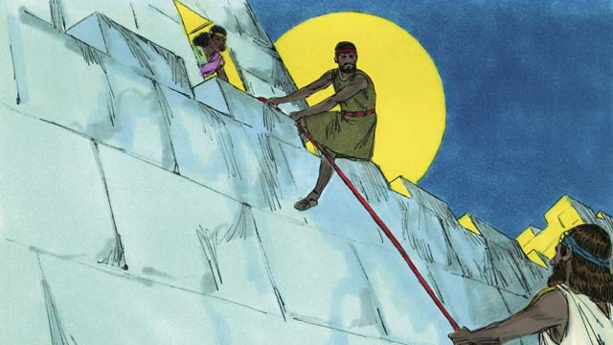

At last it was time for the Israelites to enter Canaan, the Promised Land. In that land was a city called Jericho. It had strong walls around it to protect it. Joshua sent two spies to that city. In that city lived a prostitute named Rahab. She hid these spies, and later she helped them to escape from the city. She did this because she believed God. The spies promised to protect Rahab and her family when the Israelites would destroy Jericho.

15-02

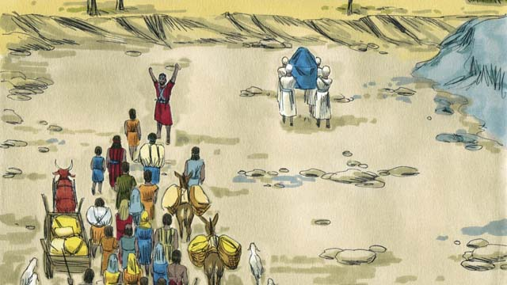

The Israelites had to cross the Jordan River to enter into the Promised Land. God told Joshua, “Have the priests go first.” When the priests started to step into the Jordan River, the water upstream stopped flowing so the Israelites could cross over to the other side of the river on dry ground.

15-03

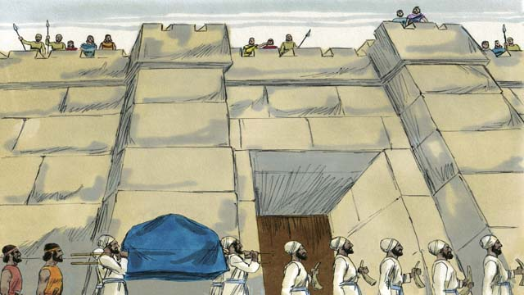

After the people crossed the Jordan River, God told Joshua to get ready to attack the city of Jericho, even though it was very strong. God told the people that their priests and soldiers must march around the city once a day for six days. So the priests and the soldiers did this.

15-04

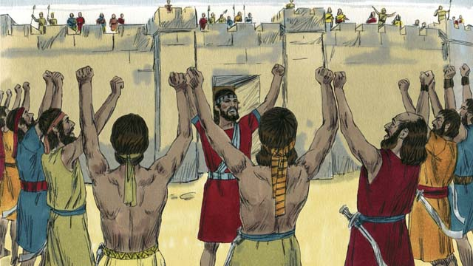

God also said that on the seventh day the Israelites must march around the city seven times. Then the priests must blow their trumpets and all the people must shout loudly. So they did this.

15-05

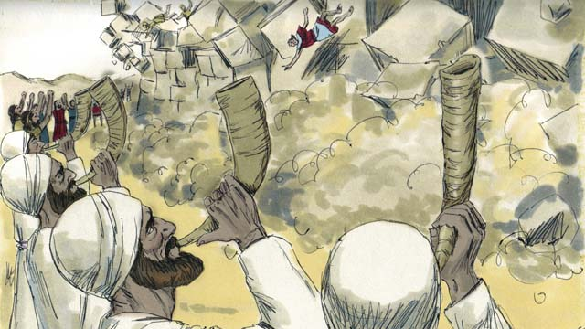

Then the walls around Jericho fell down! The Israelites destroyed everything in the city, as God had commanded. They only spared Rahab and her family, who became part of the Israelites. When the other people living in Canaan heard that the Israelites had destroyed Jericho, they were terrified that the Israelites would attack them also.

15-06

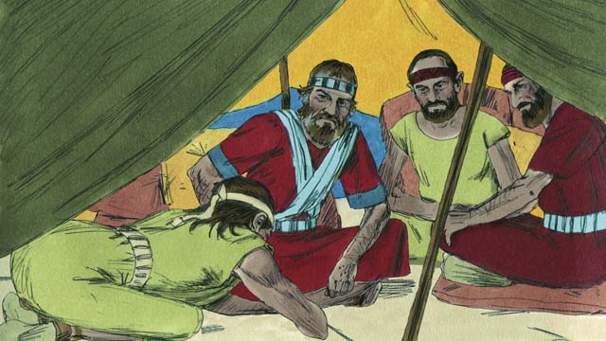

God had commanded the Israelites not to make a peace treaty with any of the people groups in Canaan. But one of the Canaanite people groups, called the Gibeonites, lied to Joshua and said they were from a place far from Canaan. They asked Joshua to make a peace treaty with them. Joshua and the other leaders of the Israelites did not ask God what they should do. Instead, they made a peace treaty with the Gibeonites.

15-07

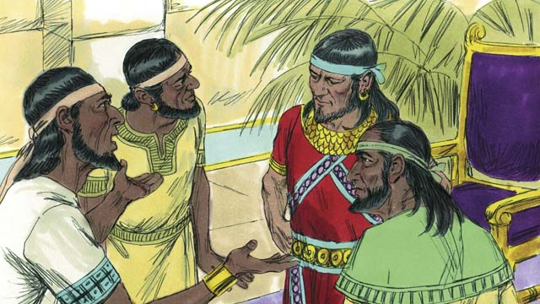

Three days later, the Israelites found out that the Gibeonites really did live in Canaan. They were angry because the Gibeonites had deceived them. But they kept the peace treaty they had made with them because it was a promise before God. Then, some time later, the kings of another people group in Canaan, the Amorites, heard that the Gibeonites had made a peace treaty with the Israelites, so they combined their armies into one large army and attacked Gibeon. The Gibeonites sent a message to Joshua asking for help.

15-08

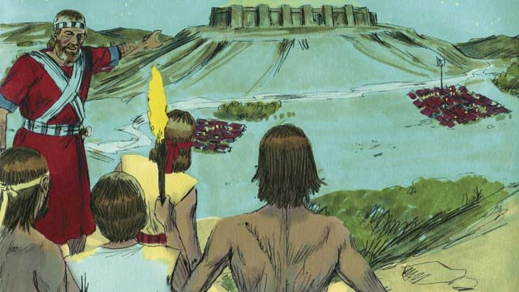

So Joshua gathered the Israelite army. They marched all night to reach the Gibeonites. In the early morning, they surprised the Amorite armies and attacked them.

15-09

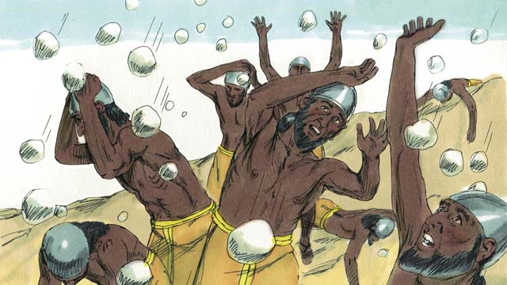

God fought for Israel that day. He caused the Amorites to be confused and he sent large hailstones that killed many of the Amorites.

15-10

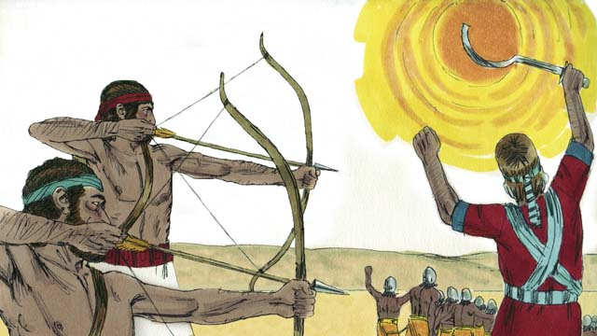

God also caused the sun to stay in one place in the sky so that Israel would have enough time to completely defeat the Amorites. On that day, God won a great victory for Israel.

15-11

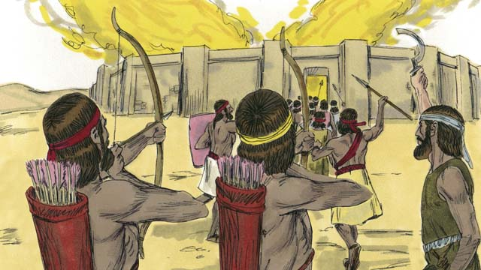

After God defeated those armies, many of the other Canaanite people groups gathered together to attack Israel. Joshua and the Israelites attacked and destroyed them.

15-12

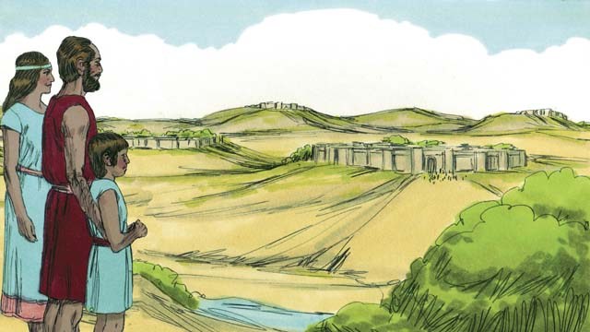

After these battles, God gave each tribe of Israel its own section of the Promised Land. Then God gave Israel peace along all its borders.

15-13

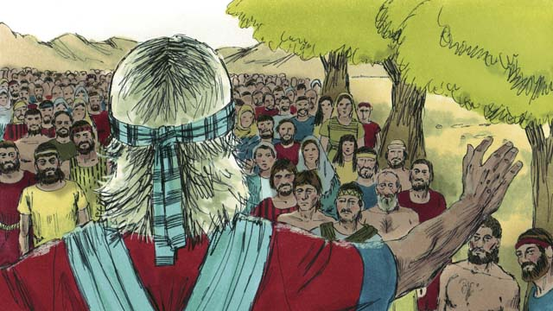

When Joshua was an old man, he called all the people of Israel together. Then Joshua reminded the people that they had promised to obey the covenant that God had made with the Israelites at Mount Sinai. The people promised to be faithful to God and obey his laws.

*A Bible story from: Joshua 1-24*

## 1 Community Study: Spiritual Battle—Taking Every Thought Captive

* **Key Idea**: engaging the spiritual battle in the mind
* **Key Passage**: 2 Corinthians 10:3-5
* **Main Session**: OBS 15 (The Promised Land)

### 1.1 Recite the Creedal Verse (3–5 minutes)

The verse below summarizes the teaching of the current passage. Read the verse out loud as a community. Read it again several times as a group until the whole community can recite it from memory.

44 Then Yahweh gave them rest on every side, just as he had sworn to their ancestors. Not one of their enemies could defeat them. Yahweh gave all their enemies into their hand. 45 Not one thing among all the good promises that Yahweh had spoken to the house of Israel failed to come true. All of them came to be. Joshua 21:44

OR

3 Call to mind the word that Moses the servant of Yahweh, commanded you when he said, ‘Yahweh your God is giving you rest, and he is giving you this land.’ Joshua 1:13

### 1.2 Think Together (5 minutes)

God promised to give the Israelites a land where they would live in rest and peace. God caused the Israelites to defeat their enemies so they could live in this land of rest. Think about what a life of peace and rest would look like.

Rest and peace that comes from God would mean…

### 1.3 Read the Passage (5 minutes)

One way that God wants to give us rest and peace is by causing us to have good and true thoughts. Our thoughts and beliefs affect the way we live our lives. Read the passage below to understand the battle that takes place in our minds.

3 For even though we walk in the flesh, we do not wage war according to the flesh. 4 For the weapons we fight with are not fleshly. Instead, they have divine power to destroy strongholds. They bring to nothing misleading arguments. 5 We also destroy every high thing that rises up against the knowledge of God. We take every thought captive into obedience to Christ. 2 Corinthians 10:3-5

### 1.4 Discuss the Idea (10–15 minutes)

The thoughts in our mind can be like a spiritual battle. God wants us to believe true and good things. Satan wants us to believe lies. We experience transformation in our lives as we start thinking the way that God wants us to think. After reading the passage above, use the following questions to help your community discuss biblical teaching on personal life transformation.

1. How does this passage describe the spiritual battle that Christians face?
2. What does God tell us to do to gain victory in this battle?
3. How have you seen your thoughts (either true thoughts or bad thoughts) affect the way you live your life?
4. Why is it important for your community to understand the spiritual battle that takes place in the mind?

### 1.5 Compare Thoughts (10 minutes)

Think about how our thoughts affect the way we live our lives. Make a list of false ways of thinking that lead to bad ways of living. Then, identify the true way of thinking that would help you start to live in a way that pleases God.

False Thought

False Behavior

True Thought

### 1.6 Pray to God (5 minutes)

Pray for each member of your community that God would help them gain victory in the world of their thoughts. Divide into groups of 2–3 and use the specific language of the above passage to pray over each member.

God, help [name of person] to “not wage war according to the flesh” God, help [name of person] to know “the weapons we fight with are not fleshly” God, help [name of person] to know “they have divine power to destroy strongholds” God, help [name of person] to “bring to nothing misleading arguments” God, help [name of person] to “destroy every high thing that rises up against the knowledge of God” God, help [name of person] to “take every thought captive into obedience to Christ”

### 1.7 Sing a Song (3–5 minutes)

Choose a song that celebrates God’s victory over the enemy. Sing this song as praise to God and encouragement of one another.

## 2 Biblical Interpretation: Observing the Details of the Story

After reading the crafted biblical story, answer the following questions to familiarize yourself with the details of the story.

### 2.1 Observation Questions

Answer the following observation questions to gain a basic understanding of the story. Read the story as a community and answer these questions as a group.

#### 15-01

When it was time to enter the Promised Land, what did Joshua do first?  
He sent two spies to Jericho.

Who helped the two Israelite spies?  
A prostitute named Rahab hid the two Israelite spies and helped them escape. She did this because she believed in God.

What did the spies promise to do for Rahab the prostitute?  
They promised to protect Rahab and her family when the Israelites destroyed the city.

#### 15-02

What river did the Israelites have to cross to enter into the Promised Land?  
The Israelites had to cross the Jordan River.

How were the Israelites able to cross the Jordan River?  
The priests would go into the Jordan River first. When the priests started to step into the Jordan River, the water stopped flowing.

On what kind of ground did the Israelites walk when they crossed the Jordan River?  
The Israelites crossed the Jordan River on dry ground.

#### 15-03

What city did God tell the Israelites to attack?  
God told the Israelites to attack the city of Jericho.

How did the Israelites attack Jericho?  
They marched around the city once a day for six days.

#### 15-04

What did the Israelites do to Jericho on the seventh day?  
On the seventh day, they marched around the city seven more times. After they marched around the city for the last time, the priests blew their trumpets and the soldiers shouted.

#### 15-05

What happened when the soldiers shouted and the priests blew trumpets?  
The walls of Jericho fell down so the Israelites could destroy everything in the city.

What happened to Rahab and her family?  
They were not killed, and they became part of the Israelites.

What did the other people living in Canaan think when they heard about Jericho?  
The other people living in the land were terrified that the Israelites would also attack them.

#### 15-06

What did God forbid Israel to do with the peoples living in the land?  
God commanded the Israelites not to make a peace treaty with any of the peoples living in the land of Canaan.

How did the Gibeonites trick the Israelites into making a peace treaty with them?  
The Gibeonites lied to the Israelites. They said they were from a place far from Canaan.

Why did Joshua and the Israelites not know the Gibeonites were lying?  
They did not ask God.

#### 15-07

Why did the Israelites keep the peace treaty and defend the Gibeonites?  
They did not kill them because the Israelites had made a promise before God.

What did the Amorites do when they heard about Israel’s peace treaty with the Gibeonites?  
The Amorites combined their armies into one big army and attacked the Gibeonites.

What did the Gibeonites do when the Amorites attacked them?  
The Gibeonites sent a message to Joshua asking for help.

#### 15-08

What did Joshua do when he heard about the Amorites attacking the Gibeonites?  
Joshua gathered the Israelite army, march to the Gibeonites, and attacked the Amorites.

#### 15-09

How else did God fight for the Israelites against the Amorites?  
He confused the Amorites and sent large hailstones on them.

#### 15-10

How else did God fight for the Israelites against the Amorites?  
He caused the sun to stay in one place so the Israelites had enough time to completely defeat them.

Who won the battle?  
God won a great victory for the Israelites.

#### 15-11

What did Joshua and the Israelites do to the other Canaanite people groups who attacked them?  
Joshua and the Israelites destroyed them.

#### 15-12

What did each tribe of Israel receive?  
God gave each of the 12 tribes of Israel its own section of the Promised Land.

What did God give to Israel on its borders?  
God gave Israel peace along all of its borders.

#### 15-13

Why did Joshua call the Israelites together when he was old?  
He called them together to remind them of their obligation to obey the covenant that God had made with them.

How did the Israelites answer Joshua?  
They promised to remain faithful to God and to follow his laws.

### 2.2 Translation Questions

Use the following translation questions to understand specific details of the passage. Discuss how you might translate these specific elements of the story.

#### 15-01

**At last it was time for** After the Israelites had wandered in the desert for 40 years, God finally permitted to enter the land of Canaan. How would you express **At last it was time for** to mean the time finally came after a long wait?

  

**It had strong walls around it to protect it** The city was completely surrounded by thick, strong walls made of stone to protect the city from enemies. How would you express **It had strong walls around it to protect it** to mean the city of Jericho was surrounded by thick, strong walls that would keep the inhabitants of the city safe from enemies?

  

**two spies to that city** Joshua sent two men to that city to secretly find out information about it. How would you express **two spies to that city** to mean two men who were sent to Jericho to secretly find out information about it?

  

**she helped them to escape** Rahab helped the two spies get out of the city and get away from the danger of the people in Jericho who wanted to harm them. How would you express **she helped them to escape** to mean Rahab assisted the two spies to get out of the city and away from the danger of the people in Jericho who wanted to harm them?

  

#### 15-02

**Have the priests go first** God told Joshua to let the priests go before the rest of the people to cross the river. How would you express **Have the priests go first** as a command that instructs Joshua to make sure the priests went into the water of the Jordan River before the rest of the people?

  

**When the priests started to step into the Jordan River** The water of the Jordan River stopped flowing at just the time when the priests began to step into the river. How would you express **When the priests started to step into the** Jordan River to mean the water of the river stopped at the same time when the priests first stepped into the water?

  

**the water upstream stopped flowing** The water in front of them flowed away downstream. The water stopped flowing from the place/direction in which the river normally flowed. How would you express **the water upstream stopped flowing** to mean the water stopped flowing from the place/direction in which the river normally flowed?

  

**cross over** The Israelites to passed from one side of the Jordan River to another. How would you express **cross over** to mean to pass from one side of something to another?

  

#### 15-03

**After the people crossed the Jordan River** The word After tells an action that happened before another action. The Israelites obeyed God by passing from one side of the Jordan to the other. Once that was completed, God gave another task for them to do. He told Joshua to get ready to attack the city of Jericho. How would you express **After the people crossed the Jordan River** to mean the people crossed the Jordan River and then God told Joshua to get read to attack the city of Jericho?

  

**to get ready to attack the city of Jericho** God told Joshua to prepare to fight against the inhabitants of Jericho. How would you express **to get ready to attack the city of Jericho** to mean God instructed Joshua to prepare to lead an offensive military assault on the inhabitants of Jericho?

  

**even though it was very strong** The city of Jericho was indeed very strong, so attacking of the city would seem to be an unwise choice. It was surprising that God told Joshua to get ready to attack Jericho when the city was strong and well-protected. How would you express **even though it was very strong** to mean it was surprising/unexpected that God would tell Joshua to attack Jericho when the city was strong and well-protected?

  

#### 15-04

**blow their trumpets** God instructed the Israelites to sound their trumpets. These trumpets were made out of ram’s horns. How would you express **blow their trumpets** to mean God commanded the Israelites to sound their trumpets by playing them?

  

#### 15-05

**Then the walls around Jericho fell down** God caused the walls to fall. The walls were thick enough to drive chariots upon. People lived inside them. These were not flimsy walls. In order for them to fall, an act of God would have to happen. God caused the walls of Jericho to fall down. How would you express **Then the walls around Jericho fell down** to mean the walls around the city of Jericho collapsed?

  

**They only spared Rahab and her family** The Israelites destroyed everything in the city of Jericho except Rahab and her family. The Israelites refrained from killing Rahab and her family and left the alive. How would you express **They only spared Rahab and her family** to mean Rahab and her family were the only ones the Israelites refrained from killing and kept alive?

  

**became part of the Israelites** Rahab and her family joined the Israelite community. How would you express **became part of the Israelites** to mean Rahab and her family became members of the nation of Israel?

  

#### 15-06

**peace treaty** A **peace treaty** is an agreement between two groups of people that they will not harm each other but will live in peace and help each other. How would you translate **peace treaty** to mean an agreement between two groups of people that they will not harm each other but will live in peace and help each other?

  

**called the Gibeonites** One of the people groups that lived in Canaan were named the Gibeonites. How would you express **called the Gibeonites** to mean one of the people groups that lived in Canaan were named the Gibeonites?

  

**lied to Joshua and said** The Gibeonites **lied to** Joshua by saying they were from a land far from Canaan. How would you express **lied to Joshua and said** to mean the Gibeonites falsely told Joshua that they were from a land far from Canaan?

  

**Instead, they made a peace treaty** The word instead contrasts what the Israelites should have done with what they actually did do. Rather than asking God what they should do, the Israelites made a peace treaty with the Gibeonites? How would you express **Instead, they made a peace treaty** to mean rather than asking God what they should do, the Israelites made a peace treaty with the Gibeonites?

  

#### 15-07

**found out** After three days, the Israelites discovered that the Gibeonites actually lived in Canaan. How would you express **found out** to mean the Israelites came to learn what they previously did not know and discovered that the Gibeonites actually lived in Canaan?

  

**because it was a promise before God** The reason Israelites did not break the peace treaty they made with the Gibeonites was they made this commitment in the presence of God when they made the peace treaty with the Gibeonites. How would you express **because it was a promise before God** to mean the reason the Israelites continued to observe the peace treaty they made with the Gibeonites was that they made this treaty as a commitment in God’s presence?

  

**so they combined their armies** The word so explains that the result of the Amorites hearing of the treaty between Israelites and the Gibeonites was to join all their armies into one large army and attack the people of Gibeon. How would you express **so they combined their armies** to mean the result of the Amorites hearing of the treaty between Israelites and the Gibeonites was to join all their armies into one large army and attack the people of Gibeon?

  

**sent a message to Joshua asking for help** The Gibeonites sent some of their people to tell Joshua that they needed the Israelites to help defend them against their enemies. How would you express **sent a message to Joshua asking for help** to mean the Gibeonites sent some of their people to tell Joshua that they needed the Israelites to help defend them against their enemies?

  

#### 15-08

**marched all night** The Israelites traveled in an organized way as an army. It took them the whole night to reach the Gibeonites. How would you express **marched all night** to mean the Israelite army traveled the whole night to arrive where the Gibeonites lived?

  

**to reach the Gibeonites** The Israelites marched to get to the Gibeonites and arrived at where the Gibeonites lived. The Gibeonites lived in Canaan, but Canaan is big enough that it took all night for the Israelite army to travel from their camp to where the Gibeonites were. How would you express **to reach the Gibeonites** to mean the Israelites traveled from their camp to arrive at the place where the Gibeonites lived?

  

**they surprised the Amorite armies** The Amorites did not know that the Israelites were coming to attack them. How would you express **they surprised the Amorite armies** to mean the Israelites attacked the Amorites suddenly and unexpectedly?

  

#### 15-09

**God fought for Israel** God was on the side of Israelites and attacked Israel’s enemies. How would you express **God fought for Israel** to mean God was on the side of Israelites and attacked Israel’s enemies?

  

**caused the Amorites** to be confused God made the Amorites panic so that the Amorites were unable to fight together well. How would you express **caused the Amorites to be confused** to mean God made the Amorites panic so that the Amorites were unable to fight together well?

  

**large hailstones** Very large balls of ice to come down from the sky. How would you express **large hailstones** to mean very large balls of ice to come down from the sky?

  

#### 15-10

**God also caused the sun to stay in one place in the sky** As the day passes, the sun appears to move through the sky. This shows the progress of time as the day passes. God made the daylight continue longer that it normally would have. How would you express **God also caused the sun to stay in one place in the sky** to mean God made the daylight continue more than it normally would and the sun did not appear to move through the sky as the day passed?

  

**so that Israel would have enough time** The purpose of God causing the sun to stay in one place was to allow the Israelites to have sufficient time in daylight to beat the Amorites in battle. How would you express **so that Israel would have enough time** to mean the purpose of God causing the sun to stay in one place was to allow the Israelites to have sufficient time in daylight to beat the Amorites in battle?

  

#### 15-11

**After God defeated those armies** The word **After** tells what happened subsequent to God defeating the Amorite armies. God defeated one large Amorite army made up of many smaller armies. Then, another large army, also made up of many smaller armies, came against Israel. How would you express **After God defeated those armies to mean** other Canaanite armies gathered to attack Israel following God’s defeat of the Amorite armies?

  

**attacked and destroyed them** The Israelites fought against other Canaanite armies and defeated them in battle. How would you express **attacked and destroyed them** to mean the Israelites fought against other Canaanite armies and defeated them in battle?

  

#### 15-12

**God gave each tribe of Israel its own section of the Promised Land** God appointed each tribe its own plot of land in the land of Canaan. How would you express **God gave each tribe of Israel its own section of the Promised Land** to mean God decided which part of the Promised Land each tribe of Israel would live on?

  

**gave Israel peace along all its borders** God allowed the Israelites to experience peace with the other people groups that surrounded them. How would you express **gave Israel peace along all its borders** to mean God allowed the Israelites to live near the other countries around Israel without fighting them?

  

#### 15-13

**When Joshua was an old man** The story transitions from Joshua’s leadership of Israel to what is to happen to them next. Joshua was over 100 years old at this time. How would you express **When Joshua was an old man** to mean many years later, when Joshua was many years old?

  

**to be faithful to God** The people promised to be loyal to God. They would worship and serve only God; they would not worship or serve any other gods. How would you express **to be faithful to God** to mean be devoted to God alone and not worship any other gods?

  

**obey his laws** The Israelites promised to follow God’s instructions. How would you express **obey his laws** to mean to do the commands God had already given them as part of the covenant?

  

## 3 Theological Dialogue: Discussing the Meaning of the Story

Take time to explore the meaning of this story together as a community. Use the following discussions as a way to grasp what truth the story teaches.

### 3.1 Discourse Questions

Use the following discourse questions to understand the meaning of the story. Pay attention to how the story itself addresses each question or theme.

##### How did God prepare the Israelites to take possession of the promised land? (15-01, 15-02)

The first city in the land of Canaan which Israel attacked was Jericho. Jericho was protected with strong walls (15-01, 15-03).

Joshua sent two spies into the city of Jericho. (15-01)

  

A prostitute named Rahab lived in Jericho. She had come to believe in God. Because she believed in God Rahab protected the Israelite spies. (15-01)

  

Because Rahab believed in God and protected the spies, the spies promised to protect Rahab and her family when the Israelites destroyed Jericho. (15-01)

  

The Israelites crossed the Jordan River on dry land. The priests stepped into the river first and the water stopped flowing. The Israelites crossed the Jordan River on dry ground. (15-02)

  

##### How God allow Israel to defeat Jericho? (15-03, 15-04, 15-05)

God told the Israelite to march around Jericho once a day for six days in a row. (15-03)

  

God told the Israelites to marched around Jericho seven times on the seventh day. The priests were to blow their trumpets and the people were to shout loudly. (15-04)

  

The Israelites obeyed God and the walls of Jericho fell down. (15-05)

  

After the walls fell down, the Israelites destroyed everything in the city. This is what God commanded them to do. (15-05)

  

The Israelites spared Rahab and her family and she became a part of the Israelites. (15-05)

  

##### How did the Israelites succeed and fail in their mission after Jericho? (15-05, 15-06, 15-07, 15-08, 15-09, 15-10)

When the other people who lived in Canaan heard about how the Israelites destroyed Jericho, they were very afraid of the Israelites. (15-05)

  

God commanded the Israelites destroy the other people living in Canaan. God told the Israelites not to make a a peace treaty with any of the Canaanite peoples. (15-06)

  

The Gibeonites deceived Joshua and said they were from outside of Canaan. They tricked the Israelites into making a peace treaty with them. The Israelites did not ask God what they were supposed to do and made a peace treaty with them. (15-06)

  

The Israelites were angry when they discovered that the Gibeonites lied to them. They Israelites could not break the peace treaty because it was a promise before God. So, when the Gibeonites were attacked by the Amorites, Joshua fought against the Amorites (15-07, 15-08)

God fought for the Israelites. He confused the Amorites. He sent hailstones that killed many Amorites. He caused the sun to stay in one place so the Israelites could completely defeat the Amorites. (15-09, 15-10)

  

##### How was God’s covenant/promises realized in the taking of the land? (15-11, 15-12, 15-13)

The Israelites defeated many other Canaanites (15-11)

God gave each Israelite tribe a portion of the land (15-12)

God gave the Israelites peace on its borders (15-12)

When Joshua was old, he reminded the Israelites of their promise to obey the covenant. The people promised to be faithful to God and obey his laws. (15-13)

  

### 3.2 Theological Questions

Answer the following theology questions as a community. Discuss what truths this story teaches.

1. How does God use his people to accomplish his promised plan? How does God use the Israelites to bring about the fulfillment of his covenant promises?
2. How does God bring victory to his people? What does the defeat of the Canaanites teach us about God and victory over his enemies?
3. What does it mean to be faithful to God? What does it mean to be in covenant relationship with God? How does Israel’s example teach us positive and negative examples of being faithful to God?

### 3.3 Translation Draft

Work as a translation team to draft each panel of this story. Pay attention to any specific translation issues that are challenging or significant.

#### Make Translation Draft

Make a draft for each section of this story.

#### Discuss and Revise

After drafting the story, discuss any translation issues that you think need special explanation.

#### Drafting Summary Reflection

Summarize any noteworthy translation decisions and the rationale/reasoning behind these translation decisions. In the final movement of this class, you will use these observations to give an account (i.e., chronicle/narrate) of how your translation improved through the checking process.

## 4 Personal Reflection: Following the Teaching of the Story

Take a moment to allow this story to evaluate your own life and to consider how God would have you respond. After this reflection, use the quality checking questions to check your translation draft among the translation team.

### 4.1 Journal Reflection

Prayerfully think about the following personal reflection questions. Write/Record your answers and/or discuss them as a group.

1. How has God prepared you to serve him?
2. How have you seen God bring about victory in your own life?
3. How has God fulfilled his promises to you?
4. How would you evaluate your faithfulness to God and his covenant?

### 4.2 Team Check

*The following activity will help you check the clarity, accuracy, and naturalness of your draft. Read the passage aloud and discuss the checking questions with other members of your translation community. You might need to reread portions (or the whole) of the biblical passage multiple times as you answer each of these questions. Record answers to these questions below.*

#### Team Checking Questions

*Use the following questions to check your translation draft for accuracy, clarity, and naturalness.*

1. **Accurate**: Has anything been **added** to your translation of this passage that is not a part of the meaning of the source text? *If additions exist, are they included only added to clarify meaning (such as implied information)?*
2. **Accurate**: Is anything **missing** from your translation of this passage that is a part of the meaning of the source text? *If some part of the meaning is missing from your translation, add it.*
3. **Accurate**: Does any meaning in your translation of this passage appear to be **different** than the meaning of the source text? *If the meaning is different, try changing your translation so that the meaning remains the same.*
4. **Natural**: Does anything sound **unnatural** to how you would say it in your language? *If portions of the passage sound unnatural in your language, try to make them sound the way you would say it in your language while staying true to the meaning of the source text.*
5. **Clear**: Is anything **unclear** or **confusing** in your translation that confuses the meaning of the source text? *If portions of the passage are unclear or confusing, revise them to clearly communicate the meaning of the source text.*
6. **Consistent**: How **consistent** is your translation within the passage and with other passages? *If portions of the passage need to be made consistent or if you need to revise translations of other passages, make these adjustments.*

#### Record Feedback

*After discussing the checking questions above as a translation community, record any feedback on your translation draft. Pay attention for parts of your translation that are translated well and parts of your translation that need correction.*

#### Discuss and Revise

*After gathering feedback on your draft, discuss it together with your translation community and make appropriate revisions in your translation.*

#### Record Translation Decisions

*As a community, discuss some of the most noteworthy translation decisions in your draft. Summarize each decision and explain the reasons your community decided on that translation. You should update these decisions each time you check your draft with various groups of people.*

You should **measure** the quality of your translation draft. You can **record translation decisions** to make it clear why you translated things a certain way. Translation decisions can help your translation team and the surrounding community be a part of the translation process.

How can you know the quality of your translation?

1. **Measure** the translation by marks/standards of quality (i.e., clear, accurate, natural, church-approved)
2. **Test** the translation with others and record feedback and conversations from in the field (i.e., church and community check)
3. **Compare** and **contrast** the translation with the source text (i.e., meaning of text and notes) and alternatives (i.e., other translation choices)
4. **Explain** the reasons why you translated a particular portion of the text.

**Example Sentences That Help Explain Your Translation Decision** Use the following example sentences to help explain your translation decisions:

1. The original text literally **says/means**, so we translated the term in this way…
2. We originally decided to translate **the biblical term** with **this term**, but we changed it because…
3. When our translation team discussed **the biblical term**, this is what we talked about…
4. **The term** is [clear, accurate, natural, consistent] because…
5. The community understands **this term** to mean…
6. We considered these other terms. We did not use **these terms** because…
7. When we checked this in the church, we learned…
8. When we checked this in the community, we learned…

**Example of Translation Decision**

In OBS 01-07 we decided to translate **blessed** like this: [actual translation]. We decided on this translation because of these reasons:

1. The word [actual translation] means to cause good things to happen to someone or something. This term is used when a person desires someone or something to prosper or flourish. This term does not refer to magic or witchcraft.
2. When we checked this word with other believers, they said it describes God showing his kindness and favor on someone or something. These are some of the terms that we did not decide to use…
3. Many of our people will understand this word. When we discussed this phrase with the surrounding community, we discovered it was a natural way to describe God causing good and beneficial things to happen.

## 5 Ministry Practice: Serving the Church with the Story

Now that you have a draft of this story, consider how this story can encourage other believers in their faith. After ministering this story to others, you will also perform a community check of your translation draft.

### 5.1 Church Ministry

Reflect on how this story can edify and mature the Christian community. Design a way to minister this story to your church community.

**Ministry Preparation**: Take time to consider how you could minister this story to others. Record some ministry ideas below.

**Ministry Implementation**: Minister this story to a group of believers as you had planned. Use the information in this study to help develop a teaching/lesson or lead a discussion of this story to other believers. Record your ministry plan below.

**Ministry Reflection**: Think about what you learned from ministering this story to other believers. Reflect on your experience below.

### 5.2 Church Community Check

After teaching or ministering this story to the church, check the translation quality with the church community. Record any feedback from your checking experience.

#### Create Checking Questions

You can use **Translation Questions** to check your draft. Each **Translation Question** explains the meaning of a specific part of the story and asks you to consider how you would translate that part of the story in your own language. Change each **Translation Question** into a **Checking Question** by asking the following questions. The first question asks you to identify how each specific phrase was translated into your language. The second question asks people in the church to determine if your translation of the phrase expresses the meaning clearly, accurately, and naturally. Look at the following examples to see how to change **Translation Questions** into **Checking Questions**:

#### Translation Question Example 1

**to proclaim the good news about Jesus** Paul and Silas traveled to Philippi for the purpose of preaching the gospel. The gospel is the good news that Jesus saves people from their sins if they will believe in Jesus. How would you express **to proclaim the good news about Jesus** to mean to tell other people the message about how Jesus can save people from their sins?

#### Translation Question Example 2

**a merchant** Paul and Silas met a woman named Lydia at the place by the river. She owned a business and sold items to make money. How would you express **a merchant** to mean a business owner who sells items for a profit?

#### Translation Question Example 3

**so Paul and Silas baptized them** The jailer and his whole family followed Paul’s instructions. They believed in Jesus. The result of this was Paul and Silas baptized them. How would you express **so Paul and Silas baptized them** to mean the result of the jailer and his family believing in Jesus that Paul and Silas baptized all of them?

You can change these into **Checking Questions** like this:

#### Checking Question Example 1

**to proclaim the good news about Jesus** How did you translate **to proclaim the good news about Jesus**? Does it mean to tell other people the message about how Jesus can save people from their sins?

#### Checking Question Example 2

**a merchant** How did you translate **a merchant**? Does it mean a business owner who sells items for a profit?

#### Checking Question Example 3

**so Paul and Silas baptized them** How did you translate **so Paul and Silas baptized them**? Does it mean the result of the jailer and his family believing in Jesus that Paul and Silas baptized all of them?

#### Record Feedback

*Discuss the* ***Checking Questions*** *with your church community, and record any feedback on your translation draft. Pay attention to parts of your translation that are translated well and parts of your translation that need correction.*

#### Discuss and Revise

*After gathering feedback on your draft, discuss it together with your translation community and make appropriate revisions to your translation.*

#### Record Translation Decisions

*Update your translation decisions and record any new and noteworthy observations on the quality of your draft.

## 6 Missional Outreach: Sharing the Truth of the Story

*After sharing this story with others, check the translation quality with the wider language community. Record any feedback from your checking experience.*

### 6.1 Mission Engagement

*Consider how you will witness this story to unbelievers. Design a way to share this story and engage them in what it teaches about Christianity and the gospel.*

**Witness Preparation**: Take time to consider how you will witness this narrative to unbelievers. Record some ideas below.

**Witness Implementation**: Share this story with an unbeliever. Use the information in this study to help develop a teaching/lesson or lead a discussion of this story to other believers. Record your ministry plan below.

**Witness Reflection**: Think about what you learned from ministering this story to unbelievers. Reflect on your experience below.

### 6.2 Sociolinguistic Check

After sharing this story with the language community, check your translation draft with the surrounding community. Record your observations.

#### Checking Approach

After witnessing this story to unbelievers, use one of the following methods to check the translation of this story. Consider using the **Observation Questions** to check your translation draft or come up with your own quality checking questions.

**Read-Retell Check:** Read your draft to those the community and ask them to retell the passage. Be attentive to any portions of the passage that are unclear, unnatural, or inaccurate.

**Comprehension Questions Checklist:** Read the draft of the passage and ask a list of comprehension questions to make sure the passage is being rightly understood. You can use the **Observation Questions** in this guide or come up with your own questions. Then, record any insights or issues that arise.

**Discussion Group:** Develop key questions to ask about the passage (both formational and translational). Read the passage and have a group discussion about the passage, paying attention to issues that need to be addressed, edited, and revised.

#### Record Feedback

*After sharing your draft with the language community, discuss the* ***Observations Questions****, and record any feedback on your translation draft. Pay attention to parts of your translation that are translated well and parts of your translation that need correction.*

#### Discuss and Revise

*After gathering feedback on your draft, discuss it together with your translation community and make appropriate revisions to your translation.*

#### Record Translation Decisions

*Update your translation decisions and record and new any noteworthy observations on the quality of your draft.

## 7 Conclusion

As a translation community, take time to reflect on all that was learned in studying, drafting, and checking this story. Celebrate all that God has taught you as a community. Then, submit your revised draft and checking summaries to network leaders for further review.