Open Bible Stories

The Deliverers

## 0 Introduction

### 0.1 Key Idea

The story of the deliverers teaches us about the seriousness of sin and God’s grace to rescue his people when they call out to him in faith.

### 0.2 Creedal Verse

And after destroying seven nations in the land of Canaan, he gave them their land as an inheritance. All this took about 450 years. And after that he gave them judges until Samuel the prophet. Acts 13:19-20

### 0.3 Metanarrative Summary

The eternal God created all things in six days. He made a good and perfect world. He made humans in his image to fill the earth and rule over creation. But humans rebelled against God and ruined God’s creation. God set to restore his world through his promise. God made a covenant with Abraham. He promised to bless all nations through Abraham. God kept his promises across the generations. God provided Abraham with a promised child, Isaac. God gave Isaac a wife and she bore twins, Jacob and Esau. God blessed Jacob and his sons, and the blessing continued to the next generation. God rescued Joseph, one of Jacob’s sons, and used him to rescue his family. God caused his people, the Israelites, to multiply in the land of Egypt; eventually, they became slaves. But, God raised up a deliverer, Moses, to deliver his people from their slavery. God sent judged the Egyptians with harsh plagues; in the final judgment, he passed over his people who covered their doorposts with the blood of a sacrificed lamb. Then, God delivered the Israelites by bringing them out of Egypt and crossing the Red Sea on dry land. God made a covenant with the Israelites and made them his people. God tested Israel in a series of wilderness wanderings and eventually brought his people into the promised land of Canaan. God raised up deliverers to lead Israel and rescue them from their enemies.

### 0.4 Open Bible Story: The Deliverers

16-01

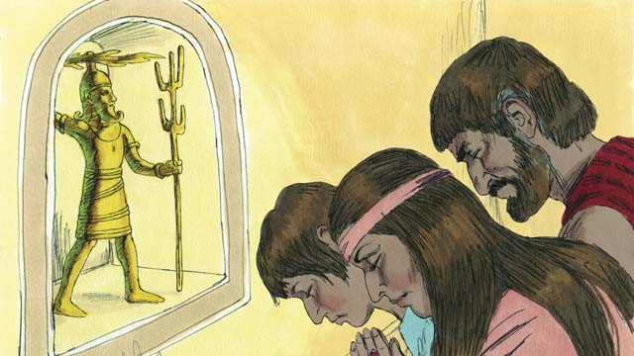

After Joshua died, the Israelites disobeyed God. They did not obey God’s laws, and they did not drive out the rest of the Canaanites from the Promised Land. The Israelites began to worship the Canaanite gods instead of Yahweh, the true God. The Israelites had no king, so everyone did what they thought was right for themselves.

16-02

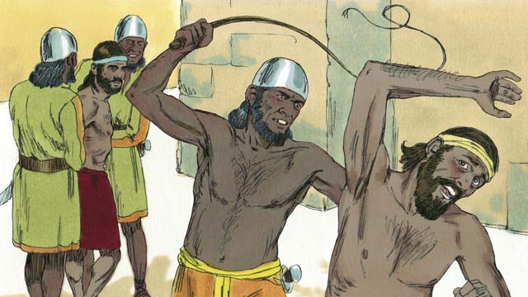

By disobeying God, the Israelites started a pattern that repeated many times. The pattern went like this: the Israelites would disobey God for several years, then he would punish them by allowing their enemies to defeat them. These enemies would steal things from the Israelites, destroy their property, and kill many of them. Then after Israel’s enemies oppressed them for many years, the Israelites would repent of their sin and ask God to rescue them.

16-03

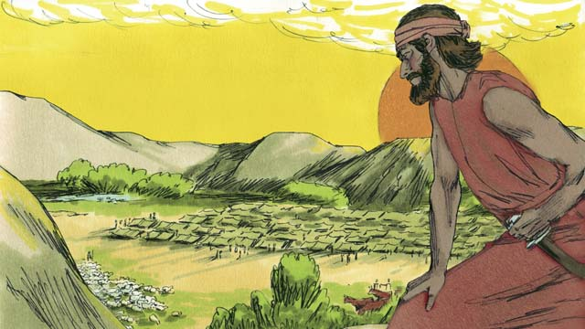

Each time the Israelites repented, God would rescue them. He did this by providing a deliverer—a person who would fight against their enemies and defeat them. Then there would be peace in the land and the deliverer would rule over them well. God sent many deliverers to rescue the people. God did this again after he allowed the Midianites, a nearby enemy people group, to defeat the Israelites.

16-04

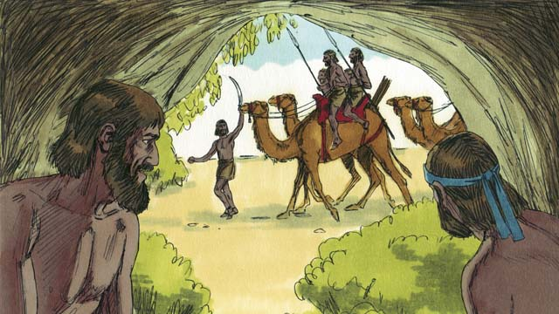

The Midianites took all of the Israelites’ crops for seven years. The Israelites were so scared, they hid in caves so the Midianites would not find them. Finally, they cried out to God to save them.

16-05

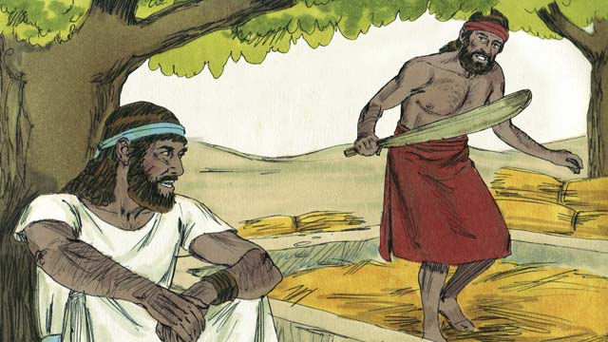

There was an Israelite man name Gideon. One day, he was threshing grain in a hidden place so the Midianites would not steal it. The angel of Yahweh came to Gideon and said, “God is with you, mighty warrior. Go and save Israel from the Midianites.”

16-06

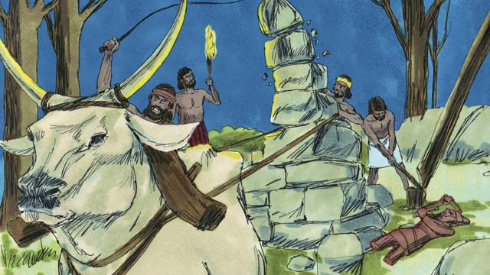

Gideon’s father had an altar dedicated to an idol. The first thing God told Gideon to do was to tear down that altar. But Gideon was afraid of the people, so he waited until nighttime. Then he tore down the altar and smashed it to pieces. He built a new altar to God nearby and made a sacrifice to God on it.

16-07

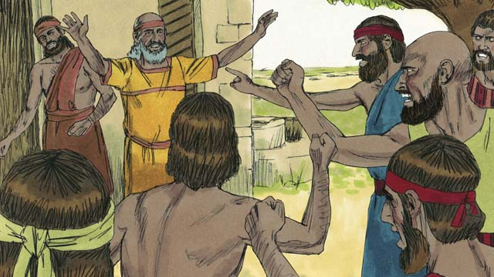

The next morning the people saw that someone had torn down and destroyed the altar, and they were very angry. They went to Gideon’s house to kill him, but Gideon’s father said, “Why are you trying to help your god? If he is a god, let him protect himself!” Because he said this, the people did not kill Gideon.

16-08

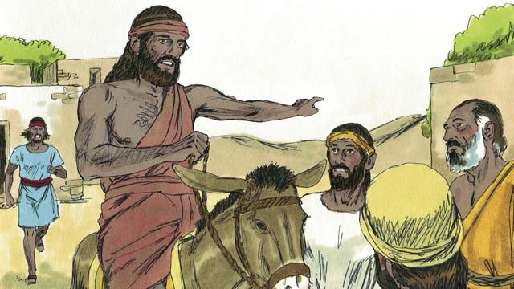

Then the Midianites came again to steal from the Israelites. There were so many of them that they could not be counted. Gideon called the Israelites together to fight them. Gideon asked God for two signs so he could be sure that God was really telling him to save Israel.

16-09

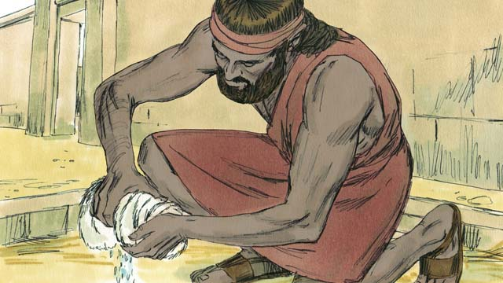

For the first sign, Gideon laid a sheep skin on the ground and asked God to let the morning dew fall only on the sheep skin and not on the ground. God did that. The next night, he asked that the ground be wet but the sheep skin dry. God did that, too. Because of these two signs, Gideon believed that God really wanted him to save Israel from the Midianites.

16-10

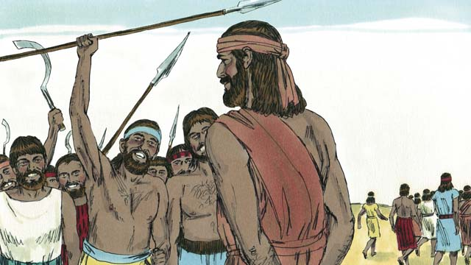

Then Gideon called for soldiers to come to him, and 32,000 men came. But God told him this was too many. So Gideon sent home 22,000 men, all who were afraid to fight. God told Gideon that he still had too many men. So Gideon sent all of them home except for 300 soldiers.

16-11

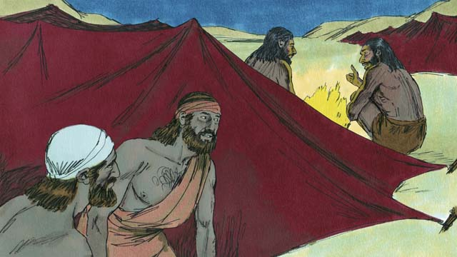

That night God told Gideon, “Go down to the Midianite camp and listen to them talk. When you hear what they say, you will no longer be afraid to attack them.” So that night, Gideon went down to the camp and heard a Midianite soldier telling his friend about something he had dreamed. The man’s friend said, “This dream means that Gideon’s army will defeat us, the Midianite army!” When Gideon heard this, he worshiped God.

16-12

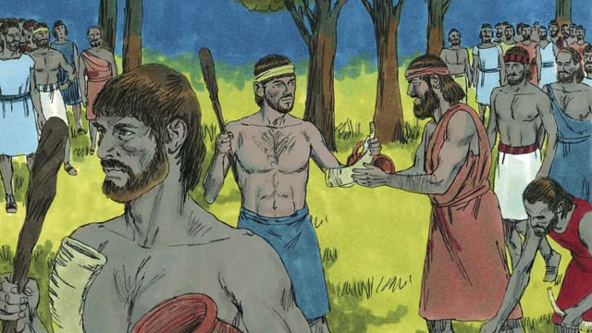

Then Gideon returned to his soldiers and gave each of them a horn, a clay pot, and a burning torch. They surrounded the camp where the Midianite soldiers were sleeping. Gideon’s 300 soldiers had the torches in the pots so the Midianites could not see the light of the torches.

16-13

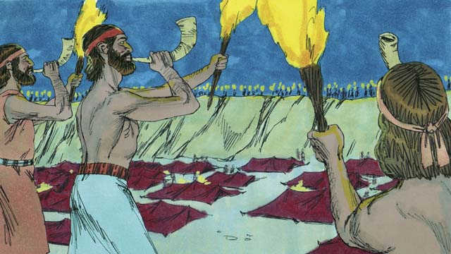

Then, all of Gideon’s soldiers broke their pots at the same moment, suddenly revealing the fire of the torches. They blew their horns and shouted, “A sword for Yahweh and for Gideon!”

16-14

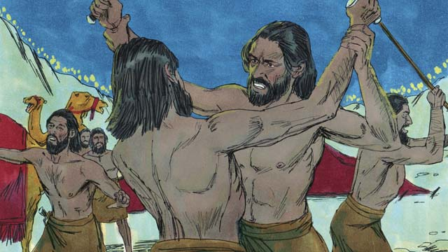

God confused the Midianites so that they started attacking and killing each other. Immediately, Gideon sent messengers to call many other Israelites to come from their homes and help chase the Midianites. They killed many of them and chased the rest of them out of the Israelites’ land. God caused 120,000 Midianites to die that day. This is how God saved Israel.

16-15

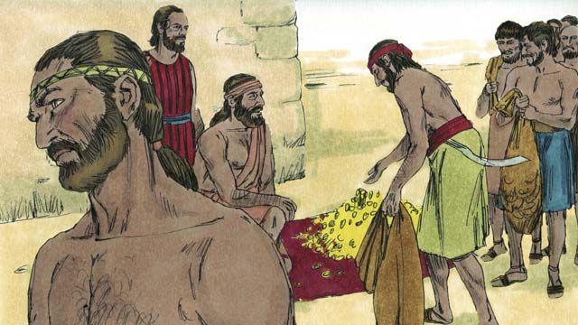

The people wanted to make Gideon their king. Gideon did not allow them to do this, but he asked them for some of the gold rings that each of them had taken from the Midianites. The people gave Gideon a large amount of gold.

16-16

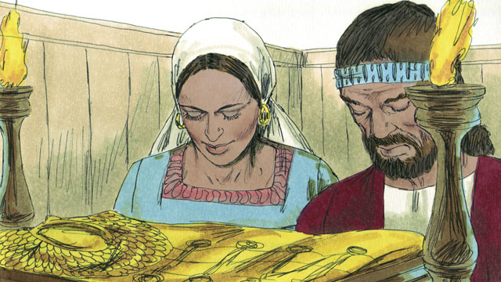

Then Gideon used the gold to make a special garment like the high priest used to wear. But the people started worshiping it as if it were an idol. So God punished Israel again because they worshiped idols. God allowed their enemies to defeat them. They finally asked God for help again, and God sent them another deliverer to rescue them.

16-17

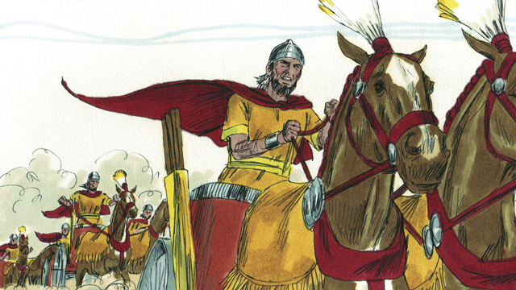

This same thing happened many times: the Israelites would sin, God would punish them, they would repent, and God would send someone to rescue them. Over many years, God sent many deliverers who saved the Israelites from their enemies.

16-18

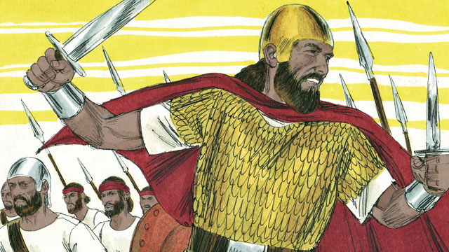

Finally, the people asked God for a king like all the other nations had. They wanted a king who was tall and strong, and who could lead them into battle. God did not like this request, but he gave them a king just as they had asked.

*A Bible story from: Judges 1-3; 6-8; 1 Samuel 1-10*

## 1 Biblical Interpretation: Observing the Details of the Story

After reading the crafted biblical story, answer the following questions to familiarize yourself with the details of the story.

### 1.1 Observation Questions

Answer the following observation questions to gain a basic understanding of the the story. Read the story as a community and answer these questions as a group.

#### 16-01

How did the Israelites disobey God after Joshua died?  
The Israelites did not obey God’s laws, they did not drive out the Canaanites, and they worshiped the Canaanite gods instead of Yahweh, the true God.

Did the Israelites have a king?  
No. At this time, the Israelites had no king.

How did the Israelites behave without a king?  
Because the Israelites had no king, everyone did what was right in their own eyes.

#### 16-02

What was the pattern of the Israelites disobedience?  
The Israelites developed a pattern that repeated many times: the Israelites disobeyed God, God punished the Israelites by allowing their enemies to defeat them, and the Israelites repented and asked God to rescue them.

How did God punish the Israelites for their disobedience?  
God allowed their enemies to defeat them. These enemies would steal things from the Israelites, destroy their property, and kill their people.

How did Israel respond after many years of being oppressed?  
After being oppressed for many years, the Israelites would reprint and ask God to rescue them.

#### 16-03

Ho How did God respond when the Israelites cried out for help?  
Each time the Israelite repented, God would rescue his people by sending them a deliverer.

How did the deliverer rescue Israel?  
The deliverer would fight against Israel’s enemies, defeat them, bring peace in the land, and rule over the Israelites.

How many delivers did God send?  
God send many deliverers.

Who were the Midianites?  
The Midianites were an enemy people who lived near the Israelites. God allowed the Midianites to defeat the Israelites.

#### 16-04

How did the Midianites attack the Israelites?  
The Midianites took all of the Israelites’s crops for seven years.

How did the Israelites respond to the Midianite attacks?  
The Israelites were sacred of the Midianites and hid in caves. Eventually, the Midianites cried out to God to save them.

#### 16-05

What was Gideon doing when the angel of Yahweh came to him?  
Gideon was threshing grain secretly so the Midianites would not steal it.

Who came to Gideon?  
The angel of Yahweh came to Gideon.

What did the angel say to Gideon?  
The angel of Yahweh told Gideon that God is with him. He called him a mighty warrior. He told Gideon to and save Israel from the Midianites.

#### 16-06

What was the first thing God told Gideon to do?  
The first thing God told Gideon to do was to tear down his father’s altar which was dedicated to an idol.

How did Gideon respond to God’s instruction?  
Gideon was afraid of the people and waited until it was night.

What did Gideon do at nighttime?  
At night, Gideon tore down the altar and smashed it in pieces. Then, he built a new altar to God and sacrificed on it.

#### 16-07

How did the people respond in the morning?  
In the morning the people were angry when they saw the altar destroyed. They went to Gideon’s house to kill him.

What did Gideon’s father tell the people?  
Gideon’s father asked the people why they were trying to help their god. He exclaimed that if the idol was a god he should be able to protect himself.

How did the people respond to Gideon’s father?  
The people did not kill Gideon because of what Gideon’s father said.

#### 16-08

How many were the Midianites when they came again to steal from the Israelites?  
The Midianites were so many that they could not be counted.

What did Gideon do when the Midianites came to steal from the Israelites?  
Gideon called the Israelites together to fight against the Midianites.

What did Gideon ask God?  
Gideon asked God for two signs so that he could be certain God was really telling him to save Israel from the Midianites.

#### 16-09

What two signs did God do to prove that he would save Israel through Gideon?  
God made the morning dew fall only on the sheepskin and not the ground, and then the dew fell only on the ground and not the sheepskin.

What did Gideon think of these signs?  
Because of these signs, Gideon believed God really wanted him to save the Israelites from the Midianites.

#### 16-10

How did the size of Gideon’s army change?  
When he called for soldiers, 32,000 men came. Then he sent home 22,000 who were afraid to fight. Then he sent more home until he had 300 hundred men.

Why did Gideon send home all except 300 of the soldiers?  
He sent them home because God told him he had too many men.

#### 16-11

What did God tell Gideon to do at night?  
God told Gideon to go down to the Midianite camp and listen to them talk.

What additional sign did God give Gideon so he would not be afraid?  
Gideon heard a Midianite soldier tell of his dream that Gideon’s army would defeat the Midianite army.

What did Gideon do when he heard the Midianite soldier’s dream?  
He worshiped God.

#### 16-12

What did Gideon do when he returned to his soldiers?  
When he returned to his soldiers, Gideon gave them each a horn, a clay pot, and a burning torch.

After this, what did the soldiers do?  
Gideon’s 300 soldiers surrounded the Midianite camp with their torches in the pots so the Midianites could not see the light of the torches.

#### 16-13

How did Gideon and his men attack the Midianites?  
They surrounded the Midianite camp, broke their pots to reveal their torches, and blew their horns and shouted, “A sword for Yahweh and for Gideon.”

#### 16-14

What did God do to help Gideon defeat the Midianites?  
God confused the Midianites so they attacked and killed each other.

What did Gideon tell the Israelites?  
Gideon told the Israelites to come from their homes and chase the Midianites.

What happened to the Midianites?  
The Israelites killed many Midianites and chased the rest out of the land. God caused 120,000 Midianites to die.

#### 16-15

After defeating the Midianites, what did the people want to do to Gideon?  
The people wanted to make Gideon their king.

How did Gideon respond?  
Gideon did not allow them to make him their king. He asked for some gold rings taken from the Midianites.

How much gold did the people give Gideon?  
The people gave a large amount of gold.

#### 16-16

What did Gideon do with the gold?  
Gideon used the gold to make a special garment like the high priest used to wear.

How did the people treat this special garment made of gold?  
The people later began to worship it as an idol.

What did God do to the Israelites because of their worship of the idol?  
God punished Israel and allowed their enemies to defeat them. Eventually, they asked God for help and he sent another deliverer to rescue them.

#### 16-17

What did the Israelites do many times?  
The Israelites would sin, God would punish them, they would repent, and God would send a deliverer to save them.

#### 16-18

Why did the people ask God for a king?  
All the other nations had kings, and the Israelites wanted someone to lead them into battle.

How did God answer their request?  
God did not like their request, but he gave them a king, just as they had asked.

### 1.2 Translation Questions

Use the following translation questions to understand specific details of the passage. Discuss how you might translate these specific elements of the story.

#### 16-01

**drive out the rest of the Canaanites from the Promised Land** God commanded the Israelites to attack the Canaanites and remove them from the land. How would you express **drive out the rest of the Canaanites from the Promised Land** to mean fight with the rest of the Canaanites to force them to leave the Promised Land?

  

**began to worship the Canaanite gods** Because the Israelites did not drive out the Canaanites from the land, the Israelites started to worship the Canaanite gods. This was not something that Israel had always done. In fact, God commanded the Israelites to only worship him. How would you express **began to worship the** Canaanite gods to mean the Israelites started serving the gods the Canaanites worshipped?

  

**the true God** There is only one God, Yahweh. He is the the only real God. Yahweh is the only one that people should worship. All other gods are false and only pretend to be God. They should not be worshipped. How would you express **the true** God to mean the one and only real God?

  

**everyone did what they thought was right for themselves** This means that the Israelites all did whatever they wanted to do, including many evil things. The people did not have a king to guide them. As a result, the people behaved in any way that they pleased. How would you express **everyone did what they thought was right for themselves** to mean that the Israelites did what they wanted to do?

  

#### 16-02

**started a pattern that repeated many times** A pattern is a something that repeats itself and happens over and over again. Israel started the following pattern: Israel disobeyed God, God punished Israel by allowing their enemies to attack them, and Israel cried out to God for help, and God would rescue Israel. This sequence happened many times. How would you express **started a pattern that repeated many times** to mean Israel’s disobedience, punishment, repentance, and deliverance happened many times in a repeated ands similar fashion?

  

**he would punish them by allowing their enemies to defeat them** God punished the Israelites because of their disobedience. The way he punished them was to permit Israel’s enemies to defeat them. How would you express **he would punish them by allowing their enemies to defeat them** to mean the way God punished the Israelites was permitting Israel’s enemies to attack them and allowing them to win the battle?

  

**ask God to rescue them** The Israelites asked God to deliver them from their enemies. How would you express **ask God to rescue them** to mean Israel prayed that God would help them and to set them free from their enemies?

  

**repent of their sin** The proper response to sin is to admit that sin is wrong and stop doing the sin. What word in your language mean repent as is to feel remorse that sin is evil and to stop doing it?

  

#### 16-03

**by providing a deliverer** The way God rescued his people was to give Israel a leader who would overpower their enemies. How would you express **by providing a deliverer** to mean the way God rescued his people was choosing and appointing someone who would fight against their enemies and defeat them?

  

**there would be peace** The deliverer would defeat Israel’s enemies and allow them to live in the land without being attacked by their enemies. How would you express **there would be peace** to mean the people could live without fear because their enemies stopped attacking them?

  

**rule over them** The deliverer rescued the Israelites from their enemies. They also had responsibility to lead and govern the Israelites. How would you express **rule over them** to mean the deliverers had authority over the Israelites like a leader does over a group of people or a nation?

  

#### 16-04

**crops** The Midianites stole **crops** from the Israelites. Crops are edible plants that grow in gardens or fields. What words in your language mean **crops** as in food and edible plants that grow in fields or gardens?

  

**were so scared** The Israelites were very afraid of the Midianites. How would you express were so sacred to mean the Israelites were very afraid of the Midianites?

  

**they hid in caves so the Midianites would not find them** The Israelites were very afraid that the Midianites. They did not want the Midianites to harm them. To keep the Midianites from harming them, the Israelites hid in caves. How would you express **they hid in caves so the Midianites would not find them** to purpose of the Israelites hiding in caves was to prevent the Midianites from finding and harming them?

  

**Finally** The Israelites did not repent from their sin and pray to God immediately. It took time for this to happen. How would you express finally to mean the Israelites at last cried out to God to save them after much time had passed?

  

**they cried out** The Israelites called to God and asked him to deliver them from the Midianites. How would you express **they cried out** to mean the Israelites called out to God and prayed desperately that he would rescue them?

  

**to save them** The Midianites oppressed the Israelites by stealing their crops. This happened for seven years. The Israelites prayed desperately that God would deliver them from the Midianites. How would you express **to save them** to mean to set them free or to rescue them from these enemies?

  

#### 16-05

**One day** The events of this scene took place in the past but it does not state the specific time. The events of this story are true and actually happened. This phrase can be used to start telling a new scene in a story or a new story. How would you express **One day** to mean the true events of this story took place at some point in time in the past even though the exact time is not given?

  

**threshing grain** The grain was wheat, which has a head of many small grains, or seeds, on the top of a thin stalk. Threshing is separating the seeds of the plant from the stalks by beating the heads of grain. The seeds are food, but the stalks are not. How would you express **threshing grain** to mean separating seeds of the plant from the stalks by beating the heads of grain?

  

**God is with you** God had a plan to use Gideon to deliver the Israelites. The angel told Gideon that God was present with him How would you express **God is with you** to mean God is present with you in a special way and has plans to use you in a special way?

  

#### 16-06

**to tear down** God told Gideon to demolish his father’s altar that was dedicated to an idol. How would you express **to tear down** to mean to take down and destroy or to violently bring down?

  

**afraid of the people** Gideon feared that his fellow Israelites who worshiped the same idol would be angry with him. How would you express **afraid of the people** to mean Gideon was fearful how the people would respond to him tearing down the altar?

  

**waited until nighttime** Gideon smashed the altar at night, when everyone was asleep so that no one would see him do it. How would you express **waited until nighttime** to mean Gideon did not destroy the altar until after it was dark outside?

  

#### 16-07

**Why are you trying to help your god?** This question is not a question that asks for information. Gideon’s father uses the question to show the people that people trying to protect their god means the god is not a real god. How would you express **Why are you trying to help your god?** to mean you should not need to help your god?

  

**If he is a god, let him protect himself** Gideon’s father makes a strong statement that if the idol were truly a god, he would be able to protect himself. How would you express **If he is a god, let him protect himself** as a strong statement that a real god is able to protect himself?

  

**Because he said this, the people did not kill** Gideon The reason the people did not kill Gideon was Gideon’s father saying that a real god is able to protect himself. How would you express **Because he said this, the people did not kill** Gideon to mean the reason the people did not kill Gideon was what Gideon’s father said about a god being able to protect himself?

  

#### 16-08

**to steal from the Israelites** The Midianites came to where the Israelites lived and stole from them. How would you express **to steal from the Israelites** to mean the Midianites came again to the Israelites land and took things that did not belong to them?

  

**they could not be counted** The number of the Midianites was too great to count. There were so many Midianites that it was very hard to count them all. How would you express **they could not be counted** to mean it would be very difficult to count all of the Midianites?

  

**two signs so he could be sure** Gideon asked God to do two miracles in order to verify what God wanted him to do. How would you express **two signs so he could be sure** to mean to make two impossible things happen in order to clarify what God wanted Gideon to do?

  

**to save Israel** God chose Gideon as a deliverer who would set the Israelites free from their enemies. How would you express **to save Israel** to mean to rescue Israel from the Midianites?

  

#### 16-09

**sheepskin** This is the skin of a sheep that has all of the wool on it. Wool is a very thick and curly hair that would hold a lot of water. How would you express **sheepskin** to mean animal skin from a sheep that is covered with thick, soft hair?

  

**let the morning dew fall only on the sheepskin** Gideon asked God to make the morning dew appear on the sheepskin and not on the ground. Dew refers to the drops of water that that form on cool surfaces at night. Dew naturally covers everything equally. How would you express **let the morning dew fall only on the sheepskin** to mean to make the the dew appear on the sheepskin but not on the ground?

  

**God did that** God did what Gideon asked him to do. How would you express **God did that** to mean God made the dew appear on the sheepskin and not on the ground as Gideon had asked him?

  

**Because of these two signs** The reason Gideon believed God wanted to deliver Israel through him was God did the two signs Gideon asked him to do. How would you express **Because of these two signs** to mean the reason Gideon believed God wants him to save Israel from the Midianites was the two signs God did for Gideon?

  

#### 16-10

**But God told him** God wanted a different number of soldiers than the number that came to fight. How would you express **But God told him** to mean the number of men who came to fight was different than the number of men God wanted to fight?

  

**too many men** There were more soldiers than God wanted for this fight. If that many solders fought and won, they would think that they won the battle with their own strength, and they would not know that God did it. How would you express **too many men** to mean Gideon had more soldiers than God wanted for this fight.

**So Gideon sent home 22,000 men** Gideon sent home 22,000 men when God told him that there were too many soldiers. How would you express **So Gideon sent home 22,000 men** to mean the result of God telling Gideon there were too many soldiers was Gideon sent home 22,000 men?

  

**except for 300 soldiers** Gideon allowed only 300 men to stay, and the rest of the men went home. How would you express **except for 300 soldiers** to mean Gideon sent many soldiers home and 300 soldiers remained?

  

#### 16-11

**Go down to the Midianite camp** God instructs Gideon to go to the Midianite camp. The Midianite soldiers were camping out in a valley and were at a lower elevation than the Israelite soldiers. Gideon had to go down to get there. How would you express **Go down to the Midianite camp** to be a command instructing Gideon to go down to the place where the Midianites had set up camp?

  

**you will no longer be afraid** God told Gideon that he would stop being afraid when he heard what the Midianites said. How would you express **you will no longer be afraid** to mean Gideon would stop being afraid?

  

**When Gideon heard this, he worshiped God.** The Midianite said that the dream meant that Gideon’s army would defeat the Midianite army. Gideon heard this. When he heard it, Gideon worshiped God. How would you express **When Gideon heard this, he worshiped God** to mean Gideon worshiped God at the time he heard what the Midianite said about the dream?

  

#### 16-12

**horn** Gideon gave each of his soldiers a ram’s **horn** that served as a trumpet to call men for battle. What words in your language **horn** as in a **horn** that came from male sheep and can be used as a trumpet?

  

**a burning torch** This was probably a piece of wood wrapped with cloth and soaked in oil so that it could burn well. (This was not the modern torch that runs on batteries.) How would you express **a burning torch** to mean a piece of wood or cloth soaked in oil so that it could burn well?

  

**so the Midianites could not see** The purpose of the Midianites putting their torches in the pots was to prevent the Midianites from seeing the light of the torches. How would you express **so the Midianites could not see** as the reason the Israelites put their torches in the pots was to keep the Midianites from seeing the light?

  

#### 16-13

**shouted** The Israelites yelled with a very loud voice. What words in your language mean **shouted** as in to yell with a very loud voice?

  

**A sword for Yahweh and for Gideon!** A sword is associated with fighting. The people shouted with a loud voice that they would fight for Yahweh and Gideon. How would you express **A sword for Yahweh and for Gideon!** to mean the people we making a strong statement that they would fight against the Midianites on behalf of Yahweh and Gideon?

  

#### 16-14

**God confused the Midianites** God caused the Midianites to be confused. They wanted to attack the Israelites, but instead, they attacked each other. How would you express **God confused the Midianites** to mean God caused the Midianites to became mixed up and unaware of what was really going on and started attacking each other?

  

**so that they started attacking and killing each other** The result of God confusing the Midianites was they started killing each other. How would you express **so that they started attacking and killing each other** to mean the outcome/result of God confusing the Midianites was they fought and killed one another?

  

#### 16-15

**did not allow them to do this** The people wanted to make Gideon king. Gideon prevented them from doing this. Gideon knew that it was better for the Israelites to have God as their king. How would you express **did not allow them to do this** to mean Gideon prevented the Israelites from making him their king?

  

**but he asked them for some gold rings** Gideon did not allow the people to make him king. This was wise. Gideon asking the Israelites for gold is the opposite. This was not wise. How would you express **but he asked them for some gold rings** to mean Gideon asking for some gold rings is different/opposite to him preventing them from making him king?

  

#### 16-16

**Gideon used the gold to make a special garment** Gideon melted down the gold objects the people had given him and formed a special garment out of that gold. How would you express **Gideon used the gold to make a special garment** to mean Gideon melted the gold objects and used the gold to make a special garment?

  

**like the high priest used to wear** The special garment Gideon made out of gold was similar to the special garment the high priest wore. How would you express **like the high priest used to wear** to mean the garment Gideon made was similar, but not exactly the same, as the garment the high priest used to wear?

  

#### 16-17

**The same thing happened many times** Similar things took repeatedly took place again and again over many years. It was a pattern. How would you express **The same thing happened many times** to mean similar events would happen over and over again for many years?

  

#### 16-18

**asked God for a king** The Israelites asked that God give them a king. How would you express **asked for a king** to mean the Israelites requested that God would give them a king to rule over them?

  

**like all the other nations had** Other nations had a king. Israel wanted to be like them and have a king too. How would you express **like all the other nations had** to mean the Israelites wanted a king similar to the kings other nations had ruling them?

  

**God did not like this request** God did not agree with what they had asked him for. God knew that they were rejecting him as their ruler and were choosing to follow a human leader instead. How would you express **God did not like this request** to mean God was not pleased with their request for a king like all the other nations?

  

## 2 Theological Dialogue: Discussing the Meaning of the Story

Take time to explore the meaning of this story together as a community. Use the following discussions as a way to grasp what truth the story teaches.

### 2.1 Discourse Questions

Use the following discourse questions to understand the meaning of the story. Pay attention to how the story itself addresses each question or theme.

##### What was the pattern of Israelite disobedience? (16-01, 16-02, 16-03, 16-04)

The Israelites disobeyed God. (16-01)

  

The Israelites did not obey God’s laws. (16-01)

  

The Israelites did not drive out the Canaanites from the land as God had told them to. (16-01)

  

The Israelites worshiped the false Canaanite gods. (16-01)

  

Everyone did what they thought was right. All the Israelites did what they wanted. (16-01)

  

The Israelites disobeyed God for years. (16-02)

  

God punished them by allowing their enemies to attack them, destroy their property, and kill them. The enemies oppressed the Israelites for many years. (16-02)

  

The Midianites were one of Israel’s enemies. They stole Israel’s crops for seven years. (16-04)

  

The Israelites were scared of their enemies. (16-04)

  

##### How did God give victory? How did God deliver the Israelites from their enemies? (16-04, 16-06, 16-10, 16-12, 16-13, 16-14)

The Israelites called out and asked God to save them. God answered the prayers of his people for deliverance. (16-04)

  

God had Gideon destroy his father’s idol. God wanted his own people to stop their idolatry. (16-06)

  

God used a very small army of 300 soldiers against he Midianites. (16-10)

  

The soldiers surrounded the Midianite camp with horns, clay pots, and burning torches. They broker the clay pots, blew their horns, and shouted a battle cry to fight for Yahweh and Gideon. God caused the Midianites to be confused. They started attacking themselves. (16-12, 16-13, 16-14)

  

Gideon called other Israelites who killed many of the Midianites and chased others out of the land. (16-14)

  

God saved Israel from the Midianites. (16-14)

  

##### How did God raise up believers to rescue Israel from their enemies? (16-04, 16-05, 16-08, 16-09, 16-11)

God provided a deliverer who would fight against Israel’s enemies. These deliverers would defeat the enemies and bring peace in the land. They would rule over the Israelites. God sent these deliverers to Israel. (16-04)

  

God sent an angel to Gideon and told him that God was with him and he would be a mighty warrior to rescue Israel from the Midianites. (16-05)

  

Gideon destroyed his father’s altar to an idol and built a new altar to God. It was important for Gideon to show Israel what true worship was. Israel was only supposed to worship Yahweh. Even Gideon’s father defended what Gideon did. (16-06, 16-07)

  

Gideon asked God for two signs to confirm he was called by God to rescued the Israelites from the Midianites. God performed both of these signs. (16-08, 16-09)

  

Gideon was scared. (16-06, 16-11)

  

God told Gideon to go to the Midianite camp and listen to the Midianites talking. Gideon heard one Midianite’s dream that Gideon’s army would defeat the Midianite army. Gideon worshiped God when he heard this dream. It gave him confidence to no longer be afraid. (16-11)

  

##### How did Gideon and Israel fail to be faithful to God? (16-15, 16-16, 16-17, 16-18)

The people tried to make Gideon king. Gideon refused. (16-15)

  

Gideon asked for a large amount of gold. He used this gold to make a special garment like the one the high priest would wear. (16-15, 16-16)

  

The people worshipped the special garment like an idol. As a result, God punished the Israelites and sent enemies to defeat them. (16-16)

  

Even though God would send rescuers to deliver Israel from their enemies, Israel would fall back into sin. (16-17)

  

The people asked God for a king like the other nations. God granted them this request even though he did not like it. (16-18)

  

### 2.2 Theological Questions

Answer the following theology questions as a community. Discuss what truths this story teaches.

1. What does it mean to be disobedient to God? How does the unfaithfulness of Gideon and Israel teach us about our own disobedience?
2. How does God bring about deliverance for his people? How does the story of Gideon teach us about God’s work to rescue his people?
3. What does it mean to be called by God to serve him? How does the story of Gideon teach us about God calling people to serve him?
4. What are some of things that cause God’s people to disobey? How did Gideon and Israel fail to live up to God’s standards?

### 2.3 Translation Draft

Work as a translation team to draft each panel of this story. Pay attention to any specific translation issues that are challenging or significant.

#### Make Translation Draft

Make a draft for each section of this story.

#### Discuss and Revise

After drafting the story, discuss any translation issues that you think need special explanation.

#### Drafting Summary Reflection

Summarize any noteworthy translation decisions and the rationale/reasoning behind these translation decisions. In the final movement of this class, you will use these observations to give an account (i.e., chronicle/narrate) of how your translation improved through the checking process.

## 3 Personal Reflection: Following the Teaching of the Story

Take a moment to allow this story to evaluate your own life and to consider how God would have you respond. After this reflection, use the quality checking questions to check your translation draft among the translation team.

### 3.1 Journal Reflection

Prayerfully think about the following personal reflection questions. Write/Record your answers and/or discuss them as a group.

1. How can you see a pattern of disobedience in your own life?
2. How might God be calling you to serve him? How might God want to use you for his purposes in the world?
3. From what do you need to be rescued? How have you experienced God’s rescue and salvation in your own life?
4. What would it look like to be faithful to God?

### 3.2 Team Check

*The following activity will help you check the clarity, accuracy, and naturalness of your draft. Read the passage aloud and discuss the checking questions with other members of your translation community. You might need to reread portions (or the whole) of the biblical passage multiple times as you answer each of these questions. Record answers to these questions below.*

#### Team Checking Questions

*Use the following questions to check your translation draft for accuracy, clarity, and naturalness.*

1. **Accurate**: Has anything been **added** to your translation of this passage that is not a part of the meaning of the source text? *If additions exist, are they included only added to clarify meaning (such as implied information)?*
2. **Accurate**: Is anything **missing** from your translation of this passage that is a part of the meaning of the source text? *If some part of the meaning is missing from your translation, add it.*
3. **Accurate**: Does any meaning in your translation of this passage appear to be **different** than the meaning of the source text? *If the meaning is different, try changing your translation so that the meaning remains the same.*
4. **Natural**: Does anything sound **unnatural** to how you would say it in your language? *If portions of the passage sound unnatural in your language, try to make them sound the way you would say it in your language while staying true to the meaning of the source text.*
5. **Clear**: Is anything **unclear** or **confusing** in your translation that confuses the meaning of the source text? *If portions of the passage are unclear or confusing, revise them to clearly communicate the meaning of the source text.*
6. **Consistent**: How **consistent** is your translation within the passage and with other passages? *If portions of the passage need to be made consistent or if you need to revise translations of other passages, make these adjustments.*

#### Record Feedback

*After discussing the checking questions above as a translation community, record any feedback on your translation draft. Pay attention for parts of your translation that are translated well and parts of your translation that need correction.*

#### Discuss and Revise

*After gathering feedback on your draft, discuss it together with your translation community and make appropriate revisions in your translation.*

#### Checking Summary Reflection

*Summarize any noteworthy translation decisions (things you corrected or affirmed in your draft) and the rationale/reasoning behind these translation decisions. In the final movement of this class, you will use these observations to give an account (i.e., chronicle/narrate) of how your translation improved through the checking process.*

## 4 Ministry Practice: Serving the Church with the Story

Now that you have a draft of this story, consider how this story can encourage other believers in their faith. After ministering this story to others, you will also perform a community check of your translation draft.

### 4.1 Church Ministry

Reflect on how this story can edify and mature the Christian community. Design a way to minister this story to your church community.

**Ministry Preparation**: Take time to consider how you could minister this story to others. Record some ministry ideas below.

**Ministry Implementation**: Minister this story to a group of believers as you had planned. Use the information in this study to help develop a teaching/lesson or lead a discussion of this story to other believers. Record your ministry plan below.

**Ministry Reflection**: Think about what you learned from ministering this story to other believers. Reflect on your experience below.

### 4.2 Church Community Check

After teaching or ministering this story to the church, check the translation quality with the church community. Record any feedback from your checking experience.

#### Create Checking Questions

You can use **Translation Questions** to check you draft. Each **Translation Question** explains the meaning of a specific part of the story and asks you to consider how you would translate that part of the story in your own language. Change each **Translation Question** into a **Checking Question** by asking the following questions. The first question asks you to identity how each specific phrase was translated in your language. The second question asks people in the church to determine if your translation of the phrase expresses the meaning clearly, accurately, and naturally. Look at the following examples to see how to change **Translation Questions** into **Checking Questions**:

#### Translation Question Example 1

**to proclaim the good news about Jesus** Paul and Silas traveled to Philippi for the purpose of preaching the gospel. The gospel is the good news that Jesus saves people from their sins if they will believe in Jesus. How would you express **to proclaim the good news about Jesus** to mean to tell other people the message about how Jesus can save people from their sins?

#### Translation Question Example 2

**a merchant** Paul and Silas met a woman named Lydia at the place by the river. She owned a business and sold items to make money. How would you express **a merchant** to mean a business owner who sells items for a profit?

#### Translation Question Example 3

**so Paul and Silas baptized them** The jailer and his whole family followed Paul’s instructions. They believed in Jesus. The result of this was Paul and Silas baptized them. How would you express **so Paul and Silas baptized them** to mean the result of the jailer and his family believing in Jesus that Paul and Silas baptized all of them?

You can change these into **Checking Questions** like this:

#### Checking Question Example 1

**to proclaim the good news about Jesus** How did you translate **to proclaim the good news about Jesus**? Does it mean to tell other people the message about how Jesus can save people from their sins?

#### Checking Question Example 2

**a merchant** How did you translate **a merchant**? Does it mean a business owner who sells items for a profit?

#### Checking Question Example 3

**so Paul and Silas baptized them** How did you translate **so Paul and Silas baptized them**? Does it mean the result of the jailer and his family believing in Jesus that Paul and Silas baptized all of them?

#### Record Feedback

*Discuss the* ***Checking Questions*** *with your church community, and record any feedback on your translation draft. Pay attention for parts of your translation that are translated well and parts of your translation that need correction.*

#### Discuss and Revise

*After gathering feedback on your draft, discuss it together with your translation community and make appropriate revisions in your translation.*

#### Checking Summary Reflection

*Summarize any noteworthy translation decisions (things you corrected or affirmed in your draft) and the rationale/reasoning behind these translation decisions. In the final movement of this class, you will use these observations to give an account (i.e., chronicle/narrate) of how your translation improved through the checking process.*

## 5 Missional Outreach: Sharing the Truth of the Story

*After sharing this story with others, check the translation quality with the wider language community. Record any feedback from your checking experience.*

### 5.1 Mission Engagement

*Consider how you will witness this story to unbelievers. Design a way to share this story and engage them in what it teaches about Christianity and the gospel.*

**Witness Preparation**: Take time to consider how you will witness this narrative to unbelievers. Record some ideas below.

**Witness Implementation**: Share this story with an unbeliever. Use the information in this study to help develop a teaching/lesson or lead a discussion of this story to other believers. Record your ministry plan below.

**Witness Reflection**: Think about what you learned from ministering this story to unbelievers. Reflect on your experience below.

### 5.2 Sociolinguistic Check

After sharing this story with the language community, check your translation draft with the surrounding community. Record your observations.

#### Checking Approach

After witnessing this story to unbelievers, use one of the following methods to check the translation of this story. Consider using the **Observation Questions** to check your translation draft or come up with your own quality checking questions.

**Read-Retell Check:** Read your draft to those the community and ask them to retell the passage. Be attentive for any portions of the passage that are unclear, unnatural, or inaccurate.

**Comprehension Questions Checklist:** Read the draft of the passage and ask a list of comprehension questions to make sure the passage is being rightly understood. You can use the **Observation Questions** in this guide or come up with your own questions. Then, record any insights or issues that arise.

**Discussion Group:** Develop key questions to ask about the passage (both formational and translational). Read the passage and have a group discussion about the passage, paying attention to issues that need to be addressed, edited, and revised.

#### Record Feedback

*After sharing your draft with language community, discuss the* ***Observations Questions****, and record any feedback on your translation draft. Pay attention for parts of your translation that are translated well and parts of your translation that need correction.*

#### Discuss and Revise

*After gathering feedback on your draft, discuss it together with your translation community and make appropriate revisions in your translation.*

#### Checking Summary Reflection

*Summarize any noteworthy translation decisions (things you corrected or affirmed in your draft) and the rationale/reasoning behind these translation decisions. In the final movement of this class, you will use these observations to give an account (i.e., chronicle/narrate) of how your translation improved through the checking process.*

## 6 Conclusion

As a translation community, take time to reflect on all that was learned in studying, drafting, and checking this story. Celebrate all that God has taught you as a community. Then, submit your revised draft and checking summaries to network leaders for further review.