Open Bible Stories

God’s Covenant with David

## 0 Introduction

### 0.1 Key Idea

The story of God’s covenant with David teaches us about God’s promise to send his Messiah to rule his people forever.

### 0.2 Creedal Verse

“And when he had removed him, he raised up David to be their king, of whom he testified and said, ‘I have found in David the son of Jesse a man after my heart, who will do all my will.’ Of this man’s offspring God has brought to Israel a Savior, Jesus, as he promised.” Acts 13:22-23

### 0.3 Metanarrative Summary

The eternal God created all things in six days. He made a good and perfect world. He made humans in his image to fill the earth and rule over creation. But humans rebelled against God and ruined God’s creation. God set to restore his world through his promise. God made a covenant with Abraham. He promised to bless all nations through Abraham. God kept his promises across the generations. God provided Abraham with a promised child, Isaac. God gave Isaac a wife and she bore twins, Jacob and Esau. God blessed Jacob and his sons, and the blessing continued to the next generation. God rescued Joseph, one of Jacob’s sons, and used him to rescue his family. God caused his people, the Israelites, to multiply in the land of Egypt; eventually, they became slaves. But, God raised up a deliverer, Moses, to deliver his people from their slavery. God sent judged the Egyptians with harsh plagues; in the final judgment, he passed over his people who covered their doorposts with the blood of a sacrificed lamb. Then, God delivered the Israelites by bringing them out of Egypt and crossing the Red Sea on dry land. God made a covenant with the Israelites and made them his people. God tested Israel in a series of wilderness wanderings and eventually brought his people into the promised land of Canaan. God raised up deliverers to lead Israel and rescue them from their enemies. God formed Israel into a kingdom. He made a covenant with King David and promised to send a king that would rule his people forever.

### 0.4 Open Bible Story: God’s Covenant with David

17-01

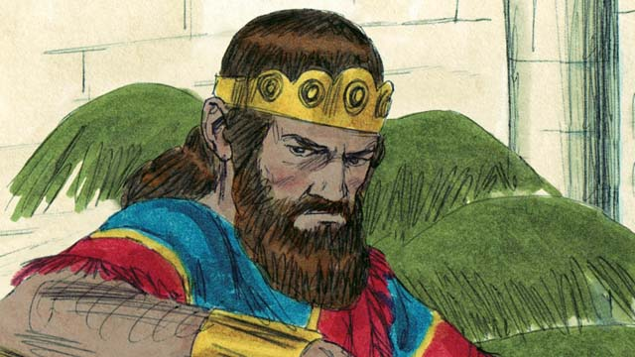

Saul was the first king of Israel. He was tall and handsome, just like the people wanted. Saul was a good king for the first few years that he ruled over Israel. But then he became a wicked man who did not obey God, so God chose a different man who would one day be king in his place.

17-02

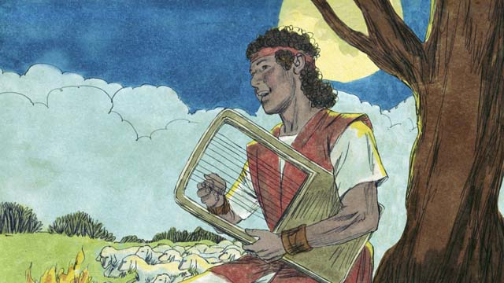

God chose a young Israelite named David and began to prepare him to one day become king after Saul. David was a shepherd from the town of Bethlehem. At different times, David killed both a lion and a bear that attacked his father’s sheep while David was watching them. David was a humble and righteous man. He trusted and obeyed God.

17-03

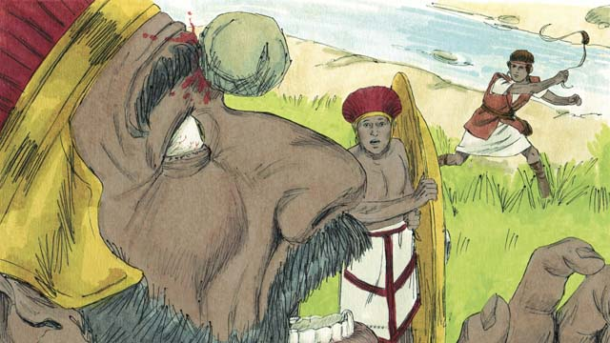

When David was still a young man, he fought against a giant named Goliath. Goliath was a very good soldier. He was very strong and about three meters tall! But God helped David kill Goliath and save Israel. After that, David won many victories over Israel’s enemies. David became a great soldier, and he led Israel’s army in many battles. The people praised him very much.

17-04

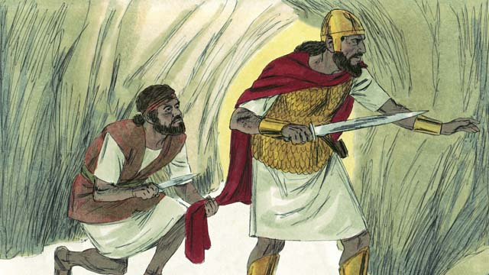

The people loved David so much that King Saul became jealous of him. Finally Saul wanted to kill him, so David ran away into the wilderness to hide from him and his soldiers. One day when Saul and his soldiers were looking for him, Saul went into a cave. It was the same cave that David was hiding in, but Saul did not see him. David went up very close behind Saul and cut off a piece of his clothing. Later, after Saul left the cave, David shouted to him to look at the cloth he was holding. In this way, Saul knew that David refused to kill him to become king.

17-05

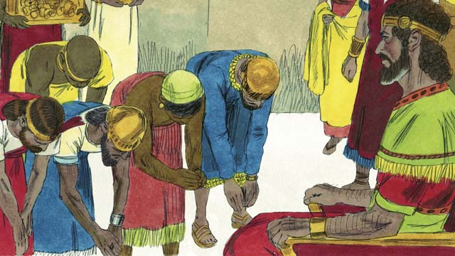

Some time later, Saul died in battle, and David became king of Israel. He was a good king, and the people loved him. God blessed David and made him successful. David fought many battles, and God helped him defeat Israel’s enemies. David conquered the city of Jerusalem and made it his capital city, where he lived and ruled. David was king for 40 years. During this time, Israel became powerful and wealthy.

17-06

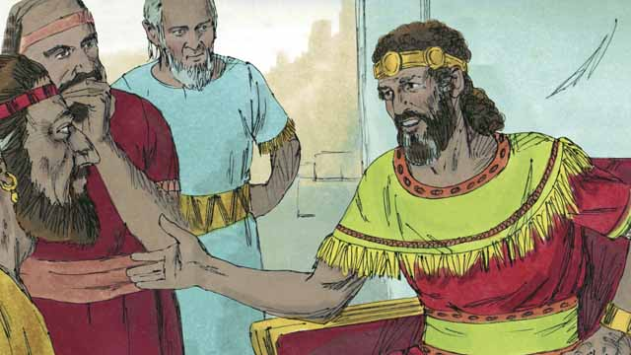

David wanted to build a temple where all the Israelites could worship God and offer him sacrifices. For about 400 years, the people had been worshiping God and offering sacrifices to him at the Tent of Meeting that Moses had made.

17-07

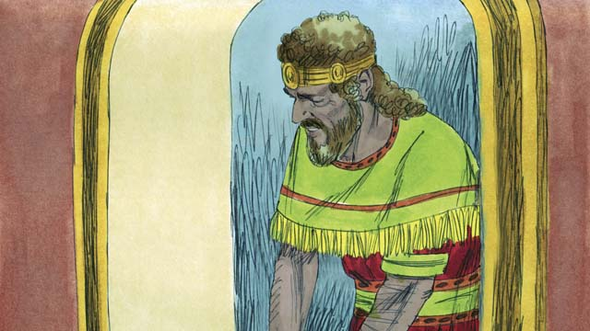

But there was a prophet named Nathan. God sent him to tell David this: “You have fought in many wars, so you will not build this Temple for me. Your son will build it. But still, I will greatly bless you. One of your descendants will rule as king over my people forever!” The only descendant of David who could rule forever was the Messiah. The Messiah was God’s Chosen One who would save the people of the world from their sin.

17-08

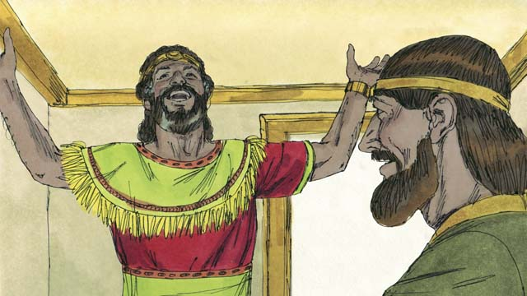

When David heard Nathan’s message, he thanked God and praised him. God was honoring him and giving him many blessings. Of course, David did not know when God would do these things. We know now that the Israelites would have to wait a long time before the Messiah came, almost 1,000 years.

17-09

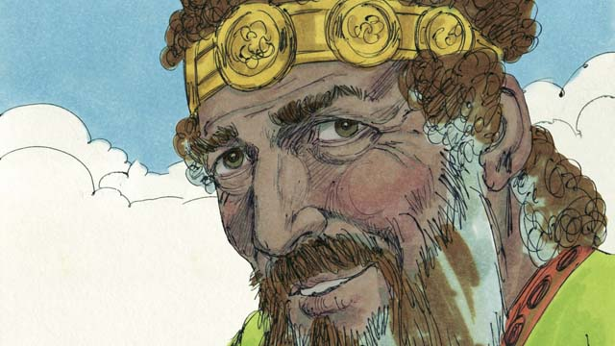

David ruled his people justly for many years. He obeyed God faithfully, and God blessed him. However, in his later years, he sinned greatly against God.

17-10

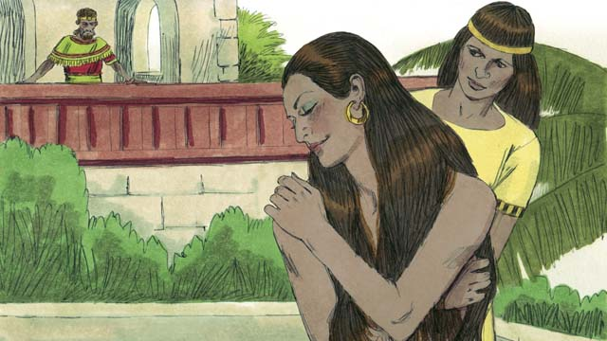

One day, David looked out from his palace and saw a beautiful woman bathing. He did not know her, but he found out that her name was Bathsheba.

17-11

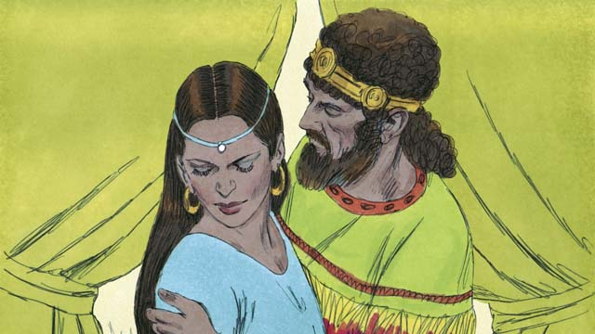

Instead of looking away, David sent someone to bring her to him. He slept with her and sent her back home. A short time later, Bathsheba sent a message to David saying that she was pregnant.

17-12

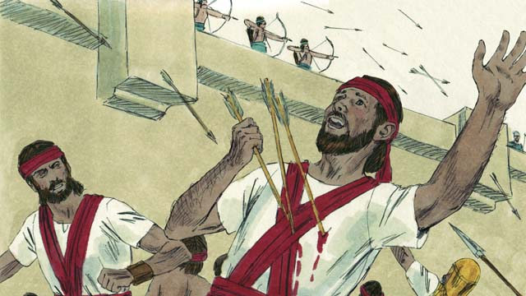

Bathsheba’s husband was a man named Uriah. He was one of David’s best soldiers. He was away fighting in a war at this time. David called Uriah back from the battle and told him to go be with his wife. But Uriah refused to go home while the rest of the soldiers were in battle. So David sent Uriah back to the battle and told the general to place him where the enemy was strongest so that he would be killed. This is what happened: Uriah died in battle.

17-13

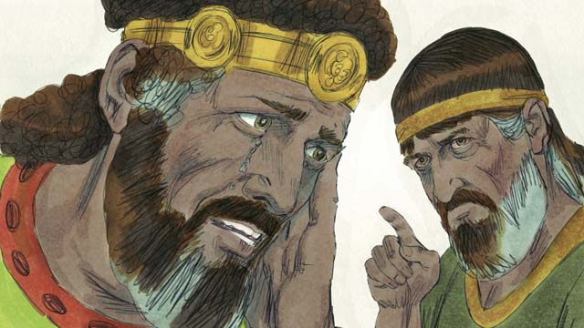

After Uriah died in the war, David married Bathsheba. Later, she gave birth to David’s son. God was very angry about what David had done, so he sent the prophet Nathan to tell David how evil his sin was. David repented of his sin and God forgave him. For the rest of his life, David followed and obeyed God, even in difficult times.

17-14

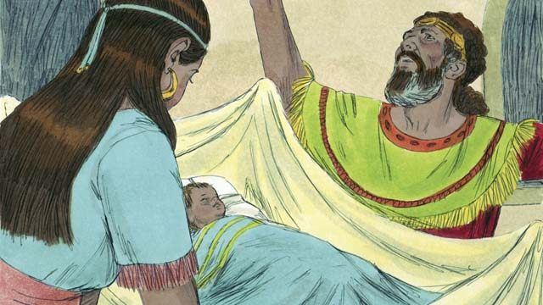

But David’s baby boy died. This is how God punished David. Also, until David died, some members of his own family rebelled against him, and David lost much power. But God was faithful and still did what he had promised David he would do for him, even though David had disobeyed him. Later, David and Bathsheba had another son, and they named him Solomon.

*A Bible story from: 1 Samuel 10; 15-19; 24; 31; 2 Samuel 5; 7; 11-12*

## 1 Community Study: Taught in Jesus—Putting on the New Self

* **Key Idea**: understanding the process of Christian formation
* **Key Passage**: Ephesians 4:17-24
* **Main Session**: OBS 17 (God’s Covenant with David)

### 1.1 Sing a Song (3–5 minutes)

God makes incredible promises to his people. Choose a song that praises God for his great and amazing promises. Sing this song together and celebrate God’s goodness and faithfulness.

### 1.2 Recite the Creedal Verse (3–5 minutes)

The verse below summarizes the teaching of the current passage. Read the verse out loud as a community. Read it again several times as a group until the whole community can recite it from memory.

And when he had removed him, he raised up David to be their king, of whom he testified and said, ‘I have found in David the son of Jesse a man after my heart, who will do all my will.’ Of this man’s offspring God has brought to Israel a Savior, Jesus, as he promised. Acts 13:22-23

OR

14 They will wage war against the Lamb. But the Lamb will conquer them because he is Lord of lords and King of kings—and with him are the called ones, the chosen ones, and the faithful ones. Revelation 17:14

### 1.3 Think About Your Culture (5 minutes)

Jesus is the King who is more powerful than all other kings. God promised that he would send Jesus as King when God made a covenant with David. As Christians, we serve Jesus as the greatest King. Think about what it means to live under Jesus’ authority.

Because we serve Jesus as King, this means…

### 1.4 Read the Passage (5 minutes)

Because Jesus is King, Christians are commanded to follow Jesus’ teachings. It can take time for Christians to learn how to live their new lives in Jesus. Read the passage below to understand what it means to live a life that follows Jesus.

17 Therefore, I say and insist on this in the Lord, that you must no longer live as the Gentiles live, in the futility of their minds. 18 They are darkened in their understanding, alienated from the life of God because of the ignorance that is in them, because of the hardness of their hearts. 19 They have no shame and have handed themselves over to sensuality, and they are continually practicing every kind of impurity. 20 But that is not how you learned about Christ. 21 I assume that you have heard about him, and that you were taught in him, as the truth is in Jesus. 22 You were taught to put off what belongs to your former manner of life, to put off the old man. It is the old man that is corrupt because of its deceitful desires. 23 You were taught to be renewed in the spirit of your minds, 24 and to put on the new man that is created in the image of God—in true righteousness and holiness. Ephesians 4:17-24

### 1.5 Discuss the Idea (10–15 minutes)

When Christians follow Jesus, they surrender their whole lives to Jesus’ authority. This means that Christians reject their old way of life and start living in a way that pleases God. After reading the passage above, use the following questions to help your community discuss biblical teaching on personal life transformation.

1. How does this passage instruct us to follow Jesus?
2. How does this passage explain a process of transformation? How do Christians change the way they live their lives?
3. What areas of your life does Jesus want you to change? What does Jesus want you to stop? What does Jesus want you to start?
4. How can you apply the principles of this passage to experience change in your own life?
5. Why is it important for your community to practice these principles of personal transformation?

### 1.6 Share Your Story (10 minutes)

Think about what it looks like to be made new in Jesus. Celebrate the ways that God has made you a new person in Christ.

Because I believe in Jesus, God is making me into a new person that is like this…

### 1.7 Pray to God (5 minutes)

Pray for members of your community to experience a change in how they live their lives. Ask that God would keep them from living like the world and to continue living in a way that pleases Christ.

## 2 Biblical Interpretation: Observing the Details of the Story

After reading the crafted biblical story, answer the following questions to familiarize yourself with the details of the story.

### 2.1 Observation Questions

Answer the following observation questions to gain a basic understanding of the the story. Read the story as a community and answer these questions as a group.

#### 17-01

Who was the first king of Israel and what was he like?  
Saul was the first king of Israel; he was tall and handsome just like people wanted.

Was Saul, the first king of Israel, a good king or a wicked king?  
He was good for the first few years, but then he became wicked and did not obey God.

What happened to Saul’s kingdom?  
Because Saul disobeyed God, God chose a different man to replace Saul as king.

#### 17-02

Who did God choose to be king to replace Saul?  
God chose a young Israelite named David to be king in Saul’s place.

What was David’s occupation before he became king?  
He was a shepherd who took care of sheep.

How did David defend the sheep under his care?  
David killed a lion and bear that attacked his father’s sheep.

What was David like?  
David was a humble and righteous man who trusted and obeyed God.

#### 17-03

Who did David fight against while he was a young man?  
When David was still a young man, he fought against a giant named Goliath.

Why was it so amazing that David was able to kill Goliath?  
Goliath was a very tall, very strong trained soldier wearing battle gear. David was a shepherd boy with no weapon but a sling.

Why did the people of Israel praise David?  
He won many victories over Israel’s enemies and became a great soldier who led Israel’s army into many battles.

#### 17-04

What did Saul and the people think about David?  
The people loved David but Saul was jealous of David.

What did David do when Saul wanted to kill him?  
Saul wanted to kill David and David ran away in the wilderness to hide.

Where did David and Saul meet one day?  
One day Saul entered a cave where David was hiding but Saul did not see David.

What did David do when he had a chance to kill Saul in the cave?  
He spared Saul and only cut off a piece of his clothes.

What did Saul learn about David from this experience?  
Saul knew that David refused to kill him to become king.

#### 17-05

When did David become king of Israel?  
David became king of Israel after Saul died in battle.

How did David become so successful?  
God blessed David and he was successful. God helped David defeat Israel’s enemies in battle.

What was the city that David conquered and then made his capital?  
He made Jerusalem his capital.

How long did David rule as king?  
David was king for 40 years.

#### 17-06

What did David want to build for God?  
David wanted to build a temple where all the Israelites could worship God and offer sacrifices.

Where were the Israelites worshiping God before this time?  
For about 400 years, the Israelites were worshiping God in the Tent of Meeting.

#### 17-07

What did the prophet Nathan tell David?  
God sent the prophet Nathan to tell David that he would not build the Temple.

Why did God not allow David to build a temple?  
David would not build it because he had fought in so many wars.

Who did God say would build the Temple?  
David’s son would build it.

What was the great promise that God gave to David?  
God promised to greatly bless David. God promised that one of David’s descendants would rule as king over God’s people forever.

What great act would the Messiah do?  
He would save the people of the world from their sin.

#### 17-08

What did David do when he heard Nathan’s message?  
When David heard Nathan’s message he thanked and praised God.

What did David not know about God’s promises?  
God greatly blessed David, but David did not know when God would fulfill his promise for a Messiah.

About long would the Israelites have to wait for God to send the Messiah?  
The Israelites would have to wait about 1,000 years for God to send the Messiah.

#### 17-09

How well did David rule the people of Israel?  
David ruled justly for many years and obeyed God faithfully. In his later years, David sinned greatly against God.

#### 17-10

Who did David see when he looked out from his palace?  
David looked out from his palace and saw a beautiful woman bathing. Her name was Bathsheba.

#### 17-11

What terrible sin did David commit with Bathsheba?  
He committed adultery with Bathsheba and sent her back home.

What message did Bathsheba send to David a short time later?  
Bathsheba sent a message to David telling him that she was pregnant.

#### 17-12

How did David try to cover up his of making Bathsheba pregnant?  
David called Bathsheba’s husband, Uriah, back from battle and told him to sleep with his wife.

What did David do when Uriah refused to sleep with his wife?  
Uriah refused to sleep with his wife while the rest of the soldiers were in battle. David sent Uriah told the general to put him where the fighting was strongest. Uriah died in battle.

#### 17-13

What did David do after Uriah died in battle?  
After Uriah died in battle, David married Bathsheba.

What did God think of what David had done?  
God was very angry about what David had done and he sent the prophet Nathan to tell him about how evil his sin was.

What did David do when Nathan confronted him about his sin?  
David repented of his sin and received God’s forgiveness.

#### 17-14

How did God punish David for his sin?  
David’s baby boy died, there was fighting in David’s family for the rest of his life, and David’s power was greatly weakened.

Did God still keep his promises to David in spite of David’s unfaithfulness?  
Yes, he still kept them.

What was the name of their son who was born later to David and Bathsheba?  
His name was Solomon.

### 2.2 Translation Questions

Use the following translation questions to understand specific details of the passage. Discuss how you might translate these specific elements of the story.

#### 17-01

**the first king of Israel** Saul was the first leader to govern Israel as king. How would you express **the first king of Israel** to mean Saul was the first king to rule over Israel?

  

**one day** The man God chose to take Saul’s place as king over Israel would become king at some time in the future. How would you express **one day** to mean some time in the future or years later?

  

**be king in his place** God chose another person to replace Saul as king. This man would rule as king instead of Saul. How would you express **be king in his place** to mean God chose another man to take Saul’s place as king over Israel?

  

#### 17-02

**God chose a young Israelite named David** God decided he wanted David to be Israel’s next king. David was an Israelite youth. God selected David for this position. How would you express **God chose a young** Israelite named David to mean God selected David to be Israel’s next king?

  

**father’s sheep** The sheep that David watched belonged to his father. How would you express **father’s sheep** to mean the sheep that belonged to David’s father?

  

**watching** At the time David killed a lion and bear he was caring for his father’s sheep. How would you express **watching** to mean David was taking care of and protecting his father’s sheep?

  

**humble** David was not arrogant or proud. He did not think as someone of great importance. How would you express **humble** to mean David was not proud and did not think of himself as better than others?

  

#### 17-03

**a giant named Goliath** A giant is a person who is unusually tall and powerful. Goliath was a huge soldier in an army that was fighting against Israel. How would you express **a giant named Goliath** to mean a person who is unusually tall and strong whose name was Goliath?

  

**He was very strong and about three meters tall!** Goliath was very strong and very tall. How would you express **He was very strong and about three meters tall!** to be a strong statement that Goliath was greatly powerful and extremely tall?

  

**After that** The first enemy of Israel that David defeated was Goliath, but after defeating Goliath, David went on to defeat many other enemies of Israel. How would you express **After that** to mean that David won many victories of Israel’s enemies following/subsequent to his defeat of Goliath?

  

#### 17-04

**that** King Saul became jealous of him The result of the people loving David so much as King Saul became jealous of him. How would you express **that** King Saul became jealous of him to mean the outcome/effect of the people’s love for David was Saul’s jealousy of David?

  

**so** David ran away into the wilderness to hide The result of Saul wanting to kill David was David fleeing to the wilderness and hiding. How would you express **so** David ran away into the wilderness to hide to mean the outcome/effect of Saul wanting to kill David was David running away into the wilderness and hiding?

  

**One day** After explaining that Saul wanting to kill David, the story tells a specific story about a time when Saul was trying to kill David. This event happened in the past, but does not state the specific time. How would you express **One day** to refer to a true even that actually happened in the past (but the specific day is not stated)?

  

#### 17-05

**made him successful** God caused David to be victorious in battle and flourish as a king. How would you express **made him successful** to mean God helped David accomplish the good things he wanted to do?

  

**and** God helped him defeat God’s blessing on David included his military efforts. David won many battles not because he was a great soldier, though he was, but because God helped him defeat Israel’s enemies. How would you express **and** God helped him defeat to mean God enabled David to win the battles he fought against Israel’s enemies?

  

**his capital city** David made Jerusalem the capital city of his kingdom. David lived in Jerusalem and ruled from there. The entire city does not belong to David, but because David is the supreme government leader and because David captured Jerusalem and made it the capital, it is often described as his. A capital city was the center of government for the country of Israel and it had the primary status above all the other cities in Israel. How would you express **his capital city** to mean the central city from which David ruled his kingdom?

  

#### 17-06

**temple** David wanted to construct a permanent building for worshiping God that would replace the portable Tent of Meeting. What words in your language mean **temple** as in a permanent building for worshipping God and offering sacrifices to God?

  

**the Tent of Meeting that Moses had made** The Tent of Meeting was built during the time of Moses. It was a movable tent for worshiping God. Moses did not build the Tent of Meeting himself. Many Israelites worked to construct the Tent of Meeting. Moses was the Israelite leader responsible for making sure the Tent of Meeting was built. How would you express **the Tent of Meeting that Moses had made** to mean the the portable tent for worshiping God which was made while Moses was leader of the Israelites?

  

#### 17-07

**But there was a prophet named Nathan** David’s desire to build a temple for God is different/opposite to the message the prophet Nathan would tell David. How would you express **But there was a prophet named Nathan** to mean the message the prophet Nathan told David was different/opposite to David’s desire to build a temple for God?

  

**so you will not build this Temple** The result of David fighting many wars was God did not allow David to build the Temple. How would you express **so you will not build this Temple** to mean the result of David fighting many wars was God did not allow him to build the temple?

  

**The Messiah was God’s Chosen One** The Messiah means Anointed One. This refers to God’s Son, Jesus Christ. The Messiah was the One God chose to save people from sin and to rule as king over his people forever. How would you express **The Messiah was God’s Chosen One** to mean the Messiah was the One God appointed?

  

**from their sin** The Messiah would rescue people from the effects of sin. How would you express **from their sin** to mean the Messiah would save people from the terrible consequences of their sin?

  

#### 17-08

**When David heard Nathan’s message** David thanked and praised God at the time David heard Nathan’s message. How would you express **When David heard Nathan’s message** to mean reason David thanked and praised God was because he heard Nathan’s message?

  

**God was honoring him** God was causing David to be respectable and honorable to others. This does not mean that God was worshiping or paying reverence to David. Rather, God was causing David to be honored and esteemed by others. How would you express **God was honoring him** to mean God was causing David to be respected and esteemed by others?

  

**Of course** It is obvious to us that it would take many years for God to fulfill his promise of sending his Messiah. This was not so obvious to David. David did not know when God would do these things, since God did not tell him when they would happen. How would you express **Of course** to mean a perspective which is obvious to the readers but not necessary obvious to David?

  

#### 17-09

**However, in his later years** David was faithful to God and obeyed God for many years. When David was older, he sinned against God. The word However contrasts David obeying God for many years with David sinning against God in his later years. How would you express **However, in his later years** to mean David’s sin later on in his life was different/opposite to his faithful obedience many years prior?

  

**sinned greatly** David disobeyed God in a very wicked way. His sin was especially evil. How would you express **sinned greatly** to mean David sinned in a very evil way?

  

#### 17-10

**David looked out from his palace and saw** Bathsheba may have been bathing at her own house, but David’s palace was very high and he was able to see over walls that were lower. How would you express **David looked out from his palace and saw** to mean David saw the woman bathing from his palace?

  

**a beautiful woman bathing** David saw an attractive woman who was taking a bath. How would you express **a beautiful woman bathing** to mean an attractive woman who was in the act of washing herself?

  

**but he found out** David did not know who the woman was. In contrast to this lack of knowledge, David discovered who she was. How would you express **but he found out** to mean David did not know the woman beforehand but intentionally came to learn who the woman was?

  

#### 17-11

**Instead of looking away** David should have looked away from the woman so that he would not be tempted to sleep with her. David did the opposite of this. He sent someone to bring her to him. How would you express **Instead of looking away** to mean rather than David looking away from Bathsheba (which is what he should have done), he sent someone to bring Bathsheba to him (which was the opposite of what he should have done)?

  

**He slept with her** This is a polite way of saying that David had sexual intercourse with Bathsheba. How would you politely express **He slept with her** to mean David had sexual intercourse with Bathsheba?

  

#### 17-12

**go be with his wife** David told Uriah to go home to be intimate with his wife. David wanted people, especially Uriah, to believe that Bathsheba was pregnant with Uriah’s child. How would you politely express **go be with his wife** to mean David told Uriah to go home and have sexual intercourse with his wife?

  

**where the enemy was strongest** David told the general to place Uriah at the location in the battle where the most fighting was going on. How would you express **where the enemy was strongest** to mean the place in the battle where the most fighting was happening and there was the greatest chance Uriah would be killed in battle?

  

**so that he would be killed** David’s purpose in telling the general to put Uriah where the enemy was the strongest was to have Uriah killed. David wanted Uriah killed to cover up his sin with Bathsheba. How would you express **so that he would be killed** to mean the purpose of David sending Uriah to the place where the enemy was the strongest was so that Uriah would be killed?

  

#### 17-13

**what David had done** The great sin that David committed was adultery with Bathsheba and the murder of her husband, Uriah. How would you express **what David had done** to refer to David’s sin of adultery with Bathsheba and his murder of Uriah?

  

**so he sent the prophet Nathan to tell David how evil his sin was** God was angry with David because of his sin. Because God was angry he sent a prophet to tell David that he had done an evil thing. The result of God’s anger was to send a prophet to tell David about his sin. How would you express **so he sent the prophet Nathan to tell David how evil his sin was** to mean the result of God being angry about David’s sin was to sent the prophet Nathan to tell David how wicked his sin was?

  

#### 17-14

**But David’s baby boy died** David repented from his sin and God forgave him. Even though David repented and God forgave him, God punished David by Bathsheba’s baby dying. Even though God forgave David of his sin, David had to bear consequences for his sin. How would you express **But David’s baby boy died** to mean the death of David’s baby was in contrast to David’s act of repentance and God’s forgiveness of David?

  

**some members of his own family rebelled against him** This fighting was very serious. Among other things, one of his sons murdered another son and tried to take David’s place as king while David was still reigning. If possible, use a word that conveys the intensity of this conflict within the family. How would you express **some members of his own family rebelled against him** to mean some of David’s family rose up and fought against him in a violent way that resisted David’s rule as king?

  

## 3 Theological Dialogue: Discussing the Meaning of the Story

Take time to explore the meaning of this story together as a community. Use the following discussions as a way to grasp what truth the story teaches.

### 3.1 Discourse Questions

Use the following discourse questions to understand the meaning of the story. Pay attention to how the story itself addresses each question or theme.

##### How did God prepare David to be king of Israel? (17-01, 17-02, 17-03, 17-04)

God chose David to be Israel’s king. Before David was king, Saul was Israel’s king. He was Israel’s first king. He was tall and handsome. He was just what the people wanted. Although he was a good king for a few years, he became wicked and disobeyed God. God chose David to replace Saul as Israel’s king. (17-01)

  

David was a shepherd. He watched his father’s sheep. God gave David strength to protect his father’s sheep. David killed a lion and a bear that attacked his father’s sheep. God used this time as a shepherd to prepare David to be Israel’s king. (17-02)

  

David was humble and righteous. He trusted and obeyed God. (17-02)

  

David defeated the giant Goliath in battle. God helped David defeat him. (17-03)

  

David had many victories over Israel’s enemies. He won many battles. The people thought David was great. God gave David victory in these battles. (17-03)

  

David ran away from Saul when Saul tried to kill him. God protected David from his enemies. (17-04)

  

David respected God so much that he did not kill Saul to try to become king. David had a deep respect and love for God. He did not try to make God’s promises happen faster than God wanted them to happen. (17-04)

  

##### What was so great about David’s rule as king of Israel? (17-05, 17-06, 17-07, 17-08, 17-09)

David became king of Israel after Saul died. He was a good king and people loved him. (17-05)

  

God had his favor and blessing upon David. God helped David win many battles against Israel’s enemies. David conquered Jerusalem and he made this city his capital city. (17-05)

  

David became powerful and wealth while he was king. David was faithful and God blessed David. (17-05)

  

David wanted to build a permanent building where God’s people would worship God. God told David he would not build it because he fought in many wars. David’s desire to build a temple was honorable but God would have the temple built by someone else. God told David his son would build it. Even though David would not build it, God said he would greatly bless David. (17-06, 17-07)

  

God promised David that one of his descendants would be the Messiah. The Messiah would rule over God’s people for all time. He would save people from their sin. (17-07)

  

David praised God and thanked God for the news that the Messiah would come from his lineage. It would take many years, but God’s promise to send the Messiah would come true. (17-08)

  

David was a just king for many years. He ruled in a way that was fair and righteous. (17-09)

  

David obeyed God and was faithful to his ways. For many years, David lived a life that was pleasing to God. (17-09)

  

God blessed David. When David was faithful to God, David enjoyed God’s blessing. (17-09)

  

##### How did David fall into great sin and how did he try to cover it up? (17-09, 17-10, 17-11, 17-12)

David’s past of faithful obedience to God did not guarantee his future faithfulness. David gave in to sin later in his life. He committed great evil against God and others. (17-09)

  

David saw Bathsheba bathing one day. He thought she was beautiful. But David did not look away from Bathsheba when he was attracted to her. Rather than turning his eyes from her, he investigated further and wanted to learn more about her. David exploring about Bathsheba a little more eventually led to him committing adultery with her. (17-10)

  

David gave in to his temptation. He had her brought to him and slept with her. David’s violated Bathsheba by giving in to his sexual desires. He used his position of power to satisfy his desires. (17-11)

  

Trickery/Deceit: David brought Uriah home from war and told him to go home and sleep with his wife. He was trying to make it seem like Bathsheba was pregnant by Uriah when it was really David who made Bathsheba pregnant. David was trying to cover up his sin and used trickery/deceit to do this. (17-12)

  

Power: David told his general to put Uriah in the place where the most fighting was. David wanted Uriah dead and arranged a situation to have Uriah killed. David was trying to cover up his sin and used his position of power to do this. (17-12)

  

##### What were the effects of David’s sin and how did David find resolution to his sin? (17-13, 17-14)

Divine Anger: God was angry about David committing adultery with Bathsheba and killing Uriah. This made God angry because David’s sin violated other humans and disobeyed God’s ways. (17-13)

  

Conviction: God sent the prophet Nathan to tell David how wicked his sin was. God wanted David to know how evil his actions were and sent David a messenger so that he would know how wicked his actions were. (17-13)

  

Repentance: David repented of his sin. He understood how wicked his actions were, how they violated others, and how they went against God’s ways. He felt genuine remorse for his sin and turned away from his sin. (17-13)

  

Forgiveness: When David repented from his sin, God forgave him. Even though David would still suffer consequences for his sin, this means that God would fully destroy David for his sin. (17-13)

  

Life Change/Obedience: David changed his life. Genuine repentance is a change of life. David followed and obeyed God. (17-13)

  

Consequences: Even though David repented and God forgave him, David still suffered consequences for his sin. Bathsheba’s baby died. David also experienced rebellion from his own family members. (17-14)

  

God’s Faithfulness: David’s family rebelled against him. God was faithful to David even though David disobeyed (17-14)

Restoration: God brought restoration to David. Eventually, God gave David another son named Solomon. (17-14)

  

### 3.2 Theological Questions

Answer the following theology questions as a community. Discuss what truths this story teaches.

1. What is the nature of God’s kingdom? What is God’s kingdom like? What can we learn about God’s kingdom from the positive and negative examples of Saul and David?
2. How should Christians be servants in God’s kingdom? How does David’s example when he ruled Israel righteously instruct us in how we should service God?
3. What is sin like and what makes it so evil in God’s eyes? How does David’s sin warn us about temptation and sin?
4. How can God’s people find freedom from their sin? What does the story of David teach us about how people can be rescued from sin?

### 3.3 Translation Draft

Work as a translation team to draft each panel of this story. Pay attention to any specific translation issues that are challenging or significant.

#### Make Translation Draft

Make a draft for each section of this story.

#### Discuss and Revise

After drafting the story, discuss any translation issues that you think need special explanation.

#### Drafting Summary Reflection

Summarize any noteworthy translation decisions and the rationale/reasoning behind these translation decisions. In the final movement of this class, you will use these observations to give an account (i.e., chronicle/narrate) of how your translation improved through the checking process.

## 4 Personal Reflection: Following the Teaching of the Story

Take a moment to allow this story to evaluate your own life and to consider how God would have you respond. After this reflection, use the quality checking questions to check your translation draft among the translation team.

### 4.1 Journal Reflection

Prayerfully think about the following personal reflection questions. Write/Record your answers and/or discuss them as a group.

1. How is God preparing you for his service?
2. How well is your life aligned with God’s kingdom priorities? What would need to change to have your life more in line with God’s kingdom?
3. What temptations to sin are you facing? How can you resist these temptations?
4. In what ways have you experienced God’s forgiveness? If you have not, how does God want to rescue you from your sin?

### 4.2 Team Check

*The following activity will help you check the clarity, accuracy, and naturalness of your draft. Read the passage aloud and discuss the checking questions with other members of your translation community. You might need to reread portions (or the whole) of the biblical passage multiple times as you answer each of these questions. Record answers to these questions below.*

#### Team Checking Questions

*Use the following questions to check your translation draft for accuracy, clarity, and naturalness.*

1. **Accurate**: Has anything been **added** to your translation of this passage that is not a part of the meaning of the source text? *If additions exist, are they included only added to clarify meaning (such as implied information)?*
2. **Accurate**: Is anything **missing** from your translation of this passage that is a part of the meaning of the source text? *If some part of the meaning is missing from your translation, add it.*
3. **Accurate**: Does any meaning in your translation of this passage appear to be **different** than the meaning of the source text? *If the meaning is different, try changing your translation so that the meaning remains the same.*
4. **Natural**: Does anything sound **unnatural** to how you would say it in your language? *If portions of the passage sound unnatural in your language, try to make them sound the way you would say it in your language while staying true to the meaning of the source text.*
5. **Clear**: Is anything **unclear** or **confusing** in your translation that confuses the meaning of the source text? *If portions of the passage are unclear or confusing, revise them to clearly communicate the meaning of the source text.*
6. **Consistent**: How **consistent** is your translation within the passage and with other passages? *If portions of the passage need to be made consistent or if you need to revise translations of other passages, make these adjustments.*

#### Record Feedback

*After discussing the checking questions above as a translation community, record any feedback on your translation draft. Pay attention for parts of your translation that are translated well and parts of your translation that need correction.*

#### Discuss and Revise

*After gathering feedback on your draft, discuss it together with your translation community and make appropriate revisions in your translation.*

#### Record Translation Decisions

*As a community, discuss some of the most noteworthy translation decisions in your draft. Summarize each decision and explain the reasons your community decided on that translation. You should update these decisions each time you check your draft with various groups of people.*

You should **measure** the quality of your translation draft. You can **record translation decisions** to make it clear why you translated things a certain way. Translation decisions can help your translation team and the surrounding community be a part of the translation process.

How can you know the quality of your translation?

1. **Measure** the translation by marks/standards of quality (i.e., clear, accurate, natural, church-approved)
2. **Test** the translation with others and record feedback and conversations from in the field (i.e., church and community check)
3. **Compare** and **contrast** the translation with the source text (i.e., meaning of text and notes) and alternatives (i.e., other translation choices)
4. **Explain** the reasons why you translated a particular portion of the text.

**Example Sentences That Help Explain Your Translation Decision** Use the following example sentences to help explain your translation decisions:

1. The original text literally **says/means**, so we translated the term in this way…
2. We originally decided to translate **the biblical term** in with **this term**, but we changed it because…
3. When our translation team discussed **the biblical term**, this is what we talked about…
4. **The term** is [clear, accurate, natural, consistent] because…
5. The community understands **this term** it to mean…
6. We considered these other terms. We did not use **these terms** because…
7. When we checked this in the church, we learned…
8. When we checked this in the community, we learned…

**Example of Translation Decision**

In OBS 01-07 we decided to translate **blessed** like this: [actual translation]. We decided this translation because of these reasons:

1. The word [actual translation] means to cause good things to happen to someone or something. This term is used when a person desires someone or something to prosper or flourish. This term does not refer to magic or witchcraft.
2. When we checked this word with other believers, they said it describes God showing his kindness and favor on someone or something. These are some of the terms that we did not decide to use…
3. Many of our people will understand this word. When we discussed this phrase with the surrounding community, we discovered it was a natural way to describe God causing good and beneficial things to happen.

## 5 Ministry Practice: Serving the Church with the Story

Now that you have a draft of this story, consider how this story can encourage other believers in their faith. After ministering this story to others, you will also perform a community check of your translation draft.

### 5.1 Church Ministry

Reflect on how this story can edify and mature the Christian community. Design a way to minister this story to your church community.

**Ministry Preparation**: Take time to consider how you could minister this story to others. Record some ministry ideas below.

**Ministry Implementation**: Minister this story to a group of believers as you had planned. Use the information in this study to help develop a teaching/lesson or lead a discussion of this story to other believers. Record your ministry plan below.

**Ministry Reflection**: Think about what you learned from ministering this story to other believers. Reflect on your experience below.

### 5.2 Church Community Check

After teaching or ministering this story to the church, check the translation quality with the church community. Record any feedback from your checking experience.

#### Create Checking Questions

You can use **Translation Questions** to check you draft. Each **Translation Question** explains the meaning of a specific part of the story and asks you to consider how you would translate that part of the story in your own language. Change each **Translation Question** into a **Checking Question** by asking the following questions. The first question asks you to identity how each specific phrase was translated in your language. The second question asks people in the church to determine if your translation of the phrase expresses the meaning clearly, accurately, and naturally. Look at the following examples to see how to change **Translation Questions** into **Checking Questions**:

#### Translation Question Example 1

**to proclaim the good news about Jesus** Paul and Silas traveled to Philippi for the purpose of preaching the gospel. The gospel is the good news that Jesus saves people from their sins if they will believe in Jesus. How would you express **to proclaim the good news about Jesus** to mean to tell other people the message about how Jesus can save people from their sins?

#### Translation Question Example 2

**a merchant** Paul and Silas met a woman named Lydia at the place by the river. She owned a business and sold items to make money. How would you express **a merchant** to mean a business owner who sells items for a profit?

#### Translation Question Example 3

**so Paul and Silas baptized them** The jailer and his whole family followed Paul’s instructions. They believed in Jesus. The result of this was Paul and Silas baptized them. How would you express **so Paul and Silas baptized them** to mean the result of the jailer and his family believing in Jesus that Paul and Silas baptized all of them?

You can change these into **Checking Questions** like this:

#### Checking Question Example 1

**to proclaim the good news about Jesus** How did you translate **to proclaim the good news about Jesus**? Does it mean to tell other people the message about how Jesus can save people from their sins?

#### Checking Question Example 2

**a merchant** How did you translate **a merchant**? Does it mean a business owner who sells items for a profit?

#### Checking Question Example 3

**so Paul and Silas baptized them** How did you translate **so Paul and Silas baptized them**? Does it mean the result of the jailer and his family believing in Jesus that Paul and Silas baptized all of them?

#### Record Feedback

*Discuss the* ***Checking Questions*** *with your church community, and record any feedback on your translation draft. Pay attention for parts of your translation that are translated well and parts of your translation that need correction.*

#### Discuss and Revise

*After gathering feedback on your draft, discuss it together with your translation community and make appropriate revisions in your translation.*

#### Record Translation Decisions

*Update your translation decisions and record and new any noteworthy observations on the quality of your draft.

## 6 Missional Outreach: Sharing the Truth of the Story

*After sharing this story with others, check the translation quality with the wider language community. Record any feedback from your checking experience.*

### 6.1 Mission Engagement

*Consider how you will witness this story to unbelievers. Design a way to share this story and engage them in what it teaches about Christianity and the gospel.*

**Witness Preparation**: Take time to consider how you will witness this narrative to unbelievers. Record some ideas below.

**Witness Implementation**: Share this story with an unbeliever. Use the information in this study to help develop a teaching/lesson or lead a discussion of this story to other believers. Record your ministry plan below.

**Witness Reflection**: Think about what you learned from ministering this story to unbelievers. Reflect on your experience below.

### 6.2 Sociolinguistic Check

After sharing this story with the language community, check your translation draft with the surrounding community. Record your observations.

#### Checking Approach

After witnessing this story to unbelievers, use one of the following methods to check the translation of this story. Consider using the **Observation Questions** to check your translation draft or come up with your own quality checking questions.

**Read-Retell Check:** Read your draft to those the community and ask them to retell the passage. Be attentive for any portions of the passage that are unclear, unnatural, or inaccurate.

**Comprehension Questions Checklist:** Read the draft of the passage and ask a list of comprehension questions to make sure the passage is being rightly understood. You can use the **Observation Questions** in this guide or come up with your own questions. Then, record any insights or issues that arise.

**Discussion Group:** Develop key questions to ask about the passage (both formational and translational). Read the passage and have a group discussion about the passage, paying attention to issues that need to be addressed, edited, and revised.

#### Record Feedback

*After sharing your draft with language community, discuss the* ***Observations Questions****, and record any feedback on your translation draft. Pay attention for parts of your translation that are translated well and parts of your translation that need correction.*

#### Discuss and Revise

*After gathering feedback on your draft, discuss it together with your translation community and make appropriate revisions in your translation.*

#### Record Translation Decisions

*Update your translation decisions and record and new any noteworthy observations on the quality of your draft.

## 7 Conclusion

As a translation community, take time to reflect on all that was learned in studying, drafting, and checking this story. Celebrate all that God has taught you as a community. Then, submit your revised draft and checking summaries to network leaders for further review.