Open Bible Stories

The Divided Kingdom

## 0 Introduction

### 0.1 Key Idea

The story of the divided kingdom teaches us about the consequences of sin and idolatry among leaders (people in positions of authority).

### 0.2 Creedal Verse

“For the time that is past suffices for doing what the Gentiles want to do, living in sensuality, passions, drunkenness, orgies, drinking parties, and lawless idolatry.” 1 Peter 4:3

### 0.3 Metanarrative Summary

The eternal God created all things in six days. He made a good and perfect world. He made humans in his image to fill the earth and rule over creation. But humans rebelled against God and ruined God’s creation. God set to restore his world through his promise. God made a covenant with Abraham. He promised to bless all nations through Abraham. God kept his promises across the generations. God provided Abraham with a promised child, Isaac. God gave Isaac a wife and she bore twins, Jacob and Esau. God blessed Jacob and his sons, and the blessing continued to the next generation. God rescued Joseph, one of Jacob’s sons, and used him to rescue his family. God caused his people, the Israelites, to multiply in the land of Egypt; eventually, they became slaves. But, God raised up a deliverer, Moses, to deliver his people from their slavery. God sent judged the Egyptians with harsh plagues; in the final judgment, he passed over his people who covered their doorposts with the blood of a sacrificed lamb. Then, God delivered the Israelites by bringing them out of Egypt and crossing the Red Sea on dry land. God made a covenant with the Israelites and made them his people. God tested Israel in a series of wilderness wanderings and eventually brought his people into the promised land of Canaan. God raised up deliverers to lead Israel and rescue them from their enemies. God formed Israel into a kingdom. He made a covenant with King David and promised to send a king that would rule his people forever. Many of Israel’s kings were evil and the kingdom of Israel divided into two kingdoms.

### 0.4 Open Bible Story: The Divided Kingdom

18-01

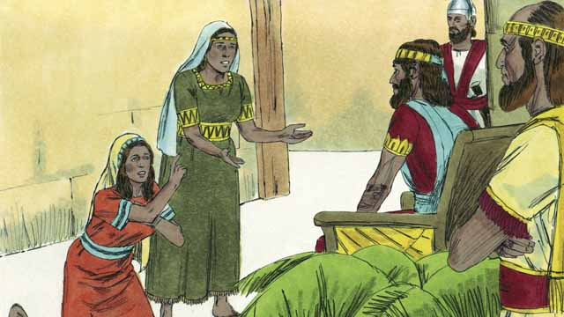

King David ruled for 40 years. Then he died, and his son Solomon began to rule over Israel. God spoke to Solomon and asked him what he wanted most that God should do for him. Solomon asked that God would make him very wise. This pleased God, so he made Solomon the wisest man in the world. Solomon learned many things and was a very wise ruler. God also made him very wealthy.

18-02

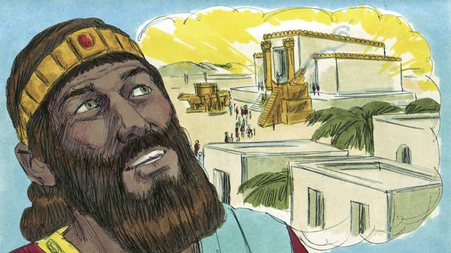

In Jerusalem, Solomon built the Temple for which his father, David, had planned and gathered materials. People now worshiped God and offered sacrifices to him at the Temple instead of at the Tent of Meeting. God came and was present in the Temple, and he lived there with his people.

18-03

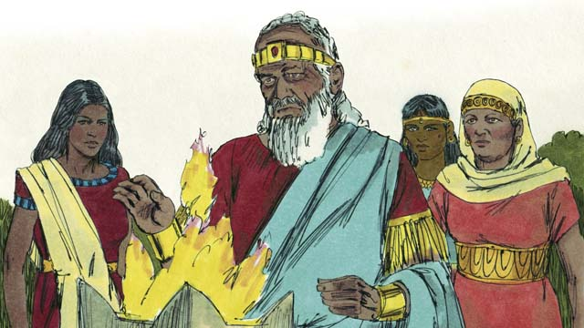

But Solomon loved women from other countries. He disobeyed God by marrying many women, almost 1,000 of them! Many of these women came from foreign countries and brought their gods with them and continued to worship them. When Solomon was old, he also worshiped their gods.

18-04

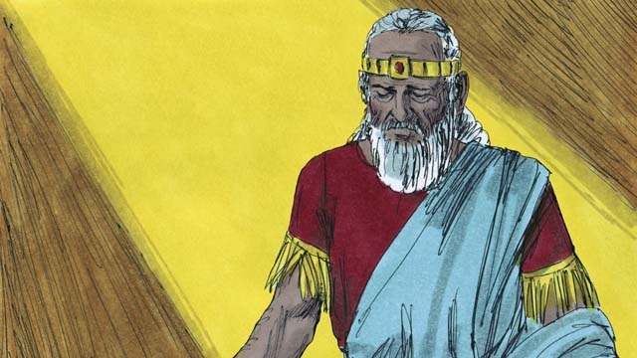

God was angry with Solomon because of this. He said that he would punish him by dividing the nation of Israel into two kingdoms. He would do this after Solomon died.

18-05

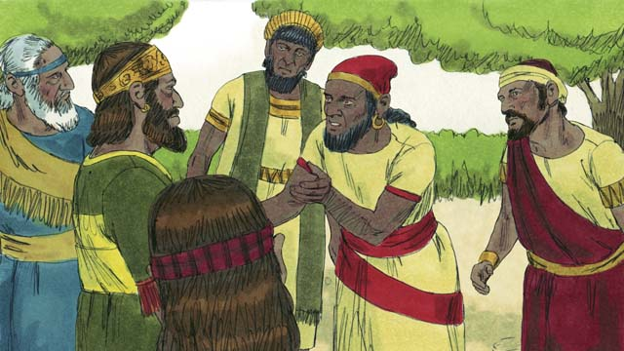

After Solomon died, his son Rehoboam became king. All the people of the nation of Israel came together to accept him as their king. They complained to Rehoboam that Solomon had made them do a lot of hard work and pay a lot of taxes. They asked Rehoboam to make them work less.

18-06

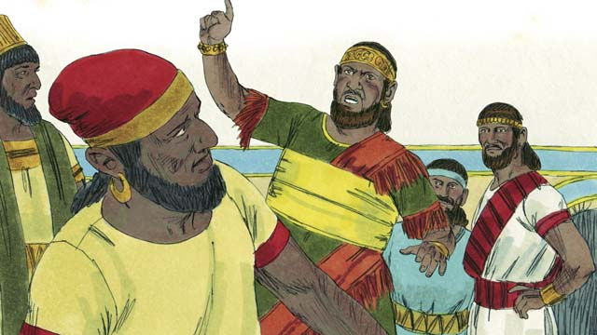

But Rehoboam answered them in a very foolish way. He said, “You say that my father, Solomon, made you work hard. But I will make you work harder than he did, and I will make you suffer worse than he did.”

18-07

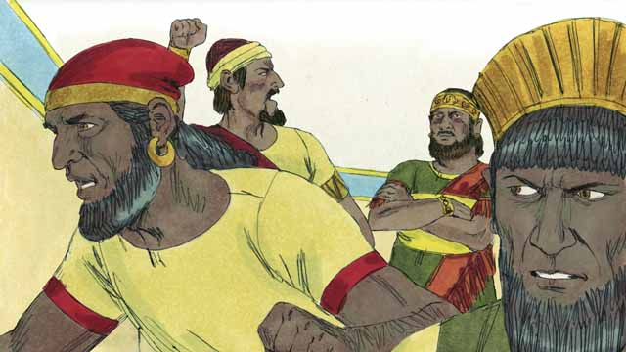

When the people heard him say this, most of them rebelled against him. Ten tribes left him; only two tribes remained with him. These two tribes called themselves the kingdom of Judah.

18-08

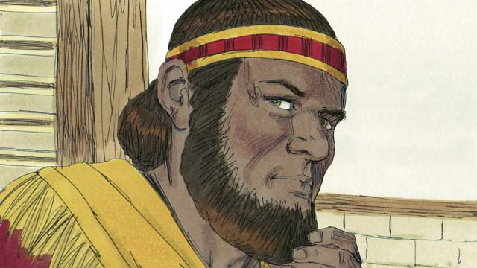

The other ten tribes made a man named Jeroboam to be their king. These tribes were in the northern part of the land. They called themselves the kingdom of Israel.

18-09

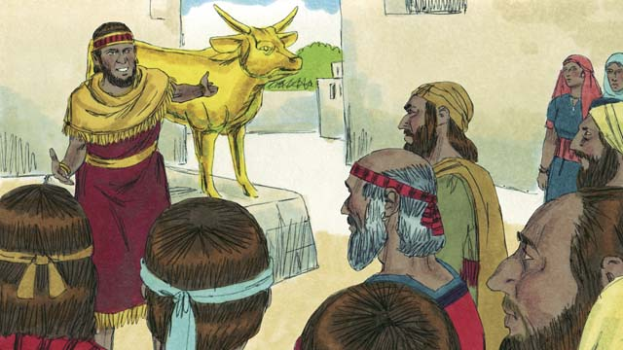

Jeroboam rebelled against God and caused the people to sin. He built two idols for his people to worship. They no longer went to Jerusalem in the kingdom of Judah to worship God at the Temple.

18-10

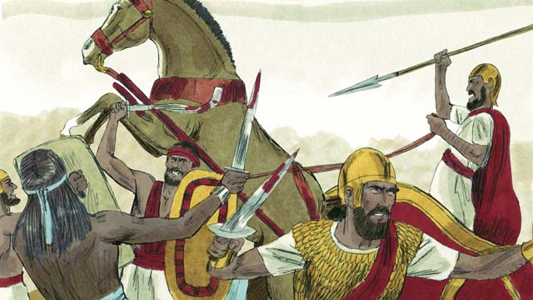

The kingdoms of Judah and Israel became enemies and often fought against each other.

18-11

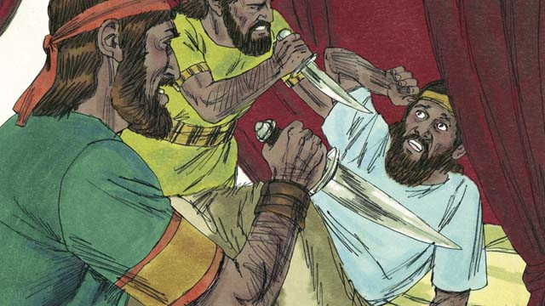

In the new kingdom of Israel, all the kings were evil. Many of these kings were killed by other Israelites who wanted to become king in their place.

18-12

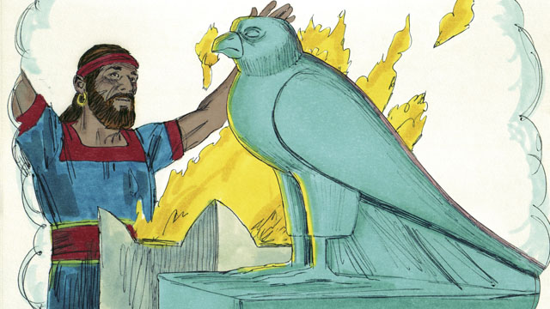

All of the kings and most of the people of the kingdom of Israel worshiped idols. When they did this, they often slept with prostitutes and sometimes even sacrificed children to the idols.

18-13

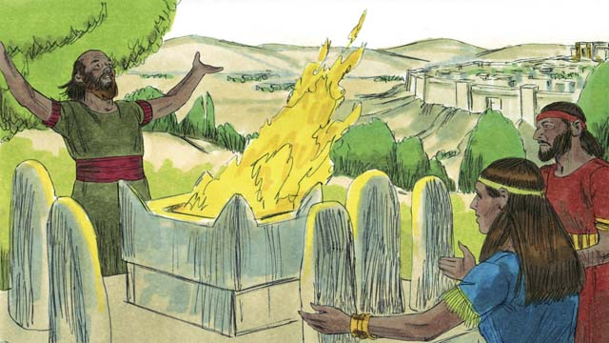

The kings of Judah were descendants of David. Some of these kings were good men who ruled justly and worshiped God. But most of Judah’s kings were evil. They ruled badly, and they worshiped idols. Some of these kings even sacrificed their children to false gods. Most of the people of Judah also rebelled against God and worshiped other gods.

*A Bible story from: 1 Kings 1-6; 11-12*

## 1 Community Study: Put on the New Man—Becoming a Community of Transformed Members

* **Key Idea**: experiencing transformation as a Christian community
* **Key Passage**: Colossians 3:1-11
* **Main Session**: OBS 18 (The Divided Kingdom)

### 1.1 Recite the Creedal Verse (3–5 minutes)

The verse below summarizes the teaching of the current passage. Read the verse out loud as a community. Read it again several times as a group until the whole community can recite it from memory.

11 Therefore Yahweh said to Solomon, “Because you have done this and have not kept the covenant and my statutes that I have commanded you, I will surely tear the kingdom from you and give it to your servant.” 1 Kings 11:11

OR

For the time that is past suffices for doing what the Gentiles want to do, living in sensuality, passions, drunkenness, orgies, drinking parties, and lawless idolatry. 1 Peter 4:3

### 1.2 Name the Temptations (5 minutes)

It is not easy to be a Christian. There are many temptations that Christians face. When Christians sin, it brings ruin to personal lives and community life. Think about the ways of the world that are temptations to Christians.

Some of the temptations that Christians face are…

### 1.3 Read the Passage (5 minutes)

When believers place their faith in Jesus, Jesus commands them to reject sinful ways of living. God joins Christians together into a community of faith. Read the passage below to understand the way that God wants Christian community to live.

1 If then God has raised you with Christ, seek the things above, where Christ is sitting at the right hand of God. 2 Think about the things above, not about the things on earth. 3 For you have died, and your life is hidden with Christ in God. 4 When Christ appears, who is your life, then you will also appear with him in glory. 5 Put to death, then, the members that are on earth—sexual immorality, uncleanness, passion, evil desire, and greed, which is idolatry. 6 It is for these things that the wrath of God is coming on the sons of disobedience. 7 It is in these things that you also once walked when you lived in them. 8 But now you must get rid of all these things—wrath, anger, evil intentions, insults, and obscene speech from your mouth. 9 Do not lie to one another, since you have taken off the old man with its practices, 10 and you have put on the new man that is being made new in knowledge according to the image of the one who created it. 11 This is where there is no Greek and Jew, circumcision and uncircumcision, barbarian, Scythian, slave, freeman, but Christ is all, and is in all. Colossians 3:1-11

### 1.4 Discuss the Idea (10–15 minutes)

Christians reject their old ways of living. God gives Christians the power to experience change. After reading the passage above, use the following questions to help your community discuss biblical teaching on personal life transformation.

1. How does this passage describe the way that Christians can experience change and transformation in their lives?
2. What does a Christian community look like that has experienced this change/transformation?
3. How would you describe the maturity of your community in light of this passage?
4. What next steps does God want you to take to apply these principles to your community life?
5. Why is it important for your community to practice these principles of personal transformation?

### 1.5 Share Your Story (10 minutes)

Think about the various principles of change discussed in the passage above. Identify 1–2 principles that you want to apply to your life. Then, identify 1–2 principles that you think are important for your community.

God is calling me to focus on the following principles…

I think that our community would mature by focusing on the following principles…

### 1.6 Pray to God (5 minutes)

Pray for your community to experience God’s transformation and change. Use the language of the above biblical passage to pray that God would cause this change in your community.

### 1.7 Sing a Song (3–5 minutes)

Choose a song that praises God for his great work of transformation. Sing this song together and celebrate God’s work of change in your lives.

## 2 Biblical Interpretation: Observing the Details of the Story

After reading the crafted biblical story, answer the following questions to familiarize yourself with the details of the story.

### 2.1 Observation Questions

Answer the following observation questions to gain a basic understanding of the the story. Read the story as a community and answer these questions as a group.

#### 18-01

Who ruled Israel after David died?  
David died after 40 years as king of Israel. His son, Solomon, was Israel’ next king.

What did Solomon ask God to do for him?  
He asked God to make him very wise.

What did God think of Solomon’s request?  
God was pleased with Solomon’s request for wisdom. God made him the wisest man in the world. God also made him very wealthy.

#### 18-02

How did David prepare for the building of the Temple?  
David planned and gathered materials for the building of the Temple.

What was the purpose of the Temple that Solomon built?  
It was a place for the people to worship God and offer sacrifices. God was present with his people in the Temple.

#### 18-03

What serious sins did Solomon commit?  
Solomon loved women from other countries. He married many foreign women and worshiped their gods in his old age.

#### 18-04

What did God think of Solomon marrying foreign wives and worshiping their false gods?  
God was very angry with Solomon for this sin.

How did God punish Solomon’s sins?  
God said he would divide the nation of Israel into two kingdoms after Solomon’s death.

#### 18-05

Who became king after Solomon?  
Solomon’s son, Rehoboam, became king of Israel after Solomon.

What complaint did the people have against Solomon?  
The Israelites complained that Solomon made them do a lot of hard work and pay a lot of taxes. They asked Rehoboam to make them work less.

#### 18-06

What foolish answer did Rehoboam give to the people?  
I will make you work harder and punish you more than my father, Solomon, did.

#### 18-07

How did many Israelites respond when they heard Rehoboam’s answer?  
Many people rebelled against Rehoboam. Ten tribes of Israel left him and only two remained.

What was the name of the kingdom founded by the two southern tribes who remained with Rehoboam?  
It was named the kingdom of Judah.

#### 18-08

How many of the tribes rebelled against Rehoboam and formed the northern kingdom?  
Ten tribes joined the kingdom of Israel. They were in the northern part of the land.

#### 18-09

What did Jeroboam do to keep his people from going to Judah to worship at the Temple?  
Jeroboam rebelled against God. He built and placed two idols in the kingdom of Israel for his people to worship.

What effect did Jeroboam’s sin have on the Israelites?  
The Israelites no longer went to Jerusalem to worship God in the Temple.

#### 18-10

How did the two kingdoms of Israelites relate to each other?  
The kingdoms of Judah and Israel became enemies and fought against each other.

#### 18-11

How many of the kings of Israel were faithful to God?  
None of them were faithful.

How did many of the kings of Israel die?  
Many of the kings of Israel were killed by other Israelites who wanted to become king.

#### 18-12

What was wrong with the worship of many Israelites?  
All the kings and most of the people in the kingdom of Israel worshiped idols.

What were some of the evil practices that were often included in the worship of idols?  
They took part in sexual immorality and child sacrifice.

#### 18-13

Who was the ancestor of the kings of Judah?  
King David was their ancestor.

Were any kings of Judah faithful to God?  
Yes, some were faithful, but most were evil. Most of the kings ruled badly and worshiped idols. Some kings sacrificed their children to false gods.

How well did the people of Judah follow God?  
Most of the people of Judah rebelled against God and worshiped other gods.

### 2.2 Translation Questions

Use the following translation questions to understand specific details of the passage. Discuss how you might translate these specific elements of the story.

#### 18-01

**Solomon began to rule over Israel** After David died, Solomon became king of Israel. This was the beginning of Solomon’s rule as king of Israel. How would you express **Solomon began to rule over Israel** to mean the beginning of Solomon’s rule as Israel’s king?

  

**so he made Solomon the wisest man in the world** Solomon asked God to make him very wise. This request pleased God. As a result, God made Solomon wiser than anyone else in the world. How would you express **so he made Solomon the wisest man in the world** to mean the result of God being pleased with Solomon’s request for wisdom was God made him the wisest man in the world?

  

#### 18-02

**instead of at the Tent of Meeting** Since the time of Moses, the Israelites offered sacrifices to God in the Tent of Meeting. The Temple was the new place where Israelites would offer sacrifices and worship God. How would you express **instead of at the Tent of Meeting** to mean the Temple replaced the Tent of Meeting as the place of worship and sacrifice?

  

**was present in the Temple** God was present in the Temple in a special way. Even though God was also present everywhere else at the same time, he made himself especially available to the people at the Temple. How would you express **was present in the Temple** to mean God was with is people in a special way by being at the Temple (even though he was also present everywhere at the same time)?

  

**with his people** The Temple was the dwelling place of God. God does not actually need a house. He is equally present everywhere at the same time. But God dwelled in the Temple in a special way so he could be in the midst of his people. How would you express **with his people** **with his people** to mean God was among his people by being present in the Temple?

  

#### 18-03

**But Solomon loved women from other countries** Solomon building the Temple was a faithful act. Solomon marrying foreign women was disobedient to God. These two actions are in contrast with one another. How would you express **But Solomon loved women from other countries** to mean Solomon building the Temple, God’s dwelling place, was opposite to Solomon loving women from other religions?

  

**brought their gods with them** Solomon married many foreign women. These women worshiped false gods. When they came to Israel, they brought their gods and continued worshiping them as they had in their home countries. How would you express **brought their gods with them** to mean the foreign women Solomon married brought their idols and continued their methods of worshiping idols with them to Israel?

  

**When Solomon was old** Eventually, Solomon became an old man. At the time he became an old man, he worshiped the false gods that his foreign wives worshiped. How would you express **When Solomon was old** to mean by the time Solomon became an old man, he worshiped the false gods of his foreign wives.

#### 18-04

**because of this** Solomon’s worship of false God’s displeased God. This made God angry with Solomon. How would you express **because of this** to mean reason God was angry was Solomon worshiped other gods?

  

**by dividing the nation of Israel into two kingdoms** God caused the nation of Israel to become two kingdoms. God did this as punishment for Solomon’s sin. How would you express **by dividing the nation of Israel into two kingdoms** to mean the way God punished Solomon was to split the nation of Israel into two nations?

  

#### 18-05

**After Solomon died** Solomon died and then Rehoboam became king. How would you express **After Solomon died** to mean Rehoboam became king of Israel subsequent to Solomon’s death?

  

**to accept him as their king** The Israelites gathered to tell Rehoboam that they were glad he was king and that they would do what he said. How would you express **to accept him as their king** to mean to approve Rehoboam as the man who ruled the country where they lived?

  

#### 18-06

**But Rehoboam answered them in a very foolish way** Rehoboam’s answer was harsh, and caused the people to turn against him. How would you express **But Rehoboam answered them in a very foolish way** to mean Rehoboam’s unwise and harsh response was different/opposite than the people’s request for a wise and gracious response?

  

**But I will make you work harder than he did** The Israelites complained that Solomon made them work hard. Rehoboam said that he would make them work even harder. Rehoboam said that the work under his rule would be worse than the work under Solomon’s rule. How would you express **But I will make you work harder than he did** to mean the work under Rehoboam would be more difficult than the work under Solomon?

  

#### 18-07

**tribes** The descendants of each of Jacob’s 12 sons had become a tribe or very large family group in the nation of Israel. Everyone in Israel belonged to one of the 12 **tribes**. How would you express **tribes** to mean groups of families in the larger community that comes from the same ancestry?

  

**rebelled against him** Most of the people refused to follow Rehoboam as their king. How would you express **rebelled against him** to mean the revolt against someone in authority and to refuse to listen to them as their leader?

  

**remained with him** Two tribes did not rebel against Rehoboam. The continued to follow him as their king. How would you express **remained with him** to mean two Israelite tribes stayed loyal to Rehoboam and continued to support him as king?

  

**the kingdom of Judah** The kingdom fo Judah was the name of the kingdom of Israelites in the southern part of the land. How would you express **the kingdom of Judah** to mean the name of the southern kingdom of Israel?

  

#### 18-08

**the kingdom of Israel** The kingdom fo Israel was the name of the kingdom of Israelites in the northern part of the land. How would you express **the kingdom of Israel** to mean the name of the northern kingdom of Israel?

  

#### 18-09

**caused the people to sin** Jeroboam rebelled against God and led the people to sin by making idols for the people to worship. How would you express **caused the people to sin** to mean Jeroboam was responsible for leading the people to sin against God?

  

#### 18-10

**Judah and Israel became enemies** The people of Judah and Israel were all descendants of Jacob and part of God’s people. They were not always enemies. Even so, they disobeyed God and fought and killed each other. How would you express **Judah and Israel became enemies** to mean the new relationship between the kingdom of Israel and the kingdom Judah at this time was one of fighting and hostility?

  

#### 18-11

**who wanted to become king in their place** Israelites who killed the kings wanted to become king of Israel. How would you express **who wanted to become king in their place** to mean the Israelites who killed the kings wanted to replace them as king of Israel?

  

#### 18-12

**When they did this** The kings and many Israelites worshiped idols. This false worship led to sleeping with prostitutes and sacrificing children. How would you express **When they did this** to mean the same time the people of the kingdom of Israel started worshiping idols, they also started sleeping with prostitutes and sacrificing children to idols?

  

#### 18-13

**ruled justly** Some of the kings of Judah ruled according to God’s laws. When they ruled, they did what was right. How would you express **ruled justly** to mean some of the kings of Judah ruled in a way that God considered right and proper?

  

## 3 Theological Dialogue: Discussing the Meaning of the Story

Take time to explore the meaning of this story together as a community. Use the following discussions as a way to grasp what truth the story teaches.

### 3.1 Discourse Questions

Use the following discourse questions to understand the meaning of the story. Pay attention to how the story itself addresses each question or theme.

##### What was Solomon’s rule like? (18-01, 18-02, 18-03, 18-04)

David ruled Israel for 40 years. Solomon became king over Israel after David died. (18-01)

  

Wisdom: Solomon asked God to make him very wise. God made Solomon the wisest man in the world at the time. (18-01)

  

Wealth: God also made Solomon wealthy. Solomon did not seek this wealth. God blessed him with this wealth because Solomon sought after wisdom first. (18-01)

  

Worship: Solomon built the Temple. This was permanent building where God would dwell with his people and God’s people would worship God and offer sacrifices to God. (18-02)

  

Women: Solomon loved many foreign women. He married many foreign women. These women brought their false worship into Israel and Solomon even worshiped some of their gods. (18-03)

  

God was not pleased with Solomon marrying many foreign women and the false worship they brought into Israel. God punished Solomon by dividing his kingdom into two. (18-04)

  

##### How did Israel divide into two kingdoms? (18-04, 18-05, 18-06, 18-07, 18-08)

God divided the kingdom of Israel into two kingdoms as punishment for Solomon’s sin. (18-04)

  

Solomon’s son, Rehoboam, acted very foolishly. The people asked for him to make them work less. Rehoboam said he would make the people work harder and suffer more than the did under Solomon. (18-05, 18-06)

  

The people rebelled against Rehoboam. Only two tribes remained with Rehoboam. The other ten tribes followed a man named Jeroboam. (18-07, 18-08)

  

##### What was the divided kingdom like? (18-09, 18-10, 18-11, 18-12, 18-13)

Sin: Jeroboam rebelled against God and caused the Israelites to sin. (18-09)

  

Idolatry: Jeroboam built idols. The people worshiped the idols instead of God. The people no longer went to the Temple to worship God. (18-09)

  

Hostility: The kingdom of Judah and the kingdom fo Israel became enemies and fought against each other. (18-10)

  

Evil: All the kings of Israel were evil. They worshiped false gods and did evil acts. (18-11, 18-12)

  

Most of the people of the kingdom of Israel worshiped false gods. Some slept with prostitutes when they worshiped false gods and some sacrifice their children to the idols. (18-12)

  

Most of the kings of Judah ruled badly. Only some of the kings of Judah were good men who ruled justly. They worshiped idols and some even sacrificed their children to false gods. (18-13)

  

Most of the people of Judah rebelled against God and worshiped false gods. (18-13)

  

### 3.2 Theological Questions

Answer the following theology questions as a community. Discuss what truths this story teaches.

1. What is God’s kingdom like? What do the good/positive things of Solomon’s rule teach us about God’s kingdom?
2. How can leaders misuse their authority to disobey God and lead others into sin? What can we learn about the wrong use of authority from the negative examples of the kings of Israel and Judah?
3. What are the effects of leaders practicing evil and rebelling against God’s ways? How does the story of the divided kingdom caution/warn us about the effects/consequences of leaders not following God’s ways?
4. How does false worship (i.e., worshiping idols) lead to other sins? In what ways does this story teach us about the way idolatry tempts people to other sins?

### 3.3 Translation Draft

Work as a translation team to draft each panel of this story. Pay attention to any specific translation issues that are challenging or significant.

#### Make Translation Draft

Make a draft for each section of this story.

#### Discuss and Revise

After drafting the story, discuss any translation issues that you think need special explanation.

#### Drafting Summary Reflection

Summarize any noteworthy translation decisions and the rationale/reasoning behind these translation decisions. In the final movement of this class, you will use these observations to give an account (i.e., chronicle/narrate) of how your translation improved through the checking process.

## 4 Personal Reflection: Following the Teaching of the Story

Take a moment to allow this story to evaluate your own life and to consider how God would have you respond. After this reflection, use the quality checking questions to check your translation draft among the translation team.

### 4.1 Journal Reflection

Prayerfully think about the following personal reflection questions. Write/Record your answers and/or discuss them as a group.

1. If you could ask God for anything (like Solomon), what would you ask him for? What does this tell about your spiritual condition?
2. How has false worship led you into other sins?
3. How have you misused authority in your life? How have you been mistreated by those who have authority?
4. In your life, how have you rebelled against God? What consequences did this rejection of God bring in your life and the lives of others?
5. What would it look like to repent of your false worship and rebellion?

### 4.2 Team Check

*The following activity will help you check the clarity, accuracy, and naturalness of your draft. Read the passage aloud and discuss the checking questions with other members of your translation community. You might need to reread portions (or the whole) of the biblical passage multiple times as you answer each of these questions. Record answers to these questions below.*

#### Team Checking Questions

*Use the following questions to check your translation draft for accuracy, clarity, and naturalness.*

1. **Accurate**: Has anything been **added** to your translation of this passage that is not a part of the meaning of the source text? *If additions exist, are they included only added to clarify meaning (such as implied information)?*
2. **Accurate**: Is anything **missing** from your translation of this passage that is a part of the meaning of the source text? *If some part of the meaning is missing from your translation, add it.*
3. **Accurate**: Does any meaning in your translation of this passage appear to be **different** than the meaning of the source text? *If the meaning is different, try changing your translation so that the meaning remains the same.*
4. **Natural**: Does anything sound **unnatural** to how you would say it in your language? *If portions of the passage sound unnatural in your language, try to make them sound the way you would say it in your language while staying true to the meaning of the source text.*
5. **Clear**: Is anything **unclear** or **confusing** in your translation that confuses the meaning of the source text? *If portions of the passage are unclear or confusing, revise them to clearly communicate the meaning of the source text.*
6. **Consistent**: How **consistent** is your translation within the passage and with other passages? *If portions of the passage need to be made consistent or if you need to revise translations of other passages, make these adjustments.*

#### Record Feedback

*After discussing the checking questions above as a translation community, record any feedback on your translation draft. Pay attention for parts of your translation that are translated well and parts of your translation that need correction.*

#### Discuss and Revise

*After gathering feedback on your draft, discuss it together with your translation community and make appropriate revisions in your translation.*

#### Record Translation Decisions

*As a community, discuss some of the most noteworthy translation decisions in your draft. Summarize each decision and explain the reasons your community decided on that translation. You should update these decisions each time you check your draft with various groups of people.*

You should **measure** the quality of your translation draft. You can **record translation decisions** to make it clear why you translated things a certain way. Translation decisions can help your translation team and the surrounding community be a part of the translation process.

How can you know the quality of your translation?

1. **Measure** the translation by marks/standards of quality (i.e., clear, accurate, natural, church-approved)
2. **Test** the translation with others and record feedback and conversations from in the field (i.e., church and community check)
3. **Compare** and **contrast** the translation with the source text (i.e., meaning of text and notes) and alternatives (i.e., other translation choices)
4. **Explain** the reasons why you translated a particular portion of the text.

**Example Sentences That Help Explain Your Translation Decision** Use the following example sentences to help explain your translation decisions:

1. The original text literally **says/means**, so we translated the term in this way…
2. We originally decided to translate **the biblical term** with **this term**, but we changed it because…
3. When our translation team discussed **the biblical term**, this is what we talked about…
4. **The term** is [clear, accurate, natural, consistent] because…
5. The community understands **this term** to mean…
6. We considered these other terms. We did not use **these terms** because…
7. When we checked this in the church, we learned…
8. When we checked this in the community, we learned…

**Example of Translation Decision**

In OBS 01-07 we decided to translate **blessed** like this: [actual translation]. We decided on this translation because of these reasons:

1. The word [actual translation] means to cause good things to happen to someone or something. This term is used when a person desires someone or something to prosper or flourish. This term does not refer to magic or witchcraft.
2. When we checked this word with other believers, they said it describes God showing his kindness and favor on someone or something. These are some of the terms that we did not decide to use…
3. Many of our people will understand this word. When we discussed this phrase with the surrounding community, we discovered it was a natural way to describe God causing good and beneficial things to happen.

## 5 Ministry Practice: Serving the Church with the Story

Now that you have a draft of this story, consider how this story can encourage other believers in their faith. After ministering this story to others, you will also perform a community check of your translation draft.

### 5.1 Church Ministry

Reflect on how this story can edify and mature the Christian community. Design a way to minister this story to your church community.

**Ministry Preparation**: Take time to consider how you could minister this story to others. Record some ministry ideas below.

**Ministry Implementation**: Minister this story to a group of believers as you had planned. Use the information in this study to help develop a teaching/lesson or lead a discussion of this story to other believers. Record your ministry plan below.

**Ministry Reflection**: Think about what you learned from ministering this story to other believers. Reflect on your experience below.

### 5.2 Church Community Check

After teaching or ministering this story to the church, check the translation quality with the church community. Record any feedback from your checking experience.

#### Create Checking Questions

You can use **Translation Questions** to check your draft. Each **Translation Question** explains the meaning of a specific part of the story and asks you to consider how you would translate that part of the story in your own language. Change each **Translation Question** into a **Checking Question** by asking the following questions. The first question asks you to identify how each specific phrase was translated into your language. The second question asks people in the church to determine if your translation of the phrase expresses the meaning clearly, accurately, and naturally. Look at the following examples to see how to change **Translation Questions** into **Checking Questions**:

#### Translation Question Example 1

**to proclaim the good news about Jesus** Paul and Silas traveled to Philippi for the purpose of preaching the gospel. The gospel is the good news that Jesus saves people from their sins if they will believe in Jesus. How would you express **to proclaim the good news about Jesus** to mean to tell other people the message about how Jesus can save people from their sins?

#### Translation Question Example 2

**a merchant** Paul and Silas met a woman named Lydia at the place by the river. She owned a business and sold items to make money. How would you express **a merchant** to mean a business owner who sells items for a profit?

#### Translation Question Example 3

**so Paul and Silas baptized them** The jailer and his whole family followed Paul’s instructions. They believed in Jesus. The result of this was Paul and Silas baptized them. How would you express **so Paul and Silas baptized them** to mean the result of the jailer and his family believing in Jesus that Paul and Silas baptized all of them?

You can change these into **Checking Questions** like this:

#### Checking Question Example 1

**to proclaim the good news about Jesus** How did you translate **to proclaim the good news about Jesus**? Does it mean to tell other people the message about how Jesus can save people from their sins?

#### Checking Question Example 2

**a merchant** How did you translate **a merchant**? Does it mean a business owner who sells items for a profit?

#### Checking Question Example 3

**so Paul and Silas baptized them** How did you translate **so Paul and Silas baptized them**? Does it mean the result of the jailer and his family believing in Jesus that Paul and Silas baptized all of them?

#### Record Feedback

*Discuss the* ***Checking Questions*** *with your church community, and record any feedback on your translation draft. Pay attention to parts of your translation that are translated well and parts of your translation that need correction.*

#### Discuss and Revise

*After gathering feedback on your draft, discuss it together with your translation community and make appropriate revisions to your translation.*

#### Record Translation Decisions

*Update your translation decisions and record any new and noteworthy observations on the quality of your draft.

## 6 Missional Outreach: Sharing the Truth of the Story

*After sharing this story with others, check the translation quality with the wider language community. Record any feedback from your checking experience.*

### 6.1 Mission Engagement

*Consider how you will witness this story to unbelievers. Design a way to share this story and engage them in what it teaches about Christianity and the gospel.*

**Witness Preparation**: Take time to consider how you will witness this narrative to unbelievers. Record some ideas below.

**Witness Implementation**: Share this story with an unbeliever. Use the information in this study to help develop a teaching/lesson or lead a discussion of this story to other believers. Record your ministry plan below.

**Witness Reflection**: Think about what you learned from ministering this story to unbelievers. Reflect on your experience below.

### 6.2 Sociolinguistic Check

After sharing this story with the language community, check your translation draft with the surrounding community. Record your observations.

#### Checking Approach

After witnessing this story to unbelievers, use one of the following methods to check the translation of this story. Consider using the **Observation Questions** to check your translation draft or come up with your own quality checking questions.

**Read-Retell Check:** Read your draft to those the community and ask them to retell the passage. Be attentive to any portions of the passage that are unclear, unnatural, or inaccurate.

**Comprehension Questions Checklist:** Read the draft of the passage and ask a list of comprehension questions to make sure the passage is being rightly understood. You can use the **Observation Questions** in this guide or come up with your own questions. Then, record any insights or issues that arise.

**Discussion Group:** Develop key questions to ask about the passage (both formational and translational). Read the passage and have a group discussion about the passage, paying attention to issues that need to be addressed, edited, and revised.

#### Record Feedback

*After sharing your draft with the language community, discuss the* ***Observations Questions****, and record any feedback on your translation draft. Pay attention to parts of your translation that are translated well and parts of your translation that need correction.*

#### Discuss and Revise

*After gathering feedback on your draft, discuss it together with your translation community and make appropriate revisions to your translation.*

#### Record Translation Decisions

*Update your translation decisions and record and new any noteworthy observations on the quality of your draft.

## 7 Conclusion

As a translation community, take time to reflect on all that was learned in studying, drafting, and checking this story. Celebrate all that God has taught you as a community. Then, submit your revised draft and checking summaries to network leaders for further review.