Open Bible Stories

The Prophets

## 0 Introduction

### 0.1 Key Idea

The story of the prophets teaches us the need to repent of our sin to escape God’s judgment and punishment.

### 0.2 Creedal Verse

“Repent therefore, and turn back, that your sins may be blotted out, that times of refreshing may come from the presence of the Lord, and that he may send the Christ appointed for you, Jesus, whom heaven must receive until the time for restoring all the things about which God spoke by the mouth of his holy prophets long ago.” Acts 3:19-21

### 0.3 Metanarrative Summary

The eternal God created all things in six days. He made a good and perfect world. He made humans in his image to fill the earth and rule over creation. But humans rebelled against God and ruined God’s creation. God set to restore his world through his promise. God made a covenant with Abraham. He promised to bless all nations through Abraham. God kept his promises across the generations. God provided Abraham with a promised child, Isaac. God gave Isaac a wife and she bore twins, Jacob and Esau. God blessed Jacob and his sons, and the blessing continued to the next generation. God rescued Joseph, one of Jacob’s sons, and used him to rescue his family. God caused his people, the Israelites, to multiply in the land of Egypt; eventually, they became slaves. But, God raised up a deliverer, Moses, to deliver his people from their slavery. God sent judged the Egyptians with harsh plagues; in the final judgment, he passed over his people who covered their doorposts with the blood of a sacrificed lamb. Then, God delivered the Israelites by bringing them out of Egypt and crossing the Red Sea on dry land. God made a covenant with the Israelites and made them his people. God tested Israel in a series of wilderness wanderings and eventually brought his people into the promised land of Canaan. God raised up deliverers to lead Israel and rescue them from their enemies. God formed Israel into a kingdom. He made a covenant with King David and promised to send a king that would rule his people forever. Many of Israel’s kings were evil and the kingdom of Israel divided into two kingdoms. God sent prophets to warn his people of God’s judgment and call them to repent.

### 0.4 Open Bible Story: The Prophets

19-01

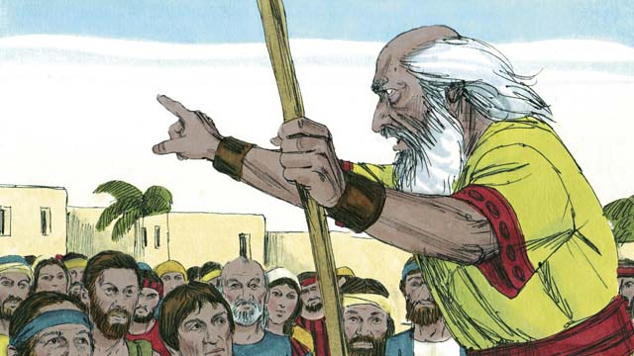

God was always sending prophets to the Israelites. The prophets heard messages from God and then told them to the people.

19-02

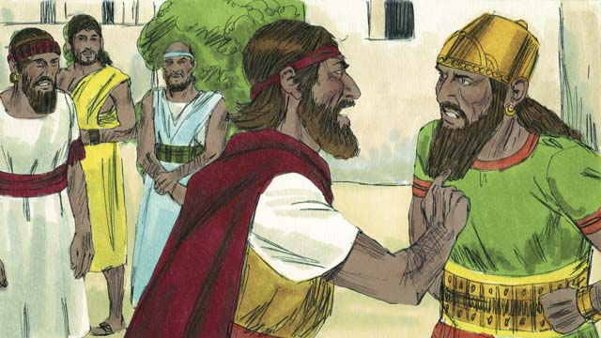

Elijah was a prophet when Ahab was king over the kingdom of Israel. Ahab was an evil man. He tried to make the people worship a false god named Baal. So Elijah told King Ahab that God was going to punish the people. He said to him, “There will be no rain or dew in the kingdom of Israel until I say it will rain again.” This made Ahab so angry that he decided to kill Elijah.

19-03

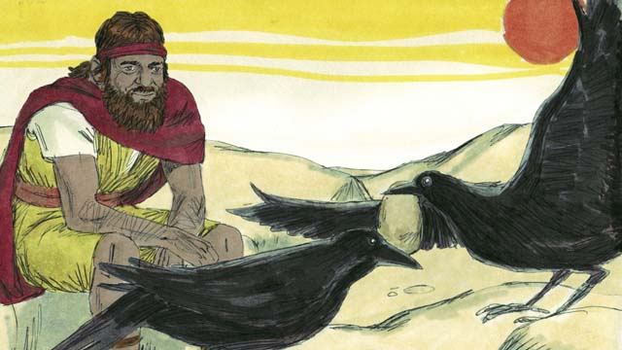

So God told Elijah to go into the wilderness to hide from Ahab. Elijah went into the wilderness to a certain stream where God directed him. Every morning and every evening, birds would bring Elijah bread and meat. During this time, Ahab and his army looked for Elijah, but they could not find him.

19-04

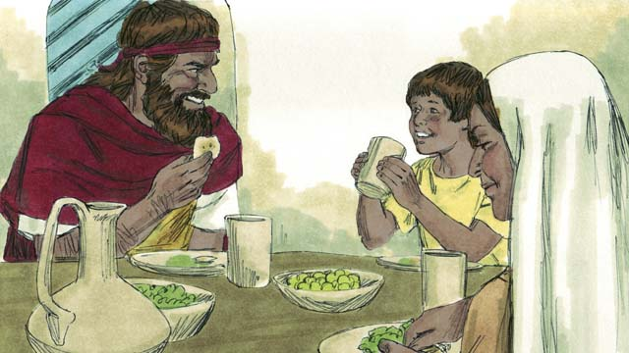

Because there was no rain, after some time the stream dried up. So Elijah went to another country close by. In that country lived a poor widow and her son. They had almost run out of food because there was no harvest. But still, as the woman took care of Elijah, God provided for her and her son. Her jar of flour and her bottle of oil never became empty. They had food during the whole famine. Elijah stayed there for about three years.

19-05

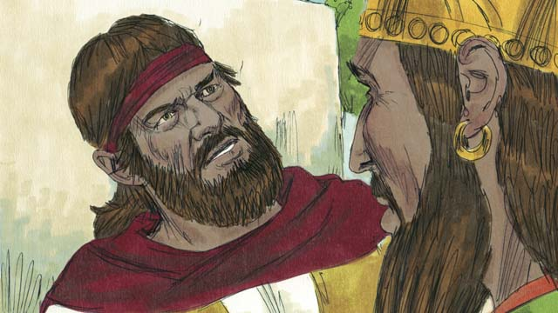

After three and a half years, God told Elijah that he would make it rain again. He told Elijah to return to the kingdom of Israel and speak with Ahab. So Elijah went to Ahab. When Ahab saw him, he said, “There you are, you troublemaker!” Elijah replied to him, “It is you who are the troublemaker! You have abandoned Yahweh. He is the true God, but you are worshiping Baal. Now you must bring all the people of the kingdom of Israel to Mount Carmel.”

19-06

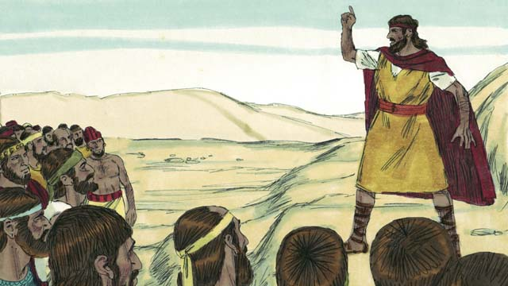

So all the people of Israel went to Mount Carmel. The men who said they spoke messages for Baal also came. These were Baal’s prophets. There were 450 of them. Elijah said to the people, “How long will you keep changing your mind? If Yahweh is God, worship him! But if Baal is God, worship him!”

19-07

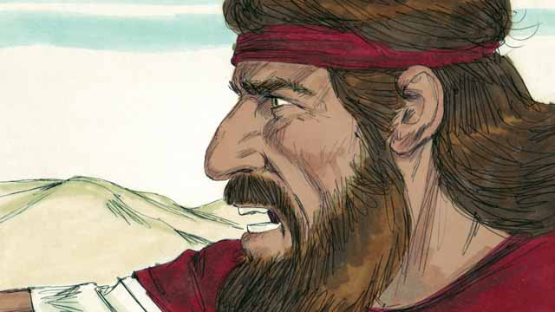

Then Elijah said to Baal’s prophets, “Kill a bull, divide the meat into pieces, and put it on an altar for a sacrifice, but do not light the fire. I will do the same later, and I will put the meat on a different altar. Then if God sends fire on the altar, you will know that he is the real God.” So the prophets of Baal prepared a sacrifice but did not light the fire.

19-08

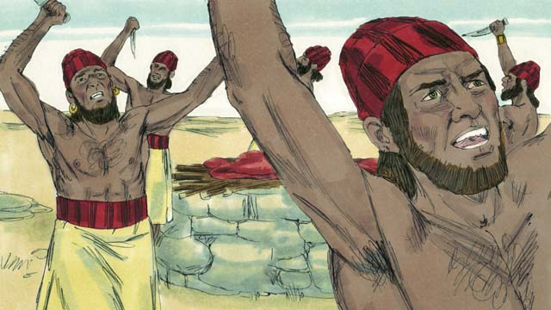

Then the prophets of Baal prayed to Baal, “Hear us, Baal!” All day long they prayed and shouted and even cut themselves with knives, but Baal did not answer, and he did not send any fire.

19-09

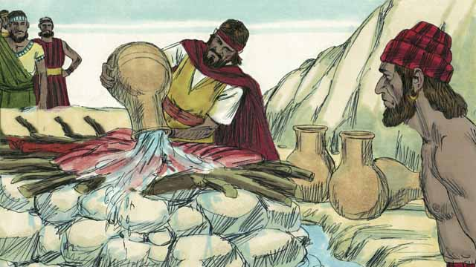

Baal’s prophets spent almost the whole day praying to Baal. They finally stopped praying. Then Elijah put the meat of another bull on an altar for God. After that, he told the people to pour 12 huge pots of water on top of the sacrifice until the meat, the wood, and even the ground around the altar were completely wet.

19-10

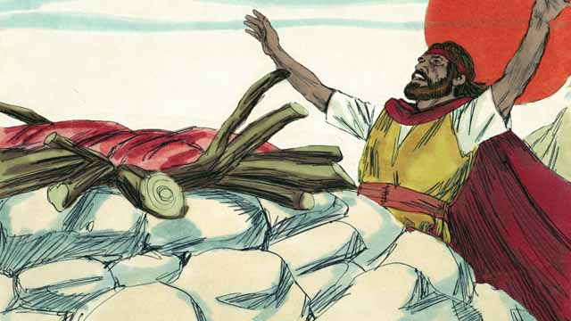

Then Elijah prayed, “Yahweh, God of Abraham, Isaac, and Jacob, show us today that you are the God of Israel and that I am your servant. Answer me so that these people will know that you are the true God.”

19-11

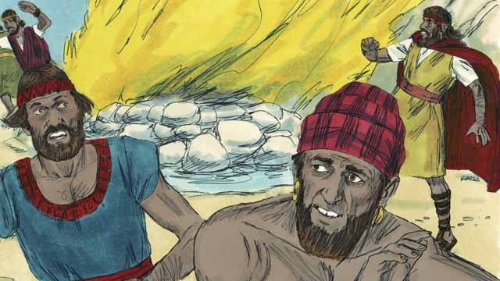

Immediately, fire fell from the sky. It burned up the meat, the wood, the rocks, the soil, and even the water that was around the altar. When the people saw this, they prostrated themselves to the ground and said, “Yahweh is God! Yahweh is God!”

19-12

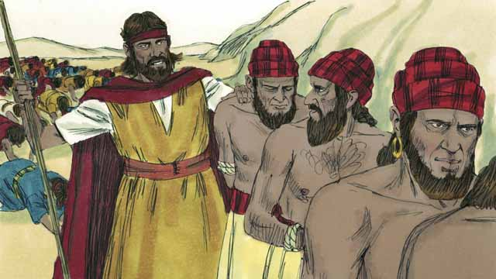

Then Elijah said, “Do not let any of the prophets of Baal escape!” So the people captured the prophets of Baal and took them away from there and killed them.

19-13

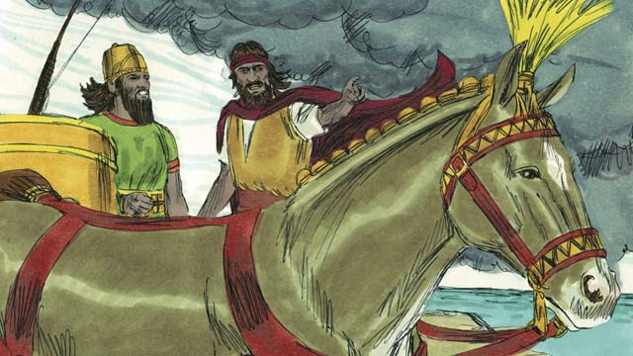

Then Elijah said to King Ahab, “Return immediately to your home, because the rain is coming.” Soon the sky became black, and a heavy rain began. Yahweh was ending the drought. This also showed that he is the true God.

19-14

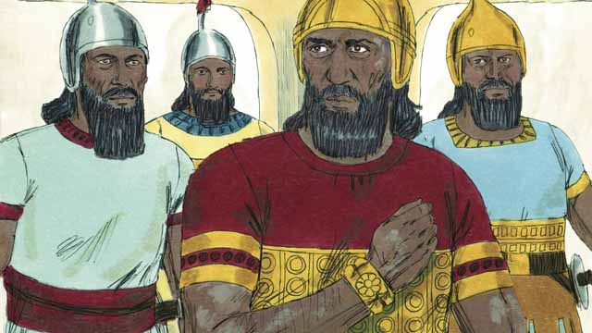

When Elijah finished his work, God chose a man named Elisha to be his prophet. God did many miracles through Elisha. One of the miracles happened to Naaman. He was the commander of an enemy army, but he had a bad skin disease. Naaman heard about Elisha, so he went to Elisha and asked him to heal him. Elisha told Naaman to go the Jordan River and dip himself in the water seven times.

19-15

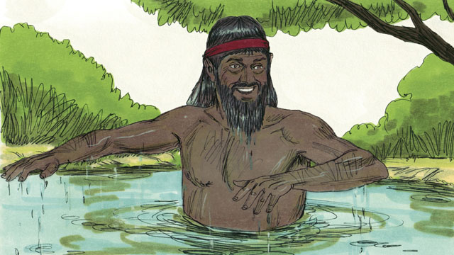

Naaman became angry. He refused to do this because it seemed foolish. But later he changed his mind. He went to the Jordan River and dipped himself seven times into the water. When he came up from the water the last time, God healed him.

19-16

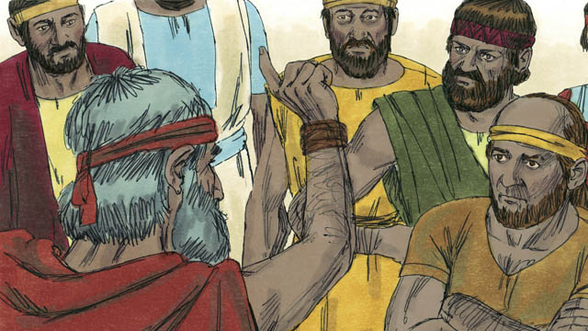

God also sent many other prophets to the people of Israel. They all told the people to stop worshiping idols. Instead, people should act justly with each other and have mercy on each other. The prophets warned the people that they must stop doing evil and obey God instead. If the people did not do this, then God would judge them as guilty, and he would punish them.

19-17

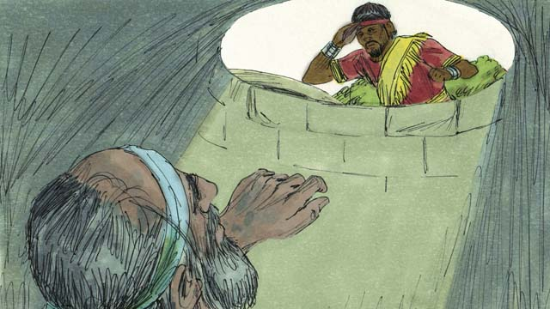

Most of the time, the people did not obey God. They often mistreated the prophets and sometimes even killed them. Once, they put the prophet Jeremiah into a dry well and left him there to die. He sank down into the mud in the bottom of the well. But then the king had mercy on him and ordered his servants to pull Jeremiah out of the well before he died.

19-18

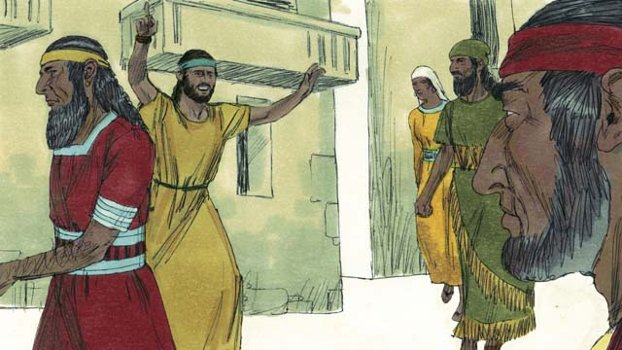

The prophets continued to speak for God even though the people hated them. They warned people that God would destroy them if they did not repent. They also reminded people that God promised to send them the Messiah.

*A Bible story from: 1 Kings 16-18; 2 Kings 5; Jeremiah 38*

##./obs_source/transclusions//obs-devotionals-unit-7#Community Study: All of You—Enjoying Brotherly Unity.md NOT FOUND!!

## 1 Biblical Interpretation: Observing the Details of the Story

After reading the crafted biblical story, answer the following questions to familiarize yourself with the details of the story.

### 1.1 Observation Questions

Answer the following observation questions to gain a basic understanding of the the story. Read the story as a community and answer these questions as a group.

#### 19-01

Who was God sending to the Israelite?  
God was always sending prophets to the Israelites.

What did the prophets do?  
The prophets heard the messages from God and spoke them to the people?  
#### 19-02  
Who was prophet during the reign of King Ahab?  
Eliah was a prophet when Ahab was king over the kingdom of Israel?  
What kind of king was Ahab?  
Ahab was an evil man. He tried to make the people worship a false god named Baal.

What did Elijah say that God was going to do to punish the people?  
Elijah said that God will withhold rain and dew in the kingdom of Israel until Elijah says it will rain again.

How did Ahab respond to this message from Elijah?  
Ahab was so angry about this message he tried to kill Elijah.

#### 19-03

Where did God tell Elijah to go to hide from Ahab?  
God told Elijah to go into the wilderness to hide from Ahab. God directed Elijah to a certain stream of water.

How did God provide for Elijah in the wilderness where he was hiding?  
Every morning and evening, God sent birds with bread and meat for him.

How successful was Ahab in finding Elijah?  
Ahab and his army looked for Elijah but they could not find him.

#### 19-04

What caused the stream where Elijah was staying to dry up?  
Because there was no rain, the stream dried up.

How did the widow treat Elijah?  
The widow took care of Elijah even though the widow and her son had almost run out of food.

How did God provide for Elijah when he lived with the widow and her son?  
God caused their flour jar and bottle of oil to never become empty.

How long did they have food?  
They had food during the whole time of the famine.

How long did Elijah stay there?  
Elijah stayed there for three years.

#### 19-05

What did God tell Elijah after three and a half years?  
God told Elijah that he would make it rain again. He told Elijah to return to the kingdom of Israel and speak with Ahab.

What did Elijah and Ahab say to each other when they met?  
Ahab called Elijah a troublemaker. Elijah told Ahab that he was the troublemaker because he abandoned Yahweh.

What great evil did Elijah say that Ahab had committed?  
Ahab had abandoned Yahweh, the true God, and had worshiped Baal.

What did Elijah tell Ahab to do?  
Elijah told Ahab to bring all the people of Israel to Mount Carmel.

#### 19-06

Who gathered at Mount Carmel?  
The people of Israel, the prophets of Baal, and Elijah gathered at Mount Carmel.

How many prophets of Baal came to Mount Carmel?  
There were 450 prophets of Baal at Mount Carmel.

What choice did Elijah tell the people they must make?  
He told them that if Yahweh is God, they should serve him, but if Baal is God, they should serve Baal.

#### 19-07

What did Elijah tell the prophets of Baal to do?  
Elijah told the prophets of Baal to kill a bull, divide its meat in pieces, and put it on an altar for sacrifice without lighting a fire.

What did Elijah tell the prophets of Baal that he would do?  
Elijah told the prophets of Baal that the would do the same thing later on a different altar.

How would the people know who was the real God?  
The people would know the real God by which altar was lit up by fire.

#### 19-08

How did the prophets of Baal try to get fire on their altar?  
The prophets of Baal prayed to Baal, shouted, and cut themselves with knives.

How did Baal respond?  
Baal did not answer and did not send rain.

#### 19-09

How long did the prophets of Baal pray to Baal to send fire?  
The prophets of Baal prayed almost the whole day and then finally stopped praying.

How did Elijah prepare the altar?  
Elijah put the meat of the bull on the altar and had the people pour twelve huge pots of water on it until the meat, wood and ground around the altar were wet.

#### 19-10

What did Elijah pray to Yahweh?  
Yahweh prayed that God would answer his prayer and show the people that he is the true God.

#### 19-11

How did God show he is the real God?  
God sent fire from the sky and burned up the meat, the wood, the rocks, the dirt, and the water around the altar.

How did the people respond when they saw this demonstration of power?  
They fell on the ground and said, “Yahweh is God! Yahweh is God!”

#### 19-12

What happened to the prophets of Baal?  
The people took them away and killed them.

#### 19-13

What did Elijah tell king Ahab about the rain returning?  
Elijah told Ahab to return home because the rain was coming.

What did the rain show?  
The rain showed that Yahweh was ending the drought and that he is the true God.

#### 19-14

Who was the prophet after Elijah?  
Elisha was prophet after Elijah.

Who was Naaman?  
Naaman was a commander of an enemy army who heard about Elisha and went to him to be healed.

What did Elisha tell Naaman to do to in order to heal his skin disease?  
He told him to dip himself seven times in the Jordan River.

#### 19-15

What did Naaman do after he heard Elisha’s instructions?  
At first he was angry and would not do it because it seemed foolish, but later he changed his mind and did it, and was completely healed.

#### 19-16

What did the prophets tell the people to do?  
They told them to stop worshiping idols and to show justice and mercy to others.

How did the prophets warn the people?  
The prophets warned the people to stop doing evil and obey God. If they did not do this, God would punish them and judge them as guilty.

#### 19-17

In general, how did the people treat the prophets?  
The people mistreated the prophets and sometimes even killed them.

How did the people mistreat the prophet Jeremiah?  
The people put Jeremiah in a dry well and left him there to die.

Did Jeremiah die in the well?  
No, the king had mercy on him and had his servants pull Jeremiah out.

#### 19-18

In general, what did the prophets do?  
The prophets spoke for God, warned about God’s judgment, and reminded them that God would send the promised Messiah.

Who was that person that God promised to send?  
The person that God would send was the Messiah.

### 1.2 Translation Questions

Use the following translation questions to understand specific details of the passage. Discuss how you might translate these specific elements of the story.

#### 19-01

**prophets** Prophets receive messages from God and tell these messages people. These messengers are chosen by God. Sometimes **prophets** told messages of things that would happen in the future. Sometimes **prophets** announced God’s judgment and called God’s people to repent of their sin. Sometimes **prophets** proclaimed God’s promise to deliver his people. How would you express **prophets** to mean a person who receives messages from God and tells these messages to people?

  

**God was always sending prophets to the Israelites** God sent many prophets to the Israelites. He did this for many years and over many generations. How would you express **God was always sending prophets to the Israelites** to mean God sent prophets to the Israelites

#### 19-02

**So Elijah told King Ahab that God was going to punish the people** Ahab tried to make the people worship Baal. This was very evil because Baal was a false god. As a result of this evil, God planned to punish the people. Would would you express **So Elijah told King Ahab that God was going to punish the people** to mean the result of Ahab trying to make the people worship Baal was God planning to punish the people?

  

**until I say it will rain again** Elijah told Ahab that there would be no rain until he commanded the rain and dew to come again. How would you express **until I say it will rain again** to mean rain would only come again at the time Elijah gave the command for it to return?

  

**This made Ahab so angry** God was going to punish the people. There would be no more rain for a long time. This news made Ahab very angry. How would you express **This made Ahab so angry** to mean the news of God’s punishment to not send rain caused Ahab to become extremely upset and angry? the people and would be no rain

  

#### 19-03

**the wilderness** The wilderness is a remote location with very few people, like the desert or the bush. God instructed Elijah to go here in order to hide from Ahab. How would you express **the wilderness** as a remote place where very few people live?

  

**where God directed him.** God told Elijah to go to the wilderness. God also led Elijah to a specific stream. This was the stream where God wanted Elijah to go. How would you express **where God directed him** to mean there was a specific stream where God wanted Elijah to go and God guided/instructed him to go there?

  

**birds would bring Elijah bread and meat** Birds brought bread and meat to Elijah every morning and every evening. This regularly and repeatedly happened every day while Elijah was at the stream in the wilderness. How would you express **birds would bring Elijah bread and meat** to mean each day birds brought Elijah bread and meat each morning and each evening?

  

**During this time** Ahab and his army were looking for Elijah at the same time he was hiding in the wilderness. How would you express **During this time** to mean the same time as Elijah was hiding in the wilderness, Ahab and his army were looking for him but could not find him?

  

#### 19-04

**because there was no harvest** The lack of rain caused a drought. This drought caused there to be no harvest. This lack of harvest caused people to nearly run out of food. How would you express **because there was no harvest** to mean the reason the widow and her son had almost run out of food was there was no harvest?

  

**But still** The widow and her son nearly ran out of food. You would expect the widow to refuse to help Elijah because she was almost out of food, but she did the unexpected and took care of him. How would you express **But still** to mean the woman did the opposite of what one would expect and took care of Elijah?

  

**took care of Elijah** The woman gave Elijah a place to stay in their house and provided food for him. It does not mean he was sick. How would you express **took care of Elijah** to mean the woman let Elijah stay in her house and gave him food?

  

**jar of flour** The woman used a clay jar in which she kept her supply of flour. How would you express **jar of flour** to mean a container made of clay to store flour?

  

**bottle of oil** In Israel, olive oil is used for cooking. This bottle was a container of cooking oil. The widow used the flour and the oil for making bread. How would you express **bottle of oil** to mean a container of cooking oil?

  

**God provided for her and her son.** Her jar of flour and her bottle of oil never became empty God took care of the widow and her son. God prevented their flour jar and their bottle of oil from becoming empty. How would you express **God provided for her and her son.** Her jar of flour and her bottle of oil never became empty to mean God caused their flour jar and their bottle of oil to never become empty?

  

#### 19-05

**you troublemaker** Ahab called Elijah troublemaker. A troublemaker is someone who causes mischief and problems. Ahab was accusing Elijah of causing trouble by telling the king that he was doing wrong and also by stopping the rain. How would you express **you troublemaker** to mean Ahab called Elijah person who caused mischief and difficulty?

  

**It is you who are the troublemaker!** Elijah responded to Ahab with a strong statement rebuke. He told Ahab that he was really the person who was causing trouble and mischief. How would you express **It is you who are the troublemaker!** to be a strong statement in which Elijah rebukes Ahab as the one who was really causing trouble/mischief?

  

**You have abandoned** Yahweh Ahab had led Israel to stop worshiping and obeying Yahweh. Ahab’s worship of Baal was a rejection of Yahweh. How would you express **You have abandoned** Yahweh to mean Ahab had forsaken God by worshipping a false god?

  

**all the people of the kingdom of Israel** Not every person in the land of Israel came to Mount Carmel. This is a generalization to refer to the leaders and people who represent the ten tribes of the northern kingdom. How would you express **all the people of the kingdom of Israel** to mean the leaders and people who represent the ten tribes of the northern kingdom came to Mount Carmel?

  

#### 19-06

**Baal’s prophets** The prophets that served the god Baal came to Mount Carmel. How would you express **Baal’s prophets** to mean the prophets who served the god Baal?

  

**How long will you keep changing your mind?** Elijah rebuked the people for not worshiping Yahweh. He used a question to reprimand them. This is not a real question asking for information. Elijah was rebuking the Israelites for repeatedly changing their minds about whether they would serve Yahweh or Baal. How would you express **How long will you keep changing your mind?** to mean stop changing your minds about whom you will worship?

  

**If Yahweh is God, worship him! But if Baal is God, worship him!** Elijah made a strong statement that the people should decide once for all who they would worship. This does not mean that Elijah was undecided. He knew that Yahweh is the real God. He wanted the people to understand that when they worship false gods, they are rejecting Yahweh as the only true God. He was telling the people that they had to make a choice. How would you express **If Yahweh is God, worship him! But if Baal is God, worship him!** as a strong statement that told the people to decide who the real God is and serve him?

  

#### 19-07

**if God sends fire on the altar** Elijah told the people that they would know that God is the true God when they saw him send fire on the altar. If God sends fire, then it proves that he is real. Elijah knows that Yahweh is the true God. He is not doubting or questioning this. He is tell the people how God would show the people that he is the true God. How would you express **if God sends fire on the altar** to mean God causing fire to come on the altar would show that he is the real God?

  

**the real God** Elijah told the people that they would know that Yahweh is the true God and Baal is a false god. How would you express **the real God** to mean the one and only true God?

  

#### 19-08

**prayed to Baal** The prophets that served Baal called out to Baal to make the request that he send fire on the altar they had prepared. How would you express **prayed to Baal** to mean the prophets of Baal asked Baal to send fire onto the bull they prepared as a sacrifice?

  

**Hear us Baal!** The prophets of Baal made a strong plea for Baal to answer their request and to send fire on the sacrifice. How would you express **Hear us,** Baal! as a strong statement asking Baal to listen to their prayer, answer their request, and send fire on the sacrifice?

  

**cut themselves with knives** The prophets that served Baal injured themselves with knives as an extreme way to show their devotion to Baal, hoping that this would persuade him to listen to them. How would you express **cut themselves with knives** to mean the prophets of Baal harmed themselves with knives to show their commitment to Baal?

  

**but Baal did not answer, and he did not send any fire.** The prophets of Baal made extreme acts of devotion by praying, shouting, and cutting themselves. They expected Baal to answer them. However, the opposite happened. Baal did not respond to the prophets. How would you express **but Baal did not answer, and he did not send any fire** to mean Baal not answering or sending fire is in contrast to the prophets praying, shouting, and cutting themselves?

  

#### 19-09

**After that** Elijah prepared the sacrifice, and then had people pour 12 pots of water over it. How would you express **After that** to mean Elijah had the people pour water over the sacrifice only subsequent to Elijah preparing the sacrifice?

  

**until the meat, the wood, and even the ground around the altar were completely wet** Elijah told the people to pour water on the sacrifice. He told them to do this up to the point that the meat, wood, and ground were wet. How would you express **until the meat, the wood, and even the ground around the altar were completely wet** to mean Elijah instructed the people to pour water on the sacrifice up to the point the meat, wood, and ground were totally wet?

  

#### 19-10

**show us** Elijah asked God to send fire on the sacrifice as proof that Yahweh was the one and only true God. How would you express **show us** to mean to demonstrate or to give evidence/proof that something is true/real?

  

**I am your servant** As a prophet, Elijah was served God. This means God used Elijah to deliver his messages to the Israelites. Elijah also prayed that God would demonstrate to the people that God had given Elijah authority to serve God and do these things. How would you express **I am your servant** to mean Elijah was devoted to God and God chose Elijah to carry out/perform God’s instructions/commands?

  

**Answer me** Elijah asked God to respond to his prayer. Specifically, Elijah asked God to send fire on the sacrifice. How would you express **Answer me** to mean Elijah asked God to respond to his prayer and send the fire he asked God for?

  

**so that these people will know** The purpose Elijah asked God to answer his prayer and send fire was that these people will see and understand that God is the one and only true God. How would you express **so that these people will know** to mean the purpose of God answering Elijah’s prayer and sending fire was for the people to see and understand that God was the one and only true God?

  

#### 19-11

**Immediately** Fire fell from the sky as soon as Elijah prayed. In contrast, the prayers of the prophets of Baal were still not answered after hours of praying. How would you express **Immediately** to emphasize that fire fell from the sky at the very moment Elijah had prayed?

  

**fell from the sky** God sent the fire. The fire came down from the sky. The fire How would you express **fell from the sky** to mean suddenly fire came down from the sky?

  

**even the water that was around the altar** The fire burned up the meat and wood. The fire was so strong that it also burned up the rocks and soil. One would expect the water to put out the fire or make it less of a fire. However, the fire was so strong that it also burned up the water around the altar. How would you express **even the water that was around the altar** to emphasize that the fire was so strong that it also burned up the water?

  

**When the people saw this, they prostrated themselves to the ground** At the time the people saw the fire consume the meat, wood, rocks, soil, and water they fell down with their faces on the ground. How would you express **When the people saw this, they prostrated themselves to the ground** to mean the people fell down with their faces to the ground at the time they saw the fire fall down from the sky and burn up the sacrifice?

  

**Yahweh is God! Yahweh is God!** Because the fire came down from the sky after Elijah prayed, the people understood that Yahweh is the only God, not just one god among others. The fact that they repeat the statement emphasizes that it is indeed true! How would you express **Yahweh is God! Yahweh is God!** as a strong statement that Yahweh is indeed the one and only true God?

  

#### 19-12

**Do not let any of the prophets of Baal escape!** The prophets of Baal tried to run away after their god was proven to be a false god. Elijah commanded the people to seize every one of the prophets of Baal. How would you express **Do not let any of the prophets of Baal escape!** to be a command and strong statement to keep the prophets of Baal from running away by seizing them?

  

**captured** The people took hold of and seized the prophets of Baal. How would you express **captured** to mean to seize or take hold of?

  

#### 19-13

**Then Elijah said to King Ahab** The prophets of Baal were killed. After this, Elijah warned Ahab. How would you express **Then Elijah said to King Ahab** to mean Elijah told King Ahab to return immediately to his home, because the rain was coming after the prophets of Baal were killed?

  

**Return immediately to your home** Elijah commanded King Ahab to go back to his house that very moment. Elijah spoke with authority as a prophet of God. How would you express **Return immediately to your home** as a command to go back to your house that very moment?

  

**the sky became black** The sky became very dark. Heavy rainclouds covered the sky, making it look dark grey or black. How would you express **the sky became black** to mean the sky became very dark from rainclouds that covered the sky?

  

**drought** There was no rain for a long time. The absence of rain for a long time is a **drought**. How would you express **drought** to mean a long dry time with no rain?

  

#### 19-14

**the commander of an enemy army** Naaman was in a position of authority in the military. He served in the military of a foreign country. How would you express **the commander of an enemy army** to mean Naaman was a commander in the army of one of the countries that was Israel’s enemy?

  

**but he had a bad skin disease** Naaman’s prestigious position of army commander is in contrast with his having this terrible disease. How would you express **but he had a bad skin disease** to mean the trouble of Naaman’s skin disease was different/opposite to the prestige/honor of his position as a military commander?

  

**Naaman heard about Elisha** People had told Naaman that Elisha was able to perform miracles. Here Elisha is used to represent the miracles that God gave Elisha the power to perform. How would you express **Naaman heard about Elisha** to mean Naaman had heard about the miracles Elisha had performed?

  

#### 19-15

**because it seemed foolish** Naaman would not do what Elisha said because he knew that washing alone could not heal his disease. How would you express **because it seemed foolish** to mean the reason of Naaman refused to obey Elisha an dip in the water of the Jordan River was it seemed foolish to him?

  

**he changed his mind** At first, Naaman refused to obey Elisha and dip in the water of the Jordan River. Later on, Naaman decided to do what Elisha had told him to do. How would you express **he changed his mind** to mean Naaman decided that he would obey what Elisha told him to do?

  

**When he came up from the water the last time** Naaman went into Jordan River and dipped himself in the water seven times. At the moment he came up from the water the last time, God healed him of his skin disease. How would you translate **When he came up from the water the last time** to mean God healed Naaman at the same time Naaman was coming up from the water the last time?

  

#### 19-16

**If the people did not do this** The prophets told the Israelites to stop doing evil and obey God. In the event that people did not do this, God would punish them. How would you translate **If the people did not do this** to mean God would punish God said that, if they did not stop doing evil, he would punish them?

  

**Instead, people should act justly with each other and have mercy on each other** The prophets told people to stop worshiping idols. The better way to live was to behave with justice and show mercy to others? How would you express **Instead, people should act justly with each other and have mercy on each other** to mean acting justly and showing mercy is opposite to worshiping idols?

  

**guilty** God considered people responsible for their wrongdoing and sin if they did not repent and obey God. How would you translate **guilty** to mean culpable for wrong that has been done?

  

#### 19-17

**a dry well** A well is a hole in the ground to gather water. This was an empty well. The well did not currently have any water in it, but it did still have mud in the bottom. How would you translate **a dry well** to mean any empty well without any water in it?

  

**had mercy on him** The king was kind to Jeremiah and helped him. How would you express **had mercy on him** to mean to show kindness and give help to someone in a difficult situation?

  

#### 19-18

**continued to speak for God** People did not like the prophets. They hated them. Despite this, the prophets continued to tell the people what God wanted to tell them. How would you express **continued to speak for God** to mean the prophets did not stop telling the people the messages that God wanted them to speak?

  

**if they did not repent** The prophets warned the people. God planned to destroy them for their sin. However, God would not destroy them on the condition that the people turned from their sin and obeyed God. How would you express to mean **if they did not repent** to mean God would destroy the people if they did not turn from their sin and obey God?

  

## 2 Theological Dialogue: Discussing the Meaning of the Story

Take time to explore the meaning of this story together as a community. Use the following discussions as a way to grasp what truth the story teaches.

### 2.1 Discourse Questions

Use the following discourse questions to understand the meaning of the story. Pay attention to how the story itself addresses each question or theme.

##### Who were prophets and how did they serve God? (19-01, 19-02)

Purpose of Prophets: God sent prophets to his people. The prophets received messages from God and told these messages to the people. (19-01)

  

Message of Punishment for Sin: The prophets told the people of the punishment that would come because of their evil and idolatry. Elijah was one of God’s prophets. He went to King Ahab. Ahab was an evil king would practiced idolatry. Elijah told Ahab that God was punishing the people by sending no dew or rain for a long time. (19-02)

  

##### How did God provide for his prophet Elijah in the wilderness and through the widow? (19-03, 19-04)

King Ahab wanted to kill Elijah. God told Elijah to go to the wilderness. This would be a place where Elijah would hide from King Ahab.(19-03)

God directed Elijah to a stream. This stream would provide water for Elijah. (19-03)

  

God sent birds to bring Elijah food. Every morning and evening, the birds brought bread and meat to Elijah. This happened every day. (19-03)

  

King Ahab and his army looked for Elijah. They could not find him. God protected his messenger from the violence of Ahab. (19-03)

  

The stream dried up, but Elijah went to a country that was close. In that country, a widow took care of Elijah with a place to stay and food. (19-04).

  

There was a famine and the woman and her son had almost run out of food. During the whole famine God provided for the widow and her son. There was always flour in her jar of flour and always oil in her bottle of cooking oil. God caused them to never be empty. (19-04)

  

##### How did Elijah serve God when he confronted King Ahab and the prophets of Baal on Mount Carmel? (19-05, 19-06, 19-07, 19-08, 19-09, 19-10, 19-11, 19-12, 19-13)

Revelation of Truth: God told Elijah that he would make it rain again. God revealed his truth to prophets. (19-05)

  

Confront Sin: Elijah confronted Ahab about his sin. He told Ahab he was a troublemaker, he abandoned God, and he worshiped false God called Baal. (19-05)

  

Call People to Worship: Elijah rebuked the people for changing their minds about whom they would worship. He told the people that they needed to make a choice about who the real God is and worship him. (19-06)

  

Show Yahweh Is the True God: Elijah set up a contest between Yahweh and Baal. Two altars were prepared. The prophets of Baal prepared a sacrifice for Ball. Elijah prepared a sacrifice for Yahweh. Each was to pray that God would send fire. The one who send fire would prove to be the real God. The prophets of Baal prayed all day but Baal did not answer. As soon as Elijah prayed, God sent fire and consumed the sacrifice (and even the water poured on the altar). In this act, Elijah demonstrated that Yahweh is the one and only true God. (19-07, 19-08, 19-09, 19-10, 19-11)

  

Judge Idolatry: Elijah told the people to capture the prophets of Baal. The people seized the prophets of Baal and killed them. God judges and punishes false prophets who serve other gods. (19-12)

  

Speak with Authority: Elijah told Ahab to return to his home because the rain was coming. Elijah spoke with authority that came from God. God showed that he was the one and only true God by bringing an end to the drought. (19-13)

  

##### How did Elisha serve God in the healing of Naaman? (19-14, 19-15)

Miracles: Elisha became a prophet after Elijah finished his work. A commander of foreign army, Naaman, asked Elisha to heal him. Elisha told Naaman to dip himself in the Jordan River seven times. Prophets have been used by God to perform miracles. (19-14)

  

Changing Mind: At first, Naaman was angry that Elisha told him to dip in the Jordan River. Later, Naaman changed his mind. Prophets speak God’s messages and tell people to change their minds and follow God. (19-15)

  

Healing: Naaman listed to Elisha’s instructions and dipped in the Jordan River seven times. After he came out of the water the last time, Naaman was healed. Prophets show the power of God to heal. (19-15)

  

##### How did other prophets serve God? (19-16, 19-17, 19-18)

Many Messengers: God sent many prophets to Israel. The prophets told people to stop their idolatry. They told people to act justly and mercifully. They told them to stop evil. They called God’s people to repent. They warned people about punishment and judgment for doing evil. They called God’s people to return to obedience. God uses human messengers to deliver truth to his people. (19-16, 19-18)

  

Suffering: God’s people often rejected the prophets and did not listen to their message. They often mistreated the prophets and killed them. One prophet named Jeremiah was tossed into a dry well and left to die. (19-17)

  

Messiah: The prophets told people that God promised to send a Messiah who would save them from their sin. (19-18)

  

### 2.2 Theological Questions

Answer the following theology questions as a community. Discuss what truths this story teaches.

1. What does the work of the prophets teach us about the character of God (what God is like)?
2. How does the messages of the prophets teach us about sin and its consequences?
3. What do the prophets teach God’s people about what it means to faithfully serve God?

### 2.3 Translation Draft

Work as a translation team to draft each panel of this story. Pay attention to any specific translation issues that are challenging or significant.

#### Make Translation Draft

Make a draft for each section of this story.

#### Discuss and Revise

After drafting the story, discuss any translation issues that you think need special explanation.

#### Drafting Summary Reflection

Summarize any noteworthy translation decisions and the rationale/reasoning behind these translation decisions. In the final movement of this class, you will use these observations to give an account (i.e., chronicle/narrate) of how your translation improved through the checking process.

## 3 Personal Reflection: Following the Teaching of the Story

Take a moment to allow this story to evaluate your own life and to consider how God would have you respond. After this reflection, use the quality checking questions to check your translation draft among the translation team.

### 3.1 Journal Reflection

Prayerfully think about the following personal reflection questions. Write/Record your answers and/or discuss them as a group.

1. What have you learned about God and his character that you have found meaningful?
2. From what sin in your life do you need to repent? Where can you see idolatry, evil, immorality, or injustice in your life?
3. How can you more faithfully follow God in your life as a Christian?
4. How would you more faithfully serve God and his purposes in the world?

### 3.2 Team Check

*The following activity will help you check the clarity, accuracy, and naturalness of your draft. Read the passage aloud and discuss the checking questions with other members of your translation community. You might need to reread portions (or the whole) of the biblical passage multiple times as you answer each of these questions. Record answers to these questions below.*

#### Team Checking Questions

*Use the following questions to check your translation draft for accuracy, clarity, and naturalness.*

1. **Accurate**: Has anything been **added** to your translation of this passage that is not a part of the meaning of the source text? *If additions exist, are they included only added to clarify meaning (such as implied information)?*
2. **Accurate**: Is anything **missing** from your translation of this passage that is a part of the meaning of the source text? *If some part of the meaning is missing from your translation, add it.*
3. **Accurate**: Does any meaning in your translation of this passage appear to be **different** than the meaning of the source text? *If the meaning is different, try changing your translation so that the meaning remains the same.*
4. **Natural**: Does anything sound **unnatural** to how you would say it in your language? *If portions of the passage sound unnatural in your language, try to make them sound the way you would say it in your language while staying true to the meaning of the source text.*
5. **Clear**: Is anything **unclear** or **confusing** in your translation that confuses the meaning of the source text? *If portions of the passage are unclear or confusing, revise them to clearly communicate the meaning of the source text.*
6. **Consistent**: How **consistent** is your translation within the passage and with other passages? *If portions of the passage need to be made consistent or if you need to revise translations of other passages, make these adjustments.*

#### Record Feedback

*After discussing the checking questions above as a translation community, record any feedback on your translation draft. Pay attention for parts of your translation that are translated well and parts of your translation that need correction.*

#### Discuss and Revise

*After gathering feedback on your draft, discuss it together with your translation community and make appropriate revisions in your translation.*

#### Record Translation Decisions

*As a community, discuss some of the most noteworthy translation decisions in your draft. Summarize each decision and explain the reasons your community decided on that translation. You should update these decisions each time you check your draft with various groups of people.*

You should **measure** the quality of your translation draft. You can **record translation decisions** to make it clear why you translated things a certain way. Translation decisions can help your translation team and the surrounding community be a part of the translation process.

How can you know the quality of your translation?

1. **Measure** the translation by marks/standards of quality (i.e., clear, accurate, natural, church-approved)
2. **Test** the translation with others and record feedback and conversations from in the field (i.e., church and community check)
3. **Compare** and **contrast** the translation with the source text (i.e., meaning of text and notes) and alternatives (i.e., other translation choices)
4. **Explain** the reasons why you translated a particular portion of the text.

**Example Sentences That Help Explain Your Translation Decision** Use the following example sentences to help explain your translation decisions:

1. The original text literally **says/means**, so we translated the term in this way…
2. We originally decided to translate **the biblical term** in with **this term**, but we changed it because…
3. When our translation team discussed **the biblical term**, this is what we talked about…
4. **The term** is [clear, accurate, natural, consistent] because…
5. The community understands **this term** it to mean…
6. We considered these other terms. We did not use **these terms** because…
7. When we checked this in the church, we learned…
8. When we checked this in the community, we learned…

**Example of Translation Decision**

In OBS 01-07 we decided to translate **blessed** like this: [actual translation]. We decided this translation because of these reasons:

1. The word [actual translation] means to cause good things to happen to someone or something. This term is used when a person desires someone or something to prosper or flourish. This term does not refer to magic or witchcraft.
2. When we checked this word with other believers, they said it describes God showing his kindness and favor on someone or something. These are some of the terms that we did not decide to use…
3. Many of our people will understand this word. When we discussed this phrase with the surrounding community, we discovered it was a natural way to describe God causing good and beneficial things to happen.

## 4 Ministry Practice: Serving the Church with the Story

Now that you have a draft of this story, consider how this story can encourage other believers in their faith. After ministering this story to others, you will also perform a community check of your translation draft.

### 4.1 Church Ministry

Reflect on how this story can edify and mature the Christian community. Design a way to minister this story to your church community.

**Ministry Preparation**: Take time to consider how you could minister this story to others. Record some ministry ideas below.

**Ministry Implementation**: Minister this story to a group of believers as you had planned. Use the information in this study to help develop a teaching/lesson or lead a discussion of this story to other believers. Record your ministry plan below.

**Ministry Reflection**: Think about what you learned from ministering this story to other believers. Reflect on your experience below.

### 4.2 Church Community Check

After teaching or ministering this story to the church, check the translation quality with the church community. Record any feedback from your checking experience.

#### Create Checking Questions

You can use **Translation Questions** to check you draft. Each **Translation Question** explains the meaning of a specific part of the story and asks you to consider how you would translate that part of the story in your own language. Change each **Translation Question** into a **Checking Question** by asking the following questions. The first question asks you to identity how each specific phrase was translated in your language. The second question asks people in the church to determine if your translation of the phrase expresses the meaning clearly, accurately, and naturally. Look at the following examples to see how to change **Translation Questions** into **Checking Questions**:

#### Translation Question Example 1

**to proclaim the good news about Jesus** Paul and Silas traveled to Philippi for the purpose of preaching the gospel. The gospel is the good news that Jesus saves people from their sins if they will believe in Jesus. How would you express **to proclaim the good news about Jesus** to mean to tell other people the message about how Jesus can save people from their sins?

#### Translation Question Example 2

**a merchant** Paul and Silas met a woman named Lydia at the place by the river. She owned a business and sold items to make money. How would you express **a merchant** to mean a business owner who sells items for a profit?

#### Translation Question Example 3

**so Paul and Silas baptized them** The jailer and his whole family followed Paul’s instructions. They believed in Jesus. The result of this was Paul and Silas baptized them. How would you express **so Paul and Silas baptized them** to mean the result of the jailer and his family believing in Jesus that Paul and Silas baptized all of them?

You can change these into **Checking Questions** like this:

#### Checking Question Example 1

**to proclaim the good news about Jesus** How did you translate **to proclaim the good news about Jesus**? Does it mean to tell other people the message about how Jesus can save people from their sins?

#### Checking Question Example 2

**a merchant** How did you translate **a merchant**? Does it mean a business owner who sells items for a profit?

#### Checking Question Example 3

**so Paul and Silas baptized them** How did you translate **so Paul and Silas baptized them**? Does it mean the result of the jailer and his family believing in Jesus that Paul and Silas baptized all of them?

#### Record Feedback

*Discuss the* ***Checking Questions*** *with your church community, and record any feedback on your translation draft. Pay attention for parts of your translation that are translated well and parts of your translation that need correction.*

#### Discuss and Revise

*After gathering feedback on your draft, discuss it together with your translation community and make appropriate revisions in your translation.*

#### Record Translation Decisions

*Update your translation decisions and record and new any noteworthy observations on the quality of your draft.

## 5 Missional Outreach: Sharing the Truth of the Story

*After sharing this story with others, check the translation quality with the wider language community. Record any feedback from your checking experience.*

### 5.1 Mission Engagement

*Consider how you will witness this story to unbelievers. Design a way to share this story and engage them in what it teaches about Christianity and the gospel.*

**Witness Preparation**: Take time to consider how you will witness this narrative to unbelievers. Record some ideas below.

**Witness Implementation**: Share this story with an unbeliever. Use the information in this study to help develop a teaching/lesson or lead a discussion of this story to other believers. Record your ministry plan below.

**Witness Reflection**: Think about what you learned from ministering this story to unbelievers. Reflect on your experience below.

### 5.2 Sociolinguistic Check

After sharing this story with the language community, check your translation draft with the surrounding community. Record your observations.

#### Checking Approach

After witnessing this story to unbelievers, use one of the following methods to check the translation of this story. Consider using the **Observation Questions** to check your translation draft or come up with your own quality checking questions.

**Read-Retell Check:** Read your draft to those the community and ask them to retell the passage. Be attentive for any portions of the passage that are unclear, unnatural, or inaccurate.

**Comprehension Questions Checklist:** Read the draft of the passage and ask a list of comprehension questions to make sure the passage is being rightly understood. You can use the **Observation Questions** in this guide or come up with your own questions. Then, record any insights or issues that arise.

**Discussion Group:** Develop key questions to ask about the passage (both formational and translational). Read the passage and have a group discussion about the passage, paying attention to issues that need to be addressed, edited, and revised.

#### Record Feedback

*After sharing your draft with language community, discuss the* ***Observations Questions****, and record any feedback on your translation draft. Pay attention for parts of your translation that are translated well and parts of your translation that need correction.*

#### Discuss and Revise

*After gathering feedback on your draft, discuss it together with your translation community and make appropriate revisions in your translation.*

#### Record Translation Decisions

*Update your translation decisions and record and new any noteworthy observations on the quality of your draft.

## 6 Conclusion

As a translation community, take time to reflect on all that was learned in studying, drafting, and checking this story. Celebrate all that God has taught you as a community. Then, submit your revised draft and checking summaries to network leaders for further review.