Open Bible Stories

Sin Enters the World

## 0 Introduction

### 0.1 Key Idea

The story of the fall teaches us how sin entered into the world.

### 0.2 Creedal Verse

“So then, as through one man sin entered into the world, in this way death entered through sin. And death spread to all people, because all sinned.” Romans 5:12

### 0.3 Metanarrative Summary

The eternal God created all things in six days. He made a good and perfect world. He made humans in his image to fill the earth and rule over creation. But humans rebelled against God and ruined God’s creation.

### 0.4 Open Bible Story: Sin Enters the World

02-01

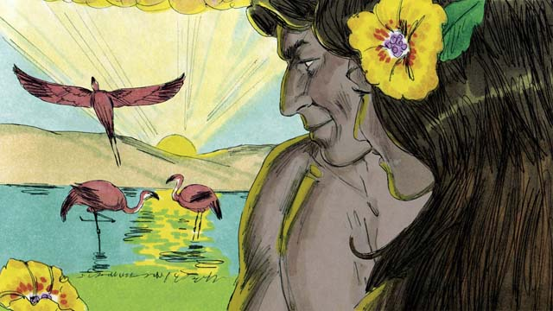

Adam and his wife were very happy living in the beautiful garden God had made for them. Neither of them wore clothes, but this did not cause them to feel any shame because there was no sin in the world. They often walked in the garden and talked with God.

02-02

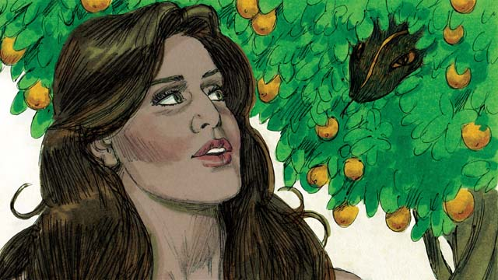

But there was a snake in the garden. He was very crafty. He asked the woman, “Did God really tell you not to eat the fruit from any of the trees in the garden?”

02-03

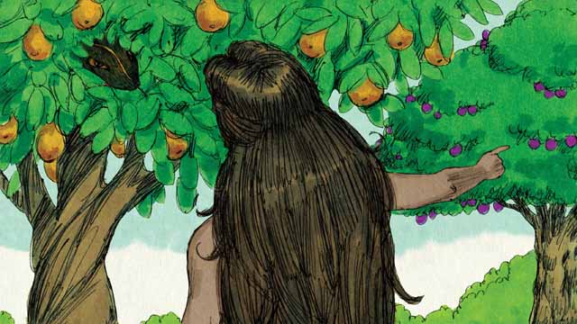

The woman answered, “God told us we could eat the fruit of any tree except from the tree of the knowledge of good and evil. God told us, ‘If you eat that fruit or even touch it, you will die.’”

02-04

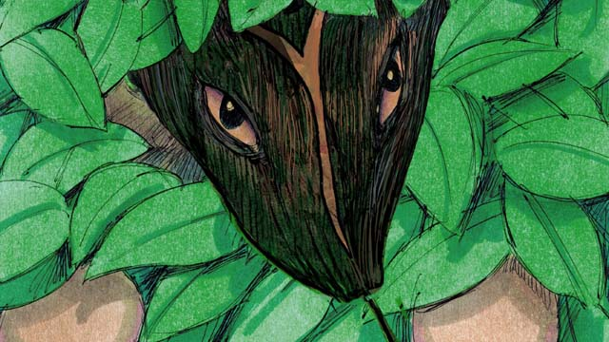

The snake responded to the woman, “That is not true! You will not die. God just knows that as soon as you eat it, you will be like God and will understand good and evil like he does.”

02-05

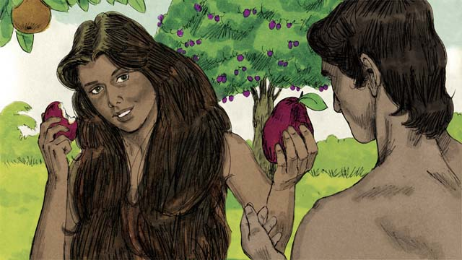

The woman saw that the fruit was beautiful and looked delicious. She also wanted to be wise, so she picked some of the fruit and ate it. Then she gave some to her husband, who was with her, and he ate it too.

02-06



Suddenly, their eyes were opened and they realized they were naked. They tried to cover their bodies by sewing leaves together to make clothes.

02-07

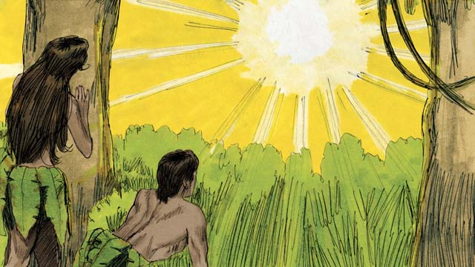

Then the man and his wife heard the sound of God walking through the garden. They both hid from God. Then God called to the man, “Where are you?” Adam replied, “I heard you walking in the garden, and I was afraid because I was naked. So I hid.”

02-08

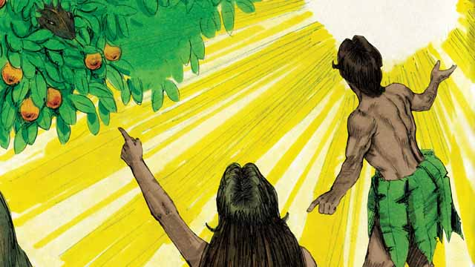

Then God asked, “Who told you that you were naked? Did you eat the fruit I told you not to eat?” The man answered, “You gave me this woman, and she gave me the fruit.” Then God asked the woman, “What have you done?” The woman replied, “The snake tricked me.”

02-09

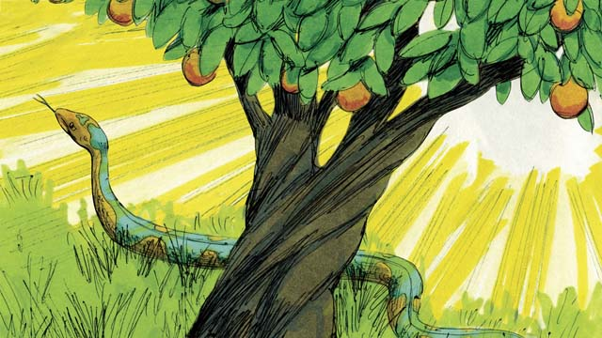

God said to the snake, “You are cursed! You will slide on your belly and eat soil. You and the woman will hate each other, and your children and her children will hate each other too. The woman’s descendant will crush your head, and you will wound his heel.”

02-10

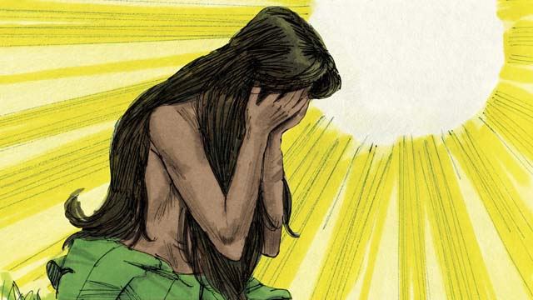

God then said to the woman, “I will make childbirth very painful for you. You will desire your husband, and he will rule over you.”

02-11

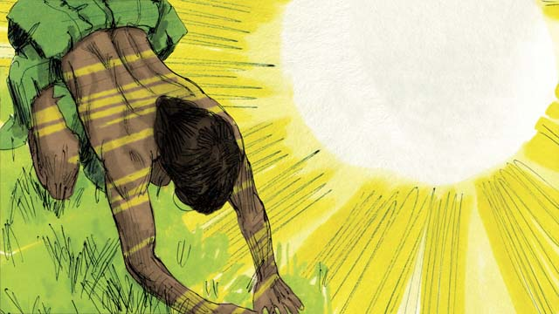

God said to the man, “You listened to your wife and disobeyed me. Now the ground is cursed, and you will need to work hard to grow food. Then you will die, and your body will return to soil.” The man named his wife Eve, which means “life-giver,” because she would become the mother of all people. And God clothed Adam and Eve with animal skins.

02-12

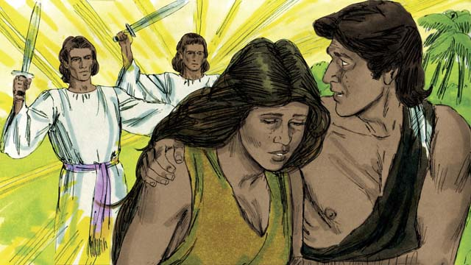

Then God said, “Now that the human beings have become like us by knowing good and evil, they must not be allowed to eat the fruit of the tree of life and live forever.” So God sent Adam and Eve away from the garden. God placed powerful angels at the entrance to the garden to keep anyone from eating the fruit of the tree of life.

*A Bible story from: Genesis 3*

## 1 Biblical Interpretation: Observing the Details of the Story

After reading the crafted biblical story, answer the following questions to familiarize yourself with the details of the story.

### 1.1 Observation Questions

Answer the following observation questions to gain a basic understanding of the the story. Read the story as a community and answer these questions as a group.

#### 02-01

What kind of life did Adam and his wife have in the garden?  
Adam and his wife were happy and naked.

Why were Adam and Eve not ashamed that they were naked?  
There was no sin in the world.God created everything.

#### 02-02

What animal spoke with Eve in the garden?  
A snake spoke to Eve.

What was the snake like?  
The snake was very crafty.

What was the snake’s first question to Eve?  
He asked, “Did God really tell you not to eat the fruit from any of the trees in the garden?”

#### 02-03

From which tree were Adam and and his wife not allowed to eat?  
They were not to eat from the tree of the knowledge of good and evil.

What did God say would happen if Adam and his wife ate from the tree of the knowledge of good and evil?  
He said they would die.

#### 02-04

What did the snake say was the reason God did not want them to eat the fruit?  
He said God was lying because God did not want them to understand things like he did.

#### 02-05

Why did the woman eat the fruit?  
She saw that it was beautiful and delicious, and she wanted to be wise.

What did the woman do after she ate the fruit?  
After the woman ate the fruit, she gave some to her husband who was with her.

Were Adam and his wife forced to eat the fruit?  
No, they freely chose to eat the fruit and disobey God.

#### 02-06

What happened when the man and woman ate the fruit?  
After the man and woman ate the fruit, their eyes were opened and they realized they were naked.

What did the man and the woman do when they realized they were naked?  
They sewed leaves together to make clothes.

#### 02-07

Who did Adam and Eve hear walking in the garden?  
They heard the sound of God walking in the garden.

What did God say to them?  
God asked them where they were.

How did Adam answer God?  
He told God that they hid because they heard his sound and were afraid.

#### 02-08

What were the next questions God asked the humans?  
He asked who told them that they were naked and whether they ate the fruit God had forbidden.

How did the man respond when God confronted him about his sin?  
He blamed the woman.

How did the woman respond when God confronted her about her sin?  
She blamed the snake.

#### 02-09

What was God’s curse on the snake?  
You will slide on your belly, and the woman’s descendant will crush your head.

How would things be between humans and snakes?  
There would be hatred between humans and snakes.

#### 02-10

What was God’s curse on the woman?  
You will have painful childbirth, and although your desire will be for your husband, he will rule over you.

#### 02-11

What was God’s curse on the man?  
You will work hard to grow food, and you will die and return to the soil.

What name did the man give to his wife?  
He named her Eve because she would be the mother of all humans.

What did God do about the humans’ nakedness?  
God clothed Adam and Eve with animal skins.

#### 02-12

How did God prevent Adam and Eve from living forever?  
He sent them out of the garden containing the tree of life and guarded the entrance with powerful angels.

### 1.2 Translation Questions

Use the following translation questions to understand specific details of the passage. Discuss how you might translate these specific elements of the story.

#### 02-01

**garden** This **garden** refers to a special collection of trees and plants that God prepared for Adam and Eve to enjoy and from which to eat. How would you speak of a **garden** as an area of land planted with trees and plants that produces food and provides beauty?

  

**shame** Shame is the feeling that comes with knowing we have sinned or that we fall short in some way. What word in your language mean **shame** as in disgrace or dishonor?

  

**sin** Sin involves actions, thoughts, and words that are against God’s will and laws. What word in your language means **sin** as in disobeying God by doing something that God does not want us to do?

  

#### 02-02

**snake** A **snake** is an elongated, legless creature that now moves by wiggling on its belly. How would you refer to a **snake** as in a legless reptile that slithers/crawls on the ground?

  

**crafty** To be **crafty** means to be clever and sly, with the intent to deceive. What words in your language mean **crafty** as in being skillful at deceiving others?

  

**Did God really tell you not to eat the fruit from any of the trees in the garden?** The snake asks this question but already knows the answer to it. He was asking this question to create doubt in the woman’s mind and question God’s goodness. How would you phrase the question **Did God really tell you not to eat the fruit from any of the trees in the garden?** in a way that clarifies that the serpent is trying to cause the woman to doubt what God actually said?

  

#### 02-03

**fruit** This is a general word for food that grows on trees. The specific **fruit** is not mentioned here. What general word in your language means **fruit** as in the food that a tree produces?

  

**If you eat that fruit or even touch it, you will die.** The woman says that eating or touching the fruit will cause one to die. She does not repeat God’s command correctly. God said not to eat the fruit. He did not say not to touch it. How would you phrase you will die as in the end of one’s physical life?

  

#### 02-04

**like God** The man and the woman were already made in the likeness of God. The snake is suggesting that the woman would be more **like God** if she understood evil. However, God never intended for her to have this knowledge. How would you phrase **like God** to mean sharing characteristics or being similar to God?

  

**understand good and evil** The snake is suggesting that eating the fruit will cause the humans to know from personal experience what things are good and what things are bad. How would you phrase **understand good and evil** to mean knowing things that are pleasing to God and things that are not pleasing to God?

  

#### 02-05

**wise** The woman wanted to have insight and understanding like the snake seemed to have, and like God has. What word in your language means **wise** as in someone who understands what is the right and moral thing to do and then does that?

  

**the fruit was beautiful and looked delicious** The fruit was appetizing and looked good to eat. How would you describe the fruit as beautiful and delicious as in the fruit looked appealing and good for food?

  

#### 02-06

**their eyes were opened** After the man and woman ate the fruit, they now understood something for the first time. How would you express **their eyes were opened** to mean that the man and the woman came to realize something they did not previously understand?

  

**they realized they were naked** After the man and the woman disobeyed God, they felt ashamed that they were naked. That is why they used leaves to try to cover their naked bodies. How would you express **they realized they were naked** to mean that at this time the man and the woman became aware that they were naked?

  

#### 02-07

**God walking** Although God is spirit, it seems that God regularly came to the garden to walk and talk with the man and the woman. We do not know what this looked like, but it could mean that God appeared in some form as he walked through the garden. How would you say **God walking** as would be used to talk about a person walking?

  

**Where are you?** God already knew the answer to this question. The purpose of the question was to force the man and the woman to explain why they were hiding and to acknowledge God was speaking to them. How would say **Where are you?** to ask someone to identify their whereabouts in order to call their attention?

  

**because I was naked** The word because explains that the reason Adam and Eve were afraid was that they were naked. Adam and Eve were fearful **because** they had come to know that they were naked and they were ashamed of their nakedness. How would you express **because I was naked** to mean the reason Adam and Eve were afraid was that they were naked?

  

**So I hid** The word so explains the result/outcome of Adam and Eve realizing they were naked. When Adam and Eve realized they were naked, they hid. How would you express **So I hid** to mean the result of Adam and Eve realizing they were naked was to hide?

  

#### 02-08

**The snake tricked me** The snake deceived or misled her. He lied to her. Don’t use a word that indicates that he cast a spell on her or bewitched her. The woman blamed the snake rather than confessing her disobedience and accepting responsibility for disobeying God. How would you say the snake tricked me to mean the snake misled the woman by lying to her?

  

#### 02-09

**You are cursed!** God speaks a curse on the snake. A curse means to cause bad things or great harm to come upon someone or something. A curse is the opposite of blessing. How would you phrase you are cursed to mean that God would bring hardship and harm upon the snake? (The word you choose should not imply magic.)

  

**will hate each other** The woman would hate the snake and the snake would hate the woman. The women’s descendants would also hate the snake’s descendants, and the snake’s descendants would hate them. How would you phrase **will hate each other** to mean that there would be hostility between the woman and the snake?

  

**will crush your head** The descendant of the woman will destroy the descendant of the snake. What word in your language means crush as in to flatten something with the heel of one’s foot?

  

**will wound his heel** The descendant of the snake will wound the descendant of the woman. What word in your language means wound as in to harm or injure?

  

#### 02-10

**childbirth very painful** Because the woman disobeyed God, God says that he will cause the woman to have much more pain when she gives birth to children. How can you express **childbirth very painful** to mean that the woman would experience a lot of pain when she gives birth to children?

  

**rule over you** As a result of sin, the man would have power over the woman. How would you express **rule over you** to mean the man would exercise authority over the woman?

  

#### 02-11

**the ground is cursed** As punishment for Adam’s disobedience, the earth would no longer be fruitful. Adam would have to work very hard to raise enough food to eat. How would you express **the ground is cursed** to mean that the ground would not be fruitful in producing food?

  

**you will die** The ultimate punishment for their disobedience was death. How would you phrase **you will die** to mean that life would come to an end?

  

**life-giver** God gave life to Adam and Eve, and it is passed on to every person through childbirth. Eve would be the female ancestor of all later generations. How would you express that Eve is the **life-giver** as in the one through whom human life would be passed on to future generations?

  

#### 02-12

**they must not be allowed** God is saying that he does not want humans to eat the fruit of the tree of life. How would you express **they must not be allowed** to mean that God was intending to prevent or prohibit them from eating the fruit of the tree of life?

  

**the tree of life** This was an actual tree with fruit. If a person ate this fruit, he would live continually and never die. How would you express **the tree of life** to mean a tree which gives people life?

  

## 2 Theological Dialogue: Discussing the Meaning of the Story

Take time to explore the meaning of this story together as a community. Use the following discussions as a way to grasp what truth the story teaches.

### 2.1 Discourse Questions

Use the following discourse questions to understand the meaning of the story. Pay attention to how the story itself addresses each question or theme.

##### Why was life in the garden so happy? (02-01)

Adam and Eve enjoyed a happy life in the garden. Life was perfect. God had provided everything that Adam and Eve needed. God made the garden for them. There was no sin and no shame in this world. Adam and Eve enjoyed a close and peaceful relationship with God. All of this would be ruined when Adam and Eve disobeyed God. (02-01)

  

##### Why did the woman and the man eat the fruit? (02-02, 02-03, 02-04, 02-05)

The snake was very crafty and caused the woman to doubt what God had said. (02-02)

  

The snake also suggested that God commanded them not to eat from any of the trees in the garden. This was a lie. God told them they could eat from all the trees in the garden except one tree: the tree of the knowledge of good and evil. (02-02)

  

The woman did not accurately repeat God’s command. The woman said God commanded them not to eat or touch the fruit. God did not command them not to touch it. He told them if they ate it, they would die. (02-03)

  

The snake denied God’s word. He said that they would not die if they disobeyed God’s command. (02-04)

  

The snake made it seem that God was withholding good things from the man and the woman. He told the woman that eating the fruit would make them like God. (02-04)

  

The humans were already created like God. (01-09)

  

The woman saw that the fruit looked good to eat. She chose to satisfy her desires rather than please God by following his command. (02-05)

  

The woman wanted to be wise. She listened to the lie of the snake. She ate the fruit to become like God and know good and evil. (02-05)

  

The woman gave some of the fruit to her husband and he also ate it. (02-05)

  

##### What happened after the woman and the man ate the fruit? (02-06, 02-07, 02-08)

The woman and the man came to realize they were naked for the first time. (02-06)

  

They felt shame over their nakedness and tried to cover it by sewing leaves together. They had a feeling of disgrace for doing wrong. (02-06)

  

They were afraid of God and they hid from him. Instead of enjoying God’s presence (cf. 02-01), they now feared him and tried to hide from him. (02-07)

  

When God asked them if they ate the fruit, they each blamed someone else. The man blamed the woman. The woman blamed the snake. Neither took responsibility for disobeying God. (02-08)

  

##### How would God’s curse effect creation? (02-09, 02-10, 02-11)

The snake would crawl on the ground. The snake spoke like he was wiser than God. As a result, God made the snake crawl on his belly. (02-09)

  

Humans and snakes would hate each other. Instead of ruling over the animals (cf. 01-09) and taking care of creation (cf. 01-10), snakes would attack humans and humans would kill snakes. (02-09)

  

Childbirth would be extremely painful. Now, obeying God’s command to fill the earth (cf. 01-15) would be painful. (02-10)

  

The woman would desire the man and the man would rule over her. Rather than man and woman enjoying a peaceful and cooperative relationship (cf. 01-14, 01-15), each would seek power and authority over the other. (02-10).

  

The ground would not be fruitful. The man was supposed to take care of the garden (cf. 01-11). Now, it would be hard for the man to work the ground and grow food. (02-11)

  

Man would die. Man was created from the soil (cf. 01-10) and now he would die and return to the soil/ground. (02-11)

  

##### What did God do for the man and the woman? (02-11, 02-12)

God clothed the humans with animal skins. Although humans disobeyed God, he provided a way to cover their shame. (02-11)

  

God prevented the humans from eating the fruit of the tree of life and living forever in their shameful condition. (02-12)

  

God removed the man and the woman from the garden. (02-12)

  

God promised that a descendant of the snake would crush the head of the serpent. (02-09)

  

### 2.2 Theological Questions

Answer the following theology questions as a community. Discuss what truths this story teaches.

1. What does this story teach us about sin? What does the temptation and disobedience of Adam and Eve teach us about sin?
2. What are consequences/effects of sin? What takes place after Adam and Eve disobeyed God that teaches us about the negative results of sin?
3. How is God able to deal with sin? What did God do in this story that showed his intention to deal with sin?

### 2.3 Translation Draft

Work as a translation team to draft each panel of this story. Pay attention to any specific translation issues that are challenging or significant.

#### Make Translation Draft

Make a draft for each section of this story.

#### Discuss and Revise

After drafting the story, discuss any translation issues that you think need special explanation.

#### Drafting Summary Reflection

Summarize any noteworthy translation decisions and the rationale/reasoning behind these translation decisions. In the final movement of this class, you will use these observations to give an account (i.e., chronicle/narrate) of how your translation improved through the checking process.

## 3 Personal Reflection: Following the Teaching of the Story

Take a moment to allow this story to evaluate your own life and to consider how God would have you respond. After this reflection, use the quality checking questions to check your translation draft among the translation team.

### 3.1 Journal Reflection

Prayerfully think about the following personal reflection questions. Write/Record your answers and/or discuss them as a group.

1. How have you experienced temptation to sin?
2. What lies do you believe that cause you to disobey God?
3. How have you experienced the negative consequences of sin in your own life?

### 3.2 Team Check

*The following activity will help you check the clarity, accuracy, and naturalness of your draft. Read the passage aloud and discuss the checking questions with other members of your translation community. You might need to reread portions (or the whole) of the biblical passage multiple times as you answer each of these questions. Record answers to these questions below.*

#### Team Checking Questions

*Use the following questions to check your translation draft for accuracy, clarity, and naturalness.*

1. **Accurate**: Has anything been **added** to your translation of this passage that is not a part of the meaning of the source text? *If additions exist, are they included only added to clarify meaning (such as implied information)?*
2. **Accurate**: Is anything **missing** from your translation of this passage that is a part of the meaning of the source text? *If some part of the meaning is missing from your translation, add it.*
3. **Accurate**: Does any meaning in your translation of this passage appear to be **different** than the meaning of the source text? *If the meaning is different, try changing your translation so that the meaning remains the same.*
4. **Natural**: Does anything sound **unnatural** to how you would say it in your language? *If portions of the passage sound unnatural in your language, try to make them sound the way you would say it in your language while staying true to the meaning of the source text.*
5. **Clear**: Is anything **unclear** or **confusing** in your translation that confuses the meaning of the source text? *If portions of the passage are unclear or confusing, revise them to clearly communicate the meaning of the source text.*
6. **Consistent**: How **consistent** is your translation within the passage and with other passages? *If portions of the passage need to be made consistent or if you need to revise translations of other passages, make these adjustments.*

#### Record Feedback

*After discussing the checking questions above as a translation community, record any feedback on your translation draft. Pay attention for parts of your translation that are translated well and parts of your translation that need correction.*

#### Discuss and Revise

*After gathering feedback on your draft, discuss it together with your translation community and make appropriate revisions in your translation.*

#### Checking Summary Reflection

*Summarize any noteworthy translation decisions (things you corrected or affirmed in your draft) and the rationale/reasoning behind these translation decisions. In the final movement of this class, you will use these observations to give an account (i.e., chronicle/narrate) of how your translation improved through the checking process.*

## 4 Ministry Practice: Serving the Church with the Story

Now that you have a draft of this story, consider how this story can encourage other believers in their faith. After ministering this story to others, you will also perform a community check of your translation draft.

### 4.1 Church Ministry

Reflect on how this story can edify and mature the Christian community. Design a way to minister this story to your church community.

**Ministry Preparation**: Take time to consider how you could minister this story to others. Record some ministry ideas below.

**Ministry Implementation**: Minister this story to a group of believers as you had planned. Use the information in this study to help develop a teaching/lesson or lead a discussion of this story to other believers. Record your ministry plan below.

**Ministry Reflection**: Think about what you learned from ministering this story to other believers. Reflect on your experience below.

### 4.2 Church Community Check

After teaching or ministering this story to the church, check the translation quality with the church community. Record any feedback from your checking experience.

#### Create Checking Questions

You can use **Translation Questions** to check you draft. Each **Translation Question** explains the meaning of a specific part of the story and asks you to consider how you would translate that part of the story in your own language. Change each **Translation Question** into a **Checking Question** by asking the following questions. The first question asks you to identity how each specific phrase was translated in your language. The second question asks people in the church to determine if your translation of the phrase expresses the meaning clearly, accurately, and naturally. Look at the following examples to see how to change **Translation Questions** into **Checking Questions**:

#### Translation Question Example 1

**to proclaim the good news about Jesus** Paul and Silas traveled to Philippi for the purpose of preaching the gospel. The gospel is the good news that Jesus saves people from their sins if they will believe in Jesus. How would you express **to proclaim the good news about Jesus** to mean to tell other people the message about how Jesus can save people from their sins?

#### Translation Question Example 2

**a merchant** Paul and Silas met a woman named Lydia at the place by the river. She owned a business and sold items to make money. How would you express **a merchant** to mean a business owner who sells items for a profit?

#### Translation Question Example 3

**so Paul and Silas baptized them** The jailer and his whole family followed Paul’s instructions. They believed in Jesus. The result of this was Paul and Silas baptized them. How would you express **so Paul and Silas baptized them** to mean the result of the jailer and his family believing in Jesus that Paul and Silas baptized all of them?

You can change these into **Checking Questions** like this:

#### Checking Question Example 1

**to proclaim the good news about Jesus** How did you translate **to proclaim the good news about Jesus**? Does it mean to tell other people the message about how Jesus can save people from their sins?

#### Checking Question Example 2

**a merchant** How did you translate **a merchant**? Does it mean a business owner who sells items for a profit?

#### Checking Question Example 3

**so Paul and Silas baptized them** How did you translate **so Paul and Silas baptized them**? Does it mean the result of the jailer and his family believing in Jesus that Paul and Silas baptized all of them?

#### Record Feedback

*Discuss the* ***Checking Questions*** *with your church community, and record any feedback on your translation draft. Pay attention for parts of your translation that are translated well and parts of your translation that need correction.*

#### Discuss and Revise

*After gathering feedback on your draft, discuss it together with your translation community and make appropriate revisions in your translation.*

#### Checking Summary Reflection

*Summarize any noteworthy translation decisions (things you corrected or affirmed in your draft) and the rationale/reasoning behind these translation decisions. In the final movement of this class, you will use these observations to give an account (i.e., chronicle/narrate) of how your translation improved through the checking process.*

## 5 Missional Outreach: Sharing the Truth of the Story

*After sharing this story with others, check the translation quality with the wider language community. Record any feedback from your checking experience.*

### 5.1 Mission Engagement

*Consider how you will witness this story to unbelievers. Design a way to share this story and engage them in what it teaches about Christianity and the gospel.*

**Witness Preparation**: Take time to consider how you will witness this narrative to unbelievers. Record some ideas below.

**Witness Implementation**: Share this story with an unbeliever. Use the information in this study to help develop a teaching/lesson or lead a discussion of this story to other believers. Record your ministry plan below.

**Witness Reflection**: Think about what you learned from ministering this story to unbelievers. Reflect on your experience below.

### 5.2 Sociolinguistic Check

After sharing this story with the language community, check your translation draft with the surrounding community. Record your observations.

#### Checking Approach

After witnessing this story to unbelievers, use one of the following methods to check the translation of this story. Consider using the **Observation Questions** to check your translation draft or come up with your own quality checking questions.

**Read-Retell Check:** Read your draft to those the community and ask them to retell the passage. Be attentive for any portions of the passage that are unclear, unnatural, or inaccurate.

**Comprehension Questions Checklist:** Read the draft of the passage and ask a list of comprehension questions to make sure the passage is being rightly understood. You can use the **Observation Questions** in this guide or come up with your own questions. Then, record any insights or issues that arise.

**Discussion Group:** Develop key questions to ask about the passage (both formational and translational). Read the passage and have a group discussion about the passage, paying attention to issues that need to be addressed, edited, and revised.

#### Record Feedback

*After sharing your draft with language community, discuss the* ***Observations Questions****, and record any feedback on your translation draft. Pay attention for parts of your translation that are translated well and parts of your translation that need correction.*

#### Discuss and Revise

*After gathering feedback on your draft, discuss it together with your translation community and make appropriate revisions in your translation.*

#### Checking Summary Reflection

*Summarize any noteworthy translation decisions (things you corrected or affirmed in your draft) and the rationale/reasoning behind these translation decisions. In the final movement of this class, you will use these observations to give an account (i.e., chronicle/narrate) of how your translation improved through the checking process.*

## 6 Conclusion

As a translation community, take time to reflect on all that was learned in studying, drafting, and checking this story. Celebrate all that God has taught you as a community. Then, submit your revised draft and checking summaries to network leaders for further review.