Open Bible Stories

The Exile and Return

## 0 Introduction

### 0.1 Key Idea

The story of the exile and return teaches us what is is like to live as God’s people in a foreign land that is not our final home.

### 0.2 Creedal Verse

“Beloved, I urge you as sojourners and exiles to abstain from the passions of the flesh, which wage war against your soul. Keep your conduct among the Gentiles honorable, so that when they speak against you as evildoers, they may see your good deeds and glorify God on the day of visitation.” 1 Peter 2:11-12

### 0.3 Metanarrative Summary

The eternal God created all things in six days. He made a good and perfect world. He made humans in his image to fill the earth and rule over creation. But humans rebelled against God and ruined God’s creation. God set to restore his world through his promise. God made a covenant with Abraham. He promised to bless all nations through Abraham. God kept his promises across the generations. God provided Abraham with a promised child, Isaac. God gave Isaac a wife and she bore twins, Jacob and Esau. God blessed Jacob and his sons, and the blessing continued to the next generation. God rescued Joseph, one of Jacob’s sons, and used him to rescue his family. God caused his people, the Israelites, to multiply in the land of Egypt; eventually, they became slaves. But, God raised up a deliverer, Moses, to deliver his people from their slavery. God sent judged the Egyptians with harsh plagues; in the final judgment, he passed over his people who covered their doorposts with the blood of a sacrificed lamb. Then, God delivered the Israelites by bringing them out of Egypt and crossing the Red Sea on dry land. God made a covenant with the Israelites and made them his people. God tested Israel in a series of wilderness wanderings and eventually brought his people into the promised land of Canaan. God raised up deliverers to lead Israel and rescue them from their enemies. God formed Israel into a kingdom. He made a covenant with King David and promised to send a king that would rule his people forever. Many of Israel’s kings were evil and the kingdom of Israel divided into two kingdoms. God sent prophets to warn his people of God’s judgment and call them to repent. When Israel did not repent, God sent his people into exile. After many years, he brought them back to the land.

### 0.4 Open Bible Story: The Exile and Return

20-01

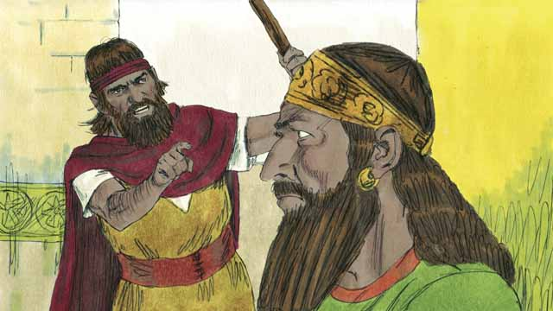

The kingdom of Israel and the kingdom of Judah both sinned against God. They broke the covenant that God had made with them at Sinai. God sent his prophets to warn them to repent and worship him again, but they refused to obey.

20-02

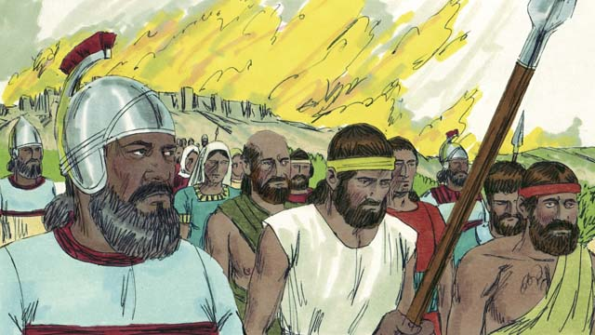

So God punished both kingdoms by allowing their enemies to destroy them. Assyria was another nation that became very powerful. The Assyrians were also very cruel to other nations. They came and destroyed the kingdom of Israel. The Assyrians killed many people in the kingdom of Israel, took away everything they wanted, and burned much of the country.

20-03

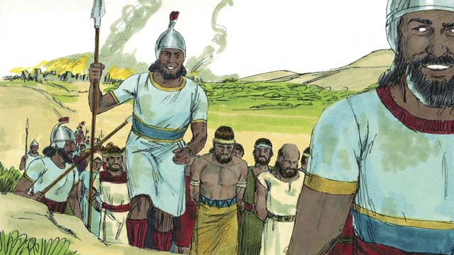

The Assyrians gathered together all the leaders, the rich people, and the people who could make valuable things. They took them to Assyria. Only some very poor Israelites remained in Israel.

20-04

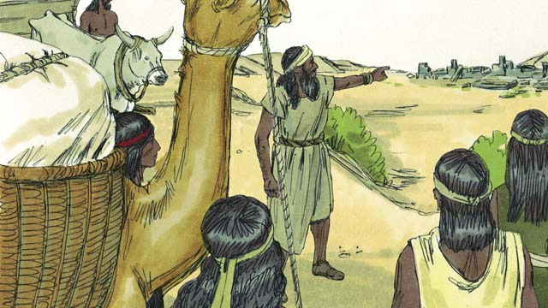

Then the Assyrians brought foreigners to live in the land. The foreigners rebuilt the cities. They intermarried with the Israelites who were left there. The descendants of these people were called Samaritans.

20-05

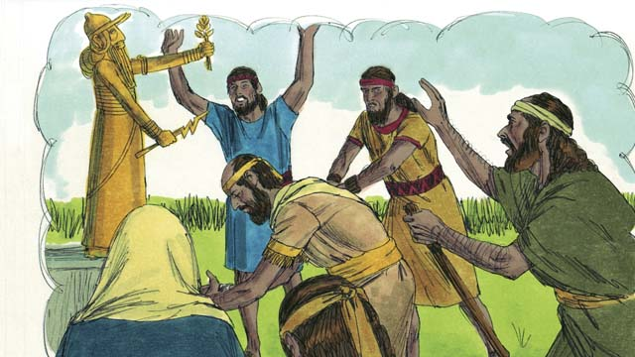

The people in the kingdom of Judah saw how God had punished the people of the kingdom of Israel for not believing and obeying him. But they still worshiped idols, including the gods of the Canaanites. God sent prophets to warn them, but they refused to listen.

20-06

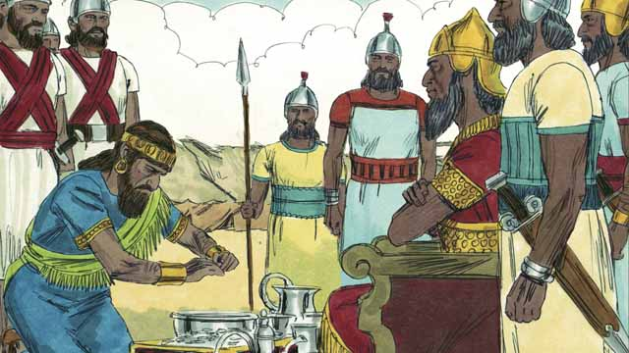

About 100 years after the Assyrians destroyed the kingdom of Israel, God sent Nebuchadnezzar, king of the Babylonians, to attack the kingdom of Judah. Babylon was a powerful nation. The king of Judah agreed to be Nebuchadnezzar’s servant and pay him a lot of money every year.

20-07

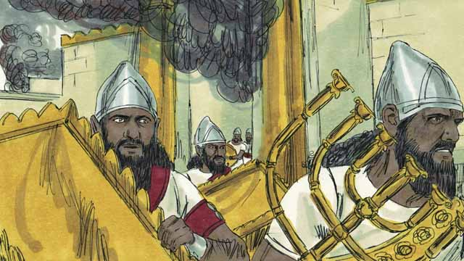

But after a few years, the king of Judah rebelled against Babylon. So, the Babylonians came back and attacked the kingdom of Judah. They captured the city of Jerusalem, destroyed the Temple, and took away all the treasures of the city and the Temple.

20-08

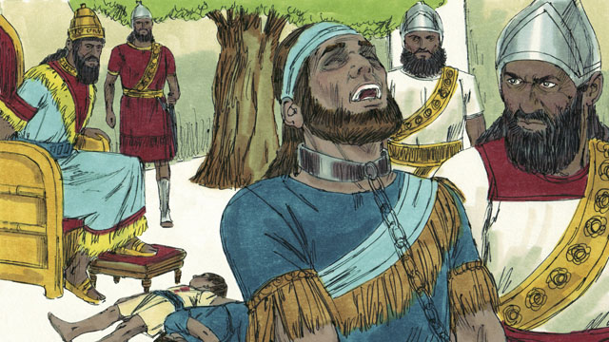

To punish the king of Judah for rebelling, Nebuchadnezzar’s soldiers killed the king’s sons in front of him and then made him blind. After that, they took the king away so he would die in prison in Babylon.

20-09

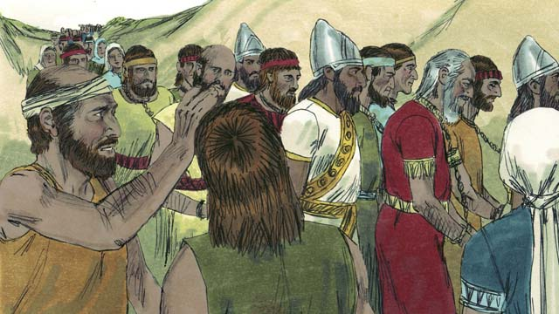

Nebuchadnezzar and his army took almost all of the people of the kingdom of Judah to Babylon, leaving only the poorest people behind to plant the fields. This period of time when God’s people were forced to leave the Promised Land is called the Exile.

20-10

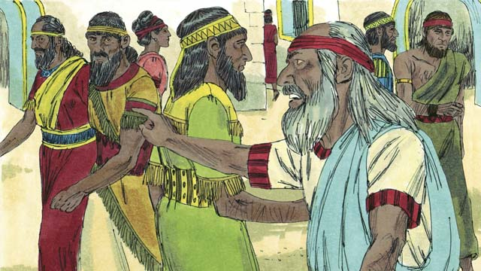

Even though God punished his people for their sin by taking them away into exile, he did not forget them or his promises. God continued to watch over his people and speak to them through his prophets. He promised that, after 70 years, they would return to the Promised Land again.

20-11

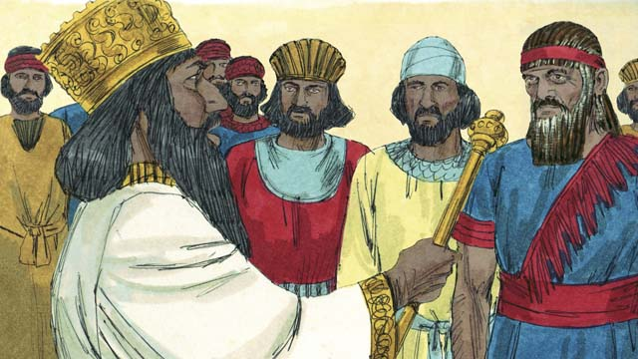

About 70 years later, Cyrus, the king of Persia, defeated Babylonia. So, instead of the Babylonian Empire, the Persian Empire now ruled over many nations. The Israelites were now called Jews. Most of them had lived their whole lives in Babylon. Only a few very old Jews even remembered the land of Judah.

20-12

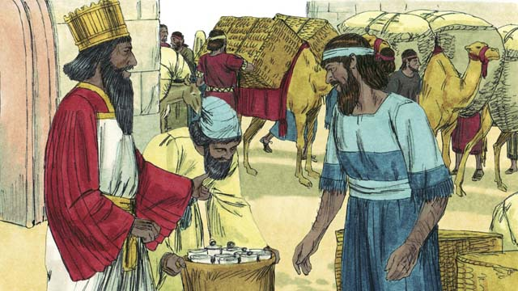

The Persians were very strong, but they had mercy on the people they conquered. Shortly after Cyrus became king of the Persians, he gave an order that any Jew who wanted to return to Judah could leave Persia and go back to Judah. He even gave them money to rebuild the Temple! So, after 70 years in exile, a small group of Jews returned to the city of Jerusalem in Judah.

20-13

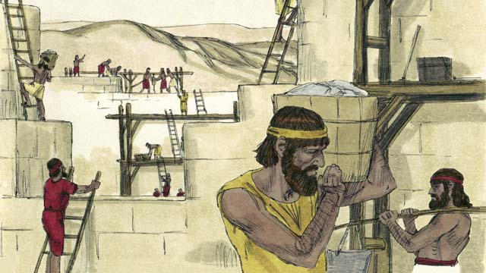

When the people arrived in Jerusalem, they rebuilt the Temple and the wall around the city. The Persians still ruled over them, but once again the Jews were living in the Promised Land and worshiping at the Temple.

*A Bible story from: 2 Kings 17; 24-25; 2 Chronicles 36; Ezra 1-10; Nehemiah 1-13*

## 1 Community Study: When Tensions Arise—Understanding Causes of Conflict

* **Key Idea**: pinpointing the roots of relationship tension
* **Key Passage**: James 4:1-2
* **Main Session**: OBS 20 (The Exile and Return)

### 1.1 Sing a Song (3–5 minutes)

Choose a song to sing to praise God and encourage one another.

### 1.2 Recite the Creedal Verse (3–5 minutes)

The verse below summarizes the teaching of the current passage. Read the verse out loud as a community. Read it again several times as a group until the whole community can recite it from memory.

Because you did not worship Yahweh your God with joyfulness and gladness of heart when you were in prosperity, therefore will you serve the enemies that Yahweh will send against you; you will serve them in hunger, in thirst, in nakedness, and in poverty. Deuteronomy 28:47-48

OR

18 Yahweh is slow to anger and abundant in covenant faithfulness. He forgives iniquity and transgression. He will by no means clear the guilty when he brings the punishment of the ancestors’ sin on their descendants, to the third and fourth generation. Numbers 13:18

### 1.3 Think Together (5 minutes)

Think about times when you experienced/saw conflict between different people. Answer the following questions together as a group.

1. When have you experienced/seen conflict arise among a group of people?
2. What do you think were the causes of these conflicts?

### 1.4 Read the Passage (5 minutes)

Conflict, tension, and disputes arise among people. To be a healthy community, we need to understand how such difficulties come about. In order to grow together as a united and one-minded community, read the passage below.

4:1 Where do quarrels and disputes among you come from? Do they not come from your desires that fight among your members? 2 You desire, and you do not have. You kill and covet, and you are not able to obtain. You fight and quarrel. James 4:1-2

### 1.5 Discuss the Idea (10–15 minutes)

Every community can expect there to be challenges and conflict. After reading the passage above, use the following questions to help your community discuss what it means to practice Christian community in a godly way.

1. As you read this passage, what are the causes of conflict and disputes among people?
2. What different kinds of conflict can arise among people?
3. Based on this passage, how can we guard ourselves against quarrels and disputes?
4. When conflicts do arise, how can we address/resolve them to restore unity to the community?

### 1.6 Pray the Verse (5 minutes)

Divide the community into groups of 2–3 people. Read the verse below. Use the verse as a guide to pray that God would give your community joy, restoration, encouragement, one-mindedness, and peace.

11 Finally, brothers, rejoice! Work for restoration, be encouraged, agree with one another, live in peace. And the God of love and peace will be with you. 2 Corinthians 13:11

## 2 Biblical Interpretation: Observing the Details of the Story

After reading the crafted biblical story, answer the following questions to familiarize yourself with the details of the story.

### 2.1 Observation Questions

Answer the following observation questions to gain a basic understanding of the the story. Read the story as a community and answer these questions as a group.

#### 20-01

Which of the two kingdoms of Israel sinned against God?  
The kingdom of Israel and the kingdom of Judah both sinned against God.

How did the kingdom of Israel and Judah sin against God?  
The kingdom of Israel and Judah broke the covenant God had made with them at Sinai.

What was the warning that the prophets spoke to the people?  
They told them to repent and worship God again.

How did the people respond to the message from cthe prophets?  
The people refused to obey.

#### 20-02

How did God punish both kingdoms?  
God punished both kingdoms by allowing their enemies to destroy them?  
Who were the Assyrians?  
The Assyrians were a powerful nation who were cruel to other nations.

What enemy destroyed the kingdom of Israel?  
The Assyrians destroyed the kingdom of Israel.

How did the Assyrians attack the kingdom of Israel?  
The Assyrians killed many people in the kingdom fo Israel, took away everything they wanted, and burned much of the country.

#### 20-03

What did the Assyrians do to some of the people of Israel?  
The Assyrians gathered the leaders, the rich, and those who could make valuable things. They took these people to Assyria.

Who did the Assyrians leave in the land of Israel?  
The Assyrians left some of the very poor Israelites in the land of Israel.

#### 20-04

Whom did the Assyrians bring into the land of Israel?  
The Assyrians brought foreigners to live in the land of Israel?  
What ddi the foreigners do in the land of Israel?  
The foreigners rebuilt the cities and intermarried with the Israelites who were left in the land.

Who were the Samaritans?  
The Samaritans were the descendants of the Israelites who married the foreigners brought to the land by the Assyrians.

#### 20-05

What did the people of Judah see happen to the people of Israel?  
The people of Judah saw how God punished the kingdom of Israel for not believing or obeying God.

Did the people of the kingdom of Judah obey God when they saw how he had punished the kingdom of Israel?  
No, they continued worshiping idols. They even worshiped Canaanite gods.

Whom did God send to warn the people of Judah?  
God sent prophets to warn the people of Judah, but they refused to listen to the prophets.

#### 20-06

When did God send Nebuchadnezzar to attack the kingdom of Judah?  
About 100 years after the Assyrians destroyed the kingdom of Israel, God sent Nebuchadnezzar, the king of the Babylonians, to attack the kingdom of Judah.

How strong was Babylon?  
Babylon was a powerful nation.

Who did the king of Judah agree to serve?  
He agreed to serve King Nebuchadnezzar of Babylon and pay him a lot of money every year.

#### 20-07

Did the king of Judah continue to serve Nebuchadnezzar?  
No. After a few years, the king of Judah rebelled abasing the king of Babylon.

How did the Babylonians respond to this rebellion?  
The Babylonians came back and attacked the kingdom of Judah?  
How successfully did the Babylonians defeat the kingdom of Judah?  
The Babylonians captured the city of Jerusalem, destroyed the Temple, and took away all the treasures of the city and Temple.

#### 20-08

When the king of Judah rebelled, what did Nebuchadnezzar’s soldiers do to him?  
They killed the king’s sons in front of him, made him blind, and took him away to die in prison in Babylon.

#### 20-09

What did Nebuchadnezzar and his army do with the people of the kingdom of Judah?  
Nebuchadnezzar and his army took almost all of the people of Judah to Babylon. They left the poorest people in the land to plant fields.

What do we call the period of time when God’s people were forced to leave the Promised Land?  
This period is called the Exile.

#### 20-10

Did God forget his promises to his people?  
No. Even though God punished his people for their sin and took them into exile, God did not forget his promises to his people. God continued to watch over his people and send them prophets.

What did God promise to the people during the Exile?  
God promised that after 70 years, they would return to the Promised Land again.

#### 20-11

Who was the king who defeated the Babylonians?  
Cyrus, king of the Persians, defeated the Babylonians. This happened after about 70 years.

What were the Israelites called at this time?  
At this time, the Israelites were called Jews.

How well did the Jews at this time remember the land of Israel?  
At this time, most of the Israelites lived their whole lives in Babylon and only a few old Jews remembered the land of Judah.

#### 20-12

What were the Persians like?  
The Persians were very strong but had mercy on they people they conquered.

What order did King Cyrus give concerning the Jews?  
He ordered that any Jew who wanted to return to Judah could go there.

How else did King Cyrus help the Israelites?  
King Cyrus also gave money for the Israelites to rebuild the Temple.

Who returned to the land of Israel?  
After 70 years of exile, a small group of Jews returned to the city of Jerusalem.

#### 20-13

What did the Jews do when they arrived in Jerusalem?  
They rebuilt the Temple and the wall around the city.

At this time were the Jews completely free?  
No. Even though they were back in the land, the Persians still ruled over them.

Why were things okay for the Jews under Persian rule?  
The Jews lived in the Promised land and worshiped at the temple.

### 2.2 Translation Questions

Use the following translation questions to understand specific details of the passage. Discuss how you might translate these specific elements of the story.

#### 20-01

**broke the covenant** The kingdom of Israel and the kingdom of Judah defied God’s commands. How would you translate **broke the covenant** to mean disobeyed the commands God had given them in his covenant with them at Mount Sinai?

  

**warn them to repent and worship him again** God sent prophets to tell caution Israel that thy would be punished if they did not change their ways. They must to stop sinning, cease worshiping false gods, and start worshiping Yahweh again. How would you translate **warn them to repent and worship him again** to mean to tell the Israelites to stop sinning and to worship Yahweh instead of other gods, or terrible things would happen to them?

  

**but they refused to obey** God sent prophets to warn the Israelites of the need to repent of their sin and worship Yahweh alone. The Israelites did the opposite of this. They were not willing to obey God. How would you translate **but they refused to obey** to mean the refusal to obey God is the opposite/contrary to the warning the prophets gave the people?

  

#### 20-02

**So God punished** The kingdom of Israel and the kingdom of Judah refused to obey God. The result of this disobedience was God punished both kingdoms. How would you translate **So God punished** to mean the result of the kingdom of Israel and the kingdom of Judah refusing to obey God was God punished them both?

  

**destroyed** The Assyrians attacked the kingdom of Israel. They defeated them in war and caused great ruin and destruction. How would you express **destroyed** to mean to defeat in a war and bring devastation and damage?

  

**both kingdoms** God punished the kingdom of Israel and the kingdom of Judah. How would you translate **both kingdoms** to mean the two kingdoms: the kingdom of Israel and the kingdom of Judah?

  

**took away** The Assyrians stole things that belonged to the Israelites. They took anything they wanted to have. How would you translate **took away** to mean the Assyrians stole valuable things and carried them back to Assyria?

  

#### 20-03

**the people who could make valuable things** The Assyrians took people to Assyria who were good at woodworking, metalworking, and building. How would you express **the people who could make valuable things** to mean skillful workers who had the ability to make or build things which were costly or valuable?

  

**very poor** Those who suffered from extreme poverty. How would you express **very poor** to mean those who were extremely impoverished?

  

**remained** The very poor Israelites stayed or were left behind in the land. How would you express **remained** to mean allowed to stay behind while others were taken from the land?

  

#### 20-04

**foreigners** The Assyrians brought people who lived in other countries and settled them in the land of Israel. How would you translate **foreigners** to mean people who were not Israelites and were from other countries/nations?

  

**intermarried** To intermarry means to marry someone from another ethic or cultural group. At this time, foreigners and Israelites married. How would you express **intermarried** to mean a mixed marriage of two ethnicities or cultures?

  

#### 20-05

**for not believing and obeying him** The reason God punished the kingdom of Israel was the Israelites did not trust God or follow his commands. How would you express **for not believing and obeying him** to mean the reason God punished the kingdom of Israel was because they did not trust God and did not follow his commands?

  

**But they still worshiped idols** The kingdom of Judah saw how God punished the kingdom of Israel. Rather than changing their ways, the kingdom of Judah continue to worship idols. This is the opposite of what they should have done. How would you translate **But they still worshiped idols** to mean the people continued to worship idols despite seeing Israel’s punishment when they refused to obey?

  

**warn** The prophets told the people the bad things that would happen in the future if they did not stop sinning. They told the people that God would punish them if they did not stop sinning. God’s coming punishment How would you translate **warn** to mean to tell to stop sinning or terrible things would happen to them?

  

**they refused to listen** The kingdom of Judah was unwilling to obey God and they defied God’s command to stop their evil behavior? How would you translate **they refused to listen** to mean the kingdom of Judah stubbornly defied God’s command and was unwilling to do what he said?

  

#### 20-06

**God sent Nebuchadnezzar** God used Nebuchadnezzar to punish the kingdom of Judah. God caused Nebuchadnezzar and the Babylonians to attack the kingdom fo Judah. God used this attack as his punishment against his people. How would you express **God sent Nebuchadnezzar** to mean God caused Nebuchadnezzar and his armies to attack the kingdom of Judah?

  

**agreed to be** Nebuchadnezzar’s servant The king of Judah was forced to either serve the Babylonian king or be destroyed. The king of Judah decided so that he would not be killed. How would you express **agreed to be** Nebuchadnezzar’s servant to mean to govern Judah under Nebuchadnezzar’s command?

  

**pay him a lot of money every year** The king of Judah also gave Nebuchadnezzar a lot of money. The king of Judah did this to keep himself from being destroyed. It was a part of being Nebuchadnezzar’s servant. How would you translate **pay him a lot of money every year** to mean to give a high quantity of money every year?

  

#### 20-07

**So, the Babylonians came back and attacked** The king of Judah became disloyal to the king of Judah. He stopped serving him. The result of this was the Babylonians came to Judah again and attacked the kingdom of Judah. How would you translate **So, the Babylonians came back and attacked** to mean result of the the king of Judah rebelling against Babylon was the Babylonians returned and attacked them?

  

**captured the city** The Babylonians took control of the city and the people there. How would you express **captured the city** to mean the Babylonians took the city of Jerusalem by force and brought the people living there under their control?

  

**took away** The Babylonians stole valuable things from Jerusalem and the Temple brought them back to Babylon. How would you express **took away** to mean they carried the treasures with them back to Babylon?

  

#### 20-08

**To punish** Nebuchadnezzar’s soldiers killed the sons of the king of Judah in front of him. They also made him blind. They also put him in prison in Babylon. The purpose of doing these bad things to the king of Judah and his family was to punish him for rebelling against Babylon. How would you express **To punish** to mean the purpose doing bad things to the king of Judah and his family was to punish the king of Judah for rebelling against Babylon?

  

**in front of him** Nebuchadnezzar’s soldiers killed the sons of the king of Judah where he could see. How would you express **in front of him** to mean before his eyes so that he could see it?

  

**made him blind** Nebuchadnezzar’s soldiers destroyed the eyes of the king of Judah? How would you express **made him blind** to mean to injure the eyes of the king of Judah so that he was unable to see?

  

**so he would die in prison in Babylon** The Babylonians took the king of Judah to Babylon. They imprisoned him there. The purpose of doing this was so that the king of Judah would die in prison. How would you express **so he would die in prison in Babylon** to mean the purpose of taking the king of Judah to Babylon was for him to die in prison?

  

#### 20-09

**leaving only the poorest people behind** The Babylonians took most of the people of the kingdom of Judah to Babylon. They left only the poorest people in Judah? How would you express **leaving only the poorest people behind** to mean letting/allowing only the poorest people stay in Judah?

  

**This period of time** The time being referred to is the time of the exile. This time lasted 70 years. How would you express **This period of time** the long 70-year period the Israelites were in exile?

  

**the Exile** The word exile means someone is removed from the country by force. The Exile is the term for this 70-year period when the Israelites were forced to live in Babylon. How would you express **the Exile** to mean a long, 70-year period of time when the Israelites were forcefully removed form their country and caused to live in another country?

  

#### 20-10

**did not forget** God punished his people by removing them from the Promised Land. This did not mean God neglected his promises to his people. God continued to honor his commitment to his people and his promises. How would you express **did not forget** to mean God did not ignore or did not neglect his promises he made to his people?

  

**watch over** During the time of the Exile, God continued to take care of his people. How would you express **watch over** to mean to protect and take care of someone?

  

**speak to them through his prophets** God told his prophets messages that he wanted them to tell his people. How would you express **speak to them through his prophets** to mean to communicate to his people by sending messages through his prophets?

  

#### 20-11

**instead of the Babylonian Empire** About 70 years later, the Persians came to power and defeated the Babylonians. When this happened, the Babylonians no longer ruled over many nations. How would you express **instead of the Babylonian Empire** to mean the Persians replaced the Babylonians as the most powerful nation at this time?

  

**The Israelites were now called Jews** At this time, people used the name Jews for Israelites. How would you express **The Israelites were now called Jews** to mean people now called the Israelites by the name Jews?

  

#### 20-12

**but they had mercy on the people they conquered** The Persians were strong. The Persians were not cruel and brutal to the people they conquered. Rather, they showed them mercy and kindness. How would you express **but they had mercy on the people they conquered** to mean the mercy and kindness which the Persians showed on the people they defeated was in contrast to how strong the Persians were?

  

**He even gave them money to rebuild the Temple!** Cyrus not only send Israelites back to the land. He did an amazing thing. He even gave them money to rebuild the Temple. How would you express **He even gave them money to rebuild the Temple!** to be a strong statement that emphasizes the surprising fact that King Cyrus of the Persians would give the Jews money to rebuild their Temple?

  

#### 20-13

**the wall** This wall was very thick (2.5 meters) and was built to protect the city from attackers. How would you express **the wall** to mean a thick wall that is used to provide protection from attackers?

  

**once again** At this time, Israelites who were in exile were now living to the land of Judah. This was the land God promised to give to his people. Now, they were living there again as the Israelites had done before the Exile. How would you express **once again** to mean those who returned to the land of Judah lived in the Promised Land as they ancestors had done before the Exile?

  

**worshiping at the Temple** The people had rebuilt the Temple which was destroyed in the exile. This was the place where God’s people were supposed to worship him before the exile. How would you express **worshiping at the Temple** to mean the people worshiped Yahweh, the One True God, at the Temple they rebuilt their devotion to God?

  

## 3 Theological Dialogue: Discussing the Meaning of the Story

Take time to explore the meaning of this story together as a community. Use the following discussions as a way to grasp what truth the story teaches.

### 3.1 Discourse Questions

Use the following discourse questions to understand the meaning of the story. Pay attention to how the story itself addresses each question or theme.

##### Why did God send his people into exile? (20-01, 20-02, 20-05)

Sinned: The kingdom of Israel and the kingdom of Judah both sinned against God. The Israelites did not follow God’s commands. (20-01)

  

Covenant Unfaithfulness: When the Israelites sinned they violated the covenant God made with his people at Sinai. The commands God gave to his people were a means of maintaining relationship with his people. When the Israelites broke these commands they broke covenant relationship with God. (20-01)

  

Stubborn Disobedience: The Israelites disobeyed God’s commands. Even though God sent prophets to warn them and call them to repent, Israel continued to sin. The Israelites refused to repent and obey God. They were stubborn in their sin. (20-01)

  

Unbelief and Disobedience: The people who lived in the kingdom of Judah saw how God punished the kingdom of Israel. GOd punished the kingdom of Israel for not believing and obeying God. (20-05).

  

Idolatry: Despite seeing what happened to the kingdom of Israel, the people of the kingdom of Judah worshiped idols and refused to listen to the prophets. (20-05)

  

Punishment: God sent his people into exile as punishment. God punished both kingdoms for their disobedience. God allowed Israel’s enemies to destroy them. Assyria defeated the northern kingdom of Israel. Years later, Babylon defeated the southern kingdom of Judah. (20-02)

  

##### How did God use the Assyrians to punish the kingdom of Israel for their sin? (20-02, 20-03, 20-04)

Assyrians: The Assyrians were a powerful and cruel people. They attacked and defeated the kingdom of Israel. God used a foreign nation to punish/discipline his people for their sin and refusal to repent. (20-02)

  

Captured and Destroyed: The Assyrians killed many Israelites, stole their possessions, and burned much of the country. They fully captured God’s people. (20-02)

  

Exile: The Assyrians took important people to Assyria and left poor Israelites in the land. Many Israelites were no longer living in the Promised Land. (20-03)

  

The Assyrians brought foreigners into Israel who rebuilt cities and married some of the Israelites. The defendants of these people were called Samaritans. They were mixed ethnicity. Because of Israel’s sin foreigners were living in the Promised Land. (20-04)

  

##### How did God use the Babylonians to punish the kingdom of Judah for their sin? (20-06, 20-07, 20�08, 20-09)

Powerful Nation: The Babylonians were a powerful people. They attacked and defeated the kingdom of Judah. God used a foreign nation to punish/discipline his people for their sin and refusal to repent. (20-06)

  

Subjection: The Babylonians gained control over the kingdom of Judah by subjugating Judah’s king. The king of Judah agreed to be a servant to the king of Babylon, Nebuchadnezzar. The king of Judah paid tribute to Nebuchadnezzar. (20-07)

  

Captured: The Babylonians attacked Judah again, captured Jerusalem, destroyed the Temple, and took away treasures from the city and Temple. God allowed Babylon to fully capture the kingdom of Judah. (20-08)

  

Humiliation: The Babylonians killed the sons of the king of Judah, made the king blind, and put him in prison in Babylon to die. The kingdom of Israel was shamed and humiliated. (20-08)

  

Exile: Nebuchadnezzar took many of the people of Judah to Babylon and left the poorest people in the land. Many Israelites were no longer living in the Promised Land. (20-09)

  

##### How did God restore his people to the land? (20-09, 20-10, 20-11, 20-12, 20-13)

Exile: Because God’s people sinned against God, they were forced to leave the Promised Land. God exiled his people from the land because of their sin. Only God could restore them to the land. (20-09)

  

Promises: While God’s people were in exile, God did not forget his promises to his people. He promised his people that they would return to the land after 70 years. God stays true to his promises even when he punishes his people. (20-10)

  

Protection: During the exile, God continued to watch over his people. He protected them and send prophets to deliver messages from God. (20-10)

  

Persia: God used the nation of Persia to bring the Israelites back into the land. The Persians defeated the Babylonians. They had mercy on the people they conquered. The king of Persia, Cyrus, sent God’s people back to the land and even gave them money to rebuild the temple. God used foreign nations to punish Israel (Assyrian and Babylon) and God used a foreign nation to restore Israel to the land (Persia). God is in control of all circumstances and used historical/political situations to accomplish his purposes. (20-11, 20-12)

  

Restoration: The Israelites who returned to the land rebuilt the Temple and the wall around the city. They were living in the Promised Land and worshiped at the Temple. God did what he promised and restored his people to the land. (20-13)

  

### 3.2 Theological Questions

Answer the following theology questions as a community. Discuss what truths this story teaches.

1. Why does God punish/discipline his people? Based on this story, why does God bring consequences on his people for their sin?
2. How does God punish people for sin from which they refuse to repent? How do the exiles by Assyria and Babylon teach us about how God disciplines/punishes his people for unrepentant sin?
3. How does God stay faithful to his own promises when his people are not faithful? What does the story of the exile and return teach us about God’s faithfulness to his own promises?

### 3.3 Translation Draft

Work as a translation team to draft each panel of this story. Pay attention to any specific translation issues that are challenging or significant.

#### Make Translation Draft

Make a draft for each section of this story.

#### Discuss and Revise

After drafting the story, discuss any translation issues that you think need special explanation.

#### Drafting Summary Reflection

Summarize any noteworthy translation decisions and the rationale/reasoning behind these translation decisions. In the final movement of this class, you will use these observations to give an account (i.e., chronicle/narrate) of how your translation improved through the checking process.

## 4 Personal Reflection: Following the Teaching of the Story

Take a moment to allow this story to evaluate your own life and to consider how God would have you respond. After this reflection, use the quality checking questions to check your translation draft among the translation team.

### 4.1 Journal Reflection

Prayerfully think about the following personal reflection questions. Write/Record your answers and/or discuss them as a group.

1. Where can you see stubborn sin in your own life (sin from which you refuse to repent)?
2. How has God disciplined you for sin in your own life?
3. How can the story of Israel’s exile and return build your faith in God’s promises?

### 4.2 Team Check

*The following activity will help you check the clarity, accuracy, and naturalness of your draft. Read the passage aloud and discuss the checking questions with other members of your translation community. You might need to reread portions (or the whole) of the biblical passage multiple times as you answer each of these questions. Record answers to these questions below.*

#### Team Checking Questions

*Use the following questions to check your translation draft for accuracy, clarity, and naturalness.*

1. **Accurate**: Has anything been **added** to your translation of this passage that is not a part of the meaning of the source text? *If additions exist, are they included only added to clarify meaning (such as implied information)?*
2. **Accurate**: Is anything **missing** from your translation of this passage that is a part of the meaning of the source text? *If some part of the meaning is missing from your translation, add it.*
3. **Accurate**: Does any meaning in your translation of this passage appear to be **different** than the meaning of the source text? *If the meaning is different, try changing your translation so that the meaning remains the same.*
4. **Natural**: Does anything sound **unnatural** to how you would say it in your language? *If portions of the passage sound unnatural in your language, try to make them sound the way you would say it in your language while staying true to the meaning of the source text.*
5. **Clear**: Is anything **unclear** or **confusing** in your translation that confuses the meaning of the source text? *If portions of the passage are unclear or confusing, revise them to clearly communicate the meaning of the source text.*
6. **Consistent**: How **consistent** is your translation within the passage and with other passages? *If portions of the passage need to be made consistent or if you need to revise translations of other passages, make these adjustments.*

#### Record Feedback

*After discussing the checking questions above as a translation community, record any feedback on your translation draft. Pay attention for parts of your translation that are translated well and parts of your translation that need correction.*

#### Discuss and Revise

*After gathering feedback on your draft, discuss it together with your translation community and make appropriate revisions in your translation.*

#### Record Translation Decisions

*As a community, discuss some of the most noteworthy translation decisions in your draft. Summarize each decision and explain the reasons your community decided on that translation. You should update these decisions each time you check your draft with various groups of people.*

You should **measure** the quality of your translation draft. You can **record translation decisions** to make it clear why you translated things a certain way. Translation decisions can help your translation team and the surrounding community be a part of the translation process.

How can you know the quality of your translation?

1. **Measure** the translation by marks/standards of quality (i.e., clear, accurate, natural, church-approved)
2. **Test** the translation with others and record feedback and conversations from in the field (i.e., church and community check)
3. **Compare** and **contrast** the translation with the source text (i.e., meaning of text and notes) and alternatives (i.e., other translation choices)
4. **Explain** the reasons why you translated a particular portion of the text.

**Example Sentences That Help Explain Your Translation Decision** Use the following example sentences to help explain your translation decisions:

1. The original text literally **says/means**, so we translated the term in this way…
2. We originally decided to translate **the biblical term** with **this term**, but we changed it because…
3. When our translation team discussed **the biblical term**, this is what we talked about…
4. **The term** is [clear, accurate, natural, consistent] because…
5. The community understands **this term** to mean…
6. We considered these other terms. We did not use **these terms** because…
7. When we checked this in the church, we learned…
8. When we checked this in the community, we learned…

**Example of Translation Decision**

In OBS 01-07 we decided to translate **blessed** like this: [actual translation]. We decided on this translation because of these reasons:

1. The word [actual translation] means to cause good things to happen to someone or something. This term is used when a person desires someone or something to prosper or flourish. This term does not refer to magic or witchcraft.
2. When we checked this word with other believers, they said it describes God showing his kindness and favor on someone or something. These are some of the terms that we did not decide to use…
3. Many of our people will understand this word. When we discussed this phrase with the surrounding community, we discovered it was a natural way to describe God causing good and beneficial things to happen.

## 5 Ministry Practice: Serving the Church with the Story

Now that you have a draft of this story, consider how this story can encourage other believers in their faith. After ministering this story to others, you will also perform a community check of your translation draft.

### 5.1 Church Ministry

Reflect on how this story can edify and mature the Christian community. Design a way to minister this story to your church community.

**Ministry Preparation**: Take time to consider how you could minister this story to others. Record some ministry ideas below.

**Ministry Implementation**: Minister this story to a group of believers as you had planned. Use the information in this study to help develop a teaching/lesson or lead a discussion of this story to other believers. Record your ministry plan below.

**Ministry Reflection**: Think about what you learned from ministering this story to other believers. Reflect on your experience below.

### 5.2 Church Community Check

After teaching or ministering this story to the church, check the translation quality with the church community. Record any feedback from your checking experience.

#### Create Checking Questions

You can use **Translation Questions** to check your draft. Each **Translation Question** explains the meaning of a specific part of the story and asks you to consider how you would translate that part of the story in your own language. Change each **Translation Question** into a **Checking Question** by asking the following questions. The first question asks you to identify how each specific phrase was translated into your language. The second question asks people in the church to determine if your translation of the phrase expresses the meaning clearly, accurately, and naturally. Look at the following examples to see how to change **Translation Questions** into **Checking Questions**:

#### Translation Question Example 1

**to proclaim the good news about Jesus** Paul and Silas traveled to Philippi for the purpose of preaching the gospel. The gospel is the good news that Jesus saves people from their sins if they will believe in Jesus. How would you express **to proclaim the good news about Jesus** to mean to tell other people the message about how Jesus can save people from their sins?

#### Translation Question Example 2

**a merchant** Paul and Silas met a woman named Lydia at the place by the river. She owned a business and sold items to make money. How would you express **a merchant** to mean a business owner who sells items for a profit?

#### Translation Question Example 3

**so Paul and Silas baptized them** The jailer and his whole family followed Paul’s instructions. They believed in Jesus. The result of this was Paul and Silas baptized them. How would you express **so Paul and Silas baptized them** to mean the result of the jailer and his family believing in Jesus that Paul and Silas baptized all of them?

You can change these into **Checking Questions** like this:

#### Checking Question Example 1

**to proclaim the good news about Jesus** How did you translate **to proclaim the good news about Jesus**? Does it mean to tell other people the message about how Jesus can save people from their sins?

#### Checking Question Example 2

**a merchant** How did you translate **a merchant**? Does it mean a business owner who sells items for a profit?

#### Checking Question Example 3

**so Paul and Silas baptized them** How did you translate **so Paul and Silas baptized them**? Does it mean the result of the jailer and his family believing in Jesus that Paul and Silas baptized all of them?

#### Record Feedback

*Discuss the* ***Checking Questions*** *with your church community, and record any feedback on your translation draft. Pay attention to parts of your translation that are translated well and parts of your translation that need correction.*

#### Discuss and Revise

*After gathering feedback on your draft, discuss it together with your translation community and make appropriate revisions to your translation.*

#### Record Translation Decisions

*Update your translation decisions and record any new and noteworthy observations on the quality of your draft.

## 6 Missional Outreach: Sharing the Truth of the Story

*After sharing this story with others, check the translation quality with the wider language community. Record any feedback from your checking experience.*

### 6.1 Mission Engagement

*Consider how you will witness this story to unbelievers. Design a way to share this story and engage them in what it teaches about Christianity and the gospel.*

**Witness Preparation**: Take time to consider how you will witness this narrative to unbelievers. Record some ideas below.

**Witness Implementation**: Share this story with an unbeliever. Use the information in this study to help develop a teaching/lesson or lead a discussion of this story to other believers. Record your ministry plan below.

**Witness Reflection**: Think about what you learned from ministering this story to unbelievers. Reflect on your experience below.

### 6.2 Sociolinguistic Check

After sharing this story with the language community, check your translation draft with the surrounding community. Record your observations.

#### Checking Approach

After witnessing this story to unbelievers, use one of the following methods to check the translation of this story. Consider using the **Observation Questions** to check your translation draft or come up with your own quality checking questions.

**Read-Retell Check:** Read your draft to those the community and ask them to retell the passage. Be attentive to any portions of the passage that are unclear, unnatural, or inaccurate.

**Comprehension Questions Checklist:** Read the draft of the passage and ask a list of comprehension questions to make sure the passage is being rightly understood. You can use the **Observation Questions** in this guide or come up with your own questions. Then, record any insights or issues that arise.

**Discussion Group:** Develop key questions to ask about the passage (both formational and translational). Read the passage and have a group discussion about the passage, paying attention to issues that need to be addressed, edited, and revised.

#### Record Feedback

*After sharing your draft with the language community, discuss the* ***Observations Questions****, and record any feedback on your translation draft. Pay attention to parts of your translation that are translated well and parts of your translation that need correction.*

#### Discuss and Revise

*After gathering feedback on your draft, discuss it together with your translation community and make appropriate revisions to your translation.*

#### Record Translation Decisions

*Update your translation decisions and record and new any noteworthy observations on the quality of your draft.

## 7 Conclusion

As a translation community, take time to reflect on all that was learned in studying, drafting, and checking this story. Celebrate all that God has taught you as a community. Then, submit your revised draft and checking summaries to network leaders for further review.