Open Bible Stories

God Promises the Messiah

## 0 Introduction

### 0.1 Key Idea

The story of God promising the Messiah teaches us how Jesus fulfills all the promises of the Old Testament as God’s promised Messiah.

### 0.2 Creedal Verse

“And beginning with Moses and all the Prophets, he interpreted to them in all the Scriptures the things concerning himself.” Luke 24:27

### 0.3 Metanarrative Summary

The eternal God created all things in six days. He made a good and perfect world. He made humans in his image to fill the earth and rule over creation. But humans rebelled against God and ruined God’s creation. God set to restore his world through his promise. God made a covenant with Abraham. He promised to bless all nations through Abraham. God kept his promises across the generations. God provided Abraham with a promised child, Isaac. God gave Isaac a wife and she bore twins, Jacob and Esau. God blessed Jacob and his sons, and the blessing continued to the next generation. God rescued Joseph, one of Jacob’s sons, and used him to rescue his family. God caused his people, the Israelites, to multiply in the land of Egypt; eventually, they became slaves. But, God raised up a deliverer, Moses, to deliver his people from their slavery. God sent judged the Egyptians with harsh plagues; in the final judgment, he passed over his people who covered their doorposts with the blood of a sacrificed lamb. Then, God delivered the Israelites by bringing them out of Egypt and crossing the Red Sea on dry land. God made a covenant with the Israelites and made them his people. God tested Israel in a series of wilderness wanderings and eventually brought his people into the promised land of Canaan. God raised up deliverers to lead Israel and rescue them from their enemies. God formed Israel into a kingdom. He made a covenant with King David and promised to send a king that would rule his people forever. Many of Israel’s kings were evil and the kingdom of Israel divided into two kingdoms. God sent prophets to warn his people of God’s judgment and call them to repent. When Israel did not repent, God sent his people into exile. After many years, he brought them back to the land. Throughout the Old Testament, God promised to send his Messiah to deliver his people form their sin.

### 0.4 Open Bible Story: God Promises the Messiah

21-01



Even when God created the world, he knew that he would send the Messiah at some time far later. He promised Adam and Eve that he would do this. He said that a descendant of Eve would be born who would crush the snake’s head. Of course, Satan appeared as a snake in order to deceive Eve. God meant that the Messiah would defeat Satan completely.

21-02

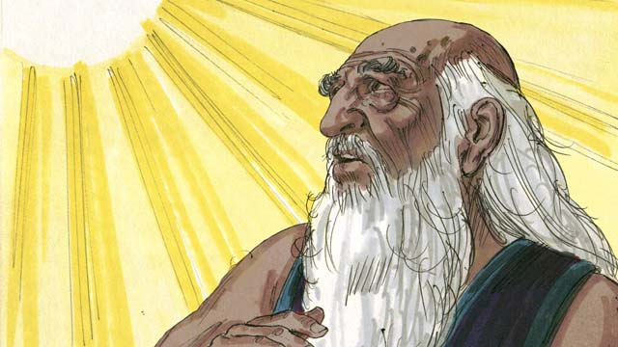

God promised Abraham that through him all people groups of the world would receive a blessing. God would fulfill this promise by sending the Messiah at some later time. The Messiah would save people from their sin out of every people group in the world.

21-03

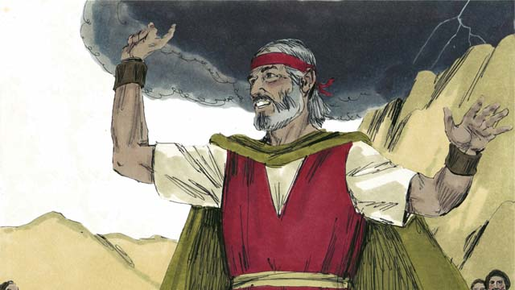

God promised Moses that in the future he would send another prophet like Moses. This prophet would be the Messiah. In this way, God promised again that he would send the Messiah.

21-04

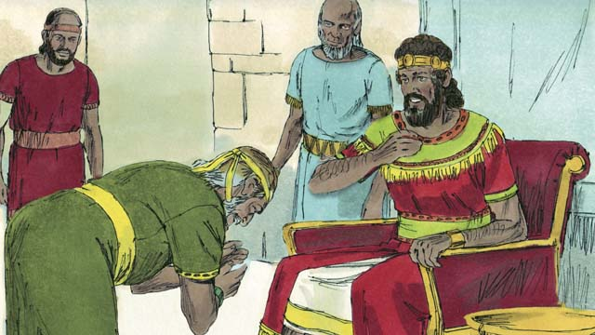

God promised King David that one of his own descendants would be the Messiah. He would be king and rule over God’s people forever.

21-05

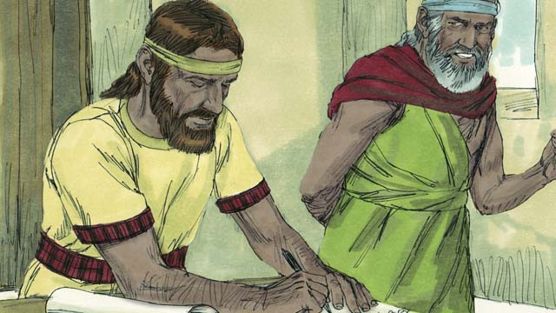

God spoke to the prophet Jeremiah and told him that he would make a New Covenant one day. The New Covenant would not be like the old covenant God made with Israel at Sinai. When he would make his New Covenant with people, he would make them to know him personally. Each person would love him and want to obey his laws. God said this would be like writing his law on their hearts. They would be his people, and God would forgive their sins. It is the Messiah who would make the New Covenant with them.

21-06

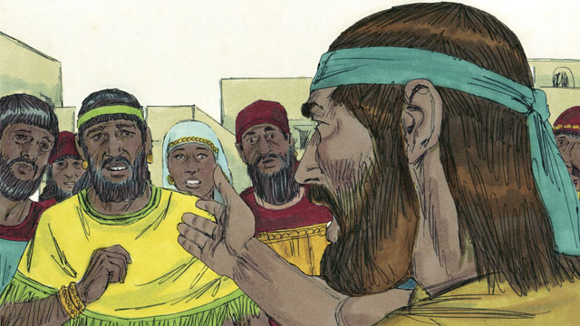

God’s prophets also said that the Messiah would be a prophet, a priest, and a king. A prophet is a person who hears the words of God and then proclaims God’s messages to the people. The Messiah that God promised to send would be the perfect prophet. That is, the Messiah would hear God’s messages perfectly, he would understand them perfectly, and he would teach them to people perfectly.

21-07

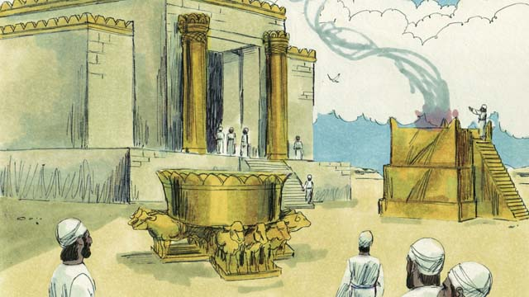

Israelite priests kept on making sacrifices to God for the people. These sacrifices were in place of God punishing the people for their sins. Priests also prayed to God for the people. However, the Messiah would be the perfect high priest who would offer himself as a perfect sacrifice to God. That is, he would never sin, and when he would give himself to be the sacrifice, no other sacrifice for sin would ever be necessary.

21-08

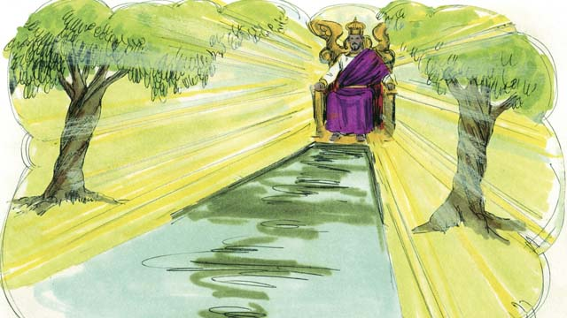

Kings and chiefs rule over groups of people, and sometimes they make mistakes. King David ruled over only the Israelites. But the Messiah, a descendant of David’s, will rule over the whole world, and he will rule forever. Also, he will always rule justly and make the right decisions.

21-09

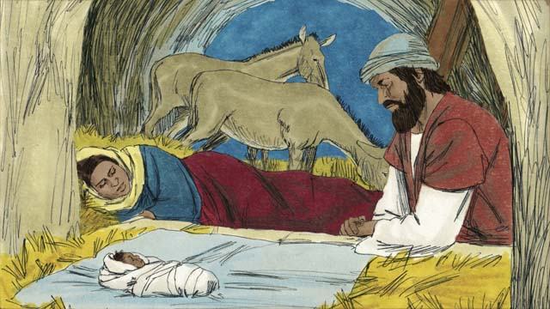

God’s prophets said many other things about the Messiah. For example, Malachi said that another prophet would come before the Messiah came. That prophet would be very important. Also, the prophet Isaiah wrote that the Messiah would be born of a virgin. And the prophet Micah said that the Messiah would be born in the town of Bethlehem.

21-10

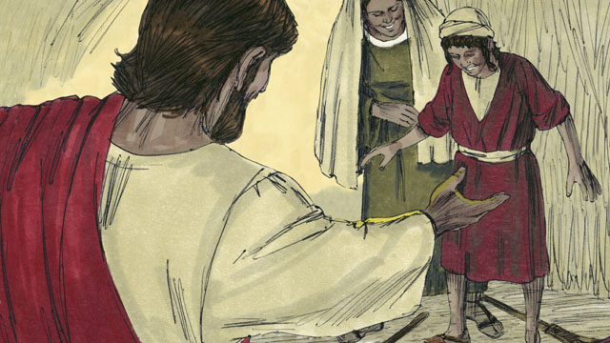

The prophet Isaiah said the Messiah would live in the region of Galilee. The Messiah would comfort people who were very sad. He would also set prisoners free. The Messiah would also heal sick people and those who could not hear, see, speak, or walk.

21-11

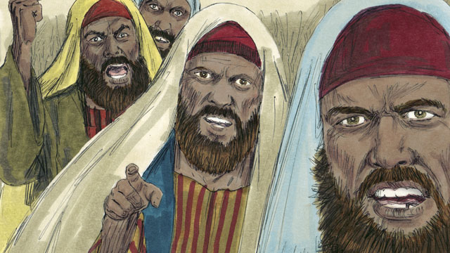

The prophet Isaiah also said that people would hate the Messiah and refuse to accept him. Other prophets said that a friend of the Messiah would turn against him. The prophet Zechariah said that this friend would receive 30 silver coins from other people for doing this. Also, some prophets said that people would kill the Messiah, and that they would gamble for his clothes.

21-12

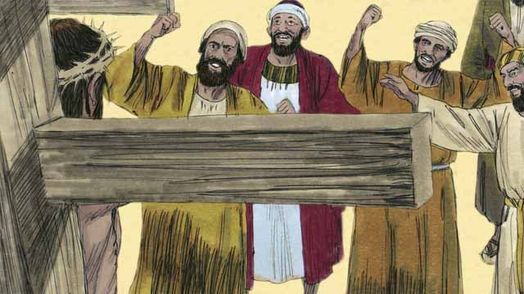

The prophets also told about how the Messiah would die. Isaiah prophesied that people would spit on, mock, and beat the Messiah. They would pierce him, and he would die in great suffering and agony, even though he had not done anything wrong.

21-13

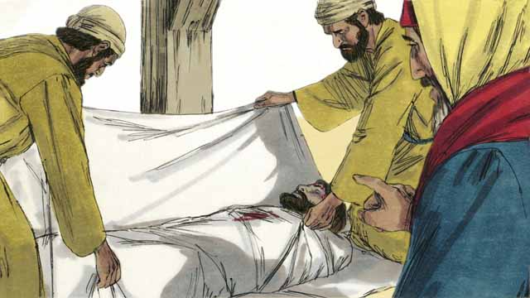

The prophets also said that the Messiah would not sin. He would be perfect. But he would die because God would punish him for other people’s sins. When he died, people would be able to have peace with God. This is why, in God’s plan, the Messiah had to die.

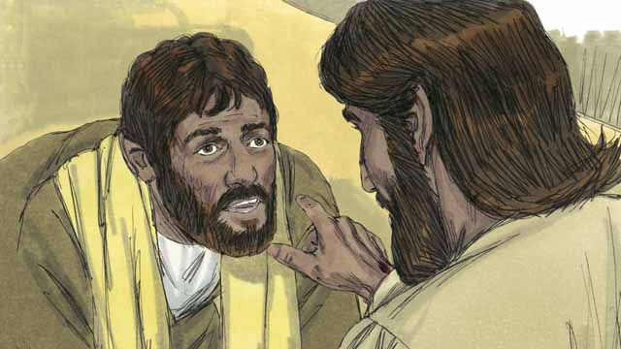

The prophets also said that God would raise the Messiah from the dead. This shows that Jesus’ death and resurrection was all God’s plan to make the New Covenant, so he could save people who had sinned against him.

21-14

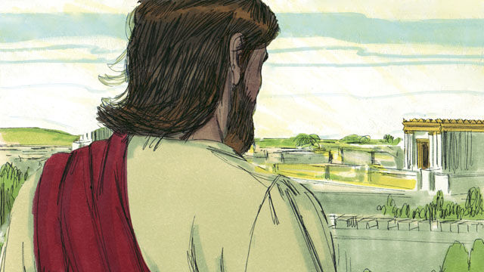

God revealed to the prophets many things about the Messiah, but the Messiah did not come during the time of any of those prophets. More than 400 years after the last of these prophecies was given, at exactly the right time, God sent the Messiah into the world.

*A Bible story from: Genesis 3; 12; Deuteronomy 18:15; 2 Samuel 7; Psalm 16; 22; 35; 69; 41; Isaiah 7:14; 9:1-7; 61; 53; 50:6; 59:16; Jeremiah 31; Daniel 7; Micah 5:2; Zechariah 11:12-13; Malachi 4:5*

## 1 Community Study: An Important Practice—Forgiving One Another

* **Key Idea**: emphasizing the importance of forgiveness
* **Key Passage**: Matthew 18:21-35
* **Main Session**: OBS 21 (God Promises the Messiah)

### 1.1 Recite the Creedal Verse (3–5 minutes)

The verse below summarizes the teaching of the current passage. Read the verse out loud as a community. Read it again several times as a group until the whole community can recite it from memory.

“He of whom Moses wrote in the law, and the prophets, we have found him: Jesus son of Joseph, from Nazareth.” John 1:45

OR

43 It is to him [Jesus] that all the prophets bear witness, so that everyone who believes in him shall receive forgiveness of sins through his name.” Acts 10:43

### 1.2 Read the Passage (5 minutes)

Even after we are saved, we will sin against others, and others will sin against us. God tells us to forgive others as he has forgiven us. In order to grow together as a united and one-minded community, read the passage below.

21 Then Peter came and said to Jesus, “Lord, how often will my brother sin against me and I forgive him? Until seven times?” 22 Jesus said to him, “I do not tell you seven times, but until seventy times seven. 23 Therefore the kingdom of heaven is similar to a certain king who wanted to settle accounts with his servants. 24 As he began the settling, one servant was brought to him who owed him ten thousand talents. 25 But since he had not the means to repay, his master commanded him to be sold, together with his wife and children and everything that he had, and payment to be made. 26 So the servant fell down, bowed down before him, and said, ‘Master, have patience with me, and I will pay you everything.’ 27 So the master of that servant, since he was moved with compassion, released him and forgave him the debt. 28 But that servant went out and found one of his fellow servants, who owed him one hundred denarii. He grasped him, took him by the throat, and said, ‘Pay me what you owe.’ 29 But his fellow servant fell down and implored him, saying, ‘Have patience with me, and I will repay you.’ 30 But the first servant refused. Instead, he went and threw him into prison until he should pay him what he owed. 31 When his fellow servants saw what had happened, they were very upset. They came and told their master everything that had happened. 32 Then that servant’s master called him, and said to him, ‘You wicked servant, I forgave you all that debt because you implored me. 33 Should you not have had mercy on your fellow servant, even as I had mercy on you?’ 34 His master was angry and handed him over to the torturers until he would pay all that was owed. 35 So also my heavenly Father will do to you, if you do not forgive your brother from your heart.” Matthew 18:21-35

### 1.3 Discuss the Idea (10–15 minutes)

Forgiveness is a core teaching of the Christian faith. When people believe in Jesus, God forgives their sins. Then, Christians show forgiveness to others. After reading the passage above, use the following questions to help your community discuss what it means to practice Christian community in a godly way.

1. What does this passage teach us about the practice of forgiveness?
2. What does it mean to forgive someone? Why is it hard to forgive other people?
3. What happens to a group of people when they do not practice forgiveness?
4. How can you encourage members of your community to practice forgiveness as you work/serve together?

### 1.4 Personal Reflection (5–10 minutes)

Read the verse below. Reflect on whether you have any unresolved issues with others. That is, identify if there is someone you need to forgive but you have not yet done so. Pray that God would remove the bitterness and unforgiveness from your heart.

Be careful so that no one lacks God’s grace, and that no root of bitterness grows up to cause trouble, so that many do not become polluted by it. Hebrews 12:14

### 1.5 Reflect Privately in Prayer (5 minutes)

Pray that God would reveal to you any person that you need to forgive. Ask God to give you clarity and strength to forgive that person of the sin they have committed against you.

### 1.6 Sing a Song (3–5 minutes)

Choose a song to sing to praise God and encourage one another.

## 2 Biblical Interpretation: Observing the Details of the Story

After reading the crafted biblical story, answer the following questions to familiarize yourself with the details of the story.

### 2.1 Observation Questions

Answer the following observation questions to gain a basic understanding of the story. Read the story as a community and answer these questions as a group.

#### 21-01

When did God first decide to send the Messiah?  
He decided this before he created the world.

What did God promise Adam and Eve?  
God promised Adam and Eve that he would send the Messiah. He told them a descendant would come from Eve who would crush the snake’s head.

What would the Messiah do to Satan?  
The Messiah would defeat Satan completely.

#### 21-02

What did God promise Abraham?  
God promised Abraham that through him all the people groups of the world would receive a blessing.

Who would God sent to fulfill his promise that all people groups will be blessed through Abraham?  
He would send the Messiah.

What would the Messiah do?  
The Messiah would save people from their sin out of every people group in the world.

#### 21-03

What did God promise Moses?  
God promised Moses that in the future he would send another prophet like Moses.

In what way would the Messiah like Moses?  
The Messiah would be a prophet like Moses.

#### 21-04

What did God promise King David?  
God promised King David that one of his own descendants would be the Messiah.

What would the Messiah do?  
The Messiah would be one of David’s descendants and would rule over God’s people as king forever.

#### 21-05

What did God promise Jeremiah?  
God told Jeremiah that he would one day make a New Covenant with his people.

How would the New Covenant be different from the Old Covenant made at Sinai?  
In the New Covenant, people would know God personally, people would love God and obey his laws, God would write his laws on their hearts, they would be God’s people, and God would forgive their sins.

Who would bring the New Covenant?  
The Messiah would make the New Covenant with God’s people.

#### 21-06

What did the prophets say about the Messiah?  
The prophets said that the Messiah would be a prophet, priest, and king.

What do prophets do?  
Prophets hear the words of God and proclaim God’s messages to his people.

How would the Messiah be the perfect prophet?  
The Messiah would hear God’s messages perfectly, understand them perfectly, and teach them perfectly.

#### 21-07

Why did priests do?  
Priests offered sacrifices to God to so God’s people did not get punished for their sin. Priests prayed to God for the people.

How would the Messiah be the perfect high priest?  
The Messiah would offer himself as a perfect sacrifice to God on behalf of the people. No other sacrifice would be necessary because the Messiah was perfect, he never sinned.

#### 21-08

What did kings do?  
Like King David, kings rule over groups of people.

How would the Messiah be the perfect king?  
The Messiah would reign over the whole world forever, rule justly, and make the right decisions.

#### 21-09

Who did the prophets say would come before the Messiah?  
The prophet Malachi said that another important prophet would come before the Messiah came.

Who did the prophets say would give birth to the Messiah?  
The prophet Isaiah said that the Messiah would be born of a virgin.

Where did the prophets say the Messiah would be born?  
The prophet Micah said that the Messiah would be born in the town of Bethlehem.

#### 21-10

Where did the prophets say the Messiah would live?  
The prophet Isaiah said the Messiah would live in the region of Galilee.

What would the Messiah be like?  
The Messiah would comfort people who were sad, set prisoners free, heal the sick, and heal the deaf, blind, mute, and lame.

#### 21-11

What did the prophets say about how people would treat the Messiah?  
The prophet Isaiah people would hate the Messiah and refuse to accept him.

What did the prophets say about the Messiah being betrayed?  
The prophet Zechariah said that a friend of the Messiah would get paid 30 pieces of silver to turn against (betray) Jesus.

What would happen when the Messiah died?  
The prophets said that people would kill the Messiah, and that they would gamble for his clothes.

#### 21-12

According to the prophets, how would the Messiah die?  
The Messiah would be mistreated and pierced, and would die in great suffering.

Did the Messiah do anything wrong to deserve death?  
No. The Messiah did not do anything wrong. He died so that he could save his people from their sin.

#### 21-13

In God’s plan, why did the Messiah have to die?  
The Messiah, being perfect, would die so that God could punish him for the people’s sin so they could have peace with God.

#### 21-14

What happened to the Messiah after he died?  
The prophets also said that God would raise the Messiah from the dead.

What would God accomplish through the death and resurrection of the Messiah?  
God would start the New Covenant and save people who had sinned against him.

#### 21-15

Did the Messiah come during the time of the prophets?  
No. The Messiah did not come during the time of the prophets.

How much time passed between the last prophecy about the Messiah and his coming into the world?  
More than 400 years had passed.

How right was the time when God sent the Messiah into the world?  
God sent the Messiah into the world at exactly the right time.

### 2.2 Translation Questions

Use the following translation questions to understand specific details of the passage. Discuss how you might translate these specific elements of the story.

#### 21-01

**Even when God created the world** At the time God created the world, he already had planned to send the Messiah to save his people from their sin. How would you express **Even when God created the world** to emphasize that God planned to send the Messiah to save his people from their sin before he created the world?

  

**crush the snake’s head** Unless the head of a venomous snake is crushed, the snake can still hurt someone. This descendant of Eve would destroy the head of the snake by stepping on it. How would you express **crush the snake’s head** to mean to stomp on the head of the snake to destroy it?

  

**Satan appeared as a snake in order to deceive Eve** Satan spoke to Eve in the form of a snake. This does not mean that he is a snake now. The snake lied by making Eve doubt what God had said and tricking her into disobeying God. How would you express **Satan appeared as a snake in order to deceive Eve** to mean the snake who deceived Eve was an appearance of Satan?

  

#### 21-02

**through him** The Messiah would come into the world as one of Abraham’s descendants. As the Messiah, the descendant would bring blessing to all people groups and save people from their sin. How would you express **through him** to mean the people groups of the world would receive a blessing because of one of Abraham’s descendants?

  

**God would fulfill this promise** God promised to bless all the people groups of the world. God would bring his promise to completion by sending the Messiah. How would you express **God would fulfill this promise** to mean God would make his promise become a reality?

  

**out of every people group in the world** The Messiah would save people from every people group. People groups are defined by people who share a common language and culture. How would you express **out of every people group in the world** to mean God would save humans from every group of people that share a common culture and language?

  

#### 21-03

**another prophet like** Moses The Messiah would be similar to Moses in some ways and different than Moses in other ways. To be like Moses, the future prophet would need to have great authority from God to lead and rescue his people. How would you express **another prophet like** Moses to mean the Messiah would be similar to Moses in his authority and power to save God’s people?

  

#### 21-04

**one of his own descendants** God promised David that the Messiah would be born in his family line. He would be a particular offspring born in David’s lineage. How would you express **one of his own descendants** to mean a direct descendant of David himself?

  

**rule over** God’s people The Messiah would be king. He would govern God’s people for all time. How would you express **rule over** God’s people to mean to exercise authority to govern a people?

  

#### 21-05

**would not be like** The New Covenant would be different than the Old Covenant in some ways. would be truly effective. People really would know God, they would truly live as his people, and He would forgive their sins completely, based on the Messiah’s sacrifice of himself one time for all who believe in him. How would you express **would not be like** to mean the New Covenant would be different from the Old Covenant in some ways?

  

**this would be like writing his law on their hearts** The heart represents the emotions or the mind. In the New Covenant, Yahweh’s law will become a part of God’s people, rather than merely being written on stone. God was comparing helping his people to understand his laws and to earnestly desire to obey them with writing on their hearts, since this is in contrast with the way God had written his law on stone tablets for the Israelites. How would you express **this would be like writing his law on their hearts** to mean Yahweh’s law will be part of their thoughts and emotions as if God wrote them on their hearts?

  

**be his people** In the New Covenant, God would make his people to be his favored people. How would you express **be his people** to mean to become God’s special and favored people?

  

#### 21-06

**the perfect prophet** The Messiah was free from any sin or defeat. He would be a prophet who would be perfect in obedience to God, giving every word God would speak to the people. He would present God perfectly to the people, helping them to know and understand God. How would you express **the perfect prophet** to mean a messenger of God who always obeyed God in every way and always spoke truly about God in every way?

  

#### 21-07

**However, the Messiah would be the perfect high priest who would offer himself as a perfect sacrifice to God** The Israelite priests offered sacrifices to God in place of God punishing his people for their sin. In contrast to the imperfect Israelite priests, the Messiah was the perfect priest. In contrast to the Israelite priests offering sacrifices to God, the Messiah would offer himself as the sacrifice. How would you express **However, the Messiah would be the perfect high priest who would offer himself as a perfect sacrifice to God** to mean the Messiah was different from the Israelite priests in that he was perfect and he both the perfect priest and the perfect sacrifice?

  

**the perfect high priest** Unlike the other high priests, the Messiah would never sin, and he would permanently take away all the sins of the people. How would you express **the perfect high priest** to mean the main priest who never sinned and can take away the sins of people once for all?

  

**offer himself** The Messiah would allow himself to be killed and this would be a sacrifice to God. How would you express **offer himself** to mean to allow himself to be killed as a sacrifice to God?

  

**a perfect sacrifice** The Messiah was a sacrifice that has no fault or imperfection. How would you express **a perfect sacrifice** to mean a flawless offering to God which is killed so that God’s people are not punished for their sin?

  

#### 21-08

**But the Messiah** Many human kings governed groups of people. These kings were not perfect and made mistakes. They did not rule over the whole world. They only ruled for a limited time. In contrast with these kings, the Messiah made no mistakes (he was perfect), he would rule over the whole world, and would rule for all time. How would you express **But the Messiah** to mean the Messiah would rule as king differently than other human kings?

  

**the whole world** The Messiah would rule everyone everywhere as king. How would you express **the whole world** to mean all people in all places?

  

**rule justly** The Messiah will govern in ways that are fair and right. How would you express **rule justly** to mean to govern as king in a way that is fair and right?

  

#### 21-09

**That prophet would be very important** God would send a prophet to come before the Messiah came. God gave this prophet a very significant job to do in preparing people for the coming of the Messiah. How would you express **That prophet would be very important** to mean God gave the prophet who came before the Messiah came a very significant work to do?

  

**the Messiah would be born of a virgin** God sent the Messiah into the world. The Messiah came into the world by being born of a woman who was a virgin. A virgin is a woman who has never had sexual intercourse with a man. How would you express **the Messiah would be born of a virgin** to mean a virgin would give birth to the Messiah?

  

#### 21-10

**set prisoners free** The Messiah set free those who have unjustly been put into prison. This could also refer to setting people free from the bondage of sin. How would you express **set prisoners free** to mean to liberate those who have been put in prison?

  

**could not hear, see, speak, or walk** The Messiah would heal people who could not hear, could not see, could not speak, or could not walk. Said another way, the Messiah would heal the deaf, blind, mute, and lame. How would you express **could not hear, see, speak, or walk** to mean people who are deaf, blind, mute, and lame?

  

#### 21-11

**refuse to accept him** People would not recognize the Messiah as truly the Messiah and did not follow him. How would you express **refuse to accept him** to mean to acknowledge the Messiah as the true Messiah and follow him?

  

**30 silver coins** At the time, each of these coins was worth the amount of money a person could earn in four days. How would you express **30 silver coins** to mean thirty coins made out of silver?

  

**gamble for his clothes** Those who killed the Messiah played a game of betting to win his clothes. How would you express **gamble for his clothes** to mean to play a game of chance to determine who would win his clothes?

  

#### 21-12

**pierce** The people who killed the Messiah thrust a sharp weapon into the Messiah. How would you express **pierce** to mean people would stab the Messiah with a sharp weapon?

  

**even though he had not done anything wrong** People killed the Messiah. The Messiah was innocent. It is not expected that an innocent, sinless man would be killed so brutally. How would you express **even though he had not done anything wrong** to mean the innocence of the Messiah is contrary to how people treated him when they brutally killed him?

  

#### 21-13

**But he would die** The Messiah is perfect and without sin. The Messiah did not deserve to die or be punished. It is not expected that a perfect man would die for other people’s sin. Instead, the Messiah died as punishment for other people’s sins. How would you express **But he would die** to mean the death of the Messiah as opposite of what would expect to happen to someone who is sinless and perfect?

  

**peace with God** Humans sin and disobey God’s laws. As a result, humans are in conflict with God. God is just and righteous to punish humans. However, the Messiah died so that God would no longer punish his people in anger. How would you express **peace with God** to mean to no longer have hostility between God and people?

  

**the Messiah** had to die God planned for the Messiah to die. How would you express **the Messiah had to die** to mean it was necessary for the Messiah to die to fulfill God’s plan and save people from punishment for their sin?

  

#### 21-14

**raise the Messiah from the dead** After the Messiah died, God would resurrect the Messiah and bring him back to life. How would you express **raise the Messiah from the dead** to mean to cause the Messiah to be alive again?

  

**to make the New Covenant** God planned to establish a new formal, binding agreement with his people. This covenant would be a new way of God relating to his people. How would you express **to make the New Covenant** to mean to put into effect a new binding agreement between two parties?

  

#### 21-15

**God revealed to the prophets** God showed the prophets truth about the Messiah. How would you express **God revealed to the prophets** to mean God told the prophets true things about the Messiah that was not always known before?

  

**at exactly the right time** God knew the perfect time to send the Messiah into the world. God sent the Messiah into the world at a time of human history that was not too late or too early. How would you express **at exactly the right time** to mean God sent the Messiah to come into the world at a time in human history that would perfectly fulfill God’s plan?

  

**into the world** God sent the Messiah to the people of the world. The Messiah existed before he lived in the world. He would come **into the world** not only for the Jews, but for all people. How would you express **into the world** to mean to the people who lived in the world?

  

## 3 Theological Dialogue: Discussing the Meaning of the Story

Take time to explore the meaning of this story together as a community. Use the following discussions as a way to grasp what truth the story teaches.

### 3.1 Discourse Questions

Use the following discourse questions to understand the meaning of the story. Pay attention to how the story itself addresses each question or theme.

##### What did God promise about the Messiah to those living in the Old Covenant? (21-01, 21-02, 21-03, 21-04)

Even before God created the world, God planned to send the Messiah. This was a part of God’s eternal plan (plan for all time). (21-01)

  

God promised Adam and Eve that he would later send the Messiah. The Messiah would be born into the world as one of Eve’s descendants and complete defeat Satan. (21-01)

  

God promised Abraham that he would later send the Messiah. The Messiah would be one of Abraham’s descendants, he would bring blessing to all people groups in the world, and he would save people from their sin out of every people group. (21-02)

  

God promised Moses that he would later send the Messiah. The Messiah would be a prophet like Moses who would come with authority from God and bring his people into freedom. (21-03)

  

God promised David that he would later send the Messiah. The Messiah would be one of David’s descendants and would rule over God’s people for all time. (21-04)

  

##### What did it mean for the Messiah to establish a New Covenant with his people? (21-05)

God spoke to Jeremiah and told him that he would make a New Covenant with his people. The Messiah would make this New Covenant possible. (21-05)

  

In the New Covenant, God would know his people personally. He would establish new way of relating to his people. (21-05)

  

In the New Covenant, God’s people would love him and want to obey his laws. God’s people would not see obedience as a burden. (21-05)

  

In the New Covenant, God would write his law on the hearts of his people so that they would be able to obey God’s commands. (21-05)

  

In the New Covenant, God would make his people his own special and chosen community of faith. (21-05)

  

In the New Covenant, God would forgive his people of their sin. (21-05)

  

##### What does it mean that the Messiah would be prophet, priest, and king? (21-06, 21-07, 21-08)

The prophets said that the Messiah would be prophet, priest, and king. (21-06)

  

As the perfect prophet, the Messiah would perfectly know God’s truth, perfectly teach them to people, and perfectly show people who God is. (21-06)

  

As the perfect priest, the Messiah would be without sin, offer himself as a prefect sacrifice for sin, and make a way for people to be made right with God. (21-07)

  

As the perfect king, the Messiah would rule over the whole world in perfect justice and righteousness. (21-08)

  

##### What did the prophets reveal about the Messiah? (21-09, 21-10, 21-11, 21-12, 21-13, 21-14, 21-15)

The prophets told ahead of time that before the Messiah came an important prophet would come. (21-09)

  

The prophets told ahead of time that the Messiah would be born by a virgin in the town of Bethlehem. (21-09)

  

The prophets told ahead of time that the Messiah would live in the region of Galilee. (21-10)

  

The prophets told ahead of time that the Messiah would comfort those who were sad, set prisoners free, and heal the sick. (21-10)

  

The prophets told ahead of time that people would hate the Messiah and not follow him. (21-11)

  

The prophets told ahead of time that one of the Messiah’s friends would betray him for 30 pieces of silver. (21-11)

  

The prophets told ahead of time that people would kill the Messiah and gamble for his clothes. (21-11)

  

The prophets told ahead of time the people would mistreat the Messiah, beat the Messiah, and pierce the Messiah. (21-12)

  

The prophets told ahead of time that the Messiah would be perfect and without sin. The Messiah died to be punished for the sin that humans should have been punished for. God planned for the Messiah to die so that people could be at peace with God. (21-13)

  

The prophets told ahead of time that the Messiah would come back to life. (21-14)

  

God revealed many things about the Messiah. God sent the Messiah just as God said to fulfill his plan and establish the New Covenant with his people. The Messiah came at just the right time to fulfill God’s plan. (21-14, 21-15)

  

### 3.2 Theological Questions

Answer the following theology questions as a community. Discuss what truths this story teaches.

1. How did God prepare people for the coming of the Messiah? What did God tell various people who lived in the Old Covenant about the Messiah?
2. What is the New Covenant and why is it so important for how God relates to his people? What does this story tell us about the New Covenant?
3. How is the Messiah the perfect prophet, perfect priest, and perfect king? What does this story tell us about what the Messiah is like?
4. How did the Messiah come into the world and what did he do to rescue people? What does this story tell us about all that the Messiah did to save people from sin?

### 3.3 Translation Draft

Work as a translation team to draft each panel of this story. Pay attention to any specific translation issues that are challenging or significant.

#### Make Translation Draft

Make a draft for each section of this story.

#### Discuss and Revise

After drafting the story, discuss any translation issues that you think need special explanation.

#### Drafting Summary Reflection

Summarize any noteworthy translation decisions and the rationale/reasoning behind these translation decisions. In the final movement of this class, you will use these observations to give an account (i.e., chronicle/narrate) of how your translation improved through the checking process.

## 4 Personal Reflection: Following the Teaching of the Story

Take a moment to allow this story to evaluate your own life and to consider how God would have you respond. After this reflection, use the quality checking questions to check your translation draft among the translation team.

### 4.1 Journal Reflection

Prayerfully think about the following personal reflection questions. Write/Record your answers and/or discuss them as a group.

1. What are some of the things that the Messiah has done that brings you greatest joy?
2. How have you experienced the blessings of the New Covenant?
3. What new convictions do you have about what the Messiah came to do and why his work is so important to fulfill God’s plan?
4. What does it mean to accept Jesus as the Messiah?

### 4.2 Team Check

*The following activity will help you check the clarity, accuracy, and naturalness of your draft. Read the passage aloud and discuss the checking questions with other members of your translation community. You might need to reread portions (or the whole) of the biblical passage multiple times as you answer each of these questions. Record answers to these questions below.*

#### Team Checking Questions

*Use the following questions to check your translation draft for accuracy, clarity, and naturalness.*

1. **Accurate**: Has anything been **added** to your translation of this passage that is not a part of the meaning of the source text? *If additions exist, are they included only added to clarify meaning (such as implied information)?*
2. **Accurate**: Is anything **missing** from your translation of this passage that is a part of the meaning of the source text? *If some part of the meaning is missing from your translation, add it.*
3. **Accurate**: Does any meaning in your translation of this passage appear to be **different** than the meaning of the source text? *If the meaning is different, try changing your translation so that the meaning remains the same.*
4. **Natural**: Does anything sound **unnatural** to how you would say it in your language? *If portions of the passage sound unnatural in your language, try to make them sound the way you would say it in your language while staying true to the meaning of the source text.*
5. **Clear**: Is anything **unclear** or **confusing** in your translation that confuses the meaning of the source text? *If portions of the passage are unclear or confusing, revise them to clearly communicate the meaning of the source text.*
6. **Consistent**: How **consistent** is your translation within the passage and with other passages? *If portions of the passage need to be made consistent or if you need to revise translations of other passages, make these adjustments.*

#### Record Feedback

*After discussing the checking questions above as a translation community, record any feedback on your translation draft. Pay attention for parts of your translation that are translated well and parts of your translation that need correction.*

#### Discuss and Revise

*After gathering feedback on your draft, discuss it together with your translation community and make appropriate revisions in your translation.*

#### Record Translation Decisions

*As a community, discuss some of the most noteworthy translation decisions in your draft. Summarize each decision and explain the reasons your community decided on that translation. You should update these decisions each time you check your draft with various groups of people.*

You should **measure** the quality of your translation draft. You can **record translation decisions** to make it clear why you translated things a certain way. Translation decisions can help your translation team and the surrounding community be a part of the translation process.

How can you know the quality of your translation?

1. **Measure** the translation by marks/standards of quality (i.e., clear, accurate, natural, church-approved)
2. **Test** the translation with others and record feedback and conversations from in the field (i.e., church and community check)
3. **Compare** and **contrast** the translation with the source text (i.e., meaning of text and notes) and alternatives (i.e., other translation choices)
4. **Explain** the reasons why you translated a particular portion of the text.

**Example Sentences That Help Explain Your Translation Decision** Use the following example sentences to help explain your translation decisions:

1. The original text literally **says/means**, so we translated the term in this way…
2. We originally decided to translate **the biblical term** with **this term**, but we changed it because…
3. When our translation team discussed **the biblical term**, this is what we talked about…
4. **The term** is [clear, accurate, natural, consistent] because…
5. The community understands **this term** to mean…
6. We considered these other terms. We did not use **these terms** because…
7. When we checked this in the church, we learned…
8. When we checked this in the community, we learned…

**Example of Translation Decision**

In OBS 01-07 we decided to translate **blessed** like this: [actual translation]. We decided on this translation because of these reasons:

1. The word [actual translation] means to cause good things to happen to someone or something. This term is used when a person desires someone or something to prosper or flourish. This term does not refer to magic or witchcraft.
2. When we checked this word with other believers, they said it describes God showing his kindness and favor on someone or something. These are some of the terms that we did not decide to use…
3. Many of our people will understand this word. When we discussed this phrase with the surrounding community, we discovered it was a natural way to describe God causing good and beneficial things to happen.

## 5 Ministry Practice: Serving the Church with the Story

Now that you have a draft of this story, consider how this story can encourage other believers in their faith. After ministering this story to others, you will also perform a community check of your translation draft.

### 5.1 Church Ministry

Reflect on how this story can edify and mature the Christian community. Design a way to minister this story to your church community.

**Ministry Preparation**: Take time to consider how you could minister this story to others. Record some ministry ideas below.

**Ministry Implementation**: Minister this story to a group of believers as you had planned. Use the information in this study to help develop a teaching/lesson or lead a discussion of this story to other believers. Record your ministry plan below.

**Ministry Reflection**: Think about what you learned from ministering this story to other believers. Reflect on your experience below.

### 5.2 Church Community Check

After teaching or ministering this story to the church, check the translation quality with the church community. Record any feedback from your checking experience.

#### Create Checking Questions

You can use **Translation Questions** to check your draft. Each **Translation Question** explains the meaning of a specific part of the story and asks you to consider how you would translate that part of the story in your own language. Change each **Translation Question** into a **Checking Question** by asking the following questions. The first question asks you to identify how each specific phrase was translated into your language. The second question asks people in the church to determine if your translation of the phrase expresses the meaning clearly, accurately, and naturally. Look at the following examples to see how to change **Translation Questions** into **Checking Questions**:

#### Translation Question Example 1

**to proclaim the good news about Jesus** Paul and Silas traveled to Philippi for the purpose of preaching the gospel. The gospel is the good news that Jesus saves people from their sins if they will believe in Jesus. How would you express **to proclaim the good news about Jesus** to mean to tell other people the message about how Jesus can save people from their sins?

#### Translation Question Example 2

**a merchant** Paul and Silas met a woman named Lydia at the place by the river. She owned a business and sold items to make money. How would you express **a merchant** to mean a business owner who sells items for a profit?

#### Translation Question Example 3

**so Paul and Silas baptized them** The jailer and his whole family followed Paul’s instructions. They believed in Jesus. The result of this was Paul and Silas baptized them. How would you express **so Paul and Silas baptized them** to mean the result of the jailer and his family believing in Jesus that Paul and Silas baptized all of them?

You can change these into **Checking Questions** like this:

#### Checking Question Example 1

**to proclaim the good news about Jesus** How did you translate **to proclaim the good news about Jesus**? Does it mean to tell other people the message about how Jesus can save people from their sins?

#### Checking Question Example 2

**a merchant** How did you translate **a merchant**? Does it mean a business owner who sells items for a profit?

#### Checking Question Example 3

**so Paul and Silas baptized them** How did you translate **so Paul and Silas baptized them**? Does it mean the result of the jailer and his family believing in Jesus that Paul and Silas baptized all of them?

#### Record Feedback

*Discuss the* ***Checking Questions*** *with your church community, and record any feedback on your translation draft. Pay attention to parts of your translation that are translated well and parts of your translation that need correction.*

#### Discuss and Revise

*After gathering feedback on your draft, discuss it together with your translation community and make appropriate revisions to your translation.*

#### Record Translation Decisions

*Update your translation decisions and record any new and noteworthy observations on the quality of your draft.

## 6 Missional Outreach: Sharing the Truth of the Story

*After sharing this story with others, check the translation quality with the wider language community. Record any feedback from your checking experience.*

### 6.1 Mission Engagement

*Consider how you will witness this story to unbelievers. Design a way to share this story and engage them in what it teaches about Christianity and the gospel.*

**Witness Preparation**: Take time to consider how you will witness this narrative to unbelievers. Record some ideas below.

**Witness Implementation**: Share this story with an unbeliever. Use the information in this study to help develop a teaching/lesson or lead a discussion of this story to other believers. Record your ministry plan below.

**Witness Reflection**: Think about what you learned from ministering this story to unbelievers. Reflect on your experience below.

### 6.2 Sociolinguistic Check

After sharing this story with the language community, check your translation draft with the surrounding community. Record your observations.

#### Checking Approach

After witnessing this story to unbelievers, use one of the following methods to check the translation of this story. Consider using the **Observation Questions** to check your translation draft or come up with your own quality checking questions.

**Read-Retell Check:** Read your draft to those the community and ask them to retell the passage. Be attentive to any portions of the passage that are unclear, unnatural, or inaccurate.

**Comprehension Questions Checklist:** Read the draft of the passage and ask a list of comprehension questions to make sure the passage is being rightly understood. You can use the **Observation Questions** in this guide or come up with your own questions. Then, record any insights or issues that arise.

**Discussion Group:** Develop key questions to ask about the passage (both formational and translational). Read the passage and have a group discussion about the passage, paying attention to issues that need to be addressed, edited, and revised.

#### Record Feedback

*After sharing your draft with the language community, discuss the* ***Observations Questions****, and record any feedback on your translation draft. Pay attention to parts of your translation that are translated well and parts of your translation that need correction.*

#### Discuss and Revise

*After gathering feedback on your draft, discuss it together with your translation community and make appropriate revisions to your translation.*

#### Record Translation Decisions

*Update your translation decisions and record and new any noteworthy observations on the quality of your draft.

## 7 Conclusion

As a translation community, take time to reflect on all that was learned in studying, drafting, and checking this story. Celebrate all that God has taught you as a community. Then, submit your revised draft and checking summaries to network leaders for further review.