Open Bible Stories

The Birth of John

## 0 Introduction

### 0.1 Key Idea

The story of the birth of John teaches us how to trust God to fulfill his promises.

### 0.2 Creedal Verse

“I tell you, among those born of women none is greater than John. Yet the one who is least in the kingdom of God is greater than he.” Luke 7:28

### 0.3 Metanarrative Summary

The eternal God created all things in six days. He made a good and perfect world. He made humans in his image to fill the earth and rule over creation. But humans rebelled against God and ruined God’s creation. God set to restore his world through his promise. God made a covenant with Abraham. He promised to bless all nations through Abraham. God kept his promises across the generations. God provided Abraham with a promised child, Isaac. God gave Isaac a wife and she bore twins, Jacob and Esau. God blessed Jacob and his sons, and the blessing continued to the next generation. God rescued Joseph, one of Jacob’s sons, and used him to rescue his family. God caused his people, the Israelites, to multiply in the land of Egypt; eventually, they became slaves. But, God raised up a deliverer, Moses, to deliver his people from their slavery. God sent judged the Egyptians with harsh plagues; in the final judgment, he passed over his people who covered their doorposts with the blood of a sacrificed lamb. Then, God delivered the Israelites by bringing them out of Egypt and crossing the Red Sea on dry land. God made a covenant with the Israelites and made them his people. God tested Israel in a series of wilderness wanderings and eventually brought his people into the promised land of Canaan. God raised up deliverers to lead Israel and rescue them from their enemies. God formed Israel into a kingdom. He made a covenant with King David and promised to send a king that would rule his people forever. Many of Israel’s kings were evil and the kingdom of Israel divided into two kingdoms. God sent prophets to warn his people of God’s judgment and call them to repent. When Israel did not repent, God sent his people into exile. After many years, he brought them back to the land. Throughout the Old Testament, God promised to send his Messiah to deliver his people form their sin. After many years, the prophet John was born. He would prepare people for the coming Messiah.

### 0.4 Open Bible Story: The Birth of John

22-01

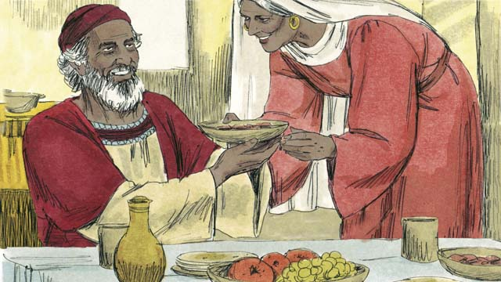

In the past, God had spoken to his prophets so they could speak to his people. Then came 400 years of silence in which he did not speak to men. Then God sent an angel to a priest named Zechariah. Zechariah and his wife, Elizabeth, honored God. They were very old, and she had never born any children.

22-02

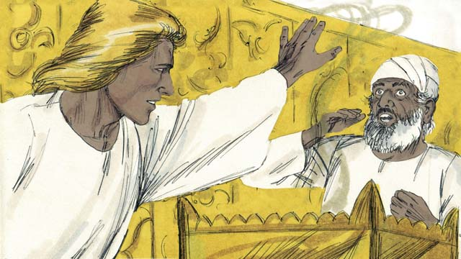

The angel said to Zechariah, “Your wife will have a son. You will name him John. God will fill him with the Holy Spirit, and John will get the people ready to accept the Messiah!” Zechariah responded, “My wife and I are too old to have children! How can I know you are telling me the truth?”

22-03

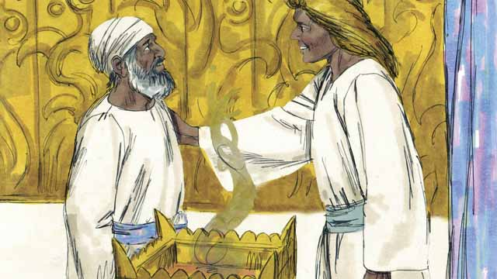

The angel responded to Zechariah, “I was sent by God to bring you this good news. Because you did not believe me, you will not be able to speak until the child is born.” Immediately, Zechariah was unable to speak. Then the angel left Zechariah. After this, Zechariah returned home and his wife became pregnant.

22-04

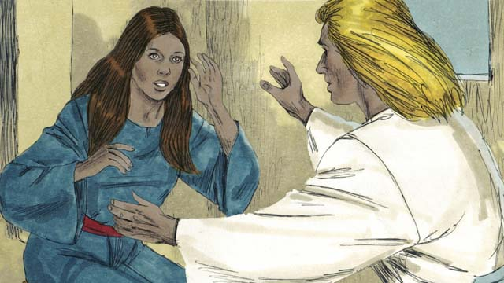

When Elizabeth was six months pregnant, the same angel suddenly appeared to Elizabeth’s relative, whose name was Mary. She was a virgin and was engaged to be married to a man named Joseph. The angel said, “You will become pregnant and give birth to a son. You are to name him Jesus. He will be the Son of the Most High God and will rule forever.”

22-05

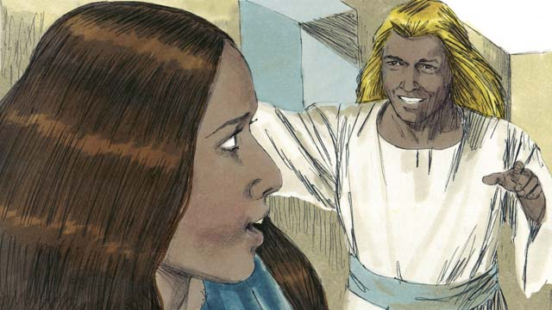

Mary replied, “How can this be, since I am a virgin?” The angel explained, “The Holy Spirit will come to you, and the power of God will come to you. So the baby will be holy, and he will be the Son of God.” Mary believed what the angel said.

22-06

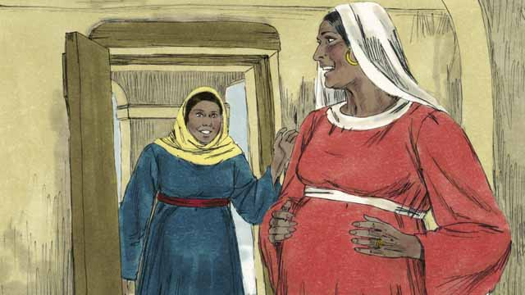

Soon after this happened, Mary went and visited Elizabeth. As soon as Mary greeted her, Elizabeth’s baby jumped inside her. The women rejoiced together about what God had done for them. After Mary visited Elizabeth for three months, Mary returned home.

22-07

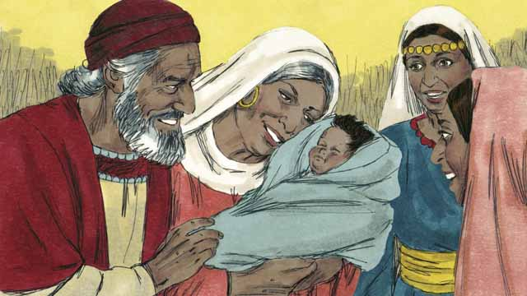

After this, Elizabeth gave birth to her baby boy. Zechariah and Elizabeth named the baby John, as the angel had commanded. Then God made Zechariah able to speak again. Zechariah said, “Praise God, because he has remembered to help his people! You, my son, will be the prophet of the Most High God. You will tell the people how they can receive forgiveness for their sins!”

*A Bible story from: Luke 1*

## 1 Biblical Interpretation: Observing the Details of the Story

After reading the crafted biblical story, answer the following questions to familiarize yourself with the details of the story.

### 1.1 Observation Questions

Answer the following observation questions to gain a basic understanding of the the story. Read the story as a community and answer these questions as a group.

#### 22-01

How did God speak to his people in the past?  
In the past, God had spoken to his prophets so they could speak to his people.

How many years had passed since God had spoken to his people?  
400 years had passed.

How did God communicate with Zechariah and Elizabeth?  
God sent an angel to Zechariah and Elizabeth.

What were Zechariah and Elizabeth like?  
Zechariah and Elizabeth honored God.

What problem did Elizabeth, Zechariah’s wife, have?  
She was very old, and had never born any children.

#### 22-02

What did the angel tell Zechariah?  
The angel told Zechariah that his wife would have a son and he was to name him John.

What did the angel say John would do in his life?  
The angel said that God would fill John with the Holy Spirit and John would get people ready to accept the Messiah.

Why did Zechariah not believe Elizabeth would have a son?  
They were too old to have children.

#### 22-03

How did the angel punish Zechariah because he did not believe?  
Zechariah was not able to speak until John was born.

What happened after Zechariah was unable to speak?  
Zechariah returned home and his wife became pregnant.

#### 22-04

How long had Elizabeth been pregnant when the angel appeared to Mary?  
She was six months pregnant.

What do we know about Mary?  
Mary was a virgin and was engaged to a man named Joseph.

What did the angel say was going to happen to Mary?  
She would become pregnant and give birth to a son and was to name him Jesus.

Who did the angel say Jesus was going to be?  
He would be the Son of the Most High God.

#### 22-05

How did Mary respond to this news?  
Mary asked how this could be possible since she was a virgin.

What did the angel tell Mary?  
The angel explained to Mary that the Holy Spirit and God’s power would come to her.

Who would this baby be?  
This baby would be God’s holy Son, Jesus.

#### 22-06

Who did Mary go to visit after after the angel left her?  
She went to visit Elizabeth.

What happened when Mary greeted Elizabeth?  
As soon as Mary greeted her, Elizabeth’s baby jumped inside her.

How did the women respond?  
The women rejoiced together about what God had done for them.

How long did Mary visit Elizabeth?  
Mary visited Elizabeth for three months and then returned home.

#### 22-07

What did Zechariah and Elizabeth name their baby?  
Elizabeth gave birth to her baby and Zechariah and Elizabeth named him John as God had commanded.

When was Zechariah able to speak again?  
After Zechariah and Elizabeth named the baby John, Zechariah was able to speak again.

What did Zechariah say about John?  
Zechariah praised God for remembering his people. He said John would be a prophet of the Most High God and would tell the people how they could receive forgiveness for their sins.

### 1.2 Translation Questions

Use the following translation questions to understand specific details of the passage. Discuss how you might translate these specific elements of the story.

#### 22-01

**Then came 400 years of silence** God spoke to his people through prophets. After the last Old Testament prophet, Malachi, had prophesied three were 400 years where God did not speak to his people in this same way. How would you express **Then came 400 years of silence** to mean God did not speak to his people with prophets in the way he did in the past for a period of 400 years?

  

**in which he did not speak to men** In the 400 years of silence, God did not send prophets to deliver messages to his people in the same way he did in the past. How would you express **in which he did not speak to men** to mean God did not give any messages to the prophets for his people?

  

**honored God** Zechariah and Elizabeth had a deep respect and esteem for God. How would you express **honored God** to mean Zechariah and Elizabeth felt deep respect and esteem for God?

  

#### 22-02

**You will name him John.** The angel is telling Zechariah exactly what he must name John. This is a command. How would you express **You will name him John** as a command that instructs Zechariah what name he should give to his son?

  

**fill him with the Holy Spirit** The angel told Zechariah that the Holy Spirit would give John wisdom and power. How would you express **fill him with the Holy Spirit** to mean John would have wisdom and power through the Holy Spirit?

  

**John will get the people ready to accept the Messiah** God would empower John for a specific work. John’s responsibility would be to prepare people to trust and serve the Messiah. How would you express **John will get the people ready to accept the Messiah** to mean John would prepare people to acknowledge and follow the Messiah when he comes?

  

**My wife and I are too old to have children!** Zechariah and Elizabeth were far too old to have children by natural means. That would require God to work a miracle. Zechhariah was surprised by the angel’s message and doubted that it could be true. How would you express **My wife and I are too old to have children!** as a strong statement that emphasizes Zechariah’s surprise and doubt that an old couple like them could bear children?

  

**How can I know you are telling me the truth?** Zechariah doubted the angel’s message. Zechariah was asking for a sign as proof that what the angel said was true. How would you express **How can I know you are telling me the truth?** as a question that means “What can you do to prove to me that this will happen?”

  

#### 22-03

**Because you did not believe me, you will not be able to speak until the child is born** Zechariah did not believe the angel’s message. This doubt was the cause of Zechariah not being able to speak until John would be born. How would you express **Because you did not believe me, you will not be able to speak until the child is born** to mean the reason Zechariah would not be able to speak until the baby was born was Zechariah did not believe the good news of the angel’s message?

  

**Immediately,** Zechariah was unable to speak First the angel said Zechariah would not be able to speak, and the next thing that happened was Zechariah could not speak. How would you express **Immediately,** Zechariah was unable to speak to mean Zechariah was unable to speak as soon as the angel told him that this would be so?

  

#### 22-04

**pregnant** Elizabeth conceived and was with child. How would you express **pregnant** in a polite way to refer to a woman who has conceived and a child is growing in her womb?

  

**When Elizabeth was six months pregnant** This scene of the story happens some time later, when Elizabeth was in her sixth month of pregnancy. The main event is Mary’s pregnancy and visit to Elizabeth. How would you express **When Elizabeth was six months pregnant** to mean at the time Elizabeth had already been pregnant for six months?

  

**Elizabeth’s relative** Elizabeth and Mary would related in some way. We don’t know exactly how these two women were related. They were kin. How would you express **Elizabeth’s relative** as a general term to describe Mary as somehow related to Elizabeth’s family?

  

**was engaged** Mary was betrothed to marry Joseph. How would you express **was engaged** to mean to be promised to be Joseph’s wife in marriage?

  

**Son of the Most High God** This is an important title for Jesus. Mary will bear a son who will be called the Son of the Most High. Jesus is therefore a human son born of a human mother, and he is also the Son of God. How would you express **Son of the Most High God** to mean the Son of the All-Powerful God who rules over everything is and supreme over all things?

  

#### 22-05

**How can this be** Mary asked the angel how this could be, since she was a virgin. Mary was not doubting the truth of the angel’s words, but asking how it would happen. How would you express **How can this be** as a question in which Mary asks how can she become pregnant?

  

**Holy Spirit will come to you, and the power of God will come to you** By the power of God, the Holy Spirit would miraculously cause Mary to become pregnant. There was no physical or sexual contact in this event. This was a miracle. How would you express **Holy Spirit will come to you, and the power of God will come to you** to mean the Holy Spirit would powerfully come to Mary and cause her to become pregnant in a miraculous way?

  

**the baby will be holy** The baby promised to Mary would be set apart and belong to God. How would you express **the baby will be holy** to mean the child born to Mary would be specially set apart by God?

  

#### 22-06

**Soon after this happened** The angel came to Mary. A short time after that, Mary left to visit Elizabeth. How would you express **Soon after this happened** to mean Mary left to visit Elizabeth a short time after the angel visited her?

  

**baby jumped inside her** The baby moved suddenly inside Elizabeth’s womb in response to Mary’s greeting to Elizabeth. How would you express **baby jumped inside her** to mean the baby suddenly moved inside Elizabeth’s womb so she could feel it?

  

**what God had done for them** Both Mary and Elizabeth were pregnant through God’s supernatural intervention. Mary had conceived without a man, and Elizabeth had conceived with Zechariah after she was past the age of childbearing. In both cases, God has made this possible. How would you express **what God had done for them** to mean the things God miraculously accomplished for Mary and Elizabeth that would not be possible in natural means?

  

#### 22-07

**Praise** God Zechariah himself was praising God and he was instructing all people to praise God. How would you express **Praise** God as a strong statement of praise that instructs others to worship God as well?

  

**because he has remembered to help his people** The reason God is worthy of praise is how he helped his people. How would you express **because he has remembered to help his people** to mean the reason God should be praised by all people is the way he care for the needs of his people?

  

**the Most High God** God is greater than everything and rules over everything. How would you express **the Most High God to mean** the supreme God who is all-powerful and rules over everything?

  

## 2 Theological Dialogue: Discussing the Meaning of the Story

Take time to explore the meaning of this story together as a community. Use the following discussions as a way to grasp what truth the story teaches.

### 2.1 Discourse Questions

Use the following discourse questions to understand the meaning of the story. Pay attention to how the story itself addresses each question or theme.

##### How did God miraculously provide a child for Zechariah and Elizabeth? (22-01, 22-02, 22-03)

For 400 years, God did not speak to his people through prophets as he did in the past. Then, God sent an angel to a priest named Zechariah. He and his wife honored and respected God. (22-01)

  

The angel told Zechariah that his wife would bear a child. Zechariah and Elizabeth were old and Elizabeth had never given birth to a child. God would do this miraculously. (22-01, 22-02)

  

Zechariah and Elizabeth were to name the child John. He would prepare people to trust and follow the Messiah. This was good news. (22-02, 22-03)

  

Zechariah doubted that this could happen. Because he did not believe the angel’s message, he was unable to speak until John was born. (22-02, 22-03)

  

God accomplished this even though Zechariah doubted. After Zechariah was unable to speak, he returned home and his wife became pregnant. (22-03)

  

##### How did God miraculously provide a child for Mary?

The same angel that appeared to Zechariah appeared to a virgin named Mary. He told Mary that she would become pregnant and give birth to a son. This was a miracle because Mary was a virgin. (22-04)

  

Mary would give birth to a son. She was supposed to name him Jesus. Jesus is the Son of God and would rule forever. (22-04)

  

The angel explained that the Holy Spirit would powerfully come to her and make her pregnant. There was no sexual or physical contact in this. The Holy Spirit miraculously made Mary pregnant by God’s power. (22-05)

  

Mary trusted God and believed what the angel said. (22-04, 22-05)

  

How did people respond to the news of these miraculous births? When Mary visited Elizabeth, the baby suddenly moved inside of Elizabeth’s womb. Both Mary and Elizabeth rejoiced that God miraculously had caused both of them to have children. In Elizabeth’s case, God caused an old, barren woman to have a child. In Mary’s case, God caused a virgin to become pregnant. (22-06)

  

When Elizabeth gave birth to her baby, Zechariah and Elizabeth named him John. They obeyed what God told Zechariah in naming him John. (22-07)

  

After they named him John, Zechariah could speak again. He praised God for taking care of his people. (22-07)

  

Zechariah stated that John would we a prophet of God and would tell people how they can have their sins forgiven. Zechariah showed great faith in acknowledging this about John. (22-07)

  

### 2.2 Theological Questions

Answer the following theology questions as a community. Discuss what truths this story teaches.

1. Who is John and what role did he have in God’s plan? What does this story teach us about the role John had in God’s plan?
2. Who is Jesus and what did he come to earth to do? What is a faithful response to God’s plan to send his Son? What does this story teach us about who Jesus is and what he came to do?
3. What is real and genuine faith in God? How does the responses of the characters in this story teach us about genuine faith?

### 2.3 Translation Draft

Work as a translation team to draft each panel of this story. Pay attention to any specific translation issues that are challenging or significant.

#### Make Translation Draft

Make a draft for each section of this story.

#### Discuss and Revise

After drafting the story, discuss any translation issues that you think need special explanation.

#### Drafting Summary Reflection

Summarize any noteworthy translation decisions and the rationale/reasoning behind these translation decisions. In the final movement of this class, you will use these observations to give an account (i.e., chronicle/narrate) of how your translation improved through the checking process.

## 3 Personal Reflection: Following the Teaching of the Story

Take a moment to allow this story to evaluate your own life and to consider how God would have you respond. After this reflection, use the quality checking questions to check your translation draft among the translation team.

### 3.1 Journal Reflection

Prayerfully think about the following personal reflection questions. Write/Record your answers and/or discuss them as a group.

1. Which of the characters can you most identify with in this story? Why do you most identify with this character?
2. How is God preparing your heart to accept/trust/receive Jesus as God’s Messiah?
3. How have you express genuine faith in God? What would it look like to express genuine faith in God?
4. How can God use you, like John, to prepare other people to meet accept Jesus?

### 3.2 Team Check

*The following activity will help you check the clarity, accuracy, and naturalness of your draft. Read the passage aloud and discuss the checking questions with other members of your translation community. You might need to reread portions (or the whole) of the biblical passage multiple times as you answer each of these questions. Record answers to these questions below.*

#### Team Checking Questions

*Use the following questions to check your translation draft for accuracy, clarity, and naturalness.*

1. **Accurate**: Has anything been **added** to your translation of this passage that is not a part of the meaning of the source text? *If additions exist, are they included only added to clarify meaning (such as implied information)?*
2. **Accurate**: Is anything **missing** from your translation of this passage that is a part of the meaning of the source text? *If some part of the meaning is missing from your translation, add it.*
3. **Accurate**: Does any meaning in your translation of this passage appear to be **different** than the meaning of the source text? *If the meaning is different, try changing your translation so that the meaning remains the same.*
4. **Natural**: Does anything sound **unnatural** to how you would say it in your language? *If portions of the passage sound unnatural in your language, try to make them sound the way you would say it in your language while staying true to the meaning of the source text.*
5. **Clear**: Is anything **unclear** or **confusing** in your translation that confuses the meaning of the source text? *If portions of the passage are unclear or confusing, revise them to clearly communicate the meaning of the source text.*
6. **Consistent**: How **consistent** is your translation within the passage and with other passages? *If portions of the passage need to be made consistent or if you need to revise translations of other passages, make these adjustments.*

#### Record Feedback

*After discussing the checking questions above as a translation community, record any feedback on your translation draft. Pay attention for parts of your translation that are translated well and parts of your translation that need correction.*

#### Discuss and Revise

*After gathering feedback on your draft, discuss it together with your translation community and make appropriate revisions in your translation.*

#### Checking Summary Reflection

*Summarize any noteworthy translation decisions (things you corrected or affirmed in your draft) and the rationale/reasoning behind these translation decisions. In the final movement of this class, you will use these observations to give an account (i.e., chronicle/narrate) of how your translation improved through the checking process.*

## 4 Ministry Practice: Serving the Church with the Story

Now that you have a draft of this story, consider how this story can encourage other believers in their faith. After ministering this story to others, you will also perform a community check of your translation draft.

### 4.1 Church Ministry

Reflect on how this story can edify and mature the Christian community. Design a way to minister this story to your church community.

**Ministry Preparation**: Take time to consider how you could minister this story to others. Record some ministry ideas below.

**Ministry Implementation**: Minister this story to a group of believers as you had planned. Use the information in this study to help develop a teaching/lesson or lead a discussion of this story to other believers. Record your ministry plan below.

**Ministry Reflection**: Think about what you learned from ministering this story to other believers. Reflect on your experience below.

### 4.2 Church Community Check

After teaching or ministering this story to the church, check the translation quality with the church community. Record any feedback from your checking experience.

#### Create Checking Questions

You can use **Translation Questions** to check you draft. Each **Translation Question** explains the meaning of a specific part of the story and asks you to consider how you would translate that part of the story in your own language. Change each **Translation Question** into a **Checking Question** by asking the following questions. The first question asks you to identity how each specific phrase was translated in your language. The second question asks people in the church to determine if your translation of the phrase expresses the meaning clearly, accurately, and naturally. Look at the following examples to see how to change **Translation Questions** into **Checking Questions**:

#### Translation Question Example 1

**to proclaim the good news about Jesus** Paul and Silas traveled to Philippi for the purpose of preaching the gospel. The gospel is the good news that Jesus saves people from their sins if they will believe in Jesus. How would you express **to proclaim the good news about Jesus** to mean to tell other people the message about how Jesus can save people from their sins?

#### Translation Question Example 2

**a merchant** Paul and Silas met a woman named Lydia at the place by the river. She owned a business and sold items to make money. How would you express **a merchant** to mean a business owner who sells items for a profit?

#### Translation Question Example 3

**so Paul and Silas baptized them** The jailer and his whole family followed Paul’s instructions. They believed in Jesus. The result of this was Paul and Silas baptized them. How would you express **so Paul and Silas baptized them** to mean the result of the jailer and his family believing in Jesus that Paul and Silas baptized all of them?

You can change these into **Checking Questions** like this:

#### Checking Question Example 1

**to proclaim the good news about Jesus** How did you translate **to proclaim the good news about Jesus**? Does it mean to tell other people the message about how Jesus can save people from their sins?

#### Checking Question Example 2

**a merchant** How did you translate **a merchant**? Does it mean a business owner who sells items for a profit?

#### Checking Question Example 3

**so Paul and Silas baptized them** How did you translate **so Paul and Silas baptized them**? Does it mean the result of the jailer and his family believing in Jesus that Paul and Silas baptized all of them?

#### Record Feedback

*Discuss the* ***Checking Questions*** *with your church community, and record any feedback on your translation draft. Pay attention for parts of your translation that are translated well and parts of your translation that need correction.*

#### Discuss and Revise

*After gathering feedback on your draft, discuss it together with your translation community and make appropriate revisions in your translation.*

#### Checking Summary Reflection

*Summarize any noteworthy translation decisions (things you corrected or affirmed in your draft) and the rationale/reasoning behind these translation decisions. In the final movement of this class, you will use these observations to give an account (i.e., chronicle/narrate) of how your translation improved through the checking process.*

## 5 Missional Outreach: Sharing the Truth of the Story

*After sharing this story with others, check the translation quality with the wider language community. Record any feedback from your checking experience.*

### 5.1 Mission Engagement

*Consider how you will witness this story to unbelievers. Design a way to share this story and engage them in what it teaches about Christianity and the gospel.*

**Witness Preparation**: Take time to consider how you will witness this narrative to unbelievers. Record some ideas below.

**Witness Implementation**: Share this story with an unbeliever. Use the information in this study to help develop a teaching/lesson or lead a discussion of this story to other believers. Record your ministry plan below.

**Witness Reflection**: Think about what you learned from ministering this story to unbelievers. Reflect on your experience below.

### 5.2 Sociolinguistic Check

After sharing this story with the language community, check your translation draft with the surrounding community. Record your observations.

#### Checking Approach

After witnessing this story to unbelievers, use one of the following methods to check the translation of this story. Consider using the **Observation Questions** to check your translation draft or come up with your own quality checking questions.

**Read-Retell Check:** Read your draft to those the community and ask them to retell the passage. Be attentive for any portions of the passage that are unclear, unnatural, or inaccurate.

**Comprehension Questions Checklist:** Read the draft of the passage and ask a list of comprehension questions to make sure the passage is being rightly understood. You can use the **Observation Questions** in this guide or come up with your own questions. Then, record any insights or issues that arise.

**Discussion Group:** Develop key questions to ask about the passage (both formational and translational). Read the passage and have a group discussion about the passage, paying attention to issues that need to be addressed, edited, and revised.

#### Record Feedback

*After sharing your draft with language community, discuss the* ***Observations Questions****, and record any feedback on your translation draft. Pay attention for parts of your translation that are translated well and parts of your translation that need correction.*

#### Discuss and Revise

*After gathering feedback on your draft, discuss it together with your translation community and make appropriate revisions in your translation.*

#### Checking Summary Reflection

*Summarize any noteworthy translation decisions (things you corrected or affirmed in your draft) and the rationale/reasoning behind these translation decisions. In the final movement of this class, you will use these observations to give an account (i.e., chronicle/narrate) of how your translation improved through the checking process.*

## 6 Conclusion

As a translation community, take time to reflect on all that was learned in studying, drafting, and checking this story. Celebrate all that God has taught you as a community. Then, submit your revised draft and checking summaries to network leaders for further review.