Open Bible Stories

The Birth of Jesus

## 0 Introduction

### 0.1 Key Idea

The story of the birth of Jesus teaches us how God sent his Son, the Messiah, at the perfect time in human history in order to save his people from their sin.

### 0.2 Creedal Verse

“But when the fullness of time had come, God sent forth his Son, born of woman, born under the law, to redeem those who were under the law, so that we might receive adoption as sons.” Galatians 4:4-5

### 0.3 Metanarrative Summary

The eternal God created all things in six days. He made a good and perfect world. He made humans in his image to fill the earth and rule over creation. But humans rebelled against God and ruined God’s creation. God set to restore his world through his promise. God made a covenant with Abraham. He promised to bless all nations through Abraham. God kept his promises across the generations. God provided Abraham with a promised child, Isaac. God gave Isaac a wife and she bore twins, Jacob and Esau. God blessed Jacob and his sons, and the blessing continued to the next generation. God rescued Joseph, one of Jacob’s sons, and used him to rescue his family. God caused his people, the Israelites, to multiply in the land of Egypt; eventually, they became slaves. But, God raised up a deliverer, Moses, to deliver his people from their slavery. God sent judged the Egyptians with harsh plagues; in the final judgment, he passed over his people who covered their doorposts with the blood of a sacrificed lamb. Then, God delivered the Israelites by bringing them out of Egypt and crossing the Red Sea on dry land. God made a covenant with the Israelites and made them his people. God tested Israel in a series of wilderness wanderings and eventually brought his people into the promised land of Canaan. God raised up deliverers to lead Israel and rescue them from their enemies. God formed Israel into a kingdom. He made a covenant with King David and promised to send a king that would rule his people forever. Many of Israel’s kings were evil and the kingdom of Israel divided into two kingdoms. God sent prophets to warn his people of God’s judgment and call them to repent. When Israel did not repent, God sent his people into exile. After many years, he brought them back to the land. Throughout the Old Testament, God promised to send his Messiah to deliver his people form their sin. After many years, the prophet John was born. He would prepare people for the coming Messiah. At the perfect time, God sent his Son, Jesus, to be born of a virgin Mary.

### 0.4 Open Bible Story: The Birth of Jesus

23-01

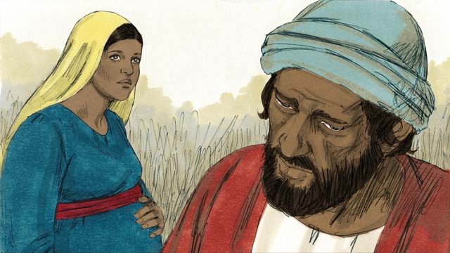

Mary was engaged to a righteous man named Joseph. When he heard that Mary was pregnant, he knew it was not his baby. However, he did not want to shame Mary, so he decided to have mercy on her and to divorce her quietly. But before he could do that, an angel came to him in a dream and spoke to him.

23-02

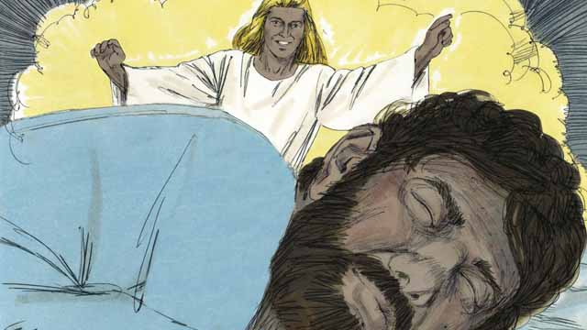

The angel said, “Joseph, do not be afraid to take Mary as your wife. The baby that is in her is from the Holy Spirit. She will give birth to a son. Name him Jesus (which means ‘Yahweh saves’), because he will save the people from their sins.”

23-03

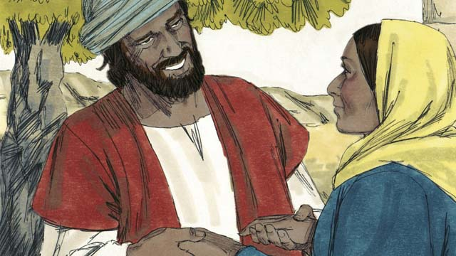

So Joseph married Mary and took her home as his wife, but he did not sleep with her until she had given birth.

23-04

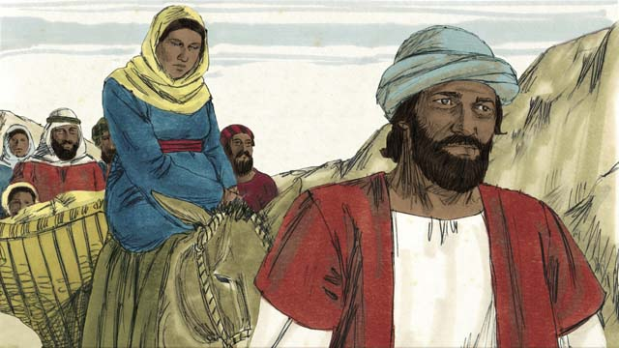

When the time was near for Mary to give birth, she and Joseph made a long journey to the town of Bethlehem. They had to go there because the Roman officials wanted to count all the people in the land of Israel. They wanted everyone to go to where their ancestors had lived. King David had been born in Bethlehem, and he was the ancestor of both Mary and Joseph.

23-05

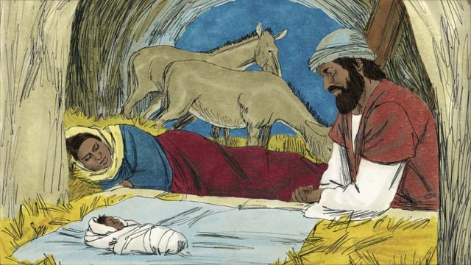

Mary and Joseph went to Bethlehem, but there was no place for them to stay except for where some animals were kept. It was there that Mary gave birth to her baby. She laid him in a feeding trough, since there was no bed for him. They named him Jesus.

23-06

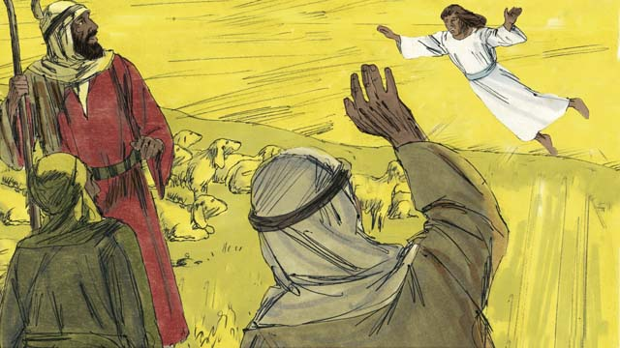

That night, there were some shepherds in a nearby field guarding their flocks. Suddenly, a shining angel appeared to them, and they were terrified. The angel said, “Do not be afraid, because I have some good news for you. The Messiah, the Master, has been born in Bethlehem!”

23-07

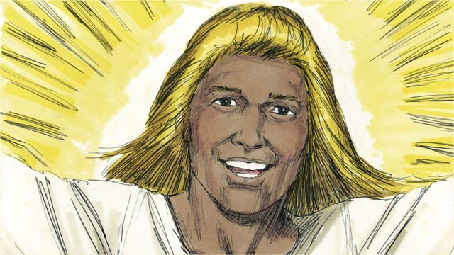

“Go search for the baby, and you will find him wrapped in pieces of cloth and lying in a feeding trough.” Suddenly, the skies were filled with angels. They were praising God. They said, “May all honor be to God in heaven. May there be peace on earth to the people he favors!”

23-08

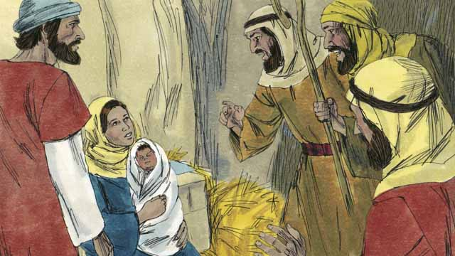

Then the angels left. The shepherds left their sheep to look for the baby. They soon arrived at the place where Jesus was and they found him lying in a feeding trough, just as the angel had told them. They were very excited. Then the shepherds returned to the fields where their sheep were. They were praising God for everything they had heard and seen.

23-09

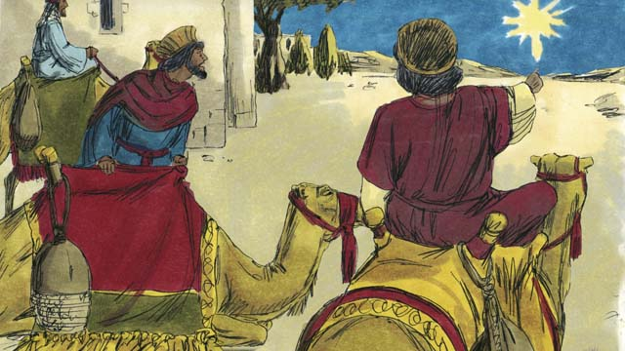

There were some men in a country far to the east. They studied the stars and were very wise. They saw an unusual star in the sky. They said that it meant that a new king of the Jews had been born. So they decided to travel from their country to see the child. After a long journey, they came to Bethlehem and found the house where Jesus and his parents were staying.

23-10

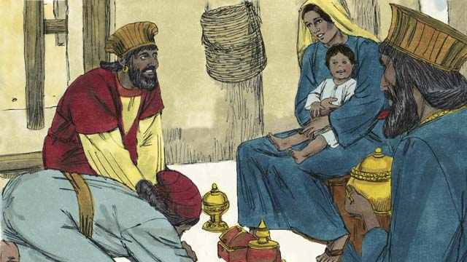

When these men saw Jesus with his mother, they bowed down and worshiped him. They gave Jesus expensive gifts. Then they returned home.

*A Bible story from: Matthew 1-2; Luke 2*

## 1 Biblical Interpretation: Observing the Details of the Story

After reading the crafted biblical story, answer the following questions to familiarize yourself with the details of the story.

### 1.1 Observation Questions

Answer the following observation questions to gain a basic understanding of the the story. Read the story as a community and answer these questions as a group.

#### 23-01

What kind of man was Joseph?  
He was a righteous man.

Was the baby Joseph’s baby?  
No. When he heard that Mary was pregnant, he knew it was not his baby.

What did Joseph plan to do with Mary since she was pregnant?  
He planned to divorce Mary quietly because he did not want to shame her.

Who appeared to Joseph in a dream?  
An angel appeared to Joseph in a dream.

#### 23-02

What caused Joseph to change his mind and marry Mary?  
An angel came and spoke to him in a dream and said, “Do not be afraid to take Mary as your wife.”

What did the angel tell Joseph about the baby?  
The angel told Joseph that the Spirit caused Mary to become pregnant, the baby would be a son, and he was to name him Jesus.

What is the meaning of the name Jesus?  
It means ‘Yahweh saves.’

Why was the baby to be named Jesus?  
The baby was to be named Jesus because he would save people from their sins.

#### 23-03

What did Joseph do with Mary after the angel gave him this message?  
Joseph married Mary and took her home to be his wife.

What did Joseph refrain from doing with Mary?  
Joseph did not sleep with Mary until she had given birth.

#### 23-04

Where did Joseph and Mary go when the time was near for Mary to give birth?  
Joseph and Mary made a long journey to the town of Bethlehem when it was time for Mary to give birth.

Why did Joseph and Mary make the long journey to Bethlehem?  
They had to go there because the Roman government told everyone to go to where their ancestors had lived in order to be counted.

Why was Bethlehem important?  
King David was born in Bethlehem, and he was the ancestor of both Mary and Joseph.

#### 23-05

What problem did Joseph and Mary encounter when they arrived in Bethlehem?  
When Joseph and Mary arrived in Bethlehem there was no place for them to stay except a place were animals stayed.

In what kind of place was Jesus born?  
He was born in a place where animals stayed.

What did Mary do when Jesus was born?  
Mary laid the baby in a feeding trough since there was no bed.

What did Joseph and Mary name the baby?  
They named the baby Jesus.

#### 23-06

Who appeared to shepherds who were guarding their flocks in a nearby field?  
A shining angel appeared to the shepherds.

How did the shepherds respond to the angel?  
The shepherds were terrified.

What was the angel’s message to the shepherds?  
The angel told them, “Do not be afraid, because I have some good news for you. The Messiah, the Master, has been born in Bethlehem!”

#### 23-07

What instructions did the angel give the shepherds?  
The angel told the shepherds go search for the baby.

How would the shepherds know it was the baby?  
The baby would be wrapped in pieces of cloth and lying in a feeding trough.

Who suddenly appeared in the sky and what were they doing?  
The skies were suddenly filled with angels who were praising God.

What did the angels say?  
The angels said, “May all honor be to God in heaven. May there be peace on earth to the people he favors!”

#### 23-08

What did the shepherds do after the angels left?  
After the angels left, the shepherds left their sheep to look for the baby.

How did shepherds know the baby when they found him?  
The baby was lying in a feeding trough just as the angel told them.

What did the shepherds do after they had seen the baby?  
They shepherds were very excited. They returned to the fields, praising God for what they had heard and seen.

#### 23-09

Who came from a country far in the east to see Jesus?  
Some men who studied the stars and were very wise came from the east to see Jesus.

How did the wise men from the east know that a new king of the Jews had been born?  
They saw an unusual star in the sky and said it meant a new king of the Jews was born.

What did the wise men from the east do when they saw the unusual star?  
The wise men from the east traveled to see the child. They came to Bethlehem and found the house where Jesus and his parents were staying.

#### 23-10

What did the wise men do when they saw Jesus?  
They bowed down and worshiped Jesus, and gave him expensive gifts.

### 1.2 Translation Questions

Use the following translation questions to understand specific details of the passage. Discuss how you might translate these specific elements of the story.

#### 23-01

**Mary was engaged to a righteous man named** Joseph Parents normally arranged the marriages of their children. A person is engaged when they are promised to be married to someone else. How would you express **Mary was engaged to a righteous man named** Joseph to mean the parents of Mary had promised her in marriage to a righteous man named Joseph?

  

**he knew it was not his baby** Mary was a virgin and Joseph did not sleep with Mary. Joseph knew that he was not the father of the baby. How would you express **he knew it was not his baby** to mean Joseph knew that he was not the one who had caused Mary to be pregnant?

  

**he did not want to shame Mary** Mary was pregnant and Joseph did not sleep with her. Mary did not commit adultery but it would appear/seem to others that she did commit adultery. Instead of embarrassing Mary in public, Joseph was merciful to Mary even though it seemed like she was an adulteress. How would you express **he did not want to shame** Mary to mean Joseph did not desire to cause Mary to be publicly disgraced?

  

**to divorce her quietly** Because Joseph was righteous, he wanted to resolve the situation in the best way possible. Joseph had not married Mary yet, but when a man and woman promised to marry each other, Jews considered them husband and wife though they did not live together. To deal with the situation in a way that honored Mary, Joseph planned to end their engagement without telling others why. How would you express **to divorce her quietly** to mean Joseph planned to break his engagement with Mary without telling others about Mary’s pregnancy?

  

#### 23-02

**do not be afraid to take Mary as your wife** The angel gave Joseph a command. He told him not to fear marrying Mary. This instruction ordered Joseph to not hesitate to have Mary as his wife or to stop thinking that you shouldn’t marry Mary. How would you express **do not be afraid to take Mary as your wife** as a command to not fear/hesitate marrying Mary?

  

**The baby that is in her is from the Holy Spirit** The Holy Spirit caused Mary to become pregnant with this child. There was no physical or sexual contact. This was a miracle. How would you express **The baby that is in her is from the Holy Spirit** to mean the baby in Mary’s womb was conceived by a miracle of the Holy Spirit?

  

**Name him Jesus** The angel instructs Joseph to call the baby Jesus. This is a command from God telling Joseph exactly what to name the baby. How would you express **Name him Jesus** as a command that instructs Joseph to give the baby the name Jesus?

  

**because he will save the people from their sins** The angel ordered Joseph to name the baby Jesus. The reason the baby was given this name was he would save people from their sins. How would you express **because he will save the people from their sins** to mean the reason Joseph was to name the baby Jesus was he would rescue people from the punishment of their sins?

  

#### 23-03

**So Joseph married Mary** Joseph planned to divorce Mary so that she would not be publicly ashamed. The angel told Joseph to marry Mary, the angel explained that the Holy Spirit caused Mary to become pregnant, and the angel told Joseph to name the baby Jesus because he would save people from their sins. The result of this message was Joseph agreed to marry Mary. How would you express **So Joseph married Mary** to mean the result of the angel’s message was Joseph changed his plan to divorce Mary quietly and, instead, kept their engagement and married her?

  

**but he did not sleep with her** Joseph married Mary. Normally, after marriage a husband and wife have sexual intercourse. It would be expected that a man would sleep with the woman he took as his wife, but Joseph did the unexpected/opposite. Joseph did not have sexual relations with Mary and kept her a virgin until the birth of the baby. How would you politely express **but he did not sleep with her** to mean Joseph did not have sexual intercourse with Mary until after the baby was born?

  

#### 23-04

**When the time was near for Mary to give birth** Joseph and Mary made a long journey to Bethlehem around the time the nine months of Mary’s pregnancy were almost over. How would you express **When the time was near for Mary to give birth** to mean at the time it was near the end of Mary’s pregnancy?

  

**to count all the people** The practice of counting the people who lived in an area was probably done so they could tax the people. How would you express **to count all the people** to mean to take a census where people write their names on a list to count the people who live in a certain place?

  

#### 23-05

**no place for them to stay** When Mary and Joseph arrived in Bethlehem, there was no usual place for them to stay. Because Bethlehem was so crowded at that time, the usual rooms for guests were already full of people. How would you express **no place for them to stay** to mean the usual places where people stayed were all full and not available?

  

**where some animals were kept** There was no room in the normal places where people could stay. So, Mary and Joseph stayed in a place for sheltering animals, not a place where people lived. How would you express **where some animals were kept** to mean a place where animals are sheltered and are cared for?

  

**a feeding trough** Mary laid her baby in an animal feedbag. The box could have been filled with hay to provide a padded surface for the baby to lie on. How would you express **a feeding trough** to mean a wooden or stone box for feeding animals?

  

**since there was no bed for him** Mary and Joseph were staying in a place where animals were sheltered. This was not a normal place for people to stay. As a result, this place would not have had a bed for a baby to sleep. How would you express **since there was no bed for him** to mean the reason Mary laid the baby in a feeding trough was there was no bed for the baby?

  

#### 23-06

**a shining angel** An angel is a spiritual being who is a servant of God. Often, angels deliver God’s messages to people. This angel was bright and surrounded by light. The shining light would have seemed even brighter in contrast to the darkness of the night. How would you express **a shining angel** to mean an angel (spiritual being who is a servant or messenger of God) surrounded by a bright light?

  

**Do not be afraid** The angel told the shepherds to stop being afraid. The angel spoke this command to the shepherds in order to comfort them. The shepherds were very afraid when they saw the angel, so he was telling them they did not need to be afraid. How would you express **Do not be afraid** to mean stop being afraid or do not fear?

  

**The Messiah, the Master, has been born in Bethlehem!** A master is a person in authority over other people. Those under the master serve him and listen to his commands. In this statement, Messiah and Master describe the same person of Jesus. As the Messiah, Jesus is the ultimate/supreme Master over all. The angel makes a strong statement that emphasizes the excitement that the Messiah—for whom the Israelites had so long been waiting —had finally come. How would you express **The Messiah, the Master, has been born in Bethlehem!** as a strong statement of excitement that the Messiah—the promised deliverer who is supreme authority over all—had finally come and had been born as a baby in the city of Bethlehem?

  

#### 23-07

**wrapped in pieces of cloth** The baby was wrapped in long strips of cloth, in a way that was typical of time and place. The custom of that time was to tightly wrap newborn babies in long strips of cloth. How would you express **wrapped in pieces of cloth** to mean baby Jesus was swaddled with long strips of cloth as in the way people bundle a newborn baby?

  

**filled with angels** At this time many angels appeared in the sky. The sky seemed full of angels because there were so many. How would you express **filled with angels** to mean there were so many angels that they seemed to fill the sky?

  

**May all honor be to God** The angels announced God’s honor and praise. Their statement means that God deserves all honor and invites all people to give honor to God. How would you express **May all honor be to God** as an instruction for everyone to God the praise that he deserves?

  

**May there be peace on earth** The angels made a strong statement for there to be peace on earth. How would you express **May there be peace on earth** as a strong statement of desire that there would no longer be hostility or disharmony in the world?

  

**the people he favors** God delights in his people, he blesses them, and he shows them good will. How would you express **the people he favors** to mean the people that God looks upon with favor, delight, or good will?

  

#### 23-08

**The shepherds left their sheep to look for the baby.** The angel commanded the shepherds to search for the baby. The shepherds had to leave their sheep to search for the baby. How would you express The shepherds left their sheep to look for the baby to mean the purpose the shepherds left their sheep in the fields was to follow the angel’s command and find the baby?

  

**everything they had heard and seen** The reason the shepherds praised God was the glorious angels and their amazing message, as well as seeing the newborn Messiah himself. How would you express **everything they had heard and seen** to mean seeing the angels, hearing all the things the angels told the shepherds, and seeing the Messiah?

  

#### 23-09

**an unusual star** The star that they noticed was not a normal star. It was something that appeared at the time of Jesus’ birth. How would you express **an unusual star** to mean a star that was not normal or typical?

  

**So they decided to travel from their country to see the child** The wise men saw an unusual star that they understood to mean a new king of the Jews was born. The result of seeing this star and understanding its meaning was for the wise men to travel a far distance to see the child. How would you express **So they decided to travel from their country to see the child** to mean the result of seeing the unusual star and understanding its meaning the wise men traveled a far distance from their country to see Jesus?

  

**the house where Jesus and his parents were staying** As much as a year or two passed before the men arrived in Bethlehem. Jesus was no longer a baby. They were no longer staying in the place for animals where he was born. How would you express **the house where Jesus and his parents were staying** to mean the home where Jesus and his family lived, a place different from the place for animals where Jesus was born?

  

#### 23-10

**bowed down** The wise men bowed low to the ground. At that time, this was the customary way of showing great respect or reverence. How would you express **bowed down** to mean to lower oneself to the ground as a way of showing someone great honor or respect?

  

**They gave Jesus expensive gifts** The wise men presented very valuable items to Jesus as tokens of honor and respect. How would you express **They gave Jesus expensive gifts** to mean the wise men gave Jesus gifts that were very costly and valuable?

  

## 2 Theological Dialogue: Discussing the Meaning of the Story

Take time to explore the meaning of this story together as a community. Use the following discussions as a way to grasp what truth the story teaches.

### 2.1 Discourse Questions

Use the following discourse questions to understand the meaning of the story. Pay attention to how the story itself addresses each question or theme.

##### What were the circumstances of Jesus’ birth? How did Jesus’ birth come about? What does this teach us about Jesus? (23-01, 23-02, 23-04, 23-05, 23-06)

Sinless: Jesus was born by Mary. She was a virgin. The Holy Spirit caused Mary to become pregnant. Jesus birth was a miracle. He was not born sinful like other humans are. (23-01, 23-02)

  

Savior: Joseph was to name Mary’s baby Jesus. The name Jesus means Yahweh saves. Jesus would save people from their sins. (23-02)

  

King: The census caused Joseph and Mary to travel to Bethlehem. Jesus was born in Bethlehem. Jesus was born in the lineage of King David. Jesus was the promised king that God promised to David in the Old Testament. Jesus was born in the same town David was born and he was a direct ancestor of David. (23-04)

  

Humble: Jesus was born in a place where animals lived. He was born in a very humble and meek way. (23-05)

  

Messiah/Master: The birth of Jesus was announced by an angel to shepherds. They said that the Messiah, the Master, was born. Jesus is the promised deliverer/Messiah and final authority/Master of all. (23-06)

  

##### What role did Joseph as a faithful servant? (23-01, 23-02, 23-03)

Righteous: Joseph was a righteous man. He wanted to quietly divorce Mary rather than causing her shame. His plan to do this showed mercy and compassion. (23-01)

  

Obedience: Joseph obeyed the angel. He married Mary and did not follow through on his plan to quietly divorce her. (23-02, 23-03)

  

Self-Control: Joseph practiced self-control. Joseph married Mary but did not have sexual relations with her until the baby was born. This shows that Joseph was godly in character and had self-restraint. (23-03)

  

##### How did different people respond to the news of Jesus’ birth? What impact did Jesus’ birth bring about? (23-02, 23-06, 23-07, 23-08, 23-09, 23-10)

Shepherds | No Fear/Trust: An angel appeared to shepherds and told them to no be afraid. The angel also tells Joseph earlier to not be afraid. Jesus removes fear. The opposite of fear is trust. A proper response to Jesus is trust. Trust in Jesus can remove all other fears. (23-02, 23-06)

  

Angels | Peace/Favor: Angels appeared in the sky and were praising God. They called all people to honor God and expressed excitement that peace would come to earth on the people God has favored. Jesus brings peace to the world and favor/grace to God’s people. (23-07)

  

Shepherds | Joy/Worship: The shepherds searched for Jesus and found him. When they found him, they were excited and praised God. Jesus brings joy and moves us to worship. (23-08)

  

Wise Men | Honor/Worship: The wise men traveled a far distance to see Jesus. They brought expensive gifts. They bowed down and worshiped Jesus. (23-09, 23-10)

  

### 2.2 Theological Questions

Answer the following theology questions as a community. Discuss what truths this story teaches.

1. Who is Jesus and what has he come to do? What does the story of the birth of Jesus tell us about who Jesus is and what he has come to do?
2. What does it look like to faithfully serve Jesus? How is Joseph a godly example for us to follow?
3. What are appropriates responses to Jesus? How do the responses of people to Jesus in this story teach us about proper responses to Jesus?

### 2.3 Translation Draft

Work as a translation team to draft each panel of this story. Pay attention to any specific translation issues that are challenging or significant.

#### Make Translation Draft

Make a draft for each section of this story.

#### Discuss and Revise

After drafting the story, discuss any translation issues that you think need special explanation.

#### Drafting Summary Reflection

Summarize any noteworthy translation decisions and the rationale/reasoning behind these translation decisions. In the final movement of this class, you will use these observations to give an account (i.e., chronicle/narrate) of how your translation improved through the checking process.

## 3 Personal Reflection: Following the Teaching of the Story

Take a moment to allow this story to evaluate your own life and to consider how God would have you respond. After this reflection, use the quality checking questions to check your translation draft among the translation team.

### 3.1 Journal Reflection

Prayerfully think about the following personal reflection questions. Write/Record your answers and/or discuss them as a group.

1. What have you learned about who Jesus is and what he has come to do?
2. How is Jesus inviting you to follow and faithfully serve him?
3. Which of the characters in this story (and their responses) most challenges you to grow in your faith?
4. How has Jesus brought about a change/impact in your own life?

### 3.2 Team Check

*The following activity will help you check the clarity, accuracy, and naturalness of your draft. Read the passage aloud and discuss the checking questions with other members of your translation community. You might need to reread portions (or the whole) of the biblical passage multiple times as you answer each of these questions. Record answers to these questions below.*

#### Team Checking Questions

*Use the following questions to check your translation draft for accuracy, clarity, and naturalness.*

1. **Accurate**: Has anything been **added** to your translation of this passage that is not a part of the meaning of the source text? *If additions exist, are they included only added to clarify meaning (such as implied information)?*
2. **Accurate**: Is anything **missing** from your translation of this passage that is a part of the meaning of the source text? *If some part of the meaning is missing from your translation, add it.*
3. **Accurate**: Does any meaning in your translation of this passage appear to be **different** than the meaning of the source text? *If the meaning is different, try changing your translation so that the meaning remains the same.*
4. **Natural**: Does anything sound **unnatural** to how you would say it in your language? *If portions of the passage sound unnatural in your language, try to make them sound the way you would say it in your language while staying true to the meaning of the source text.*
5. **Clear**: Is anything **unclear** or **confusing** in your translation that confuses the meaning of the source text? *If portions of the passage are unclear or confusing, revise them to clearly communicate the meaning of the source text.*
6. **Consistent**: How **consistent** is your translation within the passage and with other passages? *If portions of the passage need to be made consistent or if you need to revise translations of other passages, make these adjustments.*

#### Record Feedback

*After discussing the checking questions above as a translation community, record any feedback on your translation draft. Pay attention for parts of your translation that are translated well and parts of your translation that need correction.*

#### Discuss and Revise

*After gathering feedback on your draft, discuss it together with your translation community and make appropriate revisions in your translation.*

#### Record Translation Decisions

*As a community, discuss some of the most noteworthy translation decisions in your draft. Summarize each decision and explain the reasons your community decided on that translation. You should update these decisions each time you check your draft with various groups of people.*

You should **measure** the quality of your translation draft. You can **record translation decisions** to make it clear why you translated things a certain way. Translation decisions can help your translation team and the surrounding community be a part of the translation process.

How can you know the quality of your translation?

1. **Measure** the translation by marks/standards of quality (i.e., clear, accurate, natural, church-approved)
2. **Test** the translation with others and record feedback and conversations from in the field (i.e., church and community check)
3. **Compare** and **contrast** the translation with the source text (i.e., meaning of text and notes) and alternatives (i.e., other translation choices)
4. **Explain** the reasons why you translated a particular portion of the text.

**Example Sentences That Help Explain Your Translation Decision** Use the following example sentences to help explain your translation decisions:

1. The original text literally **says/means**, so we translated the term in this way…
2. We originally decided to translate **the biblical term** in with **this term**, but we changed it because…
3. When our translation team discussed **the biblical term**, this is what we talked about…
4. **The term** is [clear, accurate, natural, consistent] because…
5. The community understands **this term** it to mean…
6. We considered these other terms. We did not use **these terms** because…
7. When we checked this in the church, we learned…
8. When we checked this in the community, we learned…

**Example of Translation Decision**

In OBS 01-07 we decided to translate **blessed** like this: [actual translation]. We decided this translation because of these reasons:

1. The word [actual translation] means to cause good things to happen to someone or something. This term is used when a person desires someone or something to prosper or flourish. This term does not refer to magic or witchcraft.
2. When we checked this word with other believers, they said it describes God showing his kindness and favor on someone or something. These are some of the terms that we did not decide to use…
3. Many of our people will understand this word. When we discussed this phrase with the surrounding community, we discovered it was a natural way to describe God causing good and beneficial things to happen.

## 4 Ministry Practice: Serving the Church with the Story

Now that you have a draft of this story, consider how this story can encourage other believers in their faith. After ministering this story to others, you will also perform a community check of your translation draft.

### 4.1 Church Ministry

Reflect on how this story can edify and mature the Christian community. Design a way to minister this story to your church community.

**Ministry Preparation**: Take time to consider how you could minister this story to others. Record some ministry ideas below.

**Ministry Implementation**: Minister this story to a group of believers as you had planned. Use the information in this study to help develop a teaching/lesson or lead a discussion of this story to other believers. Record your ministry plan below.

**Ministry Reflection**: Think about what you learned from ministering this story to other believers. Reflect on your experience below.

### 4.2 Church Community Check

After teaching or ministering this story to the church, check the translation quality with the church community. Record any feedback from your checking experience.

#### Create Checking Questions

You can use **Translation Questions** to check you draft. Each **Translation Question** explains the meaning of a specific part of the story and asks you to consider how you would translate that part of the story in your own language. Change each **Translation Question** into a **Checking Question** by asking the following questions. The first question asks you to identity how each specific phrase was translated in your language. The second question asks people in the church to determine if your translation of the phrase expresses the meaning clearly, accurately, and naturally. Look at the following examples to see how to change **Translation Questions** into **Checking Questions**:

#### Translation Question Example 1

**to proclaim the good news about Jesus** Paul and Silas traveled to Philippi for the purpose of preaching the gospel. The gospel is the good news that Jesus saves people from their sins if they will believe in Jesus. How would you express **to proclaim the good news about Jesus** to mean to tell other people the message about how Jesus can save people from their sins?

#### Translation Question Example 2

**a merchant** Paul and Silas met a woman named Lydia at the place by the river. She owned a business and sold items to make money. How would you express **a merchant** to mean a business owner who sells items for a profit?

#### Translation Question Example 3

**so Paul and Silas baptized them** The jailer and his whole family followed Paul’s instructions. They believed in Jesus. The result of this was Paul and Silas baptized them. How would you express **so Paul and Silas baptized them** to mean the result of the jailer and his family believing in Jesus that Paul and Silas baptized all of them?

You can change these into **Checking Questions** like this:

#### Checking Question Example 1

**to proclaim the good news about Jesus** How did you translate **to proclaim the good news about Jesus**? Does it mean to tell other people the message about how Jesus can save people from their sins?

#### Checking Question Example 2

**a merchant** How did you translate **a merchant**? Does it mean a business owner who sells items for a profit?

#### Checking Question Example 3

**so Paul and Silas baptized them** How did you translate **so Paul and Silas baptized them**? Does it mean the result of the jailer and his family believing in Jesus that Paul and Silas baptized all of them?

#### Record Feedback

*Discuss the* ***Checking Questions*** *with your church community, and record any feedback on your translation draft. Pay attention for parts of your translation that are translated well and parts of your translation that need correction.*

#### Discuss and Revise

*After gathering feedback on your draft, discuss it together with your translation community and make appropriate revisions in your translation.*

#### Record Translation Decisions

*Update your translation decisions and record and new any noteworthy observations on the quality of your draft.

## 5 Missional Outreach: Sharing the Truth of the Story

*After sharing this story with others, check the translation quality with the wider language community. Record any feedback from your checking experience.*

### 5.1 Mission Engagement

*Consider how you will witness this story to unbelievers. Design a way to share this story and engage them in what it teaches about Christianity and the gospel.*

**Witness Preparation**: Take time to consider how you will witness this narrative to unbelievers. Record some ideas below.

**Witness Implementation**: Share this story with an unbeliever. Use the information in this study to help develop a teaching/lesson or lead a discussion of this story to other believers. Record your ministry plan below.

**Witness Reflection**: Think about what you learned from ministering this story to unbelievers. Reflect on your experience below.

### 5.2 Sociolinguistic Check

After sharing this story with the language community, check your translation draft with the surrounding community. Record your observations.

#### Checking Approach

After witnessing this story to unbelievers, use one of the following methods to check the translation of this story. Consider using the **Observation Questions** to check your translation draft or come up with your own quality checking questions.

**Read-Retell Check:** Read your draft to those the community and ask them to retell the passage. Be attentive for any portions of the passage that are unclear, unnatural, or inaccurate.

**Comprehension Questions Checklist:** Read the draft of the passage and ask a list of comprehension questions to make sure the passage is being rightly understood. You can use the **Observation Questions** in this guide or come up with your own questions. Then, record any insights or issues that arise.

**Discussion Group:** Develop key questions to ask about the passage (both formational and translational). Read the passage and have a group discussion about the passage, paying attention to issues that need to be addressed, edited, and revised.

#### Record Feedback

*After sharing your draft with language community, discuss the* ***Observations Questions****, and record any feedback on your translation draft. Pay attention for parts of your translation that are translated well and parts of your translation that need correction.*

#### Discuss and Revise

*After gathering feedback on your draft, discuss it together with your translation community and make appropriate revisions in your translation.*

#### Record Translation Decisions

*Update your translation decisions and record and new any noteworthy observations on the quality of your draft.

## 6 Conclusion

As a translation community, take time to reflect on all that was learned in studying, drafting, and checking this story. Celebrate all that God has taught you as a community. Then, submit your revised draft and checking summaries to network leaders for further review.