Open Bible Stories

John Baptizes Jesus

## 0 Introduction

### 0.1 Key Idea

The story of John baptizing Jesus us about what it means to follow Jesus in repentance, confession, and bearing fruit in lives of obedience. It also shows us that Jesus is indeed God’s Son, the promised Messiah sent to deliver his people from their sin.

### 0.2 Creedal Verse

“Before his coming, John had proclaimed a baptism of repentance to all the people of Israel.” Acts 13:24

### 0.3 Metanarrative Summary

The eternal God created all things in six days. He made a good and perfect world. He made humans in his image to fill the earth and rule over creation. But humans rebelled against God and ruined God’s creation. God set to restore his world through his promise. God made a covenant with Abraham. He promised to bless all nations through Abraham. God kept his promises across the generations. God provided Abraham with a promised child, Isaac. God gave Isaac a wife and she bore twins, Jacob and Esau. God blessed Jacob and his sons, and the blessing continued to the next generation. God rescued Joseph, one of Jacob’s sons, and used him to rescue his family. God caused his people, the Israelites, to multiply in the land of Egypt; eventually, they became slaves. But, God raised up a deliverer, Moses, to deliver his people from their slavery. God sent judged the Egyptians with harsh plagues; in the final judgment, he passed over his people who covered their doorposts with the blood of a sacrificed lamb. Then, God delivered the Israelites by bringing them out of Egypt and crossing the Red Sea on dry land. God made a covenant with the Israelites and made them his people. God tested Israel in a series of wilderness wanderings and eventually brought his people into the promised land of Canaan. God raised up deliverers to lead Israel and rescue them from their enemies. God formed Israel into a kingdom. He made a covenant with King David and promised to send a king that would rule his people forever. Many of Israel’s kings were evil and the kingdom of Israel divided into two kingdoms. God sent prophets to warn his people of God’s judgment and call them to repent. When Israel did not repent, God sent his people into exile. After many years, he brought them back to the land. Throughout the Old Testament, God promised to send his Messiah to deliver his people form their sin. After many years, the prophet John was born. He would prepare people for the coming Messiah. At the perfect time, God sent his Son, Jesus, to be born of a virgin Mary. When John and Jesus grew up, John baptized Jesus as a sign that Jesus was God’s beloved Son..

### 0.4 Open Bible Story: John Baptizes Jesus

24-01

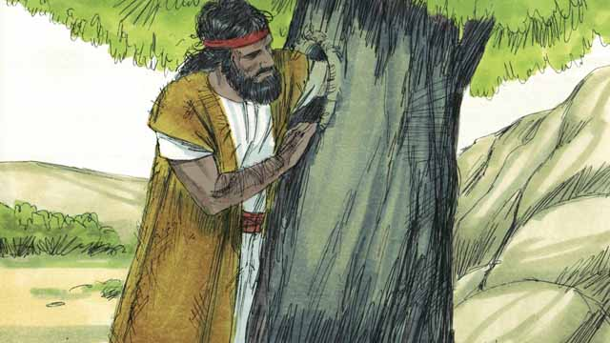

John, the son of Zechariah and Elizabeth, grew up and became a prophet. He lived in the wilderness, ate wild honey and locusts, and wore clothes made from camel hair.

24-02

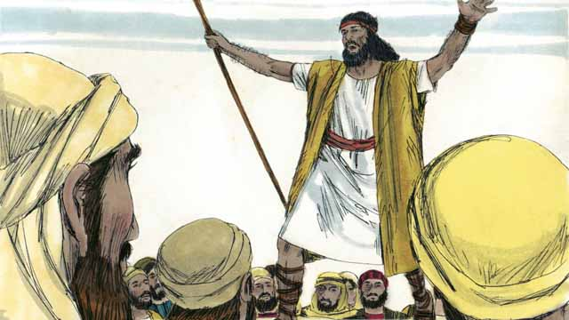

Many people came out to the wilderness to listen to John. He preached to them, saying, “Repent, for the kingdom of God is near!”

24-03

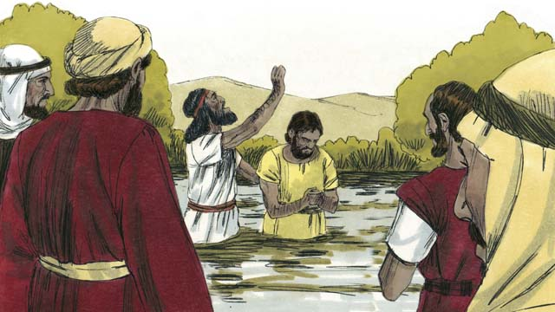

When people heard John’s message, many of them repented from their sins, and John baptized them. Many religious leaders also came to see John, but they did not repent or confess their sins.

24-04

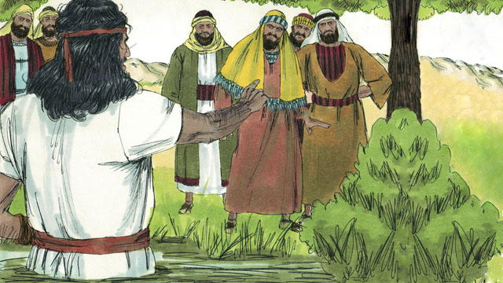

John said to the religious leaders, “You poisonous snakes! Repent and change your behavior. God will cut down every tree that does not bear good fruit, and he will throw them into the fire.” John fulfilled what the prophets had said, “See, I will soon send my messenger ahead of you, who will prepare your way.”

24-05

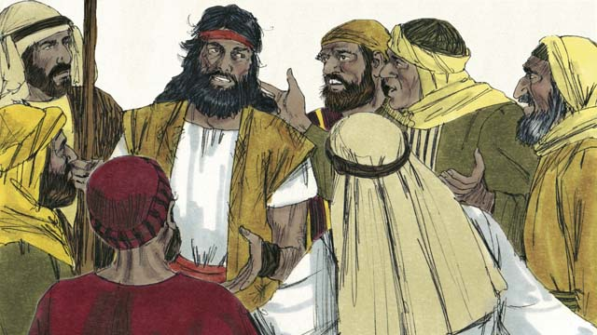

Some religious leaders asked John if he was the Messiah. John replied, “I am not the Messiah, but he is coming after me. He is so great that I am not even worthy to untie his sandals.”

24-06

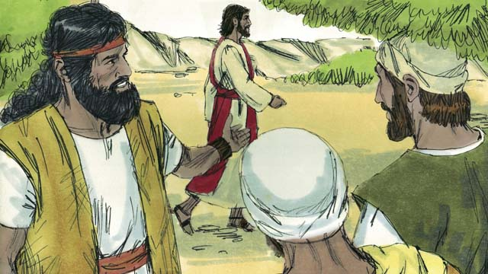

The next day, Jesus came for John to baptize him. When John saw him, he said, “Look! There is the Lamb of God who will take away the sin of the world.”

24-07

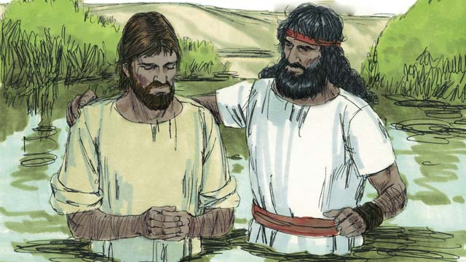

John said to Jesus, “I am not worthy to baptize you. You should baptize me instead.” But Jesus said, “You should baptize me, because it is the right thing to do.” So John baptized him even though Jesus had never sinned.

24-08

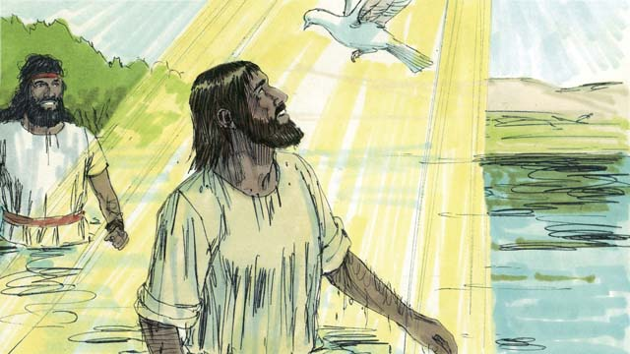

When Jesus came up out of the water after being baptized, the Spirit of God appeared in the form of a dove and came down and rested on him. At the same time, God spoke from heaven. He said, “This is my Son. I love him, and I am very pleased with him.”

24-09

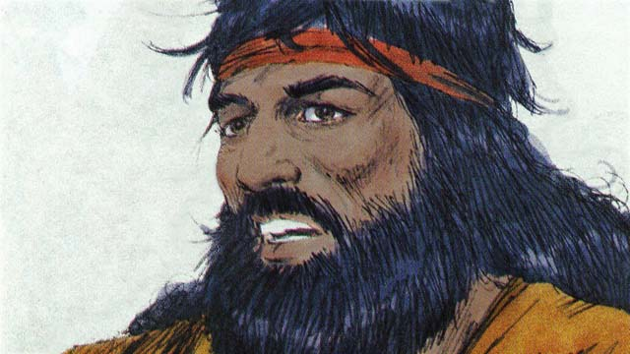

God had told John, “The Holy Spirit will come down and stay on someone you baptize. That person is the Son of God.” There is only one God. But when John baptized Jesus, he heard God the Father speak, saw God the Son, who is Jesus, and he saw the Holy Spirit.

*A Bible story from: Matthew 3; Mark 1; Luke 3; John 1:15-37*

## 1 Biblical Interpretation: Observing the Details of the Story

After reading the crafted biblical story, answer the following questions to familiarize yourself with the details of the story.

### 1.1 Observation Questions

Answer the following observation questions to gain a basic understanding of the the story. Read the story as a community and answer these questions as a group.

#### 24-01

What did John grow up to become?  
John, the son of Zechariah and Elizabeth, grew up and became a prophet.

Where did John live when he grew up?  
He lived in the wilderness.

What food did John eat and what clothes did John wear?  
John ate wild honey and locusts, and wore clothes made from camel hair

#### 24-02

How many people came to listen to John preach?  
Many people came out to the wilderness to listen to John preach.

What message did John preach to the people?  
He said, “Repent, for the kingdom of God is near!”

#### 24-03

How did many people respond positively to John’s message?  
Many people heard John’s message and repented from their sins.

What did John do to the people who repented from their sins?  
He baptized them.

How did many of the religious leaders respond to John’s message?  
Many religious leaders also came to see John, but they did not repent or confess their sins.

#### 24-04

What did John call the religious leaders?  
John called the religious leaders poisonous snakes.

What did John tell the religious leaders to do?  
John told the religious leaders to repent and change their behavior.

What did John warn the religious leaders that God would do?  
John warned the religious leaders that God would cut down every tree that does not bear good fruit, and he will throw them into the fire.

How did John fulfill what the prophets said?  
John was the messenger the prophets spoke about whom God would send ahead of the Messiah to prepare his way.

#### 24-05

What was John’s answer when the Jews asked him if he was the Messiah?  
He said he was not the Messiah, but the Messiah was coming after him.

How did John describe himself in relationship with the Messiah?  
John said that the Messiah is so great and John was not even worthy to untie his sandals.

#### 24-06

Why did Jesus come to John?  
Jesus came to John so that John would baptize him.

What title did John use for Jesus when he saw him coming to be baptized?  
He called him the Lamb of God who will take away the sin of the world.

#### 24-07

How did John initially respond to Jesus wanting to be baptized by John?  
Initially, John told Jesus that he was not worthy to baptize Jesus and that Jesus should baptize him instead.

Why did Jesus say that John should baptize him?  
He said John should baptize him because it was the right thing to do, even though Jesus never sinned.

Why did Jesus not need to repent of his sins before John baptized him?  
Jesus did not need to repent because he had never sinned.

#### 24-08

Who came to rest on Jesus after he was baptized?  
The Spirit of God appeared in the form of a dove and rested on Jesus.

What did God say after Jesus was baptized?  
He said, “This is my Son. I love him, and I am very pleased with him.”

#### 24-09

Whom did God say the person would be upon whom the Holy Spirit would come down and rest?  
The person the Holy Spirit would come down upon and stay when John baptized him would be the Son of God.

How many gods are there?  
There is only one God.

How many persons is God?  
God is one God and at the same time three persons. When John baptized Jesus, God the Father spoke to his Son and the Holy Spirit came on Jesus.

### 1.2 Translation Questions

Use the following translation questions to understand specific details of the passage. Discuss how you might translate these specific elements of the story.

#### 24-01

**grew up and became a prophet** God had chosen John to be a prophet before he was born. John would serve God as a prophet when he became an adult. How would you express **grew up and became a prophet** to mean John served God as a prophet when he became an adult?

  

**the wilderness** John lived in a place that was like a desert and removed from where other people typically lived. There were few people living out in this area. How would you express **the wilderness** to mean a remote, desert-like place?

  

**wild honey** This honey was the natural product of bees in the wilderness; it was not cultivated by people. If that is what people would understand by the word honey, you may not need to call it wild. How would you express **wild honey** to mean the natural product of bees that is found in nature and that is not cultivated by people?

  

**locusts** These were large, hopping insects with wings, like very large grasshoppers. Some people who live in the desert eat them. How would you express **locusts** to mean large hopping insects with wings that are like grasshoppers?

  

**wore clothes made from camel hair** A camel is an animal that has very rough hair. People could make clothing out of it. These clothes would not quickly wear out in the wilderness as other clothes would. This clothing symbolizes that John was a prophet like the prophets from long ago, especially the prophet Elijah. How would you express **wore clothes made from camel hair** to mean John wore clothes that were made from coarse clothes made of camel hair (rough animal hair)?

  

#### 24-02

**Repent** John commanded people to turn away from their sins and stop disobeying God. When people repent, they forsake their sins. How would you express repent as a command that instructs people to stop disobeying God and turn away from their sins?

  

**the kingdom of God is near** John preached that the kingdom of God was ready to appear. This meant that God’s reign was about to begin and soon rule over his people as king. How would you express **the kingdom of God is near** to mean the time of God’s reign was about to begin when God would rule over his people as king?

  

#### 24-03

**When people heard John’s message, many of them repented from their sins** People listened to John’s message. At the time they heard him preach, many people turned away from their sins. How would you express **When people heard John’s message, many of them repented from their sins** to mean many people stopped disobeying God and turned from their sins at the time they heard John preach?

  

**baptized** When people repented from their sins, John immersed them in water. This was a ritual act of publicly confessing sin, repenting from sin, and expressing a desire to follow God. How would you express **baptized** to mean to be immersed in water as a public ritual of commitment?

  

**but they did not repent or confess their sins** Many people turned from their sins when they heard John preach. In contrast to this, many religious leaders did not turn away from their sins and did not confess their sins when they heard John preach. How would you express **but they did not repent or confess their sins** to mean many religious leaders did the opposite of those who repented from their sins when they heard John preach?

  

**confess their sins** To confess is to acknowledge that something is true. These leaders did not want to acknowledge that they had sinned. How would you express **confess their sins** to mean to acknowledge that it is true that they have disobeyed God?

  

#### 24-04

**You poisonous snakes** John compares the religious leaders to poisonous snakes. Poisonous snakes are dangerous and represent evil. John said that these religious leaders represented evil and dangerous. How would you express **You poisonous snakes** to mean dangerous and evil like venomous snakes?

  

**God will cut down every tree that does not bear good fruit** John is not really talking about trees. John speaks of the religious leaders as if they were trees that bear bad fruit. The bad fruit represents bad actions of sining and disobeying God. As a person gets his axe ready to cut down and burn a tree that grows bad fruit, God is ready to punish people for their sins. This means God is ready to punish sinners. How would you express **God will cut down every tree that does not bear good fruit** to mean God has his axe and he is ready to cut down and burn any tree that grows bad fruit?

  

**he will throw them into the fire** John compares God’s judgment of sinners as throwing trees that bear bad fruit into the fire. Just as the fire would destroy the bad trees, God would punish those whose actions and attitudes did not come from God. How would you express **he will throw them into the fire** to mean God will judge each person who does not do follow God’s ways and punish by destroying them like would happen if someone threw a tree into a fire?

  

**John fulfilled** Prophets said that God would send a messenger who would come ahead of the Messiah in order to prepare the way for the Messiah. John was this messenger whom the prophets spoke about. He did what the prophets said the messenger would do. How would you express **John fulfilled** to mean John was doing what the prophet said God’s messenger would do?

  

**See** The prophets told people to look and see what God would do. How would you express **See** to mean look and pay attention?

  

**I will soon send my messenger ahead of you** This is a message the prophets spoke. The prophets said God would send a messenger who would come before the Messiah. How would you express **I will soon send my messenger ahead of you** to mean Yahweh would send his messenger that would come before the Messiah would come?

  

#### 24-05

**He is so great** John said that the Messiah was very important. How would you express **He is so great** to mean the Messiah is very important and prominent?

  

**I am not even worthy to untie his sandals** Untying the straps of sandals was a duty of a slave. John was saying that the one who would come is so great that John was not even worthy to be his slave. John was showing humility when he said this. How would you express **I am not even worthy to untie his sandals** to mean Jesus was so great that John did not deserve to even be his slave and do a lowly task of untying sandals?

  

#### 24-06

**Look!** John was pointing out that Jesus was present and was very important. He was calling his listeners to pay attention and take notice of him. How would you express **Look!** as a strong statement that calls people to pay attention to something really important?

  

**the Lamb of God** John speaks of Jesus as if Jesus is a lamb from God. John compares Jesus to a lamb to show that he is God’s perfect sacrifice who can take away sin. How would you express **the Lamb of God** to mean Jesus is God’s perfect sacrifice—as a lamb would be a sacrifice—who would be sacrificed to pay for people’s sins?

  

**will take away** Jesus is God’s perfect sacrifice who can remove and cleanse people from sin. As a sacrifice, Jesus makes it possible for sin to be forgiven and for people will not be punished for their sin. How would you express **will take away** to mean to remove sin so that God looks at our sin as if it never existed?

  

**the sin of the world** The word is a metonym and refers to all the people in the world. How would you express **the sin of the world** to mean the evil things done by the people who live in the world?

  

#### 24-07

**I am not worthy to baptize you** John said that he was not good enough to baptize Jesus. John recognized that he was sinful and did not think he should baptize Jesus. He thought Jesus should baptize him. How would you express **I am not worthy to baptize you** to mean John saw himself as sinful and did not think he was fit to baptize Jesus?

  

**because it is the right thing to do** Jesus never sinned. He was not baptized to repent from his sin. Jesus did not need to repent from sin because he never committed sin. Instead, Jesus was baptized to show what it means to be truly right. How would you express **because it is the right thing to do** to mean it is the proper thing that God wanted him to do?

  

**even though** Jesus had never sinned Baptism is sign of repentance. Some might think that Jesus’ baptism meant that Jesus was repenting from his own sin. But Jesus never sinned, so he had no need to repent. Other people were baptized and repented from their sin. Jesus was baptized to show that he always did what was right. How would you express **even though** Jesus had never sinned to mean Jesus was baptized to do what was right before God and this was a different reason sinful people were baptized when they repented from their sin?

  

#### 24-08

**after being baptized** John baptized Jesus by immersing him under the water. This is an action John did to Jesus. How would you express **after being baptized** to mean after John baptized Jesus by immersing him under the water?

  

**Spirit of God** appeared in the form of a dove and came down and rested on him After Jesus was baptized, the Holy Spirit descended on Jesus. This means that the Holy Spirit either came upon Jesus as a bird descends from the sky or the Holy Spirit looked like an actual dove when he descended upon Jesus. How would you express **Spirit of God** appeared in the form of a dove and came down and rested on him to mean the Holy Spirit descended upon and remained with Jesus as a dove descending from the sky and resting somewhere?

  

**This is my Son** This is an important title for Jesus. Jesus is God’s eternal Son who is at the same time equal to his Father and distinct from his Father. How would you express **This is my Son** to mean Jesus is the Son of God the Father?

  

#### 24-09

**God had told John** God had already spoken to John and told him that the Holy Spirit would come upon and remain on the one he baptized. How would you express **God had told John** to mean could mean Before Jesus came to be baptized, God had told John?

  

**But when John baptized Jesus, he heard God the Father speak, saw God the Son, who is Jesus, and he saw the Holy Spirit** There is only one God. At the same time, God is three distinct persons: God the Father, God the Son and God the Holy Spirit. How would you express **But when John baptized Jesus, he heard God the Father speak, saw God the Son, who is Jesus, and he saw the Holy Spirit** to mean there is one God who eternally exists as three distinct persons: God the Father, God the Son and God the Holy Spirit?

  

## 2 Theological Dialogue: Discussing the Meaning of the Story

Take time to explore the meaning of this story together as a community. Use the following discussions as a way to grasp what truth the story teaches.

### 2.1 Discourse Questions

Use the following discourse questions to understand the meaning of the story. Pay attention to how the story itself addresses each question or theme.

##### What was important about John’s ministry? (24-01, 24-02, 24-03, 24-04)

Prophet: John grew and became a prophet. God used John to speak God’s messages to people. (24-01)

  

Faithful Follower/Servant: John lived in the wilderness. He ate wild honey and locusts. He wore clothes that were made from tough animal hair of a camel. He lived a simple and devoted life that was focused on serving God and speaking his truth. John showed people what it looks like to follow and serve God. His lifestyle was an example for people to follow. (24-01)

  

Preacher: Many people came out to hear John. John spoke God’s messages and many people wanted to hear God’s messages. John instructed people to repent from their sins. He told them that God’s kingdom has nearly arrived. (24-02)

  

Baptizer: John baptized people who repented of their sin. This act of baptism formed people into a community of faithful servants of God. (24-03)

  

Warning: John warned people of God’s judgment that was coming. Using the example of a tree that bears bad fruit, John told people that God would punish people who did not live lives that pleased God. (24-04)

  

Preparer: John prepared the way for Jesus to come. He also prepared the way for people to come and believe in Jesus. In doing this ministry, John fulfilled what the prophets said he would do. (24-04)

  

##### How did people respond to John’s ministry and message? (24-03, 24-04)

Hearers: Many people came out to hear John’s message. They wanted to hear from God. True followers of God want to hear truth from God. (24-03)

  

Repentance: Many people repented of their sins. People stopped disobeying God and turned away from sin. (24-03)

  

Baptism: John baptized those who repented of their sins. Baptism is a ritual act of confessing sin, repenting from sin, announcing one’s commitment to God, and joining the group/community of others who follow God. (24-03)

  

Confession: Religious leaders did not repent and did not confess their sin. True believers will acknowledge the truth that they are sinful before God. Only when we admit our sin before God can we repent of our sin. (24-03)

  

Change Behavior: John commanded the religious leaders to change their behavior. These leaders did things that were evil and dangerous to others. If they truly repented from their sin than they would change the way they lived. (24-04)

  

Bear Fruit: Like a tree that bears good fruit, people who truly repented of their sin would show their repentance by living godly lives before God. (24-04)

  

##### How did John understand himself in relationship to Jesus? (24-05, 24-06, 24-07)

Humility: John knew that Jesus was very important. He did not consider himself worthy to even be Jesus’ slave. Jesus was so great that John did not consider himself important enough to untie Jesus’ sandals. When Jesus told John baptize him, John thought that he should be baptized by Jesus. (24-05, 24-07)

  

Preparer: John knew that his ministry was to point people to Jesus. Even though John was popular, he realized that Jesus was of greatest importance and pointed people to Jesus. (24-06)

  

Obedience: John did what Jesus commanded. Even though John though Jesus should baptize him, John obeyed Jesus’ command and baptized Jesus. (24-07)

  

##### What did John’s ministry show about who Jesus really is? (24-05, 24-06, 24-07, 24-08, 24-09)

Messiah: John said that Jesus was very important. In fact, Jesus was so important that John thought he was not even fit to be Jesus’ slave and do a lowly task like untying his sandals. Jesus was the promised deliverer that God’s people had been waiting for. (24-05)

  

Lamb of God: John called Jesus the Lamb of God. He was saying that Jesus was God’s perfect sacrifice to take away sin. (24-06)

  

Sinless/Righteous: Jesus never sinned. Jesus told John to baptize him because is was right to do this. Jesus’ baptism showed how righteous. (24-07)

  

Son of God: After Jesus was baptized, the Holy Spirit descended upon Jesus and remained on him. God the Father spoke out loud and said that Jesus was his Son. God loved his Son and was pleased with him. God told John that the Holy Spirit would descend upon someone he baptized and this person would be the Son of God. (24-08, 24-09)

  

Trinity: Jesus if fully God. There is one God who exists as three persons: God the Father, God the Son, and God the Holy Spirit. John heard the voice of God the Father. He saw Jesus, who is God’s Son. And, John saw the Holy Spirit defend on Jesus. (24-09)

  

### 2.2 Theological Questions

Answer the following theology questions as a community. Discuss what truths this story teaches.

1. What does it mean to faithfully serve and follow God? How is John’s life and ministry and example of what it means to be faithful to God?
2. How can people come to follow God and be in right relationship with God? How do the various responses to John’s ministry teach us about how people can come to be right before God and follow him?
3. What is baptism important? What role does baptism have in disciples following God/Christ?
4. What should be believe about Jesus? What does John’s ministry and Jesus’ baptism teach us about who Jesus is?

### 2.3 Translation Draft

Work as a translation team to draft each panel of this story. Pay attention to any specific translation issues that are challenging or significant.

#### Make Translation Draft

Make a draft for each section of this story.

#### Discuss and Revise

After drafting the story, discuss any translation issues that you think need special explanation.

#### Drafting Summary Reflection

Summarize any noteworthy translation decisions and the rationale/reasoning behind these translation decisions. In the final movement of this class, you will use these observations to give an account (i.e., chronicle/narrate) of how your translation improved through the checking process.

## 3 Personal Reflection: Following the Teaching of the Story

Take a moment to allow this story to evaluate your own life and to consider how God would have you respond. After this reflection, use the quality checking questions to check your translation draft among the translation team.

### 3.1 Journal Reflection

Prayerfully think about the following personal reflection questions. Write/Record your answers and/or discuss them as a group.

1. Have you repented of your sins and come to follow Jesus? Have you been baptized to publicly show your repentance from sin?
2. If you have come to follow Jesus, how has your life changed? If you have not come to follow Jesus, what is keeping you from doing so?
3. What new convictions have you gained about who Jesus is?
4. What change does God want to bring in your life?
5. How is John an example for you to follow?

### 3.2 Team Check

*The following activity will help you check the clarity, accuracy, and naturalness of your draft. Read the passage aloud and discuss the checking questions with other members of your translation community. You might need to reread portions (or the whole) of the biblical passage multiple times as you answer each of these questions. Record answers to these questions below.*

#### Team Checking Questions

*Use the following questions to check your translation draft for accuracy, clarity, and naturalness.*

1. **Accurate**: Has anything been **added** to your translation of this passage that is not a part of the meaning of the source text? *If additions exist, are they included only added to clarify meaning (such as implied information)?*
2. **Accurate**: Is anything **missing** from your translation of this passage that is a part of the meaning of the source text? *If some part of the meaning is missing from your translation, add it.*
3. **Accurate**: Does any meaning in your translation of this passage appear to be **different** than the meaning of the source text? *If the meaning is different, try changing your translation so that the meaning remains the same.*
4. **Natural**: Does anything sound **unnatural** to how you would say it in your language? *If portions of the passage sound unnatural in your language, try to make them sound the way you would say it in your language while staying true to the meaning of the source text.*
5. **Clear**: Is anything **unclear** or **confusing** in your translation that confuses the meaning of the source text? *If portions of the passage are unclear or confusing, revise them to clearly communicate the meaning of the source text.*
6. **Consistent**: How **consistent** is your translation within the passage and with other passages? *If portions of the passage need to be made consistent or if you need to revise translations of other passages, make these adjustments.*

#### Record Feedback

*After discussing the checking questions above as a translation community, record any feedback on your translation draft. Pay attention for parts of your translation that are translated well and parts of your translation that need correction.*

#### Discuss and Revise

*After gathering feedback on your draft, discuss it together with your translation community and make appropriate revisions in your translation.*

#### Record Translation Decisions

*As a community, discuss some of the most noteworthy translation decisions in your draft. Summarize each decision and explain the reasons your community decided on that translation. You should update these decisions each time you check your draft with various groups of people.*

You should **measure** the quality of your translation draft. You can **record translation decisions** to make it clear why you translated things a certain way. Translation decisions can help your translation team and the surrounding community be a part of the translation process.

How can you know the quality of your translation?

1. **Measure** the translation by marks/standards of quality (i.e., clear, accurate, natural, church-approved)
2. **Test** the translation with others and record feedback and conversations from in the field (i.e., church and community check)
3. **Compare** and **contrast** the translation with the source text (i.e., meaning of text and notes) and alternatives (i.e., other translation choices)
4. **Explain** the reasons why you translated a particular portion of the text.

**Example Sentences That Help Explain Your Translation Decision** Use the following example sentences to help explain your translation decisions:

1. The original text literally **says/means**, so we translated the term in this way…
2. We originally decided to translate **the biblical term** in with **this term**, but we changed it because…
3. When our translation team discussed **the biblical term**, this is what we talked about…
4. **The term** is [clear, accurate, natural, consistent] because…
5. The community understands **this term** it to mean…
6. We considered these other terms. We did not use **these terms** because…
7. When we checked this in the church, we learned…
8. When we checked this in the community, we learned…

**Example of Translation Decision**

In OBS 01-07 we decided to translate **blessed** like this: [actual translation]. We decided this translation because of these reasons:

1. The word [actual translation] means to cause good things to happen to someone or something. This term is used when a person desires someone or something to prosper or flourish. This term does not refer to magic or witchcraft.
2. When we checked this word with other believers, they said it describes God showing his kindness and favor on someone or something. These are some of the terms that we did not decide to use…
3. Many of our people will understand this word. When we discussed this phrase with the surrounding community, we discovered it was a natural way to describe God causing good and beneficial things to happen.

## 4 Ministry Practice: Serving the Church with the Story

Now that you have a draft of this story, consider how this story can encourage other believers in their faith. After ministering this story to others, you will also perform a community check of your translation draft.

### 4.1 Church Ministry

Reflect on how this story can edify and mature the Christian community. Design a way to minister this story to your church community.

**Ministry Preparation**: Take time to consider how you could minister this story to others. Record some ministry ideas below.

**Ministry Implementation**: Minister this story to a group of believers as you had planned. Use the information in this study to help develop a teaching/lesson or lead a discussion of this story to other believers. Record your ministry plan below.

**Ministry Reflection**: Think about what you learned from ministering this story to other believers. Reflect on your experience below.

### 4.2 Church Community Check

After teaching or ministering this story to the church, check the translation quality with the church community. Record any feedback from your checking experience.

#### Create Checking Questions

You can use **Translation Questions** to check you draft. Each **Translation Question** explains the meaning of a specific part of the story and asks you to consider how you would translate that part of the story in your own language. Change each **Translation Question** into a **Checking Question** by asking the following questions. The first question asks you to identity how each specific phrase was translated in your language. The second question asks people in the church to determine if your translation of the phrase expresses the meaning clearly, accurately, and naturally. Look at the following examples to see how to change **Translation Questions** into **Checking Questions**:

#### Translation Question Example 1

**to proclaim the good news about Jesus** Paul and Silas traveled to Philippi for the purpose of preaching the gospel. The gospel is the good news that Jesus saves people from their sins if they will believe in Jesus. How would you express **to proclaim the good news about Jesus** to mean to tell other people the message about how Jesus can save people from their sins?

#### Translation Question Example 2

**a merchant** Paul and Silas met a woman named Lydia at the place by the river. She owned a business and sold items to make money. How would you express **a merchant** to mean a business owner who sells items for a profit?

#### Translation Question Example 3

**so Paul and Silas baptized them** The jailer and his whole family followed Paul’s instructions. They believed in Jesus. The result of this was Paul and Silas baptized them. How would you express **so Paul and Silas baptized them** to mean the result of the jailer and his family believing in Jesus that Paul and Silas baptized all of them?

You can change these into **Checking Questions** like this:

#### Checking Question Example 1

**to proclaim the good news about Jesus** How did you translate **to proclaim the good news about Jesus**? Does it mean to tell other people the message about how Jesus can save people from their sins?

#### Checking Question Example 2

**a merchant** How did you translate **a merchant**? Does it mean a business owner who sells items for a profit?

#### Checking Question Example 3

**so Paul and Silas baptized them** How did you translate **so Paul and Silas baptized them**? Does it mean the result of the jailer and his family believing in Jesus that Paul and Silas baptized all of them?

#### Record Feedback

*Discuss the* ***Checking Questions*** *with your church community, and record any feedback on your translation draft. Pay attention for parts of your translation that are translated well and parts of your translation that need correction.*

#### Discuss and Revise

*After gathering feedback on your draft, discuss it together with your translation community and make appropriate revisions in your translation.*

#### Record Translation Decisions

*Update your translation decisions and record and new any noteworthy observations on the quality of your draft.

## 5 Missional Outreach: Sharing the Truth of the Story

*After sharing this story with others, check the translation quality with the wider language community. Record any feedback from your checking experience.*

### 5.1 Mission Engagement

*Consider how you will witness this story to unbelievers. Design a way to share this story and engage them in what it teaches about Christianity and the gospel.*

**Witness Preparation**: Take time to consider how you will witness this narrative to unbelievers. Record some ideas below.

**Witness Implementation**: Share this story with an unbeliever. Use the information in this study to help develop a teaching/lesson or lead a discussion of this story to other believers. Record your ministry plan below.

**Witness Reflection**: Think about what you learned from ministering this story to unbelievers. Reflect on your experience below.

### 5.2 Sociolinguistic Check

After sharing this story with the language community, check your translation draft with the surrounding community. Record your observations.

#### Checking Approach

After witnessing this story to unbelievers, use one of the following methods to check the translation of this story. Consider using the **Observation Questions** to check your translation draft or come up with your own quality checking questions.

**Read-Retell Check:** Read your draft to those the community and ask them to retell the passage. Be attentive for any portions of the passage that are unclear, unnatural, or inaccurate.

**Comprehension Questions Checklist:** Read the draft of the passage and ask a list of comprehension questions to make sure the passage is being rightly understood. You can use the **Observation Questions** in this guide or come up with your own questions. Then, record any insights or issues that arise.

**Discussion Group:** Develop key questions to ask about the passage (both formational and translational). Read the passage and have a group discussion about the passage, paying attention to issues that need to be addressed, edited, and revised.

#### Record Feedback

*After sharing your draft with language community, discuss the* ***Observations Questions****, and record any feedback on your translation draft. Pay attention for parts of your translation that are translated well and parts of your translation that need correction.*

#### Discuss and Revise

*After gathering feedback on your draft, discuss it together with your translation community and make appropriate revisions in your translation.*

#### Record Translation Decisions

*Update your translation decisions and record and new any noteworthy observations on the quality of your draft.

## 6 Conclusion

As a translation community, take time to reflect on all that was learned in studying, drafting, and checking this story. Celebrate all that God has taught you as a community. Then, submit your revised draft and checking summaries to network leaders for further review.