Open Bible Stories

Satan Tempts Jesus

## 0 Introduction

### 0.1 Key Idea

The story of Jesus being tempted by Satan teaches us that Jesus endured temptation without sin and can sympathize with our struggles and come to our aid when tempted.

### 0.2 Creedal Verse

“For we do not have a high priest who is unable to sympathize with our weaknesses, but one who in every respect has been tempted as we are, yet without sin.” Hebrews 4:15

### 0.3 Metanarrative Summary

The eternal God created all things in six days. He made a good and perfect world. He made humans in his image to fill the earth and rule over creation. But humans rebelled against God and ruined God’s creation. God set to restore his world through his promise. God made a covenant with Abraham. He promised to bless all nations through Abraham. God kept his promises across the generations. God provided Abraham with a promised child, Isaac. God gave Isaac a wife and she bore twins, Jacob and Esau. God blessed Jacob and his sons, and the blessing continued to the next generation. God rescued Joseph, one of Jacob’s sons, and used him to rescue his family. God caused his people, the Israelites, to multiply in the land of Egypt; eventually, they became slaves. But, God raised up a deliverer, Moses, to deliver his people from their slavery. God judged the Egyptians with harsh plagues; in the final judgment, he passed over his people who covered their doorposts with the blood of a sacrificed lamb. Then, God delivered the Israelites by bringing them out of Egypt and crossing the Red Sea on dry land. God made a covenant with the Israelites and made them his people. God tested Israel in a series of wilderness wanderings and eventually brought his people into the promised land of Canaan. God raised up deliverers to lead Israel and rescue them from their enemies. God formed Israel into a kingdom. He made a covenant with King David and promised to send a king that would rule his people forever. Many of Israel’s kings were evil and the kingdom of Israel divided into two kingdoms. God sent prophets to warn his people of God’s judgment and call them to repent. When Israel did not repent, God sent his people into exile. After many years, he brought them back to the land. Throughout the Old Testament, God promised to send his Messiah to deliver his people form their sin. After many years, the prophet John was born. He would prepare people for the coming Messiah. At the perfect time, God sent his Son, Jesus, to be born of a virgin Mary. When John and Jesus grew up, John baptized Jesus as a sign that Jesus was God’s beloved Son. Jesus endured all manner of temptation without ever sinning.

### 0.4 Open Bible Story: Satan Tempts Jesus

25-01

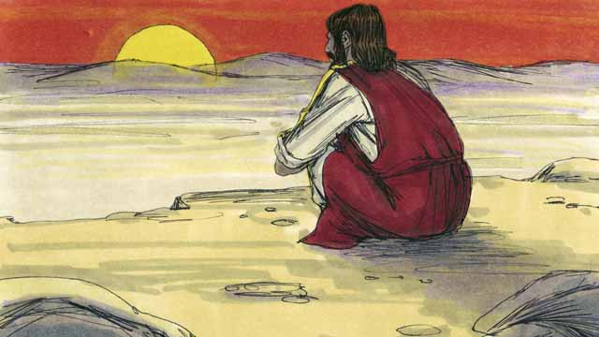

Immediately after Jesus was baptized, the Holy Spirit led him out into the wilderness. Jesus was there for 40 days and 40 nights. During that time he fasted, and Satan came to Jesus and tempted him to sin.

25-02

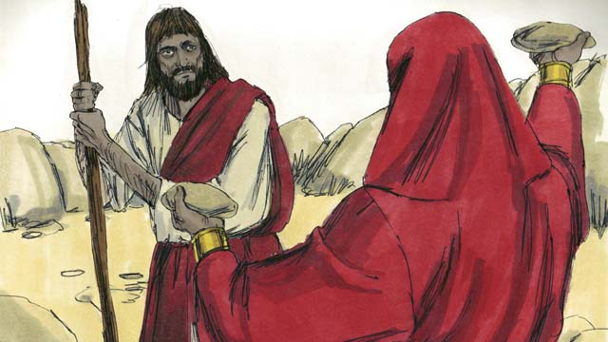

First, Satan said to Jesus, “If you are the Son of God, turn these rocks into bread so you can eat!”

25-03



But Jesus said to Satan, “It is written in God’s word, ‘People do not only need bread in order to live, but they need everything that God tells them!’”

25-04

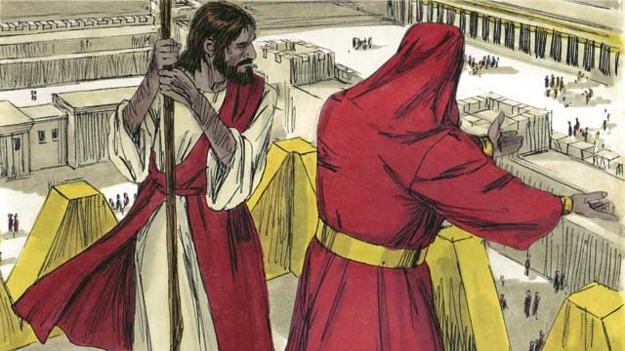

Then Satan took Jesus to the highest point on the Temple. He said to him, “If you are the Son of God, jump off to the ground, because it is written, ‘God will command his angels to carry you so your foot does not hit a stone.’”

25-05

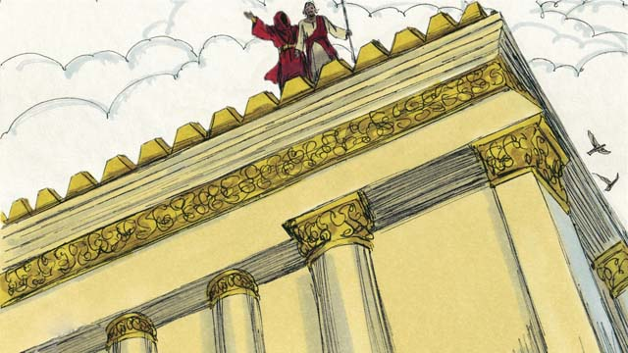

But Jesus did not do what Satan asked him to do. Instead, he said, “God tells everyone, ‘Do not test the Lord your God.’”

25-06

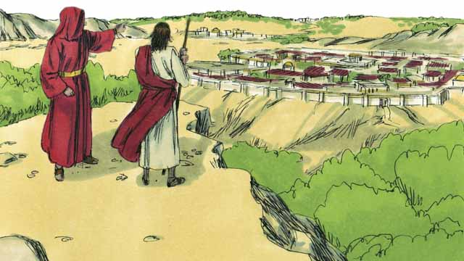

Then Satan showed Jesus all the kingdoms of the world. He showed him how powerful they were, and how wealthy they were. He said to Jesus, “I will give you all this if you bow down and worship me.”

25-07

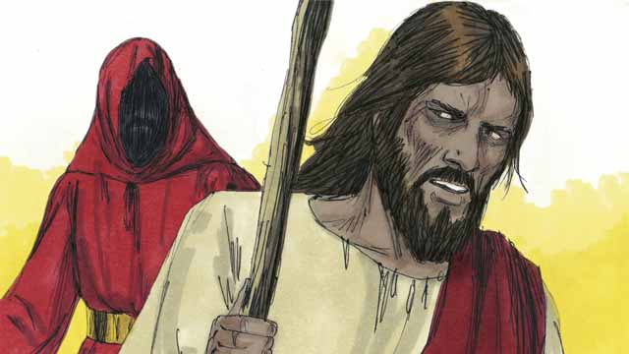

Jesus replied, “Get away from me, Satan! In God’s word he commands his people, ‘Worship only the Lord your God. Honor only him as God.’”

25-08

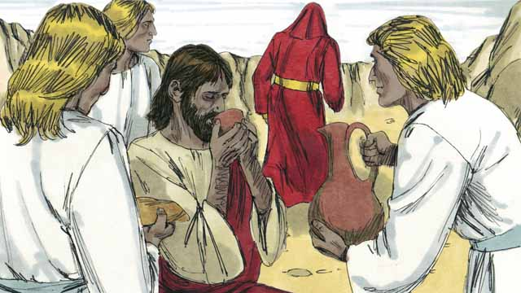

Jesus did not give in to Satan’s temptations, so Satan left him. Then angels came and took care of Jesus.

*A Bible story from: Matthew 4:1-11; Mark 1:12-13; Luke 4:1-13*

## 1 Community Study: We Are Strong When Weak—Doing Ministry in God’s Strength

* **Key Idea**: relying on God’s power as a source of ministry strength
* **Key Passage**: 2 Corinthians 12:1-10
* **Main Session**: OBS 25 (Satan Tempts Jesus)

### 1.1 Recite the Creedal Verse (3–5 minutes)

The verse below summarizes the teaching of the current passage. Read the verse out loud as a community. Read it again several times as a group until the whole community can recite it from memory.

For we do not have a high priest who cannot feel sympathy for our weaknesses. Instead, we have someone who has in all ways been tempted as we are, except that he is without sin. Hebrews 4:15

OR

For because he himself has suffered when tempted, he is able to help those who are being tempted. Hebrews 2:18

### 1.2 Sing a Song (3–5 minutes)

Choose a song to sing to praise God and encourage one another.

### 1.3 Read the Passage (3–5 minutes)

No Christian can lead/minister in their own strength and power. Christian leaders go about their work by God’s strength. As a community, read the following Bible passage together to understand the godly approach to leadership, power, and authority.

1 I must boast, but nothing is gained by it. But I will go on to visions and revelations from the Lord. 2 I know a man in Christ who fourteen years ago who—whether in the body or out of the body, I do not know, God knows—was caught up into the third heaven. 3 And I know that this man—whether in the body, or out of the body, I do not know, God knows— 4 was caught up into paradise and heard things too sacred for anyone to say. 5 On behalf of such a person I will boast. But on behalf of myself I will not boast, except about my weaknesses. 6 If I should choose to boast, I will not be a fool, because I would be speaking the truth. But I will keep from boasting, so that no one will think more of me than what he sees in me or hears from me. 7 To keep me from boasting because of the surpassing greatness of the revelations, a thorn in the flesh was given to me, a messenger from Satan to afflict me—so I would not become overly proud. 8 Three times I begged the Lord about this, for him to take it away from me. 9 But he said to me, “My grace is enough for you, for power is made perfect in weakness.” So I would much rather boast about my weakness, so that the power of Christ might reside on me. 10 Therefore I am content for Christ’s sake in weaknesses, in insults, in troubles, in persecutions and distressing situations. For whenever I am weak, then I am strong. 2 Corinthians 12:1-10

### 1.4 Discuss the Passage (10-15 minutes)

God wants all Christians to depend upon his grace and power. In particular, this is what God wants for leaders in his church. As a community, use the following questions to discuss the teaching of the biblical passage.

1. In this passage, how does Paul understand his weakness and limitations? What does Paul think about his weaknesses and limitations?
2. What does it mean for leaders/Christians to minister in weakness so that God can show his power through them?
3. What kinds of things do many leaders boast about?
4. How can you approach leadership/ministry in a way that relies on God’s power and grace?

### 1.5 Name Personal Weakness (5 minutes)

After discussing this passage, have a time of personal reflection in which each member identifies an area of weakness in their life and ministry. Then, have each person think about how God’s power can be shown through your weakness.

### 1.6 Pray to God (5 minutes)

Have each person identify the area of weakness and pray the following prayer to God.

Good God, I acknowledge that I am weak in this way… Thank you that your grace is sufficient for me and your power is made perfect in weakness, for whenever I am weak, then I am strong.

## 2 Biblical Interpretation: Observing the Details of the Story

After reading the crafted biblical story, answer the following questions to familiarize yourself with the details of the story.

### 2.1 Observation Questions

Answer the following observation questions to gain a basic understanding of the the story. Read the story as a community and answer these questions as a group.

#### 25-01

Where did Jesus go after he was baptized?  
Jesus went into the wilderness.

Who led Jesus into the wilderness?  
The Holy Spirit led him.

What did Jesus do in the wilderness?  
He fasted there for 40 days and 40 nights.

Who came to tempt Jesus to sin?  
Satan came to Jesus in the wilderness and tempted him to sin.

#### 25-02

What did Satan tempt Jesus to prove about himself?  
Satan tempted Jesus to prove that he was the Son of God.

What did Satan tempt Jesus to do with the rocks?  
He told Jesus to turn the rocks into bread so he could eat.

#### 25-03

What did Jesus quote to Satan?  
Jesus quoted God’s word to Satan.

What did God tell Satan from God’s word?  
Jesus told Satan that people do not only need bread to live, but they also need everything that God tells them.

#### 25-04

Where did Satan and Jesus go next?  
Satan took Jesus to the highest point of the Temple.

What did Satan tempt Jesus to prove about himself?  
Satan tempted Jesus to prove that he was the Son of God.

What did Satan tempt Jesus to do next?  
He told Jesus to throw himself down from the Temple.

Who did Satan say would protect Jesus?  
God would command his angels to protect Jesus.

Where did Satan get this information?  
Satan quoted from God’s word.

#### 25-05

Did Jesus do what Satan asked?  
No. Jesus did not do what Satan asked him to do.

What did Jesus quote to Satan?  
Jesus quoted God’s word to Satan.

What did God tell Satan from God’s word?  
Jesus said that God’s Word says not to test the Lord your God.

#### 25-06

What did Satan show Jesus next?  
Satan showed Jesus the power and wealth of all the kingdoms of the world.

What did Satan then offer to give Jesus?  
Satan offered to give him all the kingdoms of the world and their glory.

What did Satan ask Jesus to do in order to receive these kingdoms?  
Satan wanted Jesus to bow down and worship him.

#### 25-07

Did Jesus agree to worship Satan?  
No. Jesus commanded Satan to leave him.

What did Jesus quote to Satan?  
Jesus quoted God’s word to Satan.

What did God tell Satan from God’s word?  
Jesus told Satan that God commands his people to only worship and honor God.

#### 25-08

Did Jesus give in to Satan’s temptations?  
No. Jesus did not fall for Satan’s temptations.

What did Satan do?  
Because Jesus did not fall for Satan’s temptations, Satan left Jesus.

What happened after Satan left Jesus?  
Angels came and took care of Jesus.

### 2.2 Translation Questions

Use the following translation questions to understand specific details of the passage. Discuss how you might translate these specific elements of the story.

#### 25-01

**Immediately after Jesus was baptized** In the previous story, Jesus was baptized. Right after Jesus was baptized, the Holy Spirit led him into the wilderness. How would you translate **Immediately after Jesus was baptized** to mean the Holy Spirit led Jesus into the wilderness directly after Jesus was baptized.

**the Holy Spirit led him** The Holy Spirit guided Jesus to go into the wilderness. How would you express **the Holy Spirit led him** to mean the Holy Spirit guided him or prompted him to go?

  

**the wilderness** Jesus went into a remote, barren place with few people. This place probably had very few trees or other plants, so most people would not be able to live there. How would you express **the wilderness** to mean a remote, desert-like place where few people lived?

  

**tempted him to sin** Satan tried to persuade Jesus to disobey God. Since Jesus did not sin, this word does not imply that Satan succeeded in convincing Jesus to sin, only that he tried to get Jesus to sin. How would you express **tempted him to sin** to mean tried to convince him to sin?

  

#### 25-02

**If you are the Son of God** Satan knew that Jesus was indeed the Son of God. Jesus also knew he was indeed the Son of God. Satan was saying this to try to get Jesus to prove he is truly the Son of God in a way that would cause Jesus to sin. How would you express **If you are the Son of God** to mean since it is true that you are the Son of God?

  

**turn these rocks into bread** Satan tempted Jesus to prove he is the Son of God by supernaturally changing rocks into bread. In the Jews’ culture, bread was the main/staple food. How would you express **turn these rocks into bread** to mean make these rocks become bread/food?

  

**so you can eat** Satan asked Jesus to turn rocks into bread. During Jesus’ time in the wilderness, he was fasting and grew hungry. The purpose of turning rocks into bread would be for Jesus to eat and satisfy his hunger. So, Satan tempted Jesus to prove he was the Son of God by making food for himself out of rocks and satisfying his hunger. How would you express **so you can eat** to mean the purpose of turning rocks into bread was that Jesus could satisfy his hunger by eating food?

  

#### 25-03

**It is written** Jesus quoted a portion of God’s word. This was a passage written and recorded in the Scriptures. How would you express **It is written** to mean God’s word says or God says in his word?

  

**People do not only need bread** Jesus affirms that food is necessary to live. However, Jesus also says that bread/food is not the only thing people need to live. How would you express **People do not only need bread** to mean people need more than just physical food to live?

  

**but they need everything that God tells them!** Although Jesus acknowledges that people need bread to live, he says that people need more than just bread. People live by following God’s word. How would you express **but they need everything that God tells them!** to mean rather than just surviving by physical food, people need to listen to and obey everything God says to live?

  

#### 25-04

**jump off to the ground** Satan tempted Jesus to leap off of the top of the Temple toward the ground. How would you express **jump off to the ground** to mean to leap off the building to the ground?

  

**so your foot does not hit a stone** Satan quotes a passage of God’s word. This passage says God would send angels to protect a person from injury. In this passage the angels would carry him so that even your foot will not strike against a stone and would not be injured. How would you express **so your foot does not hit a stone** to mean so that you will not be hurt at all and not even your foot will be injured on a stone?

  

#### 25-05

**God tells everyone** Jesus responded to Satan by telling Satan a command that God gives to everyone. God prohibits anyone form testing God. How would you express **God tells everyone** to mean this is what God says to everyone?

  

**Do not test the Lord your God** God prohibits people from challenging God to take care of them when they do not even obey God. How would you express **Do not test the Lord your God** as a command to not challenge the Lord your God to prove himself to you?

  

**the Lord your God** Yahweh is the one and only God. Even if people do not believe and follow Yahweh, he is still Lord and God. Yahweh is Lord and God of all peoples and places. However, Yahweh is specifically the Lord of his people when **the**y trust and obey him. How would you express **the Lord your God** to mean Yahweh, your God who has authority over you?

  

#### 25-06

**the kingdoms of the world** Satan showed Jesus all the domains of power and human government on the earth. How would you express **the kingdoms of the world** to mean all the greatest cities, countries, and other territories of the world where humans exercise authority/government?

  

**I will give you all this** Satan told Jesus that he would make Jesus the ruler over all these countries, cities and people if Jesus worshiped Satan. How would you express **I will give you all this** to mean to give him all the wealth and power of these kingdoms on the earth?

  

**bow down** Satan asked Jesus to lower himself to the ground. This act symbolized reverence, honor, and devotion. Satan wanted Jesus to worship him. How would you express **bow down** to mean to lower oneself to the ground in act of worship and devotion?

  

#### 25-07

**Get away from me** Jesus commanded Satan to leave his presence. How would you express **Get away from me** as a command for Satan to leave Jesus alone and go away from Jesus?

  

**Worship only the Lord your God** Jesus quotes a command from God’s word. This command instructs people to praise, serve, and submit themselves only to Yahweh as God. How would you express **Worship only the Lord your God** as a command to be devoted only to Yahweh as God who has authority over your life?

  

**Honor only him as God** Jesus quotes a command from God’s word. This command instructs people to only respect, praise, and revere Yahweh as God. How would you express **Honor only him as God** as a command to only respect and revere Yahweh as God?

  

#### 25-08

**did not give in to** Jesus did not do what Satan asked. In each temptation, Jesus refused to do what Satan wanted him to do. How would you express **did not give in to** to mean Jesus did not do the things that Satan was tempting him to do?

  

**so Satan left him** Jesus did not do the things Satan tempted him to do. The result of this was Satan left Jesus alone. How would you express **so Satan left him** to mean the result of Jesus not doing the things Satan tempted him to do was Satan left Jesus alone and no longer tempted him at that moment?

  

## 3 Theological Dialogue: Discussing the Meaning of the Story

Take time to explore the meaning of this story together as a community. Use the following discussions as a way to grasp what truth the story teaches.

### 3.1 Discourse Questions

Use the following discourse questions to understand the meaning of the story. Pay attention to how the story itself addresses each question or theme.

##### How did Satan tempt Jesus? (25-01, 25-02, 25-04, 25-06)

Identity/Doubt: Satan challenged Jesus to prove that he was the Son of God. Satan knew that Jesus was the Son of God. Jesus knew that he was the Son of God. By challenging Jesus to prove what he already knew was true, Satan tried to cause Jesus to doubt or question this truth. (25-02, 25-04)

  

Hunger: Satan tempted Jesus to turn rocks into bread. Jesus was fasting in the wilderness. During this time, Jesus would have been hungry. Satan tried to get Jesus to prove he was the Son of God by satisfying his physical hunger. (25-01, 25-02)

  

Protection: Satan tempted Jesus to show how God would protect him. He asked Jesus to jump off of the Temple and show that God would send angels to keep him safe. It is wrong to test God to protect us when we do not follow his commands. Satan tried to get Jesus to disobey God and put God to a test. (25-04)

  

Wealth and Power/False Worship: Satan tempted Jesus with wealth and power. Satan offered to give Jesus the kingdoms of the earth if Jesus worshiped him. Satan tried to get Jesus to sin by desiring money and authority as more important than worshiping God alone. (25-06)

  

Wrongly Using God’s Word: Satan tempted Jesus by quoting from God’s word. Satan did not understand or use God’s word correctly. He quoted it to tried to twist it to get Jesus to sin. (25-04)

  

##### How did Jesus respond to/resist Satan’s temptations? (25-03, 25-05, 25-07, 25-08)

Fasting: Jesus was fasting for 40 days and 40 nights in the wilderness. Fasting allowed Jesus to focus his commitment and devotion to God. (25-01)

  

God’s Word: In all of the temptations, Jesus responded by quoting God’s word. (25-03, 25-05, 25-07)

  

Obedience to God’s Word: In response to the first temptation, Jesus quoted a portion of God’s word. This portion taught that people live by obeying God’s word, not just by eating food. (25-03)

  

Do Not Test God: In response to the second temptation, Jesus quoted a portion of God’s word. This portion taught that people should not put God to a test. (25-05)

  

Pure Worship: In response to the third temptation, Jesus quoted a portion of God’s word. This portion taught that people should only worship and honor God. (25-07)

  

Resistance: Jesus resisted Satan’s temptations. Jesus did not do what Satan asked him to do. This took discipline, conviction, and commitment. Satan left Jesus when Jesus did not do what Satan asked. (25-08)

  

##### How does God use temptation in this story? (25-01, 25-08)

Divine Testing: God used temptation to prove Jesus’ devotion and commitment. The Holy Spirit led Jesus into the wilderness. God allowed Jesus to be tempted by Satan. Jesus is the ultimate example of how to resist temptation to sin. God will allow his people to be tested to prove and strengthen their devotion/faith. (25-01)

  

Help: God used temptation to show his care for his people. After Jesus resisted Satan’s temptations, angels came and took care of Jesus. God provided messengers/helpers to tend to Jesus after the difficult challenge of resisting Satan’s temptations. God provides help and to his people during temptation. God’s people are not alone when they are tempted. God will allow his people to go through temptations to build our trust in God. (25-08)

  

### 3.2 Theological Questions

Answer the following theology questions as a community. Discuss what truths this story teaches.

1. What are common ways humans are tempted to sin? How does the story of Jesus’ temptation highlight common areas where God’s people are tempted to sin?
2. How can God’s people resist temptation? How does Jesus provide an example of resisting temptation?
3. What role do temptations and testing have in the Christian life? How does this story teach us about the role temptations have in the Christian life?

### 3.3 Translation Draft

Work as a translation team to draft each panel of this story. Pay attention to any specific translation issues that are challenging or significant.

#### Make Translation Draft

Make a draft for each section of this story.

#### Discuss and Revise

After drafting the story, discuss any translation issues that you think need special explanation.

#### Drafting Summary Reflection

Summarize any noteworthy translation decisions and the rationale/reasoning behind these translation decisions. In the final movement of this class, you will use these observations to give an account (i.e., chronicle/narrate) of how your translation improved through the checking process.

## 4 Personal Reflection: Following the Teaching of the Story

Take a moment to allow this story to evaluate your own life and to consider how God would have you respond. After this reflection, use the quality checking questions to check your translation draft among the translation team.

### 4.1 Journal Reflection

Prayerfully think about the following personal reflection questions. Write/Record your answers and/or discuss them as a group.

1. Which of Jesus’ temptations would you have found most challenging? Why?
2. What temptations to sin are you facing in your life?
3. How has God grown you in your faith by resting temptation to sin?
4. What steps does God want you to take to follow Jesus’ example in this story?

### 4.2 Team Check

*The following activity will help you check the clarity, accuracy, and naturalness of your draft. Read the passage aloud and discuss the checking questions with other members of your translation community. You might need to reread portions (or the whole) of the biblical passage multiple times as you answer each of these questions. Record answers to these questions below.*

#### Team Checking Questions

*Use the following questions to check your translation draft for accuracy, clarity, and naturalness.*

1. **Accurate**: Has anything been **added** to your translation of this passage that is not a part of the meaning of the source text? *If additions exist, are they included only added to clarify meaning (such as implied information)?*
2. **Accurate**: Is anything **missing** from your translation of this passage that is a part of the meaning of the source text? *If some part of the meaning is missing from your translation, add it.*
3. **Accurate**: Does any meaning in your translation of this passage appear to be **different** than the meaning of the source text? *If the meaning is different, try changing your translation so that the meaning remains the same.*
4. **Natural**: Does anything sound **unnatural** to how you would say it in your language? *If portions of the passage sound unnatural in your language, try to make them sound the way you would say it in your language while staying true to the meaning of the source text.*
5. **Clear**: Is anything **unclear** or **confusing** in your translation that confuses the meaning of the source text? *If portions of the passage are unclear or confusing, revise them to clearly communicate the meaning of the source text.*
6. **Consistent**: How **consistent** is your translation within the passage and with other passages? *If portions of the passage need to be made consistent or if you need to revise translations of other passages, make these adjustments.*

#### Record Feedback

*After discussing the checking questions above as a translation community, record any feedback on your translation draft. Pay attention for parts of your translation that are translated well and parts of your translation that need correction.*

#### Discuss and Revise

*After gathering feedback on your draft, discuss it together with your translation community and make appropriate revisions in your translation.*

#### Record Translation Decisions

*As a community, discuss some of the most noteworthy translation decisions in your draft. Summarize each decision and explain the reasons your community decided on that translation. You should update these decisions each time you check your draft with various groups of people.*

You should **measure** the quality of your translation draft. You can **record translation decisions** to make it clear why you translated things a certain way. Translation decisions can help your translation team and the surrounding community be a part of the translation process.

How can you know the quality of your translation?

1. **Measure** the translation by marks/standards of quality (i.e., clear, accurate, natural, church-approved)
2. **Test** the translation with others and record feedback and conversations from in the field (i.e., church and community check)
3. **Compare** and **contrast** the translation with the source text (i.e., meaning of text and notes) and alternatives (i.e., other translation choices)
4. **Explain** the reasons why you translated a particular portion of the text.

**Example Sentences That Help Explain Your Translation Decision** Use the following example sentences to help explain your translation decisions:

1. The original text literally **says/means**, so we translated the term in this way…
2. We originally decided to translate **the biblical term** with **this term**, but we changed it because…
3. When our translation team discussed **the biblical term**, this is what we talked about…
4. **The term** is [clear, accurate, natural, consistent] because…
5. The community understands **this term** to mean…
6. We considered these other terms. We did not use **these terms** because…
7. When we checked this in the church, we learned…
8. When we checked this in the community, we learned…

**Example of Translation Decision**

In OBS 01-07 we decided to translate **blessed** like this: [actual translation]. We decided on this translation because of these reasons:

1. The word [actual translation] means to cause good things to happen to someone or something. This term is used when a person desires someone or something to prosper or flourish. This term does not refer to magic or witchcraft.
2. When we checked this word with other believers, they said it describes God showing his kindness and favor on someone or something. These are some of the terms that we did not decide to use…
3. Many of our people will understand this word. When we discussed this phrase with the surrounding community, we discovered it was a natural way to describe God causing good and beneficial things to happen.

## 5 Ministry Practice: Serving the Church with the Story

Now that you have a draft of this story, consider how this story can encourage other believers in their faith. After ministering this story to others, you will also perform a community check of your translation draft.

### 5.1 Church Ministry

Reflect on how this story can edify and mature the Christian community. Design a way to minister this story to your church community.

**Ministry Preparation**: Take time to consider how you could minister this story to others. Record some ministry ideas below.

**Ministry Implementation**: Minister this story to a group of believers as you had planned. Use the information in this study to help develop a teaching/lesson or lead a discussion of this story to other believers. Record your ministry plan below.

**Ministry Reflection**: Think about what you learned from ministering this story to other believers. Reflect on your experience below.

### 5.2 Church Community Check

After teaching or ministering this story to the church, check the translation quality with the church community. Record any feedback from your checking experience.

#### Create Checking Questions

You can use **Translation Questions** to check your draft. Each **Translation Question** explains the meaning of a specific part of the story and asks you to consider how you would translate that part of the story in your own language. Change each **Translation Question** into a **Checking Question** by asking the following questions. The first question asks you to identify how each specific phrase was translated into your language. The second question asks people in the church to determine if your translation of the phrase expresses the meaning clearly, accurately, and naturally. Look at the following examples to see how to change **Translation Questions** into **Checking Questions**:

#### Translation Question Example 1

**to proclaim the good news about Jesus** Paul and Silas traveled to Philippi for the purpose of preaching the gospel. The gospel is the good news that Jesus saves people from their sins if they will believe in Jesus. How would you express **to proclaim the good news about Jesus** to mean to tell other people the message about how Jesus can save people from their sins?

#### Translation Question Example 2

**a merchant** Paul and Silas met a woman named Lydia at the place by the river. She owned a business and sold items to make money. How would you express **a merchant** to mean a business owner who sells items for a profit?

#### Translation Question Example 3

**so Paul and Silas baptized them** The jailer and his whole family followed Paul’s instructions. They believed in Jesus. The result of this was Paul and Silas baptized them. How would you express **so Paul and Silas baptized them** to mean the result of the jailer and his family believing in Jesus that Paul and Silas baptized all of them?

You can change these into **Checking Questions** like this:

#### Checking Question Example 1

**to proclaim the good news about Jesus** How did you translate **to proclaim the good news about Jesus**? Does it mean to tell other people the message about how Jesus can save people from their sins?

#### Checking Question Example 2

**a merchant** How did you translate **a merchant**? Does it mean a business owner who sells items for a profit?

#### Checking Question Example 3

**so Paul and Silas baptized them** How did you translate **so Paul and Silas baptized them**? Does it mean the result of the jailer and his family believing in Jesus that Paul and Silas baptized all of them?

#### Record Feedback

*Discuss the* ***Checking Questions*** *with your church community, and record any feedback on your translation draft. Pay attention to parts of your translation that are translated well and parts of your translation that need correction.*

#### Discuss and Revise

*After gathering feedback on your draft, discuss it together with your translation community and make appropriate revisions to your translation.*

#### Record Translation Decisions

*Update your translation decisions and record any new and noteworthy observations on the quality of your draft.

## 6 Missional Outreach: Sharing the Truth of the Story

*After sharing this story with others, check the translation quality with the wider language community. Record any feedback from your checking experience.*

### 6.1 Mission Engagement

*Consider how you will witness this story to unbelievers. Design a way to share this story and engage them in what it teaches about Christianity and the gospel.*

**Witness Preparation**: Take time to consider how you will witness this narrative to unbelievers. Record some ideas below.

**Witness Implementation**: Share this story with an unbeliever. Use the information in this study to help develop a teaching/lesson or lead a discussion of this story to other believers. Record your ministry plan below.

**Witness Reflection**: Think about what you learned from ministering this story to unbelievers. Reflect on your experience below.

### 6.2 Sociolinguistic Check

After sharing this story with the language community, check your translation draft with the surrounding community. Record your observations.

#### Checking Approach

After witnessing this story to unbelievers, use one of the following methods to check the translation of this story. Consider using the **Observation Questions** to check your translation draft or come up with your own quality checking questions.

**Read-Retell Check:** Read your draft to those the community and ask them to retell the passage. Be attentive to any portions of the passage that are unclear, unnatural, or inaccurate.

**Comprehension Questions Checklist:** Read the draft of the passage and ask a list of comprehension questions to make sure the passage is being rightly understood. You can use the **Observation Questions** in this guide or come up with your own questions. Then, record any insights or issues that arise.

**Discussion Group:** Develop key questions to ask about the passage (both formational and translational). Read the passage and have a group discussion about the passage, paying attention to issues that need to be addressed, edited, and revised.

#### Record Feedback

*After sharing your draft with the language community, discuss the* ***Observations Questions****, and record any feedback on your translation draft. Pay attention to parts of your translation that are translated well and parts of your translation that need correction.*

#### Discuss and Revise

*After gathering feedback on your draft, discuss it together with your translation community and make appropriate revisions to your translation.*

#### Record Translation Decisions

*Update your translation decisions and record and new any noteworthy observations on the quality of your draft.

## 7 Conclusion

As a translation community, take time to reflect on all that was learned in studying, drafting, and checking this story. Celebrate all that God has taught you as a community. Then, submit your revised draft and checking summaries to network leaders for further review.