Open Bible Stories

Jesus Starts His Ministry

## 0 Introduction

### 0.1 Key Idea

The story about the start of Jesus’ ministry teaches us about Jesus’ work of preaching, teaching, and healing.

### 0.2 Creedal Verse

“And he went throughout all Galilee, teaching in their synagogues and proclaiming the gospel of the kingdom and healing every disease and every affliction among the people.” Matthew 4:23

### 0.3 Metanarrative Summary

The eternal God created all things in six days. He made a good and perfect world. He made humans in his image to fill the earth and rule over creation. But humans rebelled against God and ruined God’s creation. God set to restore his world through his promise. God made a covenant with Abraham. He promised to bless all nations through Abraham. God kept his promises across the generations. God provided Abraham with a promised child, Isaac. God gave Isaac a wife and she bore twins, Jacob and Esau. God blessed Jacob and his sons, and the blessing continued to the next generation. God rescued Joseph, one of Jacob’s sons, and used him to rescue his family. God caused his people, the Israelites, to multiply in the land of Egypt; eventually, they became slaves. But, God raised up a deliverer, Moses, to deliver his people from their slavery. God judged the Egyptians with harsh plagues; in the final judgment, he passed over his people who covered their doorposts with the blood of a sacrificed lamb. Then, God delivered the Israelites by bringing them out of Egypt and crossing the Red Sea on dry land. God made a covenant with the Israelites and made them his people. God tested Israel in a series of wilderness wanderings and eventually brought his people into the promised land of Canaan. God raised up deliverers to lead Israel and rescue them from their enemies. God formed Israel into a kingdom. He made a covenant with King David and promised to send a king that would rule his people forever. Many of Israel’s kings were evil and the kingdom of Israel divided into two kingdoms. God sent prophets to warn his people of God’s judgment and call them to repent. When Israel did not repent, God sent his people into exile. After many years, he brought them back to the land. Throughout the Old Testament, God promised to send his Messiah to deliver his people form their sin. After many years, the prophet John was born. He would prepare people for the coming Messiah. At the perfect time, God sent his Son, Jesus, to be born of a virgin Mary. When John and Jesus grew up, John baptized Jesus as a sign that Jesus was God’s beloved Son. Jesus endured all manner of temptation without ever sinning. When he was thirty years old, he launched a public ministry of preaching, teaching, and healing.

### 0.4 Open Bible Story: Jesus Starts His Ministry

26-01

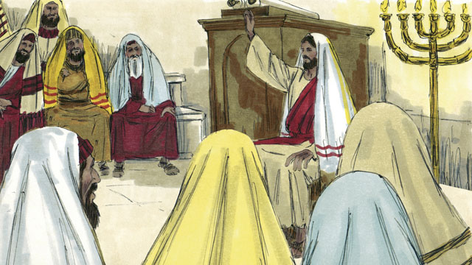

After Jesus refused Satan’s temptations, he returned to the region of Galilee. This is where he lived. The Holy Spirit was giving him much power, and Jesus went from place to place and taught people. Everyone said good things about him.

26-02

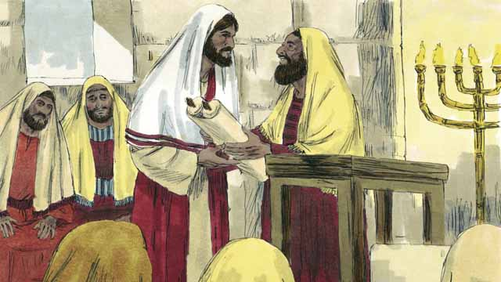

Jesus went to the town of Nazareth. This is the village where he had lived when he was a child. On the Sabbath, he went to the place of worship. The leaders handed him a scroll with the messages of the prophet Isaiah. They wanted him to read from it. So Jesus opened up the scroll and read part of it to the people.

26-03

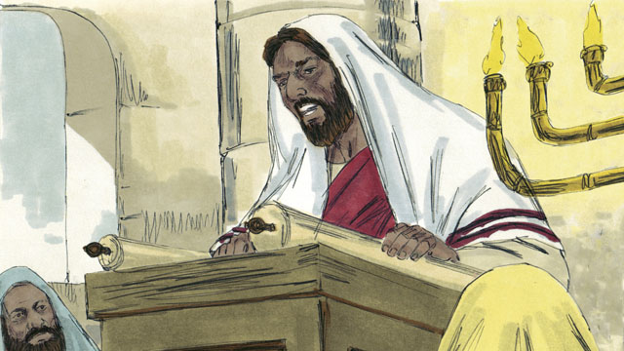

Jesus read, “God has given me his Spirit so that I can proclaim good news to the poor. He has sent me to set prisoners free, to make the blind people see again, and to free those whom others are oppressing. This is the time when the Lord will be merciful to us and help us.”

26-04

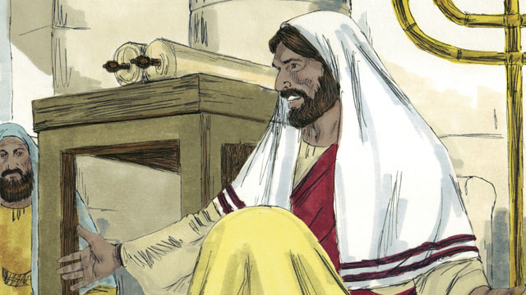

Then Jesus sat down. Everybody was watching him closely. They knew the passage of scripture that he had just read was about the Messiah. Jesus said, “The things I just read to you, they are happening right now.” All the people were amazed. “Isn’t this the son of Joseph?” they said.

26-05

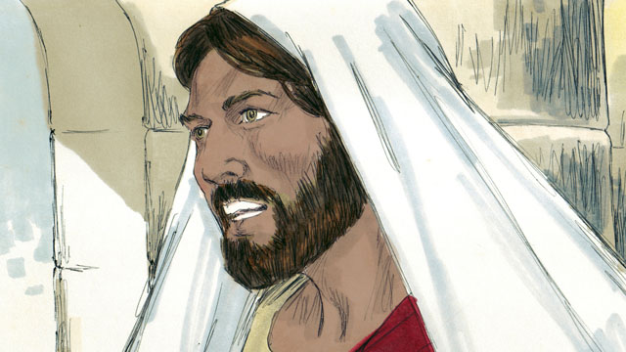

Then Jesus said, “It is true that people never accept a prophet in the town he grew up in. During the time of the prophet Elijah, there were many widows in Israel. But when it did not rain for three and a half years, God did not send Elijah to help a widow from Israel. Instead, he sent Elijah to a widow in a different nation.”

26-06

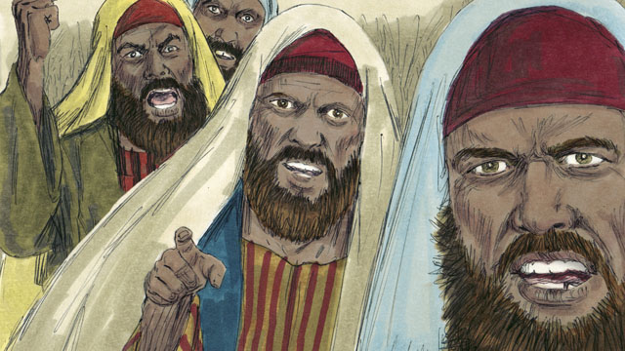

Jesus continued, saying, “And during the time of the prophet Elisha, there were many people in Israel with skin diseases. But Elisha did not heal any of them. He only healed the skin disease of Naaman, a commander of Israel’s enemies.” But the people who were listening to Jesus were Jews. So when they heard him say this, they were furious at him.

26-07

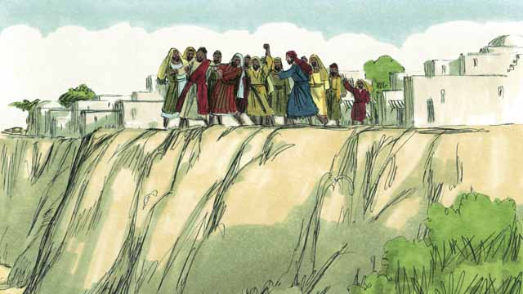

The people of Nazareth seized Jesus and dragged him out of the place of worship. They took him to the edge of a cliff to throw him off of it in order to kill him. But Jesus walked through the crowd and left the town of Nazareth.

26-08

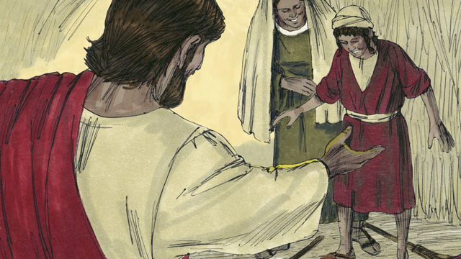

Then Jesus went throughout the region of Galilee, and large crowds came to him. They brought many people who were sick or disabled. There were some who were blind, others who were crippled, deaf, or mute, and Jesus healed them.

26-09

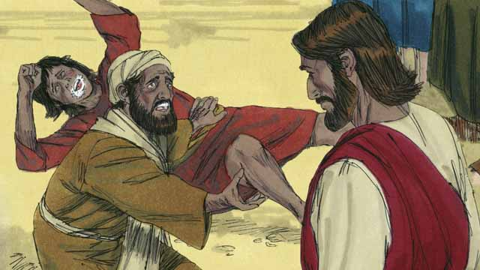

Also, many people who had demons in them were brought to Jesus. Jesus commanded the demons to come out of them, so the demons came out. The demons often shouted, “You are the Son of God!” The crowds of people were amazed, and they praised God.

26-10

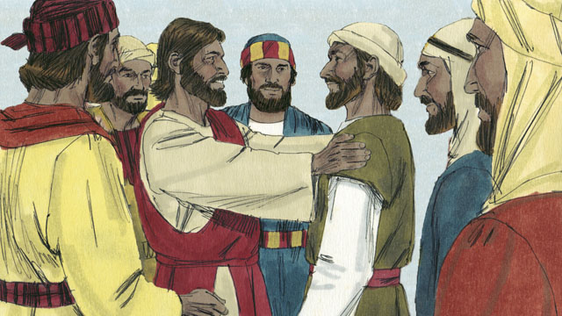

Then Jesus chose 12 men from among his disciples to be his special representatives. He called them “apostles.” These apostles traveled with Jesus and learned from him.

*A Bible story from: Matthew 4:12-25; Mark 1-3; Luke 4*

## 1 Biblical Interpretation: Observing the Details of the Story

After reading the crafted biblical story, answer the following questions to familiarize yourself with the details of the story.

### 1.1 Observation Questions

Answer the following observation questions to gain a basic understanding of the the story. Read the story as a community and answer these questions as a group.

#### 26-01

Where did Jesus go after he overcame Satan’s temptations?  
Jesus went to the region of Galilee where he lived.

Who gave Jesus much power?  
The Holy Spirit gave Jesus much power.

What did Jesus do as he traveled?  
Jesus went from place to place and taught people.

What did people say about Jesus?  
Everyone said good things about Jesus.

#### 26-02

What was the name of the city where Jesus lived as a child?  
He lived in Nazareth.

Where did Jesus go on the Sabbath?  
He went to the place of worship.

Why did the people in the place of worship hand Jesus the scroll of Isaiah?  
They wanted Jesus to read from it.

What did Jesus do with the scroll?  
Jesus opened up the scroll and read part of it to the people.

#### 26-03

What did the scroll say was the reason God gave this person the Spirit of God?  
God gave this person the Spirit of God to proclaim good news to the poor.

Why did the scroll say about the person in the passage of Isaiah?  
God sent this person to set prisoners free, make the blind see, and free those whom others are oppressing.

What did the passage of Isaiah say the Lord would do at a certain time?  
The passage said that this is the time when the Lord will be merciful to us and help us.

#### 26-04

What did people do when Jesus sat down after reading the scroll?  
Jesus sat down and everybody was watching him closely.

The passage of Scripture that Jesus read was about what person?  
It was about the Messiah.

What did Jesus say about the Scripture that he had just read?  
He said those things were happening right then.

How did the people of Jesus’ hometown react to his words?  
They were amazed and asked, “Isn’t this the son of Joseph?”

#### 26-05

What did Jesus say to the people?  
Jesus told them that people never accept a prophet in the town he grew up in.

What example did Jesus give of God’s prophets helping people from other nations when Elijah was a prophet?  
God sent Elijah to help a widow during a drought. This widow was not from Israel but from a different nation.

#### 26-06

What example did Jesus give of God’s prophets helping people from other nations when Elisha was a prophet?  
Jesus said that Elisha healed Naaman, a commander of Israel’s enemies. Naaman was not from Israel. He was from another nation.

What ethnicity were the people who were listening to Jesus?  
The people listening to Jesus were Jews.

How did these Jews respond to Jesus’ examples of Elijah and Elisha?  
The Jews were furious at Jesus when they heard what he said.

#### 26-07

How did the people respond when Jesus told them these stories?  
They seized Jesus and tried to throw him off a cliff in order to kill him.

How did Jesus escape from the crowd?  
Jesus walked through the crowd and left the town.

#### 26-08

Who came to Jesus as he went throughout the region of Galilee?  
Large crowds came to Jesus.

How did the crowds in Galilee respond to Jesus?  
They brought many people who were sick or handicapped to him so he could heal them.

What kind of sick people did the crowds bring to Jesus?  
The crowd brought people who were blind, crippled, deaf, and mute to Jesus.

What did Jesus do to many of the sick?  
Jesus healed them.

#### 26-09

What did Jesus do to people who had demons?  
Jesus commanded demons to come out of people and the demons came out.

Who did the demons acknowledge Jesus to be when he commanded them to come out of people?  
They said Jesus was the Son of God.

How did the crowds respond when Jesus cast out the demons?  
The crowds of people were amazed and praised God.

#### 26-10

How many men did Jesus choose to be his special representatives?  
He chose 12 men to be his special representatives.

What did Jesus call these special representatives?  
Jesus called these 12 special representatives apostles.

What did the apostles do?  
They apostles traveled with Jesus and learned from him.

### 1.2 Translation Questions

Use the following translation questions to understand specific details of the passage. Discuss how you might translate these specific elements of the story.

#### 26-01

**After Jesus refused Satan’s temptations** In the previous story, Satan tried to convince Jesus to disobey God. Jesus rejected and resisted these temptations by Satan. Following that story, Jesus returned to the region of Galilee. How would you express **After Jesus refused Satan’s temptations** to mean Jesus returned to the region of Galilee subsequent to the time he resisted Satan’s attempts to get him to disobey God in the wilderness?

  

**went from place to place** Jesus traveled to around and visited various towns in the region. How would you express **went from place to place** to mean Jesus traveled to different towns and other places?

  

**Everyone** Those who saw and heard Jesus spoke well of him. How would you express **Everyone** to mean all the people who knew him or heard about Jesus?

  

#### 26-02

**the place of worship** The Jews regularly gathered to read God’s word and worship God. The place where they gathered was a worship building. How would you express **the place of worship** to mean the building where the Jews gathered to worship God?

  

**scroll** At that time, people wrote on long sheets of paper or leather. These long sheets could be rolled up. How would you express **scroll** to mean a long sheet of paper or leather that was rolled up and had writing on it?

  

**a scroll with the messages of the prophet Isaiah** Isaiah had written on a scroll hundreds of years before. This was a copy of that scroll. How would you express **a scroll with the messages of the prophet Isaiah** to mean a scroll that had the words that the prophet Isaiah had written?

  

**opened up the scroll** Jesus unrolled the scroll so he could read what was written on it. How you express **opened up the scroll** to mean Jesus rolled open the scroll or unrolled the scroll?

  

#### 26-03

**proclaim good news to the poor** This passage written by the prophet Isaiah says that the person whom this passage spoke about would announce to good news that would benefit those who were poor and needy. How would you express **proclaim good news to the poor** to mean to tell poor and needy people the good message that God will help them?

  

**to set prisoners free** God sent the person spoken of in this passage to cause prisoners to be released. He would tell people who are wrongfully in prison that they will be released. How would you express **to set prisoners free** to mean to bring people out of prison and into freedom?

  

**to free those whom others are oppressing** God sent the person spoken of in this passage to rescue those who are being mistreated and victimized. How would you express **to free those whom others are oppressing** to mean to deliver people from the mistreatment, abuse, and unjust actions of others?

  

#### 26-04

**Everybody was watching him closely** People listened to Jesus as he read from the scroll. When Jesus finished reading, he sat down. The people who listened to him observed Jesus attentively to see what he would do or say. How would you express **Everybody was watching him closely** to mean all the people who were listening to Jesus were paying close attention to what Jesus would say and do next?

  

**The things** I just read to you, they are happening right now Jesus read from the scroll of Isaiah. Isaiah wrote these things hundreds of years before Jesus. Jesus told the people that the things Isaiah said would happen in the future were being fulfilled at that moment. **The things** Jesus read to the people who were gathered came true at the time they heard them. How would you express **The things** I just read to you, they are happening right now to mean the things the people just heard Jesus read were being fulfilled at that very moment?

  

**Isn’t this the son of Joseph?** The people were not asking if he was Joseph’s son or not. This question surprise at what Jesus said. They were wondering how he could be the Messiah since they thought he was only the son of an ordinary man. How would you express **Isn’t this the son of Joseph?** to mean this man is only the son of Joseph or everyone knows Jesus is just Joseph’s son?

  

#### 26-05

**people never accept a prophet in the town he grew up in** This is a proverb that states something that usually happens this way. In general, prophets are not acknowledged as prophets by the people who knew them when they grew up. How would you express **people never accept a prophet in the town he grew up in** to mean people do not recognize the authority of a prophet who has grown up among them?

  

**Instead, he sent Elijah to a widow in a different nation** There were many widows who lived in Israel during the time of Elijah. Rather than God sending Elijah to an Israelite widow, God sent Elijah to a widow who was from a foreign nation. This is the opposite of what one might expect God to do. How would you express **Instead, he sent Elijah to a widow in a different nation** to mean God did the opposite of what many Jews would expect and sent Elijah to a widow from a foreign nation?

  

#### 26-06

**during the time of the prophet Elisha** Elisha was God’s prophet who came after Elijah. Like Elijah, Elisha confronted Israelite kings who were sinning against God and he did miracles that God gave him power to do. How would you express **during the time of the prophet Elisha** to mean at the time when Elisha lived and served as a prophet of God?

  

**a commander of Israel’s enemies** Naaman was a military leader who served in a foreign nation. The people of this nation were enemies with the people of Israel. How would you express **a commander of Israel’s enemies** to mean a military leader who served in the army of a different nation which opposed Israel?

  

**they were furious at him** The Jews did not want to hear that God had blessed any people besides themselves, so they were very angry at what Jesus said. How would you express **they were furious at him** to mean the Jews were extremely angry at Jesus for what he said?

  

#### 26-07

**seized** Jesus The people of Nazareth grabbed Jesus with force. They took hold of Jesus with their hands so they could take him where they wanted him to go. How would you express **seized** Jesus to mean grabbed hold of Jesus with their hands?

  

**dragged him** The people who seized Jesus pulled him with force out of the place of worship. How would you express **dragged him** to mean to roughly pull Jesus to a different location with force?

  

**But Jesus walked through the crowd** The people tried to kill Jesus by throwing him off a cliff. The people were not able to do this. Instead, Jesus just walked through the crowd without them causing him harm. How would you express **But Jesus walked through the crowd** to mean Jesus walking through the crowd unharmed is the opposite of what the people attempted to do?

  

#### 26-08

**went throughout the region of Galilee** Jesus traveled in the region of Galilee. He visited different towns and placed in this region. How would you express **went throughout the region of Galilee** to mean Jesus traveled from place to place all around the region of Galilee?

  

**large crowds came to him** Jesus was well-known. Many people followed him and gathered around him. How would you express **large crowds came to him** to mean a lot of people gathered around Jesus?

  

#### 26-09

**who had demons in them** Some people were possessed by spirits which were evil and opposed to God. How would you express **who had demons in them** to mean people who were controlled by evil spirits?

  

**Jesus commanded the demons** Jesus spoke and told the demons to leave people. How would you express **Jesus commanded the demons** to mean Jesus spoke with authority and ordered the evil spirits to leave the people and the demons did what Jesus commanded them to do?

  

**You are the Son of God!** Jesus is the Son of God. He is fully equal to God the Father and God the Spirit but is distinct from God the Father and God the Spirit. God the Father, God the Son, and God the Spirit are one God. Even though the demons were evil, they spoke truthfully that Jesus is God’s Son, the Messiah. How would you express **You are the Son of God!** as a strong statement that Jesus is God’s Son?

  

#### 26-10

**special representatives** The 12 men would serve Jesus in other places. Jesus specifically chose them for this role. They would do things and say things for Jesus. How would you express **special representatives** to mean people Jesus specifically chose to speak and act on his behalf?

  

**apostles** Jesus called the 12 men **apostles**. Apostles were went out for a specific purpose and had the same authority as the one who sent them. How would you express **apostles** to mean people send out by Jesus for a specific purpose who have the same authority as the one who sent them?

  

**learned from him** The 12 men Jesus chose traveled with Jesus as students/disciples. They gained understanding from all that Jesus taught. How would you express **learned from him** to mean acquired knowledge and understanding from all that Jesus said and did?

  

## 2 Theological Dialogue: Discussing the Meaning of the Story

Take time to explore the meaning of this story together as a community. Use the following discussions as a way to grasp what truth the story teaches.

### 2.1 Discourse Questions

Use the following discourse questions to understand the meaning of the story. Pay attention to how the story itself addresses each question or theme.

##### What kinds of things did Jesus do in his ministry? (26-01, 26-03, 26-08, 26-09)

Power/Holy Spirit: The Holy Spirit gave Jesus power. Jesus’ ministry was powerful and able to bring change in the lives of people. (26-01)

  

Teaching: Jesus went around to different places in Galilee and taught people. One of the major activities of Jesus’ ministry was teaching the truth. (26-01)

  

Preaching: Jesus read from the scroll of Isaiah that the Messiah would proclaim good news to the poor, freedom to the prisoners, sight to the blind, and rescue for the oppressed. Jesus identified himself as the Messiah. One of the major activities of Jesus’ ministry was preaching the good news. (26-03)

  

Healing: One of the major activities of Jesus’ ministry was healing the sick, disabled, and demon-possessed. (26-08, 26-09)

  

##### What kind of people did Jesus minister to? (26-02, 26-03, 26-06, 26-08, 26-09)

Jews: Jesus taught Jews in the place of worship. Jesus is the Messiah promised to the Jews. Jesus ministered to the Jewish people. (26-02, 26-03, 26-04, 26-06)

  

Foreigners: Jesus gave the example of Elijah helping out a widow who was from a different/foreign nation. Jesus gave the example of Elisha healing Naaman of his skin disease. Naaman was a commander in a foreign army which were enemies of Israel. These examples emphasized that Jesus would minister to Jewish and non-Jewish people. (26-05, 26-06)

  

All Peoples: Jesus ministers to all different kinds of people: people from different ethnicities, people who lived in different geographies, and people who had different problems/challenges/difficulties. (26-01, 26-05, 26-06, 26-08, 26-09)

  

##### What does Jesus’ ministry teach us about who Jesus is (his identity)? (26-01, 26-04, 26-09, 26-10)

Good: People recognized that Jesus was good. He gained popularity among the people and people recognized that he brought a good impact in the world and their lives. (26-01)

  

Messiah: When Jesus said that the words of Isaiah were being fulfilled today, Jesus was claiming that the was the Messiah. Jesus was the promised deliverer God sent to proclaim good news, freedom, sight, and deliverance. (26-04)

  

Human: Jesus was born of Mary by the power of the Holy Spirit. Although Joseph did not father Jesus, Joseph functioned as the earthly father of Jesus. Jesus is God’s enteral Son and also was born as a human. (26-04)

  

Son of God: Jesus is God’s eternal Son. The demons even knew this was true about Jesus. (26-09)

  

Master: Jesus is the Master and Teacher of his students. Jesus taught his followers the ways of God. His disciples followed him and the apostles served his purposes in the world. (26-10)

  

##### How did people respond to Jesus in different ways? (26-01, 26-04, 26-06, 26-07, 26-08, 26-09, 26-10)

Good Reputation: People said good things about Jesus. Jesus had gained a good reputation among the people. (26-01)

  

Attentive: After Jesus read from the scroll of Isaiah, people paid close attention to what he would say and do next. Jesus (26-04)

Amazed: People were amazed at what Jesus said about the message he read from Isaiah. They wondered how Jesus could be the Messiah when Joseph, an ordinary man, was his father. (26-04)

  

Furious: The Jews were very angry when Jesus explained how Elijah and Elisha ministered to people who lived in foreign nations and were not Jews. The Jews became furious and tried to kill Jesus by throwing him off of a cliff. (26-06, 26-07)

  

Large Gathering/Popularity: Large crowds gathered around Jesus as he traveled and ministered throughout the region of Galilee. (26-08)

  

Amazement/Praise: Jesus commanded demons to leave people. The demons even said that Jesus was the Son of God. The people were amazed at Jesus’ power and praised God. (26-09)

  

Following/Learning: Jesus chose 12 of his disciples to be apostles. These apostles traveled with Jesus and learned from him. They were students and servants of Jesus. (26-10)

  

### 2.2 Theological Questions

Answer the following theology questions as a community. Discuss what truths this story teaches.

1. How should we correctly understand who Jesus is (i.e., his identity)? What does the story of Jesus starting his ministry teach us about his identity?
2. How did Jesus fulfill God’s promise to send the Messiah? How does this story confirm that Jesus is God’s promised Messiah?
3. What does it mean to be a follower of Jesus? How can Jesus’ ministry serve as an example for how we can serve Jesus?

### 2.3 Translation Draft

Work as a translation team to draft each panel of this story. Pay attention to any specific translation issues that are challenging or significant.

#### Make Translation Draft

Make a draft for each section of this story.

#### Discuss and Revise

After drafting the story, discuss any translation issues that you think need special explanation.

#### Drafting Summary Reflection

Summarize any noteworthy translation decisions and the rationale/reasoning behind these translation decisions. In the final movement of this class, you will use these observations to give an account (i.e., chronicle/narrate) of how your translation improved through the checking process.

## 3 Personal Reflection: Following the Teaching of the Story

Take a moment to allow this story to evaluate your own life and to consider how God would have you respond. After this reflection, use the quality checking questions to check your translation draft among the translation team.

### 3.1 Journal Reflection

Prayerfully think about the following personal reflection questions. Write/Record your answers and/or discuss them as a group.

1. What convictions have you developed about who Jesus is?
2. How has Jesus’ ministry of teaching, preaching, and healing been evident in your own life?
3. How can you relate to the different responses to Jesus that occur in this story?
4. What next steps is Jesus calling you to in order to follow and serve him?

### 3.2 Team Check

*The following activity will help you check the clarity, accuracy, and naturalness of your draft. Read the passage aloud and discuss the checking questions with other members of your translation community. You might need to reread portions (or the whole) of the biblical passage multiple times as you answer each of these questions. Record answers to these questions below.*

#### Team Checking Questions

*Use the following questions to check your translation draft for accuracy, clarity, and naturalness.*

1. **Accurate**: Has anything been **added** to your translation of this passage that is not a part of the meaning of the source text? *If additions exist, are they included only added to clarify meaning (such as implied information)?*
2. **Accurate**: Is anything **missing** from your translation of this passage that is a part of the meaning of the source text? *If some part of the meaning is missing from your translation, add it.*
3. **Accurate**: Does any meaning in your translation of this passage appear to be **different** than the meaning of the source text? *If the meaning is different, try changing your translation so that the meaning remains the same.*
4. **Natural**: Does anything sound **unnatural** to how you would say it in your language? *If portions of the passage sound unnatural in your language, try to make them sound the way you would say it in your language while staying true to the meaning of the source text.*
5. **Clear**: Is anything **unclear** or **confusing** in your translation that confuses the meaning of the source text? *If portions of the passage are unclear or confusing, revise them to clearly communicate the meaning of the source text.*
6. **Consistent**: How **consistent** is your translation within the passage and with other passages? *If portions of the passage need to be made consistent or if you need to revise translations of other passages, make these adjustments.*

#### Record Feedback

*After discussing the checking questions above as a translation community, record any feedback on your translation draft. Pay attention for parts of your translation that are translated well and parts of your translation that need correction.*

#### Discuss and Revise

*After gathering feedback on your draft, discuss it together with your translation community and make appropriate revisions in your translation.*

#### Record Translation Decisions

*As a community, discuss some of the most noteworthy translation decisions in your draft. Summarize each decision and explain the reasons your community decided on that translation. You should update these decisions each time you check your draft with various groups of people.*

You should **measure** the quality of your translation draft. You can **record translation decisions** to make it clear why you translated things a certain way. Translation decisions can help your translation team and the surrounding community be a part of the translation process.

How can you know the quality of your translation?

1. **Measure** the translation by marks/standards of quality (i.e., clear, accurate, natural, church-approved)
2. **Test** the translation with others and record feedback and conversations from in the field (i.e., church and community check)
3. **Compare** and **contrast** the translation with the source text (i.e., meaning of text and notes) and alternatives (i.e., other translation choices)
4. **Explain** the reasons why you translated a particular portion of the text.

**Example Sentences That Help Explain Your Translation Decision** Use the following example sentences to help explain your translation decisions:

1. The original text literally **says/means**, so we translated the term in this way…
2. We originally decided to translate **the biblical term** in with **this term**, but we changed it because…
3. When our translation team discussed **the biblical term**, this is what we talked about…
4. **The term** is [clear, accurate, natural, consistent] because…
5. The community understands **this term** it to mean…
6. We considered these other terms. We did not use **these terms** because…
7. When we checked this in the church, we learned…
8. When we checked this in the community, we learned…

**Example of Translation Decision**

In OBS 01-07 we decided to translate **blessed** like this: [actual translation]. We decided this translation because of these reasons:

1. The word [actual translation] means to cause good things to happen to someone or something. This term is used when a person desires someone or something to prosper or flourish. This term does not refer to magic or witchcraft.
2. When we checked this word with other believers, they said it describes God showing his kindness and favor on someone or something. These are some of the terms that we did not decide to use…
3. Many of our people will understand this word. When we discussed this phrase with the surrounding community, we discovered it was a natural way to describe God causing good and beneficial things to happen.

## 4 Ministry Practice: Serving the Church with the Story

Now that you have a draft of this story, consider how this story can encourage other believers in their faith. After ministering this story to others, you will also perform a community check of your translation draft.

### 4.1 Church Ministry

Reflect on how this story can edify and mature the Christian community. Design a way to minister this story to your church community.

**Ministry Preparation**: Take time to consider how you could minister this story to others. Record some ministry ideas below.

**Ministry Implementation**: Minister this story to a group of believers as you had planned. Use the information in this study to help develop a teaching/lesson or lead a discussion of this story to other believers. Record your ministry plan below.

**Ministry Reflection**: Think about what you learned from ministering this story to other believers. Reflect on your experience below.

### 4.2 Church Community Check

After teaching or ministering this story to the church, check the translation quality with the church community. Record any feedback from your checking experience.

#### Create Checking Questions

You can use **Translation Questions** to check you draft. Each **Translation Question** explains the meaning of a specific part of the story and asks you to consider how you would translate that part of the story in your own language. Change each **Translation Question** into a **Checking Question** by asking the following questions. The first question asks you to identity how each specific phrase was translated in your language. The second question asks people in the church to determine if your translation of the phrase expresses the meaning clearly, accurately, and naturally. Look at the following examples to see how to change **Translation Questions** into **Checking Questions**:

#### Translation Question Example 1

**to proclaim the good news about Jesus** Paul and Silas traveled to Philippi for the purpose of preaching the gospel. The gospel is the good news that Jesus saves people from their sins if they will believe in Jesus. How would you express **to proclaim the good news about Jesus** to mean to tell other people the message about how Jesus can save people from their sins?

#### Translation Question Example 2

**a merchant** Paul and Silas met a woman named Lydia at the place by the river. She owned a business and sold items to make money. How would you express **a merchant** to mean a business owner who sells items for a profit?

#### Translation Question Example 3

**so Paul and Silas baptized them** The jailer and his whole family followed Paul’s instructions. They believed in Jesus. The result of this was Paul and Silas baptized them. How would you express **so Paul and Silas baptized them** to mean the result of the jailer and his family believing in Jesus that Paul and Silas baptized all of them?

You can change these into **Checking Questions** like this:

#### Checking Question Example 1

**to proclaim the good news about Jesus** How did you translate **to proclaim the good news about Jesus**? Does it mean to tell other people the message about how Jesus can save people from their sins?

#### Checking Question Example 2

**a merchant** How did you translate **a merchant**? Does it mean a business owner who sells items for a profit?

#### Checking Question Example 3

**so Paul and Silas baptized them** How did you translate **so Paul and Silas baptized them**? Does it mean the result of the jailer and his family believing in Jesus that Paul and Silas baptized all of them?

#### Record Feedback

*Discuss the* ***Checking Questions*** *with your church community, and record any feedback on your translation draft. Pay attention for parts of your translation that are translated well and parts of your translation that need correction.*

#### Discuss and Revise

*After gathering feedback on your draft, discuss it together with your translation community and make appropriate revisions in your translation.*

#### Record Translation Decisions

*Update your translation decisions and record and new any noteworthy observations on the quality of your draft.

## 5 Missional Outreach: Sharing the Truth of the Story

*After sharing this story with others, check the translation quality with the wider language community. Record any feedback from your checking experience.*

### 5.1 Mission Engagement

*Consider how you will witness this story to unbelievers. Design a way to share this story and engage them in what it teaches about Christianity and the gospel.*

**Witness Preparation**: Take time to consider how you will witness this narrative to unbelievers. Record some ideas below.

**Witness Implementation**: Share this story with an unbeliever. Use the information in this study to help develop a teaching/lesson or lead a discussion of this story to other believers. Record your ministry plan below.

**Witness Reflection**: Think about what you learned from ministering this story to unbelievers. Reflect on your experience below.

### 5.2 Sociolinguistic Check

After sharing this story with the language community, check your translation draft with the surrounding community. Record your observations.

#### Checking Approach

After witnessing this story to unbelievers, use one of the following methods to check the translation of this story. Consider using the **Observation Questions** to check your translation draft or come up with your own quality checking questions.

**Read-Retell Check:** Read your draft to those the community and ask them to retell the passage. Be attentive for any portions of the passage that are unclear, unnatural, or inaccurate.

**Comprehension Questions Checklist:** Read the draft of the passage and ask a list of comprehension questions to make sure the passage is being rightly understood. You can use the **Observation Questions** in this guide or come up with your own questions. Then, record any insights or issues that arise.

**Discussion Group:** Develop key questions to ask about the passage (both formational and translational). Read the passage and have a group discussion about the passage, paying attention to issues that need to be addressed, edited, and revised.

#### Record Feedback

*After sharing your draft with language community, discuss the* ***Observations Questions****, and record any feedback on your translation draft. Pay attention for parts of your translation that are translated well and parts of your translation that need correction.*

#### Discuss and Revise

*After gathering feedback on your draft, discuss it together with your translation community and make appropriate revisions in your translation.*

#### Record Translation Decisions

*Update your translation decisions and record and new any noteworthy observations on the quality of your draft.

## 6 Conclusion

As a translation community, take time to reflect on all that was learned in studying, drafting, and checking this story. Celebrate all that God has taught you as a community. Then, submit your revised draft and checking summaries to network leaders for further review.