Open Bible Stories

The Story of the Good Samaritan

## 0 Introduction

### 0.1 Key Idea

The story of the Good Samaritan teaches us that loving our neighbor as ourself is a fulfilment of God’s law.

### 0.2 Creedal Verse

“For the commandments, ‘You shall not commit adultery, You shall not murder, You shall not steal, You shall not covet,’ and any other commandment, are summed up in this word: ‘You shall love your neighbor as yourself.’ Love does no wrong to a neighbor; therefore love is the fulfilling of the law.” Romans 13:9-10

### 0.3 Metanarrative Summary

The eternal God created all things in six days. He made a good and perfect world. He made humans in his image to fill the earth and rule over creation. But humans rebelled against God and ruined God’s creation. God set to restore his world through his promise. God made a covenant with Abraham. He promised to bless all nations through Abraham. God kept his promises across the generations. God provided Abraham with a promised child, Isaac. God gave Isaac a wife and she bore twins, Jacob and Esau. God blessed Jacob and his sons, and the blessing continued to the next generation. God rescued Joseph, one of Jacob’s sons, and used him to rescue his family. God caused his people, the Israelites, to multiply in the land of Egypt; eventually, they became slaves. But, God raised up a deliverer, Moses, to deliver his people from their slavery. God judged the Egyptians with harsh plagues; in the final judgment, he passed over his people who covered their doorposts with the blood of a sacrificed lamb. Then, God delivered the Israelites by bringing them out of Egypt and crossing the Red Sea on dry land. God made a covenant with the Israelites and made them his people. God tested Israel in a series of wilderness wanderings and eventually brought his people into the promised land of Canaan. God raised up deliverers to lead Israel and rescue them from their enemies. God formed Israel into a kingdom. He made a covenant with King David and promised to send a king that would rule his people forever. Many of Israel’s kings were evil and the kingdom of Israel divided into two kingdoms. God sent prophets to warn his people of God’s judgment and call them to repent. When Israel did not repent, God sent his people into exile. After many years, he brought them back to the land. Throughout the Old Testament, God promised to send his Messiah to deliver his people form their sin. After many years, the prophet John was born. He would prepare people for the coming Messiah. At the perfect time, God sent his Son, Jesus, to be born of a virgin Mary. When John and Jesus grew up, John baptized Jesus as a sign that Jesus was God’s beloved Son. Jesus endured all manner of temptation without ever sinning. When he was thirty years old, he launched a public ministry of preaching, teaching, and healing. He taught his disciples about the life of compassion

### 0.4 Open Bible Story: The Story of the Good Samaritan

27-01

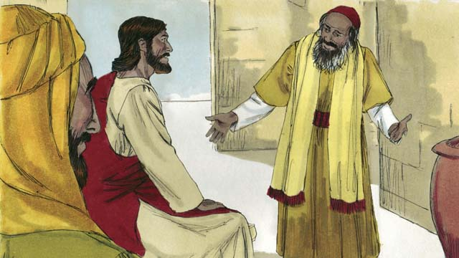

One day, an expert in the Jewish law came to Jesus. He wanted to show everyone that Jesus was teaching wrongly. So he said, “Teacher, what must I do to inherit eternal life?” Jesus answered, “What is written in God’s law?”

27-02

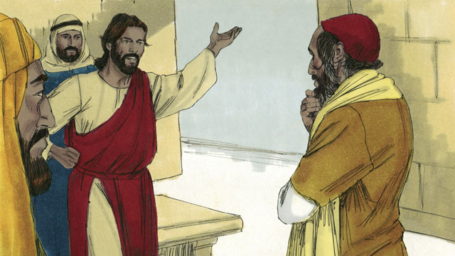

The man said, “It says, ‘Love the Lord your God with all your heart, soul, strength, and mind. And love your neighbor as yourself.’” Jesus answered, “You are correct! If you do this, you will have eternal life.”

27-03

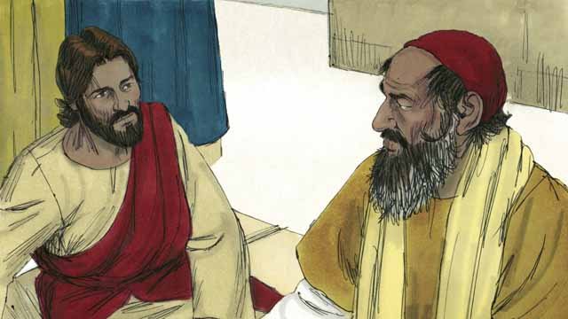

But the law expert wanted to show the people that his way of living was correct. So he asked Jesus, “Well then, who is my neighbor?”

27-04



Jesus answered the law expert by telling a story. “There was a Jewish man who was traveling along the road from Jerusalem to Jericho.”

27-05

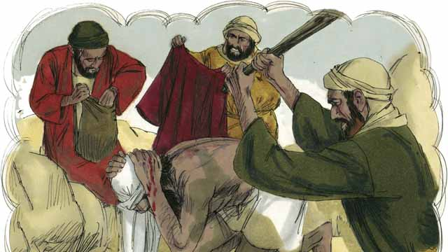

“But some robbers saw him and attacked him. They took everything he had and beat him until he was almost dead. Then they went away.”

27-06

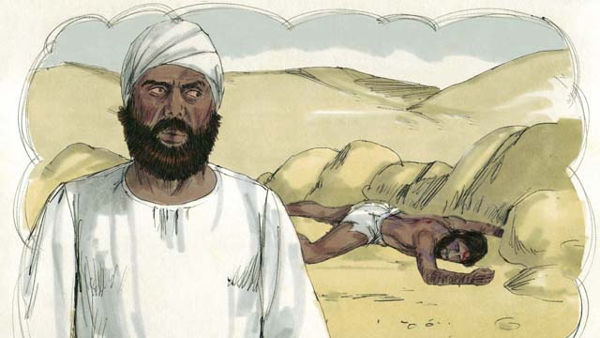

“Soon after that, a Jewish priest happened to walk down that same road. This priest saw that man lying in the road. When he saw him, he moved to the other side of the road and kept on going. He completely ignored that man.”

27-07



“Not long after that, a Levite came down the road. (Levites were a tribe of Jews who helped the priests at the Temple.) The Levite also crossed over to the other side of the road. He also ignored that man.”

27-08

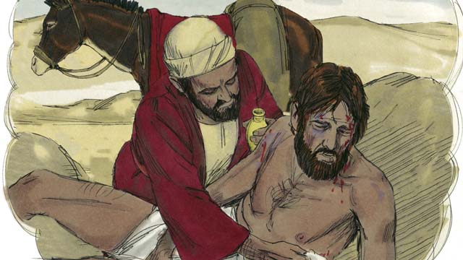

“The next person to walk down that road was a man from Samaria. (Samaritans and Jews hated each other.) The Samaritan saw the man in the road. He saw he was Jewish, but he still had very strong compassion for him. So he went to him and bandaged his wounds.”

27-09

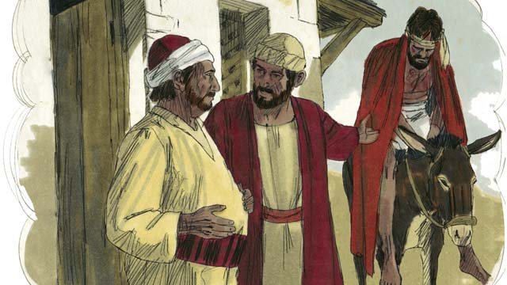

“Then the Samaritan lifted the man onto his own donkey. He took him to an inn by the road. There he continued to take care of him.”

27-10

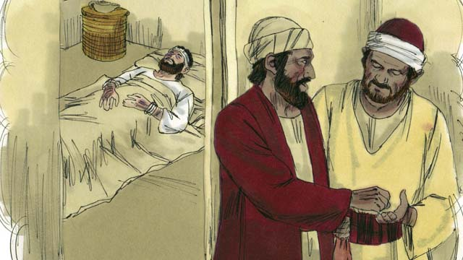

“The next day, the Samaritan needed to continue his journey. He gave some money to the person in charge of the inn. He said to him, ‘Take care of this man. If you spend any more money than this, I will repay those expenses when I return.’”

27-11

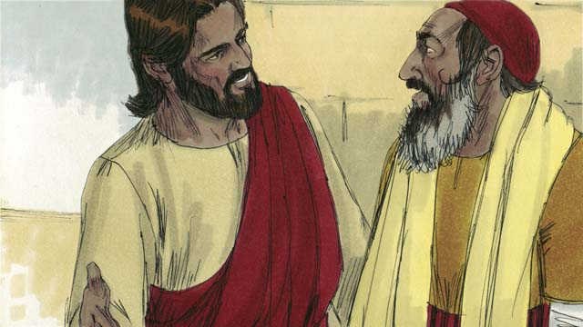

Then Jesus asked the law expert, “What do you think? Which one of the three men was a neighbor to the man who was robbed and beaten?” He replied, “The one who was merciful to him.” Jesus told him, “You go and do the same.”

*A Bible story from: Luke 10:25-37*

##./obs_source/transclusions//obs-devotionals-unit-9#Community Study: Taking Up Our Cross—Following Jesus in Self-Denial.md NOT FOUND!!

## 1 Biblical Interpretation: Observing the Details of the Story

After reading the crafted biblical story, answer the following questions to familiarize yourself with the details of the story.

### 1.1 Observation Questions

Answer the following observation questions to gain a basic understanding of the story. Read the story as a community and answer these questions as a group.

#### 27-01

What kind of expert came to Jesus?  
One day, an expert in the Jewish law came to Jesus.

Why did the expert in the Jewish law come to Jesus?  
He wanted to show everyone that Jesus was teaching wrongly.

What question did the expert in the Jewish law ask Jesus?  
He asked Jesus, “Teacher, what must I do to inherit eternal life?”  
What question did Jesus ask the expert in response?  
He asked him, “What is written in God’s law?”

#### 27-02

What did the man say was written in God’s law?  
The man told Jesus that the law said to love the Lord your God with all your heart, soul, strength, and mind and to love your neighbor as yourself.

How did Jesus respond to the man’s answer?  
Jesus told the man that he was correct and that if he did these things he would have eternal life.

#### 27-03

Why did the expert in the Jewish law ask who his neighbor was?  
He wanted to prove that his way of living was correct.

#### 27-04

How did Jesus answer the law expert?  
Jesus answered the law expert by telling him a story.

What was the story about?  
Jesus told a story about a Jewish man who was traveling along the road from Jerusalem to Jericho.

#### 27-05

In Jesus’ story, what happened to the Jewish man while he was traveling?  
Robbers attacked him, took everything he had, and beat him until he was almost dead.

#### 27-06

Who was the first person to see the wounded man?  
The first person was a Jewish priest.

What did the priest do when he saw the wounded man?  
When the Jewish priest saw the man lying the road, he moved to the other side, passed by him, and ignored the man.

#### 27-07

Who was the second person to see the wounded man and pass by?  
A Levite came next.

Who were the Levites?  
Levites were a tribe of Jews who helped the priests at the Temple.

What did the Levite do when he saw the wounded man?  
The Levite, crossed over to the other side of the road and ignored the man.

#### 27-08

Who was the third person to see the wounded man?  
He was a Samaritan.

What was the relationship between Jews and Samaritans?  
They hated each other.

What did the Samaritan do when he saw the wounded man?  
The Samaritan had very strong compassion for the wounded man and bandaged his wounds.

#### 27-09

How did the Samaritan help the wounded man?  
The Samaritan put him on his own donkey, took him to a roadside inn, and took care of him.

#### 27-10

On the next day, what did the Samaritan give to the person in charge of the inn?  
On the next day, the Samaritan gave some money to the person in charge of the inn.

What did the Samaritan tell the person in charge of the inn?  
He told him to take care of the man, and he would repay him for those expenses when he returned.

#### 27-11

What did Jesus ask the Jewish law expert after telling this story?  
Jesus asked the Jewish law expert who he though was a neighbor to the man who was beaten.

Which of the three men acted like a neighbor to the man who was robbed and beaten?  
The Samaritan who was merciful to the man was a neighbor to him.

What did Jesus tell the Jewish law expert?  
Jesus told the Jewish law expert to go and do the same as the Samaritan did.

### 1.2 Translation Questions

Use the following translation questions to understand specific details of the passage. Discuss how you might translate these specific elements of the story.

#### 27-01

**an expert in the Jewish law** This man was someone who studied and taught the laws God had given the Israelites, as well as other Jewish laws. How would you express **an expert in the Jewish law** to mean a person who studied and has specialist/specialized knowledge in the Jewish laws?

  

**to inherit eternal life** The Jewish law expert asked Jesus how he could have life with God forever. The law expert was asking how he could be worthy to receive eternal life as an inheritance from God the Father. Eternal life refers to life forever with God even after the mortal body dies. How would you translate **to inherit eternal life** to mean God will give me life with him forever?

  

**What is written in God’s law?** Jesus asked this question because he wanted the man to think about what God’s law really teaches. Jesus asked the man what God said in his law that would answer his question. How would you express **What is written in God’s law?** as a question that asks what does God’s law teach about this?

  

#### 27-02

**Love the Lord your God** The man tells what the law says by quoting the law. The Jewish law commands people to love God. How would you express **Love the Lord your God** to mean we must love the Lord our God?

  

**with all your heart, soul, strength, and mind** The list identifies different aspects of humans. The heart refers to the part of a person that has desires and emotions. The soul refers to the nonphysical, spiritual part of a person. Strength refers to the physical body and all of its abilities. The mind refers to the part of a person that thinks, plans, and has ideas. The focus is not on each of these parts, but on the concepts that make up the whole person. The law commands people to love God with the whole self and with with every part of our person. How would you express **with all your heart, soul, strength, and mind** to mean with every part of yourself (emotions, spirit, body, and thoughts)?

  

**love your neighbor as yourself** Although the word neighbor normally refers to a person who lives near us, the Jews applied the term to everyone except close relatives, foreigners, and enemies. The man tells Jesus that the law teaches that people must show genuine concern for those around us the way we would show genuine concern for ourselves. People must love others around us to the same extent that we loves ourselves. How would you express **love your neighbor as yourself** as a command to have deep concern for others and show great care for others as we would have toward ourselves?

  

#### 27-03

**Well then** The law expert did not fully expect what Jesus said about inheriting eternal life. He likely thought Jesus would have answered differently. The man posed a question to Jesus to gain more clarity on Jesus’ answer. How would you express **Well then** to mean if what you said was in fact true?

  

**who is my neighbor?** The man knew that he did not love everyone, and was asking which people he needed to love. So, he asked Jesus to clarify what he meant by neighbor. He wanted to know who he was expected to consider his neighbor. How would you express **who is my neighbor?** to mean which people should I consider neighbors?

  

#### 27-04

**by telling a story** The way Jesus answered the law expert’s question was to tell a story. Jesus told him a short story that teaches something that is true, and delivers the lesson in a way that is easy to understand and hard to forget. Jesus used this story to teach the law expert about who he should consider his neighbor. How would you express **by telling a story** to mean the means/method Jesus used to answer the law expert’s question was to tell him a story?

  

**There was a Jewish man** Jesus began the story by introducing a main character in the story. The story does not specify the person’s name or the time when this story occurred. Though the events in a parable could happen, they did not actually happen. They are told only to teach the lesson(s) that the listener is meant to learn. How would you express **There was a Jewish man** to introduce an unnamed Jewish man as a new character to the story?

  

**from** Jerusalem to Jericho In this story, the Jewish man was traveling **from** Jerusalem City to Jericho City. How would you express **from** Jerusalem to Jericho to mean **from** the city of Jerusalem to the city of Jericho?

  

#### 27-05

**everything he had** The robbers took of the Jewish man’s possessions. How would you express **everything he had** to mean **everything he had** with him, including the clothes he was wearing?

  

**until he was almost dead** The robbers attacked and beat the Jewish man. They kept beating him until he was close to dying. The robbers stopped beating him before his died and left. How would you express **until he was almost dead** to mean the robbers beat the Jewish man up to the point when he nearly died?

  

#### 27-06

**happened to walk down** A Jewish priest was going to another city and used the same road the Jewish man had used. The priest was not just walking on the road but was traveling to get to another city. The priest was not going to see the injured man. He saw the injured man unexpectedly as he was on a journey to another place. How would you express **happened to walk down** to mean the Jewish man unexpectedly saw the injured man as he was traveling to another city?

  

**When he saw him, he moved to the other side of the road** The Jewish priest saw the injured man. At this time, he moved to the other side of the road. Instead of going to help the injured man, the the Jewish priest went the opposite direction to avoid walking near him. How would you express **When he saw him, he moved to the other side of the road** to mean at the time the Jewish priest saw the injured man, the priest went to the other side of the road and continued traveling?

  

**kept on going** The Jewish priest did not stop to help the injured man. He continued on his journey without paying attention or showing care for the injured man. How would you express **kept on going** to mean the Jewish priest continued traveling down the road without caring for the injured man?

  

**He completely ignored that man** The Jewish priest did not pay attention to the injured man nor did he help him. This was surprising because the priests were very religious, and would have been expected to help their fellow Jew. How would you express **He completely ignored that man** to mean the Jewish priest did not help that man and showed no concern for that man?

  

#### 27-07

**Not long after that** The Jewish priest saw the injured man and left. Not much time passed and then a Levite came traveling down the same road. How would you express **Not long after that** to mean very soon after the Jewish priest left a Levite traveled down the same road?

  

**a Levite came down the road** Levites were an Israelite tribe from the clan of Levi. Levites were religious leaders who helped the priests in the Temple. How would you express **a Levite came down the road** to mean a priestly helper from the tribe of Levi was traveling on the same road where the injured man was lying?

  

#### 27-08

**but he still had very strong compassion for him** The injured man was Jewish. The third person traveling down the road was a Samaritan. At this time, Samaritans and Jews did not get along. By showing compassion on the injured Jewish man, the Samaritan did the opposite to what would be expected. The Samaritan showed compassion for him rather than hatred. How would you express **but he still had very strong compassion for him** to mean the Samaritan did the opposite than would have been expected and showed great care for the injured man?

  

**very strong compassion** The Samaritan had a deep feeling of pity and concern for the injured man. This feeling of concern caused the Samaritan to care for and help the injured man. How would you express **very strong compassion** to mean a deep feeling of pity and concern that causes one to care for someone who is suffering or experiencing great misfortune/difficulty/pain?

  

#### 27-09

**his own donkey** The Samaritan showed such great compassion for the injured Jewish man that he used **his own donkey** to carry the man. How would you express **his own donkey** to mean the donkey which the Samaritan owned?

  

**an inn by the road** The Samaritan took the injured Jewish man to a lodging place along the road. How would you express **an inn by the road** to mean a place where travelers could get food and stay overnight?

  

#### 27-10

**the person in charge of** The Samaritan gave money to the manager of the inn. How would you express **the person in charge of** to mean the person who owned and managed the lodging place where the injured man was staying?

  

**Take care of this man** The Samaritan makes a polite request, not an order, that the manager of the inn care for the injured man. How would you express **Take care of this man** as a polite request for the inn manager to look after the injured man and provide for his needs as his heals?

  

**If you spend any more money than this I will repay those expenses,** The Samaritan already gave money to the inn manager to care of the injured Jewish man while the Samaritan continued on his journey. It was possible that the inn manager would have used all of this money in caring for the injured man and would have needed to use his own money to continue his care during the time the Samaritan was away. The Samaritan told the inn manager that he would pay back the inn manager any money he How would you express **If you spend any more money than this, I will repay those expenses** to mean the Samaritan would pay back the inn manager in the event he need to use his own money to continue care of the injured man while the Samaritan was away on his journey?

  

#### 27-11

**Which one of the three men was a neighbor** Jesus is using the word neighbor in a broad sense. Neighbor here refers to anyone that we meet who needs our help. Jesus asked the law expert which of the three characters in the story—the Jewish priest, the Levite, or the Samaritan—acted as a true neighbor in caring for the injured man. How would you express **Which one of the three men was a neighbor** as a question that asks which character in the story behaved as a true neighbor and friend by acting in a loving way to the injured man?

  

**You go and do the same** The behavior of the Samaritan in the story is an example of loving others, even one’s enemies. Jesus commanded the law expert to do as the Samaritan did in the story. How would you express **You go and do the same** as a command to follow the example of the Samaritan and care for others, even one’s enemies?

  

## 2 Theological Dialogue: Discussing the Meaning of the Story

Take time to explore the meaning of this story together as a community. Use the following discussions as a way to grasp what truth the story teaches.

### 2.1 Discourse Questions

Use the following discourse questions to understand the meaning of the story. Pay attention to how the story itself addresses each question or theme.

##### What did Jesus teach the Jewish law expert about what it means to have eternal life? (27-01, 27-02)

God’s Word: The Jewish law expert asked Jesus how one could inherit eternal life. Jesus asked the Jewish law expert about what God’s law taught. Jesus said that the key to eternal life is found in God’s word. (27-01)

  

Double Love: The Jewish law expert said that God’s law tells people to love God with our whole being (emotions, spirit, body, and thoughts) and love others as ourselves. Jesus told him that his answer was correct. We are fully devoted to God when we love God completely and love others genuinely. (27-02)

  

##### How did Jesus’ story explain what it means to be a bad neighbor? (27-03, 27-04, 27-05, 27-06, 27-07)

Neighbor Question: The Jewish law expert was confident that he was faithful to God. He asked Jesus to explain who was considered his neighbor. (27-03)

  

Injured Man: Jesus told a story about a Jewish man who was traveling on the road. He was attacked by robbers. They took all his possessions and beat him until he was close to dead. We live in a world where people are mistreated and unjustly treated. The robbers are examples of bad treatment of others. (27-04, 27-05)

  

Bad Examples: Two Jewish religious leaders (priest and Levite) should have cared for their fellow Israelite but they passed by him. They ignored the injured man and continued on their journey. They were bad examples of caring for others. (27-06, 27-07)

  

##### How did Jesus’ story explain what it means to be a good neighbor? (27-08, 27-09, 27-10, 27-11)

Very Great Compassion: The Samaritan who traveled on the same road did something surprising and unexpected. He cared for the injured man even though the injured man was a Jew. He showed genuine compassion and had mercy on the difficult situation the man was experiencing. Our ability to care for others as neighbors starts with a heart of compassion and mercy. (27-08, 27-09, 27-10, 27-11)

  

Compassionate Action: The Samaritan showed his very great compassion and mercy by acting sacrificially to help the injured man. The Samaritan used his own donkey, took him to an inn, paid the inn manager, and told the manager he would repay any extra expenses. The Samaritan had a very strong compassion which caused him to act in a sacrificial way to care for the needs of the man. (27-08, 27-09, 27-10)

  

Do Likewise: After Jesus told the story, the Jewish law expert rightly understood that the Samaritan was a genuine neighbor to the injured man. He showed mercy to someone who was ethnically different than himself. The Samaritan is an example of how we should treat others and what it means to be a neighbor. (27-11)

  

##### What was the spiritual condition of the Jewish law expert and how did he need to change? (27-01, 27-03, 27-11)

Plot/Trap: The Jewish law expert wanted to show everyone that Jesus was teaching wrongly. He was trying to trap Jesus in his question. He was not genuinely seeking an answer for Jesus on how to live. (27-01)

  

Self-Righteous: The Jewish law expert wanted to show people that his way of living was correct. He was confident in his own way of living. (27-03)

  

Mercy/Compassion: The Jewish law expert answered correctly many of Jesus’ questions. However, his heart and life needed to change. He needed to understand and behave in a way that was a true neighbor. He needed to follow the example of the Samaritan man by showing genuine compassion and mercy to others. (27-02, 27-11)

  

### 2.2 Theological Questions

Answer the following theology questions as a community. Discuss what truths this story teaches.

1. How can someone inherit eternal life? What does this story teach about how someone can receive eternal life?
2. How is the command to love God and love others a summary of what it means to follow God? How does this story show how loving others is a way of loving God?
3. What does it mean to love our neighbors as ourselves? How does this story teach us about what it means to genuinely love our neighbors as ourselves?
4. What kinds of attitudes beliefs can keep us from following God? How did the Jewish law expert need to change in this story?

### 2.3 Translation Draft

Work as a translation team to draft each panel of this story. Pay attention to any specific translation issues that are challenging or significant.

#### Make Translation Draft

Make a draft for each section of this story.

#### Discuss and Revise

After drafting the story, discuss any translation issues that you think need special explanation.

#### Drafting Summary Reflection

Summarize any noteworthy translation decisions and the rationale/reasoning behind these translation decisions. In the final movement of this class, you will use these observations to give an account (i.e., chronicle/narrate) of how your translation improved through the checking process.

## 3 Personal Reflection: Following the Teaching of the Story

Take a moment to allow this story to evaluate your own life and to consider how God would have you respond. After this reflection, use the quality checking questions to check your translation draft among the translation team.

### 3.1 Journal Reflection

Prayerfully think about the following personal reflection questions. Write/Record your answers and/or discuss them as a group.

1. Have you received eternal life? How do you know?
2. How well are you loving God completely (with your whole being) and loving others compassionately (as yourself)?
3. What attitudes, actions, and beliefs are keeping you from fully following Christ?
4. How does God want you to change to more fully follow him?

### 3.2 Team Check

*The following activity will help you check the clarity, accuracy, and naturalness of your draft. Read the passage aloud and discuss the checking questions with other members of your translation community. You might need to reread portions (or the whole) of the biblical passage multiple times as you answer each of these questions. Record answers to these questions below.*

#### Team Checking Questions

*Use the following questions to check your translation draft for accuracy, clarity, and naturalness.*

1. **Accurate**: Has anything been **added** to your translation of this passage that is not a part of the meaning of the source text? *If additions exist, are they included only added to clarify meaning (such as implied information)?*
2. **Accurate**: Is anything **missing** from your translation of this passage that is a part of the meaning of the source text? *If some part of the meaning is missing from your translation, add it.*
3. **Accurate**: Does any meaning in your translation of this passage appear to be **different** than the meaning of the source text? *If the meaning is different, try changing your translation so that the meaning remains the same.*
4. **Natural**: Does anything sound **unnatural** to how you would say it in your language? *If portions of the passage sound unnatural in your language, try to make them sound the way you would say it in your language while staying true to the meaning of the source text.*
5. **Clear**: Is anything **unclear** or **confusing** in your translation that confuses the meaning of the source text? *If portions of the passage are unclear or confusing, revise them to clearly communicate the meaning of the source text.*
6. **Consistent**: How **consistent** is your translation within the passage and with other passages? *If portions of the passage need to be made consistent or if you need to revise translations of other passages, make these adjustments.*

#### Record Feedback

*After discussing the checking questions above as a translation community, record any feedback on your translation draft. Pay attention for parts of your translation that are translated well and parts of your translation that need correction.*

#### Discuss and Revise

*After gathering feedback on your draft, discuss it together with your translation community and make appropriate revisions in your translation.*

#### Record Translation Decisions

*As a community, discuss some of the most noteworthy translation decisions in your draft. Summarize each decision and explain the reasons your community decided on that translation. You should update these decisions each time you check your draft with various groups of people.*

You should **measure** the quality of your translation draft. You can **record translation decisions** to make it clear why you translated things a certain way. Translation decisions can help your translation team and the surrounding community be a part of the translation process.

How can you know the quality of your translation?

1. **Measure** the translation by marks/standards of quality (i.e., clear, accurate, natural, church-approved)
2. **Test** the translation with others and record feedback and conversations from in the field (i.e., church and community check)
3. **Compare** and **contrast** the translation with the source text (i.e., meaning of text and notes) and alternatives (i.e., other translation choices)
4. **Explain** the reasons why you translated a particular portion of the text.

**Example Sentences That Help Explain Your Translation Decision** Use the following example sentences to help explain your translation decisions:

1. The original text literally **says/means**, so we translated the term in this way…
2. We originally decided to translate **the biblical term** in with **this term**, but we changed it because…
3. When our translation team discussed **the biblical term**, this is what we talked about…
4. **The term** is [clear, accurate, natural, consistent] because…
5. The community understands **this term** it to mean…
6. We considered these other terms. We did not use **these terms** because…
7. When we checked this in the church, we learned…
8. When we checked this in the community, we learned…

**Example of Translation Decision**

In OBS 01-07 we decided to translate **blessed** like this: [actual translation]. We decided this translation because of these reasons:

1. The word [actual translation] means to cause good things to happen to someone or something. This term is used when a person desires someone or something to prosper or flourish. This term does not refer to magic or witchcraft.
2. When we checked this word with other believers, they said it describes God showing his kindness and favor on someone or something. These are some of the terms that we did not decide to use…
3. Many of our people will understand this word. When we discussed this phrase with the surrounding community, we discovered it was a natural way to describe God causing good and beneficial things to happen.

## 4 Ministry Practice: Serving the Church with the Story

Now that you have a draft of this story, consider how this story can encourage other believers in their faith. After ministering this story to others, you will also perform a community check of your translation draft.

### 4.1 Church Ministry

Reflect on how this story can edify and mature the Christian community. Design a way to minister this story to your church community.

**Ministry Preparation**: Take time to consider how you could minister this story to others. Record some ministry ideas below.

**Ministry Implementation**: Minister this story to a group of believers as you had planned. Use the information in this study to help develop a teaching/lesson or lead a discussion of this story to other believers. Record your ministry plan below.

**Ministry Reflection**: Think about what you learned from ministering this story to other believers. Reflect on your experience below.

### 4.2 Church Community Check

After teaching or ministering this story to the church, check the translation quality with the church community. Record any feedback from your checking experience.

#### Create Checking Questions

You can use **Translation Questions** to check you draft. Each **Translation Question** explains the meaning of a specific part of the story and asks you to consider how you would translate that part of the story in your own language. Change each **Translation Question** into a **Checking Question** by asking the following questions. The first question asks you to identity how each specific phrase was translated in your language. The second question asks people in the church to determine if your translation of the phrase expresses the meaning clearly, accurately, and naturally. Look at the following examples to see how to change **Translation Questions** into **Checking Questions**:

#### Translation Question Example 1

**to proclaim the good news about Jesus** Paul and Silas traveled to Philippi for the purpose of preaching the gospel. The gospel is the good news that Jesus saves people from their sins if they will believe in Jesus. How would you express **to proclaim the good news about Jesus** to mean to tell other people the message about how Jesus can save people from their sins?

#### Translation Question Example 2

**a merchant** Paul and Silas met a woman named Lydia at the place by the river. She owned a business and sold items to make money. How would you express **a merchant** to mean a business owner who sells items for a profit?

#### Translation Question Example 3

**so Paul and Silas baptized them** The jailer and his whole family followed Paul’s instructions. They believed in Jesus. The result of this was Paul and Silas baptized them. How would you express **so Paul and Silas baptized them** to mean the result of the jailer and his family believing in Jesus that Paul and Silas baptized all of them?

You can change these into **Checking Questions** like this:

#### Checking Question Example 1

**to proclaim the good news about Jesus** How did you translate **to proclaim the good news about Jesus**? Does it mean to tell other people the message about how Jesus can save people from their sins?

#### Checking Question Example 2

**a merchant** How did you translate **a merchant**? Does it mean a business owner who sells items for a profit?

#### Checking Question Example 3

**so Paul and Silas baptized them** How did you translate **so Paul and Silas baptized them**? Does it mean the result of the jailer and his family believing in Jesus that Paul and Silas baptized all of them?

#### Record Feedback

*Discuss the* ***Checking Questions*** *with your church community, and record any feedback on your translation draft. Pay attention for parts of your translation that are translated well and parts of your translation that need correction.*

#### Discuss and Revise

*After gathering feedback on your draft, discuss it together with your translation community and make appropriate revisions in your translation.*

#### Record Translation Decisions

*Update your translation decisions and record and new any noteworthy observations on the quality of your draft.

## 5 Missional Outreach: Sharing the Truth of the Story

*After sharing this story with others, check the translation quality with the wider language community. Record any feedback from your checking experience.*

### 5.1 Mission Engagement

*Consider how you will witness this story to unbelievers. Design a way to share this story and engage them in what it teaches about Christianity and the gospel.*

**Witness Preparation**: Take time to consider how you will witness this narrative to unbelievers. Record some ideas below.

**Witness Implementation**: Share this story with an unbeliever. Use the information in this study to help develop a teaching/lesson or lead a discussion of this story to other believers. Record your ministry plan below.

**Witness Reflection**: Think about what you learned from ministering this story to unbelievers. Reflect on your experience below.

### 5.2 Sociolinguistic Check

After sharing this story with the language community, check your translation draft with the surrounding community. Record your observations.

#### Checking Approach

After witnessing this story to unbelievers, use one of the following methods to check the translation of this story. Consider using the **Observation Questions** to check your translation draft or come up with your own quality checking questions.

**Read-Retell Check:** Read your draft to those the community and ask them to retell the passage. Be attentive for any portions of the passage that are unclear, unnatural, or inaccurate.

**Comprehension Questions Checklist:** Read the draft of the passage and ask a list of comprehension questions to make sure the passage is being rightly understood. You can use the **Observation Questions** in this guide or come up with your own questions. Then, record any insights or issues that arise.

**Discussion Group:** Develop key questions to ask about the passage (both formational and translational). Read the passage and have a group discussion about the passage, paying attention to issues that need to be addressed, edited, and revised.

#### Record Feedback

*After sharing your draft with language community, discuss the* ***Observations Questions****, and record any feedback on your translation draft. Pay attention for parts of your translation that are translated well and parts of your translation that need correction.*

#### Discuss and Revise

*After gathering feedback on your draft, discuss it together with your translation community and make appropriate revisions in your translation.*

#### Record Translation Decisions

*Update your translation decisions and record and new any noteworthy observations on the quality of your draft.

## 6 Conclusion

As a translation community, take time to reflect on all that was learned in studying, drafting, and checking this story. Celebrate all that God has taught you as a community. Then, submit your revised draft and checking summaries to network leaders for further review.