Open Bible Stories

The Rich Young Ruler

## 0 Introduction

### 0.1 Key Idea

The story of the rich young ruler teaches us that the cost of following Jesus involves denying ourselves and putting Jesus first above all.

### 0.2 Creedal Verse

“And he said to all, ’If anyone would come after me, let him deny himself and take up his cross daily and follow me. For whoever would save his life will lose it, but whoever loses his life for my sake will save it.” Luke 9:23-24

### 0.3 Metanarrative Summary

The eternal God created all things in six days. He made a good and perfect world. He made humans in his image to fill the earth and rule over creation. But humans rebelled against God and ruined God’s creation. God set to restore his world through his promise. God made a covenant with Abraham. He promised to bless all nations through Abraham. God kept his promises across the generations. God provided Abraham with a promised child, Isaac. God gave Isaac a wife and she bore twins, Jacob and Esau. God blessed Jacob and his sons, and the blessing continued to the next generation. God rescued Joseph, one of Jacob’s sons, and used him to rescue his family. God caused his people, the Israelites, to multiply in the land of Egypt; eventually, they became slaves. But, God raised up a deliverer, Moses, to deliver his people from their slavery. God judged the Egyptians with harsh plagues; in the final judgment, he passed over his people who covered their doorposts with the blood of a sacrificed lamb. Then, God delivered the Israelites by bringing them out of Egypt and crossing the Red Sea on dry land. God made a covenant with the Israelites and made them his people. God tested Israel in a series of wilderness wanderings and eventually brought his people into the promised land of Canaan. God raised up deliverers to lead Israel and rescue them from their enemies. God formed Israel into a kingdom. He made a covenant with King David and promised to send a king that would rule his people forever. Many of Israel’s kings were evil and the kingdom of Israel divided into two kingdoms. God sent prophets to warn his people of God’s judgment and call them to repent. When Israel did not repent, God sent his people into exile. After many years, he brought them back to the land. Throughout the Old Testament, God promised to send his Messiah to deliver his people form their sin. After many years, the prophet John was born. He would prepare people for the coming Messiah. At the perfect time, God sent his Son, Jesus, to be born of a virgin Mary. When John and Jesus grew up, John baptized Jesus as a sign that Jesus was God’s beloved Son. Jesus endured all manner of temptation without ever sinning. When he was thirty years old, he launched a public ministry of preaching, teaching, and healing. He taught his disciples about the life of compassion, sacrifice

### 0.4 Open Bible Story: The Rich Young Ruler

28-01

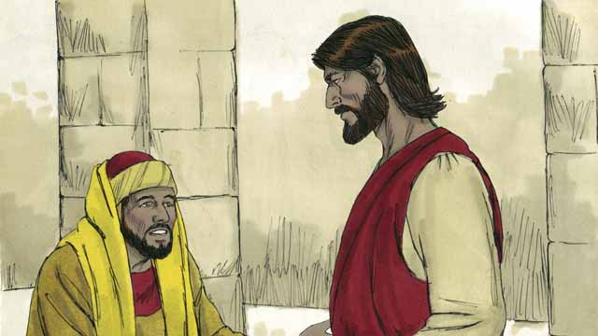

One day, a rich young ruler came up to Jesus and asked him, “Good teacher, what must I do to have eternal life?” Jesus said to him, “Why do you call me ‘good’? There is only one who is good, and that is God. But if you want to have eternal life, obey God’s laws.”

28-02

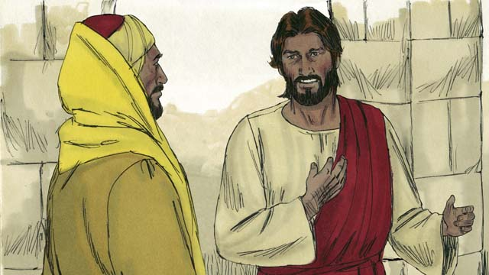

“Which ones do I need to obey?” he asked. Jesus replied, “Do not murder. Do not commit adultery. Do not steal. Do not lie. Honor your father and mother, and love your neighbor as you love yourself.”

28-03

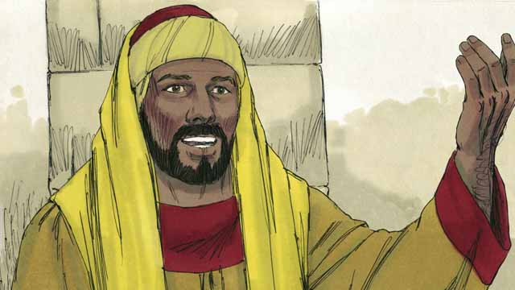

But the young man said, “I have obeyed all these laws ever since I was a boy. What do I still need to do in order to live forever?” Jesus looked at him and loved him.

28-04

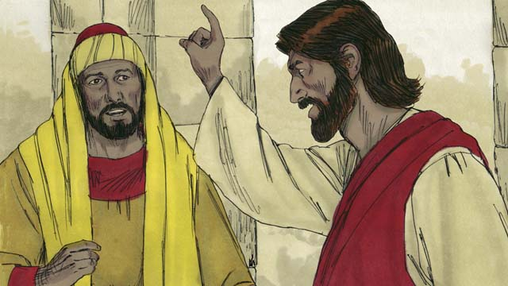

Jesus answered, “If you want to be perfect, then go and sell everything you own and give the money to the poor, and you will have treasure in heaven. Then come and follow me.”

28-05

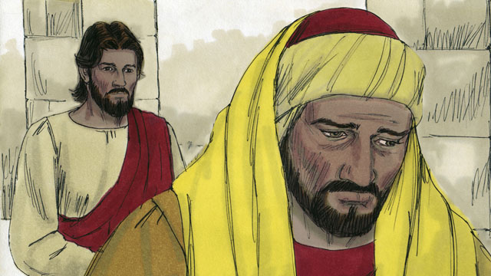

When the young man heard what Jesus said, he became very sad because he was very rich and did not want to give away all the things he possessed. He turned and went away from Jesus.

28-06

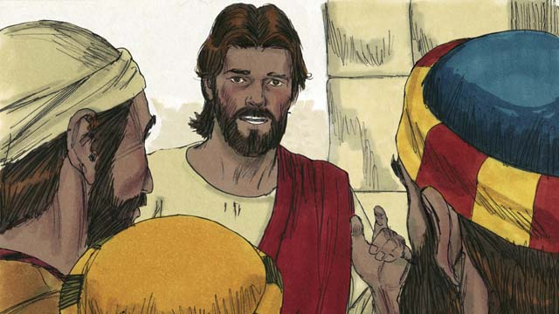

Then Jesus said to his disciples, “It is extremely hard for rich people to enter into the kingdom of God! Yes, it is easier for a camel to go through the eye of a needle than for a rich man to enter the kingdom of God.”

28-07

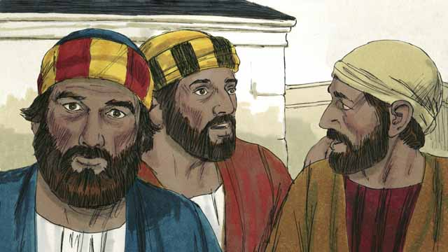

When the disciples heard what Jesus said, they were shocked. They said, “If it is like this, who will God save?”

28-08

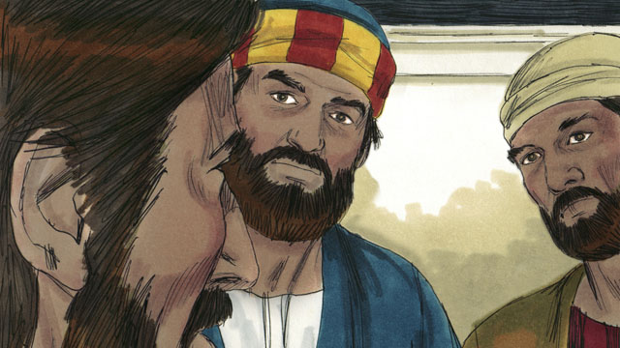

Jesus looked at the disciples and said, “It is impossible for people to save themselves. But nothing is impossible for God to do.”

28-09

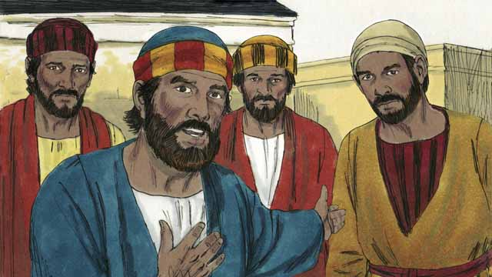

Peter said to Jesus, “We disciples have left everything and followed you. What will be our reward?”

28-10

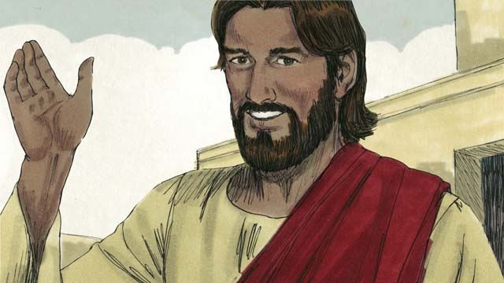

Jesus answered, “Everyone who has left houses, brothers, sisters, father, mother, children, or property for my sake will receive 100 times more and will also receive eternal life. But many who are first will be last, and many who are last will be first.”

*A Bible story from: Matthew 19:16-30; Mark 10:17-31; Luke 18:18-30*

## 1 Biblical Interpretation: Observing the Details of the Story

After reading the crafted biblical story, answer the following questions to familiarize yourself with the details of the story.

### 1.1 Observation Questions

Answer the following observation questions to gain a basic understanding of the the story. Read the story as a community and answer these questions as a group.

#### 28-01

What did the rich young ruler ask Jesus?  
He asked Jesus what he must do to have eternal life.

How did Jesus respond to the rich young ruler calling Jesus “Good teacher”?  
Jesus said that there is only one who is good, and that is God.

What did Jesus tell the young man to do in order to have eternal life?  
He told him to obey God’s laws.

#### 28-02

How did Jesus answer the rich young ruler’s question about which laws he needed to obey?  
Jesus listed the following laws: Do not murder. Do not commit adultery. Do not steal. Do not lie. Honor your father and mother, and love your neighbor as you love yourself.

#### 28-03

What did the young ruler say about the laws that Jesus listed?  
He said he had obeyed those laws ever since he was a boy.

What did the rich young ruler ask Jesus after this?  
He asked Jesus what he needed to do to live forever.

What did Jesus do after the rich young ruler asked this question?  
Jesus looked at the rich young ruler and loved him.

#### 28-04

What additional thing did Jesus tell the young man to do?  
Jesus told him to sell everything he owned and to give the money to the poor, and then to follow Jesus.

What reward did Jesus promise the rich young ruler if he would do this?  
He would have treasure in heaven.

What command did Jesus tell the man to do after selling his possessions and giving the money to the poor?  
Jesus told him to come and follow him.

#### 28-05

How did the the rich young ruler feel about Jesus’ words?  
When the young man heard what Jesus said, he became very sad.

Why did the young ruler become sad?  
He was very rich and did not want to give away all the things he possessed.

What did the rich young ruler do?  
He turned and went away from Jesus.

#### 28-06

What did Jesus say to his disciples about rich people entering the kingdom of God?  
Jesus said that it was extremely hard for rich people to enter into the kingdom of God.

How difficult is it for a rich man to enter the kingdom of God?  
It is easier for a camel to go through the eye of a needle than for a rich man to enter the kingdom of God.

#### 28-07

How did the disciples respond to what Jesus said?  
When the disciples heard what Jesus said, they were shocked and asked who God will save.

#### 28-08

What did Jesus explain to his disciples after they asked their question?  
Jesus explained that it is impossible for people to save themselves but it was possible for God to save people.

Is it possible for a rich man to be saved?  
Yes, everything is possible for God to do.

#### 28-09

What had the disciples left behind in order to follow Jesus?  
They had left everything.

What did the disciples want to know about how they left everything and followed Jesus?  
The disciples wanted to know what their reward would be for leaving everything and following Jesus.

#### 28-10

What did Jesus say would be their reward?  
Jesus explained that everyone who leaves houses, brothers, sisters, father, mother, children, or property for the sake of Jesus’ name would receive 100 times more in the next world, and also eternal life.

What did Jesus say about who is first and last?  
Many who are first will be last, and many who are last will be first?

### 1.2 Translation Questions

Use the following translation questions to understand specific details of the passage. Discuss how you might translate these specific elements of the story.

#### 28-01

**a rich young ruler** This person was wealthy, young, and powerful. How would you express **a rich young ruler** to mean a rich and powerful political official who was still young?

  

**came up to Jesus** The rich young ruler came near to Jesus in order to speak with him. How would you express **came up to Jesus** to mean approached Jesus?

  

**Good teacher** The rich young ruler addressed Jesus as morally upright and respectable. He was not saying that Jesus was simply a skilled teacher. How would you express **Good teacher** to mean righteous teacher?

  

**There is only one who is good, and that is** God Jesus does not deny that he himself is good. Jesus simply asked the rich young ruler why he called Jesus good. Jesus explained that the only one who is truly good is God. How would you express **There is only one who is good, and that is** God to mean God is the only one who is truly good?

  

**if you want to have eternal life, obey** God’s laws Eternal life means to live forever with God, even after this present life. Jesus explained that people can receive eternal life if they obey God’s commands. How would you express **if you want to have eternal life, obey** God’s laws to mean you must obey God’s commands in order to live forever with God?

  

#### 28-02

**Which ones do I need to obey?** The rich young ruler asked Jesus which commands he needed to obey in order to have eternal life. How would you express **Which ones do I need to obey?** as a question which asks which laws does one need to obey in order to live forever with God?

  

**love your neighbor as you love yourself** Jesus explained that one of the laws people needed to obey was to love one’s neighbor as much as one loves himself. This means that people are to show genuine concern for others the way they would care for their own wellbeing. How would you express **love your neighbor as you love yourself** to mean to show genuine concern for others to the same degree that you would yourself?

  

#### 28-03

**ever since I was a boy** The rich young ruler said that he obeyed all of the laws Jesus listed as a child and up to the present day/time. How would you express **ever since I was a boy** to mean from the time I was a child until now?

  

**What do I still need to do** The rich young ruler asked Jesus what else he needed to do to have eternal life. The young man said that he obeyed all of the commands Jesus listed since he was a child. However, he still felt there was something else he needed to do to have eternal life. How would you express **What do I still need to do** to mean what else do I need to do in addition to obeying these commands?

  

**loved him** Jesus had compassion on him. This compassion is the kind of concern and care God has for people. How would you express **loved him** to mean Jesus felt a genuine concern and compassion for the young man?

  

#### 28-04

**perfect** Jesus told the rich young man how he could become morally upright before God. How would you express **perfect** to mean completely righteous?

  

**sell everything you own** Jesus told the rich young man that he could become completely righteous if he sold everything that belonged to him and gave that money to poor people. How would you express **sell everything you own** to mean sell all your possessions?

  

**treasure in heaven** Jesus explained that God would reward the young man with great wealth in heaven if he sold all of his possessions and gave the money to poor people. How would you express **treasure in heaven** to mean God will reward you with riches located in heaven that you will receive when you arrive there?

  

#### 28-05

**When the young man heard what Jesus said** Jesus told the man to give away all of his possessions to poor people. At the time the young man heard Jesus’ instruction, he became very sad. How would you express **When the young man heard what Jesus said** to mean the young man became very sad at the time he heard Jesus tell him to give away what he owned?

  

**because he was very rich** The reason the man became very sad was he was very wealthy and did not want to give away all that he owned. How would you express **because he was very rich** to mean the reason the rich young ruler was very said was he owned many possessions and did not want to sell them?

  

#### 28-06

**It is extremely hard for rich people to enter into the kingdom of God!** Jesus made a strong statement that it is very difficult for wealthy people to live forever with God in his kingdom. His disciples may not have expected this to be true about wealth people. How would you express **It is extremely hard for rich people to enter into the kingdom of God!** as a strong statement that emphasizes it is very difficult for people with a lot of wealth/possessions to become a citizen in God’s kingdom?

  

**it is easier for a camel to go through the eye of a needle than for a rich man to enter the kingdom of God** Jesus made an exaggerated statement that emphasized the difficulty of a rich person becoming a citizen in God’s kingdom. Camels are very large animals (with humps on their backs) that are often used to carry heavy loads. Jesus explained that it is harder for a rich person to enter God’s kingdom than for a camel to go through the eye of a sewing needle. Jesus says this to represent something that is impossible. How would you express **it is easier for a camel to go through the eye of a needle than for a rich man to enter the kingdom of God** to mean it is more difficult for a person to become a citizen in God’s kingdom than for a camel to go through the eye of a sewing needle?

  

#### 28-07

**they were shocked** The disciples were very surprised about how hard it is for a rich person to become a citizen in God’s kingdom. They believed that God made people rich because they were more righteous than other people. How would you express **they were shocked** to mean greatly astonished at what Jesus said?

  

**If it is like this, who will God save?** The disciples asked Jesus a question that expressed their shock and surprise. The disciples were surprised that if God does not save rich people, then it seems like he will not save anyone. It seemed to the disciples that every person would face God’s judgment and condemnation for their sin. How would you express **If it is like this, who will God save?** as a question that means if it is as difficult for rich people to enter God’s kingdom as Jesus said, then who will God rescue from judgment and condemnation?

  

#### 28-08

**It is impossible for people to save themselves** People do not have the ability to save themselves from God’s judgment. All humans are imperfect sinners who deserve God’s punishment for their sin. No person can rescue himself/herself from this condemnation. How would you express **It is impossible for people to save themselves** to mean people do not have the power or ability to rescue themselves from God’s judgment?

  

**nothing is impossible for God to do** Jesus explained that things that God can do things that are impossible for people to do. God is able to do anything, even save a rich person. How would you express **nothing is impossible for God to do** to mean God is able to do impossible things, so he can save even a rich person?

  

#### 28-09

**We disciples have left everything** The disciples explained that they left all their possessions behind to follow Jesus. How would you express **We disciples have left everything** to mean the disciples gave up everything they owned to follow Jesus?

  

**What will be our reward?** The disciples asked Jesus how God would reward them for leaving everything they owned and following Jesus. How would you express **What will be our reward?** as a question that asks what will God give us as a reward?

  

#### 28-10

**100 times more** Jesus told his disciples that those who counted God as more important than all other things would receive much more in the future. To receive **100 times more** is not naming a specific number but communicating that faithful disciples who leave behind important things to follow Jesus will receive a lot more in the future than they presently have. How would you express **100 times more** to mean very much more than he had before?

  

**many who are first will be last, and many who are last will be first** Here first and last refer to people’s status or importance. Jesus is contrasting people’s status now with their status in the kingdom of heaven. Many people who are important now, will not be important later. Many people who are considered now to be of little value on earth will be highly valued in heaven. How would you express **many who are first will be last, and many who are last will be first** to mean many who seem to be important now will be the least important, and many who seem to be unimportant now will be very important?

  

## 2 Theological Dialogue: Discussing the Meaning of the Story

Take time to explore the meaning of this story together as a community. Use the following discussions as a way to grasp what truth the story teaches.

### 2.1 Discourse Questions

Use the following discourse questions to understand the meaning of the story. Pay attention to how the story itself addresses each question or theme.

##### What did Jesus teach about how someone receives eternal life? (28-01, 28-02, 28-03, 28-04, 28-05)

Obedience: One day, a rich young ruler asked Jesus what he needed to do to have eternal life. Jesus told the man that he needed to obey God’s commands to have eternal life. (28-01)

  

Something Was Lacking: Jesus listed some of God’s commands and the man said that he obeyed those commands since he was a child. He wanted to know what else he needed to do to have eternal life. The man recognized that his obedience to these commands was not enough. No person’s obedience is good enough to gain eternal life. (28-02, 28-03)

  

Full Commitment: Jesus told the man that if he wanted to be perfect he needed to sell all his possessions and give the money to poor people. This would show his full commitment that God was most important to him, even more important than his possessions. (28-04)

  

Following Jesus: Jesus told the man to follow him. One can only have eternal life by following Jesus. We follow Jesus when we make Jesus most important in our lives. (28-04)

  

The rich young ruler was very sad because he was rich and did not want to lose his possessions. His possessions were more important than following Jesus. People can only receive eternal life when they value future reward as more important than present possessions. (28-05)

  

##### What keeps people from being saved/receiving eternal life? (28-01, 28-03, 28-06, 28-07, 28-08)

Wealth, Youth, and Power: The rich young ruler was wealthy, youthful, and powerful. Our possessions, youth, and positions of power can keep us from following Jesus. (28-01)

  

Failed Obedience: Jesus said that the man needed to obey God’s laws to be saved. Yet, even when the man said he obeyed God’s laws, he wanted to know what else was needed to have eternal life. No one can obey enough/sufficiently to gain eternal life. If we rely on our own obedience to save ourselves we will not gain eternal life. (28-03)

  

Hard for Rich to Be Saved: Jesus taught his disciples that it is very hard for rich people to enter God’s kingdom. It is harder for a rich man to be saved than for a camel to go through the eye of a needle. This does not mean that rich people cannot be saved. It means that rich people tend to value their possessions more than God. It takes a major change in one’s life to follow Jesus and be saved. (28-06)

  

Only God Can Save: The disciples were shocked at Jesus’ teaching and wondered who could be saved. Jesus told his disciples that it is impossible for a person to save himself. This is something that only God can do. (28-07, 28-08)

  

##### What did Jesus explain to his disciples about what it means to genuinely follow Jesus? (28-04, 28-05, 28-09, 28-10)

Following Jesus: The disciples told Jesus that they left their possessions to follow Jesus. The rich young ruler would not give up his possessions to follow Jesus. Following Jesus means giving up present possessions for a future reward. (28-04, 28-05, 28-09)

  

Sacrifice: Jesus explained to his disciples that following Jesus will involve sacrifice. Jesus told his disciples that people must give up important things now in order to follow Jesus. People who consider Jesus as more important than houses, family, and property prove that they are true followers of Christ. Also, those who give up important things now will be much more blessed in the future. In addition to blessing, people who sacrifice and follow Jesus will receive eternal life. (28-10)

  

Humility: Jesus explained to his disciples that following Jesus will involve humility. Jesus told his disciples that those who are first/important now will be last/unimportant later on; those who are last/unimportant now will be first/important later on. Those who are important now hesitate to follow Jesus because of what it will cost them. It requires humility to put oneself in a less important position in this present life to follow Jesus. (28-10)

  

##### What did Jesus promise to those who genuinely followed Jesus? (28-01, 28-03, 28-04, 28-06, 28-07, 28-08, 28-09, 28-10)

Eternal LIfe: People who genuinely follow Jesus gain eternal life and live forever. (28-01, 28-03, 28-10)

  

Treasure in Heaven/Reward: People who genuinely follow Jesus will have treasure in heaven. Those who give up their possessions now to follow Jesus will become richly blessed and rewarded in the future. (28-04, 28-09, 28-10) Kingdom Citizen: People who genuinely follow Jesus will become citizens of God’s kingdom. (28-06)

  

Saved: People who genuinely follow Jesus will be saved/rescued from God’s wrath and judgment of their sin. (28-07, 28-08)

  

### 2.2 Theological Questions

Answer the following theology questions as a community. Discuss what truths this story teaches.

1. What does it mean/take to follow Jesus? What does this story teach about genuinely following Jesus?
2. What is promised to those who genuinely follow Christ? How does this story teach about future promises for followers of Jesus?
3. What obstacles keep people from following Christ? How does this story highlight some of these obstacles?

### 2.3 Translation Draft

Work as a translation team to draft each panel of this story. Pay attention to any specific translation issues that are challenging or significant.

#### Make Translation Draft

Make a draft for each section of this story.

#### Discuss and Revise

After drafting the story, discuss any translation issues that you think need special explanation.

#### Drafting Summary Reflection

Summarize any noteworthy translation decisions and the rationale/reasoning behind these translation decisions. In the final movement of this class, you will use these observations to give an account (i.e., chronicle/narrate) of how your translation improved through the checking process.

## 3 Personal Reflection: Following the Teaching of the Story

Take a moment to allow this story to evaluate your own life and to consider how God would have you respond. After this reflection, use the quality checking questions to check your translation draft among the translation team.

### 3.1 Journal Reflection

Prayerfully think about the following personal reflection questions. Write/Record your answers and/or discuss them as a group.

1. What have you given up to follow Jesus?
2. What people or things make it a challenge to follow Jesus?
3. How can you even more make Jesus most important in your life?
4. What hope do you have of the future life? How do these future promises/rewards encourage and motivate you in your Christian life?

### 3.2 Team Check

*The following activity will help you check the clarity, accuracy, and naturalness of your draft. Read the passage aloud and discuss the checking questions with other members of your translation community. You might need to reread portions (or the whole) of the biblical passage multiple times as you answer each of these questions. Record answers to these questions below.*

#### Team Checking Questions

*Use the following questions to check your translation draft for accuracy, clarity, and naturalness.*

1. **Accurate**: Has anything been **added** to your translation of this passage that is not a part of the meaning of the source text? *If additions exist, are they included only added to clarify meaning (such as implied information)?*
2. **Accurate**: Is anything **missing** from your translation of this passage that is a part of the meaning of the source text? *If some part of the meaning is missing from your translation, add it.*
3. **Accurate**: Does any meaning in your translation of this passage appear to be **different** than the meaning of the source text? *If the meaning is different, try changing your translation so that the meaning remains the same.*
4. **Natural**: Does anything sound **unnatural** to how you would say it in your language? *If portions of the passage sound unnatural in your language, try to make them sound the way you would say it in your language while staying true to the meaning of the source text.*
5. **Clear**: Is anything **unclear** or **confusing** in your translation that confuses the meaning of the source text? *If portions of the passage are unclear or confusing, revise them to clearly communicate the meaning of the source text.*
6. **Consistent**: How **consistent** is your translation within the passage and with other passages? *If portions of the passage need to be made consistent or if you need to revise translations of other passages, make these adjustments.*

#### Record Feedback

*After discussing the checking questions above as a translation community, record any feedback on your translation draft. Pay attention for parts of your translation that are translated well and parts of your translation that need correction.*

#### Discuss and Revise

*After gathering feedback on your draft, discuss it together with your translation community and make appropriate revisions in your translation.*

#### Checking Summary Reflection

*Summarize any noteworthy translation decisions (things you corrected or affirmed in your draft) and the rationale/reasoning behind these translation decisions. In the final movement of this class, you will use these observations to give an account (i.e., chronicle/narrate) of how your translation improved through the checking process.*

## 4 Ministry Practice: Serving the Church with the Story

Now that you have a draft of this story, consider how this story can encourage other believers in their faith. After ministering this story to others, you will also perform a community check of your translation draft.

### 4.1 Church Ministry

Reflect on how this story can edify and mature the Christian community. Design a way to minister this story to your church community.

**Ministry Preparation**: Take time to consider how you could minister this story to others. Record some ministry ideas below.

**Ministry Implementation**: Minister this story to a group of believers as you had planned. Use the information in this study to help develop a teaching/lesson or lead a discussion of this story to other believers. Record your ministry plan below.

**Ministry Reflection**: Think about what you learned from ministering this story to other believers. Reflect on your experience below.

### 4.2 Church Community Check

After teaching or ministering this story to the church, check the translation quality with the church community. Record any feedback from your checking experience.

#### Create Checking Questions

You can use **Translation Questions** to check you draft. Each **Translation Question** explains the meaning of a specific part of the story and asks you to consider how you would translate that part of the story in your own language. Change each **Translation Question** into a **Checking Question** by asking the following questions. The first question asks you to identity how each specific phrase was translated in your language. The second question asks people in the church to determine if your translation of the phrase expresses the meaning clearly, accurately, and naturally. Look at the following examples to see how to change **Translation Questions** into **Checking Questions**:

#### Translation Question Example 1

**to proclaim the good news about Jesus** Paul and Silas traveled to Philippi for the purpose of preaching the gospel. The gospel is the good news that Jesus saves people from their sins if they will believe in Jesus. How would you express **to proclaim the good news about Jesus** to mean to tell other people the message about how Jesus can save people from their sins?

#### Translation Question Example 2

**a merchant** Paul and Silas met a woman named Lydia at the place by the river. She owned a business and sold items to make money. How would you express **a merchant** to mean a business owner who sells items for a profit?

#### Translation Question Example 3

**so Paul and Silas baptized them** The jailer and his whole family followed Paul’s instructions. They believed in Jesus. The result of this was Paul and Silas baptized them. How would you express **so Paul and Silas baptized them** to mean the result of the jailer and his family believing in Jesus that Paul and Silas baptized all of them?

You can change these into **Checking Questions** like this:

#### Checking Question Example 1

**to proclaim the good news about Jesus** How did you translate **to proclaim the good news about Jesus**? Does it mean to tell other people the message about how Jesus can save people from their sins?

#### Checking Question Example 2

**a merchant** How did you translate **a merchant**? Does it mean a business owner who sells items for a profit?

#### Checking Question Example 3

**so Paul and Silas baptized them** How did you translate **so Paul and Silas baptized them**? Does it mean the result of the jailer and his family believing in Jesus that Paul and Silas baptized all of them?

#### Record Feedback

*Discuss the* ***Checking Questions*** *with your church community, and record any feedback on your translation draft. Pay attention for parts of your translation that are translated well and parts of your translation that need correction.*

#### Discuss and Revise

*After gathering feedback on your draft, discuss it together with your translation community and make appropriate revisions in your translation.*

#### Checking Summary Reflection

*Summarize any noteworthy translation decisions (things you corrected or affirmed in your draft) and the rationale/reasoning behind these translation decisions. In the final movement of this class, you will use these observations to give an account (i.e., chronicle/narrate) of how your translation improved through the checking process.*

## 5 Missional Outreach: Sharing the Truth of the Story

*After sharing this story with others, check the translation quality with the wider language community. Record any feedback from your checking experience.*

### 5.1 Mission Engagement

*Consider how you will witness this story to unbelievers. Design a way to share this story and engage them in what it teaches about Christianity and the gospel.*

**Witness Preparation**: Take time to consider how you will witness this narrative to unbelievers. Record some ideas below.

**Witness Implementation**: Share this story with an unbeliever. Use the information in this study to help develop a teaching/lesson or lead a discussion of this story to other believers. Record your ministry plan below.

**Witness Reflection**: Think about what you learned from ministering this story to unbelievers. Reflect on your experience below.

### 5.2 Sociolinguistic Check

After sharing this story with the language community, check your translation draft with the surrounding community. Record your observations.

#### Checking Approach

After witnessing this story to unbelievers, use one of the following methods to check the translation of this story. Consider using the **Observation Questions** to check your translation draft or come up with your own quality checking questions.

**Read-Retell Check:** Read your draft to those the community and ask them to retell the passage. Be attentive for any portions of the passage that are unclear, unnatural, or inaccurate.

**Comprehension Questions Checklist:** Read the draft of the passage and ask a list of comprehension questions to make sure the passage is being rightly understood. You can use the **Observation Questions** in this guide or come up with your own questions. Then, record any insights or issues that arise.

**Discussion Group:** Develop key questions to ask about the passage (both formational and translational). Read the passage and have a group discussion about the passage, paying attention to issues that need to be addressed, edited, and revised.

#### Record Feedback

*After sharing your draft with language community, discuss the* ***Observations Questions****, and record any feedback on your translation draft. Pay attention for parts of your translation that are translated well and parts of your translation that need correction.*

#### Discuss and Revise

*After gathering feedback on your draft, discuss it together with your translation community and make appropriate revisions in your translation.*

#### Checking Summary Reflection

*Summarize any noteworthy translation decisions (things you corrected or affirmed in your draft) and the rationale/reasoning behind these translation decisions. In the final movement of this class, you will use these observations to give an account (i.e., chronicle/narrate) of how your translation improved through the checking process.*

## 6 Conclusion

As a translation community, take time to reflect on all that was learned in studying, drafting, and checking this story. Celebrate all that God has taught you as a community. Then, submit your revised draft and checking summaries to network leaders for further review.