Open Bible Stories

The Story of the Unmerciful Servant

## 0 Introduction

### 0.1 Key Idea

The story of the unmerciful servant teaches us that we should forgive others as God has forgiven us.

### 0.2 Creedal Verse

“Be kind to one another, tenderhearted, forgiving one another, as God in Christ forgave you.” Ephesians 4:32

### 0.3 Metanarrative Summary

The eternal God created all things in six days. He made a good and perfect world. He made humans in his image to fill the earth and rule over creation. But humans rebelled against God and ruined God’s creation. God set to restore his world through his promise. God made a covenant with Abraham. He promised to bless all nations through Abraham. God kept his promises across the generations. God provided Abraham with a promised child, Isaac. God gave Isaac a wife and she bore twins, Jacob and Esau. God blessed Jacob and his sons, and the blessing continued to the next generation. God rescued Joseph, one of Jacob’s sons, and used him to rescue his family. God caused his people, the Israelites, to multiply in the land of Egypt; eventually, they became slaves. But, God raised up a deliverer, Moses, to deliver his people from their slavery. God judged the Egyptians with harsh plagues; in the final judgment, he passed over his people who covered their doorposts with the blood of a sacrificed lamb. Then, God delivered the Israelites by bringing them out of Egypt and crossing the Red Sea on dry land. God made a covenant with the Israelites and made them his people. God tested Israel in a series of wilderness wanderings and eventually brought his people into the promised land of Canaan. God raised up deliverers to lead Israel and rescue them from their enemies. God formed Israel into a kingdom. He made a covenant with King David and promised to send a king that would rule his people forever. Many of Israel’s kings were evil and the kingdom of Israel divided into two kingdoms. God sent prophets to warn his people of God’s judgment and call them to repent. When Israel did not repent, God sent his people into exile. After many years, he brought them back to the land. Throughout the Old Testament, God promised to send his Messiah to deliver his people form their sin. After many years, the prophet John was born. He would prepare people for the coming Messiah. At the perfect time, God sent his Son, Jesus, to be born of a virgin Mary. When John and Jesus grew up, John baptized Jesus as a sign that Jesus was God’s beloved Son. Jesus endured all manner of temptation without ever sinning. When he was thirty years old, he launched a public ministry of preaching, teaching, and healing. He taught his disciples about the life of compassion, sacrifice, and forgiveness.

### 0.4 Open Bible Story: The Story of the Unmerciful Servant

29-01

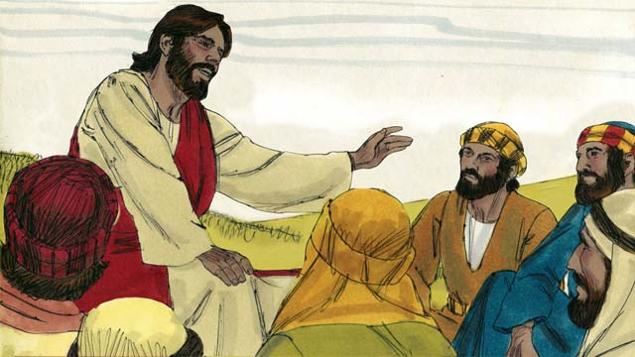

One day, Peter asked Jesus, “Master, how many times should I forgive my brother when he sins against me? Up to seven times?” Jesus said, “Not seven times, but 70 times seven!” By this, Jesus meant that we should always forgive. Then Jesus told this story.

29-02

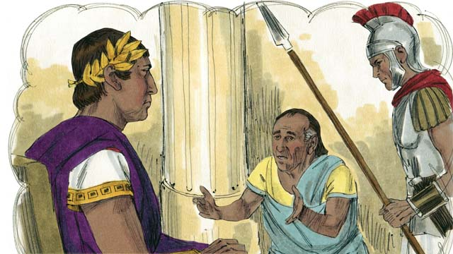

Jesus said, “The kingdom of God is like a king who wanted to settle accounts with his servants. One of his servants owed a huge debt worth 200,000 years’ wages.”

29-03

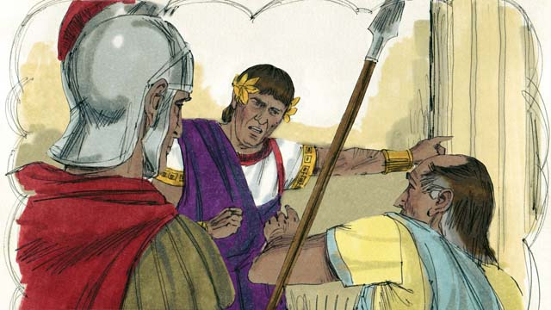

“But the servant could not pay his debt, so the king said, ‘Sell this man and his family as slaves to pay his debt.’”

29-04

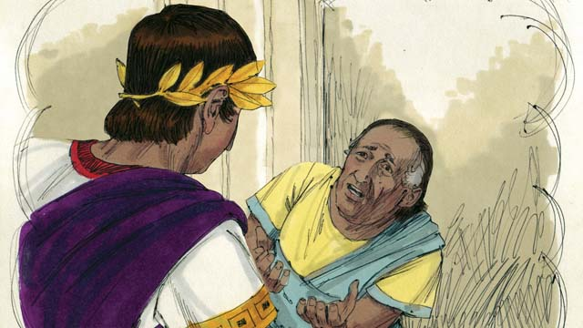

“The servant fell on his knees before the king and said, ‘Please be patient with me, and I will pay the full amount that I owe you.’ The king felt pity for the servant, so he canceled all of his debt and let him go.”

29-05

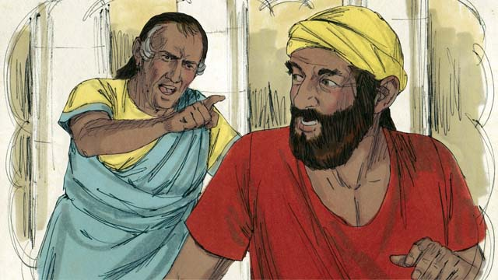

“But when the servant went out from the king, he found a fellow servant who owed him a debt worth four months’ wages. The servant grabbed his fellow servant and said, ‘Pay me the money that you owe me!’”

29-06

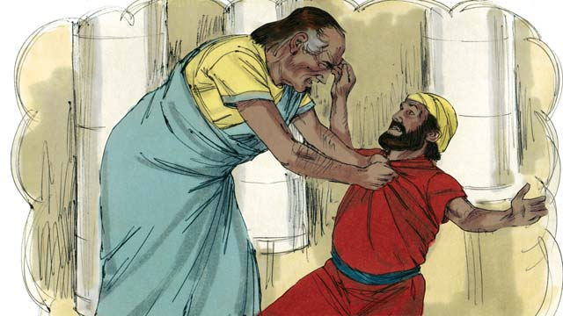

“The fellow servant fell on his knees and said, ‘Please be patient with me, and I will pay the full amount that I owe you.’ But instead, the servant threw his fellow servant into prison until he could pay the debt.”

29-07

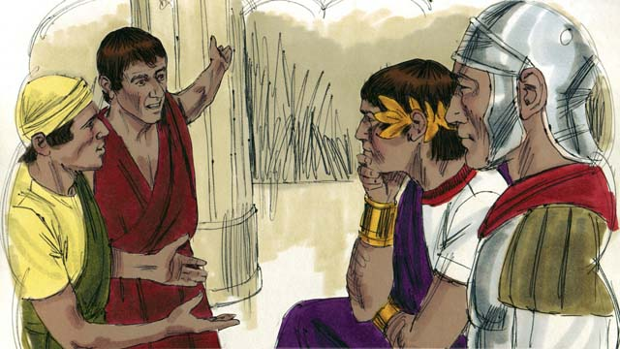

“Some other servants saw what had happened and were greatly disturbed. They went to the king and told him everything.”

29-08

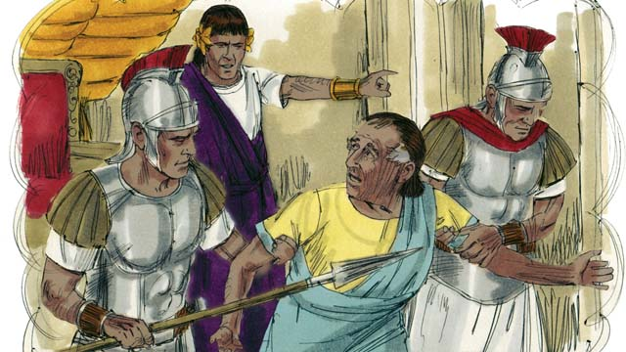

“The king called the servant and said, ‘You wicked servant! I forgave your debt because you begged me. You should have done the same.’ The king was so angry that he threw the wicked servant into prison until he could pay back all of his debt.”

29-09

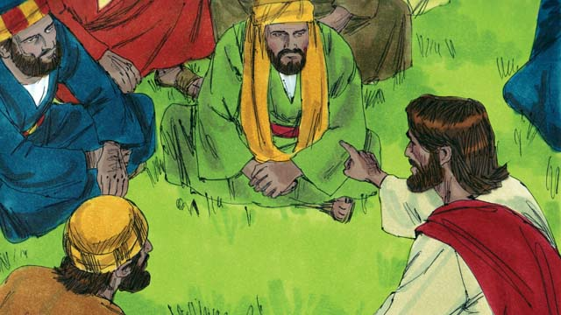

Then Jesus said, “This is what my heavenly Father will do to every one of you if you do not forgive your brother from your heart.”

*A Bible story from: Matthew 18:21-35*

## 1 Biblical Interpretation: Observing the Details of the Story

After reading the crafted biblical story, answer the following questions to familiarize yourself with the details of the story.

### 1.1 Observation Questions

Answer the following observation questions to gain a basic understanding of the the story. Read the story as a community and answer these questions as a group.

#### 29-01

What question did Peter ask Jesus?  
Peter asked Jesus, “How many times should I forgive my brother when he sins against me?”  
How many times did Peter suggest that he should forgive his brother?  
He suggested that he should forgive him seven times.

How many times did Jesus say he should forgive his brother?  
Jesus said he must forgive him 70 times seven.

What did Jesus mean when he said, 70 times seven?  
He meant that we should always forgive.

#### 29-02

What story did Jesus tell?  
Jesus told a story about a king who wants to settle accounts with his servants.

What would this story explain?  
This story would tell what the kingdom of God was like.

In the story, how much did one of the king’s servants owe him?  
One of the king’s servants owed him a huge debt worth 200,000 years’ wage.

#### 29-03

Was the servant able to pay his huge debt to the king?  
No, he was not.

How did the king decide to punish the servant with the huge debt?  
The king ordered that the man and his family be sold as slaves.

#### 29-04

What did the servant do?  
The king’s servant fell on his knows and begged the king to be patient with him.

What did the king do when the servant begged him to be patient?  
The king felt pity on the servant and canceled his debt.

#### 29-05

After this, what did the king’s servant do to a fellow servant?  
The king’s servant found a fellow servant who owed him a debt.

How much was the debt of the fellow servant?  
The fellow servant owed the other servant four months’ wages.

What did the servant then do to a fellow servant who owed him a small debt?  
He grabbed the servant and demanded that he pay the money that he owed him.

#### 29-06

What did this servant do?  
This servant fell on his knows and begged his fellow servant to be patient with him.

What did the servant do when his fellow servant fell on his knees and asked him to be patient?  
He threw his fellow servant into prison.

#### 29-07

How did the other servants react when he threw his fellow servant in prison?  
They were greatly disturbed and told the king about it.

#### 29-08

What did the king say to his servant?  
He called him a wicked servant, reminded the servant that the king forgave his debt, and told him he should have also forgiven the debt of his fellow servant.

How did the king punish the servant who did not forgive his fellow servant?  
The king was so angry that he threw him into prison until he could pay back all his debt.

#### 29-09

What did Jesus say this story taught about God?  
Jesus explained that God would do as the king did to the servant to all who did not forgive their brother.

### 1.2 Translation Questions

Use the following translation questions to understand specific details of the passage. Discuss how you might translate these specific elements of the story.

#### 29-01

**how many times should I forgive** To forgive means to pardon or cancel a debt that is owed. Someone forgives another person when they no longer hold that person as guilty or culpable for the wrong they have done/committed. How would you express **how many times should I forgive** to mean how often should I pardon others for things they have done against me?

  

**my brother** This term sometimes included people who were not actually siblings, but who shared another very strong connection such as religion, ethnic background, etc. How would you express **my brother** to mean a sibling or fellow member of one’s family but can also include someone viewed as brotherly because of common beliefs or shared group identity?

  

**sins against me** When people disobey God’s commands, they often do wrong against other people. How would you express **sins against me** to mean does something wrong against me?

  

**Not seven times, but 70 times seven!** Jesus was not talking about an exact number. He was saying that we should forgive people every time they sin against us. How would you express **Not seven times, but 70 times seven!** to mean you should not forgive only seven times, rather you should forgive 70 times seven times?

  

#### 29-02

**The kingdom of God is like** God rules over people as King. Jesus used a story of a king and his servants to show how God rules over people and what it is like to be under God’s rule. How would you express **The kingdom of God is like** to mean the way God rules people can be compared to?

  

**to settle accounts with his servants** In this story, one servant owed the king a large debt. The king wanted to collect the debts his servants owed him. How would you express **to settle accounts with his servants** to mean to have the servant repay the king the money he borrowed from the king?

  

**huge debt** The servant owed the king a very large sum of money. This debt was so large that it was near impossible for the servant to repay the king the full amount. How would you express **huge debt** to mean an enormous amount of money owed to someone else?

  

#### 29-03

**Sell this man and his family as slaves** The king commanded that the man and his family be made slaves and sold for money so that he could repay his debt to the king. How would you express **Sell this man and his family as slaves** as a command hand over the man and his family to become slavery (forced servitude) in exchange for money?

  

**to pay his debt** The reason the man would be sold was so that the money received from selling him could pay part of what he owed to they king. How would you express **to pay his debt** to mean to pay back the money he owed to the king?

  

#### 29-04

**fell on his knees** The servant rapidly came down on his knees before the king. It does not mean he fell down accidentally. This was a way to show his humility and his desire for the king to help him. How would you express **fell on his knees** to mean quickly knelt down on the ground?

  

**felt pity** The king felt compassion on the servant. The king knew that the servant and his family would suffer greatly if they were sold into slavery. How would you express **felt pity** to mean felt sorry for hardship, pain, or misfortune someone would suffer?

  

**canceled all of his debt** The king said that the servant did not need to pay back any of the money that he owed the king. Because the servant no longer owed the king money, the servant was free to go and would not be sold into slavery. How would you express **canceled all of his debt** to mean the king abolished/eliminated the servants debt and did not make him repay the money he owed the king?

  

#### 29-05

**a fellow servant** The king had more than one servant. In fact, he had many servants. Both servants in this part of the story were of similar rank before the king. How would you express **a fellow servant** to mean another man who was also a servant of the king?

  

**Pay me the money that you owe me!** The servant commanded his fellow servant to repay the money that he borrowed from him. How would you express **Pay me the money that you owe me!** to mean repay his debt by giving back to the servant the four month’s wage he had borrowed?

  

#### 29-06

**Please be patient with me** The fellow servant asked for the servant to give him some time so he could pay back the debt in full. That is, How would you express **Please be patient with me** as a polite and humble plea to not punish him but allow him time pay back the full amount of money he owed the other servant?

  

**threw his fellow servant into prison** The servant had his fellow servant put in prison because of his debt. The servant forcefully put his fellow servant in prison. How would you express **threw his fellow servant into prison** to mean forcefully had the man put into prison.

#### 29-07

**what had happened** The servant had refused to cancel the other servant’s debt and had put him into prison. How would you express **what had happened** to mean the thing the servant did by not canceling his debt and throwing him into prison?

  

**greatly disturbed** Other servants observed what the one servant did to his fellow servant. This caused the other servants to be deeply saddened and upset over what happened. How would you express **greatly disturbed** to mean deeply grieved or very distressed?

  

**everything** The other servants reported to the king how the one servant refused to cancel the debt of his fellow servant and put him in prison. How would you express **everything** to mean they told the king what the servant had done to his fellow servant?

  

#### 29-08

**called the servant** The king had authority to command people to do things. They king ordered his guards to bring the servant to him. How would you express **called the servant** to mean commanded the servant to come to him?

  

**You wicked servant!** The king called the servant evil. He made a strong statement to emphasize how unrighteous the servant was. How would you express **You wicked servant!** as a strong statement that emphasizes that the servant is very evil and morally bad?

  

**begged me** The one servant pleaded with the king to show him pity and compassion. How would you express **begged me** to mean urgently asked me to be merciful?

  

**You should have done the same** The king told the servant that the right thing to do was to forgive his fellow servant of his smaller debt because the king had forgiven his much larger debt. How would you express **You should have done the same** to mean you should have forgiven the man who owed you, just as I forgave you?

  

#### 29-09

**This is what my heavenly Father will do to every one of you** Jesus said that God would punish people who did not forgive others of sins done against them. How would you express **This is what my heavenly Father will do to every one of you** to mean God would punish people in the same way the king punished the unforgiving servant if they did not forgive others of wrongs done against them?

  

**forgive your brother from your heart** Here the heart represents a person’s inner being. Jesus taught that his servants needed to genuinely and honestly forgive others of the debts/wrongs they have done. If they did not forgive others in this way, God would punish them in a similar way to how the king punished the unforgiving servant. How would you express **forgive your brother from your heart** to mean sincerely pardon fellow persons of the wrong they have committed against you?

  

## 2 Theological Dialogue: Discussing the Meaning of the Story

Take time to explore the meaning of this story together as a community. Use the following discussions as a way to grasp what truth the story teaches.

### 2.1 Discourse Questions

Use the following discourse questions to understand the meaning of the story. Pay attention to how the story itself addresses each question or theme.

##### How does Jesus use the idea of debt to explain sin? (29-01, 29-02, 29-03, 29-05)

Sin Against One Another: People can sin against other people when they violate God’s commands. (29-01)

  

Debt: Jesus compared the kingdom of God to a king who wanted to settle accounts with his servants. When we sin against God, we put ourselves into God’s debt. When we sin against others, we put ourselves in others’ debt. (29-02)

  

Enormous Debt: One servant owed the king a debt worth 200,000 years’ wage. This huge debt would have be impossible to pay. In fact, the servant in the story could not pay his debt to the king. A person’s debt before God is impossible for people to settle or pay back. (29-02, 29-03)

  

Slavery: The servant was unable to pay back his debt to the king. As a result, the king punished the servant. He would be sold as a slave. Just like the servant before the king, human sin before God puts us in debt to God which we cannot repay and makes us deserving of punishment. Our sin makes us slaves. (29-03)

  

Sin Against Others: A fellow servant owed another servant four months’ wages. He was obligated to pay back that debt. When we sin against others, we put ourselves into their debt. (29-05)

  

##### What does Jesus teach his disciples about offering forgiveness to others who sin against us? (29-01, 29-08, 29-09)

Peter wanted to know how many times he should forgive a brother who sins against him. Christians should expect that they will be wronged by others. (29-01)

  

Jesus told Peter that he should forgive a brother who sins against him 70 times seven. This meant that God’s people should always forgive those who sin against them. (29-01)

  

The king told the servant that he should have forgiven his fellow servant as the king had forgiven his debt. We should forgive others as God has forgiven us. (29-08)

  

Jesus warned people of the consequences of not forgiving others from the heart. We should forgive others with sincerity, honesty, and genuineness. (29-09)

  

##### What does Jesus teach about how one receives forgiveness? (29-03, 29-04)

Sin and Punishment: The servant recognized that his debt was impossible to pay back and he heard that he would be sold as a slave as his punishment. Recognize the immensity of our debt and the severity of our punishment. (29-03)

  

Humility: After the servant heard the king announce his punishment, the servant humbled himself by falling on his knees. Only those who are willing to humble themselves and plead with God to be merciful can receive forgiveness. (29-04)

  

Pity: The king showed pity and mercy to the servant. He canceled his debt and let the servant go freely without needed to repay him of the money he borrowed. The king’s pity represents God’s pity and mercy on those he forgives. The only way people can be forgiven of the enormous debt and punishment of sin is to receive God’s mercy and pity. (29-04)

  

##### How does Jesus warn his disciples about not forgiving others when God has forgiven them? (29-05 ,29-02, 29-03, 29-06, 29-07, 29-08, 29-09)

Smaller Debt: The servant’s debt worth four months’ wages was small compared to the huge debt the servant owed the king. The debt that humans have against each other is small compared to the debt we have before God. (29-05; 29-02, 29-03)

  

Forceful: The servant who had his debt canceled was forceful and demanding to his fellow servant. He grabbed the servant, demanded payment of his debt, and threw him in prison. One would expect him to be kind after having his larger debt canceled. (29-05, 29-06)

  

Unforgiveness: The fellow servant pleaded for mercy, but the one servant did not show him pity. Instead, he threw the servant in prison to pay for his debt. The servant did not cancel the small debt of his fellow servant. People often do not forgive other people of sins done against them even though they have received forgiveness from God for a much larger debt/sin. (29-06)

  

Punishment: The king learned of the servant’s unforgiveness. The king was angry. The king called the servant a wicked servant and through him in prison. God will punish those who do not forgive others of debts against them. (29-07, 29-08, 29-09)

  

### 2.2 Theological Questions

Answer the following theology questions as a community. Discuss what truths this story teaches.

1. How is sin like a debt before God and others? How does this story compare sin to a debt?
2. What does real forgiveness look like? In this story, what picture does Jesus give of real forgiveness?
3. What is the connection between receiving forgiveness from God and offering forgiveness to others? How does this story highlight this relationship?

### 2.3 Translation Draft

Work as a translation team to draft each panel of this story. Pay attention to any specific translation issues that are challenging or significant.

#### Make Translation Draft

Make a draft for each section of this story.

#### Discuss and Revise

After drafting the story, discuss any translation issues that you think need special explanation.

#### Drafting Summary Reflection

Summarize any noteworthy translation decisions and the rationale/reasoning behind these translation decisions. In the final movement of this class, you will use these observations to give an account (i.e., chronicle/narrate) of how your translation improved through the checking process.

## 3 Personal Reflection: Following the Teaching of the Story

Take a moment to allow this story to evaluate your own life and to consider how God would have you respond. After this reflection, use the quality checking questions to check your translation draft among the translation team.

### 3.1 Journal Reflection

Prayerfully think about the following personal reflection questions. Write/Record your answers and/or discuss them as a group.

1. Reflect on how massive your sin is before God? How is your own sin before God like a debt impossible to pay back?
2. To what extent have you experienced God’s forgiveness of your sin?
3. In what ways is God calling you to offer forgiveness to others who have sinned against you?
4. What makes forgiveness hard for you?

### 3.2 Team Check

*The following activity will help you check the clarity, accuracy, and naturalness of your draft. Read the passage aloud and discuss the checking questions with other members of your translation community. You might need to reread portions (or the whole) of the biblical passage multiple times as you answer each of these questions. Record answers to these questions below.*

#### Team Checking Questions

*Use the following questions to check your translation draft for accuracy, clarity, and naturalness.*

1. **Accurate**: Has anything been **added** to your translation of this passage that is not a part of the meaning of the source text? *If additions exist, are they included only added to clarify meaning (such as implied information)?*
2. **Accurate**: Is anything **missing** from your translation of this passage that is a part of the meaning of the source text? *If some part of the meaning is missing from your translation, add it.*
3. **Accurate**: Does any meaning in your translation of this passage appear to be **different** than the meaning of the source text? *If the meaning is different, try changing your translation so that the meaning remains the same.*
4. **Natural**: Does anything sound **unnatural** to how you would say it in your language? *If portions of the passage sound unnatural in your language, try to make them sound the way you would say it in your language while staying true to the meaning of the source text.*
5. **Clear**: Is anything **unclear** or **confusing** in your translation that confuses the meaning of the source text? *If portions of the passage are unclear or confusing, revise them to clearly communicate the meaning of the source text.*
6. **Consistent**: How **consistent** is your translation within the passage and with other passages? *If portions of the passage need to be made consistent or if you need to revise translations of other passages, make these adjustments.*

#### Record Feedback

*After discussing the checking questions above as a translation community, record any feedback on your translation draft. Pay attention for parts of your translation that are translated well and parts of your translation that need correction.*

#### Discuss and Revise

*After gathering feedback on your draft, discuss it together with your translation community and make appropriate revisions in your translation.*

#### Record Translation Decisions

*As a community, discuss some of the most noteworthy translation decisions in your draft. Summarize each decision and explain the reasons your community decided on that translation. You should update these decisions each time you check your draft with various groups of people.*

You should **measure** the quality of your translation draft. You can **record translation decisions** to make it clear why you translated things a certain way. Translation decisions can help your translation team and the surrounding community be a part of the translation process.

How can you know the quality of your translation?

1. **Measure** the translation by marks/standards of quality (i.e., clear, accurate, natural, church-approved)
2. **Test** the translation with others and record feedback and conversations from in the field (i.e., church and community check)
3. **Compare** and **contrast** the translation with the source text (i.e., meaning of text and notes) and alternatives (i.e., other translation choices)
4. **Explain** the reasons why you translated a particular portion of the text.

**Example Sentences That Help Explain Your Translation Decision** Use the following example sentences to help explain your translation decisions:

1. The original text literally **says/means**, so we translated the term in this way…
2. We originally decided to translate **the biblical term** in with **this term**, but we changed it because…
3. When our translation team discussed **the biblical term**, this is what we talked about…
4. **The term** is [clear, accurate, natural, consistent] because…
5. The community understands **this term** it to mean…
6. We considered these other terms. We did not use **these terms** because…
7. When we checked this in the church, we learned…
8. When we checked this in the community, we learned…

**Example of Translation Decision**

In OBS 01-07 we decided to translate **blessed** like this: [actual translation]. We decided this translation because of these reasons:

1. The word [actual translation] means to cause good things to happen to someone or something. This term is used when a person desires someone or something to prosper or flourish. This term does not refer to magic or witchcraft.
2. When we checked this word with other believers, they said it describes God showing his kindness and favor on someone or something. These are some of the terms that we did not decide to use…
3. Many of our people will understand this word. When we discussed this phrase with the surrounding community, we discovered it was a natural way to describe God causing good and beneficial things to happen.

## 4 Ministry Practice: Serving the Church with the Story

Now that you have a draft of this story, consider how this story can encourage other believers in their faith. After ministering this story to others, you will also perform a community check of your translation draft.

### 4.1 Church Ministry

Reflect on how this story can edify and mature the Christian community. Design a way to minister this story to your church community.

**Ministry Preparation**: Take time to consider how you could minister this story to others. Record some ministry ideas below.

**Ministry Implementation**: Minister this story to a group of believers as you had planned. Use the information in this study to help develop a teaching/lesson or lead a discussion of this story to other believers. Record your ministry plan below.

**Ministry Reflection**: Think about what you learned from ministering this story to other believers. Reflect on your experience below.

### 4.2 Church Community Check

After teaching or ministering this story to the church, check the translation quality with the church community. Record any feedback from your checking experience.

#### Create Checking Questions

You can use **Translation Questions** to check you draft. Each **Translation Question** explains the meaning of a specific part of the story and asks you to consider how you would translate that part of the story in your own language. Change each **Translation Question** into a **Checking Question** by asking the following questions. The first question asks you to identity how each specific phrase was translated in your language. The second question asks people in the church to determine if your translation of the phrase expresses the meaning clearly, accurately, and naturally. Look at the following examples to see how to change **Translation Questions** into **Checking Questions**:

#### Translation Question Example 1

**to proclaim the good news about Jesus** Paul and Silas traveled to Philippi for the purpose of preaching the gospel. The gospel is the good news that Jesus saves people from their sins if they will believe in Jesus. How would you express **to proclaim the good news about Jesus** to mean to tell other people the message about how Jesus can save people from their sins?

#### Translation Question Example 2

**a merchant** Paul and Silas met a woman named Lydia at the place by the river. She owned a business and sold items to make money. How would you express **a merchant** to mean a business owner who sells items for a profit?

#### Translation Question Example 3

**so Paul and Silas baptized them** The jailer and his whole family followed Paul’s instructions. They believed in Jesus. The result of this was Paul and Silas baptized them. How would you express **so Paul and Silas baptized them** to mean the result of the jailer and his family believing in Jesus that Paul and Silas baptized all of them?

You can change these into **Checking Questions** like this:

#### Checking Question Example 1

**to proclaim the good news about Jesus** How did you translate **to proclaim the good news about Jesus**? Does it mean to tell other people the message about how Jesus can save people from their sins?

#### Checking Question Example 2

**a merchant** How did you translate **a merchant**? Does it mean a business owner who sells items for a profit?

#### Checking Question Example 3

**so Paul and Silas baptized them** How did you translate **so Paul and Silas baptized them**? Does it mean the result of the jailer and his family believing in Jesus that Paul and Silas baptized all of them?

#### Record Feedback

*Discuss the* ***Checking Questions*** *with your church community, and record any feedback on your translation draft. Pay attention for parts of your translation that are translated well and parts of your translation that need correction.*

#### Discuss and Revise

*After gathering feedback on your draft, discuss it together with your translation community and make appropriate revisions in your translation.*

#### Record Translation Decisions

*Update your translation decisions and record and new any noteworthy observations on the quality of your draft.

## 5 Missional Outreach: Sharing the Truth of the Story

*After sharing this story with others, check the translation quality with the wider language community. Record any feedback from your checking experience.*

### 5.1 Mission Engagement

*Consider how you will witness this story to unbelievers. Design a way to share this story and engage them in what it teaches about Christianity and the gospel.*

**Witness Preparation**: Take time to consider how you will witness this narrative to unbelievers. Record some ideas below.

**Witness Implementation**: Share this story with an unbeliever. Use the information in this study to help develop a teaching/lesson or lead a discussion of this story to other believers. Record your ministry plan below.

**Witness Reflection**: Think about what you learned from ministering this story to unbelievers. Reflect on your experience below.

### 5.2 Sociolinguistic Check

After sharing this story with the language community, check your translation draft with the surrounding community. Record your observations.

#### Checking Approach

After witnessing this story to unbelievers, use one of the following methods to check the translation of this story. Consider using the **Observation Questions** to check your translation draft or come up with your own quality checking questions.

**Read-Retell Check:** Read your draft to those the community and ask them to retell the passage. Be attentive for any portions of the passage that are unclear, unnatural, or inaccurate.

**Comprehension Questions Checklist:** Read the draft of the passage and ask a list of comprehension questions to make sure the passage is being rightly understood. You can use the **Observation Questions** in this guide or come up with your own questions. Then, record any insights or issues that arise.

**Discussion Group:** Develop key questions to ask about the passage (both formational and translational). Read the passage and have a group discussion about the passage, paying attention to issues that need to be addressed, edited, and revised.

#### Record Feedback

*After sharing your draft with language community, discuss the* ***Observations Questions****, and record any feedback on your translation draft. Pay attention for parts of your translation that are translated well and parts of your translation that need correction.*

#### Discuss and Revise

*After gathering feedback on your draft, discuss it together with your translation community and make appropriate revisions in your translation.*

#### Record Translation Decisions

*Update your translation decisions and record and new any noteworthy observations on the quality of your draft.

## 6 Conclusion

As a translation community, take time to reflect on all that was learned in studying, drafting, and checking this story. Celebrate all that God has taught you as a community. Then, submit your revised draft and checking summaries to network leaders for further review.