Open Bible Stories

The Flood

## 0 Introduction

### 0.1 Key Idea

The story of the flood teaches us about God’s promise to judge and to save.

### 0.2 Creedal Verse

“The Lord is not slow to fulfill his promise as some count slowness, but is patient toward you, not wishing that any should perish, but that all should reach repentance.” 2 Peter 3:9

### 0.3 Metanarrative Summary

The eternal God created all things in six days. He made a good and perfect world. He made humans in his image to fill the earth and rule over creation. But humans rebelled against God and ruined God’s creation. God set to restore his world through his promise.

### 0.4 Open Bible Story: The Flood

03-01

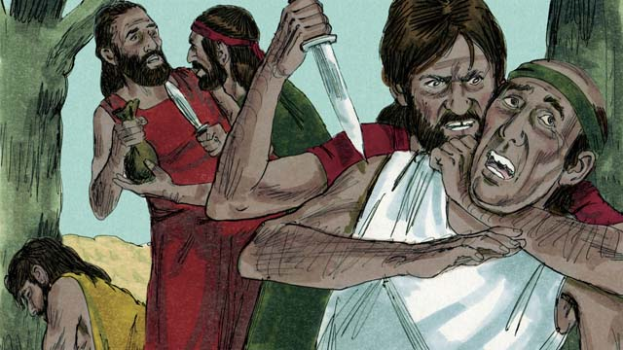

After a long time, many people were living in the world. They had become very wicked and violent. It became so bad that God decided to destroy the whole world with a huge flood.

03-02

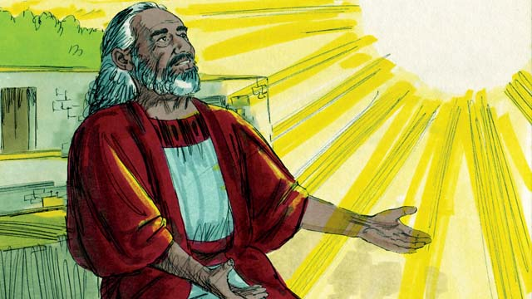

But God was pleased with Noah. He was a righteous man living among wicked people. God told Noah that he was going to make a big flood. Therefore, he told Noah to build a huge boat.

03-03

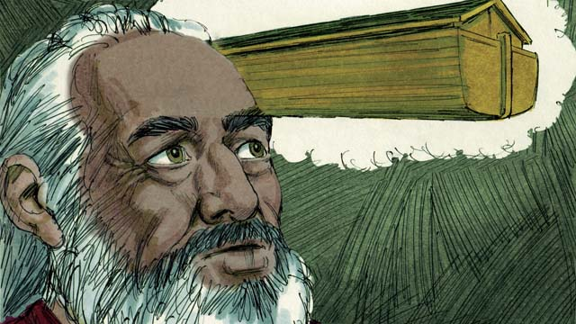

God told Noah to make the boat about 140 meters long, 23 meters wide, and 13.5 meters high. Noah was to build it with wood and to make three levels, many rooms, a roof, and a window. The boat would keep Noah, his family, and every kind of land animal safe during the flood.

03-04

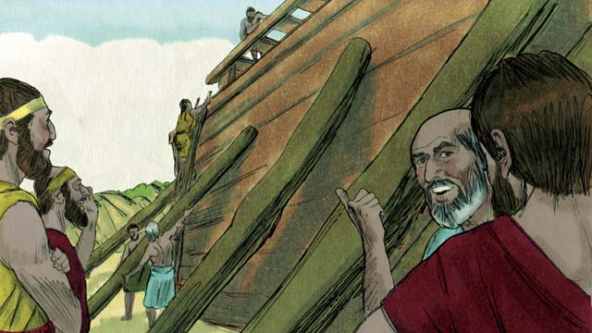

Noah obeyed God. He and his three sons built the boat just the way God had told them. It took many years to build the boat because it was so big. Noah warned the people about the flood that was coming and told them to turn to God, but they did not believe him.

03-05

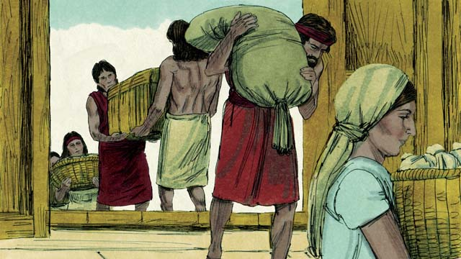

God also commanded Noah and his family to gather enough food for themselves and the animals. When everything was ready, God told Noah it was time for him, his wife, his three sons, and their wives to get into the boat—eight people in all.

03-06

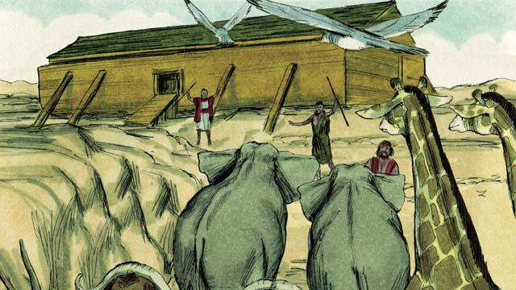

God sent a male and a female of every kind of animal and bird to Noah so they could go into the boat and be kept safe during the flood. God sent seven males and seven females of every kind of animal that could be used for sacrifices. When they were all in the boat, God himself closed the door.

03-07

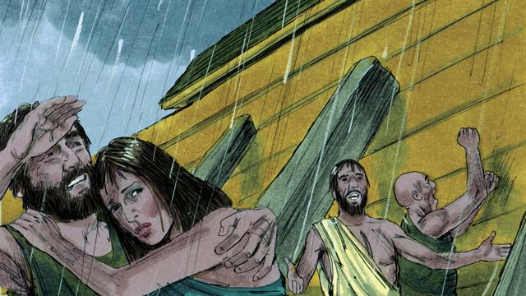

Then it began to rain, and rain, and rain. It rained for 40 days and 40 nights without stopping! Water also came gushing up out of the earth. Everything in the whole world was covered with water, even the highest mountains.

03-08

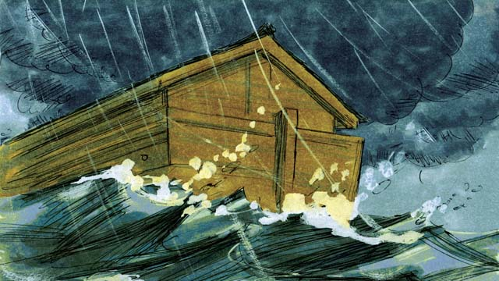

Everything that lived on the dry land died except the people and animals that were in the boat. The boat floated on the water and kept everything inside the boat safe from drowning.

03-09

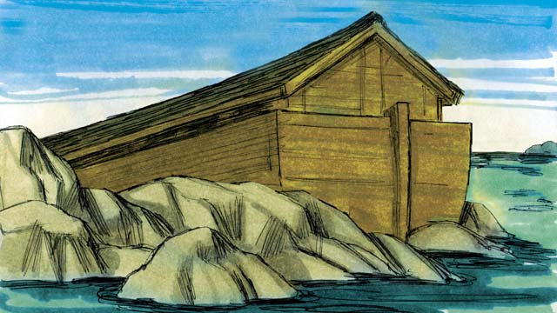

After the rains stopped, the boat floated on the water for five months, and during this time the water started going down. Then one day the boat rested on the top of a mountain, but the world was still covered with water. After three more months, the tops of the mountains were visible.

03-10

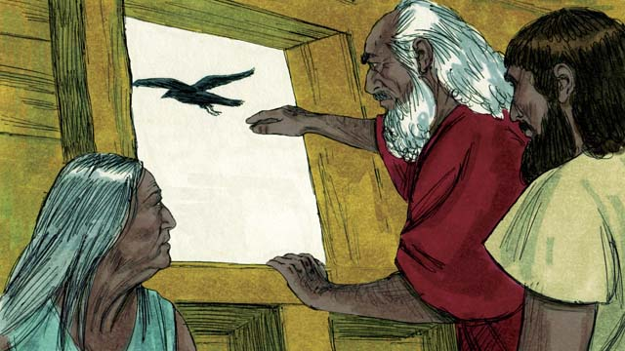

After 40 more days, Noah sent out a bird called a raven to see if the water had dried up. The raven flew back and forth looking for dry land, but it could not find any.

03-11

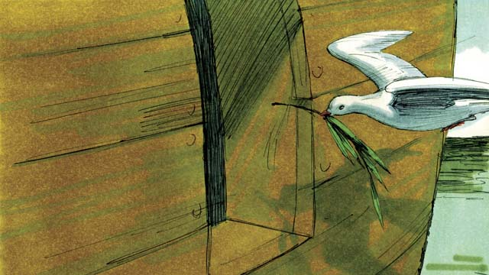

Later Noah sent out a bird called a dove. But it also could not find any dry land, so it came back to Noah. A week later he sent the dove out again, and it came back with an olive branch in its beak! The water was going down, and the plants were growing again!

03-12

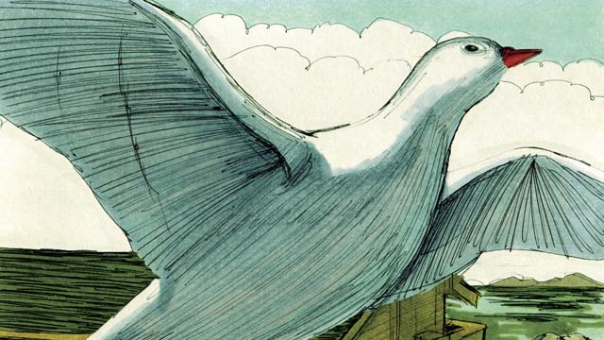

Noah waited another week and sent out the dove a third time. This time, it found a place to rest and did not come back. The water was drying up!

03-13

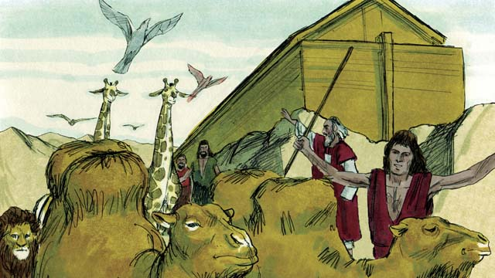

Two months later, God said to Noah, “You and your family and all the animals may leave the boat now. Have many children and grandchildren and fill the earth.” So Noah and his family came out of the boat.

03-14

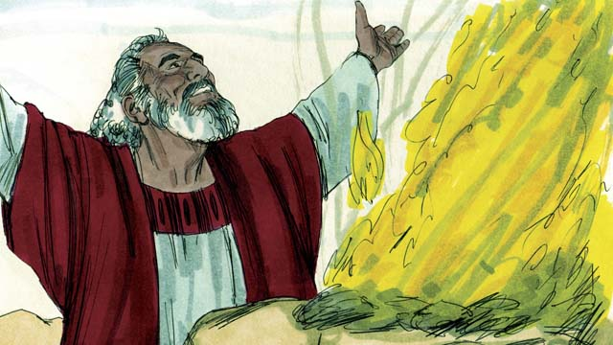

After Noah got off the boat, he built an altar and sacrificed some of each kind of animal that could be used for a sacrifice. God was happy with the sacrifice and blessed Noah and his family.

03-15

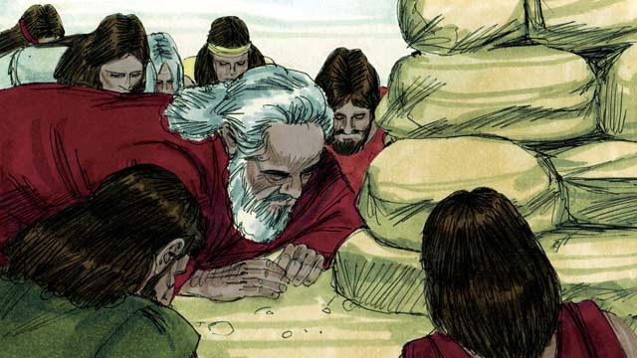

God said, “I promise I will never again curse the ground because of the evil things that people do, or destroy the world by causing a flood, even though people are sinful from the time they are children.”

03-16

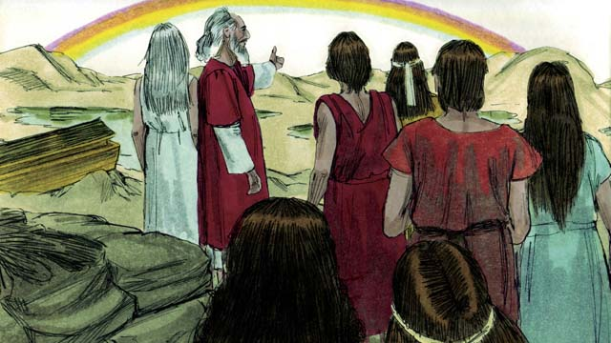

God then made the first rainbow as a sign of his promise. Every time the rainbow appeared in the sky, God would remember what he promised and so would his people.

*A Bible story from: Genesis 6-8*

## 1 Biblical Interpretation: Observing the Details of the Story

After reading the crafted biblical story, answer the following questions to familiarize yourself with the details of the story.

### 1.1 Observation Questions

Answer the following observation questions to gain a basic understanding of the story. Read the story as a community and answer these questions as a group.

#### 03-01

How many people were living in the world at this time?  
Many people were living in the world Why did God decide to destroy the world?  
People had become very wicked and violent.

How did God plan to destroy the world?  
He would send a huge flood.

#### 03-02

What did God think of Noah?  
God was pleased with Noah.

Why kind of man was Noah?  
He was a righteous man.

What did God tell Noah he was going to do?  
God told Noah that he was going to make a big flood.

What did God tell Noah to do?  
God told him to build a huge boat.

#### 03-03

What was the boat supposed to look like?  
Noah was to make the boat out of wood. He was to make it three levels high. The boat was to have many rooms, a door, and a window.

What was the purpose of the boat?  
The boat would keep Noah, his family, and the animals safe during the flood.

#### 03-04

How did Noah respond to God’s instructions?  
Noah obeyed God. He built the boat as God commanded.

How did the other people react when Noah told them that the flood would come?  
They did not believe him.

#### 03-05

What kind of preparations did God tell Noah to make?  
God told Noah to gather food for themselves and the animals.

Who did God tell to enter the ark?  
God commanded Noah and his family—eight people in total—to enter the ark.

#### 03-06

Which animals came into the boat before the flood?  
A male and a female of every kind of animal, and seven males and seven females of every kind of animal that could be used for sacrifice came into the boat.

Who closed the door of the boat after Noah’s family and the animals came inside?  
God closed the door.

#### 03-07

How long did it rain?  
It rained for 40 days and 40 nights.

How high did the water of the flood reach?  
It covered everything in the whole world, even the highest mountains.

#### 03-08

What happened to everything that lived on land?  
Everything died.

What happened to the people and animals in the boat?  
All the people and the animals in the boat were kept safe.

#### 03-09

How long did the boat float on the water for after the rain stopped?  
The boat floated on the water for five months.

Where did the boat eventually rest?  
The boat eventually rested top of a mountain.

When did the mountain tops become visible?  
After three more months, the tops of the mountains became visible.

#### 03-10

What was the first bird that Noah sent out of the ark?  
After forty days, Noah sent a raven out of the boat to see if the water dried up.

Did the raven find dry land?  
No. The raven did not find dry land.

#### 03-11

What was the next bird Noah sent out of the ark?  
Noah sent a dove out of the ark to look for dry land.

Did the dove find dry land?  
No. On its first trip the dove did not find dry land.

What happened on the dove’s second trip?  
After a week, Noah sent the dove out again and it came back with an olive branch.

#### 03-12

How did Noah know the water had dried up?  
He sent out a dove and it did not return.

#### 03-13

What did God tell Noah and his family to do when they left the boat?  
He told them to have many children and grandchildren and to fill the earth.

#### 03-14

How did Noah worship God after he got off the boat?  
He built an altar and sacrificed some of the animals.

What was God’s response to Noah’s sacrifice?  
God was pleased with sacrifice and blessed Noah and his family.

#### 03-15

What did God promise he would never do again?  
He would never again curse the ground or destroy the world with a flood.

#### 03-16

What did God make as a sign of his promise?  
He made a rainbow in the sky.

What did the rainbow signify?  
The rainbow was a sign that God would remember his promise to never destroy the world with a flood.

### 1.2 Translation Questions

Use the following translation questions to understand specific details of the passage. Discuss how you might translate these specific elements of the story.

#### 03-01

**very wicked** At this time human beings had become evil and did things that disobeyed God’s command. In what kind of situations would describe someone as **very wicked**? How would express **very wicked** to mean humans were extremely sinful and disobeyed God a lot?

  

**violent** At this time human beings were mistreating each other and causing each other harm. How would would express **violent** to mean humans were sinful and harmed one another?

  

**God decided to destroy** This does not mean that the earth would be destroyed completely. Rather God planned to destroy all the people who had rebelled against him and who had caused such evil and violence. This flood would also kill all the land animals and the birds. How would you express **God decided to destroy** to mean God determined to bring the earth to ruin as punishment for human evil?

  

**a huge flood** This flood was very deep water that would cover the earth, even in places where the ground was normally dry, and even covering the tops of the highest mountains. God planned to cause deep water to cover the earth by sending a lot of rain. How would you translate **a huge flood** to mean that very deep water covered the earth?

  

#### 03-02

**God was pleased with Noah** **God was pleased with Noah** because he feared and obeyed God. So even though Noah was not sinless, God was gracious to him and made a plan to rescue his family from the devastating flood. This does not mean Noah was lucky or that he just happened to escape. How would you express **God was pleased with Noah** to mean God approved of the way Noah lived?

  

**a righteous man** The term righteous describes a person who obeys God and is morally good. However, because all people have sinned, no one except God is completely righteous. How would you translate **a righteous man** to mean Noah was a man who was upright and obeyed God?

  

#### 03-03

**the boat** The boat was big enough to carry eight people, two of every kind of animal, and their provisions for almost a year. What words in your language mean boat as in a covered vessel made of wood that can float on top of water?

  

**safe** God had Noah build the boat to protect Noah, his family, and the animals from the flood. Everyone and everything else on land died. How would you translate **safe** to mean Noah, his family, and the animals were kept alive in the boat?

  

#### 03-04

**Noah warned the people** To warn means to tell someone about danger thing that is going to happen so that they can escape. Noah told everyone that God planned to destroy the world because of sin. How would you translate **Noah warned the people** to mean told the people about the destruction of the flood before it happened?

  

**to turn to God** This means that they should stop sinning and start obeying God. How would you phrase **to turn to God** to mean the people stopped disobeying God and starting obeying him?

  

#### 03-05

**commanded** To command means to give an order or instruction for someone else to follow. Noah was righteous because he obeyed God’s commands. How would you translate **commanded** to mean that someone with authority told someone to do something?

  

#### 03-06

**God sent** Noah did not need to find the animals. **God sent** them to him. How would you express **God sent** to mean that God caused the animals to come to Noah?

  

**every kind of animal and bird** God sent a male and female of every kind of land animal and bird that could not live in the water. Water animals did not need to go onto the boat. How would you say **every kind of animal and bird** to mean animals that lived on land and in the sky?

  

**used for sacrifices** In this story, a sacrifice involves an animal slaughtered as an offering to God. God had decided that people should sacrifice animals to him, but he only permitted them to sacrifice certain kinds of animals. How would you translate **used for sacrifices** to mean these particular animals would be accepted by God when they were slaughtered as an offering to God?

  

**God himself closed the door** This emphasizes that it was God who shut the door. God not only sent the animals but he closed the door to protect those in the boat. How would you express **God himself closed the door** to mean God shut the door of the boat and this was not something Noah or his family did?

  

#### 03-07

**rain, and rain, and rain** This emphasizes that there was an unusual, extreme amount of rain. Other languages may have a different way of emphasizing this. How would you translate **rain, and rain, and rain** to be mean there was a lot of rain for a long period of time?

  

**the whole world was covered** This refers to all the earth being covered with water from the flood. Even the tops of the mountains were covered with water. How would you translate **the whole world was covered** to mean that deep water covered all the dry land of the earth?

  

#### 03-08

**died** All the people and animals on the earth **died**. Only the people and animals on the boat were kept alive. What words in your language mean **died** as in to no longer be physically alive?

  

**floated to float means to stay on top of water without sinking.** What words in your language mean floated as in to stay on the surface of water without sinking?

  

#### 03-09

**the rains stopped** At this time it stopped raining. How would you express **the rains stopped** to mean rain was no longer falling from the sky.

**the boat rested** There was so much water from the rain that it covered the mountains. The ship floated over the mountains, and when the water started to go down, the ship went down with the water and settled on a mountain. How would you express **the boat rested** to mean the boat stayed on the top of a mountain?

  

**visible** After three months, the tops of the mountains appeared and were able to be seen because the water had gone down enough so that Noah and his family could clearly see the tops of the mountains. How words in your language mean **visible** to mean something that is able to be seen?

  

#### 03-10

**a raven** This is a black bird that flies and eats a variety of plant and animal foods, including the rotting flesh of dead animals. What words in your language mean **a raven** as in a black bird that tends to be a scavenger?

  

**water had dried up** Noah sent the raven to see if the water had gone done enough for the dry land to appear. How would you phrase water had dried to mean water going down enough to see the dry ground?

  

#### 03-11

**a dove** This is a small white or gray flying bird that eats seeds or fruit and makes a cooing sound. What words in your language mean dove as in a small white or gray bird that eats seeds and fruit?

  

**an olive branch** An olive in a small, round fruit that has a sharp and bitter taste and a hard pit. An olive tree’s fruit contains oil which people use for cooking or putting on their skin. What words in your language mean **an olive branch** as in a branch from a tree that produces olives?

  

**The water was going down** At this time, the water was getter lower. How would you express in your language the water was going down to mean the water was going away?

  

#### 03-12

**waited another week** A week is a seven-day period of time. Noah did not send out the dove again for another seven days. Noah was allowing time for the floodwaters to go down before sending out the dove again. How would you say **waited another week** to mean that Noah allowed for seven more days to pass before sending out the dove a third time?

  

#### 03-13

**leave the boat** God told Noah, his family, and the animals to go out of the boat. How would you express **leave the boat** to mean to go out of the boat as in exiting through a door?

  

**fill the earth** God gave the command for Noah and his family to have many children and grandchildren. How would you express **fill the earth** to mean to cause the earth to be full of humans in different places?

  

#### 03-14

**animal that could be used for a sacrifice** God did not accept any animal as a sacrifice. These animals were certain animals God approved for sacrifice. How would you express **animal that could be used for a sacrifice** to mean those animals God allowed people to offer as a sacrifice?

  

**God was happy** God was pleased with Noah for sacrificing these animals. How would you phrase **God was happy** to mean that God approved of the animal sacrifices that Noah offered to God?

  

#### 03-15

**promise** To **promise** means to say something that is guaranteed to happen. God gave an oath that he would never destroy the earth with a flood again. How would you translate **promise** to mean God said something that he guaranteed would happen?

  

**people are sinful from the time they are children** Humans are sinful their entire lives. No one is born into the world without sin. How would you phrase **people are sinful from the time they are children** to mean people do sinful things their entire lives?

  

#### 03-16

**rainbow** This is the multicolored arc of light that often appears in the sky after a rainstorm. How words in your language mean **rainbow** as in a many-colored arc that is visible in the sky after it rains?

  

**a sign** A sign is something (such as an object or event) that gives a certain meaning or which points to something that is true or will happen. The rainbow was **a sign** that reminded people of God’s promise to never destroy the earth with a flood ever again. What words in your language mean **a sign** as in an object or event that shows the meaning of something else?

  

## 2 Theological Dialogue: Discussing the Meaning of the Story

Take time to explore the meaning of this story together as a community. Use the following discussions as a way to grasp what truth the story teaches.

### 2.1 Discourse Questions

Use the following discourse questions to understand the meaning of the story. Pay attention to how the story itself addresses each question or theme.

##### At this point in human history, what were human beings like? (03-01, 03-02, 03-04, 03-15)

There were many people in the world. Humans had reproduced and produced many children. (03-01)

  

People also became more evil. People did wicked things. They disobeyed God’s commands and killed one another. (03-01, 03-02, 03-15)

  

The world became so bad God decided to destroy living things with a flood. (03-01)

  

People did not listen to Noah’s warning. (03-04)

  

People are sinful since the time they are children. (03-15)

  

##### How was Noah different from others in his generation? (03-02, 03-03, 03-04, 03-05, 03-14)

God was pleased with how Noah lived. (03-02)

  

Noah was righteous. He did what was morally right and did not do wicked things like other people. (03-02)

  

God commanded Noah to do things and Noah obeyed. Noah did things just the way God told him to. (03-02, 03-03, 03-04)

  

Noah warned other people about God’s judgment. He believed God enough to warn others of the flood that was coming. (03-04)

  

Noah gathered enough food for himself and the animals. (03-05)

  

Noah and his family got into the boat when God told him to. (03-05)

  

After Noah left the boat, he built an altar and offered a sacrifice to God. (03-14) God was pleased with Noah’s sacrifice and God blessed Noah and his family. (03-14)

  

##### What kind of judgment did God bring on human beings and the world? (03-07, 03-08)

God caused it to rain for 40 days and 40 nights until all the dry ground was covered with water. Even the mountain tops were covered with water. (03-07)

  

All the people and animals that lived on dry land died. (03-08)

  

##### How did God protect and provide for Noah and his family? (03-03, 03-04, 03-06, 03-08, 03-09, 03-11, 03-12, 03-13)

God had Noah build a huge boat that would keep him, his family, and the animals safe during the flood. While everything else on earth died God kept Noah, his family, and the animals safe in the huge boat. (03-03, 03-04, 03-08)

  

God caused the animals to come into the boat. This would have been impossible for Noah to do without God’s help. (03-06)

  

God closed the door of the boat. God made sure that those in the boat were secured safely and those outside could not get in. (03-06)

  

The deep water started to go down. At one point, the boat rested on the top of a mountain. (03-09)

  

The water eventually went down so that plants started growing. God had destroyed living things on the earth. Now he was giving his creation a new start. (03-11, 03-12)

  

God sent Noah, his family, and the animals out of the boat. He told them have children and grandchildren. (03-13). This is a similar command God gave to the first humans when they were created (cf. 01-15)

  

##### What was the purpose of God’s promise? (03-15, 03-16)

God promised to never destroy the earth again with a flood. God established a relationship with his people based on his promise. God always keeps his promises. (03-15)

  

God put a rainbow in the sky as a sign that he would always remember his promise to never destroy the earth with a flood the same way again. God gave the rainbow to remind people that God keeps his promises. (03-16)

  

### 2.2 Theological Questions

Answer the following theology questions as a community. Discuss what truths this story teaches.

1. How sinful are humans? How does the flood story give us insight into the sinful condition of humans?
2. What does it mean to live a life that pleases God? How does Noah teach us about this?
3. What does it look like to live a life that trusts in God’s promises? What does this story teach us about God’s promise (both his promise to judge and his promise to save)?

### 2.3 Translation Draft

Work as a translation team to draft each panel of this story. Pay attention to any specific translation issues that are challenging or significant.

#### Make Translation Draft

Make a draft for each section of this story.

#### Discuss and Revise

After drafting the story, discuss any translation issues that you think need special explanation.

#### Drafting Summary Reflection

Summarize any noteworthy translation decisions and the rationale/reasoning behind these translation decisions. In the final movement of this class, you will use these observations to give an account (i.e., chronicle/narrate) of how your translation improved through the checking process.

## 3 Personal Reflection: Following the Teaching of the Story

Take a moment to allow this story to evaluate your own life and to consider how God would have you respond. After this reflection, use the quality checking questions to check your translation draft among the translation team.

### 3.1 Journal Reflection

Prayerfully think about the following personal reflection questions. Write/Record your answers and/or discuss them as a group.

1. How would you describe the kind of life you are living? Is your life more like Noah (righteous) or the rest of the people (wicked)?
2. How have you responded to God’s warning that he will judge sin?
3. How can you make sure that you are safe when God judges the world?
4. How would your life look different if you trusted God’s promises?

### 3.2 Team Check

*The following activity will help you check the clarity, accuracy, and naturalness of your draft. Read the passage aloud and discuss the checking questions with other members of your translation community. You might need to reread portions (or the whole) of the biblical passage multiple times as you answer each of these questions. Record answers to these questions below.*

#### Team Checking Questions

*Use the following questions to check your translation draft for accuracy, clarity, and naturalness.*

1. **Accurate**: Has anything been **added** to your translation of this passage that is not a part of the meaning of the source text? *If additions exist, are they included only added to clarify meaning (such as implied information)?*
2. **Accurate**: Is anything **missing** from your translation of this passage that is a part of the meaning of the source text? *If some part of the meaning is missing from your translation, add it.*
3. **Accurate**: Does any meaning in your translation of this passage appear to be **different** than the meaning of the source text? *If the meaning is different, try changing your translation so that the meaning remains the same.*
4. **Natural**: Does anything sound **unnatural** to how you would say it in your language? *If portions of the passage sound unnatural in your language, try to make them sound the way you would say it in your language while staying true to the meaning of the source text.*
5. **Clear**: Is anything **unclear** or **confusing** in your translation that confuses the meaning of the source text? *If portions of the passage are unclear or confusing, revise them to clearly communicate the meaning of the source text.*
6. **Consistent**: How **consistent** is your translation within the passage and with other passages? *If portions of the passage need to be made consistent or if you need to revise translations of other passages, make these adjustments.*

#### Record Feedback

*After discussing the checking questions above as a translation community, record any feedback on your translation draft. Pay attention for parts of your translation that are translated well and parts of your translation that need correction.*

#### Discuss and Revise

*After gathering feedback on your draft, discuss it together with your translation community and make appropriate revisions in your translation.*

#### Checking Summary Reflection

*Summarize any noteworthy translation decisions (things you corrected or affirmed in your draft) and the rationale/reasoning behind these translation decisions. In the final movement of this class, you will use these observations to give an account (i.e., chronicle/narrate) of how your translation improved through the checking process.*

## 4 Ministry Practice: Serving the Church with the Story

Now that you have a draft of this story, consider how this story can encourage other believers in their faith. After ministering this story to others, you will also perform a community check of your translation draft.

### 4.1 Church Ministry

Reflect on how this story can edify and mature the Christian community. Design a way to minister this story to your church community.

**Ministry Preparation**: Take time to consider how you could minister this story to others. Record some ministry ideas below.

**Ministry Implementation**: Minister this story to a group of believers as you had planned. Use the information in this study to help develop a teaching/lesson or lead a discussion of this story to other believers. Record your ministry plan below.

**Ministry Reflection**: Think about what you learned from ministering this story to other believers. Reflect on your experience below.

### 4.2 Church Community Check

After teaching or ministering this story to the church, check the translation quality with the church community. Record any feedback from your checking experience.

#### Create Checking Questions

You can use **Translation Questions** to check you draft. Each **Translation Question** explains the meaning of a specific part of the story and asks you to consider how you would translate that part of the story in your own language. Change each **Translation Question** into a **Checking Question** by asking the following questions. The first question asks you to identity how each specific phrase was translated in your language. The second question asks people in the church to determine if your translation of the phrase expresses the meaning clearly, accurately, and naturally. Look at the following examples to see how to change **Translation Questions** into **Checking Questions**:

#### Translation Question Example 1

**to proclaim the good news about Jesus** Paul and Silas traveled to Philippi for the purpose of preaching the gospel. The gospel is the good news that Jesus saves people from their sins if they will believe in Jesus. How would you express **to proclaim the good news about Jesus** to mean to tell other people the message about how Jesus can save people from their sins?

#### Translation Question Example 2

**a merchant** Paul and Silas met a woman named Lydia at the place by the river. She owned a business and sold items to make money. How would you express **a merchant** to mean a business owner who sells items for a profit?

#### Translation Question Example 3

**so Paul and Silas baptized them** The jailer and his whole family followed Paul’s instructions. They believed in Jesus. The result of this was Paul and Silas baptized them. How would you express **so Paul and Silas baptized them** to mean the result of the jailer and his family believing in Jesus that Paul and Silas baptized all of them?

You can change these into **Checking Questions** like this:

#### Checking Question Example 1

**to proclaim the good news about Jesus** How did you translate **to proclaim the good news about Jesus**? Does it mean to tell other people the message about how Jesus can save people from their sins?

#### Checking Question Example 2

**a merchant** How did you translate **a merchant**? Does it mean a business owner who sells items for a profit?

#### Checking Question Example 3

**so Paul and Silas baptized them** How did you translate **so Paul and Silas baptized them**? Does it mean the result of the jailer and his family believing in Jesus that Paul and Silas baptized all of them?

#### Record Feedback

*Discuss the* ***Checking Questions*** *with your church community, and record any feedback on your translation draft. Pay attention for parts of your translation that are translated well and parts of your translation that need correction.*

#### Discuss and Revise

*After gathering feedback on your draft, discuss it together with your translation community and make appropriate revisions in your translation.*

#### Checking Summary Reflection

*Summarize any noteworthy translation decisions (things you corrected or affirmed in your draft) and the rationale/reasoning behind these translation decisions. In the final movement of this class, you will use these observations to give an account (i.e., chronicle/narrate) of how your translation improved through the checking process.*

## 5 Missional Outreach: Sharing the Truth of the Story

*After sharing this story with others, check the translation quality with the wider language community. Record any feedback from your checking experience.*

### 5.1 Mission Engagement

*Consider how you will witness this story to unbelievers. Design a way to share this story and engage them in what it teaches about Christianity and the gospel.*

**Witness Preparation**: Take time to consider how you will witness this narrative to unbelievers. Record some ideas below.

**Witness Implementation**: Share this story with an unbeliever. Use the information in this study to help develop a teaching/lesson or lead a discussion of this story to other believers. Record your ministry plan below.

**Witness Reflection**: Think about what you learned from ministering this story to unbelievers. Reflect on your experience below.

### 5.2 Sociolinguistic Check

After sharing this story with the language community, check your translation draft with the surrounding community. Record your observations.

#### Checking Approach

After witnessing this story to unbelievers, use one of the following methods to check the translation of this story. Consider using the **Observation Questions** to check your translation draft or come up with your own quality checking questions.

**Read-Retell Check:** Read your draft to those the community and ask them to retell the passage. Be attentive for any portions of the passage that are unclear, unnatural, or inaccurate.

**Comprehension Questions Checklist:** Read the draft of the passage and ask a list of comprehension questions to make sure the passage is being rightly understood. You can use the **Observation Questions** in this guide or come up with your own questions. Then, record any insights or issues that arise.

**Discussion Group:** Develop key questions to ask about the passage (both formational and translational). Read the passage and have a group discussion about the passage, paying attention to issues that need to be addressed, edited, and revised.

#### Record Feedback

*After sharing your draft with language community, discuss the* ***Observations Questions****, and record any feedback on your translation draft. Pay attention for parts of your translation that are translated well and parts of your translation that need correction.*

#### Discuss and Revise

*After gathering feedback on your draft, discuss it together with your translation community and make appropriate revisions in your translation.*

#### Checking Summary Reflection

*Summarize any noteworthy translation decisions (things you corrected or affirmed in your draft) and the rationale/reasoning behind these translation decisions. In the final movement of this class, you will use these observations to give an account (i.e., chronicle/narrate) of how your translation improved through the checking process.*

## 6 Conclusion

As a translation community, take time to reflect on all that was learned in studying, drafting, and checking this story. Celebrate all that God has taught you as a community. Then, submit your revised draft and checking summaries to network leaders for further review.