Open Bible Stories

Jesus Feeds Thousands of People

## 0 Introduction

### 0.1 Key Idea

The story of Jesus feeding the crowd of five thousand teaches us that Jesus is all-sufficient: he provides for all the needs of his people.

### 0.2 Creedal Verse

“And my God will supply every need of yours according to his riches in glory in Christ Jesus.” Philippians 4:19

### 0.3 Metanarrative Summary

The eternal God created all things in six days. He made a good and perfect world. He made humans in his image to fill the earth and rule over creation. But humans rebelled against God and ruined God’s creation. God set to restore his world through his promise. God made a covenant with Abraham. He promised to bless all nations through Abraham. God kept his promises across the generations. God provided Abraham with a promised child, Isaac. God gave Isaac a wife and she bore twins, Jacob and Esau. God blessed Jacob and his sons, and the blessing continued to the next generation. God rescued Joseph, one of Jacob’s sons, and used him to rescue his family. God caused his people, the Israelites, to multiply in the land of Egypt; eventually, they became slaves. But, God raised up a deliverer, Moses, to deliver his people from their slavery. God judged the Egyptians with harsh plagues; in the final judgment, he passed over his people who covered their doorposts with the blood of a sacrificed lamb. Then, God delivered the Israelites by bringing them out of Egypt and crossing the Red Sea on dry land. God made a covenant with the Israelites and made them his people. God tested Israel in a series of wilderness wanderings and eventually brought his people into the promised land of Canaan. God raised up deliverers to lead Israel and rescue them from their enemies. God formed Israel into a kingdom. He made a covenant with King David and promised to send a king that would rule his people forever. Many of Israel’s kings were evil and the kingdom of Israel divided into two kingdoms. God sent prophets to warn his people of God’s judgment and call them to repent. When Israel did not repent, God sent his people into exile. After many years, he brought them back to the land. Throughout the Old Testament, God promised to send his Messiah to deliver his people form their sin. After many years, the prophet John was born. He would prepare people for the coming Messiah. At the perfect time, God sent his Son, Jesus, to be born of a virgin Mary. When John and Jesus grew up, John baptized Jesus as a sign that Jesus was God’s beloved Son. Jesus endured all manner of temptation without ever sinning. When he was thirty years old, he launched a public ministry of preaching, teaching, and healing. He taught his disciples about the life of compassion, sacrifice, and forgiveness. He performed many miracles: he fed a crowd of five thousand

### 0.4 Open Bible Story: Jesus Feeds Thousands of People

30-01

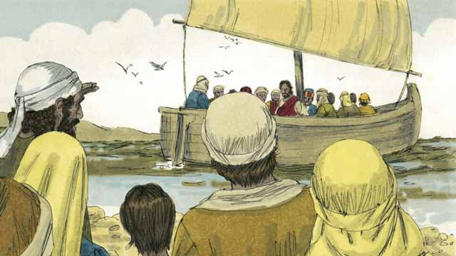

Jesus sent his apostles to preach and to teach people in many different villages. When they returned to where Jesus was, they told him what they had done. Then Jesus invited them to go with him to a quiet place across the lake to rest for a while. So, they got into a boat and went to the other side of the lake.

30-02

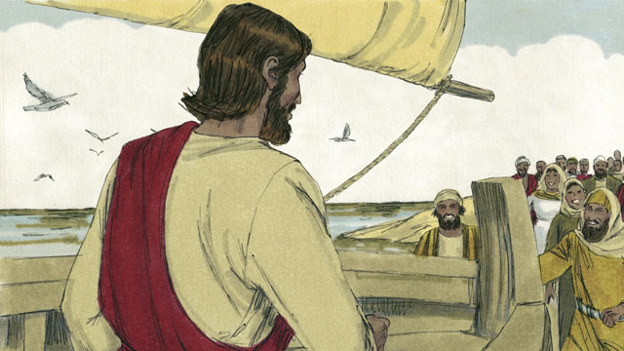

But there were many people who saw Jesus and the disciples leave in the boat. These people ran along the shore of the lake to get to the other side ahead of them. So when Jesus and the disciples arrived, a large group of people was already there, waiting for them.

30-03

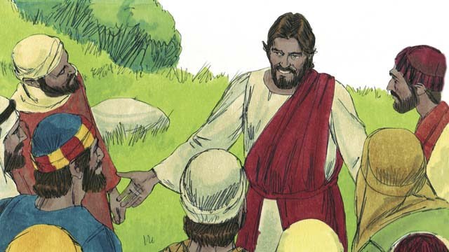

The crowd had over 5,000 men in it, not counting the women and children. Jesus felt great compassion towards the people. To Jesus, these people were like sheep without a shepherd. So he taught them and healed the people among them who were sick.

30-04

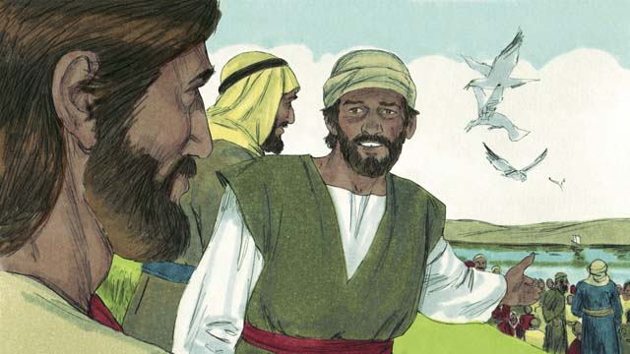

Late in the day, the disciples told Jesus, “It is late and there are no towns nearby. Send the people away so they can go get something to eat.”

30-05

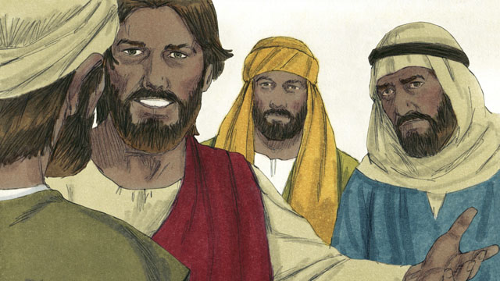

But Jesus said to the disciples, “You give them something to eat!” They responded, “How can we do that? We only have five loaves of bread and two small fish.”

30-06

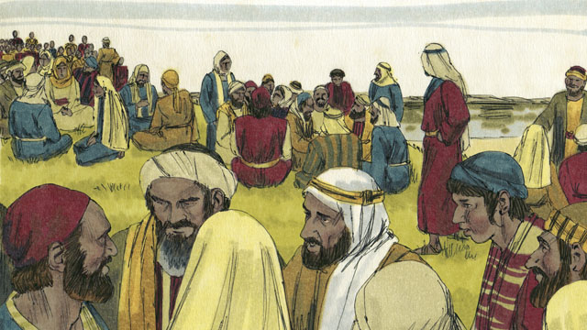

Jesus told his disciples to tell the people in the crowd to sit down on the grass in groups of 50 people each.

30-07

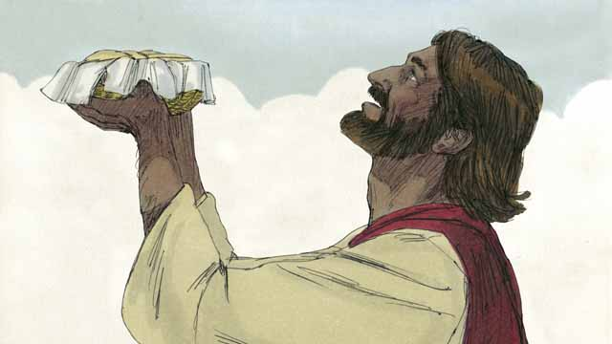

Then Jesus took the five loaves of bread and the two fish, looked up to heaven, and thanked God for the food.

30-08

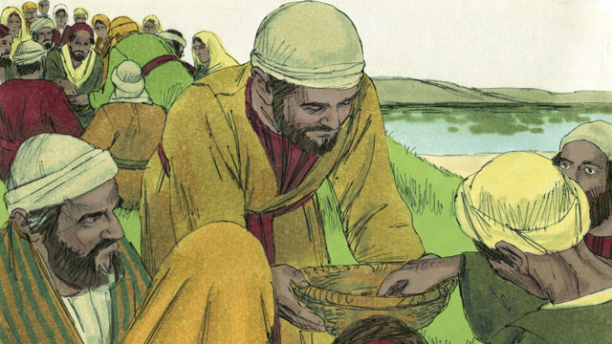

Then Jesus broke the bread and the fish into pieces. He gave the pieces to his disciples to give to the people. The disciples kept passing out the food, and it never ran out! All the people ate and were satisfied.

30-09

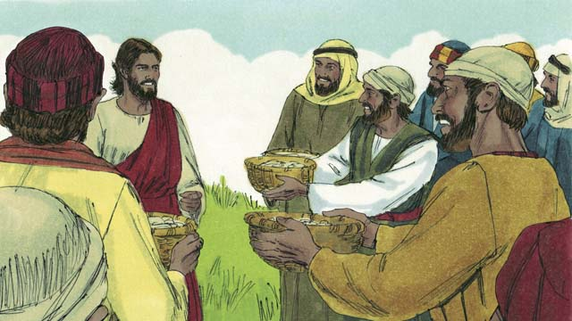

After that, the disciples collected the food that had not been eaten. It was enough to fill 12 baskets! All the food came from the five loaves of bread and two fish.

*A Bible story from: Matthew 14:13-21; Mark 6:31-44; Luke 9:10-17; John 6:5-15*

## 1 Community Study: Do Not Be Surprised—Expecting and Enduring Suffering as a Christian

* **Key Idea**: enduring suffering with Jesus’ peace and provision
* **Key Passage**: 1 Peter 4:12-19
* **Main Session**: OBS 30 (Jesus Feeds Thousands of People)

### 1.1 Recite the Creedal Verse (3–5 minutes)

The verse below summarizes the teaching of the current passage. Read the verse out loud as a community. Read it again several times as a group until the whole community can recite it from memory.

19 My God will meet all your needs according to his riches in glory in Christ Jesus. Philippians 4:19

OR

I have spoken these things to you so that you will have peace in me. In the world you have troubles, but have courage, I have conquered the world. John 16:33

### 1.2 Read the Passage (3–5 minutes)

Disciples of Jesus should expect suffering, hardship, and persecution. As a community, read the following Bible passage together to understand what it means to be committed to Jesus and his work.

12 Beloved, do not regard as strange the testing in the fire that has happened to you, as if something strange were happening to you. 13 Instead, however much you experience the sufferings of Christ, rejoice, so that you may also rejoice and be glad at the revealing of his glory. 14 If you are insulted for Christ’s name, you are blessed, because the Spirit of glory and the Spirit of God is resting on you. 15 But let none of you suffer as a murderer, a thief, an evildoer, or a meddler. 16 But if anyone suffers as a Christian, let him not be ashamed; instead, let him glorify God with that name. 17 For it is time for judgment to begin with the household of God. If it begins with us, what will be the outcome for those who do not obey God’s gospel? 18 And “If it is difficult for the righteous to be saved, what will become of the ungodly and the sinner?” 19 Therefore let those who suffer because of God’s will entrust their souls to the faithful Creator in well-doing. 1 Peter 4:12-19

### 1.3 Discuss the Passage (10-15 minutes)

Believers should not be surprised when they experience suffering. Unbelievers will oppose those who are committed to God and his work. As a community, use the following questions to discuss the teaching of the biblical passage.

1. What does this passage tell us to do when we experience suffering and persecution?
2. What suffering or persecution have you experienced because of your faith in Jesus?
3. How can your community prepare itself to endure suffering as you commit to God and his work?

### 1.4 Remember God’s Provision (5 minutes)

Remember the ways that God has provided for you. Think about how God’s past provision can give you confidence as you face suffering and persecution. Use the following sentence to express your ideas.

God provided for me in this way… This gives me the confidence to face suffering and persecution because…

### 1.5 Pray to God (5 minutes)

Pray that God would make your community prepared for suffering and persecution. If anyone is facing suffering and persecution at the present time, have the community pray for those specific needs.

### 1.6 Sing a Song (3–5 minutes)

Choose a song to sing to praise God and encourage one another.

## 2 Biblical Interpretation: Observing the Details of the Story

After reading the crafted biblical story, answer the following questions to familiarize yourself with the details of the story.

### 2.1 Observation Questions

Answer the following observation questions to gain a basic understanding of the the story. Read the story as a community and answer these questions as a group.

#### 30-01

What did Jesus send his apostles to do in the villages?  
He sent them to preach and teach.

What did the disciples tell Jesus when they returned?  
When the disciples returned, they told Jesus what they had done.

Why did Jesus take his apostles to the other side of the lake?  
He invited them to a quiet place to rest for a while.

How did Jesus and his disciples travel to the other side of the lake?  
They got into a boat and went to the other side of the lake.

#### 30-02

What did the crowd do when they saw Jesus and his disciples leave?  
Many people saw Jesus and his disciples leave in the boat and they ran along the shore to get to the other side.

Were Jesus and his apostles able to be alone and rest?  
No, many people ran to the other side ahead of them and were waiting for them to arrive.

#### 30-03

How big was the crowd of people?  
The crowd had over 5,000 men in it, not counting the women and children.

What was Jesus’ attitude toward the crowd that was waiting for them?  
He felt great compassion towards them, seeing the people like sheep without a shepherd.

How did Jesus demonstrate his compassion for the people?  
He taught them and healed the sick.

#### 30-04

Why did the disciples want to send the people away?  
It was late in the day and there were no towns nearby so they wanted to send the people away to get something to eat.

#### 30-05

How did Jesus respond to the disciples when they wanted to send the people away to get food?  
Jesus told the disciples to give them something to eat.

What did the disciples say to Jesus’ instruction to feed the crowd of people?  
The disciples asked how they could feed them.

Why were the disciples unable to feed all the people?  
They only had five loaves of bread and two small fish.

#### 30-06

What did Jesus tell his disciples to do with the crowd of people?  
Jesus told his disciples to tell the people to sit down in the grass in groups of 50 people.

#### 30-07

What did Jesus do with the five loaves of bread and the two fish?  
He looked up to heaven and thanked God for the food.

#### 30-08

What did Jesus do with the five loaves of bread and the two fish after he broke them?  
He thanked His Father in heaven, and gave the pieces to his disciples so they could give them to the people.

How many people ate from he five loaves of bread and two fish?  
The disciples kept passing out the food, and it never ran out. All the people ate and were satisfied.

#### 30-09

What did the disciples do with the left over food?  
The disciples collected the food that had not been eaten.

How much food was left over after everyone had eaten?  
There was enough to fill 12 baskets.

Where did all the food come from?  
All the food came from the five loaves of bread and the two fish.

### 2.2 Translation Questions

Use the following translation questions to understand specific details of the passage. Discuss how you might translate these specific elements of the story.

#### 30-01

**preach** Jesus sent his disciples to announce the message of the gospel to others in various villages. This message is good news that God’s kingdom had arrived and that people should repent of their sins and come to follow Jesus as the promised Messiah. How would you express **preach** to mean proclaim or announce a message?

  

**teach** Jesus also sent his disciples to explain how to live in God’s kingdom. How would you express **teach** to mean to instruct people how to live in God’s ways?

  

**a quiet place** Jesus and his disciples were busy in ministering to others. Jesus invited his disciples to come to a remote place where there would could have a break from the noise and demands of people. How would you express **a quiet place** to mean a place with few people where they could be by themselves?

  

#### 30-02

**to get to the other side ahead of them** The large crowd of people ran along the shore of the lake to get to the other side of the lake before Jesus and his disciples arrived by boat. How would you express **to get to the other side ahead of them** to mean to arrive on the other side of the lake before Jesus and his disciples arrived?

  

**when Jesus and the disciples arrived** Jesus and his disciples used a boat to travel across the lake. At the time Jesus and his disciples got to the other side of the lake, the large group of people had already came to the other side of the lake by traveling along the shore. How would you express **when Jesus and the disciples arrived** to mean the large crowd of people had already reached the other side of the lake traveling on the shoreline at the time Jesus and his disciples got to the other side of the lake by boat?

  

#### 30-03

**not counting the women and children** The number of men in the crowd was over 5,000. There were also many women and children in addition to the men. This number did not include women and children who were also there. This means the size of the crowd was much larger than 5,000 people. How would you express **not counting the women and children** to mean **not counting the women and children** who were also with there in addition to the men?

  

**Jesus felt great compassion towards the people** Jesus felt deep concern for the people. He felt pity for them because they were experiencing hard and painful situations. How would you express **Jesus felt great compassion towards the people** to mean Jesus had a deep feeling of pity and concern for the people because of the hardships and misfortunes they were suffering?

  

**like sheep without a shepherd** When Jesus saw the people, he compared them to sheep who had no shepherd to care for them. Without a shepherd, sheep are easily lost and in danger of enemies/predators. How you express **like sheep without a shepherd** to mean the people were vulnerable and lost, just like sheep are when they have no shepherd to take care of them?

  

#### 30-04

**Late in the day** At this time, the day was almost over and the evening time had almost arrived. How would you express **Late in the day** to mean when it was almost evening?

  

**Send the people away** The disciples politely suggested that Jesus tell the people to go somewhere else where they could find food. Since it was late in the day and there were no towns nearby, the disciples wanted to dismiss the crowd so they would have enough time to travel to a nearby town where they could get food. How would you express **Send the people away** as a polite request to tell the people to go to a town?

  

#### 30-05

**You give them something to eat!** Jesus instructed his disciples to find food for the people to eat. This was a strong and surprising statement since it was late in the day, no towns were nearby, and the crowd was very large. How would you express **You give them something to eat!** as a command to emphasize that the disciples themselves should find food for the people?

  

**How can we do that?** The disciples did not think it was possible for them to find food to feed such a large crowd, especially in the remote place where they were. The disciples are not really expecting Jesus to answer the question. They were expressing that Jesus’ request to feed the large crowd was impossible. How would you express **How can we do that?** to mean we cannot do this impossible thing you have asked us to do?

  

#### 30-06

**to tell the people in the crowd** Jesus told the disciples to instruct the crowd to sit in groups of 50 people. How would you express **to tell the people in the crowd** to mean instruct the group of people gathered there?

  

**to sit down on the grass in groups of 50 people each** Jesus commanded his disciples to speak to the people and have them sit in smaller groups of people. Each group had 50 people in it. How would you express **to sit down on the grass in groups of 50 people each** to mean to gather in smaller groups of 50 people and sit on the ground where there was grass?

  

#### 30-07

**Jesus took the five loaves of bread** Jesus held the five loaves of bread and the two fish in his hands. How would you express **Jesus took the five loaves of bread** to mean grasped the bread and fish his hands?

  

**looked up to heaven** Jesus looked up toward the sky to thank God the Father for the food. The Jews believed that heaven was located above the sky. How would you express **looked up to heaven** to mean Jesus focused his eyes upward toward the sky to speak to God?

  

#### 30-08

**broke the bread and the fish** Jesus separated/ripped the bread and fish into pieces in order to serve it to the people. How would you express **broke the bread and the fish** to mean tore the bread and the fish with his hands?

  

**it never ran out!** In this story, it is surprising and amazing that there was enough food to feed thousands of people from five loaves of bread and two fish. This was a miracle. God caused there to be enough food to feed such a large crowd. How would you express **it never ran out!** as a strong statement that there was always more food left as it was given to the people?

  

**were satisfied** People ate as much food as they needed until they were not hungry anymore. How would you express **were satisfied** to mean no longer hungry?

  

#### 30-09

**the disciples collected the food that had not been eaten** The people ate until they were no longer hungry. There was food left over after the people satisfied their hunger. How would you express **the disciples collected the food that had not been eaten** to mean Jesus’ disciples gathered together the food that was left over after people had eaten enough to satisfy their hunger?

  

**All the food came from the five loaves of bread and two fish** Jesus fed the entire crowd with five loaves of bread and two fish. Normally, this would not be enough to feed such a large crowd. This was a miracle. Jesus caused this food to multiply as he was feeding the crowd. How would you express **All the food came from the five loaves of bread and two fish** to mean Jesus used only five loaves of bread and two fish to feed to entire crowd and have 12 baskets of leftovers (there was not additional food from another source)?

  

## 3 Theological Dialogue: Discussing the Meaning of the Story

Take time to explore the meaning of this story together as a community. Use the following discussions as a way to grasp what truth the story teaches.

### 3.1 Discourse Questions

Use the following discourse questions to understand the meaning of the story. Pay attention to how the story itself addresses each question or theme.

##### How did Jesus and his disciples minister to people? (30-01, 30-02, 30-3)

Preaching and Teaching: Jesus sent his disciples to preach and teach in different villages. They preached the message of the gospel, calling people to repent of their sins and follow Jesus as the Messiah. They taught how followers of Jesus should live as citizens of God’s kingdom. (30-01)

  

Rest: Jesus and his disciples were busy with ministering to a lot of people. He called his disciples to retreat to a place where few people would be so they could rest. Jesus taught his disciples how to have healthy rhythms of rest and ministry. (30-01)

  

Compassion: Jesus had compassion on the crowd. He knew that they were vulnerable and lost, like sheep without a shepherd. They had also traveled quite far to see Jesus. Jesus genuinely and sincerely cared for people. If we want to minister to others, we must have a genuine compassion for them. (30-02, 30-03)

  

Teaching and Healing: Jesus healed the sick and taught people the truth. He ministered to their physical needs and taught them the truth about God. Disciples of Jesus should learn to care for both the physical needs of people and their spiritual condition before God. (30-03)

  

##### What does Jesus teach his disciples about what it means to faithfully follow him? (30-04, 30-05, 30-06, 30-07)

Trust: Late in the day, the disciples requested that Jesus send the people away so they could find something to eat. Jesus told his disciples to get the people something to eat. They thought this was impossible when they only had five loaves of bread and two fish. Jesus was testing his disciples to teach them to trust in him. (30-04, 30-05)

  

Obedience: Jesus gave his disciples instructions to have the crowd sit in groups of 50. Even though the disciples did not understand how Jesus would provide for the crowd, the disciples obeyed Jesus and organized the crowed into these smaller groups. Obeying Jesus is a sign that we really trust him. (30-06)

  

Gratitude: Jesus thanked God the Father for the food. Even though it was a small amount of food, Jesus taught his disciples to be thankful to God and remember that every one of our provisions comes from God. Thankfulness and gratitude is an appropriate response to God. (30-07)

  

##### How did Jesus provide food for the crowd? (30-08, 30-09)

Provision: Jesus divided the food into pieces. The disciples distributed these pieces of food to the people. They kept passing out the food and there continued to be enough food for the whole crowd. The food did not run out. Jesus did something that was miraculous: Jesus provided food for thousands of people with five loaves of bread and two fish. The only way to explain this miracle was that Jesus caused it to happen in his power. (30-08)

  

Satisfaction: The people ate until they were satisfied. With such a small amount of food one would expect everyone to only have small amount to eat. However, Jesus not only fed the whole crowd with a small amount of food, but the people ate until they were no longer hungry. Only Jesus can meet our deepest needs and longings. (30-08)

  

Abundance: The food that was left over filled 12 baskets. This was more food than they had at the beginning. Jesus supplied so much food from these meager portions that there was more after the people finished eating than when they Jesus started dividing up the food. Jesus provides in abundance from meager resources. (30-09)

  

No Limits: All the food came from the five loaves of bread and two fish. No extra food was supplied. Jesus caused this small quantity of food to multiply to feed a large crowd of thousands. Jesus is not limited in what he can provide. (30-09)

  

### 3.2 Theological Questions

Answer the following theology questions as a community. Discuss what truths this story teaches.

1. How should Jesus’ disciples minister to others? What does Jesus’ ministry of preaching, teaching, and healing teach us about serving others in ministry?
2. What does it mean to be a disciple of Jesus? How does this story teach us about what it means to be a faithful disciple of Jesus?
3. In what ways does Jesus meet the needs of his people? What does this story teach us about the person and work of Jesus?

### 3.3 Translation Draft

Work as a translation team to draft each panel of this story. Pay attention to any specific translation issues that are challenging or significant.

#### Make Translation Draft

Make a draft for each section of this story.

#### Discuss and Revise

After drafting the story, discuss any translation issues that you think need special explanation.

#### Drafting Summary Reflection

Summarize any noteworthy translation decisions and the rationale/reasoning behind these translation decisions. In the final movement of this class, you will use these observations to give an account (i.e., chronicle/narrate) of how your translation improved through the checking process.

## 4 Personal Reflection: Following the Teaching of the Story

Take a moment to allow this story to evaluate your own life and to consider how God would have you respond. After this reflection, use the quality checking questions to check your translation draft among the translation team.

### 4.1 Journal Reflection

Prayerfully think about the following personal reflection questions. Write/Record your answers and/or discuss them as a group.

1. How do you think you would have responded if you were among Jesus’ disciples and Jesus asked you to feed the crowd?
2. When can you remember a time when Jesus clearly provided for your needs?
3. What are various ways you need God to provide in your life?
4. How does God want you to grow in your trust, obedience, and thankfulness to Jesus?

### 4.2 Team Check

*The following activity will help you check the clarity, accuracy, and naturalness of your draft. Read the passage aloud and discuss the checking questions with other members of your translation community. You might need to reread portions (or the whole) of the biblical passage multiple times as you answer each of these questions. Record answers to these questions below.*

#### Team Checking Questions

*Use the following questions to check your translation draft for accuracy, clarity, and naturalness.*

1. **Accurate**: Has anything been **added** to your translation of this passage that is not a part of the meaning of the source text? *If additions exist, are they included only added to clarify meaning (such as implied information)?*
2. **Accurate**: Is anything **missing** from your translation of this passage that is a part of the meaning of the source text? *If some part of the meaning is missing from your translation, add it.*
3. **Accurate**: Does any meaning in your translation of this passage appear to be **different** than the meaning of the source text? *If the meaning is different, try changing your translation so that the meaning remains the same.*
4. **Natural**: Does anything sound **unnatural** to how you would say it in your language? *If portions of the passage sound unnatural in your language, try to make them sound the way you would say it in your language while staying true to the meaning of the source text.*
5. **Clear**: Is anything **unclear** or **confusing** in your translation that confuses the meaning of the source text? *If portions of the passage are unclear or confusing, revise them to clearly communicate the meaning of the source text.*
6. **Consistent**: How **consistent** is your translation within the passage and with other passages? *If portions of the passage need to be made consistent or if you need to revise translations of other passages, make these adjustments.*

#### Record Feedback

*After discussing the checking questions above as a translation community, record any feedback on your translation draft. Pay attention for parts of your translation that are translated well and parts of your translation that need correction.*

#### Discuss and Revise

*After gathering feedback on your draft, discuss it together with your translation community and make appropriate revisions in your translation.*

#### Record Translation Decisions

*As a community, discuss some of the most noteworthy translation decisions in your draft. Summarize each decision and explain the reasons your community decided on that translation. You should update these decisions each time you check your draft with various groups of people.*

You should **measure** the quality of your translation draft. You can **record translation decisions** to make it clear why you translated things a certain way. Translation decisions can help your translation team and the surrounding community be a part of the translation process.

How can you know the quality of your translation?

1. **Measure** the translation by marks/standards of quality (i.e., clear, accurate, natural, church-approved)
2. **Test** the translation with others and record feedback and conversations from in the field (i.e., church and community check)
3. **Compare** and **contrast** the translation with the source text (i.e., meaning of text and notes) and alternatives (i.e., other translation choices)
4. **Explain** the reasons why you translated a particular portion of the text.

**Example Sentences That Help Explain Your Translation Decision** Use the following example sentences to help explain your translation decisions:

1. The original text literally **says/means**, so we translated the term in this way…
2. We originally decided to translate **the biblical term** with **this term**, but we changed it because…
3. When our translation team discussed **the biblical term**, this is what we talked about…
4. **The term** is [clear, accurate, natural, consistent] because…
5. The community understands **this term** to mean…
6. We considered these other terms. We did not use **these terms** because…
7. When we checked this in the church, we learned…
8. When we checked this in the community, we learned…

**Example of Translation Decision**

In OBS 01-07 we decided to translate **blessed** like this: [actual translation]. We decided on this translation because of these reasons:

1. The word [actual translation] means to cause good things to happen to someone or something. This term is used when a person desires someone or something to prosper or flourish. This term does not refer to magic or witchcraft.
2. When we checked this word with other believers, they said it describes God showing his kindness and favor on someone or something. These are some of the terms that we did not decide to use…
3. Many of our people will understand this word. When we discussed this phrase with the surrounding community, we discovered it was a natural way to describe God causing good and beneficial things to happen.

## 5 Ministry Practice: Serving the Church with the Story

Now that you have a draft of this story, consider how this story can encourage other believers in their faith. After ministering this story to others, you will also perform a community check of your translation draft.

### 5.1 Church Ministry

Reflect on how this story can edify and mature the Christian community. Design a way to minister this story to your church community.

**Ministry Preparation**: Take time to consider how you could minister this story to others. Record some ministry ideas below.

**Ministry Implementation**: Minister this story to a group of believers as you had planned. Use the information in this study to help develop a teaching/lesson or lead a discussion of this story to other believers. Record your ministry plan below.

**Ministry Reflection**: Think about what you learned from ministering this story to other believers. Reflect on your experience below.

### 5.2 Church Community Check

After teaching or ministering this story to the church, check the translation quality with the church community. Record any feedback from your checking experience.

#### Create Checking Questions

You can use **Translation Questions** to check your draft. Each **Translation Question** explains the meaning of a specific part of the story and asks you to consider how you would translate that part of the story in your own language. Change each **Translation Question** into a **Checking Question** by asking the following questions. The first question asks you to identify how each specific phrase was translated into your language. The second question asks people in the church to determine if your translation of the phrase expresses the meaning clearly, accurately, and naturally. Look at the following examples to see how to change **Translation Questions** into **Checking Questions**:

#### Translation Question Example 1

**to proclaim the good news about Jesus** Paul and Silas traveled to Philippi for the purpose of preaching the gospel. The gospel is the good news that Jesus saves people from their sins if they will believe in Jesus. How would you express **to proclaim the good news about Jesus** to mean to tell other people the message about how Jesus can save people from their sins?

#### Translation Question Example 2

**a merchant** Paul and Silas met a woman named Lydia at the place by the river. She owned a business and sold items to make money. How would you express **a merchant** to mean a business owner who sells items for a profit?

#### Translation Question Example 3

**so Paul and Silas baptized them** The jailer and his whole family followed Paul’s instructions. They believed in Jesus. The result of this was Paul and Silas baptized them. How would you express **so Paul and Silas baptized them** to mean the result of the jailer and his family believing in Jesus that Paul and Silas baptized all of them?

You can change these into **Checking Questions** like this:

#### Checking Question Example 1

**to proclaim the good news about Jesus** How did you translate **to proclaim the good news about Jesus**? Does it mean to tell other people the message about how Jesus can save people from their sins?

#### Checking Question Example 2

**a merchant** How did you translate **a merchant**? Does it mean a business owner who sells items for a profit?

#### Checking Question Example 3

**so Paul and Silas baptized them** How did you translate **so Paul and Silas baptized them**? Does it mean the result of the jailer and his family believing in Jesus that Paul and Silas baptized all of them?

#### Record Feedback

*Discuss the* ***Checking Questions*** *with your church community, and record any feedback on your translation draft. Pay attention to parts of your translation that are translated well and parts of your translation that need correction.*

#### Discuss and Revise

*After gathering feedback on your draft, discuss it together with your translation community and make appropriate revisions to your translation.*

#### Record Translation Decisions

*Update your translation decisions and record any new and noteworthy observations on the quality of your draft.

## 6 Missional Outreach: Sharing the Truth of the Story

*After sharing this story with others, check the translation quality with the wider language community. Record any feedback from your checking experience.*

### 6.1 Mission Engagement

*Consider how you will witness this story to unbelievers. Design a way to share this story and engage them in what it teaches about Christianity and the gospel.*

**Witness Preparation**: Take time to consider how you will witness this narrative to unbelievers. Record some ideas below.

**Witness Implementation**: Share this story with an unbeliever. Use the information in this study to help develop a teaching/lesson or lead a discussion of this story to other believers. Record your ministry plan below.

**Witness Reflection**: Think about what you learned from ministering this story to unbelievers. Reflect on your experience below.

### 6.2 Sociolinguistic Check

After sharing this story with the language community, check your translation draft with the surrounding community. Record your observations.

#### Checking Approach

After witnessing this story to unbelievers, use one of the following methods to check the translation of this story. Consider using the **Observation Questions** to check your translation draft or come up with your own quality checking questions.

**Read-Retell Check:** Read your draft to those the community and ask them to retell the passage. Be attentive to any portions of the passage that are unclear, unnatural, or inaccurate.

**Comprehension Questions Checklist:** Read the draft of the passage and ask a list of comprehension questions to make sure the passage is being rightly understood. You can use the **Observation Questions** in this guide or come up with your own questions. Then, record any insights or issues that arise.

**Discussion Group:** Develop key questions to ask about the passage (both formational and translational). Read the passage and have a group discussion about the passage, paying attention to issues that need to be addressed, edited, and revised.

#### Record Feedback

*After sharing your draft with the language community, discuss the* ***Observations Questions****, and record any feedback on your translation draft. Pay attention to parts of your translation that are translated well and parts of your translation that need correction.*

#### Discuss and Revise

*After gathering feedback on your draft, discuss it together with your translation community and make appropriate revisions to your translation.*

#### Record Translation Decisions

*Update your translation decisions and record and new any noteworthy observations on the quality of your draft.

## 7 Conclusion

As a translation community, take time to reflect on all that was learned in studying, drafting, and checking this story. Celebrate all that God has taught you as a community. Then, submit your revised draft and checking summaries to network leaders for further review.