Open Bible Stories

Jesus Walks on Water

## 0 Introduction

### 0.1 Key Idea

The story of Jesus walking on water teaches us that Jesus has all power of nature and creation.

### 0.2 Creedal Verse

“For by him all things were created, in heaven and on earth, visible and invisible, whether thrones or dominions or rulers or authorities—all things were created through him and for him. And he is before all things, and in him all things hold together.” Colossians 1:16-17

### 0.3 Metanarrative Summary

The eternal God created all things in six days. He made a good and perfect world. He made humans in his image to fill the earth and rule over creation. But humans rebelled against God and ruined God’s creation. God set to restore his world through his promise. God made a covenant with Abraham. He promised to bless all nations through Abraham. God kept his promises across the generations. God provided Abraham with a promised child, Isaac. God gave Isaac a wife and she bore twins, Jacob and Esau. God blessed Jacob and his sons, and the blessing continued to the next generation. God rescued Joseph, one of Jacob’s sons, and used him to rescue his family. God caused his people, the Israelites, to multiply in the land of Egypt; eventually, they became slaves. But, God raised up a deliverer, Moses, to deliver his people from their slavery. God judged the Egyptians with harsh plagues; in the final judgment, he passed over his people who covered their doorposts with the blood of a sacrificed lamb. Then, God delivered the Israelites by bringing them out of Egypt and crossing the Red Sea on dry land. God made a covenant with the Israelites and made them his people. God tested Israel in a series of wilderness wanderings and eventually brought his people into the promised land of Canaan. God raised up deliverers to lead Israel and rescue them from their enemies. God formed Israel into a kingdom. He made a covenant with King David and promised to send a king that would rule his people forever. Many of Israel’s kings were evil and the kingdom of Israel divided into two kingdoms. God sent prophets to warn his people of God’s judgment and call them to repent. When Israel did not repent, God sent his people into exile. After many years, he brought them back to the land. Throughout the Old Testament, God promised to send his Messiah to deliver his people form their sin. After many years, the prophet John was born. He would prepare people for the coming Messiah. At the perfect time, God sent his Son, Jesus, to be born of a virgin Mary. When John and Jesus grew up, John baptized Jesus as a sign that Jesus was God’s beloved Son. Jesus endured all manner of temptation without ever sinning. When he was thirty years old, he launched a public ministry of preaching, teaching, and healing. He taught his disciples about the life of compassion, sacrifice, and forgiveness. He performed many miracles: he fed a crowd of five thousand, he walked on water

### 0.4 Open Bible Story: Jesus Walks on Water

31-01

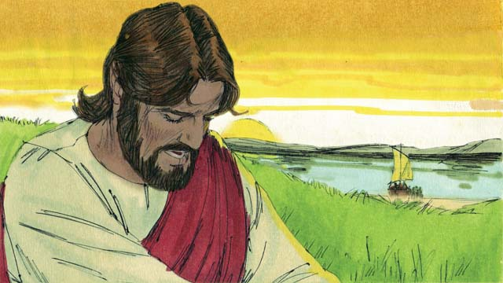

After Jesus fed the crowd, he told the disciples to get into a boat. He told them to sail to the other side of the lake while he stayed behind for a little while. So the disciples left, and Jesus sent the crowd to their homes. After that, Jesus went up on a mountainside to pray. He was there all alone, and he prayed until late at night.

31-02

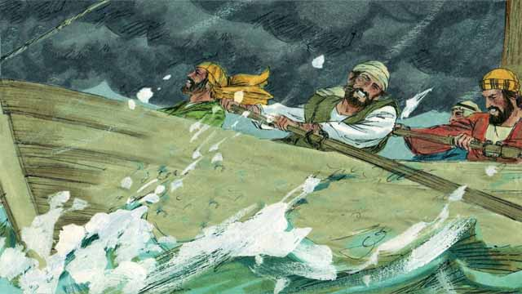

During this time, the disciples were rowing their boat, but the wind was blowing hard against them. When it was late in the night, they had only reached the middle of the lake.

31-03

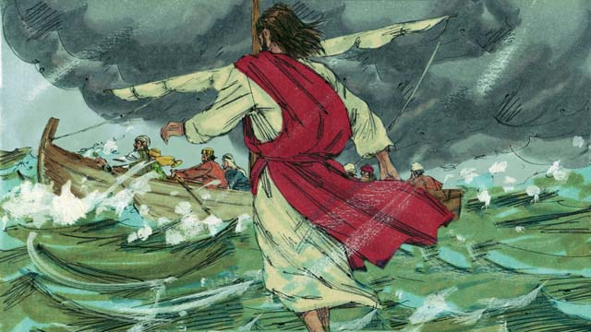

At that time, Jesus finished praying and started to go back to meet his disciples. He walked on top of the water toward their boat.

31-04

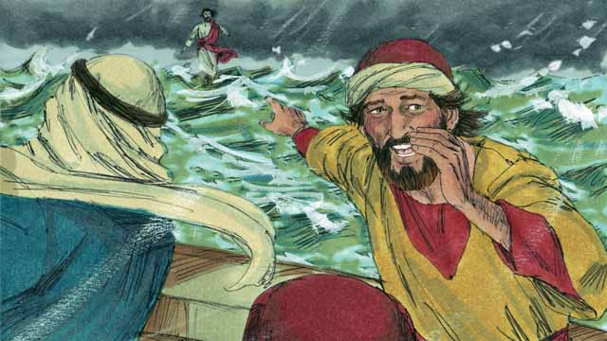

Then the disciples saw him. They were very afraid because they thought he was a ghost. Jesus knew that they were afraid, so he called out to them and said, “Do not be afraid. It is I!”

31-05

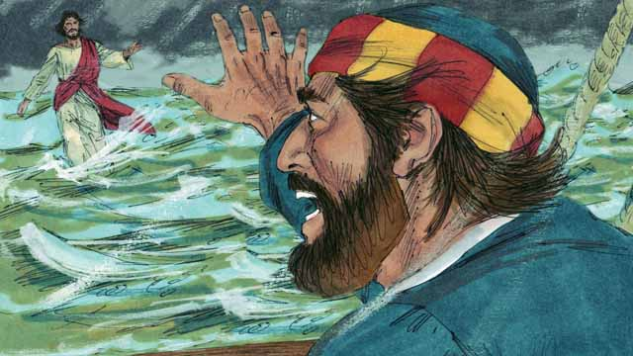

Then Peter said to Jesus, “Master, if it is you, command me to come to you on the water.” Jesus told Peter, “Come!”

31-06

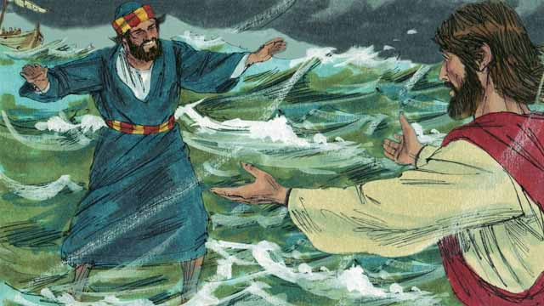

So, Peter got out of the boat and started walking to Jesus on the surface of the water. But after walking a short distance, he turned his eyes away from Jesus and began to look at the waves and to feel the strong wind.

31-07

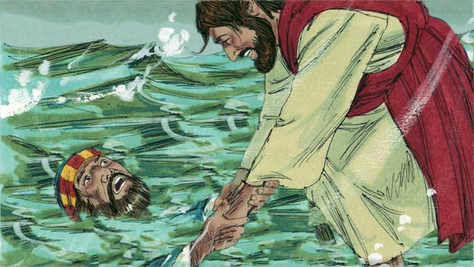

Then Peter became afraid and began to sink in the water. He cried out, “Master, save me!” Right away, Jesus reached out and grabbed him. Then he said to Peter, “You have so little faith! Why did you not trust me to keep you safe?”

31-08

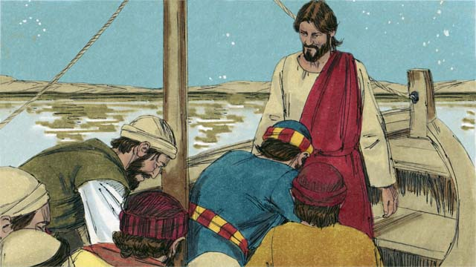

Then Peter and Jesus got into the boat, and the wind immediately stopped blowing. The water became calm. The disciples were amazed and bowed down to Jesus. They worshiped him and said to him, “Truly, you are the Son of God.”

*A Bible story from: Matthew 14:22-33; Mark 6:45-52; John 6:16-21*

## 1 Community Study: We Rejoice—Finding Joy in Suffering

* **Key Idea**: experiencing great joy in the midst of painful suffering
* **Key Passage**: Romans 5:1-5
* **Main Session**: OBS 31 (Jesus Walks on Water)

### 1.1 Pray to God (5 minutes)

Divide the community into groups of 2–3 people. Have each member identify a challenge in their life that they are currently facing. Spend a short time praying for God’s comfort and peace in each of these personal situations.

### 1.2 Sing a Song (3–5 minutes)

Choose a song to sing to praise God and encourage one another.

### 1.3 Recite the Creedal Verse (3–5 minutes)

The verse below summarizes the teaching of the current passage. Read the verse out loud as a community. Read it again several times as a group until the whole community can recite it from memory.

The men marveled and said, “What sort of man is this, that even the winds and the sea obey him?” Matthew 8:27

OR

May the God and Father of our Lord Jesus Christ be praised. He is the Father of mercies and the God of all comfort. God comforts us in all our affliction, so that we can comfort those who are in any affliction. 1 Corinthians 1:3-4

### 1.4 Read the Passage (3–5 minutes)

God provides comfort for his people in the midst of suffering and hardship. As a community, read the following Bible passage together to understand what it means to be committed to Jesus and his work.

1 Since we are justified by faith, we have peace with God through our Lord Jesus Christ. 2 Through him we also have our access by faith into this grace in which we stand, and we rejoice in the certain hope of the glory of God. 3 Not only this, but we also rejoice in our sufferings. We know that suffering produces endurance. 4 Endurance produces character, and character produces certain hope, 5 and that hope does not disappoint because the love of God has been poured into our hearts through the Holy Spirit who was given to us. Romans 5:1-5

### 1.5 Discuss the Passage (10-15 minutes)

Our commitment to God does not depend on our strength. God comforts and strengthens his people in the midst of suffering. As a community, use the following questions to discuss the teaching of the biblical passage.

1. How has Jesus made it possible for humans to have a restored relationship with God?
2. How does this passage tell believers to respond as they go through suffering and hardship?
3. Why can/should believers rejoice while they go through suffering and trials?
4. How can your community develop habits and practices that will encourage each other in the midst of suffering and persecution?

### 1.6 Share Your Thoughts

Read the passage below. Then, think about what it means to endure suffering and hardship. Share your thoughts with the community.

2 Consider it all joy, my brothers, when you experience various troubles. 3 You know that the testing of your faith produces endurance. 4 Let endurance complete its work, so that you may become fully developed and complete, not lacking anything. James 1:2-4

If we endure suffering in a way that pleases God, it would look like this…

## 2 Biblical Interpretation: Observing the Details of the Story

After reading the crafted biblical story, answer the following questions to familiarize yourself with the details of the story.

### 2.1 Observation Questions

Answer the following observation questions to gain a basic understanding of the the story. Read the story as a community and answer these questions as a group.

#### 31-01

What did Jesus tell the disciples to do while he dismissed the crowd?  
He told them to get into a boat and to sail to the other side of the lake.

What did Jesus do after he sent the disciples away in their boat?  
Jesus stayed behind a little while and went up on a mountainside alone to pray.

Who was with Jesus on the mountainside?  
Jesus was all alone.

How long did Jesus pray on the mountainside?  
Jesus prayed there until late at night.

#### 31-02

What problem did the disciples have during the night as they rowed the boat?  
During the night, the disciples rowed the boat, the wind was against them, and they only reached the middle of the lake.

#### 31-03

What did Jesus do after he finished praying?  
After Jesus finished praying, he started to go back to meet his disciples.

How did Jesus get to their boat?  
Jesus walked on top of the water toward the boat.

#### 31-04

How did the disciples react when they first saw Jesus?  
They were very afraid because they thought he was a ghost.

What did Jesus say to them to calm their fear?  
He said, “Do not be afraid. It is I!”

#### 31-05

Why did Jesus tell Peter to come to him on the water?  
Jesus told Peter to come to him because Peter asked him to do that to show that it really was Jesus.

#### 31-06

How did Peter respond to Jesus’ command for Peter to come to him?  
Peter got out of the boat and started walking on the surface of the water.

What did Peter do after walking on the water for a short distance?  
After walking a short distance, Peter turned his eyes away from Jesus.

What did Peter begin to notice when he turned his eyes away from Jesus?  
He began to look at the waves and to feel the strong wind.

#### 31-07

What happened to Peter when he became afraid of the wind and the waves?  
He began to sink into the water. and cried out for Jesus to save him.

What did Jesus do when Peter called out for help?  
Jesus reached out and grabbed Peter.

What did Jesus say as a rebuke to Peter?  
Jesus said, “You have so little faith! Why did you not trust me to keep you safe?”

#### 31-08

What happened after Jesus got into the boat?  
The wind immediately stopped blowing and the water became calm.

How did the disciples respond to this miracle?  
They disciples were amazed. They bowed down to Jesus, worshiped him, and said, “Truly, you are the Son of God.”

### 2.2 Translation Questions

Use the following translation questions to understand specific details of the passage. Discuss how you might translate these specific elements of the story.

#### 31-01

**After Jesus fed the crowd, he told the disciples to get into a boat** In the previous story, Jesus fed the crowd. Following this event, Jesus told his disciples to get into a boat. How would you express **After Jesus fed the crowd, he told the disciples to get into a boat** to mean Jesus told the disciples to get into a boat subsequent to feeding the crowd?

  

**while he stayed behind for a little while** Jesus told his disciple to cross the lake in a boat. During the time the disciples did this, Jesus remained back land for a short time. How would you express **while he stayed behind for a little while** to mean for a short time Jesus remained back on land at the same time the disciples sailed across the lake on a boat?

  

**a mountainside** Jesus went up on the side of a mountain to pray. How would you express **a mountainside** to mean the side of a mountain?

  

#### 31-02

**During this time** The disciples were rowing the boat across the lake at the same time Jesus was praying on the side of the mountain. How would you express **During this time** to mean while Jesus was praying on the mountainside?

  

**the wind was blowing hard against them** The disciples were traveling by boat across the lake. The boat had a sail, but it would not have worked when the wind was against them. So, they needed to row the boat. The wind was moving in the opposing direction they were rowing. How would you express **the wind was blowing hard against them** to mean wind was moving in the opposite direction the disciples were rowing?

  

**they had only reached the middle of the lake** If the wind was calm and the conditions on the water were fare, one would expect the disciples to have made more progress across the lake. The wind blowing against the disciples slowed down their progress across the lake. How would you express **they had only reached the middle of the lake** to mean the disciples were traveling across the lake with difficulty because of the wind and only made it about halfway across the lake?

  

#### 31-03

**At that time** The disciples were in the boat rowing against the wind. When they reached the middle of the lake, it was late in the night. Jesus also finished praying late at night. How would you express **At that time** to mean Jesus finished praying at the time late in the night when the disciples reached the middle of the lake?

  

**He walked on top of the water toward their boat** The boat was in the middle of the lake. Jesus walked across the lake in the direction of the boat. This is a miracle. He walked on the water without sinking. How would you express **He walked on top of the water toward their boat** to mean Jesus walked on the surface of the water across the lake in the direction of the disciples’ boat?

  

#### 31-04

**a ghost** The disciples did not expect to see Jesus. They also did not think that a person could walk on water. So, they thought Jesus was a spirit, since normally a human being cannot walk on water. How would you express **a ghost** to mean a spirit being without a physical body?

  

**Do not be afraid** Jesus told his disciples to not fear. How would you express **Do not be afraid** as a command to stop being afraid?

  

**It is I!** The disciples thought that Jesus was a spirit. Jesus told his disciples to stop being afraid and told them who he was. How would you express **It is I!** to mean “It is me, Jesus”?

  

#### 31-05

**if it is you** At this time, Peter did not fully believe that it was Jesus. To Peter, it seemed more likely that it was a spirit and not Jesus since people/humans do not normally walk on top of water. Peter request that Jesus prove to him that he was really Jesus by telling Peter to come out of the boat and walk on the surface of the water. How would you express **if it is you** to mean if it is really you, and not a ghost?

  

**Come!** Jesus commanded Peter to come to out on the water and walk toward Jesus on the surface of the water like Jesus was doing. How would you express **Come!** as a command to come here and walk to me?

  

#### 31-06

**after walking a short distance** Peter did not walk on top of the water for a long time. When he started walking on the water toward Jesus he was looking at Jesus. Peter only walked a short distance and then he stopped looking at Jesus and started looking at the waves. How would you express **after walking a short distance** to mean Peter only walked a small distance on the water when he stopped looking at Jesus?

  

**turned his eyes away from** After Peter walked a short distance, he looked away from Jesus and starting looking at the waves. How would you express **turned his eyes away from** to mean stopped looking at Jesus?

  

#### 31-07

**Right away, Jesus reached out and grabbed him** Peter started to sink in the water and he called out for Jesus to rescue him. Jesus did not delay and grabbed Peter to keep him from sinking. How would you express **Right away, Jesus reached out and grabbed him** to mean Jesus immediately grasped Peter (without delay) to keep him from sinking?

  

**You have so little faith!** Jesus told Peter that he did not deeply trust Jesus. This strong statement is a rebuke of Peter’s faith. How would you express **You have so little faith!** as a strong statement that rebuked Peter for having very little trust in Jesus?

  

**Why did you not trust me to keep you safe?** Jesus uses a question to tell Peter that he should not have doubted. Peter should have known that Jesus was able to protect him. Jesus is saying that Peter should not have doubted Jesus. How would you express **Why did you not trust me to keep you safe?** as a question that means Peter should not have doubted that Jesus could keep him from sinking?

  

#### 31-08

**The disciples were amazed** The disciples were very surprised at what they saw. Jesus walked on the water, Peter walked on the water, and Jesus rescued Peter from drowning. These were very astonishing events. How would you express **The disciples were amazed** to mean the disciples were completely amazed at what Jesus had done?

  

**Truly, you are the Son of God** The disciples knew with confidence that Jesus was really God’s Son. How would you express **Truly, you are the Son of God** to mean it really is true that you are the Son of God?

  

## 3 Theological Dialogue: Discussing the Meaning of the Story

Take time to explore the meaning of this story together as a community. Use the following discussions as a way to grasp what truth the story teaches.

### 3.1 Discourse Questions

Use the following discourse questions to understand the meaning of the story. Pay attention to how the story itself addresses each question or theme.

##### How did Jesus balance ministry to others, training of his disciples, and personal devotion to God? (31-01, 31-02, 31-03)

Remain on Land: After Jesus fed the crowd of thousands, he told his disciples to cross the lake by boat. He intentionally stayed back on land while they traveled across the lake. Jesus wanted to teach his disciples how to trust him even though he was not physically with them. (31-01)

  

Dismiss Crowds: Jesus dismissed the crowd and sent the people to their homes. Jesus did not always minister to the crowds. (31-01)

  

Prayer/Dependence: Jesus went up to the side of the mountain to pray. He was alone and spent a long time in pray. He prayed until late at night. Jesus modeled for his disciples what it looks like to pray and trust in God the Father. (31-01)

  

Presence: Jesus finished praying and went to meet his disciples in the middle of the lake. Jesus walked on the water to get to their boat. Even if Jesus is not physically present near us, he is present with us. Jesus is able to be anywhere at all times. (31-03)

  

##### What challenges did the disciples face in this story? (31-01, 31-02, 31-04)

In Boat without Jesus Physically Present: Jesus sent the disciples across the lake by boat. He was not physically present with them. The disciples needed to trust and follow Jesus even when he is not physically present. (31-01)

  

Rowing Hard/Facing Opposing Winds: The disciples rowed across the lake. The wind was going in the opposite direction. The disciples had to row hard. They faced challenges and opposition in obeying Jesus’ instructions. (31-02)

  

Slow Progress: The disciples rowed the boat for a long time. Late into the night, the disciples did not make the kind of progress that would be ideal. The opposing winds slowed down their progress and they only made it into the middle of the lake. (31-02)

  

Fear: The disciples were very afraid when they saw Jesus walking on water. They thought he was a ghost. (31-04)

  

##### How did Jesus relate to Peter in a way that revealed who Jesus is? (31-04, 31-05, 31-06, 31-08)

Jesus’ Knowledge: Jesus knew that his disciples were afraid. Jesus is all-knowing and is aware of all that we are experiencing. (31-04)

  

Jesus’ Presence: Jesus called out to his disciples and told them not to be afraid. The reason they did not need to be afraid was because Jesus was present with them. Jesus’ presence calms fears. (31-04)

  

Jesus’ Authority: Jesus commanded Peter to come out and walk on top of the water. Jesus gave a command. Peter submitted himself to Jesus’ command and authority. (31-05)

  

Jesus’ Power: Jesus enabled Peter to do what is normally impossible for humans to do. Jesus’ power caused Peter to walk on the surface of the water. (31-05, 31-06)

  

Son of God: In the end, Peter and the disciples confessed that Jesus is the Son of God. They worshipped Jesus. (31-08)

  

##### How did the Peter and the disciples (positively and negatively) respond to Jesus in this story? (31-06, 31-07, 31-08)

Doubt: Peter started out trusting and obeying Jesus. He walked on the water for a short distance. When Peter took his eyes off of Jesus, he noticed the waves and the wind more than Jesus’ presence. Doubt comes when we stop looking to Jesus. Faith is a continual trust and dependence on Jesus where we look to him for our protection. (31-06)

  

Fear: Peter became afraid and began to sink in the water. Peter became afraid when he stopped looking to Jesus and focused on the wind and the waves. (31-07)

  

Little Faith: Peter had some faith to listen to Jesus and get on top of the water. His faith, however, was small. He started to doubt soon after he was on the water. Peter’s lack of faith caused him to not trust Jesus. (31-07)

  

Obedience: As soon as Peter and Jesus got into the boat, the wind immediately stopped blowing. Jesus can calm the wind and the waves at his will. (31-08)

  

Amazement: The disciples were amazed at what Jesus did. Jesus walked on water. Jesus caused Peter to walk on water. Jesus rescued Peter from drowning. Jesus caused the water to become immediately calm. (31-08)

  

Worship: The disciple bowed down and worshipped Jesus. They realized that Jesus was not just a powerful man or a prophet. Jesus deserves to be worshiped as fully God. (31-08)

  

Confession of Truth: The disciples realized that Jesus is God’s Son. They said that Jesus is truly the Son of God. He is equal to God and deserves worship. (31-08)

  

### 3.2 Theological Questions

Answer the following theology questions as a community. Discuss what truths this story teaches.

1. What are various challenges we experience as a threat to faith? How was the faith of the disciples challenged in this story?
2. How should we rightly understand who Jesus is? What does this story teach us about the identity of Jesus?
3. What does it look like to respond to Jesus in faith? How do the positive and negative responses in this story teach us about the nature of faith?

### 3.3 Translation Draft

Work as a translation team to draft each panel of this story. Pay attention to any specific translation issues that are challenging or significant.

#### Make Translation Draft

Make a draft for each section of this story.

#### Discuss and Revise

After drafting the story, discuss any translation issues that you think need special explanation.

#### Drafting Summary Reflection

Summarize any noteworthy translation decisions and the rationale/reasoning behind these translation decisions. In the final movement of this class, you will use these observations to give an account (i.e., chronicle/narrate) of how your translation improved through the checking process.

## 4 Personal Reflection: Following the Teaching of the Story

Take a moment to allow this story to evaluate your own life and to consider how God would have you respond. After this reflection, use the quality checking questions to check your translation draft among the translation team.

### 4.1 Journal Reflection

Prayerfully think about the following personal reflection questions. Write/Record your answers and/or discuss them as a group.

1. What particular challenges are you facing in your life?
2. How is Jesus calling you to trust him?
3. How do you think you would have responded if you were Peter?
4. What attributes of Jesus are helpful as you learn to trust in Christ?

### 4.2 Team Check

*The following activity will help you check the clarity, accuracy, and naturalness of your draft. Read the passage aloud and discuss the checking questions with other members of your translation community. You might need to reread portions (or the whole) of the biblical passage multiple times as you answer each of these questions. Record answers to these questions below.*

#### Team Checking Questions

*Use the following questions to check your translation draft for accuracy, clarity, and naturalness.*

1. **Accurate**: Has anything been **added** to your translation of this passage that is not a part of the meaning of the source text? *If additions exist, are they included only added to clarify meaning (such as implied information)?*
2. **Accurate**: Is anything **missing** from your translation of this passage that is a part of the meaning of the source text? *If some part of the meaning is missing from your translation, add it.*
3. **Accurate**: Does any meaning in your translation of this passage appear to be **different** than the meaning of the source text? *If the meaning is different, try changing your translation so that the meaning remains the same.*
4. **Natural**: Does anything sound **unnatural** to how you would say it in your language? *If portions of the passage sound unnatural in your language, try to make them sound the way you would say it in your language while staying true to the meaning of the source text.*
5. **Clear**: Is anything **unclear** or **confusing** in your translation that confuses the meaning of the source text? *If portions of the passage are unclear or confusing, revise them to clearly communicate the meaning of the source text.*
6. **Consistent**: How **consistent** is your translation within the passage and with other passages? *If portions of the passage need to be made consistent or if you need to revise translations of other passages, make these adjustments.*

#### Record Feedback

*After discussing the checking questions above as a translation community, record any feedback on your translation draft. Pay attention for parts of your translation that are translated well and parts of your translation that need correction.*

#### Discuss and Revise

*After gathering feedback on your draft, discuss it together with your translation community and make appropriate revisions in your translation.*

#### Record Translation Decisions

*As a community, discuss some of the most noteworthy translation decisions in your draft. Summarize each decision and explain the reasons your community decided on that translation. You should update these decisions each time you check your draft with various groups of people.*

You should **measure** the quality of your translation draft. You can **record translation decisions** to make it clear why you translated things a certain way. Translation decisions can help your translation team and the surrounding community be a part of the translation process.

How can you know the quality of your translation?

1. **Measure** the translation by marks/standards of quality (i.e., clear, accurate, natural, church-approved)
2. **Test** the translation with others and record feedback and conversations from in the field (i.e., church and community check)
3. **Compare** and **contrast** the translation with the source text (i.e., meaning of text and notes) and alternatives (i.e., other translation choices)
4. **Explain** the reasons why you translated a particular portion of the text.

**Example Sentences That Help Explain Your Translation Decision** Use the following example sentences to help explain your translation decisions:

1. The original text literally **says/means**, so we translated the term in this way…
2. We originally decided to translate **the biblical term** with **this term**, but we changed it because…
3. When our translation team discussed **the biblical term**, this is what we talked about…
4. **The term** is [clear, accurate, natural, consistent] because…
5. The community understands **this term** to mean…
6. We considered these other terms. We did not use **these terms** because…
7. When we checked this in the church, we learned…
8. When we checked this in the community, we learned…

**Example of Translation Decision**

In OBS 01-07 we decided to translate **blessed** like this: [actual translation]. We decided on this translation because of these reasons:

1. The word [actual translation] means to cause good things to happen to someone or something. This term is used when a person desires someone or something to prosper or flourish. This term does not refer to magic or witchcraft.
2. When we checked this word with other believers, they said it describes God showing his kindness and favor on someone or something. These are some of the terms that we did not decide to use…
3. Many of our people will understand this word. When we discussed this phrase with the surrounding community, we discovered it was a natural way to describe God causing good and beneficial things to happen.

## 5 Ministry Practice: Serving the Church with the Story

Now that you have a draft of this story, consider how this story can encourage other believers in their faith. After ministering this story to others, you will also perform a community check of your translation draft.

### 5.1 Church Ministry

Reflect on how this story can edify and mature the Christian community. Design a way to minister this story to your church community.

**Ministry Preparation**: Take time to consider how you could minister this story to others. Record some ministry ideas below.

**Ministry Implementation**: Minister this story to a group of believers as you had planned. Use the information in this study to help develop a teaching/lesson or lead a discussion of this story to other believers. Record your ministry plan below.

**Ministry Reflection**: Think about what you learned from ministering this story to other believers. Reflect on your experience below.

### 5.2 Church Community Check

After teaching or ministering this story to the church, check the translation quality with the church community. Record any feedback from your checking experience.

#### Create Checking Questions

You can use **Translation Questions** to check your draft. Each **Translation Question** explains the meaning of a specific part of the story and asks you to consider how you would translate that part of the story in your own language. Change each **Translation Question** into a **Checking Question** by asking the following questions. The first question asks you to identify how each specific phrase was translated into your language. The second question asks people in the church to determine if your translation of the phrase expresses the meaning clearly, accurately, and naturally. Look at the following examples to see how to change **Translation Questions** into **Checking Questions**:

#### Translation Question Example 1

**to proclaim the good news about Jesus** Paul and Silas traveled to Philippi for the purpose of preaching the gospel. The gospel is the good news that Jesus saves people from their sins if they will believe in Jesus. How would you express **to proclaim the good news about Jesus** to mean to tell other people the message about how Jesus can save people from their sins?

#### Translation Question Example 2

**a merchant** Paul and Silas met a woman named Lydia at the place by the river. She owned a business and sold items to make money. How would you express **a merchant** to mean a business owner who sells items for a profit?

#### Translation Question Example 3

**so Paul and Silas baptized them** The jailer and his whole family followed Paul’s instructions. They believed in Jesus. The result of this was Paul and Silas baptized them. How would you express **so Paul and Silas baptized them** to mean the result of the jailer and his family believing in Jesus that Paul and Silas baptized all of them?

You can change these into **Checking Questions** like this:

#### Checking Question Example 1

**to proclaim the good news about Jesus** How did you translate **to proclaim the good news about Jesus**? Does it mean to tell other people the message about how Jesus can save people from their sins?

#### Checking Question Example 2

**a merchant** How did you translate **a merchant**? Does it mean a business owner who sells items for a profit?

#### Checking Question Example 3

**so Paul and Silas baptized them** How did you translate **so Paul and Silas baptized them**? Does it mean the result of the jailer and his family believing in Jesus that Paul and Silas baptized all of them?

#### Record Feedback

*Discuss the* ***Checking Questions*** *with your church community, and record any feedback on your translation draft. Pay attention to parts of your translation that are translated well and parts of your translation that need correction.*

#### Discuss and Revise

*After gathering feedback on your draft, discuss it together with your translation community and make appropriate revisions to your translation.*

#### Record Translation Decisions

*Update your translation decisions and record any new and noteworthy observations on the quality of your draft.

## 6 Missional Outreach: Sharing the Truth of the Story

*After sharing this story with others, check the translation quality with the wider language community. Record any feedback from your checking experience.*

### 6.1 Mission Engagement

*Consider how you will witness this story to unbelievers. Design a way to share this story and engage them in what it teaches about Christianity and the gospel.*

**Witness Preparation**: Take time to consider how you will witness this narrative to unbelievers. Record some ideas below.

**Witness Implementation**: Share this story with an unbeliever. Use the information in this study to help develop a teaching/lesson or lead a discussion of this story to other believers. Record your ministry plan below.

**Witness Reflection**: Think about what you learned from ministering this story to unbelievers. Reflect on your experience below.

### 6.2 Sociolinguistic Check

After sharing this story with the language community, check your translation draft with the surrounding community. Record your observations.

#### Checking Approach

After witnessing this story to unbelievers, use one of the following methods to check the translation of this story. Consider using the **Observation Questions** to check your translation draft or come up with your own quality checking questions.

**Read-Retell Check:** Read your draft to those the community and ask them to retell the passage. Be attentive to any portions of the passage that are unclear, unnatural, or inaccurate.

**Comprehension Questions Checklist:** Read the draft of the passage and ask a list of comprehension questions to make sure the passage is being rightly understood. You can use the **Observation Questions** in this guide or come up with your own questions. Then, record any insights or issues that arise.

**Discussion Group:** Develop key questions to ask about the passage (both formational and translational). Read the passage and have a group discussion about the passage, paying attention to issues that need to be addressed, edited, and revised.

#### Record Feedback

*After sharing your draft with the language community, discuss the* ***Observations Questions****, and record any feedback on your translation draft. Pay attention to parts of your translation that are translated well and parts of your translation that need correction.*

#### Discuss and Revise

*After gathering feedback on your draft, discuss it together with your translation community and make appropriate revisions to your translation.*

#### Record Translation Decisions

*Update your translation decisions and record and new any noteworthy observations on the quality of your draft.

## 7 Conclusion

As a translation community, take time to reflect on all that was learned in studying, drafting, and checking this story. Celebrate all that God has taught you as a community. Then, submit your revised draft and checking summaries to network leaders for further review.