Open Bible Stories

Jesus Heals a Demon-Possessed Man and a Sick Woman

## 0 Introduction

### 0.1 Key Idea

The story of Jesus healing the demon-possessed man and a sick woman teaches us that Jesus has power over the spiritual world and sickness.

### 0.2 Creedal Verse

“For in him the whole fullness of deity dwells bodily, and you have been filled in him, who is the head of all rule and authority.” Colossians 2:9-10

### 0.3 Metanarrative Summary

The eternal God created all things in six days. He made a good and perfect world. He made humans in his image to fill the earth and rule over creation. But humans rebelled against God and ruined God’s creation. God set to restore his world through his promise. God made a covenant with Abraham. He promised to bless all nations through Abraham. God kept his promises across the generations. God provided Abraham with a promised child, Isaac. God gave Isaac a wife, and she bore twins Jacob and Esau. God blessed Jacob and his sons, and the blessing continued to the next generation. God rescued Joseph, one of Jacob’s sons, and used him to rescue his family. God caused his people, the Israelites, to multiply in the land of Egypt; eventually, they became slaves. But God raised up a deliverer, Moses, to deliver his people from their slavery. God judged the Egyptians with harsh plagues; in the final judgment, he passed over his people, who covered their doorposts with the blood of a sacrificed lamb. Then, God delivered the Israelites by bringing them out of Egypt and crossing the Red Sea on dry land. God made a covenant with the Israelites and made them his people. God tested Israel in a series of wilderness wanderings and eventually brought his people into the promised land of Canaan. God raised up deliverers to lead Israel and rescue them from their enemies. God formed Israel into a kingdom. He made a covenant with King David and promised to send a king that would rule his people forever. Many of Israel’s kings were evil, and the kingdom of Israel was divided into two kingdoms. God sent prophets to warn his people of God’s judgment and call them to repent. When Israel did not repent, God sent his people into exile. After many years, he brought them back to the land. Throughout the Old Testament, God promised to send his Messiah to deliver his people from their sin. After many years, the prophet John was born. He would prepare people for the coming Messiah. At the perfect time, God sent his Son, Jesus, to be born of a virgin Mary. When John and Jesus grew up, John baptized Jesus as a sign that Jesus was God’s beloved Son. Jesus endured all manner of temptation without ever sinning. When he was thirty years old, he launched a public ministry of preaching, teaching, and healing. He taught his disciples about the life of compassion, sacrifice, and forgiveness. Jesus performed many miracles: he fed a crowd of five thousand, he walked on water, he healed the sick, and he cast out demons.

### 0.4 Open Bible Story: Jesus Heals a Demon-Possessed Man and a Sick Woman

32-01

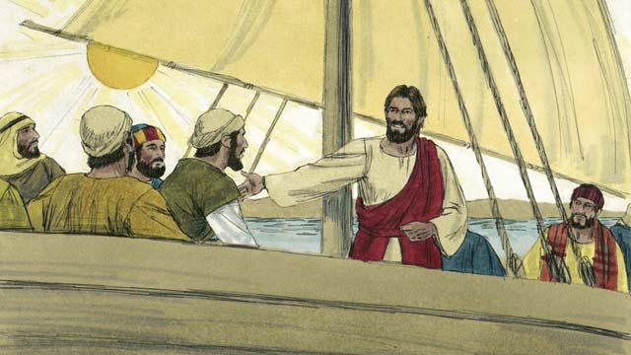

Jesus and his disciples went in their boat to the region where the Gerasene people lived. They reached land and got out of their boat.

32-02

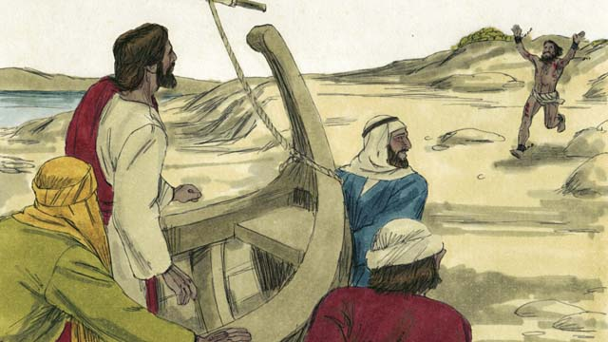

Now there was a man there who was demon-possessed.

32-03

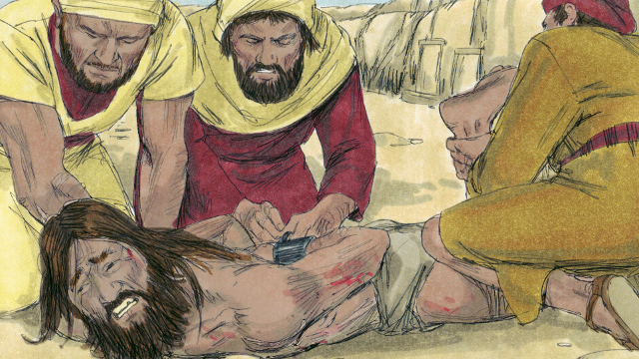

This man was so strong that nobody could control him. Sometimes people even fastened his arms and legs with chains, but he kept breaking them.

32-04

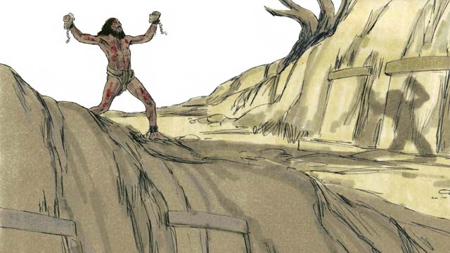

The man lived among the tombs in the area. This man would scream all day and all night. He did not wear clothes, and he often cut himself with stones.

32-05

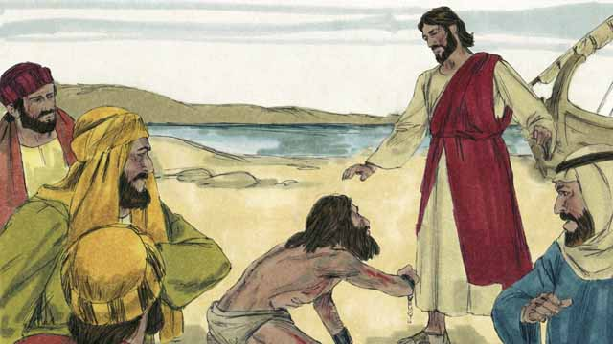

This man ran up to Jesus and knelt down in front of him. Then Jesus spoke to the demon in the man and said, “Come out of this man!”

32-06

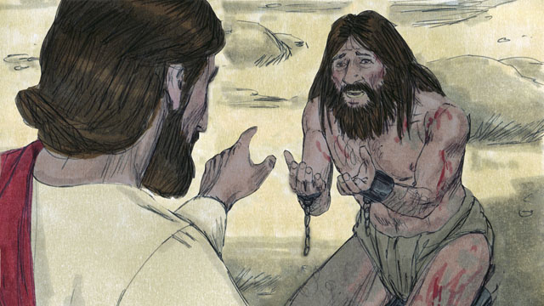

The demon cried out in a loud voice, “What do you want with me, Jesus, Son of the Most High God? Please do not torture me!” Then Jesus asked the demon, “What is your name?” He replied, “My name is Legion, because we are many.”

32-07

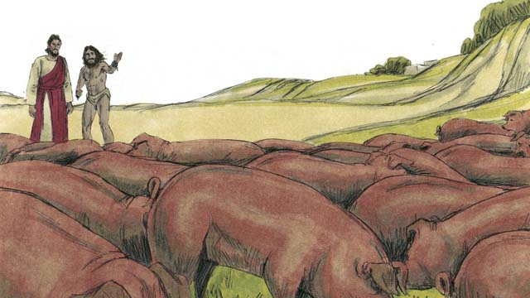

The demons begged Jesus, “Please do not send us out of this region!” There was a herd of pigs feeding on a nearby hill. So the demons begged Jesus, “Please send us into the pigs instead!” Jesus said, “Alright, go into them!”

32-08



So the demons came out of the man and entered the pigs. The pigs ran down a steep bank into the lake and drowned. There were about 2,000 pigs in the herd.

32-09

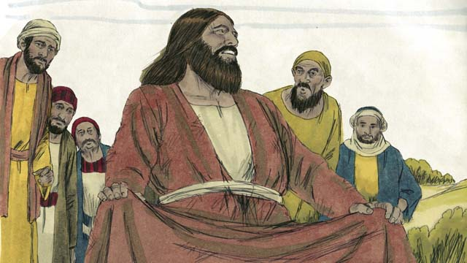

There were people taking care of those pigs. When they saw what happened, they ran into the town. There they told everyone what Jesus had done. The people from the town came and saw the man who used to have demons. He was sitting calmly, wearing clothes, and acting like a normal person.

32-10

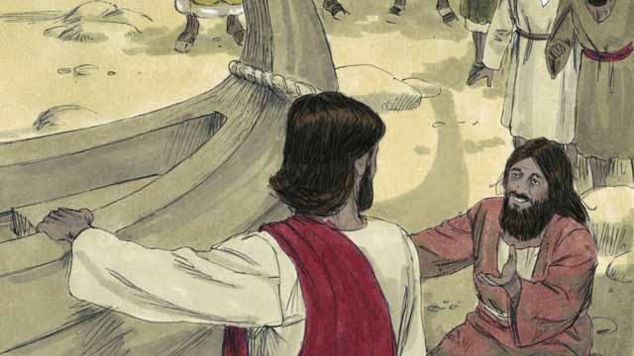

The people were very afraid and asked Jesus to leave. So Jesus got into the boat. The man who used to have the demons begged to go along with Jesus.

32-11

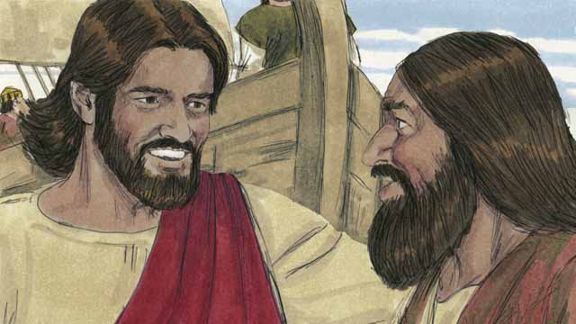

But Jesus said to him, “No. I want you to go home and tell everyone what God has done for you. Tell them how he has had mercy on you.”

32-12

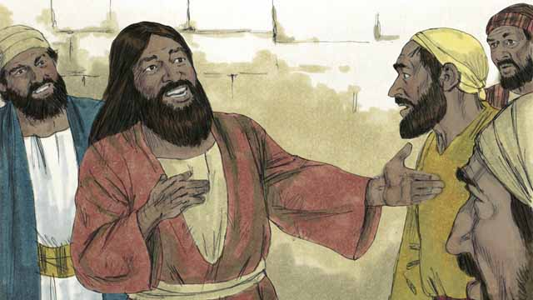

So the man went away and told everyone about what Jesus had done for him. Everyone who heard his story was amazed.

32-13

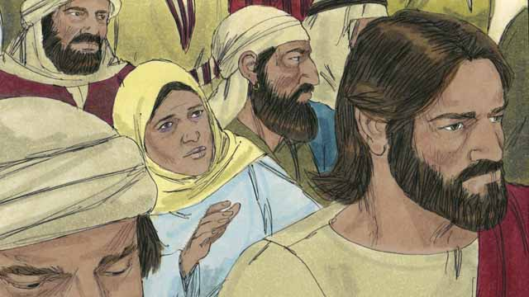

Jesus returned to the other side of the lake. After he arrived there, a large crowd gathered around him and pressed in on him. In the crowd was a woman who had suffered from a bleeding problem for 12 years. She had paid all of her money to doctors so they would heal her, but she only got worse.

32-14

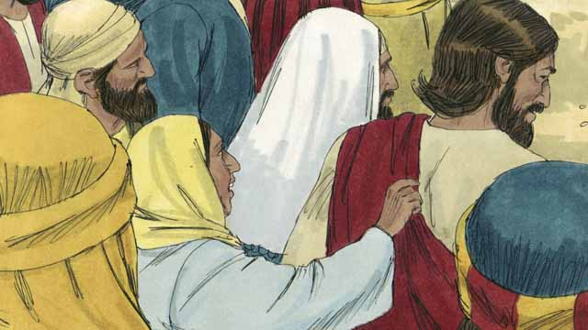

She had heard that Jesus had healed many sick people and thought, “I’m sure that if I can just touch Jesus’ clothes, then I will be healed too!” So she came up behind Jesus and touched his clothes. As soon as she touched them, the bleeding stopped!

32-15

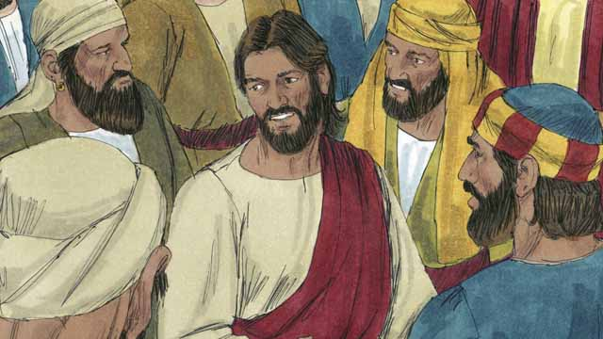

Immediately, Jesus realized that power had gone out from him. So he turned around and asked, “Who touched me?” The disciples replied, “There are many people crowding around you and bumping into you. Why did you ask, ‘Who touched me?’”

32-16

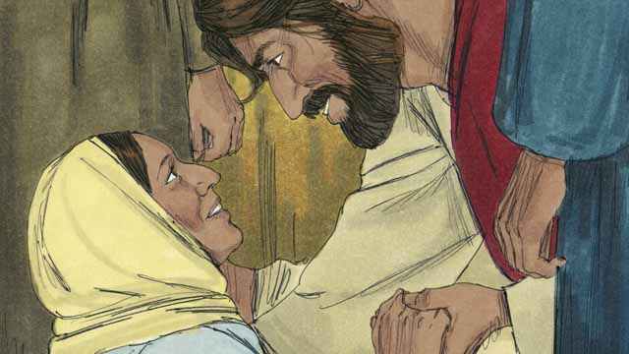

The woman fell on her knees before Jesus, shaking and very afraid. Then she told him what she had done and that she had been healed. Jesus said to her, “Your faith has healed you. Go in peace.”

*A Bible story from: Matthew 8:28-34; 9:20-22; Mark 5; Luke 8:26-48*

## 1 Community Study: Armed for Battle—Equipping Ourselves for Spiritual Warfare

* **Key Idea**: engaging the Christian life as a spiritual battle
* **Key Passage**: Ephesians 6:10-20
* **Main Session**: OBS 32 (Jesus Heals a Demon-Possessed Man and a Sick Woman)

### 1.1 Sing a Song (3–5 minutes)

Choose a song to sing to praise God and encourage one another.

### 1.2 Recite the Creedal Verse (3–5 minutes)

The verse below summarizes the teaching of the current passage. Read the verse out loud as a community. Read it again several times as a group until the whole community can recite it from memory.

For in him all the fullness of God lives in bodily form. You have been filled in him, who is the head over every power and authority. Colossians 2:9-10

OR

For this reason the Son of God was revealed, so that he would destroy the devil’s works. 1 John 3:8

### 1.3 Read the Passage (3–5 minutes)

As Christians follow Christ, they engage the life of faith as a spiritual battle/conflict. As a community, read the following Bible passage together to understand what it means to be committed to Jesus and his work.

10 Finally, be strong in the Lord and in the strength of his might. 11 Put on the whole armor of God, so that you may be able to stand against the scheming plans of the devil. 12 For our struggle is not against flesh and blood, but against the rulers, against the authorities, against the powers over this present darkness, against the spiritual forces of evil in the heavenly places. 13 Therefore put on the whole armor of God, so that you may be able to stand in this time of evil, and after you have done everything, to stand firm. 14 Stand, therefore, after you have put on the belt of truth and the breastplate of righteousness. 15 Then as shoes for your feet, put on the readiness to proclaim the gospel of peace. 16 In all circumstances take up the shield of faith, by which you will be able to put out all the flaming arrows of the evil one. 17 And take the helmet of salvation and the sword of the Spirit, which is the word of God. 18 With every prayer and request, pray at all times in the Spirit. To this end, always be watching with all perseverance, as you offer prayers for all the saints. 19 And pray for me, that a message might be given to me when I open my mouth. Pray that I might make known with boldness the hidden truth about the gospel. 20 It is for the gospel that I am an ambassador who is kept in chains, so that I may declare it boldly, as I ought to speak. Ephesians 6:10-20

### 1.4 Discuss the Passage (10-15 minutes)

The Christian life is a spiritual battle. God equips and empowers his people to engage in this battle with victory. As a community, use the following questions to discuss the teaching of the biblical passage.

1. How does this passage describe the spiritual battle/warfare of the Christian life?
2. In what ways has God equipped his people with resources to engage the spiritual battle with success?
3. How have you experienced the Christian life as a spiritual battle?
4. How can your community put on the armor described in this passage?

### 1.5 Name Growth Area (5 minutes)

Think about the passage above. Identify one specific aspect of the armor listed above that you need most to develop.

At the present time, I need to develop in this aspect to be prepared for the spiritual battle…

### 1.6 Pray to God (5 minutes)

Pray that God would give your community strength and endurance for the spiritual battle that lies ahead.

## 2 Biblical Interpretation: Observing the Details of the Story

After reading the crafted biblical story, answer the following questions to familiarize yourself with the details of the story.

### 2.1 Observation Questions

Answer the following observation questions to gain a basic understanding of the story. Read the story as a community and answer these questions as a group.

#### 32-01

Where did Jesus and his disciples travel by boat?  
Jesus and his disciples went in their boat to the region where the Gerasene people lived.

#### 32-02

Whom did Jesus meet when he arrived where the Gerasene people lived?  
He met a man there who was demon-possessed.

#### 32-03

Why were people unable to restrain the demon-possessed man?  
The demon made him so strong that he would break the chains they used to bind him.

#### 32-04

Where did the man live?  
The man lived among the tombs.

How did the man act?  
He screamed all day and night, not wearing clothes and cutting himself with stones.

#### 32-05

What did the man do when he saw Jesus?  
The man ran up to Jesus and knelt down in front of him.

What did Jesus speak to the demon in the man?  
Jesus spoke to the demon and commanded it to come out of the man.

#### 32-06

What did the demon say to Jesus?  
The demon cried out in a loud voice, asking Jesus what he wanted with him, called him Jesus, Son of the Most High God, and asked Jesus not to torture him.

What was the demon’s name?  
His name was Legion.

What did the name Legion mean?  
A ‘legion’ was a group of several thousand soldiers in the Roman army. This name meant that there were many demons in the man.

#### 32-07

Where did the demons beg Jesus to send them when they left the man?  
They asked Jesus to send them into a herd of pigs instead of sending them out of the region.

How did Jesus respond to this request?  
Jesus sent the demons into a herd of pigs.

#### 32-08

What happened to the pigs when the demons entered them?  
They ran down a steep bank into the lake and drowned.

How many pigs drowned when the demons sent them into the lake?  
There were 2,000 pigs in the herd that drowned.

#### 32-09

What did the people who took care of the pigs do?  
The people who took care of the pigs ran into the town and told everyone what Jesus had done.

What did the people from the town do?  
The people from the town came to see the man who used to have demons.

How did the man behave after the demons left him?  
He sat calmly, wore clothes, and acted like a normal person.

#### 32-10

How did the people react when they saw the man who was healed and the dead pigs?  
They were afraid and asked Jesus to leave them.

How did Jesus respond to their request that he leave?  
Jesus got into the boat to leave.

Who else went into the boat with Jesus?  
The man who used to have the demons begged Jesus to go along with him.

#### 32-11

What did Jesus tell the healed man to do instead of going with Jesus?  
Jesus told him to go home and tell his friends and family what God had done for him and how God had mercy on him.

#### 32-12

What did the man do after Jesus told him to go tell everyone what Jesus had done for him?  
The man told everyone about what Jesus did for him.

How did people respond to the man’s witness?  
The people who heard his story were amazed.

#### 32-13

Who gathered around Jesus after he arrived at the other side of the lake?  
After Jesus returned to the other side of the lake, a large crowd gathered around Jesus and pressed on Jesus.

What was wrong with one of the women in the crowd?  
A woman in the crowd suffered from a bleeding problem for 12 years, spent all her money on doctors, and only got worse.

#### 32-14

Why did the woman with the bleeding problem come to Jesus?  
She thought she would be healed if she touched Jesus’ clothes.

What happened as soon as the woman touched Jesus’ clothes?  
Her bleeding stopped.

#### 32-15

How did Jesus know someone had touched him?  
He realized that power had gone out from him.

How did the disciples respond when Jesus asked who touched him?  
The disciples told Jesus that there are many people in the crowd. They asked Jesus why he asked who touched him.

#### 32-16

How did the woman act before Jesus?  
The woman fell on her knees before Jesus, shaking and very afraid. She told Jesus that she touched his clothes and told him how she was healed.

What did Jesus say to the woman when she fell down before him?  
He told her, “Your faith has healed you. Go in peace.”

### 2.2 Translation Questions

Use the following translation questions to understand specific details of the passage. Discuss how you might translate these specific elements of the story.

#### 32-01

**the Gerasene people** The Gerasenes lived in an area along the eastern shore of the Sea of Galilee. They were descendants of the Jews, but we know few details about them. How would you express **the Gerasene people** to mean the people in the region around Gerasa, a city southeast of the Sea of Galilee?

  

**They reached land** Jesus and his disciples traveled by boat to the region where the Gerasene people lived. How would you express **They reached land** to mean they arrived on the shore?

  

#### 32-02

**was demon possessed** The man in this story had demons in him who controlled him. How would you express **was demon possessed** to mean the man was controlled by evil spirits?

  

#### 32-03

**This man was so strong that nobody could control him** The demon made him more powerful than normal humans. He was so strong that other people could not restrain him. How would you express **This man was so strong that nobody could control him** to mean the demon made the man so strong that no person could restrain him?

  

**fastened his arms and legs** People put chains around the man’s arms and legs. They shackled him to keep him under control and restricted his ability to move freely. How would you express **fastened his arms and legs** to mean restrained or bound his arms and legs with chains so he could not move freely?

  

**kept breaking them** The demon made the man so strong that he could break the chains which were put on his arms and legs. This happened many times, and each time the man continued to break the chains. How would you express **kept breaking them** to mean the man continued to break the chains each time the people bound him in chains?

  

#### 32-04

**among the tombs** The man lived near the tombs. Tombs are places where dead people are buried. How would you express **among the tombs** to mean the man lived around the area where people were buried in tombs?

  

**This man would scream all day and all night** The man cried out in a loud voice on a regular basis. He did this during the day and the night. This was a common and repeated behavior of the man that he did on a regular basis. How would you express **This man would scream all day and all night** to mean the man repeatedly cried out loudly during the day and night?

  

#### 32-05

**knelt down in front of him** The man ran up to Jesus and got on his knees before Jesus. This was a symbolic action to show that he was submitting to Jesus and asking for his help. How would you express **knelt down in front of him** to mean getting down on one’s knees in front of Jesus as an act of respect, humility, and submission?

  

**Come out of this man!** Jesus commanded the demon to leave the man. By leaving the man, the demon would no longer control him. How would you express **Come out of this man!** as a command that ordered the demon to leave the man and no longer control him?

  

#### 32-06

**cried out** The demon spoke out in a loud voice. This How would you express **cried out** to mean shouted or exclaimed?

  

**What do you want with me Jesus, Son of the Most High God?** The demon is asking for information. The demon was terrified that Jesus would judge him. He was asking this question because he was afraid of what Jesus would do to him. The question could function as a request for Jesus not to judge him. How would you express **What do you want with me Jesus, Son of the Most High God?** as a question that means what are you going to do to me?

  

**the Most High God** God is supreme and above all. This title for God is not referring to altitude or being tall. It shows that God is the greatest, strongest, and most sovereign. How would you express **the Most High God** as a title for God that means the Most Powerful God who is sovereign and supreme above all?

  

**My name is Legion, because we are many** This was the name of the group of demons controlling the man. It also indicates that the evil spirits that controlled him were very numerous. A legion was a group of several thousand soldiers in the Roman army. The name Legion compares the size of the demons to a large group of soldiers. This was the name for the group of demons because there were many demons controlling the man. How would you express **My name is Legion, because we are many** to mean the reason the name of the group of demons was legion was many demons were controlling the man, like a large crowd/army of thousands of soldiers?

  

#### 32-07

**Please do not send us out of this region!** The demons pleaded for Jesus not to force them to leave the region. The demons knew that Jesus had the authority to tell them what to do. How would you express **Please do not send us out of this region!** as a polite request for Jesus not to make the demons leave the area where the man was living?

  

**herd of pigs** There were many demons. There was also a group of many pigs nearby. The demons asked to be sent into the group of pigs. How would you express **herd of pigs** to mean a large group of pigs?

  

**Please send us into the pigs instead!** The demons pleaded for Jesus to allow them to go into a herd of pigs. They wanted to go into the pigs rather than being forced to leave the region. How would you express **Please send us into the pigs instead!** as a polite request for Jesus to allow the demons to go into the herd of pigs rather than being sent out of the region?

  

#### 32-08

**So the demons came out of the man and entered the pigs** Jesus granted the demons’ request. Jesus agreed to allow the demons to go into the herd of pigs. This resulted in the demons leaving the man and entering the pigs. How would you express **So the demons came out of the man and entered the pigs** to mean the result of Jesus granting the demons’ request was the demons left the man and went into the herd of pigs?

  

**The pigs ran down a steep bank into the lake** After the demons entered into the pigs, the pigs ran into the water of the lake. The land alongside the lake sloped down into the water. How would you express **The pigs ran down a steep bank into the lake** to mean the pigs went fast down the sloping land alongside the lake and went into the water of the lake?

  

#### 32-09

**what happened** The people taking care of the pigs saw the pigs go into the lake and drown after Jesus sent the demons into the pigs. How would you express **what happened** to mean how Jesus sent the demons out of the man and into the pigs and how the pigs ran into the water and drowned?

  

**There they told everyone what Jesus had done** The people who ran into the town told the people living there what Jesus did for the man who was controlled by evil spirits. How would you express **There they told everyone what Jesus had done** to mean to tell the people living in the town how Jesus sent out a group of demons into a herd of pigs?

  

**who used to have the demons** The demons no longer controlled the man. How would you express **who used to have the demons** to mean the man who had been controlled by the evil spirits?

  

#### 32-10

**begged to go along with Jesus** The man wanted to go with Jesus. He pleaded with Jesus to let him go with him. How would you express **begged to go along with Jesus** to mean earnestly asking Jesus if he could go with him?

  

#### 32-11

**tell everyone what God has done for you** Jesus instructed the man to go back to where he normally lived and tell all the people how God has delivered him from the group of demons. How would you express **tell everyone what God has done for you** to mean to explain to those who lived in the man’s hometown how God delivered him from being controlled by evil spirits?

  

**Tell them how he has had mercy on you** Jesus commanded the man to tell the people in his hometown how God had shown mercy on him by delivering him from the evil spirits. How would you express **Tell them how he has had mercy on you** as a command to explain how God had shown compassion/kindness and pity on the man by sending away the evil spirits which controlled him?

  

#### 32-12

**heard his story** The man did what Jesus told him to do. He told the people who lived in the area how God rescued him from the evil spirits. How would you express **heard his story** to mean the people listed to the man tell how Jesus set him free from the evil spirits?

  

#### 32-13

**pressed in on him** The people in the crowd pushed tightly against him. How would you express **pressed in on him** to mean the people crowded in tightly around Jesus?

  

**a bleeding problem** The woman did not have an open wound. Instead, her monthly flow of blood would not stop. How would you express **a bleeding problem** in a polite way to referring to a woman’s monthly flow of blood would not stop?

  

**she only got worse** The woman did not get better. Even when she used all her money to have doctors help her, her condition only became more severe. The woman grew more sick. How would you express **she only got worse** to mean the woman’s bleeding problem only became more severe instead of getting better, even after she paid all her money for doctors to help her?

  

#### 32-14

**if I can just touch Jesus’ clothes, then I will be healed** According to Jewish law, the woman was not supposed to touch anyone. She thought that by touching Jesus’ clothes, Jesus’ power would heal her. She thought Jesus would not know that she touched him. How would you express **if I can just touch Jesus’ clothes, then I will be healed** to mean the woman believed that all she needed to do was to touch Jesus’ clothes and Jesus’ power would heal her of her bleeding problem?

  

**As soon as she touched them, the bleeding stopped!** The woman touched Jesus’ clothes. At that very moment, Jesus’ power healed her of her bleeding problem. How would you express **As soon as she touched them, the bleeding stopped!** as a strong statement expressing amazement that at the very moment the woman touched Jesus’ clothes, her sickness was healed?

  

#### 32-15

**Jesus realized that power had gone out from him** Jesus did not lose any power because of this. Jesus felt that his power had healed someone else. How would you express **Jesus realized that power had gone out from him** to mean Jesus was fully aware that his healing power had flowed from him into someone else?

  

#### 32-16

**fell on her knees before Jesus** The woman knelt down in front of Jesus as an act of honor and submission. How would you express **fell on her knees before Jesus** to mean quickly knelt down in front of Jesus as an act of reverence and humility?

  

**shaking and very afraid** The woman was trembling because she was afraid. How would you express **shaking and very afraid** to mean shaking with fear?

  

**Your faith has healed you** The woman believed Jesus could heal her. How would you express **Your faith has healed you** to mean God has healed the woman because she trusted in Jesus?

  

**Go in peace** People spoke this traditional blessing when they left each other. It is spoken as people depart from each other to express peace between people as they leave each other. How would you express **Go in peace** to mean may you have peace as you go or go and know that all is well between us?

  

## 3 Theological Dialogue: Discussing the Meaning of the Story

Take time to explore the meaning of this story together as a community. Use the following discussions to grasp the truth the story teaches.

### 3.1 Discourse Questions

Use the following discourse questions to understand the meaning of the story. Pay attention to how the story itself addresses each question or theme.

##### How did the demon afflict the Gerasene man? (32-01, 32-02, 32-03, 32-04, 32-06)

Demon-Possessed: Jesus arrived in the region where the Gerasene people lived. In that place, there was a man who was demon-possessed. He was controlled by evil spirits. (32-01, 32-02)

  

Not Able to Be Controlled: The demon was so powerful that it made the man so strong that no one could control him. The man broke and chain put on his hands or feet. The man was enslaved and bound to this demon. (32-03)

  

Outcast and Unclean: The man lived in the area near the tombs. This man was cast out of normal society and was considered unclean by others. (32-04)

  

Afflicted: The man would scream day and night. He did not wear clothes. He cut himself with stones. The demon afflicted this man and made his life miserable. (32-04)

  

Many Spirits: The demon’s name was Legion because many evil sprits controlled the man. The man was afflicted with an army of evil spirits. (32-06)

  

##### How did Jesus deliver the Gerasene man from the evil spirits which controlled him? (32-05, 32-06, 32-07, 32-08, 32-09)

Jesus’ Command: The Gerasene man ran up to Jesus and knelt down in front of Jesus. Jesus gave a command for the demon to leave the man and no longer control him. (32-05)

  

Jesus’ Presence/Power: The demons knew that Jesus was God’s Son and feared that Jesus would judge them. Even though the demons were powerful, they were not more powerful than Jesus. The demons were afraid of what Jesus would and could do to them. (32-06)

  

Jesus’ Authority: The demons could not do whatever they wanted to do. They asked Jesus’ permission to go into a herd of pigs rather than to be sent out of the region. Jesus granted their request. The evil spirits entered the pigs, and the pigs ran into the lake and drowned. Evil spirits have no authority over Jesus. (32-07, 32-08)

  

Jesus’ Restoring Work: The man was sitting calmly, wearing clothes, and acting like a normal person. Jesus had restored this man by sending out the evil spirits. (32-09)

  

##### How did people respond to Jesus healing the Gerasene man? (32-09, 32-10, 32-11, 32-12)

Pig Herders Share News/Report: The people who took care of the pigs ran into town and told everyone what Jesus had done. (32-09)

  

Townspeople Afraid: The people from the town came out to see the man who used to be controlled by evil spirits. They saw with their own eyes that Jesus had delivered the man. They were afraid and asked Jesus to leave to region. (32-09, 32-10)

  

Gerasene Man Wanted to Follow Jesus: The Gerasene man begged Jesus to go with him. He wanted to follow the person who delivered him from the evil spirits. (32-10)

  

Gerasene Man Told to Share His Story: Jesus told the Gerasene man to tell his story to those in the area where he lived. He explained how Jesus showed him mercy and delivered him from the evil spirits. (32-11)

  

People Amazed: The people who heard the story of the Gerasene man were amazed at what Jesus did. (32-12)

  

##### How did the woman with a bleeding problem get healed? (32-13, 32-14, 32-15, 32-16)

Struggle to Find Help: A woman with a bleeding problem was sick for 12 years. Doctors could not help her. She spent all her money and was unable to get better. In fact, her condition got worse. The woman was unable to find help anywhere. She had exhausted her resources. (32-13)

  

Faith in Jesus: The woman believed she would be healed if she touched Jesus’ clothes. She had genuine faith. When she touched Jesus’ clothes, the bleeding immediately stopped, and she was healed. The woman trusted Jesus to heal her. (32-14, 32-16)

  

Jesus’ Power: Jesus felt his power flow to the woman with a bleeding problem. Jesus caused the woman to no longer be sick. (32-15)

  

Peace: The woman was afraid and fell on her knees before Jesus. Jesus sent the woman away fully recovered and told her to be at peace. Jesus restored the woman from her sick condition and removed her fear. (32-16)

  

### 3.2 Theological Questions

Answer the following theology questions as a community. Discuss what truths this story teaches.

1. How do people suffer in this fallen world? What do the afflictions of the Gerasene man and the bleeding woman teach us about how people suffer?
2. What does Jesus ability to heal the demon-possessed and the sick tell us about who he is? What do we learn about Jesus from his healing of the Gerasene man and the bleeding woman?
3. How should we understand the spiritual world? What does Jesus’ healing of the Gerasene man teach us about the spiritual world
4. What does it look like to respond to Jesus in genuine faith? How do the various responses in this story help us understand genuine faith in Jesus?

### 3.3 Translation Draft

Work as a translation team to draft each panel of this story. Pay attention to any specific translation issues that are challenging or significant.

#### Make Translation Draft

Make a draft for each section of this story.

#### Discuss and Revise

After drafting the story, discuss any translation issues that you think need a special explanation.

#### Drafting Summary Reflection

Summarize any noteworthy translation decisions and the rationale/reasoning behind these translation decisions. In the final movement of this class, you will use these observations to give an account (i.e., chronicle/narrate) of how your translation improved through the checking process.

## 4 Personal Reflection: Following the Teaching of the Story

Take a moment to allow this story to evaluate your own life and to consider how God would have you respond. After this reflection, use the quality checking questions to check your translation draft among the translation team.

### 4.1 Journal Reflection

Prayerfully think about the following personal reflection questions. Write/Record your answers and/or discuss them as a group.

1. Which of the struggles that the Gerasene man and bleeding woman can you most relate to from your own experience?
2. How has Jesus delivered you from your struggles?
3. Which of the responses to Jesus in this story describes your faith?
4. How can you deepen your faith and devotion to Jesus?

### 4.2 Team Check

*The following activity will help you check the clarity, accuracy, and naturalness of your draft. Read the passage aloud and discuss the checking questions with other members of your translation community. You might need to reread portions (or the whole) of the biblical passage multiple times as you answer each of these questions. Record answers to these questions below.*

#### Team Checking Questions

*Use the following questions to check your translation draft for accuracy, clarity, and naturalness.*

1. **Accurate**: Has anything been **added** to your translation of this passage that is not a part of the meaning of the source text? *If additions exist, are they only added to clarify meaning (such as implied information)?*
2. **Accurate**: Is anything **missing** from your translation of this passage that is a part of the meaning of the source text? *If some part of the meaning is missing from your translation, add it.*
3. **Accurate**: Does any meaning in your translation of this passage appear to be **different** than the meaning of the source text? *If the meaning is different, try changing your translation so that the meaning remains the same.*
4. **Natural**: Does anything sound **unnatural** to how you would say it in your language? *If portions of the passage sound unnatural in your language, try to make them sound the way you would say them in your language while staying true to the meaning of the source text.*
5. **Clear**: Is anything **unclear** or **confusing** in your translation that confuses the meaning of the source text? *If portions of the passage are unclear or confusing, revise them to clearly communicate the meaning of the source text.*
6. **Consistent**: How **consistent** is your translation within the passage and with other passages? *If portions of the passage need to be made consistent or if you need to revise translations of other passages, make these adjustments.*

#### Record Feedback

*After discussing the checking questions above as a translation community, record any feedback on your translation draft. Pay attention to parts of your translation that are translated well and parts of your translation that need correction.*

#### Discuss and Revise

*After gathering feedback on your draft, discuss it together with your translation community and make appropriate revisions to your translation.*

#### Record Translation Decisions

*As a community, discuss some of the most noteworthy translation decisions in your draft. Summarize each decision and explain the reasons your community decided on that translation. You should update these decisions each time you check your draft with various groups of people.*

You should **measure** the quality of your translation draft. You can **record translation decisions** to make it clear why you translated things a certain way. Translation decisions can help your translation team and the surrounding community be a part of the translation process.

How can you know the quality of your translation?

1. **Measure** the translation by marks/standards of quality (i.e., clear, accurate, natural, church-approved)
2. **Test** the translation with others and record feedback and conversations from in the field (i.e., church and community check)
3. **Compare** and **contrast** the translation with the source text (i.e., meaning of text and notes) and alternatives (i.e., other translation choices)
4. **Explain** the reasons why you translated a particular portion of the text.

**Example Sentences That Help Explain Your Translation Decision** Use the following example sentences to help explain your translation decisions:

1. The original text literally **says/means**, so we translated the term in this way…
2. We originally decided to translate **the biblical term** with **this term**, but we changed it because…
3. When our translation team discussed **the biblical term**, this is what we talked about…
4. **The term** is [clear, accurate, natural, consistent] because…
5. The community understands **this term** to mean…
6. We considered these other terms. We did not use **these terms** because…
7. When we checked this in the church, we learned…
8. When we checked this in the community, we learned…

**Example of Translation Decision**

In OBS 01-07 we decided to translate **blessed** like this: [actual translation]. We decided on this translation because of these reasons:

1. The word [actual translation] means to cause good things to happen to someone or something. This term is used when a person desires someone or something to prosper or flourish. This term does not refer to magic or witchcraft.
2. When we checked this word with other believers, they said it describes God showing his kindness and favor on someone or something. These are some of the terms that we did not decide to use…
3. Many of our people will understand this word. When we discussed this phrase with the surrounding community, we discovered it was a natural way to describe God causing good and beneficial things to happen.

## 5 Ministry Practice: Serving the Church with the Story

Now that you have a draft of this story, consider how this story can encourage other believers in their faith. After ministering this story to others, you will also perform a community check of your translation draft.

### 5.1 Church Ministry

Reflect on how this story can edify and mature the Christian community. Design a way to minister this story to your church community.

**Ministry Preparation**: Take time to consider how you could minister this story to others. Record some ministry ideas below.

**Ministry Implementation**: Minister this story to a group of believers as you had planned. Use the information in this study to help develop a teaching/lesson or lead a discussion of this story with other believers. Record your ministry plan below.

**Ministry Reflection**: Think about what you learned from ministering this story to other believers. Reflect on your experience below.

### 5.2 Church Community Check

After teaching or ministering this story to the church, check the translation quality with the church community. Record any feedback from your checking experience.

#### Create Checking Questions

You can use **Translation Questions** to check your draft. Each **Translation Question** explains the meaning of a specific part of the story and asks you to consider how you would translate that part of the story in your own language. Change each **Translation Question** into a **Checking Question** by asking the following questions. The first question asks you to identify how each specific phrase was translated into your language. The second question asks people in the church to determine if your translation of the phrase expresses the meaning clearly, accurately, and naturally. Look at the following examples to see how to change **Translation Questions** into **Checking Questions**:

#### Translation Question Example 1

**to proclaim the good news about Jesus** Paul and Silas traveled to Philippi for the purpose of preaching the gospel. The gospel is the good news that Jesus saves people from their sins if they will believe in Jesus. How would you express **to proclaim the good news about Jesus** to mean to tell other people the message about how Jesus can save people from their sins?

#### Translation Question Example 2

**a merchant** Paul and Silas met a woman named Lydia at the place by the river. She owned a business and sold items to make money. How would you express **a merchant** to mean a business owner who sells items for a profit?

#### Translation Question Example 3

**so Paul and Silas baptized them** The jailer and his whole family followed Paul’s instructions. They believed in Jesus. The result of this was Paul and Silas baptized them. How would you express **so Paul and Silas baptized them** to mean the result of the jailer and his family believing in Jesus that Paul and Silas baptized all of them?

You can change these into **Checking Questions** like this:

#### Checking Question Example 1

**to proclaim the good news about Jesus** How did you translate **to proclaim the good news about Jesus**? Does it mean to tell other people the message about how Jesus can save people from their sins?

#### Checking Question Example 2

**a merchant** How did you translate **a merchant**? Does it mean a business owner who sells items for a profit?

#### Checking Question Example 3

**so Paul and Silas baptized them** How did you translate **so Paul and Silas baptized them**? Does it mean the result of the jailer and his family believing in Jesus that Paul and Silas baptized all of them?

#### Record Feedback

*Discuss the* ***Checking Questions*** *with your church community, and record any feedback on your translation draft. Pay attention to parts of your translation that are translated well and parts of your translation that need correction.*

#### Discuss and Revise

*After gathering feedback on your draft, discuss it together with your translation community and make appropriate revisions to your translation.*

#### Record Translation Decisions

*Update your translation decisions and record any new and noteworthy observations on the quality of your draft.

## 6 Missional Outreach: Sharing the Truth of the Story

*After sharing this story with others, check the translation quality with the wider language community. Record any feedback from your checking experience.*

### 6.1 Mission Engagement

*Consider how you will witness this story to unbelievers. Design a way to share this story and engage them in what it teaches about Christianity and the gospel.*

**Witness Preparation**: Take time to consider how you will witness this narrative to unbelievers. Record some ideas below.

**Witness Implementation**: Share this story with an unbeliever. Use the information in this study to help develop a teaching/lesson or lead a discussion of this story with other believers. Record your ministry plan below.

**Witness Reflection**: Think about what you learned from ministering this story to unbelievers. Reflect on your experience below.

### 6.2 Sociolinguistic Check

After sharing this story with the language community, check your translation draft with the surrounding community. Record your observations.

#### Checking Approach

After witnessing this story to unbelievers, use one of the following methods to check the translation of this story. Consider using the **Observation Questions** to check your translation draft or come up with your own quality checking questions.

**Read-Retell Check:** Read your draft to those in the community and ask them to retell the passage. Be attentive to any portions of the passage that are unclear, unnatural, or inaccurate.

**Comprehension Questions Checklist:** Read the draft of the passage and ask a list of comprehension questions to make sure the passage is being rightly understood. You can use the **Observation Questions** in this guide or come up with your own questions. Then, record any insights or issues that arise.

**Discussion Group:** Develop key questions to ask about the passage (both formational and translational). Read the passage and have a group discussion about the passage, paying attention to issues that need to be addressed, edited, and revised.

#### Record Feedback

*After sharing your draft with the language community, discuss the* ***Observations Questions****, and record any feedback on your translation draft. Pay attention to parts of your translation that are translated well and parts of your translation that need correction.*

#### Discuss and Revise

*After gathering feedback on your draft, discuss it together with your translation community and make appropriate revisions to your translation.*

#### Record Translation Decisions

*Update your translation decisions and record and new any noteworthy observations on the quality of your draft.

## 7 Conclusion

As a translation community, take time to reflect on all that was learned in studying, drafting, and checking this story. Celebrate all that God has taught you as a community. Then, submit your revised draft and checking summaries to network leaders for further review.