Open Bible Stories

The Story of the Farmer

## 0 Introduction

### 0.1 Key Idea

The story of the farmer teaches us that real faith receives God’s word and produces fruit in one’s life as evidence of genuine faith.

### 0.2 Creedal Verse

“By this my Father is glorified, that you bear much fruit and so prove to be my disciples.” John 15:8

### 0.3 Metanarrative Summary

The eternal God created all things in six days. He made a good and perfect world. He made humans in his image to fill the earth and rule over creation. But humans rebelled against God and ruined God’s creation. God set to restore his world through his promise. God made a covenant with Abraham. He promised to bless all nations through Abraham. God kept his promises across the generations. God provided Abraham with a promised child, Isaac. God gave Isaac a wife and she bore twins, Jacob and Esau. God blessed Jacob and his sons, and the blessing continued to the next generation. God rescued Joseph, one of Jacob’s sons, and used him to rescue his family. God caused his people, the Israelites, to multiply in the land of Egypt; eventually, they became slaves. But, God raised up a deliverer, Moses, to deliver his people from their slavery. God judged the Egyptians with harsh plagues; in the final judgment, he passed over his people who covered their doorposts with the blood of a sacrificed lamb. Then, God delivered the Israelites by bringing them out of Egypt and crossing the Red Sea on dry land. God made a covenant with the Israelites and made them his people. God tested Israel in a series of wilderness wanderings and eventually brought his people into the promised land of Canaan. God raised up deliverers to lead Israel and rescue them from their enemies. God formed Israel into a kingdom. He made a covenant with King David and promised to send a king that would rule his people forever. Many of Israel’s kings were evil and the kingdom of Israel divided into two kingdoms. God sent prophets to warn his people of God’s judgment and call them to repent. When Israel did not repent, God sent his people into exile. After many years, he brought them back to the land. Throughout the Old Testament, God promised to send his Messiah to deliver his people form their sin. After many years, the prophet John was born. He would prepare people for the coming Messiah. At the perfect time, God sent his Son, Jesus, to be born of a virgin Mary. When John and Jesus grew up, John baptized Jesus as a sign that Jesus was God’s beloved Son. Jesus endured all manner of temptation without ever sinning. When he was thirty years old, he launched a public ministry of preaching, teaching, and healing. He taught his disciples about the life of compassion, sacrifice, and forgiveness. He performed many miracles: he fed a crowd of five thousand, he walked on water, he healed the sick, and he cast out demons. He proclaimed to people the nature of real faith

### 0.4 Open Bible Story: The Story of the Farmer

33-01

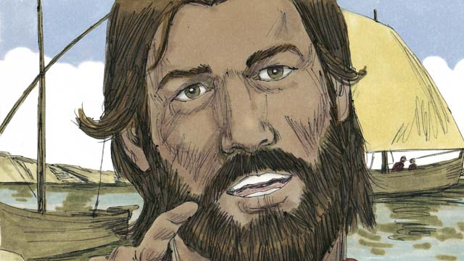

One day, Jesus was near the shore of the lake. He was teaching a very large crowd of people. So many people came to hear him that Jesus did not have enough room to speak to them all. So he got into a boat in the water. There he sat and taught the people.

33-02

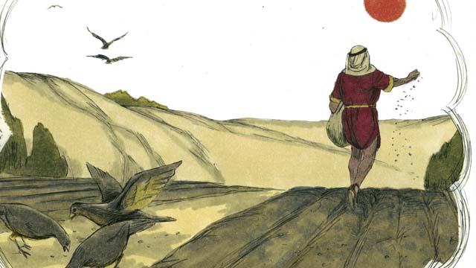

Jesus told this story. “A farmer went out to plant some seed. As he was spreading the seed by hand, some of the seed happened to fall on the path. But birds came and ate all of that seed.”

33-03

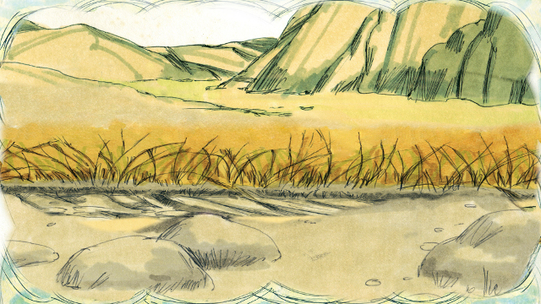

“Other seed fell on rocky ground, where there was very little soil. The seed in the rocky ground sprouted quickly, but its roots were not able to go deep into the soil. When the sun came up and it got hot, the plants withered and died.”

33-04



“Still other seed fell among thorn bushes. This seed began to grow, but the thorns choked it out. So the plants that grew from the seed in the thorny ground did not produce any grain.”

33-05

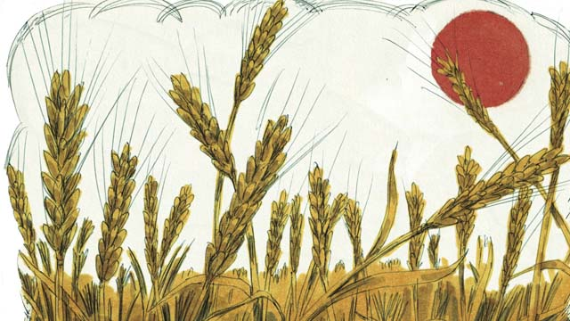

“Other seed fell into good soil. This seed grew up and produced 30, 60, or even 100 times as much grain as the seed that had been planted. Whoever wants to follow God, let him pay attention to what I am saying!”

33-06

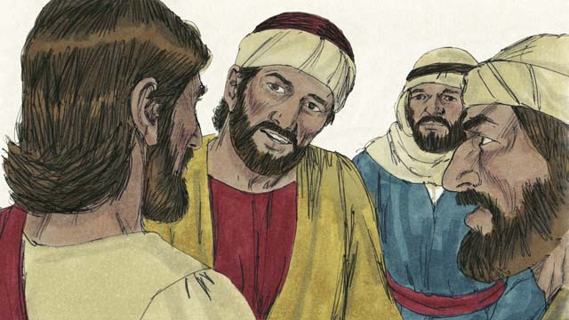

This story confused the disciples. So Jesus explained, “The seed is the word of God. The path is a person who hears God’s word, but does not understand it. Then the devil takes the word away from him. That is, the devil keeps him from understanding it.”

33-07

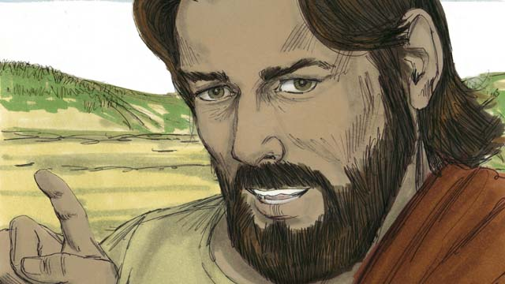

“The rocky ground is a person who hears God’s word and accepts it with joy. But when he suffers hardships, or when other people make him suffer, he falls away from God. That is, he stops trusting in God.”

33-08

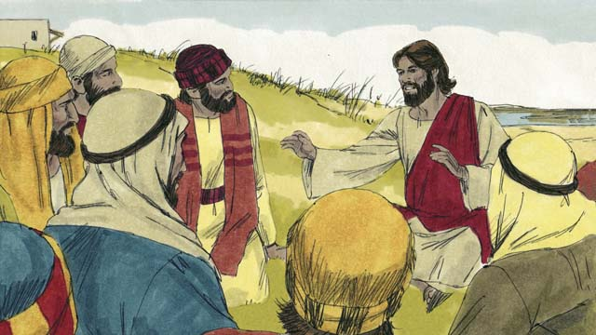

“The thorny ground is a person who hears God’s word. But he begins to worry about many things, and he tries to make a lot of money, and he tries to get many things. After some time, he is not able to love God any longer. So what he learned from God’s word does not make him able to please God. He is like wheat stalks that do not produce any grain.”

33-09

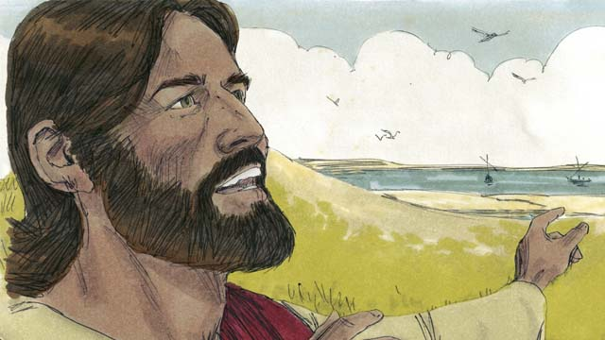

“But the seed in the good soil is a person who hears the word of God, believes it, and produces fruit.”

*A Bible story from: Matthew 13:1-23; Mark 4:1-20; Luke 8:4-15*

##./obs_source/transclusions//obs-devotionals-unit-10#Community Study: Good and Faithful Servants—Bearing Fruit as God’s Stewards.md NOT FOUND!!

## 1 Biblical Interpretation: Observing the Details of the Story

After reading the crafted biblical story, answer the following questions to familiarize yourself with the details of the story.

### 1.1 Observation Questions

Answer the following observation questions to gain a basic understanding of the story. Read the story as a community and answer these questions as a group.

#### 33-01

At the beginning of this story, what was Jesus doing near the shore of the lake?  
Jesus was teaching a very large crowd of people.

How many people gathered to listen to Jesus?  
So many people came to hear him that Jesus did not have enough room to speak to them all.

What did Jesus do because of the size of the crowd?  
Because of the size of the crowd, Jesus sat in a boat in the water and taught people from the boat.

#### 33-02

What did Jesus tell the people?  
Jesus told the people a story about a farmer who planted seed by spreading the seed on the ground by hand.

Where was the first place Jesus said some the seed fall?  
Some seed fell on the path.

What happened to the seed that fell on the path?  
The birds came and ate all of it.

#### 33-03

Where was the second place Jesus said some other seed fall?  
Some seed fell on rocky soil.

What happened to the seed that fell on the rocky ground?  
It sprouted quickly, but then withered and died when it got hot.

Why did the seed that grew on the rocky soil sprout quickly and then wither?  
The seed that grew on the rocky soil withered because its roots were not able to go deep into the soil.

#### 33-04

Where was the third place Jesus said some other seed fall?  
Some seed fell among the bushes.

What happened to the seed that fell among thorn bushes?  
It began to grow, but the thorns choked it out.

Did the plants that grew on the thorny ground produce any grain?  
No. The plants that grew from the seed in the thorny ground did not produce any grain.

#### 33-05

Where was the fourth place Jesus said some other seed fall?  
Some seed fell on good soil.

What happened to the seed that fell on the good soil?  
It grew up and produced 30, 60, or 100 times as much grain as the seed that had been planted.

What did Jesus say to people who wanted to follow God?  
Jesus said that whoever wants to follow God must pay attention to what he was.

#### 33-06

Did the disciples understand the meaning of the story?  
No, they were confused.

What does the seed represent in the story?  
The seed is the word of God.

What does the path represent?  
The path is the person who hears the word, but does not understand it, and the devil takes it away from him.

#### 33-07

What does the rocky ground represent?  
The rocky ground is the person who hears the word and accepts it with joy, but falls away.

Why does this person fall away?  
This kind of person falls away when hardship and persecution come and this kind of person stops trusting in God.

#### 33-08

What does the thorny ground represent?  
The thorny ground is the person who hears the word, but as time passes, he begins to worry about many things, and he tries to make a lot of money, and he tries to get many things. so that he is not able to please God any longer.

What happens to this kind of person?  
This kind of person is not able to love and please God.

What is this person like?  
This person is like wheat stalks that do not produce any grain.

#### 33-09

What does the seed in the good soil represent?  
The seed in the good soil is the person who hears the word, believes it, and produces fruit.

### 1.2 Translation Questions

Use the following translation questions to understand specific details of the passage. Discuss how you might translate these specific elements of the story.

#### 33-01

**One day** The events of this story happened in the past, but we are not told the specific time. How would you express **One day** to mean the events of this story actually took place in the past even though we are not told the specific day or time when they occurred?

  

**that Jesus did not have enough room to speak to them all** The crowd that gathered to hear Jesus was very large. The result of such a large crowd caused it to be hard for Jesus to speak to them all. How would you express **that Jesus did not have enough room to speak to them all** to mean the result of such a large crowd gathering to listen to Jesus was he did not have enough space to speak to them all?

  

**So he got into a boat in the water** Jesus could not speak to the crowd because of how many people gathered near the shore of the lake. The result of this was for Jesus to get into a boat and teach the people from the water. How would you express **So he got into a boat in the water** to mean the result of Jesus not able to teach the large crowd on the shore was for Jesus to get into a boat and teach the people from the water?

  

#### 33-02

**this story** The story is in the form of a parable. A parable is a short story that teaches something(s) that is true, and delivers the lesson in a way that is easy to understand and hard to forget. Though the events in a parable could happen, they did not actually happen. They are told only to teach the lesson(s) that the listener is meant to learn. How would you express **this story** to mean a short story that teaches something that is true?

  

**spreading the seed by hand** The farmer was covering all of his crop soil with seed. This is the way that farmers in the ancient Middle East typically planted grain-bearing crops. How would you express **spreading the seed by hand** to mean throwing/dispersing the seed on the soil to plant crops?

  

**some of the seed happened to fall on the path** Some of the seed landed on a path where people typically walk. The farmer did not intentionally throw seed on the path. He spread/dispersed the seed out widely on the soil and some of it fell on the path. How would you express **some of the seed happened to fall on the path** to mean some of the seed which the farmer spread widely on these soil ended up falling on the path where people walk?

  

#### 33-03

**the rocky ground** Some of the seed fell on soil that was full of rocks. How would you express **the rocky ground** to mean ground that was full of rocks?

  

**sprouted quickly** It did not take long for the seed to start to grow. The seek sprang up from the grow as a small plant really fast. How would you express **sprouted quickly** to mean the seed grew into a small seedling after a short period of time?

  

**but its roots were not able to go deep into the soil** The seed grew up into a seedling fast. In contrast with this, the roots did not go deep into the soil because the ground was full of rocks. How would you express **but its roots were not able to go deep into the soil** to mean the roots not going deep into the soil of the rocky ground is the different/opposite from how fast the seed sprouted from the ground?

  

**When the sun came up and it got hot** The sun came up and it became hot. At this time, the plants withered and died. How would you express **When the sun came up and it got hot** to mean the plants withered and died at the time the sun came up and made it hot?

  

#### 33-04

**Still** Something different happened to the seed that fell on the thorny ground that happened to the seed that fell on the rocky ground. How would you express **Still** to emphasize a contrast (something different) between what happened to the seed that fell on the thorny ground and the rocky ground?

  

**choked it out** The thorns surrounded the plant that grew among the thorn bushes and made it hard for the plant to grow. How would you express **choked it out** to mean the thorns overshadowed or crowded out the plant that grew among the thorn bushes?

  

**the thorny ground** Thorn bushes grew on this part of the ground. How would you express **the thorny ground** to mean the ground that was covered with thorny bushes?

  

#### 33-05

**good soil** Some seed fell on soil that was good for crops. How would you express **good soil** to mean fertile soil or soil that was good for growing plants?

  

**let him pay attention to what I am saying** Jesus used this story to teach his disciples about what it really means to follow God. Jesus explained that people who wanted to follow God needed to listen to what Jesus was teaching and How would you express **let him pay attention to what I am saying** to mean concentrate/focus on what Jesus was saying and consider closely what it taught them about their own lives?

  

#### 33-06

**This story confused the disciples.** At this time, Jesus’ teaching did not make sense to the disciples. How would you express This story confused the disciples to mean the disciples did not understand this story?

  

**The seed is the word of God** In this story, Jesus compared God’s word to seed. The word represents God’s message. Sowing the message represents teaching it. How would you express **The seed is the word of God** to mean the sowing of the seed is teaching people God’s message?

  

**The path is a person who hears God’s word, but does not understand** it In this story, Jesus compared a person who hears God’s word to a path. The path represents a kind of person who hears God’s word and does not understand what it means. How would you express **The path is a person who hears God’s word, but does not understand** it to mean the path is like the person who hears God’s word taught but does not understand what it means?

  

**takes the word away from him** Jesus explains that the devil takes God’s word away from some people, causing them to forget it. This is like the birds in the story that eat up the seed on that fell on the path. How would you express **takes the word away from him** to mean steals the word from his heart so he won’t believe it and be saved just as birds eat up the seed that falls on a path?

  

#### 33-07

**The rocky ground is a person who hears God’s word and accepts it with joy** In this story, Jesus compared a person who accepts God’s word with joy for a short time and then falls away with rocky ground. At first, this person joyfully believes God’s message and agrees that it is true, but then he stops following God. How would you express **The rocky ground is a person who hears God’s word and accepts it with joy** to mean the rocky ground is like the person who hears God’s message and joyfully believes it but then falls away?

  

**he suffers hardships, or when other people make him suffer** The kind of person that Jesus describes experiences difficulty life circumstances and is mistreated by others after coming to follow God. The hardship and suffering cause this person to stop following God. How would you express **he suffers hardships, or when other people make him suffer** to mean this person experiences painful misfortunes in life and is mistreated by others because he believes God’s message?

  

**falls away** The person that Jesus describes accepts God’s word with joy at first. Soon after this hardship and suffering cause this person to no longer follow or obey God. How would you express **falls away** to mean stops following or obeying God?

  

#### 33-08

**The thorny ground is a person who hears God’s word** In this story, Jesus compared a person who hears God’s word but then worries about money and possessions. His desire for the wrong things makes it hard for him to love and please God. How would you express **The thorny ground is a person who hears God’s word** to mean the thorny ground is like the person who hears God’s message but the focuses on other things more than God?

  

**He is like wheat stalks that do not produce any grain** Jesus compared the person who focuses on the desires of the world more than God to stalks of wheat which do not produce grain. This person does not produce spiritual fruit or do not behave in a way that shows God’s Spirit is working in him. Jesus speaks of a person’s good works as if they were grain. How would you express **He is like wheat stalks that do not produce any grain** to mean the person who gets concerned about the desires of the world more than God and does not show spiritual fruit (evidence of God’s spirit working in him) is compared to stalks of wheat that do not produce grain?

  

#### 33-09

**the seed in the good soil is a person who hears the word of God, believes it, and produces fruit** In this story, Jesus compared the person who truly believes God’s word and shows evidence of this genuine belief to seed that fell on good soil. The seed in the good soil represents the person who hears and believes God’s word, and produces fruit as a result. How would you express **the seed in the good soil is a person who hears the word of God, believes it, and produces fruit** to mean the seed that fell on the good soil is like the person who hears and understand God’s message, and then behaves in a way that shows God’s Spirit is working in him?

  

## 2 Theological Dialogue: Discussing the Meaning of the Story

Take time to explore the meaning of this story together as a community. Use the following discussions as a way to grasp what truth the story teaches.

### 2.1 Discourse Questions

Use the following discourse questions to understand the meaning of the story. Pay attention to how the story itself addresses each question or theme.

##### How did Jesus use the story of the farmer to teach God’s word/truth? (33-01, 33-02, 33-05)

Crowd: Jesus was teaching a large crowd of people near the shore of a lake. There were so many people that Jesus had to get into a boat and teach the crowd from the water. Jesus taught these people what it means to really follow God. Not everyone in the crowd followed Jesus. Jesus was using the story to teach people about what it meant to truly follow God. (33-01)

  

Seed Like Word of God: Just like Jesus was teaching the crowd, Jesus told a story of a farmer who cast seed on the ground. The farmer was planting crops. Jesus was teaching God’s word. The same seed was spread on the ground and Jesus’ same teaching was shared with all the people listening to him. When the seed fell on different soil, there were different results. When different people heard God’s word, they received Jesus’ teaching differently like the different soils in the story. Jesus was using the story to tell people the truth of God’s word: (33-02, 33-06)

Pay Attention: At the end of the story, Jesus told people to pay attention to what he said if they really wanted to follow God. The story taught about a spiritual reality of what it mean to follow Jesus. True followers of Jesus will focus on what Jesus says, believe it, and practice it in their lives. (33-05)

  

Explanation: Jesus took time to explain the parable to his disciples. At first, they did not understand what Jesus was saying after he finished telling the story. They were confused. He explained how the seed represented the word of God. Jesus explained how different soils in the story represented how different kinds of people respond differently to Gods word. (33-06).

  

##### What does the seed which fell on the path teach us about how some people respond to God’s word? (33-02, 33-06)

Path: Some people respond to God’s word like seed that falls on a path. The soil of the path is not great soil to grow crops. Birds can easily eat the seed before it has time to grow. Some people hear God’s word and they do not accept it. (33-02)

  

No Truth: The path represents a person who hears God’s word but does not understand it. The devil works to try to keep people from understanding God’s word. Like the birds that ate the seed on the path before the seeds could turn into plants, the devil tries to steal/take God’s word from people so they do not understand what it says. People who are ignorant of God’s word cannot truly follow Jesus. (33-06)

  

##### What does the seed which fell on the rocky ground teach us about how some people respond to God’s word? (33-03, 33-07)

Rocky Ground: Some people respond to God’s word like seed that falls on rocky ground. On rocky ground there is very little soil. The seed can sprout quickly on this ground but it is not able to have deep roots. As a result, the plant which sprouted fast eventually dies and withers when the heat of the sun comes out. Some people accept God’s word with joy and then stop believing when it gets difficult. (33-03)

  

No Roots: The rocky ground represents a person who hears God’s word and joyfully believes it. They begin believing God’s word with joy and excitement. However, this person experiences hardships/misfortunes and other people persecute/mistreat them because they have believed God’s word. This hardship is like the heat of the sun that withered the seed that grew in rocky soil. These people do not have deep roots and do not endure the hardship. They give up and stop trusting in God. People need deep roots of faith to follow God. (33-07)

  

##### What does the seed which fell on the thorny ground teach us about how some people respond to God’s word? (33-04, 33-08)

Thorny Ground: Some people respond to God’s word like seed that falls on ground full of thorn bushes. The seed grows but the thorns crowd out the plant and keep it from growing. These plants do not grow any grain. Some people hear accept God’s word but others circumstances prevent their faith from growing and producing fruit. (33-04)

  

No Fruit: The thorny ground represents a person who hears and accepts God’s word. This person begins to grow in the faith. However, the desires of the world cause this person to be more focused on the things of the world more than God. This person worries about money and possessions and eventually does not loved and please God anymore. This person grows a little but does not produce any fruit. That is, this person does show evidence in their life that God is at work. People who truly follow God will show fruit in their lives. (33-08)

  

##### What does the seed which fell on the good soil teach us about how some people respond to God’s word? (33-05, 33-09)

Good Soil: Some people respond to God’s word like seed that falls on ground that is fertile. This soil causes the seed to grow and produce a lot of crops. (33-05)

  

Fruit: Some people hear God’s word and truly accept it. These people grow in their faith, continue to follow Jesus, love God above all, and show evidence of Gods’ work in their life. (33-09)

  

### 2.2 Theological Questions

Answer the following theology questions as a community. Discuss what truths this story teaches.

1. What does it mean to truly believe and follow Jesus? What does this story teach us about the nature of true faith?
2. What different obstacles do people face in coming to believe in Jesus? How are these obstacles represented and explained in Jesus’ story of the farmer?
3. How should believers go about teaching God’s word? How does this story explain what it is like to minister to others by teaching God’s word/truth?

### 2.3 Translation Draft

Work as a translation team to draft each panel of this story. Pay attention to any specific translation issues that are challenging or significant.

#### Make Translation Draft

Make a draft for each section of this story.

#### Discuss and Revise

After drafting the story, discuss any translation issues that you think need special explanation.

#### Drafting Summary Reflection

Summarize any noteworthy translation decisions and the rationale/reasoning behind these translation decisions. In the final movement of this class, you will use these observations to give an account (i.e., chronicle/narrate) of how your translation improved through the checking process.

## 3 Personal Reflection: Following the Teaching of the Story

Take a moment to allow this story to evaluate your own life and to consider how God would have you respond. After this reflection, use the quality checking questions to check your translation draft among the translation team.

### 3.1 Journal Reflection

Prayerfully think about the following personal reflection questions. Write/Record your answers and/or discuss them as a group.

1. Which kind of soil represents the kind of person you are?
2. What obstacles in this story that keep people from fully following Jesus most challenge you?
3. What kind of fruit can you see in your own life that you have come to follow Jesus?
4. With whom might God want you to share the truth of his word? How does this story give you help to know how you can/should go about sharing the word to these people?

### 3.2 Team Check

*The following activity will help you check the clarity, accuracy, and naturalness of your draft. Read the passage aloud and discuss the checking questions with other members of your translation community. You might need to reread portions (or the whole) of the biblical passage multiple times as you answer each of these questions. Record answers to these questions below.*

#### Team Checking Questions

*Use the following questions to check your translation draft for accuracy, clarity, and naturalness.*

1. **Accurate**: Has anything been **added** to your translation of this passage that is not a part of the meaning of the source text? *If additions exist, are they included only added to clarify meaning (such as implied information)?*
2. **Accurate**: Is anything **missing** from your translation of this passage that is a part of the meaning of the source text? *If some part of the meaning is missing from your translation, add it.*
3. **Accurate**: Does any meaning in your translation of this passage appear to be **different** than the meaning of the source text? *If the meaning is different, try changing your translation so that the meaning remains the same.*
4. **Natural**: Does anything sound **unnatural** to how you would say it in your language? *If portions of the passage sound unnatural in your language, try to make them sound the way you would say it in your language while staying true to the meaning of the source text.*
5. **Clear**: Is anything **unclear** or **confusing** in your translation that confuses the meaning of the source text? *If portions of the passage are unclear or confusing, revise them to clearly communicate the meaning of the source text.*
6. **Consistent**: How **consistent** is your translation within the passage and with other passages? *If portions of the passage need to be made consistent or if you need to revise translations of other passages, make these adjustments.*

#### Record Feedback

*After discussing the checking questions above as a translation community, record any feedback on your translation draft. Pay attention for parts of your translation that are translated well and parts of your translation that need correction.*

#### Discuss and Revise

*After gathering feedback on your draft, discuss it together with your translation community and make appropriate revisions in your translation.*

#### Record Translation Decisions

*As a community, discuss some of the most noteworthy translation decisions in your draft. Summarize each decision and explain the reasons your community decided on that translation. You should update these decisions each time you check your draft with various groups of people.*

You should **measure** the quality of your translation draft. You can **record translation decisions** to make it clear why you translated things a certain way. Translation decisions can help your translation team and the surrounding community be a part of the translation process.

How can you know the quality of your translation?

1. **Measure** the translation by marks/standards of quality (i.e., clear, accurate, natural, church-approved)
2. **Test** the translation with others and record feedback and conversations from in the field (i.e., church and community check)
3. **Compare** and **contrast** the translation with the source text (i.e., meaning of text and notes) and alternatives (i.e., other translation choices)
4. **Explain** the reasons why you translated a particular portion of the text.

**Example Sentences That Help Explain Your Translation Decision** Use the following example sentences to help explain your translation decisions:

1. The original text literally **says/means**, so we translated the term in this way…
2. We originally decided to translate **the biblical term** in with **this term**, but we changed it because…
3. When our translation team discussed **the biblical term**, this is what we talked about…
4. **The term** is [clear, accurate, natural, consistent] because…
5. The community understands **this term** it to mean…
6. We considered these other terms. We did not use **these terms** because…
7. When we checked this in the church, we learned…
8. When we checked this in the community, we learned…

**Example of Translation Decision**

In OBS 01-07 we decided to translate **blessed** like this: [actual translation]. We decided this translation because of these reasons:

1. The word [actual translation] means to cause good things to happen to someone or something. This term is used when a person desires someone or something to prosper or flourish. This term does not refer to magic or witchcraft.
2. When we checked this word with other believers, they said it describes God showing his kindness and favor on someone or something. These are some of the terms that we did not decide to use…
3. Many of our people will understand this word. When we discussed this phrase with the surrounding community, we discovered it was a natural way to describe God causing good and beneficial things to happen.

## 4 Ministry Practice: Serving the Church with the Story

Now that you have a draft of this story, consider how this story can encourage other believers in their faith. After ministering this story to others, you will also perform a community check of your translation draft.

### 4.1 Church Ministry

Reflect on how this story can edify and mature the Christian community. Design a way to minister this story to your church community.

**Ministry Preparation**: Take time to consider how you could minister this story to others. Record some ministry ideas below.

**Ministry Implementation**: Minister this story to a group of believers as you had planned. Use the information in this study to help develop a teaching/lesson or lead a discussion of this story to other believers. Record your ministry plan below.

**Ministry Reflection**: Think about what you learned from ministering this story to other believers. Reflect on your experience below.

### 4.2 Church Community Check

After teaching or ministering this story to the church, check the translation quality with the church community. Record any feedback from your checking experience.

#### Create Checking Questions

You can use **Translation Questions** to check you draft. Each **Translation Question** explains the meaning of a specific part of the story and asks you to consider how you would translate that part of the story in your own language. Change each **Translation Question** into a **Checking Question** by asking the following questions. The first question asks you to identity how each specific phrase was translated in your language. The second question asks people in the church to determine if your translation of the phrase expresses the meaning clearly, accurately, and naturally. Look at the following examples to see how to change **Translation Questions** into **Checking Questions**:

#### Translation Question Example 1

**to proclaim the good news about Jesus** Paul and Silas traveled to Philippi for the purpose of preaching the gospel. The gospel is the good news that Jesus saves people from their sins if they will believe in Jesus. How would you express **to proclaim the good news about Jesus** to mean to tell other people the message about how Jesus can save people from their sins?

#### Translation Question Example 2

**a merchant** Paul and Silas met a woman named Lydia at the place by the river. She owned a business and sold items to make money. How would you express **a merchant** to mean a business owner who sells items for a profit?

#### Translation Question Example 3

**so Paul and Silas baptized them** The jailer and his whole family followed Paul’s instructions. They believed in Jesus. The result of this was Paul and Silas baptized them. How would you express **so Paul and Silas baptized them** to mean the result of the jailer and his family believing in Jesus that Paul and Silas baptized all of them?

You can change these into **Checking Questions** like this:

#### Checking Question Example 1

**to proclaim the good news about Jesus** How did you translate **to proclaim the good news about Jesus**? Does it mean to tell other people the message about how Jesus can save people from their sins?

#### Checking Question Example 2

**a merchant** How did you translate **a merchant**? Does it mean a business owner who sells items for a profit?

#### Checking Question Example 3

**so Paul and Silas baptized them** How did you translate **so Paul and Silas baptized them**? Does it mean the result of the jailer and his family believing in Jesus that Paul and Silas baptized all of them?

#### Record Feedback

*Discuss the* ***Checking Questions*** *with your church community, and record any feedback on your translation draft. Pay attention for parts of your translation that are translated well and parts of your translation that need correction.*

#### Discuss and Revise

*After gathering feedback on your draft, discuss it together with your translation community and make appropriate revisions in your translation.*

#### Record Translation Decisions

*Update your translation decisions and record and new any noteworthy observations on the quality of your draft.

## 5 Missional Outreach: Sharing the Truth of the Story

*After sharing this story with others, check the translation quality with the wider language community. Record any feedback from your checking experience.*

### 5.1 Mission Engagement

*Consider how you will witness this story to unbelievers. Design a way to share this story and engage them in what it teaches about Christianity and the gospel.*

**Witness Preparation**: Take time to consider how you will witness this narrative to unbelievers. Record some ideas below.

**Witness Implementation**: Share this story with an unbeliever. Use the information in this study to help develop a teaching/lesson or lead a discussion of this story to other believers. Record your ministry plan below.

**Witness Reflection**: Think about what you learned from ministering this story to unbelievers. Reflect on your experience below.

### 5.2 Sociolinguistic Check

After sharing this story with the language community, check your translation draft with the surrounding community. Record your observations.

#### Checking Approach

After witnessing this story to unbelievers, use one of the following methods to check the translation of this story. Consider using the **Observation Questions** to check your translation draft or come up with your own quality checking questions.

**Read-Retell Check:** Read your draft to those the community and ask them to retell the passage. Be attentive for any portions of the passage that are unclear, unnatural, or inaccurate.

**Comprehension Questions Checklist:** Read the draft of the passage and ask a list of comprehension questions to make sure the passage is being rightly understood. You can use the **Observation Questions** in this guide or come up with your own questions. Then, record any insights or issues that arise.

**Discussion Group:** Develop key questions to ask about the passage (both formational and translational). Read the passage and have a group discussion about the passage, paying attention to issues that need to be addressed, edited, and revised.

#### Record Feedback

*After sharing your draft with language community, discuss the* ***Observations Questions****, and record any feedback on your translation draft. Pay attention for parts of your translation that are translated well and parts of your translation that need correction.*

#### Discuss and Revise

*After gathering feedback on your draft, discuss it together with your translation community and make appropriate revisions in your translation.*

#### Record Translation Decisions

*Update your translation decisions and record and new any noteworthy observations on the quality of your draft.

## 6 Conclusion

As a translation community, take time to reflect on all that was learned in studying, drafting, and checking this story. Celebrate all that God has taught you as a community. Then, submit your revised draft and checking summaries to network leaders for further review.