Open Bible Stories

Jesus Teaches Other Stories

## 0 Introduction

### 0.1 Key Idea

The story of Jesus teaching parables teaches us about the nature of God’s kingdom.

### 0.2 Creedal Verse

“But seek first the kingdom of God and his righteousness, and all these things will be added to you.” Matthew 6:33

### 0.3 Metanarrative Summary

The eternal God created all things in six days. He made a good and perfect world. He made humans in his image to fill the earth and rule over creation. But humans rebelled against God and ruined God’s creation. God set to restore his world through his promise. God made a covenant with Abraham. He promised to bless all nations through Abraham. God kept his promises across the generations. God provided Abraham with a promised child, Isaac. God gave Isaac a wife, and she bore twins, Jacob and Esau. God blessed Jacob and his sons, and the blessing continued to the next generation. God rescued Joseph, one of Jacob’s sons, and used him to rescue his family. God caused his people, the Israelites, to multiply in the land of Egypt; eventually, they became slaves. But, God raised up a deliverer, Moses, to deliver his people from their slavery. God judged the Egyptians with harsh plagues; in the final judgment, he passed over his people, who covered their doorposts with the blood of a sacrificed lamb. Then, God delivered the Israelites by bringing them out of Egypt and crossing the Red Sea on dry land. God made a covenant with the Israelites and made them his people. God tested Israel in a series of wilderness wanderings and eventually brought his people into the promised land of Canaan. God raised up deliverers to lead Israel and rescue them from their enemies. God formed Israel into a kingdom. He made a covenant with King David and promised to send a king that would rule his people forever. Many of Israel’s kings were evil, and the kingdom of Israel was divided into two kingdoms. God sent prophets to warn his people of God’s judgment and call them to repent. When Israel did not repent, God sent his people into exile. After many years, he brought them back to the land. Throughout the Old Testament, God promised to send his Messiah to deliver his people from their sin. After many years, the prophet John was born. He would prepare people for the coming Messiah. At the perfect time, God sent his Son, Jesus, to be born of a virgin Mary. When John and Jesus grew up, John baptized Jesus as a sign that Jesus was God’s beloved Son. Jesus endured all manner of temptation without ever sinning. When he was thirty years old, he launched a public ministry of preaching, teaching, and healing. He taught his disciples about the life of compassion, sacrifice, and forgiveness. Jesus performed many miracles: he fed a crowd of five thousand, he walked on water, he healed the sick, and he cast out demons. He proclaimed to people the nature of real faith, God’s kingdom.

### 0.4 Open Bible Story: Jesus Teaches Other Stories

34-01

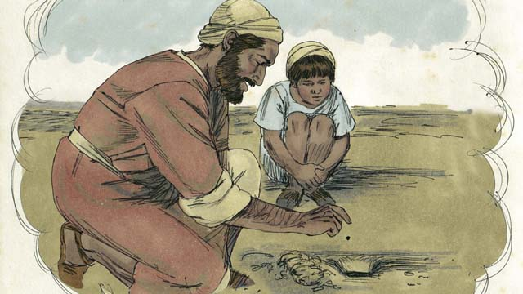

Jesus told many other stories about the kingdom of God. For example, he said, “The kingdom of God is like a mustard seed that someone planted in his field. You know that the mustard seed is the smallest seed of all.”

34-02



“But when the mustard seed grows, it becomes the largest of all of the garden plants, big enough that even the birds come and rest in its branches.”

34-03

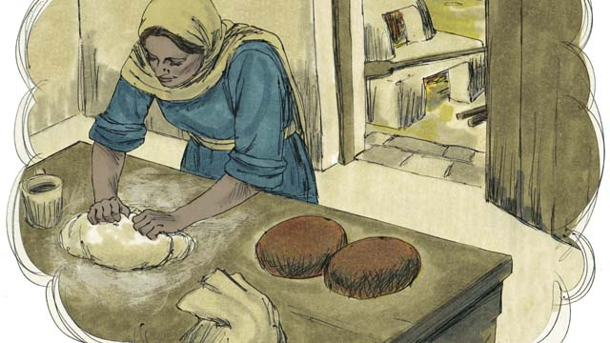

Telling another story, Jesus said, “The kingdom of God is like yeast that a woman mixes into some bread dough until it spreads throughout the dough.”

34-04

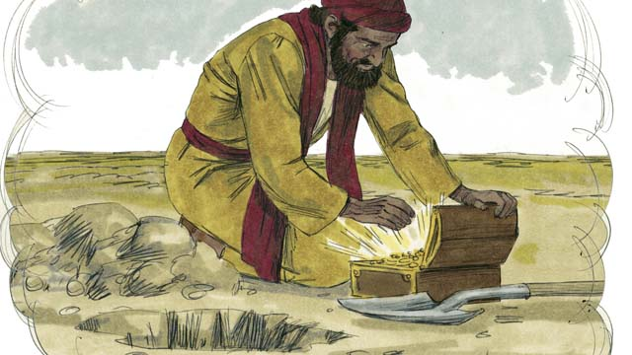

“The kingdom of God is also like treasure that someone hid in a field. Another man found the treasure and wanted it very much. So he buried it again. He was so filled with joy that he went and sold everything he had so he could buy that field where the treasure was.”

34-05

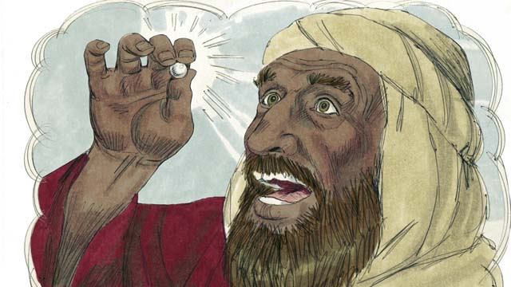

“The kingdom of God is also like a perfect pearl of great value. When a pearl merchant found it, he sold all that he had so he could buy it.”

34-06

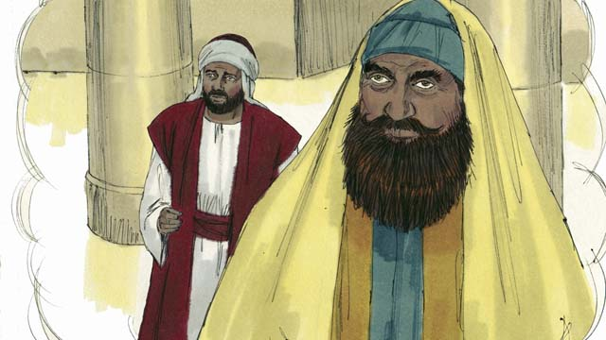

Some people thought God would accept them because they were doing good things. These people despised others who did not do those good things. So Jesus told them this story: “There were two men, both of whom went to the Temple to pray. One of them was a tax collector, and the other was a religious leader.”

34-07

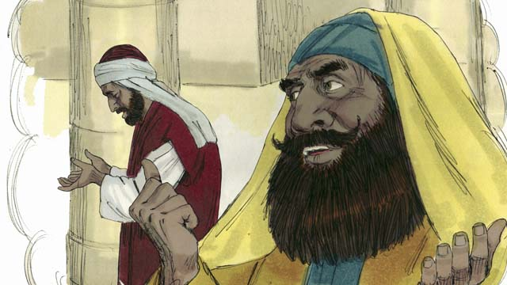

“The religious leader prayed like this, ‘Thank you, God, that I am not a sinner like other men—such as robbers, unjust men, adulterers, or even like that tax collector over there.’”

34-08

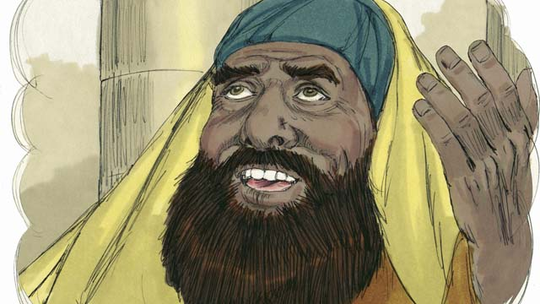

“‘For example, I fast two times every week and I give you ten percent of all the money and goods that I receive.’”

34-09

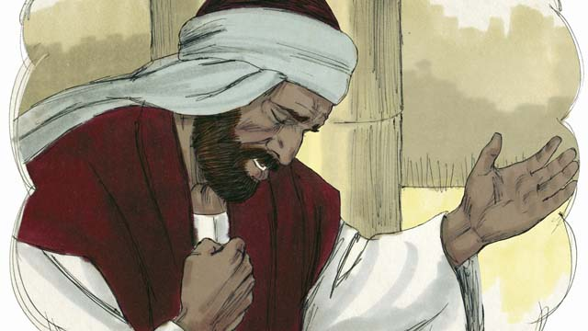

“But the tax collector stood far away from the religious leader. He did not even look up to heaven. Instead, he pounded on his chest with his fist and prayed, ‘God, please be merciful to me because I am a sinner.’”

34-10

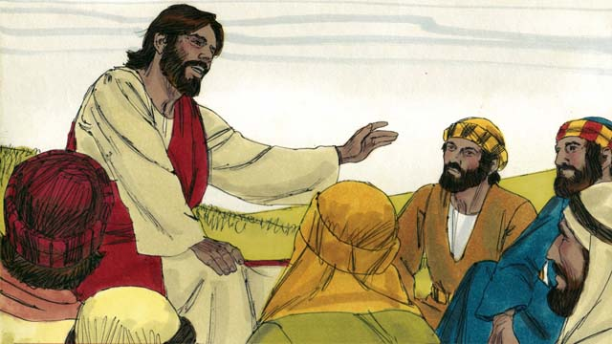

Then Jesus said, “I tell you, God heard the tax collector’s prayer, and declared him to be righteous rather than the religious leader. God will dishonor everyone who is proud, but he will honor whoever humbles himself.”

*A Bible story from: Matthew 13:31-46; Mark 4:26-34; Luke 13:18-21;18:9-14*

## 1 Community Study: Approved Servants—Aiming to Please God Most of All

* **Key Idea**: seeking for God’s approval in all that we do
* **Key Passage**: 2 Timothy 2:14-26
* **Main Session**: OBS 34 (Jesus Teaches Other Stories)

### 1.1 Recite the Creedal Verse (3–5 minutes)

The verse below summarizes the teaching of the current passage. Read the verse out loud as a community. Read it again several times as a group until the whole community can recite it from memory.

33 With many parables like this he spoke the word to them, as much as they were able to understand. Mark 4:33

OR

33 But seek first his kingdom and his righteousness and all these things will be given to you. Matthew 6:33

### 1.2 Describing Faithful Servants (5–10 minutes)

Think about faithful servants of God that you respect. As a community, describe together the characteristics of these faithful servants.

One faithful servant that I respect is …

I respect this servant because he/she is …

### 1.3 Read the Passage (3–5 minutes)

God wants us to serve him faithfully. Our lives and ministry are fully dedicated to God. As a community, read the following Bible passage together to understand what it means to serve God faithfully in your life and ministry.

14 Keep reminding them of these things. Warn them before God against quarreling about words; it is of no value, and only ruins those who listen. 15 Do your best to present yourself to God as one approved, a worker who has no reason to be ashamed, who accurately teaches the word of truth. 16 Avoid profane talk, which leads to more and more godlessness. 17 Their talk will spread like cancer. Among them are Hymenaeus and Philetus, 18 who have gone astray from the truth. They say that the resurrection has already happened, and they destroy the faith of some. 19 However, the firm foundation of God stands. It has this inscription: “The Lord knows those who are his” and “Everyone who names the name of the Lord must depart from unrighteousness.” 20 In a wealthy home, there are not only containers of gold and silver. There are also containers of wood and clay. Some of these are for honorable use, and some for dishonorable. 21 If someone cleans himself from dishonorable use, he is an honorable container. He is set apart, useful to the Master, and prepared for every good work. 22 Flee youthful lusts. Pursue righteousness, faith, love, and peace with those who call on the Lord out of a clean heart. 23 But refuse foolish and ignorant questions. You know that they give birth to arguments. 24 The Lord’s servant must not quarrel. Instead he must be gentle toward all, able to teach, and patient. 25 He must in meekness educate those who oppose him. God may perhaps give them repentance for the knowledge of the truth. 26 They may become sober again and leave the devil’s trap, after they have been captured by him for his will. 2 Timothy 2:14-26

### 1.4 Discuss the Passage (10-15 minutes)

God created us for a specific work in the world. Faithful service to God is doing what God has called us to do. As a community, use the following questions to discuss the teaching of the biblical passage.

1. How does this passage describe a faithful servant of God?
2. In what areas of life do faithful servants need to show maturity?
3. What causes Christians and Christian leaders to be unfaithful? How can you and your community guard against unfaithfulness?
4. How would you evaluate your community? What areas of growth can you identify?

### 1.5 Identify a Challenge (5 minutes)

Think about the above discussion. Try to communicate what it means to live a life that God approves.

God approves people like this…

### 1.6 Pray to God (5 minutes)

Reflect on what it means to be an approved workman. Pray for people by name in your community. Ask for God to help these people serve God in a faithful and pleasing way.

### 1.7 Sing a Song (3–5 minutes)

Identify a song that celebrates God’s faithfulness and Christian ministry responsibility. Sing this song together as a way to express your commitment to God.

## 2 Biblical Interpretation: Observing the Details of the Story

After reading the crafted biblical story, answer the following questions to familiarize yourself with the details of the story.

### 2.1 Observation Questions

Answer the following observation questions to gain a basic understanding of the story. Read the story as a community and answer these questions as a group.

#### 34-01

What were many of Jesus’ stories about?  
Jesus told many other stories about the kingdom of God.

To what kind of seed did Jesus compare the kingdom of God?  
Jesus taught that the kingdom of God was like a mustard seed that someone planted in the field.

How does a mustard seed compare to other seeds?  
It is the smallest seed of all.

#### 34-02

What happens to a mustard seed when it grows?  
It becomes the largest of all the garden plants.

How big does the mustard grow?  
The mustard seed grows a large garden plant big enough for birds to come and rest in its branches.

#### 34-03

To what cooking ingredient did Jesus compare the kingdom of God?  
Jesus taught that the kingdom of God is like yeast that a woman mixes into bread dough.

What happens to yeast when it is mixed into bread dough?  
It spreads throughout the dough, causing it to rise.

#### 34-04

To what valuable possession did Jesus compare the kingdom of God?  
Jesus taught that the kingdom of God was like treasure that someone hid in a field.

Who found the treasure?  
Another man found the treasure and wanted it very much.

What did the man do after finding the treasure hidden in the field?  
He buried it again, sold all he had, and used the money to buy the field where the treasure was.

#### 34-05

To what costly gem did Jesus compare the kingdom of God?  
Jesus taught that the kingdom of God was like a perfect pearl of great value.

What did the pearl merchant do when he found a perfect pearl?  
He sold all that he had and used the money to buy it.

#### 34-06

How did some people think God would treat them because of their good deeds?  
Some people thought God would accept them because they were doing good things.

What did these people think of others?  
These people despised others who did not do those good things.

What story did Jesus tell the people who were confident in their good deeds?  
Jesus told the story of two men who went to the temple to pray; a tax collector and a religious leader.

#### 34-07

How did the religious leader pray?  
The religious leader thanked God that he was a sinner like other men.

What kind of people did the religious leader think he was better than?  
The religious leader thought he was better than robbers, unjust men, adulterers, and tax collectors.

#### 34-08

Why did the religious leader think he was righteous?  
He fasted two times every week and gave ten percent of his money and goods.

#### 34-09

How did the tax collector pray to God?  
The tax collector stood far away from the religious leader, did not look up to heaven, and pounded his chest with his fist as he prayed.

What did the tax collector request from God?  
He asked God to be merciful to him because he was a sinner.

#### 34-10

Which man did God declare to be righteous?  
He declared that the tax collector was righteous.

What will God do to everyone who is proud?  
God will dishonor everyone who is proud.

What will God do to everyone who is humble?  
He will honor everyone who is humble.

### 2.2 Translation Questions

Use the following translation questions to understand specific details of the passage. Discuss how you might translate these specific elements of the story.

#### 34-01

**stories** Jesus used these **stories** as parables to teach truths about God’s kingdom. It is unclear if the events actually happened, but these **stories** talk about common experiences that people can relate to. How would you express **stories** to mean narratives that teach truths through events or circumstances that could have actually happened in real life?

  

**The kingdom of God is like a mustard seed** Jesus speaks of the kingdom of God as if it were a mustard seed. This probably refers to the seed of the black mustard plant, which has tiny seeds that rapidly grow into very large plants. God’s rule and reign as king may start small like a mustard seed, but he will eventually become larger than all other kingdoms. How would you express **The kingdom of God is like a mustard seed** to mean God’s rule can be compared (is similar to) a tiny mustard seed that grows into a large mustard plant that is larger than other garden plants?

  

**the smallest seed of all** The mustard seed is a very small seed. Mustard seeds were the smallest seeds known to the original hearers. At that time, it was the tiniest seed that people typically planted. How would you express **the smallest seed of all** to mean the smallest of all the seeds that people normally plant?

  

#### 34-02

**when the mustard seed grows** Jesus spoke about the size of the mustard seed plant when it becomes fully grown. How would you express **when the mustard seed grows** to mean at the time the seed of the mustard plant grows into a mature (full-grown) plant?

  

**largest of all of the garden plants** The mustard seed plant was a kind of plant that people planted in gardens. It was the largest garden plant people normally planted during this time. How would you express **largest of all of the garden plants** to mean the garden plant that becomes bigger than all the other plants that would be planted in a garden at this time?

  

**rest** The mustard plant would become big enough for birds to stay for a while on the branches. How would you express **rest** to mean **rest** to sit on or perch on?

  

#### 34-03

**The kingdom of God is like yeast** Jesus speaks of the kingdom of God as if it were yeast that is mixed into dough. This yeast is leaven that is added to bread dough to make it rise. A little bit of yeast mixed into a large amount of dough makes the whole batch of dough rise. How would you express **The kingdom of God is like yeast** to mean God’s rule can be compared (s similar to) a little bit of leaven that causes the dough to rise?

  

**bread dough** This is a mixture of flour and liquid that can be shaped and baked into bread. How would you express **bread dough** as a mixture of ground-up grain (flour) and water baked into bread?

  

**it spreads throughout the dough** When yeast/leaven is put into the dough, the yeast grows throughout all the dough. How would you express **it spreads throughout the dough** to mean every part of the dough has yeast/leaven in it?

  

#### 34-04

**The kingdom of God is also like treasure** Jesus speaks of the kingdom of God as if it were a valuable possession that someone hid in a field. How would you express **The kingdom of God is also like treasure** to mean God’s rule can be compared to (is similar to) a valuable possession that someone secretly put in place out of sight so others could not easily find it?

  

**buried it again** The man who found the treasure put it under the ground to hide it from others. How would you express **buried it again** to mean to hide it under the ground so that no one else would find it?

  

**filled with joy** The man who found the treasure was very delighted that he found it. How would you express **filled with joy** to mean the man who found the treasure was very happy and extremely excited that he found something so valuable?

  

**so he could buy that field where the treasure was** The person who buys the field to take possession of the hidden treasure. The reason the man sold his possessions was to have enough money to buy that field and make the treasure his own. How would you express **so he could buy that field where the treasure was** to mean the reason the man sold all his possessions was to have enough money to purchase the field where he buried the valuable possession and become the owner of the valuable possession?

  

#### 34-05

**The kingdom of** God is also like a perfect pearl of great value. Jesus speaks of the kingdom of God as if it were a precious gem called a pearl. Pearls are white circular gems. The pearl in this story is without any defects (perfect) and is worth a lot of money. How would you express **The kingdom of** God is also like a perfect pearl of great value to mean God’s rule can be compared to (is similar to) a beautiful stone/gem that has no flaws and is very valuable?

  

**a pearl merchant** This person is a pearl dealer or a pearl trader. This refers to a person whose business is buying and selling pearls. How would you express **a pearl merchant** to mean a person who buys and sells pearls as a business?

  

**he sold all that he had so he could buy it** The pearl merchant sold all of his possessions so that he could have enough money to purchase the pearl. How would you express **he sold all that he had so he could buy it** to mean the reason the pearl merchant sold his possessions was to have enough money to purchase the perfect and costly pearl?

  

#### 34-06

**God would accept them because they were doing good things** Some people thought that they had special favor and acceptance from God because they acted good and did good things. How would you express **God would accept them because they were doing good things** to mean some people believed that God approved of them more than others because of their good behavior?

  

**despised others** The people who were confident in their good behavior regarded other people as less important than themselves. How would you express **despised others** to mean considered other people to be inferior to them and looked down on other people?

  

**a tax collector** Tax collectors worked for the government. Their job was to get/gather money that people owed the government. They were often viewed as sinful and immoral by religious leaders. How would you express **a tax collector** to mean a person whose job it is to gather money from others that is owed to the government?

  

**a religious leader** Religious leaders thought that they themselves were the best examples of righteous good people, and they thought that tax collectors were the most unrighteous sinners. How would you express **a religious leader** to mean a person of influence and authority in a religious system?

  

#### 34-07

**The religious leader prayed like this** In this story, Jesus compares and contrasts how the religious leader and the tax collector pray. Jesus explains the way the religious leader prayed. How would you express **The religious leader prayed like this** to mean this is how the religious authority prayed?

  

**I am not a sinner like** The religious leader thanked God that he was not evil like some other people. The religious leader considered himself righteous/moral and considered other people (like the tax collectors) immoral. How would you express **I am not a sinner like** to mean the religious leader thought he was not sinful and wicked like he thought other people were?

  

**unjust men** The religious leader thought he was better than people who break the law and do evil things. How would you express **unjust men** to mean people who are not righteous?

  

#### 34-08

**I fast two times every week** The religious ruler said that he refrained from food at two different times in a week. The religious ruler was describing a habit that he would do every week. He believed that doing this would earn favor with God. How would you express **I fast two times every week** to mean the religious ruler had a habit/practice of refraining from food two times each week?

  

**I give you ten percent of all the money and goods that I receive** The religious ruler gave one-tenth of his earnings back to God as an offering. The religious ruler was describing a habit that he would do on a regular basis. He believed that doing this would earn favor with God. How would you express **I give you ten percent of all the money and goods that I receive** to mean the religious ruler had a habit of giving one-tenth of his earnings to God as a religious offering?

  

#### 34-09

**stood far away** The tax collector stayed separate and **stood far away** from the religious ruler. How would you express **stood far away** to mean the tax collector stood at a distance from the religious ruler?

  

**he pounded on his chest with his fist** The tax collector did not consider himself worthy of God’s acceptance. Because of his grief and despair, he hit his chest with his fist. How would you express **he pounded on his chest with his fist** to mean he pounded his chest in sorrow because he understood how sinful he was and how unworthy he was of God’s acceptance?

  

**God, please be merciful to me because I am a sinner** The tax collector believed he was a sinner. He pleaded with God in prayer to show him mercy and forgive his sins. He knew he needed God’s mercy because he recognized how much of a sinner he was. How would you express **God, please be merciful to me because I am a sinner** as a humble and desperate plea to God to show compassion/pity and forgive one’s sins?

  

#### 34-10

**declared him to be righteous** Even though the tax collector was a sinner, God was merciful to him because of his humility and repentance. God regarded the tax collector as upright. How would you express **declared him to be righteous** to mean God considered/reckoned the tax collector to be morally right and acceptable to God even though he was a sinner?

  

**God will dishonor everyone who is proud** God will cause the boastful and arrogant to lose honor and respect. How would you express **God will dishonor everyone who is proud** to mean God will give a lower status to those who have a high view of themselves, and he will cause them to not be important?

  

**but he will honor whoever humbles himself** God will treat the humble differently than he treats the proud. God will cause those who are meek and do not think of themselves as better than others to be esteemed and respected by others. How would you express **but he will honor whoever humbles himself** to mean God will give a higher position to those who do not have an arrogant or boastful attitude about themselves and behave in a meek way?

  

## 3 Theological Dialogue: Discussing the Meaning of the Story

Take time to explore the meaning of this story together as a community. Use the following discussions to grasp the truth the story teaches.

### 3.1 Discourse Questions

Use the following discourse questions to understand the meaning of the story. Pay attention to how the story itself addresses each question or theme.

##### What do the stories/parables that Jesus told teach us about the kingdom of God? (34-01, 34-02, 34-03, 34-04, 34-05)

Stories: Jesus told stories that taught people about God’s kingdom. These stories tell about things that can happen in real life and teach truths about God’s rule over the world. (34-01)

  

Mustard Seed | Small to Big: Jesus compared the kingdom of God to a mustard seed. Like a small seed that grows into a plant larger than the other garden plants, God’s kingdom will start small and grow to become bigger than all other kingdoms. In fact, like the birds who find rest in the branches of the mustard plant, people will only find real life when they become a part of God’s kingdom. (34-01, 34-02)

  

Yeast | Spreads Everywhere: Jesus compared the kingdom of God to yeast. Like yeast/leaven that spreads throughout an entire lump of bread dough, God’s kingdom will start in one place and spread everywhere. (34-03)

  

Treasure | Great Joy and Sacrifice: Jesus compared the kingdom of God to a treasure. A man hid the treasure in a field. Another man found the treasure. Because he wanted the treasure, the man buried it again and sold all his possessions to purchase the field and own the treasure. This treasure brought the man real joy. Like the treasure that is hidden, the kingdom of God is not entirely visible to all people. It is something people need to desire and search for. Also, the kingdom brings great joy. This joy causes people to get rid of all other valuable possessions and consider God’s kingdom the most valuable thing of all. It is worth people sacrificing everything to be a part of God’s kingdom. God’s kingdom is the only thing that brings real joy. (34-04)

  

Pearl | No Flaw and Great Value: Jesus compared the kingdom of God to a flawless and costly pearl. Like a pearl that had no defect and was also very expensive, the kingdom of God is perfect and is very valuable. Like the man in the treasure in the field, the pearl merchant sold all his possessions to purchase this pearl. God’s kingdom is without flaw, defect, or error. It is the most valuable thing to be a part of in one’s life. (34-05)

  

##### What were the different ways the religious leader and the tax collector tried to find acceptance before God? (34-06, 34-07, 34-08, 34-09, 34-10)

Some people thought that they were accepted by God because they behaved well. Many people think that doing good things makes God approve of us. However, this is not the case. No one can be good enough for God to accept him. In fact, relying on our good deeds causes us to treat others as inferior to ourselves. (34-06)

  

Comparison Is Dangerous: Jesus told a story about a tax collector and a religious leader. The religious leader thought that God accepted him because of his good/moral behavior was better than the behavior/conduct of others. The religious ruler thanked God that he was not sinful like robbers, unjust people, and adulterers. The religious leader compared himself to the tax collector and thought he was better than him. (34-07)

  

Religious Pride: The religious leader also thought that his religious/pious actions made him acceptable to God. He thought weekly fasting and a regular offering made God accept him more than others. Our religious behavior cannot make us acceptable to God. (34-08)

  

Humble Repentance: The tax collector was different than the religious leader. The religious leader thought he was righteous but was actually sinful. The tax collector knew he was sinful. The tax collector knew he was not worthy of being accepted by God. The only hope he had was to plead with God for mercy. The tax collector expressed how sad he was over his sin by beating his chest with his fist and begging God for mercy. God accepts those who genuinely come to him in humility and repentance of sin. (34-09)

  

Declared Righteous: Jesus explained that God heard the tax collectors pray. God showed mercy on the tax collector and declared him righteous. Even though the tax collector was a sinner, God regarded him as righteous (morally right before God) because God forgave his sin. Sinful humans can only be declared righteous by God if their sins are forgiven. Sins will only be forgiven for those who humbly beg God for mercy. (34-10)

  

Humility: Jesus explained that God dishonors the proud and honors the humble. People who think they are better than others and have confidence in their moral behavior will be rejected by God. Those who humble themselves and realize how low and sinful they are before God will be accepted by God. (34-10)

  

### 3.2 Theological Questions

Answer the following theology questions as a community. Discuss what truths this story teaches.

1. What is the kingdom of God like? What do we learn about God’s kingdom from this series of Jesus’ parables/stories?
2. How can sinful humans find acceptance before God? What does the story of the tax collector and the religious leader teach us about how to really be accepted by God?
3. How does pride become a part of our heart, and what are its dangers? How can one become humble, and what are its benefits? What does this story teach us about the danger of pride and the need for humility?

### 3.3 Translation Draft

Work as a translation team to draft each panel of this story. Pay attention to any specific translation issues that are challenging or significant.

#### Make Translation Draft

Make a draft for each section of this story.

#### Discuss and Revise

After drafting the story, discuss any translation issues that you think need special explanation.

#### Drafting Summary Reflection

Summarize any noteworthy translation decisions and the rationale/reasoning behind these translation decisions. In the final movement of this class, you will use these observations to give an account (i.e., chronicle/narrate) of how your translation improved through the checking process.

## 4 Personal Reflection: Following the Teaching of the Story

Take a moment to allow this story to evaluate your own life and to consider how God would have you respond. After this reflection, use the quality checking questions to check your translation draft among the translation team.

### 4.1 Journal Reflection

Prayerfully think about the following personal reflection questions. Write/Record your answers and/or discuss them as a group.

1. Which story about the kingdom of God most resonates with you?
2. How does understanding God’s kingdom instruct us how to live as followers of Jesus?
3. Do you most resemble the religious leader or the tax collector in your life? How do you know?
4. Where can you see evidence of pride in your heart and life?
5. What would it take to develop a true humility before God?

### 4.2 Team Check

*The following activity will help you check the clarity, accuracy, and naturalness of your draft. Read the passage aloud and discuss the checking questions with other members of your translation community. You might need to reread portions (or the whole) of the biblical passage multiple times as you answer each of these questions. Record answers to these questions below.*

#### Team Checking Questions

*Use the following questions to check your translation draft for accuracy, clarity, and naturalness.*

1. **Accurate**: Has anything been **added** to your translation of this passage that is not a part of the meaning of the source text? *If additions exist, are they included only added to clarify meaning (such as implied information)?*
2. **Accurate**: Is anything **missing** from your translation of this passage that is a part of the meaning of the source text? *If some part of the meaning is missing from your translation, add it.*
3. **Accurate**: Does any meaning in your translation of this passage appear to be **different** than the meaning of the source text? *If the meaning is different, try changing your translation so that the meaning remains the same.*
4. **Natural**: Does anything sound **unnatural** to how you would say it in your language? *If portions of the passage sound unnatural in your language, try to make them sound the way you would say it in your language while staying true to the meaning of the source text.*
5. **Clear**: Is anything **unclear** or **confusing** in your translation that confuses the meaning of the source text? *If portions of the passage are unclear or confusing, revise them to clearly communicate the meaning of the source text.*
6. **Consistent**: How **consistent** is your translation within the passage and with other passages? *If portions of the passage need to be made consistent or if you need to revise translations of other passages, make these adjustments.*

#### Record Feedback

*After discussing the checking questions above as a translation community, record any feedback on your translation draft. Pay attention for parts of your translation that are translated well and parts of your translation that need correction.*

#### Discuss and Revise

*After gathering feedback on your draft, discuss it together with your translation community and make appropriate revisions in your translation.*

#### Record Translation Decisions

*As a community, discuss some of the most noteworthy translation decisions in your draft. Summarize each decision and explain the reasons your community decided on that translation. You should update these decisions each time you check your draft with various groups of people.*

You should **measure** the quality of your translation draft. You can **record translation decisions** to make it clear why you translated things a certain way. Translation decisions can help your translation team and the surrounding community be a part of the translation process.

How can you know the quality of your translation?

1. **Measure** the translation by marks/standards of quality (i.e., clear, accurate, natural, church-approved)
2. **Test** the translation with others and record feedback and conversations from in the field (i.e., church and community check)
3. **Compare** and **contrast** the translation with the source text (i.e., meaning of text and notes) and alternatives (i.e., other translation choices)
4. **Explain** the reasons why you translated a particular portion of the text.

**Example Sentences That Help Explain Your Translation Decision** Use the following example sentences to help explain your translation decisions:

1. The original text literally **says/means**, so we translated the term in this way…
2. We originally decided to translate **the biblical term** with **this term**, but we changed it because…
3. When our translation team discussed **the biblical term**, this is what we talked about…
4. **The term** is [clear, accurate, natural, consistent] because…
5. The community understands **this term** to mean…
6. We considered these other terms. We did not use **these terms** because…
7. When we checked this in the church, we learned…
8. When we checked this in the community, we learned…

**Example of Translation Decision**

In OBS 01-07 we decided to translate **blessed** like this: [actual translation]. We decided on this translation because of these reasons:

1. The word [actual translation] means to cause good things to happen to someone or something. This term is used when a person desires someone or something to prosper or flourish. This term does not refer to magic or witchcraft.
2. When we checked this word with other believers, they said it describes God showing his kindness and favor on someone or something. These are some of the terms that we did not decide to use…
3. Many of our people will understand this word. When we discussed this phrase with the surrounding community, we discovered it was a natural way to describe God causing good and beneficial things to happen.

## 5 Ministry Practice: Serving the Church with the Story

Now that you have a draft of this story, consider how this story can encourage other believers in their faith. After ministering this story to others, you will also perform a community check of your translation draft.

### 5.1 Church Ministry

Reflect on how this story can edify and mature the Christian community. Design a way to minister this story to your church community.

**Ministry Preparation**: Take time to consider how you could minister this story to others. Record some ministry ideas below.

**Ministry Implementation**: Minister this story to a group of believers as you had planned. Use the information in this study to help develop a teaching/lesson or lead a discussion of this story to other believers. Record your ministry plan below.

**Ministry Reflection**: Think about what you learned from ministering this story to other believers. Reflect on your experience below.

### 5.2 Church Community Check

After teaching or ministering this story to the church, check the translation quality with the church community. Record any feedback from your checking experience.

#### Create Checking Questions

You can use **Translation Questions** to check your draft. Each **Translation Question** explains the meaning of a specific part of the story and asks you to consider how you would translate that part of the story in your own language. Change each **Translation Question** into a **Checking Question** by asking the following questions. The first question asks you to identify how each specific phrase was translated into your language. The second question asks people in the church to determine if your translation of the phrase expresses the meaning clearly, accurately, and naturally. Look at the following examples to see how to change **Translation Questions** into **Checking Questions**:

#### Translation Question Example 1

**to proclaim the good news about Jesus** Paul and Silas traveled to Philippi for the purpose of preaching the gospel. The gospel is the good news that Jesus saves people from their sins if they will believe in Jesus. How would you express **to proclaim the good news about Jesus** to mean to tell other people the message about how Jesus can save people from their sins?

#### Translation Question Example 2

**a merchant** Paul and Silas met a woman named Lydia at the place by the river. She owned a business and sold items to make money. How would you express **a merchant** to mean a business owner who sells items for a profit?

#### Translation Question Example 3

**so Paul and Silas baptized them** The jailer and his whole family followed Paul’s instructions. They believed in Jesus. The result of this was Paul and Silas baptized them. How would you express **so Paul and Silas baptized them** to mean the result of the jailer and his family believing in Jesus that Paul and Silas baptized all of them?

You can change these into **Checking Questions** like this:

#### Checking Question Example 1

**to proclaim the good news about Jesus** How did you translate **to proclaim the good news about Jesus**? Does it mean to tell other people the message about how Jesus can save people from their sins?

#### Checking Question Example 2

**a merchant** How did you translate **a merchant**? Does it mean a business owner who sells items for a profit?

#### Checking Question Example 3

**so Paul and Silas baptized them** How did you translate **so Paul and Silas baptized them**? Does it mean the result of the jailer and his family believing in Jesus that Paul and Silas baptized all of them?

#### Record Feedback

*Discuss the* ***Checking Questions*** *with your church community, and record any feedback on your translation draft. Pay attention to parts of your translation that are translated well and parts of your translation that need correction.*

#### Discuss and Revise

*After gathering feedback on your draft, discuss it together with your translation community and make appropriate revisions to your translation.*

#### Record Translation Decisions

*Update your translation decisions and record any new and noteworthy observations on the quality of your draft.

## 6 Missional Outreach: Sharing the Truth of the Story

*After sharing this story with others, check the translation quality with the wider language community. Record any feedback from your checking experience.*

### 6.1 Mission Engagement

*Consider how you will witness this story to unbelievers. Design a way to share this story and engage them in what it teaches about Christianity and the gospel.*

**Witness Preparation**: Take time to consider how you will witness this narrative to unbelievers. Record some ideas below.

**Witness Implementation**: Share this story with an unbeliever. Use the information in this study to help develop a teaching/lesson or lead a discussion of this story to other believers. Record your ministry plan below.

**Witness Reflection**: Think about what you learned from ministering this story to unbelievers. Reflect on your experience below.

### 6.2 Sociolinguistic Check

After sharing this story with the language community, check your translation draft with the surrounding community. Record your observations.

#### Checking Approach

After witnessing this story to unbelievers, use one of the following methods to check the translation of this story. Consider using the **Observation Questions** to check your translation draft or come up with your own quality checking questions.

**Read-Retell Check:** Read your draft to those the community and ask them to retell the passage. Be attentive to any portions of the passage that are unclear, unnatural, or inaccurate.

**Comprehension Questions Checklist:** Read the draft of the passage and ask a list of comprehension questions to make sure the passage is being rightly understood. You can use the **Observation Questions** in this guide or come up with your own questions. Then, record any insights or issues that arise.

**Discussion Group:** Develop key questions to ask about the passage (both formational and translational). Read the passage and have a group discussion about the passage, paying attention to issues that need to be addressed, edited, and revised.

#### Record Feedback

*After sharing your draft with the language community, discuss the* ***Observations Questions****, and record any feedback on your translation draft. Pay attention to parts of your translation that are translated well and parts of your translation that need correction.*

#### Discuss and Revise

*After gathering feedback on your draft, discuss it together with your translation community and make appropriate revisions to your translation.*

#### Record Translation Decisions

*Update your translation decisions and record and new any noteworthy observations on the quality of your draft.

## 7 Conclusion

As a translation community, take time to reflect on all that was learned in studying, drafting, and checking this story. Celebrate all that God has taught you as a community. Then, submit your revised draft and checking summaries to network leaders for further review.