Open Bible Stories

The Story of the Compassionate Father

## 0 Introduction

### 0.1 Key Idea

The story of the compassionate father teaches us about God’s readiness to forgive us of our sin and cautions us about being confident in our own righteousness.

### 0.2 Creedal Verse

“As a father shows compassion to his children, so the Lord shows compassion to those who fear him.” Psalm 130:13

### 0.3 Metanarrative Summary

The eternal God created all things in six days. He made a good and perfect world. He made humans in his image to fill the earth and rule over creation. But humans rebelled against God and ruined God’s creation. God set to restore his world through his promise. God made a covenant with Abraham. He promised to bless all nations through Abraham. God kept his promises across the generations. God provided Abraham with a promised child, Isaac. God gave Isaac a wife and she bore twins, Jacob and Esau. God blessed Jacob and his sons, and the blessing continued to the next generation. God rescued Joseph, one of Jacob’s sons, and used him to rescue his family. God caused his people, the Israelites, to multiply in the land of Egypt; eventually, they became slaves. But, God raised up a deliverer, Moses, to deliver his people from their slavery. God judged the Egyptians with harsh plagues; in the final judgment, he passed over his people who covered their doorposts with the blood of a sacrificed lamb. Then, God delivered the Israelites by bringing them out of Egypt and crossing the Red Sea on dry land. God made a covenant with the Israelites and made them his people. God tested Israel in a series of wilderness wanderings and eventually brought his people into the promised land of Canaan. God raised up deliverers to lead Israel and rescue them from their enemies. God formed Israel into a kingdom. He made a covenant with King David and promised to send a king that would rule his people forever. Many of Israel’s kings were evil and the kingdom of Israel divided into two kingdoms. God sent prophets to warn his people of God’s judgment and call them to repent. When Israel did not repent, God sent his people into exile. After many years, he brought them back to the land. Throughout the Old Testament, God promised to send his Messiah to deliver his people form their sin. After many years, the prophet John was born. He would prepare people for the coming Messiah. At the perfect time, God sent his Son, Jesus, to be born of a virgin Mary. When John and Jesus grew up, John baptized Jesus as a sign that Jesus was God’s beloved Son. Jesus endured all manner of temptation without ever sinning. When he was thirty years old, he launched a public ministry of preaching, teaching, and healing. He taught his disciples about the life of compassion, sacrifice, and forgiveness. He performed many miracles: he fed a crowd of five thousand, he walked on water, he healed the sick, and he cast out demons. He proclaimed to people the nature of real faith, God’s kingdom, and the how fallen humans can be restored in relationship with God.

### 0.4 Open Bible Story: The Story of the Compassionate Father

35-01

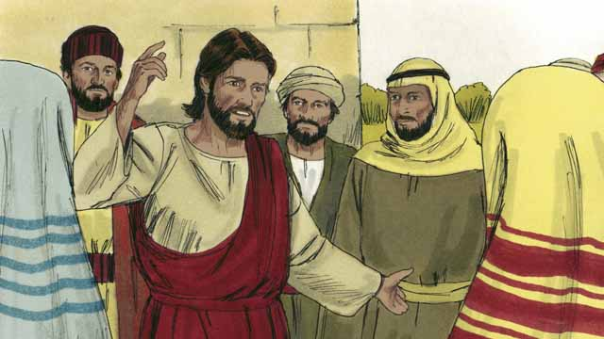

One day, Jesus was teaching many people who had gathered to hear him. These people were tax collectors and also other people who did not try to obey the Law of Moses.

35-02

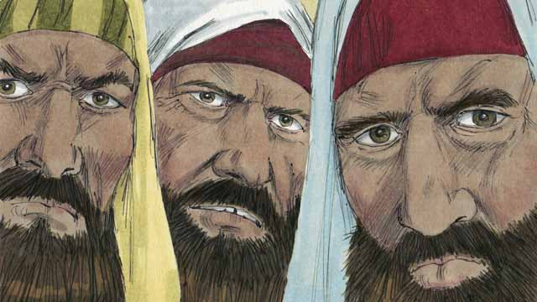

Some religious leaders saw Jesus talking to these people as friends. So they began to tell each other that he was doing wrong. Jesus heard them talk, so he told them this story.

35-03

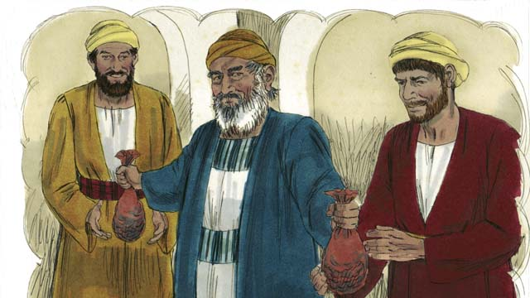

“There was a man who had two sons. The younger son told his father, ‘Father, I want my inheritance now!’ So the father divided his property between his two sons.”

35-04

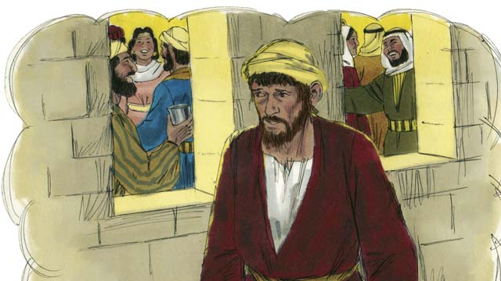

“Soon the younger son gathered all that he had and went far away and wasted his money in sinful living.”

35-05

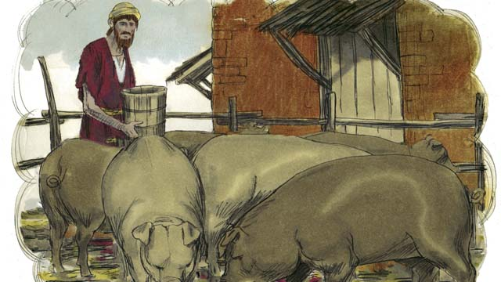

“After that, a severe famine occurred in the land where the younger son was, and he had no money to buy food. So he took the only job he could find, feeding pigs. He was so miserable and hungry that he wanted to eat the pigs’ food.”

35-06

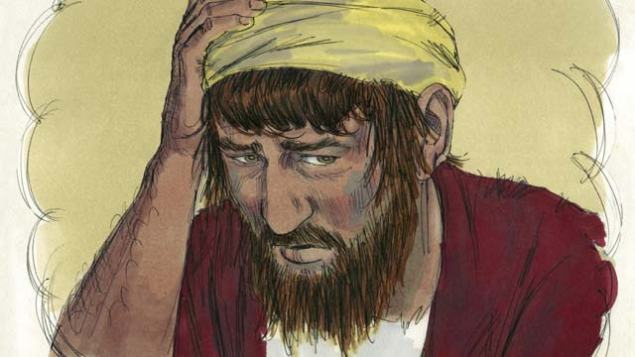

“Finally, the younger son said to himself, ‘What am I doing? All my father’s servants have plenty to eat, and yet here I am starving. I will go back to my father and ask to be one of his servants.’”

35-07

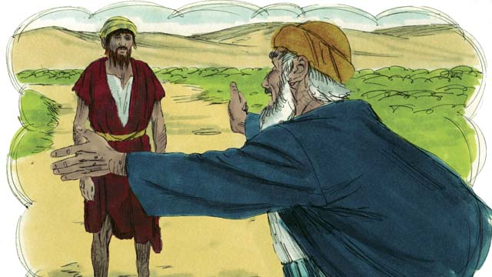

“So the younger son started back towards his father’s home. When he was still far away, his father saw him and felt compassion for him. He ran to his son and hugged him and kissed him.”

35-08

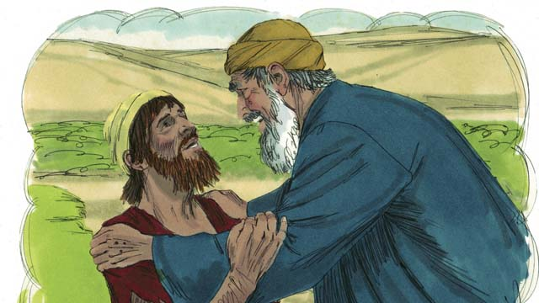

“The son said, ‘Father, I have sinned against God and against you. I am not worthy to be your son.’”

35-09

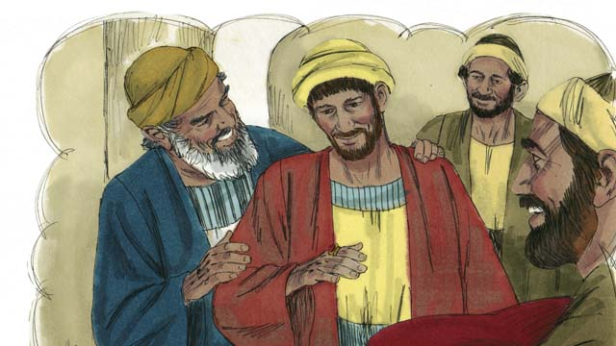

“But his father told one of his servants, ‘Go quickly and bring the best clothes and put them on my son! Put a ring on his finger and put sandals on his feet. Then kill the best calf so we can have a feast and celebrate, because my son was dead, but now he is alive! He was lost, but now we have found him!’”

35-10

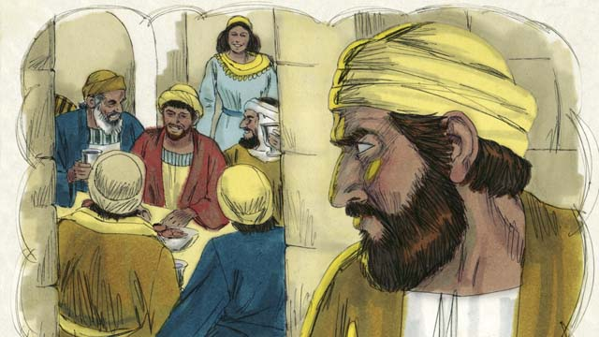

“So the people began to celebrate. Before long, the older son came home from working in the field. He heard the music and dancing and wondered what was happening.”

35-11

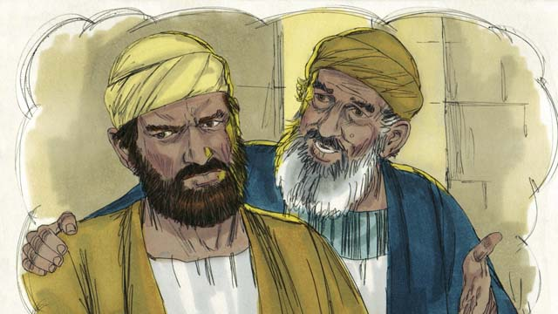

“When the older son found out that they were celebrating because his brother had come home, he was very angry and would not go into the house. His father came out and begged him to come and celebrate with them, but he refused.”

35-12

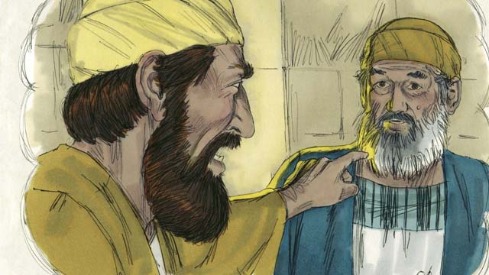

“The older son said to his father, ‘All these years I have worked faithfully for you! I never disobeyed you, and still you did not give me even one small goat so I could celebrate with my friends. But this son of yours has wasted your money doing sinful things. When he came home, you killed the best calf to celebrate!’”

35-13

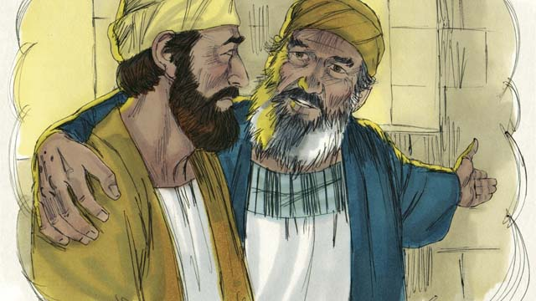

“The father answered, ‘My son, you are always with me, and everything I have is yours. But it is right for us to celebrate because your brother was dead, but now is alive. He was lost, but now we have found him!’”

*A Bible story from: Luke 15*

## 1 Biblical Interpretation: Observing the Details of the Story

After reading the crafted biblical story, answer the following questions to familiarize yourself with the details of the story.

### 1.1 Observation Questions

Answer the following observation questions to gain a basic understanding of the the story. Read the story as a community and answer these questions as a group.

#### 35-01

What kind people gathered to hear Jesus teach in this story?  
Many people who were tax collectors and people who did not obey the Law of Moses gathered to hear Jesus teach.

#### 35-02

How did Jesus treat these people?  
Jesus was talking to these people as friends.

How did the religious leaders respond to Jesus talking to the tax collectors and sinners as friends?  
The religious leaders told others that Jesus was doing something wrong.

What did Jesus do when he heard the religious leaders criticize him?  
Jesus heard them talking and told them a story.

#### 35-03

Who were the characters in Jesus’ story?  
The story was about a man who had two sons.

What did the younger son demand from his father?  
He wanted his inheritance right away.

How did the father respond to the request of the younger son?  
The father divided up his property between his sons.

#### 35-04

What did the younger son do with his inheritance?  
The younger son gathered up all his possessions, went far away, and wasted it in sinful living.

#### 35-05

What happened in the land where the younger son went to live?  
There was a severe famine.

How did the famine affect the younger son?  
Eventually, the younger son had no money to buy food.

What did the younger son do to survive during the famine?  
He took a job feeding pigs.

What did the younger son feel like at this time?  
The younger son was so miserable and hungry that he wanted to eat the pigs food.

#### 35-06

Why did the younger son decide to return home?  
He realized that father’s servants had plenty to eat, and yet he was starving.

What was the younger son planning to ask his father?  
He was going to ask his father to let him be one of his servants.

#### 35-07

When the did the father see his son returning home?  
The younger son started back towards his father’s home and the father saw him when he was still far away.

What did the father do when he saw the younger son approaching?  
He felt compassion for him, ran to him, hugged him, and kissed him.

#### 35-08

What did the younger son say to his father when they met?  
He said, “Father, I have sinned against God and against you. I am not worthy to be your son.”

#### 35-09

How did the father respond to the younger son’s confession?  
He put clothes, a ring, and sandals on the younger son and had a feast to celebrate his return.

What did the father say about his son returning home?  
The father said that his son was dead but was now alive, he was lost but was now found.

#### 35-10

How did people act when the son returned home?  
The people began to celebrate.

Where was the older son at this time?  
The older son was working in the field and heard the music and dancing and wondered what was happening.

#### 35-11

How did the older son react when he learned that his brother had come home?  
He was very angry and refused to go into the house.

What did the father say to the older son?  
The father begged the older son to come and celebrate.

How did the older son respond to his father’s plea?  
The older son refused to join the celebration.

#### 35-12

What was the older son’s complaint to his father?  
The older son said he had worked faithfully for his father and obeyed him, and his father did not give him even a small goat to celebrate.

What did the older son say about the celebration of the younger son?  
The older son said that the younger son wasted money doing sinful things, but when he came home he was given the best calf to celebrate his return.

#### 35-13

How much of the father’s possessions now belonged to the older son?  
Everything the father had now belonged to the older son.

What reason did the father give for celebrating the return of his younger son?  
His son had been dead, but now was alive. He had been lost, but now was found.

### 1.2 Translation Questions

Use the following translation questions to understand specific details of the passage. Discuss how you might translate these specific elements of the story.

#### 35-01

**tax collectors** Tax collectors gathered money from people that was owed to the government. At this time, **tax collectors** were considered to be the worst of sinners because often they stole money from people by collecting a higher tax than the government required and keeping the difference for themselves. How would you express **tax collectors** to mean people whose job it is to collect money from citizens that is owed to the government?

  

**people who did not try to obey the Law of Moses** This group of people disobeyed God’s law and did not attempt to follow it. How would you express **people who did not try to obey the Law of Moses** to mean people who sinned by breaking God’s commands without making an effort to follow these commands?

  

#### 35-02

**talking to these people as friends** Jesus was speaking with sinners and tax collectors in a friendly way. The religious leaders considered this a problem because they did not think religious people should associate with sinners. How would you express **talking to these people as friends** to mean speaking to people in a kind and accepting way like friends would speak to each other?

  

**Jesus heard them talk** Jesus overheard the religious leaders criticize him. The religious leaders did not speak their criticism directly to Jesus. They told other people and Jesus heard what they said to these people. How would you express **Jesus heard them talk** to mean Jesus heard what the religious leaders said about him to other people?

  

#### 35-03

**There was a man** Jesus tells a story about a man who had two sons. The man in this story is not given a name. How would you express **There was a man** to introduce a new (unspecified/unnamed) character in a story/narrative?

  

**I want my inheritance now!** The younger son makes a strong request from his father. The son said this to emphasize that he was not willing to wait until after his father died in order to receive his inheritance. An inheritance is the part of your wealth that will be rightfully given to a child when the father dies. How would you express **I want my inheritance now!** as a strong request by the younger son that father give his inheritance wealth now rather than waiting until after his father dies?

  

**property** The father listened to the younger son’s request. The father separated his possessions and allocated some for his older son and his younger son. How would you express **property** to mean a person’s wealth and possessions that would include land, animals, and money?

  

#### 35-04

**wasted his money** The younger son spent all his money without getting anything of value in exchange. Some people might describe this as “throwing” one’s money away or “eating” one’s money. How would you express **wasted his money** to mean the younger son used all his money on things that were not valuable and did not help him sustain his wealth?

  

**sinful living** The younger son spent his money doing things that were against God’s laws and commands. How would you express **sinful living** to mean acting and behaving in a way that is immoral and disobedient to God’s commands?

  

#### 35-05

**a severe famine occurred** A famine occurs when there is very little food to eat for a group of people living in a certain area. How would you express **a severe famine occurred** to mean there was a really bad time when there was very little food to eat for the people living in the area where the younger son was staying?

  

**he took the only job he could find** The younger son needed to work so he could earn money. A job refers to work that he would do for someone else in exchange for payment. The younger son could not find a good job that would pay good money. The only job that was available for him was the dirty and low-paying job of feeding pigs. How would you express **he took the only job he could find** to mean the younger son worked to earn some money doing the only work that he could get at that time?

  

**feeding pigs** The younger son was able to find a job **feeding pigs**. This would have been considered as one of the lowest jobs in society at this time. How would you express **feeding pigs** to mean a job of low status giving food to pigs?

  

#### 35-06

**said to himself** The younger son either thought these words or said them out loud to himself. Either way, these words represent the thoughts of the younger son about his living conditions. How would you express **said to himself** to mean the younger son expressed his thoughts to himself without necessarily speaking to another person?

  

**What am I doing?** The son isn’t really asking for information on what he is doing at the moment. He asked the question to himself to express dissatisfaction with how he was living. The younger son had wasted his inheritance, was living far from home, and was ready to share food with pigs. He was living a miserable life because of his disobedient decisions. How would you express **What am I doing?** as a question the son asks to convey that it did not make sense for him to be living in such miserable conditions?

  

#### 35-07

**When he was still far away** The father saw his younger son returning home while he was some distance away. The son was getting close to his father’s house but was still far enough away that most people in the house would not have seen him. How would you express **When he was still far away** to mean the the father saw he younger son within sight of his father’s home, but still a distance away?

  

**felt compassion** The father loved his son and had deep concern for him. How would you express **felt compassion** to mean the father felt felt deep love and pity toward his younger son?

  

**hugged him and kissed him** The father did this to show his son that he loved him and was glad that the son was coming home. In this time and culture, this is how fathers would show affection to their sons. How would express **hugged him and kissed him** to mean the father embraced his son with a hug and kiss him showing the affection of a father for a son?

  

#### 35-08

**sinned against God and against you** The younger son realized that he violated God’s commands. He also recognized that he did not treat his father in a morally right way either. How would you express **sinned against God and against you** to mean disobeyed God’s commands and done things that were wrong to his father?

  

**I am not worthy to be your son** The son told his father that he did not think he was good enough to be considered his fathers’ son. How would you express **I am not worthy to be your son** to mean the younger son did not think he deserved to be a son to his father anymore because of his sin against God and his father?

  

#### 35-09

**Put a ring on his finger** A ring was a sign of authority that men wore on one of their fingers. How would you express **Put a ring on his finger** as an act that means the father considered the younger son to be fully respected as a member of the family?

  

**the best calf** The father told his servants to kill the the fattest calf for a feast. This was the calf that had been fattened so that, when cooked, it would taste the best. How would you express **the best calf** to mean fattest calf that would have the best tasting meat when cooked for a meal?

  

**my son was dead, but now he is alive!** The father speaks of the son being gone as if he were dead. The father also speaks of the son returning home as if he has come back to life. This is a strong statement that emphasizes the father’s emotion and joy of having his son back home. How would you express **my son was dead, but now he is alive!** to mean the father grieved when his son was gone as if the son had died and now the father was happy that his son had returned home as if the son had come back to life?

  

**He was lost, but now we have found him!** The father speaks of the son being gone as if he were lost. The father also speaks of the son returning home as if he has be found again. This is a strong statement that emphasizes the father’s emotion and joy of having his son back home. How would you express **He was lost, but now we have found him!** to mean the father grieved when his son was gone as if the son had been lost and now the father was happy that his son had returned home as if the son had been found?

  

#### 35-10

**Before long** The people were celebrating for little time when the older son returned home from work. How would you express **Before long** to mean soon or after a little while?

  

**wondered what was happening** The older son was surprised by the music and dancing. He did not expect this. How would you express **wondered what was happening** to mean the older son was surprised by the music and dancing because he did not expect it and wanted to know why there was a celebration?

  

#### 35-11

**begged him to come** The father pleaded with his older son to join the celebration. How would you express **begged him to come** to mean the father pleaded emotionally with his older son to participate in the celebration for the younger son?

  

**but he refused** The father pleaded with his older son to join the celebration. The old son did the opposite of his father’s request. The older son would not listen to his father. He did not go into the celebration. How would you express **but he refused** to mean the older son rejected/turned down his father’s request to participate in the celebration?

  

#### 35-12

**All these years** I have worked faithfully for you! The older son told his father how he had been loyal all the time the younger son was living a sinful life. The old older son thought that his father was treating him unfairly. He gave a celebration for his younger brother who lived sinfully but did not have a celebration for his older son who was loyal to him. How would you express **All these years** I have worked faithfully for you! as a strong statement that shows that the older son felt his father was treating him unfairly by giving a celebration to the younger son rather than to the older son?

  

**one small goat** A small goat would have fed fewer people than the best calf, and would not be valued as much. The older brother is complaining that his father was treating the sinful younger son better than him. How would you express **one small goat** to mean the father did not give even small celebration for the older son who had served his father loyally?

  

**this son of yours** The older son was angry. The older son rejected his younger brother and he disapproved of his father for welcoming back this wayward son. How would you express **this son of yours** to mean the older brother did not consider the younger son to be his brother, especially because he felt his father had acted unfairly in giving a celebration to his younger son?

  

#### 35-13

**it is right for us** The father explained that it was appropriate/proper to celebrate the return of the younger son. How would you express **it is right for us** to mean it is the right/proper things to do in welcoming back the younger son?

  

**your brother** The father refers to his younger son as **your brother** to remind the older son of his relationship to the younger son and of how he should love his younger brother. How would you express **your brother** to mean the younger son is truly the brother to his older brother and he should love him in that way?

  

## 2 Theological Dialogue: Discussing the Meaning of the Story

Take time to explore the meaning of this story together as a community. Use the following discussions as a way to grasp what truth the story teaches.

### 2.1 Discourse Questions

Use the following discourse questions to understand the meaning of the story. Pay attention to how the story itself addresses each question or theme.

##### How did Jesus interact with sinners and religious leaders? (35-01, 35-02)

Sinners: Jesus was teaching a group of people who did not follow God’s laws. This group was composed of people who were considered sinful. There were tax collectors. These people were known for stealing money from people. Also, there were people who did not try to obey God. Although Jesus did not participate in their sin, Jesus was interacting with these people as friends. (35-01, 35-02)

  

Religious Leaders: Religious leaders criticized Jesus for being friendly with sinners. These religious leaders thought they were better than other sinners. They thought that Jesus should not be interacting with sinners in this way. The religious leaders told other people that Jesus was acting wrongly. In response, Jesus told the religious leaders a story that would confront their pride and attitude of being morally superior to others. (35-02)

  

##### In Jesus’ story, how did the younger son wrongly? (35-03, 35-04, 35-05)

Disrespect: The younger son asked for his inheritance before his father died. He made a demanding request that his father give him the inheritance. This would have been disrespectful and dishonoring to his father. (35-03)

  

Rejection of Family: The younger son took his possessions and lived in a far away land. The younger son rejected his family and wanted to live life his own way. (35-04)

  

Sinful Living: The younger son wasted all his money on sinful living. He used the wealth of his inheritance to do things that did not please God and things that broke God’s commands. Seeking a life of pleasure, the younger son lived in sin. (35-04)

  

Misery: The younger son ran out of money and could not by food. He took a job of lowly status feeding pigs. He was so miserable and hungry that he wanted to eat the pigs’ food. His life of sin led him to misery, hunger, and shame. (35-05)

  

##### How did the younger son get restored? (35-06, 35-07, 35-08, 35-09, 35-10)

Honest Acknowledgement of Sin’s Misery: The younger son came to realize that his sinful living was foolish. He chose to live in sin and it led to a life of misery. Meanwhile, even the servants in his father’s house were eating better than he was. The son came to realize that his life of sin had led to misery and life was much better in his father’s home. The younger son had to admit he foolishness of his sin and the good of his father’s house before he would return home. (35-06)

  

Return Home/Leave Sin: The younger son decided that he would return home to his father. His life was better with his father than living a life of sin. The younger son was restored by returning home to his father and leaving his life of sin. (35-06)

  

Father’s Compassion: The younger son was only received back home because the father had compassion on him. When the son was still a distance away, the father saw him and welcomed him by hugging and kissing him. (35-07)

  

Humble Confession: The younger son acknowledged that he sinned against God and his father. His sin made him unworthy to be part of his father’s family. They younger son showed humility and confessed his sins. (35-08)

  

Full Acceptance: The younger son was fully restored to a position/status of honor in the family. The father put on him the best clothes, a ring on his finger, and sandals on his feet. He also had the best calf slaughtered for a feast and celebration. The father received the son back into the family as a full son. This was because of the compassion and grace of the father. (35-09, 35-10)

  

Back to Life/Being Found: The father restoring the son to the family was like a dead person coming back to life and someone lost being found again. The son was given new life by being restored to his father’s family. (35-09)

  

##### How did the older brother respond (35-10, 35-11, 35-12, 35-13)

Anger: The older brother found out about the celebration for his younger brother and was very angry. The older brother thought the father was being unfair in his treatment of the two sons. (35-10, 35-11)

  

Refusing to Join Celebration: The older brother did not join the celebration. He was so angry that he refused to share the joy of his lost brother coming home and being restored to the family. The older brother did not find joy welcoming his wayward brother back home. (35-11)

  

Rejection: The older brother told his father that the younger brother was “this son of yours.” The older brother rejected his brother as a brother and showed disapproval of his father’s actions. The old brother rejected his younger brother as family. (35-12)

  

Jealousy: The older brother complained to his father. He explained that he faithfully served him while his younger brother lived in sin but the father did not have a celebration for him. The older brother was jealous of the father’s treatment of the younger son. (35-12)

  

The older brother did not realize that he had all the provisions of his father’s house while he was living there. The father did not treat the older brother unfairly. The older brother had access to the privileges of the father’s household. Because the older brother thought he was better than the younger brother, he did not rejoice in the blessings that he enjoy or the return of his wayward brother. (35-13)

  

### 2.2 Theological Questions

Answer the following theology questions as a community. Discuss what truths this story teaches.

1. How is sin a rebellion against/rejection of God? How does the rebellion of the younger brother teach us about the nature of sin?
2. How can sinners be restored to a relationship with God? What does the return of the younger brother teach us about what it means to be restored in our relationship with God?
3. What keeps people from returning to God? How does the rebellion of the younger brother and the angry response of the older brother help us understand what can keep people from returning to God?

### 2.3 Translation Draft

Work as a translation team to draft each panel of this story. Pay attention to any specific translation issues that are challenging or significant.

#### Make Translation Draft

Make a draft for each section of this story.

#### Discuss and Revise

After drafting the story, discuss any translation issues that you think need special explanation.

#### Drafting Summary Reflection

Summarize any noteworthy translation decisions and the rationale/reasoning behind these translation decisions. In the final movement of this class, you will use these observations to give an account (i.e., chronicle/narrate) of how your translation improved through the checking process.

## 3 Personal Reflection: Following the Teaching of the Story

Take a moment to allow this story to evaluate your own life and to consider how God would have you respond. After this reflection, use the quality checking questions to check your translation draft among the translation team.

### 3.1 Journal Reflection

Prayerfully think about the following personal reflection questions. Write/Record your answers and/or discuss them as a group.

1. How did your life before you became a Christian look like the rebellion of the younger son?
2. How has God restored you and received you into his family like the father received the wayward son back into his family?
3. In what ways are you in danger of a proud and self-righteous spirit in which you think you are better than others?
4. How does Jesus’ example give you a model to follow in terms of how to minister to sinful people?

### 3.2 Team Check

*The following activity will help you check the clarity, accuracy, and naturalness of your draft. Read the passage aloud and discuss the checking questions with other members of your translation community. You might need to reread portions (or the whole) of the biblical passage multiple times as you answer each of these questions. Record answers to these questions below.*

#### Team Checking Questions

*Use the following questions to check your translation draft for accuracy, clarity, and naturalness.*

1. **Accurate**: Has anything been **added** to your translation of this passage that is not a part of the meaning of the source text? *If additions exist, are they included only added to clarify meaning (such as implied information)?*
2. **Accurate**: Is anything **missing** from your translation of this passage that is a part of the meaning of the source text? *If some part of the meaning is missing from your translation, add it.*
3. **Accurate**: Does any meaning in your translation of this passage appear to be **different** than the meaning of the source text? *If the meaning is different, try changing your translation so that the meaning remains the same.*
4. **Natural**: Does anything sound **unnatural** to how you would say it in your language? *If portions of the passage sound unnatural in your language, try to make them sound the way you would say it in your language while staying true to the meaning of the source text.*
5. **Clear**: Is anything **unclear** or **confusing** in your translation that confuses the meaning of the source text? *If portions of the passage are unclear or confusing, revise them to clearly communicate the meaning of the source text.*
6. **Consistent**: How **consistent** is your translation within the passage and with other passages? *If portions of the passage need to be made consistent or if you need to revise translations of other passages, make these adjustments.*

#### Record Feedback

*After discussing the checking questions above as a translation community, record any feedback on your translation draft. Pay attention for parts of your translation that are translated well and parts of your translation that need correction.*

#### Discuss and Revise

*After gathering feedback on your draft, discuss it together with your translation community and make appropriate revisions in your translation.*

#### Record Translation Decisions

*As a community, discuss some of the most noteworthy translation decisions in your draft. Summarize each decision and explain the reasons your community decided on that translation. You should update these decisions each time you check your draft with various groups of people.*

You should **measure** the quality of your translation draft. You can **record translation decisions** to make it clear why you translated things a certain way. Translation decisions can help your translation team and the surrounding community be a part of the translation process.

How can you know the quality of your translation?

1. **Measure** the translation by marks/standards of quality (i.e., clear, accurate, natural, church-approved)
2. **Test** the translation with others and record feedback and conversations from in the field (i.e., church and community check)
3. **Compare** and **contrast** the translation with the source text (i.e., meaning of text and notes) and alternatives (i.e., other translation choices)
4. **Explain** the reasons why you translated a particular portion of the text.

**Example Sentences That Help Explain Your Translation Decision** Use the following example sentences to help explain your translation decisions:

1. The original text literally **says/means**, so we translated the term in this way…
2. We originally decided to translate **the biblical term** in with **this term**, but we changed it because…
3. When our translation team discussed **the biblical term**, this is what we talked about…
4. **The term** is [clear, accurate, natural, consistent] because…
5. The community understands **this term** it to mean…
6. We considered these other terms. We did not use **these terms** because…
7. When we checked this in the church, we learned…
8. When we checked this in the community, we learned…

**Example of Translation Decision**

In OBS 01-07 we decided to translate **blessed** like this: [actual translation]. We decided this translation because of these reasons:

1. The word [actual translation] means to cause good things to happen to someone or something. This term is used when a person desires someone or something to prosper or flourish. This term does not refer to magic or witchcraft.
2. When we checked this word with other believers, they said it describes God showing his kindness and favor on someone or something. These are some of the terms that we did not decide to use…
3. Many of our people will understand this word. When we discussed this phrase with the surrounding community, we discovered it was a natural way to describe God causing good and beneficial things to happen.

## 4 Ministry Practice: Serving the Church with the Story

Now that you have a draft of this story, consider how this story can encourage other believers in their faith. After ministering this story to others, you will also perform a community check of your translation draft.

### 4.1 Church Ministry

Reflect on how this story can edify and mature the Christian community. Design a way to minister this story to your church community.

**Ministry Preparation**: Take time to consider how you could minister this story to others. Record some ministry ideas below.

**Ministry Implementation**: Minister this story to a group of believers as you had planned. Use the information in this study to help develop a teaching/lesson or lead a discussion of this story to other believers. Record your ministry plan below.

**Ministry Reflection**: Think about what you learned from ministering this story to other believers. Reflect on your experience below.

### 4.2 Church Community Check

After teaching or ministering this story to the church, check the translation quality with the church community. Record any feedback from your checking experience.

#### Create Checking Questions

You can use **Translation Questions** to check you draft. Each **Translation Question** explains the meaning of a specific part of the story and asks you to consider how you would translate that part of the story in your own language. Change each **Translation Question** into a **Checking Question** by asking the following questions. The first question asks you to identity how each specific phrase was translated in your language. The second question asks people in the church to determine if your translation of the phrase expresses the meaning clearly, accurately, and naturally. Look at the following examples to see how to change **Translation Questions** into **Checking Questions**:

#### Translation Question Example 1

**to proclaim the good news about Jesus** Paul and Silas traveled to Philippi for the purpose of preaching the gospel. The gospel is the good news that Jesus saves people from their sins if they will believe in Jesus. How would you express **to proclaim the good news about Jesus** to mean to tell other people the message about how Jesus can save people from their sins?

#### Translation Question Example 2

**a merchant** Paul and Silas met a woman named Lydia at the place by the river. She owned a business and sold items to make money. How would you express **a merchant** to mean a business owner who sells items for a profit?

#### Translation Question Example 3

**so Paul and Silas baptized them** The jailer and his whole family followed Paul’s instructions. They believed in Jesus. The result of this was Paul and Silas baptized them. How would you express **so Paul and Silas baptized them** to mean the result of the jailer and his family believing in Jesus that Paul and Silas baptized all of them?

You can change these into **Checking Questions** like this:

#### Checking Question Example 1

**to proclaim the good news about Jesus** How did you translate **to proclaim the good news about Jesus**? Does it mean to tell other people the message about how Jesus can save people from their sins?

#### Checking Question Example 2

**a merchant** How did you translate **a merchant**? Does it mean a business owner who sells items for a profit?

#### Checking Question Example 3

**so Paul and Silas baptized them** How did you translate **so Paul and Silas baptized them**? Does it mean the result of the jailer and his family believing in Jesus that Paul and Silas baptized all of them?

#### Record Feedback

*Discuss the* ***Checking Questions*** *with your church community, and record any feedback on your translation draft. Pay attention for parts of your translation that are translated well and parts of your translation that need correction.*

#### Discuss and Revise

*After gathering feedback on your draft, discuss it together with your translation community and make appropriate revisions in your translation.*

#### Record Translation Decisions

*Update your translation decisions and record and new any noteworthy observations on the quality of your draft.

## 5 Missional Outreach: Sharing the Truth of the Story

*After sharing this story with others, check the translation quality with the wider language community. Record any feedback from your checking experience.*

### 5.1 Mission Engagement

*Consider how you will witness this story to unbelievers. Design a way to share this story and engage them in what it teaches about Christianity and the gospel.*

**Witness Preparation**: Take time to consider how you will witness this narrative to unbelievers. Record some ideas below.

**Witness Implementation**: Share this story with an unbeliever. Use the information in this study to help develop a teaching/lesson or lead a discussion of this story to other believers. Record your ministry plan below.

**Witness Reflection**: Think about what you learned from ministering this story to unbelievers. Reflect on your experience below.

### 5.2 Sociolinguistic Check

After sharing this story with the language community, check your translation draft with the surrounding community. Record your observations.

#### Checking Approach

After witnessing this story to unbelievers, use one of the following methods to check the translation of this story. Consider using the **Observation Questions** to check your translation draft or come up with your own quality checking questions.

**Read-Retell Check:** Read your draft to those the community and ask them to retell the passage. Be attentive for any portions of the passage that are unclear, unnatural, or inaccurate.

**Comprehension Questions Checklist:** Read the draft of the passage and ask a list of comprehension questions to make sure the passage is being rightly understood. You can use the **Observation Questions** in this guide or come up with your own questions. Then, record any insights or issues that arise.

**Discussion Group:** Develop key questions to ask about the passage (both formational and translational). Read the passage and have a group discussion about the passage, paying attention to issues that need to be addressed, edited, and revised.

#### Record Feedback

*After sharing your draft with language community, discuss the* ***Observations Questions****, and record any feedback on your translation draft. Pay attention for parts of your translation that are translated well and parts of your translation that need correction.*

#### Discuss and Revise

*After gathering feedback on your draft, discuss it together with your translation community and make appropriate revisions in your translation.*

#### Record Translation Decisions

*Update your translation decisions and record and new any noteworthy observations on the quality of your draft.

## 6 Conclusion

As a translation community, take time to reflect on all that was learned in studying, drafting, and checking this story. Celebrate all that God has taught you as a community. Then, submit your revised draft and checking summaries to network leaders for further review.