Open Bible Stories

The Transfiguration

## 0 Introduction

### 0.1 Key Idea

The story of the transfiguration teaches us about the nature of Christ and the power of his resurrection.

### 0.2 Creedal Verse

“He is the radiance of the glory of God and the exact imprint of his nature, and he upholds the universe by the word of his power. After making purification for sins, he sat down at the right hand of the Majesty on high.” Hebrews 1:3

### 0.3 Metanarrative Summary

The eternal God created all things in six days. He made a good and perfect world. He made humans in his image to fill the earth and rule over creation. But humans rebelled against God and ruined God’s creation. God set to restore his world through his promise. God made a covenant with Abraham. He promised to bless all nations through Abraham. God kept his promises across the generations. God provided Abraham with a promised child, Isaac. God gave Isaac a wife and she bore twins, Jacob and Esau. God blessed Jacob and his sons, and the blessing continued to the next generation. God rescued Joseph, one of Jacob’s sons, and used him to rescue his family. God caused his people, the Israelites, to multiply in the land of Egypt; eventually, they became slaves. But, God raised up a deliverer, Moses, to deliver his people from their slavery. God judged the Egyptians with harsh plagues; in the final judgment, he passed over his people who covered their doorposts with the blood of a sacrificed lamb. Then, God delivered the Israelites by bringing them out of Egypt and crossing the Red Sea on dry land. God made a covenant with the Israelites and made them his people. God tested Israel in a series of wilderness wanderings and eventually brought his people into the promised land of Canaan. God raised up deliverers to lead Israel and rescue them from their enemies. God formed Israel into a kingdom. He made a covenant with King David and promised to send a king that would rule his people forever. Many of Israel’s kings were evil and the kingdom of Israel divided into two kingdoms. God sent prophets to warn his people of God’s judgment and call them to repent. When Israel did not repent, God sent his people into exile. After many years, he brought them back to the land. Throughout the Old Testament, God promised to send his Messiah to deliver his people form their sin. After many years, the prophet John was born. He would prepare people for the coming Messiah. At the perfect time, God sent his Son, Jesus, to be born of a virgin Mary. When John and Jesus grew up, John baptized Jesus as a sign that Jesus was God’s beloved Son. Jesus endured all manner of temptation without ever sinning. When he was thirty years old, he launched a public ministry of preaching, teaching, and healing. He taught his disciples about the life of compassion, sacrifice, and forgiveness. He performed many miracles: he fed a crowd of five thousand, he walked on water, he healed the sick, and he cast out demons. He proclaimed to people the nature of real faith, God’s kingdom, and the how fallen humans can be restored in relationship with God. Toward the end of his ministry, Jesus revealed his power and glory to his disciples

### 0.4 Open Bible Story: The Transfiguration

36-01

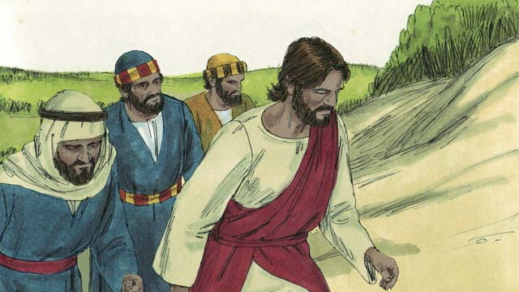

One day, Jesus took three of his disciples, Peter, James, and John, with him. (The disciple named John was not the same person who baptized Jesus.) They went up on a high mountain by themselves to pray.

36-02

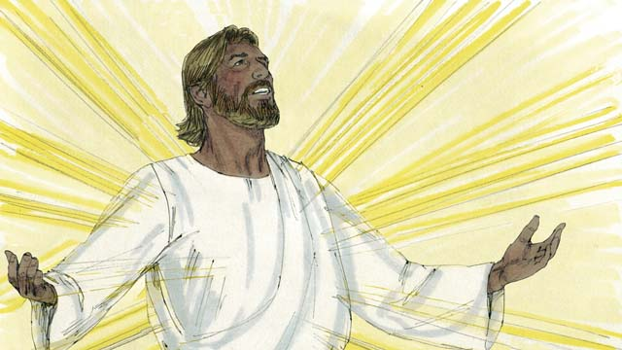

As Jesus was praying, his face became as bright as the sun. His clothes became as white as light, whiter than anyone on earth could make them.

36-03

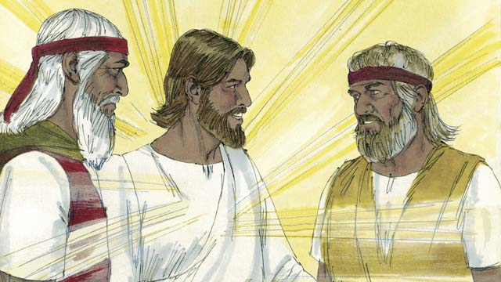

Then Moses and the prophet Elijah appeared. These men had lived on the earth hundreds of years before this. They talked with Jesus about his death, because he would soon die in Jerusalem.

36-04

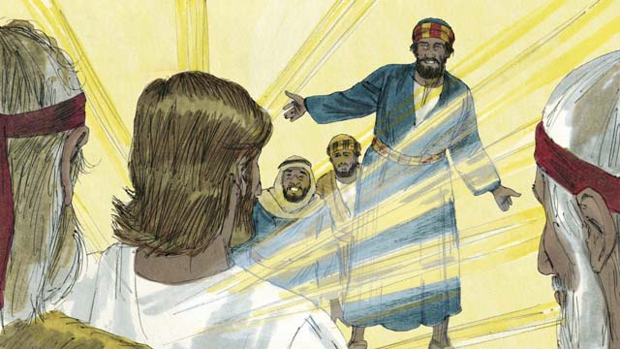

As Moses and Elijah were talking with Jesus, Peter said to Jesus, “It is good for us to be here. Let us make three shelters, one for you, one for Moses, and one for Elijah.” But Peter did not know what he was saying.

36-05

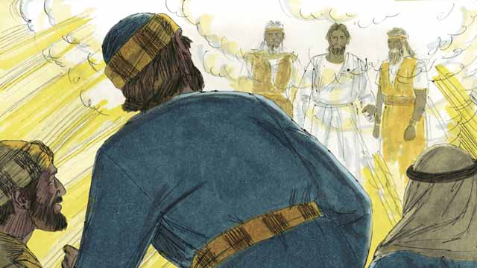

As Peter was talking, a bright cloud came down and surrounded them. Then they heard a voice coming from the cloud. It said, “This is my Son whom I love. I am pleased with him. Listen to him.” The three disciples were terrified and fell on the ground.

36-06

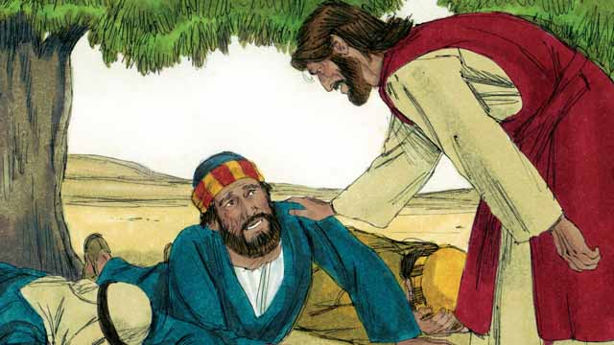

Then Jesus touched them and said, “Do not be afraid. Get up.” When they looked around, the only one still there was Jesus.

36-07

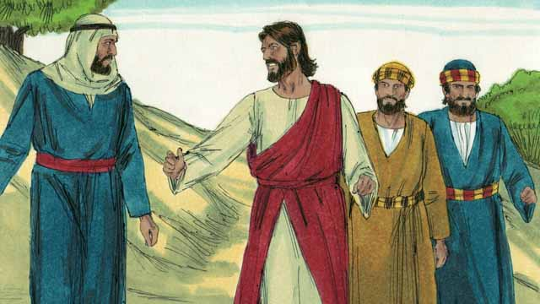

Jesus and the three disciples went back down the mountain. Then Jesus said to them, “Do not tell anyone yet about what happened here. I will soon die and then come back to life. After that, you may tell people.”

*A Bible story from: Matthew 17:1-9; Mark 9:2-8; Luke9:28-36*

## 1 Biblical Interpretation: Observing the Details of the Story

After reading the crafted biblical story, answer the following questions to familiarize yourself with the details of the story.

### 1.1 Observation Questions

Answer the following observation questions to gain a basic understanding of the the story. Read the story as a community and answer these questions as a group.

#### 36-01

Who did Jesus take with him up the mountain?  
He took three of his disciples—Peter, James, and John.

Why did Jesus bring them up on the mountain?  
They went up on a high mountain by themselves to pray.

#### 36-02

What change happened to Jesus as he was praying?  
His face became as bright as the sun and his clothes became as white as light.

How white did his clothes become?  
They became as white as light, whiter than anyone on earth could make them.

#### 36-03

Who were the two men who appeared with Jesus?  
Moses and the prophet Elijah appeared.

Why was it miraculous that Moses and Elijah appeared with Jesus?  
They both lived hundreds of years before this.

What were Moses and Elijah discussing with Jesus?  
They talked about Jesus’ death.

Where was Jesus going to die?  
He was going to die in Jerusalem.

#### 36-04

What did Peter think about Moses and Elijah appearing on the mountain?  
Peter said that it was good that they were there at the time Moses and Elijah appeared.

What did Peter suggest that they do for Jesus, Moses, and Elijah?  
He wanted to make three shelters, one for Jesus, one for Moses, and one for Elijah.

What was wrong with what Peter said?  
Peter did not really know what he was saying.

#### 36-05

What happened as Peter was talking?  
A bright cloud came down and surrounded them, and they heard a voice speak from the cloud.

What did the voice from the bright cloud say to the disciples?  
It said, “This is my Son whom I love. I am pleased with him. Listen to him.”

How did the three disciples respond to this voice?  
The three disciples were terrified and fell on the ground.

#### 36-06

What did Jesus do to his three disciples?  
Jesus touched them, told them to not be afraid, and instructed them to get up.

What did the disciples see when they looked around?  
When they looked around, the only one still there was Jesus.

#### 36-07

What did Jesus tell the disciples to do about what they had seen as they went down the mountain ?  
He told them not tell anyone about what happened on the mountain until after he died and came back to life.

When did Jesus tell his disciples they could speak about what happened on the mountain?  
Jesus told his disciples that they could speak about what happened on the mountain after Jesus rose from the dead.

### 1.2 Translation Questions

Use the following translation questions to understand specific details of the passage. Discuss how you might translate these specific elements of the story.

#### 36-01

**One day** The events of this story actually took place in history. The story does not specify the exact time they occurred. How would you express **One day** to identify true events that actually took place on an unspecified day and at an unspecified time?

  

**Jesus took three of his disciples** Jesus brought his three disciples up on a high mountain to pray. How would you express **Jesus took three of his disciples** to mean Jesus specifically chose three disciples (Peter, James, and John) to go with him up on a high mountain and Jesus led them to that place?

  

**James** This is a different **James** than the one who wrote the Book of **James** in the Bible. How would you express **James** to mean the disciple of Jesus but not the one who wrote the Book of **James** in the Bible?

  

#### 36-02

**his face became as bright as the sun** At this time, Jesus’ appearance changed. His face became very bright that is looked like the brightness of the sun. How would you express **his face became as bright as the sun** to mean Jesus’ face reflect intense light that it was compared to (similar to) the bright shining of the sun?

  

**His clothes became as white as light** At this time, Jesus’ appearance changed. His clothes became very white light the color of light. How would you express **His clothes became as white as light** to mean Jesus’ clothes changed color and became like the color white that is compared to (similar to) the pure color of light?

  

**whiter than anyone on earth could make them** Jesus’ clothes turned extremely white. This color is so white that it was more white that people could make their clothes when they bleach them. How would you express **whiter than anyone on earth could make them** to mean Jesus’ clothes were more white than people could make their clothes white when they bleach them?

  

#### 36-03

**appeared** Moses and Elijah were very important people in Israel’s history. God made a covenant with Moses and gave him the law. Elijah was a prophet of God. He spoke God’s messages to people and confronted false gods. They both lived and died hundreds of years ago in past generations. On the mountain, Moses and Elijah showed up out of nowhere. How would you express **appeared** to mean Elijah and Moses suddenly and unexpectedly were present on the mountain?

  

**because he would soon die in Jerusalem** Moses and Elijah spoke with Jesus about the fact that he would die. The reason they spoke with Jesus about this was Jesus’s death would happen in a short time. Specifically, Jesus would die in the city of Jerusalem. How would you express **because he would soon die in Jerusalem** to mean the reason Moses and Elijah spoke with Jesus about his death was Jesus would die in the city of Jerusalem in a short time?

  

#### 36-04

**It is good for us to be here** It is not clear whether us refers only to Peter, James, and John, or if it refers to everyone there, including Jesus, Elijah, and Moses. Peter thought it was positive that they were up on the mountain while these events took place. How would you express **It is good for us to be here** to mean it was good that they were on the mountain while these events were happening?

  

**shelters** Peter wanted to make temporary **shelters** that functioned like tents or garden huts. Peter thought it was a good idea to build these **shelters**. These **shelters** were small, individual, temporary **shelters** like the Jews made from tree branches during an annual Jewish holiday. How would you express **shelters** to mean small, temporary dwellings where people could stay for a short time?

  

**did not know what he was saying** Peter spoke without thinking clearly because he was so excited about what was taking place on the mountain. How would you express **did not know what he was saying** to mean Peter was speaking without really understanding what was happening?

  

#### 36-05

**a voice coming from the cloud** God spoke out loud and the sound of his voice was heard coming from the clouds. How would you express **a voice coming from the cloud** to mean God spoke and the sound of his voice was heard from the cloud in the sky?

  

**terrified** Peter, James, and John were very sacred when they heard God speak out loud. How would you express **terrified** to mean extremely afraid?

  

**fell on the ground** The disciples immediately go down on the ground. The reason they did this was they were terrified of the sound of God’s voice. How would you express **fell on the ground** to mean quickly bowed to the ground as an act of awe and fear?

  

#### 36-06

**touched them** Jesus put his hand on the disciples (perhaps on the shoulder). How would you express **touched them** to mean Jesus placed his hand on the disciples?

  

**Do not be afraid** Jesus told the disciples to not fear what was happening. This was a command. How would you express **Do not be afraid** as a command to stop being afraid?

  

**Get up** The disciples were kneeling or laying on the ground and Jesus instructed them to stand up. How would you express **Get up** as a command to stand up on one’s feet and stop laying/kneeling on the ground?

  

**the only one still there was Jesus** Moses and Elijah left and Jesus was the only one of those three who remained. The disciples were still on the mountain with Jesus. How would you express **the only one still there was** Jesus to mean Jesus was remained on the mountain after Moses and Elijah left?

  

#### 36-07

**I will soon die and then come back to life** Jesus explained that he would die sometime in the near future. After his death, Jesus would become alive again. This is a miracle. Only God can make dead people come back to life. How would you express **I will soon die and then come back to life** to mean Jesus would die at a time/day that was not too far in the future and after his death he would become alive again?

  

**After that, you may tell people** Jesus explained to his disciples that they were allowed to tell people about the events that happened on the mountain after the time Jesus rose from the dead. How would you express **After that, you may tell people** to mean Jesus permitted his disciples to tell others about what took place on the mountain only subsequent to his resurrection from the dead?

  

## 2 Theological Dialogue: Discussing the Meaning of the Story

Take time to explore the meaning of this story together as a community. Use the following discussions as a way to grasp what truth the story teaches.

### 2.1 Discourse Questions

Use the following discourse questions to understand the meaning of the story. Pay attention to how the story itself addresses each question or theme.

##### Why did Jesus bring his three disciples up on the mountain? (36-01, 36-02)

Solitude/Be By Themselves: Jesus brought Peter, James, and John up to the mountain. He only brought these three of all his disciples. They went up to the mountain to be by themselves. (36-01)

  

Prayer: Jesus brought the disciples up on the mountain to pray. Jesus’ appearance changed while he was praying. (36-01, 36-02)

  

##### Learning about Jesus: Jesus’ appearances changed to bright light and whiteness. Jesus brought the disciples on the mountain to teach the about himself and what he had come to do? (36-02)

##### What was happened on the mountain that showed who Jesus really is and what he came on earth to do? (36-02, 36-03, 36-05, 36-06, 36-07)

Bright and White: The appearance of Jesus changed. He became bright as the sun and white as light. This showed that Jesus was full of glory and majesty. (36-02)

  

Jesus as Fulfillment: Moses and Elijah appeared and talked with Jesus. These were important leaders in Israel’s history and faith. Eventually Moses and Elijah left and Jesus was the only one of the three left. This highlighted that these important leaders pointed people to Jesus. Jesus is the fulfillment of God’s promises in the Old Testament to send a deliverer. (36-03, 36-06)

  

Jesus’ Death: Jesus, Moses, and Elijah spoke about the fact that in a short time Jesus would die in the city of Jerusalem. Jesus would die to save people from their sin. (36-03, 36-07)

  

Jesus’ Resurrection: Jesus told his disciples that he would come back to life. After Jesus would die in Jerusalem, he would become alive again. In this way, Jesus conquered death and sin. (36-07)

  

Jesus as God’s Eternal Son: God spoke out loud and explained that Jesus was his Son and he loved him. Jesus is greater than Moses and Elijah. He is God’s eternal Son who is equal to God the Father and deserves worship and praise. (36-05)

  

##### How did God the Father and Jesus the Son correct his disciples understanding of what was happening on the mountain? (36-04, 36-05, 36-06, 36-07)

Ignorance: Peter did not fully understand what was happening. He acted out of ignorance. He wanted to build three shelters to celebrate the Jewish Feast of Booths. In this way, Peter was treating Jesus similar to Moses and Elijah. However, Jesus is superior to them. Moses and Elijah were only human leaders chosen by God. Jesus is God’s eternal Son who came to earth as a human to save humanity. Peter is ignorant of the meaning of what was really happening on the mountain. (36-04)

  

True Faith: Rightly Understanding Who Jesus Is: God spoke out loud and explained who Jesus is. He said that Jesus is God’s Son and God the Father loved him. God wanted Jesus’ disciples to know who Jesus really is. He is God’s eternal Son who came to earth as a human but has existed for all time. (36-05)

  

Obedience: God told the disciples to listen to Jesus. God wanted Jesus’ disciples to listen and obey what Jesus told them. Following Jesus as a disciple means to obey what Jesus says. (36-05)

  

Exclusive Trust: Jesus touched his fearful disciples, told them to stop being afraid, and to get up. Only Jesus could calm the fears of the disciples. To follow Jesus is to trust Jesus with our lives. It is important that when Jesus did this, Jesus was the only one who was there. Moses and Elijah had left. Moses and Elijah were important figures in Israel’s faith. However, disciples should not put their trust in these people. The only one a disciples should put their full confidence and trust is in Jesus. (36-06)

  

Sharing with Others: Jesus instructed his disciples to wait to tell people about what happened on the mountain until Jesus rose from the dead. Jesus’ resurrection would be the appropriate time to speak about these events to others. God wants disciples of Jesus to speak about Jesus to others and tell them about how his death and resurrection can bring them life. (36-07)

  

### 2.2 Theological Questions

Answer the following theology questions as a community. Discuss what truths this story teaches.

1. How should we understand who Jesus is and what came on earth to do? What does Jesus’ transfiguration (i.e., his changing of appearance) tell us about his person and work?
2. What does it mean to be a faithful follower of Jesus? How does the disciples’ experience on the mountain teach us about the nature of discipleship?

### 2.3 Translation Draft

Work as a translation team to draft each panel of this story. Pay attention to any specific translation issues that are challenging or significant.

#### Make Translation Draft

Make a draft for each section of this story.

#### Discuss and Revise

After drafting the story, discuss any translation issues that you think need special explanation.

#### Drafting Summary Reflection

Summarize any noteworthy translation decisions and the rationale/reasoning behind these translation decisions. In the final movement of this class, you will use these observations to give an account (i.e., chronicle/narrate) of how your translation improved through the checking process.

## 3 Personal Reflection: Following the Teaching of the Story

Take a moment to allow this story to evaluate your own life and to consider how God would have you respond. After this reflection, use the quality checking questions to check your translation draft among the translation team.

### 3.1 Journal Reflection

Prayerfully think about the following personal reflection questions. Write/Record your answers and/or discuss them as a group.

1. When have you experienced meaningful times of prayer when you felt close to God and God’s people?
2. How do you think you would have responded if you saw the events up on the mountain?
3. What misunderstandings of Jesus need to be corrected in your own belief/thinking?
4. In what ways does this story help you more faithfully follow Jesus?

### 3.2 Team Check

*The following activity will help you check the clarity, accuracy, and naturalness of your draft. Read the passage aloud and discuss the checking questions with other members of your translation community. You might need to reread portions (or the whole) of the biblical passage multiple times as you answer each of these questions. Record answers to these questions below.*

#### Team Checking Questions

*Use the following questions to check your translation draft for accuracy, clarity, and naturalness.*

1. **Accurate**: Has anything been **added** to your translation of this passage that is not a part of the meaning of the source text? *If additions exist, are they included only added to clarify meaning (such as implied information)?*
2. **Accurate**: Is anything **missing** from your translation of this passage that is a part of the meaning of the source text? *If some part of the meaning is missing from your translation, add it.*
3. **Accurate**: Does any meaning in your translation of this passage appear to be **different** than the meaning of the source text? *If the meaning is different, try changing your translation so that the meaning remains the same.*
4. **Natural**: Does anything sound **unnatural** to how you would say it in your language? *If portions of the passage sound unnatural in your language, try to make them sound the way you would say it in your language while staying true to the meaning of the source text.*
5. **Clear**: Is anything **unclear** or **confusing** in your translation that confuses the meaning of the source text? *If portions of the passage are unclear or confusing, revise them to clearly communicate the meaning of the source text.*
6. **Consistent**: How **consistent** is your translation within the passage and with other passages? *If portions of the passage need to be made consistent or if you need to revise translations of other passages, make these adjustments.*

#### Record Feedback

*After discussing the checking questions above as a translation community, record any feedback on your translation draft. Pay attention for parts of your translation that are translated well and parts of your translation that need correction.*

#### Discuss and Revise

*After gathering feedback on your draft, discuss it together with your translation community and make appropriate revisions in your translation.*

#### Checking Summary Reflection

*Summarize any noteworthy translation decisions (things you corrected or affirmed in your draft) and the rationale/reasoning behind these translation decisions. In the final movement of this class, you will use these observations to give an account (i.e., chronicle/narrate) of how your translation improved through the checking process.*

## 4 Ministry Practice: Serving the Church with the Story

Now that you have a draft of this story, consider how this story can encourage other believers in their faith. After ministering this story to others, you will also perform a community check of your translation draft.

### 4.1 Church Ministry

Reflect on how this story can edify and mature the Christian community. Design a way to minister this story to your church community.

**Ministry Preparation**: Take time to consider how you could minister this story to others. Record some ministry ideas below.

**Ministry Implementation**: Minister this story to a group of believers as you had planned. Use the information in this study to help develop a teaching/lesson or lead a discussion of this story to other believers. Record your ministry plan below.

**Ministry Reflection**: Think about what you learned from ministering this story to other believers. Reflect on your experience below.

### 4.2 Church Community Check

After teaching or ministering this story to the church, check the translation quality with the church community. Record any feedback from your checking experience.

#### Create Checking Questions

You can use **Translation Questions** to check you draft. Each **Translation Question** explains the meaning of a specific part of the story and asks you to consider how you would translate that part of the story in your own language. Change each **Translation Question** into a **Checking Question** by asking the following questions. The first question asks you to identity how each specific phrase was translated in your language. The second question asks people in the church to determine if your translation of the phrase expresses the meaning clearly, accurately, and naturally. Look at the following examples to see how to change **Translation Questions** into **Checking Questions**:

#### Translation Question Example 1

**to proclaim the good news about Jesus** Paul and Silas traveled to Philippi for the purpose of preaching the gospel. The gospel is the good news that Jesus saves people from their sins if they will believe in Jesus. How would you express **to proclaim the good news about Jesus** to mean to tell other people the message about how Jesus can save people from their sins?

#### Translation Question Example 2

**a merchant** Paul and Silas met a woman named Lydia at the place by the river. She owned a business and sold items to make money. How would you express **a merchant** to mean a business owner who sells items for a profit?

#### Translation Question Example 3

**so Paul and Silas baptized them** The jailer and his whole family followed Paul’s instructions. They believed in Jesus. The result of this was Paul and Silas baptized them. How would you express **so Paul and Silas baptized them** to mean the result of the jailer and his family believing in Jesus that Paul and Silas baptized all of them?

You can change these into **Checking Questions** like this:

#### Checking Question Example 1

**to proclaim the good news about Jesus** How did you translate **to proclaim the good news about Jesus**? Does it mean to tell other people the message about how Jesus can save people from their sins?

#### Checking Question Example 2

**a merchant** How did you translate **a merchant**? Does it mean a business owner who sells items for a profit?

#### Checking Question Example 3

**so Paul and Silas baptized them** How did you translate **so Paul and Silas baptized them**? Does it mean the result of the jailer and his family believing in Jesus that Paul and Silas baptized all of them?

#### Record Feedback

*Discuss the* ***Checking Questions*** *with your church community, and record any feedback on your translation draft. Pay attention for parts of your translation that are translated well and parts of your translation that need correction.*

#### Discuss and Revise

*After gathering feedback on your draft, discuss it together with your translation community and make appropriate revisions in your translation.*

#### Checking Summary Reflection

*Summarize any noteworthy translation decisions (things you corrected or affirmed in your draft) and the rationale/reasoning behind these translation decisions. In the final movement of this class, you will use these observations to give an account (i.e., chronicle/narrate) of how your translation improved through the checking process.*

## 5 Missional Outreach: Sharing the Truth of the Story

*After sharing this story with others, check the translation quality with the wider language community. Record any feedback from your checking experience.*

### 5.1 Mission Engagement

*Consider how you will witness this story to unbelievers. Design a way to share this story and engage them in what it teaches about Christianity and the gospel.*

**Witness Preparation**: Take time to consider how you will witness this narrative to unbelievers. Record some ideas below.

**Witness Implementation**: Share this story with an unbeliever. Use the information in this study to help develop a teaching/lesson or lead a discussion of this story to other believers. Record your ministry plan below.

**Witness Reflection**: Think about what you learned from ministering this story to unbelievers. Reflect on your experience below.

### 5.2 Sociolinguistic Check

After sharing this story with the language community, check your translation draft with the surrounding community. Record your observations.

#### Checking Approach

After witnessing this story to unbelievers, use one of the following methods to check the translation of this story. Consider using the **Observation Questions** to check your translation draft or come up with your own quality checking questions.

**Read-Retell Check:** Read your draft to those the community and ask them to retell the passage. Be attentive for any portions of the passage that are unclear, unnatural, or inaccurate.

**Comprehension Questions Checklist:** Read the draft of the passage and ask a list of comprehension questions to make sure the passage is being rightly understood. You can use the **Observation Questions** in this guide or come up with your own questions. Then, record any insights or issues that arise.

**Discussion Group:** Develop key questions to ask about the passage (both formational and translational). Read the passage and have a group discussion about the passage, paying attention to issues that need to be addressed, edited, and revised.

#### Record Feedback

*After sharing your draft with language community, discuss the* ***Observations Questions****, and record any feedback on your translation draft. Pay attention for parts of your translation that are translated well and parts of your translation that need correction.*

#### Discuss and Revise

*After gathering feedback on your draft, discuss it together with your translation community and make appropriate revisions in your translation.*

#### Checking Summary Reflection

*Summarize any noteworthy translation decisions (things you corrected or affirmed in your draft) and the rationale/reasoning behind these translation decisions. In the final movement of this class, you will use these observations to give an account (i.e., chronicle/narrate) of how your translation improved through the checking process.*

## 6 Conclusion

As a translation community, take time to reflect on all that was learned in studying, drafting, and checking this story. Celebrate all that God has taught you as a community. Then, submit your revised draft and checking summaries to network leaders for further review.