Open Bible Stories

Jesus Raises Lazarus from the Dead

## 0 Introduction

### 0.1 Key Idea

The story Jesus raising Lazarus from the dead teaches us Jesus has power over death.

### 0.2 Creedal Verse

“For as by a man came death, by a man has come also the resurrection of the dead.” 1 Corinthians 15:21

### 0.3 Metanarrative Summary

The eternal God created all things in six days. He made a good and perfect world. He made humans in his image to fill the earth and rule over creation. But humans rebelled against God and ruined God’s creation. God set to restore his world through his promise. God made a covenant with Abraham. He promised to bless all nations through Abraham. God kept his promises across the generations. God provided Abraham with a promised child, Isaac. God gave Isaac a wife and she bore twins, Jacob and Esau. God blessed Jacob and his sons, and the blessing continued to the next generation. God rescued Joseph, one of Jacob’s sons, and used him to rescue his family. God caused his people, the Israelites, to multiply in the land of Egypt; eventually, they became slaves. But, God raised up a deliverer, Moses, to deliver his people from their slavery. God judged the Egyptians with harsh plagues; in the final judgment, he passed over his people who covered their doorposts with the blood of a sacrificed lamb. Then, God delivered the Israelites by bringing them out of Egypt and crossing the Red Sea on dry land. God made a covenant with the Israelites and made them his people. God tested Israel in a series of wilderness wanderings and eventually brought his people into the promised land of Canaan. God raised up deliverers to lead Israel and rescue them from their enemies. God formed Israel into a kingdom. He made a covenant with King David and promised to send a king that would rule his people forever. Many of Israel’s kings were evil and the kingdom of Israel divided into two kingdoms. God sent prophets to warn his people of God’s judgment and call them to repent. When Israel did not repent, God sent his people into exile. After many years, he brought them back to the land. Throughout the Old Testament, God promised to send his Messiah to deliver his people form their sin. After many years, the prophet John was born. He would prepare people for the coming Messiah. At the perfect time, God sent his Son, Jesus, to be born of a virgin Mary. When John and Jesus grew up, John baptized Jesus as a sign that Jesus was God’s beloved Son. Jesus endured all manner of temptation without ever sinning. When he was thirty years old, he launched a public ministry of preaching, teaching, and healing. He taught his disciples about the life of compassion, sacrifice, and forgiveness. He performed many miracles: he fed a crowd of five thousand, he walked on water, he healed the sick, and he cast out demons. He proclaimed to people the nature of real faith, God’s kingdom, and the how fallen humans can be restored in relationship with God. Toward the end of his ministry, Jesus revealed his power and glory to his disciples and raised a dead man to life

### 0.4 Open Bible Story: Jesus Raises Lazarus from the Dead

37-01

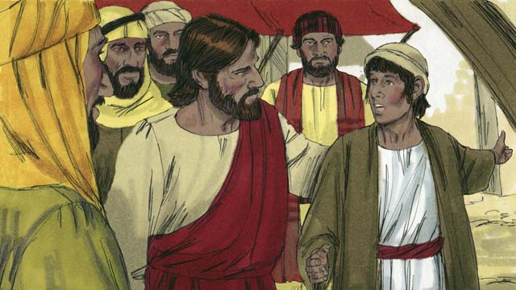

There was a man named Lazarus. He had two sisters named Mary and Martha. They were all close friends of Jesus. One day someone told Jesus that Lazarus was very sick. When Jesus heard this, he said, “This sickness will not end with Lazarus dying. Instead, it will cause people to honor God.”

37-02

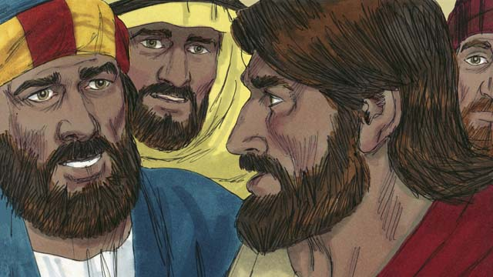

Jesus loved his friends, but he waited where he was for two days. After those two days he said to his disciples, “Let’s go back to Judea.” “But Teacher,” the disciples answered, “just a short time ago the people there wanted to kill you!” Jesus said, “Our friend Lazarus has fallen asleep, and I must wake him.”

37-03

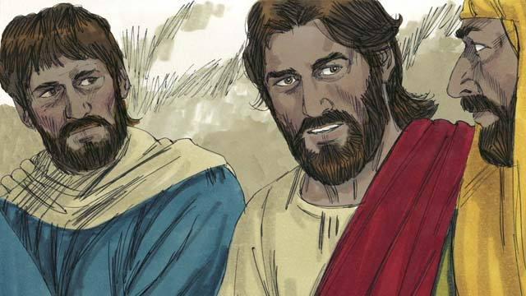

Jesus’ disciples replied, “Master, if Lazarus is sleeping, then he will get better.” Then Jesus told them plainly, “Lazarus is dead. I am glad that I was not there, so that you may believe in me.”

37-04

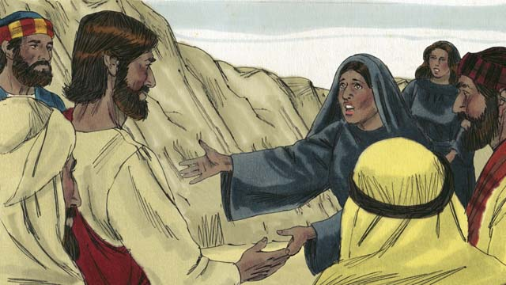

When Jesus arrived at Lazarus’ hometown, Lazarus had already been dead for four days. Martha went out to meet Jesus and said, “Master, if only you had been here, my brother would not have died. But I believe God will give you whatever you ask from him.”

37-05

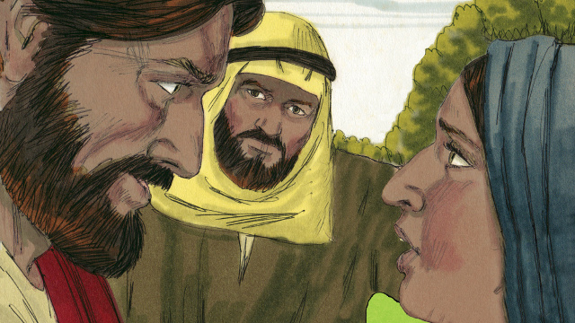

Jesus replied, “I am the Resurrection and the Life. Whoever believes in me will live, even though he dies. Everyone who believes in me will never die. Do you believe this?” Martha answered, “Yes, Master! I believe you are the Messiah, the Son of God.”

37-06

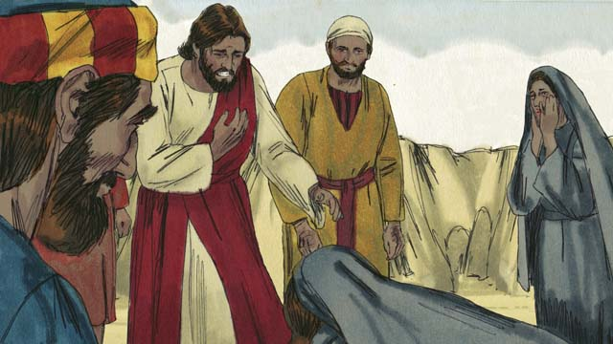

Then Mary arrived. She fell at the feet of Jesus and said, “Master, if only you had been here, my brother would not have died.” Jesus asked them, “Where have you put Lazarus?” They told him, “In the tomb. Come and see.” Then Jesus wept.

37-07

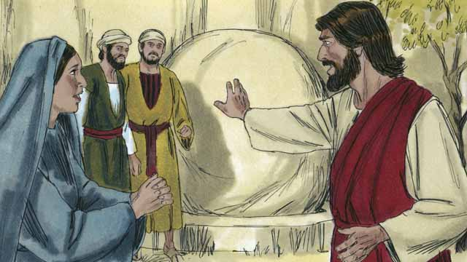

The tomb was a cave with a stone rolled in front of its opening. When Jesus arrived at the tomb, he told them, “Roll the stone away.” But Martha said, “He has been dead for four days. There will be a bad smell.”

37-08

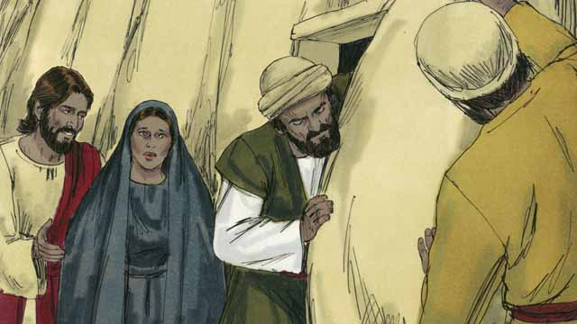

Jesus answered, “Did I not tell you that you would see God’s power if you believe in me?” So they rolled the stone away.

37-09

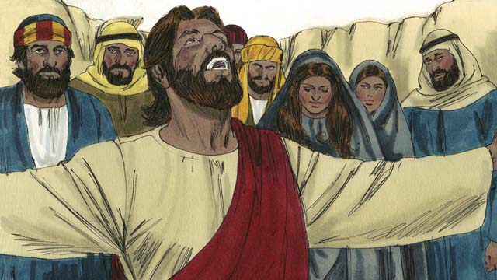

Then Jesus looked up to heaven and said, “Father, thank you for hearing me. I know you always listen to me, but I say this in order to help all these people standing here, so that they will believe you sent me.” Then Jesus shouted, “Lazarus, come out!”

37-10

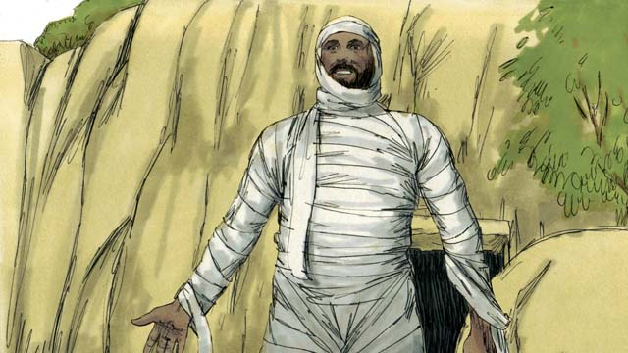

So Lazarus came out! He was still wrapped in grave clothes. Jesus told them, “Help him take off those grave clothes and release him!” Many of the Jews believed in Jesus because of this miracle.

37-11

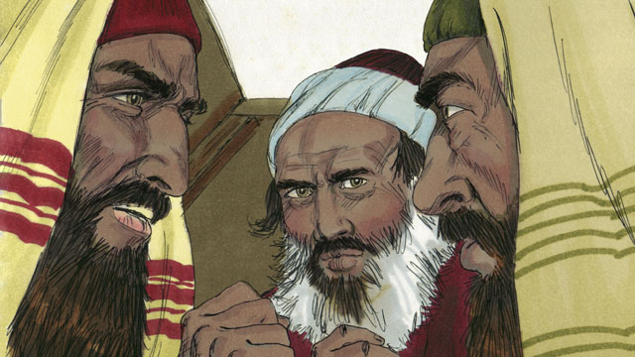

But the religious leaders of the Jews envied Jesus, so they gathered together to plan how they could kill Jesus and Lazarus.

*A Bible story from: John 11:1-46*

## 1 Community Study: Unless the Lord—Working God’s Power

* **Key Idea**: relying on God to make our work fruitful
* **Key Passage**: Psalm 127:1-2
* **Main Session**: OBS 37 (Jesus Raises Lazarus from the Dead)

### 1.1 Recite the Creedal Verse (3–5 minutes)

The verse below summarizes the teaching of the current passage. Read the verse out loud as a community. Read it again several times as a group until the whole community can recite it from memory.

21 For as the Father raises the dead and gives them life, so also the Son gives life to whomever he wishes. John 5:21

OR

39 See now that I, even I, am God, and that there is no god besides me; I kill, and I make alive; I wound, and I heal, and there is no one who can save you from my might. Deuteronomy 32:39

### 1.2 Acknowledging Our Need for God’s Power (5–10 minutes)

God is powerful enough to raise people from the dead. This same God empowers us to go about his work. As a community, reflect on your need for God’s power in your community and work.

We need God’s power to help us in these ways…

### 1.3 Read the Passage (3–5 minutes)

God wants you to serve him in God’s strength. Only God can energize us to serve him. As a community, read the following Bible passage together to understand the important truth that God is behind all of the work and success in our lives and ministries.

1 Unless Yahweh builds the house, they work uselessly, those who build it. Unless Yahweh guards the city, the watchman stands guard uselessly. 2 It is useless for you to rise up early, to come home late, or to eat the bread of hard work, for Yahweh provides for his beloved as they sleep. Psalm 127:1-2

### 1.4 Discuss the Passage (10-15 minutes)

God calls us to serve him with devotion and commitment. Nevertheless, God is the only source of strength and success in our lives. As a community, use the following questions to discuss the teaching of the biblical passage.

1. How does this passage describe our work for God? How can the image of building a house and watching over a city relate to the work of ministry?
2. How does this passage describe work that is not done in God’s strength?
3. How does this passage teach us to go about God’s work with healthy and godly rhythms of work and rest?
4. How can your community remain focused on God’s work and apply the principles of this passage to have a healthy approach to your work?

### 1.5 Enjoying God’s Power (5 minutes)

Reflect on the above discussion. Consider how God’s strength and power can energize your work.

I know God is very powerful because of these things…

Because God is powerful, I can serve him in this way…

### 1.6 Pray to God (5 minutes)

Pray that God will help your community to work in God’s strength. Pray as a large group, asking God to give you the strength and power to continue his work.

### 1.7 Sing a Song (3–5 minutes)

Sing a song as a community that celebrates God’s strength, power, and might. Specifically, sing a song that celebrates God’s work of resurrection.

## 2 Biblical Interpretation: Observing the Details of the Story

After reading the crafted biblical story, answer the following questions to familiarize yourself with the details of the story.

### 2.1 Observation Questions

Answer the following observation questions to gain a basic understanding of the the story. Read the story as a community and answer these questions as a group.

#### 37-01

Who were Lazarus, Mary, and Martha?  
Lazarus, Mary, and Martha were close friends of Jesus.

What happened to Lazarus?  
Lazarus got very sick.

What did Jesus say would be the end result of Lazarus’ sickness?  
Jesus said that the Lazarus’ sickness would not end up with Lazarus dying, but it would be for the glory of God.

#### 37-02

What did Jesus do after he heard about Lazarus’ sickness?  
He waited where he was for two more days.

Why were the disciples concerned when Jesus decided to go to Judea?  
They were concerned because the people in Judea wanted to kill Jesus.

How did Jesus answer his disciples when they expressed concern for Jesus’ safety?  
Jesus told his disciples that Lazarus had fallen asleep and Jesus had to wake him.

#### 37-03

What did the disciples think Jesus meant when he said that Lazarus had fallen asleep?  
They thought he was just asleep and would get better.

What did Jesus plainly tell the disciples about Lazarus?  
Jesus said that Lazarus had died.

Why was Jesus glad that he was not there when Lazarus died?  
Jesus was glad because something would happen that would make the disciples believe in him.

#### 37-04

How long had Lazarus been dead when Jesus arrived at Lazarus’ hometown?  
He had been dead for four days.

What did Martha say to Jesus when she greeted him?  
Martha met Jesus and said that if Jesus had only been there then Lazarus would not have died.

Did Martha believe that Jesus could have healed Lazarus?  
Yes, she believed God would give Jesus whatever he asked from him.

#### 37-05

What did Jesus say about himself?  
Jesus called himself the Resurrection and the Life.

What will happen to believers because Jesus is the Resurrection and the Life?  
Whoever believes in Jesus will live, even though he dies, and everyone who believes in Jesus will never die.

What did Martha saw when Jesus asked if she believed what he said?  
Martha said, “Yes, Master! I believe you are the Messiah, the Son of God.”

#### 37-06

What did Mary do when she arrived?  
Mary fell at the feet of Jesus and said to Jesus that Lazarus would not have died if Jesus had been there.

What question did Jesus ask at this time?  
Jesus asked about where they put the body of Lazarus.

How did they respond to Jesus’ question about where Lazarus was?  
They told Jesus that Lazarus was placed in a tomb. They invited Jesus to come and see.

How did Jesus respond?  
Jesus wept.

#### 37-07

What was the tomb like?  
The tomb was a cave with a stone rolled in front of its opening.

What did Jesus say when he arrived at the tomb?  
When Jesus arrived at the tomb, he told them to roll away the stone.

How long had Lazarus been dead?  
He had been dead for four days.

What did Martha think about Jesus’ instructions to roll away the stone?  
Martha said that there would be a bad smell because Lazarus had been dead for four days.

#### 37-08

How did Jesus answer Martha’s concern?  
Jesus reminded them that they would see God’s power if they believed in him.

What did they do with the stone?  
They rolled away the stone from the tomb.

#### 37-09

How did Jesus pray to God the Father?  
Jesus looked up to heaven and thanked God.

Why did Jesus thank the Father out loud?  
He did that so the people would believe that the Father had sent him.

What did Jesus command Lazarus to do?  
He commanded Lazarus to come out of the tomb! #### 37-10  
What happened after Jesus commanded Lazarus to come out?  
Lazarus came out of the tomb still wearing his grave clothes.

What instructions did Jesus give?  
Jesus told them to help Lazarus take off the grave clothes and release him.

Who responded in faith as a result of this miracle?  
Many Jews believed in Jesus because of this miracle.

#### 37-11

How did the religious leaders of the Jews react when they saw the miracle?  
They envied Jesus and planned to kill him and Lazarus.

### 2.2 Translation Questions

Use the following translation questions to understand specific details of the passage. Discuss how you might translate these specific elements of the story.

#### 37-01

**This sickness will not end with Lazarus dying** Lazarus was very sick. Jesus said that his sickness would not ultimately end up in death. Jesus’ disciples probably thought this meant that Lazarus would not die. But Jesus knew that, although Lazarus would die from his sickness, he would live in the end. How would you express **This sickness will not end with Lazarus dying** to mean the final result of this sickness will not be the death of Lazarus?

  

**Instead, it will cause people to honor God** The final result of Lazarus’ sickness would be not be death. A very different result would take place. Lazarus’ sickness would be used to cause people to praise God. How would you express **Instead, it will cause people to honor God** to mean Lazarus’ sickness would result in people praising God rather than Lazarus ultimately dying?

  

#### 37-02

**Jesus loved his friends** Jesus considered Lazarus and his sisters (Mary and Martha) friends. He was felt a deep affection for them as friends. How would you express **Jesus loved his friends** to mean Jesus cared deeply for Lazarus, Mary, and Martha?

  

**but he waited where he was for two days** Jesus deeply loved Lazarus, Mary, and Martha. Typically, people would go visit a sick friend as soon as possible. Instead of visiting Lazarus immediately, Jesus stayed two extra days. This seems different/opposite to how friends would care for each other. This does not mean that Jesus did not care for Lazarus and his sisters. Jesus delayed visiting Lazarus knowing that he would do a miracle to bring Lazarus back from the dead. How would you express **but he waited where he was for two days** to mean Jesus he stayed where he was for two days, even though Jesus loved Lazarus and his sisters?

  

**just a short time ago the people there wanted to kill you!** The disciples were concerned that Jesus would return to a place where people wanted to kill him. The disciples said this to emphasize the great danger Jesus faced if he went to Judea. How would you express **just a short time ago the people there wanted to kill you!** as a strong statement that shows concern for Jesus’ safety by warning him of the danger that he would face if he returned to Judea?

  

**has fallen asleep** When a person dies it looks like they have fallen asleep. This is a polite way of saying that Lazarus has died. Although Jesus was using this word with a different meaning, the disciples did not understand that yet. How would you express **has fallen asleep** as a polite way of saying that someone has died?

  

**I must wake him** Jesus described bringing Lazarus back to life as waking him up from sleep. Lazarus was not really sleeping. He actually died. Jesus was using this to say that he would make Lazarus alive again. Although Jesus was using this word with a different meaning, the disciples did not understand that yet. How would you express **I must wake him** to mean Jesus would bring Lazarus back to life similar to waking someone up who is sleeping?

  

#### 37-03

**if Lazarus is sleeping, then he will get better** The disciples thought that Jesus meant that Lazarus was actually sleeping. In reality, Lazarus had died. The disciples did not yet understand what had happened. How would you express **if Lazarus is sleeping, then he will get better** to mean there is no reason for us to go to him now, since he will get well?

  

**I am glad that I was not there** Jesus was not happy that Lazarus died, but rather he was happy that God was going to show how great he is. How would you express **I am glad that I was not there** to mean Jesus was happy that he was not there to heal Lazarus when he was sick because now God would show his great power by bringing Lazarus back to life?

  

**so that you may believe in me** Jesus was happy for the chance to show God’s power in brining Lazarus back to life. The purpose of this miracle was to cause people to trust Jesus. How would you express **so that you may believe in me** to mean the reason Jesus wanted to show God’s power and bring Lazarus back to life was to cause people to place their faith in Jesus?

  

#### 37-04

**if only you had been here, my brother would not have died** Martha is stating a hypothetical situation—what could have happened if Jesus had not waited for Lazarus to die before he came. Martha is describing something that did not happen but could have happened. Martha believe that if Jesus returned when Lazarus was sick he would have healed him and he would not have died. How would you express **if only you had been here, my brother would not have died** to mean Martha believed that if Jesus had returned earlier he could have prevented Lazarus from dying?

  

**will give you whatever you ask from him** Martha was convinced that God the Father would grant any request that Jesus asked. How would you express **will give you whatever you ask from him** to mean Martha believed that God will do whatever Jesus ask him to do?

  

#### 37-05

**I am the Resurrection and the Life** This is one of several very powerful I am statements in which Jesus says something about his essential nature. In this one, Jesus indicates that he is the provider or source of resurrection and life. How would you express **I am the** Resurrection and the Life to mean Jesus is the one who resurrects people (brings people back to life after they died) and causes them to live?

  

**will live, even though he dies** Jesus is saying something surprising. Normally, when people die, they are no longer alive. However, Jesus is able to bring people back to life. Therefore, Jesus explained that every person who trusts in Jesus would live forever even though they would die. How would you express **will live, even though he dies** to mean people who trust in Jesus will live forever even though they die because Jesus has the power to bring dead people back to life?

  

**will never die** Jesus is explaining what will ultimately happen to people. People who trust in Jesus will physically die, but Jesus has the power to bring them back to life. So, even though they die, they don’t finally stay dead. How would you express **will never die** to mean every person who believes in Jesus will never finally stay dead because Jesus will bring them back to life and cause them to live forever?

  

#### 37-06

**fell at the feet of Jesus** Mary got on her knees before Jesus so that she was on the ground near his feet. This was a sign of honor and reverence. How would you express **fell at the feet of** Jesus to mean Mary knelt down at Jesus feet as a sign of respect?

  

**if only you had been here, my brother would not have died** Mary is stating a hypothetical situation—what could have happened if Jesus had not waited for Lazarus to die before he came. Mary is describing something that did not happen but could have happened. Mary believe that if Jesus returned when Lazarus was sick he would have healed him and he would not have died. How would you express **if only you had been here, my brother would not have died** to mean Mary believed that if Jesus had returned earlier he could have prevented Lazarus from dying?

  

**Then Jesus wept** Jesus mourned Lazarus’ death by crying. This showed that Jesus loved Lazarus and grieved his death. How would you express **Then** Jesus wept to mean Jesus expressed his grief and sadness by crying?

  

#### 37-07

**Roll the stone away** Jesus gave instructions for the stone to be moved away from the entrance of the tomb. How would you express **Roll the stone away** as a command to push/roll the stone away from the opening of the tomb?

  

**He has been dead for four days** At this point, Lazarus had been dead for four days. This means that his body would start decaying and give off a smell. How would you express **He has been dead for four days** to mean Lazarus died four days ago and his body is lying there?

  

#### 37-08

**Did I not tell you that you would see God’s power if you believe in me?** Jesus is asking this question but is not looking for an answer or information. Jesus asked the question to show that people did not fully believe Jesus and did not understand what he was about to do. He wanted to remind them that if they believed in Jesus they would see God do powerful things. How would you express **Did I not tell you that you would see God’s power if you believe in me?** as a question in which Jesus is telling people to remember that Jesus told them that they would see God show how powerful he is if they believed/trusted in Jesus?

  

#### 37-09

**hearing me** Jesus prayed to God the Father and God the Father answered Jesus’ prayers. How would you express **hearing me** to mean Jesus is thanking God the Father for listening to him when he prays to him?

  

**Lazarus, come out!** Jesus spoke to Lazarus and commanded him to come out of the tomb. How would you express **Lazarus, come out!** as a strong command for Lazarus to walk out of the tomb on his own?

  

#### 37-10

**Lazarus came out!** Those watching did not expect Lazarus to come back to life. Now they saw him walking out of the tomb. This was a surprise and a shock. How would you express **Lazarus came out!** as a strong statement that emphasizes the shocking fact that Lazarus, who had been dead, walked out of the tomb.

**He was still wrapped in grave clothes** At this time, people wrapped a dead body in strips of cloth and placed them in a tomb. Lazarus went directly from being dead to walking out of the tomb at Jesus’ command. He walked out of the tomb and still had burial bandages on. How would you express **He was still wrapped in grave clothes** to mean Lazarus walked out of the tomb and was still covered in his burial clothes?

  

**Many of the Jews believed in Jesus because of this miracle** After Jesus raised Lazarus from the dead, many Jewish people put their trust in Jesus. How would you express **Many of the Jews believed in Jesus because of this miracle** to mean the reason many Jewish people put their faith in Jesus (trusted him as the Messiah) was God had done this amazing miracle and had made Lazarus come alive again?

  

#### 37-11

**envied** The religious leaders were jealous of Jesus. Many people were following Jesus and the religious leaders wanted people to follow them. How would you express **envied** to mean the Jewish religious leaders were jealous of Jesus’ power and popularity and that so many Jews were believing in Jesus?

  

**gathered together** The religious leaders met together to figure out how to kill Jesus. This was a not a casual meeting, but a meeting for a specific purpose�to plan how to kill Jesus. How would you express **gathered together** to mean to assemble together and join together for a purpose?

  

## 3 Theological Dialogue: Discussing the Meaning of the Story

Take time to explore the meaning of this story together as a community. Use the following discussions as a way to grasp what truth the story teaches.

### 3.1 Discourse Questions

Use the following discourse questions to understand the meaning of the story. Pay attention to how the story itself addresses each question or theme.

##### How did Jesus use Lazarus’ sickness to bring about God’s purposes? (37-01, 37-02, 37-03, 37-05, 37-08, 37-09)

Love/Friendship: One of Jesus’ close friends was really sick. His name was Lazarus. Jesus loved his friends. Sickness, pain, and disease affected people that Jesus cared deeply about. Jesus wept when he arrived back in Judea and asked where they put Lazarus’ body. (37-01, 37-02, 37-06)

  

Power: Jesus explained that Lazarus’ sickness would not end up with him being dead forever. Jesus has the power to overcome sickness and death. (37-01)

  

Praise: Jesus said that Lazarus’ sickness would be used to cause people to praise God. Jesus intentionally waited two extra days before heading back to Judea. Jesus would allow Lazarus to die so that Jesus could bring him back to life. This would cause people to praise God. (37-01, 37-02)

  

Belief: Jesus was not happy that Lazarus died. Jesus was happy that he did not heal Lazarus so that he could bring him back to life and cause people to believe in him. (37-03, 37-09)

  

See God’s Power: Jesus told people that they would see God’s power if they believed. If they trusted in Jesus, God would do an amazing thing that only God could do. (37-08)

  

##### How did Jesus bring Lazarus back to life? (37-05, 37-07, 37-08, 37-09, 37-10)

Identity: Jesus told Martha that he is the Resurrection and the Life. Jesus has the power to bring dead people back to life again. Jesus revealed to people who he is. He has the power of life and can overcome death by bringing people back to life again. (37-05)

  

Promise: Jesus explained that every person who believes in Jesus would live forever. Because Jesus can raise people from the dead, he can give eternal life to his followers. Even though followers of Christ physically die, Jesus will bring them back to life again so they can live forever. Jesus gave a promise of eternal life to those who would believe in him. (37-05)

  

Trust: Jesus gave instructions for the stone to be moved away. Martha questioned this instruction because Lazarus had been dead for four days and his body would smell. Jesus told people that if they really believed they would see God’s power. Asking them to roll back the stone was an invitation for them to trust Jesus. They trusted Jesus and rolled the stone away. (37-07, 37-08)

  

Power: Jesus prayed to God the Father. He thanked God for hearing him. Jesus gave a command for Lazarus to come out of the tomb and Lazarus came back to life and walked out of the tomb. Lazarus did this immediately and still had his grave clothes on. (37-09, 37-10)

  

##### How did different people respond to Jesus in this story? (37-02, 37-03, 37-04, 37-05, 37-06, 37-10, 37-11)

People in Judea | Hostility: The disciples were concerned about Jesus going back to Judea because people wanted to kill Jesus a short time ago. Jesus was willing to go back into a dangerous place to bring help out Lazarus and show God’s power. Some people wanted Jesus dead. (37-02)

  

Disciples | Misunderstanding: The disciples did not fully understand what Jesus was saying. Jesus explained that Lazarus was sleeping and that Jesus would return to Judea to wake him up. The disciples thought that Lazarus was actually sleeping, but Jesus said this to explain that Lazarus had died. (37-02, 37-03)

  

Martha | Hopeful: Martha believed that Jesus could have healed Lazarus if he was there. She expressed grief that Jesus did not come earlier, but also expressed faith that God would give Jesus anything he asked. Martha was hopefully that Jesus would do something amazing. (37-04)

  

Martha | Faith: Martha believed in Jesus. She believed that Jesus was her Master, the Messiah, and the Son of God. Submitted to Jesus as Master, Martha gave her life to Jesus as his servant. Trusting Jesus as Messiah, Martha put her hope in Jesus as God’s promised deliverer. Accepting that Jesus is truly God’s Son, Martha was believed that Jesus was the eternal Son of God. (37-05)

  

Mary | Grief: Mary fell at Jesus’ feet when she met him. Mary believed that Jesus could have healed Lazarus if he was there. (37-06)

  

Many Jews | Belief: Many Jews believed in Jesus because of the miracle. Jesus bringing Lazarus back to life convinced them that Jesus is God’s Son and the promised Messiah. (37-10)

  

Religious Leaders | Jealousy: The religious leaders plotted to kill Jesus. They were jealous that people were following Jesus and not them. They planned how they would kill Jesus. (37-11)

  

### 3.2 Theological Questions

Answer the following theology questions as a community. Discuss what truths this story teaches.

1. Why did God send Jesus to earth? How does the story of Lazarus teach us about God’s purposes in sending Jesus?
2. What should we believe about Jesus? What does this story teach us about who Jesus is (his nature and identity)?
3. What does it mean to follow Jesus? How does this story teach us about what it means to genuinely believe in Jesus?

### 3.3 Translation Draft

Work as a translation team to draft each panel of this story. Pay attention to any specific translation issues that are challenging or significant.

#### Make Translation Draft

Make a draft for each section of this story.

#### Discuss and Revise

After drafting the story, discuss any translation issues that you think need special explanation.

#### Drafting Summary Reflection

Summarize any noteworthy translation decisions and the rationale/reasoning behind these translation decisions. In the final movement of this class, you will use these observations to give an account (i.e., chronicle/narrate) of how your translation improved through the checking process.

## 4 Personal Reflection: Following the Teaching of the Story

Take a moment to allow this story to evaluate your own life and to consider how God would have you respond. After this reflection, use the quality checking questions to check your translation draft among the translation team.

### 4.1 Journal Reflection

Prayerfully think about the following personal reflection questions. Write/Record your answers and/or discuss them as a group.

1. How can align our life with God’s purposes?
2. What does this story teach you about Jesus that most encourages your faith?
3. How would you describe your faith in Jesus? Which characters in this story do you most relate to?
4. How does the promise of the resurrection (live forever with Jesus) impact the way you live and serve as a follower of Jesus?

### 4.2 Team Check

*The following activity will help you check the clarity, accuracy, and naturalness of your draft. Read the passage aloud and discuss the checking questions with other members of your translation community. You might need to reread portions (or the whole) of the biblical passage multiple times as you answer each of these questions. Record answers to these questions below.*

#### Team Checking Questions

*Use the following questions to check your translation draft for accuracy, clarity, and naturalness.*

1. **Accurate**: Has anything been **added** to your translation of this passage that is not a part of the meaning of the source text? *If additions exist, are they included only added to clarify meaning (such as implied information)?*
2. **Accurate**: Is anything **missing** from your translation of this passage that is a part of the meaning of the source text? *If some part of the meaning is missing from your translation, add it.*
3. **Accurate**: Does any meaning in your translation of this passage appear to be **different** than the meaning of the source text? *If the meaning is different, try changing your translation so that the meaning remains the same.*
4. **Natural**: Does anything sound **unnatural** to how you would say it in your language? *If portions of the passage sound unnatural in your language, try to make them sound the way you would say it in your language while staying true to the meaning of the source text.*
5. **Clear**: Is anything **unclear** or **confusing** in your translation that confuses the meaning of the source text? *If portions of the passage are unclear or confusing, revise them to clearly communicate the meaning of the source text.*
6. **Consistent**: How **consistent** is your translation within the passage and with other passages? *If portions of the passage need to be made consistent or if you need to revise translations of other passages, make these adjustments.*

#### Record Feedback

*After discussing the checking questions above as a translation community, record any feedback on your translation draft. Pay attention for parts of your translation that are translated well and parts of your translation that need correction.*

#### Discuss and Revise

*After gathering feedback on your draft, discuss it together with your translation community and make appropriate revisions in your translation.*

#### Record Translation Decisions

*As a community, discuss some of the most noteworthy translation decisions in your draft. Summarize each decision and explain the reasons your community decided on that translation. You should update these decisions each time you check your draft with various groups of people.*

You should **measure** the quality of your translation draft. You can **record translation decisions** to make it clear why you translated things a certain way. Translation decisions can help your translation team and the surrounding community be a part of the translation process.

How can you know the quality of your translation?

1. **Measure** the translation by marks/standards of quality (i.e., clear, accurate, natural, church-approved)
2. **Test** the translation with others and record feedback and conversations from in the field (i.e., church and community check)
3. **Compare** and **contrast** the translation with the source text (i.e., meaning of text and notes) and alternatives (i.e., other translation choices)
4. **Explain** the reasons why you translated a particular portion of the text.

**Example Sentences That Help Explain Your Translation Decision** Use the following example sentences to help explain your translation decisions:

1. The original text literally **says/means**, so we translated the term in this way…
2. We originally decided to translate **the biblical term** in with **this term**, but we changed it because…
3. When our translation team discussed **the biblical term**, this is what we talked about…
4. **The term** is [clear, accurate, natural, consistent] because…
5. The community understands **this term** it to mean…
6. We considered these other terms. We did not use **these terms** because…
7. When we checked this in the church, we learned…
8. When we checked this in the community, we learned…

**Example of Translation Decision**

In OBS 01-07 we decided to translate **blessed** like this: [actual translation]. We decided this translation because of these reasons:

1. The word [actual translation] means to cause good things to happen to someone or something. This term is used when a person desires someone or something to prosper or flourish. This term does not refer to magic or witchcraft.
2. When we checked this word with other believers, they said it describes God showing his kindness and favor on someone or something. These are some of the terms that we did not decide to use…
3. Many of our people will understand this word. When we discussed this phrase with the surrounding community, we discovered it was a natural way to describe God causing good and beneficial things to happen.

## 5 Ministry Practice: Serving the Church with the Story

Now that you have a draft of this story, consider how this story can encourage other believers in their faith. After ministering this story to others, you will also perform a community check of your translation draft.

### 5.1 Church Ministry

Reflect on how this story can edify and mature the Christian community. Design a way to minister this story to your church community.

**Ministry Preparation**: Take time to consider how you could minister this story to others. Record some ministry ideas below.

**Ministry Implementation**: Minister this story to a group of believers as you had planned. Use the information in this study to help develop a teaching/lesson or lead a discussion of this story to other believers. Record your ministry plan below.

**Ministry Reflection**: Think about what you learned from ministering this story to other believers. Reflect on your experience below.

### 5.2 Church Community Check

After teaching or ministering this story to the church, check the translation quality with the church community. Record any feedback from your checking experience.

#### Create Checking Questions

You can use **Translation Questions** to check you draft. Each **Translation Question** explains the meaning of a specific part of the story and asks you to consider how you would translate that part of the story in your own language. Change each **Translation Question** into a **Checking Question** by asking the following questions. The first question asks you to identity how each specific phrase was translated in your language. The second question asks people in the church to determine if your translation of the phrase expresses the meaning clearly, accurately, and naturally. Look at the following examples to see how to change **Translation Questions** into **Checking Questions**:

#### Translation Question Example 1

**to proclaim the good news about Jesus** Paul and Silas traveled to Philippi for the purpose of preaching the gospel. The gospel is the good news that Jesus saves people from their sins if they will believe in Jesus. How would you express **to proclaim the good news about Jesus** to mean to tell other people the message about how Jesus can save people from their sins?

#### Translation Question Example 2

**a merchant** Paul and Silas met a woman named Lydia at the place by the river. She owned a business and sold items to make money. How would you express **a merchant** to mean a business owner who sells items for a profit?

#### Translation Question Example 3

**so Paul and Silas baptized them** The jailer and his whole family followed Paul’s instructions. They believed in Jesus. The result of this was Paul and Silas baptized them. How would you express **so Paul and Silas baptized them** to mean the result of the jailer and his family believing in Jesus that Paul and Silas baptized all of them?

You can change these into **Checking Questions** like this:

#### Checking Question Example 1

**to proclaim the good news about Jesus** How did you translate **to proclaim the good news about Jesus**? Does it mean to tell other people the message about how Jesus can save people from their sins?

#### Checking Question Example 2

**a merchant** How did you translate **a merchant**? Does it mean a business owner who sells items for a profit?

#### Checking Question Example 3

**so Paul and Silas baptized them** How did you translate **so Paul and Silas baptized them**? Does it mean the result of the jailer and his family believing in Jesus that Paul and Silas baptized all of them?

#### Record Feedback

*Discuss the* ***Checking Questions*** *with your church community, and record any feedback on your translation draft. Pay attention for parts of your translation that are translated well and parts of your translation that need correction.*

#### Discuss and Revise

*After gathering feedback on your draft, discuss it together with your translation community and make appropriate revisions in your translation.*

#### Record Translation Decisions

*Update your translation decisions and record and new any noteworthy observations on the quality of your draft.

## 6 Missional Outreach: Sharing the Truth of the Story

*After sharing this story with others, check the translation quality with the wider language community. Record any feedback from your checking experience.*

### 6.1 Mission Engagement

*Consider how you will witness this story to unbelievers. Design a way to share this story and engage them in what it teaches about Christianity and the gospel.*

**Witness Preparation**: Take time to consider how you will witness this narrative to unbelievers. Record some ideas below.

**Witness Implementation**: Share this story with an unbeliever. Use the information in this study to help develop a teaching/lesson or lead a discussion of this story to other believers. Record your ministry plan below.

**Witness Reflection**: Think about what you learned from ministering this story to unbelievers. Reflect on your experience below.

### 6.2 Sociolinguistic Check

After sharing this story with the language community, check your translation draft with the surrounding community. Record your observations.

#### Checking Approach

After witnessing this story to unbelievers, use one of the following methods to check the translation of this story. Consider using the **Observation Questions** to check your translation draft or come up with your own quality checking questions.

**Read-Retell Check:** Read your draft to those the community and ask them to retell the passage. Be attentive for any portions of the passage that are unclear, unnatural, or inaccurate.

**Comprehension Questions Checklist:** Read the draft of the passage and ask a list of comprehension questions to make sure the passage is being rightly understood. You can use the **Observation Questions** in this guide or come up with your own questions. Then, record any insights or issues that arise.

**Discussion Group:** Develop key questions to ask about the passage (both formational and translational). Read the passage and have a group discussion about the passage, paying attention to issues that need to be addressed, edited, and revised.

#### Record Feedback

*After sharing your draft with language community, discuss the* ***Observations Questions****, and record any feedback on your translation draft. Pay attention for parts of your translation that are translated well and parts of your translation that need correction.*

#### Discuss and Revise

*After gathering feedback on your draft, discuss it together with your translation community and make appropriate revisions in your translation.*

#### Record Translation Decisions

*Update your translation decisions and record and new any noteworthy observations on the quality of your draft.

## 7 Conclusion

As a translation community, take time to reflect on all that was learned in studying, drafting, and checking this story. Celebrate all that God has taught you as a community. Then, submit your revised draft and checking summaries to network leaders for further review.