Open Bible Stories

Jesus Is Betrayed

## 0 Introduction

### 0.1 Key Idea

The story Jesus being betrayed teaches us about what it means to be faithful/devoted and unfaithful to Jesus.

### 0.2 Creedal Verse

“He was despised and rejected by men, a man of sorrows and acquainted with grief; and as one from whom men hide their faces he was despised, and we esteemed him not.” Isaiah 53:3

### 0.3 Metanarrative Summary

The eternal God created all things in six days. He made a good and perfect world. He made humans in his image to fill the earth and rule over creation. But humans rebelled against God and ruined God’s creation. God set to restore his world through his promise. God made a covenant with Abraham. He promised to bless all nations through Abraham. God kept his promises across the generations. God provided Abraham with a promised child, Isaac. God gave Isaac a wife and she bore twins, Jacob and Esau. God blessed Jacob and his sons, and the blessing continued to the next generation. God rescued Joseph, one of Jacob’s sons, and used him to rescue his family. God caused his people, the Israelites, to multiply in the land of Egypt; eventually, they became slaves. But, God raised up a deliverer, Moses, to deliver his people from their slavery. God judged the Egyptians with harsh plagues; in the final judgment, he passed over his people who covered their doorposts with the blood of a sacrificed lamb. Then, God delivered the Israelites by bringing them out of Egypt and crossing the Red Sea on dry land. God made a covenant with the Israelites and made them his people. God tested Israel in a series of wilderness wanderings and eventually brought his people into the promised land of Canaan. God raised up deliverers to lead Israel and rescue them from their enemies. God formed Israel into a kingdom. He made a covenant with King David and promised to send a king that would rule his people forever. Many of Israel’s kings were evil and the kingdom of Israel divided into two kingdoms. God sent prophets to warn his people of God’s judgment and call them to repent. When Israel did not repent, God sent his people into exile. After many years, he brought them back to the land. Throughout the Old Testament, God promised to send his Messiah to deliver his people form their sin. After many years, the prophet John was born. He would prepare people for the coming Messiah. At the perfect time, God sent his Son, Jesus, to be born of a virgin Mary. When John and Jesus grew up, John baptized Jesus as a sign that Jesus was God’s beloved Son. Jesus endured all manner of temptation without ever sinning. When he was thirty years old, he launched a public ministry of preaching, teaching, and healing. He taught his disciples about the life of compassion, sacrifice, and forgiveness. He performed many miracles: he fed a crowd of five thousand, he walked on water, he healed the sick, and he cast out demons. He proclaimed to people the nature of real faith, God’s kingdom, and the how fallen humans can be restored in relationship with God. Toward the end of his ministry, Jesus revealed his power and glory to his disciples and raised a dead man to life Jesus was betrayed by one of his disciples

### 0.4 Open Bible Story: Jesus Is Betrayed

38-01

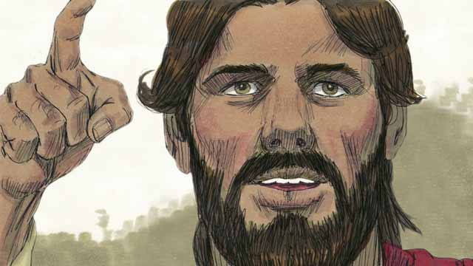

Every year, the Jews celebrated the Passover. This was a celebration of how God had saved their ancestors from slavery in Egypt many centuries earlier. About three years after Jesus first began preaching and teaching publicly, Jesus told his disciples that he wanted to celebrate this Passover with them in Jerusalem, and that he would be killed there.

38-02

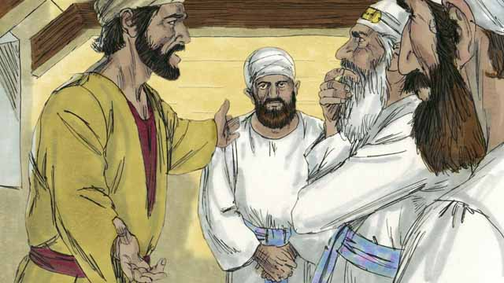

One of Jesus’ disciples was a man named Judas. Judas was in charge of the apostles’ moneybag, but he often stole money out of the bag. After Jesus and the disciples arrived in Jerusalem, Judas went to the Jewish leaders. He offered to betray Jesus by identifying him to the authorities in exchange for money. He knew that the Jewish leaders did not accept that Jesus was the Messiah. He knew that they wanted to kill him.

38-03

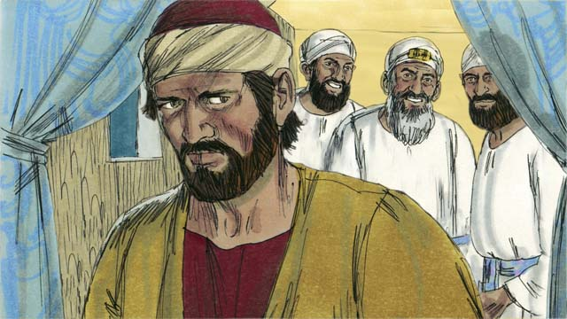

The Jewish leaders, led by the high priest, paid Judas 30 silver coins to betray Jesus by handing him over to them. This happened just as the prophets said it would. Judas agreed, took the money, and went away. He began looking for an opportunity to help them arrest Jesus.

38-04

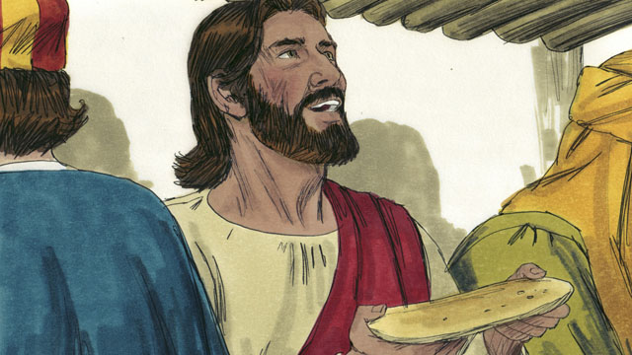

In Jerusalem, Jesus celebrated the Passover with his disciples. During the Passover meal, Jesus took some bread and broke it. He said, “Take and eat this. This is my body, which I will give for you. Do this to remember me.” In this way, Jesus said that he would die for them, that he would sacrifice his body for them.

38-05

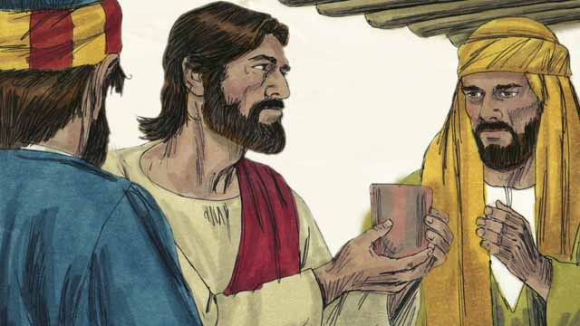

Then Jesus picked up a cup of wine and said, “Drink this. It is my blood of the New Covenant that I will pour out so that God will forgive your sins. Do what I am doing now, to remember me every time you drink it.”

38-06

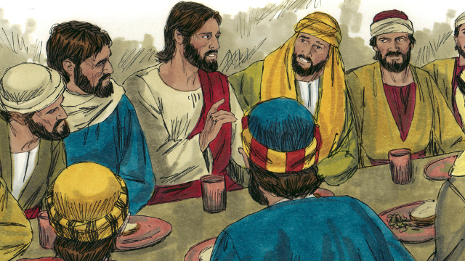

Then Jesus said to the disciples, “One of you will betray me.” The disciples were shocked, and asked who would do such a thing. Jesus said, “The person to whom I give this piece of bread is the betrayer.” Then he gave the bread to Judas.

38-07

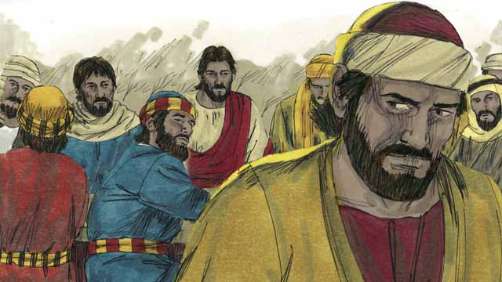

After Judas took the bread, Satan entered into him. Judas left and went to help the Jewish leaders arrest Jesus. It was nighttime.

38-08

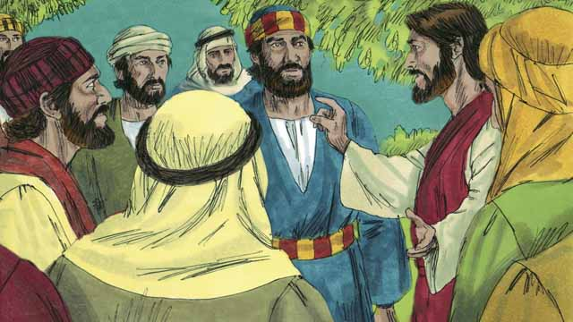

After the meal, Jesus and his disciples walked to the Mount of Olives. Jesus said, “You will all abandon me tonight. It is written, ‘I will strike the shepherd and all the sheep will be scattered.’”

38-09

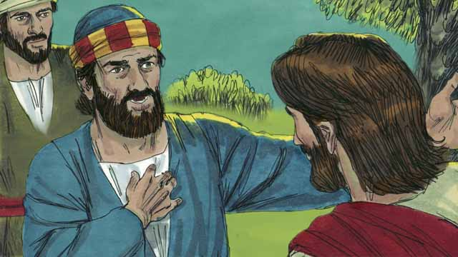

Peter replied, “Even if all the others abandon you, I will not!” Then Jesus said to Peter, “Satan wants to have all of you, but I have prayed for you, Peter, that your faith will not fail. Even so, tonight, before the rooster crows, you will deny three times that you even know me.”

38-10

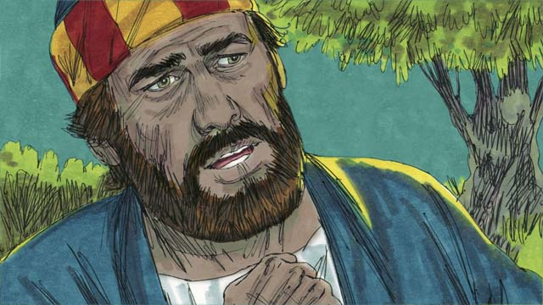

Peter then said to Jesus, “Even if I must die, I will never deny you!” All the other disciples said the same thing.

38-11

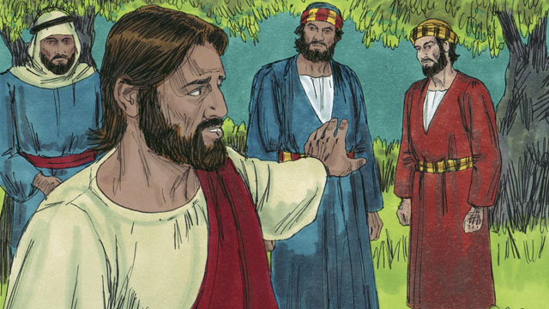

Then Jesus went with his disciples to a place called Gethsemane. Jesus told his disciples to pray that they would not enter into temptation. Then Jesus went to pray by himself.

38-12

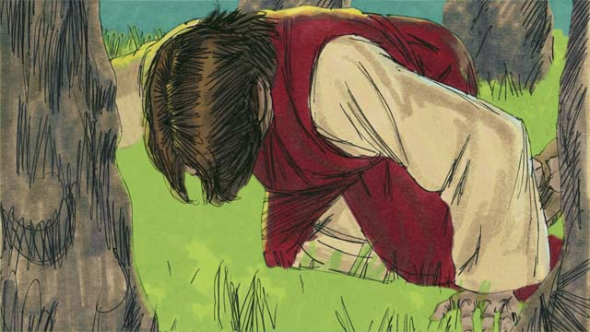

Jesus prayed three times, “My Father, if it is possible, please let me not have to drink this cup of suffering. But if there is no other way for people’s sins to be forgiven, then let your will be done.” Jesus was very troubled and his sweat was like drops of blood. God sent an angel to strengthen him.

38-13

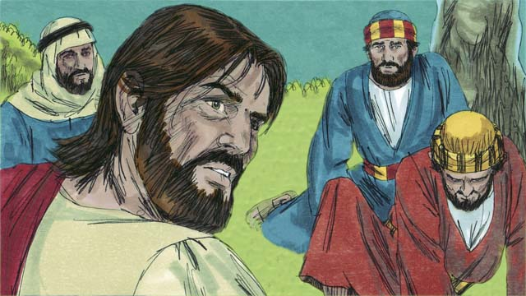

After each time of prayer, Jesus came back to his disciples, but they were asleep. When he returned the third time, Jesus said, “Wake up! My betrayer is here.”

38-14

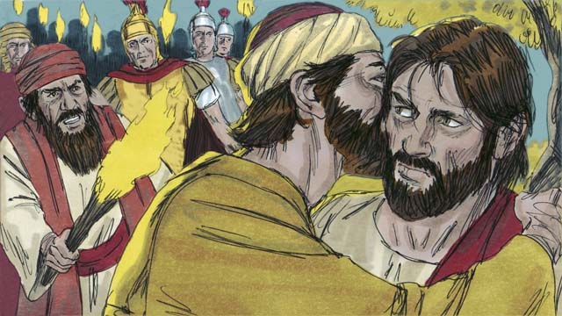

Judas came with the Jewish leaders, soldiers, and a large crowd. They were carrying swords and clubs. Judas came to Jesus and said, “Greetings, Teacher,” and kissed him. He did this to show the Jewish leaders the man to arrest. Then Jesus said, “Judas, are you betraying me with a kiss?”

38-15

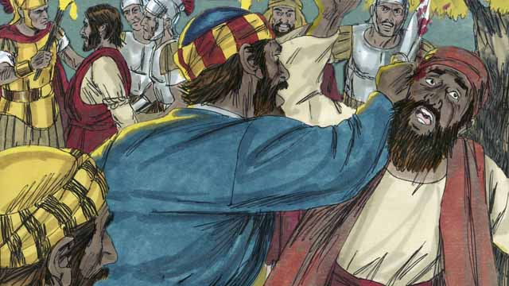

As the soldiers were seizing Jesus, Peter pulled out his sword and cut off the ear of a servant of the high priest. But Jesus said, “Put the sword away! I could ask the Father for an army of angels to defend me, but I must obey my Father.” Jesus healed the man’s ear. Then all the disciples ran away.

*A Bible story from: Matthew 26:14-56; Mark 14:10-50; Luke 22:1-53; John 18:1-11*

## 1 Biblical Interpretation: Observing the Details of the Story

After reading the crafted biblical story, answer the following questions to familiarize yourself with the details of the story.

### 1.1 Observation Questions

Answer the following observation questions to gain a basic understanding of the the story. Read the story as a community and answer these questions as a group.

#### 38-01

What was the meaning of Passover that the Jews celebrated every year?  
The Passover was a celebration of how God had freed the ancestors of the Jews from slavery in Egypt.

How long did Jesus preach and teach publicly?  
Jesus preached and taught publicly for three years.

What meal did Jesus want to celebrate with his disciples toward the end of his three-year, public ministry?  
Toward the end of his three-year, public ministry Jesus wanted to celebrate the Passover with his disciples in Jerusalem.

What else would happen to Jesus in Jerusalem?  
Jesus would be killed in Jerusalem.

#### 38-02

What was Judas responsible for?  
Judas was a disciples of Jesus in charge of the apostles’ moneybag.

Why did Judas go to the Jewish leaders in Jerusalem?  
Judas met with the Jewish leaders to betray Jesus.

What did Judas want in exchange for betraying Jesus to the Jewish leaders?  
He offered to betray Jesus in exchange for money.

Why would the Jewish leaders agree to this?  
The Jewish leaders did not accept Jesus as the Messiah and wanted to kill him.

#### 38-03

How much did the Jewish leaders pay Judas to betray Jesus?  
They paid him 30 silver coins.

Who said that the Messiah would be betrayed for 30 silver coins?  
The prophets predicted that this would happen.

What did Judas do after he agreed to betray Jesus?  
Judas took the money, went away, and looked for an opportunity to help them arrest Jesus.

#### 38-04

What food did Jesus give his disciples at the Passover meal?  
Jesus took bread and broke it for them to eat.

At the Passover meal, what did Jesus say about the bread?  
He said, “This is my body, which is given for you.”

What did the bread symbolize?  
Jesus gave his disciples the bread to remember that Jesus would die as a sacrifice for them.

#### 38-05

What other item did Jesus serve his disciples?  
Jesus picked up a cup of wine for them to drink.

What did Jesus say about the cup?  
He said, “It is my blood of the New Covenant that I will pour out so that God will forgive your sins.”

What did Jesus want them to do with the cup in the future?  
Jesus told his disciples to continue to do what he was doing with the cup as a way to remember Jesus every time they drank from it.

#### 38-06

How did the disciples respond when Jesus said one of the disciples would betray him?  
The disciple were shocked and asked who would do such a thing.

Who did Jesus say would betray him?  
Jesus said the one to whom he would give the bread would betray him.

Who did Jesus give the bread to at that time?  
Jesus gave the bread to Judas.

#### 38-07

What happened to Judas after he took the bread from Jesus?  
Satan entered into Judas.

Where did Judas go after taking the bread?  
After this, Judas left the meal and went to help the Jewish leaders arrest Jesus.

What time of the day was it at this moment?  
It was nighttime.

#### 38-08

Where did Jesus go with his disciples after the meal?  
After the meal, Jesus went with his disciples to the Mount of Olives.

What did Jesus predict would happen to the disciples that night?  
He said they would all abandon him.

What Scripture did Jesus quote?  
Jesus quoted a passage that said, “I will strike the shepherd and all the sheep will be scattered.”

#### 38-09

How did Peter respond to Jesus predicting that the disciples would abandon him?  
Peter said that he would not abandon Jesus even if all the other disciples did.

What did Jesus warn Peter?  
Jesus warned Peter that Satan wanted to have all of the disciples but Jesus prayed that their faith would not fail.

What did Jesus say that Peter would do before the rooster crowed?  
He said that Peter would deny three times that he knew Jesus.

#### 38-10

How did Peter respond to Jesus’ prediction that Peter would deny him three times?  
Peter said that even if he had to die he would not deny Jesus.

How did the disciples respond to Jesus’ predictions about them?  
They said that they would die rather than deny Jesus.

#### 38-11

Where did Jesus go with his disciples to pray?  
Jesus went with his disciples to Gethsemane.

How did Jesus tell his disciples to pray?  
Jesus told his disciples to pray that they would not enter into temptation.

Where did Jesus go?  
Jesus went by himself to pray.

#### 38-12

How many times did Jesus pray in Gethsemane?  
Jesus prayed three times.

What did Jesus pray to his Father at Gethsemane?  
He asked his Father not to make him drink the cup of suffering, but for God’s will to be done if there was no other way for people’s sins to be forgiven.

How troubled was Jesus?  
Jesus was very troubled and sweat drops of blood.

How did God strengthen Jesus?  
God sent an angel to strengthen Jesus.

#### 38-13

What were the disciples doing while Jesus prayed?  
They were sleeping.

What did Jesus say to his disciples the third time?  
Jesus told his disciples, “Wake up! My betrayer is here.”

#### 38-14

Who came to arrest Jesus?  
Judas came with the Jewish leaders, soldiers, and a large crowd.

What were people carrying?  
They were carrying swords and clubs.

How did the soldiers know which person was Jesus?  
Judas greeted Jesus and kissed him as a sign for them to arrest him.

What did Jesus say to Judas?  
Jesus asked Judas, “Judas, are you betraying me with a kiss?”

#### 38-15

What did Peter do in order to defend Jesus?  
As they were seizing Jesus, Peter pulled out a sword and cut off the ear of a servant of the high priest.

What did Jesus tell Peter to do?  
Jesus commanded Peter to put his sword away.

Why did Jesus say that he did not need Peter to defend him?  
Jesus said he could ask the Father for an army of angels, but he must obey his Father.

What did Jesus do with the man’s ear?  
Jesus healed the man’s ear.

What did the disciples do after Jesus was arrested?  
They all ran away.

### 1.2 Translation Questions

Use the following translation questions to understand specific details of the passage. Discuss how you might translate these specific elements of the story.

#### 38-01

**many centuries earlier** God saved the Israelites from slavery a very long time before the events of this story. A century is one hundred years. How would you express **many centuries earlier** to mean hundreds of years earlier?

  

**About three years after** Jesus first began preaching and teaching publicly Jesus preached and taught people publicly for three years. The events of this story take place at the end of this three-year period of time. How would you express **About three years after** Jesus first began preaching and teaching publicly to mean at the end of the three-year period of Jesus’ teaching and preaching publicly?

  

#### 38-02

**in charge of the apostles’ moneybag** Judas was responsible to keep and watch over the money that the apostles held in common. How would you express **in charge of the apostles’ moneybag** to mean responsible to hold the bag that had the disciples’ money in it and to distribute funds from it?

  

**he often stole money out of the bag** Judas would take money from the money that was commonly owned by the disciples. This money did not belong to him. This did not happen only once, but Judas did this frequently. How would you express **he often stole money out of the bag** to mean Judas repeatedly took funds that did not belong to him out of the money that the apostles shared?

  

**He offered to betray Jesus** Judas decided on his own to go to the Jewish leaders and help them arrest Jesus. Handing Jesus over to the Jewish leaders was an act of disloyalty and betrayal. How would you express **He offered to betray Jesus** to mean Judas volunteered to be disloyal to Jesus by helping the Jewish leaders arrest Jesus?

  

#### 38-03

**30 silver coins** Judas agreed to help the Jewish leaders arrest Jesus for a payment of **30 silver coins**. Each of these coins was worth about four days’ wages. How would you express **30 silver coins** to mean thirty pieces of silver that equaled several months’ salary?

  

**This happened just as the prophets said it would** The Old Testament prophets predicted that the Messiah would be betrayed for 30 silver coins. How would you express **This happened just as the prophets said it would** to mean this even took place just as the prophets predicted it would?

  

**He began looking for an opportunity to help them arrest Jesus** After agreeing to betray Jesus, Judas tried to find a suitable moment to betray Jesus. He was looking for a time when he could assist the Jewish leaders to arrest Jesus. How would you express **He began looking for an opportunity to help them arrest Jesus** to mean Judas tried to find a fitting time when he could turn Jesus over to the Jewish leaders?

  

#### 38-04

**Jesus celebrated the Passover** Jesus and his disciples observed the special Jewish feast of Passover together. They participated together in the common practices/rituals that caused Jews to remember God delivering Israel from slavery in Egypt. How would you express **Jesus celebrated the Passover** to mean Jesus commemorated the Jewish feast of Passover with his disciples?

  

**took some bread** Jesus This could picked up a piece of bread. This bread did not have yeast in it and was flat. How would you express **took some bread** to mean Jesus picked up a flat loaf of bread?

  

**broke it** Jesus broke the bread by tearing it into pieces for the people to eat. He may have divided it into many pieces or he may have divided it into two pieces and given them to the apostles to divide among themselves. How would you express **broke it** to mean ripped the bread into pieces so that people could it eat.

**This is my body** Jesus used the bread as a symbol of his body. How would you express **This is my body** to mean this bread represents my body?

  

**Do this to remember me** Jesus told his disciples to do what he was doing as a way to remember what Jesus would do for them. Jesus was referring to his death, which would happen soon. How would you express **Do this to remember me** as a command to repeat the same thing Jesus did as a way to remind yourselves of what Jesus was doing for them?

  

#### 38-05

**Drink this** Jesus instructed his disciples to drink the wine from the cup. Jesus picked up the cup and offered the cup to his disciples. The drink in the cup was wine which is made from grapes so that it had a deep red color. How would you express **Drink this** to mean drink what is in this cup?

  

**It is my blood** Jesus used the wine as a symbol of his blood. It is not actual blood. How would you express **It is my blood** to mean this wine/drink represents my blood?

  

**blood of the New Covenant** Jesus would shed his blood when he would die on the cross. His blood was the basis for the New Covenant. How would you express **blood of the New Covenant** to mean Jesus blood that makes the New Covenant possible?

  

**I will pour out** Jesus would bleed when he died on the cross. Blood coming out of his body is compared to pouring out wine from a cup. How would you express **I will pour out** to mean blood would come from Jesus body as he died on the cross?

  

**remember me** Jesus wanted his disciples to focus on Jesus and recall what he would do for them in dying on the cross. He told his disciples to take the cup to remind themselves of this and to celebrate it. How would you express **remember me** to mean to commemorate Jesus by remembering how he would die on the cross and offer his blood to make the New Covenant possible?

  

#### 38-06

**The disciples were shocked** The disciples were very surprised and upset that Jesus said that one of the disciples would betray him. They did not expect this. How would you express **The disciples were shocked** to mean the disciples were very surprised and upset by the statement that one of the disciples would betray Jesus?

  

**give this piece of bread** Jesus identified the person who would betray him by passing him a piece of bread. How would you express **give this piece of bread** to mean hand this piece of bread?

  

**is the betrayer** Jesus passed a piece of bread to Judas. Jesus used this act to identify who would betray him. How would you express **is the betrayer** to mean the person who will be disloyal to Jesus and help the Jewish leaders arrest him?

  

#### 38-07

**Satan entered into him** Satan took control of Judas after he took the bread from Jesus. How would you express **Satan entered into him** to mean Satan went into him and took control of him?

  

**Judas left and went** At this time, Judas left the room where the disciples and Jesus were eating the meal. How would you express **Judas left and went** to mean Judas left the meal and went and went outside?

  

#### 38-08

**Mount of Olives** This is the name of a hill covered with olive trees, just outside the walls of the city of Jerusalem. How would you express **Mount of** Olives to mean a hill filled with olive trees?

  

**abandon me** Jesus told the disciples that they would be disloyal to Jesus and leave him. How would you express **abandon me** to mean to desert Jesus?

  

**It is written** Jesus quotes from Scripture to show that the prophets predicted that the disciples would desert Jesus. God recorded this prophecy in the written Old Testament Scriptures. To be written as a prophecy in Scriptures means what is written will happen. How would you express **It is written** to mean one of God’s prophets wrote in God’s word?

  

**I will strike the shepherd and all the sheep all the sheep will be scattered** The prophecy says God will allow harm to be done to a shepherd which will cause the sheep to run away. Jesus is compared to a shepherd and the disciples are compared to sheep. This prophecy predicts how Jesus will be harmed and this will cause his followers to run away. How would you express **I will strike the shepherd and all the sheep all the sheep will be scattered** to mean God would allow people to harm a keeper of sheep and this would cause the sheep of the flock will run off in all directions?

  

#### 38-09

**Even if all the others abandon you I will not!,** Peter said this to emphasize that he would never desert Jesus. Peter is stating a hypothetical situation. The other disciples might be disloyal to Jesus and abandon him, but Peter said that he would not abandon Jesus. How would you express **Even if all the others abandon you I will not!,** as a strong statement in which Peter emphasizes to Jesus that he would not desert Jesus even if all the other disciples were disloyal to Jesus and deserted him?

  

**Satan wants to have all of you** Jesus warned Peter that Satan desired to completely control the disciples and have the disciples work for evil purposes. How would express **Satan wants to have all of you** to mean the devil wanted to get all the disciples to serve him completely?

  

**that your faith will not fail** Jesus prayed that Peter would continue to believe in Jesus and that Peter would not follow Satan. How would you express **that your faith will not fail** to mean that Peter would not stop believing in Jesus and serving Jesus?

  

**before the rooster crows** Roosters often crow about the time the sun comes up, so the hearers might have understood these words as an expression for the sun coming up in the morning. Roosters usually crow at dawn and signal the start of the morning. The actual crowing of a rooster is an important part of the story later on. How would you express **before the rooster crows** to mean **before the rooster crows** at dawn tomorrow?

  

#### 38-10

**Even if I must die, I will never deny you!** Peter made a strong statement to Jesus that emphasized that Peter would never renounce Jesus and would continue to be a faithful disciple. Peter said that he would stay faithful to Jesus even if he died doing so. How would you express **Even if I must die, I will never deny you!** as a strong statement which Peter says to tells Jesus that he would not disown Jesus or deny that he was a disciple of Jesus even if he had to die to stay faithful to Jesus?

  

#### 38-11

**a place called Gethsemane** Jesus and his disciples went to a nearby place called Gethsemane. This place was at the base of the Mount of Olives. How would you express **a place called Gethsemane** to mean **a place called** Gethsemane at the foot of the Mount of Olives?

  

**they would not enter into temptation** Jesus instructed his disciples to ask God to help them not be tempted. How would you express **they would not enter into temptation** to mean Jesus told his disciples to pray that God would make sure that Satan would not entice the disciples to sin?

  

#### 38-12

**if it is possible** Jesus prayed to God the Father and asked that God to keep him from suffering if God would permit it to happen. How would you express **if it is possible** to mean if God would allow it to happen?

  

**drink this cup of suffering** Jesus speaks of the work that he must do, including dying on the cross, as if it were a bitter liquid that God has commanded him to drink from a cup. How would you express **drink this cup of suffering** to mean endure this suffering that is about to happen?

  

**let your will be done** Jesus prayed that God would cause to happen what God wanted to happen. How would you express **let your will be done** to mean God would do what he planned?

  

#### 38-13

**After each time of prayer** Jesus prayed three times in this story. How would you express **After each time of prayer** to mean Jesus returned to his disciples every time Jesus prayed that prayer?

  

#### 38-14

**kissed him** Good friends would kiss each other on the cheek, but a disciple would probably kiss his master on the hand to show respect. No one knows for sure how Judas kissed Jesus. This was an act/sign of friendship that Judas used to betray Jesus. How would you express **kissed him** to mean a kiss that is a sign of friendship or respect for a teacher?

  

**are you betraying me with a kiss?** Jesus asked Judas if he was really going to betray me with a kiss? Jesus is not looking for an answer to this question. He is expressing that Judas is doing an upsetting thing by using an act of friendship and respect to betray Jesus. Betraying Jesus in this way made Judas’ betrayal all the worse. How would you express **are you betraying me with a kiss?** as a question that emphasizes the sadness of Judas betraying Jesus with an act of friendship and respect?

  

#### 38-15

**pulled out his sword** Peter **pulled out his sword** from the place where he was carrying it. How would you express **pulled out his sword** to mean Peter drew his sword from the place where it was being held?

  

**I must obey my Father** Jesus said that he had to do what his Father told him to do. This mean that Jesus would not fight against the crowd and prevent his arrest. Instead, Jesus would allow himself to get arrested because this was God the Father’s plan/will. How would you express **I must obey my Father** to mean Jesus must obey his Father’s will and allow himself to be arrested?

  

## 2 Theological Dialogue: Discussing the Meaning of the Story

Take time to explore the meaning of this story together as a community. Use the following discussions as a way to grasp what truth the story teaches.

### 2.1 Discourse Questions

Use the following discourse questions to understand the meaning of the story. Pay attention to how the story itself addresses each question or theme.

##### What was important about the Passover meal Jesus had with his disciples? (38-01, 38-02, 38-03, 38-04, 38-05)

Passover Meal: The Passover meal was a celebration meal Jews did every year to commemorate God liberating Israel from slavery in Egypt. At the end of Jesus’ three-year ministry, Jesus wanted to celebrate this feast with his disciples before he was killed. Jesus’ death on the cross would liberate people from the bondage of sin just like God liberated Israel from Egypt in the first Passover God. (38-01)

  

Jewish Plan to Kill Jesus: The Jewish leaders did not believe Jesus was the Messiah. The Jews wanted to kill Jesus. The meal anticipated Jesus’ crucifixion. (38-02)

  

Judas’ Plot: Judas agreed to betray Jesus to the Jewish leaders for 30 pieces of silver. This happened just like the prophets predicted. God planned for Jesus to be arrested and die on the cross. The prophets told about this beforehand. (38-02, 38-03)

  

Bread Represents Jesus’ Body: Jesus celebrated the Passover with his disciples in Jerusalem. During the meal, he took bread, broke it in pieces, and gave it to his disciples. This bread represented Jesus body. Jesus would die for them and sacrifice his body for them. The meal/bread helped Jesus’ disciples remember the sacrifice Jesus made by dying for them. (38-04)

  

Drink Represents Jesus’ Blood: During the meal, Jesus offered his disciples to drink from a cup of wine. The wine represented Jesus’ blood. Jesus would die as a sacrifice and his blood would provide the forgiveness of sins. This forgiveness would make the New Covenant with God possible. Jesus had them drink wine from this cup to help them remember what Jesus was accomplishing by dying as their sacrifice. (38-05)

  

##### How did Jesus’ betrayal and arrest come about? (38-02, 38-03, 38-06, 38-07, 38-08, 38-09, 38-10, 38-14, 38-15)

Greed and Deceit: Judas was in charge of the moneybag where the money for the disciples was stored. He had a habit of stealing money from the money bag. Judas had developed a habit of deceit and he was greedy. (38-02)

  

Prophets Prophesied and Judas Conspired: Judas made a deal with the Jewish leaders to help them arrest Jesus in exchange for money. Judas knew the Jewish leaders wanted to kill Jesus. Judas agreed to betray Jesus for 30 pieces of silver. This was prophesied by the Old Testament prophets and Judas himself sought out the opportunity to betray Jesus for money. The prophets predicted Jesus’ betrayal. (38-02, 38-03)

  

Betrayer Identified: During the meal, Jesus told his disciples that one of them would betray him. The disciples were shocked at this announcement. Jesus identified Judas as the betrayer by handing him a piece of bread. (38-06)

  

Satan Controls Judas: Judas took the piece of bread and Satan entered him. Satan controlled Judas and caused him to help the Jewish leaders arrest Jesus. (38-07)

  

Disciples Abandon Jesus: Jesus also predicted that all his disciples would abandon him. This was also predicted by the Old Testament prophets. Jesus’ disciples would desert Jesus on the night of his betrayal. Peter told Jesus that he would not abandon Jesus even if all the other disciples deserted him. Jesus told Peter that he would deny Jesus three times before the next morning. One of Jesus’ main disciples would abandon Jesus three times. Peter and all the disciples said they would not deny Jesus even if they had to die. (38-08, 38-09, 38-10)

  

Large Crowd and Weapons: Judas came to Gethsemane with the Jewish leaders, soldiers, and a large crowd. The crowd was carrying swords and clubs. They planned to use force if necessary to arrest Jesus. (38-14)

  

Sign of Friendship: Judas betrayed Jesus with a kiss. This kiss was as sign of friendship and respect. It was very evil to pretend to be Jesus’ friend but act with deceit and bad motives in a way that would harm him. (38-14)

  

Voluntary Arrest: Jesus did not have Peter defend him with a sword. He told him to put away the sword. Jesus voluntarily give himself up to be arrested because he knew that it was the will of God the Father. (38-15)

  

##### Why was Jesus’ time of prayer in Gethsemane important? (38-11, 38-12, 38-13)

Prayer: Jesus took his disciples to a place called Gethsemane. He told them to pray so they would not enter temptation. Prayer is a way to stay faithful to Jesus and resist the temptations of Satan. (38-11)

  

Doing God’s Will: Jesus prayed that God would allow him not to suffer if it was possible. Jesus knew, however, that only by suffering and dying could God forgive sin. So, Jesus asked that God’s will and plan would happen even if mean that Jesus would suffer and die. Jesus showed that prayer is a way to deepen our commitment to God. (38-12)

  

Expressing Sorrow and Finding Strength in God: During this time of prayer, Jesus was very troubled and sweat drops like blood. God sent an angel to strengthen him. Prayer is a way to express our sorrow and find strength from God. (38-12)

  

Staying Watchful: Jesus prayed his prayer three times. Each time he returned to his disciples, they were sleeping. Jesus was practicing diligence and perseverance in prayer. The disciples showed weakness by falling asleep at a time when they needed to be watchful and alert. Prayer is a means to stay watchful and alert against evil and temptation. (38-13)

  

##### How were different people in the story disloyal and faithful? (38-01, 38-02, 38-06, 38-09, 38-10, 38-13, 38-14, 38-15)

Jewish Leaders: The Jewish leaders wanted to kill Jesus. They were opposed to Jesus even though they were religious leaders. (38-01, 38-02)

  

Judas: Judas betrayed Jesus while acting like his friend and disciple. Satan used him to perform an evil act of betrayal. (38-02, 38-03, 38-06, 38-09, 38-14)

  

Disciples: Jesus predicted that the disciples would all abandon him. The disciples said they would not abandon Jesus. However, the disciples fell asleep in the garden and ran away after Jesus was arrested. (38-10, 38-13, 38-15)

  

Peter: Peter said that he would continue to follow Jesus and believe in him even if he had to die. Jesus told Peter that he would deny him three times. Peter tried to defend Jesus by force by drawing his sword and cutting off the ear of the servant of the high priest. Jesus told Peter to put the sword away. Jesus could call an army of angels to defend himself. (38-15)

  

Jesus: Jesus showed the ultimate example of faithfulness. He obeyed God the Father even though it cost him his life. (38-15)

  

### 2.2 Theological Questions

Answer the following theology questions as a community. Discuss what truths this story teaches.

1. How does Jesus’ death bring about salvation and the forgiveness of sins? How is Jesus’ death a sacrifice for sin? How does Jesus’ Passover meal with his disciples teach us about the importance of Jesus’ death as a sacrifice for sins?
2. What is Jesus like and what is his relationship with God the Father? What did Jesus’ time in Gethsemane teach us about the character of Jesus and his relationship to God the Father?
3. What does it mean to be a disciple fully committed to Christ? How do various people in this story (from their positive or negative example) teach us what it means to follow Jesus faithfully?

### 2.3 Translation Draft

Work as a translation team to draft each panel of this story. Pay attention to any specific translation issues that are challenging or significant.

#### Make Translation Draft

Make a draft for each section of this story.

#### Discuss and Revise

After drafting the story, discuss any translation issues that you think need special explanation.

#### Drafting Summary Reflection

Summarize any noteworthy translation decisions and the rationale/reasoning behind these translation decisions. In the final movement of this class, you will use these observations to give an account (i.e., chronicle/narrate) of how your translation improved through the checking process.

## 3 Personal Reflection: Following the Teaching of the Story

Take a moment to allow this story to evaluate your own life and to consider how God would have you respond. After this reflection, use the quality checking questions to check your translation draft among the translation team.

### 3.1 Journal Reflection

Prayerfully think about the following personal reflection questions. Write/Record your answers and/or discuss them as a group.

1. When have you ever experienced betrayal, disloyalty, and overwhelming sorrow? What were these experiences like?
2. How most challenges and encourages you about how Jesus endured suffering to serve God?
3. Which people in the story most describes the strength of your faith?
4. How does Jesus’ example of prayer encourage you to pray to God?
5. In what ways has Jesus (as the sacrifice for sin) set you free from the bondage of sin?

### 3.2 Team Check

*The following activity will help you check the clarity, accuracy, and naturalness of your draft. Read the passage aloud and discuss the checking questions with other members of your translation community. You might need to reread portions (or the whole) of the biblical passage multiple times as you answer each of these questions. Record answers to these questions below.*

#### Team Checking Questions

*Use the following questions to check your translation draft for accuracy, clarity, and naturalness.*

1. **Accurate**: Has anything been **added** to your translation of this passage that is not a part of the meaning of the source text? *If additions exist, are they included only added to clarify meaning (such as implied information)?*
2. **Accurate**: Is anything **missing** from your translation of this passage that is a part of the meaning of the source text? *If some part of the meaning is missing from your translation, add it.*
3. **Accurate**: Does any meaning in your translation of this passage appear to be **different** than the meaning of the source text? *If the meaning is different, try changing your translation so that the meaning remains the same.*
4. **Natural**: Does anything sound **unnatural** to how you would say it in your language? *If portions of the passage sound unnatural in your language, try to make them sound the way you would say it in your language while staying true to the meaning of the source text.*
5. **Clear**: Is anything **unclear** or **confusing** in your translation that confuses the meaning of the source text? *If portions of the passage are unclear or confusing, revise them to clearly communicate the meaning of the source text.*
6. **Consistent**: How **consistent** is your translation within the passage and with other passages? *If portions of the passage need to be made consistent or if you need to revise translations of other passages, make these adjustments.*

#### Record Feedback

*After discussing the checking questions above as a translation community, record any feedback on your translation draft. Pay attention for parts of your translation that are translated well and parts of your translation that need correction.*

#### Discuss and Revise

*After gathering feedback on your draft, discuss it together with your translation community and make appropriate revisions in your translation.*

#### Record Translation Decisions

*As a community, discuss some of the most noteworthy translation decisions in your draft. Summarize each decision and explain the reasons your community decided on that translation. You should update these decisions each time you check your draft with various groups of people.*

You should **measure** the quality of your translation draft. You can **record translation decisions** to make it clear why you translated things a certain way. Translation decisions can help your translation team and the surrounding community be a part of the translation process.

How can you know the quality of your translation?

1. **Measure** the translation by marks/standards of quality (i.e., clear, accurate, natural, church-approved)
2. **Test** the translation with others and record feedback and conversations from in the field (i.e., church and community check)
3. **Compare** and **contrast** the translation with the source text (i.e., meaning of text and notes) and alternatives (i.e., other translation choices)
4. **Explain** the reasons why you translated a particular portion of the text.

**Example Sentences That Help Explain Your Translation Decision** Use the following example sentences to help explain your translation decisions:

1. The original text literally **says/means**, so we translated the term in this way…
2. We originally decided to translate **the biblical term** in with **this term**, but we changed it because…
3. When our translation team discussed **the biblical term**, this is what we talked about…
4. **The term** is [clear, accurate, natural, consistent] because…
5. The community understands **this term** it to mean…
6. We considered these other terms. We did not use **these terms** because…
7. When we checked this in the church, we learned…
8. When we checked this in the community, we learned…

**Example of Translation Decision**

In OBS 01-07 we decided to translate **blessed** like this: [actual translation]. We decided this translation because of these reasons:

1. The word [actual translation] means to cause good things to happen to someone or something. This term is used when a person desires someone or something to prosper or flourish. This term does not refer to magic or witchcraft.
2. When we checked this word with other believers, they said it describes God showing his kindness and favor on someone or something. These are some of the terms that we did not decide to use…
3. Many of our people will understand this word. When we discussed this phrase with the surrounding community, we discovered it was a natural way to describe God causing good and beneficial things to happen.

## 4 Ministry Practice: Serving the Church with the Story

Now that you have a draft of this story, consider how this story can encourage other believers in their faith. After ministering this story to others, you will also perform a community check of your translation draft.

### 4.1 Church Ministry

Reflect on how this story can edify and mature the Christian community. Design a way to minister this story to your church community.

**Ministry Preparation**: Take time to consider how you could minister this story to others. Record some ministry ideas below.

**Ministry Implementation**: Minister this story to a group of believers as you had planned. Use the information in this study to help develop a teaching/lesson or lead a discussion of this story to other believers. Record your ministry plan below.

**Ministry Reflection**: Think about what you learned from ministering this story to other believers. Reflect on your experience below.

### 4.2 Church Community Check

After teaching or ministering this story to the church, check the translation quality with the church community. Record any feedback from your checking experience.

#### Create Checking Questions

You can use **Translation Questions** to check you draft. Each **Translation Question** explains the meaning of a specific part of the story and asks you to consider how you would translate that part of the story in your own language. Change each **Translation Question** into a **Checking Question** by asking the following questions. The first question asks you to identity how each specific phrase was translated in your language. The second question asks people in the church to determine if your translation of the phrase expresses the meaning clearly, accurately, and naturally. Look at the following examples to see how to change **Translation Questions** into **Checking Questions**:

#### Translation Question Example 1

**to proclaim the good news about Jesus** Paul and Silas traveled to Philippi for the purpose of preaching the gospel. The gospel is the good news that Jesus saves people from their sins if they will believe in Jesus. How would you express **to proclaim the good news about Jesus** to mean to tell other people the message about how Jesus can save people from their sins?

#### Translation Question Example 2

**a merchant** Paul and Silas met a woman named Lydia at the place by the river. She owned a business and sold items to make money. How would you express **a merchant** to mean a business owner who sells items for a profit?

#### Translation Question Example 3

**so Paul and Silas baptized them** The jailer and his whole family followed Paul’s instructions. They believed in Jesus. The result of this was Paul and Silas baptized them. How would you express **so Paul and Silas baptized them** to mean the result of the jailer and his family believing in Jesus that Paul and Silas baptized all of them?

You can change these into **Checking Questions** like this:

#### Checking Question Example 1

**to proclaim the good news about Jesus** How did you translate **to proclaim the good news about Jesus**? Does it mean to tell other people the message about how Jesus can save people from their sins?

#### Checking Question Example 2

**a merchant** How did you translate **a merchant**? Does it mean a business owner who sells items for a profit?

#### Checking Question Example 3

**so Paul and Silas baptized them** How did you translate **so Paul and Silas baptized them**? Does it mean the result of the jailer and his family believing in Jesus that Paul and Silas baptized all of them?

#### Record Feedback

*Discuss the* ***Checking Questions*** *with your church community, and record any feedback on your translation draft. Pay attention for parts of your translation that are translated well and parts of your translation that need correction.*

#### Discuss and Revise

*After gathering feedback on your draft, discuss it together with your translation community and make appropriate revisions in your translation.*

#### Record Translation Decisions

*Update your translation decisions and record and new any noteworthy observations on the quality of your draft.

## 5 Missional Outreach: Sharing the Truth of the Story

*After sharing this story with others, check the translation quality with the wider language community. Record any feedback from your checking experience.*

### 5.1 Mission Engagement

*Consider how you will witness this story to unbelievers. Design a way to share this story and engage them in what it teaches about Christianity and the gospel.*

**Witness Preparation**: Take time to consider how you will witness this narrative to unbelievers. Record some ideas below.

**Witness Implementation**: Share this story with an unbeliever. Use the information in this study to help develop a teaching/lesson or lead a discussion of this story to other believers. Record your ministry plan below.

**Witness Reflection**: Think about what you learned from ministering this story to unbelievers. Reflect on your experience below.

### 5.2 Sociolinguistic Check

After sharing this story with the language community, check your translation draft with the surrounding community. Record your observations.

#### Checking Approach

After witnessing this story to unbelievers, use one of the following methods to check the translation of this story. Consider using the **Observation Questions** to check your translation draft or come up with your own quality checking questions.

**Read-Retell Check:** Read your draft to those the community and ask them to retell the passage. Be attentive for any portions of the passage that are unclear, unnatural, or inaccurate.

**Comprehension Questions Checklist:** Read the draft of the passage and ask a list of comprehension questions to make sure the passage is being rightly understood. You can use the **Observation Questions** in this guide or come up with your own questions. Then, record any insights or issues that arise.

**Discussion Group:** Develop key questions to ask about the passage (both formational and translational). Read the passage and have a group discussion about the passage, paying attention to issues that need to be addressed, edited, and revised.

#### Record Feedback

*After sharing your draft with language community, discuss the* ***Observations Questions****, and record any feedback on your translation draft. Pay attention for parts of your translation that are translated well and parts of your translation that need correction.*

#### Discuss and Revise

*After gathering feedback on your draft, discuss it together with your translation community and make appropriate revisions in your translation.*

#### Record Translation Decisions

*Update your translation decisions and record and new any noteworthy observations on the quality of your draft.

## 6 Conclusion

As a translation community, take time to reflect on all that was learned in studying, drafting, and checking this story. Celebrate all that God has taught you as a community. Then, submit your revised draft and checking summaries to network leaders for further review.