Open Bible Stories

Jesus Is Put on Trial

## 0 Introduction

### 0.1 Key Idea

The story of Jesus being put on trial teaches us that Jesus was innocent of any crimes and was sentenced to death to pay for the guilt of humans.

### 0.2 Creedal Verse

“He committed no sin, neither was deceit found in his mouth. 23 When he was reviled, he did not revile in return; when he suffered, he did not threaten, but continued entrusting himself to him who judges justly.” 1 Peter 2:22-23

### 0.3 Metanarrative Summary

The eternal God created all things in six days. He made a good and perfect world. He made humans in his image to fill the earth and rule over creation. But humans rebelled against God and ruined God’s creation. God set to restore his world through his promise. God made a covenant with Abraham. He promised to bless all nations through Abraham. God kept his promises across the generations. God provided Abraham with a promised child, Isaac. God gave Isaac a wife, and she bore twins, Jacob and Esau. God blessed Jacob and his sons, and the blessing continued to the next generation. God rescued Joseph, one of Jacob’s sons, and used him to rescue his family. God caused his people, the Israelites, to multiply in the land of Egypt; eventually, they became slaves. But God raised up a deliverer, Moses, to deliver his people from slavery. God judged the Egyptians with harsh plagues; in the final judgment, he passed over his people, who covered their doorposts with the blood of a sacrificed lamb. Then, God delivered the Israelites by bringing them out of Egypt and crossing the Red Sea on dry land. God made a covenant with the Israelites and made them his people. God tested Israel in a series of wilderness wanderings and eventually brought his people into the promised land of Canaan. God raised up deliverers to lead Israel and rescue them from their enemies. God formed Israel into a kingdom. He made a covenant with King David and promised to send a king that would rule his people forever. Many of Israel’s kings were evil, and the kingdom of Israel was divided into two kingdoms. God sent prophets to warn his people of God’s judgment and call them to repent. When Israel did not repent, God sent his people into exile. After many years, he brought them back to the land. Throughout the Old Testament, God promised to send his Messiah to deliver his people from their sin. After many years, the prophet John was born. He would prepare people for the coming Messiah. At the perfect time, God sent his Son, Jesus, to be born of a virgin Mary. When John and Jesus grew up, John baptized Jesus as a sign that Jesus was God’s beloved Son. Jesus endured all manner of temptation without ever sinning. When he was thirty years old, he launched a public ministry of preaching, teaching, and healing. He taught his disciples about the life of compassion, sacrifice, and forgiveness. Jesus performed many miracles: he fed a crowd of five thousand, he walked on water, he healed the sick, and he cast out demons. He proclaimed to people the nature of real faith, God’s kingdom, and how fallen humans can be restored in relationship with God. Toward the end of his ministry, Jesus revealed his power and glory to his disciples He raised a dead man to life. Jesus was betrayed by one of his disciples and put on trial before a Roman governor.

### 0.4 Open Bible Story: Jesus Is Put on Trial

39-01

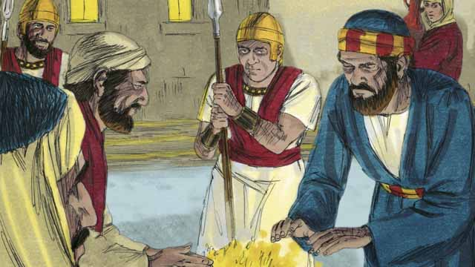

It was now the middle of the night. The soldiers led Jesus to the house of the high priest because he wanted to question Jesus. Peter was following far behind them. When the soldiers took Jesus into the house, Peter stayed outside and warmed himself by a fire.

39-02

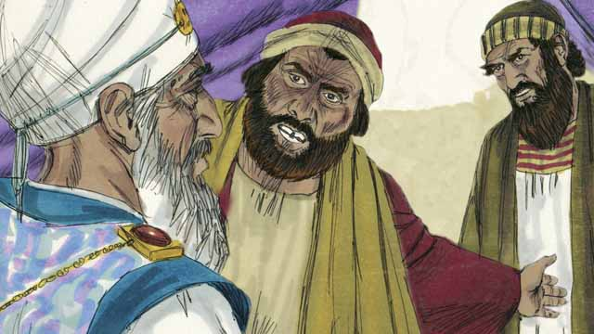

Inside the house, the Jewish leaders put Jesus on trial. They brought many false witnesses who lied about him. However, their statements did not agree with each other, so the Jewish leaders could not prove he was guilty of anything. Jesus did not say anything.

39-03

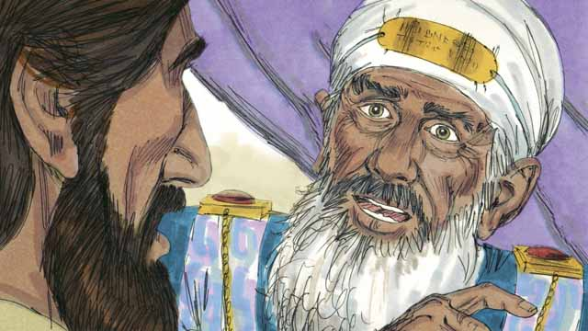

Finally, the high priest looked directly at Jesus and said, “Tell us, are you the Messiah, the Son of the living God?”

39-04

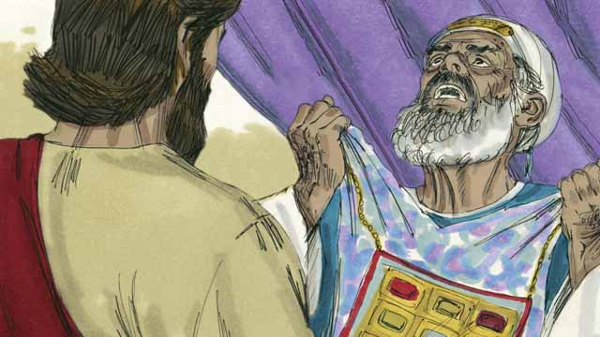

Jesus said, “I am, and you will see me seated with God and coming from heaven.” The high priest tore his clothes because he was angry at what Jesus said. He shouted to the other leaders, “We do not need any more witnesses to tell us what this man has done! You yourselves have heard him say that he is the Son of God. What is your decision about him?”

39-05

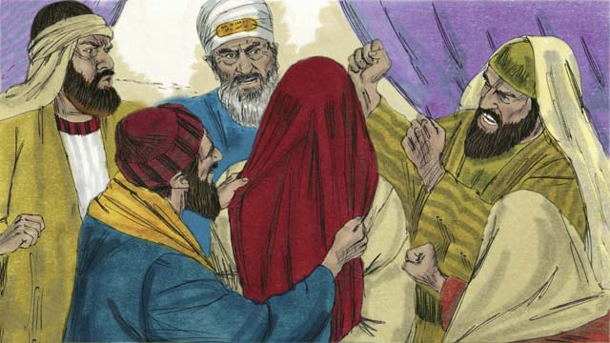

The Jewish leaders all answered the high priest, “He deserves to die!” Then they blindfolded Jesus, spit on him, hit him, and mocked him.

39-06

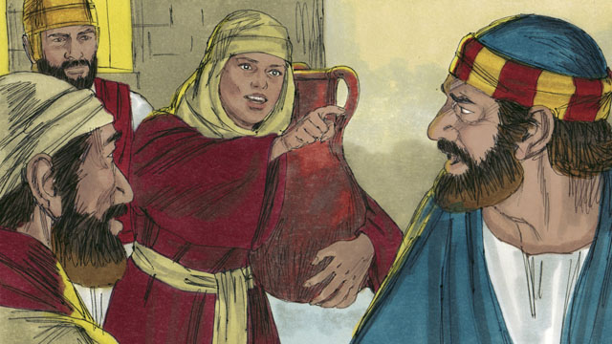

As for Peter, he was waiting outside the house. A servant girl saw him. She said to him, “You also were with Jesus!” Peter denied it. Later, another girl said the same thing, and Peter denied it again. Finally, some people said, “We know that you were with Jesus because you both are from Galilee.”

39-07

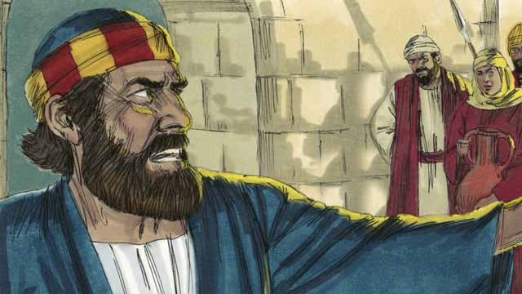

Then Peter said, “May God curse me if I know this man!” Immediately after Peter swore like this, a rooster crowed. Jesus turned around and looked at Peter.

39-08

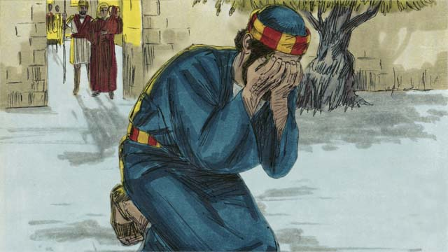

Peter went away and cried bitterly. At the same time, Judas, the one who had betrayed Jesus, saw that the Jewish leaders had condemned Jesus to die. Judas became full of sorrow and went away and killed himself.

39-09

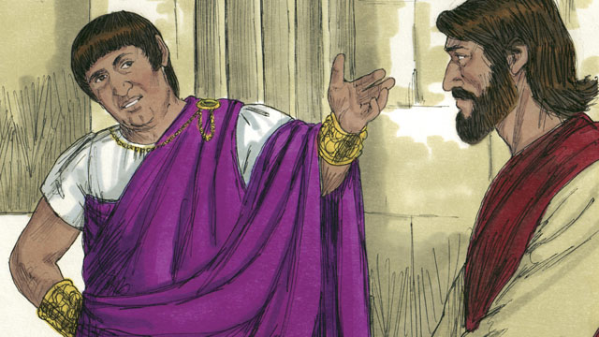

Now Pilate was the governor of Judea. He worked for Rome. The Jewish leaders brought Jesus to him. They wanted Pilate to condemn Jesus and kill him. Pilate asked Jesus, “Are you the king of the Jews?”

39-10

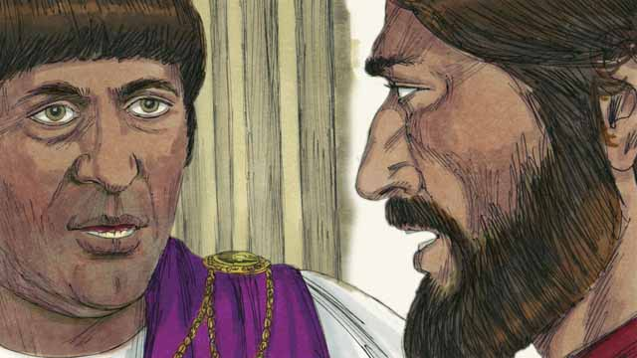

Jesus answered, “You have said the truth. But my kingdom is not here on earth. If it were, my servants would fight for me. I have come to earth to tell the truth about God. Everyone who loves the truth listens to me.” Pilate asked, “What is truth?”

39-11

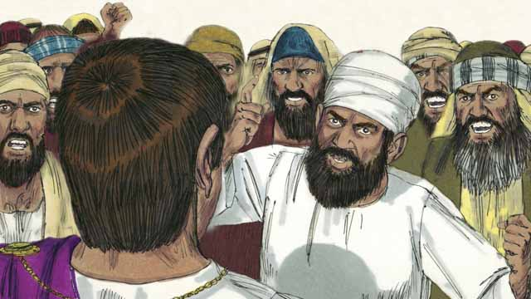

After speaking with Jesus, Pilate went out to the crowd and said, “I cannot find any reason that this man deserves to die.” But the Jewish leaders and the crowd shouted, “Crucify him!” Pilate replied, “He is not guilty of doing anything wrong.” But they shouted even louder. Then Pilate said a third time, “He is not guilty!”

39-12

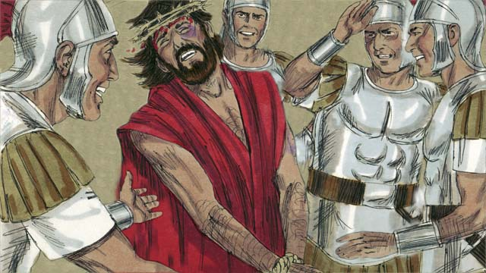

Pilate became afraid that the crowd would begin to riot, so he agreed to have his soldiers crucify Jesus. The Roman soldiers whipped Jesus and put a royal robe and a crown made of thorns on him. Then they mocked him by saying, “Look, the King of the Jews!”

*A Bible story from: Matthew 26:57-27:26; Mark 14:53-15:15; Luke 22:54-23:25; John 18:12-19:16*

## 1 Community Study: Healthy Vulnerability—Naming Fears That Harm Personal Relationships

* **Key Idea**: identifying fears that cripple ministry and harm community
* **Key Passage**: Proverbs 29:25
* **Main Session**: OBS 39 (Jesus Is Put on Trial)

### 1.1 Recite the Creedal Verse (3–5 minutes)

The verse below summarizes the teaching of the current passage. Read the verse out loud as a community. Read it again several times as a group until the whole community can recite it from memory.

See, we are going up to Jerusalem, and the Son of Man will be delivered to the chief priests and scribes. They will condemn him to death 19 and will deliver him to the Gentiles for them to mock, to flog, and to crucify him. But on the third day he will be raised up. Matthew 20:18-19

OR

22 He committed no sin, neither was any deceit found in his mouth. 23 When he was reviled, he did not revile back. When he suffered, he did not threaten back, but he gave himself to the one who judges justly. 1 Peter 2:22-23

### 1.2 Reflect on Your Fears (5–10 minutes)

Jesus came to save people from sin. People falsely accused, mocked, and rejected Jesus. Many times, we can fear what other people think about us or what they might say about us. This fear can prevent us from having healthy relationships. Take a moment to privately reflect on some of your own fears about what other people might think or might say about you.

I am afraid that people might think (or say) this about me…

This fear causes me to feel and act in the following ways…

### 1.3 Read the Passage (3–5 minutes)

Our personal fears and anxieties (i.e., our insecurities) can make it hard to trust other people. God wants us to find security and safety in him. Unfortunately, many people try to find security in other people and other things. Read the passage below to learn about what God says about fear and insecurity.

25 The fear of man makes a snare, but the one who trusts in Yahweh will be protected. Proverbs 29:25

### 1.4 Discuss the Passage (10-15 minutes)

When we fear what others think and say about us, we can feel anxious and insecure. God wants us to find safety and security in him. When we find our security in God, we are able to build healthy relationships of trust and vulnerability. As a community, use the following questions to discuss the teaching of the biblical passage.

1. What does this passage teach about fearing people? How is the fear of people a snare (trap)?
2. What are some fears, anxieties, and insecurities people experience? How can these fears be like a prison for us?
3. What does this passage teach about trusting God? How can trusting God help us overcome our fears and insecurities?
4. Why is it important for your community to resolve personal fears and insecurities?

### 1.5 Describe Trust in God (5 minutes)

Think about what it means to trust God. Reflect on what it means for God to protect you. Complete the following sentence to express how your feelings, thoughts, and actions would change if you trusted God to protect you.

Because God protects me, I do not need to be afraid of…

### 1.6 Pray to God (5 minutes)

Pray that God would remove fears and insecurities in your community. Have each member of your community say a brief prayer that God would provide protection and safety from fear and insecurity. After each person prays, have the whole group pray the Scripture passage together.

Gracious God, help me to no longer be afraid of…

Pray Together: I sought Yahweh and he answered me, and he gave me victory over all my fears. Psalm 34:4

### 1.7 Sing a Song (3–5 minutes)

Choose a song that expresses trust in God for protection and safety. Sing this song together as a community.

## 2 Biblical Interpretation: Observing the Details of the Story

After reading the crafted biblical story, answer the following questions to familiarize yourself with the details of the story.

### 2.1 Observation Questions

Answer the following observation questions to gain a basic understanding of the story. Read the story as a community and answer these questions as a group.

#### 39-01

What time of the day was it when the Jewish leaders began to question Jesus?  
It was the middle of the night.

Why did the soldiers lead Jesus to the house of the high priest?  
The soldiers led Jesus to the house of the high priest because he wanted to question Jesus.

How far behind was Peter?  
Peter followed far behind them.

Where was Peter when they took Jesus into the house?  
Peter stayed outside and warmed himself by a fire.

#### 39-02

What did the Jewish leaders do inside the house?  
The Jewish leaders put Jesus on trial.

Who came to accuse Jesus?  
They brought many false witnesses who lied about Jesus.

Why could the Jewish leaders not prove Jesus was guilty of anything?  
The statements of the false witnesses did not agree with each other.

What did Jesus say during this time?  
Jesus did not say anything.

#### 39-03

What question did the high priest finally ask Jesus?  
He asked Jesus, “Are you the Messiah, the Son of the living God?”

#### 39-04

What answer did Jesus give to the high priest?  
Jesus said, “I am, and you will see me seated with God and coming from heaven.”

How did the high priest respond to Jesus’ statement?  
The high priest tore his clothes and was angry at what Jesus said.

How many more witnesses did the high priest think they needed?  
The high priest did not think they needed any more witnesses against Jesus.

What was the crime that the high priest said that Jesus had committed?  
He said that Jesus had claimed he was the Son of God.

#### 39-05

What did the Jewish leaders say to the high priest?  
The Jewish leaders told the high priest that Jesus deserved to die.

After this, what did they do to Jesus?  
Then they blindfolded Jesus, spit on him, hit him, and mocked him.

#### 39-06

Where was Peter during Jesus’ trial?  
Peter was waiting outside the house of the high priest.

What did the servant girl say to Peter?  
The servant girl said that Peter was with Jesus.

How did Peter respond to what the servant girl said?  
Peter denied that he was with Jesus.

What did Peter do when another girl said the same thing?  
Peter denied it again.

Why did the people think that Peter had been with Jesus?  
Peter and Jesus were both from Galilee.

#### 39-07

What did Peter say about people thinking he was with Jesus?  
Peter swore that he did not know Jesus and brought a curse on himself if he was lying.

What happened immediately after Peter denied Jesus the third time?  
A rooster crowed, and Jesus turned and looked at Peter.

#### 39-08

What did Peter do after he denied Jesus three times and heard the rooster crow?  
Peter went away and cried bitterly.

What did Judas do when he saw that the Jewish leaders had condemned Jesus?  
Judas became full of sorrow and went away and killed himself.

#### 39-09

Who was Pilate?  
Pilate was the Roman governor of Judea.

Why did the Jewish leaders take Jesus to the Roman governor Pilate?  
They wanted Pilate to condemn Jesus and kill him because they didn’t have the authority to do it themselves.

What was the first question that Pilate asked Jesus?  
He asked, “Are you the king of the Jews?”

#### 39-10

What did Jesus tell Pilate about his kingdom?  
Jesus told Pilate that his kingdom was not on earth or his servants would have fought for him.

What did Jesus say was the reason he came to earth?  
Jesus said he came to earth, to tell the truth about God.

How do people act who love the truth?  
People who love the truth listen to Jesus.

#### 39-11

What did Pilate tell the crowd about Jesus?  
Pilate told the crowd that he could not find any reason that Jesus deserved to die.

What were the people telling Pilate to do to Jesus?  
The people shouted, “Crucify him!” How many times did Pilate say to the crowd that Jesus was not guilty?  
He said three times that Jesus was not guilty.

#### 39-12

If he believed Jesus was innocent, why did Pilate allow Jesus to be crucified?  
Pilate became afraid that the crowd would begin to riot.

How did the Roman soldiers treat Jesus?  
They whipped Jesus, put a royal robe and a crown of thorns on him, and mocked him.

What did they call Jesus as they mocked him?  
They mocked Jesus by calling him King of the Jews.

### 2.2 Translation Questions

Use the following translation questions to understand specific details of the passage. Discuss how you might translate these specific elements of the story.

#### 39-01

**the middle of the night** The soldiers led Jesus to the house of the high priest very late at night. How would you express **the middle of the night** to mean halfway through the night?

  

**to question Jesus** The high priest wanted to ask Jesus questions to try to find something they could accuse Jesus of doing wrong. How would you express **to question Jesus** to mean interrogate or examine Jesus by asking him questions in an effort to show him as guilty of doing something wrong?

  

#### 39-02

**put Jesus on trial** The Jewish leaders had a formal meeting to accuse Jesus of doing something wrong. Usually, a trial is held to find out if someone is innocent or guilty of a certain crime. In this case, the leaders were determined to have Jesus found guilty. How would you express **put Jesus on trial** to mean have a hearing or official/legal proceedings that determine whether Jesus was innocent or guilty?

  

**lied about him** False witnesses told lies about Jesus. They wanted Jesus to be charged as guilty of wrongdoing even though he did not do the wrong things they accused him of doing. How would you express **lied about him** to mean falsely accused him of doing something wrong?

  

**their statements did not agree with each other** The things the false witnesses said about Jesus were very different from each other. How would you express **their statements did not agree with each other** to mean the false witnesses said things about Jesus that contradicted each other?

  

**he was guilty of anything** The Jewish leaders were unable to show Jesus culpable of wrongdoing. How would you express **he was guilty of anything** to mean they could not demonstrate that Jesus had done anything wrong?

  

#### 39-03

**the high priest looked directly at Jesus** The head priest focused his attention and eyes on Jesus. He wanted Jesus to give him a clear answer to a specific question. How would you express **the high priest looked directly at Jesus** to mean the head priest gazed at Jesus with focused attention to get a clear answer from him?

  

**the Son of the living God** Jesus is the eternal Son of God. He is fully divine like God the Father. God is alive and full of life. How would you express **the Son of the living God** to mean Jesus is fully divine and the eternal Son of God the Father who is alive and full of life?

  

#### 39-04

**I am** Jesus said that he was what the high priest said. Jesus is the Messiah and the Son of God. **I am** is also the name of God. By saying simply **I am**, Jesus was also saying that he is God. How would you express **I am** to mean Jesus is who the high priest said he was, and Jesus called himself by God’s name?

  

**seated with God** and coming from heaven. Because God is the ruler over all, people talk about him as sitting on a throne in heaven. By saying that he would be **seated with** God, Jesus claimed he had the authority to rule with the Father. How would you express **seated with God** and coming from heaven to mean sitting beside God and reigning with God and then coming from heaven to earth?

  

**tore his clothes because he was angry** The Jews would tear their clothes to show grief or anger. How would you express **tore his clothes because he was angry** to mean the leading priest was so upset/enraged that Jesus claimed the authority of God that he ripped his clothes to show this anger?

  

**We do not need any more witnesses to tell us what this man has done!** The leading priest considered Jesus’ claim of God’s authority blasphemy. He made a strong statement that said he thought they had already proved that Jesus was guilty of irreverence toward God. How would you express **We do not need any more witnesses to tell us what this man has done!** as a strong statement that no other evidence was needed to prove that Jesus was guilty of wrongdoing?

  

**What is your decision about him?** The leading priest asked the other Jewish leaders whether they thought he was innocent or guilty for claiming to have God’s authority. The chief priest wanted the religious leaders to condemn Jesus for claiming to be equal with God. How would you express **What is your decision about him?** as a question asking the Jewish leaders whether they considered Jesus innocent or guilty?

  

#### 39-05

**He deserves to die!** The Jewish leaders said Jesus should die for claiming to be equal to God. How would you express **He deserves to die!** as a strong statement that emphasizes the opinion of the Jewish leaders that Jesus should be killed (put to death) because he called himself equal to God?

  

**they blindfolded Jesus** They put a piece of cloth on Jesus’ eyes so he could not see. How would you express **they blindfolded Jesus** to mean they covered Jesus’ eyes so that he could not see?

  

**spit on him** They spat on Jesus to say he was worthless. This was a way of showing contempt for someone. How would you express **spit on him** to mean they spit on Jesus, to insult and shame him?

  

#### 39-06

**You also were with Jesus!** The servant girl said Peter had spent time with Jesus and followed him. The servant girl said this to accuse Peter of being a criminal. How would you express **You also were with Jesus!** to mean Peter was one of Jesus’ followers who spent time with him and followed him?

  

**denied it** Peter said the servant girl’s statement was not true. Peter was lying. He really was one of Jesus’ disciples but did not admit it because of fear. How would you express **denied it** to mean Peter said that he was not with Jesus and that what the servant girl said was false?

  

**We know that you were with Jesus because you both are from Galilee** The servant girl could probably tell Peter was from Galilee from the way he talked. How would you express **We know that you were with Jesus because you both are from Galilee** to mean people could tell from the way Jesus and Peter talked that they came from the region of Galilee?

  

#### 39-07

**May God curse me if I know this man!** Even though Peter was lying, Peter wanted people to really believe him that he did not know Jesus. He also referred to Jesus as this man to make it sound like he did not know him. Peter spoke a curse on himself if he was lying. He stated that God should cause him harm if he actually did know Jesus. How would you express **May God curse me if I know this man!** as a strong statement that God would punish Peter if he was lying to them?

  

**Immediately after** Peter swore like this, a rooster crowed. At the very time after Peter spoke a curse on himself, a rooster crowed. How would you express **Immediately after** Peter swore like this, a rooster crowed to mean a rooster made a loud crowing sound right away following Peter’s curse?

  

#### 39-08

**cried bitterly** Peter was so filled with sadness that he denied Jesus three times that he wept with deep remorse and regret. How would you express **cried bitterly** to mean Peter cried, feeling deep sorrow?

  

**the one who had betrayed Jesus** Judas was disloyal to Jesus and assisted the Jewish leaders when they arrested Jesus. How would you express **the one who had betrayed Jesus** to mean the person who was disloyal to Jesus and helped the Jewish arrest Jesus?

  

**had condemned Jesus to die** The Jewish leaders gave Jesus a death sentence. They judged him guilty and said he deserved to be killed. How would you express **had condemned Jesus to die** to mean the Jewish leaders had said that Jesus was guilty and must die?

  

#### 39-09

**He worked for Rome** The Roman government had appointed Pilate to govern the region of Judea in Israel. How would you express **He worked for Rome** to mean Pilate was a government official who ruled the region of Judea on behalf of the Roman government?

  

**They wanted Pilate to condemn Jesus and kill him** As governor, Pilate had the authority to condemn Jesus to death and to give approval for his crucifixion, or he could set him free. The Jewish religious leaders did not have the authority to have someone killed. How would you express **They wanted Pilate to condemn Jesus and kill him** to mean the Jewish leaders desired that Pilate use his authority to sentence Jesus to death?

  

#### 39-10

**my kingdom is not here on earth** Jesus told Pilate that his kingdom did not work like the kingdoms of human governments and rulers. How would you express **my kingdom is not here on earth** to mean Jesus’ kingdom is not like earthly kingdoms?

  

**If it were, my servants would fight for me** Jesus made a hypothetical statement to show that his kingdom was not like the kingdom of human rulers. He said that if his kingdom worked like human governments, then his disciples would fight to free Jesus. How would you express **If it were, my servants would fight for me** to mean Jesus’ disciples would physically fight to set Jesus free if Jesus’ kingdom was like the government of human rulers?

  

**listens to me** Jesus said that people who love the truth follow Jesus’ commands. This includes not just hearing Jesus’ words, but also doing what he says. How would you express **listens to me** to mean hears Jesus’ teaching and obeys Jesus?

  

**What is truth?** Pilate did not think it was possible to know the truth. Pilate asks a question to reflect his belief that no one really knows what truth is. How would you express **What is truth?** as a question that means can anyone know what is true?

  

#### 39-11

**He is not guilty** Pilate says that Jesus is innocent of wrong. Pilate could not find a good reason that Jesus would be guilty and deserve to die. How would you express **He is not guilty** to mean Jesus was innocent and had done nothing wrong?

  

#### 39-12

**begin to riot** Pilate feared the crowd would act violently and become unruly. How would you express **begin to riot** to mean to start doing violent things in their anger?

  

**he agreed to have** Pilate did not want to kill Jesus because he believed that Jesus was innocent. But he was forced to tell his soldiers to crucify Jesus because he feared the crowd. How would you express **he agreed to have** to mean Pilate gave his permission to do what the crowd asked and have Jesus killed?

  

**put a royal robe and a crown made of thorns on him** A robe and crown symbolized royalty. The robe was like a king’s robe. This robe had a bright color, so it looked like the kind of robe that a king would wear. This crown was a ring woven from thorns. A king would wear a crown of gold. They put the robe and crown on Jesus to mock him. How would you express **put a royal robe and a crown made of thorns on him** to mean the soldiers humiliated Jesus by dressing him up as a king and making fun of his claim to be the King of the Jews?

  

**Look, the King of the Jews!** They were saying this to mock Jesus. They were calling Jesus “King of the Jews,” but they did not really believe he was a king. And yet what they were saying was true. How would you express **Look, the King of the Jews!** as an ironic statement that said Jesus was the King of Jews to mock him but, in reality, was actually true?

  

## 3 Theological Dialogue: Discussing the Meaning of the Story

Take time to explore the meaning of this story together as a community. Use the following discussions to grasp the truth the story teaches.

### 3.1 Discourse Questions

Use the following discourse questions to understand the meaning of the story. Pay attention to how the story itself addresses each question or theme.

##### How was Jesus treated during his trial before the Jewish leaders and Pilate? (39-01, 39-02, 39-03, 39-04, 39-05, 39-09, 39-11, 39-12)

Questioning Jesus: The soldiers brought Jesus to the house of the high priest. The high priest wanted to ask Jesus questions to show he was guilty of wrongdoing. They did this in the secrecy of the middle of the night. The Jewish leaders wanted to kill Jesus. (39-01, 39-09)

  

Accusation of Guilt: The leaders put Jesus on trial and brought false witnesses to accuse Jesus. Jesus did not say anything. Their statements contradicted each other, and the Jewish leaders could not find evidence proving Jesus was guilty of wrongdoing. These things showed that Jesus was innocent of wrongdoing. When Jesus went before Pilate, he could not find anything that Jesus did that was wrong. Pilate told the crowd three times that Jesus was innocent. The trials of Jesus showed his innocence and that he was not guilty of sin. (39-02; 39-11)

  

Shame and Humiliation: The Jewish leaders said that Jesus deserved to die because he claimed he was equal to God. They blindfolded him, spit on him, and mocked him. Later the soldiers mocked Jesus as king. Jesus endured humiliation, mistreatment, and mockery even though he was innocent. (39-05, 39-12)

  

Physical Pain: They hit Jesus. Later, the soldiers whipped Jesus. Pending Death: Jesus faced death. The Jewish leaders wanted Jesus condemned to death. Pilate sentenced Jesus to death by crucifixion. The crowd of people called for Jesus to be crucified. (39-05, 39-11, 39-12)

  

##### How did Peter act when Jesus was on trial and when people associated him with Jesus? (39-06, 39-07, 39-08)

Distance: Peter followed Jesus far behind while he was going to trial in the house of the high priest. Peter was interested in what was going to happen but kept his distance from the situation. He stayed outside and warmed himself by the fire. (39-01)

  

Denial: Three times, people accused Peter of being with Jesus. Peter denied this three times even though he was one of Jesus’ disciples. Peter even spoke down a curse on himself to prove that he did not know Jesus. (39-06, 39-07)

  

Conviction: After Peter denied Jesus three times, the rooster crowed, and Jesus looked at Peter. The prophecy Jesus gave that Peter would deny Jesus three times came true. (39-07)

  

Sorrow: When Peter realized what he had done, he left and wept with great sorrow. In contrast, Judas was so filled with sorrow that he killed himself. (39-08)

  

##### How do real disciples relate to Jesus? (39-10)

Believing Truth: Jesus came to earth to teach the truth about God. True followers come to accept the truth that Jesus teaches. (39-10)

  

Obeying Truth: Jesus told Pilate that those who love the truth will listen to Jesus and obey his commands. True faith follows Jesus and believes the truth that Jesus brings. (39-10)

  

Questioning Truth: Pilate questioned whether it was possible to know the truth. Pilate chose to listen to the crowds rather than to Jesus. (39-10)

  

##### What did Jesus trial reveal about who Jesus is? (39-03, 39-04, 39-09, 39-10, 39-11, 39-12)

Innocence of Wrong: Jesus was accused of wrongdoing but was innocent of this wrongdoing. Ironically, Jesus was sentenced because of his claims to be equal to God and to be the King of the Jews. These things are true of Jesus. (39-09, 39-11, 39-12)

  

Messiah, Son of God, Divine, and King: The high priest asked Jesus if he is the Messiah, the Son of the living God. Jesus told him that he is. He used a phrase “I am,” which is similar to God’s name. Jesus also said he would be seated next to God to rule and come to earth from the clouds. The Jewish leaders knew Jesus was making claims to be equal to God. In this, Jesus announced that he is the Messiah, God’s eternal Son, equal with God, and has the right to rule as king with God the Father. (39-03, 39-04)

  

King of the Jews: Jesus went before Pilate, and Pilate asked if Jesus was King of the Jews. Jesus told him that he is the King of the Jews. The Roman soldiers mocked Jesus as King of the Jews with a robe and crown of thorns. What they mocked was actually true of Jesus. He really is the King of the Jews. (39-09, 39-10, 39-12)

  

Heavenly Kingdom: Jesus told Pilate that his kingdom is not like the kingdoms of the world. Jesus did not have his disciples fight to set him free. People fight with violence to defend human kingdoms; Jesus died on the cross to set people free. (39-10)

  

### 3.2 Theological Questions

Answer the following theology questions as a community. Discuss what truths this story teaches.

1. What did Jesus suffer and endure for the salvation of people? What does this store teach us about the suffering of Jesus?
2. What should we believe about Jesus? How does this story give us a correct understanding of who Jesus is?
3. What does it mean to faithfully follow Jesus? How does this story teach disciples about what it means to faithfully follow Jesus?

### 3.3 Translation Draft

Work as a translation team to draft each panel of this story. Pay attention to any specific translation issues that are challenging or significant.

#### Make Translation Draft

Make a draft for each section of this story.

#### Discuss and Revise

After drafting the story, discuss any translation issues that you think need special explanation.

#### Drafting Summary Reflection

Summarize any noteworthy translation decisions and the rationale/reasoning behind these translation decisions. In the final movement of this class, you will use these observations to give an account (i.e., chronicle/narrate) of how your translation improved through the checking process.

## 4 Personal Reflection: Following the Teaching of the Story

Take a moment to allow this story to evaluate your own life and to consider how God would have you respond. After this reflection, use the quality checking questions to check your translation draft among the translation team.

### 4.1 Journal Reflection

Prayerfully think about the following personal reflection questions. Write/Record your answers and/or discuss them as a group.

1. What unjust suffering (rejection, humiliation, shame, pain, accusation) have you experienced in life?
2. How does Jesus understand the suffering and hardship you have endured by virtue of what he suffered in his trial and sentencing? What comfort does this story bring to your life?
3. What truths about Jesus have you come to more deeply understand and believe from this story?
4. How do you think you would have responded if you were Peter when he was asked if he was with Jesus?
5. How can you grow in your love of the truth and submission to Jesus?

### 4.2 Team Check

*The following activity will help you check the clarity, accuracy, and naturalness of your draft. Read the passage aloud and discuss the checking questions with other members of your translation community. You might need to reread portions (or the whole) of the biblical passage multiple times as you answer each of these questions. Record answers to these questions below.*

#### Team Checking Questions

*Use the following questions to check your translation draft for accuracy, clarity, and naturalness.*

1. **Accurate**: Has anything been **added** to your translation of this passage that is not a part of the meaning of the source text? *If additions exist, are they included only added to clarify meaning (such as implied information)?*
2. **Accurate**: Is anything **missing** from your translation of this passage that is a part of the meaning of the source text? *If some part of the meaning is missing from your translation, add it.*
3. **Accurate**: Does any meaning in your translation of this passage appear to be **different** than the meaning of the source text? *If the meaning is different, try changing your translation so that the meaning remains the same.*
4. **Natural**: Does anything sound **unnatural** to how you would say it in your language? *If portions of the passage sound unnatural in your language, try to make them sound the way you would say it in your language while staying true to the meaning of the source text.*
5. **Clear**: Is anything **unclear** or **confusing** in your translation that confuses the meaning of the source text? *If portions of the passage are unclear or confusing, revise them to clearly communicate the meaning of the source text.*
6. **Consistent**: How **consistent** is your translation within the passage and with other passages? *If portions of the passage need to be made consistent or if you need to revise translations of other passages, make these adjustments.*

#### Record Feedback

*After discussing the checking questions above as a translation community, record any feedback on your translation draft. Pay attention for parts of your translation that are translated well and parts of your translation that need correction.*

#### Discuss and Revise

*After gathering feedback on your draft, discuss it together with your translation community and make appropriate revisions in your translation.*

#### Record Translation Decisions

*As a community, discuss some of the most noteworthy translation decisions in your draft. Summarize each decision and explain the reasons your community decided on that translation. You should update these decisions each time you check your draft with various groups of people.*

You should **measure** the quality of your translation draft. You can **record translation decisions** to make it clear why you translated things a certain way. Translation decisions can help your translation team and the surrounding community be a part of the translation process.

How can you know the quality of your translation?

1. **Measure** the translation by marks/standards of quality (i.e., clear, accurate, natural, church-approved)
2. **Test** the translation with others and record feedback and conversations from in the field (i.e., church and community check)
3. **Compare** and **contrast** the translation with the source text (i.e., meaning of text and notes) and alternatives (i.e., other translation choices)
4. **Explain** the reasons why you translated a particular portion of the text.

**Example Sentences That Help Explain Your Translation Decision** Use the following example sentences to help explain your translation decisions:

1. The original text literally **says/means**, so we translated the term in this way…
2. We originally decided to translate **the biblical term** with **this term**, but we changed it because…
3. When our translation team discussed **the biblical term**, this is what we talked about…
4. **The term** is [clear, accurate, natural, consistent] because…
5. The community understands **this term** to mean…
6. We considered these other terms. We did not use **these terms** because…
7. When we checked this in the church, we learned…
8. When we checked this in the community, we learned…

**Example of Translation Decision**

In OBS 01-07 we decided to translate **blessed** like this: [actual translation]. We decided on this translation because of these reasons:

1. The word [actual translation] means to cause good things to happen to someone or something. This term is used when a person desires someone or something to prosper or flourish. This term does not refer to magic or witchcraft.
2. When we checked this word with other believers, they said it describes God showing his kindness and favor on someone or something. These are some of the terms that we did not decide to use…
3. Many of our people will understand this word. When we discussed this phrase with the surrounding community, we discovered it was a natural way to describe God causing good and beneficial things to happen.

## 5 Ministry Practice: Serving the Church with the Story

Now that you have a draft of this story, consider how this story can encourage other believers in their faith. After ministering this story to others, you will also perform a community check of your translation draft.

### 5.1 Church Ministry

Reflect on how this story can edify and mature the Christian community. Design a way to minister this story to your church community.

**Ministry Preparation**: Take time to consider how you could minister this story to others. Record some ministry ideas below.

**Ministry Implementation**: Minister this story to a group of believers as you had planned. Use the information in this study to help develop a teaching/lesson or lead a discussion of this story to other believers. Record your ministry plan below.

**Ministry Reflection**: Think about what you learned from ministering this story to other believers. Reflect on your experience below.

### 5.2 Church Community Check

After teaching or ministering this story to the church, check the translation quality with the church community. Record any feedback from your checking experience.

#### Create Checking Questions

You can use **Translation Questions** to check your draft. Each **Translation Question** explains the meaning of a specific part of the story and asks you to consider how you would translate that part of the story in your own language. Change each **Translation Question** into a **Checking Question** by asking the following questions. The first question asks you to identify how each specific phrase was translated into your language. The second question asks people in the church to determine if your translation of the phrase expresses the meaning clearly, accurately, and naturally. Look at the following examples to see how to change **Translation Questions** into **Checking Questions**:

#### Translation Question Example 1

**to proclaim the good news about Jesus** Paul and Silas traveled to Philippi for the purpose of preaching the gospel. The gospel is the good news that Jesus saves people from their sins if they will believe in Jesus. How would you express **to proclaim the good news about Jesus** to mean to tell other people the message about how Jesus can save people from their sins?

#### Translation Question Example 2

**a merchant** Paul and Silas met a woman named Lydia at the place by the river. She owned a business and sold items to make money. How would you express **a merchant** to mean a business owner who sells items for a profit?

#### Translation Question Example 3

**so Paul and Silas baptized them** The jailer and his whole family followed Paul’s instructions. They believed in Jesus. The result of this was Paul and Silas baptized them. How would you express **so Paul and Silas baptized them** to mean the result of the jailer and his family believing in Jesus that Paul and Silas baptized all of them?

You can change these into **Checking Questions** like this:

#### Checking Question Example 1

**to proclaim the good news about Jesus** How did you translate **to proclaim the good news about Jesus**? Does it mean to tell other people the message about how Jesus can save people from their sins?

#### Checking Question Example 2

**a merchant** How did you translate **a merchant**? Does it mean a business owner who sells items for a profit?

#### Checking Question Example 3

**so Paul and Silas baptized them** How did you translate **so Paul and Silas baptized them**? Does it mean the result of the jailer and his family believing in Jesus that Paul and Silas baptized all of them?

#### Record Feedback

*Discuss the* ***Checking Questions*** *with your church community, and record any feedback on your translation draft. Pay attention to parts of your translation that are translated well and parts of your translation that need correction.*

#### Discuss and Revise

*After gathering feedback on your draft, discuss it together with your translation community and make appropriate revisions to your translation.*

#### Record Translation Decisions

*Update your translation decisions and record any new and noteworthy observations on the quality of your draft.

## 6 Missional Outreach: Sharing the Truth of the Story

*After sharing this story with others, check the translation quality with the wider language community. Record any feedback from your checking experience.*

### 6.1 Mission Engagement

*Consider how you will witness this story to unbelievers. Design a way to share this story and engage them in what it teaches about Christianity and the gospel.*

**Witness Preparation**: Take time to consider how you will witness this narrative to unbelievers. Record some ideas below.

**Witness Implementation**: Share this story with an unbeliever. Use the information in this study to help develop a teaching/lesson or lead a discussion of this story to other believers. Record your ministry plan below.

**Witness Reflection**: Think about what you learned from ministering this story to unbelievers. Reflect on your experience below.

### 6.2 Sociolinguistic Check

After sharing this story with the language community, check your translation draft with the surrounding community. Record your observations.

#### Checking Approach

After witnessing this story to unbelievers, use one of the following methods to check the translation of this story. Consider using the **Observation Questions** to check your translation draft or come up with your own quality checking questions.

**Read-Retell Check:** Read your draft to those the community and ask them to retell the passage. Be attentive to any portions of the passage that are unclear, unnatural, or inaccurate.

**Comprehension Questions Checklist:** Read the draft of the passage and ask a list of comprehension questions to make sure the passage is being rightly understood. You can use the **Observation Questions** in this guide or come up with your own questions. Then, record any insights or issues that arise.

**Discussion Group:** Develop key questions to ask about the passage (both formational and translational). Read the passage and have a group discussion about the passage, paying attention to issues that need to be addressed, edited, and revised.

#### Record Feedback

*After sharing your draft with the language community, discuss the* ***Observations Questions****, and record any feedback on your translation draft. Pay attention to parts of your translation that are translated well and parts of your translation that need correction.*

#### Discuss and Revise

*After gathering feedback on your draft, discuss it together with your translation community and make appropriate revisions to your translation.*

#### Record Translation Decisions

*Update your translation decisions and record and new any noteworthy observations on the quality of your draft.

## 7 Conclusion

As a translation community, take time to reflect on all that was learned in studying, drafting, and checking this story. Celebrate all that God has taught you as a community. Then, submit your revised draft and checking summaries to network leaders for further review.