Open Bible Stories

God’s Covenant with Abraham

## 0 Introduction

### 0.1 Key Idea

The story of God’s covenant with Abraham teaches us about God’s promised plan to restore blessing to his fallen world.

### 0.2 Creedal Verse

“And if you are Christ’s, then you are Abraham’s offspring, heirs according to promise.” Galatians 3:29

### 0.3 Metanarrative Summary

The eternal God created all things in six days. He made a good and perfect world. He made humans in his image to fill the earth and rule over creation. But humans rebelled against God and ruined God’s creation. God set to restore his world through his promise. God made a covenant with Abraham. He promised to bless all nations through Abraham.

### 0.4 Open Bible Story: God’s Covenant with Abraham

04-01

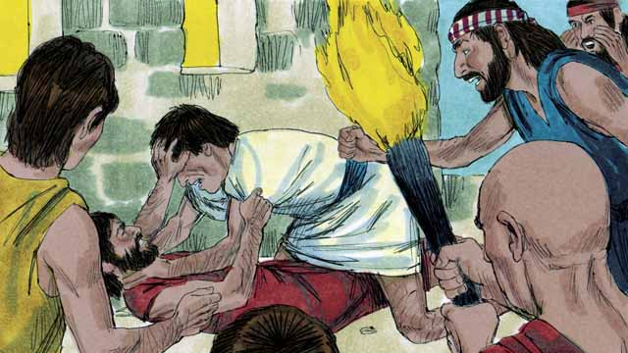

Many years after the flood, there were again many people in the world, and they still sinned against God and each other. Because they all spoke the same language, they gathered together and built a city instead of spreading out over the earth as God had commanded.

04-02

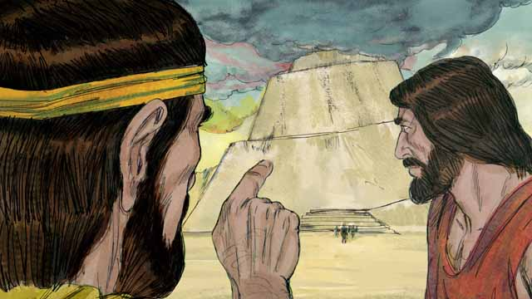

They were very proud, and they did not want to obey God’s commands about how they should live. They even began building a tall tower that would reach heaven. God saw that, if they all kept working together to do evil, they could do many more sinful things.

04-03

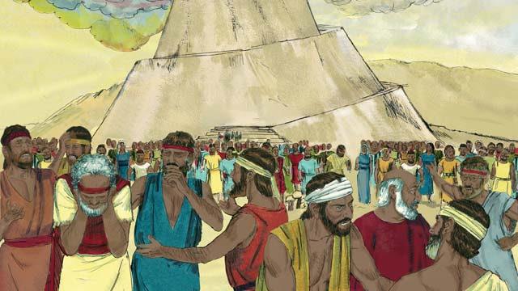

So God changed their language into many different languages and spread the people out all over the world. The city they had begun to build was called Babel, which means “confused.”

04-04

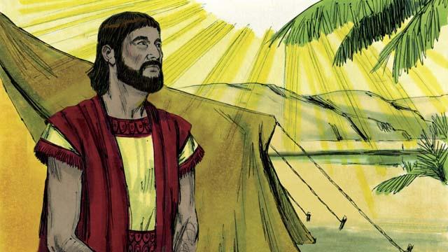

Hundreds of years later, God spoke to a man named Abram. God told him, “Leave your country and family and go to the land I will show you. I will bless you and make you a great nation. I will make your name great. I will bless those who bless you and curse those who curse you. All families on earth will be blessed because of you.”

04-05

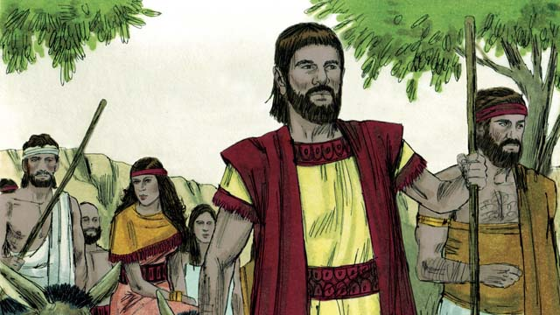

So Abram obeyed God. He took his wife, Sarai, together with all of his servants and everything he owned and went to the land God showed him, the land of Canaan.

04-06

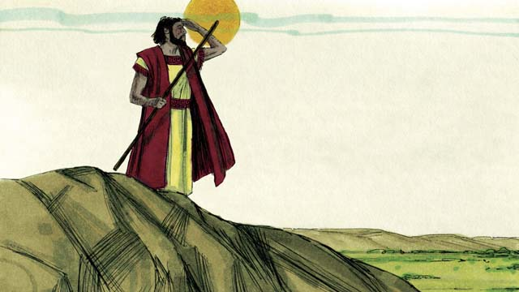

When Abram arrived in Canaan, God said, “Look all around you. I will give to you all this land, and your descendants will always possess it.” Then Abram settled in the land.

04-07

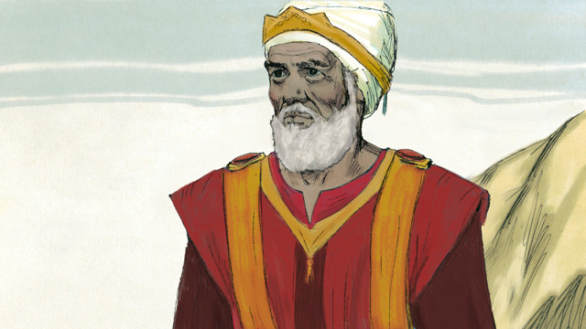

There was a man named Melchizedek who was a priest of God Most High. One day, after Abram had been in a battle, he and Abram met. Melchizedek blessed Abram and said, “May God Most High who owns heaven and earth bless Abram.” Then Abram gave Melchizedek a tenth of everything he had won in the battle.

04-08

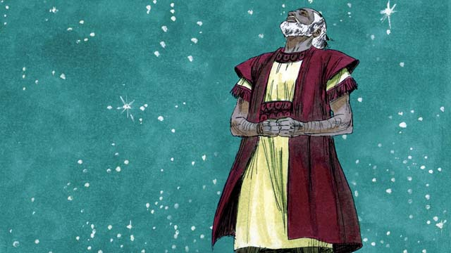

Many years went by, but Abram and Sarai still did not have a son. God spoke to Abram and promised again that he would have a son and as many descendants as the stars in the sky. Abram believed God’s promise. God declared that Abram was righteous because he believed in God’s promise.

04-09

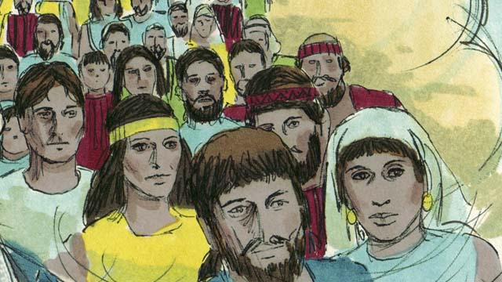

Then God made a covenant with Abram. Normally, a covenant is an agreement between two parties to do things for each other. But in this case, God made a promise to Abram while Abram was in a deep sleep, but he could still hear God. God said, “I will give you a son from your own body. I give the land of Canaan to your descendants.” But Abram still did not have a son.

*A Bible story from: Genesis 11-15*

## 1 Community Study: One Body, Many Members—Enjoying God’s Design of Christian Community

* **Key Idea**: celebrating the unity and diversity of God’s people
* **Key Passage**: 1 Corinthians 12:12-27
* **Main Session**: OBS 4 (Covenant with Abraham)

### 1.1 Recite the Creedal Verse (3–5 minutes)

The verse below summarizes the teaching of the current passage. Read the verse out loud as a community. Read it again several times as a group until the whole community can recite it from memory.

Then if you are Christ’s, you are Abraham’s descendants, and heirs according to promise. Galatians 3:29

### 1.2 Read the Passage (5 minutes)

God forms believers into a community called the church. The church is like a person: one body made up of many parts. God wants his people to be unified and united (to function as one) and celebrate the diversity and uniqueness of individual members (who use their unique giftedness for the good of the community). In order to understand God’s design of Christian community, read the passage below.

12 For as the body is one and has many members and all are members of the same body, so it is with Christ. 13 For by one Spirit we were all baptized into one body, whether Jews or Greeks, whether bound or free, and all were made to drink of one Spirit. 14 For the body is not a single member, but many. 15 If the foot says, “Since I am not the hand, I am not part of the body,” it is not any less a part of the body. 16 And if the ear says, “Because I am not an eye, I am not part of the body,” it is not any less a part of the body. 17 If the whole body were an eye, where would the sense of hearing be? If the whole body were an ear, where would the sense of smell be? 18 But God arranged each part of the body as he designed it. 19 If they were all the same member, where would the body be? 20 So now they are many members, but only one body. 21 The eye cannot say to the hand, “I have no need of you.” Nor does the head say to the feet, “I have no need of you.” 22 But the members of the body that appear to be weaker are essential, 23 and the parts of the body that we think are less honorable, we give them greater honor, and our unpresentable members have more dignity. 24 Now our presentable members have no need to be treated with dignity, for they already have dignity. But God has joined all the members together, and he gave more honor to those that lacked it. 25 He did this so there may be no division within the body, but that the members should care for one another with the same affection. 26 So when one member suffers, all the members suffer together; or when one member is honored, all the members rejoice together. 27 Now you are the body of Christ and individually members of it. 1 Corinthians 12:12-27

### 1.3 Explore the Idea (10–15 minutes)

The above passage introduces us to God’s design for Christian community. Use the following questions to learn what it means for your group to function like one body made up of many members.

1. How does this passage describe what it means to be a part of the church community?
2. What are some challenges of being a part of a community that acts as one body and is made up of different individual members?
3. How can a Christian community encourage the unity of the whole group and also celebrate the unique giftedness of diverse members?
4. What are ways your community can realize God’s vision for being one body made up of many parts?

### 1.4 Envision the Community (5–10 minutes)

Think about what it would look like for your community to remain unified and also celebrate the uniqueness of each member. Imagine what the fruit might be to work in such a God-honoring community.

By God’s help, if our community acts as one body with many members, then the result would be…

### 1.5 Pray to God (5 minutes)

Christians can only enjoy the unity and diversity of Christian community with God’s help. It is not possible to maintain Christian community in our own human strength. Spend time praying as a community that God would help you realize the vision of the above passage and work together as a body.

### 1.6 Sing a Song (3–5 minutes)

Reflect on what it means to be a Christian community. Sing a song that celebrates God’s work in forming God’s people together as a unified body.

## 2 Biblical Interpretation: Observing the Details of the Story

After reading the crafted biblical story, answer the following questions to familiarize yourself with the details of the story.

### 2.1 Observation Questions

Answer the following observation questions to gain a basic understanding of the the story. Read the story as a community and answer these questions as a group.

#### 04-01

After the flood, did people follow God’s commands?  
No. People continued to sin.

How many different languages were there in the world at that time?  
There was only one language.

Instead of spreading out over the earth, what did humans do?  
Humans gathered together and built a city instead of spreading over the earth.

#### 04-02

Why did people not follow God’s commands?  
People were proud and did not want to follow how God told them to live.

What did the people work together to do instead of spreading out over the earth?  
They started to build a tall tower that would reach heaven.

What did God think of the tower humans were building?  
God thought building the tower was evil and if they kept working together they would do even more sinful things.

#### 04-03

What did God do to cause the people to spread out all over the world?  
He changed their language into many different languages.

What was the name of the city that they were building?  
It was named Babel.

What does the name Babel mean?  
It means ‘confused.’

#### 04-04

What did God tell Abram to do?  
God told Abram to leave his country and family and go to another land.

What did God promise to do for Abram?  
He promised to give Abram all the land he could see, to make his name great, to make his descendants a great nation, and to bless all the families on earth through him.

#### 04-05

How did Abram respond to God’s command?  
Abram obeyed God.

To which land did Abram go?  
He went to the land of Canaan.

#### 04-06

What promise did God make to Abram about Canaan?  
God would give it to Abram and his descendants would always possess it.

Where did Abram settle?  
Abram settled in the land of Canaan.

#### 04-07

Who was Melchizedek?  
He was the priest of God Most High.

When did Abram and Melchizedek meet?  
They met one day after Abram had been in battle.

What did Melchizedek do for Abram?  
He blessed Abram.

What did Abram give to Melchizedek?  
He gave him a tenth of all he owned.

#### 04-08

What did God promise Abram after he had lived in Canaan for many years?  
Abram would have a son and as many descendants as the stars in the sky.

What did Abram think of God’s promise?  
Abram believed God’s promise.

Why did God say Abram was righteous?  
He said this because Abram believed God’s promise.

#### 04-09

How did God make his promise to Abram?  
God made a covenant with Abram.

What is a covenant?  
A covenant is an agreement between two parties.

When did God make his covenant with Abram?  
God made a covenant with Abram while Abram was in a deep sleep.

What did God promise to Abram in this covenant?  
God promised he would give Abram a son, many descendants, and the land of Canaan.

### 2.2 Translation Questions

Use the following translation questions to understand specific details of the passage. Discuss how you might translate these specific elements of the story.

#### 04-01

**the same language** At this time, there was only one language, so they could all understand each other. How would you express **the same language** to mean all people spoke one language and could communicate with each other?

  

**gathered together** The people at this time came together and stayed close to one another. God commanded humans to spread out over the earth. How would you phrase **gathered together** to mean people came together into one area?

  

**a city** A city is a place where a lot of people live and work close together. It is a large town. What words in your language mean **a city** as in place where many people live and work in a similar area?

  

#### 04-02

**very proud** The people thought very highly about themselves. A proud person often does not admit his own faults and thinks he is better than others. He is not humble. How would you translate **very proud** to mean the people thought very highly of themselves and considered themselves to be very great?

  

**a tall tower that would reach heaven** This structure was so tall that its top would be in the sky. How would you express **a tall tower that would reach heaven** to mean a tall building that would be as high as the sky?

  

#### 04-03

**changed their language** In an instant, God miraculously gave them different languages to speak so that, suddenly, they were no longer able to understand each other. How would you express **changed their language** to mean God made the people speak in different languages?

  

**spread the people** When God changed their languages, he caused these groups of people to scatter out on the earth. Each group moved to its own area. How would you express **spread the people** to mean God caused the people to move and live in different places?

  

**confused** The name of the city was called Babel. This word in Hebrew sounds like the word for **confused**. To be **confused** means to be unable to understand what someone is saying. When God changed the languages of the people, they were unable to understand each other. What words in your language mean **confused** as in to mixed-up or unable to understand?

  

#### 04-04

**bless** To **bless** someone or something means to cause good and beneficial things to happen to the person or thing that is being **bless**ed. When God **bless**es someone, they prosper. How words in your language mean **bless** as in to cause good and beneficial things to happen?

  

**make you a great nation** God would cause Abram to have many descendants, and they would become a large and important nation or country. How would you express a great nation to mean God would cause Abram’s descendants to be a large and important people or country?

  

**will make your name great** This means that God would cause Abram to have a good reputation and be known by many people in the world. How would you translate **will make your name great** to mean God would cause Abram and his family to be well-known throughout the world and people would think well of them?

  

#### 04-05

**obeyed** To obey means to follow someone’s commands. Abram did what God told him to. What words in your language me **obeyed** as in to follow the orders or instructions of someone else?

  

**God showed him** Somehow God made it clear to Abram where he was to go. The text doesn’t tell how **God showed him**. How would you express **God showed him** to mean that God made it clear and obvious where Abram should go?

  

#### 04-06

**possess** To **possess** the land means to own the land and dwell in it. God promised to give the land to Abram and also to his descendants. He promised they would own it and dwell in it forever. How would you express **possess** to mean that they would own the land of Canaan as a place to live?

  

**settled** Abram and his family lived in the land of Canaan. To settle means to stay in a place where one lives. What words in your language mean **settled** as in to live in a place by dwelling there?

  

#### 04-07

**priest** A **priest** is someone God has chosen to offer sacrifices to God on behalf of God’s people. Priests also offered regular prayers to God on behalf of his people and performed other religious rites. What words in your language would you use for a **priest** as a person God has chosen to offer sacrifices? What does a **priest** do in your culture? How similar is this term to the biblical idea of a **priest**?

  

**God Most High** The people of Canaan worshiped many false gods. The title Most High God explains that the God that Melchizedek worshiped was far superior to all of them, and was the same God that Abram worshiped. How would you express **God Most High** to mean the one and only supreme God who is superior to all?

  

#### 04-08

**promised** To promise means to say something that is guaranteed to happen. God gave an oath that he would never destroy the earth with a flood again. How would you translate **promised** to mean God said something that he guaranteed would happen?

  

**as the stars in the sky** This expression means that Abram’s descendants will be so many that no one can count them all. How would you express **as the stars in the sky** to mean Abram’s descendants would be so many that they could not be counted?

  

**believed** To believe means to accept or trust that it is true. What words in your language mean **believed** as in to trust or accept that something is true?

  

**God declared that** Abram was righteous God said that Abram was right and acceptable to God. This did not mean that Abram was sinless. Instead, it means that God said that Abram was upright because he believed in God. How would you express **God declared that** Abram was righteous to mean that God said that Abram was upright and acceptable to God?

  

#### 04-09

**covenant** God had already said he would give Canaan to Abram’s descendants (cf. 04:06). Now God stated the same thing again to Abram as an official promise. A **covenant** is a formal agreement between two parties which makes a promise official. What words in your language mean **covenant** as in a formal, binding agreement between two parties that one or both parties must fulfill?

  

**from your own body** With his own body, Abram would cause his wife to become pregnant, so that, together, they would have their own, natural son. This was an amazing promise, since Abram and Sarai were very old. How would you express **from your own body** to mean Abram would have a son of his very own by his wife becoming pregnant?

  

## 3 Theological Dialogue: Discussing the Meaning of the Story

Take time to explore the meaning of this story together as a community. Use the following discussions as a way to grasp what truth the story teaches.

### 3.1 Discourse Questions

Use the following discourse questions to understand the meaning of the story. Pay attention to how the story itself addresses each question or theme.

##### At this point in human history, what were human beings like? (04-01, 04-02, 04-03)

Years after the flood, there were many people on the earth. Noah and his family had many children and grandchildren. (04-01)

  

People still disobeyed God and sinned against each other. God started his creation over with Noah. But humans were still sinful and continued to disobey God. (04-01)

  

All people spoke one language. Instead of spreading out over the earth like God commanded, the people gathered together and built a city. People were more interested honoring themselves than honoring God. (04-01)

  

People were also very proud. They thought they were great and did not need to follow God’s commands. (04-02)

  

Humans tried to show how great they were by building a tower that reached up to heaven. Even though it is not possible to build a tower that reaches heaven, humans were so proud that they thought they could be as great as God. (04-02)

  

As long as humans were gathered together, they would do more and more evil. When humans don’t follow God’s commands, it also encourages others to not follow his commands. (04-02)

  

God was not pleased with people. He changed the languages of people so they could not understand each other and spread out over the earth. The place where this happened was called Babel. This means confused. The proud acts of people failed and brought confusion. (04-03)

  

##### How did God plan to restore his world? What promises did God give to Abram? (04-04, 04-05, 04-06, 04-08)

God made a promise to a man named Abram. His promise to Abram would be a way of blessing the world. (04-04)

  

God promised that he would give Abram the land of Canaan. God would lead Abram to this land. (04-04, 04-05, 04-06)

  

God promised that Abram would have a son. Through this son Abram would have many descendants. His descendants would become as many as the stars in the sky. (04-04, 04-08)

  

God promised that Abram would become become a great nation and have a great name/honor. Instead of people making themselves great like the humans did at Babel, only God can make people great. (04-04)

  

God promised to bless Abram. God also promised that he would bless the whole world because of Abram. (04-04)

  

##### How did Abram respond to God’s promise? (04-04, 04-05, 04-06, 04-07, 04-08, 04-09)

God told Abram to leave his country and family and travel to another land. Abram trusted God and obeyed his command. He left his land, traveled to Canaan, and settled there. (04-04, 04-05, 04-06)

  

God gave Abram victory in battle. Abram gave Melchizedek a tenth of what he won in battle. Abram learned that all that he had came from God. He responded by generously giving a gift to Melchizedek. (04-07)

  

God promised Abram that he would give him a son. Abraham believed God’s promise and God saw him as righteous. (04-08)

  

God made a covenant with Abram as a way of showing that his promise would come true. God made this covenant while Abram was in a deep sleep. God does not depend upon humans to fulfill his promises. (04-09)

  

### 3.2 Theological Questions

Answer the following theology questions as a community. Discuss what truths this story teaches.

1. How are humans sinful and disobedient of God? What are ways this story shows us ways in which people are sinful?
2. How much can we trust God’s promises? What kinds of promises does God give in this story that teaches us about God’s promises?
3. What does it mean to believe (or trust) in God’s promises? What does Abram teach us about the nature of faith?

### 3.3 Translation Draft

Work as a translation team to draft each panel of this story. Pay attention to any specific translation issues that are challenging or significant.

#### Make Translation Draft

Make a draft for each section of this story.

#### Discuss and Revise

After drafting the story, discuss any translation issues that you think need special explanation.

#### Drafting Summary Reflection

Summarize any noteworthy translation decisions and the rationale/reasoning behind these translation decisions. In the final movement of this class, you will use these observations to give an account (i.e., chronicle/narrate) of how your translation improved through the checking process.

## 4 Personal Reflection: Following the Teaching of the Story

Take a moment to allow this story to evaluate your own life and to consider how God would have you respond. After this reflection, use the quality checking questions to check your translation draft among the translation team.

### 4.1 Journal Reflection

Prayerfully think about the following personal reflection questions. Write/Record your answers and/or discuss them as a group.

1. How can you see pride and disobedience in your own life?
2. How hard do you think it would be to follow God’s command to Abram? Why is it hard to trust God’s promises?
3. Have you put your trust in God’s promises? How do you know?

### 4.2 Team Check

*The following activity will help you check the clarity, accuracy, and naturalness of your draft. Read the passage aloud and discuss the checking questions with other members of your translation community. You might need to reread portions (or the whole) of the biblical passage multiple times as you answer each of these questions. Record answers to these questions below.*

#### Team Checking Questions

*Use the following questions to check your translation draft for accuracy, clarity, and naturalness.*

1. **Accurate**: Has anything been **added** to your translation of this passage that is not a part of the meaning of the source text? *If additions exist, are they included only added to clarify meaning (such as implied information)?*
2. **Accurate**: Is anything **missing** from your translation of this passage that is a part of the meaning of the source text? *If some part of the meaning is missing from your translation, add it.*
3. **Accurate**: Does any meaning in your translation of this passage appear to be **different** than the meaning of the source text? *If the meaning is different, try changing your translation so that the meaning remains the same.*
4. **Natural**: Does anything sound **unnatural** to how you would say it in your language? *If portions of the passage sound unnatural in your language, try to make them sound the way you would say it in your language while staying true to the meaning of the source text.*
5. **Clear**: Is anything **unclear** or **confusing** in your translation that confuses the meaning of the source text? *If portions of the passage are unclear or confusing, revise them to clearly communicate the meaning of the source text.*
6. **Consistent**: How **consistent** is your translation within the passage and with other passages? *If portions of the passage need to be made consistent or if you need to revise translations of other passages, make these adjustments.*

#### Record Feedback

*After discussing the checking questions above as a translation community, record any feedback on your translation draft. Pay attention for parts of your translation that are translated well and parts of your translation that need correction.*

#### Discuss and Revise

*After gathering feedback on your draft, discuss it together with your translation community and make appropriate revisions in your translation.*

#### Record Translation Decisions

*As a community, discuss some of the most noteworthy translation decisions in your draft. Summarize each decision and explain the reasons your community decided on that translation. You should update these decisions each time you check your draft with various groups of people.*

You should **measure** the quality of your translation draft. You can **record translation decisions** to make it clear why you translated things a certain way. Translation decisions can help your translation team and the surrounding community be a part of the translation process.

How can you know the quality of your translation?

1. **Measure** the translation by marks/standards of quality (i.e., clear, accurate, natural, church-approved)
2. **Test** the translation with others and record feedback and conversations from in the field (i.e., church and community check)
3. **Compare** and **contrast** the translation with the source text (i.e., meaning of text and notes) and alternatives (i.e., other translation choices)
4. **Explain** the reasons why you translated a particular portion of the text.

**Example Sentences That Help Explain Your Translation Decision** Use the following example sentences to help explain your translation decisions:

1. The original text literally **says/means**, so we translated the term in this way…
2. We originally decided to translate **the biblical term** with **this term**, but we changed it because…
3. When our translation team discussed **the biblical term**, this is what we talked about…
4. **The term** is [clear, accurate, natural, consistent] because…
5. The community understands **this term** to mean…
6. We considered these other terms. We did not use **these terms** because…
7. When we checked this in the church, we learned…
8. When we checked this in the community, we learned…

**Example of Translation Decision**

In OBS 01-07 we decided to translate **blessed** like this: [actual translation]. We decided on this translation because of these reasons:

1. The word [actual translation] means to cause good things to happen to someone or something. This term is used when a person desires someone or something to prosper or flourish. This term does not refer to magic or witchcraft.
2. When we checked this word with other believers, they said it describes God showing his kindness and favor on someone or something. These are some of the terms that we did not decide to use…
3. Many of our people will understand this word. When we discussed this phrase with the surrounding community, we discovered it was a natural way to describe God causing good and beneficial things to happen.

## 5 Ministry Practice: Serving the Church with the Story

Now that you have a draft of this story, consider how this story can encourage other believers in their faith. After ministering this story to others, you will also perform a community check of your translation draft.

### 5.1 Church Ministry

Reflect on how this story can edify and mature the Christian community. Design a way to minister this story to your church community.

**Ministry Preparation**: Take time to consider how you could minister this story to others. Record some ministry ideas below.

**Ministry Implementation**: Minister this story to a group of believers as you had planned. Use the information in this study to help develop a teaching/lesson or lead a discussion of this story to other believers. Record your ministry plan below.

**Ministry Reflection**: Think about what you learned from ministering this story to other believers. Reflect on your experience below.

### 5.2 Church Community Check

After teaching or ministering this story to the church, check the translation quality with the church community. Record any feedback from your checking experience.

#### Create Checking Questions

You can use **Translation Questions** to check your draft. Each **Translation Question** explains the meaning of a specific part of the story and asks you to consider how you would translate that part of the story in your own language. Change each **Translation Question** into a **Checking Question** by asking the following questions. The first question asks you to identify how each specific phrase was translated into your language. The second question asks people in the church to determine if your translation of the phrase expresses the meaning clearly, accurately, and naturally. Look at the following examples to see how to change **Translation Questions** into **Checking Questions**:

#### Translation Question Example 1

**to proclaim the good news about Jesus** Paul and Silas traveled to Philippi for the purpose of preaching the gospel. The gospel is the good news that Jesus saves people from their sins if they will believe in Jesus. How would you express **to proclaim the good news about Jesus** to mean to tell other people the message about how Jesus can save people from their sins?

#### Translation Question Example 2

**a merchant** Paul and Silas met a woman named Lydia at the place by the river. She owned a business and sold items to make money. How would you express **a merchant** to mean a business owner who sells items for a profit?

#### Translation Question Example 3

**so Paul and Silas baptized them** The jailer and his whole family followed Paul’s instructions. They believed in Jesus. The result of this was Paul and Silas baptized them. How would you express **so Paul and Silas baptized them** to mean the result of the jailer and his family believing in Jesus that Paul and Silas baptized all of them?

You can change these into **Checking Questions** like this:

#### Checking Question Example 1

**to proclaim the good news about Jesus** How did you translate **to proclaim the good news about Jesus**? Does it mean to tell other people the message about how Jesus can save people from their sins?

#### Checking Question Example 2

**a merchant** How did you translate **a merchant**? Does it mean a business owner who sells items for a profit?

#### Checking Question Example 3

**so Paul and Silas baptized them** How did you translate **so Paul and Silas baptized them**? Does it mean the result of the jailer and his family believing in Jesus that Paul and Silas baptized all of them?

#### Record Feedback

*Discuss the* ***Checking Questions*** *with your church community, and record any feedback on your translation draft. Pay attention to parts of your translation that are translated well and parts of your translation that need correction.*

#### Discuss and Revise

*After gathering feedback on your draft, discuss it together with your translation community and make appropriate revisions to your translation.*

#### Record Translation Decisions

*Update your translation decisions and record any new and noteworthy observations on the quality of your draft.

## 6 Missional Outreach: Sharing the Truth of the Story

*After sharing this story with others, check the translation quality with the wider language community. Record any feedback from your checking experience.*

### 6.1 Mission Engagement

*Consider how you will witness this story to unbelievers. Design a way to share this story and engage them in what it teaches about Christianity and the gospel.*

**Witness Preparation**: Take time to consider how you will witness this narrative to unbelievers. Record some ideas below.

**Witness Implementation**: Share this story with an unbeliever. Use the information in this study to help develop a teaching/lesson or lead a discussion of this story to other believers. Record your ministry plan below.

**Witness Reflection**: Think about what you learned from ministering this story to unbelievers. Reflect on your experience below.

### 6.2 Sociolinguistic Check

After sharing this story with the language community, check your translation draft with the surrounding community. Record your observations.

#### Checking Approach

After witnessing this story to unbelievers, use one of the following methods to check the translation of this story. Consider using the **Observation Questions** to check your translation draft or come up with your own quality checking questions.

**Read-Retell Check:** Read your draft to those the community and ask them to retell the passage. Be attentive to any portions of the passage that are unclear, unnatural, or inaccurate.

**Comprehension Questions Checklist:** Read the draft of the passage and ask a list of comprehension questions to make sure the passage is being rightly understood. You can use the **Observation Questions** in this guide or come up with your own questions. Then, record any insights or issues that arise.

**Discussion Group:** Develop key questions to ask about the passage (both formational and translational). Read the passage and have a group discussion about the passage, paying attention to issues that need to be addressed, edited, and revised.

#### Record Feedback

*After sharing your draft with the language community, discuss the* ***Observations Questions****, and record any feedback on your translation draft. Pay attention to parts of your translation that are translated well and parts of your translation that need correction.*

#### Discuss and Revise

*After gathering feedback on your draft, discuss it together with your translation community and make appropriate revisions to your translation.*

#### Record Translation Decisions

*Update your translation decisions and record and new any noteworthy observations on the quality of your draft.

## 7 Conclusion

As a translation community, take time to reflect on all that was learned in studying, drafting, and checking this story. Celebrate all that God has taught you as a community. Then, submit your revised draft and checking summaries to network leaders for further review.