Open Bible Stories

Jesus Is Crucified

## 0 Introduction

### 0.1 Key Idea

The story Jesus being crucified teaches us Jesus died on the cross as a sacrifice to be punished for the sin of people so that God would not punish people who believe in Jesus.

### 0.2 Creedal Verse

“For Christ also suffered once for sins, the righteous for the unrighteous, that he might bring us to God, being put to death in the flesh but made alive in the spirit.” 1 Peter 3:18

### 0.3 Metanarrative Summary

The eternal God created all things in six days. He made a good and perfect world. He made humans in his image to fill the earth and rule over creation. But humans rebelled against God and ruined God’s creation. God set to restore his world through his promise. God made a covenant with Abraham. He promised to bless all nations through Abraham. God kept his promises across the generations. God provided Abraham with a promised child, Isaac. God gave Isaac a wife and she bore twins, Jacob and Esau. God blessed Jacob and his sons, and the blessing continued to the next generation. God rescued Joseph, one of Jacob’s sons, and used him to rescue his family. God caused his people, the Israelites, to multiply in the land of Egypt; eventually, they became slaves. But, God raised up a deliverer, Moses, to deliver his people from their slavery. God judged the Egyptians with harsh plagues; in the final judgment, he passed over his people who covered their doorposts with the blood of a sacrificed lamb. Then, God delivered the Israelites by bringing them out of Egypt and crossing the Red Sea on dry land. God made a covenant with the Israelites and made them his people. God tested Israel in a series of wilderness wanderings and eventually brought his people into the promised land of Canaan. God raised up deliverers to lead Israel and rescue them from their enemies. God formed Israel into a kingdom. He made a covenant with King David and promised to send a king that would rule his people forever. Many of Israel’s kings were evil and the kingdom of Israel divided into two kingdoms. God sent prophets to warn his people of God’s judgment and call them to repent. When Israel did not repent, God sent his people into exile. After many years, he brought them back to the land. Throughout the Old Testament, God promised to send his Messiah to deliver his people form their sin. After many years, the prophet John was born. He would prepare people for the coming Messiah. At the perfect time, God sent his Son, Jesus, to be born of a virgin Mary. When John and Jesus grew up, John baptized Jesus as a sign that Jesus was God’s beloved Son. Jesus endured all manner of temptation without ever sinning. When he was thirty years old, he launched a public ministry of preaching, teaching, and healing. He taught his disciples about the life of compassion, sacrifice, and forgiveness. He performed many miracles: he fed a crowd of five thousand, he walked on water, he healed the sick, and he cast out demons. He proclaimed to people the nature of real faith, God’s kingdom, and the how fallen humans can be restored in relationship with God. Toward the end of his ministry, Jesus revealed his power and glory to his disciples and raised a dead man to life Jesus was betrayed by one of his disciples and put on trial before a Roman governor Jesus was sentenced to death and crucified on a cross

### 0.4 Open Bible Story: Jesus Is Crucified

40-01

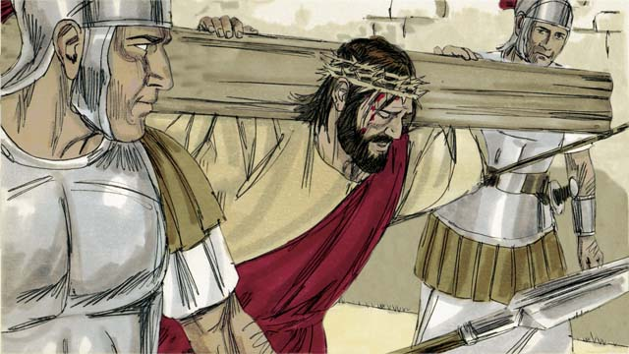

After the soldiers mocked Jesus, they led him away to crucify him. They made him carry the cross on which he would die.

40-02

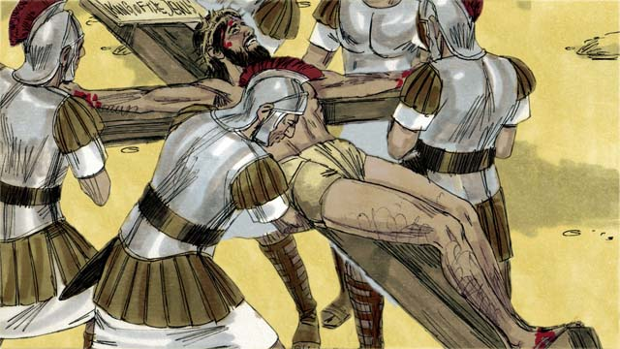

The soldiers brought Jesus to a place called ‘the Skull’ and nailed his hands and feet to the cross. But Jesus said, “Father, forgive them, because they do not know what they are doing.” They also put a sign on the cross above his head. It said, “King of the Jews.” This is what Pilate had told them to write.

40-03

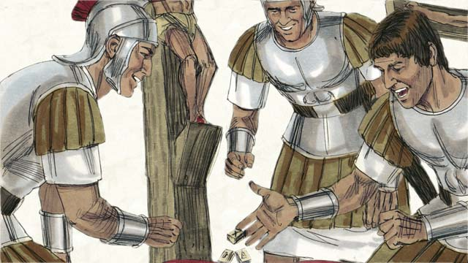

Then the soldiers gambled for Jesus’ clothing. When they did this, they fulfilled a prophecy that said, “They divided my garments among them, and gambled for my clothing.”

40-04

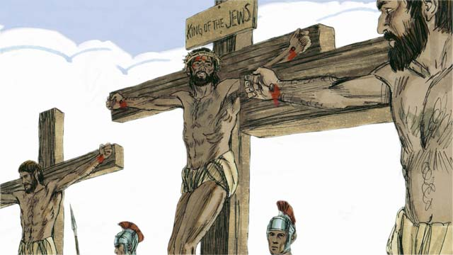

There were also two robbers whom the soldiers crucified at the same time, putting them on either side of Jesus. One of the robbers mocked Jesus, but the other said to him, “Do you not fear that God will punish you? We are guilty of doing many bad things, but this man is innocent.” Then he said to Jesus, “Please remember me when you become king in your kingdom.” Jesus answered him, “Today you will be with me in Paradise.”

40-05

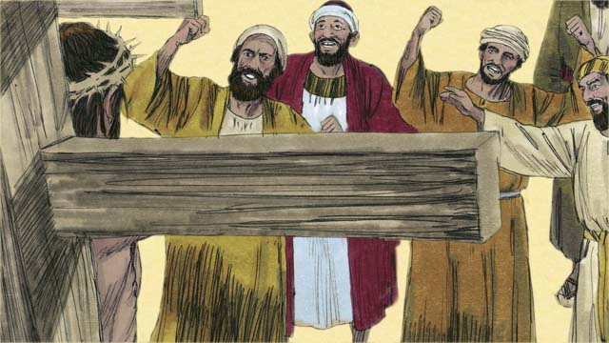

The Jewish leaders and the other people in the crowd mocked Jesus. They said to him, “If you are the Son of God, come down from the cross and save yourself! Then we will believe you.”

40-06

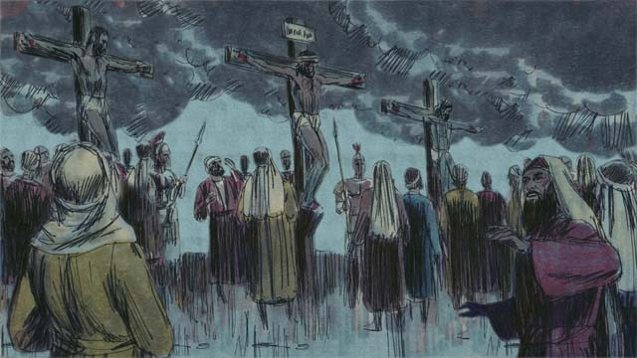

Then the sky over the whole region became completely dark, even though it was the middle of the day. It became dark at noon and stayed dark for three hours.

40-07

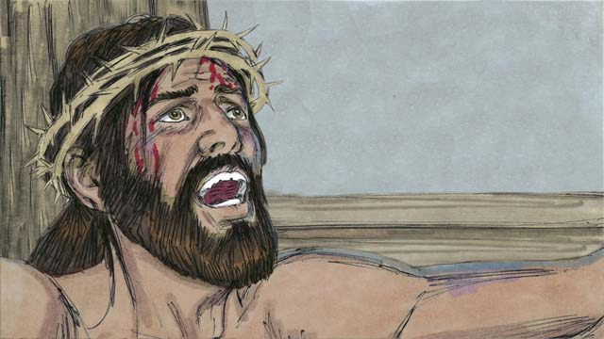

Then Jesus cried out, “It is finished! Father, I am giving my spirit into your hands.” Then he bowed his head and gave up his spirit. When he died, there was an earthquake. In the Temple, the large curtain that separated the people from the presence of God was torn in two from the top to the bottom.

40-08

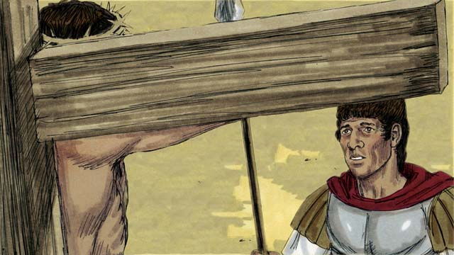

Through his death, Jesus opened the way for people to come to God. When a soldier guarding Jesus saw everything that had happened, he said, “Certainly, this man was innocent. He was the Son of God.”

40-09

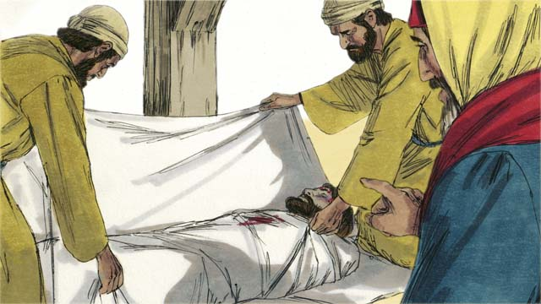

Then two Jewish leaders named Joseph and Nicodemus came and asked Pilate for Jesus’ body. They believed that Jesus was the Messiah. They wrapped his body in cloth, took it to a tomb cut out of rock and placed it inside. Then they rolled a large stone in front of the tomb to block the opening.

*A Bible story from: Matthew 27:27-61; Mark 15:16-47; Luke 23:26-56; John 19:17-42*

## 1 Community Study: Genuine Trust—Cultivating Security in Personal Relationships

* **Key Idea**: establishing a community where people can be open and honest
* **Key Passage**: Psalm 28:7-9
* **Main Session**: OBS 40 (Jesus Is Crucified)

### 1.1 Recite the Creedal Verse (3–5 minutes)

The verse below summarizes the teaching of the current passage. Read the verse out loud as a community. Read it again several times as a group until the whole community can recite it from memory.

18 Christ also suffered once for sins. He who is righteous suffered for us, who were unrighteous, so that he would bring us to God. 1 Peter 3:18

OR

24 He himself carried our sins in his body to the tree, so that we would have no more part in sin, and so that we would live for righteousness. By his bruises you have been healed. 1 Peter 2:24

### 1.2 Think about Trust (5–10 minutes)

God wants people to trust Jesus. Jesus experienced much suffering and painfully died on the cross. God saves people when they trust in Jesus. Describe what you think it means to trust in Jesus.

To trust in Jesus means…

I can trust Jesus because…

### 1.3 Read the Passage (3–5 minutes)

God is completely trustworthy. We learn to trust others as we grow in our trust in God. Read the passage below to learn about what God says about trust and protection.

7 Yahweh is my strength and my shield; my heart trusts in him, and I am helped. Therefore my heart greatly rejoices, and I will praise him with singing. 8 Yahweh is the strength of his people, and he is the saving refuge of his anointed one. 9 Save your people and bless your inheritance. Be their shepherd and carry them forever. Psalm 28:7-9

### 1.4 Discuss the Passage (10-15 minutes)

God provides protection and safety for his people. God’s people are the community of believers who trust in God. As a community, use the following questions to discuss the teaching of the biblical passage.

1. How does this passage instruct us to trust in God? What are the benefits and blessings of trusting in God?
2. How does this passage describe God’s protection of his people? What metaphors (figures of speech) are used to describe the way God keeps his people safe?
3. How does our trust in God help us be able to trust other people? What are some challenges that make it hard to trust one another?
4. Why is it important for your community to develop a deep trust in God and healthy trust in one another?

### 1.5 Describe Trust in God (5 minutes)

Think about what it means to trust other people. Discuss what it would look like if your community was a community that trusted one another.

If our community was a community of trust, it would be like this…

### 1.6 Pray to God (5 minutes)

Pray that God would help your community be a community of trust. After each person prays, have the whole group pray the Scripture passage together.

Gracious God, make our community a community of trust…

Pray Together: Those who trust in Yahweh are like Mount Zion, unshakable, forever enduring. Psalm 125:1

### 1.7 Sing a Song (3–5 minutes)

Choose a song that celebrates God’s faithfulness. Sing this song together as a community.

## 2 Biblical Interpretation: Observing the Details of the Story

After reading the crafted biblical story, answer the following questions to familiarize yourself with the details of the story.

### 2.1 Observation Questions

Answer the following observation questions to gain a basic understanding of the the story. Read the story as a community and answer these questions as a group.

#### 40-01

After the soldiers mocked Jesus, what were they going to do to him?  
The soldiers led Jesus away to crucify him.

When the soldiers led Jesus away to crucify him, what did they make him carry?  
They made him carry the cross on which he would die.

#### 40-02

What was the name of the place where Jesus was crucified?  
It was called ‘the Skull.’

How did the soldiers attach Jesus to the cross?  
They nailed his hands and feet to the cross.

What did Jesus pray concerning the people who were crucifying him?  
He prayed, “Father, forgive them, because they do not know what they are doing.”

What was written on the sign above Jesus’ head?  
The sign said, “King of the Jews.”

Who told them to write this on the sign?  
Pilate told them to write “King of the Jews” on the sign.

#### 40-03

How did the soldiers divide up Jesus’ clothes?  
They gambled for his clothing as had been prophesied.

What did the prophecy say?  
The prophecy said that they would divide up his garments and gamble for his clothing.

#### 40-04

Who else was crucified at the same time with Jesus?  
Two robbers were crucified at the same time on either side of Jesus.

What did the robber who did not mock Jesus ask him to do?  
He asked Jesus to remember him in his kingdom.

What did the other robber ask the robber who mocked Jesus?  
The one robber asked robber who mocked Jesus whether he feared God who would punish him.

What did that robber say about Jesus and the guilt of the robbers?  
The robber who did not mock Jesus said that Jesus was innocent while both robbers did many bad things.

What did that robber ask Jesus?  
He asked Jesus to remember him when he became king in his kingdom.

What was Jesus’ answer to the request of the robber?  
Jesus said, “Today, you will be with me in Paradise.”

#### 40-05

How did the Jewish leaders and people treat Jesus?  
The Jewish leaders and people in the crowd mocked Jesus.

What did the crowd want Jesus to do to prove that he was the Son of God?  
They told him to come down from the cross and save himself.

#### 40-06

What unusual thing happened in the sky in the middle of the day?  
It became completely dark at noon and stayed dark for three hours.

#### 40-07

What were the last words Jesus cried out from the cross?  
Jesus cried out, “It is finished! Father, I give my spirit into your hands.”

What happened after Jesus committed himself to God the Father?  
Jesus bowed his head and gave up his spirit.

What miraculous things happened immediately after Jesus died?  
There was an earthquake and the large curtain in the Temple was torn in two, from top to bottom.

#### 40-08

What did Jesus accomplish through his death?  
Jesus opened the way for people to come to God.

How did the soldier guarding Jesus respond?  
A solider guarding Jesus saw what happened and said that Jesus was innocent and the Son of God.

#### 40-09

Who asked Pilate for Jesus’ body?  
Two Jewish leaders named Joseph and Nicodemus asked for his body.

Who did Joseph and Nicodemus think Jesus was?  
Joseph and Nicodemus believed Jesus was the Messiah.

What did they do with the body?  
They wrapped the body in cloth and placed it in a tomb cut out of rock, and then rolled a large stone in front of the tomb.

### 2.2 Translation Questions

Use the following translation questions to understand specific details of the passage. Discuss how you might translate these specific elements of the story.

#### 40-01

**led him away** The soldiers took Jesus away as one would take a prisoner away to a sentence. How would you express **led him away** to mean forced him to go with them as a prisoner?

  

**to crucify him** Crucifixion was a common way the Romans punished criminals. They would execute people by nailing or binding the person to a wooden beam or cross. How would you express **to crucify him** to mean to kill him on a cross?

  

#### 40-02

**a place called ‘the Skull’** The place where the soldiers crucified Jesus was called the Skull. This is a small escarpment near Jerusalem with a rocky, white face which looks somewhat like a skull. How would you express **a place called ‘the Skull’** to mean a place that people called ‘the Skull’?

  

**forgive them, because they do not know what they are doing** Jesus prayed to God the Father that he would not punish them for their sin because they did not really understand who they were crucifying. The soldiers thought Jesus was only a criminal who deserved to die. They did not understand that he was the Son of God. How would you express **forgive them, because they do not know what they are doing** to mean they do not understand the meaning of what they are doing, so please forgive them?

  

#### 40-03

**the soldiers gambled for Jesus’ clothing** The soldiers played a game of betting to win Jesus’ clothes. We do not know how they did this, but they could have tossed stones on the ground to win Jesus’ clothing or chosen sticks to decide who could take Jesus’ clothes. The winner received his clothing. How would you express **the soldiers gambled for Jesus’ clothing** to mean the soldiers played a game of chance to win Jesus’ clothes?

  

**they fulfilled a prophecy that said** The prophets predicted long ago that people would gamble for Jesus’ clothing. How would you express **they fulfilled a prophecy that said** to mean the soldiers did what the scriptures had long ago predicted would happen to the Messiah?

  

#### 40-04

**two robbers** These two criminals were guilty of using force or violence to steal things. How would you express **two robbers** to mean two bandits who were guilty of taking things that did not belong to them?

  

**Do you not fear that God will punish you?** The robber does not expect an answer to this question; it is a way to make a strong statement to tell the other robber that he should fear God. How would you express **Do you not fear that God will punish you?** as a question means you should fear God who will judge you for the crimes you have committed and wrongs you have done?

  

**We are guilty of doing many bad things, but this man is innocent** The robber admitted that the two robbers had committed crimes but Jesus was not guilty of any crime. The robbers deserved to die for their crimes but Jesus did not do anything wrong to deserve to die. How would you express **We are guilty of doing many bad things, but this man is innocent** to mean the two robbers did evil things and deserved to die, but this man, Jesus, had done nothing wrong and did not deserve to die?

  

**Please remember me** The robber asked Jesus to allow him to be with Jesus. Remember here does not mean to recall something after forgetting it. The robber is making a humble request that Jesus would give him access to God’s kingdom. How would you express **Please remember me** as a humble request that Jesus would accept him and welcome him into his kingdom?

  

**in your kingdom** The robber asked Jesus to welcome him to be with him at the time Jesus became king and established his kingdom. How would you express **in your kingdom** to mean the time when Jesus establishes his kingdom and rules as king?

  

**Today you will be with me in Paradise** Jesus told the robber that he would be with Jesus that very day. They both would die and spirit of the robber would be with Jesus in heaven because he believed and trusted Jesus. How would you express **Today you will be with me in Paradise** to mean the robber’s spirit would be with Jesus in heaven that very day after he died?

  

#### 40-05

**If you are the Son of God, come down from the cross and save yourself!** Jesus is really the Son of God. He also has all power. Jesus allowed people to crucify him on the cross. The people mocking Jesus did not believe this. They were trying to mock Jesus because they expected the Son of God to not be mistreated and crucified like what was happening to Jesus. They did not believe Jesus was the Son of God. They also did not understand why Jesus was dying on the cross. The people were mocking Jesus, but he truly was the Son of God. How would you express **If you are the Son of God, come down from the cross and save yourself!** as a way to mock Jesus by saying that if he really was the Son of God he should come off the cross and rescue himself from death?

  

**Then we will believe you** The people said that they would believe that Jesus is the Messiah if Jesus came off of the cross by his own power. They did not really believe in him. They only said they would believe in Jesus if Jesus performed this act. Jesus was dying on the cross for a reason the people did not believe or understand. How would you express **Then we will believe you** to mean the people would believe Jesus is the Messiah if he showed them his power and came down from the cross?

  

#### 40-06

**even though it was the middle of the day** The sky in that region became dark like it was night time. However, it was the middle of the day. This is a surprising thing to happen in the middle of the day. It was a miracle. How would you express **even though it was the middle of the day** to mean an unexpected thing happened when God caused the sky to turn dark like night but it was the afternoon?

  

#### 40-07

**It is finished!** Jesus said these words right before he died on the cross. He was saying that he accomplished the work that God gave Jesus to do. This means that Jesus’ work of salvation was complete. How would you express **It is finished!** to mean the work of salvation is completed or Jesus accomplished the work of salvation by dying on the cross?

  

**I am giving my spirit into your hands** Jesus gave himself to God’s protection and safekeeping. Jesus trusted God the Father to care for him after death. How would you express **I am giving my spirit into your hands** to mean Jesus entrusted his spirit to God’s care?

  

**bowed his head and gave up his spirit** This is the point when Jesus died. Because his physical body final died, Jesus’ head moved downward and his spirit went to God. These phrases tell that Jesus died. How would you express **bowed his head and gave up his spirit** to mean when Jesus died he lowered his head and released his spirit to God?

  

**In the Temple, the large curtain that separated the people from the presence of God was torn in two** At the time Jesus died, God caused the large curtain in the Temple to be divided into two pieces. This curtain was a large, strong fabric hung in the Temple. It was a thick curtain or hanging fabric that separated one room from another. This curtain separated the people from the most holy place in the temple. When the curtain was torn, the people now had access to God’s presence. How would you expressI **In the Temple, the large curtain that separated the people from the presence of God was torn in two** to mean God tore in two the thick fabric in the Temple that separated the people from his presence?

  

#### 40-08

**Through his death** Jesus accomplished salvation for people by dying on the cross. God restores people to himself by Jesus’ crucifixion. How would you express **Through his death** to mean Jesus made it possible for people to be restored to God by means of his death?

  

**Jesus opened the way for people to come to God** Jesus made it possible for people to know God personally by dying on the cross. Jesus’ death on the cross was a sacrifice that paid for human sin. Jesus was punished for the sin of people instead of humans being punished for their sin. The tearing of the curtain showed that the barrier between God and people had been removed. Only those who believe in Jesus can have forgiveness of their sin. How would you express **Jesus opened the way for people to come to God** to mean Jesus made it possible for people to come near God and know him personally because of his death on the cross?

  

#### 40-09

**asked Pilate for Jesus’ body** Joseph and Nicodemus requested to have Jesus body so they could bury it. How would you express **asked Pilate for Jesus’ body** to mean they asked Pilate to permit them to take Jesus’ body down from the cross so they could bury it?

  

**took it to a tomb cut out of rock and placed it inside** Jesus was buried in a tomb that was cut out of a rock. This opening was covered by a large stone that was rolled in front of the entrance. How would you express **took it to a tomb cut out of rock and placed it inside** to mean they buried Jesus inside a tomb that was made by cutting out an open space in a large rock area?

  

## 3 Theological Dialogue: Discussing the Meaning of the Story

Take time to explore the meaning of this story together as a community. Use the following discussions as a way to grasp what truth the story teaches.

### 3.1 Discourse Questions

Use the following discourse questions to understand the meaning of the story. Pay attention to how the story itself addresses each question or theme.

##### What did Jesus endure in his crucifixion? (40-01, 40-02, 40-03, 40-04, 40-05, 40-07)

Mocking and Shame: The soldiers mocked Jesus. They made him carry the cross upon which he would die. One of the robbers mocked Jesus on the cross. The Jewish leaders and people in the crowd also mocked Jesus. They said that if really was the Son of God that he should save himself by coming down from the cross. Jesus endured shame and humiliation. (40-01, 40-04, 40-05)

  

Physical Pain: The soldiers led Jesus away to be killed on a cross. They nailed his hands and feet to the wooden cross and allowed him to hang there to die. Jesus endured physical pain. (40-01, 40-02)

  

Accusation and Guilt: Pilate told them to write “King of the Jews” on a sign above Jesus’ head. People did not believe Jesus was the King of the Jews. This sign mocked Jesus and accused him of speaking wrongly about himself. People accused Jesus of wrongdoing. The irony of this sign is that Jesus is actually the King of the Jews. Jesus was innocent and was killed for sins he did not commit. (40-02)

  

Humiliation and God’s Plan: The soldiers gambled for Jesus’ clothes. Removing all of his clothes was humiliating. This also fulfilled a prophecy that was given many years before. Jesus’ death on the cross was part of God’s plan. (40-03)

  

Death: Jesus died on the cross. After hours of hanging on the cross, Jesus physically died. Jesus endured death on the cross. (40-01, 40-07)

  

##### What people showed lack of faith in Jesus? (40-01, 40-02, 40-03, 40-04, 40-05)

Soldiers: The soldiers mocked Jesus. They participated in killing Jesus. They also gambled for his clothes. They (40-01, 40-02, 40-03)

Robber: The one robber mocked and reviled Jesus. The robber assumed that if Jesus was on the cross he was not powerful to save himself. (40-05)

  

Jewish Leaders and People: The Jewish leaders and the crowd expressed doubt that Jesus was the Son of God. They completely misunderstood who he is and why he was dying on the cross. They were examples of lack of belief. (40-05)

  

##### What was Jesus accomplishing by dying on the cross? (40-02, 40-04, 40-06, 40-07, 40-08)

Jesus’ Identity: Jesus proved who he really was. In this story, Jesus is identified as the King of the Jews (40-02, 40-04), the Son of God (40-05, 40-08), and the Messiah (40-09).

Jesus’ Innocence: Jesus showed that he was innocent on the cross. (40-04, 40-08)

  

Forgiveness: Jesus asked God to forgive people because they did not know who they were killing on the cross. Jesus went to the cross to save people from their sin. (40-02)

  

Eternal Life: Jesus promised the robber who believed in him that he would be with Jesus in Paradise that very day. Jesus went to the cross to make eternal life with God possible. (40-04)

  

Confronting Darkness: Before Jesus died, the sky became dark in the region. It was the afternoon but it was dark like the night. It stayed dark for three hours. Jesus’ death was God’s means of fighting against the darkness in the world and all the sad and sorrowful effects of sin. (40-06)

  

Complete God’s Work/Plan of Salvation: Just before Jesus died he cried out, “It is finished!” Jesus was saying that his death on the cross was completing the work God the Father sent Jesus to earth to accomplish. Jesus’ death was completing God’s work/plan to save people from their sin. (40-07)

  

Remove Barrier Between God and People: At the moment Jesus died, the large curtain in the temple that separated people from God was torn in two. Jesus’ death on the cross removed the barrier that kept people from God. (40-07)

  

Restore Relationship with God: Jesus’ death on the cross made it possible for people to be restored to a relationship with God. Sin separates people from God. Jesus died on the cross on was punished for sin that humans committed. By believing in Jesus people can have their sins forgiven because of Jesus’ sacrifice. Jesus’ death made it possible to be reconciled to God. (40-08)

  

##### How did the robber on the cross, the Roman solider, Joseph, and Nicodemus show their faith in Jesus? (40-04, 40-08, 40-09)

Robber: One robber on the cross expressed believe in Jesus. He acknowledged that he was guilty of doing wrong. He showed a fear of God. He believed Jesus was innocent of wrongdoing. He asked Jesus to accept him into his kingdom and allow. Jesus told that robber that he would enjoy life with God that very day after he died. (40-04)

  

Roman Soldier: The Roman solider who saw what happened came to believe that Jesus was innocent. He also became convinced that Jesus is God’s Son. (40-08)

  

Joseph and Nicodemus: Joseph and Nicodemus asked permission to bury Jesus’ body. They wanted to treat Jesus with respect and honor. They believed that Jesus was the Messiah. (40-09)

  

### 3.2 Theological Questions

Answer the following theology questions as a community. Discuss what truths this story teaches.

1. What kinds of things did Jesus endure on the cross? How does this story show the various things Jesus endured on the cross in order to rescue humans from their sin?
2. Why did Jesus allow himself to be killed on the cross? What does this story tell us about what Jesus was accomplishing through his crucifixion?
3. What does it look like to really believe in Jesus? How do the various characters in this story treat or respond to Jesus in a way that teaches us about the nature of genuine faith?

### 3.3 Translation Draft

Work as a translation team to draft each panel of this story. Pay attention to any specific translation issues that are challenging or significant.

#### Make Translation Draft

Make a draft for each section of this story.

#### Discuss and Revise

After drafting the story, discuss any translation issues that you think need special explanation.

#### Drafting Summary Reflection

Summarize any noteworthy translation decisions and the rationale/reasoning behind these translation decisions. In the final movement of this class, you will use these observations to give an account (i.e., chronicle/narrate) of how your translation improved through the checking process.

## 4 Personal Reflection: Following the Teaching of the Story

Take a moment to allow this story to evaluate your own life and to consider how God would have you respond. After this reflection, use the quality checking questions to check your translation draft among the translation team.

### 4.1 Journal Reflection

Prayerfully think about the following personal reflection questions. Write/Record your answers and/or discuss them as a group.

1. What new convictions have you developed about who Jesus is and what he accomplished on the cross?
2. Have you placed your faith in Jesus? Have you trusted in Jesus’ death to restore your relationship with God? How do you know?
3. How is Jesus suffering on the cross a means of comfort for you?
4. How does Jesus’ behavior on the cross provide an example for how you should treat others who are far from God?
5. How has Jesus’s death on the cross brought you freedom from sin and reconciliation with God?

### 4.2 Team Check

*The following activity will help you check the clarity, accuracy, and naturalness of your draft. Read the passage aloud and discuss the checking questions with other members of your translation community. You might need to reread portions (or the whole) of the biblical passage multiple times as you answer each of these questions. Record answers to these questions below.*

#### Team Checking Questions

*Use the following questions to check your translation draft for accuracy, clarity, and naturalness.*

1. **Accurate**: Has anything been **added** to your translation of this passage that is not a part of the meaning of the source text? *If additions exist, are they included only added to clarify meaning (such as implied information)?*
2. **Accurate**: Is anything **missing** from your translation of this passage that is a part of the meaning of the source text? *If some part of the meaning is missing from your translation, add it.*
3. **Accurate**: Does any meaning in your translation of this passage appear to be **different** than the meaning of the source text? *If the meaning is different, try changing your translation so that the meaning remains the same.*
4. **Natural**: Does anything sound **unnatural** to how you would say it in your language? *If portions of the passage sound unnatural in your language, try to make them sound the way you would say it in your language while staying true to the meaning of the source text.*
5. **Clear**: Is anything **unclear** or **confusing** in your translation that confuses the meaning of the source text? *If portions of the passage are unclear or confusing, revise them to clearly communicate the meaning of the source text.*
6. **Consistent**: How **consistent** is your translation within the passage and with other passages? *If portions of the passage need to be made consistent or if you need to revise translations of other passages, make these adjustments.*

#### Record Feedback

*After discussing the checking questions above as a translation community, record any feedback on your translation draft. Pay attention for parts of your translation that are translated well and parts of your translation that need correction.*

#### Discuss and Revise

*After gathering feedback on your draft, discuss it together with your translation community and make appropriate revisions in your translation.*

#### Record Translation Decisions

*As a community, discuss some of the most noteworthy translation decisions in your draft. Summarize each decision and explain the reasons your community decided on that translation. You should update these decisions each time you check your draft with various groups of people.*

You should **measure** the quality of your translation draft. You can **record translation decisions** to make it clear why you translated things a certain way. Translation decisions can help your translation team and the surrounding community be a part of the translation process.

How can you know the quality of your translation?

1. **Measure** the translation by marks/standards of quality (i.e., clear, accurate, natural, church-approved)
2. **Test** the translation with others and record feedback and conversations from in the field (i.e., church and community check)
3. **Compare** and **contrast** the translation with the source text (i.e., meaning of text and notes) and alternatives (i.e., other translation choices)
4. **Explain** the reasons why you translated a particular portion of the text.

**Example Sentences That Help Explain Your Translation Decision** Use the following example sentences to help explain your translation decisions:

1. The original text literally **says/means**, so we translated the term in this way…
2. We originally decided to translate **the biblical term** with **this term**, but we changed it because…
3. When our translation team discussed **the biblical term**, this is what we talked about…
4. **The term** is [clear, accurate, natural, consistent] because…
5. The community understands **this term** to mean…
6. We considered these other terms. We did not use **these terms** because…
7. When we checked this in the church, we learned…
8. When we checked this in the community, we learned…

**Example of Translation Decision**

In OBS 01-07 we decided to translate **blessed** like this: [actual translation]. We decided on this translation because of these reasons:

1. The word [actual translation] means to cause good things to happen to someone or something. This term is used when a person desires someone or something to prosper or flourish. This term does not refer to magic or witchcraft.
2. When we checked this word with other believers, they said it describes God showing his kindness and favor on someone or something. These are some of the terms that we did not decide to use…
3. Many of our people will understand this word. When we discussed this phrase with the surrounding community, we discovered it was a natural way to describe God causing good and beneficial things to happen.

## 5 Ministry Practice: Serving the Church with the Story

Now that you have a draft of this story, consider how this story can encourage other believers in their faith. After ministering this story to others, you will also perform a community check of your translation draft.

### 5.1 Church Ministry

Reflect on how this story can edify and mature the Christian community. Design a way to minister this story to your church community.

**Ministry Preparation**: Take time to consider how you could minister this story to others. Record some ministry ideas below.

**Ministry Implementation**: Minister this story to a group of believers as you had planned. Use the information in this study to help develop a teaching/lesson or lead a discussion of this story to other believers. Record your ministry plan below.

**Ministry Reflection**: Think about what you learned from ministering this story to other believers. Reflect on your experience below.

### 5.2 Church Community Check

After teaching or ministering this story to the church, check the translation quality with the church community. Record any feedback from your checking experience.

#### Create Checking Questions

You can use **Translation Questions** to check your draft. Each **Translation Question** explains the meaning of a specific part of the story and asks you to consider how you would translate that part of the story in your own language. Change each **Translation Question** into a **Checking Question** by asking the following questions. The first question asks you to identify how each specific phrase was translated into your language. The second question asks people in the church to determine if your translation of the phrase expresses the meaning clearly, accurately, and naturally. Look at the following examples to see how to change **Translation Questions** into **Checking Questions**:

#### Translation Question Example 1

**to proclaim the good news about Jesus** Paul and Silas traveled to Philippi for the purpose of preaching the gospel. The gospel is the good news that Jesus saves people from their sins if they will believe in Jesus. How would you express **to proclaim the good news about Jesus** to mean to tell other people the message about how Jesus can save people from their sins?

#### Translation Question Example 2

**a merchant** Paul and Silas met a woman named Lydia at the place by the river. She owned a business and sold items to make money. How would you express **a merchant** to mean a business owner who sells items for a profit?

#### Translation Question Example 3

**so Paul and Silas baptized them** The jailer and his whole family followed Paul’s instructions. They believed in Jesus. The result of this was Paul and Silas baptized them. How would you express **so Paul and Silas baptized them** to mean the result of the jailer and his family believing in Jesus that Paul and Silas baptized all of them?

You can change these into **Checking Questions** like this:

#### Checking Question Example 1

**to proclaim the good news about Jesus** How did you translate **to proclaim the good news about Jesus**? Does it mean to tell other people the message about how Jesus can save people from their sins?

#### Checking Question Example 2

**a merchant** How did you translate **a merchant**? Does it mean a business owner who sells items for a profit?

#### Checking Question Example 3

**so Paul and Silas baptized them** How did you translate **so Paul and Silas baptized them**? Does it mean the result of the jailer and his family believing in Jesus that Paul and Silas baptized all of them?

#### Record Feedback

*Discuss the* ***Checking Questions*** *with your church community, and record any feedback on your translation draft. Pay attention to parts of your translation that are translated well and parts of your translation that need correction.*

#### Discuss and Revise

*After gathering feedback on your draft, discuss it together with your translation community and make appropriate revisions to your translation.*

#### Record Translation Decisions

*Update your translation decisions and record any new and noteworthy observations on the quality of your draft.

## 6 Missional Outreach: Sharing the Truth of the Story

*After sharing this story with others, check the translation quality with the wider language community. Record any feedback from your checking experience.*

### 6.1 Mission Engagement

*Consider how you will witness this story to unbelievers. Design a way to share this story and engage them in what it teaches about Christianity and the gospel.*

**Witness Preparation**: Take time to consider how you will witness this narrative to unbelievers. Record some ideas below.

**Witness Implementation**: Share this story with an unbeliever. Use the information in this study to help develop a teaching/lesson or lead a discussion of this story to other believers. Record your ministry plan below.

**Witness Reflection**: Think about what you learned from ministering this story to unbelievers. Reflect on your experience below.

### 6.2 Sociolinguistic Check

After sharing this story with the language community, check your translation draft with the surrounding community. Record your observations.

#### Checking Approach

After witnessing this story to unbelievers, use one of the following methods to check the translation of this story. Consider using the **Observation Questions** to check your translation draft or come up with your own quality checking questions.

**Read-Retell Check:** Read your draft to those the community and ask them to retell the passage. Be attentive to any portions of the passage that are unclear, unnatural, or inaccurate.

**Comprehension Questions Checklist:** Read the draft of the passage and ask a list of comprehension questions to make sure the passage is being rightly understood. You can use the **Observation Questions** in this guide or come up with your own questions. Then, record any insights or issues that arise.

**Discussion Group:** Develop key questions to ask about the passage (both formational and translational). Read the passage and have a group discussion about the passage, paying attention to issues that need to be addressed, edited, and revised.

#### Record Feedback

*After sharing your draft with the language community, discuss the* ***Observations Questions****, and record any feedback on your translation draft. Pay attention to parts of your translation that are translated well and parts of your translation that need correction.*

#### Discuss and Revise

*After gathering feedback on your draft, discuss it together with your translation community and make appropriate revisions to your translation.*

#### Record Translation Decisions

*Update your translation decisions and record and new any noteworthy observations on the quality of your draft.

## 7 Conclusion

As a translation community, take time to reflect on all that was learned in studying, drafting, and checking this story. Celebrate all that God has taught you as a community. Then, submit your revised draft and checking summaries to network leaders for further review.