Open Bible Stories

God Raises Jesus from the Dead

## 0 Introduction

### 0.1 Key Idea

The story of God raising Jesus from the dead teaches us Jesus defeated death by coming back to life and promises resurrection life to all who believe in Jesus.

### 0.2 Creedal Verse

“Blessed be the God and Father of our Lord Jesus Christ! According to his great mercy, he has caused us to be born again to a living hope through the resurrection of Jesus Christ from the dead.” 1 Peter 1:3

### 0.3 Metanarrative Summary

The eternal God created all things in six days. He made a good and perfect world. He made humans in his image to fill the earth and rule over creation. But humans rebelled against God and ruined God’s creation. God set to restore his world through his promise. God made a covenant with Abraham. He promised to bless all nations through Abraham. God kept his promises across the generations. God provided Abraham with a promised child, Isaac. God gave Isaac a wife and she bore twins, Jacob and Esau. God blessed Jacob and his sons, and the blessing continued to the next generation. God rescued Joseph, one of Jacob’s sons, and used him to rescue his family. God caused his people, the Israelites, to multiply in the land of Egypt; eventually, they became slaves. But, God raised up a deliverer, Moses, to deliver his people from their slavery. God judged the Egyptians with harsh plagues; in the final judgment, he passed over his people who covered their doorposts with the blood of a sacrificed lamb. Then, God delivered the Israelites by bringing them out of Egypt and crossing the Red Sea on dry land. God made a covenant with the Israelites and made them his people. God tested Israel in a series of wilderness wanderings and eventually brought his people into the promised land of Canaan. God raised up deliverers to lead Israel and rescue them from their enemies. God formed Israel into a kingdom. He made a covenant with King David and promised to send a king that would rule his people forever. Many of Israel’s kings were evil and the kingdom of Israel divided into two kingdoms. God sent prophets to warn his people of God’s judgment and call them to repent. When Israel did not repent, God sent his people into exile. After many years, he brought them back to the land. Throughout the Old Testament, God promised to send his Messiah to deliver his people form their sin. After many years, the prophet John was born. He would prepare people for the coming Messiah. At the perfect time, God sent his Son, Jesus, to be born of a virgin Mary. When John and Jesus grew up, John baptized Jesus as a sign that Jesus was God’s beloved Son. Jesus endured all manner of temptation without ever sinning. When he was thirty years old, he launched a public ministry of preaching, teaching, and healing. He taught his disciples about the life of compassion, sacrifice, and forgiveness. He performed many miracles: he fed a crowd of five thousand, he walked on water, he healed the sick, and he cast out demons. He proclaimed to people the nature of real faith, God’s kingdom, and the how fallen humans can be restored in relationship with God. Toward the end of his ministry, Jesus revealed his power and glory to his disciples and raised a dead man to life Jesus was betrayed by one of his disciples and put on trial before a Roman governor Jesus was sentenced to death and crucified on a cross Three days later, Jesus rose again from the dead.

### 0.4 Open Bible Story: God Raises Jesus from the Dead

41-01

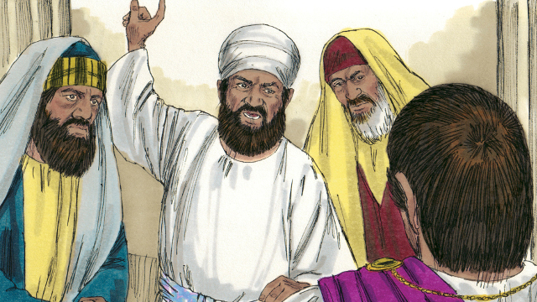

After the soldiers crucified Jesus, the Jewish leaders said to Pilate, “That liar, Jesus, said he would rise from the dead after three days. Someone must guard the tomb to make sure that his disciples do not steal the body. If they do, they will say he has risen from the dead.”

41-02

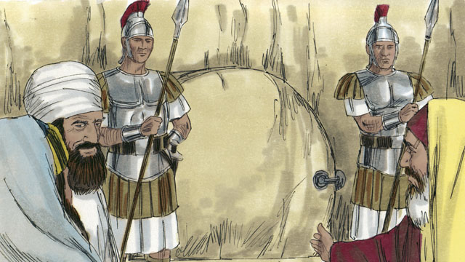

Pilate said, “Take some soldiers and guard the tomb as well as you can.” So they placed a seal on the stone at the entrance of the tomb. They also put soldiers there to make sure no one could steal the body.

41-03

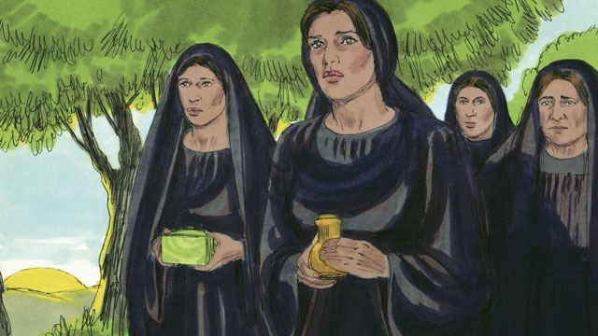

The day after Jesus died was a Sabbath day. No one could work on the Sabbath day, so no friends of Jesus went to his tomb. But on the day after the Sabbath, very early in the morning, several women got ready to go to Jesus’ tomb. They wanted to put more spices on his body.

41-04

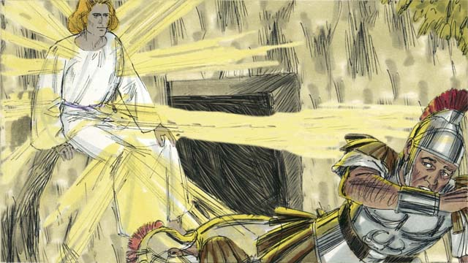

Before the women arrived, there was a great earthquake at the tomb. An angel came from heaven. He rolled away the stone that was covering the entrance to the tomb and sat on it. This angel was shining as brightly as lightning. The soldiers at the tomb saw him. They were so terrified that they fell to the ground like dead men.

41-05

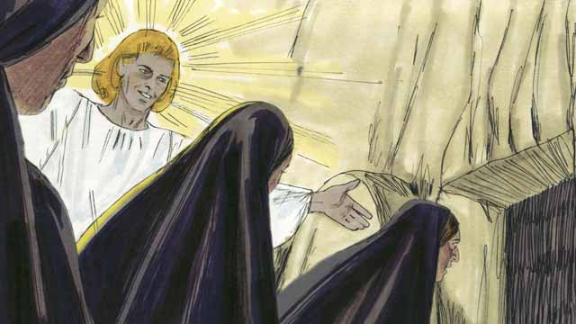

When the women arrived at the tomb, the angel told them, “Do not be afraid. Jesus is not here. He has risen from the dead, just like he said he would! Look in the tomb and see.” The women looked into the tomb and saw where Jesus’ body had been laid. His body was not there!

41-06

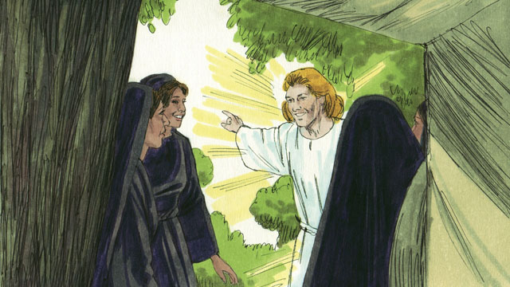

Then the angel told the women, “Go and tell the disciples, ‘Jesus has risen from the dead and he will go to Galilee ahead of you.’”

41-07

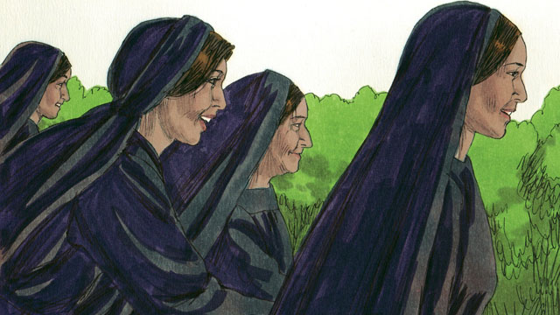

The women were amazed and very joyful. They ran to tell the disciples the good news.

41-08

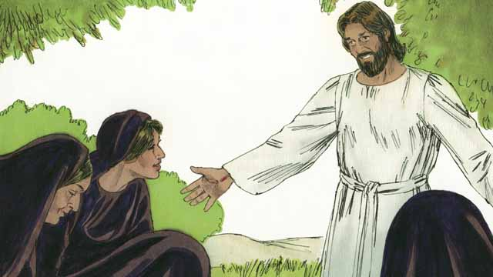

As the women were on their way to tell the disciples the good news, Jesus appeared to them. They bowed down at his feet. Then Jesus said, “Do not be afraid. Go and tell my disciples to go to Galilee. They will see me there.”

*A Bible story from: Matthew 27:62-28:15; Mark 16:1-11; Luke 24:1-12; John 20:1-18*

## 1 Community Study: Rich Delight—Experiencing Joy in Personal Relationships

* **Key Idea**: finding joy in relationships with one another
* **Key Passage**: Romans 12:15
* **Main Session**: OBS 41 (God Raises Jesus from the Dead)

### 1.1 Recite the Creedal Verse (3–5 minutes)

The verse below summarizes the teaching of the current passage. Read the verse out loud as a community. Read it again several times as a group until the whole community can recite it from memory.

9 We know that since Christ has been raised from the dead he cannot die again; death no longer has authority over him. Romans 6:9

OR

Jesus said to her, “I am the resurrection and the life; he who believes in me, even if he dies, will live; 26 and whoever lives and believes in me will never die. Do you believe this?” John 11:25-26

### 1.2 Think about Trust (5–10 minutes)

Jesus is stronger than death. Jesus’ resurrection from the dead shows us that God has power over all things and can cause us to be joyful in all circumstances. Think about how Jesus’ resurrection is a source of joy.

Because Jesus has resurrected from the dead, he is more powerful than…

Jesus’ resurrection brings joy because…

### 1.3 Read the Passage (3–5 minutes)

When we find joy in God, we are able to enjoy our relationships with one another. When Christians deeply trust each other, they share each other’s burdens and joys. Read the passage below to learn about what God teaches about joy and sorrow in relationships.

15 Rejoice with those who rejoice; weep with those who weep. Romans 12:15

### 1.4 Discuss the Passage (10-15 minutes)

God wants us to enjoy relationship with one another. A healthy Christian community finds joy in others in the community. As a community, use the following questions to discuss the teaching of the biblical passage.

1. How do these passages instruct believers to relate to one another?
2. How might these instructions be different than how people typically relate to one another?
3. How does Jesus’ resurrection give us the power to rejoice and weep with other believers?
4. Why is it important for your community to enjoy other members of the community? How will joy in relationships make your community strong and healthy?

### 1.5 Rejoice and Weep (5 minutes)

Think about others in your community who have a reason for rejoicing and weeping. Identify a person that you can rejoice with. Then, identify a person you can weep with.

One person I can rejoice with is…

One person I can weep with is…

### 1.6 Pray to God (5 minutes)

Pray that God would help your community be a community of joy. After each person prays, have the whole group pray the Scripture passage together.

Gracious God, make our community a joy that…

Pray Together: Our hearts rejoice in him, for we trust in his holy name. Psalm 33:21

### 1.7 Sing a Song (3–5 minutes)

Choose a song that rejoices in God. Sing this song together as a community.

## 2 Biblical Interpretation: Observing the Details of the Story

After reading the crafted biblical story, answer the following questions to familiarize yourself with the details of the story.

### 2.1 Observation Questions

Answer the following observation questions to gain a basic understanding of the the story. Read the story as a community and answer these questions as a group.

#### 41-01

What did Jesus say would happen three days after his death?  
He would rise from the dead.

Did the Jewish leaders believe that Jesus would rise again?  
No, they thought he was lying.

What instructions did the Jewish leaders give?  
The Jewish leaders told Pilate that someone must guard the tomb.

What were the Jewish leaders afraid that the disciples would do?  
They thought the disciples would steal the body and say that Jesus had risen from the dead.

#### 41-02

What did the Jewish leaders do to secure Jesus’ tomb?  
They put soldiers to guard the tomb and placed a seal on the stone at the entrance of the tomb.

#### 41-03

What special day was the day after Jesus’ crucifixion?  
The day after Jesus’ crucifixion was the Sabbath day.

Why did no one visit Jesus on the day after his crucifixion?  
No one visited Jesus on the day after his crucifixion because this was the Sabbath day and Jews were not allowed to work on the Sabbath.

When did the women go to Jesus’ tomb?  
They went there very early on the morning after the Sabbath day.

Why did the women go to Jesus’ tomb?  
The women wanted to put more spices on Jesus’ body.

#### 41-04

What miraculous events happened at the tomb before the women arrived there?  
There was an earthquake and an angel appeared, rolled away the stone, and sat on it.

What did the angel look like?  
The angel was shining as brightly as lightning.

What did the soldiers do when they saw that angel?  
They were terrified and fell to the ground like dead men.

#### 41-05

What did the angel say to the women when they arrived at the tomb?  
The angel told them not to be afraid, for Jesus had risen from the dead. The angel told them to look in the tomb and see.

What did the women see when they looked in the tomb?  
The women looked in the tomb where Jesus’ body was laid his body was not there.

#### 41-06

What did the angel tell the women to say to the disciples?  
He told them to tell the disciples that Jesus has risen from the dead, and that he would go to Galilee ahead of them.

#### 41-07

How did the women respond to the angel’s message?  
The women were amazed and very joyful.

What did the women do?  
The women ran to tell the disciples the good news that Jesus rose from the dead.

#### 41-08

Who appeared to the women as they were on their way to speak to the disciples?  
Jesus appeared to them.

What did the women do when they saw Jesus?  
They bowed down at his feet.

What did Jesus say to them?  
Jesus told them not to be afraid, to go tell the disciples to go Galilee, and to inform them that they would see Jesus there.

### 2.2 Translation Questions

Use the following translation questions to understand specific details of the passage. Discuss how you might translate these specific elements of the story.

#### 41-01

**After the soldiers crucified Jesus, the Jewish leaders said to Pilate** The soldiers crucified Jesus. Then, the Jewish leaders spoke to Pilate to ask him to guard the tomb. How would you express **After the soldiers crucified Jesus, the Jewish leaders said to Pilate** to mean the Jewish leaders spoke to Pilate after he had had Jesus crucified?

  

**That liar Jesus, said,** The Jewish leaders called Jesus a liar. Jesus was telling the truth but the Jewish leaders did not believe him. They refused to believe that Jesus told the truth about being the Son of God. How would you express **That liar Jesus, said,** to mean that man, Jesus, lied and said?

  

**rise from the dead** Jesus predicted that he would come back to life again after he had died. His resurrection from the dead is a miracle. How would you express **rise from the dead** to mean come back to life or become alive again?

  

**If they do, they will say he has risen from the dead** The Jewish leaders were concerned that the disciples would steal Jesus’ body from the tomb to make it seem like Jesus rose from the dead. How would you express **If they do, they will say he has risen from the dead** to mean the Jewish leaders thought that the disciples would only be able to say Jesus had risen from the dead if they were able to steal his body?

  

#### 41-02

**Take some soldiers and guard the tomb as well as you can** Pilate instructed them to instruct some soldiers to watch over the tomb. He told them that these soldiers should guard the tomb as effectively as they were able to in order to prevent anyone from stealing Jesus’ body. How would you express **Take some soldiers and guard the tomb as well as you can** to mean order some soldiers to watch over the tomb and do their best to prevent anyone from stealing Jesus’ body?

  

**they placed a seal on the stone** The religious leaders and the soldiers placed a mark on the stone that covered the entrance of the tomb. They put a soft material like clay or wax between the stone and the tomb and marked it with an official seal. If anyone moved the stone, the material would break and show that someone had entered the tomb. How would you express **they placed a seal on the stone** to mean a mark on the stone in front of the tomb to forbid people from moving the stone?

  

#### 41-03

**No one could work on the Sabbath day** The Sabbath day rules did not permit a Jew to walk very far or to do any other kind of work. How would you express **No one could work on the Sabbath day** to mean, according to Jewish law, Jews were not permitted to work on the Sabbath day, which included prohibiting Jews from walking a far distance?

  

**put more spices on his body** These spices refer to sweet-smelling herbs that were placed on a dead body to cover the bad smell. It was the custom of the Jews to wash the body and then wrap it with strong, pleasant smelling spices to prevent the dead body from smelling bad so quickly. This was also a sign of honor and devotion. How would you express **put more spices on his body** to mean the women wanted to put sweet-smelling herbs or oils on Jesus body to keep the body from smelling bad?

  

#### 41-04

**Before the women arrived, there was a great earthquake at the tomb** First there was the earthquake and appearance of the angel, and then the women arrived at the tomb. An earthquake causes the ground to shake violently. How would you express **Before the women arrived, there was a great earthquake at the tomb** to mean a strong earthquake caused the ground to forcefully shake prior to the women arriving at the tomb?

  

**was shining as brightly as lightning** The angel was giving off bright light like lightning. How would you express **was shining as brightly as lightning** to mean the angel gleamed (gave off light) with strong light like lighting?

  

**fell to the ground like dead men** The soldiers fell down and did not move. They looked just like dead men who do not move. They probably had fainted from fright. How would you express **fell to the ground like dead men** to mean the soldiers suddenly collapsed to the ground and did not move like dead people who are motionless?

  

#### 41-05

**When the women arrived at the tomb, the angel told them** These two events happened at the same time. The women arrived at the tomb and the angel spoke to them at the same moment. How would you express **When the women arrived at the tomb, the angel told them** to mean the angel spoke to the womb at the time they arrived at the tomb?

  

**Do not be afraid** The angel instructed the women to not fear. An angel shining like lightning was a frightening sight, so that angel was trying to calm the women from being terrified. How would you express **Do not be afraid** as a command to stop being sacred?

  

**He has risen from the dead** The angel told the women that Jesus had resurrected from the dead. How would you express **He has risen from the dead** to mean Jesus has come back to life?

  

**His body was not there!** The women did not find Jesus’ body in the tomb. This was a great surprise. How would you express **His body was not there!** as a strong statement that emphasizes how surprised they were that the body of Jesus was no longer in the tomb?

  

#### 41-06

**Go and tell the disciples** The angel instructed the women to leave the tomb area and report to the disciples that Jesus had risen from the dead. How would you express **Go and tell the disciples** as a command to depart from the tomb and inform the disciples that Jesus had come back to life?

  

**Jesus has risen from the dead** The angel instructed the women to tell the disciples that Jesus had come back to life. Jesus was among those who died and were no loner alive, but God’s power caused Jesus to come to life again. This expression describes all dead people together in the underworld. To rise from among them speaks of becoming alive again. How would you express **Jesus has risen from the dead** to mean Jesus came back to life from among all those who have died?

  

**he will go to Galilee ahead of you** The angel said that Jesus would arrive in Galilee before the apostles and other disciples. Jesus would meet the apostles and disciples in Galilee when they arrived. How would you express **he will go to Galilee ahead of you** to mean Jesus will meet the apostles and other disciples in Galilee when they arrive there?

  

#### 41-07

**the good news** The women went to tell the disciples that Jesus had risen from the dead. This was very good news to report to the disciples and would bring great joy. How would you express **the good news** to mean the exciting message that Jesus was no longer dead but came back to life?

  

#### 41-08

**bowed down at his feet** The women fell down on the ground in front of Jesus. They did this symbolic action to honor Jesus as they would expect to do in the presence of a king. How would you express **bowed down at his feet** to mean the women lowered their body on the ground in front of Jesus as an act of honor and respect.

**will see me** At this point, the disciples knew that Jesus died. Jesus told the women that the disciples would see Jesus in Galilee. This would help the disciples believe that Jesus really did come back to life. How would you express **will see me** to mean the disciples would meet with Jesus in person and see that he had come back to life?

  

## 3 Theological Dialogue: Discussing the Meaning of the Story

Take time to explore the meaning of this story together as a community. Use the following discussions as a way to grasp what truth the story teaches.

### 3.1 Discourse Questions

Use the following discourse questions to understand the meaning of the story. Pay attention to how the story itself addresses each question or theme.

##### What did the Jewish leaders and Pilate think about Jesus raising from the dead? (41-01, 41-02)

Jewish Leaders Asking Pilate: The Jewish leaders did not believe that Jesus would raise from the dead. They feared that Jesus’ disciples would steal the body to make it seem like Jesus rose from the dead. They asked Pilate to help prevent this from happening. (41-01)

  

Soldiers, Stone, and Seal: Pilate ordered soldiers to guard the tomb. A large stone was rolled in front of the tomb. Pilate instructed his soldiers to place a seal on at the entrance of the tomb. He did these things to make sure no one would steal Jesus’ body. (41-01, 41-02)

  

##### What did the women experience when they arrived at the tomb? (41-03, 41-04, 41-05)

Anticipation: Several women arrived at the tomb on the day after the Sabbath day. They came to put more spices on Jesus’ body. They came to honor Jesus. They had to wait a whole day before they could visit him again. (41-03)

  

God’s Power: The ground shook violently at the tomb because of an earthquake. An angel came from heaven, rolled away the tomb, and sat on it. This angel was very bright like lightning. The soldiers saw the angel and fell to the ground like men who had died. All these events show the power of God and emphasized that God rose Jesus from the dead in his power. (41-04)

  

Message of Peace: The angel told the women to not be afraid. The soldiers were afraid and became like dead people. The women were not supposed to be afraid because Jesus came back from the dead. (41-05)

  

Empty Tomb: The women looked inside the tomb and saw that it was empty. They witnessed with their own eyes that Jesus was no longer in the tomb where they had buried him. (41-05)

  

##### What did the angel and Jesus tell the women to do? (41-05, 41-06, 41-07, 41-08)

No Be Afraid: The angel and Jesus told the women to no be afraid. The women were amazed and experienced great joy. (41-05, 41-07, 41-08)

  

Announce the Good News: The angel instructed the women to report to the disciples that Jesus had risen from the dead. This was good news. It was a message of great rejoicing because Jesus came back to life. The women were so amazed and joyful that they ran to tell the disciples this news. The women were given the task of announcing the good news of Jesus’ resurrection to others. (41-06, 41-07, 41-08)

  

Meet Jesus in Galilee: The angel told the women to tell the disciples and apostles to go to Galilee and Jesus would meet them there. When the women saw Jesus, Jesus also told them to tell the disciples to go to Galilee and they would see Jesus there. The promise that the disciples would see Jesus in Galilee would give them proof/evidence that Jesus really did rise from the dead. (41-08)

  

##### How did various people and situations change in the story of Jesus’ resurrection? (41-01, 41-02, 41-03, 41-04, 41-05, 41-06, 41-07, 41-08)

Human Power to Divine Power: Pilate showed his power by putting soldiers at the tomb and a seal at the opening to keep people from stealing Jesus’ body. God showed his power with an earthquake and an angel. (41-01, 41-02, 41-04)

  

Sadness to Joy: The women came to the tomb thinking they would put more spices on Jesus dead body. They left the tomb amazed and joyful that Jesus was alive. (41-03, 41-07)

  

Death to Life: The soldiers fell down as dead men. Jesus was dead but was now alive from the dead. (41-04, 41-05, 41-06)

  

Doubt to Faith: The Jewish leaders did not believe that Jesus would rise from the dead. Jesus instructed his disciples to meet him in Galilee to prove to them that he rose from the dead. (41-01, 41-08)

  

Fear to No Fear: The soldiers who were set to guard the tomb became terrified at the sight of the angel. The angel and Jesus told the women to not be afraid. (41-04, 41-05, 41-08).

  

### 3.2 Theological Questions

Answer the following theology questions as a community. Discuss what truths this story teaches.

1. What confidence can we have in Jesus’ resurrection from the dead? How does this story give confidence that Jesus really did raise from the dead?
2. How important in Jesus’ resurrection? What transformation and change does Jesus’ resurrection bring in the world and the lives of his people? How does this story show how Jesus’ resurrection brings about change/transformation/reversal in people and world situations?
3. How does Jesus’ resurrection move God’s people to mission and evangelism? What are the various ways the women are told to be witnesses of Jesus’ resurrection?

### 3.3 Translation Draft

Work as a translation team to draft each panel of this story. Pay attention to any specific translation issues that are challenging or significant.

#### Make Translation Draft

Make a draft for each section of this story.

#### Discuss and Revise

After drafting the story, discuss any translation issues that you think need special explanation.

#### Drafting Summary Reflection

Summarize any noteworthy translation decisions and the rationale/reasoning behind these translation decisions. In the final movement of this class, you will use these observations to give an account (i.e., chronicle/narrate) of how your translation improved through the checking process.

## 4 Personal Reflection: Following the Teaching of the Story

Take a moment to allow this story to evaluate your own life and to consider how God would have you respond. After this reflection, use the quality checking questions to check your translation draft among the translation team.

### 4.1 Journal Reflection

Prayerfully think about the following personal reflection questions. Write/Record your answers and/or discuss them as a group.

1. How has your confidence in Jesus’ resurrection grown as a result of this story?
2. In what ways has Jesus brought a transformation in your life?
3. Who are people that Jesus wants you to announce the good news of Jesus’ resurrection?
4. How does Jesus’ resurrection bring you comfort, joy, and amazement?

### 4.2 Team Check

*The following activity will help you check the clarity, accuracy, and naturalness of your draft. Read the passage aloud and discuss the checking questions with other members of your translation community. You might need to reread portions (or the whole) of the biblical passage multiple times as you answer each of these questions. Record answers to these questions below.*

#### Team Checking Questions

*Use the following questions to check your translation draft for accuracy, clarity, and naturalness.*

1. **Accurate**: Has anything been **added** to your translation of this passage that is not a part of the meaning of the source text? *If additions exist, are they included only added to clarify meaning (such as implied information)?*
2. **Accurate**: Is anything **missing** from your translation of this passage that is a part of the meaning of the source text? *If some part of the meaning is missing from your translation, add it.*
3. **Accurate**: Does any meaning in your translation of this passage appear to be **different** than the meaning of the source text? *If the meaning is different, try changing your translation so that the meaning remains the same.*
4. **Natural**: Does anything sound **unnatural** to how you would say it in your language? *If portions of the passage sound unnatural in your language, try to make them sound the way you would say it in your language while staying true to the meaning of the source text.*
5. **Clear**: Is anything **unclear** or **confusing** in your translation that confuses the meaning of the source text? *If portions of the passage are unclear or confusing, revise them to clearly communicate the meaning of the source text.*
6. **Consistent**: How **consistent** is your translation within the passage and with other passages? *If portions of the passage need to be made consistent or if you need to revise translations of other passages, make these adjustments.*

#### Record Feedback

*After discussing the checking questions above as a translation community, record any feedback on your translation draft. Pay attention for parts of your translation that are translated well and parts of your translation that need correction.*

#### Discuss and Revise

*After gathering feedback on your draft, discuss it together with your translation community and make appropriate revisions in your translation.*

#### Record Translation Decisions

*As a community, discuss some of the most noteworthy translation decisions in your draft. Summarize each decision and explain the reasons your community decided on that translation. You should update these decisions each time you check your draft with various groups of people.*

You should **measure** the quality of your translation draft. You can **record translation decisions** to make it clear why you translated things a certain way. Translation decisions can help your translation team and the surrounding community be a part of the translation process.

How can you know the quality of your translation?

1. **Measure** the translation by marks/standards of quality (i.e., clear, accurate, natural, church-approved)
2. **Test** the translation with others and record feedback and conversations from in the field (i.e., church and community check)
3. **Compare** and **contrast** the translation with the source text (i.e., meaning of text and notes) and alternatives (i.e., other translation choices)
4. **Explain** the reasons why you translated a particular portion of the text.

**Example Sentences That Help Explain Your Translation Decision** Use the following example sentences to help explain your translation decisions:

1. The original text literally **says/means**, so we translated the term in this way…
2. We originally decided to translate **the biblical term** in with **this term**, but we changed it because…
3. When our translation team discussed **the biblical term**, this is what we talked about…
4. **The term** is [clear, accurate, natural, consistent] because…
5. The community understands **this term** it to mean…
6. We considered these other terms. We did not use **these terms** because…
7. When we checked this in the church, we learned…
8. When we checked this in the community, we learned…

**Example of Translation Decision**

In OBS 01-07 we decided to translate **blessed** like this: [actual translation]. We decided this translation because of these reasons:

1. The word [actual translation] means to cause good things to happen to someone or something. This term is used when a person desires someone or something to prosper or flourish. This term does not refer to magic or witchcraft.
2. When we checked this word with other believers, they said it describes God showing his kindness and favor on someone or something. These are some of the terms that we did not decide to use…
3. Many of our people will understand this word. When we discussed this phrase with the surrounding community, we discovered it was a natural way to describe God causing good and beneficial things to happen.

## 5 Ministry Practice: Serving the Church with the Story

Now that you have a draft of this story, consider how this story can encourage other believers in their faith. After ministering this story to others, you will also perform a community check of your translation draft.

### 5.1 Church Ministry

Reflect on how this story can edify and mature the Christian community. Design a way to minister this story to your church community.

**Ministry Preparation**: Take time to consider how you could minister this story to others. Record some ministry ideas below.

**Ministry Implementation**: Minister this story to a group of believers as you had planned. Use the information in this study to help develop a teaching/lesson or lead a discussion of this story to other believers. Record your ministry plan below.

**Ministry Reflection**: Think about what you learned from ministering this story to other believers. Reflect on your experience below.

### 5.2 Church Community Check

After teaching or ministering this story to the church, check the translation quality with the church community. Record any feedback from your checking experience.

#### Create Checking Questions

You can use **Translation Questions** to check you draft. Each **Translation Question** explains the meaning of a specific part of the story and asks you to consider how you would translate that part of the story in your own language. Change each **Translation Question** into a **Checking Question** by asking the following questions. The first question asks you to identity how each specific phrase was translated in your language. The second question asks people in the church to determine if your translation of the phrase expresses the meaning clearly, accurately, and naturally. Look at the following examples to see how to change **Translation Questions** into **Checking Questions**:

#### Translation Question Example 1

**to proclaim the good news about Jesus** Paul and Silas traveled to Philippi for the purpose of preaching the gospel. The gospel is the good news that Jesus saves people from their sins if they will believe in Jesus. How would you express **to proclaim the good news about Jesus** to mean to tell other people the message about how Jesus can save people from their sins?

#### Translation Question Example 2

**a merchant** Paul and Silas met a woman named Lydia at the place by the river. She owned a business and sold items to make money. How would you express **a merchant** to mean a business owner who sells items for a profit?

#### Translation Question Example 3

**so Paul and Silas baptized them** The jailer and his whole family followed Paul’s instructions. They believed in Jesus. The result of this was Paul and Silas baptized them. How would you express **so Paul and Silas baptized them** to mean the result of the jailer and his family believing in Jesus that Paul and Silas baptized all of them?

You can change these into **Checking Questions** like this:

#### Checking Question Example 1

**to proclaim the good news about Jesus** How did you translate **to proclaim the good news about Jesus**? Does it mean to tell other people the message about how Jesus can save people from their sins?

#### Checking Question Example 2

**a merchant** How did you translate **a merchant**? Does it mean a business owner who sells items for a profit?

#### Checking Question Example 3

**so Paul and Silas baptized them** How did you translate **so Paul and Silas baptized them**? Does it mean the result of the jailer and his family believing in Jesus that Paul and Silas baptized all of them?

#### Record Feedback

*Discuss the* ***Checking Questions*** *with your church community, and record any feedback on your translation draft. Pay attention for parts of your translation that are translated well and parts of your translation that need correction.*

#### Discuss and Revise

*After gathering feedback on your draft, discuss it together with your translation community and make appropriate revisions in your translation.*

#### Record Translation Decisions

*Update your translation decisions and record and new any noteworthy observations on the quality of your draft.

## 6 Missional Outreach: Sharing the Truth of the Story

*After sharing this story with others, check the translation quality with the wider language community. Record any feedback from your checking experience.*

### 6.1 Mission Engagement

*Consider how you will witness this story to unbelievers. Design a way to share this story and engage them in what it teaches about Christianity and the gospel.*

**Witness Preparation**: Take time to consider how you will witness this narrative to unbelievers. Record some ideas below.

**Witness Implementation**: Share this story with an unbeliever. Use the information in this study to help develop a teaching/lesson or lead a discussion of this story to other believers. Record your ministry plan below.

**Witness Reflection**: Think about what you learned from ministering this story to unbelievers. Reflect on your experience below.

### 6.2 Sociolinguistic Check

After sharing this story with the language community, check your translation draft with the surrounding community. Record your observations.

#### Checking Approach

After witnessing this story to unbelievers, use one of the following methods to check the translation of this story. Consider using the **Observation Questions** to check your translation draft or come up with your own quality checking questions.

**Read-Retell Check:** Read your draft to those the community and ask them to retell the passage. Be attentive for any portions of the passage that are unclear, unnatural, or inaccurate.

**Comprehension Questions Checklist:** Read the draft of the passage and ask a list of comprehension questions to make sure the passage is being rightly understood. You can use the **Observation Questions** in this guide or come up with your own questions. Then, record any insights or issues that arise.

**Discussion Group:** Develop key questions to ask about the passage (both formational and translational). Read the passage and have a group discussion about the passage, paying attention to issues that need to be addressed, edited, and revised.

#### Record Feedback

*After sharing your draft with language community, discuss the* ***Observations Questions****, and record any feedback on your translation draft. Pay attention for parts of your translation that are translated well and parts of your translation that need correction.*

#### Discuss and Revise

*After gathering feedback on your draft, discuss it together with your translation community and make appropriate revisions in your translation.*

#### Record Translation Decisions

*Update your translation decisions and record and new any noteworthy observations on the quality of your draft.

## 7 Conclusion

As a translation community, take time to reflect on all that was learned in studying, drafting, and checking this story. Celebrate all that God has taught you as a community. Then, submit your revised draft and checking summaries to network leaders for further review.