Open Bible Stories

Jesus Returns to Heaven

## 0 Introduction

### 0.1 Key Idea

The story of Jesus returning to heaven teaches us that Jesus really rose from the dead by showing himself to his disciples and gave them a mission to preach the gospel to all people groups in the world.

### 0.2 Creedal Verse

“Thus it is written, that the Christ should suffer and on the third day rise from the dead, 47 and that repentance for the forgiveness of sins should be proclaimed in his name to all nations, beginning from Jerusalem.” Luke 24:46-47.

### 0.3 Metanarrative Summary

The eternal God created all things in six days. He made a good and perfect world. He made humans in his image to fill the earth and rule over creation. But humans rebelled against God and ruined God’s creation. God set to restore his world through his promise. God made a covenant with Abraham. He promised to bless all nations through Abraham. God kept his promises across the generations. God provided Abraham with a promised child, Isaac. God gave Isaac a wife, and she bore twins, Jacob and Esau. God blessed Jacob and his sons, and the blessing continued to the next generation. God rescued Joseph, one of Jacob’s sons, and used him to rescue his family. God caused his people, the Israelites, to multiply in the land of Egypt; eventually, they became slaves. But God raised up a deliverer, Moses, to deliver his people from slavery. God judged the Egyptians with harsh plagues; in the final judgment, he passed over his people, who covered their doorposts with the blood of a sacrificed lamb. Then, God delivered the Israelites by bringing them out of Egypt and crossing the Red Sea on dry land. God made a covenant with the Israelites and made them his people. God tested Israel in a series of wilderness wanderings and eventually brought his people into the promised land of Canaan. God raised up deliverers to lead Israel and rescue them from their enemies. God formed Israel into a kingdom. He made a covenant with King David and promised to send a king that would rule his people forever. Many of Israel’s kings were evil, and the kingdom of Israel was divided into two kingdoms. God sent prophets to warn his people of God’s judgment and call them to repent. When Israel did not repent, God sent his people into exile. After many years, he brought them back to the land. Throughout the Old Testament, God promised to send his Messiah to deliver his people from their sin. After many years, the prophet John was born. He would prepare people for the coming Messiah. At the perfect time, God sent his Son, Jesus, to be born of a virgin Mary. When John and Jesus grew up, John baptized Jesus as a sign that Jesus was God’s beloved Son. Jesus endured all manner of temptation without ever sinning. When he was thirty years old, he launched a public ministry of preaching, teaching, and healing. He taught his disciples about the life of compassion, sacrifice, and forgiveness. Jesus performed many miracles: he fed a crowd of five thousand, he walked on water, he healed the sick, and he cast out demons. He proclaimed to people the nature of real faith, God’s kingdom, and how fallen humans can be restored in relationship with God. Toward the end of his ministry, Jesus revealed his power and glory to his disciples. He raised a dead man to life. Jesus was betrayed by one of his disciples and put on trial before a Roman governor. Jesus was sentenced to death and crucified on a cross Three days later, Jesus rose again from the dead. After meeting with many of his disciples, Jesus went back to heaven.

### 0.4 Open Bible Story: Jesus Returns to Heaven

42-01

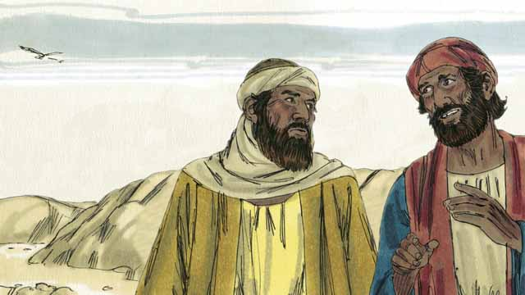

On the day that God raised Jesus from the dead, two of his disciples were going to a nearby town. As they walked, they talked about what had happened to Jesus. They had hoped he was the Messiah, but he was killed. Now the women said he was alive again. They did not know what to believe.

42-02

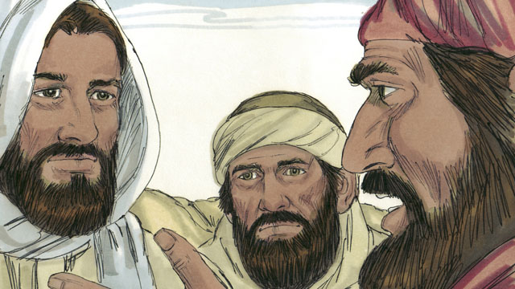

Jesus approached them and started walking with them, but they did not recognize him. He asked what they were talking about. They told him about all the things that had happened to Jesus during the previous few days. They thought they were talking to a foreigner who did not know what had happened in Jerusalem.

42-03

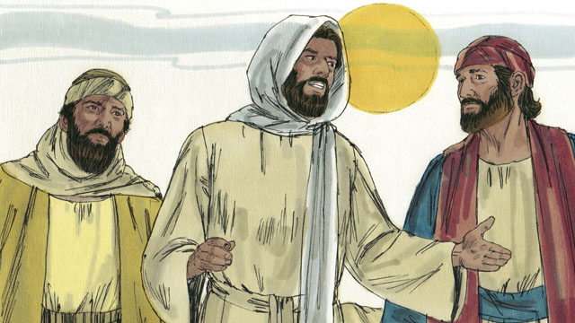

Then Jesus explained to them what God’s word said about the Messiah. Long ago, prophets had said that evil men would make the Messiah suffer and die. But the prophets also said he would rise again on the third day.

42-04

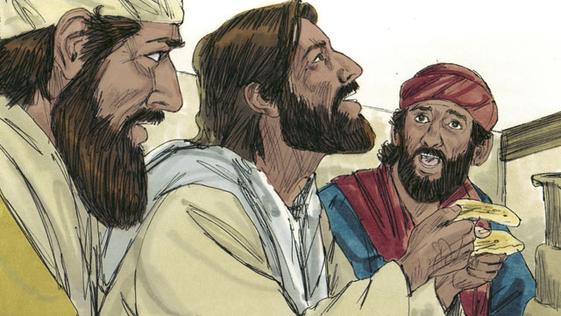

When they arrived at the town where the two men wanted to stay, it was almost evening. They invited Jesus to stay with them, so he went into a house with them. They sat down to eat their evening meal. Jesus picked up a loaf of bread, thanked God for it, and broke it. Suddenly, they recognized that he was Jesus. But at that moment, he disappeared from their sight.

42-05

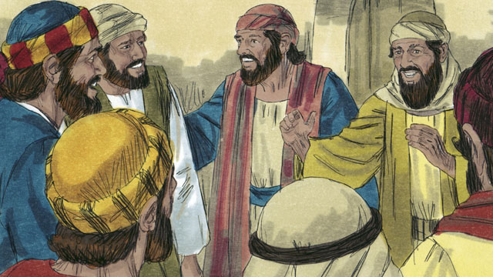

The two men said to each other, “That was Jesus! That is why we were so excited when he explained God’s word to us!” Immediately they left and went back to Jerusalem. When they arrived, they told the disciples, “Jesus is alive! We have seen him!”

42-06

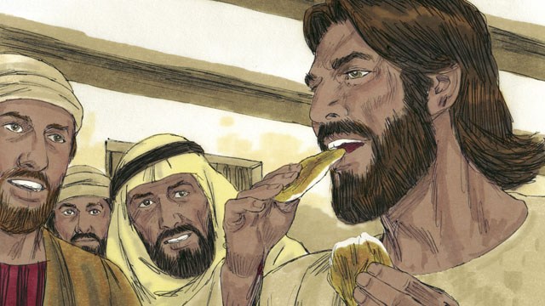

As the disciples were talking, Jesus suddenly appeared in the room with them. He said, “Peace to you!” The disciples thought he was a ghost, but Jesus said, “Why are you afraid? Why do you not think it is really I, Jesus? Look at my hands and feet. Ghosts do not have bodies like I do.” To show that he was not a ghost, he asked for something to eat. They gave him a piece of fish, and he ate it.

42-07

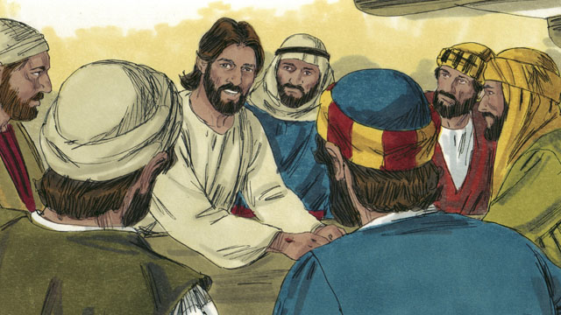

Jesus said, “Everything about me that God’s word says will happen, I have told you that it must happen.” Then Jesus made them understand God’s word better. He said, “Long ago, prophets wrote that I, the Messiah, would suffer, die, and then rise from the dead on the third day.”

42-08

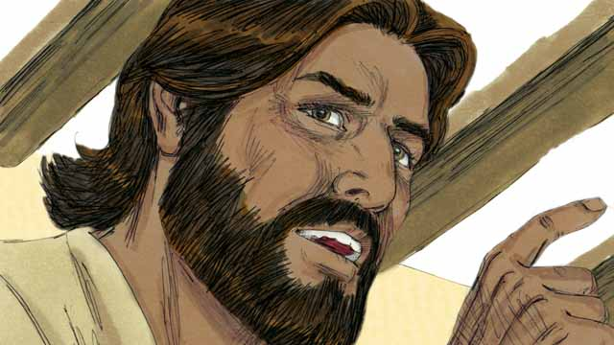

“The prophets also wrote that my disciples will proclaim God’s message. They will tell everyone to repent. If they repent, God will forgive their sins. My disciples will proclaim this message starting in Jerusalem. Then they will go to all people groups everywhere. You are witnesses of everything I have said and done, and of everything that happened to me.”

42-09

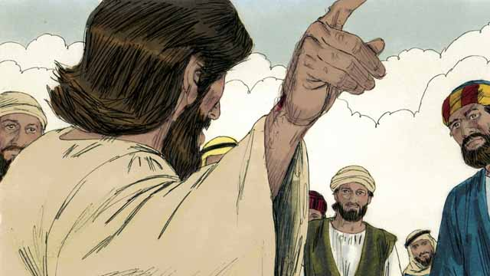

During the next 40 days, Jesus appeared to his disciples many times. Once, he even appeared to more than 500 people at the same time! In many ways, he proved to his disciples that he was alive and taught them about the kingdom of God.

42-10

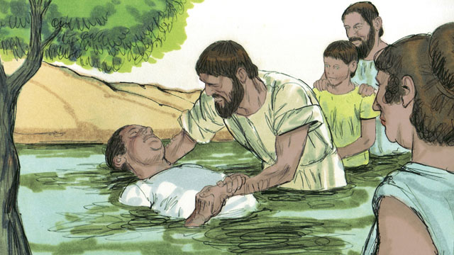

Jesus said to his disciples, “God has given me the right to rule over everyone in heaven and on earth. So I am telling you now: go and make disciples in all people groups. In order to do this, you must baptize them in the name of the Father, the Son, and the Holy Spirit. You must also teach them to obey everything I have commanded you. Remember, I will always be with you.”

42-11

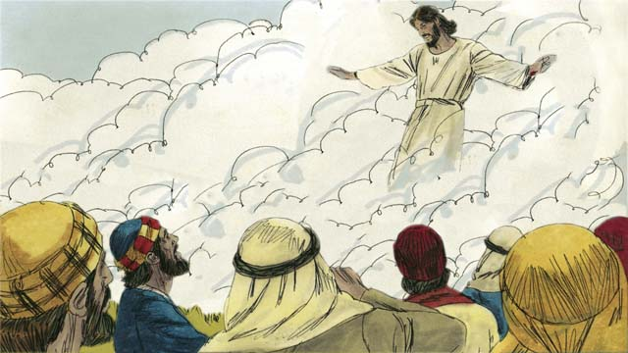

Forty days after Jesus rose from the dead, he told his disciples, “Stay in Jerusalem until my Father gives you power. He will do this by sending the Holy Spirit upon you.” Then Jesus went up to heaven, and a cloud hid him from their sight. Jesus sat down in heaven at the right hand of God to rule over all things.

*A Bible story from: Matthew 28:16-20; Mark 16:12-20; Luke 24:13-53; John 20:19-23; Acts 1:1-11*

## 1 Community Study: Deep Commitment—Building Loyalty in Personal Relationships

* **Key Idea**: entrusting ourselves to each other in love
* **Key Passage**: John 15:9-14
* **Main Session**: OBS 42 (Jesus Returns to Heaven)

### 1.1 Recite the Creedal Verse (3–5 minutes)

The verse below summarizes the teaching of the current passage. Read the verse out loud as a community. Read it again several times as a group until the whole community can recite it from memory.

22 Christ is at the right hand of God. He went into heaven. Angels, authorities, and powers must submit to him. 1 Peter 3:22

OR

12 But when Christ offered for all time one sacrifice for sins, he sat down at the right hand of God. Hebrews 10:12

### 1.2 Think about Jesus’ Rule (5–10 minutes)

Jesus is king. After he resurrected from the dead, Jesus ascended to heaven. He rules over everything and everyone. Jesus completed his work of salvation. Think about what it means to live under Jesus’ power.

To live under Jesus’ rule means…

### 1.3 Read the Passage (3–5 minutes)

Our commitment to Jesus causes us to be committed to one another. Jesus sacrificed his life to save us. God calls us to devote our lives to him and other believers. Read the passage below to learn about what God teaches about sacrificial devotion in relationships.

9 As the Father has loved me, I have also loved you. Remain in my love. 10 If you keep my commandments, you will remain in my love, as I have kept the commandments of my Father and remain in his love. 11 I have spoken these things to you so that my joy will be in you and so that your joy will be complete. 12 This is my commandment, that you love one another as I have loved you. 13 No one has greater love than this—that he lay down his life for his friends. 14 You are my friends if you do the things that I command you. John 15:9-14

### 1.4 Discuss the Passage (10-15 minutes)

Jesus demonstrated his love and commitment to us. In a healthy Christian community, Christians are committed to Jesus and to one another. As a community, use the following questions to discuss the teaching of the biblical passage.

1. How does Jesus describe what it means to commit to Jesus and to one another?
2. How does our commitment to Jesus cause us to commit to one another?
3. What challenges make it hard for Christians to be committed to one another?
4. Why is it important for your community to have a commitment and devotion described in this passage?

### 1.5 Describe Commitment (5 minutes)

After discussing the passage, explore what it means to be committed to one another. Share your summary thoughts as a group.

Christian commitment means…

### 1.6 Pray to God (5 minutes)

Pray that God would help your community be committed to God and to others. After each person prays, have the whole group pray the Scripture passage together.

Gracious God, help us to show our commitment to one another by…

Pray Together: Beloved, let us love one another, for love is from God, and everyone who loves is born from God and knows God. [[1 John 4#4:7]]

### 1.7 Sing a Song (3–5 minutes)

Choose a song that expresses commitment to God. Sing this song together as a community.

## 2 Biblical Interpretation: Observing the Details of the Story

After reading the crafted biblical story, answer the following questions to familiarize yourself with the details of the story.

### 2.1 Observation Questions

Answer the following observation questions to gain a basic understanding of the story. Read the story as a community and answer these questions as a group.

#### 42-01

What were two of Jesus’ disciples doing at the beginning of this story?  
On the day Jesus came back to life, two of Jesus’ disciples were walking on a road to a nearby town.

What were the two disciples talking about as they walked along the road?  
They were talking about what had happened to Jesus.

What concern did the two disciples have?  
They hoped Jesus was the Messiah, but he was killed. The women said he was alive again, but they did not know what to believe.

#### 42-02

Who approached the two disciples while they were walking on the road?  
Jesus approached the two disciples on the road and started walking with them.

Did the disciples recognize Jesus?  
No. They did not recognize it was Jesus at this time.

What did Jesus say to them?  
Jesus asked them what they were talking about.

What did the disciples tell Jesus?  
They told Jesus about the things that had happened to Jesus during the previous few days.

Who did the two disciples think Jesus was when he approached them on the road?  
They thought he was a foreigner who did not know what had happened in Jerusalem.

#### 42-03

What explanation did Jesus give to the disciples on the road?  
Jesus explained what God’s word said about the Messiah.

What had the prophets said would happen to the Messiah?  
They had said the Messiah would suffer and die but would rise again on the third day.

#### 42-04

What time did the two disciples arrive in town?  
They arrived when it was almost evening.

What time did the two disciples say to Jesus when they arrived in the town where they wanted to stay?  
The disciples invited Jesus to stay with them.

How did Jesus respond to their invitation?  
Jesus went into the house with the disciples and sat down for an evening meal.

What did Jesus do during the evening meal with the disciples?  
Jesus picked up bread, thanked God for it, and broke the bread.

What happened when Jesus broke the bread?  
The disciples recognized that it was Jesus, and then Jesus disappeared from their sight.

#### 42-05

What did the two disciples say after they recognized Jesus?  
They acknowledged that the man was Jesus, and they said that this was why they were so excited while Jesus instructed them from God’s word.

What did the two disciples do after Jesus left them?  
They returned to Jerusalem and told the other disciples that Jesus was alive and that they had seen him.

#### 42-06

What did Jesus say to the disciples when he appeared in the room?  
Jesus said to his disciples, “Peace to you!” What did the disciples think about Jesus when he appeared in the room?  
They thought Jesus was a ghost.

What did Jesus ask his disciples?  
Jesus asked them why they were afraid and why they did not think it was really Jesus.

How did Jesus prove to the disciples that he was not a ghost?  
To show that he was not a ghost, Jesus showed them his hands and feet. He told them that ghosts do not have bodies like him, asked for something to eat, and ate a piece of fish.

#### 42-07

What did Jesus say would happen in God’s word?  
Jesus explained that everything said about Jesus in God’s word would certainly happen.

What enabled the disciples to understand God’s word?  
Jesus made them understand God’s word better.

What did Jesus say the prophets wrote about the Messiah?  
Jesus explained that the prophets predicted the Messiah would suffer, die, and rise again on the third day.

#### 42-08

What was the message that Jesus’ disciples were to proclaim?  
They would proclaim God’s message that everyone should repent so that God would forgive their sins.

Where were Jesus’ disciples to proclaim this message?  
They would proclaim it first in Jerusalem, and then go to all people groups everywhere.

What were the disciples to be witnesses of?  
The disciples were witnesses of all that Jesus said, all that he did, and all that happened to him.

#### 42-09

How long did Jesus continue to appear to the disciples?  
He appeared to them many times during the next 40 days.

How big was the largest group of disciples that saw Jesus during this time?  
He appeared to more than 500 disciples at the same time.

What were some reasons Jesus appeared to his disciples?  
He appeared to them to prove that he was alive and to teach them about God’s kingdom.

#### 42-10

What right did God the Father give to Jesus?  
God the Father gave Jesus the right to rule over everyone in heaven and on earth.

What did Jesus command his disciples to go and do?  
He told them to go and make disciples of all people groups, baptizing them in the name of the Father, the Son, and the Holy Spirit and teaching them to obey everything he had commanded them.

What promise did Jesus give his disciples?  
Jesus promised that he would be with his disciples always.

#### 42-11

Why did Jesus tell the disciples to wait in Jerusalem?  
They were to wait until the Father gave them power when the Holy Spirit came on them.

Where did Jesus go 40 days after his resurrection?  
He went up to heaven.

How did Jesus go up to heaven?  
Jesus went up to heaven, and a cloud hid him from their sight.

What did Jesus do when he arrived in heaven?  
He sat down at the right hand of God to rule over all things.

### 2.2 Translation Questions

Use the following translation questions to understand specific details of the passage. Discuss how you might translate these specific elements of the story.

#### 42-01

**As they walked, they talked about what had happened to Jesus** Two disciples walked toward a nearby town. They discussed the events concerning Jesus that took place over the past few days. They had this discussion while they were walking toward the town. How would you express **As they walked, they talked about what had happened to Jesus** to mean the two disciples discussed the events surrounding Jesus’ trial, suffering, and crucifixion while they walked along the road toward a nearby town?

  

**They had hoped that he was the Messiah, but then he was killed** The disciples thought the Messiah would reign as king of Israel. They did not expect him to die, so they could not reconcile Jesus being Messiah with Jesus being crucified. His death was in contrast to their expectations for the Messiah. How would you express **They had hoped that he was the Messiah, but then he was killed** to mean the disciples expected Jesus to reign with power as Israel’s king, but the opposite of their expectation happened: Jesus was crucified on a cross?

  

#### 42-02

**Jesus approached them and started walking with them, but they did not recognize him** The disciples knew Jesus well, so you would expect them to recognize him, but they did not. How would you express **Jesus approached them and started walking with them, but they did not recognize him** to mean the disciples had an opposite/different response to Jesus than one would expect of his disciples: they did not know it was Jesus walking with them along the road?

  

**all the things that had happened to Jesus** This refers to Jesus’ trial, suffering, death, burial, and the reports of his resurrection. How would you express **all the things that had happened to Jesus** to mean the events that transpired over the past days that resulted in Jesus’ trial, mistreatment, crucifixion, burial, and resurrection?

  

#### 42-03

**Jesus explained to them what** God’s word said about the Messiah Jesus taught his disciples what the Old Testament Scriptures predicted about God’s promised Messiah. How would you express **Jesus explained to them what** God’s word said about the Messiah to mean Jesus described in detail what the prophets foretold about the Messiah?

  

**evil men would make the Messiah suffer and die** Jesus is all-powerful, and no one could force him to do anything he did not agree to do. Therefore, Jesus voluntarily submitted to the suffering, mistreatment, and death he experienced. How would you express **evil men would make the Messiah suffer and die** to mean wicked people would mistreat/afflict and kill the Messiah?

  

**on the third day** The prophets predicted that the Messiah would come back to life three days after he died. How would you express **on the third day** to mean **on the third day** after Jesus’ death?

  

#### 42-04

**it was almost evening** Jesus and the two disciples arrived at the town toward the end of the day when the sun was going down. How would you express **it was almost evening** to mean the day was ending and it was starting to get dark?

  

**Suddenly, they recognized that he was Jesus** Even though they were his followers, the disciples did not know they were speaking with Jesus. The moment Jesus broke the bread, the disciples immediately knew that the man was Jesus. How would you express **Suddenly, they recognized that he was Jesus** to mean the disciples instantly realized that the man eating with them was Jesus at the time when Jesus broke the bread?

  

**at that moment, he disappeared from their sight** At the very point in time, the disciples recognized that it was Jesus, he was gone from their sight. How would you express **at that moment, he disappeared from their sight** to mean Jesus suddenly vanished from their sight and was no longer there at the very time they knew that it was Jesus?

  

#### 42-05

**That was Jesus!** The two disciples did not expect the man to be Jesus, especially after they had talked with him as they traveled to the town. They were surprised to realize that the man with them was Jesus. This exclamation emphasizes how shocked the disciples were to see Jesus alive again. How would you express **That was Jesus!** as a strong statement that identifies the man as Jesus with a sense of shock and surprise?

  

**That is why we were so excited when he explained God’s word to us!** The disciples experienced great joy and enthusiasm when Jesus explained God’s word to his disciples while they traveled to the town. The disciples only realized afterward that they were so excited because the man explaining God’s word to them was Jesus. They make this strong statement to emphasize the realization that they were so excited because the person talking to them was Jesus. How would you express **That is why we were so excited when he explained God’s word to us!** as a strong statement that conveys the sudden realization that the reason the disciples were so eager and enthusiastic as they listened to God’s word on the road was because it was Jesus who was teaching them?

  

**Jesus is alive!** The two disciples made a strong statement of surprise that Jesus was alive. People do not normally see people alive after they have died. The disciples did not expect to see Jesus alive at this time. How would you express **Jesus is alive!** as a strong statement that conveys the astonishment and amazement that they saw Jesus alive?

  

**We have seen him!** The two disciples were amazed that they heard that Jesus was alive and had personally seen him. How would you express **We have seen him!** as a strong statement that conveys the disciples’ surprise and amazement that they had personally seen Jesus alive?

  

#### 42-06

**The disciples thought he was a ghost** A ghost is the spirit of a dead person. When Jesus appeared to the disciples in the room, they thought they were seeing the spirit of a person who had died. How would you express **The disciples thought he was a ghost** to mean the disciples thought they were seeing Jesus as a spirit and as physically alive?

  

**Why are you afraid?** Jesus uses this question to comfort his disciples. He is not actually seeking information or looking for a specific question. Jesus uses the question to tell them there is no reason to be afraid. How would you express **Why are you afraid?** as a question that tells someone not to be frightened?

  

**Why do you not think it is really I, Jesus?** Jesus uses this question to mildly rebuke the disciples. Jesus is not seeking an answer to the question. Jesus was telling them not to doubt that he was alive. How would you express **Why do you not think it is really I, Jesus?** as a question that reprimands the disciples for not believing that Jesus was alive and instructs them to stop doubting?

  

#### 42-07

**Everything about me that God’s word says will happen, I have told you that it must happen** Jesus tells his disciples that all the things that the Old Testament Scriptures predicted would take place concerning Jesus would have to come about. How would you express **Everything about me that God’s word says will happen, I have told you that it must happen** to mean all the prophecies predicted about Jesus in the Old Testament will certainly take place just as God’s word said?

  

**Jesus made them understand God’s word better** Jesus taught his disciples so that they could know more clearly what God’s word meant. How would you express **Jesus made them understand God’s word better** to mean Jesus taught his disciples what the Scriptures were so they could understand more clearly what they actually meant?

  

#### 42-08

**my disciples will proclaim God’s message** Jesus explained that the prophets predicted that Jesus’ disciples would announce God’s word to others, calling people to turn from their sin. How would you express **my disciples will proclaim God’s message** to mean God’s word predicted that Jesus’ followers would preach (or announce) the message of forgiveness to others?

  

**If they repent God will forgive their sins,** God’s message told people how they can have their sins forgiven. God forgives the sins of people who turn from their sins. If people repent, then God will forgive their sins. If they do not repent, then he will not forgive their sins. How would you express **If they repent, God will forgive their sins** to mean God forgives the sins of people on the condition that they forsake and reject (turn away) from their sin?

  

**My disciples will proclaim this message starting in Jerusalem** Jesus’ disciples were given the task to preach this message of the forgiveness of sins. They would begin preaching this message in Jerusalem and then preach it to people who lived throughout the world. How would you express **My disciples will proclaim this message starting in Jerusalem** to mean Jesus’ disciples would begin to proclaim God’s message in Jerusalem?

  

**You are witnesses of everything I have said and done** Witnesses tell other people a true account of what they have experienced. Jesus’ disciples would tell other people the things Jesus did and taught. How would you express **You are witnesses of everything I have said and done** to mean the disciples would tell others the truth about what Jesus did and taught?

  

#### 42-09

**Jesus appeared to his disciples many times** During this period of forty days, Jesus showed up to his disciples so they could see that he was really alive. Jesus did this on many different instances. How would you express **Jesus appeared to his disciples many times** to mean Jesus made himself visible to his disciples and showed that he really came back to life on many different occasions and situations?

  

#### 42-10

**make disciples in all people groups** Jesus sent his disciples on a mission. He told his disciples to share God’s message with others so that people from all different cultures, languages, and societies would come to believe in Jesus and be his followers. How would you express **make disciples in all people groups** to mean to help people from every people group become followers of Jesus?

  

**baptize** In the New Testament, the terms “**baptize**” and “baptism” usually refer to ritually bathing a Christian with water to show that he has been cleansed from sin and has been united with Christ. How would you express **baptize** to mean to apply water in a ritual ceremony to show that a believer’s sins have been forgiven and the believer has been initiated into a community of believers?

  

**in the name of the Father, the Son, and the Holy Spirit** The disciples were to baptize people who came to believe in Jesus. When they baptized them, they were to do so by the authority of God the Father, God the Son, and God the Holy Spirit. There is only one God. The true God exists as three persons. Therefore, God is one and only true God who eternally exists as three persons: Father, Son, and Spirit. How would you express **in the name of the Father, the Son, and the Holy Spirit** to mean disciples were to be baptized believers under the authority of God the Father, God the Son, and God the Holy Spirit?

  

#### 42-11

**a cloud hid him from their sight** Jesus went up to heaven, and he was no longer visible because a cloud prevented the disciples from seeing him. How would you express **a cloud hid him from their sight** to mean Jesus disappeared into a cloud and was no longer visible to his disciples?

  

**Jesus sat down in heaven at the right hand of God** Jesus went to heaven and took his seat on the right hand of God the Father. To sit down was a symbolic act that indicated that Jesus’ work was completed. Furthermore, sitting at the right hand of God represents taking the place of honor and authority beside him. How would you express **Jesus sat down in heaven at the right hand of God** to mean Jesus completed the work God the Father sent him to do, and Jesus went to heaven and took his rightful place of authority and honor by sitting on on the right side next to God the Father?

  

## 3 Theological Dialogue: Discussing the Meaning of the Story

Take time to explore the meaning of this story together as a community. Use the following discussions to grasp the truth the story teaches.

### 3.1 Discourse Questions

Use the following discourse questions to understand the meaning of the story. Pay attention to how the story itself addresses each question or theme.

##### What were the two disciples experiencing/feeling as they traveled on the road to the nearby town? (42-01, 42-02)

Hope: Two disciples traveling to a nearby town were talking about what happened to Jesus during the past days. They hoped that Jesus was the Messiah. People hope for deliverance from sin and its destructive consequences. (42-01)

  

Disappointment: The disciples wanted to believe that Jesus was the Messiah, but they were not sure what to believe since Jesus was killed on the cross. The disciples did not expect Jesus to die on the cross. Without understanding God’s plan, it would seem like Jesus’ death was a disappointment. However, Jesus’ death on the cross was God’s way of saving humanity. (42-01)

  

Uncertainty: The disciples heard the report of the women that Jesus had risen again. They did not personally see Jesus. At this point, they did not know what to believe. (42-01)

  

Ignorant: The disciples did not know that they were talking to Jesus. They thought he was a person from a foreign land who did not know the events that took place in the past days. At this point, the disciples were ignorant that they were talking to Jesus. They did not recognize Jesus for who he really is. (42-02)

  

##### How did Jesus show/reveal himself to his disciples? (42-02, 42-03, 42-04, 42-05, 42-06)

Walking/Presence with Disciples: Jesus appeared to two disciples walking on a road to a nearby town. Jesus walked with them on their way to the town. Jesus wanted to know what they were talking about and listened to the significant events that were important to them. Jesus took the time to be with his disciples (and listen to them) on their trip to the town. (42-02)

  

Teaching God’s Word: Jesus explained God’s word to them. He taught them what the Scriptures predicted about the Messiah. He explained that the prophets said the Messiah would suffer, die, and rise again on the third day. (42-03)

  

Meal Fellowship: Jesus accepted the invitation to stay with the disciples. They sat down together for an evening meal. Jesus took bread, gave thanks, and broke it. At this point, the disciples understood that the man they were eating with was Jesus. Jesus fellowshipped with his disciples around a meal. This meal not only showed Jesus’ care for his disciples but also reminded them of the last meal Jesus had with his disciples when he broke bread and said the bread represented Jesus’ body which would be broken by being crucified on a cross. This bread caused the disciples to recognize Jesus. (42-04)

  

Surprise and Amazement: Jesus disappeared as soon as the disciples recognized it was Jesus. They were amazed that Jesus was alive. They recognized that Jesus was the reason they were so excited when they traveled on the road. They were surprised that Jesus had personally appeared to them. (42-05)

  

Evidence That Jesus is Alive: Jesus appeared to his disciples again. They were in a room. They thought he was a ghost. Jesus rebuked them for their fear and unbelief. He proved to them that he was really alive and not a ghost. Jesus told them to look at his hands and feet. Also, he ate a piece of fish to prove that he was really alive. Jesus wanted to calm their fears and answer their doubts. (42-06)

  

##### What mission/assignment/work did Jesus give his disciples to do in the world? (42-07, 42-08, 42-09, 42-10, 42-11)

Gospel Message: Jesus told the disciples that all the prophecies written about Jesus must come true. Jesus taught them God’s word so they could understand it more clearly. Specifically, Jesus explained that the prophets predicted that Jesus would suffer, die, and rise again. This is a short summary of the good news of the gospel: Jesus saving humanity through his suffering, death, and resurrection. (42-07)

  

Message of Forgiveness: The prophets also said that Jesus’ disciples would preach the gospel message. It is a message of forgiveness. God’s gospel message is that everyone who repents of their sins can have the forgiveness of sins. (42-08)

  

Global Mission: Jesus told his disciples that they would preach this message of forgiveness all peoples throughout the world. They would tell the truth about all that Jesus said and did. (42-08)

  

Kingdom Work: Over a period of forty days, Jesus appeared to his disciples on many different occasions. He proved that he was alive and taught them about the kingdom of God. Jesus’ disciples would be witnesses of Jesus’ resurrection as they preached the message to people throughout the world because they had witnessed Jesus alive after his death. By preaching the message of Jesus’ resurrection, they were announcing God’s kingdom: Jesus rules and reigns over all because he came back to life from the dead. Jesus’ mission to the world was a mission in service of God’s kingdom. (42-09)

  

Great Commission: Jesus commanded his disciples to make disciples in all the people groups of the world. They would make disciples by preaching the gospel, baptizing believers in the name of the Father, Son, and Holy Spirit, and teaching them to obey all of Jesus’ teachings. This is the Great Commission. This explains the Christian mission (make disciples of all people groups) and how it is fulfilled (preaching, baptizing, teaching). (42-10)

  

Empowered Mission: Jesus promised his disciples would have his authority and presence as they went about the mission. Jesus rose to heaven and reigns with God the Father in all authority. Jesus also said the Father would send the Holy Spirit to strengthen the disciples. He also told them to wait in Jerusalem for the Holy Spirit to come upon them. When the Holy Spirit came upon them, they would have the power to be witnesses of Jesus’ resurrection in the world. (42-10, 42-11)

  

### 3.2 Theological Questions

Answer the following theology questions as a community. Discuss what truths this story teaches.

1. Why is it important that Jesus appeared to his disciples after his resurrection? How does this story show the importance of Jesus’ post-resurrection appearances?
2. How did Jesus fulfill the promises of the prophets? In what ways does this story prove that Jesus is the Messiah predicted by the Old Testament Scriptures?
3. What is the mission of Jesus’ disciples? What does this story teach us about Jesus’ mission in the world and how Jesus’ disciples can fulfill this mission?

### 3.3 Translation Draft

Work as a translation team to draft each panel of this story. Pay attention to any specific translation issues that are challenging or significant.

#### Make Translation Draft

Make a draft for each section of this story.

#### Discuss and Revise

After drafting the story, discuss any translation issues that you think need special explanation.

#### Drafting Summary Reflection

Summarize any noteworthy translation decisions and the rationale/reasoning behind these translation decisions. In the final movement of this class, you will use these observations to give an account (i.e., chronicle/narrate) of how your translation improved through the checking process.

## 4 Personal Reflection: Following the Teaching of the Story

Take a moment to allow this story to evaluate your own life and to consider how God would have you respond. After this reflection, use the quality checking questions to check your translation draft among the translation team.

### 4.1 Journal Reflection

Prayerfully think about the following personal reflection questions. Write/Record your answers and/or discuss them as a group.

1. What feelings might you be having if you were one of the two disciples walking toward the nearby town? Which of their experiences and feelings can you relate to?
2. In what ways have you encountered the power and presence of the resurrected Jesus?
3. How does this true story help you overcome fears, doubts, and uncertainty in your own life?
4. How is God calling you to live out Jesus’ mission on earth during your life?

### 4.2 Team Check

*The following activity will help you check the clarity, accuracy, and naturalness of your draft. Read the passage aloud and discuss the checking questions with other members of your translation community. You might need to reread portions (or the whole) of the biblical passage multiple times as you answer each of these questions. Record answers to these questions below.*

#### Team Checking Questions

*Use the following questions to check your translation draft for accuracy, clarity, and naturalness.*

1. **Accurate**: Has anything been **added** to your translation of this passage that is not a part of the meaning of the source text? *If additions exist, are they included only added to clarify meaning (such as implied information)?*
2. **Accurate**: Is anything **missing** from your translation of this passage that is a part of the meaning of the source text? *If some part of the meaning is missing from your translation, add it.*
3. **Accurate**: Does any meaning in your translation of this passage appear to be **different** than the meaning of the source text? *If the meaning is different, try changing your translation so that the meaning remains the same.*
4. **Natural**: Does anything sound **unnatural** to how you would say it in your language? *If portions of the passage sound unnatural in your language, try to make them sound the way you would say it in your language while staying true to the meaning of the source text.*
5. **Clear**: Is anything **unclear** or **confusing** in your translation that confuses the meaning of the source text? *If portions of the passage are unclear or confusing, revise them to clearly communicate the meaning of the source text.*
6. **Consistent**: How **consistent** is your translation within the passage and with other passages? *If portions of the passage need to be made consistent or if you need to revise translations of other passages, make these adjustments.*

#### Record Feedback

*After discussing the checking questions above as a translation community, record any feedback on your translation draft. Pay attention for parts of your translation that are translated well and parts of your translation that need correction.*

#### Discuss and Revise

*After gathering feedback on your draft, discuss it together with your translation community and make appropriate revisions in your translation.*

#### Record Translation Decisions

*As a community, discuss some of the most noteworthy translation decisions in your draft. Summarize each decision and explain the reasons your community decided on that translation. You should update these decisions each time you check your draft with various groups of people.*

You should **measure** the quality of your translation draft. You can **record translation decisions** to make it clear why you translated things a certain way. Translation decisions can help your translation team and the surrounding community be a part of the translation process.

How can you know the quality of your translation?

1. **Measure** the translation by marks/standards of quality (i.e., clear, accurate, natural, church-approved)
2. **Test** the translation with others and record feedback and conversations from in the field (i.e., church and community check)
3. **Compare** and **contrast** the translation with the source text (i.e., meaning of text and notes) and alternatives (i.e., other translation choices)
4. **Explain** the reasons why you translated a particular portion of the text.

**Example Sentences That Help Explain Your Translation Decision** Use the following example sentences to help explain your translation decisions:

1. The original text literally **says/means**, so we translated the term in this way…
2. We originally decided to translate **the biblical term** with **this term**, but we changed it because…
3. When our translation team discussed **the biblical term**, this is what we talked about…
4. **The term** is [clear, accurate, natural, consistent] because…
5. The community understands **this term** to mean…
6. We considered these other terms. We did not use **these terms** because…
7. When we checked this in the church, we learned…
8. When we checked this in the community, we learned…

**Example of Translation Decision**

In OBS 01-07 we decided to translate **blessed** like this: [actual translation]. We decided on this translation because of these reasons:

1. The word [actual translation] means to cause good things to happen to someone or something. This term is used when a person desires someone or something to prosper or flourish. This term does not refer to magic or witchcraft.
2. When we checked this word with other believers, they said it describes God showing his kindness and favor on someone or something. These are some of the terms that we did not decide to use…
3. Many of our people will understand this word. When we discussed this phrase with the surrounding community, we discovered it was a natural way to describe God causing good and beneficial things to happen.

## 5 Ministry Practice: Serving the Church with the Story

Now that you have a draft of this story, consider how this story can encourage other believers in their faith. After ministering this story to others, you will also perform a community check of your translation draft.

### 5.1 Church Ministry

Reflect on how this story can edify and mature the Christian community. Design a way to minister this story to your church community.

**Ministry Preparation**: Take time to consider how you could minister this story to others. Record some ministry ideas below.

**Ministry Implementation**: Minister this story to a group of believers as you had planned. Use the information in this study to help develop a teaching/lesson or lead a discussion of this story to other believers. Record your ministry plan below.

**Ministry Reflection**: Think about what you learned from ministering this story to other believers. Reflect on your experience below.

### 5.2 Church Community Check

After teaching or ministering this story to the church, check the translation quality with the church community. Record any feedback from your checking experience.

#### Create Checking Questions

You can use **Translation Questions** to check your draft. Each **Translation Question** explains the meaning of a specific part of the story and asks you to consider how you would translate that part of the story in your own language. Change each **Translation Question** into a **Checking Question** by asking the following questions. The first question asks you to identify how each specific phrase was translated into your language. The second question asks people in the church to determine if your translation of the phrase expresses the meaning clearly, accurately, and naturally. Look at the following examples to see how to change **Translation Questions** into **Checking Questions**:

#### Translation Question Example 1

**to proclaim the good news about Jesus** Paul and Silas traveled to Philippi for the purpose of preaching the gospel. The gospel is the good news that Jesus saves people from their sins if they will believe in Jesus. How would you express **to proclaim the good news about Jesus** to mean to tell other people the message about how Jesus can save people from their sins?

#### Translation Question Example 2

**a merchant** Paul and Silas met a woman named Lydia at the place by the river. She owned a business and sold items to make money. How would you express **a merchant** to mean a business owner who sells items for a profit?

#### Translation Question Example 3

**so Paul and Silas baptized them** The jailer and his whole family followed Paul’s instructions. They believed in Jesus. The result of this was Paul and Silas baptized them. How would you express **so Paul and Silas baptized them** to mean the result of the jailer and his family believing in Jesus that Paul and Silas baptized all of them?

You can change these into **Checking Questions** like this:

#### Checking Question Example 1

**to proclaim the good news about Jesus** How did you translate **to proclaim the good news about Jesus**? Does it mean to tell other people the message about how Jesus can save people from their sins?

#### Checking Question Example 2

**a merchant** How did you translate **a merchant**? Does it mean a business owner who sells items for a profit?

#### Checking Question Example 3

**so Paul and Silas baptized them** How did you translate **so Paul and Silas baptized them**? Does it mean the result of the jailer and his family believing in Jesus that Paul and Silas baptized all of them?

#### Record Feedback

*Discuss the* ***Checking Questions*** *with your church community, and record any feedback on your translation draft. Pay attention to parts of your translation that are translated well and parts of your translation that need correction.*

#### Discuss and Revise

*After gathering feedback on your draft, discuss it together with your translation community and make appropriate revisions to your translation.*

#### Record Translation Decisions

*Update your translation decisions and record any new and noteworthy observations on the quality of your draft.

## 6 Missional Outreach: Sharing the Truth of the Story

*After sharing this story with others, check the translation quality with the wider language community. Record any feedback from your checking experience.*

### 6.1 Mission Engagement

*Consider how you will witness this story to unbelievers. Design a way to share this story and engage them in what it teaches about Christianity and the gospel.*

**Witness Preparation**: Take time to consider how you will witness this narrative to unbelievers. Record some ideas below.

**Witness Implementation**: Share this story with an unbeliever. Use the information in this study to help develop a teaching/lesson or lead a discussion of this story to other believers. Record your ministry plan below.

**Witness Reflection**: Think about what you learned from ministering this story to unbelievers. Reflect on your experience below.

### 6.2 Sociolinguistic Check

After sharing this story with the language community, check your translation draft with the surrounding community. Record your observations.

#### Checking Approach

After witnessing this story to unbelievers, use one of the following methods to check the translation of this story. Consider using the **Observation Questions** to check your translation draft or come up with your own quality checking questions.

**Read-Retell Check:** Read your draft to those the community and ask them to retell the passage. Be attentive to any portions of the passage that are unclear, unnatural, or inaccurate.

**Comprehension Questions Checklist:** Read the draft of the passage and ask a list of comprehension questions to make sure the passage is being rightly understood. You can use the **Observation Questions** in this guide or come up with your own questions. Then, record any insights or issues that arise.

**Discussion Group:** Develop key questions to ask about the passage (both formational and translational). Read the passage and have a group discussion about the passage, paying attention to issues that need to be addressed, edited, and revised.

#### Record Feedback

*After sharing your draft with the language community, discuss the* ***Observations Questions****, and record any feedback on your translation draft. Pay attention to parts of your translation that are translated well and parts of your translation that need correction.*

#### Discuss and Revise

*After gathering feedback on your draft, discuss it together with your translation community and make appropriate revisions to your translation.*

#### Record Translation Decisions

*Update your translation decisions and record and new any noteworthy observations on the quality of your draft.

## 7 Conclusion

As a translation community, take time to reflect on all that was learned in studying, drafting, and checking this story. Celebrate all that God has taught you as a community. Then, submit your revised draft and checking summaries to network leaders for further review.