Open Bible Stories

The Church Begins

## 0 Introduction

### 0.1 Key Idea

The story of the beginning of the church teaches us that the Holy Spirit empowers Jesus’ followers to preach the gospel and forms Jesus’ followers into the community of believers called the church.

### 0.2 Creedal Verse

“For in one Spirit we were all baptized into one body—Jews or Greeks, slaves or free—and all were made to drink of one Spirit.” 1 Corinthians 12:13

### 0.3 Metanarrative Summary

The eternal God created all things in six days. He made a good and perfect world. He made humans in his image to fill the earth and rule over creation. But humans rebelled against God and ruined God’s creation. God set to restore his world through his promise. God made a covenant with Abraham. He promised to bless all nations through Abraham. God kept his promises across the generations. God provided Abraham with a promised child, Isaac. God gave Isaac a wife and she bore twins, Jacob and Esau. God blessed Jacob and his sons, and the blessing continued to the next generation. God rescued Joseph, one of Jacob’s sons, and used him to rescue his family. God caused his people, the Israelites, to multiply in the land of Egypt; eventually, they became slaves. But, God raised up a deliverer, Moses, to deliver his people from their slavery. God judged the Egyptians with harsh plagues; in the final judgment, he passed over his people who covered their doorposts with the blood of a sacrificed lamb. Then, God delivered the Israelites by bringing them out of Egypt and crossing the Red Sea on dry land. God made a covenant with the Israelites and made them his people. God tested Israel in a series of wilderness wanderings and eventually brought his people into the promised land of Canaan. God raised up deliverers to lead Israel and rescue them from their enemies. God formed Israel into a kingdom. He made a covenant with King David and promised to send a king that would rule his people forever. Many of Israel’s kings were evil and the kingdom of Israel divided into two kingdoms. God sent prophets to warn his people of God’s judgment and call them to repent. When Israel did not repent, God sent his people into exile. After many years, he brought them back to the land. Throughout the Old Testament, God promised to send his Messiah to deliver his people form their sin. After many years, the prophet John was born. He would prepare people for the coming Messiah. At the perfect time, God sent his Son, Jesus, to be born of a virgin Mary. When John and Jesus grew up, John baptized Jesus as a sign that Jesus was God’s beloved Son. Jesus endured all manner of temptation without ever sinning. When he was thirty years old, he launched a public ministry of preaching, teaching, and healing. He taught his disciples about the life of compassion, sacrifice, and forgiveness. He performed many miracles: he fed a crowd of five thousand, he walked on water, he healed the sick, and he cast out demons. He proclaimed to people the nature of real faith, God’s kingdom, and the how fallen humans can be restored in relationship with God. Toward the end of his ministry, Jesus revealed his power and glory to his disciples and raised a dead man to life Jesus was betrayed by one of his disciples and put on trial before a Roman governor Jesus was sentenced to death and crucified on a cross Three days later, Jesus rose again from the dead. After meeting with many of his disciples, Jesus went back to heaven. The Holy Spirit empowered Jesus’ followers and formed them into his church

### 0.4 Open Bible Story: The Church Begins

43-01

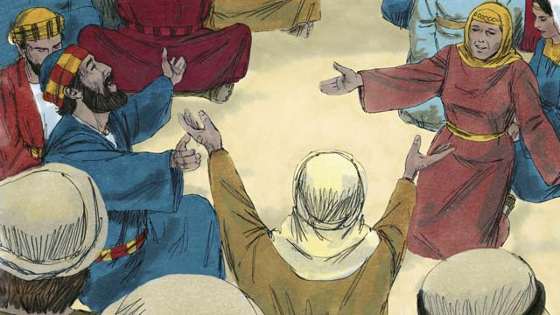

After Jesus returned to heaven, the disciples stayed in Jerusalem as Jesus had commanded them to do. The believers there constantly gathered together to pray.

43-02

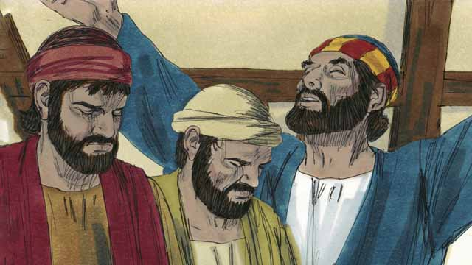

Every year, 50 days after the Passover, the Jews celebrated an important day called Pentecost. Pentecost was a time when the Jews celebrated the wheat harvest. Jews came from all over the world to Jerusalem to celebrate Pentecost together. This year the time for Pentecost came about a week after Jesus had gone back to heaven.

43-03

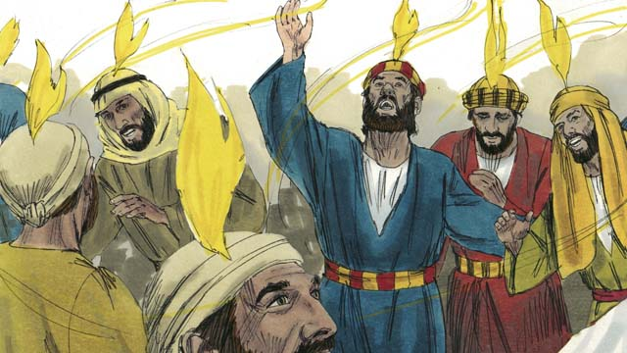

While the believers were all together, suddenly the house where they had gathered was filled with a sound like a strong wind. Then something that looked like flames of fire appeared over the heads of all the believers. They were all filled with the Holy Spirit and they praised God in other languages. They did not know these languages, but these were languages that the Holy Spirit enabled them to speak.

43-04

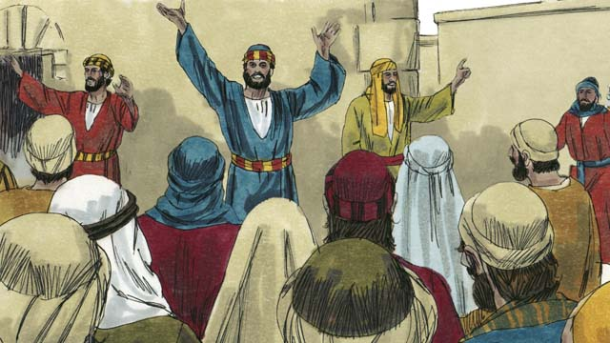

When the people in Jerusalem heard this noise, they came together in a crowd to see what was happening. They heard the believers proclaiming the great things God had done. They were astonished because they could understand even though they were from many different countries and spoke many different languages. The disciples were from Israel and spoke Aramaic, Hebrew, or Greek, but the people were each hearing what God had done in their own native language.

43-05

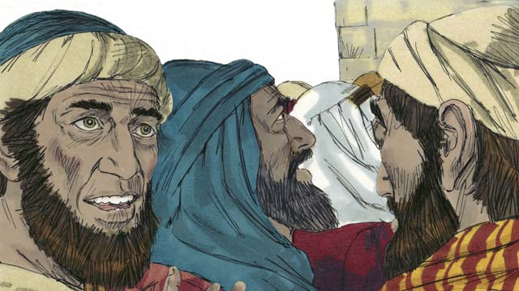

Some of these people said that the disciples were drunk. But Peter stood up and said to them, “Listen to me! These people are not drunk! Instead, what you see is what the prophet Joel said would happen: God said, ‘In the last days, I will pour out my Spirit.’”

43-06

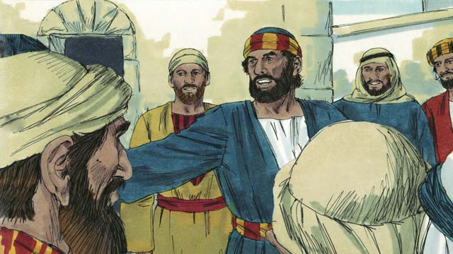

“Men of Israel, Jesus was a man who did many wonderful things to show who he was. He did many amazing things by God’s power. You know this because you saw these things. But you crucified him!”

43-07



“Jesus died, but God raised him from the dead. This made come true what a prophet wrote: ‘You will not let your Holy One rot in the grave.’ We are witnesses that God raised Jesus to life again.”

43-08

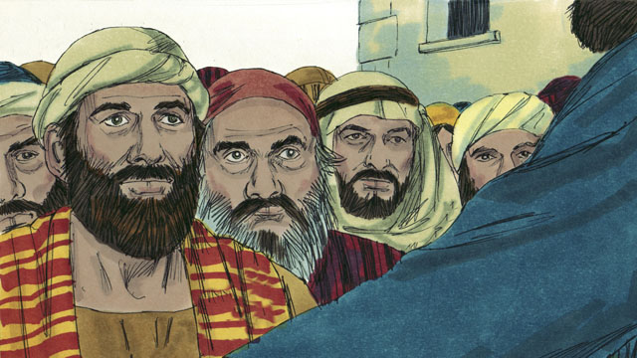

“God the Father has now honored Jesus by making him sit at his right hand. And Jesus has sent the Holy Spirit to us just as he promised he would do. The Holy Spirit is causing the things that you are now seeing and hearing.”

43-09

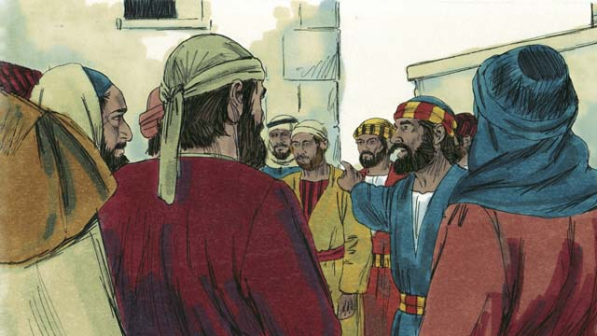

“You crucified this man, Jesus. But know for certain that God has caused Jesus to become both the Lord of everything and the Messiah!”

43-10

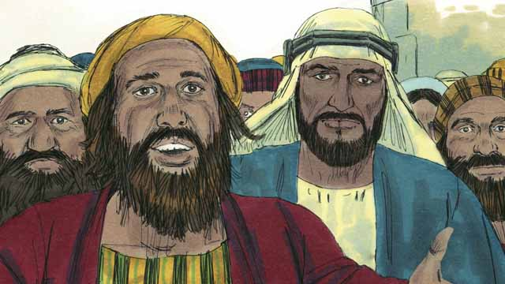

The people listening to Peter were deeply moved by the things that he said. So they asked Peter and the disciples, “Brothers, what should we do?”

43-11

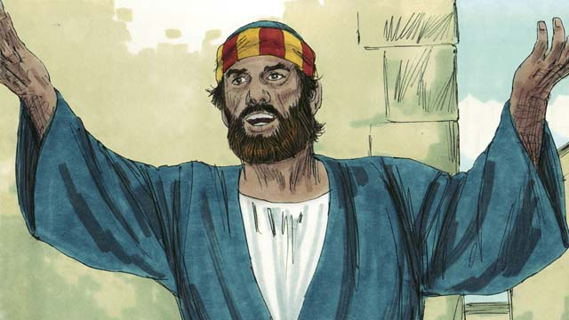

Peter answered them, “All of you need God to forgive your sins. So repent and be baptized every one of you in the name of Jesus Christ. Then God will also give you the Holy Spirit as a gift.”

43-12

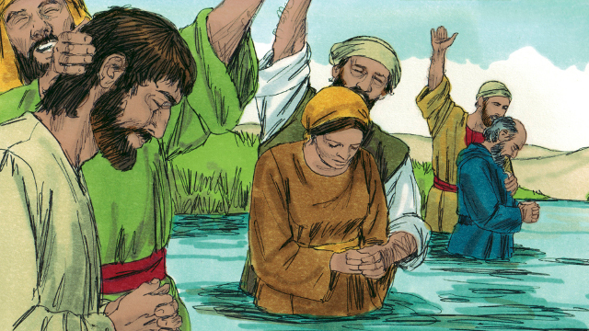

About 3,000 people believed what Peter said and became disciples of Jesus. They were baptized and became part of the church at Jerusalem.

43-13

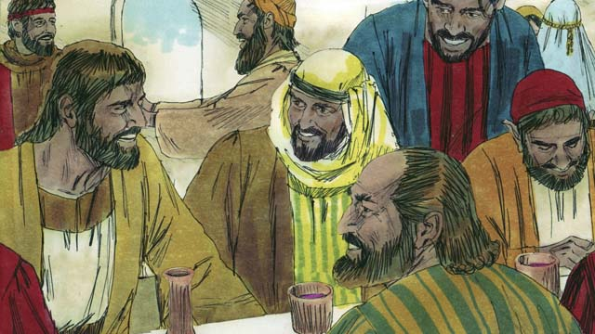

The believers continually listened as the apostles taught them. They often met together and ate together, and they often prayed with each other. They praised God together and they shared everything they had with each other. Everyone in the city thought well of them. Every day, more people became believers.

*A Bible story from: Acts 1:12-14; 2*

## 1 Biblical Interpretation: Observing the Details of the Story

After reading the crafted biblical story, answer the following questions to familiarize yourself with the details of the story.

### 1.1 Observation Questions

Answer the following observation questions to gain a basic understanding of the the story. Read the story as a community and answer these questions as a group.

#### 43-01

What did the disciples do after Jesus returned to heaven?  
After Jesus returned to heaven, the disciples stayed in Jerusalem as Jesus commanded them.

What were the disciples doing while they waited in Jerusalem?  
They constantly gathered together to pray.

#### 43-02

When did the Jews celebrate Pentecost?  
They celebrated Pentecost every year, 50 days after the Passover.

Why was Pentecost as special day of celebration?  
Pentecost was a time when the Jews celebrated the wheat harvest.

Who came to Jerusalem to celebrate Pentecost?  
Jews from all over the world traveled to Jerusalem to celebrate Pentecost together.

When time Pentecost occur this particular year?  
This particular year, the time for Pentecost came one week after Jesus had returned to heaven.

#### 43-03

What happened to the believers during the Pentecost after Jesus rose from the dead?  
There was a sound like a strong wind, and something like flames of fire appeared over their heads. They were filled with the Holy Spirit and began to speak in other languages.

Did the believers know these languages?  
No. The believers did not know these languages, but the Holy Spirit enabled them to speak the languages.

#### 43-04

Who gathered to observe the believers speaking in other languages?  
The people in Jerusalem gathered in a crowd to see what was happening.

What were the believers saying?  
The believers were speaking/proclaiming great things God had done.

Why were the people in the crowd astonished?  
The people in the crowd were from many different countries, but they each heard the Jewish disciples (who spoke Aramaic, Hebrew, and Greek) speaking in their native language.

#### 43-05

What did some of the people think was the reason the disciples were talking this way?  
They thought the disciples were drunk.

How did Peter respond to the accusation that they were drunk?  
Peter instructed the people to listen to him, he told them that they were not drunk, and he explained that the prophet Joel predicted that this would happen.

What did Peter say was causing them to speak these languages?  
Peter said God would pour out his Spirit in the last days.

#### 43-06

What did Peter say about how Jesus showed people who he really was?  
Peter proclaimed that Jesus did miracles/wonders by God’s power to show who he was.

How would people know that Jesus did such miracles?  
Peter said that people witnessed Jesus do these miracles.

Who did Peter say was responsible for crucifying Jesus?  
He said the people in the crowd crucified Jesus.

#### 43-07

What happened to Jesus?  
Peter explained that Jesus died and God raised him to life again.

Who affirmed Jesus’ resurrection from the dead?  
Peter explained that the prophet predicted that the Messiah would raise again to life and the disciples were witnesses of Jesus’ resurrection when he appeared to them many times.

#### 43-08

What happened to Jesus after he rose again from the dead?  
God honored Jesus by having him sit at his right hand.

Who did Jesus send to his disciples?  
Jesus sent the Holy Spirit to his followers just as he promised he would do.

What caused the disciples to be able to speak in other languages?  
The Holy Spirit caused them to be able to speak in other languages.

#### 43-09

Who did Peter say crucified Jesus?  
Peter said the people crucified Jesus.

What were the two things that Peter said God caused Jesus to become?  
He became Lord and Messiah.

#### 43-10

How did the people respond to Peter’s message?  
They were deeply moved and asked, “Brothers, what should we do?”

#### 43-11

What did Peter tell the people to do?  
He told them they needed God to forgive their sins, so they should repent and be baptized in the name of Jesus Christ.

What did Peter say they would receive if they did this?  
Peter said God would give them the Holy Spirit if they repented and were baptized in the name of Jesus.

#### 43-12

How many people believed and were baptized that day?  
About 3,000 people believed.

What community did these people form after they were baptized?  
These believers became part of the church.

#### 43-13

What did the disciples spend their time doing?  
The disciples continually listened to the teaching of the apostles, spent time together, ate together, prayed with each other, praised God together, and shared everything.

What did the people in the city think of the Christians?  
The people who lived in the city thought well of the Christians.

How often did new believers come to faith in Christ?  
Every day, more people became believers.

### 1.2 Translation Questions

Use the following translation questions to understand specific details of the passage. Discuss how you might translate these specific elements of the story.

#### 43-01

**After Jesus returned to heaven, the disciples stayed in Jerusalem** First Jesus went back to heaven. Then the disciples waited in Jerusalem. How would you express **After Jesus returned to heaven, the disciples stayed in Jerusalem** to mean the disciples remained in Jerusalem for a while subsequent to Jesus going back up to heaven?

  

**The believers there constantly gathered together to pray** The disciples of Jesus met together on a regular basis to pray to God. How would you express **The believers there constantly gathered together to pray** to mean the followers of Jesus regularly met with one another to pray to God?

  

#### 43-02

**the Jews celebrated an important day called Pentecost** Pentecost means ‘fiftieth (day).’ Pentecost is a special holy day that Jews celebrated 50 days after Passover. This happened in May. During this special day of celebration, the Jews would thank God for the wheat (a grain crop) harvest by bringing offerings and celebrate by having special meals. How would you express **the Jews celebrated an important day called Pentecost** to mean the Jewish people thanked God for the wheat harvest fifty days after Passover on a day called Pentecost?

  

**This year the time for** Pentecost came about a week after Jesus had gone back to heaven Pentecost happened every year. The year Jesus died, it took place around one week after Jesus went back to heaven. How would you express **This year the time for** Pentecost came about a week after Jesus had gone back to heaven to mean on the year the Jesus died, Pentecost took place around seven days after Jesus returned to heaven?

  

#### 43-03

**While the believers were all together** Two events happened at the same time—the believers were together, and there was a sound like a strong wind. How would you express **While the believers were all together** to mean a noise like strong wind filled the house at the same time the believers were meeting together in the house?

  

**a sound like a strong wind** In the house, there was a sound that the wind makes when it blows hard. How would you express **a sound like a strong wind** to mean a noise that a strong wind makes?

  

**filled with the Holy Spirit** The Holy Spirit came upon the believers in the house and provided them with power. How would you express **filled with the Holy Spirit** to mean the believers were given ability/power by the Holy Spirit?

  

**they praised God in other languages** The believers filled with the Holy Spirit spoke as people from other places speak. The believers did not know these languages until the Holy Spirit gave them the power to speak them. They were speaking in foreign language about the great things that God has done. How would you express **they praised God in other languages** to mean the believers honored and celebrated the great things God had done in languages other than their own language?

  

#### 43-04

**they came together in a crowd to see what was happening** The people in city of Jerusalem heard the disciples speaking in foreign languages. People who were from other parts of the world would have been surprised to hear someone speaking their native language. This happened to many people who spoke many different languages. It cause them to pay attention to this surprising and unexpected thing that was taking place. How would you express **they came together in a crowd to see what was happening** to mean people in the city of Jerusalem heard the believers speaking languages and formed a large group of people to observe what was taking place?

  

**even though they were from many different countries and spoke many different languages** The people gathered in the city of Jerusalem were from many countries and spoke different languages. They did not expect a Jew in Jerusalem to speak their native language like this. How would you express **even though they were from many different countries and spoke many different languages** to mean the people were surprised that they could understand what they believers were saying despite the fact that they spoke different languages?

  

#### 43-05

**Listen to me!** Peter stated this command in order to cause the crowd to pay attention to what he was going to tell them. How would you express **Listen to me!** as a strong statement that commands someone to pay close attention to what you are going to say?

  

**the last days** The prophet Joel spoke God’s message that God would give his Spirit in great measure toward the final days of the world. How would you express **the last days** to mean the final days before the end of the world?

  

**I will pour out my Spirit** The prophet Joel spoke God’s message many years before this time. He predicted that God would give the Holy Spirit generously. He describes this generous provision of the Holy Spirit as pouring out. This means that people would fully experience the Holy Spirit. How would you express **I will pour out my Spirit** to mean God would give the Holy Spirit abundantly to all people as someone who would pour out liquid from a container?

  

#### 43-06

**Men of Israel** Peter addresses Jewish people (People of Israel) from various people groups and languages. This included men and women. Peter considers these people fellow Jews along with himself. How would you express **Men of Israel** to mean Jewish people, including men and women?

  

**Jesus was a man who did many wonderful things to show who he was** Jesus performed many miracles. Jesus used these miracles to clarify for people who he really is. How would you express **Jesus was a man who did many wonderful things to show who he was** to mean Jesus did many miraculous things to demonstrate to people that he is the Messiah?

  

**But you crucified him!** Peter strong accuses the people in the crowd of murdering Jesus, the Messiah whom God had sent to them. The Jews did not actually nail Jesus to the cross. However, the Jewish leaders caused him to be condemned and many of the people in the crowd had shouted for him to be crucified. Jesus did many wonderful things, so you would expect people to recognize that he was sent from God. Instead, they crucified him. How would you express **But you crucified him!** to mean the people treated Jesus opposite than one would expect and caused Jesus to be killed on a cross?

  

#### 43-07

**You will not let your Holy One rot in the grave** The prophet predicted that God would not allow the Messiah to remain dead and decay in the grave. This refers to the fact that Jesus did not remain in the tomb very long. It is another way of saying that he did not stay dead, but rather, came back to life again. How would you express **You will not let your Holy One rot in the grave** to mean God would not permit the Messiah, his chosen one, to remain dead and decompose in a tomb but would bring him back to life?

  

**We are witnesses that God raised Jesus to life again** Peter said that Jesus’ disciples would testify to the truth that God brought Jesus back to life. Peter included himself in this group of witnesses. How would you express **We are witnesses that God raised Jesus to life again** to mean Jesus’ followers (including Peter) attest/testify to others that God resurrected Jesus (God caused Jesus to come back to life again)?

  

#### 43-08

**God the Father has now honored Jesus by making him sit at his right hand** God the Father set Jesus at his right side. This was the most important side and referred to the place of highest honor and authority. Because Jesus completed the work of salvation, he sat down at the right side of God the Father. This means Jesus rules with the same authority as God the Father. How would you express **God the Father has now honored Jesus by making him sit at his right hand** to mean God the Father affirmed Jesus’ honor and rule by having him sit on his right side, the most important place of respect and authority?

  

**The Holy Spirit is causing the things that you are now seeing and hearing** Peter is referring to the believers speaking in foreign languages. This was a miracle. They were speaking languages that they did not previously understand. Peter explains that the Holy Spirit is giving the believers the power to do this. The people in the city of Jerusalem were observing and hearing this as it happened. How would you express **The Holy Spirit is causing the things that you are now seeing and hearing** to mean the Holy Spirit is enabling the believers to speak in foreign languages that the people were now observing and understanding?

  

#### 43-09

**know for certain that** Peter tells the people a fact that is true. He wants them to know that God affirmed that Jesus is Lord and Messiah. He does not want people to doubt this fact. How would you express **know for certain that** as a command to understand a fact to be proven true without any doubt?

  

**God has caused** Jesus to become both the Lord of everything and the Messiah Jesus is fully equal with God the Father. Since Jesus is eternal, he always has been Lord and Messiah. Jesus is sovereign over all things and he is the deliverer God promised to send to save people from their sin. God made it clear to people that Jesus is Lord and Messiah by raising him from the dead and establishing him at his right side. This is always Jesus’ rightful place. How would you express **God has caused** Jesus to become both the Lord of everything and the Messiah to mean God the Father confirmed that Jesus is sovereign Lord and the promised Messiah by raising him from the dead and honoring him to the highest place at his right hand?

  

#### 43-10

**deeply moved by** The people felt very strong emotions when they heard Peter’s speech. They were very troubled by their own guilt before God. How would you express **deeply moved by** to mean the people felt very sad when they heard Peter’s words?

  

**So they asked** The people felt strong emotions when they heard Peter’s speech. As a result, they people asked Peter how they should respond. How would you express **So they asked** to mean the result of the people feeling strong emotions of conviction was to asked Peter and the disciples what they should do?

  

#### 43-11

**So repent and be baptized** Peter explained that the people needed God to forgive their sins. Based on this truth, the people needed to repent (turn from their sin) and be baptized (have water applied to them in a ritual way the symbolized purification and initiation into the community of faith). In short, the people should repent and be baptized because they want to be forgiven of their sins. How would you express **So repent and be baptized** to mean the result/outcome of the people needing God to forgive their sin was for them to turn from their sin and be baptized with water?

  

**in the name of Jesus Christ** Peter told the people to be repent and be baptized in Jesus’ name. This means those who were baptized were confirmed as believers by Jesus’ authority and put themselves under Jesus authority. How would you express **in the name of Jesus Christ** to mean to be baptized in the authority of Jesus Christ?

  

**Then God will also give you the Holy Spirit as a gift** If the people repented, God would give them the Holy Spirit. How would you express **Then God will also give you the Holy Spirit as a gift** to mean the result of people repenting of their sin and being baptized was that God would give the people the Holy Spirit as a gift?

  

#### 43-12

**They were baptized and became part of the church at Jerusalem** Baptism with water was a symbol of purification. It was also an initiation ritual which brought members into a community of other believers. How would you express **They were baptized and became part of the church at Jerusalem** to mean the people were baptized with water and joined the community of believers in the city of Jerusalem?

  

#### 43-13

**The believers continually listened as the apostles taught them** The believers paid attention to the teaching of the apostles and obeyed what they taught. This was a habit that they regularly did. How would you express **The believers continually listened as the apostles taught them** to mean the followers of Jesus heard what the apostles taught and obeyed the teaching?

  

**thought well of them** The people who lived in the city had respect for the Christians. The Christians had a good reputation. How would you express **thought well of them** to mean had a positive opinion of them?

  

## 2 Theological Dialogue: Discussing the Meaning of the Story

Take time to explore the meaning of this story together as a community. Use the following discussions as a way to grasp what truth the story teaches.

### 2.1 Discourse Questions

Use the following discourse questions to understand the meaning of the story. Pay attention to how the story itself addresses each question or theme.

##### How did the Holy Spirit come upon the believers at Pentecost? (43-01, 43-02, 43-03, 43-04, 43-05)

Waiting: Jesus returned to heaven to be with God the Father. After this, the disciples remained in Jerusalem. Jesus commanded them to do this. They waiting in Jerusalem for God to send the Holy Spirit. (43-01)

  

Celebration of Harvest: The Holy Spirit came on the day of Pentecost. This was a special holy day that Jews celebrated the firstfruits of the wheat harvest. It came 50 days after Passover. On the year Jesus died, Pentecost took place about a week after Jesus went back to heaven. Pentecost celebrated God’s blessing that God provided the harvest. This represented God providing for his people. God would provide for his people by sending the Holy Spirit. (43-02, 43-03)

  

Power to Speak Foreign Languages: When the Holy Spirit came, he filled the believers and they spoke foreign languages that they previously did not know. A loud noise like a strong wind filled the house. Something like flames appeared over the heads of the believers. The Holy Spirit gave the disciples the power to speak foreign languages. (43-03)

  

Worship, Praise, and Astonishment: The people in the city of Jerusalem were astonished that Jews from Jerusalem were speaking in the native languages of people who were from other countries. The believers told about the great things God had done as they spoke in other languages. The people were amazed and astonished. (43-03, 43-04)

  

Abundant Provision: The people did not fully understand what was happening. They thought that the believers were drunk. Peter corrected their misunderstanding. He explained that the prophet Joel predicted that God would abundantly provide the Holy Spirit in the last days. God provided the Holy Spirit abundantly and generously. This was a sign of the final days of human history and also of God’s power to work in and through his people. (43-05)

  

##### What were the main parts/contents of Peter’s message to the people? (43-06, 43-07, 43-08, 43-09)

Miracles and Ministry: Peter preached that Jesus performed miracles and and did amazing things by God’s power. These miracles healed people who were sick, set people free from demons, or helped people in difficult situations. One reason Jesus did miracles was to show that he was the Messiah. (43-06)

  

Crucifixion: Peter preached that Jesus was crucified on a cross. Peter specially told the people that they were responsible for Jesus dying on the cross. Even though the people did not actually nail Jesus to the cross, many rejected him as the Messiah. Also, Jesus died on the cross to forgive sin. Since all people are sinners, we are part of the reason Jesus died on the cross. (43-06, 43-07, 43-09)

  

Resurrection: Peter preached that Jesus rose again from the dead. The Old Testament Scriptures (and prophets) predicted that the Messiah would come back to life. (43-07)

  

Ascension: Jesus returned to heaven and sat down on the right side of God the Father. This was a place of honor and authority. Jesus completed the work of salvation and took his rightful place as king. God promised that he would do this. God confirmed that Jesus is Lord/Ruler of all things and the promised Messiah who came to deliver people from their sin. (43-08, 43-09)

  

##### How did the people respond to Peter’s message? (43-10, 43-11, 43-12)

Conviction: The people felt strong emotions of guilt when they heard Peter’s message. They knew that they were guilty of sin. They felt these emotions so strongly that they asked Peter what they should do to make things right. (43-10)

  

Repentance: Peter told the people to repent. They all needed God to forgive their sins. The only way their guilt would be taken away was for God to forgive them. God would forgive them if they turned away from and rejected their sinful lives and turned to God. (43-10)

  

Baptism: Peter also told the people that they should be baptized. This means to have water applied to them in a ritual way to symbolize the forgiveness of their sins, their faith in Jesus, and their inclusion in the community of believers (the church). When the people were baptized, they became a part of the church in the city of Jerusalem. Baptism is a public profession of faith in Jesus as the Messiah, a rejection of one’s past life of sin, and a commitment to join the church community. (43-11, 43-12)

  

##### What did Jesus’ followers/disciples do as a community of believers? (43-01, 43-12, 43-13)

Habit of Meeting Together: Before Pentecost, the believers met together on a regular basis to pray. They practiced their faith as a community of believers. Even after the Holy Spirit came, the believers met together on a regular basis. The believers had a habit of being together. (43-01, 43-13)

  

Baptism: People became members of the church through baptism. Baptism is a ritual act in which believers publicly acknowledge their faith in Jesus, repent from their sin, and join the church community. (43-12)

  

Prayer: The believers spent time praying together. They had a habit of praying to God. (43-01, 43-13)

  

Fellowship: The believers ate meals together. Sharing meals together was something that people did with family and close friends. The church community was acting like a family. (43-13)

  

Sharing Possessions: The believers shared their possessions with one another. They helped out other community members who were in need. Again, this shows how these believers treated one another like family. (43-13)

  

Teaching: The believers listened to the teaching of the apostles. They also did this on a regular basis. They heard the teaching and obeyed it. (43-13)

  

Worship/Praise: The believers worshipped God together. They praised God for the great things he did. (43-13)

  

Good Reputation: The believers had a good reputation with those who were not Christians. This does not mean that Christians acted in sinful ways to make unbelievers like them. Instead, Christians lived upright and respectable lives and this caused the other people to respect them. (43-13)

  

New Christians: Other people became believers on a daily basis. Jesus’ disciples were witnesses of Jesus’ resurrection to others. Also, the way Christians lived together as a community was really attractive to others. Many people came to believe in Jesus, repent of their sin, get baptized, and become part of the church community. (43-07, 43-13)

  

### 2.2 Theological Questions

Answer the following theology questions as a community. Discuss what truths this story teaches.

1. Who is the Holy Spirit and what important role does he have in God’s work? What does the story of Pentecost teach us about the person and work of the Holy Spirit?
2. What is the core content of the gospel message? How does Peter’s speech provide a summary of the gospel message?
3. What is the appropriate response to the gospel message? How do people become believers/disciples? What does this story teach us about how people became followers of Jesus and joined the church?
4. What does it mean to be the church? How does this story give a picture of what it means for believers to be a part of a faith community?

### 2.3 Translation Draft

Work as a translation team to draft each panel of this story. Pay attention to any specific translation issues that are challenging or significant.

#### Make Translation Draft

Make a draft for each section of this story.

#### Discuss and Revise

After drafting the story, discuss any translation issues that you think need special explanation.

#### Drafting Summary Reflection

Summarize any noteworthy translation decisions and the rationale/reasoning behind these translation decisions. In the final movement of this class, you will use these observations to give an account (i.e., chronicle/narrate) of how your translation improved through the checking process.

## 3 Personal Reflection: Following the Teaching of the Story

Take a moment to allow this story to evaluate your own life and to consider how God would have you respond. After this reflection, use the quality checking questions to check your translation draft among the translation team.

### 3.1 Journal Reflection

Prayerfully think about the following personal reflection questions. Write/Record your answers and/or discuss them as a group.

1. How has the Holy Spirit give you power to be a witness for Jesus?
2. How has your understanding and belief in the gospel grown deeper as a result of this story?
3. In what ways has Jesus taken away your guilt as a sinner?
4. In what ways can you participate in helping the church become a healthy faith community?

### 3.2 Team Check

*The following activity will help you check the clarity, accuracy, and naturalness of your draft. Read the passage aloud and discuss the checking questions with other members of your translation community. You might need to reread portions (or the whole) of the biblical passage multiple times as you answer each of these questions. Record answers to these questions below.*

#### Team Checking Questions

*Use the following questions to check your translation draft for accuracy, clarity, and naturalness.*

1. **Accurate**: Has anything been **added** to your translation of this passage that is not a part of the meaning of the source text? *If additions exist, are they included only added to clarify meaning (such as implied information)?*
2. **Accurate**: Is anything **missing** from your translation of this passage that is a part of the meaning of the source text? *If some part of the meaning is missing from your translation, add it.*
3. **Accurate**: Does any meaning in your translation of this passage appear to be **different** than the meaning of the source text? *If the meaning is different, try changing your translation so that the meaning remains the same.*
4. **Natural**: Does anything sound **unnatural** to how you would say it in your language? *If portions of the passage sound unnatural in your language, try to make them sound the way you would say it in your language while staying true to the meaning of the source text.*
5. **Clear**: Is anything **unclear** or **confusing** in your translation that confuses the meaning of the source text? *If portions of the passage are unclear or confusing, revise them to clearly communicate the meaning of the source text.*
6. **Consistent**: How **consistent** is your translation within the passage and with other passages? *If portions of the passage need to be made consistent or if you need to revise translations of other passages, make these adjustments.*

#### Record Feedback

*After discussing the checking questions above as a translation community, record any feedback on your translation draft. Pay attention for parts of your translation that are translated well and parts of your translation that need correction.*

#### Discuss and Revise

*After gathering feedback on your draft, discuss it together with your translation community and make appropriate revisions in your translation.*

#### Record Translation Decisions

*As a community, discuss some of the most noteworthy translation decisions in your draft. Summarize each decision and explain the reasons your community decided on that translation. You should update these decisions each time you check your draft with various groups of people.*

You should **measure** the quality of your translation draft. You can **record translation decisions** to make it clear why you translated things a certain way. Translation decisions can help your translation team and the surrounding community be a part of the translation process.

How can you know the quality of your translation?

1. **Measure** the translation by marks/standards of quality (i.e., clear, accurate, natural, church-approved)
2. **Test** the translation with others and record feedback and conversations from in the field (i.e., church and community check)
3. **Compare** and **contrast** the translation with the source text (i.e., meaning of text and notes) and alternatives (i.e., other translation choices)
4. **Explain** the reasons why you translated a particular portion of the text.

**Example Sentences That Help Explain Your Translation Decision** Use the following example sentences to help explain your translation decisions:

1. The original text literally **says/means**, so we translated the term in this way…
2. We originally decided to translate **the biblical term** in with **this term**, but we changed it because…
3. When our translation team discussed **the biblical term**, this is what we talked about…
4. **The term** is [clear, accurate, natural, consistent] because…
5. The community understands **this term** it to mean…
6. We considered these other terms. We did not use **these terms** because…
7. When we checked this in the church, we learned…
8. When we checked this in the community, we learned…

**Example of Translation Decision**

In OBS 01-07 we decided to translate **blessed** like this: [actual translation]. We decided this translation because of these reasons:

1. The word [actual translation] means to cause good things to happen to someone or something. This term is used when a person desires someone or something to prosper or flourish. This term does not refer to magic or witchcraft.
2. When we checked this word with other believers, they said it describes God showing his kindness and favor on someone or something. These are some of the terms that we did not decide to use…
3. Many of our people will understand this word. When we discussed this phrase with the surrounding community, we discovered it was a natural way to describe God causing good and beneficial things to happen.

## 4 Ministry Practice: Serving the Church with the Story

Now that you have a draft of this story, consider how this story can encourage other believers in their faith. After ministering this story to others, you will also perform a community check of your translation draft.

### 4.1 Church Ministry

Reflect on how this story can edify and mature the Christian community. Design a way to minister this story to your church community.

**Ministry Preparation**: Take time to consider how you could minister this story to others. Record some ministry ideas below.

**Ministry Implementation**: Minister this story to a group of believers as you had planned. Use the information in this study to help develop a teaching/lesson or lead a discussion of this story to other believers. Record your ministry plan below.

**Ministry Reflection**: Think about what you learned from ministering this story to other believers. Reflect on your experience below.

### 4.2 Church Community Check

After teaching or ministering this story to the church, check the translation quality with the church community. Record any feedback from your checking experience.

#### Create Checking Questions

You can use **Translation Questions** to check you draft. Each **Translation Question** explains the meaning of a specific part of the story and asks you to consider how you would translate that part of the story in your own language. Change each **Translation Question** into a **Checking Question** by asking the following questions. The first question asks you to identity how each specific phrase was translated in your language. The second question asks people in the church to determine if your translation of the phrase expresses the meaning clearly, accurately, and naturally. Look at the following examples to see how to change **Translation Questions** into **Checking Questions**:

#### Translation Question Example 1

**to proclaim the good news about Jesus** Paul and Silas traveled to Philippi for the purpose of preaching the gospel. The gospel is the good news that Jesus saves people from their sins if they will believe in Jesus. How would you express **to proclaim the good news about Jesus** to mean to tell other people the message about how Jesus can save people from their sins?

#### Translation Question Example 2

**a merchant** Paul and Silas met a woman named Lydia at the place by the river. She owned a business and sold items to make money. How would you express **a merchant** to mean a business owner who sells items for a profit?

#### Translation Question Example 3

**so Paul and Silas baptized them** The jailer and his whole family followed Paul’s instructions. They believed in Jesus. The result of this was Paul and Silas baptized them. How would you express **so Paul and Silas baptized them** to mean the result of the jailer and his family believing in Jesus that Paul and Silas baptized all of them?

You can change these into **Checking Questions** like this:

#### Checking Question Example 1

**to proclaim the good news about Jesus** How did you translate **to proclaim the good news about Jesus**? Does it mean to tell other people the message about how Jesus can save people from their sins?

#### Checking Question Example 2

**a merchant** How did you translate **a merchant**? Does it mean a business owner who sells items for a profit?

#### Checking Question Example 3

**so Paul and Silas baptized them** How did you translate **so Paul and Silas baptized them**? Does it mean the result of the jailer and his family believing in Jesus that Paul and Silas baptized all of them?

#### Record Feedback

*Discuss the* ***Checking Questions*** *with your church community, and record any feedback on your translation draft. Pay attention for parts of your translation that are translated well and parts of your translation that need correction.*

#### Discuss and Revise

*After gathering feedback on your draft, discuss it together with your translation community and make appropriate revisions in your translation.*

#### Record Translation Decisions

*Update your translation decisions and record and new any noteworthy observations on the quality of your draft.

## 5 Missional Outreach: Sharing the Truth of the Story

*After sharing this story with others, check the translation quality with the wider language community. Record any feedback from your checking experience.*

### 5.1 Mission Engagement

*Consider how you will witness this story to unbelievers. Design a way to share this story and engage them in what it teaches about Christianity and the gospel.*

**Witness Preparation**: Take time to consider how you will witness this narrative to unbelievers. Record some ideas below.

**Witness Implementation**: Share this story with an unbeliever. Use the information in this study to help develop a teaching/lesson or lead a discussion of this story to other believers. Record your ministry plan below.

**Witness Reflection**: Think about what you learned from ministering this story to unbelievers. Reflect on your experience below.

### 5.2 Sociolinguistic Check

After sharing this story with the language community, check your translation draft with the surrounding community. Record your observations.

#### Checking Approach

After witnessing this story to unbelievers, use one of the following methods to check the translation of this story. Consider using the **Observation Questions** to check your translation draft or come up with your own quality checking questions.

**Read-Retell Check:** Read your draft to those the community and ask them to retell the passage. Be attentive for any portions of the passage that are unclear, unnatural, or inaccurate.

**Comprehension Questions Checklist:** Read the draft of the passage and ask a list of comprehension questions to make sure the passage is being rightly understood. You can use the **Observation Questions** in this guide or come up with your own questions. Then, record any insights or issues that arise.

**Discussion Group:** Develop key questions to ask about the passage (both formational and translational). Read the passage and have a group discussion about the passage, paying attention to issues that need to be addressed, edited, and revised.

#### Record Feedback

*After sharing your draft with language community, discuss the* ***Observations Questions****, and record any feedback on your translation draft. Pay attention for parts of your translation that are translated well and parts of your translation that need correction.*

#### Discuss and Revise

*After gathering feedback on your draft, discuss it together with your translation community and make appropriate revisions in your translation.*

#### Record Translation Decisions

*Update your translation decisions and record and new any noteworthy observations on the quality of your draft.

## 6 Conclusion

As a translation community, take time to reflect on all that was learned in studying, drafting, and checking this story. Celebrate all that God has taught you as a community. Then, submit your revised draft and checking summaries to network leaders for further review.