Open Bible Stories

Stephen and Philip

## 0 Introduction

### 0.1 Key Idea

The story of Stephen and Philip teaches us how the gospel spreads through martyrdom and the work of the Holy Spirit.

### 0.2 Creedal Verse

“So everyone who acknowledges me before men, I also will acknowledge before my Father who is in heaven, but whoever denies me before men, I also will deny before my Father who is in heaven.” Matthew 10:32-33.

### 0.3 Metanarrative Summary

The eternal God created all things in six days. He made a good and perfect world. He made humans in his image to fill the earth and rule over creation. But humans rebelled against God and ruined God’s creation. God set to restore his world through his promise. God made a covenant with Abraham. He promised to bless all nations through Abraham. God kept his promises across the generations. God provided Abraham with a promised child, Isaac. God gave Isaac a wife, and she bore twins, Jacob and Esau. God blessed Jacob and his sons, and the blessing continued to the next generation. God rescued Joseph, one of Jacob’s sons, and used him to rescue his family. God caused his people, the Israelites, to multiply in the land of Egypt; eventually, they became slaves. But God raised up a deliverer, Moses, to deliver his people from slavery. God judged the Egyptians with harsh plagues; in the final judgment, he passed over his people, who covered their doorposts with the blood of a sacrificed lamb. Then, God delivered the Israelites by bringing them out of Egypt and crossing the Red Sea on dry land. God made a covenant with the Israelites and made them his people. God tested Israel in a series of wilderness wanderings and eventually brought his people into the promised land of Canaan. God raised up deliverers to lead Israel and rescue them from their enemies. God formed Israel into a kingdom. He made a covenant with King David and promised to send a king that would rule his people forever. Many of Israel’s kings were evil, and the kingdom of Israel was divided into two kingdoms. God sent prophets to warn his people of God’s judgment and call them to repent. When Israel did not repent, God sent his people into exile. After many years, he brought them back to the land. Throughout the Old Testament, God promised to send his Messiah to deliver his people from their sin. After many years, the prophet John was born. He would prepare people for the coming Messiah. At the perfect time, God sent his Son, Jesus, to be born of a virgin Mary. When John and Jesus grew up, John baptized Jesus as a sign that Jesus was God’s beloved Son. Jesus endured all manner of temptation without ever sinning. When he was thirty years old, he launched a public ministry of preaching, teaching, and healing. He taught his disciples about the life of compassion, sacrifice, and forgiveness. Jesus performed many miracles: he fed a crowd of five thousand, he walked on water, he healed the sick, and he cast out demons. He proclaimed to people the nature of real faith, God’s kingdom, and how fallen humans can be restored in relationship with God. Toward the end of his ministry, Jesus revealed his power and glory to his disciples. He raised a dead man to life. Jesus was betrayed by one of his disciples and put on trial before a Roman governor. Jesus was sentenced to death and crucified on a cross Three days later, Jesus rose again from the dead. After meeting with many of his disciples, Jesus went back to heaven. The Holy Spirit empowered Jesus’ followers and formed them into his church. Jesus’ disciples, like Peter and John, performed miracles and preached the good news about Jesus. New leaders like Stephen and Philip served the church and preached about Jesus.

### 0.4 Open Bible Story: Stephen and Philip

45-01

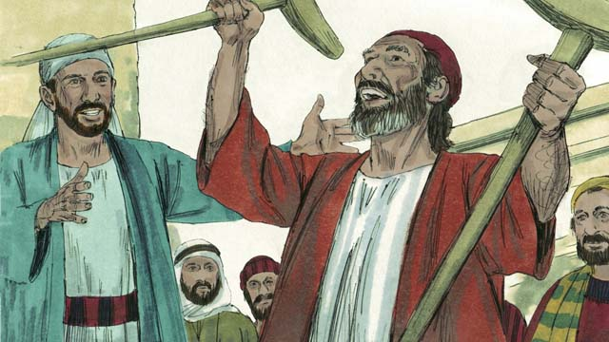

One of the leaders among the first followers of Jesus was a man named Stephen. Everyone respected him. The Holy Spirit gave him much power and wisdom. Stephen did many miracles. Many people believed him when he taught them to trust in Jesus.

45-02

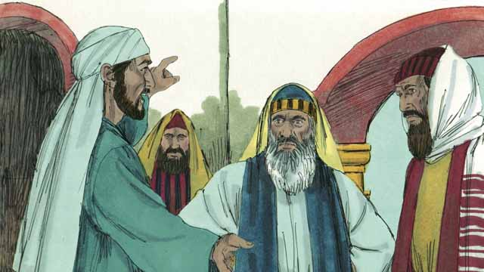

One day when Stephen was teaching about Jesus, some Jews who did not believe in Jesus came and began to argue with him. They became very angry, so they went to the religious leaders and told lies about him. They said, “We heard Stephen speak evil things about Moses and God!” So the religious leaders arrested Stephen and brought him to the high priest and the other leaders of the Jews. More false witnesses came and lied to them about Stephen.

45-03

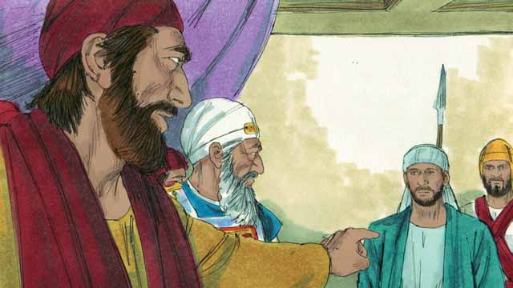

The high priest asked Stephen, “Are these men telling the truth about you?” Stephen began to say many things in order to answer the high priest. He said that God had done many wonderful things for the people of Israel from the time when Abraham lived to the time of Jesus. But the people had always disobeyed God. Stephen said, “You people are stubborn and rebellious against God. You always reject the Holy Spirit, just as our ancestors always rejected God and always killed his prophets. But you did something worse than they did! You killed the Messiah!”

45-04

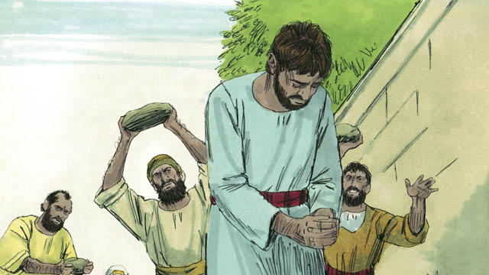

When the religious leaders heard this, they were so angry that they covered their ears and yelled loudly. They dragged Stephen out of the city and threw stones at him in order to kill him.

45-05

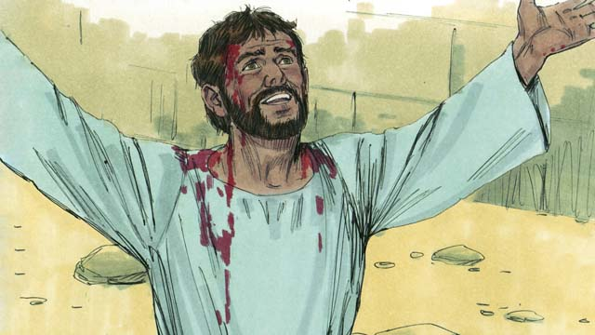

As Stephen was dying, he cried out, “Jesus, receive my spirit.” He fell to his knees and cried out again, “Master, do not hold this sin against them.” Then he died.

45-06

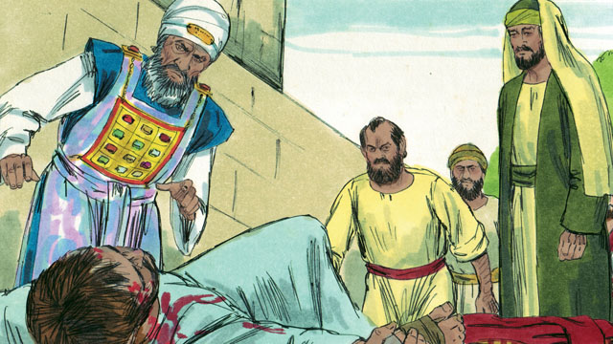

That day many people in Jerusalem started persecuting the followers of Jesus, so the believers fled to other places. But in spite of this, they preached about Jesus everywhere they went.

45-07

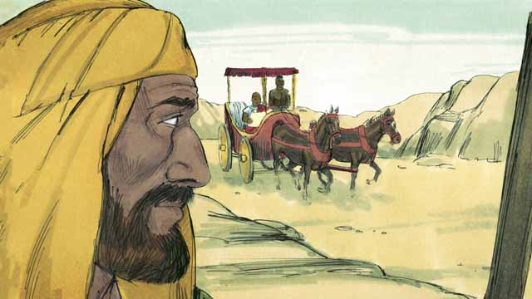

There was a believer in Jesus named Philip. He fled from Jerusalem, as did most other believers. He went to the region of Samaria, where he preached to people about Jesus. Many people believed him and were saved. One day, an angel came from God to Philip and told him to go into the wilderness, and to walk down a certain road. Philip went there. As he was walking on the road, he saw a man riding in his chariot. This man was an important official from the land of Ethiopia. The Holy Spirit told Philip to go and talk with this man.

45-08

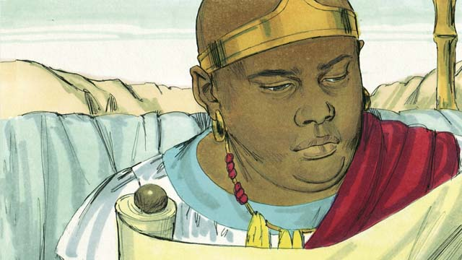

So Philip went to the chariot. He heard the Ethiopian reading God’s word. He was reading what the prophet Isaiah had written. The man read, “They led him like a lamb to be killed, and as a lamb is silent, he did not say a word. They treated him unfairly and did not respect him. They took his life away from him.”

45-09

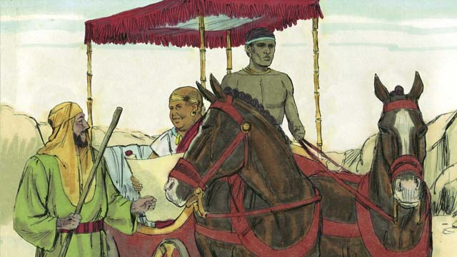

Philip asked the Ethiopian, “Do you understand what you are reading?” The Ethiopian replied, “No. I cannot understand it unless someone explains it to me. Please come and sit next to me. Was Isaiah writing about himself or someone else?”

45-10

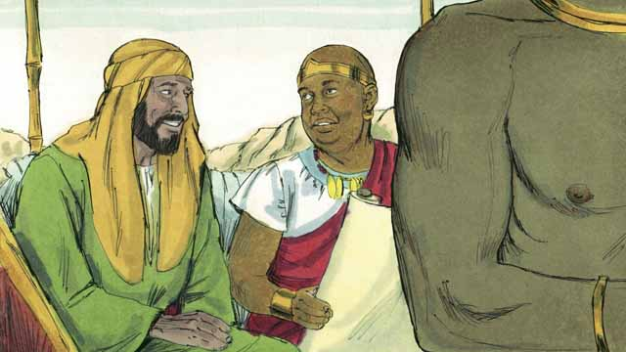

Philip got into the chariot and sat down. Then he told the Ethiopian man that Isaiah had written about Jesus. Philip also spoke about many other parts of God’s word. In this way, he told the man the good news about Jesus.

45-11

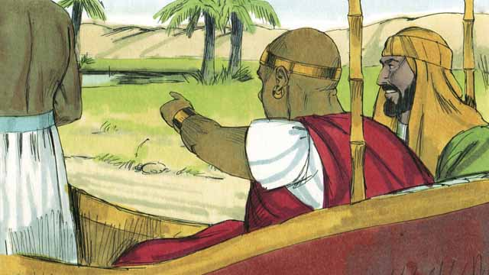

As Philip and the Ethiopian traveled, they came to some water. The Ethiopian said, “Look! There is some water! May I be baptized?” And he told the driver to stop the chariot.

45-12

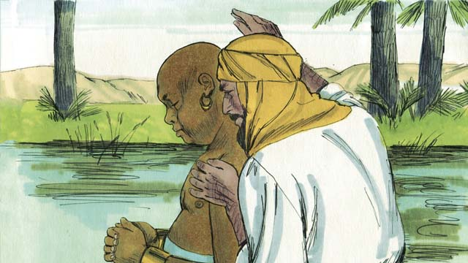

So they went down into the water, and Philip baptized the Ethiopian. After they came up out of the water, the Holy Spirit suddenly carried Philip away to another place. There Philip continued to tell people about Jesus.

45-13

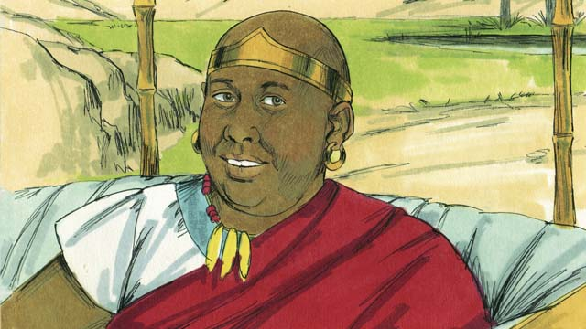

The Ethiopian continued traveling toward his home. He was happy that he now knew Jesus.

*A Bible story from: Acts 6-8*

## 1 Community Study: Christlike Community—Clothing Ourselves with Christ’s Character

* **Key Idea**: exemplifying the character of Christ in our relationship with each other
* **Key Passage**: Colossians 3:12-17
* **Main Session**: OBS 45 (Stephen and Philip)

### 1.1 Recite the Creedal Verse (3–5 minutes)

The verse below summarizes the teaching of the current passage. Read the verse out loud as a community. Read it again several times as a group until the whole community can recite it from memory.

15 He disarmed the powers and authorities and made a public spectacle of them, by being victorious over them by the cross. Colossians 2:15

OR

13 He has rescued us from the dominion of darkness and transferred us to the kingdom of his beloved Son. 14 In his Son we have redemption, the forgiveness of sins. Colossians 1:13-14

### 1.2 Reflect on God’s Power (5–10 minutes)

God is powerful enough to change people and communities. The powers of darkness are not more powerful than God. God has full authority and power over Satan and his evil forces. Discuss together how you experienced God’s power in your own life.

I have experienced God’s power over evil in these ways…

### 1.3 Read the Passage (3–5 minutes)

Jesus rules over all. He rules over the forces of darkness. And, Jesus rules over the hearts of his people. When Jesus reigns supreme, his people begin to look like Christ. Read the passage below to learn about the characteristics of believers when Christ rules.

12 Therefore, as God’s chosen ones, holy and beloved, put on a heart of mercy, kindness, humility, gentleness, and patience. 13 Bear with one another. Be gracious to each other. If someone has a complaint against someone else, forgive in the same way that the Lord has forgiven you. 14 Above all these things, have love, which is the bond of perfection. 15 Let the peace of Christ rule in your hearts. It was for this peace that you were called in one body. And be thankful. 16 Let the word of Christ live in you richly. With all wisdom teach and admonish one another with psalms and hymns and spiritual songs. Sing with thankfulness in your hearts to God. 17 Whatever you do, in word or in deed, do all in the name of the Lord Jesus. Give thanks to God the Father through him. Colossians 3:12-17

### 1.4 Discuss the Passage (10-15 minutes)

Christians embody the characteristics of Christ. These characteristics become true of our personal lives and community as we allow Jesus to rule and reign. As a community, use the following questions to discuss the teaching of the biblical passage.

1. What key characteristics should mark Christians? How are these characteristics exemplified in Christ?
2. What is the opposite of these characteristics? What negative characteristics do we need to renounce/remove if we want to live like Christ?
3. What are the instructions in this passage? How does this passage teach us to develop these characteristics in our lives and community?
4. What concrete actions and practices can your community take so that these characteristics are true of your community?

### 1.5 Celebrate the Present (5 minutes)

Think about the change that God has powerfully brought into your life. Take time as a community to celebrate this change and name the specific characteristics listed in this passage. Use the following short prompts to help guide your time of testimony.

In the past I/we were like this…

Now, God’s power has changed us so that we are like this…

### 1.6 Pray to God (5 minutes)

Pray as a whole community that God would help your community be more like the description in this passage. Use the passage above to guide your prayer.

### 1.7 Sing a Song (3–5 minutes)

Identify a song that celebrates the character of Christ. Sing this song joyfully together.

## 2 Biblical Interpretation: Observing the Details of the Story

After reading the crafted biblical story, answer the following questions to familiarize yourself with the details of the story.

### 2.1 Observation Questions

Answer the following observation questions to gain a basic understanding of the story. Read the story as a community and answer these questions as a group.

#### 45-01

What was the name of the key Christian leader at the beginning of this story?  
One of the leaders from the first followers of Jesus was named Stephen.

What do we learn about Stephen?  
Everyone respected him, the Holy Spirit gave him much power and wisdom, and he did many miracles.

How did many people respond to Stephen’s teaching?  
Many people believed him when he taught them to trust in Jesus.

#### 45-02

How did some of the Jews who did not believe in Jesus respond to Stephen’s teaching?  
Some of the Jews that did not believe in Jesus argued with Stephen. They became angry and told lies about Stephen to the religious leaders.

What was the false charge that some Jews brought against Stephen?  
They said they heard Stephen speak evil things about Moses and God.

What did the religious leaders do to Stephen?  
The religious leaders arrested Stephen and brought him to the high priest and other Jewish leaders.

Who else came to testify against Stephen?  
More false witnesses told lies about Stephen.

#### 45-03

What did the high priest ask Stephen?  
The high priest asked Stephen if the witnesses were speaking true things about him.

How did Stephen respond to the high priest?  
Stephen said God did many wonderful things for the people of Israel, but the Israelites always disobeyed God.

What did Stephen say about the people?  
Stephen told the people they were stubborn, rebellious, and always rejected the Holy Spirit, just as the Jewish ancestors did.

What did Stephen say the people had done that was worse than their ancestors?  
They killed the Messiah.

#### 45-04

How did the religious leaders respond to Stephen’s rebuke?  
The religious leaders were so angry they covered their ears and yelled loudly.

How did the religious leaders react to Stephen’s accusation?  
They dragged Stephen out of the city and threw stones at him in order to kill him.

#### 45-05

What did Stephen say as he was dying?  
As Stephen was dying, he said, “Jesus, receive my spirit.”

What was the last thing Stephen said before he died?  
The last thing he said was, “Master, do not hold this sin against them.”

#### 45-06

What happened to the believers on the day Stephen was killed?  
On the day Stephen was killed, many people in Jerusalem started persecuting followers of Jesus.

What did the believers do when the persecution began in Jerusalem?  
They fled to other places and preached about Jesus wherever they went.

Did the believers stop preaching about Jesus?  
No. The believers continued to preach about Jesus everywhere they went, even though they were persecuted.

#### 45-07

What Christian leader ministered in Samaria?  
Philip was a Christian leader who fled from Jerusalem and preached about Jesus to the people in Samaria.

How did people respond to Philip’s preaching?  
Many people believed and were saved.

What did an angel tell Philip to do?  
One day, an angel told Philip to go into the wilderness and walk on a certain road.

Who did Philip meet on the road in the wilderness?  
He met an important official from Ethiopia who was riding in his chariot.

What did the Holy Spirit tell Philip?  
The Holy Spirit told Philip to go and talk with Ethiopian official.

#### 45-08

What was the Ethiopian official doing as Philip approached?  
He was reading what the prophet Isaiah wrote.

What did the portion of Isaiah say?  
That particular passage in Isaiah said that people would lead the Messiah to slaughter, the Messiah would remain silent, people would mistreat and disrespect him, and people would kill him.

#### 45-09

What question did Philip ask the Ethiopian official?  
Philip asked the Ethiopian official if he understood what he was reading.

Did the official understand the prophecy that he was reading?  
No, he needed someone to explain it to him.

What did Ethiopian official invite Philip to do?  
The Ethiopian official invited Philip to sit next to him and explain whether Isaiah was speaking about himself or someone else.

#### 45-10

Did Philip accept the invitation of the Ethiopian official?  
Yes. Philip got into the chariot and sat down.

Who did Philip say Isaiah had written about?  
He said Isaiah had written about Jesus.

What else did Philip explain to the Ethiopian official?  
Philip spoke from many other parts of God’s word and told the man the good news about Jesus.

#### 45-11

After Philip explained the prophecy and they came to some water, what did the Ethiopian ask Philip?  
The Ethiopian asked if he could be baptized and told the driver to stop the chariot.

#### 45-12

What did Philip and the Ethiopian do after the driver stopped the chariot?  
Philip and the Ethiopian went down into the water, and Philip baptized the Ethiopian.

What happened to Philip after he baptized the Ethiopian official?  
The Holy Spirit carried Philip away to another place.

What did Philip continue to do after he was taken away?  
After the Holy Spirit carried Philip to another place, Philip continued to tell people about Jesus.

#### 45-13

What did the Ethiopian official do after Philip left him?  
He continued traveling toward his home, happy that he knew Jesus.

### 2.2 Translation Questions

Use the following translation questions to understand specific details of the passage. Discuss how you might translate these specific elements of the story.

#### 45-01

**The Holy Spirit gave him much power and wisdom** The Holy Spirit enabled Stephen to do powerful things, such as miracles. Also, the Holy Spirit gave Stephen understanding and discernment. How would you express **The Holy Spirit gave him much power and wisdom** to mean the Holy Spirit gave Stephen the ability to do miracles and gave him understanding?

  

**Many people believed him when he taught them to trust in Jesus** Stephen taught people about Jesus. During these times of teaching, many people believed his message about Jesus, and they put their trust in Jesus. How would you express **Many people believed him when he taught them to trust in Jesus** to mean many people trusted Jesus as a result of Stephen’s teaching?

  

#### 45-02

**so they went to the religious leaders and told lies about him** Some Jews argued with Stephen and became very angry with Stephen and what he was teaching. The result of their anger was to say things that were not true about Stephen. How would you express **so they went to the religious leaders and told lies about him** to mean the result of the Jews becoming angry with Stephen was they said false things about him to the religious leaders?

  

**We heard Stephen speak evil things about Moses and God!** The Jews who were angry with Stephen told the religious leaders that Stephen said wicked things about Moses and God. This was not true. Stephen did not say these things. The Jews gave this false report to try to harm Stephen. The Jews expressed how angry they were with Stephen and tried to make the other people angry with him as well. How would you express **We heard Stephen speak evil things about Moses and God!** as a strong statement that accused Stephen of saying disrespectful and wicked things about Moses and God?

  

#### 45-03

**You always reject the Holy Spirit!** Stephen rebuked the people who were accusing him. He accused them of never obeying the Holy Spirit. How would you express **You always reject the Holy Spirit!** to mean the people continually refuse to listen to the Holy Spirit?

  

**just as our ancestors always rejected God and always killed his prophets** Stephen said that the people accusing him were behaving just like the Jewish people who lived a long time ago. The Jews who lived a long time ago turned away from God and murdered God’s messengers. Stephen’s accusers were acting in a similar way by continually refusing to listen to the Holy Spirit. How would you express **just as our ancestors always rejected God and always killed his prophets** to mean Stephen’s accusers were acting in the same way the Jews did who lived a long time ago when they continually refused to listen to God and continually murdered his messengers?

  

**But you did something worse than they did!** You killed the Messiah! Stephen made a strong statement to accuse the Jews of murdering the Messiah God had sent them. The act of murdering the Messiah was far worse than what the Jews did, who lived long ago. How would you express **But you did something worse than they did!** You killed the Messiah! as strong statements that accuse the people of doing something more evil than the ancient Israelites when they crucified the Messiah?

  

#### 45-04

**covered their ears** The religious leaders were very angry at Stephen’s rebuke. They placed their hands over their ears as a symbolic action to show that they did not want to hear what Stephen said. How would you express **covered their ears** to mean they put their hands over their ears to show that they disliked what Stephen said and did not want to hear it anymore?

  

**yelled loudly** The religious leaders made very loud sounds with their voices. They were very upset and shouted in anger. How would you express **yelled loudly** to mean the religious leaders were very angry and made very loud sounds with their voices to show their anger?

  

**They dragged Stephen out of the city** The people used force to take Stephen outside the main part of the city. How would you express **They dragged Stephen out of the city** to mean forcefully bringing Stephen outside the city against his will?

  

#### 45-05

**As Stephen was dying, he cried out** The people were throwing stones at Stephen to kill him. Stephen was almost dead. At this point in time, Stephen spoke very loudly. How would you express **As Stephen was dying, he cried out** to mean just before Stephen died, he called out in a loud voice?

  

**Jesus, receive my spirit** Stephen was almost dead. Soon, his physical body would no longer be alive. Stephen politely asked Jesus to take his spirit. How would you express **Jesus, receive my spirit** as a polite request for Jesus to take Stephen’s spirit and keep it alive and safe?

  

**He fell to his knees** Stephen lowered himself down on his knees. This was an act of humble submission to God. How would you express **He fell to his knees** to mean Stephen knelt down and brought his body in a lowly and humble position that showed honor and submission to God?

  

**do not hold this sin against them** Stephen knew that the people were sinning by killing him. Stephen did not want God to punish them for their sin. Stephen was asking God to forgive them for killing him. How would you express **do not hold this sin against them** to mean do not consider them guilty of the sin of killing me and forgive their sin?

  

#### 45-06

**That day many people in Jerusalem started persecuting the followers of Jesus** People were mistreating and violently oppressing believers of Jesus. This started on the day Stephen was killed. How would you express **That day many people in Jerusalem started persecuting the followers of Jesus** to mean people who lived in Jerusalem began oppressing and mistreating believers of Jesus on the same day Stephen was killed?

  

**so the believers fled to other places** The believers moved to live in other locations. The reason they did this was because people were persecuting followers of Jesus. How would you express **so the believers fled to other places** to mean the result of people persecuting believers of Jesus was followers of Jesus scattered and moved to live in other places?

  

**But in spite of opposition** The Jewish leaders thought they could stop the spread of Jesus’ teaching by persecuting his followers. Instead, this caused them to scatter and spread the message even more widely. How would you express **But in spite of opposition** to mean the believers continued to preach Jesus even though one would expect them to stop preaching because of the opposition and persecution they were experiencing?

  

#### 45-07

**an angel came from God to Philip and told him to go into the wilderness** God sent an angel to deliver a message to Philip. The angel instructed Philip to go into a desert-like area where few people live. How would you express **an angel came from God to Philip and told him to go into the wilderness** to mean God sent a heavenly messenger to Philip, and he instructed Philip to go into a remote place where not many people live?

  

**This man was an important official from the land of Ethiopia** This man was from Ethiopia. Ethiopia is a country in Eastern Africa. The man had high status as a worker for the Ethiopian government. How would you express **This man was an important official from the land of Ethiopia** to mean the man riding in the chariot was a high-ranking government worker for the Ethiopian government?

  

#### 45-08

**They led him like a lamb to be killed** This passage refers to the Messiah. The Messiah is compared to a lamb. The passage predicts that the Messiah will die, and his death will take place like people leading a lamb to be slaughtered. How would you express **They led him like a lamb to be killed** to mean people would kill the Messiah in a similar way to people leading a lamb to be slaughtered?

  

**as a lamb is silent** This passage refers to the Messiah. It predicts that the Messiah will be killed. His death is compared to someone leading a lamb to be slaughtered. The lamb will die without making a sound. People will kill the Messiah, and the Messiah will not make a sound to resist his death. How would you express **as a lamb is silent** to mean like a lamb that does not make any sound even when it is about to be killed?

  

#### 45-09

**Do you understand what you are reading?** The Ethiopian was intelligent and could read but lacked spiritual discernment. How would you express **Do you understand what you are reading?** as a question asking if you understand the meaning of your reading?

  

**Please come and sit next to me** It is implied here that Philip agreed to travel down the road with him to explain the scriptures. The Ethiopian official invited Philip to sit next to him in his chariot. How would you express **Please come and sit next to me** as a polite invitation that requests Philip to get aboard the chariot and sit next to the Ethiopian official?

  

#### 45-10

**In this way, he told the man the good news about Jesus** Philip explained to the Ethiopian official that the passage in Isaiah was referring to the Messiah, Jesus. He also explained other passages of Scripture and used these passages to share the good news about Jesus. How would you express **In this way, he told the man the good news about Jesus** to mean Philip taught passages in the Old Testament Scripture to share the good news about Jesus saving people from their sin?

  

#### 45-11

**some water** There was enough water that Philip and the Ethiopian official could get into it and put the official under the water. Perhaps the water was like a pond, lake, or stream. How would you express **some water** to mean a body of water large enough for the two men to get into the water and for Philip to baptize the Ethiopian official in the water?

  

**May I be baptized?** The Ethiopian official asked Philip to baptize him. He wanted to be baptized and asked this question to clarify that there was no reason that prevented Philip from baptizing him. How would you express **May I be baptized?** as a question that asks Philip to baptize him?

  

#### 45-12

**the Holy Spirit suddenly carried Philip away to another place** The Holy Spirit immediately took Philip away from that place and brought him to a different location. This happened instantly and in a moment. How would you express **the Holy Spirit suddenly carried Philip away to another place** to mean the Holy Spirit instantly snatched Philip away and brought him to a different location?

  

**There Philip continued to tell people about Jesus** When Philip arrived in a different location, he preached the gospel to those living there. How would you express **There Philip continued to tell people about Jesus** to mean Philip continued to preach in the place the Spirit brought him that Jesus can save people from their sins?

  

#### 45-13

**He was happy that he now knew Jesus** The Ethiopian official traveled back to his country of Ethiopia and was very happy that he was saved from his sin because he had believed in Jesus. How would you express **He was happy that he now knew Jesus** to mean the Ethiopian official was experiencing strong feelings of joy because he believed in Jesus and had his sins forgiven?

  

## 3 Theological Dialogue: Discussing the Meaning of the Story

Take time to explore the meaning of this story together as a community. Use the following discussions to grasp the truth the story teaches.

### 3.1 Discourse Questions

Use the following discourse questions to understand the meaning of the story. Pay attention to how the story itself addresses each question or theme.

##### What was the ministry of Stephen and Philip like? (45-01, 45-02, 45-04, 45-07)

Stephen: Stephen was a believer in Jesus. He was a leader among the followers of Jesus. People respected him. The Holy Spirit gave him power and wisdom. He performed many miracles. Stephen taught people about Jesus and invited them to trust Jesus for their salvation. He died because he told others about Jesus. (45-01, 45-02, 45-04, 45-05)

  

Philip: Philip was a follower of Jesus. He fled from persecution and traveled to Samaria to tell people about Jesus. (45-07)

  

##### What was the message of the gospel that Stephen and Philip preached? (45-01, 45-03, 45-08, 45-09, 45-10, 45-11, 45-13)

Jesus: Stephen and Philip told people about Jesus. The message of the gospel is about Jesus. (45-01, 45-07)

  

Rebuke/Conviction: Stephen rebuked the people as being stubborn and rebellious. He said that they were acting just like the ancient Jewish people. He said they continually rejected the Holy Spirit, rejected God, and killed his messengers. Stephen explained that they acted worse than the ancient Israelites in that they killed the Messiah. The message of the gospel confronts us about our sin and rebellion against God. (45-03)

  

Jesus’ Death: Philip met the Ethiopian official reading from the prophet Isaiah. He read about how people would mistreat, disrespect, and kill the Messiah. The Messiah did not resist the people who wanted him killed. He did not fully understand the meaning of what he was reading. So, Philip explained to him that the passage was speaking about Jesus. The message of the gospel announces that God sent his Messiah to die on the cross like a lamb that was slaughtered. (45-08, 45-09, 45-10)

  

Good News of Salvation: Philip explained other parts of the Scripture and showed how Jesus saves people from their sins. This is good news. God’s planned to send Jesus to rescue his people from their sins by dying on the cross. The message of the gospel is the good news that Jesus can save people from their sin. (45-10)

  

Baptism: The Ethiopian believed in Jesus and asked Philip to baptize him. The Ethiopian was from a different culture. But this did not prevent him from being a believer and a part of God’s community. Philip baptized him to show that he believed in Jesus, his sins were forgiven, and he was a member of God’s people. (45-11, 45-12)

  

##### What different kinds of responses did people have to good news about Jesus? (45-01, 45-02, 45-03, 45-04, 45-05, 45-06, 45-07, 45-11, 45-12, 45-13)

Conversion: Stephen and Philip told many people about Jesus. Many people believed in Jesus through the preaching of Stephen and Philip. (45-01, 45-07)

  

Argument: Jews argued with Stephen. They did not agree with what he was saying about Jesus. (45-02)

  

Anger: The Jews became angry with Stephen. When Stephen spoke to the religious leaders, they also became angry with him. Lies and Accusations: People told lies about Stephen to the religious leaders. They accused him of disrespecting God and Moses. False witnesses told lies about Stephen (45-02, 45-03)

Rejection: The religious leaders were so angry with what Stephen said that they covered their ears and shouted loudly. They rejected what he said and did not want to continue to hear it. (45-04)

  

Murder: The people dragged Stephen out of the city and three stones at him. They ended up killing him. (45-04, 45-05)

  

Persecution: On the same day Stephen was killed, people started to persecute and oppress Christians. This caused believers to flee to other locations. (45-06)

  

Baptism: The Ethiopian official asked Philip to baptize him. Because the official believed in Jesus, it was fitting for him to get baptized to show his faith in Jesus and join him in the church community. (45-11, 45-12)

  

Joy: The Ethiopian was very happy that he believed in Jesus and his sins were forgiven. (45-13)

  

##### How did the good news of Jesus spread so that many people came to believe in Jesus? (45-01, 45-02, 45-05, 45-06, 45-07, 45-12)

Preaching: Stephen and Philip preached the message of Jesus. The told people about Jesus and invited them to believe in him. (45-01, 45-07)

  

Travels: Philip traveled to other locations to preach the gospel. Many of the believers moved to different locations and shared the gospel with the people who lived in those regions. God calls some people to travel to different locations to share the gospel with others. (45-06, 45-07, 45-12)

  

Martyrdom: Stephen died because of his faith in Jesus and commitment to preach the good news to others. His death demonstrated genuine faith in Christ. (45-05)

  

Persecution: The people persecuted and mistreated the believers. This caused the believers to spread to various places. The believers shared the gospel with people in the places they went. (45-06)

  

Divine Leading: God sent an angel to tell Philip to go into the wilderness and walk down a certain road where he would meet the Ethiopian official. Philip did not arrange this meeting. God arranged it. God also snatched Philip away from that location and brought him to another location where he continued to preach the gospel. (45-07, 45-12)

  

Holy Spirit: The Holy Spirit empowered Stephen with wisdom. This wisdom allowed him to preach and defend the gospel when the Jews argued against him. (45-01, 45-02).

  

The Holy Spirit also told Philip to go to the Ethiopian official and talk with him. (45-07)

  

### 3.2 Theological Questions

Answer the following theology questions as a community. Discuss what truths this story teaches.

1. What are the core elements of the gospel? What aspects of the gospel were evident in this story of the ministry of Stephen and Philip?
2. How do people variously respond to the gospel? How does this story show different reactions to the gospel?
3. How does God bring about the spread of the gospel? What does this story teach about how God caused the gospel to spread and more people to come to believe in Jesus?

### 3.3 Translation Draft

Work as a translation team to draft each panel of this story. Pay attention to any specific translation issues that are challenging or significant.

#### Make Translation Draft

Make a draft for each section of this story.

#### Discuss and Revise

After drafting the story, discuss any translation issues that you think need special explanation.

#### Drafting Summary Reflection

Summarize any noteworthy translation decisions and the rationale/reasoning behind these translation decisions. In the final movement of this class, you will use these observations to give an account (i.e., chronicle/narrate) of how your translation improved through the checking process.

## 4 Personal Reflection: Following the Teaching of the Story

Take a moment to allow this story to evaluate your own life and to consider how God would have you respond. After this reflection, use the quality checking questions to check your translation draft among the translation team.

### 4.1 Journal Reflection

Prayerfully think about the following personal reflection questions. Write/Record your answers and/or discuss them as a group.

1. How has this story continued to solidify your belief in the gospel?
2. What kind of persecution and mistreatment have you experienced because of your faith in Jesus?
3. How has God arranged circumstances for you to share the gospel with others?
4. How can you be alert and watchful for God’s leading to share the gospel with others?

### 4.2 Team Check

*The following activity will help you check the clarity, accuracy, and naturalness of your draft. Read the passage aloud and discuss the checking questions with other members of your translation community. You might need to reread portions (or the whole) of the biblical passage multiple times as you answer each of these questions. Record answers to these questions below.*

#### Team Checking Questions

*Use the following questions to check your translation draft for accuracy, clarity, and naturalness.*

1. **Accurate**: Has anything been **added** to your translation of this passage that is not a part of the meaning of the source text? *If additions exist, are they included only added to clarify meaning (such as implied information)?*
2. **Accurate**: Is anything **missing** from your translation of this passage that is a part of the meaning of the source text? *If some part of the meaning is missing from your translation, add it.*
3. **Accurate**: Does any meaning in your translation of this passage appear to be **different** than the meaning of the source text? *If the meaning is different, try changing your translation so that the meaning remains the same.*
4. **Natural**: Does anything sound **unnatural** to how you would say it in your language? *If portions of the passage sound unnatural in your language, try to make them sound the way you would say it in your language while staying true to the meaning of the source text.*
5. **Clear**: Is anything **unclear** or **confusing** in your translation that confuses the meaning of the source text? *If portions of the passage are unclear or confusing, revise them to clearly communicate the meaning of the source text.*
6. **Consistent**: How **consistent** is your translation within the passage and with other passages? *If portions of the passage need to be made consistent or if you need to revise translations of other passages, make these adjustments.*

#### Record Feedback

*After discussing the checking questions above as a translation community, record any feedback on your translation draft. Pay attention for parts of your translation that are translated well and parts of your translation that need correction.*

#### Discuss and Revise

*After gathering feedback on your draft, discuss it together with your translation community and make appropriate revisions in your translation.*

#### Record Translation Decisions

*As a community, discuss some of the most noteworthy translation decisions in your draft. Summarize each decision and explain the reasons your community decided on that translation. You should update these decisions each time you check your draft with various groups of people.*

You should **measure** the quality of your translation draft. You can **record translation decisions** to make it clear why you translated things a certain way. Translation decisions can help your translation team and the surrounding community be a part of the translation process.

How can you know the quality of your translation?

1. **Measure** the translation by marks/standards of quality (i.e., clear, accurate, natural, church-approved)
2. **Test** the translation with others and record feedback and conversations from in the field (i.e., church and community check)
3. **Compare** and **contrast** the translation with the source text (i.e., meaning of text and notes) and alternatives (i.e., other translation choices)
4. **Explain** the reasons why you translated a particular portion of the text.

**Example Sentences That Help Explain Your Translation Decision** Use the following example sentences to help explain your translation decisions:

1. The original text literally **says/means**, so we translated the term in this way…
2. We originally decided to translate **the biblical term** with **this term**, but we changed it because…
3. When our translation team discussed **the biblical term**, this is what we talked about…
4. **The term** is [clear, accurate, natural, consistent] because…
5. The community understands **this term** to mean…
6. We considered these other terms. We did not use **these terms** because…
7. When we checked this in the church, we learned…
8. When we checked this in the community, we learned…

**Example of Translation Decision**

In OBS 01-07 we decided to translate **blessed** like this: [actual translation]. We decided on this translation because of these reasons:

1. The word [actual translation] means to cause good things to happen to someone or something. This term is used when a person desires someone or something to prosper or flourish. This term does not refer to magic or witchcraft.
2. When we checked this word with other believers, they said it describes God showing his kindness and favor on someone or something. These are some of the terms that we did not decide to use…
3. Many of our people will understand this word. When we discussed this phrase with the surrounding community, we discovered it was a natural way to describe God causing good and beneficial things to happen.

## 5 Ministry Practice: Serving the Church with the Story

Now that you have a draft of this story, consider how this story can encourage other believers in their faith. After ministering this story to others, you will also perform a community check of your translation draft.

### 5.1 Church Ministry

Reflect on how this story can edify and mature the Christian community. Design a way to minister this story to your church community.

**Ministry Preparation**: Take time to consider how you could minister this story to others. Record some ministry ideas below.

**Ministry Implementation**: Minister this story to a group of believers as you had planned. Use the information in this study to help develop a teaching/lesson or lead a discussion of this story to other believers. Record your ministry plan below.

**Ministry Reflection**: Think about what you learned from ministering this story to other believers. Reflect on your experience below.

### 5.2 Church Community Check

After teaching or ministering this story to the church, check the translation quality with the church community. Record any feedback from your checking experience.

#### Create Checking Questions

You can use **Translation Questions** to check your draft. Each **Translation Question** explains the meaning of a specific part of the story and asks you to consider how you would translate that part of the story in your own language. Change each **Translation Question** into a **Checking Question** by asking the following questions. The first question asks you to identify how each specific phrase was translated into your language. The second question asks people in the church to determine if your translation of the phrase expresses the meaning clearly, accurately, and naturally. Look at the following examples to see how to change **Translation Questions** into **Checking Questions**:

#### Translation Question Example 1

**to proclaim the good news about Jesus** Paul and Silas traveled to Philippi for the purpose of preaching the gospel. The gospel is the good news that Jesus saves people from their sins if they will believe in Jesus. How would you express **to proclaim the good news about Jesus** to mean to tell other people the message about how Jesus can save people from their sins?

#### Translation Question Example 2

**a merchant** Paul and Silas met a woman named Lydia at the place by the river. She owned a business and sold items to make money. How would you express **a merchant** to mean a business owner who sells items for a profit?

#### Translation Question Example 3

**so Paul and Silas baptized them** The jailer and his whole family followed Paul’s instructions. They believed in Jesus. The result of this was Paul and Silas baptized them. How would you express **so Paul and Silas baptized them** to mean the result of the jailer and his family believing in Jesus that Paul and Silas baptized all of them?

You can change these into **Checking Questions** like this:

#### Checking Question Example 1

**to proclaim the good news about Jesus** How did you translate **to proclaim the good news about Jesus**? Does it mean to tell other people the message about how Jesus can save people from their sins?

#### Checking Question Example 2

**a merchant** How did you translate **a merchant**? Does it mean a business owner who sells items for a profit?

#### Checking Question Example 3

**so Paul and Silas baptized them** How did you translate **so Paul and Silas baptized them**? Does it mean the result of the jailer and his family believing in Jesus that Paul and Silas baptized all of them?

#### Record Feedback

*Discuss the* ***Checking Questions*** *with your church community, and record any feedback on your translation draft. Pay attention to parts of your translation that are translated well and parts of your translation that need correction.*

#### Discuss and Revise

*After gathering feedback on your draft, discuss it together with your translation community and make appropriate revisions to your translation.*

#### Record Translation Decisions

*Update your translation decisions and record any new and noteworthy observations on the quality of your draft.

## 6 Missional Outreach: Sharing the Truth of the Story

*After sharing this story with others, check the translation quality with the wider language community. Record any feedback from your checking experience.*

### 6.1 Mission Engagement

*Consider how you will witness this story to unbelievers. Design a way to share this story and engage them in what it teaches about Christianity and the gospel.*

**Witness Preparation**: Take time to consider how you will witness this narrative to unbelievers. Record some ideas below.

**Witness Implementation**: Share this story with an unbeliever. Use the information in this study to help develop a teaching/lesson or lead a discussion of this story to other believers. Record your ministry plan below.

**Witness Reflection**: Think about what you learned from ministering this story to unbelievers. Reflect on your experience below.

### 6.2 Sociolinguistic Check

After sharing this story with the language community, check your translation draft with the surrounding community. Record your observations.

#### Checking Approach

After witnessing this story to unbelievers, use one of the following methods to check the translation of this story. Consider using the **Observation Questions** to check your translation draft or come up with your own quality checking questions.

**Read-Retell Check:** Read your draft to those the community and ask them to retell the passage. Be attentive to any portions of the passage that are unclear, unnatural, or inaccurate.

**Comprehension Questions Checklist:** Read the draft of the passage and ask a list of comprehension questions to make sure the passage is being rightly understood. You can use the **Observation Questions** in this guide or come up with your own questions. Then, record any insights or issues that arise.

**Discussion Group:** Develop key questions to ask about the passage (both formational and translational). Read the passage and have a group discussion about the passage, paying attention to issues that need to be addressed, edited, and revised.

#### Record Feedback

*After sharing your draft with the language community, discuss the* ***Observations Questions****, and record any feedback on your translation draft. Pay attention to parts of your translation that are translated well and parts of your translation that need correction.*

#### Discuss and Revise

*After gathering feedback on your draft, discuss it together with your translation community and make appropriate revisions to your translation.*

#### Record Translation Decisions

*Update your translation decisions and record and new any noteworthy observations on the quality of your draft.

## 7 Conclusion

As a translation community, take time to reflect on all that was learned in studying, drafting, and checking this story. Celebrate all that God has taught you as a community. Then, submit your revised draft and checking summaries to network leaders for further review.