Open Bible Stories

Saul Becomes a Follower of Jesus

## 0 Introduction

### 0.1 Key Idea

The story of Saul becoming a follower of Jesus teaches us that God can save the worst of sinners and use them for his purposes in the world.

### 0.2 Creedal Verse

“The saying is trustworthy and deserving of full acceptance, that Christ Jesus came into the world to save sinners, of whom I am the foremost. But I received mercy for this reason, that in me, as the foremost, Jesus Christ might display his perfect patience as an example to those who were to believe in him for eternal life.” 1 Timothy 1:15-16

### 0.3 Metanarrative Summary

The eternal God created all things in six days. He made a good and perfect world. He made humans in his image to fill the earth and rule over creation. But humans rebelled against God and ruined God’s creation. God set to restore his world through his promise. God made a covenant with Abraham. He promised to bless all nations through Abraham. God kept his promises across the generations. God provided Abraham with a promised child, Isaac. God gave Isaac a wife and she bore twins, Jacob and Esau. God blessed Jacob and his sons, and the blessing continued to the next generation. God rescued Joseph, one of Jacob’s sons, and used him to rescue his family. God caused his people, the Israelites, to multiply in the land of Egypt; eventually, they became slaves. But, God raised up a deliverer, Moses, to deliver his people from their slavery. God judged the Egyptians with harsh plagues; in the final judgment, he passed over his people who covered their doorposts with the blood of a sacrificed lamb. Then, God delivered the Israelites by bringing them out of Egypt and crossing the Red Sea on dry land. God made a covenant with the Israelites and made them his people. God tested Israel in a series of wilderness wanderings and eventually brought his people into the promised land of Canaan. God raised up deliverers to lead Israel and rescue them from their enemies. God formed Israel into a kingdom. He made a covenant with King David and promised to send a king that would rule his people forever. Many of Israel’s kings were evil and the kingdom of Israel divided into two kingdoms. God sent prophets to warn his people of God’s judgment and call them to repent. When Israel did not repent, God sent his people into exile. After many years, he brought them back to the land. Throughout the Old Testament, God promised to send his Messiah to deliver his people form their sin. After many years, the prophet John was born. He would prepare people for the coming Messiah. At the perfect time, God sent his Son, Jesus, to be born of a virgin Mary. When John and Jesus grew up, John baptized Jesus as a sign that Jesus was God’s beloved Son. Jesus endured all manner of temptation without ever sinning. When he was thirty years old, he launched a public ministry of preaching, teaching, and healing. He taught his disciples about the life of compassion, sacrifice, and forgiveness. He performed many miracles: he fed a crowd of five thousand, he walked on water, he healed the sick, and he cast out demons. He proclaimed to people the nature of real faith, God’s kingdom, and the how fallen humans can be restored in relationship with God. Toward the end of his ministry, Jesus revealed his power and glory to his disciples and raised a dead man to life Jesus was betrayed by one of his disciples and put on trial before a Roman governor Jesus was sentenced to death and crucified on a cross Three days later, Jesus rose again from the dead. After meeting with many of his disciples, Jesus went back to heaven. The Holy Spirit empowered Jesus’ followers and formed them into his church Jesus’ disciples, like Peter and John, performed miracles and preached the good news about Jesus. New leaders like Stephen and Philip served the church and preached about Jesus Even Saul, a persecutor of Jesus’ followers, became a Christian

### 0.4 Open Bible Story: Saul Becomes a Follower of Jesus

46-01

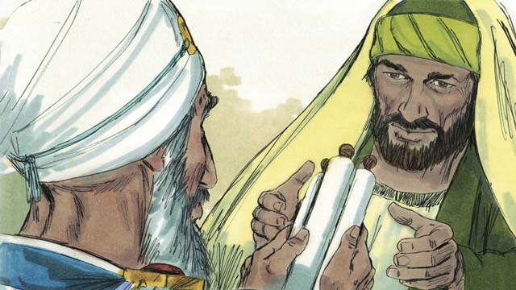

There was a man named Saul who did not believe in Jesus. When he was a young man, he guarded the robes of the men who killed Stephen. Later he persecuted the believers. He went from house to house in Jerusalem to arrest both men and women and to put them in prison. Then the high priest gave Saul permission to go to the city of Damascus. He told Saul to arrest followers of Jesus there and to bring them back to Jerusalem.

46-02

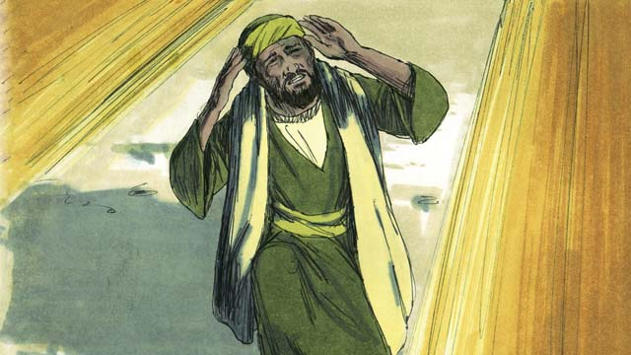

So Saul began to travel to Damascus. Just before he reached the city, a bright light in the sky shone all around him, and he fell to the ground. Saul heard someone say, “Saul! Saul! Why are you persecuting me?” Saul asked, “Who are you, Master?” Jesus replied to him, “I am Jesus. You are persecuting me!”

46-03

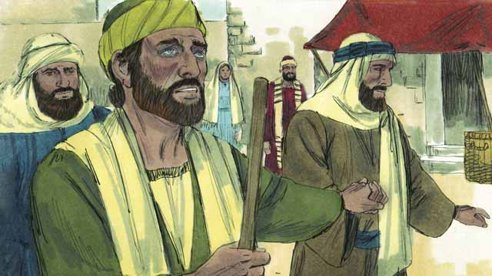

When Saul got up, he could not see. His friends had to lead him into Damascus. Saul did not eat or drink anything for three days.

46-04

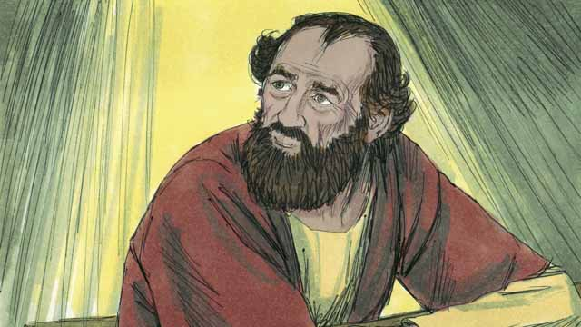

There was a disciple in Damascus named Ananias. God said to him, “Go to the house where Saul is staying. Place your hands on him so that he can see again.” But Ananias said, “Master, I have heard how this man has persecuted the believers.” God answered him, “Go! I have chosen him to declare my name to the Jews and to people from other people groups. He will suffer many things for my name.”

46-05

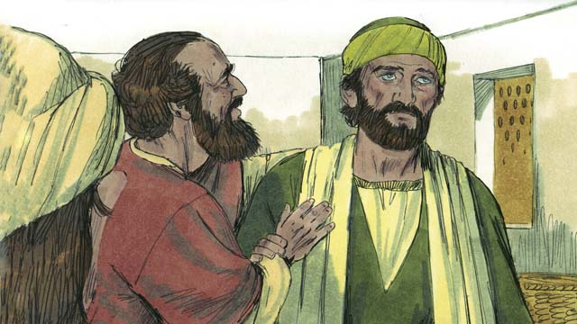

So Ananias went to Saul, placed his hands on him, and said, “Jesus, who appeared to you on your way here, sent me to you so that you can see again, and so the Holy Spirit will fill you.” Immediately Saul was able to see again, and Ananias baptized him. Then Saul ate some food and became strong again.

46-06

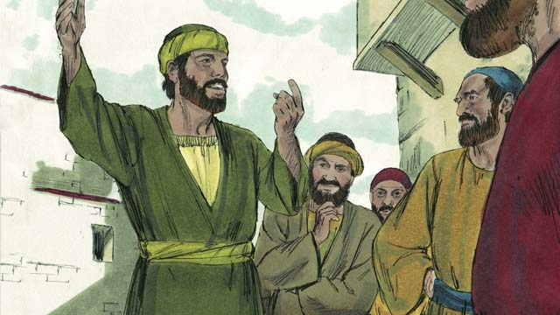

Right away Saul began preaching to the Jews in Damascus. He said, “Jesus is the Son of God!” The Jews were amazed because Saul had tried to kill believers, and now he believed in Jesus! Saul argued with the Jews. He showed that Jesus was the Messiah.

46-07

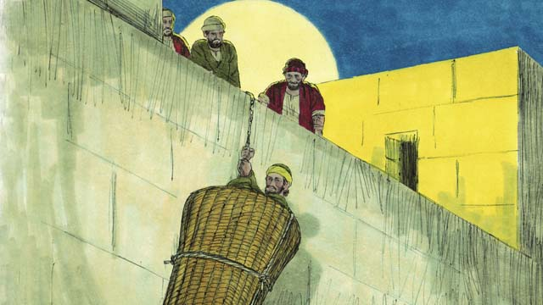

After many days, the Jews made a plan to kill Saul. They sent people to watch for him at the city gates in order to kill him. But Saul heard about the plan, and his friends helped him escape. One night they lowered him over the city wall in a basket. After Saul escaped from Damascus, he continued to preach about Jesus.

46-08

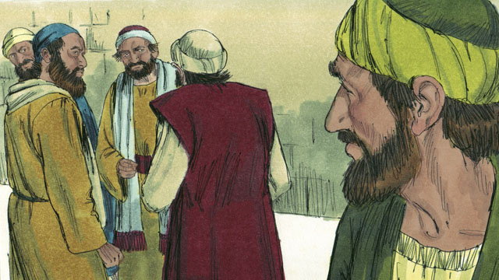

Saul went to Jerusalem to meet with the apostles, but they were afraid of him. Then a believer named Barnabas took Saul to the apostles. He told them how Saul had preached boldly in Damascus. After that the apostles accepted Saul.

46-09

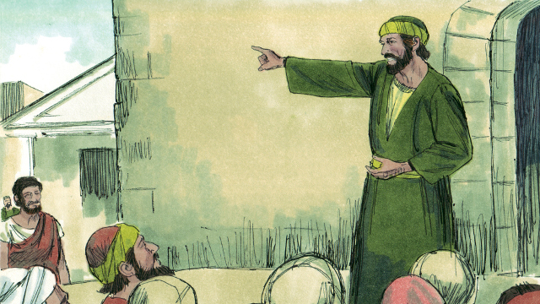

Some believers who fled from the persecution in Jerusalem went far away to the city of Antioch and preached about Jesus. Most of the people in Antioch were not Jews, but for the first time, people who were not Jews became believers. Barnabas and Saul went there to teach these new believers more about Jesus and to strengthen the church. It was at Antioch that believers in Jesus were first called ‘Christians.’

46-10

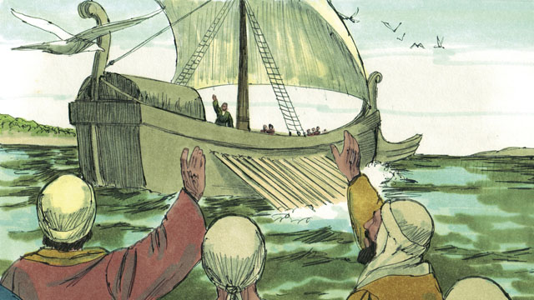

One day, the followers of Jesus at Antioch were fasting and praying. The Holy Spirit said to them, “Set apart for me Barnabas and Saul to do the work I have called them to do.” So the church in Antioch prayed for Barnabas and Saul and placed their hands on them. Then they sent them out to preach the good news about Jesus in many other places. Barnabas and Saul taught people in different people groups, and many people believed in Jesus.

*A Bible story from: Acts 8:1-3; 9:1-31; 11:19-26; 13-14*

## 1 Community Study: Mission Community—Embracing God’s Purpose

* **Key Idea**: viewing Christian community as a community of purpose
* **Key Passage**: 1 Peter 2:9-12
* **Main Session**: ## OBS 46 (Saul Becomes a Follower of Jesus)

### 1.1 Recite the Creedal Verse (3–5 minutes)

The verse below summarizes the teaching of the current passage. Read the verse out loud as a community. Read it again several times as a group until the whole community can recite it from memory.

15 This message is reliable and worthy of all acceptance, that Christ Jesus came into the world to save sinners. I am the worst of these. 16 But for this reason I was given mercy, so that in me, the foremost, Christ Jesus might demonstrate all patience. He did this as an example for those who would trust in him for eternal life. 1 Timothy 1:15-16

OR

9 For I am the least of the apostles. I am unworthy to be called an apostle because I persecuted the church of God. 10 But by the grace of God I am what I am, and his grace in me was not in vain. 1 Corinthians 15:9-10

### 1.2 Pray a Confession (5–10 minutes)

It is important to always remember the impact of God’s grace in our lives. A community is strong and united as it remembers God’s transforming grace. In groups of 2-3 people, pray this prayer to God.

God, I am the least of all the disciples. My life before Jesus was like this…

Merciful God, you have changed my life to be like this… By the grace of God I am what I am.

### 1.3 Read the Passage (3–5 minutes)

God’s grace and mercy dramatically changes people. God can transform the lives of those who are opposed to him and make them his servants. Read the passage below to learn about how God transforms the church community to be a part of his mission in the world.

9 But you are a chosen people, a royal priesthood, a holy nation, a people for God’s possession, so that you would announce the wonderful actions of the one who called you out from darkness into his marvelous light. 10 Once you were not a people, but now you are the people of God. You did not receive mercy, but now you have received mercy. 11 Beloved, I call on you as foreigners and exiles to abstain from fleshly desires, which make war against your soul. 12 You should have good behavior among the Gentiles, so that, if they speak about you as having done evil things, they may observe your good works and praise God on the day of his coming. 1 Peter 2:9-12

### 1.4 Discuss the Passage (10-15 minutes)

The church community is transformed by God’s grace. This same grace launches the church on God’s mission. As a community, use the following questions to discuss the teaching of the biblical passage.

1. How does this passage describe the church?
2. How do these descriptions of the church inform the church’s identity and mission?
3. How does the church sharing a common mission help believers live in a godly way toward each other and outsiders?
4. What would it look like for your community to be a community on mission? What things are you already doing to help in this? What things would you have to change about how you relate to each other?

### 1.5 Summarize the Mission (5 minutes)

Take time in groups of 2-3 to share a simple sentence about the mission of the church and the mission of your community. When completed, share some examples with the large group.

The mission of the church is…

The mission of our community is…

### 1.6 Pray to God (5 minutes)

Pray that God will help your community become a community on mission. Ask 2 or 3 people to pray out loud before the whole community.

### 1.7 Sing a Song (3–5 minutes)

Choose a song about God’s mission. Sing this song as a community.

## 2 Biblical Interpretation: Observing the Details of the Story

After reading the crafted biblical story, answer the following questions to familiarize yourself with the details of the story.

### 2.1 Observation Questions

Answer the following observation questions to gain a basic understanding of the the story. Read the story as a community and answer these questions as a group.

#### 46-01

What was Saul like before he became a disciple of Jesus?  
Saul did not believe in Jesus, he guarded the robes of the men who killed Stephen, and he persecuted believers by going house to house to arrest and imprison followers of Jesus.

Why was Saul going to Damascus?  
The high priest gave Saul permission to go to Damascus, arrest followers of Jesus, and to bring them back to Jerusalem.

#### 46-02

What happened to Saul before he reached the city?  
Just before Saul reached the city of Damascus, a bright light shone all around him, he fell to the ground, and he heard a voice speaking to him.

What did the person say to Saul?  
He asked Saul, “Why are you persecuting me?”  
What did Saul learn about who this person was?  
Saul asked who the person was and he said he was Jesus and that Saul was persecuting him.

#### 46-03

What happened to Saul when he got up after seeing the bright light?  
Saul could not see. His friends led him into Damascus and he did not eat or drink for three days.

#### 46-04

Who did God send to Saul?  
God told Ananias, a disciple who lived in Damascus, to go to the place Saul was staying.

What did God tell Ananias to do when he came to Saul?  
God told Ananias to place his hands on Saul so he could see again.

Why was Ananias afraid to speak to Saul?  
He had heard that Saul was persecuting the believers.

What did God say was the purpose for which he had chosen Saul?  
God had chosen Saul to declare God’s name to the Jews and to people from other people groups.

What hardship would Saul face in doing God’s work?  
God told Ananias that Saul would suffer many things for God’s name?

#### 46-05

What did Ananias do to Saul when he came to him?  
He placed his hands on him.

What did Ananias say to Saul?  
Ananias told Saul that Jesus sent him to Saul so he could see again and the Holy Spirit would fill Saul.

How long did it take for Saul to regain his sight?  
Saul was able to see immediately.

What did Ananias do to Saul after he regained his sight?  
Ananias baptized him.

What did Saul do after Ananias baptized him?  
Saul ate some food and became strong again.

#### 46-06

How did Saul right away start to do God’s work in Damascus?  
Immediately, Saul began preaching to the Jews in Damascus.

What message did Saul immediately begin preaching to the Jews?  
He preached, “Jesus is the Son of God!” How did some Jews respond to Saul’s preaching?  
Jews were amazed that Saul believed in Jesus since he had tried to kill believers a little while earlier.

How did Saul interact with the Jews?  
Saul argued with the Jews and showed them that Jesus is the Messiah.

#### 46-07

How did the Jews respond to Saul’s preaching?  
They made a plan to kill Saul.

How did the Jews plan to kill Saul?  
The sent people to watch for Saul at the city gates in order to kill him.

How did Saul escape from Damascus?  
Saul heard about the plan and his friends lowered him over the city wall in a basket so he could escape.

Did this cause Saul to stop preaching?  
Saul continued to preach about Jesus.

#### 46-08

How did people respond when Saul arrived in Jerusalem?  
Saul met with the apostles in Jerusalem but they were afraid of Saul.

Who helped Saul to be accepted by the disciples in Jerusalem?  
A believer named Barnabas took Saul to the apostles and told them how Saul had preached boldly in Damascus.

How did people treat Saul after Barnabas told them how Paul preached boldly?  
After Barnabas said these thing, the apostles accepted Saul.

#### 46-09

Why did some believers go to Antioch?  
Some believers fled to the far away city Antioch because of the persecution.

What did some of these believers do in Antioch?  
They preached about Jesus.

What was different about the people who became believers in Antioch?  
They were not Jews.

What was unique about the believers in Antioch?  
This was the first time people who were not Jews became believers.

Who showed up to teach these news believers?  
Barnabas and Saul came to Antioch to teach the new believers and strengthen the church.

What name first began to be used for the believers in Antioch?  
They called them “Christians.”

#### 46-10

What was the church in Antioch doing when the Holy Spirit told them to set apart Barnabas and Saul?  
They were praying and fasting.

How did the church in Antioch send out Barnabas and Saul?  
The believers prayed for Barnabas and Saul, placed their hands on them, and sent them out.

What was the purpose for which the church in Antioch sent out Saul and Barnabas?  
They sent them out to preach the good news about Jesus in many other places.

Who did Barnabas and Saul preach to?  
Barnabas and Saul preached to people in many different people groups.

How successful was their preaching?  
Many believed in Jesus.

### 2.2 Translation Questions

Use the following translation questions to understand specific details of the passage. Discuss how you might translate these specific elements of the story.

#### 46-01

**from house to house** Saul went into the homes of believers and had them arrested. He did this to many believers. How would you express **from house to house** to mean into many houses?

  

**to arrest both men and women** Saul was not just arresting all kinds of people. He was arresting people who were disciples of Jesus. How would you express **to arrest both men and women** to mean Saul detained (bring into legal custody) men and women who believed in Jesus?

  

**the high priest gave** Saul permission to go to the city of Damascus The high priest permitted Saul to go to the city of Damascus to continue persecuting believers of Jesus. Damascus is now the capital of the country of Syria. During Saul’s time, it was a city belonging to the Roman Empire. Most of the people there were not Jewish, but there were some Jews and also some followers of Jesus living there. How would you express **the high priest gave** Saul permission to go to the city of Damascus to mean the leading priest allowed Saul to travel to the city of Damascus to continue arresting believers?

  

**to bring them back to Jerusalem** The leading priest instructed Saul to place believers in custody and transport them back to Jerusalem. The purpose of this was so that the Jewish leaders could punish them for being disciples of Jesus. How would you express **to bring them back to Jerusalem** to mean to escort believers back to Jerusalem where Jewish leaders would judge and punish them?

  

#### 46-02

**Just before he reached the city, a bright light in the sky shone all around him** Saul was traveling to the city of Damascus. He was close to arriving in the city. A little time prior to arriving in the city of Damascus, a strong light came from the sky and was all around Saul. How would you express **Just before he reached the city, a bright light in the sky shone all around him** to mean a strong shining light came from the sky and surrounded Saul when he had nearly arrived in the city of Damascus?

  

**Why are you persecuting me?** Jesus is asking a question but is not really seeking an answer. This question communicates a rebuke to Saul for mistreating Jesus and orders him to stop persecuting Jesus. How would you express **Why are you persecuting me?** as a question that reprimands Saul for oppressing and afflicting Jesus?

  

#### 46-03

**When Saul got up, he could not see** Saul fell on the ground when the light surrounded him. At the time Saul got back on his feet, he was unable to see. How would you express **When Saul got up, he could not see** to mean Saul had no ability to see (he was blind) at the time he stood back on his feet?

  

**Saul did not eat or drink anything for three days** It is not stated whether he chose not to eat or drink as a form of worship, or if he had no appetite because he was too distressed from his situation. It is preferable not to specify the reason. How would you express **Saul did not eat or drink anything for three days** to mean Saul had nothing to eat or drink for three consecutive days?

  

#### 46-04

**Go!** Jesus ordered Ananias to travel to Saul as do what Jesus already told him to do. This command also mildly rebukes Ananias’ fear and hesitation. God is reassuring Ananias and and make clear why God is sending him to Saul. How would you express **Go!** as a command that Ananias should stop objecting and go to Saul as God instructed him to do?

  

**to declare my name to the Jews and to people from other people groups** Jesus told Ananias that Saul would preach about Jesus to all kinds of people: Jewish people and non-Jewish people who lived in many different places. How would you express **to declare my name to the Jews and to people from other people groups** to mean Saul would tell all kinds of people about Jesus, both Israelites and those who were not Israelites?

  

**He will suffer many things for my name** Jesus told Ananias that Saul would experience many painful hardships because of serving Jesus and preaching to people about Jesus. How would you express **He will suffer many things for my name** to mean people would persecute and oppress Saul because he would teach others about Jesus?

  

#### 46-05

**placed his hands on him** Ananias Ananias put his hands on Saul. This was a symbol of giving a blessing to Saul. How would you express **placed his hands on him** Ananias to mean Ananias put his hands on Saul to symbolize God’s favor and grace on Saul?

  

**the Holy Spirit will fill you** Ananias told Saul that the Holy Spirit would give Saul great power and ability. How would you express **the Holy Spirit will fill you** to mean the Holy Spirit would empower Saul to act in God’s strength and for God’s purposes?

  

**Saul ate some food and became strong again** Saul was weak because he did not eat or drink anything for three consecutive days. At this time, Saul ate food and his body regained energy. How would you express **Saul ate some food and became strong again** to mean Saul consumed food and it energized his body?

  

#### 46-06

**The Jews were amazed because Saul had tried to kill believers** The Jews who heard Saul preach about Jesus were very surprised. Not too long ago, Saul was arresting and imprisoning disciples who believed in Jesus. Now Saul was preaching about Jesus. How would you express **The Jews were amazed because Saul had tried to kill believers** to mean the reason the Jews were very surprised about Saul preaching Jesus was Saul had previously tried to kill disciples of Jesus?

  

**argued with the Jews** Paul spoke persuasively with the Jews. He tried to convince them to believe in Jesus. How would you express **argued with the Jews** to mean Paul gave the Jews good reasons for believing in Jesus?

  

**He showed that Jesus was the Messiah** Paul explained that Jesus is the promised Messiah God sent to save people from their sins. Paul likely explained from Old Testament Scriptures how Jesus is the Messiah. How would you express **He showed that Jesus was the Messiah** to mean Paul demonstrated that Jesus is the Messiah God promised to send who would save people from their sins?

  

#### 46-07

**the Jews made a plan to kill Saul** Here the Jews refers to the leaders of the Jews. These leaders developed a plan that would result in killing Saul. How would you express **the Jews made a plan to kill Saul** to mean the Jewish leaders formed a plot to murder Saul?

  

**lowered him over the city wall in a basket** Friends of Saul assisted Saul to escape the city so that he would not be killed. The people who wanted to kill Saul were waiting at the city gates. Paul got into a large basket and Saul’s friends lowered him over the city wall. Now Paul was able to get away from those who were trying to kill him. How would you express **lowered him over the city wall in a basket** to mean Saul’s friends helped Saul get into a large basket and lowered the basket with him in it over the city wall?

  

#### 46-08

**but they were afraid of him** Saul traveled to the city of Jerusalem to meet with Jesus’ apostles. Even though Saul was now a disciple of Jesus, the apostles feared Saul because he used to kill believers. How would you express **but they were afraid of him** to mean the apostles being afraid of Saul is a different/opposite response than Paul wanting to meet with the apostles?

  

**After that the apostles accepted Saul** Barnabas told the apostles how Saul preached boldly about Jesus. Then, the apostles treated Saul like a fellow disciple and were now longer afraid of him. How would you express **After that the apostles accepted Saul** to mean the apostles believed that Saul also was a believer in Jesus after Barnabas told them how Saul boldly told people about Jesus?

  

#### 46-09

**to strengthen the church** Barnabas and Saul traveled to the city of Antioch to teach the new believers. This teaching helped the church to grow strong spiritually. How would you express **to strengthen the church** to mean Barnabas and Saul traveled to the city of Antioch to help the believers in Jesus to grow strong in their faith and to believe more firmly in Jesus?

  

**believers in Jesus were first called ‘Christians’** For the first time, people called believers in Jesus Christians. How would you express **believers in Jesus were first called ‘Christians’** to mean the people of Antioch first called the believers in Jesus ‘Christians?’”

  

#### 46-10

**Set apart for me Barnabas and Saul to do the work I have called them to do** The Holy Spirit told the believers to designate Barnabas and Saul for a specific work that God called them to perform. How would you express **Set apart for me Barnabas and Saul to do the work I have called them to do** to mean appoint Paul and Barnabas to do the special work God chose them to do?

  

**placed their hands on them** The believers in Antioch put their hands on Barnabas and Paul, perhaps on their head, shoulder or back. This act showed that the leaders agreed that the Holy Spirit had called Barnabas and Saul to do this work. How would you express **placed their hands on them** to mean the believers in Antioch put their hands on Barnabas and Saul to bless them with the power and authority of the Holy Spirit and to show their unity and affirmation that the Spirit was sending them on this mission?

  

**sent them out** The believers in Antioch sent Barnabas and Saul to go do what the Holy Spirit called them to do. How would you express **sent them out** to mean the believers sent them on their journey to do the work God chose them to do?

  

## 3 Theological Dialogue: Discussing the Meaning of the Story

Take time to explore the meaning of this story together as a community. Use the following discussions as a way to grasp what truth the story teaches.

### 3.1 Discourse Questions

Use the following discourse questions to understand the meaning of the story. Pay attention to how the story itself addresses each question or theme.

##### What kind of persecution/hardship did the early believers endure? (46-01, 46-09)

Stephen: People killed Stephen for preaching about Jesus. Saul was not a believer. He supported the killing of Stephen. (46-01)

  

Jerusalem Believers: Saul persecuted believers in Jerusalem. He went to the houses of believers to arrest and imprison them. (46-01)

  

Damascus Believers: The leading priest gave Saul permission to arrest believers in Damascus and bring them back to Jerusalem to be judged and punished. (46-01)

  

Antioch: Persecution caused believers to move to other areas. Some moved to a city far away called Antioch. (46-09)

  

##### How did Saul’s conversion come about? (46-02, 46-03, 46-04, 46-05, 46-08)

Conviction: Jesus met Saul while he was traveling to Damascus. Just before Saul reached the city, a bright light surrounded Saul and he fell on the ground. Jesus rebuked Saul for persecuting him. Saul’s persecution of beliers was an attack on Jesus. Jesus confronted and convicted Saul of his sin. (46-02)

  

Realize Weakness and Blindness: After meeting Jesus on the road, Saul was blind and could not see. He had to be lead into the city of Damascus. He did not eat or drink for three days. Saul had to recognize that he was weak. He was not living life or seeing reality correctly. (46-03)

  

Change: God told Ananias to go to Saul and place hands on him so Saul would recover his ability to see. Ananias was afraid of Saul because he killed believers. God told Ananias to go to Saul and do what God told him. Ananias obeyed God. He went to Saul, placed hands on him, and Saul could see again. God brought a miraculous change to Saul. Through God’s power, Saul became a believer in Jesus. (46-04, 46-05)

  

Mission: God chose Saul to preach Jesus to all kinds of people. Saul would endure many painful experiences as he told people about Jesus. (46-04)

  

Holy Spirit: Ananias also told Saul that the Holy Spirit would fill him. God would give Saul the power to live for God and to serve God by preaching about Jesus. (46-05)

  

Baptism: Ananias baptized Saul after Saul was able to see again. Baptism was a ritual where believers publicly announced faith in Jesus and joined the community of believers. (46-05)

  

Community Member: It took some time for the believers to accept Saul. At first, Ananias was afraid of Saul. The apostles in Jerusalem were also afraid of Saul. After Barnabas explained how Paul preached boldly, they accepted him as a real follower of Jesus. (46-04, 46-08)

  

##### How did the early believers in Jesus go about doing God’s mission/work? (46-04, 46-06, 46-07, 46-09, 46-10)

Preaching: God said that he chose Saul to preach about Jesus to all kinds of people. After Saul became a believers, Saul did not delay preaching the gospel. He immediately began preaching to Jews. He tried to convince them that Jesus was the Messiah. Saul continued to preach about Jesus after he escaped from a plot to kill him. Believers preached about Jesus as they fled persecution. People in the city of Antioch became believers because other believers told them about Jesus. (46-04, 46-06, 46-07, 46-09)

  

Suffering: Believers faced suffering and mistreatment as they preached about Jesus. Jesus said that Saul would eventually suffer for preaching about Jesus. Some people were amazed at Paul’s preaching. He used to kill believers of Jesus and now he was preaching about Jesus. Jewish leads devised a plot to kill Saul. They waited for him at the city gates, but friends of Saul helped him escape by lowering him in a basket over the city walls. (46-04, 46-07)

  

Church Strengthening: Barnabas and Saul went to Antioch to teach the new believers about Jesus and make their faith in Jesus strong. (46-09)

  

Sending Missionaries: The believers in Antioch sent Barnabas and Saul to travel to other places to tell people about Jesus. The Holy Spirit set apart Barnabas and Saul for a specific, special work that God wanted them to do. The church prayed for them and sent them on their journey to continue to preach the gospel in other areas. (46-10)

  

### 3.2 Theological Questions

Answer the following theology questions as a community. Discuss what truths this story teaches.

1. How does God bring a transformation/change in those who become genuine disciples of Jesus? How did Saul becoming a believer teach us about what kind of change is involved in becoming a follower of Jesus?
2. What is the mission of followers of Jesus? What kind of work/mission has God called believes to do? What does the activity of the early believers teach us about what it means to do God’s work/mission on earth?

### 3.3 Translation Draft

Work as a translation team to draft each panel of this story. Pay attention to any specific translation issues that are challenging or significant.

#### Make Translation Draft

Make a draft for each section of this story.

#### Discuss and Revise

After drafting the story, discuss any translation issues that you think need special explanation.

#### Drafting Summary Reflection

Summarize any noteworthy translation decisions and the rationale/reasoning behind these translation decisions. In the final movement of this class, you will use these observations to give an account (i.e., chronicle/narrate) of how your translation improved through the checking process.

## 4 Personal Reflection: Following the Teaching of the Story

Take a moment to allow this story to evaluate your own life and to consider how God would have you respond. After this reflection, use the quality checking questions to check your translation draft among the translation team.

### 4.1 Journal Reflection

Prayerfully think about the following personal reflection questions. Write/Record your answers and/or discuss them as a group.

1. What kind of change/transformation has God brought about in your life as a result of becoming a Christian?
2. In what ways is God continuing to change you as you follow Jesus?
3. How has God used your own personal hardship and persecution as a means to share the gospel with others?
4. How does God want you to participate in God’s mission work of spreading the gospel and strengthening churches among all different kinds of people?

### 4.2 Team Check

*The following activity will help you check the clarity, accuracy, and naturalness of your draft. Read the passage aloud and discuss the checking questions with other members of your translation community. You might need to reread portions (or the whole) of the biblical passage multiple times as you answer each of these questions. Record answers to these questions below.*

#### Team Checking Questions

*Use the following questions to check your translation draft for accuracy, clarity, and naturalness.*

1. **Accurate**: Has anything been **added** to your translation of this passage that is not a part of the meaning of the source text? *If additions exist, are they included only added to clarify meaning (such as implied information)?*
2. **Accurate**: Is anything **missing** from your translation of this passage that is a part of the meaning of the source text? *If some part of the meaning is missing from your translation, add it.*
3. **Accurate**: Does any meaning in your translation of this passage appear to be **different** than the meaning of the source text? *If the meaning is different, try changing your translation so that the meaning remains the same.*
4. **Natural**: Does anything sound **unnatural** to how you would say it in your language? *If portions of the passage sound unnatural in your language, try to make them sound the way you would say it in your language while staying true to the meaning of the source text.*
5. **Clear**: Is anything **unclear** or **confusing** in your translation that confuses the meaning of the source text? *If portions of the passage are unclear or confusing, revise them to clearly communicate the meaning of the source text.*
6. **Consistent**: How **consistent** is your translation within the passage and with other passages? *If portions of the passage need to be made consistent or if you need to revise translations of other passages, make these adjustments.*

#### Record Feedback

*After discussing the checking questions above as a translation community, record any feedback on your translation draft. Pay attention for parts of your translation that are translated well and parts of your translation that need correction.*

#### Discuss and Revise

*After gathering feedback on your draft, discuss it together with your translation community and make appropriate revisions in your translation.*

#### Record Translation Decisions

*As a community, discuss some of the most noteworthy translation decisions in your draft. Summarize each decision and explain the reasons your community decided on that translation. You should update these decisions each time you check your draft with various groups of people.*

You should **measure** the quality of your translation draft. You can **record translation decisions** to make it clear why you translated things a certain way. Translation decisions can help your translation team and the surrounding community be a part of the translation process.

How can you know the quality of your translation?

1. **Measure** the translation by marks/standards of quality (i.e., clear, accurate, natural, church-approved)
2. **Test** the translation with others and record feedback and conversations from in the field (i.e., church and community check)
3. **Compare** and **contrast** the translation with the source text (i.e., meaning of text and notes) and alternatives (i.e., other translation choices)
4. **Explain** the reasons why you translated a particular portion of the text.

**Example Sentences That Help Explain Your Translation Decision** Use the following example sentences to help explain your translation decisions:

1. The original text literally **says/means**, so we translated the term in this way…
2. We originally decided to translate **the biblical term** in with **this term**, but we changed it because…
3. When our translation team discussed **the biblical term**, this is what we talked about…
4. **The term** is [clear, accurate, natural, consistent] because…
5. The community understands **this term** it to mean…
6. We considered these other terms. We did not use **these terms** because…
7. When we checked this in the church, we learned…
8. When we checked this in the community, we learned…

**Example of Translation Decision**

In OBS 01-07 we decided to translate **blessed** like this: [actual translation]. We decided this translation because of these reasons:

1. The word [actual translation] means to cause good things to happen to someone or something. This term is used when a person desires someone or something to prosper or flourish. This term does not refer to magic or witchcraft.
2. When we checked this word with other believers, they said it describes God showing his kindness and favor on someone or something. These are some of the terms that we did not decide to use…
3. Many of our people will understand this word. When we discussed this phrase with the surrounding community, we discovered it was a natural way to describe God causing good and beneficial things to happen.

## 5 Ministry Practice: Serving the Church with the Story

Now that you have a draft of this story, consider how this story can encourage other believers in their faith. After ministering this story to others, you will also perform a community check of your translation draft.

### 5.1 Church Ministry

Reflect on how this story can edify and mature the Christian community. Design a way to minister this story to your church community.

**Ministry Preparation**: Take time to consider how you could minister this story to others. Record some ministry ideas below.

**Ministry Implementation**: Minister this story to a group of believers as you had planned. Use the information in this study to help develop a teaching/lesson or lead a discussion of this story to other believers. Record your ministry plan below.

**Ministry Reflection**: Think about what you learned from ministering this story to other believers. Reflect on your experience below.

### 5.2 Church Community Check

After teaching or ministering this story to the church, check the translation quality with the church community. Record any feedback from your checking experience.

#### Create Checking Questions

You can use **Translation Questions** to check you draft. Each **Translation Question** explains the meaning of a specific part of the story and asks you to consider how you would translate that part of the story in your own language. Change each **Translation Question** into a **Checking Question** by asking the following questions. The first question asks you to identity how each specific phrase was translated in your language. The second question asks people in the church to determine if your translation of the phrase expresses the meaning clearly, accurately, and naturally. Look at the following examples to see how to change **Translation Questions** into **Checking Questions**:

#### Translation Question Example 1

**to proclaim the good news about Jesus** Paul and Silas traveled to Philippi for the purpose of preaching the gospel. The gospel is the good news that Jesus saves people from their sins if they will believe in Jesus. How would you express **to proclaim the good news about Jesus** to mean to tell other people the message about how Jesus can save people from their sins?

#### Translation Question Example 2

**a merchant** Paul and Silas met a woman named Lydia at the place by the river. She owned a business and sold items to make money. How would you express **a merchant** to mean a business owner who sells items for a profit?

#### Translation Question Example 3

**so Paul and Silas baptized them** The jailer and his whole family followed Paul’s instructions. They believed in Jesus. The result of this was Paul and Silas baptized them. How would you express **so Paul and Silas baptized them** to mean the result of the jailer and his family believing in Jesus that Paul and Silas baptized all of them?

You can change these into **Checking Questions** like this:

#### Checking Question Example 1

**to proclaim the good news about Jesus** How did you translate **to proclaim the good news about Jesus**? Does it mean to tell other people the message about how Jesus can save people from their sins?

#### Checking Question Example 2

**a merchant** How did you translate **a merchant**? Does it mean a business owner who sells items for a profit?

#### Checking Question Example 3

**so Paul and Silas baptized them** How did you translate **so Paul and Silas baptized them**? Does it mean the result of the jailer and his family believing in Jesus that Paul and Silas baptized all of them?

#### Record Feedback

*Discuss the* ***Checking Questions*** *with your church community, and record any feedback on your translation draft. Pay attention for parts of your translation that are translated well and parts of your translation that need correction.*

#### Discuss and Revise

*After gathering feedback on your draft, discuss it together with your translation community and make appropriate revisions in your translation.*

#### Record Translation Decisions

*Update your translation decisions and record and new any noteworthy observations on the quality of your draft.

## 6 Missional Outreach: Sharing the Truth of the Story

*After sharing this story with others, check the translation quality with the wider language community. Record any feedback from your checking experience.*

### 6.1 Mission Engagement

*Consider how you will witness this story to unbelievers. Design a way to share this story and engage them in what it teaches about Christianity and the gospel.*

**Witness Preparation**: Take time to consider how you will witness this narrative to unbelievers. Record some ideas below.

**Witness Implementation**: Share this story with an unbeliever. Use the information in this study to help develop a teaching/lesson or lead a discussion of this story to other believers. Record your ministry plan below.

**Witness Reflection**: Think about what you learned from ministering this story to unbelievers. Reflect on your experience below.

### 6.2 Sociolinguistic Check

After sharing this story with the language community, check your translation draft with the surrounding community. Record your observations.

#### Checking Approach

After witnessing this story to unbelievers, use one of the following methods to check the translation of this story. Consider using the **Observation Questions** to check your translation draft or come up with your own quality checking questions.

**Read-Retell Check:** Read your draft to those the community and ask them to retell the passage. Be attentive for any portions of the passage that are unclear, unnatural, or inaccurate.

**Comprehension Questions Checklist:** Read the draft of the passage and ask a list of comprehension questions to make sure the passage is being rightly understood. You can use the **Observation Questions** in this guide or come up with your own questions. Then, record any insights or issues that arise.

**Discussion Group:** Develop key questions to ask about the passage (both formational and translational). Read the passage and have a group discussion about the passage, paying attention to issues that need to be addressed, edited, and revised.

#### Record Feedback

*After sharing your draft with language community, discuss the* ***Observations Questions****, and record any feedback on your translation draft. Pay attention for parts of your translation that are translated well and parts of your translation that need correction.*

#### Discuss and Revise

*After gathering feedback on your draft, discuss it together with your translation community and make appropriate revisions in your translation.*

#### Record Translation Decisions

*Update your translation decisions and record and new any noteworthy observations on the quality of your draft.

## 7 Conclusion

As a translation community, take time to reflect on all that was learned in studying, drafting, and checking this story. Celebrate all that God has taught you as a community. Then, submit your revised draft and checking summaries to network leaders for further review.