Open Bible Stories

Paul and Silas in Philippi

## 0 Introduction

### 0.1 Key Idea

The story of Paul and Silas in Philippi teaches us how the mission of Jesus is to preach the gospel to all people groups in the world.

### 0.2 Creedal Verse

“Thus I make it my ambition to preach the gospel, not where Christ has already been named, lest I build on someone else’s foundation.” Romans 15:20

### 0.3 Metanarrative Summary

The eternal God created all things in six days. He made a good and perfect world. He made humans in his image to fill the earth and rule over creation. But humans rebelled against God and ruined God’s creation. God set to restore his world through his promise. God made a covenant with Abraham. He promised to bless all nations through Abraham. God kept his promises across the generations. God provided Abraham with a promised child, Isaac. God gave Isaac a wife and she bore twins, Jacob and Esau. God blessed Jacob and his sons, and the blessing continued to the next generation. God rescued Joseph, one of Jacob’s sons, and used him to rescue his family. God caused his people, the Israelites, to multiply in the land of Egypt; eventually, they became slaves. But, God raised up a deliverer, Moses, to deliver his people from their slavery. God judged the Egyptians with harsh plagues; in the final judgment, he passed over his people who covered their doorposts with the blood of a sacrificed lamb. Then, God delivered the Israelites by bringing them out of Egypt and crossing the Red Sea on dry land. God made a covenant with the Israelites and made them his people. God tested Israel in a series of wilderness wanderings and eventually brought his people into the promised land of Canaan. God raised up deliverers to lead Israel and rescue them from their enemies. God formed Israel into a kingdom. He made a covenant with King David and promised to send a king that would rule his people forever. Many of Israel’s kings were evil and the kingdom of Israel divided into two kingdoms. God sent prophets to warn his people of God’s judgment and call them to repent. When Israel did not repent, God sent his people into exile. After many years, he brought them back to the land. Throughout the Old Testament, God promised to send his Messiah to deliver his people form their sin. After many years, the prophet John was born. He would prepare people for the coming Messiah. At the perfect time, God sent his Son, Jesus, to be born of a virgin Mary. When John and Jesus grew up, John baptized Jesus as a sign that Jesus was God’s beloved Son. Jesus endured all manner of temptation without ever sinning. When he was thirty years old, he launched a public ministry of preaching, teaching, and healing. He taught his disciples about the life of compassion, sacrifice, and forgiveness. He performed many miracles: he fed a crowd of five thousand, he walked on water, he healed the sick, and he cast out demons. He proclaimed to people the nature of real faith, God’s kingdom, and the how fallen humans can be restored in relationship with God. Toward the end of his ministry, Jesus revealed his power and glory to his disciples and raised a dead man to life Jesus was betrayed by one of his disciples and put on trial before a Roman governor Jesus was sentenced to death and crucified on a cross Three days later, Jesus rose again from the dead. After meeting with many of his disciples, Jesus went back to heaven. The Holy Spirit empowered Jesus’ followers and formed them into his church Jesus’ disciples, like Peter and John, performed miracles and preached the good news about Jesus. New leaders like Stephen and Philip served the church and preached about Jesus Even Saul, a persecutor of Jesus’ followers, became a Christian and preached the gospel to many people

### 0.4 Open Bible Story: Paul and Silas in Philippi

47-01

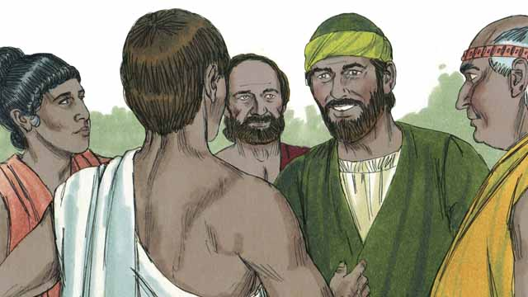

As Saul traveled throughout the Roman Empire, he began to use his Roman name, ‘Paul.’ One day, Paul and his friend Silas went to the town of Philippi to proclaim the good news about Jesus. They went to a place by the river outside the city where people gathered to pray. There they met a woman named Lydia who was a merchant. She loved and worshiped God.

47-02

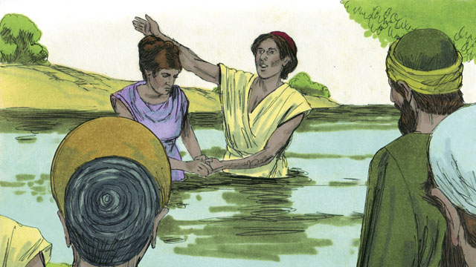

God enabled Lydia to believe the message about Jesus. Paul and Silas baptized her and her family. She invited Paul and Silas to stay at her house, so they stayed there.

47-03

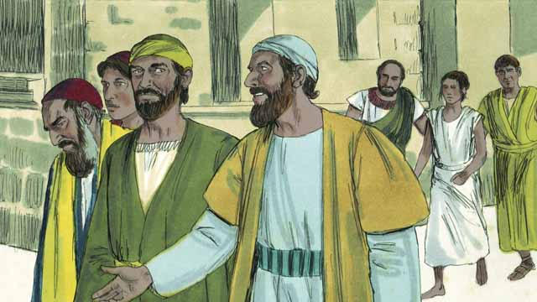

Paul and Silas often met with people at the place where Jews prayed. Every day as they walked there, a slave girl possessed by a demon followed them. By means of this demon, she predicted the future for people, so she made a lot of money for her masters as a fortuneteller.

47-04

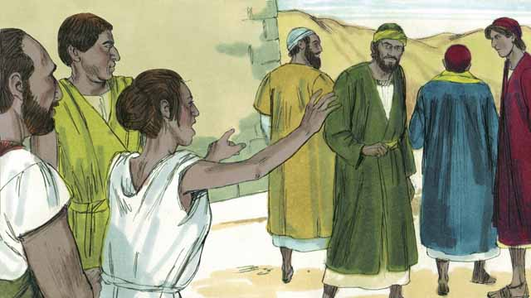

The slave girl kept yelling as they walked, “These men are servants of the Most High God. They are telling you the way to be saved!” She did this so often that Paul became annoyed.

47-05

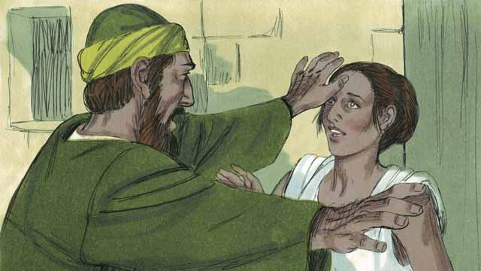

Finally, one day when the slave girl started yelling, Paul turned to her and said to the demon that was in her, “In the name of Jesus, come out of her.” Right away the demon left her.

47-06

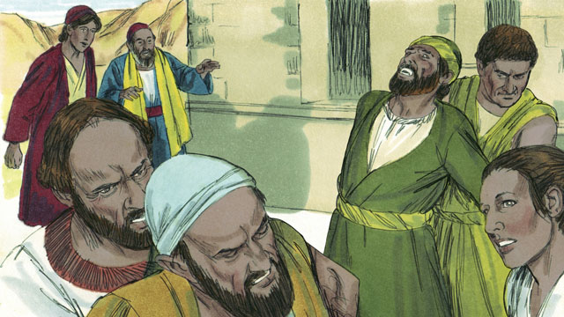

The men who owned the slave girl became very angry! They realized that, without the demon, the slave girl could not tell people the future. This meant that people would no longer pay her owners to have her tell their future.

47-07

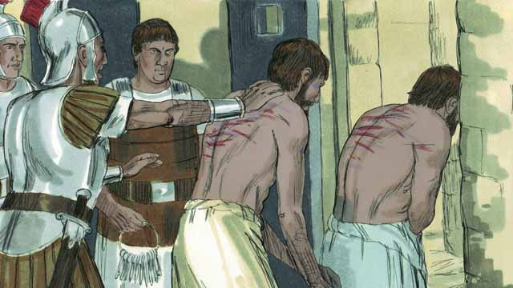

So the owners of the slave girl took Paul and Silas to the Roman authorities, who beat Paul and Silas, and then threw them into jail.

47-08

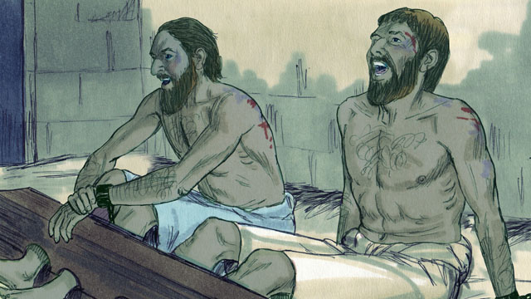

They put Paul and Silas in the part of the prison where there were the most guards. They even attached their feet to large pieces of wood. But in the middle of the night, Paul and Silas were singing songs of praise to God.

47-09



Suddenly, there was a violent earthquake! All the prison doors opened wide, and the chains of all the prisoners fell off.

47-10

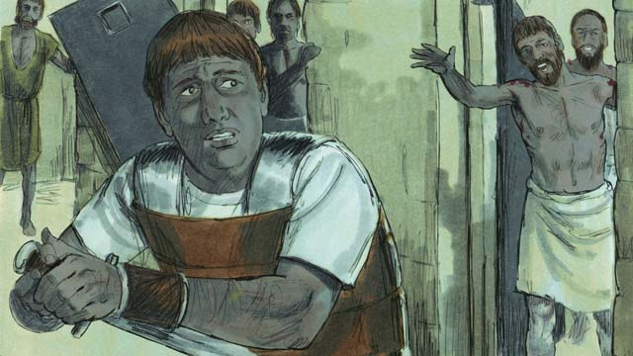

Then the jailer woke up. He saw that the prison doors were open. He thought that all the prisoners had escaped. He was afraid the Roman authorities would kill him for allowing them to go, so he got ready to kill himself! But Paul saw him and shouted, “Stop! Do not hurt yourself. We are all here.”

47-11

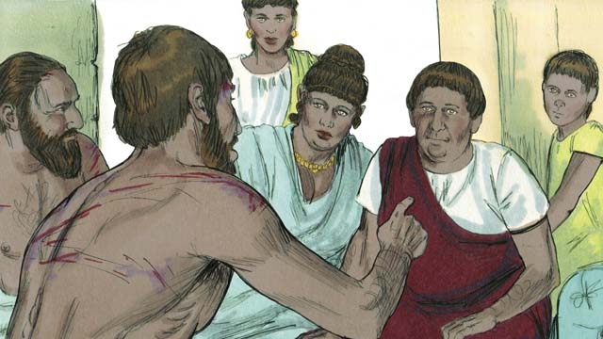

The jailer trembled as he came to Paul and Silas and asked, “What must I do to be saved?” Paul answered, “Believe in Jesus, the Master, and you and your family will be saved.” Then the jailer took Paul and Silas into his home and washed their wounds. Paul preached the good news about Jesus to everyone in his house.

47-12

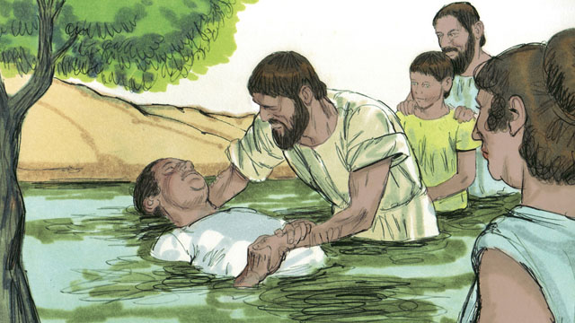

The jailer and his whole family believed in Jesus, so Paul and Silas baptized them. Then the jailer gave Paul and Silas a meal, and they rejoiced together.

47-13

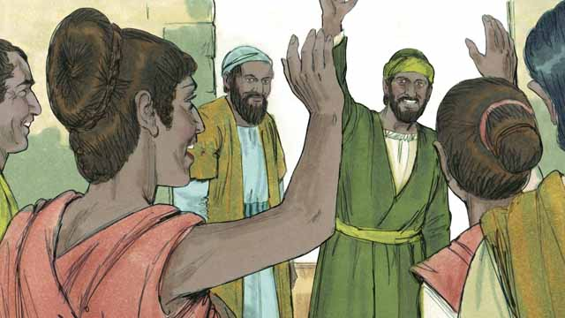

The next day the leaders of the city released Paul and Silas from prison and asked them to leave Philippi. Paul and Silas visited Lydia and some other friends and then left the city. The good news about Jesus kept spreading, and the Church kept growing.

47-14

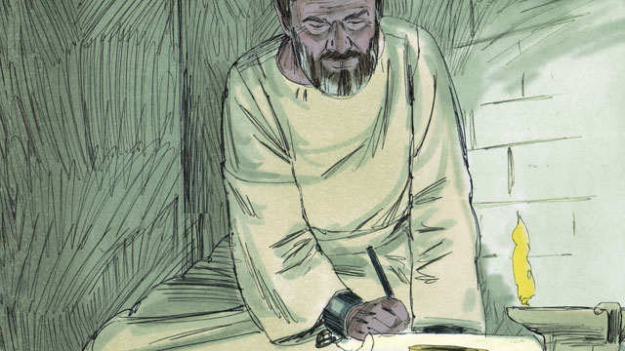

Paul and other leaders of the believers traveled to many cities. They preached and taught people the good news about Jesus. They also wrote many letters to encourage and teach the believers in the churches. Some of these letters became books of the Bible.

*A Bible story from: Acts 16:11-40*

## 1 Community Study: Seasoned Community—Open Doors for Gospel Work

* **Key Idea**: looking for opportunities to minister to others in grace and wisdom
* **Key Passage**: Colossians 4:2-6
* **Main Session**: OBS 47 (Paul and Silas in Philippi)

### 1.1 Recite the Creedal Verse (3–5 minutes)

The verse below summarizes the teaching of the current passage. Read the verse out loud as a community. Read it again several times as a group until the whole community can recite it from memory.

8 Remember Jesus Christ, from David’s seed, who was raised from the dead. This is according to my gospel message, 9 for which I am suffering to the point of being bound with chains as a criminal. But the word of God is not bound. 2 Timothy 2:8-9

OR

3:1 Now, brothers, pray for us, that the word of the Lord may rush and be glorified, as it also is with you. 2 Pray that we may be delivered from wicked and evil people, for not all have faith. 2 Thessalonians 3:1-2

### 1.2 Testimonies of Mission Participation (5 minutes)

Divide into groups of 2-3 people. Share opportunities God has provided for you to participate in God’s mission.

These are some mission opportunities God has provided for me in the last weeks…

### 1.3 Read the Passage (3–5 minutes)

God invites his people to participate in his mission. The church community should look for open doors to serve God’s work in the world. Read the passage below to learn about how God invites believers into his work.

2 Continue steadfastly in prayer. Stay alert in it in thanksgiving. 3 Pray together for us also, that God would open a door for the word, to speak the secret truth of Christ. Because of this, I am chained up. 4 Pray that I may make it clear, as I ought to speak. 5 Walk in wisdom toward those outside, and redeem the time. 6 Let your words always be with grace. Let them be seasoned with salt, so that you may know how you should answer each person. Colossians 4:2-6

### 1.4 Discuss the Passage (10-15 minutes)

God’s mission for the world is defining mark of the church. Believers should be ready for opportunities to serve God’s work in the world. As a community, use the following questions to discuss the teaching of the biblical passage.

1. What instructions does this passage give to believers? How do these instructions shape a community of believers?
2. How does this passage teach believers to relate to the world?
3. What open doors has God brought to your community? How might God be inviting you to enter into these open doors as mission opportunities?
4. How can your community be ready for opportunities as God leads? How can your translation work directly connect with God’s mission?

### 1.5 Brainstorm Together (5 minutes)

Think together about how the work of translation can open new opportunities for mission.

Our work of translation can open new ministry opportunities in these ways…

### 1.6 Pray to God (5 minutes)

Pray that God will open doors for your community to participate in his mission work.

### 1.7 Sing a Song (3–5 minutes)

Identify a song about God’s mission and God’s people participating in God’s mission. Celebrate God’s work of redemption in the world.

## 2 Biblical Interpretation: Observing the Details of the Story

After reading the crafted biblical story, answer the following questions to familiarize yourself with the details of the story.

### 2.1 Observation Questions

Answer the following observation questions to gain a basic understanding of the the story. Read the story as a community and answer these questions as a group.

#### 47-01

What was the Roman name that Saul began to use?  
He began to use the name “Paul.”

Where did Paul and Silas go in Philippi to proclaim the good news about Jesus?  
They went to a place by the river outside the city where people gathered to pray.

Who did Paula and Silas meet by the river?  
Paul and Silas met a woman merchant named Lydia who loved and worshipped God.

#### 47-02

What made it possible for Lydia to believe in Jesus?  
God enabled Lydia to understand the message about Jesus.

What did Paul and Silas do to Lydia after she believed?  
They baptized Lydia and her family.

Where did Lydia invite Paul and Silas to stay?  
Lydia invited Paul and Silas to stay at her house.

#### 47-03

Where did Paul and Silas often meet with people?  
Paul and Silas often met with people at the place where Jews prayed.

Who would follow Paul and Silas as they walked to the place where Jews prayed?  
Every day a slave girl possessed by a demon followed Paul and Silas as they went there.

What did power did the slave girl have?  
The slave girl possessed by a demon predicted the future and made her masters a lot of money as a fortuneteller.

#### 47-04

What did the demon-possessed slave girl keep yelling when she saw Paul and Silas?  
She yelled, “These men are servants of the Most High God. They are telling you the way to be saved!”

What did Paul think about what the demon-possessed slave girl was yelling?  
Paul was annoyed by what she was saying.

#### 47-05

Eventually, how did Paul respond to the demon’s testimony?  
Paul commanded the demon to leave the slave girl.

By what name did Paul command the demon to leave the slave girl?  
Paul gave this command in the name of Jesus.

What did the demon do?  
The demon left the slave girl right away.

#### 47-06

How did the masters of the slave girl respond after the demon left her?  
The men who owned the slave girl became very angry! Why were the owners of the slave girl angry that the demon was gone?  
They realized that people would no longer pay money to them for her to tell people the future.

#### 47-07

Where did the owners of the slave girl take Paul and Silas?  
They took Paul and Silas to the Roman authorities?  
What did the Roman authorities do to Paul and Silas?  
They beat Paul and Silas and threw them in jail.

#### 47-08

Where did they put Paul and Silas?  
They put Paul and Silas in the part of the prison with the most guards and they attached their feet to large pieces of wood.

What were Paul and Silas doing in the middle of the night in jail?  
They were singing songs of praise to God.

#### 47-09

What happened while Paul and Silas were singing?  
There was a violent earthquake, the prison doors flew open, and the chains of the prisoners fell off.

#### 47-10

What did the jailer see when he woke up?  
When the jailer woke up, he saw the prison doors open.

Why was the jailer afraid?  
He thought all the prisoners had escaped, and that the Roman authorities would kill him for letting them go.

What was the jailer ready to do to himself?  
The jailer was ready to kill himself.

What did Paul tell the jailer?  
Paul told the jailer to not kill himself and that none of the prisoners had left.

#### 47-11

What question did the jailer ask Paul?  
He asked, “What must I do to be saved?”  
What did Paul say the jailer had to do in order to be saved?  
Paul told him to believe in Jesus, the Master.

Where did the jailer take Paul and Silas?  
The jailer took Paul and Silas to his home and washed their wounds.

What did Paul say when he arrived at the house?  
Paul preached the good news about Jesus to everyone in his house.

#### 47-12

Who believed in Jesus as a result of Paul’s preaching?  
The jailer and his whole family believed in Jesus.

What did Paul and Silas do to the jailer and his family after they believed in Jesus?  
Paul and Silas baptized them.

What did the jailer give to Paul and Silas?  
The jailer gave Paul and Silas a meal.

How did they all feel?  
They rejoiced together.

#### 47-13

What did the city leaders do to Paul and Silas?  
The next day the city leaders released Paul and Silas from prison and told them to leave Philippi.

Who did Paul and Silas visit before they left the city of Philippi?  
Paul and Silas visited Lydia and some other friends and then left the city.

What kind of progress was the good news making?  
The good news about Jesus kept spreading, and the Church kept growing.

#### 47-14

What kinds of things did Paul and other church leaders do as leaders of the early believers?  
Paul and other leaders traveled to many cities, preached about Jesus, and wrote many letters to encourage and teach the believers in the churches.

What happened to some of the letters Paul and other follower of Jesus leaders wrote to the believers in the churches?  
Some of these letters became books of the Bible.

### 2.2 Translation Questions

Use the following translation questions to understand specific details of the passage. Discuss how you might translate these specific elements of the story.

#### 47-01

**to proclaim the good news about Jesus** Paul and Silas traveled to Philippi for the purpose of preaching the gospel. The gospel is the good news that Jesus saves people from their sins if they will believe in Jesus. How would you express **to proclaim the good news about Jesus** to mean to tell other people the message about how Jesus can save people from their sins?

  

**a merchant** Paul and Silas met a woman named Lydia at the place by the river. She owned a business and sold items to make money. How would you express **a merchant** to mean a business owner who sells items for a profit?

  

#### 47-02

**God enabled Lydia to believe the message about Jesus** Lydia could not believe in Jesus in her own strength. This was something God had to give Lydia the ability to do. So God caused Lydia to believe in the good news about Jesus. How would you express **God enabled Lydia to believe the message about Jesus** to mean God made it possible for Lydia to believe message that Paul and Silas preached about Jesus?

  

**She invited Paul and Silas to stay at her house** Lydia asked that Paul and Silas lodge at her house. This was the normal custom of the day for people to provide hospitality to visitors in their homes. There were no immoral motives in this arrangement. How would you express **She invited Paul and Silas to stay at her house** to mean Lydia offered her house as a place where Paul and Silas could lodge as visitors during their time in Philippi?

  

#### 47-03

**a slave girl possessed by a demon** This girl was controlled by an evil spirit. She was also subjected to human owners who had authority over her. How would you express **a slave girl possessed by a demon** to mean girl who was under the legal custody of human masters and who was also controlled by an evil spirit?

  

**a fortuneteller** A fortuneteller tried to get information from spirits in the supernatural world. A person who does this is sometimes called a ‘diviner’ or ‘soothsayer.’ The demon gave the girl special power to predict the future. The girl’s owners used this ability to make money from people. How would you express **a fortuneteller** to mean someone who told people what would happen to them in the future?

  

#### 47-04

**the way to be saved** The slave girl was saying that Paul and Silas were telling people God’s plan of salvation. God’s plan to save people is compared to a path or road that a person walks on. Like a path that leads people to a destination, God’s plan of salvation guides people on how they can be saved. How would you express **the way to be saved** to compare God’s plan to save people to a path people walk on?

  

**She did this so often that Paul became annoyed** The slave girl yelled out these words many times. Eventually, this caused Paul to become irritated. How would you express **She did this so often that Paul became annoyed** to mean the result of the slave girl yelling out these words about Paul and Silas on many occasions was that Paul became irritated?

  

#### 47-05

**turned to her** Paul focused his eyes in the direction of the slave girl. How would you express **turned to her** to mean Paul turned in the direction of the slave girl and focused his attention on her?

  

**In the name of Jesus, come out of her** Paul spoke a command that ordered the demon to leave the slave girl and stop controlling her. He gave this command by the power and authority of Jesus. Paul is acting as a representative of Jesus. Because of Jesus’ authority, Paul could command the demon to leave. How would you express **In the name of Jesus, come out of her** as a command that gave an order by the authority and power of Jesus for the demon to go away from the slave girl and no longer control her?

  

**Right away the demon left her** The evil spirit left the slave girl and stopped controlling her at the time Paul ordered it to leave. How would you express to **Right away the demon left her** mean the demon came out of the slave girl immediately?

  

#### 47-06

**They realized that, without the demon, the slave girl could not tell people the future** The demon gave the slave girl the power to predict the future. The slave girl would no longer be able to predict the future without the power from the demon. The owners understood this. How would you express **They realized that, without the demon, the slave girl could not tell people the future** to mean the owners of the slave girl clearly understood that the slave girl would no longer be able to predict the future now that she did not have the demon?

  

**This meant that people would no longer pay her owners to have her tell their future** The slave girl no longer had the power to predict the future. The result of this was the owners of the slave girl would lose business. How would you express **This meant that people would no longer pay her owners to have her tell their future** to mean the result of the slave girl not being able to predict the future was people would stop paying the owners to longer pay the owners.

#### 47-07

**beat Paul and Silas** The Roman authorities physically harmed Paul and Silas. How would you express **beat Paul and Silas** to mean the officials in the Roman government repeatedly struck Paul and Silas in a way to injure and punish them?

  

**then threw them into jail** The Roman authorities put Paul and Silas in jail after they beat them. How would you express **then threw them into jail** to mean the officials in the Roman government forcefully put Paul and Silas in prison after the officials injured Paul and Silas by repeating hitting them?

  

#### 47-08

**They even attached their feet to large pieces of wood** They locked the feet of Paul and Silas in large pieces of wood so that they could not move around freely or escape from prison. How would you express **They even attached their feet to large pieces of wood** to mean they added an extra measure of restriction by fastening the feet of Paul and Silas to big pieces of wood?

  

**But in the middle of the night Paul and Silas were singing songs of praise to God,** Paul and Silas did something different/opposite than what was expected. Paul and Silas had been beaten, put in prison with their feet locked into wood. You would expect them to be crying or protesting, but instead of doing that, they were singing songs of praise to God. They did this when it was very late at night. How would you express **But in the middle of the night Paul and Silas were singing songs of praise to God,** to mean, when it was very late at night, Paul and Silas did the opposite of what many people would expect and praised God by singing?

  

#### 47-09

**Suddenly, there was a violent earthquake!** Without any warning, the ground shook violently. People did not expect the earthquake to occur. It happened abruptly. How would you express **Suddenly, there was a violent earthquake!** to mean the ground unexpectedly shook intensely with very strong movements/tremors?

  

**the chains of all the prisoners fell off** They put chains on the prisoners to restrain them. These chains belonged to the Roman government and were used to hold the prisoners in place. At the time the earthquake happened, these chains suddenly came off the prisoners. How would you express **the chains of all the prisoners fell off** to mean the chains suddenly came apart so that the prisoners were released?

  

#### 47-10

**so he got ready to kill himself** The jailer knew that the Roman authorities would kill him if the prisoners escaped. As a result, the jailer planned to kill himself. How would you express **so he got ready to kill himself** to mean the result of the jailer being afraid that the Roman authorities would kill him was he intended to kill himself?

  

**But Paul saw him and shouted** You would expect that the prisoners had escaped and that the jailer will kill himself. Instead Paul stops him from killing himself, and tells him that all the prisoners are still in the jail. How would you express **But Paul saw him and shouted** to mean Paul did something different/opposite than one would expect and called out with a loud voice to stop the jailer from killing himself?

  

#### 47-11

**What must I do to be saved?** The jailer asked Paul what the jailer needed to do so that God would save him. The jailer hoped for God to save him from being punished by the God who caused the earthquake. How would you express **What must I do to be saved?** as a question that asks what must I do for God to save me from my sins?

  

**Believe in Jesus, the Master** Paul answered the jailer’s question with a command to believe in Jesus. He explained that Jesus is the Master who has authority over all. This was addressed to both the jailer and his family, who all then believed and were baptized. How would you express **Believe in Jesus, the Master** as a command to the group to trust in Jesus as the ultimate/highest authority?

  

**you and your family will be saved** Paul told them that if they believed in Jesus God would save the jailer and his family. How would you express **you and your family will be saved** to mean God will save you and your family from eternal punishment for your sins?

  

#### 47-12

**so Paul and Silas baptized them** The jailer and his whole family followed Paul’s instructions. They believed in Jesus. The result of this was Paul and Silas baptized them. How would you express **so Paul and Silas baptized them** to mean the result of the jailer and his family believing in Jesus that Paul and Silas baptized all of them?

  

#### 47-13

**The good news about Jesus kept spreading** People were sharing the message of Jesus saving people from their sins. Many people in different locations heard this message and believed in Jesus. How would you express **The good news about Jesus kept spreading** to mean people in more and more places were hearing the good news about Jesus?

  

**the Church kept growing** Many people believed in Jesus and became a part of **the** Church. How would you express **the Church kept growing** to mean more and more people were believing in Jesus?

  

#### 47-14

**They also wrote many letters to encourage and teach the believers in the churches** The leaders of the early believers wrote messages and sent these to the churches. These letters strengthened and instructed believers in their belief. How would you express **They also wrote many letters to encourage and teach the believers in the churches** to mean leaders of the believers wrote down letters/messages and sent these messages to groups of believers in different in order to make their faith strong and instruct in what it means to be a believer of Jesus?

  

## 3 Theological Dialogue: Discussing the Meaning of the Story

Take time to explore the meaning of this story together as a community. Use the following discussions as a way to grasp what truth the story teaches.

### 3.1 Discourse Questions

Use the following discourse questions to understand the meaning of the story. Pay attention to how the story itself addresses each question or theme.

##### How did Lydia become a believer? (47-01, 47-02)

Missionary Work: Paul and Silas traveled throughout the Roman Empire in order to preach the gospel with many people living in many different areas. Paul and Silas came to Philippi as one of the places on their journey. They specifically came to preach the good news about Jesus. Lydia came to believe in Jesus because leaders like Paul and Silas traveled to other areas to tell other people about the gospel of Jesus. (47-01)

  

Religious Interest: In Philippi, Paul and Silas went to a place where people gathered to pray. They met Lydia there. She loved and worshipped God. Paul and Silas shared the gospel with Lydia, someone with religious interest, who was concerned about being right/acceptable before God. (47-01)

  

God’s Power: God gave Lydia the ability to believe. Lydia heard the gospel and became a believer in Jesus. Her family also believed. God caused Lydia to believe in Jesus. This was not something that she could do on her own. 47-02)

Baptism and Service: Paul and Silas baptized Lydia. She announced her faith in Jesus and then showed hospitality to Paul and Silas by inviting them to stay with her. Lydia was a business woman. Lydia became a believer and then used her her resources to serve these leaders. (47-01, 47-02)

  

##### How did Paul drive out the evil spirit from the demon-possessed slave girl? (47-03, 47-04, 47-05, 47-06)

Demon-Possessed: A slave girl was possessed by an evil spirit. The demon gave her the power to tell the future. The spirit controlled her. She was spiritually oppressed. (47-03)

  

Human Masters: The slave girl was owned by human masters. They used her as a business to make a profit. People would pay the owners money to have the slave girl predict the future. The slave girl was exploited/mistreated by human owners. (47-03, 47-06)

  

Not Experiencing Freedom: The slave girl followed Paul and Silas on their way to the place where Jews prayed. The slave girl continually called out in a loud voice. She said that Paul and Silas were servants of God and that they were telling people how God saves them. Paul was irritated that she was saying this. The slave girl was speaking about the salvation of Jesus but she was still afflicted by the demon and owned by her human masters. She did not experience the freedom and salvation that the demon was speaking about. (47-03, 47-04)

  

No More Afflicted by Demon: Paul looked at the girl and commanded the demon to leave her by the authority of Jesus. Immediately, the demon left the girl and no longer controlled her. The power of Jesus set the slave girl free from the demon. We do not know what her owners did with her, but her owners could no longer use her for profit as a fortuneteller. The power of Jesus have the slave girl freedom from affliction and financial exploitation. (47-05, 47-06)

  

##### How did the arrest of Paul and Silas lead to the conversion/salvation of the jailer and his family? (47-07, 47-08, 47-09, 47-10, 47-11, 47-12)

Beating and Prison: The owners of the slave girl were very angry that they could no longer make money by the slave girl telling the future. They brought Paul and Silas to the Roman authorities. They beat Paul and Silas and put them in prison. They put Paul and Silas in the place where there were the most guards. They put chains on Paul and Silas and locked their feet in wooden stocks. Paul and Silas were beaten and imprisoned for representing Jesus. (47-07, 47-08)

  

Praise of God: Paul and Silas sang songs of praise to God in the middle of the night. Rather than feeling despair, Paul and Silas praised God despite their difficult situation. (47-08)

  

Divine Power and Divine Opportunities: God sent an earthquake and all of the chains fell off the prisoners and the doors were opened. God was creating an opportunity for Paul and Silas to share the gospel in prison. The jailer was afraid that the prisoners escaped and was read to kill himself. Rather than trying to escape and letting the jailer kill himself, Paul used the opportunity to tell the jailer about Jesus. (47-09, 47-10)

  

Believe in Jesus: The jailer wanted to know what he had to do for God to save him. God Paul told the jailer that he and his family needed to believe in Jesus for God to save him and his family. Paul preached the gospel to his whole family. They believed in Jesus. (47-11)

  

Baptism and Service: Paul and Silas baptized the whole family. Then, the jailer shared a meal with Paul and Silas. Just like Lydia was baptized and served Paul and Silas, the jailer used his resources to serve other believers after he was baptized. (47-12)

  

##### How did the church grow and become strong? (47-13, 47-14)

Visiting Believers: The city leaders released Paul and Silas from prison and asked them to leave the city. Before they left, Paul and Silas visited Lydia and some other friends. Paul visited believers as a way to help them have a strong faith. (47-13)

  

Many New Believers: Many people became believers. People shared the good news about Jesus and people trusted Jesus to save them from their sins. (47-13) Mission Trips: Paul and other leaders traveled to many cities to tell people about Jesus. They preached the good news about Jesus saving people from their sin. (47-13)

  

Teaching and Encouragement: Leaders of the believers encouraged believers and taught them about what it means to be a follower of Jesus. They wrote letters to these groups of believers and some of these letters became books of the Bible. Leaders wanted churches to be strong and healthy as well as for the good news of Jesus to spread to more and more people. (47-14)

  

### 3.2 Theological Questions

Answer the following theology questions as a community. Discuss what truths this story teaches.

1. What does it look like for people to experience God saving them from their sins? What do the stories about Lydia and the jailer teach us about how God saves people?
2. How does God’s power bring about a change in people’s lives? How does this story show God’s power to change people?
3. How can believers/churches focus on the spread of the gospel and the health of church communities? What does this story teach us about focusing on the spread of the gospel and the strengthening of churches?

### 3.3 Translation Draft

Work as a translation team to draft each panel of this story. Pay attention to any specific translation issues that are challenging or significant.

#### Make Translation Draft

Make a draft for each section of this story.

#### Discuss and Revise

After drafting the story, discuss any translation issues that you think need special explanation.

#### Drafting Summary Reflection

Summarize any noteworthy translation decisions and the rationale/reasoning behind these translation decisions. In the final movement of this class, you will use these observations to give an account (i.e., chronicle/narrate) of how your translation improved through the checking process.

## 4 Personal Reflection: Following the Teaching of the Story

Take a moment to allow this story to evaluate your own life and to consider how God would have you respond. After this reflection, use the quality checking questions to check your translation draft among the translation team.

### 4.1 Journal Reflection

Prayerfully think about the following personal reflection questions. Write/Record your answers and/or discuss them as a group.

1. How have you come to believe in Jesus? How did you come to experience God saving you from your sins?
2. How has God powerfully changed, saved, and rescued you from your life of sin?
3. What other values can compete for your loyalty to Jesus?
4. How does God want you to participate in the spread of the gospel and the strengthening of churches?

### 4.2 Team Check

*The following activity will help you check the clarity, accuracy, and naturalness of your draft. Read the passage aloud and discuss the checking questions with other members of your translation community. You might need to reread portions (or the whole) of the biblical passage multiple times as you answer each of these questions. Record answers to these questions below.*

#### Team Checking Questions

*Use the following questions to check your translation draft for accuracy, clarity, and naturalness.*

1. **Accurate**: Has anything been **added** to your translation of this passage that is not a part of the meaning of the source text? *If additions exist, are they included only added to clarify meaning (such as implied information)?*
2. **Accurate**: Is anything **missing** from your translation of this passage that is a part of the meaning of the source text? *If some part of the meaning is missing from your translation, add it.*
3. **Accurate**: Does any meaning in your translation of this passage appear to be **different** than the meaning of the source text? *If the meaning is different, try changing your translation so that the meaning remains the same.*
4. **Natural**: Does anything sound **unnatural** to how you would say it in your language? *If portions of the passage sound unnatural in your language, try to make them sound the way you would say it in your language while staying true to the meaning of the source text.*
5. **Clear**: Is anything **unclear** or **confusing** in your translation that confuses the meaning of the source text? *If portions of the passage are unclear or confusing, revise them to clearly communicate the meaning of the source text.*
6. **Consistent**: How **consistent** is your translation within the passage and with other passages? *If portions of the passage need to be made consistent or if you need to revise translations of other passages, make these adjustments.*

#### Record Feedback

*After discussing the checking questions above as a translation community, record any feedback on your translation draft. Pay attention for parts of your translation that are translated well and parts of your translation that need correction.*

#### Discuss and Revise

*After gathering feedback on your draft, discuss it together with your translation community and make appropriate revisions in your translation.*

#### Record Translation Decisions

*As a community, discuss some of the most noteworthy translation decisions in your draft. Summarize each decision and explain the reasons your community decided on that translation. You should update these decisions each time you check your draft with various groups of people.*

You should **measure** the quality of your translation draft. You can **record translation decisions** to make it clear why you translated things a certain way. Translation decisions can help your translation team and the surrounding community be a part of the translation process.

How can you know the quality of your translation?

1. **Measure** the translation by marks/standards of quality (i.e., clear, accurate, natural, church-approved)
2. **Test** the translation with others and record feedback and conversations from in the field (i.e., church and community check)
3. **Compare** and **contrast** the translation with the source text (i.e., meaning of text and notes) and alternatives (i.e., other translation choices)
4. **Explain** the reasons why you translated a particular portion of the text.

**Example Sentences That Help Explain Your Translation Decision** Use the following example sentences to help explain your translation decisions:

1. The original text literally **says/means**, so we translated the term in this way…
2. We originally decided to translate **the biblical term** with **this term**, but we changed it because…
3. When our translation team discussed **the biblical term**, this is what we talked about…
4. **The term** is [clear, accurate, natural, consistent] because…
5. The community understands **this term** to mean…
6. We considered these other terms. We did not use **these terms** because…
7. When we checked this in the church, we learned…
8. When we checked this in the community, we learned…

**Example of Translation Decision**

In OBS 01-07 we decided to translate **blessed** like this: [actual translation]. We decided on this translation because of these reasons:

1. The word [actual translation] means to cause good things to happen to someone or something. This term is used when a person desires someone or something to prosper or flourish. This term does not refer to magic or witchcraft.
2. When we checked this word with other believers, they said it describes God showing his kindness and favor on someone or something. These are some of the terms that we did not decide to use…
3. Many of our people will understand this word. When we discussed this phrase with the surrounding community, we discovered it was a natural way to describe God causing good and beneficial things to happen.

## 5 Ministry Practice: Serving the Church with the Story

Now that you have a draft of this story, consider how this story can encourage other believers in their faith. After ministering this story to others, you will also perform a community check of your translation draft.

### 5.1 Church Ministry

Reflect on how this story can edify and mature the Christian community. Design a way to minister this story to your church community.

**Ministry Preparation**: Take time to consider how you could minister this story to others. Record some ministry ideas below.

**Ministry Implementation**: Minister this story to a group of believers as you had planned. Use the information in this study to help develop a teaching/lesson or lead a discussion of this story to other believers. Record your ministry plan below.

**Ministry Reflection**: Think about what you learned from ministering this story to other believers. Reflect on your experience below.

### 5.2 Church Community Check

After teaching or ministering this story to the church, check the translation quality with the church community. Record any feedback from your checking experience.

#### Create Checking Questions

You can use **Translation Questions** to check your draft. Each **Translation Question** explains the meaning of a specific part of the story and asks you to consider how you would translate that part of the story in your own language. Change each **Translation Question** into a **Checking Question** by asking the following questions. The first question asks you to identify how each specific phrase was translated into your language. The second question asks people in the church to determine if your translation of the phrase expresses the meaning clearly, accurately, and naturally. Look at the following examples to see how to change **Translation Questions** into **Checking Questions**:

#### Translation Question Example 1

**to proclaim the good news about Jesus** Paul and Silas traveled to Philippi for the purpose of preaching the gospel. The gospel is the good news that Jesus saves people from their sins if they will believe in Jesus. How would you express **to proclaim the good news about Jesus** to mean to tell other people the message about how Jesus can save people from their sins?

#### Translation Question Example 2

**a merchant** Paul and Silas met a woman named Lydia at the place by the river. She owned a business and sold items to make money. How would you express **a merchant** to mean a business owner who sells items for a profit?

#### Translation Question Example 3

**so Paul and Silas baptized them** The jailer and his whole family followed Paul’s instructions. They believed in Jesus. The result of this was Paul and Silas baptized them. How would you express **so Paul and Silas baptized them** to mean the result of the jailer and his family believing in Jesus that Paul and Silas baptized all of them?

You can change these into **Checking Questions** like this:

#### Checking Question Example 1

**to proclaim the good news about Jesus** How did you translate **to proclaim the good news about Jesus**? Does it mean to tell other people the message about how Jesus can save people from their sins?

#### Checking Question Example 2

**a merchant** How did you translate **a merchant**? Does it mean a business owner who sells items for a profit?

#### Checking Question Example 3

**so Paul and Silas baptized them** How did you translate **so Paul and Silas baptized them**? Does it mean the result of the jailer and his family believing in Jesus that Paul and Silas baptized all of them?

#### Record Feedback

*Discuss the* ***Checking Questions*** *with your church community, and record any feedback on your translation draft. Pay attention to parts of your translation that are translated well and parts of your translation that need correction.*

#### Discuss and Revise

*After gathering feedback on your draft, discuss it together with your translation community and make appropriate revisions to your translation.*

#### Record Translation Decisions

*Update your translation decisions and record any new and noteworthy observations on the quality of your draft.

## 6 Missional Outreach: Sharing the Truth of the Story

*After sharing this story with others, check the translation quality with the wider language community. Record any feedback from your checking experience.*

### 6.1 Mission Engagement

*Consider how you will witness this story to unbelievers. Design a way to share this story and engage them in what it teaches about Christianity and the gospel.*

**Witness Preparation**: Take time to consider how you will witness this narrative to unbelievers. Record some ideas below.

**Witness Implementation**: Share this story with an unbeliever. Use the information in this study to help develop a teaching/lesson or lead a discussion of this story to other believers. Record your ministry plan below.

**Witness Reflection**: Think about what you learned from ministering this story to unbelievers. Reflect on your experience below.

### 6.2 Sociolinguistic Check

After sharing this story with the language community, check your translation draft with the surrounding community. Record your observations.

#### Checking Approach

After witnessing this story to unbelievers, use one of the following methods to check the translation of this story. Consider using the **Observation Questions** to check your translation draft or come up with your own quality checking questions.

**Read-Retell Check:** Read your draft to those the community and ask them to retell the passage. Be attentive to any portions of the passage that are unclear, unnatural, or inaccurate.

**Comprehension Questions Checklist:** Read the draft of the passage and ask a list of comprehension questions to make sure the passage is being rightly understood. You can use the **Observation Questions** in this guide or come up with your own questions. Then, record any insights or issues that arise.

**Discussion Group:** Develop key questions to ask about the passage (both formational and translational). Read the passage and have a group discussion about the passage, paying attention to issues that need to be addressed, edited, and revised.

#### Record Feedback

*After sharing your draft with the language community, discuss the* ***Observations Questions****, and record any feedback on your translation draft. Pay attention to parts of your translation that are translated well and parts of your translation that need correction.*

#### Discuss and Revise

*After gathering feedback on your draft, discuss it together with your translation community and make appropriate revisions to your translation.*

#### Record Translation Decisions

*Update your translation decisions and record and new any noteworthy observations on the quality of your draft.

## 7 Conclusion

As a translation community, take time to reflect on all that was learned in studying, drafting, and checking this story. Celebrate all that God has taught you as a community. Then, submit your revised draft and checking summaries to network leaders for further review.