Open Bible Stories

Jesus Is the Promised Messiah

## 0 Introduction

### 0.1 Key Idea

The story that shows Jesus is the promised Messiah teaches us Jesus is the deliverer that God promised to send to rescue humanity from sin and judgment.

### 0.2 Creedal Verse

“Philip found Nathanael and said to him, ‘We have found him of whom Moses in the Law and also the prophets wrote, Jesus of Nazareth, the son of Joseph.’” John 1:4]

### 0.3 Metanarrative Summary

The eternal God created all things in six days. He made a good and perfect world. He made humans in his image to fill the earth and rule over creation. But humans rebelled against God and ruined God’s creation. God set to restore his world through his promise. God made a covenant with Abraham. He promised to bless all nations through Abraham. God kept his promises across the generations. God provided Abraham with a promised child, Isaac. God gave Isaac a wife, and she bore twins Jacob and Esau. God blessed Jacob and his sons, and the blessing continued to the next generation. God rescued Joseph, one of Jacob’s sons, and used him to rescue his family. God caused his people, the Israelites, to multiply in the land of Egypt; eventually, they became slaves. But God raised up a deliverer, Moses, to deliver his people from slavery. God judged the Egyptians with harsh plagues; in the final judgment, he passed over his people, who covered their doorposts with the blood of a sacrificed lamb. Then, God delivered the Israelites by bringing them out of Egypt and crossing the Red Sea on dry land. God made a covenant with the Israelites and made them his people. God tested Israel in a series of wilderness wanderings and eventually brought his people into the promised land of Canaan. God raised up deliverers to lead Israel and rescue them from their enemies. God formed Israel into a kingdom. He made a covenant with King David and promised to send a king that would rule his people forever. Many of Israel’s kings were evil, and the kingdom of Israel was divided into two kingdoms. God sent prophets to warn his people of God’s judgment and call them to repent. When Israel did not repent, God sent his people into exile. After many years, he brought them back to the land. Throughout the Old Testament, God promised to send his Messiah to deliver his people from their sin. After many years, the prophet John was born. He would prepare people for the coming Messiah. At the perfect time, God sent his Son, Jesus, to be born of a virgin Mary. When John and Jesus grew up, John baptized Jesus as a sign that Jesus was God’s beloved Son. Jesus endured all manner of temptation without ever sinning. When he was thirty years old, he launched a public ministry of preaching, teaching, and healing. He taught his disciples about the life of compassion, sacrifice, and forgiveness. Jesus performed many miracles: he fed a crowd of five thousand, he walked on water, he healed the sick, and he cast out demons. He proclaimed to people the nature of real faith, God’s kingdom, and how fallen humans can be restored in relationship with God. Toward the end of his ministry, Jesus revealed his power and glory to his disciples. He raised a dead man to life. Jesus was betrayed by one of his disciples and put on trial before a Roman governor. Jesus was sentenced to death and crucified on a cross Three days later, Jesus rose again from the dead. After meeting with many of his disciples, Jesus went back to heaven. The Holy Spirit empowered Jesus’ followers and formed them into his church. Jesus’ disciples, like Peter and John, performed miracles and preached the good news about Jesus. New leaders like Stephen and Philip served the church and preached about Jesus. Even Saul, a persecutor of Jesus’ followers, became a Christian and preached the gospel to many people. Jesus is the promised Messiah.

### 0.4 Open Bible Story: Jesus Is the Promised Messiah

48-01



When God created the world, everything was perfect. There was no sin. Adam and Eve loved each other, and they loved God. There was no sickness or death. This was the way God wanted the world to be.

48-02



Satan spoke to Eve in the garden through the snake because he wanted to deceive her. Then she and Adam sinned against God. Because they sinned, everyone on earth dies.

48-03



Because Adam and Eve sinned, something even worse happened. They became enemies of God. As a result, every person since then has sinned. Every person is an enemy of God from birth. There was no peace between people and God. But God wanted to make peace.

48-04



God promised that one of Eve’s descendants would crush Satan’s head, and Satan would bite his heel. In other words, Satan would kill the Messiah, but God would raise him to life again. The Messiah would take away Satan’s power forever. Many years later, God showed that the Messiah is Jesus.

48-05

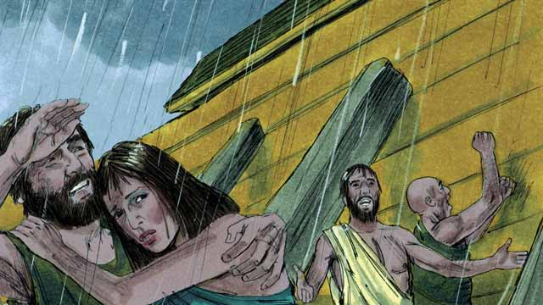

God told Noah to build a boat to save his family from the flood he was going to send. This is how God saved the people who believed in him. In the same way, everyone deserves death from God because they have sinned. But God sent Jesus to save everyone who believes in him.

48-06

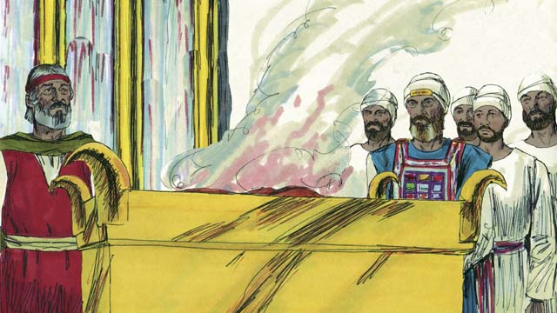

For hundreds of years, priests kept on offering sacrifices to God. This showed people that they committed sin and deserved God’s punishment. But those sacrifices could not forgive their sins. Jesus did what the priests could not do. He gave himself to be the only sacrifice that could take away everyone’s sin. He accepted onto himself the punishment that we should have received for our sins. For this reason, Jesus is the Great High Priest.

48-07

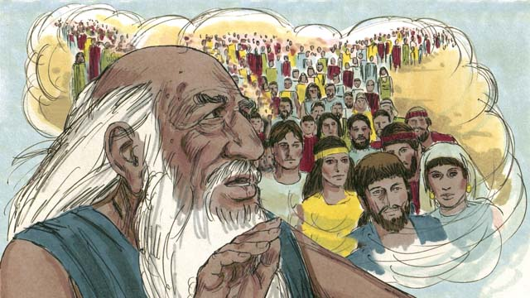

God had told Abraham, “I will bless all the people groups on the earth through you.” Jesus was a descendant of this Abraham. God blesses all the people groups through Abraham because God saves everyone who believes in Jesus from sin. When these people believe in Jesus, God considers them to be descendants of Abraham.

48-08

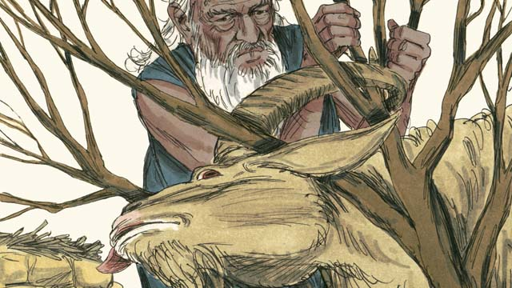

God told Abraham to sacrifice his own son, Isaac, to him. But then God gave a ram for the sacrifice instead of Isaac. We all deserve to die for our sins! But God gave Jesus to be a sacrifice to die in our place. That is why we call Jesus the Lamb of God.

48-09

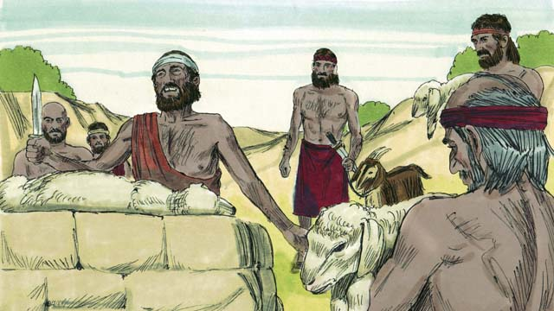

When God sent the last plague on Egypt, he told each Israelite family to kill a lamb. The lamb must not have any flaws. Then they had to spread its blood on the tops and sides of their door frames. When God saw the blood, he passed over their houses and did not kill their firstborn sons. When this happened, God called this the Passover.

48-10

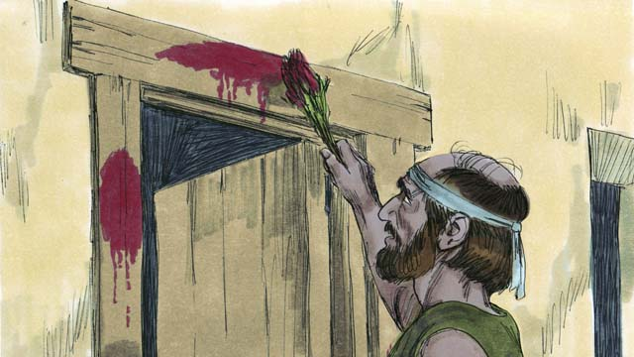

Jesus is like a Passover Lamb. He never sinned, so there was nothing wrong with him. He was killed at the time of the Passover festival. When anyone believes in Jesus, the blood of Jesus pays for that person’s sin. It is as if God passed over that person because he does not punish him.

48-11

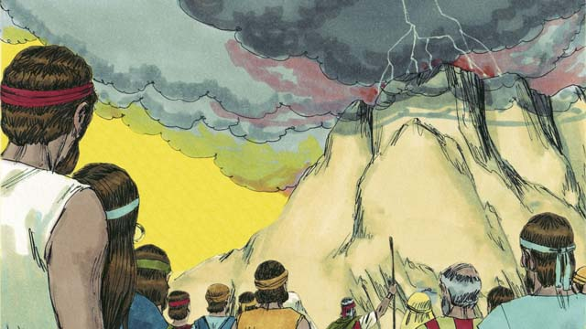

God made a covenant with the Israelites because they were the people he had chosen to belong to himself. But God has now made a New Covenant that is for everyone. If anyone in any people group accepts this New Covenant, he joins God’s people. He does this because he believes in Jesus.

48-12

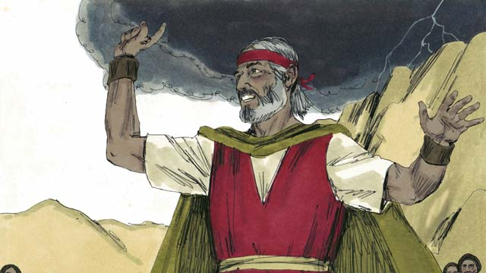

Moses was a prophet who proclaimed the word of God with great power. But Jesus is the greatest prophet of all. He is God, so all the things he did and said were the actions and words of God. That is why the Scriptures call Jesus the Word of God.

48-13

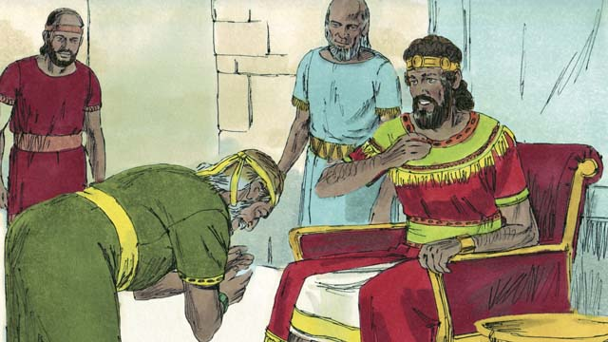

God promised King David that one of his descendants would rule as king over God’s people forever. Jesus is the Son of God and the Messiah, so he is the descendant of David, who can rule forever.

48-14

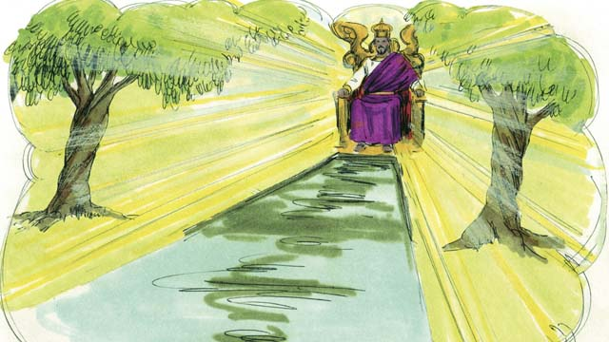

David was a king of Israel, but Jesus is the king of the entire universe! He will come again and rule his kingdom with justice and peace forever.

*A Bible story from: Genesis 1-3, 6, 14, 22; Exodus 12, 20; 2 Samuel 7; Hebrews 3:1-6, 4:14-5:10, 7:1-8:13, 9:11-10:18; Revelation 21*

## 1 Community Study: Remembering Together—Taking Time to Review God’s Work

* **Key Idea**: recalling all that God has done
* **Key Passage**: 2 Timothy 1:3-6
* **Main Session**: OBS 48 (Jesus Is the Promised Messiah)

### 1.1 Recite the Creedal Verse (3–5 minutes)

The verse below summarizes the teaching of the current passage. Read the verse out loud as a community. Read it again several times as a group until the whole community can recite it from memory.

8 Remember Jesus Christ, from David’s seed, who was raised from the dead. This is according to my gospel message 2 Timothy 2:8

OR

3:1 Beloved, this is now the second letter that I have written to you; and in both of them they are reminders to stir up your sincere mind, 2 so that you will recall the words spoken in the past by the holy prophets and the command of our Lord and Savior given through your apostles. 2 Peter 3:1-2

### 1.2 Remember Truths about Jesus (5 minutes)

Think about the many stories you studied about the Bible. Identify some of the stories where you learned the most about Jesus.

These are some of the stories where I learned the most about Jesus…

These are some of the things I learned about Jesus…

### 1.3 Read the Passage (3–5 minutes)

Christian community becomes strong as it remembers important things God wants them to remember. It takes focus and concentration to recall these important things in our life and community. Read the passage below to learn about the important practice of remembering.

3 I thank God, whom I serve from my forefathers, with a clean conscience, as I constantly remember you in my prayers night and day. 4 As I remember your tears, I long to see you, that I may be filled with joy. 5 I have been reminded of your genuine faith, which lived first in your grandmother Lois and your mother Eunice, and I am convinced that it lives in you also. 6 This is the reason I am reminding you to rekindle the gift of God which is in you through the laying on of my hands. 2 Timothy 1:3-6

### 1.4 Discuss the Passage (10-15 minutes)

As the gospel spreads, God wants the church to focus on the spread of the gospel to unreached areas. These places are areas where people do not yet believe in the gospel. A focus on frontier areas shapes your community. As a community, use the following questions to discuss the teaching of the biblical passage.

1. What are the different ways Paul talks about remembering in this passage? Specifically, what are the things that Paul remembers or reminds Timothy about?
2. Why is it important to remember? How does the practice of remembering aid our spiritual growth and ministry practice?
3. What negative things might happen to your community if you do not practice remembering?
4. How can your community develop a healthy practice of remembering together?

### 1.5 Remember the Past Journey (5 minutes)

Spend time remembering the past as a community. Specifically, remember the moments of challenge and moments of joy that your community experienced over the past months together.

When I think about the past months together, these are the difficult moments I remember…

When I think about the past months together, these are the joyful moments I remember…

### 1.6 Pray to God (5 minutes)

Divide into groups of 2-3 people. Think about the people your work will impact. Spend time remembering them by praying for them as a community.

### 1.7 Sing a Song (3–5 minutes)

Sing a song together as a community that remembers God’s goodness and grace in your lives.

## 2 Biblical Interpretation: Observing the Details of the Story

After reading the crafted biblical story, answer the following questions to familiarize yourself with the details of the story.

### 2.1 Observation Questions

Answer the following observation questions to gain a basic understanding of the story. Read the story as a community and answer these questions as a group.

#### 48-01

What was the world like when God first created it?  
When God first created the world, everything was perfect. There was no sin, sickness, or death, and people loved each other and God.

What did God think of the world when he first created it?  
Everything in the world was the way God wanted it to be.

#### 48-02

How did Satan deceive Eve?  
Satan spoke to Even through a snake to deceive her.

Why does everyone on earth die?  
They die because Adam and Eve sinned against God.

#### 48-03

How did the sin of Adam and Eve affect their relationship with God?  
Because Adam and Eve sinned, they became enemies of God.

How many people have sinned since Adam and Eve?  
Since the time that Adam and Eve sinned against God, every person has also sinned.

When do people become enemies of God?  
Every person is born as an enemy of God.

What did God want to do to fix the relationship between God and people?  
There was no peace between God and the people, but God wanted to make peace.

#### 48-04

What did God promise would happen to Satan?  
God promised that one of Eve’s descendants would crush Satan’s head, and Satan would bite his heel.

What does this prophecy mean?  
This means that Satan would kill the Messiah, but God would bring him back to life and take away Satan’s power forever.

Who is the Messiah?  
Many years after Adam and Even, God showed that the Messiah is Jesus.

#### 48-05

How did God save people in the time Noah lived?  
God told Noah to build a boat to save him and his family, and God would save everyone who believed from a flood.

In what way is Jesus like the boat God provided when he destroyed the earth by the flood?  
Everyone deserves death, but God sent Jesus as a way to save people who believe in him.

#### 48-06

How did people deal with their sin through the priests in Israel?  
People sinned and deserved God’s punishment, and priests continually offered sacrifices.

Did these sacrifices ultimately forgive sins?  
The sacrifices did not fully forgive the sins of people.

How was Jesus different from Israel’s priests?  
Jesus did what the priests could not do by forgiving the sins of people.

How is Jesus different than the priests who came before him?  
He offered himself as the only sacrifice to be punished for our sin so that he could take away the sin of everyone.

What does this tell us about Jesus?  
Jesus is the Great High Priest.

#### 48-07

What promise did God give to Abraham?  
God promised to bless all the peoples of the earth through Abraham.

How was Jesus related to Abraham?  
Jesus was a descendant of Abraham.

How is God’s promise to Abraham fulfilled through Jesus?  
God considers everyone who believes in Jesus, from any people group, to be a descendant of Abraham.

#### 48-08

What sacrifice did God tell Abraham to make?  
God told Abraham to sacrifice his own son, Isaac.

Did Abraham sacrifice Isaac?  
God provided a ram for the sacrifice so that Isaac did not have to die.

How is Jesus like the ram that was sacrificed instead of Isaac?  
All people deserve to die, but Jesus is the Lamb of God, who God gave to be a sacrifice in our place.

#### 48-09

What did God tell the Israelites to do at the time God sent the last plague on Egypt?  
God told each Israelite family to sacrifice a lamb.

What condition did the lamb need to be in?  
The lamb must not have any flaws.

What were the people to do with the blood?  
The Israelites had to spread the blood of the lamb on the tops and sides of their door frames.

What would God do when he saw the blood?  
When God saw the blood of the lamb, he passed over their houses and did not kill their firstborn sons.

What did God call this event?  
God called this the Passover.

#### 48-10

How is Jesus like the Passover Lamb?  
Jesus never sinned, and there is nothing wrong with him, so his blood (his death) causes God to pass over and not punish anyone who believes in Jesus.

When was Jesus killed?  
Jesus was killed at the time of the Passover festival.

#### 48-11

How did God relate to the people of Israel?  
God made a covenant with the Israelites because they were the people he had chosen to belong to himself.

Who is the New Covenant for?  
God made a New Covenant that is for any person.

Who can be part of God’s people?  
Anyone from any people group can join God’s people through the New Covenant by believing in Jesus.

#### 48-12

How was Moses a prophet of God?  
Moses was a prophet who proclaimed God’s word in power.

In what way is Jesus the greatest prophet of all?  
He is God, so all the things he did and said were the actions and words of God.

What do the Scriptures call Jesus?  
The Scriptures call Jesus the Word of God.

#### 48-13

What did God promise Kind David?  
God promised King David that one of his descendants would rule as king over God’s people forever.

How does Jesus fulfill God’s promise to King David?  
Because Jesus is the Son of God, he is the descendant of David, who can rule forever.

#### 48-14

In what way is Jesus a greater king than David?  
Jesus is the king of the entire universe.

What will Jesus do when he comes back to earth?  
Jesus will come again and rule his kingdom with justice and peace.

### 2.2 Translation Questions

Use the following translation questions to understand specific details of the passage. Discuss how you might translate these specific elements of the story.

#### 48-01

**God created the world** The one and only true God exists for all time. Before **God created the world**, only God existed. At this time, nothing existed except God the Father, God the Son, and God the Holy Spirit. God made everything that exists. How would you express **God created the world** to mean God made the world out of nothing?

  

**everything was perfect** When God first created the world, everything that God created was the way that God wanted it to be. It had no flaw and did exactly what God wanted it to do. How would you express **everything was perfect** to mean everything God created was exactly as it should be to accomplish all that God intended for it?

  

**There was no sin** When God created the world everything listened to God and obeyed God. At this time, no one ever sinned or did evil. How would you express **There was no sin** to mean nothing evil had happened?

  

**There was no sickness or death** When God created the world, people did not get sick or die. How would you express **There was no sickness or death** to mean no one got sick, and no one died?

  

#### 48-02

**deceive her** Satan spoke to Eve through a snake and told her things that were not true. Satan said things that were false to cause Eve to doubt what God had said. By doing this, he tricked her into disobeying God. How would you express **deceive her** to mean Satan lied to Eve to cause her to believe things that were false?

  

**Because they sinned, everyone on earth dies** Adam and Eve disobeyed God’s commands. The result of this was that all people ended up dying at some point. How would you express **Because they sinned, everyone on earth dies** to mean the reason all humans die is Adam and Eve acted in an evil way by disobeying God’s command when they lived in the garden?

  

#### 48-03

**But God wanted to make peace** All people are sinful and enemies of God. God is just and fair to punish all people and destroy them. God wanted to do the opposite. God wanted to fix the relationship between people and himself so they were no longer enemies. How would you express **But God wanted to make peace** to mean rather than God destroying people, God did the opposite and desired to fix the relationship between God and people and make humans no longer his enemies?

  

#### 48-04

**crush** Satan’s head God said that one of Eve’s descendants would step on Satan’s head and smash it down flat This (**crush**ing the head) represents a person stepping on the head of a snake. The head is completely **crush**ed, and the snake is dead and therefore harmless. How would you express **crush** Satan’s head to mean to shatter Satan’s head by stepping on it with the result that Satan is destroyed?

  

**bite his heel** One of Eve’s descendants would crush Satan’s head. Satan would attack this descendant of Eve like a snake on the ground biting the rear part of a person’s foot. In this case, Satan would cause the Messiah to suffer but would not destroy him. How would express **bite his heel** to mean Satan would injure and harm the Messiah like a snake that bites the rear part of a person’s foot?

  

**but God would raise him to life again** People normally remain dead when they are killed. Satan would kill the Messiah, so you would expect him to be dead. Instead, God did something surprising by raising the Messiah to life again. How would you express **but God would raise him to life again** to mean God did something surprising and unexpected by causing Jesus to come back to life?

  

#### 48-05

**But God sent Jesus to save everyone who believes in him** All people have sinned against God and deserve to be punished for their sin. You would expect God to kill everyone because everyone has sinned. Instead, God sent Jesus to save people from their sin. How would you express **But God sent Jesus to save everyone who believes in him** to mean rather than destroying all people, God did the opposite and sent Jesus to save people who believe in him?

  

#### 48-06

**But those sacrifices could not forgive their sins** God told the Israelites to offer sacrifices to God because of their sins. However, the sacrifices could show people their sin and that it deserved punishment, but it could not ultimately forgive those sins. How would you express **But those sacrifices could not forgive their sins** to mean the sacrifices God commanded worked differently than people would expect in that they showed people their sin but could not ultimately remove the sins that people committed?

  

**He gave himself** Jesus had the power to stop people from killing him. Jesus permitted people to crucify him when he was killed on the cross. How would you express **He gave himself** to mean Jesus allowed himself to be killed?

  

**He accepted onto himself the punishment that we should have received for our sins** God punished Jesus for the sins people committed. People deserve God to punish them for the evil things that they do. However, God punished Jesus instead of the people. In this way, Jesus was a sacrifice that died to take away the sins of people. How would you express **He accepted onto himself the punishment that we should have received for our sins** to mean Jesus experienced the judgment that people deserved to experience because of their sin?

  

#### 48-07

**all the people groups on the earth** God promised Abraham that he would use Abraham to bless people who lived in different parts of the world. How would you express **all the people groups on the earth** to mean people from all different parts of the world?

  

**because God saves from sin everyone who believes in Jesus** God blesses people who live in all parts of the world when they become believers in Jesus. Jesus is a descendant of Abraham, and people who believe in Jesus are counted as descendants of Abraham who enjoy the blessings God has promised. How would you express **because God saves from sin everyone who believes in Jesus** to mean God blesses all people through Abraham because God rescues all people from their sin who believe in Jesus, who is a descendant of Abraham?

  

**When these people believe in Jesus** God considers people who believe in Jesus to be descendants of Abraham at the time they believe in Jesus. Even though they are not his physical descendants, God counts believers in Jesus as legitimate descendants of Abraham. How would you express **When these people believe in Jesus** to mean God considers people who believe in Jesus to be Abraham’s descendants at the time they believe in Jesus?

  

#### 48-08

**But then God gave a ram for the sacrifice instead of Isaac** God instructed Abraham to sacrifice his son Isaac. Rather than allowing Abraham to complete the sacrifice by killing Isaac, God provided a ram so that Abraham could sacrifice the ram in place of Isaac. How would you express **But then God gave a ram for the sacrifice instead of Isaac** to mean rather than allowing Abraham to kill Isaac as a sacrifice, God did the opposite and provided a ram in Isaac’s place so that he would not have to offer Isaac as a sacrifice?

  

**We all deserve to die for our sins!** All people are guilty of sinning against God. God is just and fair to punish all people for their sins. This includes us. How would you express **We all deserve to die for our sins!** as a strong statement that emphasizes all people (including us) should die because of the evil things we have done against God?

  

**But God gave Jesus to be a sacrifice to die in our place** All people should die because of their sin. Rather than killing every person, God sent Jesus to be a sacrifice for people. We all deserve to die for our sin, but instead, God gave Jesus to die in our place. How would you express **But God gave Jesus to be a sacrifice to die in our place** to mean rather than destroying all people because of their sin, God did the opposite and sent Jesus to die in the place of each of us so that God would not have to kill us?

  

#### 48-09

**When God sent the last plague on Egypt God sent many disasters on Egypt** to judge them. God commanded each Israelite family to slaughter a lamb. God told them to do this when he caused the final disaster to come upon Egypt. How would you express **When God sent the last plague on Egypt** to mean God instructed each Israelite family to kill a lamb when God caused the final disaster to come on Egypt?

  

**passed over** God did not kill the firstborn sons who were in the house with lamb’s blood on the doors. God went by these houses. This Passover event shows how God will pay for people’s sins. How would you express **passed over** to mean God moved by the houses with lamb’s blood on the doors and did not kill the firstborn sons who live there?

  

#### 48-10

**the blood of Jesus pays for that person’s sin** When Jesus died, he bled. The blood represents Jesus’ death on the cross. Jesus’ death is compared to a payment for sin. When people sin, they are in debt to God. Jesus’ death is like a payment that settles the debt that humans have against God because of their sin. How would you express **the blood of Jesus pays for that person’s sin** to mean the sacrifice that Jesus made of himself when he died for sinners was like a payment that settled the debt of sin that people had against God?

  

**It is as if God passed over that person, because he does not punish him** People who believe in Jesus are like the Israelites who trusted God. The Israelites put the lamb’s blood on their doors, and God did not kill the firstborn of that house. In a similar way, Jesus died so that those who believe in Jesus are not punished by God because of the sacrifice represented in Jesus’ blood. How would you express **It is as if God passed over that person, because he does not punish him** to mean God does not punish people who believe in Jesus in a similar way that passed over the Israelite houses with the lamb’s blood on the door?

  

#### 48-11

**because they were the people he had chosen to belong to himself** God made a covenant with the Israelite people. The reason God made this covenant with them was God chose the Israelites to be his special people. How would you express **because they were the people he had chosen to belong to himself** to mean God made a covenant with the people of Israel because God selected them to have a special relationship with himself?

  

**If anyone in any people group accepts this New Covenant, he joins God’s people** People who agree with the New Covenant are those people who believe in Jesus. These people become a part/members of God’s people. How would you express **If anyone in any people group accepts this New Covenant, he joins God’s people** to mean the result of people living by the New Covenant and believing in Jesus is they become members of God’s people?

  

#### 48-12

**But Jesus is the greatest prophet of all** Moses was a prophet. Many other prophets came after Moses. Jesus is different than all these prophets. Jesus is better than all of the other prophets who came before. How would you express **But Jesus is the greatest prophet of all** to mean Jesus is the most important prophet and is different/superior/better than all the other messengers/prophets God sent?

  

**the Scriptures call Jesus the Word of God** Jesus reveals God’s character. The other prophets preached God’s message, but Jesus revealed God in his preaching and actions. How would you express **the Scriptures call Jesus the Word of God** to mean God’s written word says that Jesus is God’s Word who shows people what God is really like through his words and actions?

  

#### 48-13

**so he is the descendant of David who can rule forever** Jesus is God’s Son who is equal to God the Father. Jesus is the Messiah God promised to send to save people from their sins. How would you express **so he is the descendant of David who can rule forever** to mean the result of Jesus being the Son of God and the Messiah is he is the descendant of David who can rule forever?

  

#### 48-14

**but Jesus is the king of the entire universe** David was a king of Israel. He was only a human. He only ruled for a period of time. And he only ruled over the people of Israel. In contrast to David, Jesus rules over all that God has made. How would you express **but Jesus is the king of the entire universe** to mean Jesus is different from David in that Jesus rules over everything God created?

  

## 3 Theological Dialogue: Discussing the Meaning of the Story

Take time to explore the meaning of this story together as a community. Use the following discussions to grasp the truth the story teaches.

### 3.1 Discourse Questions

Use the following discourse questions to understand the meaning of the story. Pay attention to how the story itself addresses each question or theme.

##### How did sin enter into the world? How did God’s good and perfect world get ruined by sin? (48-01, 48-02, 48-03)

Perfect World: God created the world perfect. In the beginning, there was no sin in the world. Everything was just the way God wanted it to be. There was no sin, sickness, or death. Everything loved and obeyed God. (48-01)

  

Deception: Satan deceived Eve in the garden. He told her things that were not true. (48-02)

  

Disobedience: Adam and Eve disobeyed God. They did what God told them not to do. They listen to Satan rather than listening to God. (48-02)

  

Death: The sin and disobedience of Adam and Eve caused everyone on Earth to eventually die. (48-02)

  

Hostility/Enemies: The sin and disobedience of Adam and Eve caused people to be enemies against God. The peaceful relationship between God and people no longer existed. There was no peace between people and God. (48-03)

  

From the Time of Birth: Every person is sinful from the time of birth. People are born into the world as sinners who are enemies of God. (48-03)

  

##### How did God plan to save people from sin? (48-03, 48-04)

God Wanted to Make Peace: God wanted to fix the broken relationship with people. God wanted to make peace with humans so that they would no longer be his enemies. God took the initiative to deliver his creation. (48-03)

  

Promised Messiah: God promised that one of Eve’s descendants would destroy Satan. This descendant is the Messiah. The promised Messiah is Jesus. God said that Satan would attack and harm the Messiah, but God would bring the Messiah back to life again. The Messiah would take away Satan’s power for all time. God planned to restore his fallen creation by sending a promised deliverer, the Messiah. (48-04)

  

##### What do stories in the Old Testament teach us about who Jesus is and how Jesus saves people from sin? (48-04, 48-05, 48-06, 48-07, 48-08, 48-09, 48-10, 48-11, 48-12, 48-13, 48-14)

Jesus Is the Messiah: God promised to send a deliverer/Messiah. This Messiah is Jesus. (48-04)

  

Jesus Is Savior/Rescuer | Noah and the Flood: In the time of Noah, God said he would send a flood to destroy all people because of their sin. Noah and his family trusted God. God saved Noah through the flood by telling Noah to build a boat. Noah and his family trusted God and entered the boat. All people deserve to die because of their sin, but Jesus saves/rescues everyone who believes in him. (48-05)

  

Jesus Is Sacrifice and High Priest: God told the Israelites to have priests offer sacrifices for their sins. The sacrifices reminded God’s people that they deserved to die for their sins. These sacrifices could not ultimately take away sin. Jesus died as an ultimate sacrifice for sin. Since Jesus allowed people to kill him, Jesus is also a priest who offers sacrifices. Jesus is the priest and sacrifice who takes away sin by offering himself as a sacrifice for sin. God spared Isaac by providing a ram for Abraham to sacrifice so that Abraham did not have to kill Isaac. Jesus is the Lamb of God who is killed so that people who believe in Jesus do not have to die for their sins. During the exodus, God told the Israelites to kill a lamb and put its blood on the door. God did not punish those houses with lamb’s blood on the doors. Jesus is the Passover Lamb that allows people who believe in Jesus to escape God’s punishment. In sum, Jesus is a sacrifice for the sins of people. God Jesus experienced the punishment that people deserved to experience so that God would not have to punish people who believed in Jesus. (48-06, 48-08, 48-09, 48-10)

  

Jesus Brings the New Covenant: God made a covenant with Abraham. God promised to bless people in all parts of the world through Abraham. Jesus is a descendant of Abraham and makes those who believe in Jesus descendants of Abraham. God chose the Israelites to be his special people. They enjoyed a special relationship with God. Jesus makes it possible in the New Covenant for people from all parts of the world to enjoy a relationship with God by believing in Jesus. People who believe in Jesus become part of God’s people, no matter their culture or language. (48-07, 48-11)

  

Jesus Is the Word of God/Prophet: God sent messengers to tell people God’s messages and to tell people what God is like. God also gave these messengers great power. Jesus is better than all the prophets/messengers God sent in the past. Jesus is more powerful than all of them since he is equal to God the Father. Also, Jesus fully showed people who God is by his actions and words. Jesus could do this because he is equal to God. For this reason, Jesus is called the Word of God. (48-12)

  

Jesus Is Righteous King: David ruled Israel as king. God promised that the Messiah would be one of David’s descendants. God said that the Messiah would rule forever, and he would rule over all that God created. God also said that the Messiah would rule in justice and peace. (48-13, 48-14)

  

### 3.2 Theological Questions

Answer the following theology questions as a community. Discuss what truths this story teaches.

1. How did sin enter into the world, and what effects does sin have on people? What does this story teach us about how God’s good and perfect world was ruined by sin?
2. How did God plan to save his people from sin? How does this story teach us about God’s plan to rescue and restore people to a relationship with himself?
3. In what ways is Jesus the promised Messiah whom God sent to save people from sin? What does this story teach us about who Jesus is and how he fulfilled God’s plans and saves people from sin?

### 3.3 Translation Draft

Work as a translation team to draft each panel of this story. Pay attention to any specific translation issues that are challenging or significant.

#### Make Translation Draft

Make a draft for each section of this story.

#### Discuss and Revise

After drafting the story, discuss any translation issues that you think need a special explanation.

#### Drafting Summary Reflection

Summarize any noteworthy translation decisions and the rationale/reasoning behind these translation decisions. In the final movement of this class, you will use these observations to give an account (i.e., chronicle/narrate) of how your translation improved through the checking process.

## 4 Personal Reflection: Following the Teaching of the Story

Take a moment to allow this story to evaluate your own life and to consider how God would have you respond. After this reflection, use the quality checking questions to check your translation draft among the translation team.

### 4.1 Journal Reflection

Prayerfully think about the following personal reflection questions. Write/Record your answers and/or discuss them as a group.

1. How have you experienced the negatives effects of sin in your own life?
2. What are wrong ways you have tried to deal with sin and restore your relationship with God?
3. Which Old Testament stories, which Jesus fulfilled as the Messiah, most encourage your faith in Jesus?
4. How can you deepen/strengthen your trust in Jesus as the only one who can deliver people from sin?

### 4.2 Team Check

*The following activity will help you check the clarity, accuracy, and naturalness of your draft. Read the passage aloud and discuss the checking questions with other members of your translation community. You might need to reread portions (or the whole) of the biblical passage multiple times as you answer each of these questions. Record answers to these questions below.*

#### Team Checking Questions

*Use the following questions to check your translation draft for accuracy, clarity, and naturalness.*

1. **Accurate**: Has anything been **added** to your translation of this passage that is not a part of the meaning of the source text? *If additions exist, are they only added to clarify meaning (such as implied information)?*
2. **Accurate**: Is anything **missing** from your translation of this passage that is a part of the meaning of the source text? *If some part of the meaning is missing from your translation, add it.*
3. **Accurate**: Does any meaning in your translation of this passage appear to be **different** than the meaning of the source text? *If the meaning is different, try changing your translation so that the meaning remains the same.*
4. **Natural**: Does anything sound **unnatural** to how you would say it in your language? *If portions of the passage sound unnatural in your language, try to make them sound the way you would say them in your language while staying true to the meaning of the source text.*
5. **Clear**: Is anything **unclear** or **confusing** in your translation that confuses the meaning of the source text? *If portions of the passage are unclear or confusing, revise them to clearly communicate the meaning of the source text.*
6. **Consistent**: How **consistent** is your translation within the passage and with other passages? *If portions of the passage need to be made consistent or if you need to revise translations of other passages, make these adjustments.*

#### Record Feedback

*After discussing the checking questions above as a translation community, record any feedback on your translation draft. Pay attention to parts of your translation that are translated well and parts of your translation that need correction.*

#### Discuss and Revise

*After gathering feedback on your draft, discuss it together with your translation community and make appropriate revisions to your translation.*

#### Record Translation Decisions

*As a community, discuss some of the most noteworthy translation decisions in your draft. Summarize each decision and explain the reasons your community decided on that translation. You should update these decisions each time you check your draft with various groups of people.*

You should **measure** the quality of your translation draft. You can **record translation decisions** to make it clear why you translated things a certain way. Translation decisions can help your translation team and the surrounding community be a part of the translation process.

How can you know the quality of your translation?

1. **Measure** the translation by marks/standards of quality (i.e., clear, accurate, natural, church-approved)
2. **Test** the translation with others and record feedback and conversations from in the field (i.e., church and community check)
3. **Compare** and **contrast** the translation with the source text (i.e., meaning of text and notes) and alternatives (i.e., other translation choices)
4. **Explain** the reasons why you translated a particular portion of the text.

**Example Sentences That Help Explain Your Translation Decision** Use the following example sentences to help explain your translation decisions:

1. The original text literally **says/means**, so we translated the term in this way…
2. We originally decided to translate **the biblical term** with **this term**, but we changed it because…
3. When our translation team discussed **the biblical term**, this is what we talked about…
4. **The term** is [clear, accurate, natural, consistent] because…
5. The community understands **this term** to mean…
6. We considered these other terms. We did not use **these terms** because…
7. When we checked this in the church, we learned…
8. When we checked this in the community, we learned…

**Example of Translation Decision**

In OBS 01-07 we decided to translate **blessed** like this: [actual translation]. We decided on this translation because of these reasons:

1. The word [actual translation] means to cause good things to happen to someone or something. This term is used when a person desires someone or something to prosper or flourish. This term does not refer to magic or witchcraft.
2. When we checked this word with other believers, they said it describes God showing his kindness and favor on someone or something. These are some of the terms that we did not decide to use…
3. Many of our people will understand this word. When we discussed this phrase with the surrounding community, we discovered it was a natural way to describe God causing good and beneficial things to happen.

## 5 Ministry Practice: Serving the Church with the Story

Now that you have a draft of this story, consider how this story can encourage other believers in their faith. After ministering this story to others, you will also perform a community check of your translation draft.

### 5.1 Church Ministry

Reflect on how this story can edify and mature the Christian community. Design a way to minister this story to your church community.

**Ministry Preparation**: Take time to consider how you could minister this story to others. Record some ministry ideas below.

**Ministry Implementation**: Minister this story to a group of believers as you had planned. Use the information in this study to help develop a teaching/lesson or lead a discussion of this story with other believers. Record your ministry plan below.

**Ministry Reflection**: Think about what you learned from ministering this story to other believers. Reflect on your experience below.

### 5.2 Church Community Check

After teaching or ministering this story to the church, check the translation quality with the church community. Record any feedback from your checking experience.

#### Create Checking Questions

You can use **Translation Questions** to check your draft. Each **Translation Question** explains the meaning of a specific part of the story and asks you to consider how you would translate that part of the story in your own language. Change each **Translation Question** into a **Checking Question** by asking the following questions. The first question asks you to identify how each specific phrase was translated into your language. The second question asks people in the church to determine if your translation of the phrase expresses the meaning clearly, accurately, and naturally. Look at the following examples to see how to change **Translation Questions** into **Checking Questions**:

#### Translation Question Example 1

**to proclaim the good news about Jesus** Paul and Silas traveled to Philippi for the purpose of preaching the gospel. The gospel is the good news that Jesus saves people from their sins if they will believe in Jesus. How would you express **to proclaim the good news about Jesus** to mean to tell other people the message about how Jesus can save people from their sins?

#### Translation Question Example 2

**a merchant** Paul and Silas met a woman named Lydia at the place by the river. She owned a business and sold items to make money. How would you express **a merchant** to mean a business owner who sells items for a profit?

#### Translation Question Example 3

**so Paul and Silas baptized them** The jailer and his whole family followed Paul’s instructions. They believed in Jesus. The result of this was Paul and Silas baptized them. How would you express **so Paul and Silas baptized them** to mean the result of the jailer and his family believing in Jesus that Paul and Silas baptized all of them?

You can change these into **Checking Questions** like this:

#### Checking Question Example 1

**to proclaim the good news about Jesus** How did you translate **to proclaim the good news about Jesus**? Does it mean to tell other people the message about how Jesus can save people from their sins?

#### Checking Question Example 2

**a merchant** How did you translate **a merchant**? Does it mean a business owner who sells items for a profit?

#### Checking Question Example 3

**so Paul and Silas baptized them** How did you translate **so Paul and Silas baptized them**? Does it mean the result of the jailer and his family believing in Jesus that Paul and Silas baptized all of them?

#### Record Feedback

*Discuss the* ***Checking Questions*** *with your church community, and record any feedback on your translation draft. Pay attention to parts of your translation that are translated well and parts of your translation that need correction.*

#### Discuss and Revise

*After gathering feedback on your draft, discuss it together with your translation community and make appropriate revisions to your translation.*

#### Record Translation Decisions

*Update your translation decisions and record any new and noteworthy observations on the quality of your draft.

## 6 Missional Outreach: Sharing the Truth of the Story

*After sharing this story with others, check the translation quality with the wider language community. Record any feedback from your checking experience.*

### 6.1 Mission Engagement

*Consider how you will witness this story to unbelievers. Design a way to share this story and engage them in what it teaches about Christianity and the gospel.*

**Witness Preparation**: Take time to consider how you will witness this narrative to unbelievers. Record some ideas below.

**Witness Implementation**: Share this story with an unbeliever. Use the information in this study to help develop a teaching/lesson or lead a discussion of this story with other believers. Record your ministry plan below.

**Witness Reflection**: Think about what you learned from ministering this story to unbelievers. Reflect on your experience below.

### 6.2 Sociolinguistic Check

After sharing this story with the language community, check your translation draft with the surrounding community. Record your observations.

#### Checking Approach

After witnessing this story to unbelievers, use one of the following methods to check the translation of this story. Consider using the **Observation Questions** to check your translation draft or come up with your own quality checking questions.

**Read-Retell Check:** Read your draft to those in the community and ask them to retell the passage. Be attentive to any portions of the passage that are unclear, unnatural, or inaccurate.

**Comprehension Questions Checklist:** Read the draft of the passage and ask a list of comprehension questions to make sure the passage is being rightly understood. You can use the **Observation Questions** in this guide or come up with your own questions. Then, record any insights or issues that arise.

**Discussion Group:** Develop key questions to ask about the passage (both formational and translational). Read the passage and have a group discussion about the passage, paying attention to issues that need to be addressed, edited, and revised.

#### Record Feedback

*After sharing your draft with the language community, discuss the* ***Observations Questions****, and record any feedback on your translation draft. Pay attention to parts of your translation that are translated well and parts of your translation that need correction.*

#### Discuss and Revise

*After gathering feedback on your draft, discuss it together with your translation community and make appropriate revisions to your translation.*

#### Record Translation Decisions

*Update your translation decisions and record and new any noteworthy observations on the quality of your draft.

## 7 Conclusion

As a translation community, take time to reflect on all that was learned in studying, drafting, and checking this story. Celebrate all that God has taught you as a community. Then, submit your revised draft and checking summaries to network leaders for further review.