Open Bible Stories

God’s New Covenant

## 0 Introduction

### 0.1 Key Idea

The story of God’s New Covenant teaches us that Jesus brings in the blessings of a new way of being restored to a relationship with God in the New Covenant.

### 0.2 Creedal Verse

“Therefore he is the mediator of a new covenant, so that those who are called may receive the promised eternal inheritance, since a death has occurred that redeems them from the transgressions committed under the first covenant.” Hebrews 9:15

### 0.3 Metanarrative Summary

The eternal God created all things in six days. He made a good and perfect world. He made humans in his image to fill the earth and rule over creation. But humans rebelled against God and ruined God’s creation. God set to restore his world through his promise. God made a covenant with Abraham. He promised to bless all nations through Abraham. God kept his promises across the generations. God provided Abraham with a promised child, Isaac. God gave Isaac a wife, and she bore twins Jacob and Esau. God blessed Jacob and his sons, and the blessing continued to the next generation. God rescued Joseph, one of Jacob’s sons, and used him to rescue his family. God caused his people, the Israelites, to multiply in the land of Egypt; eventually, they became slaves. But God raised up a deliverer, Moses, to deliver his people from slavery. God judged the Egyptians with harsh plagues; in the final judgment, he passed over his people, who covered their doorposts with the blood of a sacrificed lamb. Then, God delivered the Israelites by bringing them out of Egypt and crossing the Red Sea on dry land. God made a covenant with the Israelites and made them his people. God tested Israel in a series of wilderness wanderings and eventually brought his people into the promised land of Canaan. God raised up deliverers to lead Israel and rescue them from their enemies. God formed Israel into a kingdom. He made a covenant with King David and promised to send a king that would rule his people forever. Many of Israel’s kings were evil, and the kingdom of Israel was divided into two kingdoms. God sent prophets to warn his people of God’s judgment and call them to repent. When Israel did not repent, God sent his people into exile. After many years, he brought them back to the land. Throughout the Old Testament, God promised to send his Messiah to deliver his people from their sin. After many years, the prophet John was born. He would prepare people for the coming Messiah. At the perfect time, God sent his Son, Jesus, to be born of a virgin Mary. When John and Jesus grew up, John baptized Jesus as a sign that Jesus was God’s beloved Son. Jesus endured all manner of temptation without ever sinning. When he was thirty years old, he launched a public ministry of preaching, teaching, and healing. He taught his disciples about the life of compassion, sacrifice, and forgiveness. Jesus performed many miracles: he fed a crowd of five thousand, he walked on water, he healed the sick, and he cast out demons. He proclaimed to people the nature of real faith, God’s kingdom, and how fallen humans can be restored in relationship with God. Toward the end of his ministry, Jesus revealed his power and glory to his disciples. He raised a dead man to life, Jesus was betrayed by one of his disciples and put on trial before a Roman governor. Jesus was sentenced to death and crucified on a cross Three days later, Jesus rose again from the dead. After meeting with many of his disciples, Jesus went back to heaven. The Holy Spirit empowered Jesus’ followers and formed them into his church. Jesus’ disciples, like Peter and John, performed miracles and preached the good news about Jesus. New leaders like Stephen and Philip served the church and preached about Jesus. Even Saul, a persecutor of Jesus’ followers, became a Christian and preached the gospel to many people. Jesus is the promised Messiah and brings in blessings of a New Covenant.

### 0.4 Open Bible Story: God’s New Covenant

49-01



An angel told Mary, a young woman, that she would give birth to God’s Son. She was still a virgin, but the Holy Spirit came to her and made her become pregnant. She gave birth to a son and named him Jesus. Therefore, Jesus is both God and human.

49-02

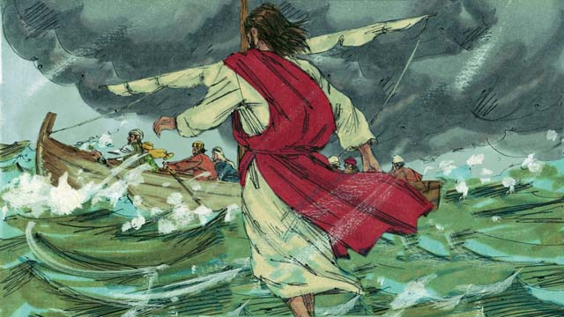

Jesus did many miracles that show that he is God. He walked on water and stopped storms. He healed many sick people and drove demons out of many others. He raised dead people to life and turned five loaves of bread and two small fish into enough food to feed over 5,000 people.

49-03

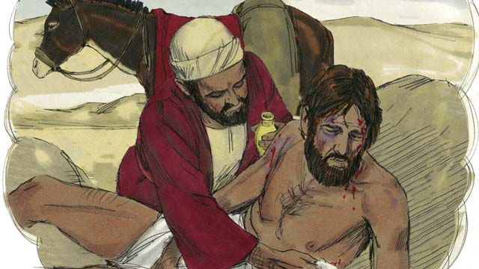

Jesus was also a great teacher. Everything he taught, he taught correctly. People should do what he told them to do because he is the Son of God. For example, he taught that you must love other people the same way you love yourself.

49-04

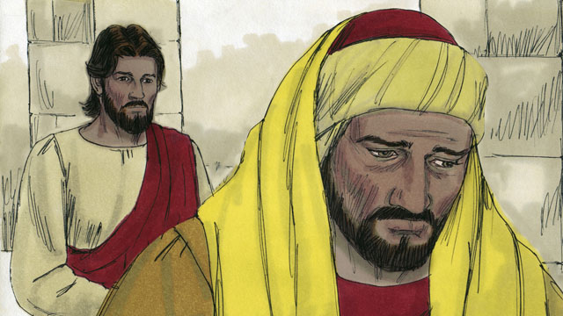

He also taught that you need to love God more than you love anything else, including your possessions.

49-05

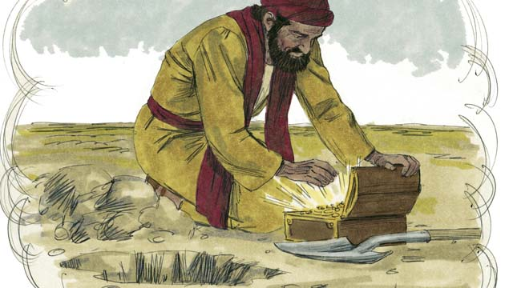

Jesus said it is better to be in God’s kingdom than have anything else in the world. God must save you from your sins in order for you to enter his kingdom.

49-06

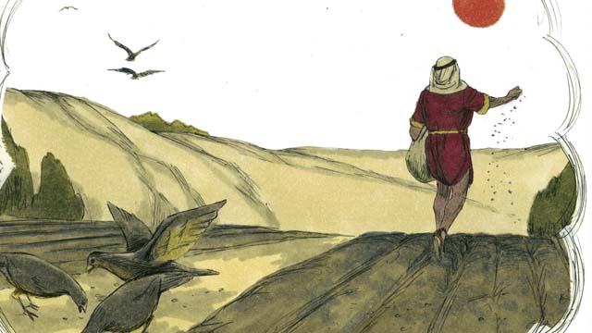

Jesus said that some people will accept him. God will save these people. However, other people will not accept him. He also said that some people are like good soil. Because they accept the good news about Jesus, God saves them. However, other people are like the hard soil on a path. God’s Word is like seed that falls on the path, but nothing grows there. These people reject the message about Jesus. They refuse to enter into his kingdom.

49-07

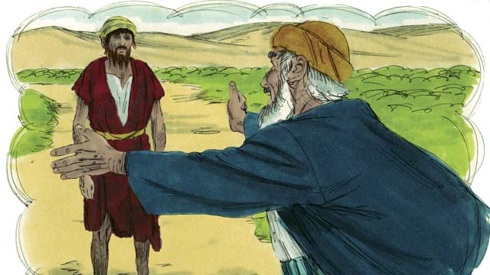

Jesus taught that God loves sinners very much. He wants to forgive them and to make them his children.

49-08



Jesus also told us that God hates sin. Because Adam and Eve sinned, all of their descendants also sin. Every person in the world sins and is far from God. Everyone is an enemy of God.

49-09

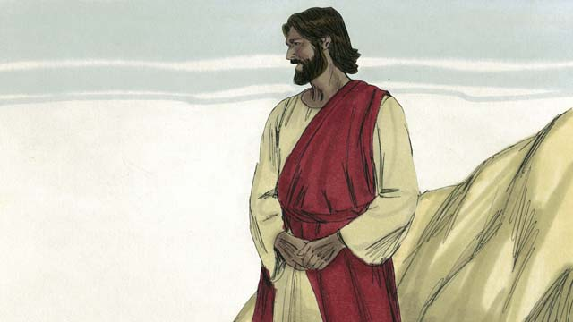

But God loved everyone in the world in this way: he gave his only Son so that God will not punish those who believe in Jesus. Instead, believers will live with him forever.

49-10

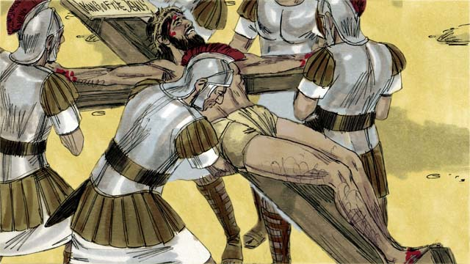

You deserve to die because you have sinned. It would be right for God to punish you, but Jesus took the punishment for sin in our place. God punished Jesus by killing him on a cross.

49-11

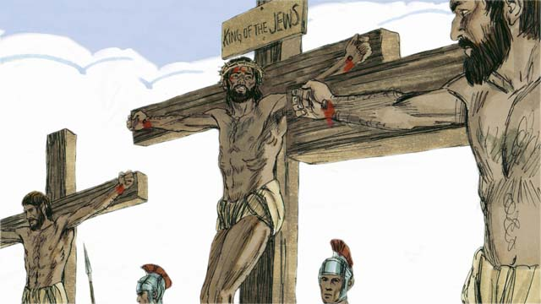

Jesus never sinned. He accepted the punishment for sin, including the worst possible death. In this way, he was the perfect sacrifice to take away your sins and the sins of every person in the world. Jesus sacrificed himself to God, so God will forgive any sin, even terrible sins, of the people who believe in Jesus.

49-12

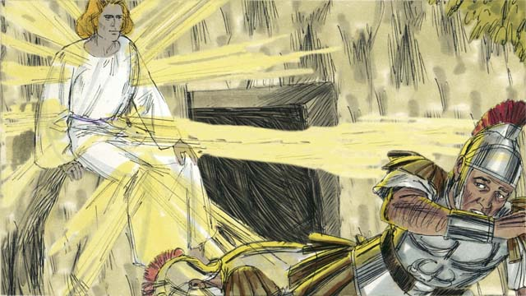

Even if you do many very good things, this will not make God save you. There is nothing you can do on your own to become friends with him. Instead, you should believe that Jesus is the Son of God, that he died on the cross instead of you, and that God raised him to life again. If you believe this, God will forgive you for having sinned.

49-13

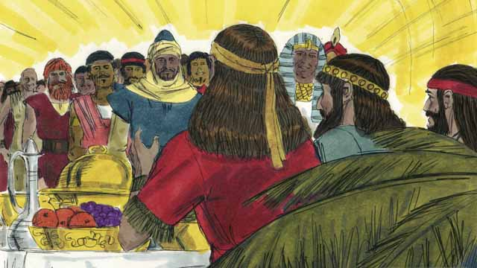

God will save everyone who believes in Jesus and accepts him as their Master. But he will not save those who do not believe in him. It does not matter if you are rich or poor, man or woman, old or young, or where you live. God loves you and wants you to believe in Jesus so he can be a friend to you.

49-14

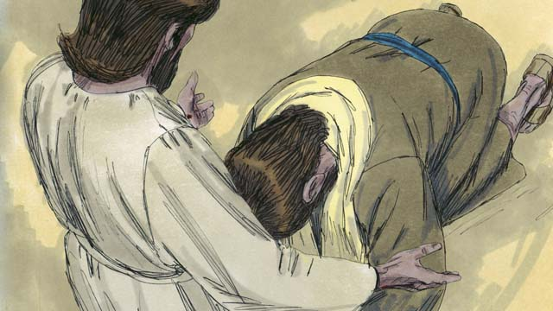

Jesus is calling you to believe in him and to be baptized. Do you believe that Jesus is the Messiah, the only Son of God? Do you believe you are a sinner and deserve God’s punishment for your sin? Do you believe Jesus died on the cross to take away your sins?

49-15

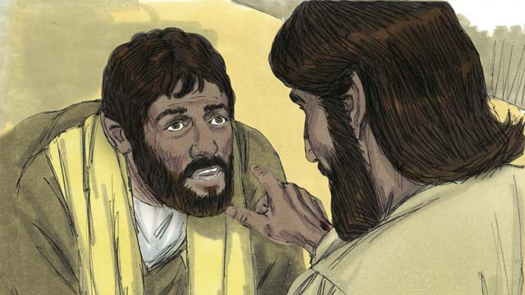

If you believe in Jesus and confess what he has done for you, you are a follower of Jesus! Satan no longer rules you in his kingdom of darkness. God is now ruling over you in his kingdom of light. God has enabled you to no longer sin as you used to do. He has given you a new, right way of living.

49-16

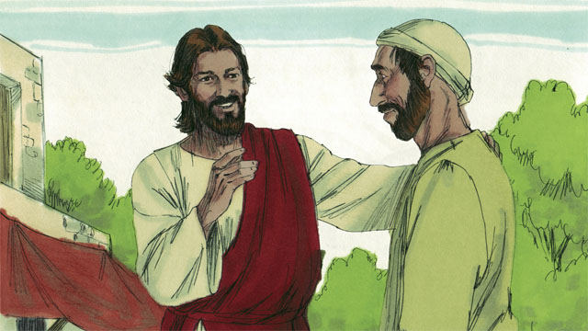

If you are a follower of Jesus, God has forgiven your sins because of what Jesus did. Now, God considers you to be a close friend instead of an enemy.

49-17

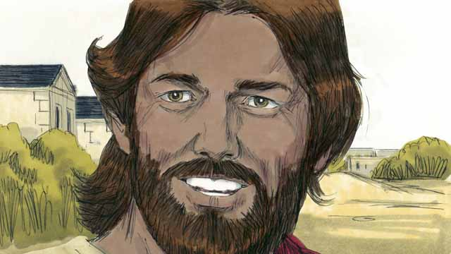

If you are a friend of God and a servant of Jesus, the Master, you will want to obey what Jesus teaches you. Even though you are a follower of Jesus, Satan will still tempt you to sin. But God always does what he says he will do. He says that if you confess your sins, he will forgive you. He will give you strength to fight against sin.

49-18

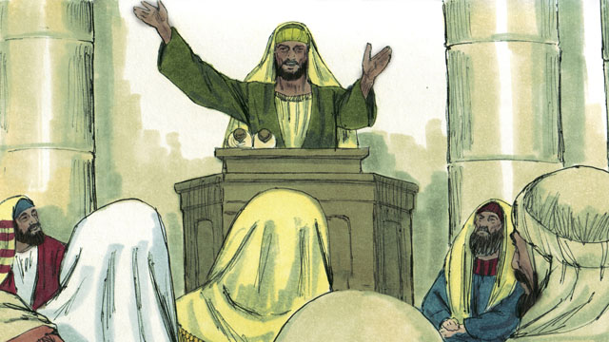

God tells you to pray and to study his word. He also tells you to worship him together with other followers of Jesus. You must also tell other people what he has done for you. If you do all these things, you will become a strong friend of his.

*A Bible story from: Genesis 3; Matthew 13-14; Mark 10:17-31; Luke 2; 10:25-37; 15; John 3:16; Romans 3:21-26, 5:1-11; 2 Corinthians 5:17-21; Colossians 1:13-14; 1 John 1:5-10*

## 1 Community Study: Community Thanksgiving—Expressing Gratitude to God

* **Key Idea**: giving thanks to God for his great work
* **Key Passage**: 2 Thessalonians 1:3-4
* **Main Session**: OBS 49 (God’s New Covenant)

### 1.1 Recite the Creedal Verse (3–5 minutes)

The verse below summarizes the teaching of the current passage. Read the verse out loud as a community. Read it again several times as a group until the whole community can recite it from memory.

6 But now Christ has received a much better ministry, just as he is also the mediator of a better covenant, which is based on better promises. Hebrews 8:6

OR

9:1 I will give thanks to Yahweh with my whole heart; I will tell about all your marvelous deeds. Psalm 9:1

### 1.2 Remember Your Community Growth (5 minutes)

Think about the ways your community has grown in the faith and experienced God’s goodness. Share these as a community.

These are some of the ways our community has grown and become strong in the faith…

These are some of the wonderful deeds God has done among us…

### 1.3 Read the Passage (3–5 minutes)

Christian community becomes strong as it expresses thanksgiving to God. When God’s people are grateful, it makes the whole group of believers stronger. Read the passage below to learn about the important practice of thanksgiving.

3 We should always give thanks to God for you, brothers. For this is appropriate, because your faith is growing more and more, and the love each of you has for one another increases. 4 So we ourselves speak proudly about you among the churches of God. We talk about your patience and faith in all your persecutions. We talk about the afflictions that you endure. 2 Thessalonians 1:3-4

### 1.4 Discuss the Passage (10-15 minutes)

There are many reasons to be thankful. God is a good God who sustains his people and uses hardship to grow them in their faith. As a community, use the following questions to discuss the teaching of the biblical passage.

1. How does Paul express thanksgiving in this passage? What does it mean to give thanks to God for other people?
2. How can believers be thankful through hardship? How does this passage teach about this?
3. What negative things might happen to your community if you do not practice thanksgiving?
4. How can your community develop a healthy practice of thanksgiving and gratitude?

### 1.5 Express Gratitude (5 minutes)

Think about the past months together as a community. Identify the hardships you endured, the people you appreciate, and reasons to be thankful to God. Share these together as a community.

When I think about the past months together, these are some of the hardships we endured…

When I think about the past months together, these are some of the people I am grateful for…

When I think about the past months together, these are some reasons I am thankful to God…

### 1.6 Pray to God (5 minutes)

As a whole community, use the sentences in the above activity to guide you in prayer. Offer these prayers aloud as a community.

### 1.7 Sing a Song (3–5 minutes)

Sing a song of thanksgiving to God. Praise him for his goodness to you and your community. Allow this song to encourage your community to endure hardship well.

## 2 Biblical Interpretation: Observing the Details of the Story

After reading the crafted biblical story, answer the following questions to familiarize yourself with the details of the story.

### 2.1 Observation Questions

Answer the following observation questions to gain a basic understanding of the story. Read the story as a community and answer these questions as a group.

#### 49-01

Who gave birth to God’s Son?  
Mary, a young woman who was a virgin, gave birth to God’s Son, Jesus.

How did she become pregnant with Jesus?  
The Holy Spirit made her become pregnant with Jesus.

Is Jesus both God and human?  
Yes. Jesus is both fully God and fully human at the same time.

How is Jesus both God and human?  
Jesus became human because he was born of a woman. At the same time, he was and is God, and was born of a virgin made pregnant by an act of the Holy Spirit.

#### 49-02

How did Jesus prove that he is God?  
He did many miracles.

What were some of the miracles Jesus did?  
Jesus walked on water, stopped storms, healed many sick people, drove out demons, raised dead people, and fed over 5,000 people with five loaves of bread and two small fish.

#### 49-03

What kind of teacher was Jesus?  
Jesus was a great teacher and everything Jesus taught was true/correct.

Why should people listen to Jesus’ teaching?  
People should listen to what Jesus says because he is the Son of God.

What did Jesus teach about how we should love other people?  
We should love them in the same way as we love ourselves.

#### 49-04

What did Jesus teach about who we should love more than anything else?  
We should love God more than anything else.

#### 49-05

What is the most important thing for anyone?  
The most important thing is to belong to the kingdom of God.

Is there anything more important than being a part of God’s kingdom?  
No. Nothing in the world is as good/important as being a part of God’s kingdom.

How can people belong to the kingdom of God?  
God must save people from their sins in order for them to belong to God’s kingdom.

#### 49-06

How will people respond to Jesus?  
Some people are like good soil and accept Jesus; others are like hard soil on a path and reject Jesus.

What happens to the people that accept Jesus?  
God saves the people who accept Jesus.

What do people do when they reject the message about Jesus?  
They refuse to enter into his kingdom.

#### 49-07

Does God care for sinners?  
Yes. God loves sinners very much.

What does God want to do for sinners?  
He wants to forgive them and make them his children.

#### 49-08

What does God hate?  
He hates sin.

What happened because Adam and Eve sinned?  
Because Adam and Eve sinned, all people are sinners, all people are far from God, and all people are enemies of God.

#### 49-09

Who does God love?  
God loves everyone in the world.

How did God show his love for people?  
God showed his love for people by allowing Jesus, God’s Son, to be punished for human sin.

Who are the people God does not punish?  
God does not punish people who believe in Jesus.

How long will believers in Jesus live?  
People who believe in Jesus all live with God forever.

#### 49-10

What do we deserve from God because of our sin?  
We deserve to die because we have sinned. It is right for God to punish people.

What did God do to Jesus when he died on the cross?  
God punished Jesus for the sins that people did.

How did God punish Jesus?  
God punished Jesus by killing him on a cross.

#### 49-11

Why was Jesus’ sacrifice able to take away the sins of every person in the world?  
Jesus could take away our sins because he never sinned and was the perfect sacrifice.

How much sin will God forgive?  
Jesus can forgive any sin of any person who believes in Jesus.

#### 49-12

Will God save us if we do good things?  
No. God will not save us if we do good things.

Can we do anything to make ourselves friends with God?  
We can do nothing to become friends with God.

How can we become friends with God?  
We need to believe that Jesus is God’s Son, that he died on the cross in our place, and that God brought Jesus back to life.

What happens if we believe this about Jesus?  
If we believe this, God will forgive all of our sins.

#### 49-13

Who will God save?  
God will save everyone who believes in Jesus and accepts him as his Master.

Will God save those who do not believe in Jesus?  
No. God will not save those who do not believe in Jesus.

What kinds of people can become friends with God?  
Any person can become friends with God: rich or poor, man or woman, old or young, and people from all parts of the world.

Does God love you?  
Yes. God loves you.

How do people become friends with God?  
We become friends with God by believing in Jesus.

#### 49-14

What is Jesus calling you to do?  
Jesus is calling you to believe in Jesus and be baptized.

What does Jesus want you to believe?  
Jesus wants you to believe that Jesus is the Messiah, that Jesus is God’s Son, that you are a sinner who deserves God’s punishment, and that Jesus died on the cross to take away your sins.

#### 49-15

What happens when you believe in Jesus?  
When you believe in Jesus, you become a follower of Jesus, Satan no longer rules over you, God rules over you, God enables you to no longer sin, and God gives you a new way to live.

#### 49-16

If you are a follower of Jesus, are you still an enemy of God?  
No, you are now a close friend of God.

#### 49-17

Who wants to obey Jesus’ teaching?  
Servants of Jesus want to obey Jesus’ teaching.

Are followers of Jesus still tempted to sin?  
Yes, they are tempted.

What should followers of Jesus do when they sin?  
They should confess their sins to God.

What does God promise to do if we confess our sins?  
He promises to forgive and give us strength to fight against sin. God always does what he says he will do.

#### 49-18

What are some things that God tells followers of Jesus to do?  
He tells us to pray, study his word, worship him, and tell others about what he has done for us.

What will happen if followers of Jesus do these things?  
If followers of Jesus do these things, they will become strong followers of Jesus.

### 2.2 Translation Questions

Use the following translation questions to understand specific details of the passage. Discuss how you might translate these specific elements of the story.

#### 49-01

**the Holy Spirit came to her and made her become pregnant** The Holy Spirit caused Mary to become pregnant with Jesus. Mary was a virgin, so you would not expect her to become pregnant. Instead, the Holy Spirit caused her to become pregnant. Nothing sexual happened. God the Holy Spirit caused a miracle to happen by making a virgin pregnant with a child. How would you express **the Holy Spirit came to her and made her become pregnant** to mean the Holy Spirit caused a miracle to happen by making the virgin Mary pregnant with Jesus?

  

#### 49-02

**raised dead people to life** One of the miracles Jesus did was to bring dead people back to life. How would you express **raised dead people to life** to mean Jesus caused dead people to become alive again?

  

**he turned five loaves of bread and two small fish into enough food to feed over 5,000 people** Jesus fed over 5,000 people with five loaves of bread and two small fish. This was a miracle. Jesus caused this small portion of food to last to feed the large crowd of people. How would you express **he turned five loaves of bread and two small fish into enough food to feed over 5,000 people** to mean Jesus used only five loaves of bread and two small fish to feed a crowd that was more than 5,000 people?

  

#### 49-03

**Jesus was also a great teacher** Jesus taught people the truth. Everything that Jesus said was true. How would you express **Jesus was also a great teacher** to mean Jesus was a very important and an excellent teacher?

  

**to love other people the same way you love yourself** Jesus told people to care for others to the same degree (as much as) that they care for themselves. How would you express **to love other people the same way you love yourself** to mean to show genuine concern and care for others the same amount that people care for themselves?

  

#### 49-04

**love God more than you love anything else** Jesus taught his followers to **love** God more than all things. How would you express **love God more than you love anything else** to mean that we should love God most of all?

  

#### 49-05

**it is better to be in God’s kingdom than to have anything else in the world** Jesus compared being in God’s kingdom with having things in the world. Jesus taught that being a part of God’s kingdom is better than having anything else. How would you express **it is better to be in God’s kingdom than to have anything else in the world** to mean people should desire to be a part of God’s kingdom more than anything else because being a part of God’s kingdom is most?

  

#### 49-06

**other people will not** Jesus taught that God saves people who accept Jesus. However, God does not save people who do not accept Jesus. How would you express **other people will not** to mean **other people will not** accept Jesus and therefore will not be saved?

  

**God’s Word is like seed** The message of salvation is compared to a seed that is sown on the ground. The seed has the potential for life and growth but only grows if it falls on good soil. How would you express **God’s Word is like seed** to mean the message of Jesus saving people from their sins is similar to seed that is scattered on the ground?

  

#### 49-07

**to make them his children** God wants to forgive the sins of people and cause them to become a part of his family. When people believe in Jesus, God brings these believers into his family and makes them his children. How would you express **to make them his children** to mean God wants to make people a part of his family when they believe in Jesus?

  

#### 49-08

**Every person in the world sins and is far from God** All people disobey God’s commands and do evil things. Sinful people do not have a close or personal relationship with God as friends who have. In this way, sin makes people far from God. How would you express **Every person in the world sins and is far from God** to mean all people do evil things against God’s commands, and this causes people to not be in friendship with God?

  

#### 49-09

**But God loved everyone in the world** Everyone is an enemy of God, so you would expect God to hate and destroy them. Instead, God loves everyone and gave his son for them. How would you express **But God loved everyone in the world** to mean all people are enemies of God and deserve to be punished, but God treated them differently than expected by loving all people in the world?

  

**he gave his only Son** God loves people. God allowed his only Son, Jesus, to be a sacrifice for sins. God sacrificed Jesus by allowing him to be crucified on the cross. How would you express **he gave his only Son** to mean God offered his only Son to the world as a sacrifice for sins?

  

**Instead, believers will live with him forever** God sacrificed Jesus so that he would not punish believers in Jesus. The opposite of punishing sinners is allowing them to live forever with God. Also, those who believe in God still sin, so you would expect them to be punished. Instead, they will live with God forever. How would you express **Instead, believers will live with him forever** to mean rather than God punishing people who believe in Jesus, God did the opposite by allowing them to live with God forever?

  

#### 49-10

**because you have sinned** People deserve to be punished for their sin. God is right to punish people with death because all people sin. How would you express **because you have sinned** to mean it is right for God to punish you with death because you did evil things and did not follow God’s commands?

  

**but Jesus took the punishment for sin in our place** People who sin should be punished for the wrong/evil things they have done. You would expect God to be angry with you because of your sin. Instead, he punished Jesus. How would you express **but Jesus took the punishment for sin in our place** to mean God did the opposite of punishing us for our sin and punished Jesus instead of us?

  

#### 49-11

**take away** The sacrifice of Jesus causes God to look at our sin as if it never existed. If people believe in Jesus, God removes the penalty for their sin. How would you express **take away** to mean remove the punishment for sin?

  

**so God will forgive any sin** Jesus offered himself as a sacrifice to God. Jesus was punished **so** that people who believed in Jesus would not be punished. The result of this is God will forgive any kind of sin that people commit if they believe in Jesus. How would you express **so God will forgive any sin** to mean the result of Jesus sacrificing himself is God will forgive people of all kinds of sins if they believe in Jesus?

  

#### 49-12

**If you believe this** God does not forgive the sins of everyone. God forgives the sins of people who believe Jesus is God’s Son who died on the cross as a sacrifice for sin and rose again from the dead. How would you express **If you believe this** to mean God will forgive you of your sin on the condition that you believe that Jesus is the Son of God who died on the cross and rose again from the dead?

  

#### 49-13

**But he will not save those who do not believe in him** God saves everyone who believes. But people who do not believe are excluded from everyone. Some people do not believe in Jesus, and God will not save those people. How would you express **But he will not save those who do not believe in him** to mean God will only save those who believe in Jesus and accept him as their Master, and he will not save those who do not believe in him?

  

**so he can be a friend to you** God loves people and wants them to believe in Jesus. The result of believing in Jesus is God can be a friend to those people who believe in Jesus. How would you express **so he can be a friend to you** to mean the result of believing in Jesus is people would no longer be enemies with God, but they would have peace with God as friends have between each other?

  

#### 49-14

**Jesus is calling you to believe in him** Jesus is inviting people to entrust their whole life to him. This is the only way God will save people from their sin. How would you express **Jesus is calling you to believe in him** to mean Jesus is telling people to trust in him to save them from their sin?

  

#### 49-15

**Satan no longer rules you in his kingdom of darkness** Darkness is used here to refer to sin and everything that is evil. The Bible often compares evil to darkness and goodness to light. Satan uses his power to do evil things against people. Satan no longer has power or control over those people who believe in Jesus. How would you express **Satan no longer rules you in his kingdom of darkness** to mean Satan does not have the power to control people in ways that are evil, like the darkness?

  

**God is now ruling over you in his kingdom of light** Light here refers to God’s holiness and goodness. The Bible often compares evil to darkness and goodness to light. God uses his power over people in ways that are good and righteous. People who believe in Jesus are under God’s power. How would you express **God is now ruling over you in his kingdom of light** to mean God rules over people who believe in Jesus in a way that is righteous and good, like the light?

  

#### 49-16

**If you are a follower of Jesus**, God does not forgive the sins of all people. God forgives the sins of people who have believed in Jesus and become followers of him. If you are a Christ follower, God has forgiven your sins, and you are his close friend. How would you express **If you are a follower of Jesus** to mean God has already forgiven the sins of those people who have become followers of Jesus?

  

**God considers you to be a close friend** All people are sinful and enemies of God. When people believe in Jesus, this relationship changes. God regards people who believe in Jesus as friends. How would you express **God considers you to be a close friend** to mean God thinks of people who believe in Jesus as loving friends who are at peace with one another?

  

#### 49-17

**If you are a friend of God and a servant of Jesus the Master** People do not naturally want to obey Jesus. However, people who believe in Jesus have become a friend of God and a servant of Jesus. The result of this change is they will want to obey Jesus. How would you express **If you are a friend of God and a servant of Jesus the Master** to mean people who have become a friend of God and servants of Jesus will desire to do the things that Jesus commands?

  

**if you confess your sins** God does not forgive the sins of all people. He only forgives the sins of people who acknowledge to God that they have done evil things against God’s commands and ask God to forgive them of their sins. How would you express **if you confess your sins** to mean God promises to forgive the sins of people who admit to God what they have done wrong?

  

#### 49-18

**You must also tell other people what he has done for you** God wants people who believe in Jesus to tell other people how God has saved them. This means telling other people who Jesus is and how he is a sacrifice for sins. How would you express **You must also tell other people what he has done for you** to mean God commands believers in Jesus to tell other people how Jesus saved them from their sins and how he can save them from their sins as well?

  

## 3 Theological Dialogue: Discussing the Meaning of the Story

Take time to explore the meaning of this story together as a community. Use the following discussions to grasp the truth the story teaches.

### 3.1 Discourse Questions

Use the following discourse questions to understand the meaning of the story. Pay attention to how the story itself addresses each question or theme.

##### How did Jesus bring about the New Covenant and make it possible for people to be saved from their sin? (49-01, 49-02, 49-03, 49-04, 49-05, 49-06, 49-07, 49-08, 49-09, 49-10, 49-11)

Announcement: God sent an angel to Mary and told her that God would cause her to give birth to God’s Son. God let people know in advance that he would send his Son to earth. (49-01)

  

Birth: The Holy Spirit performed a miracle and made a virgin named Mary pregnant while she was still a virgin. Mary gave birth to a son and named him Jesus. Jesus is God’s Son and the promised Messiah God said he would send to save people from their sin. (49-01)

  

Fully God, Fully Man: Jesus is equal to God and has always existed. When Jesus was born into the world, Jesus also became a human without ever stopping being fully God. Since Jesus was born from Mary, he is fully human. Since Jesus has always existed as God’s Son, he is fully God. Jesus is fully God and fully human at the same time. (49-01)

  

Miracles: Jesus did many miracles. These miracles showed who Jesus is and what he came to do. Jesus walked on water, stopped storms, healed the sick, drove out demons, raised the dead, and fed a crowd of 5,000 with small portions of food. Jesus showed his power over nature, sickness, evil spirits, and death. (49-02)

  

Teaching: Jesus taught people the truth. Jesus never lied. Everything he said was correct and true. Jesus taught people to love others and love God above all things. (49-03, 49-04)

  

Preaching: Jesus told people how God saves people. All people have sinned and are enemies of God. He told people what it means to be a part of God’s kingdom and have their sins forgiven. Only people who believe in Jesus will have their sins forgiven and enter God’s kingdom. God loves sinners and wants them to be his children. (49-05, 49-06, 49-07, 49-08)

  

Cross: God loves people and offered Jesus as a sacrifice for sin. Jesus died on the cross as a sacrifice for sin. Jesus never sinned, so he was the perfect sacrifice for sins. Jesus was punished for the sins that people committed so that God would forgive the sins of people who believed in Jesus. (49-09, 49-10, 49-11)

  

##### How do people experience God’s salvation and become followers of Jesus? (49-12, 49-13, 49-14)

Good Deeds Can’t Save: People cannot be saved by doing good things. There is nothing people can do in their own strength to have their sins forgiven or make things right with God. (49-12)

  

Believing in Jesus: God saves people who believe in Jesus. True followers of Jesus believe that Jesus is the Son of God, that Jesus is the Messiah, that we are sinners, that Jesus died on the cross as a sacrifice for sin, that Jesus came back to life, and that trusting in Jesus will take away our sins and make us friends with God. To believe in Jesus is to accept Jesus as Master and live their lives in service of Jesus. (49-12, 49-13, 49-14)

  

Baptism: Followers of Jesus get baptized (49-14)

##### What good things happen to people who believe in Jesus? (49-15, 49-16, 49-17, 49-18)

Forgiveness of Sins: God forgives the sins of people who believe in Jesus. (49-16; cf. 49-11, 49-12, 49-14)

  

Friendship with God: People who believe in Jesus become friends with God. They are no longer God’s enemies (49-16; cf. 49-13)

Eternal Life: God makes people who believe in Jesus live forever. (49-09)

  

God’s Rule: God rules over people who believe in Jesus. Satan no longer has power over them. (49-15)

  

Obedience: People who believe in Jesus will want to obey Jesus’ commands. (49-17)

  

Resist Sin and Temptation: God will help people who follow Jesus fight against sin and not give in to temptation. (49-17)

  

Growing in the Faith: Followers of Jesus grow in their faith by praying, reading the Bible, worshipping with God’s people, and telling others about Jesus. (49-18)

  

### 3.2 Theological Questions

Answer the following theology questions as a community. Discuss what truths this story teaches.

1. How did Jesus bring about the New Covenant (i.e., a new way of relating to God)? What does this story tell about all that Jesus did to make it possible to be at peace with God?
2. What does it mean to be a follower of Jesus? How does this story teach us about what it means to experience God’s salvation and follow Jesus?
3. What are the benefits that come with God’s salvation? How does this story teach us about the good things that followers of Jesus enjoy?

### 3.3 Translation Draft

Work as a translation team to draft each panel of this story. Pay attention to any specific translation issues that are challenging or significant.

#### Make Translation Draft

Make a draft for each section of this story.

#### Discuss and Revise

After drafting the story, discuss any translation issues that you think need special explanation.

#### Drafting Summary Reflection

Summarize any noteworthy translation decisions and the rationale/reasoning behind these translation decisions. In the final movement of this class, you will use these observations to give an account (i.e., chronicle/narrate) of how your translation improved through the checking process.

## 4 Personal Reflection: Following the Teaching of the Story

Take a moment to allow this story to evaluate your own life and to consider how God would have you respond. After this reflection, use the quality checking questions to check your translation draft among the translation team.

### 4.1 Journal Reflection

Prayerfully think about the following personal reflection questions. Write/Record your answers and/or discuss them as a group.

1. What have you learned about who Jesus is and how he has come to save people?
2. Before believing in Jesus, how were you an enemy with God?
3. How did God bring you to become a follower of Jesus? How is God calling you to follow Jesus as your Savior and Master?
4. What are some of the benefits of salvation that cause you to celebrate with joy?

### 4.2 Team Check

*The following activity will help you check the clarity, accuracy, and naturalness of your draft. Read the passage aloud and discuss the checking questions with other members of your translation community. You might need to reread portions (or the whole) of the biblical passage multiple times as you answer each of these questions. Record answers to these questions below.*

#### Team Checking Questions

*Use the following questions to check your translation draft for accuracy, clarity, and naturalness.*

1. **Accurate**: Has anything been **added** to your translation of this passage that is not a part of the meaning of the source text? *If additions exist, are they included only added to clarify meaning (such as implied information)?*
2. **Accurate**: Is anything **missing** from your translation of this passage that is a part of the meaning of the source text? *If some part of the meaning is missing from your translation, add it.*
3. **Accurate**: Does any meaning in your translation of this passage appear to be **different** than the meaning of the source text? *If the meaning is different, try changing your translation so that the meaning remains the same.*
4. **Natural**: Does anything sound **unnatural** to how you would say it in your language? *If portions of the passage sound unnatural in your language, try to make them sound the way you would say it in your language while staying true to the meaning of the source text.*
5. **Clear**: Is anything **unclear** or **confusing** in your translation that confuses the meaning of the source text? *If portions of the passage are unclear or confusing, revise them to clearly communicate the meaning of the source text.*
6. **Consistent**: How **consistent** is your translation within the passage and with other passages? *If portions of the passage need to be made consistent or if you need to revise translations of other passages, make these adjustments.*

#### Record Feedback

*After discussing the checking questions above as a translation community, record any feedback on your translation draft. Pay attention for parts of your translation that are translated well and parts of your translation that need correction.*

#### Discuss and Revise

*After gathering feedback on your draft, discuss it together with your translation community and make appropriate revisions in your translation.*

#### Record Translation Decisions

*As a community, discuss some of the most noteworthy translation decisions in your draft. Summarize each decision and explain the reasons your community decided on that translation. You should update these decisions each time you check your draft with various groups of people.*

You should **measure** the quality of your translation draft. You can **record translation decisions** to make it clear why you translated things a certain way. Translation decisions can help your translation team and the surrounding community be a part of the translation process.

How can you know the quality of your translation?

1. **Measure** the translation by marks/standards of quality (i.e., clear, accurate, natural, church-approved)
2. **Test** the translation with others and record feedback and conversations from in the field (i.e., church and community check)
3. **Compare** and **contrast** the translation with the source text (i.e., meaning of text and notes) and alternatives (i.e., other translation choices)
4. **Explain** the reasons why you translated a particular portion of the text.

**Example Sentences That Help Explain Your Translation Decision** Use the following example sentences to help explain your translation decisions:

1. The original text literally **says/means**, so we translated the term in this way…
2. We originally decided to translate **the biblical term** with **this term**, but we changed it because…
3. When our translation team discussed **the biblical term**, this is what we talked about…
4. **The term** is [clear, accurate, natural, consistent] because…
5. The community understands **this term** to mean…
6. We considered these other terms. We did not use **these terms** because…
7. When we checked this in the church, we learned…
8. When we checked this in the community, we learned…

**Example of Translation Decision**

In OBS 01-07 we decided to translate **blessed** like this: [actual translation]. We decided on this translation because of these reasons:

1. The word [actual translation] means to cause good things to happen to someone or something. This term is used when a person desires someone or something to prosper or flourish. This term does not refer to magic or witchcraft.
2. When we checked this word with other believers, they said it describes God showing his kindness and favor on someone or something. These are some of the terms that we did not decide to use…
3. Many of our people will understand this word. When we discussed this phrase with the surrounding community, we discovered it was a natural way to describe God causing good and beneficial things to happen.

## 5 Ministry Practice: Serving the Church with the Story

Now that you have a draft of this story, consider how this story can encourage other believers in their faith. After ministering this story to others, you will also perform a community check of your translation draft.

### 5.1 Church Ministry

Reflect on how this story can edify and mature the Christian community. Design a way to minister this story to your church community.

**Ministry Preparation**: Take time to consider how you could minister this story to others. Record some ministry ideas below.

**Ministry Implementation**: Minister this story to a group of believers as you had planned. Use the information in this study to help develop a teaching/lesson or lead a discussion of this story to other believers. Record your ministry plan below.

**Ministry Reflection**: Think about what you learned from ministering this story to other believers. Reflect on your experience below.

### 5.2 Church Community Check

After teaching or ministering this story to the church, check the translation quality with the church community. Record any feedback from your checking experience.

#### Create Checking Questions

You can use **Translation Questions** to check your draft. Each **Translation Question** explains the meaning of a specific part of the story and asks you to consider how you would translate that part of the story in your own language. Change each **Translation Question** into a **Checking Question** by asking the following questions. The first question asks you to identify how each specific phrase was translated into your language. The second question asks people in the church to determine if your translation of the phrase expresses the meaning clearly, accurately, and naturally. Look at the following examples to see how to change **Translation Questions** into **Checking Questions**:

#### Translation Question Example 1

**to proclaim the good news about Jesus** Paul and Silas traveled to Philippi for the purpose of preaching the gospel. The gospel is the good news that Jesus saves people from their sins if they will believe in Jesus. How would you express **to proclaim the good news about Jesus** to mean to tell other people the message about how Jesus can save people from their sins?

#### Translation Question Example 2

**a merchant** Paul and Silas met a woman named Lydia at the place by the river. She owned a business and sold items to make money. How would you express **a merchant** to mean a business owner who sells items for a profit?

#### Translation Question Example 3

**so Paul and Silas baptized them** The jailer and his whole family followed Paul’s instructions. They believed in Jesus. The result of this was Paul and Silas baptized them. How would you express **so Paul and Silas baptized them** to mean the result of the jailer and his family believing in Jesus that Paul and Silas baptized all of them?

You can change these into **Checking Questions** like this:

#### Checking Question Example 1

**to proclaim the good news about Jesus** How did you translate **to proclaim the good news about Jesus**? Does it mean to tell other people the message about how Jesus can save people from their sins?

#### Checking Question Example 2

**a merchant** How did you translate **a merchant**? Does it mean a business owner who sells items for a profit?

#### Checking Question Example 3

**so Paul and Silas baptized them** How did you translate **so Paul and Silas baptized them**? Does it mean the result of the jailer and his family believing in Jesus that Paul and Silas baptized all of them?

#### Record Feedback

*Discuss the* ***Checking Questions*** *with your church community, and record any feedback on your translation draft. Pay attention to parts of your translation that are translated well and parts of your translation that need correction.*

#### Discuss and Revise

*After gathering feedback on your draft, discuss it together with your translation community and make appropriate revisions to your translation.*

#### Record Translation Decisions

*Update your translation decisions and record any new and noteworthy observations on the quality of your draft.

## 6 Missional Outreach: Sharing the Truth of the Story

*After sharing this story with others, check the translation quality with the wider language community. Record any feedback from your checking experience.*

### 6.1 Mission Engagement

*Consider how you will witness this story to unbelievers. Design a way to share this story and engage them in what it teaches about Christianity and the gospel.*

**Witness Preparation**: Take time to consider how you will witness this narrative to unbelievers. Record some ideas below.

**Witness Implementation**: Share this story with an unbeliever. Use the information in this study to help develop a teaching/lesson or lead a discussion of this story to other believers. Record your ministry plan below.

**Witness Reflection**: Think about what you learned from ministering this story to unbelievers. Reflect on your experience below.

### 6.2 Sociolinguistic Check

After sharing this story with the language community, check your translation draft with the surrounding community. Record your observations.

#### Checking Approach

After witnessing this story to unbelievers, use one of the following methods to check the translation of this story. Consider using the **Observation Questions** to check your translation draft or come up with your own quality checking questions.

**Read-Retell Check:** Read your draft to those the community and ask them to retell the passage. Be attentive to any portions of the passage that are unclear, unnatural, or inaccurate.

**Comprehension Questions Checklist:** Read the draft of the passage and ask a list of comprehension questions to make sure the passage is being rightly understood. You can use the **Observation Questions** in this guide or come up with your own questions. Then, record any insights or issues that arise.

**Discussion Group:** Develop key questions to ask about the passage (both formational and translational). Read the passage and have a group discussion about the passage, paying attention to issues that need to be addressed, edited, and revised.

#### Record Feedback

*After sharing your draft with the language community, discuss the* ***Observations Questions****, and record any feedback on your translation draft. Pay attention to parts of your translation that are translated well and parts of your translation that need correction.*

#### Discuss and Revise

*After gathering feedback on your draft, discuss it together with your translation community and make appropriate revisions to your translation.*

#### Record Translation Decisions

*Update your translation decisions and record and new any noteworthy observations on the quality of your draft.

## 7 Conclusion

As a translation community, take time to reflect on all that was learned in studying, drafting, and checking this story. Celebrate all that God has taught you as a community. Then, submit your revised draft and checking summaries to network leaders for further review.