Open Bible Stories

The Son of Promise

## 0 Introduction

### 0.1 Key Idea

The story of Issac’s promised birth teaches us God always fulfills his promises.

### 0.2 Creedal Verse

“And if you are Christ’s, then you are Abraham’s offspring, heirs according to promise.” Galatians 3:29

### 0.3 Metanarrative Summary

The eternal God created all things in six days. He made a good and perfect world. He made humans in his image to fill the earth and rule over creation. But humans rebelled against God and ruined God’s creation. God set to restore his world through his promise. God made a covenant with Abraham. He promised to bless all nations through Abraham. God kept his promises across the generations. God provided Abraham with a promised child, Isaac.

### 0.4 Open Bible Story: The Son of Promise

05-01

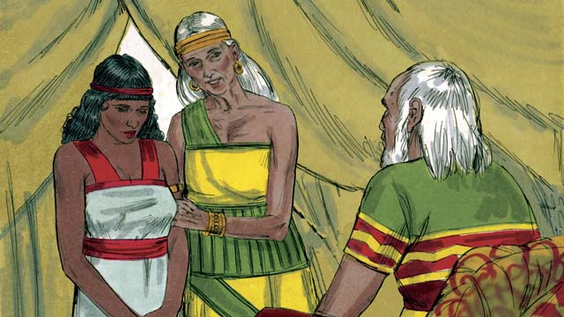

Ten years after Abram and Sarai arrived in Canaan, they still did not have a child. So Abram’s wife, Sarai, said to him, “Since God has not allowed me to have children, and now I am too old to have children, here is my servant, Hagar. Marry her also so she can have a child for me.”

05-02

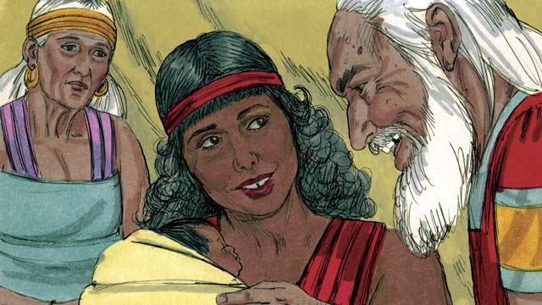

So Abram married Hagar. Hagar had a baby boy, and Abram named him Ishmael. But Sarai became jealous of Hagar. When Ishmael was thirteen years old, God again spoke to Abram.

05-03

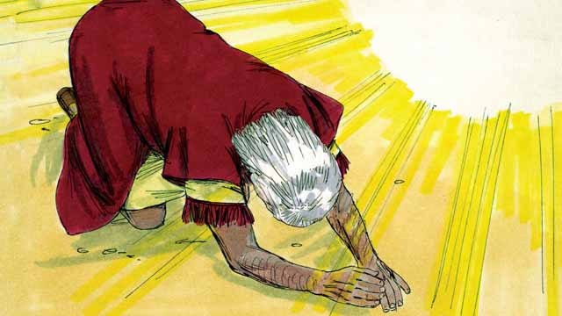

God said, “I am God Almighty. I will make a covenant with you.” Then Abram bowed to the ground. God also told Abram, “You will be the father of many nations. I will give you and your descendants the land of Canaan as their possession, and I will be their God forever. You must circumcise every male in your family.”

05-04

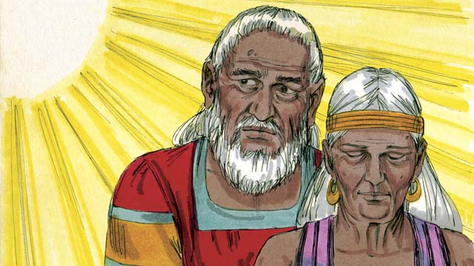

“Your wife, Sarai, will have a son—he will be the son of promise. Name him Isaac. I will make my covenant with him, and he will become a great nation. I will make Ishmael a great nation, too, but my covenant will be with Isaac.” Then God changed Abram’s name to Abraham, which means “father of many.” God also changed Sarai’s name to Sarah, which means “princess.”

05-05

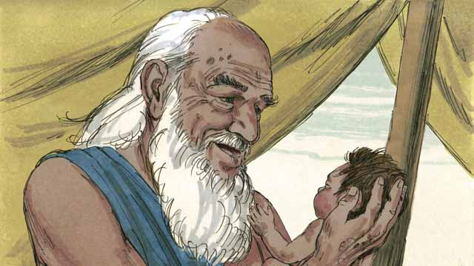

That day Abraham circumcised all the males in his household. About a year later, when Abraham was 100 years old and Sarah was 90, Sarah gave birth to Abraham’s son. They named him Isaac, as God had told them to do.

05-06

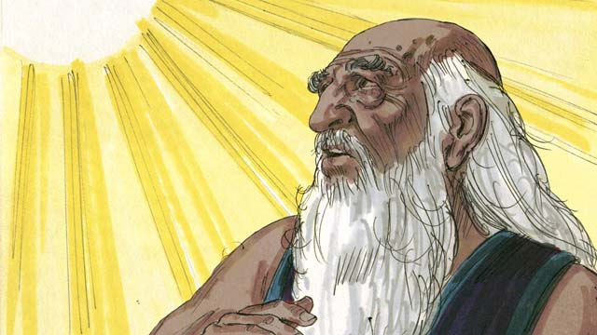

When Isaac was a young man, God tested Abraham’s faith by saying, “Take Isaac, your only son, and kill him as a sacrifice to me.” Again, Abraham obeyed God. He prepared to sacrifice his son.

05-07

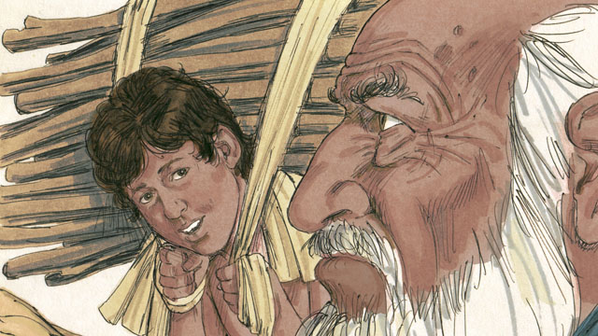

As Abraham and Isaac walked to the place of sacrifice, Isaac asked, “Father, we have wood for the sacrifice, but where is the lamb?” Abraham replied, “God will provide the lamb for the sacrifice, my son.”

05-08

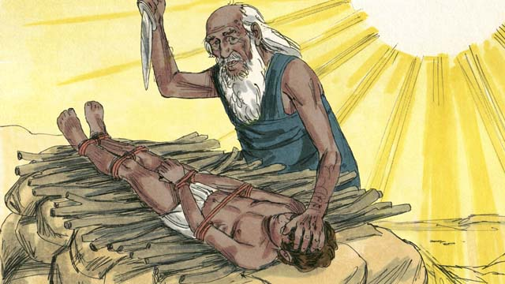

When they reached the place of sacrifice, Abraham tied up his son Isaac and laid him on an altar. He was about to kill his son when God said, “Stop! Do not hurt the boy! Now I know that you fear me because you did not keep your only son from me.”

05-09

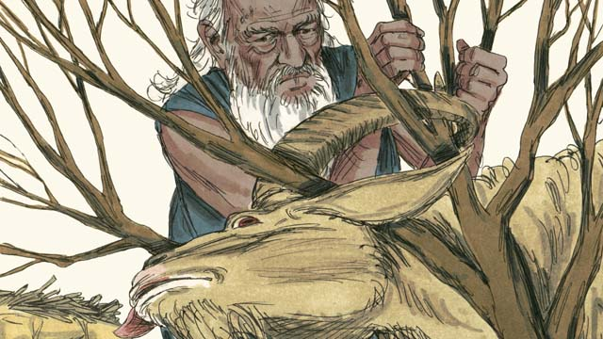

Nearby, Abraham saw a ram that was stuck in a bush. God had provided the ram to be the sacrifice instead of Isaac. Abraham happily offered the ram as a sacrifice.

05-10

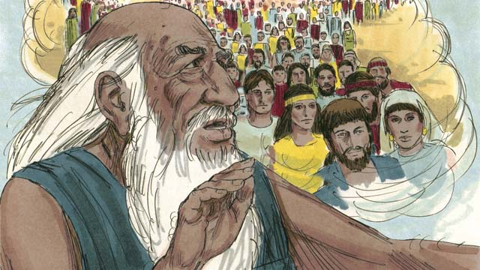

Then God said to Abraham, “Because you were willing to give me everything, even your only son, I promise to bless you. Your descendants will be more than the stars in the sky. Because you have obeyed me, I will bless all the families of the world through your family.”

*A Bible story from: Genesis 16-22*

## 1 Biblical Interpretation: Observing the Details of the Story

After reading the crafted biblical story, answer the following questions to familiarize yourself with the details of the story.

### 1.1 Observation Questions

Answer the following observation questions to gain a basic understanding of the the story. Read the story as a community and answer these questions as a group.

#### 05-01

Why did Sarai think she would not have children?  
She was too old.

What did Sarai tell Abram to do in order to have a child?  
Sarai told Abram to marry her servant Hagar, so Hagar could have a child for her.

#### 05-02

What was the name of Hagar’s child?  
His name was Ishmael.

What problem happened between Sarai and Hagar?  
Sarai became jealous of Hagar.

#### 05-03

What covenant promises did God make to Abram?  
Abram would be the father of many nations, and God would give the land of Canaan to him and to his descendants.

What did God tell Abram to do as a sign of the covenant between them?  
Abram must circumcise every male in his family.

#### 05-04

Who did God say would be the son of the promise?  
Isaac, Sarai’s son, would be the son of promise.

Who did God say would become a great nation?  
Both Isaac and Ishmael would become great nations.

With which child did God say he would make his covenant?  
God said he would make his covenant with Isaac.

What did Abram’s new name, Abraham, mean?  
His name means father of many.

What did Sarai’s new name, Sarah, mean?  
Her name means princess.

#### 05-05

What did Abraham do to all the males of his household?  
Abraham circumcised all the males of his household.

How old were Abraham and Sarah when Isaac was born?  
Abraham was 100 years old and Sarah was 90 years old when Isaac was born.

#### 05-06

What did God ask Abraham to do to Isaac when Isaac was a young man?  
God asked Abraham to sacrifice Isaac to him.

Why did God ask Abraham to sacrifice Isaac?  
God did this to test Abraham’s faith.

How did Abraham respond to God’s test?  
Abraham obeyed God and prepared Issac as a sacrifice.

#### 05-07

What did Isaac asked his father when they walked to the place of sacrifice?  
He asked his father where they lamb for the sacrifice was.

What did Abraham tell Isaac was the reason they did not have a lamb for the sacrifice?  
Abraham said God would provide the lamb for the sacrifice.

#### 05-08

What did Abraham do to Isaac when they reached the place of sacrifice?  
Abraham tied up his son Isaac and laid him on the altar.

What did God tell Abraham as he was about to sacrifice Isaac?  
God told Abraham to stop and not hurt his son. God now saw that Abraham was willing to obey God.

Did God want Abraham to kill Isaac?  
No, he only wanted to see if Abraham would obey him.

#### 05-09

What did God provide as a sacrifice instead of Isaac?  
He provided a ram stuck in a bush.

What did Abraham do with the ram?  
Abraham happily offered the ram as the sacrifice instead of his son Isaac.

#### 05-10

What did God promise to do for Abraham because Abraham had obeyed him?  
He promised that Abraham’s descendants would be more than the stars in the sky, and that all the families of the world would be blessed through his family.

### 1.2 Translation Questions

Use the following translation questions to understand specific details of the passage. Discuss how you might translate these specific elements of the story.

#### 05-01

**Marry her also** The custom of that time allowed a man to have more than one wife. Abram would take Hagar as a second wife, but Hagar would not have the full status of a wife as Sarai did. She was still Sarai’s servant. How would you express **Marry her also** to mean Abram would take Hagar as a second wife?

  

**have a child for me** Because Hagar was Sarai’s servant, she did not have the same rights as Sarai. Sarai would be considered the mother of any children that Hagar bore. How would you express **have a child for me** to mean Abram was to have a child with Hagar that would be considered Sarai’s child?

  

#### 05-02

**married** Hagar became Abram’s concubine—a ‘second wife’ of lower status. Hagar was still Sarai’s servant. How would you express **married** to mean that Abram took Hagar to be his second wife, one who had lower status than Sarai?

  

**jealous** To be **jealous** means to be angry or resentful at someone because you envy or covet something they have. How would you express **jealous** to mean Sarai was angry or resentful at Hagar because she had a child and Sarai could not?

  

#### 05-03

**Almighty** This means that God is the strongest and the most powerful. There is no one greater or stronger or more powerful than God. What words in your language mean **Almighty** as in the most powerful? Does this mean that God is the supreme God above all?

  

**I will be their** God This means that God would be the God that they will worship. How would you express **I will be their** God to mean that God would be the God they serve?

  

**circumcise every male** To circumcise means to cut the foreskin off of a man or male child. It is often associated with a religious rite or ritual. How would you express **circumcise every male** to mean to cut off the foreskin of a man or male child?

  

#### 05-04

**the son of promise** Isaac would be the son that God promised to Sarai and Abram. He would also be the son that God would use to give Abram many descendants. How would you express **the son of promise** to mean Isaac would be the son that God said in advance they would have?

  

**father of many** As God had promised, Abraham would become the ancestor of many people who would even become many nations. How would you express **father of many** to mean Abraham would have many descendants?

  

**princess** A **princess** is a daughter of a king. The names Sarai and Sarah apparently both meant ‘**princess**.’ But God changed her name to signify that she would be the mother of many nations, and some of her descendants would be kings. How would you translate **princess** to mean the daughter of a king?

  

#### 05-05

**all the males in his household** This means all of the men and boys that Abraham was responsible for, including his male servants, young and old. How would you express all the males in the his household to mean all the men and boys for whom Abraham was responsible?

  

#### 05-06

**God tested** Abraham’s faith God wanted Abraham to show that he was completely submitted to God, that he would obey whatever God told him to do. How would you express **God tested** Abraham’s faith to mean God gave Abraham some commands to see if he really trusted God?

  

**your only son** It is implied that God knows that Abraham has another son, Ishmael. This emphasizes that Isaac is the son that God promised to give Abraham. How would you express **your only son** to mean Isaac was the only son God promised?

  

**prepared to sacrifice his son** Abraham got ready to sacrifice his son. God stopped him before he killed his son. How would you express **prepared to sacrifice his son** to mean Abraham got his son ready to be killed as a sacrifice?

  

#### 05-07

**the lamb** A young sheep or goat would be the normal animal for a sacrifice. What words in your language mean **the lamb** as in a sheep or a goat?

  

**provide the lamb** Abraham may have believed that Isaac was the lamb that God provided, although God fulfilled Abraham’s words by providing a ram to sacrifice in Isaac’s place. How would you express **provide the lamb** to mean God would supply the lamb the was needed for the sacrifice?

  

#### 05-08

**altar** An **altar** is a raised structure on which people burned animals and grains as offerings to God. What words in your language mean **altar** as in a place where people slaughter animals as sacrifices to God?

  

**about to kill his son** God did not want human sacrifice. God wanted to see that Abraham loved God more than he loved his son and would obey God even when God told him to give his son back to God. How would you express **about to kill his son** to mean that Abraham was in the act of killing his son when God told him to stop?

  

**you fear me** Abraham feared God, which included respect and reverence for God. Because of those things, he obeyed God. How would you express **you fear me** to mean that Abraham and a respect and reverence for God to obey his commands?

  

#### 05-09

**ram** A **ram** is an adult male sheep. What words in your language mean **ram** as in an adult male sheep?

  

**stuck in a bush** God provided the ram for Abraham and it was caught in a bush for Abraham to get. Just at the right moment, God caused the ram to be stuck in the bush. How would you express **stuck in a bush** to mean the ram was unable to move from the bush?

  

**happily offered** Abraham was very happy to offer the ram as a sacrifice instead of his son Isaac. God had provided this for them. How would you express **happily offered** to mean that Abraham was very pleased and joyful to offer the ram as a sacrifice instead of Isaac?

  

#### 05-10

**willing to give me everything** Abraham showed that he was ready to give everything to God, even sacrifice his son. This showed his devotion to God. How would you express **willing to give me everything** to mean Abraham was ready to dedicate everything to God without withholding what mattered most to him?

  

**all the families of the world** Families are larger distinct groups of people. It refers to the other people groups who are not descendants of Abraham. How would you express **all the families of the world** to mean distinct people groups from different kinds ethnicity or culture

## 2 Theological Dialogue: Discussing the Meaning of the Story

Take time to explore the meaning of this story together as a community. Use the following discussions as a way to grasp what truth the story teaches.

### 2.1 Discourse Questions

Use the following discourse questions to understand the meaning of the story. Pay attention to how the story itself addresses each question or theme.

##### How did Abram and Sarai doubt God’s promise to give them a child? (05-01, 05-02)

God promised Abram and Sarai would have a son. After ten years in Canaan, Abram and Sarai did not have a child. God’s promises always come true. Sometimes people can doubt when they have to wait for God’s promise for a long time. (05-01)

  

Sarai thought she was too old to have a child. This is understandable in normal circumstances. But God is able to do amazing things that do not seem possible in normal circumstances. (05-01)

  

Abram and Sarai did not trust God to fulfill his promise in his own way. They tried to bring about God’s promise in their own way. Sarai told Abram to marry her servant Hagar and have a child with her. Because Abram and Sarai doubted God, they disobeyed God.(05-01, 05-02)

##### How did God officially affirm his promise to Abram? (05-02, 05-03, 05-04, 05-05)

God spoke to Abram when Ishmael was thirteen years old. God communicates his promises to his people. (05-02)

  

God told Abram that he was God Almighty. God is all-powerful and able to do all things to accomplish his plan and fulfill his promises. (05-03)

  

God made a covenant with Abram. This was an official agreement that showed Abram that God would keep his promise. This covenant would continue with Isaac. (05-03, 05-04)

  

God told Abram again that he would have many descendants and dwell in the land of Canaan. God promised that Abram would have a son. (05-03, 05-04)

  

God told Abraham to circumcise the males in his household. This was a sign that God’s promise would come true. Abram obeyed God and circumcised all the males in his household. (05-03, 05-05)

  

God changed Abram’s name to Abraham. Abraham means father of many. He changed Sarai’s name to Sarah. Sarah means princess. God was showing Abraham that his promise would come true. Abraham would have many descendants. Abraham would even have kings among his descendants. (05-04)

  

When Abraham was 100 years old and Sarah was 90 years old, Sarah gave birth to Isaac. God provided a son for Abram and Sarah when they were really old (beyond normal child-bearing years). (05-05)

  

##### How did God test Abraham’s faith? (05-03, 05-05, 05-06, 05-07, 05-08, 05-10)

God told Abram to circumcise all the males in his household. Abram obeyed God and did this. (05-03, 05-05)

  

God told Abraham to offer his son Isaac as a sacrifice to God. God did not want Abraham to kill his son. He told Abraham to do this to see if Abraham would trust him and obey his command. Abraham obeyed God and prepared to sacrifice Isaac. (05-06)

  

Isaac asked his father where the lamb for the sacrifice would was. Abraham told him that God would provide the lamb. Abraham did not know how God would provide the lamb but he trusted God. (05-07)

  

Abraham tied up his son, laid him on the altar, and was ready to kill him. Abraham trusted God and was willing to sacrifice his only son to God. (05-08)

  

Abraham was willing to give God everything. He did not even withhold his only son from God. Abraham’s faith and obedience showed that he trusted God. (05-10)

  

##### How did God provide a sacrifice for Abram? (05-07, 05-08, 05-09, 05-10)

Abraham trusted God to provide a lamb for the sacrifice. (05-07)

  

Just as Abraham was about to kill Isaac, God told Abraham not to kill his son. God stopped Abraham from sacrificing Isaac. (05-08)

  

God provided a ram stuck in a bush. This would not be normally expected. God provided a sacrifice that would be offered in place of Isaac. The ram died. Isaac was kept alive. (05-09)

  

God promised to bless Abraham and make his descendants many. He promised to bless the peoples of the world through Abraham. (05-10)

  

### 2.2 Theological Questions

Answer the following theology questions as a community. Discuss what truths this story teaches.

1. What causes people to doubt God’s promises? What does this story teach us about doubt and disobedience?
2. Why should we trust God’s promises? What does God do in this story to show us why we can trust his promises?
3. What kind of sacrifice is acceptable to God? What does this story teach us about how God provides for his people through sacrifice?

### 2.3 Translation Draft

Work as a translation team to draft each panel of this story. Pay attention to any specific translation issues that are challenging or significant.

#### Make Translation Draft

Make a draft for each section of this story.

#### Discuss and Revise

After drafting the story, discuss any translation issues that you think need special explanation.

#### Drafting Summary Reflection

Summarize any noteworthy translation decisions and the rationale/reasoning behind these translation decisions. In the final movement of this class, you will use these observations to give an account (i.e., chronicle/narrate) of how your translation improved through the checking process.

## 3 Personal Reflection: Following the Teaching of the Story

Take a moment to allow this story to evaluate your own life and to consider how God would have you respond. After this reflection, use the quality checking questions to check your translation draft among the translation team.

### 3.1 Journal Reflection

Prayerfully think about the following personal reflection questions. Write/Record your answers and/or discuss them as a group.

1. When have you ever doubted God’s promises? How did your doubt cause you to disobey God’s commands?
2. When have you ever experienced God testing your faith? What was this experience like?
3. How might you have responded if you were in Abram or Sarai’s situation?
4. What does it look like for you to trust God with everything you have?

### 3.2 Team Check

*The following activity will help you check the clarity, accuracy, and naturalness of your draft. Read the passage aloud and discuss the checking questions with other members of your translation community. You might need to reread portions (or the whole) of the biblical passage multiple times as you answer each of these questions. Record answers to these questions below.*

#### Team Checking Questions

*Use the following questions to check your translation draft for accuracy, clarity, and naturalness.*

1. **Accurate**: Has anything been **added** to your translation of this passage that is not a part of the meaning of the source text? *If additions exist, are they included only added to clarify meaning (such as implied information)?*
2. **Accurate**: Is anything **missing** from your translation of this passage that is a part of the meaning of the source text? *If some part of the meaning is missing from your translation, add it.*
3. **Accurate**: Does any meaning in your translation of this passage appear to be **different** than the meaning of the source text? *If the meaning is different, try changing your translation so that the meaning remains the same.*
4. **Natural**: Does anything sound **unnatural** to how you would say it in your language? *If portions of the passage sound unnatural in your language, try to make them sound the way you would say it in your language while staying true to the meaning of the source text.*
5. **Clear**: Is anything **unclear** or **confusing** in your translation that confuses the meaning of the source text? *If portions of the passage are unclear or confusing, revise them to clearly communicate the meaning of the source text.*
6. **Consistent**: How **consistent** is your translation within the passage and with other passages? *If portions of the passage need to be made consistent or if you need to revise translations of other passages, make these adjustments.*

#### Record Feedback

*After discussing the checking questions above as a translation community, record any feedback on your translation draft. Pay attention for parts of your translation that are translated well and parts of your translation that need correction.*

#### Discuss and Revise

*After gathering feedback on your draft, discuss it together with your translation community and make appropriate revisions in your translation.*

#### Checking Summary Reflection

*Summarize any noteworthy translation decisions (things you corrected or affirmed in your draft) and the rationale/reasoning behind these translation decisions. In the final movement of this class, you will use these observations to give an account (i.e., chronicle/narrate) of how your translation improved through the checking process.*

## 4 Ministry Practice: Serving the Church with the Story

Now that you have a draft of this story, consider how this story can encourage other believers in their faith. After ministering this story to others, you will also perform a community check of your translation draft.

### 4.1 Church Ministry

Reflect on how this story can edify and mature the Christian community. Design a way to minister this story to your church community.

**Ministry Preparation**: Take time to consider how you could minister this story to others. Record some ministry ideas below.

**Ministry Implementation**: Minister this story to a group of believers as you had planned. Use the information in this study to help develop a teaching/lesson or lead a discussion of this story to other believers. Record your ministry plan below.

**Ministry Reflection**: Think about what you learned from ministering this story to other believers. Reflect on your experience below.

### 4.2 Church Community Check

After teaching or ministering this story to the church, check the translation quality with the church community. Record any feedback from your checking experience.

#### Create Checking Questions

You can use **Translation Questions** to check you draft. Each **Translation Question** explains the meaning of a specific part of the story and asks you to consider how you would translate that part of the story in your own language. Change each **Translation Question** into a **Checking Question** by asking the following questions. The first question asks you to identity how each specific phrase was translated in your language. The second question asks people in the church to determine if your translation of the phrase expresses the meaning clearly, accurately, and naturally. Look at the following examples to see how to change **Translation Questions** into **Checking Questions**:

#### Translation Question Example 1

**to proclaim the good news about Jesus** Paul and Silas traveled to Philippi for the purpose of preaching the gospel. The gospel is the good news that Jesus saves people from their sins if they will believe in Jesus. How would you express **to proclaim the good news about Jesus** to mean to tell other people the message about how Jesus can save people from their sins?

#### Translation Question Example 2

**a merchant** Paul and Silas met a woman named Lydia at the place by the river. She owned a business and sold items to make money. How would you express **a merchant** to mean a business owner who sells items for a profit?

#### Translation Question Example 3

**so Paul and Silas baptized them** The jailer and his whole family followed Paul’s instructions. They believed in Jesus. The result of this was Paul and Silas baptized them. How would you express **so Paul and Silas baptized them** to mean the result of the jailer and his family believing in Jesus that Paul and Silas baptized all of them?

You can change these into **Checking Questions** like this:

#### Checking Question Example 1

**to proclaim the good news about Jesus** How did you translate **to proclaim the good news about Jesus**? Does it mean to tell other people the message about how Jesus can save people from their sins?

#### Checking Question Example 2

**a merchant** How did you translate **a merchant**? Does it mean a business owner who sells items for a profit?

#### Checking Question Example 3

**so Paul and Silas baptized them** How did you translate **so Paul and Silas baptized them**? Does it mean the result of the jailer and his family believing in Jesus that Paul and Silas baptized all of them?

#### Record Feedback

*Discuss the* ***Checking Questions*** *with your church community, and record any feedback on your translation draft. Pay attention for parts of your translation that are translated well and parts of your translation that need correction.*

#### Discuss and Revise

*After gathering feedback on your draft, discuss it together with your translation community and make appropriate revisions in your translation.*

#### Checking Summary Reflection

*Summarize any noteworthy translation decisions (things you corrected or affirmed in your draft) and the rationale/reasoning behind these translation decisions. In the final movement of this class, you will use these observations to give an account (i.e., chronicle/narrate) of how your translation improved through the checking process.*

## 5 Missional Outreach: Sharing the Truth of the Story

*After sharing this story with others, check the translation quality with the wider language community. Record any feedback from your checking experience.*

### 5.1 Mission Engagement

*Consider how you will witness this story to unbelievers. Design a way to share this story and engage them in what it teaches about Christianity and the gospel.*

**Witness Preparation**: Take time to consider how you will witness this narrative to unbelievers. Record some ideas below.

**Witness Implementation**: Share this story with an unbeliever. Use the information in this study to help develop a teaching/lesson or lead a discussion of this story to other believers. Record your ministry plan below.

**Witness Reflection**: Think about what you learned from ministering this story to unbelievers. Reflect on your experience below.

### 5.2 Sociolinguistic Check

After sharing this story with the language community, check your translation draft with the surrounding community. Record your observations.

#### Checking Approach

After witnessing this story to unbelievers, use one of the following methods to check the translation of this story. Consider using the **Observation Questions** to check your translation draft or come up with your own quality checking questions.

**Read-Retell Check:** Read your draft to those the community and ask them to retell the passage. Be attentive for any portions of the passage that are unclear, unnatural, or inaccurate.

**Comprehension Questions Checklist:** Read the draft of the passage and ask a list of comprehension questions to make sure the passage is being rightly understood. You can use the **Observation Questions** in this guide or come up with your own questions. Then, record any insights or issues that arise.

**Discussion Group:** Develop key questions to ask about the passage (both formational and translational). Read the passage and have a group discussion about the passage, paying attention to issues that need to be addressed, edited, and revised.

#### Record Feedback

*After sharing your draft with language community, discuss the* ***Observations Questions****, and record any feedback on your translation draft. Pay attention for parts of your translation that are translated well and parts of your translation that need correction.*

#### Discuss and Revise

*After gathering feedback on your draft, discuss it together with your translation community and make appropriate revisions in your translation.*

#### Checking Summary Reflection

*Summarize any noteworthy translation decisions (things you corrected or affirmed in your draft) and the rationale/reasoning behind these translation decisions. In the final movement of this class, you will use these observations to give an account (i.e., chronicle/narrate) of how your translation improved through the checking process.*

## 6 Conclusion

As a translation community, take time to reflect on all that was learned in studying, drafting, and checking this story. Celebrate all that God has taught you as a community. Then, submit your revised draft and checking summaries to network leaders for further review.