Open Bible Stories

Jesus Returns

## 0 Introduction

### 0.1 Key Idea

The story Jesus returning teaches us about the great things God will do when Jesus returns to the earth.

### 0.2 Creedal Verse

“Beloved, we are God’s children now, and what we will be has not yet appeared; but we know that when he appears we shall be like him, because we shall see him as he is. 3 And everyone who thus hopes in him purifies himself as he is pure.” 1 John 3:2-3

### 0.3 Metanarrative Summary

The eternal God created all things in six days. He made a good and perfect world. He made humans in his image to fill the earth and rule over creation. But humans rebelled against God and ruined God’s creation. God set to restore his world through his promise. God made a covenant with Abraham. He promised to bless all nations through Abraham. God kept his promises across the generations. God provided Abraham with a promised child, Isaac. God gave Isaac a wife and she bore twins, Jacob and Esau. God blessed Jacob and his sons, and the blessing continued to the next generation. God rescued Joseph, one of Jacob’s sons, and used him to rescue his family. God caused his people, the Israelites, to multiply in the land of Egypt; eventually, they became slaves. But, God raised up a deliverer, Moses, to deliver his people from their slavery. God judged the Egyptians with harsh plagues; in the final judgment, he passed over his people who covered their doorposts with the blood of a sacrificed lamb. Then, God delivered the Israelites by bringing them out of Egypt and crossing the Red Sea on dry land. God made a covenant with the Israelites and made them his people. God tested Israel in a series of wilderness wanderings and eventually brought his people into the promised land of Canaan. God raised up deliverers to lead Israel and rescue them from their enemies. God formed Israel into a kingdom. He made a covenant with King David and promised to send a king that would rule his people forever. Many of Israel’s kings were evil and the kingdom of Israel divided into two kingdoms. God sent prophets to warn his people of God’s judgment and call them to repent. When Israel did not repent, God sent his people into exile. After many years, he brought them back to the land. Throughout the Old Testament, God promised to send his Messiah to deliver his people form their sin. After many years, the prophet John was born. He would prepare people for the coming Messiah. At the perfect time, God sent his Son, Jesus, to be born of a virgin Mary. When John and Jesus grew up, John baptized Jesus as a sign that Jesus was God’s beloved Son. Jesus endured all manner of temptation without ever sinning. When he was thirty years old, he launched a public ministry of preaching, teaching, and healing. He taught his disciples about the life of compassion, sacrifice, and forgiveness. He performed many miracles: he fed a crowd of five thousand, he walked on water, he healed the sick, and he cast out demons. He proclaimed to people the nature of real faith, God’s kingdom, and the how fallen humans can be restored in relationship with God. Toward the end of his ministry, Jesus revealed his power and glory to his disciples and raised a dead man to life Jesus was betrayed by one of his disciples and put on trial before a Roman governor Jesus was sentenced to death and crucified on a cross Three days later, Jesus rose again from the dead. After meeting with many of his disciples, Jesus went back to heaven. The Holy Spirit empowered Jesus’ followers and formed them into his church Jesus’ disciples, like Peter and John, performed miracles and preached the good news about Jesus. New leaders like Stephen and Philip served the church and preached about Jesus Even Saul, a persecutor of Jesus’ followers, became a Christian and preached the gospel to many people Jesus is the promised Messiah and brings in blessings of a New Covenant. At the end of the world, Jesus will return to earth, the dead will come back to life, God will punish Satan and those who rejected Jesus, and God will recreate the world where God’s people will live with God forever in complete peace.

### 0.4 Open Bible Story: Jesus Returns

50-01

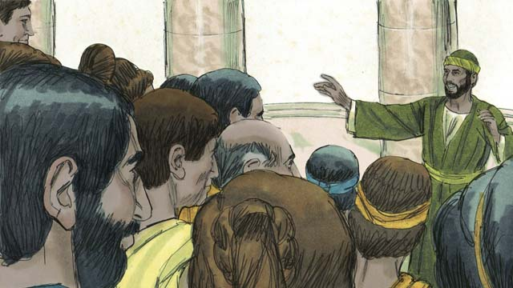

For almost 2,000 years, more and more people around the world have been hearing the good news about Jesus the Messiah. The Church has been growing. Jesus promised he would return at the end of the world. Though he has not yet come back, he will keep his promise.

50-02

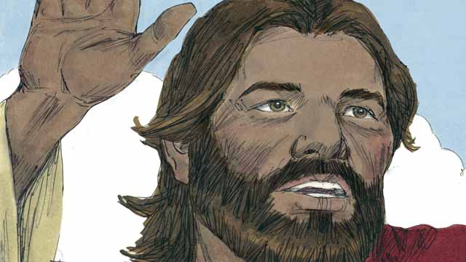

As we wait for Jesus to return, God wants us to live in a way that is holy and that honors him. He also wants us to tell others about his kingdom. When Jesus was living on earth, he said, “My disciples will preach the good news about the kingdom of God to people everywhere in the world, and then the end will come.”

50-03

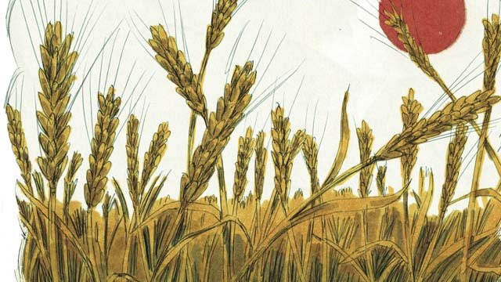

Many people groups still have not heard about Jesus. Before he returned to heaven, Jesus told his followers to proclaim the good news to people who have never heard it. He said, “Go and make disciples in all people groups!” and “The fields are ripe for harvest!”

50-04

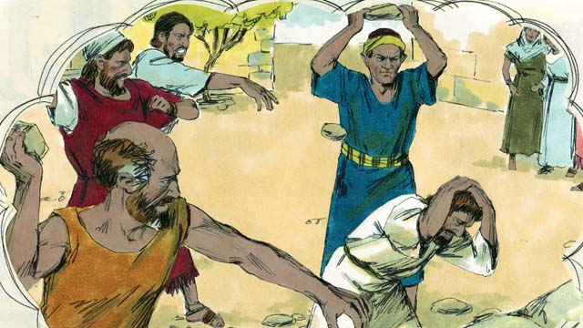

Jesus also said, “A man’s servant is not greater than his master. The important people in this world have hated me, and they will also torture you and kill you because of me. In this world you will suffer, but be strong, because I have defeated Satan, the one who rules this world. If you remain faithful to me to the end, then God will save you!”

50-05

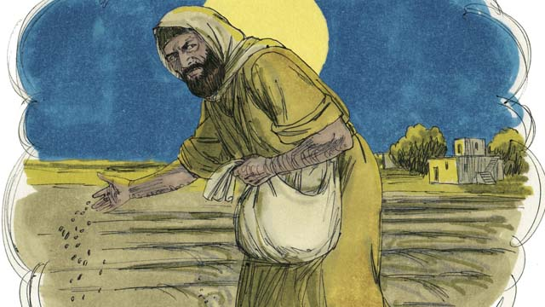

Jesus told his disciples a story to explain what will happen to people when the world ends. He said, “A man planted good seed in his field. While he was sleeping, his enemy came and planted weed seeds among the wheat seeds, and then he went away.”

50-06

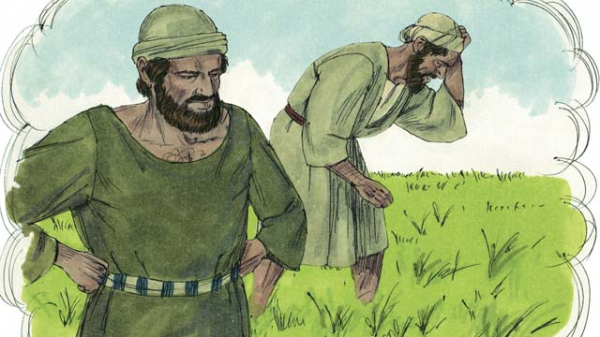

“When the plants sprouted, the servants of the man said, ‘Master, you planted good seed in that field. So why are there weeds in it?’ The man answered, ‘Only my enemies would want to plant them. It is one of my enemies who did this.’”

50-07

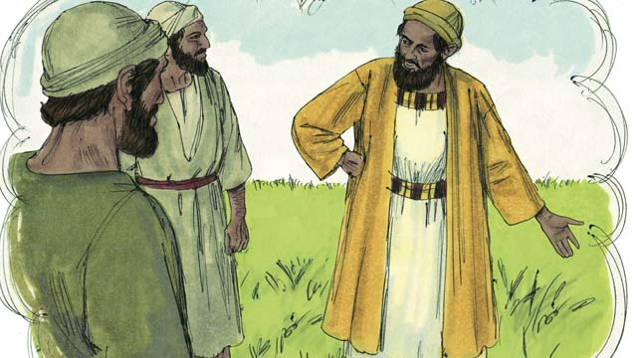

“The servants responded to their master, ‘Should we pull out the weeds?’ The master said, ‘No. If you do that, you will pull out some of the wheat as well. Wait until the harvest. Then gather the weeds into piles so you can burn them. But bring the wheat into my barn.’”

50-08

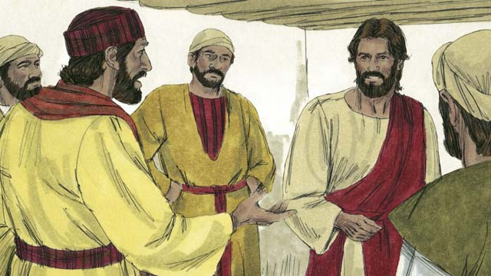

The disciples did not understand the meaning of the story, so they asked Jesus to explain it to them. Jesus said, “The man who planted the good seed represents the Messiah. The field represents the world. The good seed represents the people of God’s kingdom.”

50-09

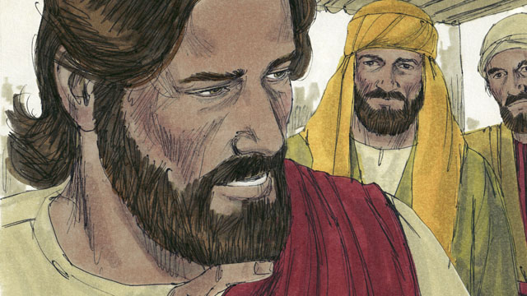

“The weeds represent the people who belong to the devil, the evil one. The man’s enemy, the one who planted the weeds, represents the devil. The harvest represents the end of the world, and the harvesters represent God’s angels.”

50-10

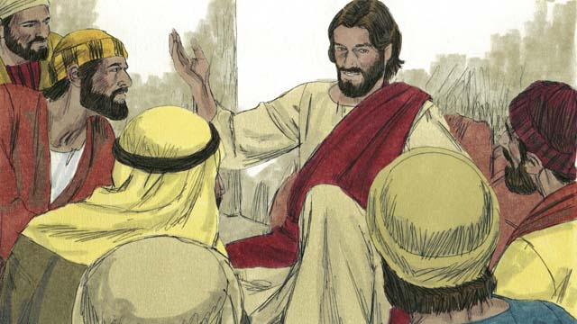

“When the world ends, the angels will gather together all the people who belong to the devil. The angels will throw them into a very hot fire. There those people will cry and grind their teeth in terrible suffering. But the people who are righteous, who have followed Jesus, will shine like the sun in the kingdom of God their Father.”

50-11

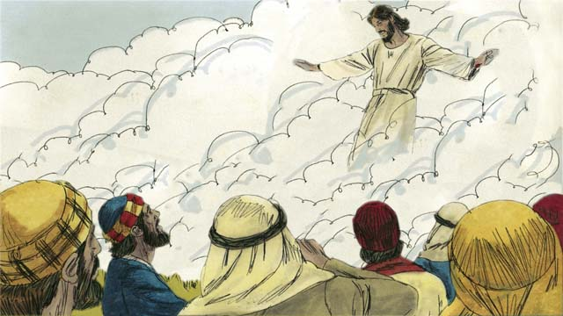

Jesus also said that he would return to earth just before the world ends. He will come back the same way that he left. That is, he will have a real body, and he will come on the clouds in the sky. When Jesus returns, every follower of Jesus who has died will rise from the dead and meet him in the sky.

50-12

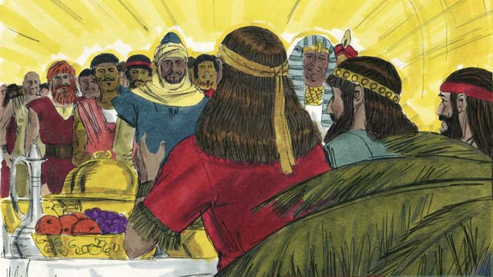

Then the followers of Jesus who are still alive will rise up into the sky and join with the other followers of Jesus who rose from the dead. They will all be with Jesus there. After that, Jesus will live with his people. They will have complete peace forever as they live together.

50-13

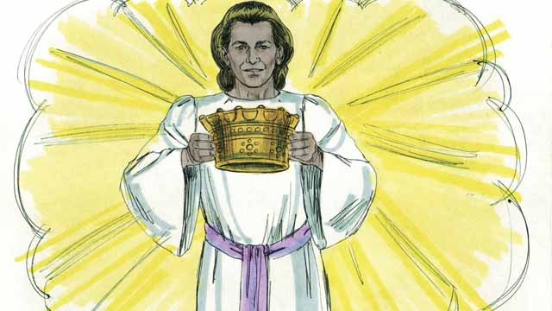

Jesus promised to give a crown to everyone who believes in him. They will rule with God over everything forever. They will have perfect peace.

50-14

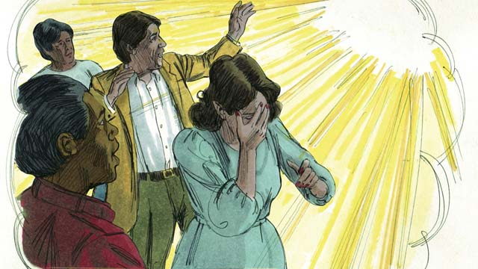

But God will judge everyone who does not believe in Jesus. He will throw them into hell. There they will weep and grind their teeth, and they will suffer forever. A fire that never goes out will continually burn them, and worms will never stop eating them.

50-15

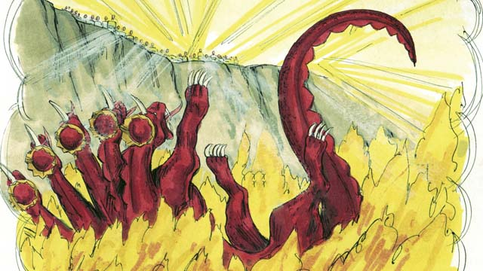

When Jesus returns, he will completely destroy Satan and his kingdom. He will throw Satan into hell. Satan will burn there forever, along with everyone who chose to follow him rather than to obey God.

50-16

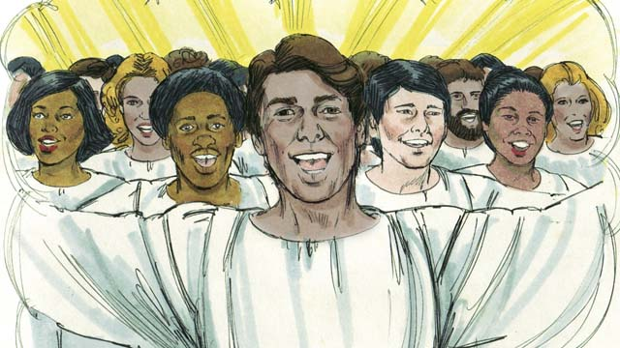

Because Adam and Eve disobeyed God and brought sin into this world, God cursed it and decided to destroy it. But some day God will create a new heaven and a new earth that will be perfect.

50-17

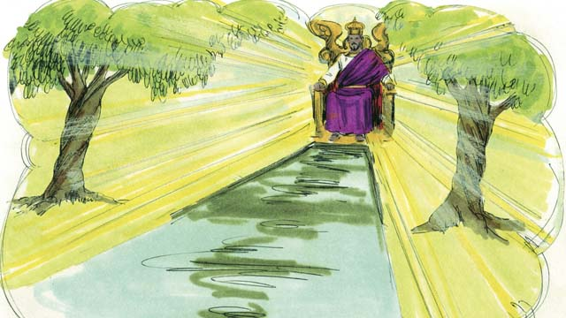

Jesus and his people will live on the new earth, and he will reign forever over everything. He will wipe away every tear from people’s eyes. No one will suffer or be sad any longer. They will not cry. They will not be sick or die. And there will be nothing evil there. Jesus will rule his kingdom justly and with peace. He will be with his people forever.

*A Bible story from: Matthew 13:24-42; 22:13; 24:14; 28:18; John 4:35; 15:20; 16:33; 1 Thessalonians 4:13-5:11; James 1:12; Revelation 2:10; 20:10; 21-22*

## 1 Biblical Interpretation: Observing the Details of the Story

After reading the crafted biblical story, answer the following questions to familiarize yourself with the details of the story.

### 1.1 Observation Questions

Answer the following observation questions to gain a basic understanding of the the story. Read the story as a community and answer these questions as a group.

#### 50-01

During the last 2,000 years, what has happened to the number of people who believe in Jesus?  
More and more people have been hearing and believing the good news about Jesus.

What causes the church to grow?  
The church grows as more people believe in Jesus.

When did Jesus promise he would return?  
Jesus promised he would return at the end of the world.

Will Jesus keep his promise to return?  
Yes. Jesus will keep his promise to return even though he has not returned yet.

#### 50-02

How does God want us to live as we wait for Jesus to return?  
He wants us to live in a way that is holy and that honors him.

What did Jesus say would happen before the end of the world comes?  
His disciples would preach the good news of the kingdom of God to people everywhere in the world.

When will the end of the world come?  
The end of the world will come when God’s people preach the good news about Jesus to people everywhere in the world.

#### 50-03

How many people groups have not yet heard about Jesus?  
Many people groups have still not heard about Jesus.

What did Jesus tell his disciples to do before he returned to heaven?  
Before Jesus returned to heaven, he told his disciples to preach the good news to people who never heard it.

What assignment did Jesus give his disciples?  
Jesus told his disciples to go and make disciples of all people groups.

How ready are people to hear the good news about Jesus?  
Jesus told his disciples that the fields are ripe for harvest.

#### 50-04

How will the world that hated Jesus treat his disciples?  
The world will cause his disciples to suffer just as they caused Jesus to suffer.

How did Jesus tell his disciples to endure suffering?  
Jesus told his disciples to expect suffering and to be strong when they suffer.

Who did Jesus defeat?  
Jesus told his disciples that he defeated Satan, God’s enemy who rules the world.

What is God’s promise to those who remain faithful to the end?  
If Jesus’ disciples remain faithful to the end, God promises to save them.

#### 50-05

In Jesus’ story about the end of the world, how did the weeds come to be among the wheat?  
An enemy planted weeds among the wheat seeds while the man was asleep.

#### 50-06

How did the man explain to his servants that there were weeds in the field where good seed was planted?  
The man explained that his enemies did this.

#### 50-07

Why didn’t the servants pull out the weeds?  
Their master did not want them to accidentally pull out the wheat along with the weeds.

When did the man say they could pull the weeds?  
The man told them to wait until the harvest when they can pull out the wheat and the weeds.

How would they separate the weeds from the wheat?  
They would put the weeds in piles and burn them and they would bring the wheat into the barn.

#### 50-08

Did the disciples understand the story of the wheat and the weeds?  
No. The disciples did not understand this story.

Who does the man in the story represent?  
The man in the story represents the Messiah.

What does the field represent?  
The field represents the world.

What does the good seed represent?  
The good seed represents the people of God’s kingdom.

#### 50-09

Who does the weeds represent?  
The weeds represented people who belong to the devil.

Who does the man’s enemy represent?  
The man’s enemy represents the devil.

What does the harvest represent?  
The harvest represents the end of the world.

Who do the harvesters represent?  
The harvesters represent angels.

#### 50-10

What will happen to the people who belong to the devil at the end of the world?  
The angels will gather them up and throw them into a very hot fire, where they will suffer terribly.

What will happen to the people who are righteous followers of Jesus at the end of the world?  
The righteous followers of Jesus will shine like the sun in the kingdom of God.

#### 50-11

When will Jesus come back?  
Jesus will come back just before the world ends.

In what form will Jesus return to the earth?  
He will return the way that he left, with a real body, and on the clouds in the sky.

When Jesus returns, what will happen to every follower of Jesus who has died?  
They will also rise to meet him in the sky.

#### 50-12

When Jesus returns, what will happen to the followers of Jesus who are still alive?  
The followers of Jesus who are alive will rise up into the sky and join with the other followers of Jesus who rose from the dead.

Where will God’s people live forever?  
They will live with Jesus in complete peace forever.

#### 50-13

What did Jesus promise those who believe in him?  
Jesus promised that he would give believers a crown, that believers would rule forever with God, and that they would have perfect peace.

#### 50-14

What did God say would happen to those who do not believe in Jesus?  
God will judge all those who do not believe by throwing them into hell where they will suffer forever with burning and destruction.

#### 50-15

What will Jesus do to Satan when he returns?  
Jesus will completely destroy Satan by throwing him into hell, where he will burn forever.

Who else will be in hell?  
All people who chose to follow Satan rather than God will be in hell forever.

#### 50-16

Why did God curse the world and decide to destroy it?  
God cursed the world and decided to destroy it because of the sin of Adam and Eve.

What new world will God create?  
Some day God will create a new heaven and a new earth that will be perfect.

#### 50-17

Who will live on the new earth/creation?  
Jesus and his people will live on the new earth and reign over all things.

At this time, what will God do to sadness, suffering, and sin?  
When God creates the new world, God will remove all sadness, suffering, and sin.

What will life be like in the new heaven and new earth?  
Jesus will rule his kingdom justly and with peace, and he will be with his people forever.

### 1.2 Translation Questions

Use the following translation questions to understand specific details of the passage. Discuss how you might translate these specific elements of the story.

#### 50-01

**The Church has been growing** As more and more people believe in Jesus the size of the church community increases in number. The church grows as the number of believers in Jesus increases. How would you express **The Church has been growing** to mean the number of people in the Church around the world has been increasing?”

  

**at the end of the world** Jesus said that he will come back to earth in the final days of this world. How would you express **at the end of the world** to mean right before the present world comes to an end?

  

**Though he has not yet come back, he will keep his promise** Jesus promised that he will return to earth before the end of the world. Jesus has not come back for 2,000 years. It might seem like Jesus is not coming back as he promised, but Jesus will certainly come back as he promised. How would you express **Though he has not yet come back, he will keep his promise** to mean Jesus will one day surely come back to earth as he said he would even if he has not returned after 2,000 years?

  

#### 50-02

**As we wait for Jesus to return, God wants us to live in a way that is holy and that honors him** Disciples are waiting for Jesus to return to earth as he promised. During this time of waiting for Jesus to return, disciples are supposed to live lives that are set apart to God and that respect God. How would you express **As we wait for Jesus to return, God wants us to live in a way that is holy and that honors him** to mean God wants believers to live in ways that are godly and that esteem God during the time they wait for Jesus to return to earth as he promised?

  

**then the end will come** Disciples of Jesus will preach the message of God’s kingdom to all peoples in the world. After this, this present world will end. How would you express **then the end will come** to mean the end of this world will come when the disciples tell all peoples in the world about God’s kingdom?”

  

#### 50-03

**make disciples in all people groups** Jesus commanded his followers to help people from all people groups believe in Jesus and become devoted to him. How would you express **make disciples in all people groups** to mean to help people to become followers of Jesus from all the different groups of people who live throughout the world?

  

**The fields are ripe for harvest** Jesus compares the work of making disciples to farmers who harvest crops in a field. The fields represent people. The words ripe for harvest mean that people are ready to accept the message of Jesus, like fields that are ready to be harvested. Jesus is telling his disciples that people are ready to be gathered and brought to God like fields whose crops are ripe and ready to be gathered. How would you express **The fields are ripe for harvest** to mean people are ready to be brought to God like fields that are ripe for harvest?

  

#### 50-04

**A man’s servant is not greater than his master** Jesus explains that a servant is not more important than the master who has authority over him. A servant should not expect to be treated better than his master. How would you express **A man’s servant is not greater than his master** to mean a servant is not treated better than the person who has authority over the servant?

  

**The important people in this world have hated me** Jesus told his followers that people the world considered significant greatly disliked Jesus. How would you express **The important people in this world have hated me** to mean people who have a high position of power and authority despised Jesus?

  

**they will also torture you and kill you because of me** Jesus told his followers that people will violently mistreat and murder believers because they are followers of Jesus. Believers obey Jesus, teach others about Jesus, and belong to Jesus. People will persecute believers because they represent Jesus. How would you express **they will also torture you and kill you because of me** to mean the reason people who hate Jesus will afflict believers with cruel physical pain and will murder believers is they belong to Jesus and represent Jesus?

  

**If you remain faithful to me to the end, then God will save you** God will save people who keep trusting and obeying Jesus until the end of their lives. How would you express **If you remain faithful to me to the end, then God will save you** to mean God will rescue people from punishment on the condition that they stay loyal to Jesus to until they die?

  

#### 50-05

**good seed** This seed was wheat grain. This **good seed** involves seed that will produce a crop that people can use for food. It is the opposite of seed that produces weeds. How would you express **good seed** to mean seed that produces a crop that can be used for food?

  

**weed seeds** The **weed seeds** that were planted would grow up as tall grass but could not be eaten. They were useless. How would you express **weed seeds** to mean seeds that produce vegetation that cannot be used for food?

  

#### 50-06

**Master, you planted good seed** The landowner probably had his servants plant the seeds. The servants represent the master, so the work the servants do is as if the master had done it. How would you express **Master, you planted good seed** to mean the man in charge of the servants had good seed planted by the work of his servants?

  

#### 50-07

**Should we pull out the weeds?** The servants asked their master if he wanted them to remove the weeds from the ground. How would you express **Should we pull out the weeds?** as a question in which the servants ask if the master wanted the servants to we is exclusive. It refers to the servants but not the master. The servants would not expect the master to take out the weeds from the field by pulling them out of the ground?

  

**If you do that, you will pull out some of the wheat as well** The master explained to his servants that they would remove some of the wheat from the ground if the servants tried to remove the weeds at this time. It would be too difficult to distinguish young wheat from the weeds, and to pull the weeds without accidentally uprooting the wheat. How would you express **If you do that, you will pull out some of the wheat as well** to mean you will accidentally pull out some of the wheat also if you try to remove the weeds at this present time?

  

**Wait until the harvest** The master told the servants to delay pulling up the weeds until it was time to bring in the harvest of wheat. Because harvest was the right time to remove the wheat from the ground, the servants did not need to worry about accidentally removing the wheat too early by pulling out the weeds. How would you express **Wait until the harvest** to mean postpone pulling out the weeds until the crops were ripe and ready to be gathered in for the harvest?

  

**bring the wheat into my barn** At the time of harvest, the servants would gather the wheat into a barn. This refers to the building where the harvested wheat grain was saved and stored. How would you express **bring the wheat into my barn** to mean gather the harvested wheat into a storehouse?

  

#### 50-08

**The disciples did not understand the meaning of the story, so they asked Jesus to explain it to them.** The disciples understood the words of the story. However, they did not understand its spiritual significance (i.e., what the story taught about being a follower of Jesus). How would you express **The disciples did not understand the meaning of the story, so they asked Jesus to explain it to them** to mean the result of the disciples not comprehending what the story meant was they asked Jesus to explain it?

  

**The good seed represents the people of God’s kingdom** The good seed in the story represents the people who belong to or are part of the kingdom of God. How would you express **The good seed represents the people of God’s kingdom** to mean the good seed in the story represented the people who live under God’s authority and have submitted to God’s rule in his kingdom?

  

#### 50-09

**The weeds represent the people who belong to the devil** The weeds in the story taught something about people who are loyal to and obey Satan. How would you express **The weeds represent the people who belong to the devil** to mean the weeds in the story represent people who are ruled by Satan and follow his ways?

  

**The harvest represents the end of the world** In the story, the time of the harvest teaches something about the time when the world will come to an end. How would you express **The harvest represents the end of the world** to mean the time of gathering ripe crops from the field represents the time when this present world comes to an end?

  

**the harvesters represent God’s angels** In the story, the people who gather the harvest refers to God’s heavenly messengers. How would you express **the harvesters represent God’s angels** to mean the people in the story who remove the ripe crops from the field represent heavenly messengers who serve God?

  

#### 50-10

**all the people who belong to the devil** People who do not believe in Jesus follow the evil ways of the devil. How would you express **all the people who belong to the devil** to mean people who reject Jesus and who are ruled by the devil and obey his wicked ways?

  

**cry and grind their teeth in terrible suffering** People who do not believe in Jesus will be thrown into a very hot fire as a punishment for rejecting Jesus. Because they will experience ongoing pain and misery, these people will make loud sounds and grit their teeth together as an expression of their pain. How would you express **cry and grind their teeth in terrible suffering** to mean people punished in the very hot fire will make loud sounds of distress and will grate their teeth together to show the extreme sadness and suffering they are experiencing?

  

**But the people who are righteous, who have followed Jesus, will shine like the sun** People who follow Jesus are the same as the people who are righteous. God sees people who believe in Jesus as righteous because he forgives their sin. Also, believers act righteously because they obey Jesus’ commands. Followers of Jesus have a different/opposite experience than those who reject Jesus. The people who are righteous because they followed Jesus will not be thrown in the fire with everyone else. Followers of Jesus will experience good things like a sun that is brightly shining. How would you express **But the people who are righteous, who have followed Jesus, will shine like the sun** to mean people who believe in Jesus will show pure goodness as the sun shows bright light?

  

#### 50-11

**He will come back the same way that he left** Jesus promised that he would return to earth just like he left the earth. How would you express **He will come back the same way that he left** to mean Jesus promises to leave heaven and return to the earth at some time in the future just like he left earth to return to heaven at the time after his resurrection?

  

**will come on the clouds in the sky** Jesus promised that the clouds of the sky will carry Jesus along at the time he returns to earth. How would you express **will come on the clouds in the sky** to mean the clouds in the sky will surround Jesus as he comes back to earth?

  

**When Jesus returns, every follower of Jesus who has died will rise from the dead and meet him in the sky** At the time Jesus returns to earth, believers in Jesus who already died will come back to life. Those who believe in Jesus will go up to be near Jesus while he is in the sky. How would you express **When Jesus returns, every follower of Jesus who has died will rise from the dead and meet him in the sky** to mean believers who are dead will come back to life and going Jesus in the sky at the time Jesus returns to earth?

  

#### 50-12

**Then the followers of Jesus who are still alive** Believers who are alive at the time Jesus returns to earth will gather with Jesus. This will happen after the followers of Jesus who died rose to meet Jesus in the air. How would you express **Then the followers of Jesus who are still alive** to mean Jesus’ followers who are still alive when Jesus returns will also join Jesus after Jesus’ followers who had died first come back to life and join with Jesus?

  

**After that Jesus will live with his people,** All believers will gather to be near Jesus. Then, Jesus will continue to live with his people for all time. How would you express **After that Jesus will live with his people,** to mean Jesus and his followers will live together forever subsequent to Jesus’ followers joining Jesus?

  

#### 50-13

**Jesus promised to give a crown to everyone who believes in him** Jesus said that he will gift all believers with a crown, a symbol of honor, royalty, and authority. This crown represents our reward for believing in Jesus and serving him in this life. How would you express **Jesus promised to give a crown to everyone who believes in him** to mean Jesus will reward all people who believed in Jesus?

  

**They will have perfect peace** At this time, people will not experience sin, sadness, or hardship. All things will be the way God wants them to be. Nothing will disturb this peace. How would you express **They will have perfect peace** to mean people will completely enjoy life without any conflict, anxiety, or fear?

  

#### 50-14

**But God will judge everyone who does not believe** At the end of the world, God promises to reward believers, to rule over believers, and to give believers complete and total peace. In contrast to this, God promises to punish all people who did not believe in Jesus. How would you express **But God will judge everyone who does not believe** to mean the punishment and pain people who do not believe in Jesus will experience is different/opposite to the wonderful place of peace where Jesus’ followers will live?

  

#### 50-15

**When Jesus returns, he will completely destroy Satan and his kingdom** At the time Jesus comes back to earth, Jesus will prevent Satan from ever again doing evil things or from controlling people in evil ways. How would you express **When Jesus returns, he will completely destroy Satan and his kingdom** to mean Jesus will totally defeat Satan and put an end to his evil rule over people?kingdom?

  

#### 50-16

**Because Adam and Eve disobeyed God and brought sin into this world** The first humans, Adam and Eve, did not do what God told them to do. Their disobedience caused sin and evil to enter into the world. As a result, God punished the world and determined to destroy it. How would you express **Because Adam and Eve disobeyed God and brought sin into this world** to mean the reason God cursed the world and planned to punish it was Adam and Eve did not obey God and caused sin to enter into the world?

  

**But some day God will create a new heaven and a new earth that will be perfect** It is expected that God will destroy the world because of sin. Instead of leaving it destroyed, God creates a new heaven and a new earth. How would you express **But some day God will create a new heaven and a new earth that will be perfect** to mean God will remake the world into a new and improved world (both heaven and earth) that will be without any sin or flaw?

  

#### 50-17

**He will wipe away every tear from people’s eyes** God promises that he will tenderly take away any sadness people have. Wiping tears from the eyes of people is an act that comforts people and removes sorrow. How would you express **He will wipe away every tear from people’s eyes** to mean God will bring an end to all of our grief and make all trouble and hardship end?

  

**Jesus will rule his kingdom justly and with peace** In the future, Jesus will have authority of his people for all time. When Jesus rules over his people, he will use his authority in ways that are fair and bring about goodness for all people. How would you express **Jesus will rule his kingdom justly and with peace** to mean Jesus will govern his people fairly, in a way that brings them peace?

  

## 2 Theological Dialogue: Discussing the Meaning of the Story

Take time to explore the meaning of this story together as a community. Use the following discussions as a way to grasp what truth the story teaches.

### 2.1 Discourse Questions

Use the following discourse questions to understand the meaning of the story. Pay attention to how the story itself addresses each question or theme.

##### What mission did Jesus give to his disciples? (50-01, 50-02, 50-03, 50-04)

God’s Mission: Jesus resurrected from the dead and went back to heaven around 2,000 years ago. Since that time, more and more people have become believers. When people believe Jesus and become his followers, the church grows in number. God is accomplishing his mission on earth to save people from their sins. Jesus will come back as he promised. Until that happens, God is causing more people to believe in Jesus. (50-01)

  

Worldwide Evangelism and Church Planting: Jesus commanded his followers to preach the gospel to people and tell them the message of God’s kingdom. Believers continue to share with all people groups the good news of Jesus saving people from their sin and believers continue to plant churches throughout the world until Jesus returns to earth. In particular, Jesus commanded his followers to preach the gospel where people have never heard the message. When the gospel is shared with all peoples, the end of the world will come. (50-01, 50-02, 50-03)

  

Holy Living: God wants his people to live holy lives. The hope of Jesus returning to earth motivates believers to live godly lives and act in a way that honors God. The holy lives of God’s people are witness of the gospel to those who have not yet believed in Jesus. (50-02)

  

Making Disciples: Jesus specifies the mission for believers. He tells them to make disciples of all people groups. Disciples are believers who obey Jesus’ teaching. Jesus said that many people in the world are ready to become believers, like a harvest of crops that is ripe to be picked. (50-03)

  

Endure Suffering: Jesus told his followers that they would be mistreated by other people. Jesus endured suffering and believers should expect suffering as well. Also, Jesus told his followers that they should also remain strong in suffering and not give up believing in Jesus or following Jesus. Jesus has defeated Satan and evil no longer rules the world. Jesus has already won the battle against evil. Jesus will save those who continue to believe in Jesus and follow him until the end. (50-4)

  

##### What happens at end of the world? (50-05, 50-06, 50-07, 50-08, 50-09, 50-10)

Final Judgment: Until the end of the world, people live in the world who believe in Jesus and who do not believe in Jesus. This is like a field that has weeds growing among wheat grain. God will not separate the weeds (unbelievers) from the wheat (believers) until the end of the world. At the end of the world, there will be a final judgment. The final judgment will be like a harvest in which the weeds and wheat are pulled from the ground. The weeds are gathered into a pile where they will be burned and the wheat is gathered into a storehouse. At the end of the world, angels will gather people who do not believe in Jesus and follow the devil (i.e., the weeds) and throw them in a fire of judgment and punishment. They will suffer in sadness and pain forever. Those people who follow Jesus (i.e., the wheat) will enjoy goodness and blessing with God forever. (50-05, 50-06, 50-07, 50-08, 50-09, 50-10)

  

##### What events will take place? (50-11, 50-12, 50-13, 50-14, 50-15, 50-16, 50-17)

Jesus’ Return: At the end of the world, Jesus will return to the earth. He will come in the same way that he left earth when he went back to heaven. Jesus has a real body and will come from heaven on the clouds. (50-11)

  

Resurrection from the Dead: People who died will come back to life. The dead who believed in Jesus will rise again and meet Jesus in the sky. Believers who are alive at the time Jesus returns will also join with Jesus in the sky. (50-11, 50-12)

  

Eternal Life: Jesus will live with his people forever. They will enjoy total peace. They will receive a reward from Jesus. And, they will rule with Jesus forever. (50-12, 50-13)

  

Final Judgment: God will punish all people who did not believe in Jesus. He will throw in them into hell. In that place there will be pain, suffering, and sadness that never ends. A fire will burn them forever and worms will not stop eating them. (50-14, 50-15)

  

Defeat of Satan: God will completely destroy Satan. He will throw Satan into the fire of hell where he will experience pain and suffering forever. (50-15)

  

Recreation of the World: God cursed the world because of the sin of Adam and Eve. At the end of the world, God will make the world new again. God will create a new heaven and a new earth that will be perfect. There will be no more sadness, sickness, or sin. God and his people will live there for all time in peace. (50-16, 50-17)

  

### 2.2 Theological Questions

Answer the following theology questions as a community. Discuss what truths this story teaches.

1. What is the mission of Jesus’ disciples as they wait for his return to earth? How does this story explain the mission Jesus’ disciples are called to do while they wait for Jesus to return?
2. What will take place at the final judgment at the end of the world? What does the story of the good and bad seed teach us about the future judgment?
3. What does the future (eternity) look like for people who believe in Jesus? What is the future (eternity) look like for people who do not believe in Jesus? What does this story tell us about what eternity will be like for believers (the righteous) and people who do not believe in Jesus (the unrighteous)?

### 2.3 Translation Draft

Work as a translation team to draft each panel of this story. Pay attention to any specific translation issues that are challenging or significant.

#### Make Translation Draft

Make a draft for each section of this story.

#### Discuss and Revise

After drafting the story, discuss any translation issues that you think need special explanation.

#### Drafting Summary Reflection

Summarize any noteworthy translation decisions and the rationale/reasoning behind these translation decisions. In the final movement of this class, you will use these observations to give an account (i.e., chronicle/narrate) of how your translation improved through the checking process.

## 3 Personal Reflection: Following the Teaching of the Story

Take a moment to allow this story to evaluate your own life and to consider how God would have you respond. After this reflection, use the quality checking questions to check your translation draft among the translation team.

### 3.1 Journal Reflection

Prayerfully think about the following personal reflection questions. Write/Record your answers and/or discuss them as a group.

1. How are you participating in Jesus’ mission while you wait for his return?
2. Who has God put in your life with whom God wants you to share the gospel?
3. As you think of the many things God promises to give believes in the future, which of these things most motivate you and give you hope to serve Jesus and continue be faithful to follow him?
4. How can you encourage fellow believers with these truths of God’s future promises?

### 3.2 Team Check

*The following activity will help you check the clarity, accuracy, and naturalness of your draft. Read the passage aloud and discuss the checking questions with other members of your translation community. You might need to reread portions (or the whole) of the biblical passage multiple times as you answer each of these questions. Record answers to these questions below.*

#### Team Checking Questions

*Use the following questions to check your translation draft for accuracy, clarity, and naturalness.*

1. **Accurate**: Has anything been **added** to your translation of this passage that is not a part of the meaning of the source text? *If additions exist, are they included only added to clarify meaning (such as implied information)?*
2. **Accurate**: Is anything **missing** from your translation of this passage that is a part of the meaning of the source text? *If some part of the meaning is missing from your translation, add it.*
3. **Accurate**: Does any meaning in your translation of this passage appear to be **different** than the meaning of the source text? *If the meaning is different, try changing your translation so that the meaning remains the same.*
4. **Natural**: Does anything sound **unnatural** to how you would say it in your language? *If portions of the passage sound unnatural in your language, try to make them sound the way you would say it in your language while staying true to the meaning of the source text.*
5. **Clear**: Is anything **unclear** or **confusing** in your translation that confuses the meaning of the source text? *If portions of the passage are unclear or confusing, revise them to clearly communicate the meaning of the source text.*
6. **Consistent**: How **consistent** is your translation within the passage and with other passages? *If portions of the passage need to be made consistent or if you need to revise translations of other passages, make these adjustments.*

#### Record Feedback

*After discussing the checking questions above as a translation community, record any feedback on your translation draft. Pay attention for parts of your translation that are translated well and parts of your translation that need correction.*

#### Discuss and Revise

*After gathering feedback on your draft, discuss it together with your translation community and make appropriate revisions in your translation.*

#### Checking Summary Reflection

*Summarize any noteworthy translation decisions (things you corrected or affirmed in your draft) and the rationale/reasoning behind these translation decisions. In the final movement of this class, you will use these observations to give an account (i.e., chronicle/narrate) of how your translation improved through the checking process.*

## 4 Ministry Practice: Serving the Church with the Story

Now that you have a draft of this story, consider how this story can encourage other believers in their faith. After ministering this story to others, you will also perform a community check of your translation draft.

### 4.1 Church Ministry

Reflect on how this story can edify and mature the Christian community. Design a way to minister this story to your church community.

**Ministry Preparation**: Take time to consider how you could minister this story to others. Record some ministry ideas below.

**Ministry Implementation**: Minister this story to a group of believers as you had planned. Use the information in this study to help develop a teaching/lesson or lead a discussion of this story to other believers. Record your ministry plan below.

**Ministry Reflection**: Think about what you learned from ministering this story to other believers. Reflect on your experience below.

### 4.2 Church Community Check

After teaching or ministering this story to the church, check the translation quality with the church community. Record any feedback from your checking experience.

#### Create Checking Questions

You can use **Translation Questions** to check you draft. Each **Translation Question** explains the meaning of a specific part of the story and asks you to consider how you would translate that part of the story in your own language. Change each **Translation Question** into a **Checking Question** by asking the following questions. The first question asks you to identity how each specific phrase was translated in your language. The second question asks people in the church to determine if your translation of the phrase expresses the meaning clearly, accurately, and naturally. Look at the following examples to see how to change **Translation Questions** into **Checking Questions**:

#### Translation Question Example 1

**to proclaim the good news about Jesus** Paul and Silas traveled to Philippi for the purpose of preaching the gospel. The gospel is the good news that Jesus saves people from their sins if they will believe in Jesus. How would you express **to proclaim the good news about Jesus** to mean to tell other people the message about how Jesus can save people from their sins?

#### Translation Question Example 2

**a merchant** Paul and Silas met a woman named Lydia at the place by the river. She owned a business and sold items to make money. How would you express **a merchant** to mean a business owner who sells items for a profit?

#### Translation Question Example 3

**so Paul and Silas baptized them** The jailer and his whole family followed Paul’s instructions. They believed in Jesus. The result of this was Paul and Silas baptized them. How would you express **so Paul and Silas baptized them** to mean the result of the jailer and his family believing in Jesus that Paul and Silas baptized all of them?

You can change these into **Checking Questions** like this:

#### Checking Question Example 1

**to proclaim the good news about Jesus** How did you translate **to proclaim the good news about Jesus**? Does it mean to tell other people the message about how Jesus can save people from their sins?

#### Checking Question Example 2

**a merchant** How did you translate **a merchant**? Does it mean a business owner who sells items for a profit?

#### Checking Question Example 3

**so Paul and Silas baptized them** How did you translate **so Paul and Silas baptized them**? Does it mean the result of the jailer and his family believing in Jesus that Paul and Silas baptized all of them?

#### Record Feedback

*Discuss the* ***Checking Questions*** *with your church community, and record any feedback on your translation draft. Pay attention for parts of your translation that are translated well and parts of your translation that need correction.*

#### Discuss and Revise

*After gathering feedback on your draft, discuss it together with your translation community and make appropriate revisions in your translation.*

#### Checking Summary Reflection

*Summarize any noteworthy translation decisions (things you corrected or affirmed in your draft) and the rationale/reasoning behind these translation decisions. In the final movement of this class, you will use these observations to give an account (i.e., chronicle/narrate) of how your translation improved through the checking process.*

## 5 Missional Outreach: Sharing the Truth of the Story

*After sharing this story with others, check the translation quality with the wider language community. Record any feedback from your checking experience.*

### 5.1 Mission Engagement

*Consider how you will witness this story to unbelievers. Design a way to share this story and engage them in what it teaches about Christianity and the gospel.*

**Witness Preparation**: Take time to consider how you will witness this narrative to unbelievers. Record some ideas below.

**Witness Implementation**: Share this story with an unbeliever. Use the information in this study to help develop a teaching/lesson or lead a discussion of this story to other believers. Record your ministry plan below.

**Witness Reflection**: Think about what you learned from ministering this story to unbelievers. Reflect on your experience below.

### 5.2 Sociolinguistic Check

After sharing this story with the language community, check your translation draft with the surrounding community. Record your observations.

#### Checking Approach

After witnessing this story to unbelievers, use one of the following methods to check the translation of this story. Consider using the **Observation Questions** to check your translation draft or come up with your own quality checking questions.

**Read-Retell Check:** Read your draft to those the community and ask them to retell the passage. Be attentive for any portions of the passage that are unclear, unnatural, or inaccurate.

**Comprehension Questions Checklist:** Read the draft of the passage and ask a list of comprehension questions to make sure the passage is being rightly understood. You can use the **Observation Questions** in this guide or come up with your own questions. Then, record any insights or issues that arise.

**Discussion Group:** Develop key questions to ask about the passage (both formational and translational). Read the passage and have a group discussion about the passage, paying attention to issues that need to be addressed, edited, and revised.

#### Record Feedback

*After sharing your draft with language community, discuss the* ***Observations Questions****, and record any feedback on your translation draft. Pay attention for parts of your translation that are translated well and parts of your translation that need correction.*

#### Discuss and Revise

*After gathering feedback on your draft, discuss it together with your translation community and make appropriate revisions in your translation.*

#### Checking Summary Reflection

*Summarize any noteworthy translation decisions (things you corrected or affirmed in your draft) and the rationale/reasoning behind these translation decisions. In the final movement of this class, you will use these observations to give an account (i.e., chronicle/narrate) of how your translation improved through the checking process.*

## 6 Conclusion

As a translation community, take time to reflect on all that was learned in studying, drafting, and checking this story. Celebrate all that God has taught you as a community. Then, submit your revised draft and checking summaries to network leaders for further review.