Open Bible Stories

God Provides for Isaac

## 0 Introduction

### 0.1 Key Idea

The story of Isaac and Rebekah teaches that God provides for his people.

### 0.2 Creedal Verse

“By faith Isaac invoked future blessings on Jacob and Esau.” Hebrew 11:20

### 0.3 Metanarrative Summary

The eternal God created all things in six days. He made a good and perfect world. He made humans in his image to fill the earth and rule over creation. But humans rebelled against God and ruined God’s creation. God set to restore his world through his promise. God made a covenant with Abraham. He promised to bless all nations through Abraham. God kept his promises across the generations. God provided Abraham with a promised child, Isaac. God gave Isaac a wife and she bore twins, Jacob and Esau.

### 0.4 Open Bible Story: God Provides for Isaac

06-01

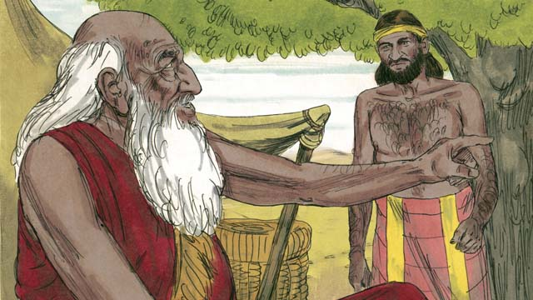

When Abraham was very old, his son Isaac had grown to be a man. So Abraham sent one of his servants back to the land where his relatives lived to bring back a wife for his son, Isaac.

06-02

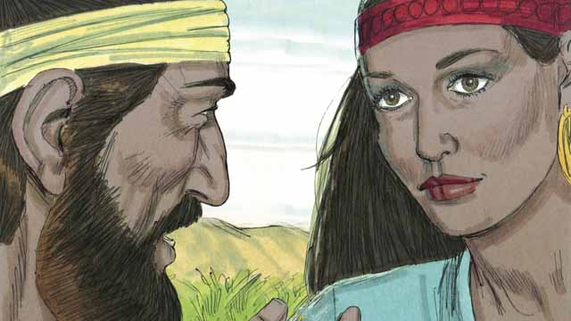

After a very long journey to the land where Abraham’s relatives lived, God led the servant to Rebekah. She was the granddaughter of Abraham’s brother.

06-03

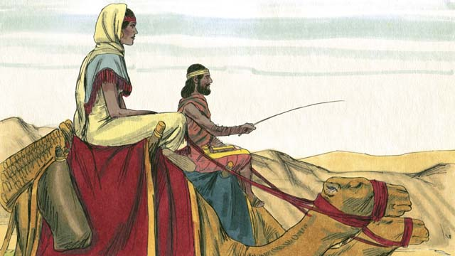

Rebekah agreed to leave her family and go back with the servant to Isaac’s home. Isaac married her as soon as she arrived.

06-04

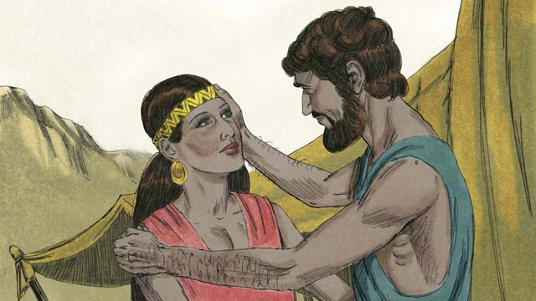

After a long time, Abraham died. God then blessed Abraham’s son Isaac because of the covenant he had made with Abraham. One of God’s promises in that covenant was that Abraham would have countless descendants. But Isaac’s wife, Rebekah, could not have children.

06-05

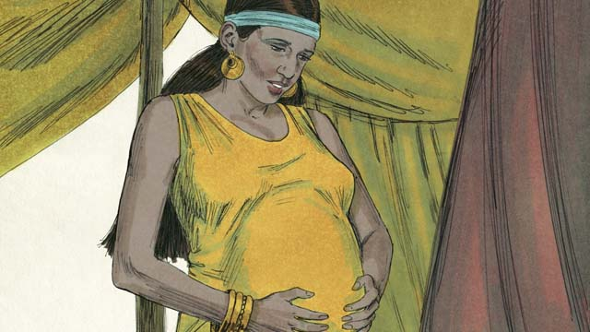

Isaac prayed for Rebekah, and God allowed her to get pregnant with twins. The two babies struggled with each other while they were still in Rebekah’s womb, so Rebekah asked God what was happening.

06-06

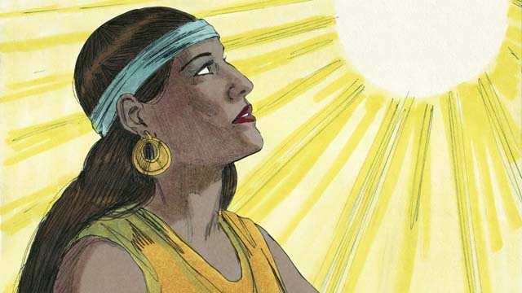

God told Rebekah, “You will give birth to two sons. Their descendants will become two different nations. They will struggle with each other. But the nation coming from your older son will have to obey the nation coming from your younger son.”

06-07

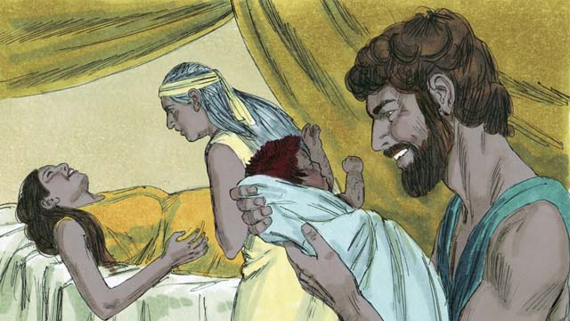

When Rebekah’s babies were born, the older son came out red and hairy, and they named him Esau. Then the younger son came out holding on to Esau’s heel, and they named him Jacob.

*A Bible story from: Genesis 24:1-25:26*

## 1 Biblical Interpretation: Observing the Details of the Story

After reading the crafted biblical story, answer the following questions to familiarize yourself with the details of the story.

### 1.1 Observation Questions

Answer the following observation questions to gain a basic understanding of the the story. Read the story as a community and answer these questions as a group.

#### 06-01

How old were Abraham and Isaac at the beginning of this story?  
Abraham was very old and Isaac had grown to be a man.

Why did Abraham send his servant back to the land of Abraham’s relatives?  
He sent him to bring back a wife for his Abraham’s son, Isaac.

#### 06-02

How did the servant find Rebekah?  
God led him to her.

How was Rebekah related to Abraham?  
Rebekah was the granddaughter of Abraham’s brother.

#### 06-03

Was Rebekah forced to go with the servant to marry Isaac?  
No, she agreed to go.

What happened when Rebekah arrived to Isaacs home and met Isaac?  
Isaac married Rebekah.

#### 06-04

What promises of God were passed on to Isaac when Abraham died?  
All of the promises that God had made to Abraham, including that he would have countless descendants, were passed on to Isaac.

Why did it appear that the promise of countless descendants would not be fulfilled through Isaac?  
Rebekah could not have children.

#### 06-05

What happened when Isaac prayed for Rebekah?  
God allowed Rebekah to get pregnant with twins.

What were the twins doing inside of Rebekah’s womb?  
The twins struggled with each other inside the womb.

#### 06-06

What did God tell Rebekah about the number of children she would have?  
God told Rebekah that she would give birth to two sons.

What did God tell Rebekah about her two twin sons before they were born?  
They would become two nations, and the older son will serve the younger one.

#### 06-07

What was the name of the older son?  
His name was Esau.

What did Esau look like?  
Esau was red and hairy.

What was the name of the younger son?  
His name was Jacob.

What was Jacob doing when he was born?  
He was holding on to Esau’s heel.

### 1.2 Translation Questions

Use the following translation questions to understand specific details of the passage. Discuss how you might translate these specific elements of the story.

#### 06-01

**sent one of his servants back** Abraham told the servant to return to the same place where Abraham used to live long ago before he came to Canaan. This was the place where his relatives lived. How would express **sent one of his servants back** to mean Abraham told his servant to return to the place he used to live before living in Canaan?

  

**to bring back a wife** Abraham told the servant to bring back an unmarried woman for his son, Isaac, to marry. How would you express **to bring back a wife** to mean to find an unmarried woman for Isaac to marry and to cause her to return with him to Isaac?

  

#### 06-02

**God led the servant** God specifically directed the servant to Rebekah. How would you express **God led the servant** to mean God guided the servant and showed him that Rebekah was the unmarried woman Isaac was supposed to marry?

  

**the granddaughter of** Abraham’s brother Rebekah was the daughter of Abraham’s brother’s son. Her grandfather was Abraham’s brother. How would you express **the granddaughter of** Abraham’s brother to mean Abraham was the brother of Rebekah’s grandfather?

  

#### 06-03

**Rebekah agreed** Even though Rebekah’s parents were arranging her marriage, they did not force her to go marry Isaac. How would you express **Rebekah agreed** to mean Rebekah decided that she would go with the servant to marry Isaac and that she was not forced to go?

  

**as soon as she arrived** Isaac married Rebekah when she came to Isaac’s home. How would you express **as soon as she arrived** to mean Isaac married Rebekah at the time she met Isaac and came to his home?

  

#### 06-04

**because of the covenant he had made with** Abraham The promises of the covenant that God made with Abraham were not for him only, but also for his descendants. The reason God blessed Isaac was the promise he made to Abraham. How would you express **because of the covenant he had made with** Abraham to mean the reason God blessed Isaac was the promises he made to Abraham?

  

**countless** The word **countless** means there would be so many descendants that people would not be able to count them. What words in your language mean **countless** as in so many that people would not be able to number/count them?

  

**could not have children** At this time, Rebekah was barren. She was unable to have children. How would you express **could not have children** to mean Rebekah was not able to have babies?

  

#### 06-05

**Isaac prayed for** Rebekah Isaac talked to God and asked for God to help Rebekah. How would you express **Isaac prayed for** Rebekah to mean Isaac asked God to help Rebekah?

  

**God allowed her to get pregnant** Rebekah could not have children. God answered Isaac’s prayer. God made it possible for her to have children. How would you express **God allowed her to get pregnant** to mean God made it possible for Rebekah to become pregnant?

  

**struggled with each other** The two babies were shoving and kicking each other while they were in the womb. How would you express **struggled with each other** to mean the two babies were fighting one another (kicking and pushing) while they were in Rebekah’s womb?

  

**in Rebekah’s womb**The womb is the inner part of a woman where a baby grows. How would you express **in Rebekah’s womb** to mean the two babies were struggling inside of her?

  

#### 06-06

**two different nations** Each of the children would have many descendants that would become two different people groups. How would you express **two different nations** to mean each of the children would have many descendants that would become two different people groups?

  

**They will struggle with each other** Both the two sons and the nations that will come from them will continually fight with each other. How would you express **They will struggle with each other** to mean that the two sons and the nations that come from them will continually fight each other?

  

**your older son** Even though the babies were twins, the baby that came out first would be treated as the older son. How would you express **your older son** to mean the twin baby that was born first?

  

#### 06-07

**Rebekah’s babies were born** This refers to the time when the babies came out of Rebekah’s womb and were alive in the world. How would you express **Rebekah’s babies were born** to mean the time when the babies came out of Rebekah’s womb and into the world?

  

**red and hairy** The older son was red and had a lot of hair on his body. This may mean that his skin was very red or that the hair on his body was red. How would you express **red and hairy** to mean the older son was red and had a lot of hair on his body?

  

**the older son…the younger son** The babies were twins. The baby born first was the older son. The baby born second was the younger son. How would you express **the older son…the younger son** to refer to the twin baby born first and the twin baby born second?

  

**holding on to Esau’s heel** When Jacob was being born, he was holding on to the back part of Esau’s foot. How would you express **holding on to Esau’s heel** to mean Jacob was holding on to the back part of Esau’s foot at the time he was being born?

  

## 2 Theological Dialogue: Discussing the Meaning of the Story

Take time to explore the meaning of this story together as a community. Use the following discussions as a way to grasp what truth the story teaches.

### 2.1 Discourse Questions

Use the following discourse questions to understand the meaning of the story. Pay attention to how the story itself addresses each question or theme.

##### How did provide a wife for Isaac? (06-01, 06-02, 06-03)

Abraham sent one of his servants back to the land of his relatives to find a wife for his son Isaac. Abraham wanted Isaac to marry someone who would share his faith and values. God used Abraham’s faithfulness to provide for Isaac. (06-01)

  

God led Abraham’s servant to Rebekah. The servant did not discover Rebekah himself. God guided the servant to find Rebekah. (06-02)

  

Rebekah was the granddaughter of Abraham’s brother. One way the servant knew that this choice was from God was because Rebekah was a part of Abraham’s extended family. God honored Abraham’s desire to find an appropriate wife for Isaac and provided a woman from his extended family. (06-02)

  

Rebekah agreed to go back with the servant to Isaac’s home. God worked in Rebekah to agree to go. She was not forced to go. (06-03)

  

Isaac married Rebekah when she arrived. Even though God used people—Abraham, the servant, Rebekah—God brought about the circumstances to provide a wife for Isaac. (06-03)

  

##### How did God provide a child for Isaac and Rebekah? (06-04, 06-05, 06-06, 06-07)

God promised that Abraham would have countless descendants. Rebekah was barren and was not able to have children. God’s promise gave confidence that Isaac and Rebekah would have a child. (06-04)

  

Isaac prayed for Rebekah. God answered the prayer and caused Rebekah to become pregnant with twins (06-05)

God told Rebekah that she would give birth to two sons. He explained that these sons would have many descendants and would each become a nation. God provided children who would become numerous nations. (06-06)

  

Eventually, Rebekah gave birth to her two children. Just like God provided a wife for Isaac, he also provided children for Isaac and Rebekah. (06-07)

  

##### How did God keep the promises of his covenant? (06-04, 06-06, 06-07)

God blessed Isaac because of his covenant with Abraham. God kept his promise to Abraham across generations. (06-04)

  

Each of these children would have many descendants which would become nations. (06-06)

  

God would cause the older son to serve the younger son. Even though the custom of the day would have the younger son serve the older son, God would cause the older son to serve the younger son. God was choosing which line of descendants he would continue his covenant. (06-06)

  

The two sons and their descendants would be in conflict with one another. God would fulfill the promises of his covenant even though there would be conflict among humans. Human conflict would not deter God’s covenant promises from being fulfilled. (06-07)

  

### 2.2 Theological Questions

Answer the following theology questions as a community. Discuss what truths this story teaches.

1. How does God provide for his people? What do we learn about how God provides for his people form this story?
2. What does it mean to pray to God? What does this story teach us about prayer?
3. How does God keep the promises of his covenant? What do we learn about God’s promises and his covenant in this story?

### 2.3 Translation Draft

Work as a translation team to draft each panel of this story. Pay attention to any specific translation issues that are challenging or significant.

#### Make Translation Draft

Make a draft for each section of this story.

#### Discuss and Revise

After drafting the story, discuss any translation issues that you think need special explanation.

#### Drafting Summary Reflection

Summarize any noteworthy translation decisions and the rationale/reasoning behind these translation decisions. In the final movement of this class, you will use these observations to give an account (i.e., chronicle/narrate) of how your translation improved through the checking process.

## 3 Personal Reflection: Following the Teaching of the Story

Take a moment to allow this story to evaluate your own life and to consider how God would have you respond. After this reflection, use the quality checking questions to check your translation draft among the translation team.

### 3.1 Journal Reflection

Prayerfully think about the following personal reflection questions. Write/Record your answers and/or discuss them as a group.

1. How have you experienced God providing for you?
2. What specific needs would you hope God provides for you or for someone else? How would you pray to God to meet personal needs or the needs of others?
3. Which part of Isaac’s story is most interesting to you? Why?
4. How should respond to God as he fulfills his promises?

### 3.2 Team Check

*The following activity will help you check the clarity, accuracy, and naturalness of your draft. Read the passage aloud and discuss the checking questions with other members of your translation community. You might need to reread portions (or the whole) of the biblical passage multiple times as you answer each of these questions. Record answers to these questions below.*

#### Team Checking Questions

*Use the following questions to check your translation draft for accuracy, clarity, and naturalness.*

1. **Accurate**: Has anything been **added** to your translation of this passage that is not a part of the meaning of the source text? *If additions exist, are they included only added to clarify meaning (such as implied information)?*
2. **Accurate**: Is anything **missing** from your translation of this passage that is a part of the meaning of the source text? *If some part of the meaning is missing from your translation, add it.*
3. **Accurate**: Does any meaning in your translation of this passage appear to be **different** than the meaning of the source text? *If the meaning is different, try changing your translation so that the meaning remains the same.*
4. **Natural**: Does anything sound **unnatural** to how you would say it in your language? *If portions of the passage sound unnatural in your language, try to make them sound the way you would say it in your language while staying true to the meaning of the source text.*
5. **Clear**: Is anything **unclear** or **confusing** in your translation that confuses the meaning of the source text? *If portions of the passage are unclear or confusing, revise them to clearly communicate the meaning of the source text.*
6. **Consistent**: How **consistent** is your translation within the passage and with other passages? *If portions of the passage need to be made consistent or if you need to revise translations of other passages, make these adjustments.*

#### Record Feedback

*After discussing the checking questions above as a translation community, record any feedback on your translation draft. Pay attention for parts of your translation that are translated well and parts of your translation that need correction.*

#### Discuss and Revise

*After gathering feedback on your draft, discuss it together with your translation community and make appropriate revisions in your translation.*

#### Record Translation Decisions

*As a community, discuss some of the most noteworthy translation decisions in your draft. Summarize each decision and explain the reasons your community decided on that translation. You should update these decisions each time you check your draft with various groups of people.*

You should **measure** the quality of your translation draft. You can **record translation decisions** to make it clear why you translated things a certain way. Translation decisions can help your translation team and the surrounding community be a part of the translation process.

How can you know the quality of your translation?

1. **Measure** the translation by marks/standards of quality (i.e., clear, accurate, natural, church-approved)
2. **Test** the translation with others and record feedback and conversations from in the field (i.e., church and community check)
3. **Compare** and **contrast** the translation with the source text (i.e., meaning of text and notes) and alternatives (i.e., other translation choices)
4. **Explain** the reasons why you translated a particular portion of the text.

**Example Sentences That Help Explain Your Translation Decision** Use the following example sentences to help explain your translation decisions:

1. The original text literally **says/means**, so we translated the term in this way…
2. We originally decided to translate **the biblical term** in with **this term**, but we changed it because…
3. When our translation team discussed **the biblical term**, this is what we talked about…
4. **The term** is [clear, accurate, natural, consistent] because…
5. The community understands **this term** it to mean…
6. We considered these other terms. We did not use **these terms** because…
7. When we checked this in the church, we learned…
8. When we checked this in the community, we learned…

**Example of Translation Decision**

In OBS 01-07 we decided to translate **blessed** like this: [actual translation]. We decided this translation because of these reasons:

1. The word [actual translation] means to cause good things to happen to someone or something. This term is used when a person desires someone or something to prosper or flourish. This term does not refer to magic or witchcraft.
2. When we checked this word with other believers, they said it describes God showing his kindness and favor on someone or something. These are some of the terms that we did not decide to use…
3. Many of our people will understand this word. When we discussed this phrase with the surrounding community, we discovered it was a natural way to describe God causing good and beneficial things to happen.

## 4 Ministry Practice: Serving the Church with the Story

Now that you have a draft of this story, consider how this story can encourage other believers in their faith. After ministering this story to others, you will also perform a community check of your translation draft.

### 4.1 Church Ministry

Reflect on how this story can edify and mature the Christian community. Design a way to minister this story to your church community.

**Ministry Preparation**: Take time to consider how you could minister this story to others. Record some ministry ideas below.

**Ministry Implementation**: Minister this story to a group of believers as you had planned. Use the information in this study to help develop a teaching/lesson or lead a discussion of this story to other believers. Record your ministry plan below.

**Ministry Reflection**: Think about what you learned from ministering this story to other believers. Reflect on your experience below.

### 4.2 Church Community Check

After teaching or ministering this story to the church, check the translation quality with the church community. Record any feedback from your checking experience.

#### Create Checking Questions

You can use **Translation Questions** to check you draft. Each **Translation Question** explains the meaning of a specific part of the story and asks you to consider how you would translate that part of the story in your own language. Change each **Translation Question** into a **Checking Question** by asking the following questions. The first question asks you to identity how each specific phrase was translated in your language. The second question asks people in the church to determine if your translation of the phrase expresses the meaning clearly, accurately, and naturally. Look at the following examples to see how to change **Translation Questions** into **Checking Questions**:

#### Translation Question Example 1

**to proclaim the good news about Jesus** Paul and Silas traveled to Philippi for the purpose of preaching the gospel. The gospel is the good news that Jesus saves people from their sins if they will believe in Jesus. How would you express **to proclaim the good news about Jesus** to mean to tell other people the message about how Jesus can save people from their sins?

#### Translation Question Example 2

**a merchant** Paul and Silas met a woman named Lydia at the place by the river. She owned a business and sold items to make money. How would you express **a merchant** to mean a business owner who sells items for a profit?

#### Translation Question Example 3

**so Paul and Silas baptized them** The jailer and his whole family followed Paul’s instructions. They believed in Jesus. The result of this was Paul and Silas baptized them. How would you express **so Paul and Silas baptized them** to mean the result of the jailer and his family believing in Jesus that Paul and Silas baptized all of them?

You can change these into **Checking Questions** like this:

#### Checking Question Example 1

**to proclaim the good news about Jesus** How did you translate **to proclaim the good news about Jesus**? Does it mean to tell other people the message about how Jesus can save people from their sins?

#### Checking Question Example 2

**a merchant** How did you translate **a merchant**? Does it mean a business owner who sells items for a profit?

#### Checking Question Example 3

**so Paul and Silas baptized them** How did you translate **so Paul and Silas baptized them**? Does it mean the result of the jailer and his family believing in Jesus that Paul and Silas baptized all of them?

#### Record Feedback

*Discuss the* ***Checking Questions*** *with your church community, and record any feedback on your translation draft. Pay attention for parts of your translation that are translated well and parts of your translation that need correction.*

#### Discuss and Revise

*After gathering feedback on your draft, discuss it together with your translation community and make appropriate revisions in your translation.*

#### Record Translation Decisions

*Update your translation decisions and record and new any noteworthy observations on the quality of your draft.

## 5 Missional Outreach: Sharing the Truth of the Story

*After sharing this story with others, check the translation quality with the wider language community. Record any feedback from your checking experience.*

### 5.1 Mission Engagement

*Consider how you will witness this story to unbelievers. Design a way to share this story and engage them in what it teaches about Christianity and the gospel.*

**Witness Preparation**: Take time to consider how you will witness this narrative to unbelievers. Record some ideas below.

**Witness Implementation**: Share this story with an unbeliever. Use the information in this study to help develop a teaching/lesson or lead a discussion of this story to other believers. Record your ministry plan below.

**Witness Reflection**: Think about what you learned from ministering this story to unbelievers. Reflect on your experience below.

### 5.2 Sociolinguistic Check

After sharing this story with the language community, check your translation draft with the surrounding community. Record your observations.

#### Checking Approach

After witnessing this story to unbelievers, use one of the following methods to check the translation of this story. Consider using the **Observation Questions** to check your translation draft or come up with your own quality checking questions.

**Read-Retell Check:** Read your draft to those the community and ask them to retell the passage. Be attentive for any portions of the passage that are unclear, unnatural, or inaccurate.

**Comprehension Questions Checklist:** Read the draft of the passage and ask a list of comprehension questions to make sure the passage is being rightly understood. You can use the **Observation Questions** in this guide or come up with your own questions. Then, record any insights or issues that arise.

**Discussion Group:** Develop key questions to ask about the passage (both formational and translational). Read the passage and have a group discussion about the passage, paying attention to issues that need to be addressed, edited, and revised.

#### Record Feedback

*After sharing your draft with language community, discuss the* ***Observations Questions****, and record any feedback on your translation draft. Pay attention for parts of your translation that are translated well and parts of your translation that need correction.*

#### Discuss and Revise

*After gathering feedback on your draft, discuss it together with your translation community and make appropriate revisions in your translation.*

#### Record Translation Decisions

*Update your translation decisions and record and new any noteworthy observations on the quality of your draft.

## 6 Conclusion

As a translation community, take time to reflect on all that was learned in studying, drafting, and checking this story. Celebrate all that God has taught you as a community. Then, submit your revised draft and checking summaries to network leaders for further review.