Open Bible Stories

God Blesses Jacob

## 0 Introduction

### 0.1 Key Idea

The story of God blessing Jacob teaches us how God kept his promises to the next generations.

### 0.2 Creedal Verse

“By faith Isaac invoked future blessings on Jacob and Esau.” Hebrew 11:20

### 0.3 Metanarrative Summary

The eternal God created all things in six days. He made a good and perfect world. He made humans in his image to fill the earth and rule over creation. But humans rebelled against God and ruined God’s creation. God set to restore his world through his promise. God made a covenant with Abraham. He promised to bless all nations through Abraham. God kept his promises across the generations. God provided Abraham with a promised child, Isaac. God gave Isaac a wife and she bore twins, Jacob and Esau. God blessed Jacob and his sons, and the blessing continued to the next generation.

### 0.4 Open Bible Story: God Blesses Jacob

07-01

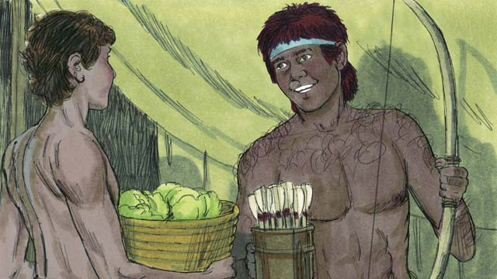

As the boys grew up, Jacob loved to stay at home, but Esau loved to hunt animals. Rebekah loved Jacob, but Isaac loved Esau.

07-02

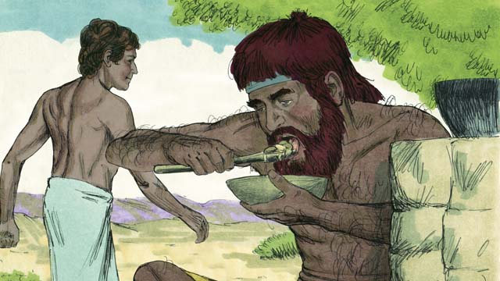

One day, when Esau came back from hunting, he was very hungry. Esau said to Jacob, “Give me some of the food you have made.” Jacob responded, “First, promise me that everything you should receive because you were born first, you will give it all to me.” So Esau promised to give to Jacob all those things. Then Jacob gave him some food.

07-03

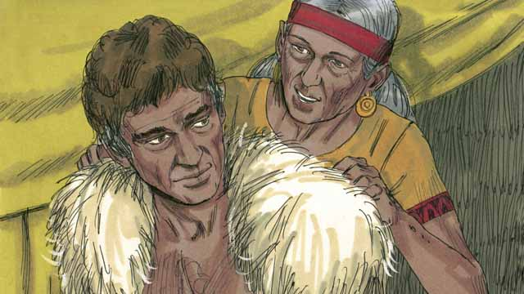

Isaac wanted to give his blessing to Esau. But before he did, Rebekah and Jacob tricked him by having Jacob pretend to be Esau. Isaac was old and could no longer see. So Jacob put on Esau’s clothes and put goatskins on his neck and hands.

07-04

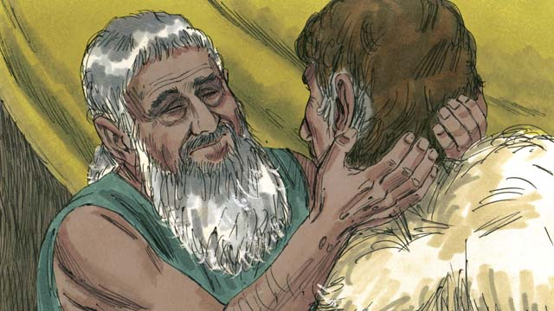

Jacob came to Isaac and said, “I am Esau. I have come so that you can bless me.” When Isaac felt the goat hair and smelled the clothes, he thought it was Esau and blessed him.

07-05

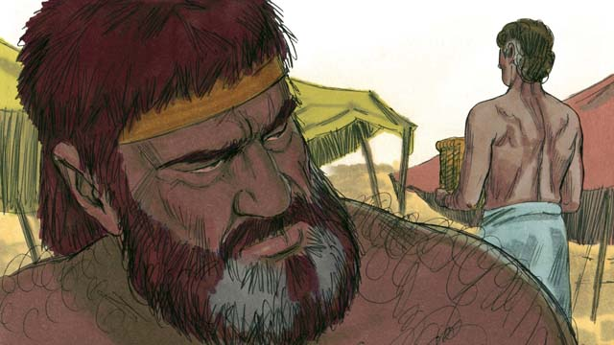

Esau hated Jacob because Jacob had stolen his rights as oldest son and also his blessing. So he planned to kill Jacob after their father died.

07-06

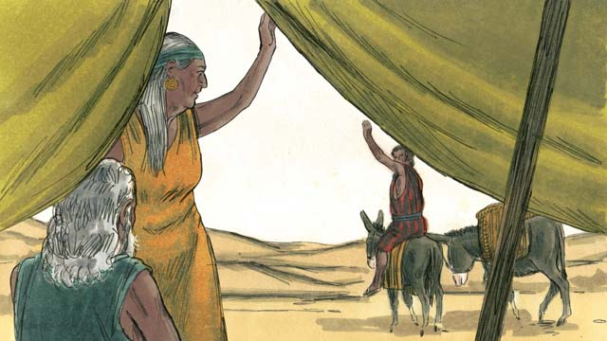

But Rebekah heard of Esau’s plan. So she and Isaac sent Jacob far away to live with her relatives.

07-07

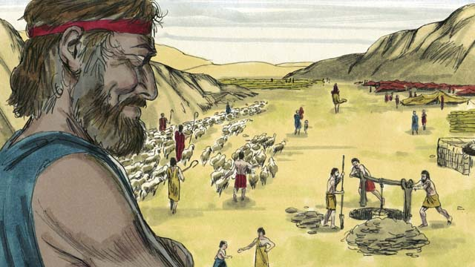

Jacob lived with Rebekah’s relatives for many years. During that time he married and had 12 sons and a daughter. God made him very wealthy.

07-08

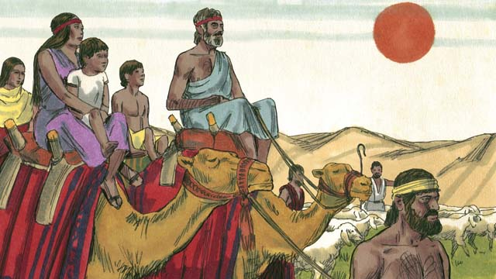

After 20 years away from his home in Canaan, Jacob returned there with his family, his servants, and all his flocks and herds of animals.

07-09

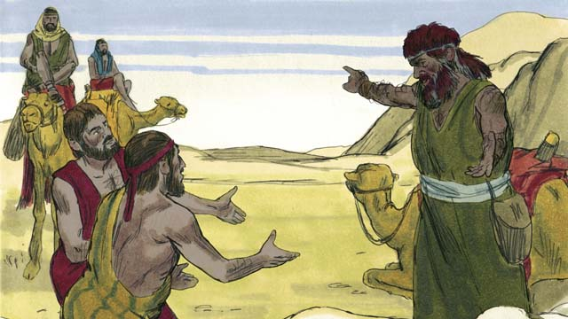

Jacob was very afraid because he thought Esau still wanted to kill him. So he sent many of his animals to Esau as a gift. The servants who brought the animals said to Esau, “Your servant, Jacob, is giving you these animals. He is coming soon.”

07-10

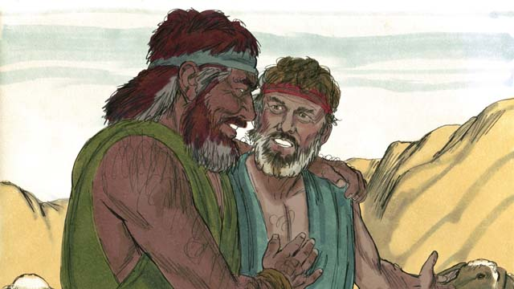

But Esau no longer wanted to harm Jacob. Instead, he was very happy to see him again., so the brothers lived peacefully in Canaan. Then Isaac died, and Jacob and Esau buried him. The covenant promises God had made to Abraham now passed on from Isaac to Jacob.

*A Bible story from: Genesis 25:27-35:29*

## 1 Biblical Interpretation: Observing the Details of the Story

After reading the crafted biblical story, answer the following questions to familiarize yourself with the details of the story.

### 1.1 Observation Questions

Answer the following observation questions to gain a basic understanding of the the story. Read the story as a community and answer these questions as a group.

#### 07-01

What did Jacob and Esau each love to do?  
Jacob loved to stay at home. Esau loved to hunt animals.

Which son did Rebekah love? Which son did Isaac love?  
Rebekah loved Jacob. Isaac loved Esau.

Who was the older son?  
Esau was the older twin son. Jacob was the younger twin son.

#### 07-02

How did Esau feel when he came back from hunting?  
Esau came back from hunting and was very hungry.

What did Esau ask his younger brother?  
Esau asked Jacob for some food.

What did Jacob have Esau promise?  
Jacob told Esau to promise to give him all he would receive for being the firstborn.

Why did he give everything that he should receive to Jacob, the younger son?  
Everything Esau should have received as the older son, he gave Jacob in exchange for some food.

#### 07-03

To whom did Isaac want to give his formal blessing?  
He wanted to give it to Esau.

How did Jacob trick Isaac into giving him the blessing?  
He pretended to be Esau by wearing goatskins so that Isaac would think he was Esau.

#### 07-04

What did Jacob say to his father, Isaac?  
Jacob told his father, Isaac, he was Esau. Jacob also said that he came to receive a blessing from his father.

Who did Isaac think was speaking with him?  
When Isaac felt the goat hair and smelled the clothes, he thought it was Esau.

What did Isaac do to Jacob?  
Isaac blessed Jacob thinking that it was Esau.

#### 07-05

What did Esau feel toward Jacob?  
Because Jacob stole Esau’s blessing, Esau hated his brother, Jacob.

What did Esau plan to do to Jacob?  
Esau planned to kill Jacob after Isaac died.

#### 07-06

What did Isaac and Rebekah do when Rebekah heard of Esau’s plan to kill Jacob?  
They sent Jacob far away to live with Rebekah’s relatives.

#### 07-07

What happened to Jacob during the next twenty years?  
He married, had 12 sons and a daughter, and God made him wealthy.

#### 07-08

How long did Jacob live away from his family in Canaan?  
Jacob lived away from his family for twenty years.

What did Jacob do after these twenty years?  
Jacob returned to his family with all of his servants and animals.

#### 07-09

Why was Jacob afraid when he returned to Canaan?  
He thought Esau would kill him.

What did Jacob do in order to soothe Esau’s anger?  
He sent herds of animals to Esau as a gift.

#### 07-10

Was Esau still angry with Jacob?  
No, he no longer wanted to harm Jacob.

Where did Jacob settle to live?  
He settled in Canaan and lived peacefully with his brother.

After Isaac’s death, who received the covenant promises that God originally gave to Abraham?  
Jacob received them.

### 1.2 Translation Questions

Use the following translation questions to understand specific details of the passage. Discuss how you might translate these specific elements of the story.

#### 07-01

**at home** This refers to the area around the family dwellings. Jacob preferred to stay close to the tents where they lived. How would you express **at home** to mean the place where his family lived?

  

**loved to stay at home…loved to hunt** Jacob liked to stay home and Esau like to hunt. How would you express **loved to stay at home…loved to hunt** to mean Jacob enjoyed/preferred staying around the family dwellings and Esau enjoyed/preferred to hunt animals?

  

**Rebekah loved Jacob, but Isaac loved Esau** Rebekah was more fond of Jacob, and Isaac was more fond of Esau. This does not necessarily mean that Rebekah and Isaac did not love the other son, but that each parent had a favorite. How would you express **Rebekah loved Jacob, but Isaac loved Esau** to mean Rebekah’s favorite child was Jacob and Isaac’s favorite child was Esau?

  

#### 07-02

**promise me** Jacob told Esau to make a promise to him: to swear that he would do something. How would you express **promise me** to mean a command telling someone to swear that they would do something?

  

**everything you should receive because you were born first** According to their custom, since Esau was the oldest son, he should have been the one to receive twice as much of their father’s wealth when their father died. Jacob thought of a way to take these rights of the oldest son from Esau. How would you express **everything you should receive because you were born first** to mean the rights to the larger portion of wealth from their father?

  

#### 07-03

**give his blessing** It was customary for fathers to formally express their desire for good things to happen to their children. Normally, the older son received the best promise. Isaac wanted this extra prosperity to happen to Esau. How would you express **give his blessing** to mean Isaac wanted to formally express his desire for good things to happen to Esau?

  

**tricked him** The word trick means to do something to deliberately deceive someone. Rebekah came up with a plan to deceive Isaac into giving Jacob the special blessing instead of Esau. How would you express **tricked him** to mean Rebekah and Jacob did something deliberately to deceive Isaac?

  

**pretend** The word **pretend** shows how Jacob would deceive his father (who had very poor eyesight in his old age). What words in your language mean **pretend** as in to make something seem like one thing but to be something different in reality?

  

#### 07-04

**When Isaac felt the goat hair and smelled the clothes** Isaac believed he was speaking to Isaac when he felt the goat hair and smelled the clothes. This action resulted in Isaac believing he was speaking with Esau. How would you express **When Isaac felt the goat hair and smelled the clothes** to mean that Isaac thought he was speaking with Esau at the time he felt the goat hair and smelled the clothes?

  

**he thought it was Esau** He thought that the person he was touching and smelling was Esau. How would you express **he thought it was Esau** to mean that Isaac believed he was speaking with Esau?

  

#### 07-05

**rights as oldest son** This refers to the the extra blessing and inheritance that belonged to Esau because he was the firstborn son. Jacob found a way to get the larger portion of their father’s wealth that should have gone to Esau as the older son. How would you express **rights as oldest son** to mean the extra blessing and inheritance the belonged to the firstborn son?

  

**because** Jacob had stolen The connecting word **because** connects the reason, Jacob stole Esau’s rights and blessing, with the result, Esau hated Jacob. How would you express **because** Jacob had stolen to mean the reason Esau hated Jacob was **because** Jacob had stolen his rights to the inheritance?

  

**So he planned to kill** Jacob The word So connects the result, Esau planned to kill Jacob, with the reason, Esau hated Jacob. How would you express so he planned to kill Jacob to mean Esau determined to kill Jacob because he hated him?

  

#### 07-06

**But Rebekah heard Esau’s plan** The connecting word But is used in a contrast relationship. It contrasts Esau’s plan to kill Jacob with Rebekah hearing of it and devising a different plan. Rebekah acted opposite to Esau. Esau planned to kill Jacob; Rebekah acted to protect Jacob. How would you express **But Rebekah heard Esau’s plan** to mean Rebekah responded differently/opposite to Esau’s plan?

  

**Esau’s plan** This refers to the plan that Esau had decided to do. **Esau’s plan** was to kill Jacob after his father died. How would you express **Esau’s plan** to mean the intent or decision Esau made to kill Jacob after their father died?

  

**far away to live with her relatives** Since Abraham’s brother was Rebekah’s grandfather, her relatives were also Isaac’s relatives. How would you express **far away to live with her relatives** to mean the family members who lived in in the same land where she used to live?

  

#### 07-07

**During that time** Jacob married, had children, and became wealthy while he was living with Rebekah’s relatives. How would you express during that time to mean that Jacob married, had children, and became wealthy while he was living with Rebekah’s relatives?

  

**very wealthy** This included money, large herds of animals and other possessions. How would you express **very wealthy** to mean that Jacob had become rich in possessions?

  

#### 07-08

**After 20 years** After twenty years living in the land where his relatives were Jacob returned home. Jacob had lived for twenty years in the land where his mother was from. How would you express **After 20 years** to mean Jacob returned home at the end of twenty years living with Rebekah’s relatives?

  

**all his flocks and herds of animals** This refers to ownership—all the groups of animals that belonged to him. How would you express **all his flocks and herds of animals** to mean all the flocks and herds that belonged to Jacob as his possession?

  

#### 07-09

**gift** Jacob sent many animals to Esau as a **gift**. He was hoping the **gift** would cause his brother to no longer hate him. What words in your language mean **gift** as in a present one offers to someone else?

  

**Your servant, Jacob** Jacob was not actually Esau’s servant. But Jacob told his servants to say this because he wanted to show Esau that he was coming to him humbly and respectfully, so that Esau would no longer be angry with him. How would you express **Your servant, Jacob** to mean that Jacob was coming to his brother, Esau, humbly and respectfully as a servant would to a master?

  

#### 07-10

**But Esau no longer wanted to harm Jacob** The connecting word But here contrasts Jacob’s fear of Esau wanting to kill him with Esau no longer wanting to harm Jacob. How would you express **But Esau no longer wanted to harm Jacob** to mean that Esau had different/opposite feelings toward Jacob?

  

**lived peacefully** This refers to the fact that Esau and Jacob were not angry at each other and did not fight with each other. How would you express **lived peacefully** to mean Esau and Jacob were no longer angry with each other and no longer fought with each other?

  

**covenant promises** These were the promises that God made in his covenant with Abraham. How would you express **covenant promises** to mean the things God guaranteed his would do (promises) for Abraham as a result of the formal agreement (covenant) he made with him?

  

**passed on from Isaac to Jacob** The promises went from Abraham to his son Isaac, and now to Isaac’s son Jacob. Esau did not receive the promises. How would you express **passed on from Isaac to Jacob** to mean that the promises God made to Abraham continued to the descendants of Jacob not the descendants of Esau?

  

## 2 Theological Dialogue: Discussing the Meaning of the Story

Take time to explore the meaning of this story together as a community. Use the following discussions as a way to grasp what truth the story teaches.

### 2.1 Discourse Questions

Use the following discourse questions to understand the meaning of the story. Pay attention to how the story itself addresses each question or theme.

##### What caused conflict between Esau and Jacob? (07-01)

Favoritism: Rebekah favored Jacob and Isaac favored Esau. When parents have favorites among their children this can cause conflict between the children. (07-01)

  

Self-Interest: Esau traded his rights as the firstborn son in exchange for food. In a moment of hunger, Esau promised to give Jacob the wealth that was supposed to be for the firstborn. Not only did Jacob take advantage of his brother’s hunger, but Esau also acted rashly to give something so valuable away for one meal. Both Jacob and Esau were self-interested. Jacob took advantage of his brother’s hunger to take the inheritance rights; Esau tried to satisfy his hunger rather than thinking of the long-term inheritance. (07-02)

  

Deceit: Rebekah and Jacob tricked Isaac by having Jacob dress in goatskins and put on Esau’s clothes. Isaac thought Jacob was Esau. Isaac blessed Jacob instead of Esau. This act of deception and tricker would cause great conflict between Jacob and Esau. (07-03, 07-04)

  

Hatred: By tricking Isaac, Jacob stole the blessing from Esau. Because Jacob stole this blessing, Esau hated Jacob and planned to kill him after Isaac died. Stealing and hatred can cause a desire to harm others. (07-05)

  

##### How did God bless Jacob? (07-06)

Rebekah sent Jacob to live with her relatives. This kept Esau from killing his brother. Jacob lived at a distance from Esau for an extended period of time. (07-6)

  

During his time away, Jacob married, had children, and increased in wealth. God blessed Jacob with a family and many possessions. (07-07)

  

After twenty years, Jacob returned home with his family and possessions. Jacob returned home with more than when he left. (07-08)

  

##### How did the relationship between Jacob and Esau get restored? (07-01)

Jacob was afraid of Esau. He thought Esau wanted to kill him. Sins we commit have have effects later in life. Jacob had to realize the consequences of his sin. (07-09)

  

Jacob sent a gift to his brother. He was hoping that the gift would cause his brother to no longer want to kill him. (07-10)

  

When they met, Esau no longer wanted to kill Jacob. They lived peacefully in the land. (07-10)

  

##### How did keep his covenant promises to the next generation? (07-10)

The younger son gained the rights of the firstborn. In that culture, the firstborn son would be the preferred choice for the greater inheritance. God was doing what many people did not expect. (07-02).

  

Jacob gained the blessing that Isaac wanted to give to Esau. God was doing what many people did not expect. (07-04).

  

God caused Jacob to become wealthy. Jacob did not become wealthy on his own. God provided for him even though he did not deserve it. (07-7)

  

God protected Jacob from his brother. The restored relationship between Jacob and Esau was not something that Jacob. God had made it possible for Esau and Jacob to live peacefully with one another. (07-09)

  

God caused the covenant promises to continued to the descendants of Jacob. God chose to which descendants he wanted his covenant promises to continue. (07-10)

  

### 2.2 Theological Questions

Answer the following theology questions as a community. Discuss what truths this story teaches.

1. What causes conflict in human relationships? How does the story of Jacob and Esau help us understand why human relationships can have conflict?
2. How are the promises of God’s blessing undeserved (an act of grace)? How do we see God blessing Jacob despite Jacob’s wrongdoing?
3. How can human relationships be restored to peace? How does the story of Jacob and Esau show us what restored relationship looks like?

### 2.3 Translation Draft

Work as a translation team to draft each panel of this story. Pay attention to any specific translation issues that are challenging or significant.

#### Make Translation Draft

Make a draft for each section of this story.

#### Discuss and Revise

After drafting the story, discuss any translation issues that you think need special explanation.

#### Drafting Summary Reflection

Summarize any noteworthy translation decisions and the rationale/reasoning behind these translation decisions. In the final movement of this class, you will use these observations to give an account (i.e., chronicle/narrate) of how your translation improved through the checking process.

## 3 Personal Reflection: Following the Teaching of the Story

Take a moment to allow this story to evaluate your own life and to consider how God would have you respond. After this reflection, use the quality checking questions to check your translation draft among the translation team.

### 3.1 Journal Reflection

Prayerfully think about the following personal reflection questions. Write/Record your answers and/or discuss them as a group.

1. When have you been tricked or deceived by someone else? How did this feel?
2. When have you tricked or deceived others? What consequences did you experience?
3. How can trusting God help you enjoy God’s blessing and a life of peace with others?
4. What are the obstacles that are keeping you from trusting God? How can you tell that you are trusting God?

### 3.2 Team Check

*The following activity will help you check the clarity, accuracy, and naturalness of your draft. Read the passage aloud and discuss the checking questions with other members of your translation community. You might need to reread portions (or the whole) of the biblical passage multiple times as you answer each of these questions. Record answers to these questions below.*

#### Team Checking Questions

*Use the following questions to check your translation draft for accuracy, clarity, and naturalness.*

1. **Accurate**: Has anything been **added** to your translation of this passage that is not a part of the meaning of the source text? *If additions exist, are they included only added to clarify meaning (such as implied information)?*
2. **Accurate**: Is anything **missing** from your translation of this passage that is a part of the meaning of the source text? *If some part of the meaning is missing from your translation, add it.*
3. **Accurate**: Does any meaning in your translation of this passage appear to be **different** than the meaning of the source text? *If the meaning is different, try changing your translation so that the meaning remains the same.*
4. **Natural**: Does anything sound **unnatural** to how you would say it in your language? *If portions of the passage sound unnatural in your language, try to make them sound the way you would say it in your language while staying true to the meaning of the source text.*
5. **Clear**: Is anything **unclear** or **confusing** in your translation that confuses the meaning of the source text? *If portions of the passage are unclear or confusing, revise them to clearly communicate the meaning of the source text.*
6. **Consistent**: How **consistent** is your translation within the passage and with other passages? *If portions of the passage need to be made consistent or if you need to revise translations of other passages, make these adjustments.*

#### Record Feedback

*After discussing the checking questions above as a translation community, record any feedback on your translation draft. Pay attention for parts of your translation that are translated well and parts of your translation that need correction.*

#### Discuss and Revise

*After gathering feedback on your draft, discuss it together with your translation community and make appropriate revisions in your translation.*

#### Checking Summary Reflection

*Summarize any noteworthy translation decisions (things you corrected or affirmed in your draft) and the rationale/reasoning behind these translation decisions. In the final movement of this class, you will use these observations to give an account (i.e., chronicle/narrate) of how your translation improved through the checking process.*

## 4 Ministry Practice: Serving the Church with the Story

Now that you have a draft of this story, consider how this story can encourage other believers in their faith. After ministering this story to others, you will also perform a community check of your translation draft.

### 4.1 Church Ministry

Reflect on how this story can edify and mature the Christian community. Design a way to minister this story to your church community.

**Ministry Preparation**: Take time to consider how you could minister this story to others. Record some ministry ideas below.

**Ministry Implementation**: Minister this story to a group of believers as you had planned. Use the information in this study to help develop a teaching/lesson or lead a discussion of this story to other believers. Record your ministry plan below.

**Ministry Reflection**: Think about what you learned from ministering this story to other believers. Reflect on your experience below.

### 4.2 Church Community Check

After teaching or ministering this story to the church, check the translation quality with the church community. Record any feedback from your checking experience.

#### Create Checking Questions

You can use **Translation Questions** to check you draft. Each **Translation Question** explains the meaning of a specific part of the story and asks you to consider how you would translate that part of the story in your own language. Change each **Translation Question** into a **Checking Question** by asking the following questions. The first question asks you to identity how each specific phrase was translated in your language. The second question asks people in the church to determine if your translation of the phrase expresses the meaning clearly, accurately, and naturally. Look at the following examples to see how to change **Translation Questions** into **Checking Questions**:

#### Translation Question Example 1

**to proclaim the good news about Jesus** Paul and Silas traveled to Philippi for the purpose of preaching the gospel. The gospel is the good news that Jesus saves people from their sins if they will believe in Jesus. How would you express **to proclaim the good news about Jesus** to mean to tell other people the message about how Jesus can save people from their sins?

#### Translation Question Example 2

**a merchant** Paul and Silas met a woman named Lydia at the place by the river. She owned a business and sold items to make money. How would you express **a merchant** to mean a business owner who sells items for a profit?

#### Translation Question Example 3

**so Paul and Silas baptized them** The jailer and his whole family followed Paul’s instructions. They believed in Jesus. The result of this was Paul and Silas baptized them. How would you express **so Paul and Silas baptized them** to mean the result of the jailer and his family believing in Jesus that Paul and Silas baptized all of them?

You can change these into **Checking Questions** like this:

#### Checking Question Example 1

**to proclaim the good news about Jesus** How did you translate **to proclaim the good news about Jesus**? Does it mean to tell other people the message about how Jesus can save people from their sins?

#### Checking Question Example 2

**a merchant** How did you translate **a merchant**? Does it mean a business owner who sells items for a profit?

#### Checking Question Example 3

**so Paul and Silas baptized them** How did you translate **so Paul and Silas baptized them**? Does it mean the result of the jailer and his family believing in Jesus that Paul and Silas baptized all of them?

#### Record Feedback

*Discuss the* ***Checking Questions*** *with your church community, and record any feedback on your translation draft. Pay attention for parts of your translation that are translated well and parts of your translation that need correction.*

#### Discuss and Revise

*After gathering feedback on your draft, discuss it together with your translation community and make appropriate revisions in your translation.*

#### Checking Summary Reflection

*Summarize any noteworthy translation decisions (things you corrected or affirmed in your draft) and the rationale/reasoning behind these translation decisions. In the final movement of this class, you will use these observations to give an account (i.e., chronicle/narrate) of how your translation improved through the checking process.*

## 5 Missional Outreach: Sharing the Truth of the Story

*After sharing this story with others, check the translation quality with the wider language community. Record any feedback from your checking experience.*

### 5.1 Mission Engagement

*Consider how you will witness this story to unbelievers. Design a way to share this story and engage them in what it teaches about Christianity and the gospel.*

**Witness Preparation**: Take time to consider how you will witness this narrative to unbelievers. Record some ideas below.

**Witness Implementation**: Share this story with an unbeliever. Use the information in this study to help develop a teaching/lesson or lead a discussion of this story to other believers. Record your ministry plan below.

**Witness Reflection**: Think about what you learned from ministering this story to unbelievers. Reflect on your experience below.

### 5.2 Sociolinguistic Check

After sharing this story with the language community, check your translation draft with the surrounding community. Record your observations.

#### Checking Approach

After witnessing this story to unbelievers, use one of the following methods to check the translation of this story. Consider using the **Observation Questions** to check your translation draft or come up with your own quality checking questions.

**Read-Retell Check:** Read your draft to those the community and ask them to retell the passage. Be attentive for any portions of the passage that are unclear, unnatural, or inaccurate.

**Comprehension Questions Checklist:** Read the draft of the passage and ask a list of comprehension questions to make sure the passage is being rightly understood. You can use the **Observation Questions** in this guide or come up with your own questions. Then, record any insights or issues that arise.

**Discussion Group:** Develop key questions to ask about the passage (both formational and translational). Read the passage and have a group discussion about the passage, paying attention to issues that need to be addressed, edited, and revised.

#### Record Feedback

*After sharing your draft with language community, discuss the* ***Observations Questions****, and record any feedback on your translation draft. Pay attention for parts of your translation that are translated well and parts of your translation that need correction.*

#### Discuss and Revise

*After gathering feedback on your draft, discuss it together with your translation community and make appropriate revisions in your translation.*

#### Checking Summary Reflection

*Summarize any noteworthy translation decisions (things you corrected or affirmed in your draft) and the rationale/reasoning behind these translation decisions. In the final movement of this class, you will use these observations to give an account (i.e., chronicle/narrate) of how your translation improved through the checking process.*

## 6 Conclusion

As a translation community, take time to reflect on all that was learned in studying, drafting, and checking this story. Celebrate all that God has taught you as a community. Then, submit your revised draft and checking summaries to network leaders for further review.