Open Bible Stories

God Saves Joseph and His Family

## 0 Introduction

### 0.1 Key Idea

The story of God saving Joseph and his family teaches us that God rescued Joseph and his family from death.

### 0.2 Creedal Verse

“And the patriarchs, jealous of Joseph, sold him into Egypt; but God was with him and rescued him out of all his afflictions and gave him favor and wisdom before Pharaoh, king of Egypt, who made him ruler over Egypt and over all his household.” Acts 7:9-11

### 0.3 Metanarrative Summary

The eternal God created all things in six days. He made a good and perfect world. He made humans in his image to fill the earth and rule over creation. But humans rebelled against God and ruined God’s creation. God set to restore his world through his promise. God made a covenant with Abraham. He promised to bless all nations through Abraham. God kept his promises across the generations. God provided Abraham with a promised child, Isaac. God gave Isaac a wife and she bore twins, Jacob and Esau. God blessed Jacob and his sons, and the blessing continued to the next generation. God rescued Joseph, one of Jacob’s sons, and used him to rescue his family.

### 0.4 Open Bible Story: God Saves Joseph and His Family

08-01

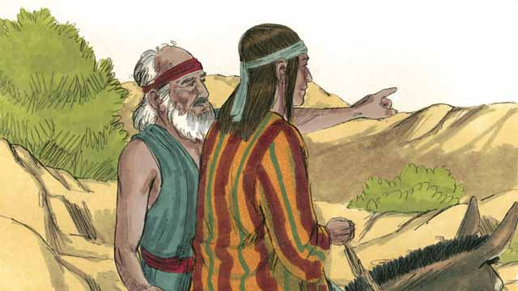

Many years later, when Jacob was an old man, he sent his favorite son, Joseph, to check on his brothers who were taking care of the flocks.

08-02

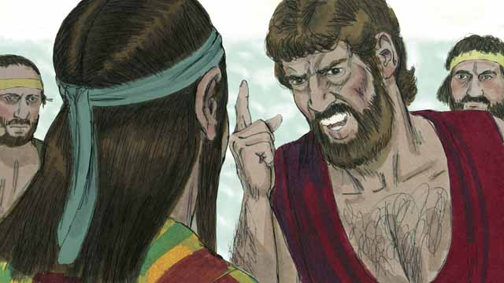

Joseph’s brothers hated him because their father loved him most, and because Joseph had dreamed that he would be their ruler. When Joseph came to his brothers, they took him captive and sold him to some slave traders.

08-03

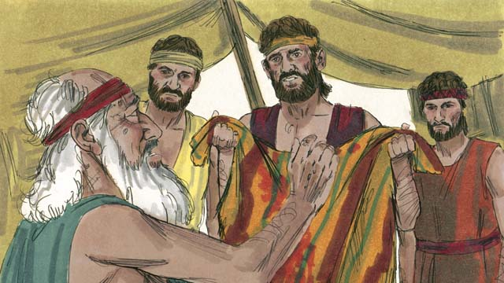

Before Joseph’s brothers returned home, they tore Joseph’s robe and dipped it in goat’s blood. Then they showed the robe to their father so he would think that a wild animal had killed Joseph. Jacob was very sad.

08-04

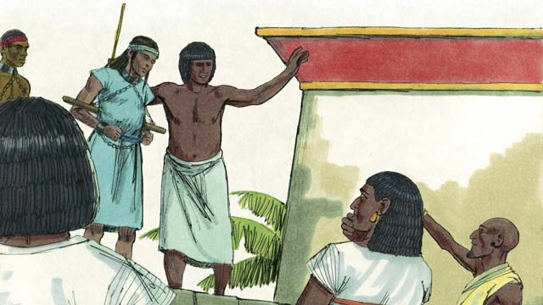

The slave traders took Joseph to Egypt. Egypt was a large, powerful country located along the Nile River. The slave traders sold Joseph as a slave to a wealthy government official. Joseph served his master well, and God blessed Joseph.

08-05

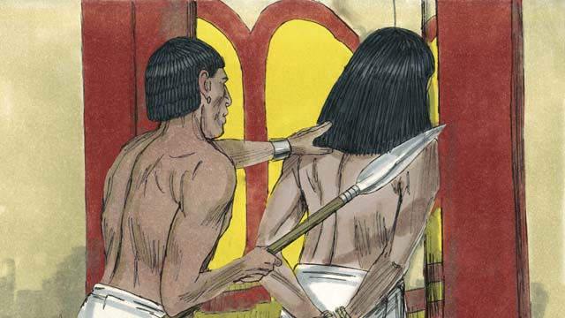

His master’s wife tried to sleep with Joseph, but Joseph refused to sin against God in this way. She became angry and falsely accused Joseph so that he was arrested and sent to prison. Even in prison, Joseph remained faithful to God, and God blessed him.

08-06

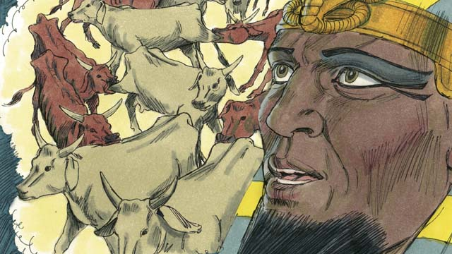

After two years, Joseph was still in prison even though he was innocent. One night the Pharaoh, which is what the Egyptians called their kings, had two dreams that disturbed him greatly. None of his advisors could tell him the meaning of the dreams.

08-07

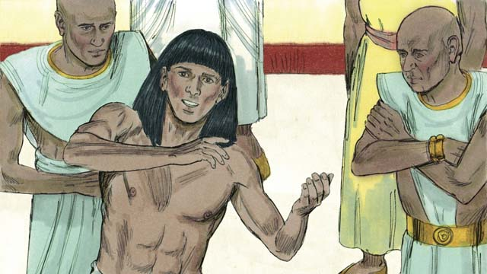

God had given Joseph the ability to interpret dreams, so Pharaoh had Joseph brought to him from the prison. Joseph interpreted the dreams for him and said, “God is going to send seven years of plentiful harvests followed by seven years of famine.”

08-08

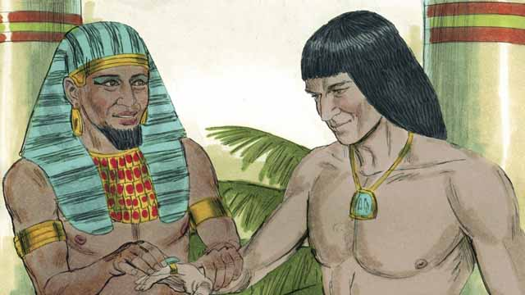

Pharaoh was so impressed with Joseph that he appointed him to be the second most powerful man in all of Egypt!

08-09

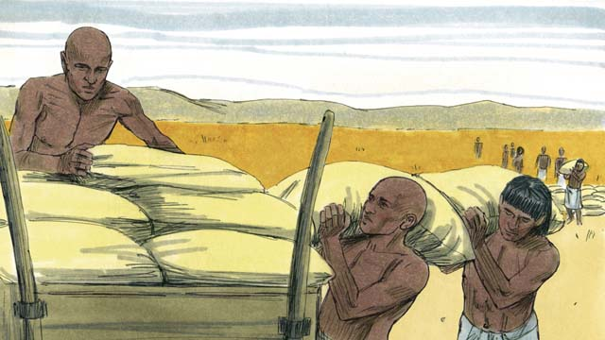

Joseph told the people to store up large amounts of food during the seven years of good harvests. When the seven years of famine came, Joseph sold the food to the people so they would have enough to eat.

08-10

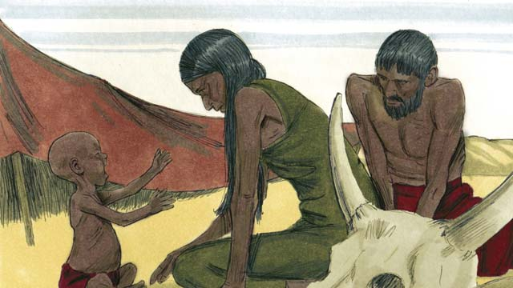

The famine was severe not only in Egypt, but also in Canaan where Jacob and his family lived.

08-11

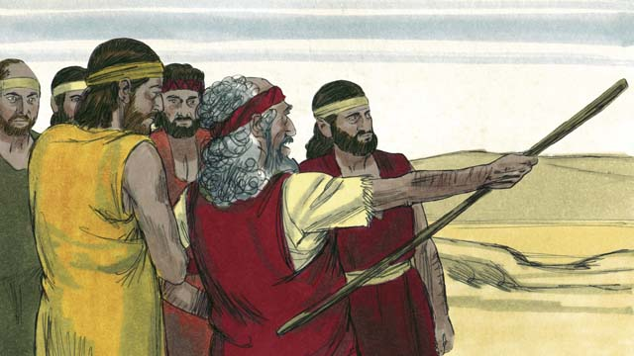

So, Jacob sent his older sons to Egypt to buy food. The brothers did not recognize Joseph when they stood before him to buy food. But Joseph recognized them.

08-12

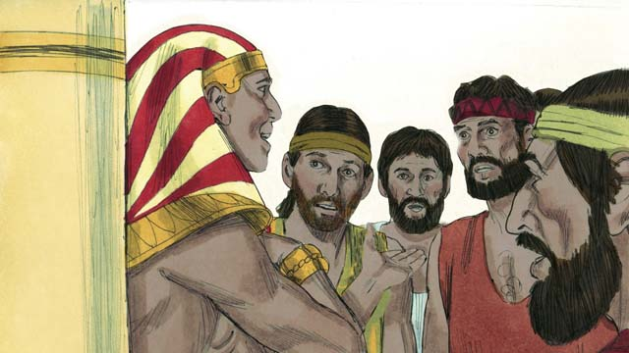

After testing his brothers to see if they had changed, Joseph said to them, “I am your brother, Joseph! Do not be afraid. You tried to do evil when you sold me as a slave, but God used the evil for good! Come and live in Egypt so I can provide for you and your families.”

08-13

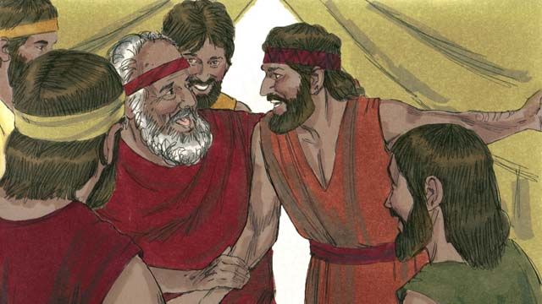

When Joseph’s brothers returned home and told their father, Jacob, that Joseph was still alive, he was very happy.

08-14

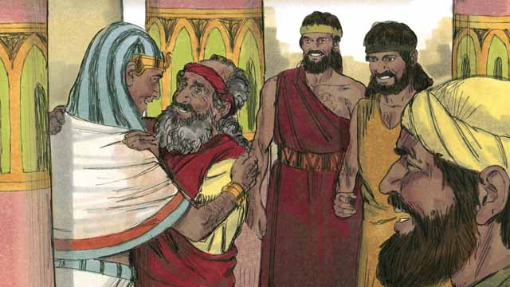

Even though Jacob was an old man, he moved to Egypt with all of his family, and they all lived there. Before Jacob died, he blessed each of his sons.

08-15

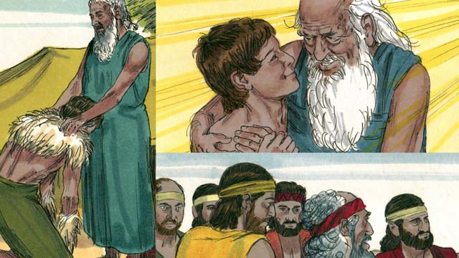

The covenant promises that God gave to Abraham were passed on to Isaac, then to Jacob, and then to Jacob’s 12 sons and their families. The descendants of the 12 sons became the 12 tribes of Israel.

*A Bible story from: Genesis 37-50*

## 1 Community Study: Importance of Love—Making Love Central to Christian Relationships

* **Key Idea**: treating one another with love
* **Key Passage**: 1 Corinthians 13:1-8
* **Main Session**: OBS 8 (God Saves Joseph and His Family)

### 1.1 Sing to God (3–5 minutes)

Choose a song to sing to praise God and encourage one another.

### 1.2 Recite the Creedal Verse (3–5 minutes)

The verse below summarizes the teaching of the current passage. Read the verse out loud as a community. Read it again several times as a group until the whole community can recite it from memory.

Because the patriarchs were jealous of Joseph, they sold him into Egypt; but God was with him and rescued him from all his troubles. He gave Joseph favor and wisdom in the presence of Pharaoh, king of Egypt, who had made him governor over Egypt and over all his household. Acts 7:9-10

### 1.3 Think Together (5 minutes)

One of the most important ways we can relate to one another is to love one another. We can only love one another if we have received God’s love in our own lives. Think together as a community for common ways (both right and wrong) that people, in general, think about love.

Many people think that love is…

### 1.4 Read the Passage (5 minutes)

God tells us to love one another. Loving others is not an easy thing to do, but it is an important way to relate to each other. When Christians love each other, their work together and life together honors God. In order to understand God’s design of Christian community, read the passage below.

13:1 Suppose that I speak with the tongues of men and of angels. But if I do not have love, I have become a noisy gong or a clanging cymbal. 2 Suppose that I have the gift of prophecy and understand all hidden truths and knowledge, and that I have all faith so as to remove mountains. But if I do not have love, I am nothing. 3 Suppose that I give all I own to feed the poor, and that I give my body to be burned. But if I do not have love, I gain nothing. 4 Love is patient and kind. Love does not envy or boast. It is not arrogant 5 or rude. It is not self-serving. It is not easily angered, nor does it keep a count of wrongs. 6 It does not rejoice in unrighteousness. Instead, it rejoices in the truth. 7 Love bears all things, believes all things, hopes all things, and endures all things. 8 Love never ends. 1 Corinthians 13:1-8

### 1.5 Discuss the Idea (10–15 minutes)

Christian community is maintained by Christians loving one another. Use the following questions to explore what it means to be a part of a loving Christian community.

1. Why is love such an important way for Christians to relate to one another?
2. How does this passage help us understand what it means to love?
3. How is this description of love different from the ways other people (who are not believers) treat each other?
4. Why is it hard to love other Christians the way this passage tells us to?
5. How can your community grow in showing one another love?

### 1.6 Pick One Description (5 minutes)

Reflect on the passage and discussion above. Identify one of the descriptions of love that most surprised you or that most challenged you. Explain why you found this description of love so surprising.

I was most surprised/challenged to learn that love is [fill in one description from 1 Corinthians 13:1-8] because…

### 1.7 Pray to God (5 minutes)

Pray as a whole community that God would help each of you develop in love for one another. Also, thank God for the great love he has shown to people.

## 2 Biblical Interpretation: Observing the Details of the Story

After reading the crafted biblical story, answer the following questions to familiarize yourself with the details of the story.

### 2.1 Observation Questions

Answer the following observation questions to gain a basic understanding of the story. Read the story as a community and answer these questions as a group.

#### 08-01

What did Jacob think of his son Joseph?  
Jacob considered Joseph his favorite son.

When Jacob was an old man, what did he send his son, Joseph, to do?  
When Jacob was an old man, he sent Joseph to check on his sons who were taking care of the flocks.

#### 08-02

Why did Joseph’s brothers hate him?  
Because Joseph was Jacob’s favorite son, and because Joseph had dreamed he would be their ruler.

What evil thing did Joseph’s brothers do to him?  
They took him captive and sold him to some slave traders.

#### 08-03

How did Joseph’s brothers explain his disappearance to Jacob?  
They tore Joseph’s robe and put goat’s blood on it so that Jacob would think a wild animal had killed him.

How did Jacob feel about what his sons’ said about Joseph?  
When Jacob heard what his sons said about Joseph, Jacob was very sad.

#### 08-04

Where did the slave traders take Jacob?  
The slave traders took Joseph to Egypt.

What kind of place was Egypt?  
Egypt was a large, powerful country located along the Nile River.

What did Joseph do in Egypt?  
Joseph served as a slave to a wealthy government official. Joseph served his master well.

Did God abandon Joseph in Egypt?  
No, in everything Joseph did, God blessed him.

#### 08-05

What did the wife of Joseph’s master do to Joseph?  
The wife of Joseph’s master tried to sleep with Joseph.

Why was Joseph sent to prison in Egypt?  
Joseph refused to sleep with his master’s wife, so she falsely accused him.

What was Joseph’s faith like in prison?  
Even in prison, Joseph remained faithful to God. God blessed him.

#### 08-06

How long was Joseph in prison?  
Even though he was innocent, Joseph was in prison for two years.

While Joseph was in prison, what happened to Pharaoh?  
One night Pharaoh had two dreams. No one was able to tell the meaning of the dreams.

#### 08-07

What ability had God given Joseph?  
God gave him the ability to interpret dreams.

Who did Pharaoh use to interpret his dreams?  
Pharaoh brought Joseph out of prison to interpret his dreams.

What was the meaning of Pharaoh’s dream?  
God was going to send seven years of plentiful harvests followed by seven years of famine.

#### 08-08

How did Pharaoh reward Joseph after Joseph interpreted his dream?  
Pharaoh made Joseph the second most powerful man in Egypt.

#### 08-09

How did Joseph prepare for the famine?  
Joseph told the Egyptians to store up large amounts of food during the seven good years, and then he sold the food to the people during the seven years of famine.

#### 08-10

How severe was the famine?  
The famine was very severe. It affected not only Egypt but the place where Joseph was from, Canaan.

#### 08-11

Where did Jacob send his older sons?  
Jacob sent his older sons to Egypt to buy food.

Why did Joseph’s brothers come to Egypt?  
They came to buy food because the famine was severe in Canaan also.

What happened when the brothers met Joseph again?  
The brothers did not recognize Joseph. Joseph did recognize his brothers.

#### 08-12

Before Joseph told his brothers who he was, why did he test them?  
Joseph tested them to see if they had changed.

What did Joseph tell his brothers?  
Joseph told them not to be afraid of him. Joseph explained that what they meant for evil, God used for good. Joseph also told them to come to live in Egypt so he could provide food for them and their families.

How did God cause good to come from Joseph’s brothers selling him as a slave?  
Joseph became a powerful ruler in Egypt, and God used him to provide food for his family and many other people during the famine.

#### 08-13

After the brothers returned home and told their father Joseph was still alive, how did Jacob respond?  
Jacob was very happy when he heard that his son Joseph was still alive.

#### 08-14

What did Jacob do after he found out that Joseph was alive?  
Jacob moved his whole family to Egypt.

What did Jacob do before he died?  
Jacob blessed each of his sons before he died.

#### 08-15

After Jacob died, who received the promises that God gave to Abraham?  
The 12 sons of Jacob received them.

What did the descendants of the 12 sons of Jacob become?  
They became the 12 tribes of Israel.

### 2.2 Translation Questions

Use the following translation questions to understand specific details of the passage. Discuss how you might translate these specific elements of the story.

#### 08-01

**Many years later, when Jacob was an old man** This begins a new event in the story. This story happens many years later when Jacob becomes an old man. How would you express **Many years later, when Jacob was an old man** to mean that this story takes place many years later when Jacob has become an old man?

  

**his favorite son** This phase refers to a social relationship—the favorite son who was born to him. Joseph was the son he loved more than any of his other children. This does not mean Jacob hated his other sons. It means that Jacob loved Joseph most of all, more than his other sons. How would you express **his favorite son** to mean Joseph was the son he loved more than any of his other children?

  

**check on** This means that Joseph is to go and see if everything is all right with his brothers. Jacob sent Jospeh to see about his brothers’ well-being. What words in your language mean **check on** as in to go see if everything is all right and learn about one’s well-being?

  

#### 08-02

**because their father loved him most** The word because tells the reason Joseph’s brothers hated him. One reason the brothers hated Joseph was the fact that Jacob loved Joseph more than his other sons. How would you express **because their father loved him most** to mean one reason the brothers hated Joseph was Jacob loved Joseph more than his other sons?

  

**because Joseph had dreamed** The word because tells another reason Joseph’s brothers hated him. Another reason the brothers hated Joseph was the fact that Joseph dreamed that he would be their ruler. How would you express **because Joseph had dreamed** to mean another reason the brothers hated Joseph was Joseph dreamed that he would be their ruler?

  

**When Joseph came** The word When indicates the order of events. After Joseph came the brothers took him captive and sold him. How would you express **When Joseph came** to mean the brothers took Joseph captive and sold him after Jospeh came to check on them?

  

**slave traders** These were people who made a business of buying people from one owner and selling them as slaves to another owner. What words in your language mean **slave traders** as in those people who buy people from one owner and sell them as slaves to another owner?

  

#### 08-03

**Before Joseph’s brothers returned home** The connecting word **Before** indicates the order of events. Joseph’s brothers tore his robe and dipped it in blood. Then they returned home. How would you express **Before Joseph’s brothers returned home** to mean Joseph’s brothers returned home only after they tore his robe and dipped it in blood?

  

**goat’s blood** This blood is from the goat. The brothers wanted Jacob to think that the blood on the clothes was Joseph’s blood but it was the blood of a goat. How would you express **goat’s blood** to mean blood that came from a goat?

  

**so he would think that a wild animal** The word so connects the reason (showing Jacob the torn robe dipped in blood), with the desired result (Jacob thinking a wild animal killed Joseph). How would you express **so he would think that a wild animal** to mean the desired result of showing the torn and bloody robe to Jacob was that he would think Joseph was killed by a wild animal?

  

#### 08-04

**Egypt was a large, powerful country located along the Nile River** This is background information about the country of Egypt where the slave traders took Joseph. How would you express **large, powerful country** to mean Egypt was a big and strong nation? How would you express **located along the Nile River** to mean Egypt was the land where the Nile River flowed?

  

**a wealthy government official** This was a person who was part of the Egyptian government. He was a leader in Egypt’s government. How would you express **a wealthy government official** to mean a rich leader in the Egyptian government?

  

**served his master well** Joseph fulfilled his duties as a servant. He followed the orders of his master. Joseph’s master was pleased with him. How would you express **served his master well** to mean Joseph fulfilled his duties as a servant?

  

#### 08-05

**tried to sleep with Joseph** The master’s wife tried to seduce Joseph to have sex with her. To sleep with is a way of expressing this in order not to be crude or offensive. How would you express **tried to sleep with Joseph** to mean the master’s wife tried to seduce Joseph to have sex with her? How would you express this in a way that is not rude or offensive?

  

**sin against God** It is against God’s law for people to have sex together if they are not married to each other. Joseph did not want to sin by disobeying God’s law. How would you express **sin against God** to mean an act that would disobey God’s command?

  

**Even in prison** The word Even indicates a contrast. You would expect Joseph to become bitter in prison but, instead, he continued to be faithful and God continued to bless him. How would you express **Even in prison** to mean Joseph behaved in prison in a different way than one might expect?

  

**remained faithful to God** Even though Joseph was in prison, he continued to obey God. How would you express **remained faithful to God** to mean Joseph continued to be loyal and devoted to God?

  

#### 08-06

**even though he was innocent** The word even indicates a contrast. You would expect that only guilty people are put in prison. But Joseph was innocent and did not deserve to be in prison. He was innocent. How would you express **even though he was innocent** to mean that Joseph was not in prison for the reason one would expect (being guilty)?

  

**disturbed him greatly** This means that the king felt very afraid and confused (because of what he had seen in the dreams). How would you express **disturbed him greatly** to mean the dreams upset the king and caused the king to be very afraid and without peace?

  

**advisors** These were men with special powers and knowledge who could sometimes tell what dreams meant. Some translations refer to them as ‘wise men.’ What words in your language mean **advisors** as in wise men who could tell what dreams mean?

  

**the meaning of the dreams** People in Egypt believed that dreams were messages from the gods telling them about what would happen in the future. God used Pharaoh’s dreams to tell him what would happen. How would you express **the meaning of the dreams** to mean the importance or significance of the dreams?

  

#### 08-07

**God had given** God enabled Joseph to interpret dreams. This was an ability God had already given to Joseph prior to this time. This was not the first time God enabled Joseph had interpreted dreams. How would you express **God had given** to mean God had already Joseph the ability to interpret dreams prior to this moment?

  

**to interpret dreams** To interpret is to tell what something means. So Joseph was able to tell people what their dreams meant. How would you express **to interpret dreams** to mean to explain the meaning or significance of dreams?

  

**Pharaoh had Joseph brought to him** Pharaoh ordered his servants to bring Joseph to him. How would you express **Pharaoh had Joseph brought to him** to mean Pharaoh instructed his servants to bring Joseph to him?

  

**God is going to send** God was planning on doing something in the future. The dream told what God was going to do in the future. This event did not happen yet. How would you express **God is going to send** to mean God would send the years of plenty and years of famine sometime after the time Joseph interpreted the dreams?

  

**famine** The gardens and fields would produce so little food that people and animals would not have enough to eat. What words in your language mean **famine** as in a time where there is not enough food to eat?

  

#### 08-08

**Pharaoh was so impressed with Joseph** Pharaoh was amazed by Joseph’s wisdom and felt respect for him; he trusted Joseph to make wise decisions that would benefit the people. How would you express **Pharaoh was so impressed with Joseph** to mean Pharaoh was amazed by Joseph’s wisdom and had respect for him?

  

**the second most powerful man** Pharaoh made Joseph a very powerful and important ruler over all of Egypt. Only Pharaoh was more powerful and important than Joseph. How would you express **the second most powerful man** to mean Joseph was placed in a very powerful and important position of leadership of which only Pharaoh was more powerful and important?

  

**he appointed him to be the second most powerful man in all of Egypt!** This is a strong statement that emphasizes how unusual it was for a slave to be so honored by the Pharaoh. How would you state **he appointed him to be the second most powerful man in all of Egypt!** with emphasis to show that it was unusual for a slave to be honored the way Pharaoh honored him?

  

#### 08-09

**to store up large amounts of food** From the abundant harvests, they took food to the cities and stored it there. The food then belonged to Pharaoh. How would you express **to store up large amounts of food** to mean to gather large quantities of food for future use?

  

**sold the food** During the years of famine, Joseph gave people the food in exchange for payment. How would you express **sold the food** to mean Joseph gave the food to the people in exchange for payment?

  

#### 08-10

**severe** The famine was very bad. There was very little food and many people outside of Egypt were starving. What words in your language mean **severe** as in a very bad famine where there is little food and people were starving?

  

**Egypt, but also in Canaan** The famine was severe in the land of Egypt and also in the land of Canaan. The word but also explains how many people the famine affected. The famine was not only severe in Egypt. It also was severe in the land of Canaan, a land which was far away. How would you express **Egypt, but also in Canaan** to mean the famine was so severe that it even affected those people living in the land of Canaan?

  

#### 08-11

**So, Jacob sent his older sons to Egypt to buy food** The word So tells the result of the famine being so severe. The result of the famine also being severe in Canaan was Jacob sent his sons to buy food in Egypt. How would you express **So, Jacob sent his older sons to Egypt to buy food** to mean the reason Jacob sent his sons to buy food in Egypt was because the famine was also very severe in Canaan?

  

**recognize** To **recognize** is to know what something really is or to know who someone really is. The brothers did not know that the man was their brother, Joseph. Joseph knew that they were his brothers. What words in your language mean **recognize** as in to know who someone really is?

  

**But Joseph recognized them** The connecting word But indicates a contrast relationship. It contrasts Joseph’s brothers not recognizing him with Joseph recognizing them. Joseph knew things opposite/different from his brothers. Joseph knew he was speaking to his brothers. His brothers did not know they were speaking with Joseph. How would you express **But Joseph recognized them** to mean that Joseph recognized his brothers was the opposite/different to his brothers (they did not recognize Joseph)?

  

#### 08-12

**testing his brothers** Joseph placed his older brothers in a difficult situation to see if they would respond correctly. Joseph wanted to see if his brothers had changed. By seeing what his brothers did in the difficult situation, Joseph knew they had changed. How would you express **testing his brothers** to mean Joseph put his older brothers in a difficult situation to see if they changed and would act correctly?

  

**if they had changed** Joseph tested his brothers to see if they were different than they used to be. Years ago Joseph’s brothers sold him into slavery. Joseph wanted to find out if they would now do what was right. How would you express **if they had changed** to mean Joseph wanted to see if his brothers were different than they used to be when they sold him into slavery?

  

**Do not be afraid** Joseph gave this command to his brothers who were afraid because they had greatly wronged Joseph. Now, as a great ruler, Joseph had the power to punish them. Joseph could refuse to sell them food, or could even put them in prison or kill them. Joseph was telling his brothers that they did not need to fear any punishment from Joseph. How would you express **Do not be afraid** as a command that tells someone not to fear?

  

**evil for good** Joseph’s brothers did an evil thing when they sold Joseph as a slave and he was taken to Egypt. But God allowed this so that Joseph could save thousands of people, including his own family, from starving during the famine. This was a very good thing. How would you express **evil for good** to mean God caused the evil of the brothers selling Jospeh into slavery to turn out to be good by causing the whole family to survive the famine?

  

#### 08-13

**still alive** Joseph was not dead as Jacob had thought. How would you express **still alive** to mean that Joseph was not dead as Jacob had thought?

  

#### 08-14

**Even though Jacob was an old man, he moved to Egypt** The word even suggests that something happened that is different than what normally would happen or something that is expected to happen. Egypt was a great distance away from Canaan, and it would have been difficult for an elderly man to walk or ride a cart that far. How would you express **Even though Jacob was an old man, he moved to Egypt** to emphasize that Jacob moved to Egypt despite being old and despite the fact that Egypt was far away?

  

**Before Jacob died** The word before tells something that happens prior to something else. Jacob died in Egypt. He did not get to return to Canaan, the land God had promised to give to him and his descendants. How would you express **Before Jacob died** to mean Jacob blessed each of his sons prior to his death?

  

#### 08-15

**The covenant promises** Long ago God made an agreement with Abraham and promised him that he would give him many descendants; they would possess the land of Canaan and become a great nation. God also promised that all peoples would be blessed through Abraham’s line. How would you express **The covenant promises** to mean the promises that God gave when he made his covenant with Abraham?

  

**were passed on to** The covenant promises continued to future generations. God’s promise to Abraham was also for Abraham’s children, grandchildren and all the rest of his descendants. How would you express **were passed on to** to mean the covenant promises given to Abraham continued to Isaac, Jacob, Jacob’s twelve sons, and their families?

  

## 3 Theological Dialogue: Discussing the Meaning of the Story

Take time to explore the meaning of this story together as a community. Use the following discussions as a way to grasp what truth the story teaches.

### 3.1 Discourse Questions

Use the following discourse questions to understand the meaning of the story. Pay attention to how the story itself addresses each question or theme.

##### What kind of evil was done to Joseph? (08-01, 08-02, 08-03, 08-04, 08-05, 08-07)

Joseph was Jacob’s favorite son. His favoritism made the brothers jealous. (08-01, 08-02)

  

Joseph’s brothers hated him. They sold him to slave traders. Jealousy caused the brothers to mistreat Joseph. (08-02)

  

Joseph’s brothers lied about Joseph being killed by a wild animal. The brothers deceived their father. (08-03)

  

Joseph was sold to Egypt as a slave. Egypt was a large and powerful country. Joseph became a slave in a foreign country. (08-04)

  

Joseph’s master tried to seduce Joseph to sleep with her. Joseph was only a servant. It would have been hard to refuse his master’s wife. However, Joseph did not sleep with her. He did not give in to her request or his own desires. (08-05)

  

The master’s wife falsely accused Joseph. Joseph did not sleep with her, but she accused Joseph of wrongdoing. Joseph was innocent, and he was placed in prison. Joseph was not treated fairly or justly. (08-05)

  

Joseph spent two years in prison. He was innocent. He was not guilty of any crimes. The mistreatment against Joseph lasted a long time. (08-07)

  

##### What kind of life did Joseph live? (08-01, 08-04, 08-05, 08-07, 08-09, 08-12)

Joseph obeyed his father. Jacob told Joseph to check on his brothers. Joseph listened to his father’s instructions. (08-01)

  

Joseph served his Egyptian master well. Even though he was a slave in a foreign land, Joseph worked hard as a servant and worked to please his master. (08-04)

  

Joseph followed God above all. When the master’s wife tried to get Joseph to sleep with him, Joseph refused to sin against God. Joseph did what would please God. He followed God’s commands before the commands of anyone else (08-05)

Even though Joseph was innocent, he was put in prison. While Joseph was in prison, Joseph did not stop trusting God. Joseph continued to be faithful to God even in prison. (08-05)

  

Joseph used his ability to interpret Pharaoh’s dreams. (08-07)

  

Joseph was a very wise leader. During the years of plenty, he had the people store large amounts of food. (08-09)

  

When the famine came, Joseph sold the food so the people would have enough to eat. This made Egypt gain money and provided food for the people. (08-09)

  

Joseph did not take revenge on his brothers. Joseph tested them to see if they changed. Then, Joseph told them to come to Egypt so he could provide food for his family. (08-12)

  

##### How did God cause good things to happen to Joseph and his family through bad/difficult situations? (08-02, 08-04, 08-05, 08-06, 08-07, 08-08, 08-10 08-11, 08-12, 08-13)

Youngest Will Rule: Joseph was the youngest brother. God gave him a dream that said he would be ruler over his old brothers. Normally, older brothers would be in charge of younger brothers. God was doing the opposite of what humans normally think. God was showing that his choice is the most important. (08-02)

  

Slave of Important Official: Even though Joseph was a slave in Egypt, God made him a slave to a wealthy government official. God was arranging the situation so that Joseph would be put in a position of authority. Even though Joseph was a slave. (08-04)

  

Blessed as a slave In Egypt: Even though Joseph was a slave in a foreign land, God blessed Joseph. (08-04)

  

Blessed as a Prisoner: God blessed Joseph when he was in prison. God caused things to go well for Joseph even when he was wrongly sent to prison. (08-05)

  

Prisoner to Interpreter: God gave Joseph the ability to interpret dreams. Pharaoh’s advisors/wise men could not interpret the dreams. God used Joseph to interpret Pharaoh’s dreams. Pharaoh had Joseph taken out of prison to interpret his dreams. (08-06, 08-07)

  

Predicting Future Events: God used Joseph to tell Pharaoh what God was going to do. God was going to cause seven years of plentiful harvests to be followed by seven years of famine. (08-07)

  

Powerful Leader: Pharaoh was so impressed with Joseph that he made him the second most powerful man in Egypt. Joseph was a slave and prisoner and now was the second most powerful leader in Egypt. (08-08)

  

God used the famine to cause Jacob and his family to come to Egypt. (08-10, 08-11)

  

Changed Brothers: Joseph tested his brothers to see if they had changed. The brothers who once hated him had become different than they were before. (08-11)

  

Forgiveness and Reconciliation: God brought reconciliation between Joseph and his brothers. Joseph did not take revenge on them. Joseph told them not to be afraid. (08-12)

  

Belief: Joseph believed that God used the bad things that people intended to bring about good things. (08-12)

  

Sadness to Joy: Jacob’s sadness was turned to joy when he learned that Joseph was alive. (08-13)

  

##### How did God keep his covenant promises to the next generation? (08-14, 08-15)

Jacob moved his whole family to Egypt. God protected this family by Joseph providing food for them during the famine. (08-14)

  

Before Jacob died, Jacob blessed each of his sons. Jacob spoke his intent that God would cause good things to happen to each of them. (08-14)

  

God continued his covenant promises from Jacob to his twelve sons. The covenant promises continued even after Jacob died. (08-15)

  

### 3.2 Theological Questions

Answer the following theology questions as a community. Discuss what truths this story teaches.

1. What are some of the causes of suffering and hardship? How does the story of Joseph teach us about suffering and hardship in the world?
2. What does it look like to trust God and live faithfully in hardship? How does Joseph provide an example of faithful living before God?
3. How does God use evil things to bring about good things? How does the story of Joseph show us God brings good things out of hard circumstances?

### 3.3 Translation Draft

Work as a translation team to draft each panel of this story. Pay attention to any specific translation issues that are challenging or significant.

#### Make Translation Draft

Make a draft for each section of this story.

#### Discuss and Revise

After drafting the story, discuss any translation issues that you think need a special explanation.

#### Drafting Summary Reflection

Summarize any noteworthy translation decisions and the rationale/reasoning behind these translation decisions. In the final movement of this class, you will use these observations to give an account (i.e., chronicle/narrate) of how your translation improved through the checking process.

## 4 Personal Reflection: Following the Teaching of the Story

Take a moment to allow this story to evaluate your own life and to consider how God would have you respond. After this reflection, use the quality checking questions to check your translation draft among the translation team.

### 4.1 Journal Reflection

Prayerfully think about the following personal reflection questions. Write/Record your answers and/or discuss them as a group.

1. What kind of suffering have you experienced in life? How can you relate to Joseph’s experiences?
2. How might you have responded if you were in Joseph’s situation? How does his faithful example show areas of your life in which you need to grow?
3. What broken relationships are in your life? How can Joseph’s story teach you how to reconcile (be at peace) with those who have wronged you?
4. How can you trust God more with your life?

### 4.2 Team Check

*The following activity will help you check the clarity, accuracy, and naturalness of your draft. Read the passage aloud and discuss the checking questions with other members of your translation community. You might need to reread portions (or the whole) of the biblical passage multiple times as you answer each of these questions. Record answers to these questions below.*

#### Team Checking Questions

*Use the following questions to check your translation draft for accuracy, clarity, and naturalness.*

1. **Accurate**: Has anything been **added** to your translation of this passage that is not a part of the meaning of the source text? *If additions exist, are they only added to clarify meaning (such as implied information)?*
2. **Accurate**: Is anything **missing** from your translation of this passage that is a part of the meaning of the source text? *If some part of the meaning is missing from your translation, add it.*
3. **Accurate**: Does any meaning in your translation of this passage appear to be **different** than the meaning of the source text? *If the meaning is different, try changing your translation so that the meaning remains the same.*
4. **Natural**: Does anything sound **unnatural** to how you would say it in your language? *If portions of the passage sound unnatural in your language, try to make them sound the way you would say them in your language while staying true to the meaning of the source text.*
5. **Clear**: Is anything **unclear** or **confusing** in your translation that confuses the meaning of the source text? *If portions of the passage are unclear or confusing, revise them to clearly communicate the meaning of the source text.*
6. **Consistent**: How **consistent** is your translation within the passage and with other passages? *If portions of the passage need to be made consistent or if you need to revise translations of other passages, make these adjustments.*

#### Record Feedback

*After discussing the checking questions above as a translation community, record any feedback on your translation draft. Pay attention to parts of your translation that are translated well and parts of your translation that need correction.*

#### Discuss and Revise

*After gathering feedback on your draft, discuss it together with your translation community and make appropriate revisions to your translation.*

#### Record Translation Decisions

*As a community, discuss some of the most noteworthy translation decisions in your draft. Summarize each decision and explain the reasons your community decided on that translation. You should update these decisions each time you check your draft with various groups of people.*

You should **measure** the quality of your translation draft. You can **record translation decisions** to make it clear why you translated things a certain way. Translation decisions can help your translation team and the surrounding community be a part of the translation process.

How can you know the quality of your translation?

1. **Measure** the translation by marks/standards of quality (i.e., clear, accurate, natural, church-approved)
2. **Test** the translation with others and record feedback and conversations from in the field (i.e., church and community check)
3. **Compare** and **contrast** the translation with the source text (i.e., meaning of text and notes) and alternatives (i.e., other translation choices)
4. **Explain** the reasons why you translated a particular portion of the text.

**Example Sentences That Help Explain Your Translation Decision** Use the following example sentences to help explain your translation decisions:

1. The original text literally **says/means**, so we translated the term in this way…
2. We originally decided to translate **the biblical term** with **this term**, but we changed it because…
3. When our translation team discussed **the biblical term**, this is what we talked about…
4. **The term** is [clear, accurate, natural, consistent] because…
5. The community understands **this term** to mean…
6. We considered these other terms. We did not use **these terms** because…
7. When we checked this in the church, we learned…
8. When we checked this in the community, we learned…

**Example of Translation Decision**

In OBS 01-07 we decided to translate **blessed** like this: [actual translation]. We decided on this translation because of these reasons:

1. The word [actual translation] means to cause good things to happen to someone or something. This term is used when a person desires someone or something to prosper or flourish. This term does not refer to magic or witchcraft.
2. When we checked this word with other believers, they said it describes God showing his kindness and favor on someone or something. These are some of the terms that we did not decide to use…
3. Many of our people will understand this word. When we discussed this phrase with the surrounding community, we discovered it was a natural way to describe God causing good and beneficial things to happen.

## 5 Ministry Practice: Serving the Church with the Story

Now that you have a draft of this story, consider how this story can encourage other believers in their faith. After ministering this story to others, you will also perform a community check of your translation draft.

### 5.1 Church Ministry

Reflect on how this story can edify and mature the Christian community. Design a way to minister this story to your church community.

**Ministry Preparation**: Take time to consider how you could minister this story to others. Record some ministry ideas below.

**Ministry Implementation**: Minister this story to a group of believers as you had planned. Use the information in this study to help develop a teaching/lesson or lead a discussion of this story with other believers. Record your ministry plan below.

**Ministry Reflection**: Think about what you learned from ministering this story to other believers. Reflect on your experience below.

### 5.2 Church Community Check

After teaching or ministering this story to the church, check the translation quality with the church community. Record any feedback from your checking experience.

#### Create Checking Questions

You can use **Translation Questions** to check your draft. Each **Translation Question** explains the meaning of a specific part of the story and asks you to consider how you would translate that part of the story in your own language. Change each **Translation Question** into a **Checking Question** by asking the following questions. The first question asks you to identify how each specific phrase was translated into your language. The second question asks people in the church to determine if your translation of the phrase expresses the meaning clearly, accurately, and naturally. Look at the following examples to see how to change **Translation Questions** into **Checking Questions**:

#### Translation Question Example 1

**to proclaim the good news about Jesus** Paul and Silas traveled to Philippi for the purpose of preaching the gospel. The gospel is the good news that Jesus saves people from their sins if they will believe in Jesus. How would you express **to proclaim the good news about Jesus** to mean to tell other people the message about how Jesus can save people from their sins?

#### Translation Question Example 2

**a merchant** Paul and Silas met a woman named Lydia at the place by the river. She owned a business and sold items to make money. How would you express **a merchant** to mean a business owner who sells items for a profit?

#### Translation Question Example 3

**so Paul and Silas baptized them** The jailer and his whole family followed Paul’s instructions. They believed in Jesus. The result of this was Paul and Silas baptized them. How would you express **so Paul and Silas baptized them** to mean the result of the jailer and his family believing in Jesus that Paul and Silas baptized all of them?

You can change these into **Checking Questions** like this:

#### Checking Question Example 1

**to proclaim the good news about Jesus** How did you translate **to proclaim the good news about Jesus**? Does it mean to tell other people the message about how Jesus can save people from their sins?

#### Checking Question Example 2

**a merchant** How did you translate **a merchant**? Does it mean a business owner who sells items for a profit?

#### Checking Question Example 3

**so Paul and Silas baptized them** How did you translate **so Paul and Silas baptized them**? Does it mean the result of the jailer and his family believing in Jesus that Paul and Silas baptized all of them?

#### Record Feedback

*Discuss the* ***Checking Questions*** *with your church community, and record any feedback on your translation draft. Pay attention to parts of your translation that are translated well and parts of your translation that need correction.*

#### Discuss and Revise

*After gathering feedback on your draft, discuss it together with your translation community and make appropriate revisions to your translation.*

#### Record Translation Decisions

*Update your translation decisions and record any new and noteworthy observations on the quality of your draft.

## 6 Missional Outreach: Sharing the Truth of the Story

*After sharing this story with others, check the translation quality with the wider language community. Record any feedback from your checking experience.*

### 6.1 Mission Engagement

*Consider how you will witness this story to unbelievers. Design a way to share this story and engage them in what it teaches about Christianity and the gospel.*

**Witness Preparation**: Take time to consider how you will witness this narrative to unbelievers. Record some ideas below.

**Witness Implementation**: Share this story with an unbeliever. Use the information in this study to help develop a teaching/lesson or lead a discussion of this story with other believers. Record your ministry plan below.

**Witness Reflection**: Think about what you learned from ministering this story to unbelievers. Reflect on your experience below.

### 6.2 Sociolinguistic Check

After sharing this story with the language community, check your translation draft with the surrounding community. Record your observations.

#### Checking Approach

After witnessing this story to unbelievers, use one of the following methods to check the translation of this story. Consider using the **Observation Questions** to check your translation draft or come up with your own quality checking questions.

**Read-Retell Check:** Read your draft to those in the community and ask them to retell the passage. Be attentive to any portions of the passage that are unclear, unnatural, or inaccurate.

**Comprehension Questions Checklist:** Read the draft of the passage and ask a list of comprehension questions to make sure the passage is being rightly understood. You can use the **Observation Questions** in this guide or come up with your own questions. Then, record any insights or issues that arise.

**Discussion Group:** Develop key questions to ask about the passage (both formational and translational). Read the passage and have a group discussion about the passage, paying attention to issues that need to be addressed, edited, and revised.

#### Record Feedback

*After sharing your draft with the language community, discuss the* ***Observations Questions****, and record any feedback on your translation draft. Pay attention to parts of your translation that are translated well and parts of your translation that need correction.*

#### Discuss and Revise

*After gathering feedback on your draft, discuss it together with your translation community and make appropriate revisions to your translation.*

#### Record Translation Decisions

*Update your translation decisions and record and new any noteworthy observations on the quality of your draft.

## 7 Conclusion

As a translation community, take time to reflect on all that was learned in studying, drafting, and checking this story. Celebrate all that God has taught you as a community. Then, submit your revised draft and checking summaries to network leaders for further review.